SAFETY
Most recently amended on XXX, 2022 by resolution 22-R-XXXXX. Originally adopted on March 6, 1976 by resolution 76-R-5427. The Seismic Safety element, which has been merged into this element, was originally adopted on March 7, 1975 by resolution 75-R-5326.
Table of Contents
Overview S-1
Goals and Policies S-18
S 1 Protection of Life and Property S-18
S 2 Fire Department Service S-18
S 3 Existing and New Development and Redevelopment S-19
S 4 Protection from Flood Hazards S-21
S 5 Protection from Geologic Hazards S-22
S 6 Protection from Hazardous Materials S-23
S 7 Preparation for Natural or Manmade Disasters S-24
Amendments S-28

Figures
Figure 1 – Very High Fire Hazard Severity Zone Map S-5
Figure 2 – Fire and Flood Hazard Essential Public Facilities Map S-6
Figure 3 – Flood Hazard Map S-8
Figure 4 – Inundation Hazard Map S-9
Figure 5 – Geologic Area Map S-13
Figure 6 – Fault Map S-14
Figure 7 – Landslide and Liquefaction Zones Maps S-15

Overview
Beverly Hills takes pride in maintaining a safe environment for its citizens. The primary purpose of the Safety Element is to reduce the potential risk of death, injuries, property damage, and economic and social dislocation resulting from earthquakes, both urban and wildland fires, terrorism, floods, earthquakes, landslides, public health emergencies, and other natural and man-made disasters. This element specifically addresses fire, flood, geologic and seismic hazards, hazardous materials, noise, and natural and man-made disaster preparedness.

Fire Hazards

Wildland Fires
Wildland fires present a substantial hazard to life and property in areas of Beverly Hills that are built within or adjacent to hillsides and mountainous areas commonly referred to as the Wildland Interface. The area of the City north of Sunset Boulevard has been classified as the Very High Fire Hazard Severity Zone (VHFHSZ) as a result (see discussion below). Two factors contributing to the risk of a wildland fire igniting and spreading within the VHFHSZ include heavy vegetation adjacent to homes and residential lot densities, which increase the risk of fire-spread due to intense radiated heat as well as direct flame impingement on the homes. Burning homes, especially those with flammable wood roofs, can propagate the spread of a fire, particularly downwind during severe seasonal Santa Ana wind conditions. Our climate is changing, and long-term trends, such as changes in temperature (warming), precipitation (decreasing), and extreme weather (increasing storms), will likely result in more frequent and more intense wildland fires. The impact of climate change on future fire hazards in Beverly Hills is further detailed in the Climate Vulnerability Assessment.
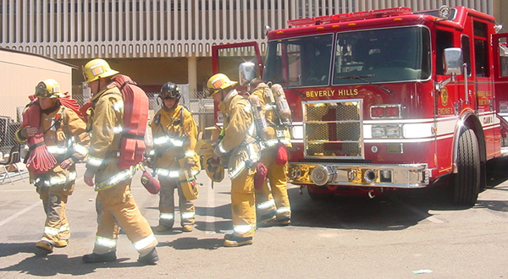
Beverly Hills Fire Department

Urban Fires
Fires could also ignite in urbanized areas of the City because of a wildfire, earthquake, or some other phenomena. A disruption in the water system, causing a reduction in hydrant pressures, could allow a normally controllable structure fire to escape containment by firefighting forces and spread to adjoining buildings; or a fire that starts in the flatlands in severe winds might cause spot fires with flying brands and ignite other buildings downwind by igniting wood roofs or vegetation.
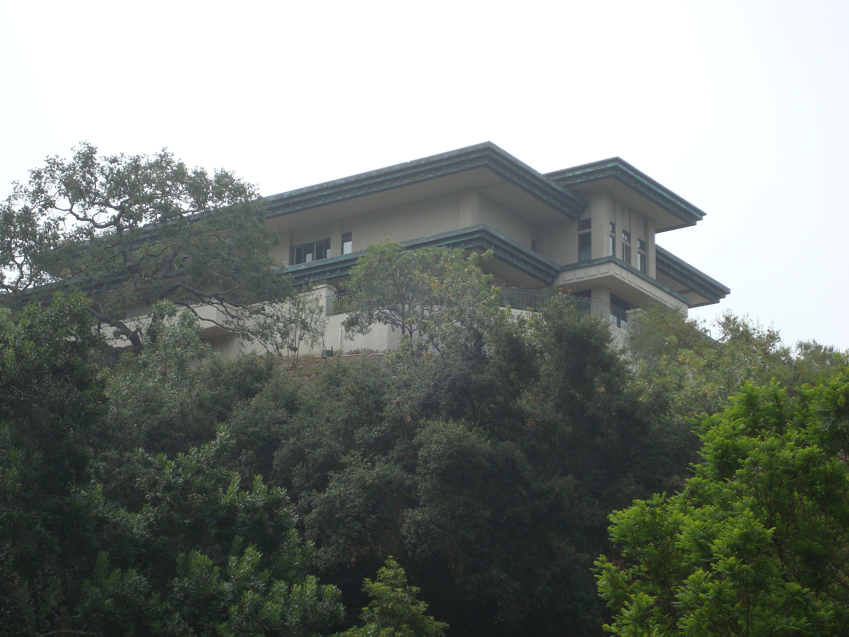Beverly Hills High Fire Hazard Severity Zone
Beverly Hills maintains fire prevention and suppression plans and programs to prepare for and mitigate potential fire hazards. Mutual aid agreements with other agencies allow for increased equipment and staffing in emergencies. In addition, the City’s Fire Code includes standards for building construction, renovations, and additions, and for the maintenance and clearance of vegetative growth.
There are currently no designated fire breaks within the City, as confirmed by the Beverly Hills Fire Department (BHFD). Land in the VHFHSZ north of Sunset Boulevard is fully built out, so the creation of fire breaks is not practicable. There are some buffer areas that do not have a dense amount of vegetation and fuel that are known, but they do not meet the definition or requirements to be technically considered a fire break. The City conducts annual inspections and enforcements for brush clearance and vegetation to increase defensible space around structures within the VHFHSZ. More information regarding fire breaks, fuel, and fires are detailed in the 2017-2022 Local Hazard Mitigation Action Plan, herein referred to as the LHMAP.

Very High Fire Hazard Severity Zones
Beverly Hills adopted the 2019 California Building Code and adds amendments to the California Building Code in Title 9 of the Beverly Hills Municipal Code. The California Building Code Chapter 7A requires that buildings constructed in areas identified as VHFHSZ must be built using fire-resistive features. Within the City of Beverly Hills, the area of the City north of Sunset Boulevard has been designated as a VHFHSZ. Figure 1 shows the VHFHSZ in the City of Beverly Hills and classifies this area as a Local Responsibility Area (LRA). The City’s opportunity sites as identified in the 2021-2029 Housing Element are not located in the VHFHSZ. Therefore, the redevelopment in the City of the opportunity sites would not be in areas that would have potential impacts from fires. In Beverly Hills, the BHFD is responsible for the LRAs. As determined in the LHMAP, approximately 1,620 parcels with an estimated valuation of at least $2.1 billion are located in a VHFHSZ. Detailed data regarding wildfire and historic wildfire events are listed in the LHMAP.
The City of Beverly Hills currently has multiple programs to mitigate the dangers of fire hazards. The BHFD, currently led by Fire Chief Gregory Barton, operates the City’s three fire stations:
- Station #1/Fire Department Headquarters: 445 N. Rexford Drive
- Station #2/Coldwater Canyon: 1100 Coldwater Canyon Drive
- Station #3/Doheny Drive: 180 S. Doheny Drive
The Los Angeles County Fire Department (LACFD) and the BHFD have a Mutual Aid Agreement for all hazard responses. Under this agreement, the BHFD takes main responsibility for hazard mitigation and fire protection for parcels located in the LRA of the VHFHSZ. Thus, the BHFD has primary responsibility for fire protection, while the LACFD is a cooperating agency providing fire response services if needed.
The LHMAP discusses in detail the different local, State, and federal agencies responsible for fire and hazard protection in the City of Beverly Hills. For example, the BHFD partners with community residents in the Just In Case BH Program (Just In Case BH) to create a Community Emergency Response Team (CERT). This City-wide program educates volunteers about disaster preparedness for the hazards that may impact their area and trains them in basic disaster response skills, such as fire safety, light search and rescue, team organization, and disaster medical operations. Just In Case BH helps to create a neighborhood of CERT-trained neighbors, doctors, and medical supplies, and also provides a central location for a supply of food and water in the event of an emergency. The program will also supply block captains with a way to communicate during power and internet outages. Just In Case BH also makes publicly available online maps on the City’s website for emergency gathering zones for community action and emergency response. Just in Case BH’s maps divide the City into nine zones by the City’s main arterials (e.g., Santa Monica Boulevard, Beverly Drive) for community emergency response.
Evacuation plans for parcels located in the VHFHSZ and within the City of Beverly Hills can be found on the City’s website at https://gis.beverlyhills.org/GISDocs/PublicMaps/WildFireEvacuationRoutes.pdf. There are multiple evacuation routes in the VHFHSZ, including Benedict Canyon Drive, Lexington Road, North Beverly Drive, Coldwater Canyon Drive, Schuyler Road, Loma Vista Drive, Doheny Road, North Hillcrest Road, and Carla Ridge. The evacuation routes direct residents to the north and out of the VHFHSZ or to the south onto Sunset Boulevard. While there are some cul-de-sacs within the VHFHSZ that would have one ingress or egress, by definition, residents would have access to reach at least two emergency evacuation routes upon exiting the cul-de-sac. Therefore, there are no residential developments in the VHFHSZ that do not have at least two emergency evacuation routes upon exiting the cul-de-sac. All roads in the BHFD’s jurisdiction meet or exceed the standards referenced in Title 14, California Code of Regulations, Division 1.5, Chapter 7, Subchapter 2, Articles 2 and 3. In the event of a wildfire in a VHFHSZ, evacuation orders will be communicated jointly by the BHFD and the Beverly Hills Police Department (BHPD), where the BHPD will enforce evacuation through the established evacuation routes. Further, in the case of a high fire day, parking within the VHFHSZ will be restricted, and all gates will remain open to ensure efficiency during evacuation.
Historically, fires in Southern California, and Beverly Hills in particular, have been exacerbated several times per year when the Santa Ana wind conditions make the threat of fire even greater than normal. Due to Beverly Hill’s proximity to the wildland/urban interface, fire history, and the continued appearance of meteorological events that increase wildfire fuel, Beverly Hills is at high risk for wildfires. The fire season may also be lengthening due to the longer dry and warm season and shorter wet and rainy season. Recent years have shown that vegetation is growing earlier, which results in vegetation being available as a fuel source for a longer period of time. Due to exacerbated drought conditions, dryer vegetation would result in increased fuel for wildfires. The LHMAP has more information about wild and urban fires, causes, and mitigation strategies.
The BHFD confirmed there are no areas defined as State Responsibility Areas (SRAs) in the City of Beverly Hills. Furthermore, there are currently no planned structures, roads, utilities, and essential public facilities in SRAs within City limits. As of 2021, the BHFD has not determined if the BHFD will need to relocate and/or distribute more fire stations. Figure 2 shows essential public facilities throughout Beverly Hills and their approximate location in or near fire hazard and flood hazard zones (discussed below) in Beverly Hills. Essential public facilities include hospitals and health care facilities, emergency shelters, fire stations, emergency command centers, and emergency communications facilities. Essential public facilities work together with fire stations during hazardous events to provide community organization and services in the event of an emergency.

Figure 1
Figure 2

Flood Hazards
Flash floods result from large and intense rainfalls that occur over short periods of time. The flooding would tend to occur in the winter months when precipitation is greater, and can occur within several seconds to several hours, with little or no warning.
The City of Beverly Hills was most recently affected by rainfall flooding in February 2003, causing flooding of subterranean garages, loss of personal property, including vehicles, and temporary loss of electric and gas service to the buildings in the 300 North Oakhurst Drive/Doheny Drive areas. Fortunately, none of flooding events in the City have had significant long-term effects.
In the United States, the responsibility for managing flood risks is shared across the federal, State, and local government agencies and the private sector. The U.S. Army Corps of Engineers (USACE) established the National Flood Risk Management Program, which provides current and accurate floodplain information, identifying and assessing flood hazards, improving public awareness and comprehension of flood hazards and risk, and integrating flood damage and flood hazard reduction programs across federal, State, and local agencies. Historically, the City of Beverly Hills has areas that are subject to flooding. Figure 3 illustrates the flood hazard zones in and around the City of Beverly Hills based on data from the Federal Emergency Management Agency (FEMA). Based on recent FEMA Preliminary Flood Insurance Rate Map Panels and designated floodway maps available from the Central Valley Flood Protection Board, the City of Beverly Hills is located in a “Zone X,” defined as an “area of minimal flood hazard.” As of 2021, the Department of Water Resources’ “Best Available Map” tool shows that the City of Beverly Hills is not located within a 100-year or 200-year flood plain zone. The City of Beverly Hills is not considered to be geographically located within a Special Flood Hazard Area (SFHA) within the Ballona Creek watershed. Due to the City’s location, floodway maps from the Central Valley Flood Protection board do not show any floodways and levee centerlines in the City of Beverly Hills, and the City is not located in any levee protection zones.
Flooding may also result when water retention structures fail due to an earthquake. Portions of Beverly Hills are threatened by flooding from the City’s Greystone Reservoir, Woodland Reservoir, Sunset Reservoir, and the City’s above-ground reservoirs (according to the 2020 UWMP, Reservoirs 4B, 5, 6, 3A). Damage to the structures caused by an earthquake, however, would probably be a minor breach, which would allow time for warning and reduction of the stored water in the reservoir. The City also lies in the inundation path of the Lower Franklin Canyon Reservoir which is located north of the City. In the event of a breach of this reservoir, the residential area north of Carmelita Drive would be exposed to immediate and severe danger. Below that point, the danger diminishes rapidly although flooding of most structures in this section of the inundation path would occur. Figure 4 illustrates debris basins and areas of extremely high inundation hazards in and around the City of Beverly Hills.
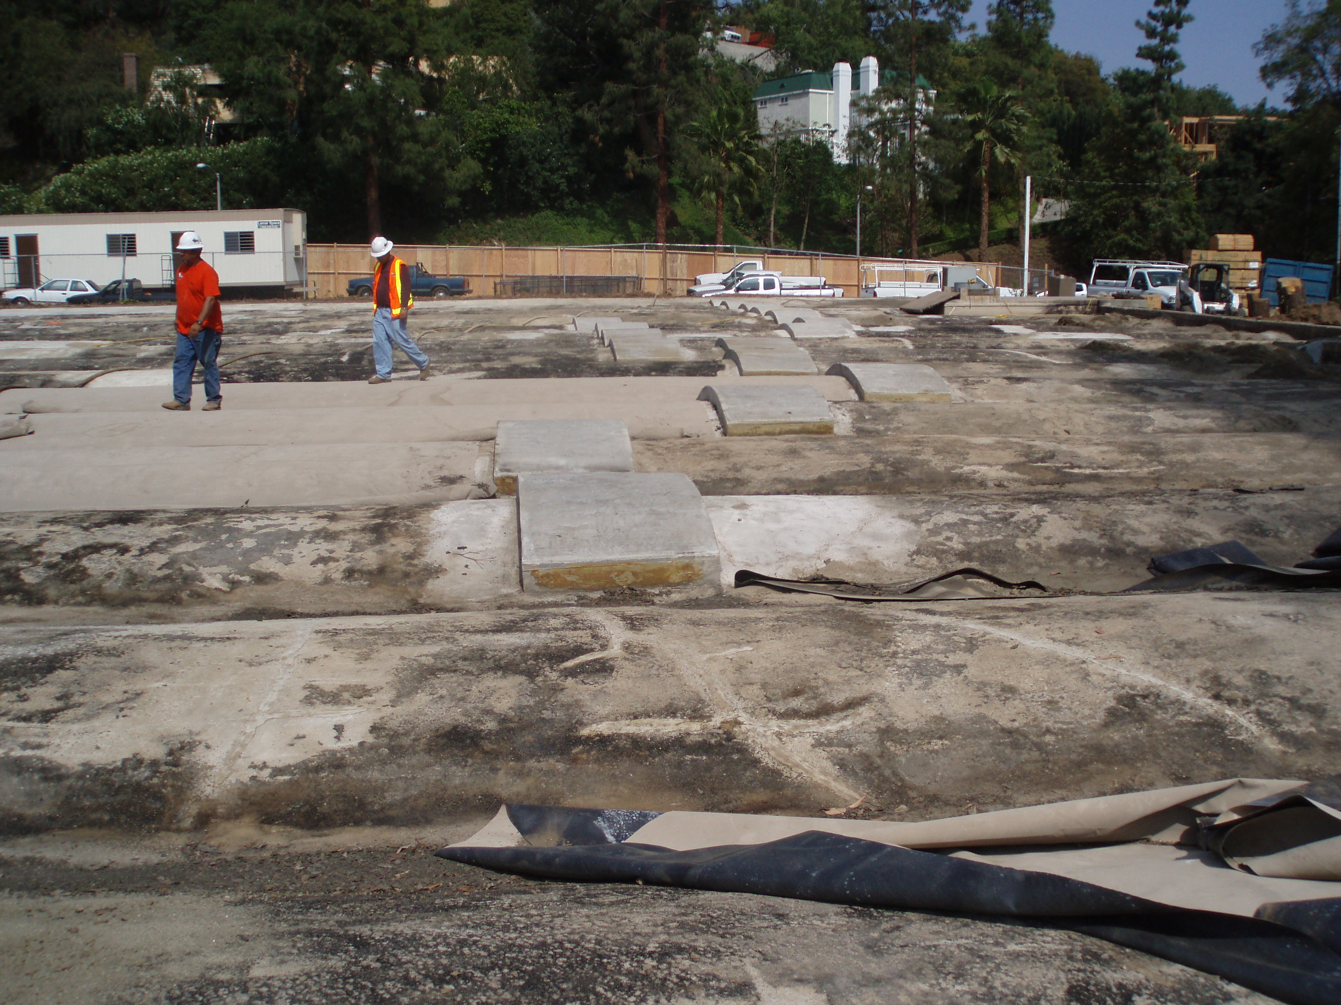Coldwater Canyon Reservoir

Figure 3
Figure 4
Reservoir or dam failure may result in loss of life and damage to structures, roads, and utilities. Several influences can affect the severity of a reservoir or dam failure event: the amount of water impounded and the density, type, and value of development and infrastructure located downstream of the reservoir or dam. Furthermore, downed tree limbs and other debris can cause localized flooding during heavy rain events. Therefore, the City is at a moderate risk of future flood events. To protect the City from hazards, the City of Beverly Hills and the County of Los Angeles have a Master Mutual Aid Agreement for all hazard response. Currently, there is no specific agreement for flood hazards in particular, but the Master Mutual Aid Agreement encompasses various hazards, such as flood, fire, earthquake, pestilence, war, sabotage, and riot. Under this agreement, the City of Beverly Hills and the County of Los Angeles are the primary agencies responsible for flood protection in the City. While the City’s opportunity sites as identified in the 2021-2029 Housing Element are not located in flood hazard zones, there are opportunity sites located south of Santa Monica Boulevard within the inundation area. As of 2021, the City does not have public, readily available evacuation route maps for flood and geological hazards. As of 2021, the BHFD is currently drafting the City evacuation plan, which may address flood and geological hazard (discussed below) evacuation routes. The redevelopment of the opportunity sites located south of Santa Monica Boulevard that are located within the inundation areas would have mitigation programs in place to address the potential for flooding. As determined in the Climate Vulnerability Assessment, the Los Angeles County Flood Control District’s Holly Hill Storm Drain upgrade project was implemented to reduce flooding hazards; therefore, the impacts from flooding would be limited.

Geologic and Seismic Hazards
The City of Beverly Hills is highly diverse geologically, as a result of the seismic setting of the surrounding region and the effects of climate. The impacts of climate change on geologic and seismic hazards are further discussed in the LHMAP. Figure 5 shows the different geological foundations that make up the City. The City of Beverly Hills’ exposure to geologic and seismic hazards is directly related to its proximity to active faults.
There are several active faults in or near the City of Beverly Hills. The Hollywood and Santa Monica faults converge within the City. The Newport-Inglewood Fault is located approximately 2 miles south of the City. Figure 6 identifies the regional faults affecting Beverly Hills. The City’s proximity to active seismic faults makes it highly susceptible to geologic and seismic hazards, including expansive soils, subsidence, liquefaction, and landslides. The Hollywood and Santa Monica faults running through the City are approximately located along South Santa Monica Boulevard and North Doheny Drive.

Liquefaction Hazard
Liquefaction is one of the most destructive secondary effects of seismic shaking. Liquefaction results from the loss of soil strength due to a sudden increase in pore water pressure during shaking. It occurs primarily in saturated and loose, fine to medium grained soils, in areas where the groundwater table is 50 feet or less below the surface. Liquefaction causes foundations of structures to move, leading to varying degrees of structural damage. In general, all of the South East area of Beverly Hills is underlain by recently deposited sediments that may include potentially liquefiable layers. If groundwater levels in this area rise to within 50-feet of the ground surface, the sediments would have a moderate to high susceptibility to liquefaction. As shown in Figure 7, the zones with higher liquefaction potential exist in the northern canyons, as well as in the eastern and southern areas of the City.

Expansive Soils Hazard
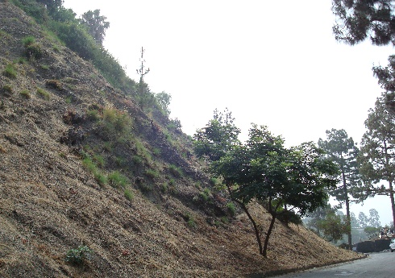
Soils that expand when exposed to water are considered expansive soils. Such expansion can cause structural damage to foundations and roads without proper structural engineering. Clay soils in Beverly Hills have potential for expansion and would swell and shrink with changes in moisture content.
Hillside Areas north of Sunset Boulevard

Subsidence Hazard
Subsidence can occur as a result of excessive groundwater or petroleum withdrawals which cause the ground surface to sink. Subsidence produces cracks in pavements and buildings and may dislocate wells, pipelines, and water drains. Beverly Hills has experienced limited subsidence over the years; however, it is still a potential hazard within the City.

Landslide Hazard
Landslides are often associated with earthquakes, but other factors may also influence their occurrence, including the slope, the moisture content of the soil, and the composition of the subsurface geology. The potential for landslides increases with vegetation loss from wildfires or drought. The City’s hillside areas, north of Sunset Boulevard, are susceptible to hillside slope failures during heavy rains. Heavy rains or improper grading may trigger a landslide. Figure 7 shows landslide zones in Beverly Hills. Landslide zones are located in the northern area of Beverly Hills. In the past, slope failures have been reported in the northern hillside areas of the City due to heavy rainfalls and soil erosion. The hillside residential development has also placed additional loads on the subsurface bedrock, which further contributed to the slope failure. As stated in the LHMAP, no significant or major debris flow resulting from landslides in the northern hillside area has been recorded in the City, and small debris flows in the past were localized and were cleaned up by the City’s Public Works Department. While a major landslide in the hillside area could destroy roadway pavement and limit access for residents in the northern hillside areas, historical occurrences have only had a minimal impact on the City. Furthermore, there are landslide mitigation activities and programs that are implemented into the City’s Landslide Building/Zoning Codes. Because the City already has existing landslide hazard mitigation measures and programs in place, the City is in general is considered to have only a slight risk for landslides.

Figure 5

Figure 6
Figure 7

Hazardous Materials
A hazardous material is defined as any material that due to its quantity, concentration, physical or chemical characteristics, poses a significant present or potential hazard to human health and safety or to the environment if released. Federal, State, and local agency databases maintain comprehensive information on the locations of facilities using large quantities of hazardous materials, as well as facilities generating hazardous waste. Hazardous materials and/or sites found in Beverly Hills include brownfield sites, toxic discharge, leaking underground fuel tanks, and household hazardous waste.

Disaster Preparedness
The City has developed two plans designed to implement programs to facilitate emergency management: the Emergency Operations Plan (EOP) and the Hazard Mitigation Action Plan (HMAP), described below. As previously discussed, the Just In Case BH Program assists the City in the case of an emergency. The City has an emergency notification program to alert citizens about current emergencies and to deliver essential information in the event of a natural or manmade emergency. Messages are typically provided through land line phones, cell phones, e-mail, and more. While residents and businesses with land line telephone numbers are already included in the emergency alert system, residents and business owners without land lines must register the devices with which they wish to receive the messages. The City also uses three notification systems to broadcast alerts related to emergencies (http://www.beverlyhills.org/departments/firedepartment/justincasebh/alerts/web.jsp). The Wireless Emergency Alert (WEA) will send text message alerts based on geographic vicinity to the affected area. Nixle provides general updates on local public safety via text message alerts. Everbridge will send alerts through the chosen communication method (text, email, or phone). Emergency evacuation maps are available on the City’s website.

Emergency Operations Plan (EOP)
The EOP addresses the City’s planned response to emergency situations associated with all hazards such as natural and man-made disasters, technological incidents, and national security emergencies. The EOP does not address normal day-to-day emergencies or the well-established and routine procedures used in coping with such emergencies (i.e. routine police and fire response calls). Instead, the operational concepts reflected in the EOP focus on potential large-scale disasters which can generate unique situations requiring unusual emergency responses.
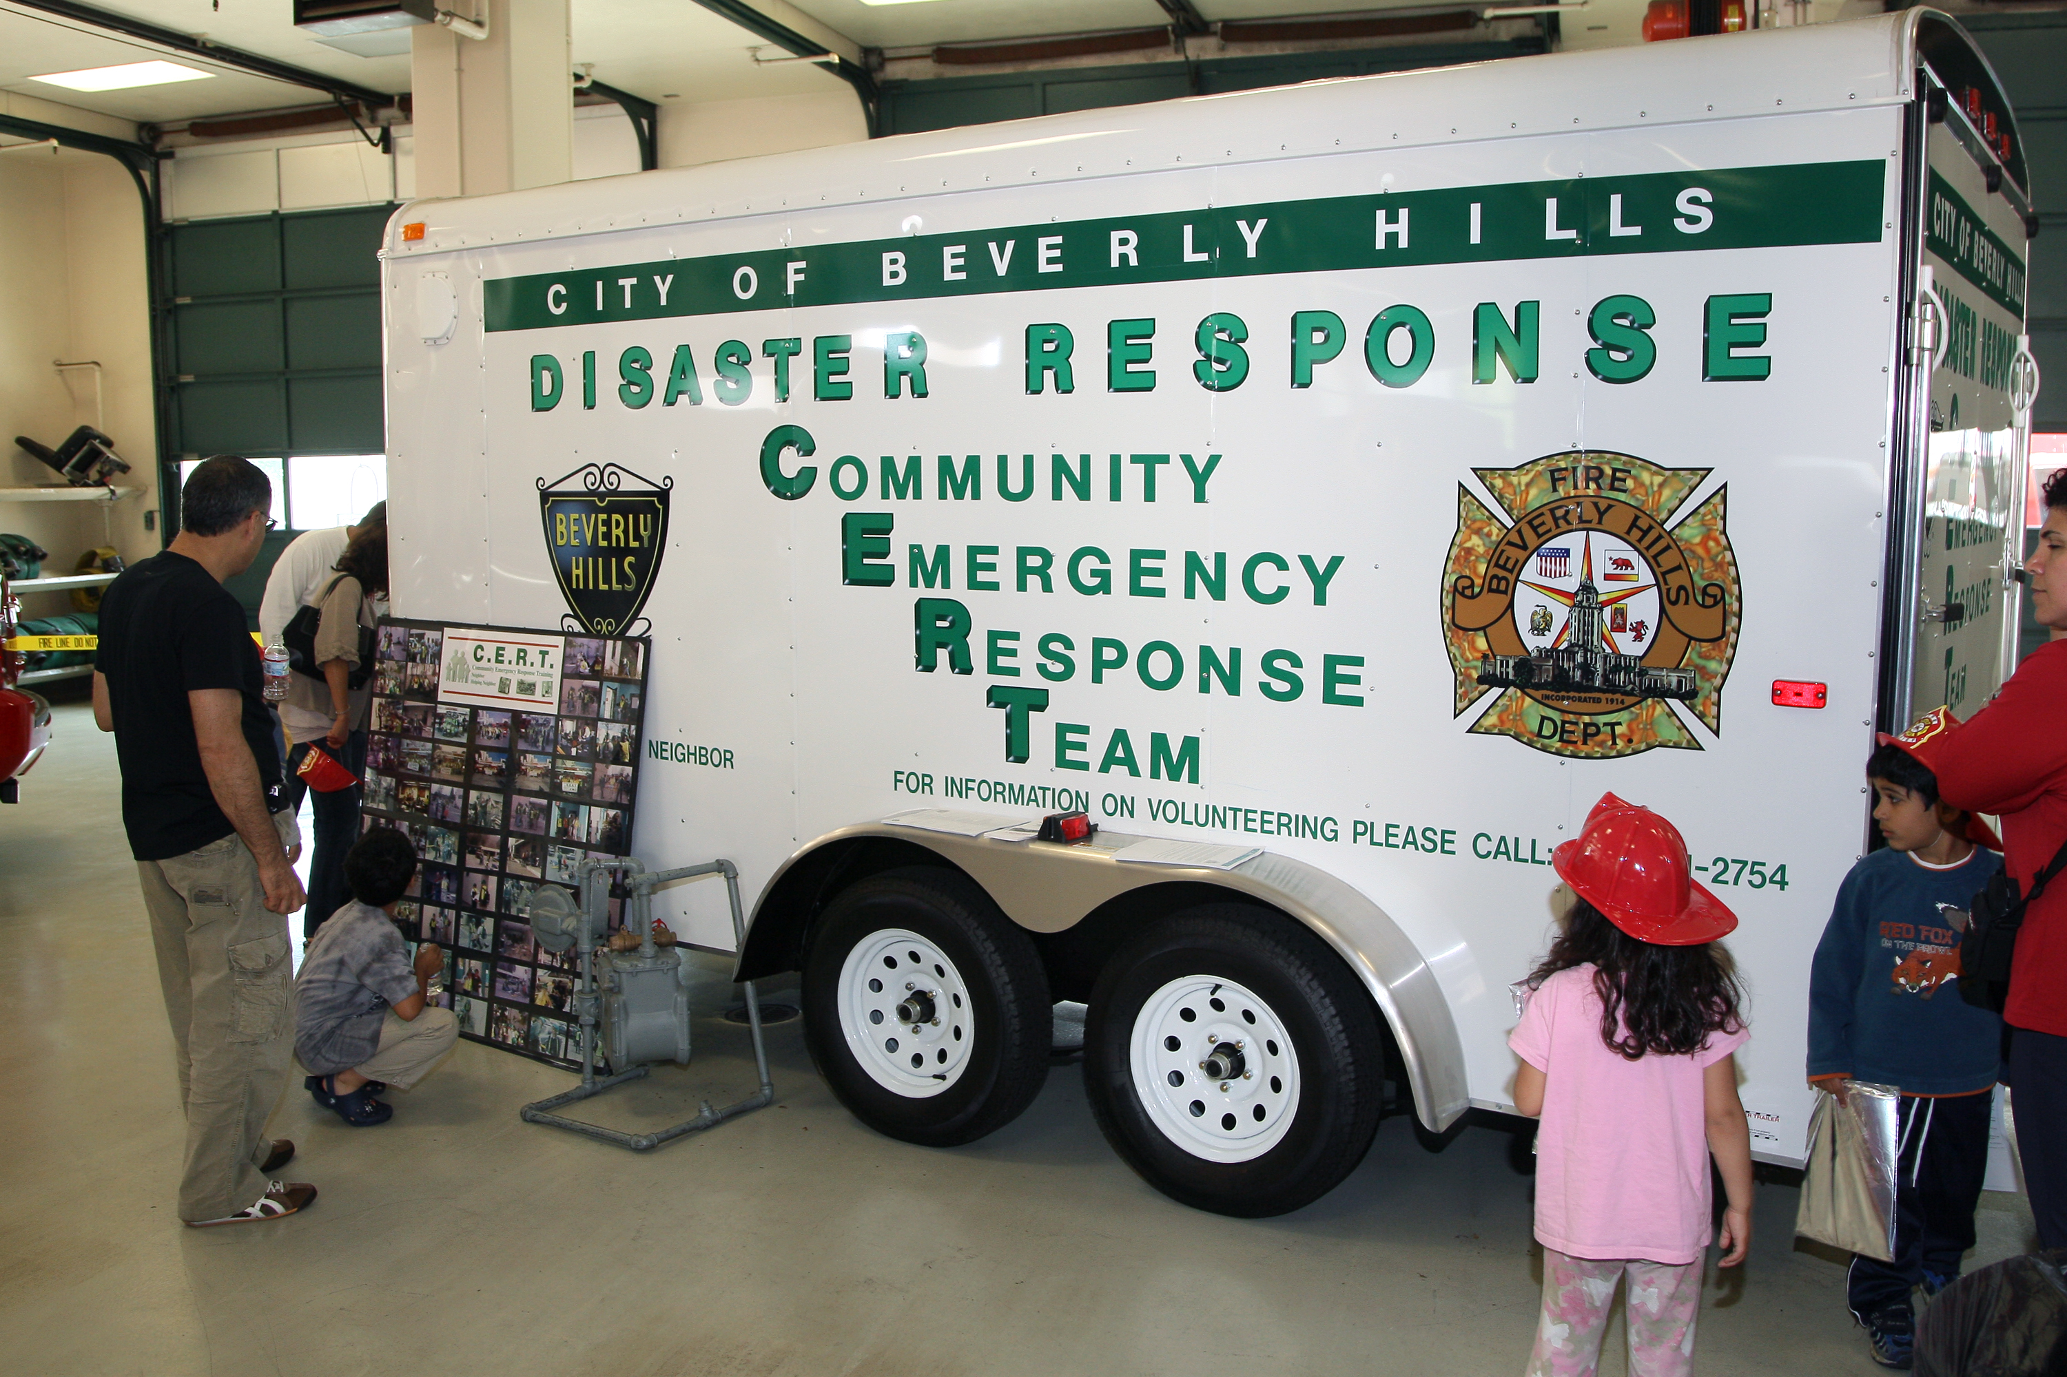Beverly Hills Disaster Response Trailer
Some emergencies will be preceded by a build-up or warning period, providing sufficient time to warn the public and implement mitigation measures designed to reduce loss of life and property damage. Other emergencies occur with little or no advance warning, thus requiring immediate activation of the emergency operations plan and commitment of resources. All City departments must be prepared to respond promptly and effectively to any foreseeable emergency, including the provision and utilization of mutual aid.
An Emergency Operations Center (EOC) is a location from which centralized emergency management can be performed during a major emergency or disaster. The City’s primary EOC and an alternate EOC are located within the City. The Director of Emergency Services has the authority to direct all EOC activity. The Director of Emergency Management is responsible for the City’s overall Emergency Management policy and coordination.
The plan/program provides an overview of operational concepts, identifies components of the City’s Emergency Management Organization within the Standardized Emergency Management System (SEMS) and the National Incident Management System (NIMS), and describes the overall responsibilities of federal, state, and local agencies for protecting life and property and assuring the overall well-being of the population.

Local Hazard Mitigation Action Plan (LHMAP)
The LHMAP includes resources and information to assist City departments, residents, public and private sector organizations, and others interested in participating in planning for hazards. The LHMAP provides a list of activities that may assist the City in reducing risk and preventing loss from future hazard events. The strategies address multi-hazard issues, as well as activities for earthquakes, wildfires, terrorism, earth movements, flooding, and wind storms.

Terrorism
Terrorism is a continuing threat throughout the world and within the United States. In recent years, terrorism has taken on new form with the introduction of chemical, biological, and radiological weapons. The probability that an individual/location will be targeted by a terrorist is a function of the attractiveness of the target, potential for success, and potential for avoiding identification and capture.
Beverly Hills is an internationally known, high-profile community with strong political and economic ties, and is frequently the focus of political events, dignitary visits, demonstrations, and marches. It is routine for Heads of State to visit and conduct business within the City. These factors make the City an attractive potential target for terrorist activity. It is not possible to estimate the probability of a terrorist attack. However, based on law enforcement’s role in combating terrorism, the City has identified critical sites and has assessed the vulnerability of these sites to a terrorist attack. Venues likely to suffer the impact of terrorism include government facilities, entertainment and cultural facilities, including the business district, and the popular hotels.
In Beverly Hills, the Police Department is the lead agency for the City response/crisis management. The City’s Office of Emergency Management is responsible for consequence management.
…

 | Goals and Policies
S 1 Protection of Life and Property. The protection of human life and property from the risks of wildfires and urban fires.
 |  |  |  |  | S 1.1 |  | Water Supply Reliability. Improve water supply reliability and capacity to fight wild fires and structure fires in the Zone 9 area, the Coldwater Canyon area, and other areas contiguous to the City, such as City of Los Angeles and Franklin Canyon Reservoir. (Imp. 3.2, 6.1)
 |  |  |  |  | S 1.2 |  | Property Maintenance. Continue to require property owners to conduct regular maintenance on their properties and roadways to reduce the fire danger and maintain a fire-safe landscape. (Imp. 2.4, 5.3)
 |  |  |  |  | S 1.3 |  | Brush Clearance. Conduct annual inspections and enforcement of the expanded requirement of 200 feet of brush clearance to increase defensible space around structures in the Very High Fire Hazard Severity Zone. (Imp. 1.3, 2.4)
 |  |  |  |  | S 1.4 |  | Hazard Mitigation Action Plan. Review and evaluate annually for progress in implementing the City's Hazard Mitigation Action Plan, and revise as needed for compliance with local, State and Federal requirements every five years. (Imp. 1.3, 6.1)
 |  |  |  |  | S 1.5 |  | Fire Hazard Mitigation. Require that fire hazard mitigation strategies, such as accelerating the 2013 compliance year for replacement of all non-Class A roofs in the VHFHSZ, are implemented and that effective public outreach and education is provided. (Imp. 1.3, 2.4, 8.1)
S 2 Fire Department Service. An efficient, well-equipped, and responsive fire department that offers maximum feasible personal safety and protection from loss of life and property caused by wildfires and urban fires.
 |  |  |  |  |  | S 2.1 | Fire Protection Service. Continue to research and implement methods for modernizing and improving the efficiency and effectiveness of the Fire Department in responding to fires, suppressing fires, and mitigating fire hazards. (Imp. 6.1)
 |  |  |  |  |  | S 2.2 | Fire Protection Capability. Maintain and expand the amount of firefighting equipment and personnel necessary for adequate initial response to fire emergencies in all buildings and areas in the City, including high-rise buildings and natural areas. Support and maintain mutual aid agreements to supplement those forces. (Imp. 6.1, 7.1)
 |  |  |  |  |  | S 2.3 | Emergency Management Exercises. Conduct periodic fire related emergency management exercises with City personnel and surrounding jurisdictions. (Imp. 1.3, 7.1)
S 3 Existing and New Development and Redevelopment. All existing and new development and redevelopment address the provision of fire protection in a proactive and preventative manner.
 |  |  |  |  |  | S 3.1 | Safety Standards. Continue to regularly update and enforce the City's building and fire codes to reflect the highest and best available standards for fire safety design as well as recommendations set forth by the "Fire Wise" assessment and Joint Wildland Interface Task Force. (Imp. 2.4)
 |  |  |  |  |  | S 3.2 | Impacts of New Development. Assess the impacts of significant increases in development density and intensity, and subsequent impacts on traffic congestion, water infrastructure capacity, fire hazards, and emergency response times. (Imp. 2.1, 2.2)
 |  |  |  |  |  | S 3.3 | Fire Protection Services. Require that new development and re-development of structures provide adequate fire safety features and responder access so as not to cause a reduction of fire protection services below acceptable, safe levels. (Imp. 2.4)
 |  |  |  |  |  | S 3.4 | Fire Department Access. Design private and public access drives and roadways to preserve and maintain Fire Department access to properties. (Imp. 2.4)
 |  |  |  |  |  | S 3.5 | Fire Protection for New and Existing Buildings. Require all new residential and commercial buildings, all substantial renovations, and all existing buildings having five-stories or exceeding a height of 55-feet, to be equipped with an automatic fire extinguishing system. (Imp. 2.4)
 |  |  |  |  |  | S 3.6 | Retrofit Existing Building and Related Infrastructure. Ensure that the needs to protect the most critical essential public facilities and related infrastructure from climate change hazards such as temporary inundation due to inland flooding, increased wind/storm events, an increase in high heat days, and/or wildfire are considered at the time at which retrofitting or expansion projects are undertaken.
 |  |  |  |  |  | S 3.7 | Fuel Modification Standards. Enforce a prohibition on the planting of certain vegetation that are considered to be undesirable and invasive due to their physical or chemical characteristics related to flammability risk on private properties in the Very High Fire Hazard Severity Zone (VHFHSZ), and encourage compliance with this standard in all other areas of the City.
 |  |  |  |  |  | S 3.8 | Code Compliance. Ensure all new development and/or redevelopment within the Local Responsibility Area (LRA) and Very High Fire Hazard Severity Zone (VHFHSZ) will comply with all provisions of the California Code of Regulations related to Fire Hazard Reduction Around Buildings and Structures Regulations for LRAs and VHFHSZs, and the most current version of the California Building Codes and California Fire Code.
 |  |  |  |  |  | S 3.9 | Required Fire Plans. All new development located in the Local Responsibility Area (LRA) and/or Very High Fire Hazard Severity Zone (VHFHSZ) shall be required to provide a site-specific Fire Protection Plan (FPP) and a Fuel Modification Plan that address fuel modification or incorporate open space and other defensible space areas, as well as multiple points of ingress and egress before approval.
 |  |  |  |  |  | S 3.10 | New Essential Public Facilities. Locate new essential public facilities, where feasible, outside of Very High Fire Hazard Severity Zones to ensure their reliability and accessibility during disasters, unless the facility is designed to mitigate the hazard.
 |  |  |  |  |  | S 3.11 | Post-Fire Assessment. Directly following a wildfire disaster, the City shall conduct a post-fire assessment to identify vulnerabilities and projects that address vulnerabilities. The goal of the post-fire assessment shall be to protect public safety, enhance access and evacuation, and reestablish essential functional needs to communities and ecosystems to minimize flooding, protect water quality, reduce landslide and debris flow occurrence, and limit pollution.
S 4 Protection from Flood Hazards. To reduce the potential risk of flood hazards to human life and public and private property.
 |  |  |  |  | S 4.1 |  | Flood Mitigation Design. Require that new development incorporate sufficient measures to mitigate flood hazards, including the design of onsite drainage systems linking with citywide storm drainage, gradation of the site so that runoff does not impact adjacent properties or structures on the site, and elevation of the structures above any flooding elevation. (Imp. 2.3, 3.4)
 |  |  |  |  | S 4.2 |  | Permeable Surface Area. Require the use of permeable surfaces for new development and redevelopment, including alleys and driveways for residential, commercial, and City properties. (Imp. 2.1)
 |  |  |  |  | S 4.3 |  | Storm Drain Clearance. Research and implement new technologies to prevent trash and debris from entering storm water drains. (Imp. 3.4)
 |  |  |  |  | S 4.4 |  | Hazard Mitigation Action Plan. Ensure that the City's Hazard Mitigation Action Plan is evaluated annually and revised every five years, that the current mitigation strategies addressing flood hazards are implemented where feasible, and that effective public outreach and education is included. (Imp. 1.3, 8.1)
 |  |  |  |  | S 4.5 |  | Reservoirs Assessment. Develop and maintain a program for periodically assessing, monitoring, and maintaining the structural integrity of reservoirs. (Imp. 3.2)
 |  |  |  |  | S 4.6 |  | Facility Use or Storage of Hazardous Materials. Require that all new facilities storing, using, or otherwise involved with substantial quantities of on-site hazardous materials within flood zones comply with standards of elevation, anchoring, and flood proofing, and that hazardous materials be stored in watertight containers. (Imp. 1.3, 2.1, 2.4, 3.2)
S 5 Protection from Geologic Hazards. To reduce the known level of risk to loss of life, personal injury, public and private property damage, economic and social dislocation, and disruption of vital community services that would result from earthquake damage or other geologic disturbance
 |  |  |  |  |  | S 5.1 | Safety Standards. Require new development and redevelopment to be in compliance with seismic and geologic hazard safety standards, including design and construction standards that regulate land use in areas known to have or to potentially have, significant seismic and/or other geologic hazards. (Imp. 2.2, 2.4)
 |  |  |  |  |  | S 5.2 | Building and Fire Codes. Continue to update the City's building and fire codes once every three years, or whenever the State updates the California building and fire codes, to reflect the highest and best available standards for seismic design and performance of buildings and to conform to State requirements. (Imp. 2.4)
 |  |  |  |  |  | S 5.3 | Reinforce Existing Buildings. Continue to require upgrade of unreinforced masonry (URM) buildings to address any structural and nonstructural seismic deficiency of existing buildings. (Imp. 2.4)
 |  |  |  |  |  | S 5.4 | Other Un-reinforced Masonry Buildings. Develop and implement a program for property owners to reinforce and strengthen other "at risk" buildings in the City to minimize loss of life and property damage in the event of seismic or geologic hazards. (Imp 1.3, 2.4)
 |  |  |  |  |  | S 5.5 | Hazard Mitigation Action Plan. Review and evaluate annually progress in implementing the City's Hazard Mitigation Action Plan, and revise as needed for compliance with local, State and Federal requirements every five years. Ensure that mitigation strategies addressing seismic and geologic hazards are implemented where feasible, and that effective public outreach and education is included. (Imp. 1.3)
 |  |  |  |  |  | S 5.6 | Assistance Programs. Develop assistance programs for senior citizens who own single-family homes to seismically retrofit their homes per current safety standards. Assistance programs should include maintaining lists of approved contractors, outreach to senior citizens and education efforts. (Imp. 6.1, 8.1)
S 6 Protection from Hazardous Materials. To ensure that the health, safety and general welfare of residents, visitors and the overall natural environment is protected to the maximum extent feasible from harmful exposure to hazardous materials
 |  |  |  |  |  | S 6.1 | Inter-jurisdictional Coordination. Continue to coordinate with and support the Los Angeles County Certified Unified Program Agency (CUPA), the Los Angeles County Fire Department, and their Health & Hazardous Materials Division (HHMD) in carrying out inspections, emergency response, enforcement, and site mitigation oversight of hazardous materials and waste. (Imp. 7.1)
 |  |  |  |  |  | S 6.2 | Hazardous Waste Collection. Conduct frequent and convenient household hazardous waste round-ups. (Imp. 6.1, 7.1)
 |  |  |  |  |  | S 6.3 | Educate Residents and Businesses. Educate residents and businesses on methods of reducing or eliminating use of hazardous materials, using safer non-toxic equivalents and proper disposal of household hazardous materials such as medications, batteries and e-waste. (Imp. 8.1)
 |  |  |  |  |  | S 6.4 | Hazardous Materials Regulation. Enforce current laws requiring all users, producers, and transporters of hazardous materials and waste to clearly identify the materials that they store, use, produce, or transport, and to notify the appropriate City, county, State, and federal agencies in the event of a violation. (Imp. 7.1, 7.2)
 |  |  |  |  |  | S 6.5 | Known Areas of Contamination. Require proponents of projects in known areas of contamination from oil operations or other uses to perform comprehensive soil and groundwater contamination assessments at their expense, in accordance with American Society for Testing and Materials standards, and if contamination exceeds regulatory action levels require the proponent to undertake remediation procedures prior to grading and development under the supervision of the Los Angeles County Environmental Health Division, County Department of Toxic Substances Control, or Regional Water Quality Control Board (depending upon the nature of the identified contamination). (Imp. 7.1, 7.2)
 |  |  |  |  |  | S 6.6 | Siting of Sensitive Uses. For uses that generate or use hazardous materials, develop and implement strict land use controls, performance standards, and structure design standards, including development setbacks from sensitive uses such as schools, hospitals, day care facilities, elder care facilities, residential uses, and other sensitive uses. (Imp. 2.2)
S 7 Preparation for Natural or Manmade Disasters. A city that has a strengthened and maximized potential to prepare for, mitigate against, respond to, and recover from natural or human-induced disasters and multi-disasters, and to minimize the loss of life and damage to life, property, and the environment.
 |  |  |  |  |  | S 7.1 | Emergency Operations Center. Maintain the Emergency Operations Center (EOC), ensuring that the City has a functional EOC that meets Federal and State guidelines. (Imp. 1.3, 6.1)
 |  |  |  |  |  | S 7.2 | Emergency Operations Plan. Review and update the City's Emergency Operations Plan on an annual basis and submit the plan to the State for approval every five years. (Imp. 1.3)
 |  |  |  |  |  | S 7.3 | Hazard Mitigation Action Plan. Review and evaluate annually for progress in implementing the City's Hazard Mitigation Action Plan, and revise as needed for compliance with local, State and Federal requirements every five years. Submit the plan to the State for approval every five years. Ensure that effective public outreach and education, including efforts to reach at-risk populations, are a component of the plan. (Imp. 1.3)
 |  |  |  |  |  | S 7.4 | Emergency Funding. Review and update regularly plans and procedures that allow the City to declare a disaster area and receive its fair share of Federal and State emergency funds in the event of a serious emergency or disaster. (Imp. 1.3, 4.2)
 |  |  |  |  |  | S 7.5 | Joint Effort in Emergency/Disaster Management. Ensure that emergency disaster management is the mutual responsibility of all City Departments and a variety of stakeholders, including the Citizen Corp Program, Beverly Hills Unified School District, private schools, local residents, and the business community. (Imp. 7.1, 7.3)
 |  |  |  |  |  | S 7.6 | Mutual Aid Systems. Maintain participation in local, regional, State, and national mutual aid systems. (Imp. 1.3, 7.1)
 |  |  |  |  |  | S 7.7 | Emergency Drills and Exercises. Conduct emergency drills and exercises throughout the City to test the effectiveness of emergency operation plans. Collaborate with other agencies, jurisdictions, and stakeholders on a regular basis. (Imp. 1.3)
 |  |  |  |  |  | S 7.8 | Emergency Management Systems Training. Conduct training sessions using Incident Command System (ICS), State Emergency Management System (SEMS) and National Incident Management System (NIMS) to ensure that all staff are familiar with these systems and other relevant plans consistent with their role as disaster service workers. (Imp. 1.3, 7.1)
 |  |  |  |  |  | S 7.9 | Training and Equipment. Ensure that all law enforcement, fire, health, and emergency agencies of the City are trained and equipped for emergency awareness and operations in the event of a terrorist attack. (Imp. 1.3, 6.1, 7.1)
 |  |  |  |  |  | S 7.10 | Funding for Training Programs. Pursue funding in support of inter-agency training. (Imp. 4.2, 4.3)
 |  |  |  |  |  | S 7.11 | Public Notification and Evacuation. Ensure that the City's emergency preparedness plans provide for efficient and orderly notification and evacuation on a citywide basis. (Imp. 1.3, 8.1)
 |  |  |  |  |  | S 7.12 | Public Education Programs. Sponsor and support public education programs pertaining to emergency disaster preparedness, mitigation response, and recovery protocols and procedures. Distribute information to stakeholders, residents, businesses, community-base organizations, faith-based organizations, schools, businesses and other groups. (Imp. 8.1)
 |  |  |  |  |  | S 7.13 | Risk Assessment of Critical Facilities. Perform a risk assessment of critical City facilities, and perform upgrades as necessary to improve security levels, including Information Technology infrastructure such as communication, "smart city" infrastructure improvements, and disaster recovery capability. (Imp. 1.3)
 |  |  |  |  |  | S 7.14 | Post-disaster Reconstruction. Participate in the development of programs and procedures that emphasize coordination between appropriate public agencies and private entities to remove debris and promote rapid reconstruction following a disaster event. (Imp. 1.3, 7.1, 7.2)
 |  |  |  |  |  | S 7.15 | Disaster Technology Communication Systems. Evaluate and upgrade as necessary the technology and communication systems that first responders and others use to coordinate disaster response. Coordinate communications with Beverly Hills Unified School District, regional, State and Federal entities. (Imp. 1.3, 7.1, 7.2)
 |  |  |  |  |  | S 7.16 | Prepare a Climate Action and Adaptation Plan.  Create climate action and adaptation plan that identifies strategies to reduce greenhouse gas emissions and to prepare and mitigate the impacts resulting from climate change.

…

Amendments
Date | Resolution | Description
March 6, 1976 | 76-R-5427 | Adoption of Safety element
March 7, 1975 | 75-R-5326 | Adoption of Seismic Safety element
January 12, 2010 | 10-R-12725 | Broad range of amendments updating the element to include local desires and State requirements. Amendment merged the Seismic Safety element into the Safety element
November 15, 2011 | 11-R-12845 | Adding the August 17, 2010 Hazard Mitigation Plan
XX XX, 2022 | 22-R-XXXX | Broad range of amendments updating the element, including the incorporation of the Local Hazard Mitigation Action Plan 2017-2022, input from advisory boards, and State requirements such as the Climate Vulnerability Assessment.

…

Based on correspondence with Mike Hand, Fire Marshal/Battalion Chief, of the BHFD on November 9, 2021.

