ELEMENT 11
Safety
This Element evaluates and mitigates the risk of climate change and natural hazards such as seismic and geologic activity, wildfires, and flooding.

Introduction
Natural and human-caused hazards present the City with a series of overlapping challenges. The hazards addressed in this Safety Element can expose people, infrastructure, transportation, buildings and property, and ecosystems to a wide range of stressors. The Safety Element includes goals and policies that proactively advance community resilience by identifying actions that promote safety and reduce risks from natural and human-caused hazards and climate change, while also ensuring an effective response and recovery from disastrous events.

What We Are Trying to Achieve
- A plan to effectively respond to natural and human-caused hazards and climate change.
- Residents are protected from the effects of natural and human-caused hazards and climate change.
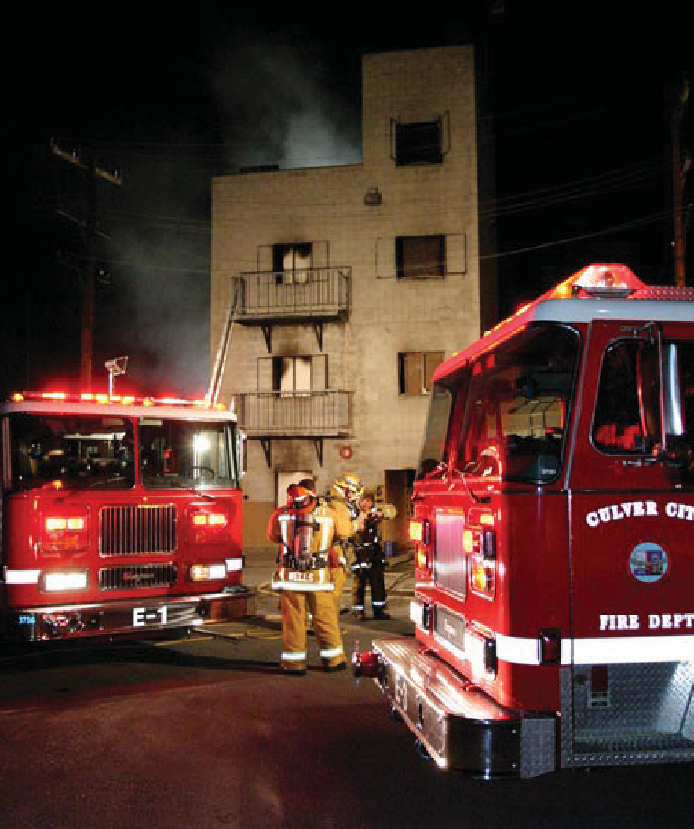

Culver City Fire Department Training Exercise

Key Issues and Opportunities
Culver City and its people are susceptible to various hazards, both natural and human-caused. This Safety Element identifies these known hazards in the community, such as pandemics, earthquakes, liquefaction, landslides, flooding, wildfire, climate change, and hazardous materials risks. This section summarizes the city’s hazards profile.
The Multi-Jurisdictional Hazard Mitigation Plan (MJHMP) for the City of Culver City planning area was developed in accordance with the Disaster Mitigation Act of 2000 (DMA 2000) and followed FEMA’s most recent Local Hazard Mitigation Plan guidance. The MJHMP incorporates a process where hazards are identified and profiled, the people and facilities at risk are analyzed, and mitigation actions are developed to reduce or eliminate hazard risk. The implementation of these mitigation actions, which include both short-term and long-term strategies, involve planning, policy changes, programs, projects, and other activities. To review the most current MJHMP, please visit https://www.culvercity.org/hazardmitigationplan.

Seismic Hazards
The Newport-Inglewood Fault Zone, a designated Alquist-Priolo Earthquake Fault Zone, is located in the northern portion of the city, as shown in Figure 37. The Newport-Inglewood Fault Zone, along with other regional faults, is capable of significant ground shaking in the city.
Older buildings constructed before modern building codes are likely to be more vulnerable to seismic hazards. Much of Culver City has an aging building stock with over 87 percent of houses constructed before 1980. Depending on their construction characteristics, these buildings may be vulnerable to damage from earthquakes if not retrofitted through means like foundation bolting and “soft story” retrofits. While the City encourages upgrades through State programs like the California Earthquake Authority Earthquake Brace + Bolt program, many older buildings were not adequately designed to be resilient to natural and climate hazards. The City adopted a Soft Weak Open Front Walls (Soft Story) Ordinance in 2021 amending the City’s Building Code to require seismic retrofit of vulnerable buildings. The Ordinance will be implemented over a five-year period based upon a citywide property risk assessment survey.
Unreinforced masonry (masonry buildings that lack steel reinforcing) and soft-story/weak-story buildings (buildings with large openings in ground floor building exterior walls, like garage doors and storefronts) face greater threats from fault rupture and ground shaking. Similarly, buildings with weak foundations and ground reinforcements, or lacking deep foundation systems, may face increased risks from liquefaction and landslides. Seismic hazards of all types may also interrupt services provided through important infrastructure networks, particularly if they are older systems. Power and communication lines, natural gas pipes, water and sewer pipes, and roadways may all be impacted.
In addition to ground shaking and fault rupture hazards, seismic hazards within the city include elevated liquefaction risk and seismically-induced slope instability. Liquefaction occurs when the force of an earthquake’s shaking causes groundwater to mix with the soil, leading to the ground mixture becoming fluid. This may cause buildings and structures to tilt, collapse, or suffer damage. Most of the city is in an area of elevated liquefaction risk, except for the city’s northwestern and southeastern borders, as shown in Figure 38. While the likelihood of liquefaction occurring in a future seismic event depends on several factors, there is a possibility for widespread damage from liquefaction in the community.
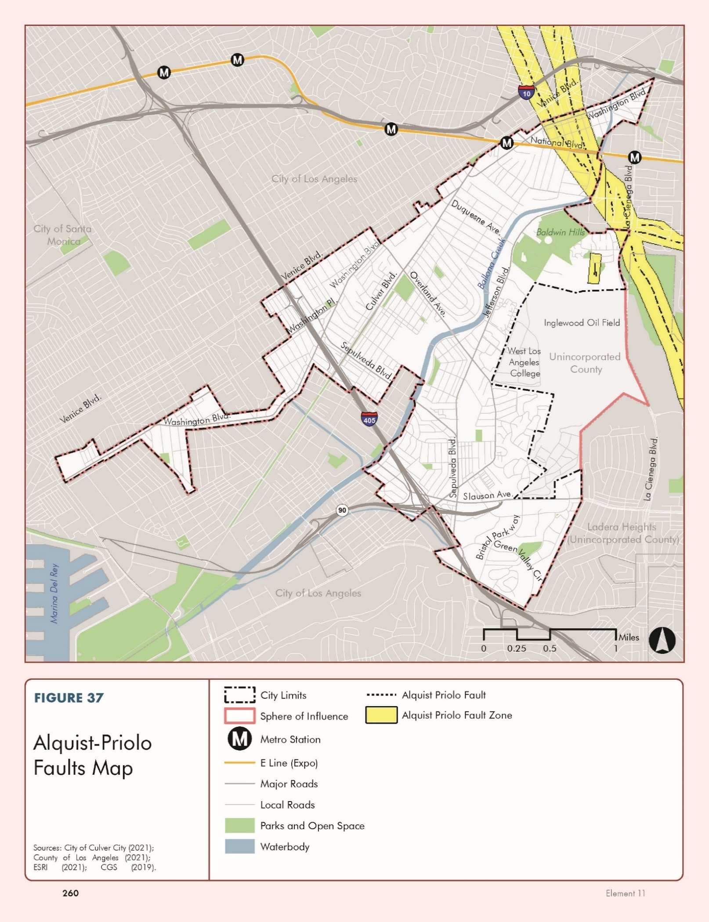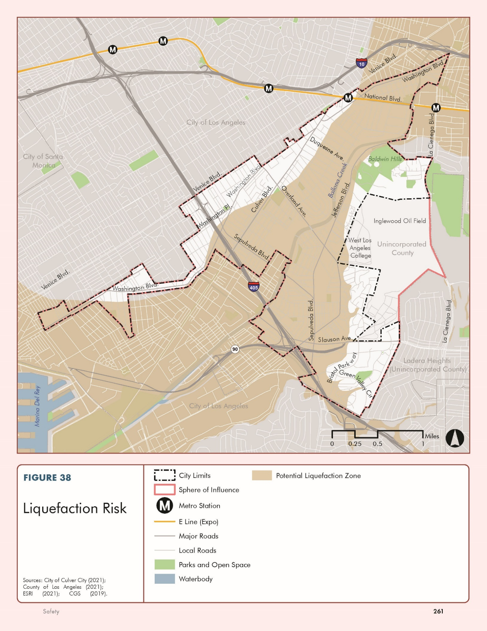

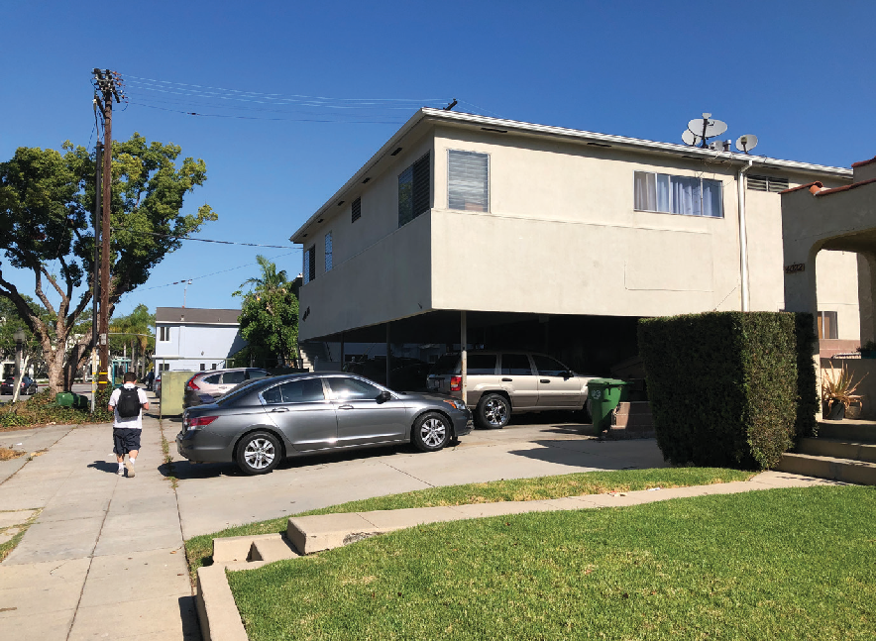
Apartment building with soft-story in Park East neighborhood
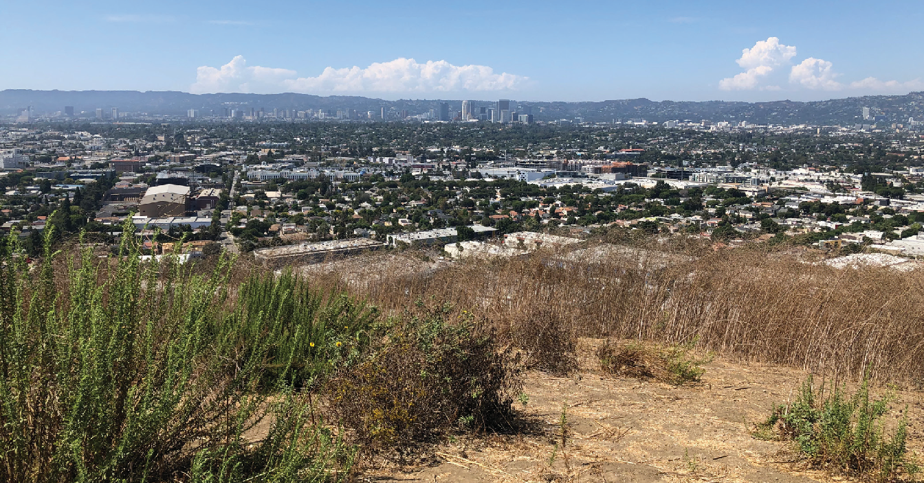
Aerial view of Culver City

Geologic Hazards
Slope instability leading to mudslides and landslides is a potential risk within the city. Due to their topography, the Blair Hills (located near the Baldwin Hills) and the Culver Crest neighborhoods have elevated landslide risk, as shown in Figure 39. Past landslides in these areas have not been widespread but show there is potential for landslides large enough to significantly damage or destroy buildings. Given the generally flat topography throughout most of the city, landslide hazards are largely confined to the Blair Hills and Culver Crest neighborhoods.
Other geologic hazards could include expansive soils and land subsidence (which is the caving in or sinking of an area). However, Culver City does not appear to be at risk from subsidence or expansive soils in developed areas, as there are no known historical occurrences although Bill Botts Field, a sports field in Culver City Park, has experienced subsidence as a result of it being built upon a former landfill that was not properly compacted prior to construction.
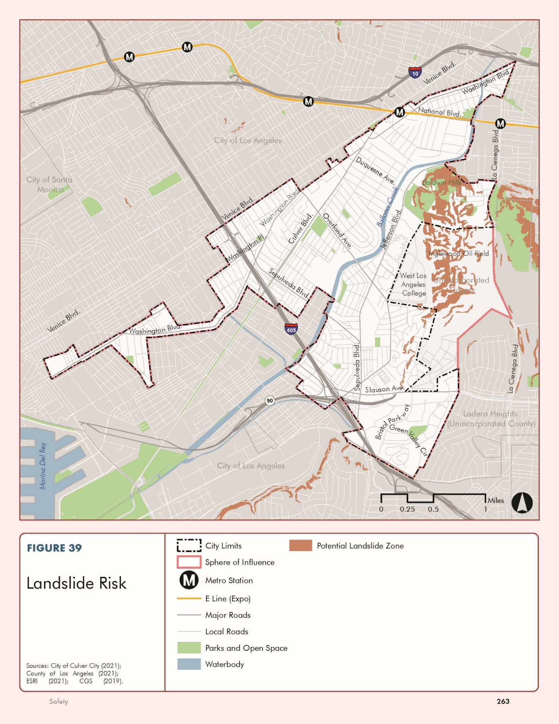

Flooding
The city has been relatively free of major flood events over recent time,58 although small-scale localized flooding has occurred during intense precipitation events. The main waterway in the city is Ballona Creek, which is a flood protection channel that drains the Los Angeles basin to the ocean that was built in the 1930s by the Army Corps of Engineers. The channel is comprised of an extensive system of tributaries and drains, mostly underground, that funnel stormwater into Ballona Creek. A small area in the northern part of the city has an elevated risk for flooding, as shown in Figure 40. This area is roughly bordered by Ballona Creek, Fairfax Avenue, and Adams Boulevard, and lies within a 100-year flood zone for a one- to three-foot flood. This means that there is a one in 100 chance that a flood event large enough to cause one to three feet of inundation will occur in any given year (Zone AO). Several smaller areas nearby are also within a 100-year flood zone (Zone A). These areas are at risk from a flood capable of causing inundation of less than one foot with a chance of occurring between one in 100 and one in 500 in any given year (Zone X). Due to the city’s location, it is not at risk for tsunamis or seiches. Culver City is also susceptible to flooding from nearby dam failures and participates annually in updating each of their Emergency Action Plans to ensure they are current. A list of those dams and their inundation maps are contained in the City’s MJHMP.
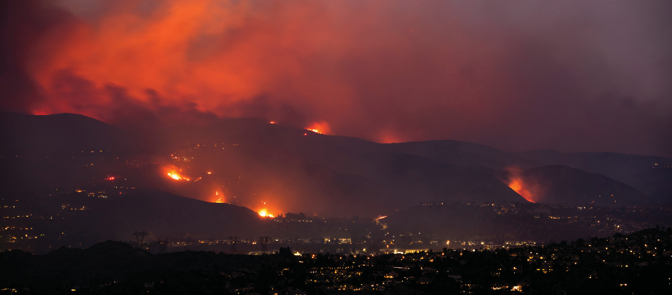
2019 Getty Fire
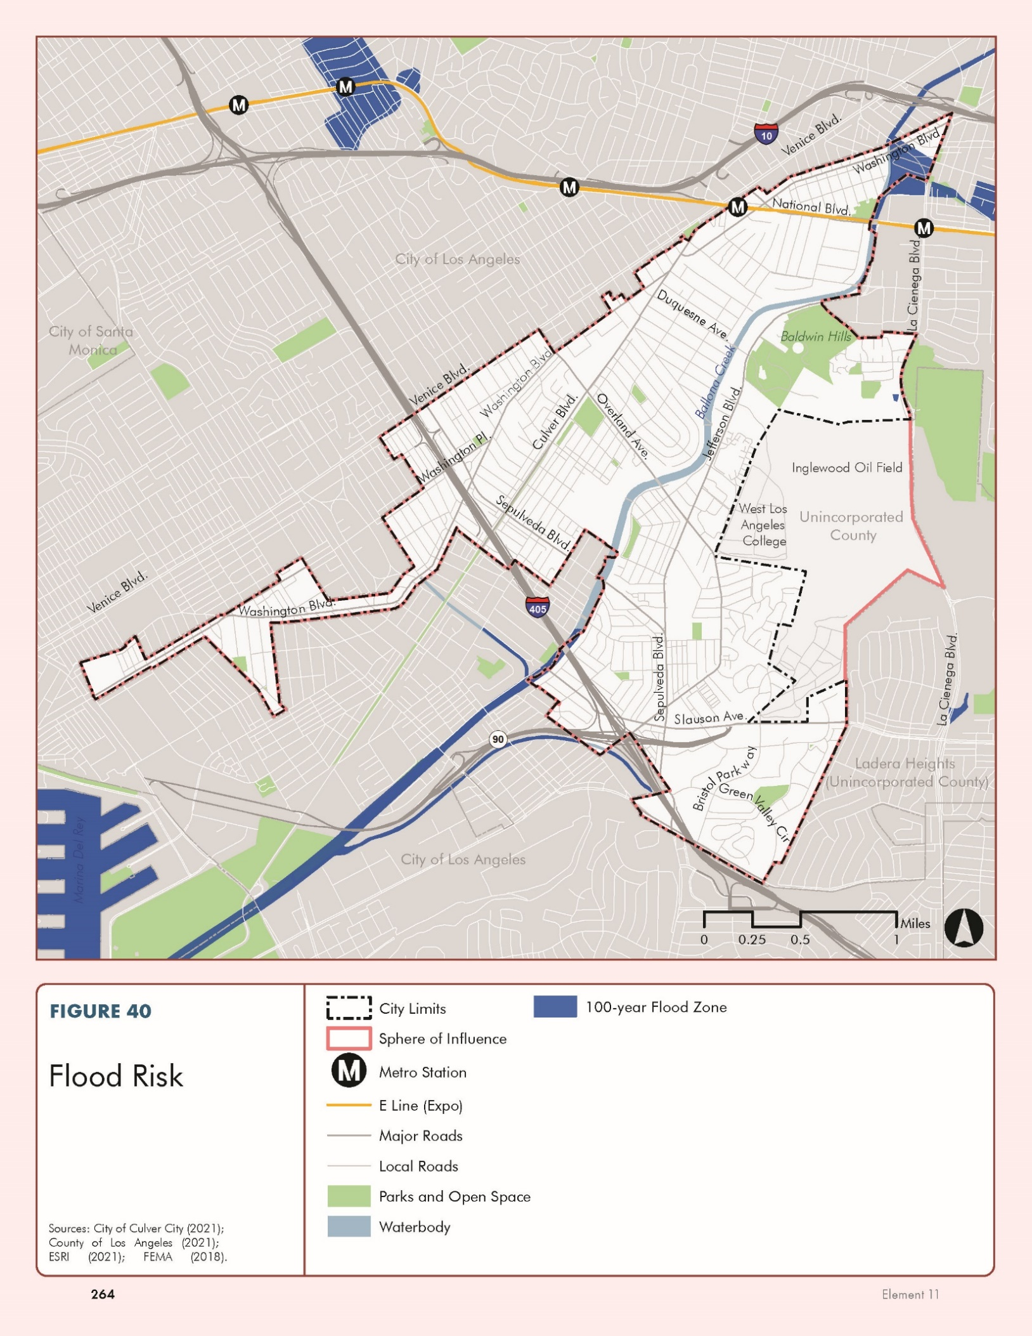

Wildfire
Wildfires often occur in forests or other wildlands with ample vegetation. In areas where structures and other human development meet or intermingle with wildlands or vegetative fuels [referred to as the wildland-urban interface (WUI)], wildfires can cause significant property damage and pose extreme threats to public health and safety. Wildland fires have historically occurred in the surrounding Los Angeles County region but have not affected the city (including the 2019 Getty Fire in Los Angeles, 2003 Padua Fire in Los Angeles County, and the 1993 Topanga Fire in Malibu). Table 1 below includes a full list of notable significant fires which occurred from 1878 to 2020. Smaller incidents with limited impacts to the planning area are more common historical occurrences than major wildfire incidents. Nevertheless, while major wildfires have occurred in other parts of Los Angeles County, the city experiences secondary effects such as smoke and poor air quality.

TABLE 2 Largest Wildfires in Los Angeles County History
Type | Fire Name | Location | Acres Burned
2009 | Station Fire | Angeles National Forest, Flintridge | 106,577
2020 | Bobcat Fire | Angeles National Forest, north Monrovia - Juniper Hills | 115,796
1970 | Clampitt Fire | Newhall to Chatsworth/Simi Valley | 105,212
2018 | Woolsey Fire | Southeast Ventura County to Malibu, Los Angeles County | 96,949
1919 | Ravenna Fire | Angeles National Forest, Big Tujunga Canyon | 75,000
1878 | Unnamed Fire | San Gabriel Mountains | 60,000
1919 | San Gabriel Fire | Angeles National Forest, San Gabriel Canyon | 60,000
2007 | Ranch Fire | Townsend Peak, southwest Templin Highway and I-5 | 54,000
1982 | Dayton Canyon | Malibu Canyon to Canoga Park | 54,000
1924 | San Gabriel Fire | Angeles National Forest, San Gabriel Canyon | 49,421
Source: Los Angeles Almanac, Wildfires in Los Angeles County, http://www.laalmanac.com/fire/fi07.php#largest, accessed July 20, 2023.

In California, wildfire protection is a shared responsibility among local, state, tribal, and federal organizations, each with legal and financial obligations. In Culver City, this collaborative effort involves several agencies at different levels of government. The Culver City Fire Department and the Los Angeles County Fire Department oversee fire protection and emergency services within the City and its surrounding areas.
The CCFD provides local fire protection services and has developed an Emergency Operations Plan (EOP) tailored to the unique needs of the community. This plan outlines the City’s response to various emergencies, including wildfires. Additionally, the CCFD offers the Community Emergency Response Team (CERT) program, which trains residents to assist in emergency response efforts, enhancing community resilience. The CCFD also provides multiple resources on it’s website, including disaster preparedness guides, to prepare and safeguard the community (see https://www.culvercityfd.org/Emergency-Preparedness)
The LACoFD implements several programs to mitigate fire risks and enhance community preparedness, such as the Ready! Set! Go! Program, which helps residents understand how to prepare their properties for wildfire, create evacuation plans, and stay informed during a fire event. The department's comprehensive Strategic Fire Plan provides a framework for fire prevention, suppression strategies, and emergency response protocols.
Federal entities like the United States Forest Service (USFS), Federal Emergency Management Agency (FEMA), and National Park Service (NPS) contribute resources and support to combat wildfires and manage fire-prone areas. Further, Southern California Edison (SCE), a special district responsible for electricity distribution, aids in wildfire prevention through measures such as Public Safety Power Shutoffs.
Through the integration of local, state, and federal efforts, Culver City benefits from a comprehensive and coordinated approach to fire protection and suppression, ensuring the safety and resilience of the community.
California Government Code Section 51178 requires CAL FIRE to identify and map “severity zones” in the state based on severity of fire hazards that are expected to occur there. While CAL FIRE does the mapping and recommends them to local areas, it is the responsibility of the local jurisdiction to adopt them by ordinance. There are three zones based on increasing fire hazard: medium, high, and very high. In 2011 CAL FIRE developed a Fire Hazard Severity Zone map (FHSZ), which identified the eastern portion of the city in a Very High Fire Hazard Severity Zones (VHFHSZ), as shown in Figure 41.
The VHFHSZ area in Culver City includes the eastern portion of the Culver Crest neighborhood, the Blair Hills neighborhood, and areas within the Inglewood Oil Field (IOF). CAL FIRE has made subsequent updates to their FHSZ map, which removed the Blair Hills neighborhood and areas within the IOF. However, based on the recommendation of the Culver City Fire Department and City staff, Culver City will utilize the 2011 CAL FIRE FHSZ map as shown in Figure 41. Development within these areas must follow certain Municipal Building Code and Municipal Fire Code restrictions for development types, landscaping requirements, fuel management, and brush clearance requirements to reduce risks associated with wildfires. Figure 42 identifies the VHFHSZ together with the distribution of existing and planned land uses, including structures, roads, utilities and essential public facilities, including fire stations. There are three fire stations in Culver City and a fire training building near the VHFHSZ.
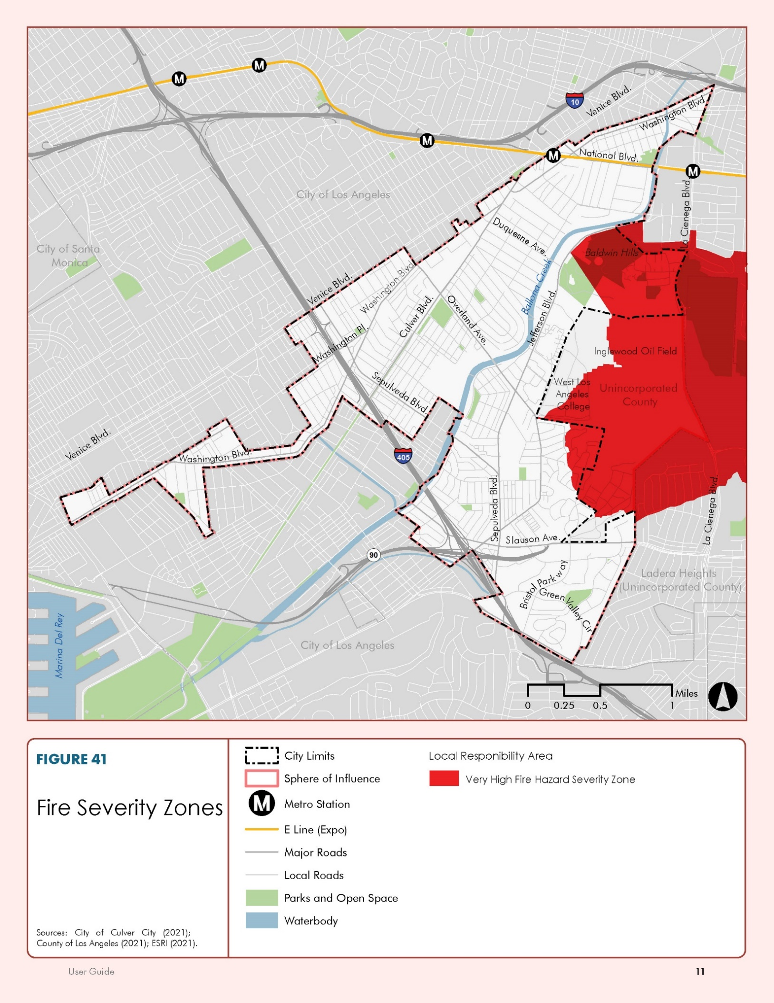
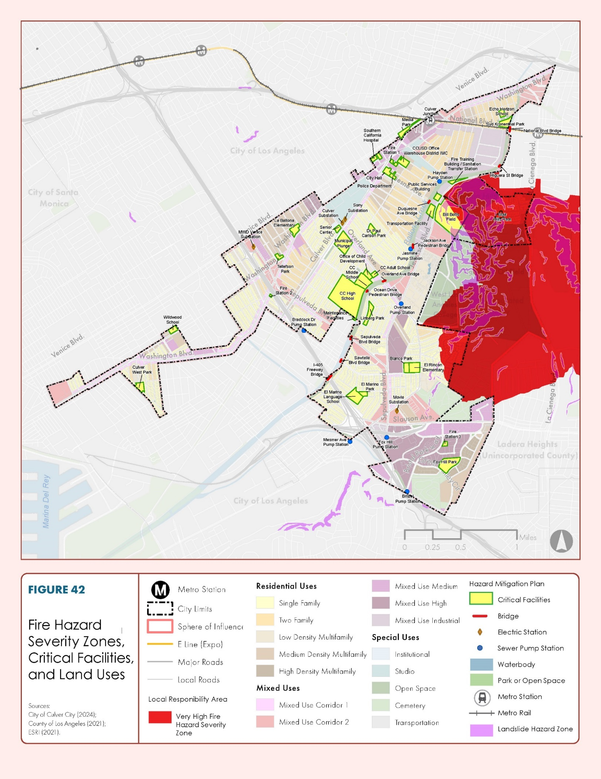

Climate Change
This Safety Element discusses climate change in terms of changing weather patterns that may exacerbate hazards. Refer to the Greenhouse Gas Reduction Element for additional discussion on climate change and policies to reduce greenhouse gas emissions citywide.
Climate change is not a distinct hazard, but rather a phenomenon that could exacerbate hazards, particularly through severe weather events, flooding, and wildfires. Climate change is expected to decrease precipitation levels and increase drought conditions. However, some evidence suggests it may increase the number of more intense storms that are likely to drop a larger amount of water in a shorter period. These events could overwhelm the ability of soil to absorb or infrastructure to drain the stormwater, and thus create flooding, landslides, and mudslides. Overall, drier conditions from climate change are also expected to dry out soils. This will make it more difficult for water to soak into the ground, further increasing the risk of flooding. Additionally, the City’s MJHMP describes how global warming increases wildfire risk in several ways. For example, fire seasons are longer due to earlier spring runoff, conditions are drier, more fuel is available for fires due to warmer and drier conditions, and lightning is more frequent as thunderstorms become more severe.

Evacuation Planning
As discussed above, there are various hazards that can occur in the city that could affect life and property. Given current climate change, disasters including drought, severe weather, flooding, and other emergencies will likely increase in the coming years, making emergency preparedness even more important.
In 2019 and 2020, California enacted two pieces of legislation regarding evacuation and require that cities update their Safety Elements, Emergency Operations Plan, or MJHMP, to identify and evaluate evacuation routes. California Government Code Section 65302.15, adopted through Assembly Bill (AB) 747, includes the requirement to identify evacuation routes and their capacity, safety, and viability under a range of emergency scenarios. In addition, California Government Code Section 65302(g)(5), adopted through Senate Bill (SB) 99, requires identification of residential developments in Very High Fire Hazard Severity Zones that do not have at least two emergency evacuation routes. Findings from this evacuation planning analysis and process may be found in the General Plan Appendix C.
Interstates 10 and 405, Venice Boulevard, Lincoln Boulevard, Jefferson Boulevard, and Sepulveda Boulevard all serve as potential evacuation routes, along with other roadways as needed. Information about emergency evacuation routes is shown in the maps contained in the MJHMP. These maps identify areas and communities with only one access route, particularly in residential areas, and distances to destinations for three evacuation scenarios.

Hazardous Materials
Chemical compounds, like petroleum hydrocarbons, that are released, leaked, or disposed of on or below the ground surface in the city, can contaminate surface runoff waters and tributaries connecting to Ballona Creek which flows into the nearby Santa Monica Bay, and can infiltrate into underlying soil and groundwater. Disturbing a previously contaminated area through grading or excavation operations can expose the public to health hazards from physical contact with contaminated materials or hazardous vapors.
The California Department of Toxic Substances (DTSC) and the State Water Resources Control Board (SWRCB) monitor areas where historical or ongoing activities have resulted in known or suspected release of hazardous materials into soil and groundwater, and where current investigation and clean-up activities are located. According to the DTSC EnviroStor and SWRCB GeoTracker databases, 14 sites in the city are actively being remediated, assessed, or are in a verification monitoring program. Of the additional 108 listings also shown in the city, 100 have been closed and require no further action, five are inactive, and two are eligible for closure.
The Inglewood Oil Field (IOF), which is one of the largest urban oil fields in the nation and has been in continuous operation since 1924, straddles Culver City and the unincorporated area of Los Angeles County known as Baldwin Hills. In 2008, the Los Angeles County Board of Supervisors adopted the Baldwin Hills Community Standards District (BHCSD), which established the oil and gas regulations for operation of the majority area of the IOF, within the unincorporated County just easterly of and adjacent to Culver City. The BHCSD includes requirements for monitoring and managing potential concerns related to release of hazardous materials. Independent of the County’s BHCSD regulatory program, in 2017, the City Council initiated preparation of an amortization study to evaluate and financially and factually support ending oil and gas extraction activities within the Culver City portion of the IOF. As a result of the information learned through the completed amortization study, in concert with other community safety considerations, in October 2021, the City adopted an Oil Termination Ordinance to implement an amortization program that would terminate and phase out nonconforming oil and gas activities within the Culver City portion of the IOF by November 24, 2026.
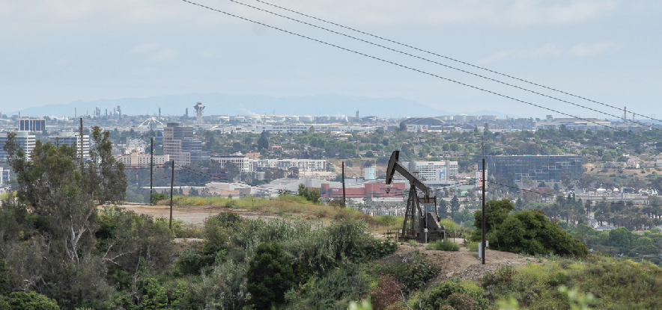
Inglewood Oil Field
From 2013 to 2019, there have been two reportable releases of hazardous materials from the IOF within City boundaries, neither of which reached Ballona Creek. In 2013, an inter-facility pipeline leaked seven barrels of produced water that drained onto the street and then into the storm drain near Blackwelder Street (near the intersection of La Cienega Boulevard and Fairfax Avenue). In April 2019, there was an oil-water leak along Leash Lane near the Bone Yard dog park. The leak traveled along the curb and gutter to a storm drain inlet, was redirected from the storm drain, and the flow traveled toward, but was fully contained just short of, the intersection at Jefferson Boulevard and Duquesne Avenue.

Utilities
While most are not visible, utilities (telephone, cable television, water, sanitary sewer, electricity, and natural gas) are essential to daily life, public health, and the regional and local economy. More frequent and intense storm events expose utility assets to disruption, but also change the demand and availability of energy and water supplies and may increase costs. Additionally, aging infrastructure has the potential to cause breaks and spills from utility lines and be especially susceptible to damage from earthquakes. Post-disaster utility restoration is critical for recovery, as are redundancies to reduce damage and disruption.

Communication
An important component of community resilience is communication. Interdisciplinary and inter-jurisdictional communication infrastructure is essential during a disaster. Alert and warning systems and messaging for the community must be maintained and accessible to help with responding to and recovering from a disaster.

Critical Facilities
Damage to critical facilities caused by a hazard event, such as an earthquake, has the potential to impair response and recovery from the event and disrupt services. The City’s critical facilities include City Hall, the police station, fire stations, sanitation transfer station, several parks, and various sewage pump stations, which provide important services to the community, especially during a disaster. 2 identifies these critical facilities.
TABLE 2 Culver City Critical Facilities
Type
City Hall
Fire Station No. 1/Emergency
Operations Center (EOC)
Fire Station No. 2
Fire Station No. 3
Fire Training Building
Police Station
Public Works Yard
Sanitation Transfer Station
Transportation Facility
City Parks and Recreation
Blair Hills Park
Blanco Park
Culver City Park (Botts Field)
Culver West Park
Dr. Paul Carlson Park
El Marino Park
Fox Hills Park
Ivy Substation & Media Park
Lindberg Park
Municipal Plunge
Senior Center
Syd Kronenthal Park
Tellefson Park
Veterans Park & Memorial Building
City Pump Stations
Braddock Sewer Pump Station
Bristol Sewer Pump Station
Fox Hills Sewer Pump Station
Hayden Sewer Pump Station
Jasmine Sewer Pump Station
Mesmer Sewer Pump Station
Overland Sewer Pump Station
Medical
Southern California Hospital at
Culver City
Source: City of Culver City and Culver City Unified School District Multi-Jurisdictional Hazard Mitigation Plan, 2017

Policy Framework

GOAL S-1
Community resilience. The City proactively advances community resilience and is prepared for all hazards, including climate disruption.
S-1.1: Emergency-related planning documents. Continue to update emergency-related planning documents (including the Multi-Jurisdictional Hazard Mitigation Plan) every five years to ensure consistency with State and federal law, best practices, local conditions, and recent science.
S-1.2: Multi-Jurisdictional Hazard Mitigation Plan. Continue to incorporate the hazards and mitigation measures identified in the Multi-Jurisdictional Hazard Mitigation Plan (MJHMP) into City emergency planning, capital projects, and programs.
S-1.3: Evacuation plan. Continue to develop and maintain an evacuation plan for the City to effectively communicate protocols to residents, distribute evacuation notices, and ensure that all transportation modes can effectively execute their evacuations.
S-1.4: Short- and long-term recovery. Develop plans for short- and long-term recovery after disasters. In these plans, require an evaluation of redevelopment to be conducted following disasters, particularly after large fires.
S-1.5: Care for vulnerable populations. Incorporate procedures into emergency and hazard mitigation plans (including the Emergency Operations Plan) to care for vulnerable populations, like seniors, during hazardous events.
S-1.6: Southern California Edison. Work with Southern California Edison to minimize the impacts of public safety power shutoffs.
S-1.7: Hazard risk evaluation. Regularly evaluate, identify, and communicate new hazard risks and incorporate them into planning and programs.
S-1.8: Coordinate with regional and State agencies. Coordinate with regional and State agencies to monitor potential changes in severity, frequency, and affected areas from future emergency situations, especially due to climate change.
S-1.9: Municipal climate preparedness planning and assessment. Implement climate preparedness planning across City departments, programs, and operations.
S-1.10: Natural disaster impacts on housing units. Ensure that housing units damaged during a natural disaster are repaired or replaced during rebuilding and recovery in ways that advance the General Plan’s policies, objectives, and actions, to the fullest extent feasible.
GOAL S-2
Critical facilities. Critical facilities have been designed to continue operating after earthquakes and other emergencies or catastrophic events.
S-2.1: Critical facility location. Avoid locating any new critical facilities including but not limited to, hospitals and health care facilities, emergency shelters, emergency command centers, emergency communication facilities, and utilities within or immediately adjacent to hazard areas (hazard areas are shown in Figure 37 through Figure 41). If no reasonable alternative is available, implement features to reduce their impact, including construction methods or other methods to minimize damage if these facilities must be located in a hazard area.
S-2.2: Back-up power. Continue to provide back-up power and supplies at critical facilities and identify any critical facilities that may not currently have them to maintain basic functions during emergency situations.
GOAL S-3
Community engagement. A community that is educated about and engaged in efforts related to reducing hazardous risks and climate change.
S-3.1: Public awareness of hazards. Increase public awareness of hazards, emergency preparation and response, and recovery through public education programs, evacuation plan updates, and informational signage. Create specific awareness campaigns for at-risk populations.
S-3.2: Educational programs. Promote community-based educational programs in fire safety and emergency preparedness through neighborhood-level and business outreach and engagement. Consider community volunteer groups like Community Emergency Response Team (CERT), Neighborhood Watch, Volunteers in Policing, and Culver City Amateur Radio Emergency Service (CCARES).
S-3.3: Employee capacity to identify hazards. Increase City employee capacity to identify hazards, and assist in emergency preparedness, response, and recovery. Train City staff through the Standardized Emergency Management System (SEMS) and the National Incident Management System (NIMS) training programs and through Emergency Operations Center (EOC) drills.
S-3.4: Emergency communication policy. Maintain the City’s emergency communication policy and protocols and use City website, media resources, emergency alert notification systems, social media, and program advertising to provide information and communicate with the community before, during, or after events that threaten community health, safety, and welfare.
S-3.5: Emergency alert systems. Continue to use emergency alert systems, like Everbridge, and coordinate with CCARES and CERT members to notify community members when there is an imminent threat or a need to evacuate.
S-3.6: Information distribution. Continue to distribute information about ways to reduce the threat of hazards to all community members through mailings, printed notifications, social media, the City website, television and digital devices, smart phone apps, and in-person events and workshops.
GOAL S-4
Seismic hazards. Culver City residents and businesses are prepared for earthquake hazards, minimizing the economic impact of strong ground shaking, liquefaction, and fault rupture on public and private property.
S-4.1: Retrofitting and rehabilitation. Promote strengthening planned utilities (where feasible) and retrofitting and rehabilitating existing potentially hazardous structures and aging lifeline utilities to increase public safety and minimize potential damage from seismic and geologic hazards and inadequate maintenance.
S-4.2: Project permit and review process. Strengthen the project permit and review process to ensure that proper actions are taken to mitigate potential adverse effects of seismic hazards. Consider structural and nonstructural seismic design and construction practices that minimize earthquake damage to critical facilities and structures designed for human occupancy.
S-4.3: Geological and geotechnical investigations. Continue to require geological and geotechnical investigations in areas of potential seismic or geologic hazards as part of the environmental and development review process.
S-4.4: Development or redevelopment within the Newport-Inglewood Fault Zone. Monitor development or redevelopment within the Newport-Inglewood Fault Zone in accordance with State law.
S-4.5: Newport-Inglewood Fault Zone cooperation. Cooperate with State and federal agencies in investigating the Newport-Inglewood Fault Zone geology. The City shall consider partnering with the U.S. Geological Survey’s Earthquake Hazards Program to better identify the active traces of the Newport-Inglewood Fault.
S-4.6: Alquist-Priolo hazard zone collaboration. Collaborate with the U.S. Geological Survey regarding compliance with regulations applicable to areas within the Alquist-Priolo hazard zone.
S-4.7: Earthquake-safe design. Ensure that new structures are designed to, and existing structures perform such that they minimize risk associated with earthquake hazards.
S-4.8: Seismic code enforcement. Continue enforcing the California Building Standards Code’s Seismic Design Category provisions, including those related to near-source seismic conditions.
S-4.9: Seismic vulnerability inventory. Continue maintaining an inventory of private buildings vulnerable to seismic activity, including unreinforced masonry and soft story structures. Prioritize retrofitting more vulnerable structures.
S-4.10: Seismic retrofit funding. Continue to identify potential funding sources to assist with seismic retrofits.
S-4.11: Agency cooperation. Cooperate with other agencies, like the California Earthquake Authority Earthquake Brace + Bolt program, and private interests to implement incentive programs and educate private landowners on foundation bolting and bracing.
S-4.12: Liquefaction vulnerability. Require new development in the liquefaction vulnerability zone to conduct liquefaction vulnerability studies with mitigation measures that addresses liquefaction, when warranted, for geological reports that the City requires emphasis on lower-income families.
GOAL S-5
Geologic hazards. The Blair Hills and Culver Crest neighborhoods are protected from the social and economic effects of geologic hazards associated with unstable slopes.
S-5.1: Development in areas with high landslide potential. Continue ensuring required compliance with State regulations during development and redevelopment within areas with high landslide potential during environmental and development review processes.
S-5.2: Site stability. Continue to require the following, when determined necessary, through standard City requirements, the Hillside Grading and Permitting Ordinance, the California Environmental Quality Act (CEQA), and other regulations:
- Preliminary geotechnical and geologic investigations in areas with high landslide potential;
- Evaluation of site stability and possible impact on adjacent properties, before final project design is approved; and
- Preparation of reports, investigations, and design recommendations for grading permits, building permits, and subdivision applications by a State-geotechnical engineer and State-certified engineering geologist.
S-5.3: Building safety. Continue to require the following, when determined necessary through City requirements, CEQA, and other regulations:
- Meeting the California Building Standards Code and Hillside Grading and Permitting Ordinance adopted by Culver City, coordinating between the project civil engineer, engineering geologist, and geotechnical engineer during grading and construction operations; and
- Certifying that building sites are stable to potential adverse effects of rain, earthquakes, and differential settlement before issuing building permits.
S-5.4: Geotechnical site investigations. Require geotechnical site investigations before permitting reuse or rebuilding of a failed area, adjacent unstable slopes, or debris flow path. Establish standards to improve setbacks or surface/subsurface drainage, construct buttresses or other retaining structures, or reconstruct slopes, that will minimize future risk to persons and property or public liability.
S-5.5: Geologic hazard management. Whenever possible, mitigate geologic hazards in a manner that preserves the aesthetic or natural conditions of hillside areas through minimal grading, or corrective landform grading and revegetation with appropriate plant materials. When these goals conflict, protecting life and property shall take precedence.
S-5.6: Vegetation management. Reduce the potential for landslides by sufficiently removing dead, woody vegetation after a catastrophic fire.
GOAL S-6
Flood hazards. The community is resilient to flood and inundation hazards.
For related policies and implementation actions connected to parks and public facilities, see the Parks, Recreation, and Public Facilities Element.
S-6.1: Flood hazard safety. Minimize injury, loss of life, property damage, and economic and social disruption caused by flood and inundation hazards.
S-6.2: National Flood Insurance Program. Continue participating in the National Flood Insurance Program.
S-6.3: Property protection. Encourage property owners, particularly property owners in and next to flood hazard areas, to improve drainage on their properties through low-impact development features (including but not limited to bioswales or an increase in pervious materials to support groundwater recharge).
S-6.4: Flood control supply. Maintain an adequate supply of sandbags and other low-cost flood control measures to protect City facilities and to meet public demand.
S-6.5: Critical facilities. Consider locating critical public facilities – including hospitals and healthcare facilities, emergency shelters, police and fire stations, and emergency communication facilities – outside of the 100-year flood plain.
S-6.6: Storm drain system evaluation. Continue to evaluate the effectiveness of City-owned storm drain systems and improve them as-needed.
S-6.7: City-owned drainage systems. Monitor City-owned drainage infrastructure during rain events and take emergency action, as necessary, to avoid or minimize flooding.
S-6.8: Drainage systems at base of hills. Study drainage systems in selected areas at the base of hills (specifically the Blair Hills and Culver Crest neighborhoods) to identify where drainage improvements may be necessary.
S-6.9: Culvert and storm drain system maintenance. Maintain the culverts and storm drain system to prevent debris or other obstructions from accumulating, as that would hamper the effectiveness of the system during rainy days.
GOAL S-7
Fire hazards. Threats to public safety from wildland and urban fire hazards are reduced and property damage minimized.
S-7.1: California Building Code and California Fire Code. Continue to adopt and enforce the most up-to-date California Building Code and California Fire Code, with local amendments as appropriate. Maintain consistency with California Code of Regulations Title 14 Natural Resources Division 1.5 Department of Forestry Chapter 7 - Fire Protection.
S-7.2: Fire protection and prevention mutual aid agreements. Continue to maintain cooperative fire protection and fire prevention mutual aid agreements with relevant agencies.
S-7.3: Support for fire prevention awareness. Continue to support the Culver City Fire Department, California State Fire Marshal, and other relevant agencies to promote the implementation and awareness of fire prevention programs.
S-7.4: Fire prevention code enforcement. Develop design standards and strengthen performance review and code enforcement programs to ensure proposed development incorporates fire prevention features.
S-7.5: Comply with minimum standards for fire protection. Require new development to meet the State’s minimum standards for fire protection unless the City’s Municipal Code defines more stringent standards. Require that ingress and egress routes be constructed using the most current State Fire Safe Regulations, Fire Code, and/or Municipal Code that meets these minimum requirements. These standards include:
- Adequate road widths to accommodate emergency vehicles and developments; and
- Enforcing Municipal Code provisions that require automatic fire extinguishing systems and other fire safety standards;
- Minimum fuel modification requirements in SRA and VHFHSZs;
- Fire protection plans for new development in VHFHSZ;
- Ability for a safe and efficient fire department response;
- Adequacy of water supply for new development (i.e., maintenance and long-term integrity); and
- Adequacy of fire flow (gallons per minute) to extinguish a fire at the proposed development.
S-7.6: Firefighting capability. Strengthen City firefighting capability to respond to multiple fire incidents caused by an earthquake, Santa Ana winds, climate change, or other extraordinary circumstances.
S-7.7: Building Code and Fire Code provisions. Enforce the standards and guidelines of the City’s Building Code and Fire Code fire safety provisions. Require additional standards for high-risk, high occupancy, dependent, and essential facilities where appropriate. This shall include assurance that structural and nonstructural architectural elements of the building are designed not to:
- Impede emergency egress for fire safety personnel, equipment, and apparatuses; and
- Hinder evacuation from fire, including potential blockage of stairways or fire doors.
S-7.8: Long-range fire safety planning. Continue to conduct and implement long-range fire safety planning and protection, including projections for emergency services for the City if needed, to cope with increasing urban density caused by new development, redevelopment, and property infilling. Consider more stringent Building or Fire Municipal Code standards, improved infrastructure, and improved mutual aid agreements with the public sector.
S-7.9: Wildfire hazard. If warranted, avoid approving new development in areas subject to wildfire hazard. Enforce the standards and guidelines of the City’s Building Code and Fire Code fire safety provisions to reduce wildfire hazard. For areas within fire hazard severity zones, the California Fire Code requires construction methods intended to mitigate wildfire exposure, hazardous vegetation and fuel management, create defensible space around all buildings and structures, and maintain community fire breaks.
S-7.10: Fire-safe landscapes. Encourage residents to plant and maintain drought-resistant, fire-retardant landscape species on slopes to reduce the risk of brush fire and soil erosion in areas adjacent to canyons. Develop stringent site design and maintenance standards for areas with high fire hazard or soil erosion potential.
S-7.11: Cooperate with other agencies. Cooperate with other agencies and private interests to educate private landowners on firesafe measures to achieve a low-risk condition.
S-7.12: Future fire risk. Using best available science, plan for future fire risk because of climate change or other factors and alert public and private landowners in future risk areas.
S-7.13: Fire code enforcement. Continue to enforce the California Fire Code and Municipal Fire Code Amendments for new construction in Very High Fire Hazard Severity Zones like using sprinklers in residential structures.
S-7.14: Evacuation routes. Require all development proposals to identify evacuation routes or establish new evacuation routes as needed. Consider including the following actions, or similar actions that achieve the same outcomes, in conjunction with established fire standards when formalizing plans for potential or imminent evacuation routes, particularly in the VHFHSZ:
- Increase capacity through use of contraflow lanes;
- Manage traffic control, including through turn restrictions and route or ramp closures, to minimize outflows from evacuation areas;
- Manage street parking on high hazard days;
- Continually improve communication systems and implement strategies that improve disaster alerts;
- Instigate dynamic route guidance and monitoring;
- Implement phased evacuations;
- Promote reductions in vehicle volumes during evacuations, such as by encouraging households to use only one vehicle to evacuate; and
- Closely monitor power issues that could affect traffic signals and slow down evacuations.
S-7.15: Non-compliant development. Identify or develop programs to provide financial incentives or assistance to existing non-compliant development for defensible space maintenance, home gardening, low-cost retrofits, and other measures to reduce fire hazard.
S-7.16: Proper addressing and signage. Implement proper addressing and signage for all streets and homes in compliance with Culver City Fire Department standards to assist in fire emergencies.
S-7.17: Fire prevention and suppression needs. Coordinate with Los Angeles Department of Water & Power (LADWP) and Golden State Water Company, as well as other water service providers within the city and neighboring cities and fire agencies in neighboring cities, to plan for future fire prevention and suppression needs including identifying future water supply for fire suppression needs.
S-7.18: Long-term fire-reduction maintenance. Ensure long-term maintenance of all fire hazard reduction projects, including community fire breaks and private road and public road clearance.
GOAL S-8
Hazardous materials. Local code enforcement actions are strengthened to minimize threats to public health and safety from hazardous materials. For example, the risk of multiple releases caused by earthquakes, industrial uses, and activities within the IOF will be minimal.
S-8.1: Hazardous materials coordination. Coordinate with the Culver City Fire Department and Los Angeles County’s CleanLA to prepare for and respond to hazardous materials incidents.
S-8.2: Hazardous materials use, storage, and transport. Require businesses that use, store, or transport hazardous materials to adopt measures that protect public health and safety.
S-8.3: City website updates. Maintain the City’s website and other outlets with information on how to safely handle and dispose of household chemicals.
S-8.4: Disposal of hazardous waste and construction materials. Revise, update, and maintain standards to dispose of hazardous waste and construction materials properly and effectively.
S-8.5: Travel routes for hazardous material transport. Identify and establish specific travel routes to transport hazardous materials and wastes. Consider capacity to safely accommodate additional truck traffic, avoiding residential areas, and using interstate or State divided highways as preferred routes.
S-8.6: Gas releases. Evaluate the potential for methane or hydrogen sulfide gas releases due to active or abandoned oil facilities or natural conditions. Ensure development is consistent with federal, State, and local safety guidelines, standards, and requirements related to soil gas releases.
GOAL S-9
Inglewood Oil Field. Oil production uses are phased out or replaced with land uses that the City determines to be more compatible with the adjacent communities and their character.
For related policies and implementation actions connected to the Inglewood Oil Field, see Conservation Goal 5.
S-9.1: IOF safety. Eliminate and safely remove all infrastructure that is vulnerable to failure and poses a threat to public safety, health, welfare, and the environment from within the Culver City portion of the IOF and continue to work with the County of Los Angeles to address and eliminate safety concerns for oil and gas operations continuing within the County portion of the IOF that is just easterly but adjacent to Culver City.
S-9.2: IOF strategy. Prioritize the public health, safety, and welfare of the community and develop a strategy for end of operations for the IOF.
GOAL S-10
Heat and air quality. A City prepared for the combined impacts of extreme heat and poor air quality.
S-10.1: Resilient building design. Support resilient building design by helping residents weatherize homes to keep them cooler/warmer and more energy efficient and to improve indoor air quality.
S-10.2: Heat island impacts. Reduce the heat island effect by implementing a variety of adaptation solutions.
S-10.3: Cooling and warming centers. Review, update, and maintain facilities that can be used for refuge during excessive heat and cold days.
S-10.4: Coordinated transportation system. Promote a zero-emission transportation sector to improve air quality.

Implementation Actions
Key: Types of actions may include partnership, program, study, plan, physical improvements, and more.
Key: Timeframe icons for implementation actions table.
Short-term 1-5 Years
Medium-term 5-10 Years
Long-term 10+ Years
Ongoing
Implementation Action | Associated Goal(s) | Timeframe | Type of Action | Primary Responsibility | Secondary Responsibility
IA.S-1: Multi-Jurisdictional Hazard Mitigation Plan in General Plan. Adopt the MJHMP by reference into the General Plan per AB 2140. | S-1 |  | Plan | Planning and Development | Public Works
IA.S-2: Multi-Jurisdictional Hazard Mitigation Plan in City’s Municipal Code. Review and update the City’s Municipal Code and applicable ordinances to implement the strategies identified in the MJHMP and other emergency planning efforts. | S-1 |  | Plan | Public Works | Planning and Development
IA.S-3: Alternative bus routes. Establish alternative bus routes as part of Culver CityBus emergency planning efforts to maintain service if key roads are blocked. | S-1 |  | Plan | Public Works | Planning and Development; Transportation
IA.S-4: Resilient infrastructure standards. Periodically adjust building, facility, and infrastructure design standards to address asset-specific vulnerabilities associated with the hazards. | S-1 |  | Plan | Public Works | —
IA.S-5: Back-up power. Conduct energy-efficiency retrofits, expand energy conservation efforts, and pursue using renewable energy at City facilities to help avoid service disruptions during emergency situations. Consider using microgrids (localized grids that operate independently of the traditional grid to mitigate grid disturbances) to support energy resiliency at key facilities. | S-2 |  | Physical Improvements | Public Works | Planning and Development
IA.S-6: Funding programs for resilient building design. Review and update existing funding programs, such as the Property-Assessed Clean Energy program, to promote climate-resilient design and retrofits. | S-10 |  | Program | Housing and Human Services | Planning and Development
IA.S-7: Heat island priority areas. Identify areas of greatest risk of the urban heat island effect and target resources in these areas, including more trees, cool roofs, and cool pavement. | S-10 |  | Study, Plan | Planning and Development | Public Works
IA.S-8: Cooling and warming centers distribution plan. Maintain the capability to operate cooling and warming centers equitably throughout the city when needed. | S-10 |  | Plan | Housing and Human Services | Planning and Development
IA.S-9: Central resilience office. Study establishing a central resilience office to better integrate and coordinate City operations for emergency response, Fire, Police, and Public Works. | GL-6 |  | Study; Reorganization | City Manager’s Office | Fire; Police; Public Works; Planning and Development

58 The city experienced flooding in 1963 due to the Baldwin Hills dam collapse, which killed five people and damaged more than 200 homes. The flood swept northward from the reservoir (at present day Kenneth Hahn State Recreation Area), affecting the area roughly bounded by La Brea, Jefferson, and La Cienega boulevards. Since the dam was not rebuilt, associated flood risk is no longer an issue.

