Board of Forestry and Fire Protection

FINAL STATEMENT OF REASONS (FSOR), pursuant to GOV §11346.9(a)

“State Minimum Fire Safe Regulations”
Board of Forestry and Fire Protection
Title 14 of the California Code o1f Regulations
Division 1.5, Chapter 7, Subchapter 2, Articles 1 and 5

Adopt
§§ 1270.08; 1276.05

Amend
§§ 1270.00, 1270.01, 1270.02, 1270.03, 1270.04, 1270.05, 1270.06, 1270.07, 1276.01, 1276.02, 1276.03, 1276.04

Repeal
§§ 1271.00

UPDATE OF INFORMATION CONTAINED IN ISOR (pursuant to GOV §11346.9(a)(1))
In addition to the ISOR, the Board of Forestry and Fire Protection (Board) published two Supplemental Statements of Reasons (SSOR) on January 3, 2022 and May 10, 2022.
In addition to the documents identified in the ISOR, the Board additionally relied upon the following list of technical, theoretical, and/or empirical studies, reports or similar documents to develop the proposed action:
1. National Fire Protection Association (NFPA), “A Better Understanding of NFPA 70E: What Makes Someone an Authority Having Jurisdiction.” NFPA Today, October 16, 2020.
2. CAL FIRE “2020 Unit Strategic Fire Plan Amador-El Dorado Unit”

All material relied upon was identified in the ISOR or SSOR and made available for public review prior to the close of the public comment periods.

SUMMARY OF BOARD’S MODIFICATIONS TO 45-DAY NOTICED RULE TEXT AND INFORMATION REQUIRED PURSUANT TO GOV §11346.2(b)(1)) (pursuant to GOV §11346.9(a)(1))
The Board modified the 45-day noticed rule text to narrow the scope of the rulemaking to only those changes required to effectuate the changes made to PRC 4290 by SB 901
(Chapter 626, 2018), and to improve the clarity of certain administrative processes within Article 1 of the existing regulations. The narrowed purpose of the proposed action is to:
- Establish standards for fuel breaks and greenbelts near communities;
- Establish measures for the preservation of undeveloped ridgelines;
- Improve clarity regarding the inspection and enforcement agencies;
- Promote local jurisdiction compliance with the Fire Safe Regulations and to clarify the process by which that occurs;
- Increase the flexibility offered to local jurisdictions in implementing the minimum standards provided in these regulations.

MANDATE ON LOCAL AGENCIES AND SCHOOL DISTRICTS (pursuant to GOV §11346.9(a)(2)):
The adopted regulation does not impose a mandate on local agencies or school districts.

COST TO ANY LOCAL AGENCY OR SCHOOL DISTRICT WHICH MUST BE REIMBURSED IN ACCORDANCE WITH THE APPLICABLE GOVERNMENT CODE SECTIONS COMMENCING WITH GOV §17500 (pursuant to GOV §11346.9(a)(2)):
The adopted regulation does not impose a reimbursable cost to any local agency or school district.

ALTERNATIVE 3, BOARD’S ADOPTED ALTERNATIVE (update, pursuant to GOV §11346.9(a)(1)), of information pursuant to GOV §11346.2(b)(4)): Adopt Rulemaking Proposal as Modified Through Formal Public Review and Comment Process
The Board selected Alternative #3 as proposed and modified through the formal public review and comment process.

The proposed action is the most cost-efficient, equally or more effective, and least burdensome alternative. Alternatives 1 and 2 would not be more effective or equally effective while being less burdensome or impact fewer small businesses than the proposed action. Specifically, alternatives 1 and 2 would not be less burdensome and equally effective in achieving the purposes of the regulation in a manner that ensures full compliance with the authorizing statute or other law being implemented or made specific by the proposed regulation than the proposed action. Additionally, alternatives 1 and 2 would not be more effective in carrying out the purpose for which the action is proposed and would not be as effective and less burdensome to affected private persons than the proposed action or would not be more cost-effective to affected private persons and equally effective in implementing the statutory policy or other provision of law than the proposed action. Further, none of the alternatives would have any adverse impact on small business. Small business means independently owned and operated, not dominant in their field of operations and having annual gross receipts less than $1,000,000.

ALTERNATIVES DETERMINATION (pursuant to GOV §11346.9(a)(4) and (5))
No other alternatives have been proposed or otherwise brought to the Board's attention, except as set forth in the ISOR and provided herein in the summary and responses to comments. Based upon the findings below and a review of alternatives the Board has determined the following:

- No alternative considered would be more effective in carrying out the purpose for which the regulation was intended.

- No alternative would be as effective and less burdensome to affected private persons than the adopted regulation.

- No alternative would be more cost effective to affected private persons and equally effective in implementing the statutory policy or other provision of law.

- No alternative considered would lessen any adverse economic impact on small businesses.

FINDINGS (BASED ON INFORMATION, FACTS, EVIDENCE AND EXPERT OPINION) TO SUPPORT THE ALTERNATIVES DETERMINATION

- The Board finds that the adopted alternative improves addresses the legislative mandate in PRC 4290 to address fuel breaks, greenbelts, and ridgelines.

- The Board finds the adopted alternative strikes a balance between performance based and prescriptive standards.

- The Board finds that a minimum level of prescriptive standards were needed to implement the statute.

- The Board finds the adopted alternative fulfills the obligations of the Board, specified in statute, and represents a product based upon compromise and the greatest degree of consensus achievable at the time the Board authorized noticing of these amendments.

- The Board finds agency representatives reviewed and provided input into these amendments.

BRIEF SYNOPSIS OF ADDITIONAL ALTERNATIVES CONSIDERED AND REJECTED (update, pursuant to GOV §11346.9(a)(1)), of information pursuant to GOV §11346.2(b)(4))

Alternative 1: No Action
The Board considered taking no action, but the “No Action” alternative was rejected because it would not address the legislative mandates in PRC 4290 to address fuel breaks, greenbelts, and ridgelines.

Alternative 2: Performance Based Standards
This alternative would have utilized performance-based standards instead of prescriptive based standards to achieve fire safety.

The Board rejected this alternative as specific, prescriptive requirements are necessary to achieve fire safety. Prescriptive requirements establish clear and enforceable statewide minimum standards that are more effective than performance based measures. Where possible, the Board included performance based measures instead of or in addition to prescriptive standards.

Documents Incorporated by Reference (pursuant to 1 CCR § 20(c)(1))
The Board has incorporated by reference the following documents within the regulations:

1. Manual of Uniform Traffic Control Devices 2017 Revision 2
2. American Association of State Highway and Transportation Officials (AASHTO). 2018. A Policy on Geometric Design of Highways and Streets, 7th Edition.
3. National Fire Protection Association (NFPA), Standard 1142, "Standard on Water Supplies for Suburban and Rural Fire Fighting", 2022 ed.
4. US Federal Highway Administration “Highway Functional Classification Concepts, Criteria, and Procedures,” 2013 Edition Page 4 of 8
5. American Association of State Highway and Transportation Officials (AASHTO) Standard Specifications for Highway Bridges, 17th Edition, published 2002

These documents are of sufficient length or contain images, diagrams, matrices, and other elements which would be impractical to publish within the California Code of Regulations and which, if published within that format, may result in a loss of document fidelity to a degree which may result in a lack of clarity within the substance of the documents.

SUMMARY AND RESPONSE TO COMMENTS (pursuant to GOV 11346.9(a)(3))

The comments below are identified in the following format: The letter S or W followed by a series of numbers separated by a hyphen, followed by the name and affiliation (if any) of the commenter (e.g., W1-8: John Doe, Healthy Forest Association).
S: Indicates the comment was received from a speaker during the Board hearing associated with the Notices of Proposed Action.
W: Indicates the comment was received in a written format.
1st number: Identifies the comments

General Responses

General Response to California Environmental Quality Act (CEQA) Comments:

The Board received numerous comments regarding CEQA compliance with respect to the proposed action. Specifically, some comments suggested that the proposal would increase development in undeveloped areas that would need to be studied in an environmental impact report. Notably, many of those comments were on an early version of the proposal, and were not repeated with respect to the revised proposal.

Moreover, these objections or recommendations regarding CEQA do not constitute comments specifically directed at the Board’s proposed action or to the procedures followed by the Board in proposing the action as such relate to the Administrative Procedure Act (APA). The APA and CEQA are independent statutory schemes. The APA rulemaking requirements do not encompass CEQA compliance, substantively or procedurally. If a proposed rulemaking action is a project subject to CEQA, the rulemaking agency must comply with the applicable requirements pursuant thereto. Such compliance, however, is outside the scope of the APA rulemaking process. To the extent CEQA applies to a rulemaking action and CEQA requires or permits comments regarding CEQA compliance, comments are appropriate under that statutory scheme.

General Response to Comments Regarding Existing Roads:

The Board received numerous comments related to the proposed action and existing roads, such as the applicability, interpretation, recommended guidance, and exemption of building construction with respect to existing roads. Specifically, some commenters suggested that the standards in the minimum fire safe regulations relating to road width and length of dead-roads should not apply to certain development accessed from certain roads. Earlier versions of this proposal attempted to address those concerns within the context of the existing framework in the Public Resources Code, but stakeholders raised additional concerns, as evidenced in the many comments submitted in prior iterations of this proposal. If the underlying framework of PRC 4290 is amended by the Legislature, the Board may contemplate future regulatory actions in order to ensure compliance with any changes to statute and the Board is committed to working with stakeholders on any issues raised during that process.

The narrowed scope of the proposed action, as identified within the Supplemental Statement of Reasons published with the “Second 15-Day Notice of Addition of Documents and Information to Rulemaking File and Modified Text” on May 10, 2022, no longer proposes changes to the existing regulations with respect to existing roads, and thus such comments are not specifically directed at the Board’s proposed action or to the procedures followed by the Board in proposing the action.

Other comments offered interpretations of those existing rules and suggested that the Board should provide guidance on the application of those rules. The following information may be helpful.

Public Resources Code (PRC) § 4290 expressly states that the regulations apply “to the perimeters and access to all residential, commercial, and industrial building construction…” The statute also references roads in multiple places without suggesting an intent to distinguish between existing and new roads. The Board is unaware of any authority suggesting that building construction accessed from existing roads should be treated differently than on new roads.

Further, the regulations do not differentiate between building construction on new roads and building construction on existing roads. The regulations define the term “road” in 14 CCR § 1271 without distinguishing between new and existing roads. Section 1273.00 requires all “roads, whether public or private,” to satisfy the regulatory requirements (unless exempted under 14 CCR § 1270.02(d)), and again makes no distinction between new and existing roads. When addressing the width of roads, 14 CCR § 1273.01 applies that section to “all roads.” In short, the regulations do not provide a basis for distinguishing between building construction on new roads and building construction on existing roads.

While the Board is unaware of any court decision specifically addressing PRC § 4290 or the regulations, the Office of the California Attorney General has commented on the statute and regulations, and its interpretation in those comments may provide helpful guidance. The first was in a 1993 Attorney General Opinion (76 Ops.Cal Atty.19, No. 92-807), which opined that the regulations apply generally to all building construction after 1991 and that the statutory exemption related to pre-1991 parcels was to be narrowly construed to exempt construction and development activity already in the “pipeline” as of 1991. The Board amended the regulations in 2013 in part to ensure consistency with the 1993 Attorney General Opinion.

More recently, and prior to the expansion of the regulations into the VHFHSZ in July 2021, the Office of the Attorney General provided a letter, dated October 25, 2019, to the Planning Commission of Monterey County regarding the Paraiso Springs Resort project. That letter reviewed the Board’s regulations regarding existing roads and stated, in pertinent part:

“[W]hether Paraiso Springs Road is an existing road is inconsequential. Paraiso Springs Road will now be the sole access to the new commercial construction within an SRA.”
…
”SRA regulations explicitly “apply to: (1) the perimeters and access to all residential, commercial, and industrial building construction within the SRA approved after January 1, 1991…”” (Emphasis in original.) “Thus, the Monterey County Code exemption for existing roads is inapposite – the Paraiso Springs Road is now “access” to a Project that falls within the scope of the SRA regulations.”
…
“Finally, we note that exempting the Project from the SRA regulations simply because Paraiso Springs Road is a pre-existing road would undermine the intent of the SRA regulations. SRA regulations are meant to ensure that “[t]he future design and construction of structures, subdivisions and developments in the SRA shall provide for basic emergency access…”
…
“While this road may have been exempt from the SRA width and dead-end road limitations prior to development of the Project, there is no basis for an interpretation that allows construction within the SRA of a large new resort that would depend upon the use of that road for the sole emergency access to and evacuation from the Project. It is the construction of a new project that triggers the application of the SRA regulations; the fact that the Project is being constructed at the end of an existing road does not negate the triggering effect of the new construction. A contrary interpretation would incentivize development without adequate evacuation routes and emergency access in the SRA rather than prevent it.”

While comments addressing the application of the minimum fire safe regulations to development that is accessed from existing roads do not address the proposal, the information described above may be relevant to those that remain interested in this issue.

General Response to Constitutionality Comments:

The Board received numerous comments regarding the constitutionality (whether Federal or State) of the proposed action or its implementation, with some of the comments proposing suggested changes to the regulatory language. Specifically, those comments suggest that application of the regulations may effect a taking of private property. These comments do not cite to any judicial determination regarding the constitutionality of PRC § 4290, the existing Fire Safe Regulations, or the proposed action, and the Board is unaware of any. These objections or recommendations regarding constitutional matters are outside the scope of the Board’s authority, and changes to the proposed action are not necessary or appropriate to effectuate the purpose of the statute. These objections or recommendations regarding constitutional matters are outside the scope of the Board’s authority, and changes to the proposed action are not necessary or appropriate to effectuate the purpose of the statute.

General Response to Exceptions and Exemptions Comments:

Section 1270.06 allows CAL FIRE or the local jurisdiction to make exceptions on a case-by-case basis where the exceptions provide the same practical effect towards providing defensible space. Denials of such exception requests can be appealed to local governments. This existing exception procedure allows local jurisdictions, who have first-hand knowledge of the local terrain, fire history and other conditions, to make judgment calls as to what measures will adequately provide defensible space. This process ensures that development may proceed where technical conformance with these regulations is not possible, and that appropriate fire protections are incorporated into the project. The Board will continue to evaluate implementation going forward and, as explained above, commits to continuing to work with stakeholders on appropriate updates to these regulations.

WRITTEN COMMENTS AND RESPONSES RESULTING FROM 45-DAY NOTICE OF PROPOSED RULEMAKING PUBLISHED NOVEMBER 19, 2021

Comment W1: Multiple Writers
Millie Pease; Denny Minners; Beth Brown; Tony Gheno; Steven White; Roger Haughton; Paul & Ardith Feucht; Nathan Frankhauser; Patricia Damery; Mel Kirk; Malinda Dahlin; Louis Canotas; Larry England; Kimberlee Kay; Katherine Crist; Jubilee Morton; Jordan Borean; John & Juliana Feriani; Jim Jordan; Jeffrey & Judith Kocher; Jason Diestel; Greg Garro; Elizabeth Swisher & Tom Freeman; Elizabeth Jones; Ed Rector; David Titchenal; Connie M. Perreira; charlotte7751@att.net; Bob Kirk; Sonoma County Rural Alliance; Harris Nussbaum; Kit Long; Michael & Virginia Cummings; Marisa Brower-Gifford; Victoria Mahnke; Valerie Newell; Lois Miller; Glennda Morse; John Morse; Judith Bennett; Donna Mize; Jeanne & Gary Cecchi; Arl Sen; Jeff Peiffer; Craig Bourasa; Sandy Bourasa; Robin & Joshua Lee; David & Lesley Edmonds; Ellen Holmes; Jay Ross; Sherry Smith; Judith Kirk; Diane Knowles; Lani Steele; Janet Bond; Shirley Ritter; Randy Milligan; Ray & Domi Smith; Judy Johnson; Julie Kloper; Heather Kranz; Julia Manis; Mike Barnett; Diane Olson; Jeannemarie Hall; Ted Ryan; Judith Collins; Greg Dower; Jamie Howell; Dennis Golden; Anna Weems; Judith Bennett; Debbie Haggard; Emmett & Barbara Baker; Geralyn DeCarlo; Michael & Evelyn Salmiery; Gregg & Jan Owens; Barbara Rivenes; Pam Smithers; Warren Davis; Greg & Debbie Haggard; Bill Grove & Debbie Haggard; Gloria Bozza; Pete & Maureen Mastelotto; Margaret Garner; Teri Faulkner; Richard Navarro; Barbara Guggia; Dick & Vi Strain; George Bachich; Lighthouse for the Blind & Visually Impaired; Enchanted Hills Camp; Kellie Duckhorn; Bob Roper; Steve Chilton; Susan Cueva; Susan Cueva; Denise Merrick; Kathleen Sarapochillo; Sydney Pitcher; Brenda Kiefer; Dan Chandler; Palle Nielsen; Brendan Richards & India Stephenson; Stuart Smith; Bari Nazario; Kellie Anderson & Family; Jen Tanner; John Griffin; Lilian Morgan; Maroka Kawamura; Bill & Mary Comfort; Joan Teitler; Rachael Spencer & Kevin Rooney; Tom Rutherford; Darryl McElmurry; Paul Harder; Ron Rhyno; Patrick Kelly; Osborn Erickson; Hiedie S. Conner; Origins Council; Paul Harder; Marylee Guinon; Amy Boyle; Denny & Jeanne Dennison; Ann & Bob Storms; Napa Vision 2050; Fran Peace; Ted and Katy Ryan

The Board would like to thank the commenter for their input. The comments in this letter are general in nature and do not propose specific changes to the rule text or the additional documents noticed within the 45-day notice.

Comment W2: Multiple Writers
Suzanne Cruz & Dick Todd; Suzanne Cruz; Jim Pappas; Carol Ann Bisnett; Preserve Rural Sonoma County; Nancy & Brantly Richardson; Ron Dodge; Joel Dyar, Rachel Zierdt; Jeff Spragens; Gordon Endow; William T. Everett; Anne Seeley; Cindy Schellenberg; Charlene Stone; Jean Wetzel Chinn; Laura Dowling

This letter contains comments which are not related to the modifications made to the rule text or the additional documents noticed within the 45-day notice, or address an outdated draft of the rule text, and are not relevant.

Comment W3: Multiple Writers
Humboldt County Board of Supervisors; Tuolumne County Alliance for Resources and the Environment; Vince and Pam Landolina; Sophie Curtis; Sheri Sanders; Sherwood Design Engineers; Marijane Cassinetto; Laura Jennings; Andrew Jesse; Larry P Barsetti; Julianna Healy; Joel Battle; Jesse Stevens; Geno Cotrone; Forest Trillium; Dan and Carolyn Yelick; Bernard and Laura Murphy; Reuben Chirnside; Debbie Hencke; Berliner Cohen LLP; Tuolumne County Business Council; Kirsten Olsen; Tim Schram; Mary Hagler and Stacy Saetta; Adil Allawi; Larry McVoy; Tuolumne County Association of Realtors

This letter addresses changes to Article 2, Ingress and Egress. The Board is no longer proposing changes to Article 2, consistent with the narrowed scope of the proposed action as identified within the Supplemental Statement of Reasons published with the “Second 15-Day Notice of Addition of Documents and Information to Rulemaking File and Modified Text” on May 10, 2022. The comment is not specifically directed at the Board’s proposed action or to the procedures followed by the Board in proposing the action.

Comment W4-1: Alpine County Board of Supervisors
The first two and last two paragraphs of this letter are introductory/conclusive in nature; the comments are not specifically directed at the Board’s proposed action or to the procedures followed by the Board in proposing the action.

1. There is not adequate road funding for improvement of substandard facilities to meet the new requirements. New funding sources such as property tax assessments are unlikely to be supported, placing significant burden on new development. Since 1991 there have been only a handful of new roads built in the County. At the existing pace of new development, the County will not be able to retroactively address existing deficiencies.
2. Unique conditions in Alpine County make the application of the proposed Fire Safe Regulations challenging for all levels of development. The exception to the standards process (Section 1270.06) will become the defacto regulation as the objective standards fail to meet the County's development needs on the ground.

3. Markleeville, Bear Valley, and Kirkwood have only one dead end collector road for access to the state highway system. Most of the existing local roads serving neighborhoods were developed prior to the adoption of the Fire Safe Regulations in 1991 and are sub-standard per the regulation.

Board response: The Board is no longer proposing changes to Article 2, consistent with the narrowed scope of the proposed action as identified within the Supplemental Statement of Reasons published with the “Second 15-Day Notice of Addition of Documents and Information to Rulemaking File and Modified Text” on May 10, 2022. The comment is not specifically directed at the Board’s proposed action or to the procedures followed by the Board in proposing the action.

Rule text edit: No

Comment W5-1: Lisa Lai
Thank you for your effort on this multifaceted issue of the new fire road changes. This is a complex issue to deliberate on and we appreciate your receptivity to public comment.
Here are our public comments on the most recent version of the draft.
Thank you for giving existing rural property owners the ability to still build houses on their land without road widening. - Let's keep this.
Thank you for grandfathering in existing 1-mile dead-end roads. - Let's keep this. There are more changes in the draft we need to see out here in rural CA.

Existing businesses, especially small, family-owned, need to be able to expand to meet the cost of inflation and other economic factors. Small business is one of the engines of the California economy, please don't cripple this important sector with these overly burdensome road widening requirements.
Small businesses who may want/need to add a few employees, expand their footprint or increase their intensity of use should not need to widen roads.
Please look at the options for a tiered approach to scaling a business . . . having up to 10 employees is still a very small business and should not trigger widening. Also, increasing intensity of use or increasing footprint should NOT AUTOMATICALLY trigger widening. Please give rural business owners the opportunity to survive and thrive in California.

Board response: The Board is no longer proposing changes to the road standards in Article 2, consistent with the narrowed scope of the proposed action as identified within the Supplemental Statement of Reasons published with the “Second 15-Day Notice of Addition of Documents and Information to Rulemaking File and Modified Text” on May 10, 2022. The comment is not specifically directed at the Board’s proposed action or to the procedures followed by the Board in proposing the action.

Rule text edit: No

Comment W5-2: Lisa Lai

Also, Cannabis needs to be recognized as an agricultural crop, or at the very least treated like one in this ordinance. Cannabis grows in the ground like all other crops and creates fire breaks, compared to unmanaged forests. Dirt roads and rows through the cultivation site create more firebreaks. Water will be on hand for firefighters to access. Cannabis needs to be considered exempt along with other agricultural uses. These road rules have not been updated for 30 years, and within the next 30 years, cannabis will be federally legal and have the right to farm status. So adding it now is simply prudent foresight.

Board response: The Board is no longer considering changes to the definition of “Agriculture,” consistent with the narrowed scope of the proposed action as identified within the Supplemental Statement of Reasons published with the “Second 15-Day Notice of Addition of Documents and Information to Rulemaking File and Modified Text” on May 10, 2022. The comment is not specifically directed at the Board’s proposed action or to the procedures followed by the Board in proposing the action.

Rule text edit: No

Comment W5-3: Lisa Lai

Please include forest management in the plan- It makes no sense to widen roads without expectations for forest management. This extreme road widening concept may not be necessary if we focus more on managing our forests.

Board response: Forest management plans are outside the scope of the Board’s authority under PRC 4290. The California Wildfire and Forest Resilience Task Force Action Plan, however, is a comprehensive strategy to address California’s wildfire crisis.

Rule text edit: No

Comment W5-4: Lisa Lai

Please add these important changes and give rural business owners the ability to continue being successful in California, especially at a time of deep economic turmoil like we are in now, California needs all the extra tax revenue and other benefits small rural businesses can offer.
Many municipalities have been vocal in their concerns that California is so large that a one-size-fits-all blanket ordinance is unreasonable. Rural communities have issues such as historical monuments, topography and easements that this ordinance has not addressed.

Board response: PRC 4290 authorizes the Board to write “minimum standards…applicable to all construction.” The most practical way to implement this statute is to develop statewide minimum standards while allowing local jurisdictions to writer stricter standards if they prefer. This establishes a known safety baseline that is achieved across the state. For situations such as historical monuments, topography, or easements, the exception process allows for case by case exceptions from the Fire Safe Regulations.

Rule text edit: No

Comment W5-5: Lisa Lai

We would like to see a full EIR and thorough cost analysis before this ordinance moves forward.
Funding is also a major issue that we would like to address. The state needs to seek federal funding for our rural communities that have been affected by the recent wildfires. We cannot see the costs associated put on the heads of our constituents.
Thank you for your time in addressing these recommendations.

Board response: Please see General CEQA Response and the Economic and Fiscal Impact Statement

Rule text edit: No

Comment W6-1: Preserve Rural Sonoma County
Neighbors to Preserve Rural Sonoma County opposes the proposed 2021 Minimum Fire-Safe Regulations as they fail to provide adequate baseline measures or state oversight to ensure the safety of firefighters, residents and businesses for firefighting or evacuation. In addition, these proposed regulations allow new development, including commercial and industrial, in high risk wildfire areas.

We also request that the Board of Forestry perform a complete Environmental Impact Report on the proposed regulations in order to provide accurate information to the Board of Forestry and the public about the environmental impacts of the proposed changes to the Fire Safe Regulations as required by the California Environmental Quality Act. Sonoma County has suffered terrible losses in recent fires.

We know that fires are now a way of life here and will occur again. Our residents have been traumatized and many people wonder when the next catastrophe will occur.

Public safety must be the top priority over new development that can endanger lives and property. These regulations are significantly weaker for new development on existing road infrastructure than the existing 2020 regulations dating back to 1991.

It would be morally irresponsible to cave to the pressure from development interests
when lives are at stake. It would be preferable to keep the current regulations than to approve the proposed changes that undermine public safety.

Please do the right thing and help our County have the safest roads possible.

Board response: The Board is no longer proposing changes to the road standards in these regulations, consistent with the narrowed scope of the proposed action as identified within the Supplemental Statement of Reasons published with the “Second 15-Day Notice of Addition of Documents and Information to Rulemaking File and Modified Text” on May 10, 2022. The comment is not specifically directed at the Board’s proposed action or to the procedures followed by the Board in proposing the action.

Please see General CEQA Response

Rule text edit: No

Comment W7-1: Jonathan Baum
I came here to comment on the proposed set of laws that limit development in high risk fire areas. I live in Nevada, and have interest in building a small cabin in Northern California. My plans are on hold, since I could potentially buy land, and then be told I can never develop it. The land is in an existing community with roads that are 50 feet wide, there is a fire hydrant in front of the property, and a fire department as well. However, the roads are a bit steep, and may not meet some of the rules in the bill in relation to one of more road conditions.

I came here today to state that I think limiting development, and building permits AS A WHOLE, and altogether in EXISTING communities is the wrong way to go. I believe existing communities and property holders should get a pass, however should be held to higher standards of building, and in regards to defensible space. The land owners should be held accountable. The government also should be be held accountable to educate citizens, and offer assistance to EXISTING COMMUNITIES.

Everyone knows that continued growth is the same ideology of the cancer cell, especially in the midst of unprecedented fires. I believe the answer lies in smart growth, forest fuel reduction, and higher standards when it comes to building.
California has been proactive with law changes in recent years. People are paying attention.

Land owners who own current land and want an addition, people rebuilding, or potential buyers who are interested in developed parcels with current parcel numbers should absolutely not be punished. Ultimately, I believe the answer lies in the middle. To allow growth, but to have more enforcement, and education regarding fire safe behavior.

I believe all sides (landowners, fire fighters, insurance companies, local and state governments, wild animals)can win with this bill, especially if we all focus on making areas in high fire danger but not limited to; parcels, public lands, parks, towns, and cities safer than they are currently without undue hardship to current landowners.
I hope you guys make the right decision.

Board response: The comments in this letter are general in nature and do not propose specific changes to the rule text or the additional documents noticed within the 45-day notice.

Rule text edit: No

Comment W8-1: Hessel Farmers Grange
This letter is duplicative of Lisa Lai’s. Please see response to W5.

Comment W9-1: California Association of Realtors
The California Association of REALTORS® is opposed to many of the proposed revisions to the State Fire Safe Regulations. The revisions would impose incredible economic and logistical burdens on homeowners and communities that are already seeking to meet multiple existing fire-safe and wildfire- reduction standards that have been implemented over the past few years. As you know, these Fire Safe Standards apply to over a third of California’s total land. The DRAFT regulations will deprive existing owners the right to access and use their properties, exacerbate the massive housing shortage, and ultimately drive-up housing prices throughout the state.

First, we would like to express our objection to the statement that the proposed requirements are justified because “By limiting Building construction in those areas where these minimum Wildfire protection standards are not satisfied, this reduces the risk of wildfires in these areas, which among other things protects the health, safety and welfare of residents, and protects natural resources and the environment.” Humans have successfully occupied and managed California forest lands long before the Board of Forestry and Fire Protection (BOF) crafted the original Fire Safe Regulations. In fact, human- managed fires have been vital for vegetation management, habitat preservation, supporting fisheries, and reducing the intensity of naturally occurring fires. The potential for fire in no way should prohibit or preclude the ability of people to safely and thoughtfully live in State Responsibility Areas or regions
mapped as Fire Hazard Severity Zones.

Board response: The Board is no longer proposing to adopt this section. The comment is not specifically directed at the Board’s proposed action or to the procedures followed by the Board in proposing the action.

Rule text edit: No

Comment W9-2: California Association of Realtors
We are concerned with the ambiguity of the application of the proposed changes. It is unclear the extent to which the exemptions will apply to the reconstruction or repair of a home due to a wildfire. The applications and exemptions of the rules are confusing such that no guarantee of exemption appears to truly exist.

Furthermore, denying an exemption because a home does not meet the setback requirement is unfair.

Many property owners are limited in where they can rebuild for precisely the reasons why Section 1276.01 offers mitigation approaches for smaller setbacks. All wildfire repair or rebuild projects should be exempt from the new proposed regulations, especially if the project meets the new setback mitigation standards.

Board response: The regulatory exemption for wildfire rebuilds was a previous emergency regulatory action and is outside the scope of the proposed action. Please see General Response to Exceptions and Exemptions Comments. The comment is not specifically directed at the Board’s proposed action or to the procedures followed by the Board in proposing the action.

Rule text edit: No

Comment W9-3: California Association of Realtors
Another major concern is that the newly limited length of a one-way road will prove insufficient for many property owners to have access to their parcels. This provision is very concerning as it would create a regulatory taking of many home sites throughout the state.

The proposed changes to the Fire Safe Regulations create new geographic and economic hurdles that will be impossible for most homeowners and property owners to overcome. As a result, the regulations will serve to displace and gentrify rural California regions and create a regulatory environment where only the very wealthy can meet the new standards.

We encourage the approval of reasonable approaches to fire safety that do not have an undue economic impact on Californians who are already trying to meet home hardening and vegetation management demands. We also encourage approaches that preserve the ability for homeownership and housing availability in California. Only six months ago Governor Newsom stated “Wildfire resilience must become a more consistent part of land use and development decisions. However, it must be done while meeting our housing needs.” We agree with the Governor that wildfire policies should not be adverse to housing.

It is for these reasons we must OPPOSE the Proposed Amendments the Fire Safe Regulations.

Board response: The Board is no longer proposing changes to the road standards in Article 2, consistent with the narrowed scope of the proposed action as identified within the Supplemental Statement of Reasons published with the “Second 15-Day Notice of Addition of Documents and Information to Rulemaking File and Modified Text” on May 10, 2022. The comment is not specifically directed at the Board’s proposed action or to the procedures followed by the Board in proposing the action.

Rule text edit: No

Comment W10-1: Brian Wilkinson
This letter is duplicative of Lisa Lai’s. Please see response to W4.

Comment W11-1: Nancy and Brantly Richardson
The first two pages of this letter address insurance regulations promulgated by the California Department of Insurance and compliance with the California Environmental Quality Act (CEQA).

Board response: Comments related to the Department of Insurance regulations do not address the Board’s rulemaking and are outside the scope of the proposed action. Please see General CEQA Response for a response on the CEQA issues raised in the comment.

Rule text edit: No

Comment W11-2: Nancy and Brantly Richardson
The BOF ISOR (Initial Statement of Reasons, April 23, 2021) has a section on economic impact, but what is stated there is just the opposite of what the watered down regs do! ISOR states that they are ‘a continuation of existing fire safe development regulations’ (p45), and that they will neither create nor eliminate jobs or businesses, or result in expansion of existing businesses, that they will have beneficial effects on health, welfare, worker safety and may benefit the environment (see below). Those statements are patently wrong as the amended regs remove prior restrictions on new development or expansion of businesses on existing roads, and will accordingly foster new development with great risk of harm to people and environment.

Board response: The Board is no longer proposing changes to the road standards in Article 2, consistent with the narrowed scope of the proposed action as identified within the Supplemental Statement of Reasons published with the “Second 15-Day Notice of Addition of Documents and Information to Rulemaking File and Modified Text” on May 10, 2022. The comment is not specifically directed at the Board’s proposed action or to the procedures followed by the Board in proposing the action.

Please also see the Economic and Fiscal Impact Statement.

Rule text edit: No

Comment W12-1: Coastal Mendocino Association of Realtors
The Coastal Mendocino Association of REALTORS® is OPPOSED to several of the proposed revisions to the State Fire Safe Regulations. The revisions would impose additional burdens on homeowners and communities that are currently seeking to meet other fire-safe and wildfire­reduction standards that have been implemented over the past few years. These changes will result in owners being deprived of the right to access and utilize their property, worsen the housing shortage, and increase housing prices.

We are also concerned with the ambiguity of the application of the proposed changes. It is unclear the extent to which the exemptions will apply to the reconstruction or repair of a home due to a wildfire. The applications and exemptions of the rules are confusing such that no guarantee of exemption exists.

Denying an exemption because a home does not meet the setback requirement is unfair. Many property owners are limited in where they can rebuild for precisely the reasons why Section 1276.01 offers mitigation approaches for smaller setbacks. All wildfire repair or rebuild projects should be exempt from the new proposed regulations, especially if the project meets the new setback mitigation standards.

We are also extremely concerned about the proposed limits on the length and width of one-way and dead-end roads, which will prove insufficient for many property owners to have access to their properties. This is very concerning, as it would create a regulatory taking for many home sites.

The proposed changes to the Fire Safe Regulations would create new geographic and economic hurdles that will be impossible for most homeowners and property owners to overcome. As a result, the regulations will serve to displace and gentrify rural California regions and create a regulatory environment where only the very wealthy can meet the new standards.

We encourage the approval of reasonable approaches to fire safety that do not have an undue economic impact on Californians who are already trying to meet home hardening and vegetation management demands. We also encourage approaches that preserve the ability for homeownership and housing availability in California. Less than a year ago, Governor Newsom stated "Wildfire resilience must become a more consistent part of land use and development decisions. However, it must be done while meeting our housing needs." We agree with the Governor that wildfire policies should not be adverse to housing.

It is for these reasons we must OPPOSE the Proposed Amendments the Fire Safe Regulations.

Board response: Please see response to W9

Rule text edit: No

Comment W13-1: Kohl Hetrick
In this document you will find suggestions for adjustment to the FINAL DRAFT version that will be of benefit to the clear application.
I am providing this as a resident of a SRA Very High Fire Area. I have more than 7 years’ experience as a Fire Code Officer and therefore offer this respectfully. I have reviewed this document, both as a VHFHSZ resident and developer, as well as a Development Plan Reviewer and Inspector.
Thank you for the opportunity to provide this document during the public comment period.
Kohl Hetrick

Comment W13-2: Kohl Hetrick
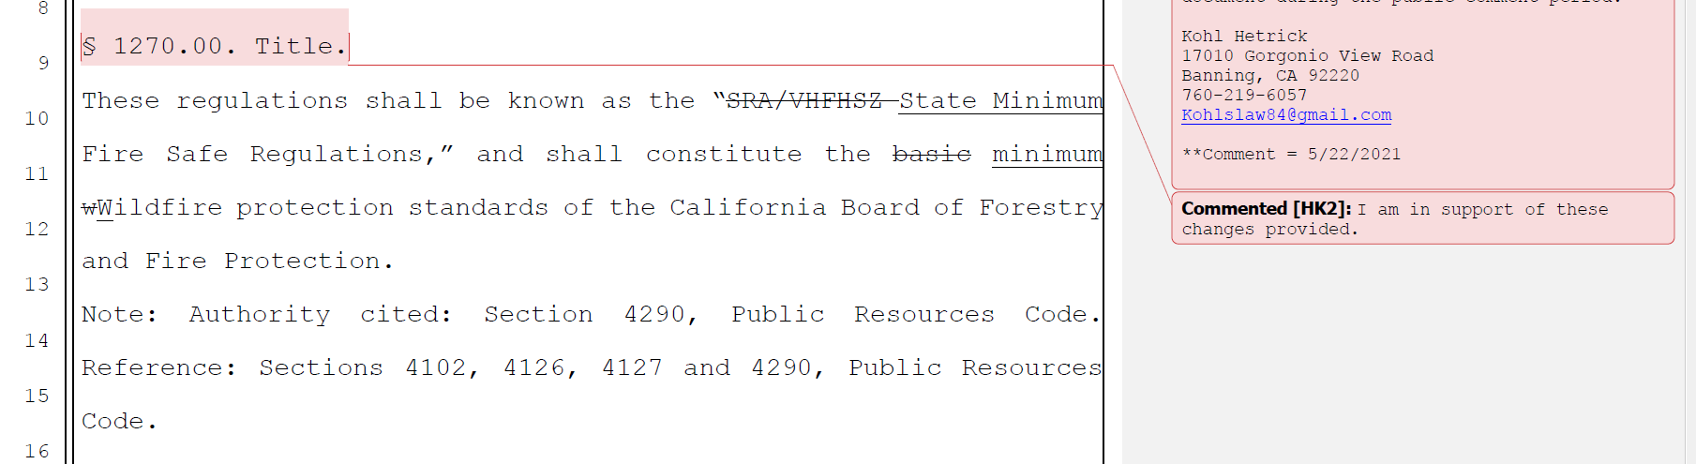

Board response: The Board appreciates the letter writer’s support. The comments in this comment bubble are general in nature and do not propose specific changes to the rule text or the additional documents noticed within the 45-day notice.

Comment W13-3: Kohl Hetrick
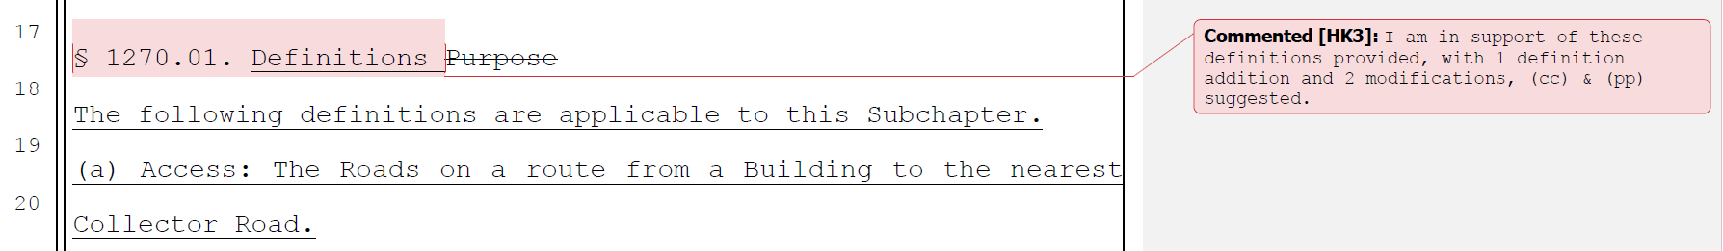

Board response: The Board appreciates the letter writer’s support. The comments in this comment bubble are general in nature and do not propose specific changes to the rule text or the additional documents noticed within the 45-day notice.

Rule text edit: No

Comment W13-4: Kohl Hetrick
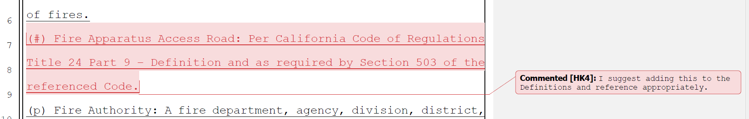

Board response: A definition for the term “fire apparatus access road” is unnecessary. Where the Board uses the term “fire apparatus access road,” its meaning is clear from the use of the defined terms “fire apparatus” and “road.” To use the term as suggested by the letter writer could cause confusion regarding the requirements for Fire Apparatus Access Road as they are established in Title 24 versus the standards in the Fire Safe Regulations.

Rule text edit: No

Comment W13-5: Kohl Hetrick
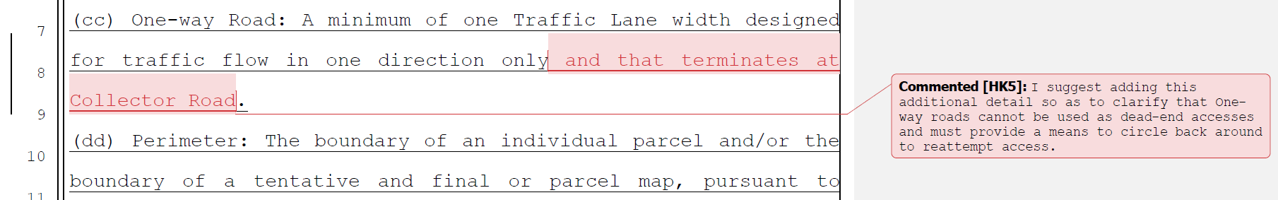

Board response: The Board is no longer using the term “Collector road” in these regulations, so this reference in the definition of “one way road” is not necessary.

Rule text edit: No

Comment W13-6: Kohl Hetrick

Board response: The Board is not proposing any changes to the definition of “turnout,” consistent with the narrowed scope of the proposed action as identified within the Supplemental Statement of Reasons published with the “Second 15-Day Notice of Addition of Documents and Information to Rulemaking File and Modified Text” on May 10, 2022. The comment is not specifically directed at the Board’s proposed action or to the procedures followed by the Board in proposing the action.

Rule text edit: No

Comment W13-7: Kohl Hetrick
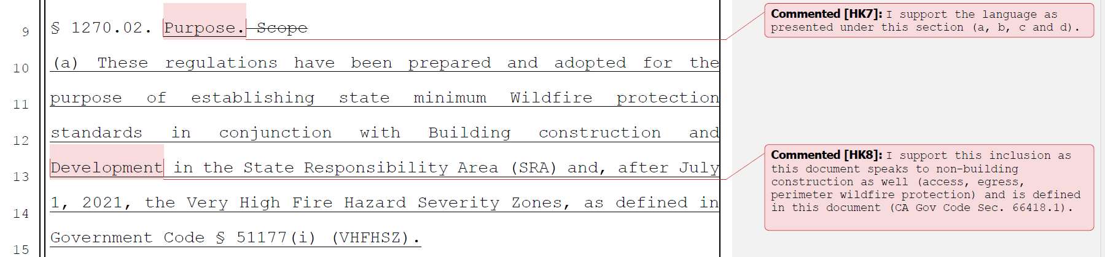

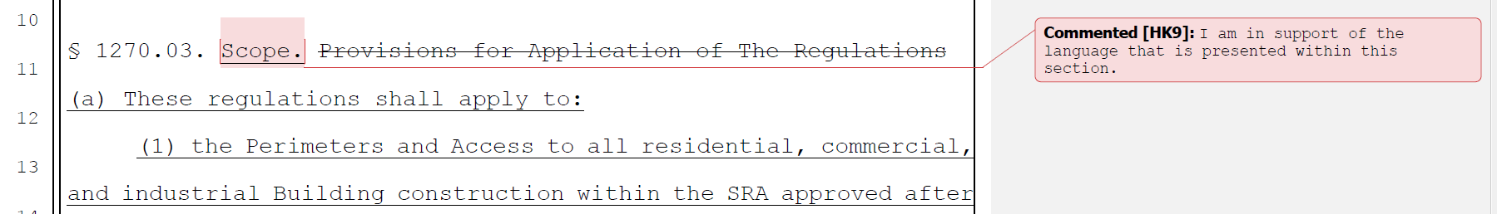

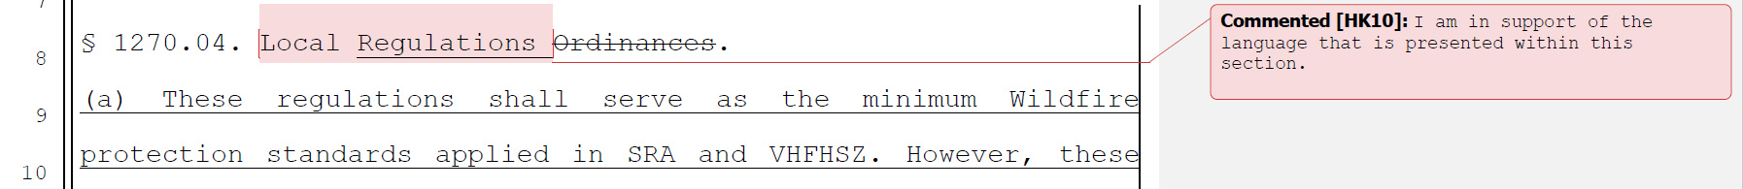

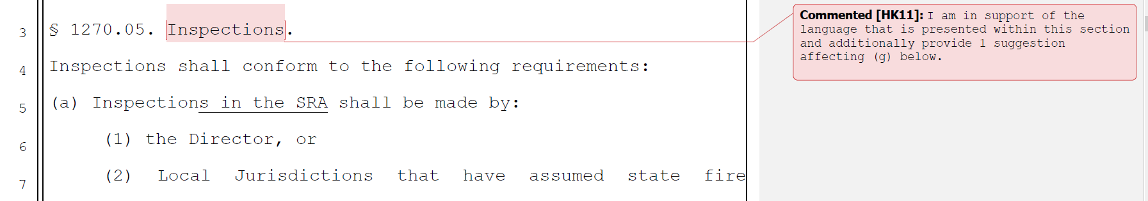

Board response: The Board appreciates the letter writer’s support. The comments in these comment bubbles are general in nature and do not propose specific changes to the rule text or the additional documents noticed within the 45-day notice.

Rule text edit: No

Comment W13-8: Kohl Hetrick
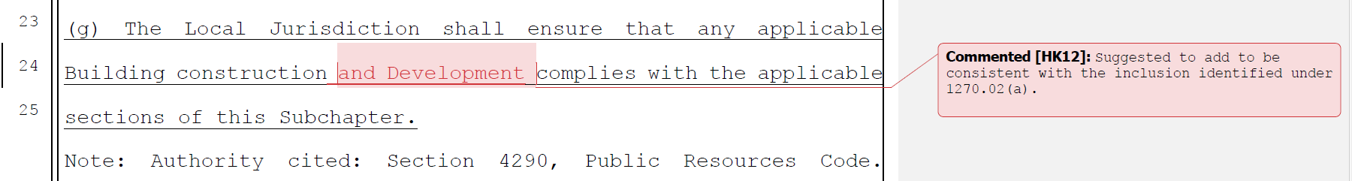

Board response: The Board is no longer proposing changes to this section, consistent with the narrowed scope of the proposed action as identified within the Supplemental Statement of Reasons published with the “Second 15-Day Notice of Addition of Documents and Information to Rulemaking File and Modified Text” on May 10, 2022. The comment is not specifically directed at the Board’s proposed action or to the procedures followed by the Board in proposing the action.

Comment W13-9: Kohl Hetrick
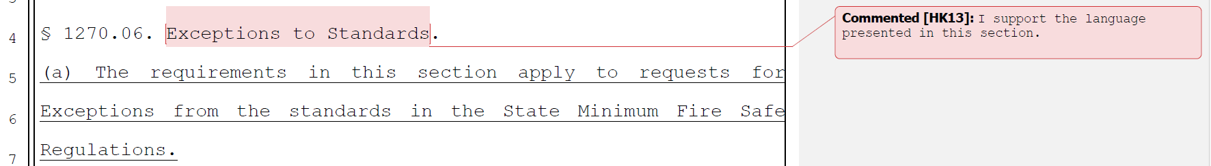

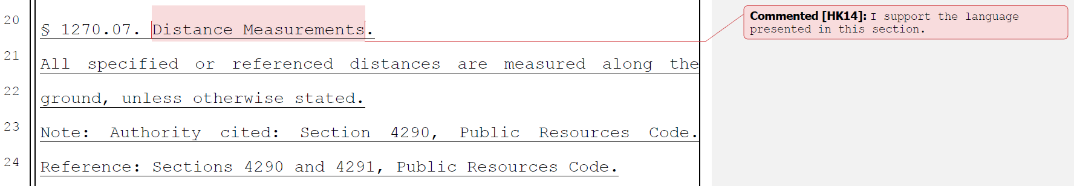
Board response: The Board appreciates the letter writer’s support. The comments in these comment bubbles are general in nature and do not propose specific changes to the rule text or the additional documents noticed within the 45-day notice.

Rule text edit: No

Comment W13-10: Kohl Hetrick
Pages 21 through 61 address Articles 2, 3, and 4.

Board response: The Board is no longer proposing changes to those Articles, consistent with the narrowed scope of the proposed action as identified within the Supplemental Statement of Reasons published with the “Second 15-Day Notice of Addition of Documents and Information to Rulemaking File and Modified Text” on May 10, 2022. The comment is not specifically directed at the Board’s proposed action or to the procedures followed by the Board in proposing the action.

Rule text edit: No

Comment W13-11: Kohl Hetrick
The letter writer added a comment bubble to each section of Article 5 with the text “I support the language presented in this section.”

Board response: The Board appreciates the letter writer’s support. The comments in these comment bubbles are general in nature and do not propose specific changes to the rule text or the additional documents noticed within the 45-day notice.

Rule text edit: No

Comment W14-1: Mariposa County Board of Supervisors
This letter addresses the process for designating the Fire Hazard Severity Zones by CAL FIRE.

Board response: This letter does not propose specific changes to the rule text or the additional documents noticed within the 45-day notice.

Rule text edit: No

Comment W15-1: Yuba County Board of Supervisors
The first page of this letter addresses Article 2, Ingress and Egress. The Board is no longer proposing changes to Article 2, consistent with the narrowed scope of the proposed action as identified within the Supplemental Statement of Reasons published with the “Second 15-Day Notice of Addition of Documents and Information to Rulemaking File and Modified Text” on May 10, 2022.

Moreover, Section 1270.03(b)(2) states that the reconstruction or repair of a Building due to a wildfire would trigger the minimum access requirements should the reconstruction or repair encroach on the new setback requirements, change the use of the building. Reconstruction or repair is subject to all the minimum requirements should the work be due to reasons unrelated to a wildfire. This would prohibit many small businesses and homeowners from rebuilding structures on parcels within the SRA.
Section 1270.03(b)(2) would particularly affect under-insured and lower-income residents who cannot afford to either improve access back to the nearest collector road or move elsewhere. The potential implications of these regulations include significant and adverse distortions to local housing stock and the local economy. The resulting displacement of the more vulnerable members of the community would also hinder achievement of the County's housing goals, exacerbating our housing and homelessness crisis. We commend your staffs concern for "replicating an excessively hazardous situation," but prohibiting residents from rebuilding their homes and businesses is not a solution. We must find an alternative that reduces fire hazards in an incremental manner without creating severe short-term implications.

Board response: The regulatory exemption for wildfire rebuilds was a previous emergency regulatory action and is outside the scope of the proposed action. Please see General Response to Exceptions and Exemptions Comments. Please see General Response to Exceptions and Exemptions Comments. The comment is not specifically directed at the Board’s proposed action or to the procedures followed by the Board in proposing the action.

Rule text edit: No

Comment W16-1: Santa Cruz County Board of Supervisors
The first page and a half of this letter are introductory in nature; the comments are not specifically directed at the Board’s proposed action or to the procedures followed by the Board in proposing the action.
Rebuilding After Natural Disaster
The March 15, 2021 revisions that added an exemption for rebuilding after a wildfire
(1270.03(c)) and the exemption for Accessory Dwelling Units (ADUs) (1270.03(d)) address two of our concerns regarding rebuilding fragile communities after disaster. However, there is no difference between the situation that exists after a wildfire and after any other type of natural disaster that causes widespread damage or loss of residences, such as earthquake or flood. After any disaster modern codes will cause replacement homes to be more protected and resilient than the original homes, and simple replacement does not increase density or intensity of development. Therefore, there is a lack of nexus and proportionality in requiring compliance with the standards after disasters other than wildfire, as well as a basic logical inconsistency. We request that the exemption for wildfire be extended to cover natural disaster of any type. (For consistency, Section 1273.12(b), which addresses road standards for existing roads, should be amended to apply to non-wildfire natural disasters, as well).
The text of the regulations refers to "reconstruction" (1270.03 b(2) et seq.) This term should be changed to "replacement" to make clear that rebuilding need not create an exact replica of what was previously present. In the Santa Cruz County CZU fire recovery there are numerous instances in which shifting the footprint or relocating the replacement home decreases risks from geologic hazards, increases environmental sustainability, decreases risk from fire, or is an otherwise superior, safer outcome. It is important that the regulations not remove or confuse this option.

Board response: The regulatory exemption for wildfire rebuilds was a previous emergency regulatory action and is outside the scope of the proposed action. Please see General Response to Exceptions and Exemptions Comments. The comment is not specifically directed at the Board’s proposed action or to the procedures followed by the Board in proposing the action. Please see General Response to Exceptions and Exemptions Comments.

Rule text edit: No

Comment W16-2: Santa Cruz County Board of Supervisors
Recognize the Need for Local Authorities to Administer the Exception Process Regarding the exception process that has been added (1270.06), we fully agree with including a process that allows for case-by-case determinations in situations in which minimum standards cannot be fully met. Meeting all minimum standards for roads that are contained in the regulations is a physical impossibility on many existing roads in the Santa Cruz Mountains. The alternative to an exception process is displacement of families and small business. However, the decisionmaker on exception requests should be the local Fire Agency, the local jurisdiction, or the two local authorities working together. Designating the local authorities as the decisionmakers of the exception process in their own right, rather than identifying the decisionmaker indirectly through the Inspection section (1270.05), is more reliable, straightforward and transparent.

Board response: The Board is only proposing those changes to 1270.06 necessary to implement the changes to PRC 4290 required by SB 901, consistent with the narrowed scope of the proposed action as identified within the Supplemental Statement of Reasons published with the “Second 15-Day Notice of Addition of Documents and Information to Rulemaking File and Modified Text” on May 10, 2022. The comment is not specifically directed at the Board’s proposed action or to the procedures followed by the Board in proposing the action.

Rule text edit: No

Comment W16-3: Santa Cruz County Board of Supervisors
Standards Relative to New Development
The concept of "de minimus” development should be added to the regulations to recognize that there is some minor amount of change in the built environment that does not increase density, decrease evacuation safety, or increase intensity such that full scale road access and other improvements are triggered. The legal concepts of nexus and proportionality apply here, as well. According to the current proposal a mere addition to an existing home or construction of a shed on a commercial property could trigger significant road improvements without creating proportional impact. This is unworkable as drafted. The Board might look to accepted thresholds in other land use regulations for models, for example, the threshold of more than four new lots (definition of a subdivision in the Subdivision Map Act CGC 66401) or the threshold of four units or 2500 square feet of commercial space (CEQA Categorical Exemption Class 3, CCR 15303.3). At a minimum, residential development that does not create new lots or increase the number of units should be de minimus.
Regarding intensity, in Santa Cruz County we have small wineries, small Christmas tree and pumpkin farms, and other small commercial and non-profit enterprises scattered throughout the mountains. If the proposed road and other standards are triggered by
very small improvements (as opposed to the establishment of new commercial enterprise), disinvestment and deterioration will follow. The regulations should identify a set of "de minimus" improvements for existing commercial enterprises that will not be subject to the full weight of the standards.

Board response: The Board is no longer proposing changes to application of these standards, consistent with the narrowed scope of the proposed action as identified within the Supplemental Statement of Reasons published with the “Second 15-Day Notice of Addition of Documents and Information to Rulemaking File and Modified Text” on May 10, 2022. The comment is not specifically directed at the Board’s proposed action or to the procedures followed by the Board in proposing the action.

Rule text edit: No

Comment W16-4: Santa Cruz County Board of Supervisors
Feasibility of the Proposed Road Standards for New Roads
The definition of new road (1270.01 aa) should not encompass the extension of an existing road to serve existing lots of record. Where these roads are extended in existing right of way to meet existing parcels, with no new parcels being created as part of the development, that extension should be considered as existing road.
It is most likely that standards for new roads will come into play when new roads are needed to serve or upgrade existing development within a perimeter. We are concerned that the minimum radius of curvature, width in some cases, and dimensions of required turn-arounds are not feasible on some rural parcels because of terrain and geologic conditions. In those areas massive grading would be required to meet radius of curvature, necessitating extensive retaining structures or other major engineering. The regulations should acknowledge the potential for environmental impact, inside and outside of the Coastal Zone, and make provision for allowing alternate methods to minimize environmental impacts in these situations, particularly where roads will serve existing uses.
Lastly, the method for determining the maximum length of a dead-end road (1273.08) should be modified to consider the actual size of the parcels along the subject road, rather than the size indicated by the zoning. Parcels are frequently larger or smaller than the zoning for a variety of reasons, and in Santa Cruz County, for example, in the rural area the minimum parcel size is not given by the zoning. Instead, it is calculated by a Rural Density Matrix that depends on a multitude of factors. This modification would also solve the problem of defaulting to the lowest length when there are a variety of parcel sizes, which is common.

Board response: The Board is no longer proposing a definition for new road or changes to the road standards in Article 2, consistent with the narrowed scope of the proposed action as identified within the Supplemental Statement of Reasons published with the “Second 15-Day Notice of Addition of Documents and Information to Rulemaking File and Modified Text” on May 10, 2022. The comment is not specifically directed at the Board’s proposed action or to the procedures followed by the Board in proposing the action.

Rule text edit: No

Comment W16-5: Santa Cruz County Board of Supervisors
Ridgelines
The proposed regulations prohibit new building on "strategic ridgelines" (1276.02). Strategic ridgelines are not defined in the document and are not identified on any map. Therefore, it is impossible for the local community to understand the scope and effect of this prohibition. A prohibition on building on private property is an extreme measure and such regulations should only be contemplated and adopted with the utmost transparency. Because there is inadequate information available to the public to evaluate or respond to this proposed prohibition, the section should be re-written to define and provide for identification of strategic ridgelines, with appropriate regulations proposed as a discrete second step.

Board response: The regulations delegate the authority to determine strategic ridgelines to the local jurisdiction in 1276.02(a). This allows the local government to determine where, if any, strategic ridgelines exist in the local jurisdiction after determining any impacts to fire risk. When determining strategic ridgelines, 1276.02(a)(3), (a)(4), and (a)(6) allow the local jurisdiction to consider things like planned uses, ownership patterns, or other development concerns when identifying strategic ridgelines. Identifying strategic ridgelines where development should be excluded is similar to other regulations that prohibit development on steep slopes, fault zones, riparian corridors, or other locations that are particularly sensitive or hazardous.

Rule text edit: No

Comment W16-6: Santa Cruz County Board of Supervisors
No CEQA Document Has Been Circulated
The County will be a Responsible Agency under CEQA and must rely upon the Board of Forestry's environmental document or this project. We therefore request an opportunity to comment upon any proposed CEQA document.

Board response: Please see General CEQA Response

Rule text edit: No

Comment W16-7: Santa Cruz County Board of Supervisors
Conclusion
Effective and equitable minimum standards for fire safety must acknowledge and accommodate local conditions so that standards can be feasibly accomplished on the ground. They also must align with the principles of nexus and proportionality. Standards that are overly burdensome relative to the size of a development project will prevent the investment and incremental upgrading (and increased safety that results), which keep rural communities vital. In addition, we are concerned about a scenario in which a natural disaster other than wildfire damages homes, and recovery is stymied because the disaster exemption applies only to wildfire. The County of Santa Cruz urges the Board of Forestry to find a more suitable balance between ideal upgrades on one hand and realistic improvements that preserve our communities on the other. We urge the Board to take additional time as needed to make further revisions to the proposed regulations to address these comments.

Board response: The Board circulated additional proposed changes for a 15 day comment period on January 3, 2022 and May 10, 2022. The Board is no longer proposing changes to the applicability of these regulations or the standards in Articles 2, 3, and 4, consistent with the narrowed scope of the proposed action as identified within the Supplemental Statement of Reasons published with the “Second 15-Day Notice of Addition of Documents and Information to Rulemaking File and Modified Text” on May 10, 2022. The comment is not specifically directed at the Board’s proposed action or to the procedures followed by the Board in proposing the action.

Rule text edit: No

Comment W17-1: Christopher Owens
Excepting the below excerpt, the comments in this letter are either not specific or are unnecessarily redundant with more specific comments presented in other comment letters.

The economic impact these proposals will create will be the most devastating thing ever seen in this state. 100,000's of Private contractors and skilled business men/women will be unemployed due to the new impossible proposals that are being set forth. These rural communities depend on the private sector to thrive, not the public/government sector. In a time when most private sector people are getting back to work from COVID, you will beat them back down to zero work unemployed. No new construction.

Board response: The proposal will not cause significant economic impacts. Please see the Economic and Fiscal Impact Statement for additional data and analysis.

Rule text edit: No

Comment W18-1: Peggy Moak
The first page of this letter is introductory in nature; the comments are not specifically directed at the Board’s proposed action or to the procedures followed by the Board in proposing the action.

- The road standards, applicable even to personal driveways, are far too stringent, unaffordable for most rural public entities to accomplish stated upgrades, and certainly unaffordable for property owners who wish to build – or, as written, even add a room to their home, or expand a living area.
Board response: The Board is no longer proposing changes to the road standards, consistent with the narrowed scope of the proposed action as identified within the Supplemental Statement of Reasons published with the “Second 15-Day Notice of Addition of Documents and Information to Rulemaking File and Modified Text” on May 10, 2022. The comment is not specifically directed at the Board’s proposed action or to the procedures followed by the Board in proposing the action.

Rule text edit: No

Comment W18-2: Peggy Moak
- Although exemptions apply for wildfire rebuilds, that limited exemption is not sufficient to encompass all legitimate building scenarios for individuals living in the VHFHSZ, i.e. what if a home needs to be rebuilt because of an independent structure fire? What if it is damaged by an earthquake?

- Many of the setback and other requirements cannot be met for rebuilds, due to lot size or configuration – again, this makes rebuilding impossible, as written. Local Building officials should be able to evaluate and make discretionary decisions in their jurisdictions.

- What if the property owner decides to sell their wildfire damaged parcel to a willing buyer, who now cannot build under a wildfire rebuild exemption? What if the current owner simply wants to make their home more spacious, or upgrade the construction or change the location of the home on their property? The regulations preclude all of these reasonable scenarios, and many more.

Board response: The regulatory exemption for wildfire rebuilds was a previous emergency regulatory action and is outside the scope of the proposed action. Please see General Response to Exceptions and Exemptions Comments. The comment is not specifically directed at the Board’s proposed action or to the procedures followed by the Board in proposing the action.

Rule text edit: No

Comment W18-3: Peggy Moak
- Why would expanding the footprint of an existing home trigger the regulations? It’s not increasing the number of people in the home, just the space it occupies – this makes no sense at all.
Board response: The Board is no longer proposing this change, consistent with the narrowed scope of the proposed action as identified within the Supplemental Statement of Reasons published with the “Second 15-Day Notice of Addition of Documents and Information to Rulemaking File and Modified Text” on May 10, 2022. The comment is not specifically directed at the Board’s proposed action or to the procedures followed by the Board in proposing the action.

Rule text edit: No

Comment W18-4: Peggy Moak
- The change to the parcel split provisions is unnecessary – it has been 4 or more for a very long time – what purpose does it serve to change it to 3 parcels, and ditto for a lot line adjustment? Property owners have made plans, sometimes estate plans, hinged on this long time standard – this is another example of a taking of property.
Board response: The Board is no longer proposing this change, consistent with the narrowed scope of the proposed action as identified within the Supplemental Statement of Reasons published with the “Second 15-Day Notice of Addition of Documents and Information to Rulemaking File and Modified Text” on May 10, 2022. The comment is not specifically directed at the Board’s proposed action or to the procedures followed by the Board in proposing the action.

Rule text edit: No

Comment W18-6: Peggy Moak
- There will be a revenue consequence to the local taxing agencies – property taxes will decline, permit fees will go uncollected, development – for which there are already reasonable fire‐ hardening standards – will decline drastically, meaning many of the fire devastated communities will not be able to recover to the extent necessary to support local agency services, schools, parks, medical services, etc.
Board response: Without more specific information, it is unclear how the letter writer believes these regulations will have a revenue impact on local taxing agencies. The Board has conducted an economic impacts analysis and found there to be no significant impacts. The Board has no specific changes to offer in response to this comment.

Rule text edit: No

Comment W19-1: Butte County Board of Supervisors
This letter is in response to the Notice of Proposed Action to adopt the draft Fire Safe Regulations, specifically Title 14 of the California Code of Regulations (14 CCR), Division 1.5, Chapter 7 Subchapter 2, Articles 1-5 currently in the formal rulemaking public comment period. The State of California is very diverse and state regulations need to incorporate areas that widely vary, particularly when dealing with important issue such as rebuilding from disasters, access and development.
Local jurisdictions are responsible for implementing regulations and have the most experience in dealing with the interpretation of regulations in their areas and in coordination with other competing state and local regulations. With the release of the latest draft, Butte County has prepared a redlined version of the regulations with comments and concerns. Comments are summarized below:
  - Fire rebuilds are exempt so long as they do not encroach on the new 30-foot setback or change building occupancy. Many rebuilds are structures being built back on lots that either do not allow for this setback or the previous house footprint would not comply. Existing infrastructure is in place for the previous location and limits the placement of the rebuild.
  - Except where exempt, all new building construction must comply, and the proposed regulations would make many by-right uses unable to proceed.
  - Exemptions only for Wildfire rebuilds, but other things such as individual fires and other types of disasters cause the need for rebuilds.
  - Exemptions are allowed only when there is substantial compliance and must be filed with both the Board of Forestry and Cal Fire without clear understanding of the review or comment period or other requirements for this action.
  - Applies to all new roads and driveways, as well as existing roads and driveways that: (1) involve parcel splits or LLAs that serve 3 or more parcels; (2) involve a zone change that increases intensity or density; or (3) involves a use permit that increases density or intensity. This is a substantial change from existing regulations and has potentially significant consequences.
  - Building construction is prohibited where roads do not meet the minimum requirements without consideration for existing conditions or funding for the maintenance and improvements that these regulations would place on local jurisdictions and landowners.
  - The maximum length of a dead-end road is half a mile.
  - New dead-end roads must connect to through roads. The unique topography and previous development patterns of areas need to be considered and options incorporated into the regulations. One-size fits all regulations do not work.
  - Dead end roads must have a turnaround at the end, and a turnaround in the middle (when serving parcels zoned for more than 5 acres). Without consideration to the topography on existing roadways this will be impossible to implement particularly in existing conditions where roadways already exist.
  - Turn outs generally required every 400 feet for roads and driveways. With the necessary tapers and dimensions given in the regulations this would require most of the roadways to be widened in rural areas.
  - Existing roads cannot exceed 25% grade over 500 feet.
- Water supply infrastructure shall be (1) underground; (2) made of non-combustible materials; (3) have a 100- foot defensible space; or (4) be enclosed in a building.
  - All parcels shall have a minimum 30-foot rear, side, and front yard setback; unless non­combustible walls, nonvegetated landscaping, and/or other fire hardening. The current language is vague and could result in delays in reviews and unclear direction to the public as to what they must do.
- The cost of the improvements and associated CEQA review for improvements that would be required off-site for projects subject to the proposed regulations would be extremely costly further exacerbate the lack of affordability of housing across California.
Moving this process forward without taking the additional time to vet the immense number of concerns that are being raised will result in regulations that are difficult to implement and cause undue harm to efforts to implement General Plan policies, maintain infrastructure, and rebuild from disasters. Furthermore, if adopted as written, the unintended consequence could very well be that people continue to build and occupy structures in these areas without engaging in the permitting process resulting in unknown number of people and unpermitted structures being located in the very area the Board is trying to regulate.

Board response: The regulatory exemption for wildfire rebuilds was a previous emergency regulatory action and is outside the scope of the proposed action. Please see General Response to Exceptions and Exemptions Comments. The Board is no longer proposing changes to the road standards or their applicability, consistent with the narrowed scope of the proposed action as identified within the Supplemental Statement of Reasons published with the “Second 15-Day Notice of Addition of Documents and Information to Rulemaking File and Modified Text” on May 10, 2022. The comment is not specifically directed at the Board’s proposed action or to the procedures followed by the Board in proposing the action.

Rule text edit: No

Comment W19-2: Butte County Board of Supervisors

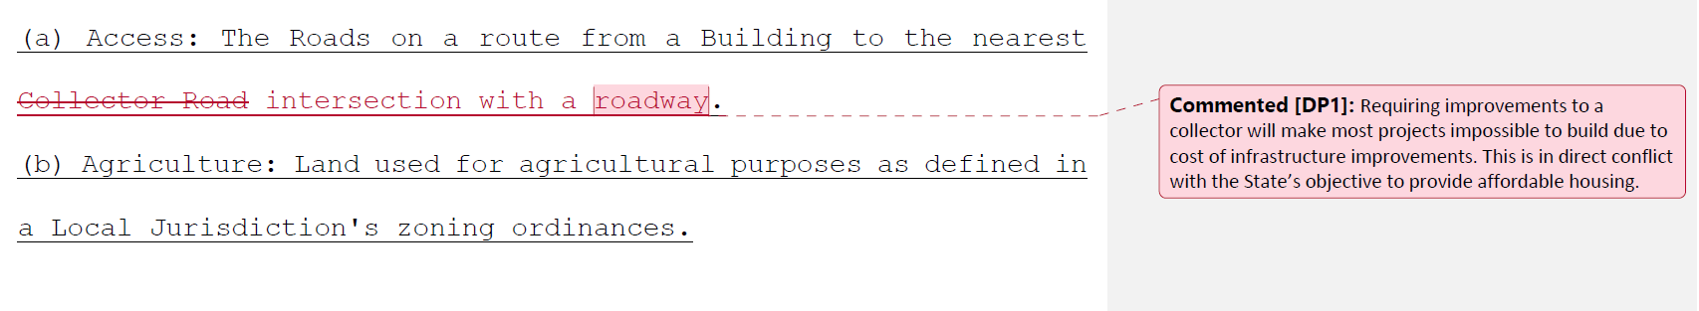

Board response: The Board is no longer proposing a definition for “Access road,” consistent with the narrowed scope of the proposed action as identified within the Supplemental Statement of Reasons published with the “Second 15-Day Notice of Addition of Documents and Information to Rulemaking File and Modified Text” on May 10, 2022. The comment is not specifically directed at the Board’s proposed action or to the procedures followed by the Board in proposing the action.

Rule text edit: No

Comment W19-3: Butte County Board of Supervisors

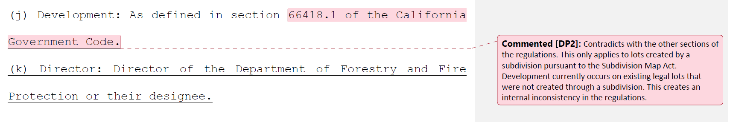

Board response: The Board is not proposing changes to the definition of “Development,” consistent with the narrowed scope of the proposed action as identified within the Supplemental Statement of Reasons published with the “Second 15-Day Notice of Addition of Documents and Information to Rulemaking File and Modified Text” on May 10, 2022. The comment is not specifically directed at the Board’s proposed action or to the procedures followed by the Board in proposing the action.

Rule text edit: No

Comment W19-4: Butte County Board of Supervisors

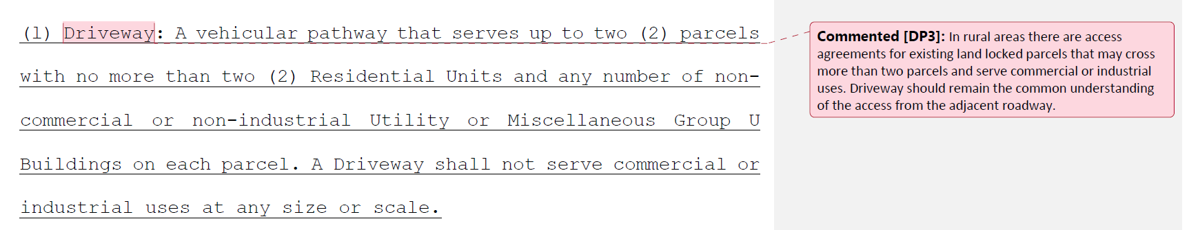

Board response: The Board is not proposing changes to the underlying concept of a driveway as it is currently contemplated in the existing regulations. “Access from the adjacent roadway” does not provide additional regulatory clarity and would result in confusion regarding when a vehicular pathway is required to meet the road versus the driveway standards. The Board’s definition provides a reasonable amount of specificity such that it is clear to the regulated public when a vehicular pathway needs to meet one standard or the other.

Rule text edit: No

Comment W19-5: Butte County Board of Supervisors

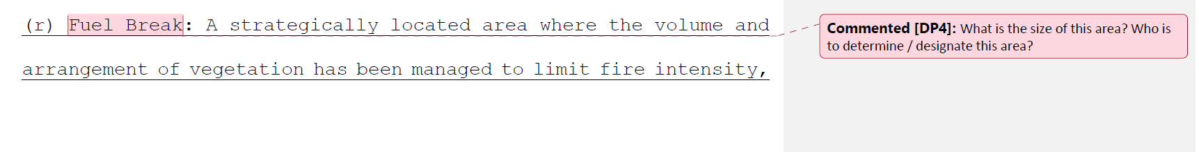

Board response: The need for and location of fuel breaks are determined by the local jurisdiction pursuant to 1276.03.

Rule text edit: No

Comment W19-6: Butte County Board of Supervisors

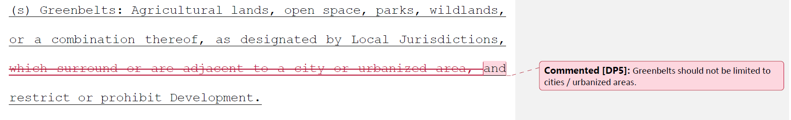

Board response: In the 15 day noticed rule text published on May 10, 2022, the Board revised the definition of “greenbelts” to read “open space, parks, wildlands, other areas, or a combination thereof, as designated by Local Jurisdictions, which are in, surround, or are adjacent to a city or urbanized area, that may function as Fuel Breaks and where Building construction is restricted or prohibited.” PRC 4290 specifically requires the Board to write regulations for “greenbelts near communities.” It would be outside the scope of the Board’s authority to write regulations for greenbelts that were not related to urbanized development.

Rule text edit: No

Comment W19-7: Butte County Board of Supervisors

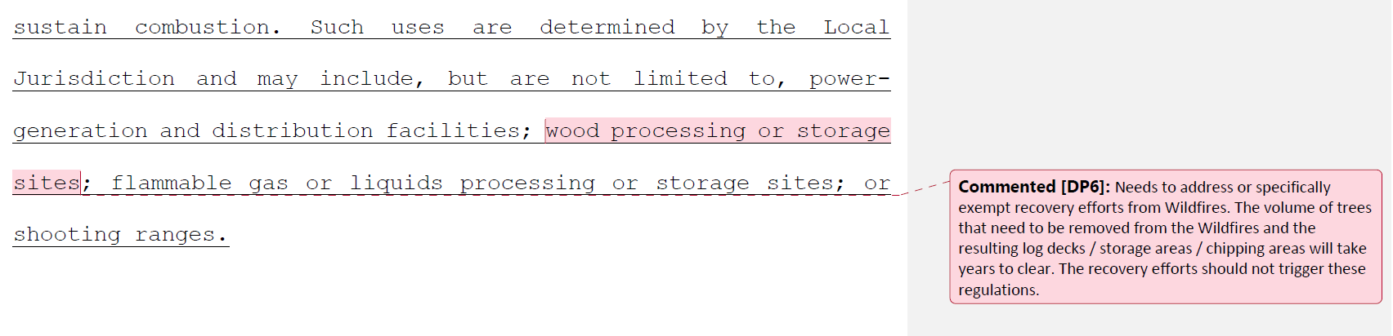

Board response: The term “hazardous land use” is only used within the context of determining where Fuel Breaks may be located (1276.03(d)(3) – “Directly adjacent to a hazardous land use to limit the spread of fire from such uses…”). This is an optional consideration for local jurisdictions – they may decide to build a fuel break around wood processing or storage sites, or they may determine that since a post-wildfire wood storage site is temporary, that it does not need a fuel break. There are no specific requirements for wood processing or storage sites in these regulations.

Rule text edit: No

Comment W19-8: Butte County Board of Supervisors

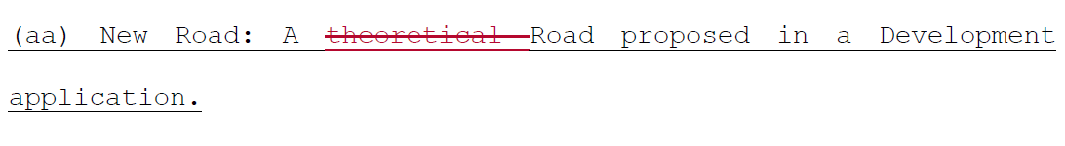

Board response: The Board is no longer proposing to add a definition for “new road,” consistent with the narrowed scope of the proposed action as identified within the Supplemental Statement of Reasons published with the “Second 15-Day Notice of Addition of Documents and Information to Rulemaking File and Modified Text” on May 10, 2022. The comment is not specifically directed at the Board’s proposed action or to the procedures followed by the Board in proposing the action.

Rule text edit: No

Comment W19-9: Butte County Board of Supervisors

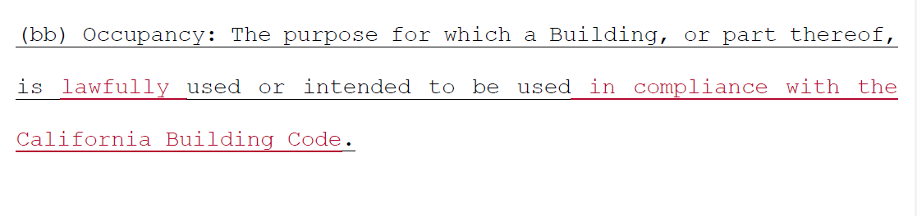

Board response: The Board is not proposing changes to the definition of “occupancy.”

Rule text edit: No

Comment W19-10: Butte County Board of Supervisors

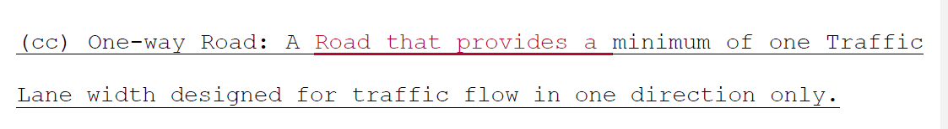

Board response: The Board agrees this change is appropriate. This change was made in the 15 day noticed rule text published on January 3, 2022.

Rule text edit: Yes

Comment W19-11: Butte County Board of Supervisors

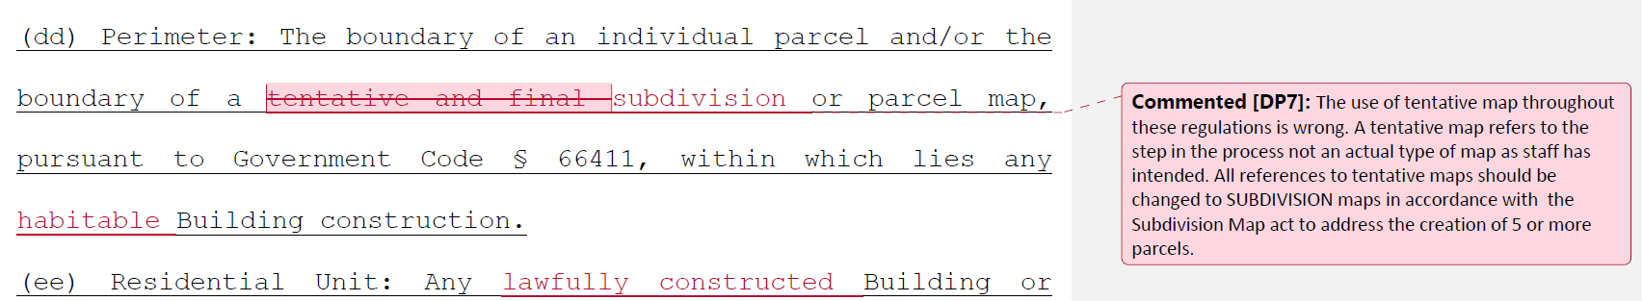

Board response: The Board is not proposing a definition for the term “perimeter,” consistent with the narrowed scope of the proposed action as identified within the Supplemental Statement of Reasons published with the “Second 15-Day Notice of Addition of Documents and Information to Rulemaking File and Modified Text” on May 10, 2022. The comment is not specifically directed at the Board’s proposed action or to the procedures followed by the Board in proposing the action.

Rule text edit: No

Comment W19-12: Butte County Board of Supervisors

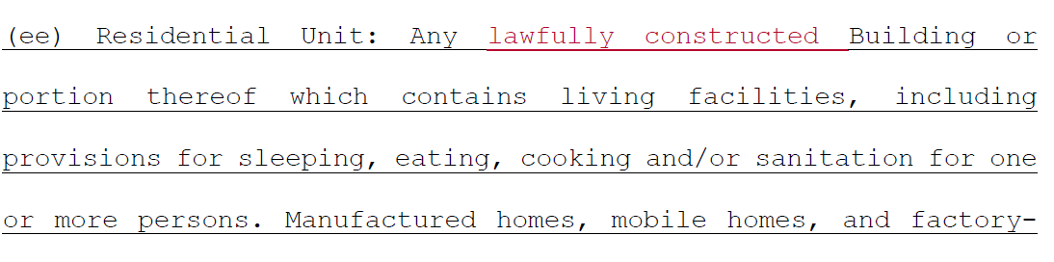

Board response: The term “residential unit” is used in these regulations in the context of determining whether a vehicular pathway needs to meet the requirements for a “road” or a “driveway” (both defined terms). The intent is for the road standards to apply to more than four residential units, and it is irrelevant whether the residential units are lawfully constructed or not. It would undermine the fire safety of the road requirements if a community of four illegally constructed residential units and one legally constructed residential unit only needed to apply the driveway standard to the pathway leading to their property, but a community of five legally constructed residential units would need to comply with the stricter road standards. The first community has the same fire risk as the second community, but would be allowed to comply with less strict standards if the Board proposed the rule text change suggested here. Therefore, the Board has not adopted this proposed change.

Rule text edit: No

Comment W19-13: Butte County Board of Supervisors

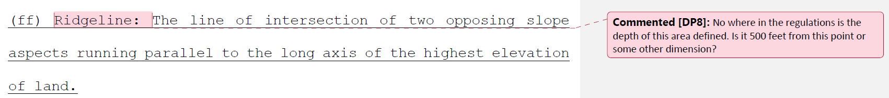

Board response: It would be impossible to determine a consistent ridgeline width across the state. A ridgeline may be a narrow mountain peak or a wider ridge in the foothills. The local jurisdiction is delegated the authority to determine where, if any, strategic ridgelines are located, and where development is to be prohibited on such ridgelines.

Rule text edit: No

Comment W19-14: Butte County Board of Supervisors

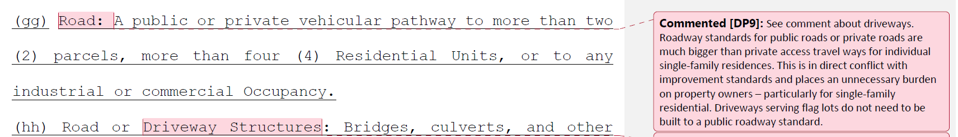

Board response: Please see response to W19-4

Rule text edit: No

Comment W19-15: Butte County Board of Supervisors

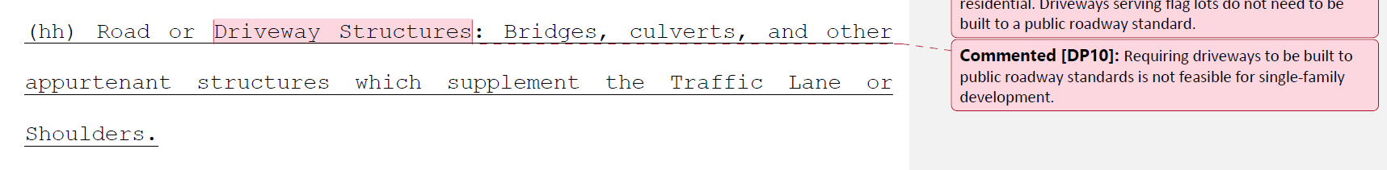

Board response: The Board is no longer proposing changes to the road and driveway standards in Article 2, consistent with the narrowed scope of the proposed action as identified within the Supplemental Statement of Reasons published with the “Second 15-Day Notice of Addition of Documents and Information to Rulemaking File and Modified Text” on May 10, 2022. The comment is not specifically directed at the Board’s proposed action or to the procedures followed by the Board in proposing the action.

Rule text edit: No

Comment W19-16: Butte County Board of Supervisors

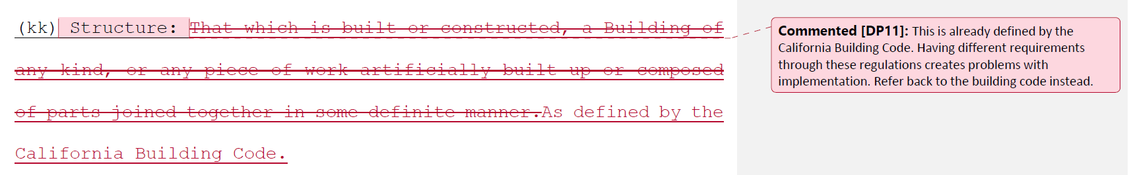

Board response: The Board proposes to delete the phrase “an edifice or building of any kind” from the definition of “structure,” which more closely aligns the definition of “Structure” here with the definition in the California Building Code.

Rule text edit: No

Comment W19-17: Butte County Board of Supervisors

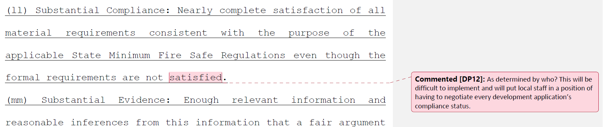

Board response: The Board is no longer proposing a definition for “substantial compliance,” consistent with the narrowed scope of the proposed action as identified within the Supplemental Statement of Reasons published with the “Second 15-Day Notice of Addition of Documents and Information to Rulemaking File and Modified Text” on May 10, 2022. The comment is not specifically directed at the Board’s proposed action or to the procedures followed by the Board in proposing the action.

Rule text edit: No

Comment W19-18: Butte County Board of Supervisors

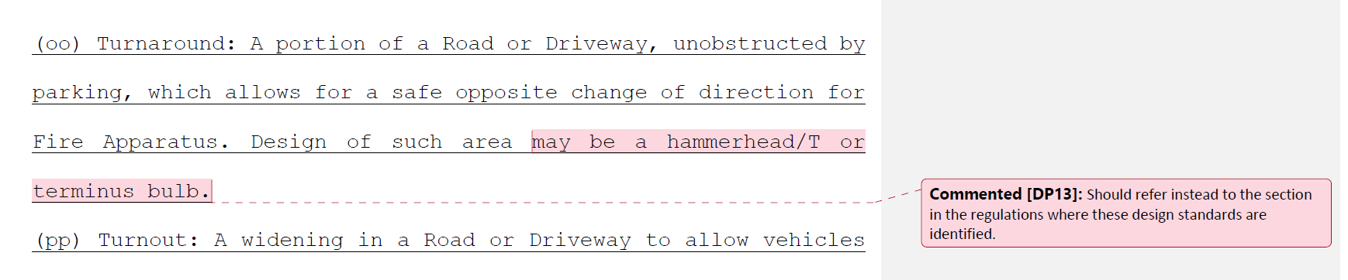

Board response: The Board made this change in the rule text published January 3, 2022.

Rule text edit: Yes

Comment W19-19: Butte County Board of Supervisors

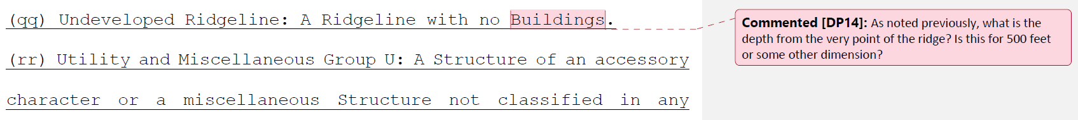

Board response: Please see response to W19-13.

Rule text edit: No

Comment W19-20: Butte County Board of Supervisors
The writer suggests adding the sentence “These regulations are not intended to apply to any Building Construction or Development that occurred or received a discretionary approval from a local jurisdiction prior to the effective date of the regulations.” to the end of § 1270.02(a).

Board response: The Board is no longer proposing changes to 1270.02(a), consistent with the narrowed scope of the proposed action as identified within the Supplemental Statement of Reasons published with the “Second 15-Day Notice of Addition of Documents and Information to Rulemaking File and Modified Text” on May 10, 2022. The comment is not specifically directed at the Board’s proposed action or to the procedures followed by the Board in proposing the action.

Rule text edit: No

Comment W19 -21: Butte County Board of Supervisors
The writer suggests changing “subsections (b), (c), (d) and (e) below” in § 1270.03(a)(1) to “subsections (b) through (g) below.”

Board response: The Board no longer proposes subsections (e,), (f), or (g) in 1270.03, consistent with the narrowed scope of the proposed action as identified within the Supplemental Statement of Reasons published with the “Second 15-Day Notice of Addition of Documents and Information to Rulemaking File and Modified Text” on May 10, 2022. The comment is not specifically directed at the Board’s proposed action or to the procedures followed by the Board in proposing the action.

Rule text edit: No

Comment W19 -23: Butte County Board of Supervisors
The writer suggests changing the term “tentative and parcel maps” throughout this section to “subdivision and parcel maps.”

Board response: The Board is not proposing changes to the applicability of these regulations, consistent with the narrowed scope of the proposed action as identified within the Supplemental Statement of Reasons published with the “Second 15-Day Notice of Addition of Documents and Information to Rulemaking File and Modified Text” on May 10, 2022. The comment is not specifically directed at the Board’s proposed action or to the procedures followed by the Board in proposing the action.

Rule text edit: No

Comment W19-24: Butte County Board of Supervisors
The writer proposes adding the following text to § 1270.03(b): These regulations also do not apply where an application for a Building permit in the VHFHSZ is filed after the
effective date of these regulations for Development or Building construction on a parcel that was formed from a parcel map or subdivision map approved prior to the effective date of these regulations, to the extent that conditions relating to the Perimeters and Access to the Buildings were imposed by the map.

Board response: The Board is not proposing changes to this section, consistent with the narrowed scope of the proposed action as identified within the Supplemental Statement of Reasons published with the “Second 15-Day Notice of Addition of Documents and Information to Rulemaking File and Modified Text” on May 10, 2022. The comment is not specifically directed at the Board’s proposed action or to the procedures followed by the Board in proposing the action.

Rule text edit: No

Comment W19-25: Butte County Board of Supervisors
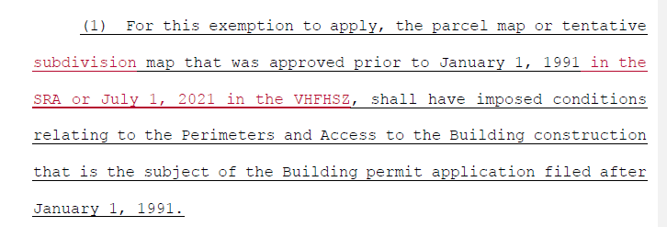

Board response: The Board is no longer proposing this section, consistent with the narrowed scope of the proposed action as identified within the Supplemental Statement of Reasons published with the “Second 15-Day Notice of Addition of Documents and Information to Rulemaking File and Modified Text” on May 10, 2022. The comment is not specifically directed at the Board’s proposed action or to the procedures followed by the Board in proposing the action.

Rule text edit: No

Comment W19-26: Butte County Board of Supervisors
The letter writer proposes deleting § 1270.03(c)(1). A comment bubble reads “The local jurisdiction legal non-conforming regulations should apply. Requiring the level of improvements contemplated in these regulations on individual property owners for repair work is overreach.”

Board response: The Board is no longer proposing changes to 1270.03(c)(1), consistent with the narrowed scope of the proposed action as identified within the Supplemental Statement of Reasons published with the “Second 15-Day Notice of Addition of Documents and Information to Rulemaking File and Modified Text” on May 10, 2022. The comment is not specifically directed at the Board’s proposed action or to the procedures followed by the Board in proposing the action.

Rule text edit: No

Comment W19-27: Butte County Board of Supervisors
The letter writer proposes changing the term “changes” in § 1270.03(c)(2) to “intensifies.”

Board response: The Board is no longer proposing changes to 1270.03(c)(2), consistent with the narrowed scope of the proposed action as identified within the Supplemental Statement of Reasons published with the “Second 15-Day Notice of Addition of Documents and Information to Rulemaking File and Modified Text” on May 10, 2022. The comment is not specifically directed at the Board’s proposed action or to the procedures followed by the Board in proposing the action.

Rule text edit: No

Comment W19-28: Butte County Board of Supervisors
A comment bubble highlights the term “Wildfire” in § 1270.03(c)(3). The comment bubble reads “This should not be limited to Wildfire. Damage ‐ destruction of structures happens for all kinds of reasons and should not be limited to declared Wildfires. It would be unconscionable not to allow property owners to rebuild after other types of sudden and unintended casualties. The fact that these regulations are aimed at wildfire protection does not (and should not) restrict the types of casualties that may trigger the need to rebuild.”

Board response: The regulatory exemption for wildfire rebuilds was a previous emergency regulatory action and is outside the scope of the proposed action. Please see General Response to Exceptions and Exemptions Comments. The comment is not specifically directed at the Board’s proposed action or to the procedures followed by the Board in proposing the action.

Rule text edit: No

Comment W19-29: Butte County Board of Supervisors
The letter writer proposes new text for § 1270.03(e) – “These regulations shall not apply to Greenbelts, Greenways, Parcels, Roads or Driveways used solely for Agriculture, mining, or the management of timberland and harvesting of forest products or Outdoor Recreation on lands owned or leased by local public agencies.”

Board response: The Board is no longer proposing 1270.03(e), consistent with the narrowed scope of the proposed action as identified within the Supplemental Statement of Reasons published with the “Second 15-Day Notice of Addition of Documents and Information to Rulemaking File and Modified Text” on May 10, 2022. The comment is not specifically directed at the Board’s proposed action or to the procedures followed by the Board in proposing the action.

Rule text edit: No

Comment W19-30: Butte County Board of Supervisors
The letter writer proposes a new subsection § 1270.03(f) – “(f) These regulations shall not apply where the application of the regulations would result in a taking of private property under the federal or California Constitution.”

Board response: The commenter has provided no judicial determination as to the unconstitutionality of PRC § 4290, the existing Fire Safe Regulations, or the proposed rulemaking language, and the Board is unaware of any. The proposed language regarding constitutional matters is outside the scope of the Board’s authority and is not necessary or appropriate to effectuate the purpose of the statute. The comment is not specifically directed at the Board’s proposed action or to the procedures followed by the Board in proposing the action. Please see General Response to Constitutionality Comment.

Rule text edit: No

Comment W19-31: Butte County Board of Supervisors

A comment bubble highlights the phrase “corresponding minimum standard in this.” In § 1270.04(b). The comment bubble reads “This removes the local application of the other options that would equal or exceed the regulations if these regulations also have to be abided by.”

Board response: Removing this phrase implies that all individual standards in the Fire Safe Regulations must be equaled or exceeded in full for a local regulation to apply. That is not correct. A single local regulation, such as the standard for driveway width, may be exceeded in the local regulation and therefor applied in lieu of the state minimum standard, even if another individual local regulation, such as the standard for road width, may not be equal to or exceeding the state minimum standard. Removing the phrase suggested by the letter writer instead requires that all local regulations must equal or exceed all the standards in the Fire Safe Regulations in order for any one of them to be applied.

Rule text edit: No

Comment W19-32: Butte County Board of Supervisors

Two comment bubbles highlight the phrase “case-by-case basis” in § 1270.04(c). One comment bubble reads “The BOF Staff will not be able to timely respond to all the exception requests that these regulations will generate statewide nor have the local expertise to effectively decide exceptions.”

The second comment bubble reads “Who is tasked with approving exceptions. Is it the local agency or BOF or other state agency?”

Board response: The Board of Forestry and Fire Protection do not play a role in individual exception requests. Specific requirements regarding exception approvals are in 1270.07.

Rule text edit: No

Comment W19-33: Butte County Board of Supervisors

A comment bubble highlights the term “commencement” in § 1270.04(d). The comment bubble reads “This is vague language and needs to be clarified. Does this mean when the first public review draft is available? Or prior to the public hearing on the ordinance?”

A comment bubble highlights the term “process” in § 1270.04(d). The comment bubble reads “The “may” statement seems to suggest that notification is voluntary. If so, doesn’t seem to make much sense to have a voluntary policy where only some agency may notify the BOF.”

A comment bubble highlights the phrase “the Board at least 90 days” in § 1270.04(e). The comment bubble reads “This is not a timely response. Many ordinances are drafted and adopted within that timeframe. This is an unreasonable delay to the process. The BOF has in the process of this regulation moved faster than this added ordinance adoption and is does not have an exemption for minor changes.”

A comment bubble highlights the phrase “may provide recommendations” in § 1270.04(f). The comment bubble reads “What happens if the BOF doesn’t provide recommendations? Will a letter be issued stating one way or the other? The timeline has the same concerns as the previous comment.”

Board response: The Board is no longer proposing these sections, consistent with the narrowed scope of the proposed action as identified within the Supplemental Statement of Reasons published with the “Second 15-Day Notice of Addition of Documents and Information to Rulemaking File and Modified Text” on May 10, 2022. The comment is not specifically directed at the Board’s proposed action or to the procedures followed by the Board in proposing the action.

Rule text edit: No

Comment W19-34: Butte County Board of Supervisors
The letter writer proposes to add “or their delegate” to § 1270.05(a)(1).

Board response: The defined term “Director” includes “or their delegate.” To add “or their delegate” to 1270.05(a)(1) would be redundant.

Rule text edit: No

Comment W19-35: Butte County Board of Supervisors

A comment bubble highlights the term “represents” in § 1270.05(b)(1). The comment bubble reads “What is the criteria that will be applied to this?”

Board response: The term “represents” is undefined in these regulations, so the plain English definition is controlling. Merriam-Webster defines “represents” as “to bring clearly before the mind” (https://www.merriam-webster.com/dictionary/represents, accessed July 17, 2022). A local jurisdiction wishing to make it clear they have the appropriate resources to perform the delegated inspection authority may provide contracts for workers, staffing reports, or previous inspections reports. The term “represents” leaves it open ended for local jurisdictions to provide whatever documentation is most appropriate for demonstrating this capacity.

Rule text edit: No

Comment W19-36: Butte County Board of Supervisors

A comment bubble highlights the phrase “SRA shall be provided” in § 1270.05(e). The comment bubble reads “by who?”

Board response: By the local jurisdiction who issues violations.

Rule text edit: No

Comment W19-37: Butte County Board of Supervisors

The letter writer proposes to delete the term “the county” from § 1270.06(b)(2). A comment bubble reads “Without jurisdiction to do anything regarding the exception, filing documents with the county does not accomplish anything. This does not comply with Butte County’s records retention and does not take into account the individual Counties’ policies and practices. In this digital age, the requirement from the state to retain records onsite is outdated and ill‐advised.”

Board response: The letter writer misinterprets the intention of this section. In instances where the local jurisdiction, not CAL FIRE, is the inspection authority, they shall forward any exceptions to the appropriate CAL FIRE office that administers SRA fire protection in that area. For example, a County who has been delegated inspection authority would forward exceptions to the CAL FIRE office. The CAL FIRE office is not required to send exception requests granted by CAL FIRE to the County.

Rule text edit: No

Comment W19-38: Butte County Board of Supervisors
The letter writer proposes to delete the term “mean(s)” from § 1270.06(c)(1)(iii).

Board response: The Board is no longer proposing this section, consistent with the narrowed scope of the proposed action as identified within the Supplemental Statement of Reasons published with the “Second 15-Day Notice of Addition of Documents and Information to Rulemaking File and Modified Text” on May 10, 2022. The comment is not specifically directed at the Board’s proposed action or to the procedures followed by the Board in proposing the action.

Rule text edit: No

Comment W19-39: Butte County Board of Supervisors
The letter writer proposes to rephrase the last line of § 1270.06(d) to read “existing Local Jurisdiction agency appeal processes.” A comment bubble reads “The appeal process under this scenario would be to the jurisdiction which may or not be the jurisdiction with authority of enforcement.”

Board response: The Board is no longer proposing changes to this section, consistent with the narrowed scope of the proposed action as identified within the Supplemental Statement of Reasons published with the “Second 15-Day Notice of Addition of Documents and Information to Rulemaking File and Modified Text” on May 10, 2022. The comment is not specifically directed at the Board’s proposed action or to the procedures followed by the Board in proposing the action.

Rule text edit: No

Comment W19-40: Butte County Board of Supervisors
A comment bubble highlights § 1270.06(d)(2). The comment bubble reads “As written, this would be in addition to the requirements previously noted in section c(1)(iii) above – redundancy would be an issue. Was the intent to have the inspection entity provide their analysis of the information submitted by the applicant?”

Board response: The Board is no longer proposing changes to this section, consistent with the narrowed scope of the proposed action as identified within the Supplemental Statement of Reasons published with the “Second 15-Day Notice of Addition of Documents and Information to Rulemaking File and Modified Text” on May 10, 2022. The comment is not specifically directed at the Board’s proposed action or to the procedures followed by the Board in proposing the action.

Rule text edit: No

Comment W19-41: Butte County Board of Supervisors
Pages 27 though 73 address Articles 2, 3, and 4. The Board is no longer proposing changes to those Articles, consistent with the narrowed scope of the proposed action as identified within the Supplemental Statement of Reasons published with the “Second 15-Day Notice of Addition of Documents and Information to Rulemaking File and Modified Text” on May 10, 2022. The comment is not specifically directed at the Board’s proposed action or to the procedures followed by the Board in proposing the action.

Comment W19-42: Butte County Board of Supervisors
The letter writer proposes replacing “tentative and parcel map process” in § 1276.00(b) with “subdivision and parcel map process.”

Board response: The Board is not proposing changes to the applicability of these regulations, consistent with the narrowed scope of the proposed action as identified within the Supplemental Statement of Reasons published with the “Second 15-Day Notice of Addition of Documents and Information to Rulemaking File and Modified Text” on May 10, 2022. The comment is not specifically directed at the Board’s proposed action or to the procedures followed by the Board in proposing the action.

Rule text edit: No

Comment W19-43: Butte County Board of Supervisors
The letter writer proposes adding “new” in front of “Buildings” in § 1276.01(a). A comment bubble reads “How will additions / modifications to buildings be handled? A specific exemption should be added to the regulations to clearly allow for existing structures previously built within the setback can expand within the same line as the current structure.”

Board response: The Board is no longer proposing a definition for the term “new,” so it’s use here would be confusing.

Rule text edit: No

Comment W19-44: Butte County Board of Supervisors
A comment bubble highlights the phrase “reducing exposed windows” in § 1276.01(b)(3). The comment bubble reads “Reduce from what? Are any windows allowable?”

Board response: See response to W247-12

Rule text edit: No

Comment W19-45: Butte County Board of Supervisors
A comment bubble highlights the phrase “Preservation of Undeveloped Ridgelines” in § 1276.02(b). The comment bubble reads “How much of the ridgeline? Depending on parcel sizes this could result in a taking.”

Board response: Please see response to W19-13.

Rule text edit: No

Comment W19-46: Butte County Board of Supervisors
A comment bubble highlights the phrase “approval of three (3) or more new parcels” in § 1276.03(a)(1). The comment bubble reads “See previous comment about creating an implementation problem between 3 and 4 parcel Parcel maps.”

A comment bubble highlights the term “or” in § 1276.03(a)(1). The comment bubble reads “consider revising to include subdivision maps (5 residential lots or more).”

Board response: Please see response to W140-3.

Rule text edit: No

Comment W20-1: Amador County Board of Supervisors
The first page of this letter addresses Article 2, Ingress and Egress. The Board is no longer proposing changes to Article 2, consistent with the narrowed scope of the proposed action as identified within the Supplemental Statement of Reasons published with the “Second 15-Day Notice of Addition of Documents and Information to Rulemaking File and Modified Text” on May 10, 2022. The comment is not specifically directed at the Board’s proposed action or to the procedures followed by the Board in proposing the action.

Ridgelines. We agree that some ridgelines are strategically important for reducing fire risk and improving fire protection. Further, we understand that SB 901 directs the Board of Forestry and Fire Protection (BOF) to include protection of undeveloped ridgelines in order to reduce fire risk and improve fire protection. The Amador Fire Safe Council (AFSC) argues that development of ridgelines can improve ridges as critical fuel breaks. The AFSC makes a compelling case pointing out that: (1) development on ridgelines provides important road access to firefighters; (2) construction of fuel breaks on ridgelines requires the permission of the landowner, so a collaborative relationship must be created and maintained; and (3) landowners on ridgelines provide invaluable contributions towards maintenance of strategic fuel breaks.

The AFSC views are supported by the fact that the Pine Acres Fuel Break is credited by Cal Fire for stopping the 2015 Butte Fire from entering Amador County. The Pine Acres Fuel Break was constructed within the subdivisions located on ridgelines above the Mokelumne River. The fuel break needs some maintenance, but much has been maintained by the homeowners within it. Based on this evidence, the proposed regulation prohibiting development of undeveloped ridges is not reasonable, would place the county in jeopardy of being sued for take, and would have a chilling effect on ridgeline landowners' willingness to collaborate in publicly-funded construction of fuel breaks on their property.

Board response: PRC 4290(c) requires the Board to “preserve undeveloped ridgelines to reduce fire risk and improve fire protection” and to define the term “ridgeline” for that purpose. The Board examined evidence that indicates that human developed increases fire risk, and that structures at the top of drainages or other topographic features that act as chimneys are at particular fire risk, and determined the most effective way to preserve undeveloped ridgelines for the purposes of reducing fire risk and improving fire protection would be to prohibit development on ridgelines identified as strategic.

In 1276.02, the local jurisdiction is authorized to identify strategic ridgelines. Factors that the local jurisdiction can consider include “proximity to any existing or proposed residential, commercial, or industrial land uses,” construction where mass grading may eliminate the fire risk of the ridgeline, and other factors deemed relevant by the local jurisdiction, among others. Amador County retains the authority to determine that ridgelines with private ownerships possess other features that reduce fire risk, and therefor do not need to be preserved as undeveloped.

Rule text edit: No

Comment W20-2: Amador County Board of Supervisors
Fuel Breaks, Greenbelts and Open Spaces. The specifications in the proposed regulations for vegetation management within fuel breaks, greenbelts and open spaces in order to provide effective fire protection is appropriate. We suggest that the regulations accept adherence to a current County­wide Community Wildfire Protection Plan in lieu of the provisions in the draft related to fuel breaks, greenbelts and open spaces.

Board response: PRC 4290(c) requires the Board “periodically update regulations for fuel breaks and greenbelts near communities to provide greater fire safety.” The Board establishes statewide minimum standards for fuel breaks and greenbelts in 1276.03 and 1276.04. A Community Wildfire Protection Plan (CWPP) is a document where fuel breaks and greenbelts may be planned, but the Board is required to specifically establish standards for fuel breaks and greenbelts applicable to “all residential, commercial, and industrial building construction.” Delegating these standards to CWPPs would not fulfill the Board’s mandate in PRC 4290(c).

Rule text edit: No

Comment W20-3: Amador County Board of Supervisors
Other Items
In addition to improvements suggested above, we are astonished that the fiscal impact, housing cost and economic impact on business analyses suggest virtually no impact. It is an inescapable fact that expanded State regulations means more administrative costs to counties. The analysis argues that these costs can be recovered through fees. If fees are imposed, they would be placed on the home or business construction project. One way or another, costs go up and impact the cost of housing and the competitiveness of California businesses. Moreover, the expanded regulations related to road specifications will add significantly to the cost of new housing and businesses. We strongly suggest all the fiscal analyses be revisited.

We appreciate the fact that SB 901 places specific deadlines on the BOF and explicitly identifies items to be addressed (e.g. ridgelines, road standards and fuel breaks). However, SB 901 does not, in most cases, direct the BOS as to how to address these items. In fact, many of the new sections proposed threaten the County's direct land use authority. The State has never had adequate resources to do their job regarding inspection of property to ensure defensible space and management of the property for fire protection. Now, the proposal is that a County without additional funding from the State be responsible for inspections under the oversight of our State fire agency. This creates another layer of unfunded mandates.

Our view is prevention of catastrophic wildfire and safe ingress and egress in the event of fire is most effectively accomplished through a collaborative approach between individual citizens, local communities, counties and the state. Unfortunately, as currently written, the draft regulations come across as a non-negotiable overly-prescriptive mandate from the State, not as an invitation to collaborate.

Thank you again for the opportunity to comment.

Board response: The Board is no longer proposing changes to the road standards, consistent with the narrowed scope of the proposed action as identified within the Supplemental Statement of Reasons published with the “Second 15-Day Notice of Addition of Documents and Information to Rulemaking File and Modified Text” on May 10, 2022. A revised Std 399, the Economic and Fiscal Impact Statement, is available as part of the rulemaking package for review.

The Board is unaware of the specific sections of the proposed regulations that require the County be responsible for inspections under the oversight of CAL FIRE. In fact, 1270.06(a)(1) specifically states that inspections in the SRA shall be conducted by the Director, or local jurisdictions under certain conditions. This language is largely unchanged from existing regulation. The local jurisdiction is authorized as the inspection authority in the VHFHSZ, because CAL FIRE does not have inspection authority in that area. The application of these rules to the VHFHSZ is a function of statute, not regulation, and the Board does not have the authority to require CAL FIRE to inspect where CAL FIRE does not have that statutory authority.

Rule text edit: No

Comment W21-1: Midpeninsula Regional Open Space District
The first two pages of this letter are introductory in nature; the comments are either not specifically directed at the Board’s proposed action or to the procedures followed by the Board in proposing the action.

Concerns
1. The proposed regulations appear to apply to future residential, commercial, and
industrial building construction. However, the proposed regulations are unclear regarding how they may apply to future capital improvements associated with agency- approved plans. For example, as written, it is unclear whether public access improvements in park and open space settings (such as new parking lots, road and trail improvements, restrooms, trail bridges and other visitor facilities) trigger these new regulatory requirements.

2. The proposed regulations are broadly applied to changes in land uses, where an increase in use intensity or density may trigger these additional regulations. For Midpen lands within the SRA and VHFHSZ, it is unclear whether public agency projects that support outdoor recreational access would trigger these proposed regulations.

3. It appears that the subdivision of lands may trigger upgrades to existing infrastructure under these new regulations, where a public agency like Midpen may be required to upgrade existing roads, driveways, bridges, water tanks and supply infrastructure, in conjunction with the approval of a land division to protect the natural resource values of key lands, including lands that are important to protect critical wildlife corridors. These regulations may be triggered regardless of any actual development occurring at the time of land division.

4. There would be significant costs associated with upgrades to existing roads, secondary routes, driveways to existing facilities, water systems and etc., if these proposed regulations applied to minor projects, such as repairs to existing buildings. Costs to implement these additional regulations would need to be factored into future design and construction and may ultimately affect project viability and a public agency’s long- term operational capacity.

5. If the proposed regulations trigger additional improvements to new infrastructure beyond what is currently required or expected, a public agency would first need to assess the feasibility and impact of these additional improvements. For example, widening roadways, driveways, or turnarounds and/or adding a secondary access route may require additional property rights, increase long-term maintenance responsibilities, resulting in greater total project costs, and may create additional impacts to the surrounding natural and cultural resources. What remains unclear is whether recreational facilities would be exempt from these requirements.

Board response: The Board is no longer proposing changes to the application of these regulations or to the road standards in Article 2, consistent with the narrowed scope of the proposed action as identified within the Supplemental Statement of Reasons published with the “Second 15-Day Notice of Addition of Documents and Information to Rulemaking File and Modified Text” on May 10, 2022. An exemption for recreational facilities is not a part of the proposed action and is outside the scope of the proposed action.

Rule text edit: No

Comment W21-2: Midpeninsula Regional Open Space District

Recommendations
To address the concerns raised above, Midpen respectfully requests the following considerations:
1. Clarification of definitions in the regulations to remove ambiguity in the language. For example, the definition of “development” should be clarified to exempt low intensity public recreational structures (such as restrooms, trailheads, parking lots, trail bridges, and shade structures) from regulatory requirements that are intended to apply to private residential, commercial, and industrial development.

Board response: The Board is no longer proposing changes to the term “development,” consistent with the narrowed scope of the proposed action as identified within the Supplemental Statement of Reasons published with the “Second 15-Day Notice of Addition of Documents and Information to Rulemaking File and Modified Text” on May 10, 2022. The comment is not specifically directed at the Board’s proposed action or to the procedures followed by the Board in proposing the action.

Rule text edit: No

Comment W21-3: Midpeninsula Regional Open Space District

2. Clarification for how proposed regulations under §1270.03 would apply if an exempt agricultural/ranch is dually used for maintenance and patrol, and/or as a public access trail.

Board response: Providing additional exemptions or for trails is outside the scope of the proposed action. The comment is unrelated to the proposed action.

Rule text edit: No

Comment W21-4: Midpeninsula Regional Open Space District

3. Clarification on the extent and scale of access upgrades that may be triggered for new construction and for repairs and modifications to existing facilities.

Board response: The Board is no longer proposing changes to the road standards or their applicability, consistent with the narrowed scope of the proposed action as identified within the Supplemental Statement of Reasons published with the “Second 15-Day Notice of Addition of Documents and Information to Rulemaking File and Modified Text” on May 10, 2022. The comment is not specifically directed at the Board’s proposed action or to the procedures followed by the Board in proposing the action.

Rule text edit: No

Comment W21-5: Midpeninsula Regional Open Space District

4. Clarification of what land use changes on open space lands would qualify as an increase in use intensity or density and therefore trigger the proposed regulations.

Board response: The Board is no longer proposing changes to the road standards or their applicability, consistent with the narrowed scope of the proposed action as identified within the Supplemental Statement of Reasons published with the “Second 15-Day Notice of Addition of Documents and Information to Rulemaking File and Modified Text” on May 10, 2022. The comment is not specifically directed at the Board’s proposed action or to the procedures followed by the Board in proposing the action.

Rule text edit: No

Comment W21-6: Midpeninsula Regional Open Space District

5. If public lands and recreational facilities are not explicitly exempt, consideration for providing a transition period for public agencies to address approved capital improvement plans that are in the pipeline. For Midpen, these approved plans include La Honda Creek Master Plan, Bear Creek Redwoods Preserve Plan and other Board approved Use and Management Plans. Consider allowing approved capital improvement plans to be governed by the existing regulations rather than subject to burdensome requirements of the new regulations.

Board response: The Board is no longer proposing changes to the road standards or their applicability, consistent with the narrowed scope of the proposed action as identified within the Supplemental Statement of Reasons published with the “Second 15-Day Notice of Addition of Documents and Information to Rulemaking File and Modified Text” on May 10, 2022. The comment is not specifically directed at the Board’s proposed action or to the procedures followed by the Board in proposing the action.

Rule text edit: No

Comment W21-7: Midpeninsula Regional Open Space District

6. Allowance for greater flexibility and alternatives, such as use of existing fuel breaks along existing roads/trails instead of road widening, to facilitate fire response.

Board response: The Board is no longer proposing changes to the road standards or their applicability, consistent with the narrowed scope of the proposed action as identified within the Supplemental Statement of Reasons published with the “Second 15-Day Notice of Addition of Documents and Information to Rulemaking File and Modified Text” on May 10, 2022. The comment is not specifically directed at the Board’s proposed action or to the procedures followed by the Board in proposing the action.

Rule text edit: No

Comment W22-1: American Institute of Architects Monterey Bay

The first two paragraphs of this letter are introductory in nature; the comments are not specifically directed at the Board’s proposed action or to the procedures followed by the Board in proposing the action.

Fire risk exists, potentially more so with our changing global weather patterns. However, to adopt regulations that are simply not achievable for far too many fails to serve the public interest. We request that the Board of Forestry consider its new minimum road standards and other provisions (such as for ridgeline development) for application only to new subdivisions and larger developments. Otherwise, you would not be adopting minimum standards, but rather would be effectuating an abrupt halt on development of much needed housing in our communities and exposing the State and local jurisdictions to takings claims.

Board response: The Board is no longer proposing changes to the road standards or their applicability, consistent with the narrowed scope of the proposed action as identified within the Supplemental Statement of Reasons published with the “Second 15-Day Notice of Addition of Documents and Information to Rulemaking File and Modified Text” on May 10, 2022. The comment is not specifically directed at the Board’s proposed action or to the procedures followed by the Board in proposing the action.

Rule text edit: No

Comment W22-2: American Institute of Architects Monterey Bay

Why has the Board of Forestry chosen to prohibit development in strategic ridgeline areas rather than allow for implementation of various measures that are available to mitigate wildfire risk or even improve existing conditions for strategic ridgelines? The Legislature did not direct the Board to prohibit development, but rather directed the Board to develop measures to reduce wildfire risk. Architects routinely investigate a home site’s fire risk and the measures available to mitigate those risks. An ember defense plan through hardening of homes with various measures such as use of ‘Class A’ rated fire resistant roofing, use of other fire-rated non-combustible building and decking materials, home design features such as eliminating overhangs, or careful detailing of overhangs that are non-combustible, exterior improvements such as fire-resistant landscaping and fuel load reduction within at least 100 feet in all directions using defensible space guidelines, best management practices that eliminate highly flammable materials away from the home, large separations using greenbelts, firebreaks, etc. Why aren’t such measures being considered that can allow development on existing lots of record?

Board response: Home hardening, fire resistant landscaping, and defensible space are outside the scope of this proposed rulemaking. The comment is not specifically directed at the Board’s proposed action or to the procedures followed by the Board in proposing the action.

Rule text edit: No

Comment W22-3: American Institute of Architects Monterey Bay

Also, why is the Board proposing to apply new rigorous standards to existing lots of record – especially for areas that have already complied with the State’s existing regulations? We fail to see any justification for requiring a property owner to rebuild or improve infrastructure that is already meeting the very intense, existing standards. New requirements should be imposed on only new subdivisions, or very large projects.
The Board of Forestry should consider that new development – even under existing standards – can actually reduce the risk of loss of life and property due to a wildfire. California has thousands of rural neighborhoods and communities that have been developed over many years. The last homes to be built in a neighborhood have requirements on them that are far beyond what might have been required by structures built decades ago in those same communities. A new home is often bringing in a new paved driveway, fire hydrant, increased all-weather access, and more. These already required items can improve a Fire Department’s access to an existing area, improving their ability to defend life and property. A prohibition of development or implementing a standard that will in effect prohibit development should be the exception, not the rule.
Please reconsider the proposed regulations so that prohibitions occur only in those limited cases where a wildfire risk is so extreme that various measures to address wildfire risk would truly be undermined. Most importantly, new regulations such as these, which could render thousands of existing lots of record unbuildable, will likely bind up the courts and have a tremendous cost to our Government on these takings
claims. Please do not have new regulations apply to existing lots of record.
We thank you for the opportunity to provide comment. We believe we have the same overall goals, of balancing a series of values. We both want to balance the built form with the natural environment, balancing much needed housing with public safety. These proposed regulations do not help us do our job. They will negatively impact rural areas in particular.

Do not apply these proposed regulations to existing lots of record.

Board response: The Board is no longer proposing changes to the road standards or their applicability, consistent with the narrowed scope of the proposed action as identified within the Supplemental Statement of Reasons published with the “Second 15-Day Notice of Addition of Documents and Information to Rulemaking File and Modified Text” on May 10, 2022. The comment is not specifically directed at the Board’s proposed action or to the procedures followed by the Board in proposing the action.

Rule text edit: No

Comment W23(a)-1: Santa Clara County Board of Supervisors

I am writing to urge you to adopt Santa Clara County's proposed changes to the State Minimum Fire Safety Regulations draft amendments. As the Supervisor who represents the majority of rural areas in Santa Clara County, I am the elected representative for hundreds of thousands of constituents impacted by the State Minimum Fire Safety Regulations, especially the hillside communities within the Santa Cruz mountains_

Past fires such as the one that ravaged Lexington Hills in 1985 or last year's SCU Lightning Complex Fire are stark warnings that we must do more to protect our residents and our natural resources from wildfires. We are grateful for the Board of Forestry and Fire Protection's attention to this important matter, however, as currently drafted, the regulations place an onerous financial burden on private property owners and local jurisdictions. They also are contrary to our State's commitment to being environmental stewards.

The County of Santa Clara has for decades discouraged high intensity uses and development in the rural hillsides and mountains through our Zoning Ordinance and General Plan. Our County also has developed a comprehensive Community Wildfire Protection Plan and engages in proactive steps such as vegetation clearance and prescribed bums in County parks. The County welcomes updates to the State Minimum Fire Safety Regulations as another means to contend with wildfires, but as written, the draft regulations would require expensive and environmentally devastating road upgrades, even for low intensity uses such as outdoor recreation, or single-family homes on existing roads that do not significantly increase the density or fire risk.

Additionally, these State standards will be enforced by local jurisdictions in the local Very High Fire Hazard Severity Zone, and in the State Response Area local jurisdictions will be asked to weigh in through the exception appeals process. Unless the draft regulations are made more flexible, local governments will be placed in an untenable position of deciding when it is appropriate to challenge State regulations on a case-by-case basis. We believe that our proposed changes would better enable local jurisdictions such as the County to implement them in a fair and equitable manner, while also balancing our responsibility to protect endangered species and other environmental resources. We ask that you adopt them and help us all work together to reduce the risks posed by wildfires.

Board response: Please see responses to W23(b).

Rule text edit: No

Comment W23(b)-1: Santa Clara County Office of the Executive
The first six pages of this letter are introductory in nature; the comments are not specifically directed at the Board’s proposed action or to the procedures followed by the Board in proposing the action.

The letter writer proposes to add a definition for the term “Average Daily Traffic Volume.”

Board response: The term “average daily traffic volume” is not used in these regulations, so a definition is not necessary.

Rule text edit: No

Comment W23-2: Santa Clara County Office of the Executive
The letter writer proposes to add “occupancy” to the end of the definition of “Building.”

Board response: The Board is not proposing any changes to the definition of “building.”

Rule text edit: No

Comment W23-3: Santa Clara County Office of the Executive
The letter writer proposes to add “that bend upon vehicular impact and rebound to their original position” to the end of the definition of “Clear Width.”

Board response: The Board is no longer proposing a definition for “clear width,” consistent with the narrowed scope of the proposed action as identified within the Supplemental Statement of Reasons published with the “Second 15-Day Notice of Addition of Documents and Information to Rulemaking File and Modified Text” on May 10, 2022. The comment is not specifically directed at the Board’s proposed action or to the procedures followed by the Board in proposing the action.

Rule text edit: No

Comment W23-4: Santa Clara County Office of the Executive
The letter writer proposes a new definition for Development which reads “A subdivision of land, or the use or development of land for which the California Building Code requires a permit for construction. Does not include facilities owned or operated by state or local public agencies except for Residential Units.” A comment bubble reads “The definition in Gov’t Code § 66418.1 (“the uses to which the land which is the subject of a map shall be put, the buildings to be constructed on it, and all alterations of the land and construction incident thereto”) is limited to development of lots subdivided pursuant to the Subdivision Map Act. A significant portion of development occurs on existing legal lots that were not created through a subdivision map.
If the intent is for the regs to only apply to development on lots created through subdivision maps, then this is a significant issue that needs to be clarified in the regs.”

Board response: The Board is not proposing any changes to the definition of “development.”

Rule text edit: No

Comment W23-5: Santa Clara County Office of the Executive
The letter writer proposes a new defined term “Feasible.”

Board response: The term “feasible” is not used in these regulations, so a definition for the term is unnecessary.

Rule text edit: No

Comment W23-6: Santa Clara County Office of the Executive
The letter writer proposes to specify “CAL FIRE or any other” fire department in the definition of “Fire Authority.”

Board response: CAL FIRE, as an agency, is already included in the definition of “fire authority” by nature of CAL FIRE being a fire department responsible for enforcing the minimum fire safety standards in a local jurisdiction.

Rule text edit: No

Comment W23-7: Santa Clara County Office of the Executive
The letter writer proposes a new definition for Greenbelts which reads “agricultural lands, open space, parks, wildlands, or a combination thereof, as designated by Local Jurisdictions, which are in, surround, or near areas subject to these regulations that may function as Fuel Breaks or are adjacent to a city or urbanized area, and where Development is restricted or prohibited.” A comment bubble reads “Greenbelts should not be limited to areas adjacent to cities/urbanized areas. Should also be in or near the SRA and VHFHSZ.”

Board response: Please see response to W19-6.

Rule text edit: No

Comment W23-8: Santa Clara County Office of the Executive
The letter writer proposes the new defined terms “Inspection” and “Inspection Entity.”

Board response: The Board is not proposing changes to the inspection process, consistent with the narrowed scope of the proposed action as identified within the Supplemental Statement of Reasons published with the “Second 15-Day Notice of Addition of Documents and Information to Rulemaking File and Modified Text” on May 10, 2022. The comment is not specifically directed at the Board’s proposed action or to the procedures followed by the Board in proposing the action.

Rule text edit: No

Comment W23-9: Santa Clara County Office of the Executive
The letter writer proposes a new definition for the term “Local Responsibility Area” that reads “those areas of land outside a State Responsibility Area and where prevention and fire suppression is not primarily the responsibility of a federal agency pursuant to Public Resources Code (PRC) section 4125.

Board response: The Board is no longer proposing a definition for the term “Local Responsibility Area,” consistent with the narrowed scope of the proposed action as identified within the Supplemental Statement of Reasons published with the “Second 15-Day Notice of Addition of Documents and Information to Rulemaking File and Modified Text” on May 10, 2022. The comment is not specifically directed at the Board’s proposed action or to the procedures followed by the Board in proposing the action.

Rule text edit: No

Comment W23-10: Santa Clara County Office of the Executive
The letter writer proposes a new definition for the term “Occupancy” that reads “the purpose for which a Building, or part thereof, is lawfully used or intended to be used “in compliance with the California Building Code.”

Board response: The Board is not proposing changes to the definition of “occupancy.”

Rule text edit: No

Comment W23-11: Santa Clara County Office of the Executive
The letter writer proposes to add “road that provides a” to the definition of One-way Road.

Board response: The Board agrees this provides additional clarity and made this change in the 15 day noticed rule text published on January 3, 2022.

Rule text edit: Yes

Comment W23-12: Santa Clara County Office of the Executive
The letter writer proposes to add a new defined term “Outdoor Recreation.”

Board response: The term “outdoor recreation” is not used in these regulations, so a definition is unnecessary.

Rule text edit: No

Comment W23-13: Santa Clara County Office of the Executive
The letter writer proposes a new definition to the term “Perimeter” which reads “The boundary of an individual parcel of land and /or the boundary of a parcel on an approved tentative or final or parcel map approved pursuant to Government Code § 66411, within which any Development or Building Construction is proposed.

Board response: The Board is no longer proposing a definition for the term “perimeter,” consistent with the narrowed scope of the proposed action as identified within the Supplemental Statement of Reasons published with the “Second 15-Day Notice of Addition of Documents and Information to Rulemaking File and Modified Text” on May 10, 2022. The comment is not specifically directed at the Board’s proposed action or to the procedures followed by the Board in proposing the action.

Rule text edit: No

Comment W23-14: Santa Clara County Office of the Executive
The letter writer proposes adding the phrase “lawfully constructed” to the defined term “Residential Unit.”

Board response: Please see response to W19-12.

Rule text edit: No

Comment W23-15: Santa Clara County Office of the Executive
The letter writer proposes a new definition for the term “Road” which reads “a public or private vehicular pathway to more than two (2) parcels each of which contains any Structure, more than four (4) Residential Units, or any industrial or commercial occupancy.”

Board response: This definition does not provide the clarity provided for in the Board’s proposed definition of “road.” Field reports from enforcement authorities indicate that it was confusing regarding how many residential units were allowed on each parcel and at what point a vehicular pathway met the threshold for a road rather than a driveway. The Board is proposing to revise the definition of “road” so that a road is clearly applicable to more than four residential units and any industrial or commercial occupancy, regardless of how many parcels those residential units or industrial or commercial occupancies sit on. The number of residential units, not the number of parcels, is what influences fire risk, so the Board is proposing to make that clearer through the proposed change to the definition of “road.”

Rule text edit: No

Comment W23-16: Santa Clara County Office of the Executive
The letter writer proposes adding “for which the California Building Code requires a permit for construction” to the definition of the term “Structure.”

Board response: The term “structure” is used more broadly in the regulations than would be allowable by adding the proposed phrase to the definition of “structure.” For example, the term “structure” is used in the term “road and driveway structure,” which are not typically pieces of infrastructure that require a building permit. Adding the suggested phrase to the definition of structure would cause inconsistencies between the defined term and how it is used in the rule text.

Rule text edit: No

Comment W23-17: Santa Clara County Office of the Executive
The letter writer proposes a new definition for “Substantial Compliance” which reads “Compliance with the material requirements consistent with the purpose of the applicable State Minimum Fire Safe Regulations even though the formal requirements are not satisfied. Where a specific code standard from the California Fire Code or National Fire Protection Association (NFPA) is referenced in this Article, any sections of the California Fire Code or NFPA standards regarding alternative methods of compliance, equivalencies, or modifications to the specified standards shall constitute substantial compliance with the applicable State Minimum Fire Safe Regulations.”

Board response: The Board is no longer proposing a definition for “substantial compliance,” consistent with the narrowed scope of the proposed action as identified within the Supplemental Statement of Reasons published with the “Second 15-Day Notice of Addition of Documents and Information to Rulemaking File and Modified Text” on May 10, 2022. The comment is not specifically directed at the Board’s proposed action or to the procedures followed by the Board in proposing the action.

Rule text edit: No

Comment W23-18: Santa Clara County Office of the Executive
The letter writer proposes adding the phrase “or as approved by the Local Jurisdiction for areas located within the Local Responsibility Area.” To the defined term “turnaround.”

Board response: In the 15 day noticed rule text published on May 10, 2022, the Board proposes to delete the specific requirements for “turnarounds” from the definition of the term, as the requirements are already located in 1273.05. The Board is not proposing changes to the standards in 1273.05, consistent with the narrowed scope of the proposed action as identified within the Supplemental Statement of Reasons published with the “Second 15-Day Notice of Addition of Documents and Information to Rulemaking File and Modified Text” on May 10, 2022. Where a turnaround is proposed to different standards than those in 1275.03, the project proponent may request an exception from the standard.

Rule text edit: Yes

Comment W23-19: Santa Clara County Office of the Executive
The letter writer proposes rewriting § 1270.03(a)(1) to read “(1) the Perimeters and Access to all residential, commercial, and industrial Building construction approved after January 1, 1991 within the SRA, and approved after July 1, 2021 within the VHFHSZ, except as set forth below in subsections (b) through (g), below.

Board response: The Board no longer proposes subsections (e,), (f), or (g) in 1270.03, consistent with the narrowed scope of the proposed action as identified within the Supplemental Statement of Reasons published with the “Second 15-Day Notice of Addition of Documents and Information to Rulemaking File and Modified Text” on May 10, 2022. The comment is not specifically directed at the Board’s proposed action or to the procedures followed by the Board in proposing the action.

Rule text edit: No

Comment W23-20: Santa Clara County Office of the Executive
The letter writer proposes rewriting § 1270.03(a)(3) to read “(3) all tentative and parcel maps or other Developments within the SRA approved after January 1, 1991, and within the VHFHSZ after July 1, 2021; and”

The letter writer proposes rewriting § 1270.03(a)(4) to read “(4) applications for Building permits on a parcel approved in a pre-1991 parcel or tentative map within the SRA, or a pre-July 1, 2021 parcel or tentative map within the VHFHSZ, to the extent that conditions relating to the Perimeters and Access to the Buildings were not imposed as part of the approval of the parcel or tentative map.”

The letter writer proposes rewriting § 1270.03(b) to read “These regulations do not apply where an application for a Building permit in the SRA is filed after January 1, 1991 for Development or Building construction on a parcel that was formed from a parcel map or tentative map (if the final map for the tentative map is approved within the time prescribed by the local ordinance) approved prior to January 1, 1991, to the extent that conditions relating to the Perimeters and Access to the Buildings were imposed by the parcel map or tentative map approved prior to January 1, 1991. These regulations also do not apply where an application for a Building permit in the VHFHSZ is filed after July 1, 2021 for Development or Building construction on a parcel that was formed from a parcel map or tentative map approved prior to July 1, 2021, to the extent that conditions relating to the Perimeters and Access to the Buildings were imposed by the parcel map or tentative map approved prior to July 1, 2021.”

The letter writer proposes a new subsection reading “(c) These regulations do not apply to Development of one new Structure of 1,000 square feet or less or one addition to an existing Structure totaling 1,000 square feet or less that is developed on a parcel after July 1, 2021. This exemption is limited to either one new Structure or addition to an existing Structure per parcel regardless of whether the entire 1,000 square feet is used, and only applies to parcels upon which any Building was lawfully constructed before July 1, 2021.” A comment bubble reads “The purpose of this is to allow a reasonable de minimis amount of additional development on lots lawfully developed for before 7/1/21.”

Board response: The Board is not proposing changes to the scope or applicability of the regulations, consistent with the narrowed scope of the proposed action as identified within the Supplemental Statement of Reasons published with the “Second 15-Day Notice of Addition of Documents and Information to Rulemaking File and Modified Text” on May 10, 2022. The comment is not specifically directed at the Board’s proposed action or to the procedures followed by the Board in proposing the action.

Rule text edit: No

Comment W23-21: Santa Clara County Office of the Executive
The letter writer proposes to rewrite subsection (c) to read “(dc) At the discretion of the Local Jurisdiction, and subject to any requirements imposed by the Local Jurisdiction to ensure reasonable ingress, egress, and capacity for evacuation and emergency response during a Wildfire, these regulations shall not apply to the reconstruction or repair of a lawfully constructed Building due to a Wildfire, earthquake, flood, or other sudden and unintended casualty subject to the following:”

The letter writer proposes to rewrite subsection (c)(1) to read “to the maximum extent Feasible, reconstruction shall not encroach on the minimum setback requirements in § 1276.01 (Building and Parcel Siting and Setbacks);

The letter writer proposes to rewrite subsection (c)(2) to read “this exemption shall not apply if the reconstruction or repair changes the lawful use of the Building or Buildings that had existed immediately preceding the Wildfire, earthquake, flood, or other sudden and unintended casualty;”

The letter writer proposes to rewrite subsection (c)(3) to read “(3) nothing in this subsection shall be construed to alter the extent to which these regulations apply to the reconstruction or repair of a Building for reasons unrelated to a Wildfire, earthquake, flood, or other sudden and unintended casualty; and”

Board response: The regulatory exemption for wildfire rebuilds was a previous emergency regulatory action and is outside the scope of the proposed action. Please see General Response to Exceptions and Exemptions Comments. The comment is not specifically directed at the Board’s proposed action or to the procedures followed by the Board in proposing the action.

Rule text edit: No

Comment W23-22: Santa Clara County Office of the Executive
The letter writer proposes to rewrite subsection (e” to read “(fe) These regulations shall not apply to Greenbelts, Greenways, Roads or parcels used solely for Agriculture, mining, the management of timberland and harvesting of forest products, or Outdoor Recreation on lands owned or leased by state or local public agencies.”

Board response: The Board is no longer proposing 1270.03(e), consistent with the narrowed scope of the proposed action as identified within the Supplemental Statement of Reasons published with the “Second 15-Day Notice of Addition of Documents and Information to Rulemaking File and Modified Text” on May 10, 2022. The comment is not specifically directed at the Board’s proposed action or to the procedures followed by the Board in proposing the action.

Rule text edit: No

Comment W23-23: Santa Clara County Office of the Executive
The letter writer proposes to add a new subsection (g) which reads “(g) These regulations shall not apply where application of the regulations would result in a taking of private property under the federal or California Constitution.”

Board response: Please see response to General Response Regarding Constitutionality Comments.

Rule text edit: No

Comment W23-24: Santa Clara County Office of the Executive
The letter writer proposes to delete “also fully complies” in § 1270.04(b) and replace it with “is in full or Substantial Compliance.”

Board response: The Board is no longer proposing this change to 1270.04(b), consistent with the narrowed scope of the proposed action as identified within the Supplemental Statement of Reasons published with the “Second 15-Day Notice of Addition of Documents and Information to Rulemaking File and Modified Text” on May 10, 2022. The comment is not specifically directed at the Board’s proposed action or to the procedures followed by the Board in proposing the action.

Rule text edit: No

Comment W23-25: Santa Clara County Office of the Executive
The letter writer proposes to rename § 1270.05 Inspections to “Inspections and Inspection Entities.” The letter writer also suggests rewriting §1270.05(a) to read “The Inspection Entity in the SRA shall be”

Board response: The Board is not proposing changes to the inspection process, consistent with the narrowed scope of the proposed action as identified within the Supplemental Statement of Reasons published with the “Second 15-Day Notice of Addition of Documents and Information to Rulemaking File and Modified Text” on May 10, 2022. The comment is not specifically directed at the Board’s proposed action or to the procedures followed by the Board in proposing the action.

Rule text edit: No

Comment W23-26: Santa Clara County Office of the Executive
The letter writer proposes to rewrite § 1270.05(c) to read “The Inspection Entity in the VHFHSZ shall be the Local Jurisdiction or Fire Authority.”

Board response: The Board is not proposing changes to the inspection process, consistent with the narrowed scope of the proposed action as identified within the Supplemental Statement of Reasons published with the “Second 15-Day Notice of Addition of Documents and Information to Rulemaking File and Modified Text” on May 10, 2022. The comment is not specifically directed at the Board’s proposed action or to the procedures followed by the Board in proposing the action.

Rule text edit: No

Comment W23-27: Santa Clara County Office of the Executive
The letter writer proposes to rewrite § 1270.06(b)(1) to read “Exceptions shall only be granted where the Exception provides for Substantial Compliance with the minimum standards provided in this Subchapter, or to the limited extent that application of a particular standard or standards in this Subchapter are not Feasible.”

The letter writer proposes to rewrite § 1270.06(c)(1)(iii) to read “material facts demonstrating that the proposed alternative mean(s) is in Substantial Compliance with the State Minimum Fire Safe Regulation for which the Exception is requested and/or that compliance with the particular regulation(s) for which the Exception is requested is not Feasible; and”

Board response: The Board is no longer proposing to use the term “substantial compliance,” consistent with the narrowed scope of the proposed action as identified within the Supplemental Statement of Reasons published with the “Second 15-Day Notice of Addition of Documents and Information to Rulemaking File and Modified Text” on May 10, 2022. The comment is not specifically directed at the Board’s proposed action or to the procedures followed by the Board in proposing the action.

Rule text edit: No

Comment W23-28: Santa Clara County Office of the Executive
The letter writer proposes to rewrite § 1270.06(d) to read “Exception decisions may be appealed. The Local Jurisdiction may establish a special appeal process for Exception requests or may utilize existing local Building or planning department appeal processes.”

The letter writer proposes to rewrite § 1270.06(d)(2) to read “(2) The Inspection Entity shall provide documentation demonstrating how the requested Exception is or is not in Substantial Compliance with the standards in this Subchapter or that application of a particular standard or standards in this Subchapter are not Feasible.”

Board response: The Board is not proposing changes to the exception process, consistent with the narrowed scope of the proposed action as identified within the Supplemental Statement of Reasons published with the “Second 15-Day Notice of Addition of Documents and Information to Rulemaking File and Modified Text” on May 10, 2022. The comment is not specifically directed at the Board’s proposed action or to the procedures followed by the Board in proposing the action.

Rule text edit: No

Comment W23-29: Santa Clara County Office of the Executive
Pages 21 through 41 address Articles 2, 3, and 4. The Board is no longer proposing changes to those Articles, consistent with the narrowed scope of the proposed action as identified within the Supplemental Statement of Reasons published with the “Second 15-Day Notice of Addition of Documents and Information to Rulemaking File and Modified Text” on May 10, 2022. The comment is not specifically directed at the Board’s proposed action or to the procedures followed by the Board in proposing the action.

Comment W23-30: Santa Clara County Office of the Executive
The letter writer proposing adding the word “subdivision” to § 1276.00(b).

The letter writer proposes a new subsection (c) to § 1276.00 that reads “(c) Any addition or modification to a lawfully constructed Residential Unit that existed on a parcel before July 1, 2021 that does not meet the requirements of § 1276.01 (Building and Parcel Siting and Setbacks) or § 1276.02(c) (Ridgelines) shall be limited to a cumulative 1,000 square feet after July 1, 2021, provided the addition or modification complies with the requirement in § 1276.01(b), where applicable.”

Board response: The Board is no longer proposing changes to 1276.00, consistent with the narrowed scope of the proposed action as identified within the Supplemental Statement of Reasons published with the “Second 15-Day Notice of Addition of Documents and Information to Rulemaking File and Modified Text” on May 10, 2022. The comment is not specifically directed at the Board’s proposed action or to the procedures followed by the Board in proposing the action.

Rule text edit: No

Comment W23-31: Santa Clara County Office of the Executive
The letter writer proposes to revise § 1276.01(a) so that it reads “(a) All parcels shall provide a minimum thirty (30) foot setback for all new Buildings and additions to Existing Buildings from all property lines and/or the center of a Road, except as provided for in subsections (b) and § 1276.00(c). This requirement does not apply to Buildings and additions that are entirely below ground.”

Board response: The proposed action does not include making a distinction between above or below-ground structures, or providing certain exemptions for those that may be below ground.

Rule text edit: No

Comment W23-32: Santa Clara County Office of the Executive
The letter writer proposes a new subsection (b) that reads “(b) For any Building or Structure lawfully constructed before July 1, 2021 that lies completely within the thirty (30) foot setback, the footprint of the Building or Structure may be expanded within the setback area by a maximum of 1,000 cumulative square feet after July 1, 2021 provided the expansion would not result in further encroachment toward the Road”

Board response: The scope of the proposed action does not include exempting activities from being subject to the regulations. The comment is outside the scope of the proposed action. The comment is not specifically directed at the Board’s proposed action or to the procedures followed by the Board in proposing the action.

Rule text edit: No

Comment W23-33: Santa Clara County Office of the Executive
The letter writer proposes to replace “strategically important” in § 1276.02(b) with “strategic pursuant to subsection (a)”

Board response: The letter writer’s proposal provides for functionally the same understanding of the requirements and intent of 1276.02(b) as the Board’s proposed language.

Rule text edit: No

Comment W23-34: Santa Clara County Office of the Executive
The letter writer proposes to add “unless such prohibition would result in a taking of private property under the federal or California Constitution.” To the end of the first sentence in § 1276.02(c).

Board response: Please see General Response to Constitutionality Comments

Rule text edit: No

Comment W24-1: Carmel River Watershed Conservancy
Our Conservancy has been actively involved in preventing the spread of wildfires in to urban interface ever since the Soberanes Fire burned approximately one-third of our upper watershed. Our Past President, Michael Waxer, has been a member of our Monterey Firesafe Council since last year and with the AIA Monterey Bay chapter. That chapter has expended much effort to support the rebuilding of our local community after our recent wildfires, to include the River, the Carmel, and the Dolan Fires. Our Conservancy wishes to endorse this letter from the local AIA chapter and we respectfully request that the Board of Forestry not approve these proposed regulations as sent out to the public. There are serious flaws in these proposed regulations, as stated in the AIA chapter letter below.

Board response: Please see response to W22.

Rule text edit: No

Comment W25-1: Deborah Eppstein
The first six pages of this letter are introductory in nature; the comments are not specifically directed at the Board’s proposed action or to the procedures followed by the Board in proposing the action.
A. Article 1. Loopholes, Exceptions and Exemptions
1. Exceptions to Standards § 1270.06.
Although there is language requiring Substantial Compliance and Substantial Evidence, the exception process is open to abuse by local jurisdictions, and if not tightened up, does not implement the requirements of PRC 4290 for BOF to “adopt regulations implementing minimum fire safety standards related to defensible space…”.

We have seen recent examples of the exception process in Sonoma County applied to completely circumvent the 20 ft road width requirement in the current regulations. The County allowed 10-12 ft wide dirt and gravel roads, over a mile long, with turnouts spaced up to 1000 ft apart, to be deemed equivalent to a 20 ft wide road. It also claimed that this provided safe concurrent fire apparatus ingress and civilian evacuation, and unobstructed traffic circulation during a wildfire emergency as required under the current regulations. ‘Concurrent’ means ‘at the same time’. The reason for two 10 ft wide traffic lanes is to allow vehicles including fire apparatus to pass at the same time; a 10-12 ft wide road with turnouts does not come close to achieving that (note comments in October 23, 2020 letter to Sonoma County from Sr. Board Counsel, Attachment 1), and allowing exceptions to encompass an entire road and to deviate so widely from the intent makes a mockery of the fire safe regulations. Even if revised regulations are adopted that provide a reduced standard of 14 ft width for much new development on existing roads, the local exception process could then reduce this to 10 ft wide or less, and reduce turnout frequency substantially for the entire length of a road. Both of these examples are clearly not meeting the minimum standards mandated by BOF pursuant to PRC 4290. Even the BOF February 8 draft of the regulations prohibited the exception process from being applied to the reduced regulations for existing roads below the thresholds; this prohibition needs to be retained.

I propose adding a new section (f) to § 1270.06 to prevent local jurisdictions from using the exception process to circumvent the intent and required minimum standards of the fire safe regulations:

“Notwithstanding the foregoing, no Exception shall be granted that applies to more than 200 linear feet of a Road or Driveway, or no more than 10% of the total Road or Driveway length, whichever is less.” This also applies to length of dead-end roads. Furthermore, no exceptions can be applied to the minimum standards in § 1273.12 for Existing Roads below the thresholds in § 1273.00(c).

Board response: The Board is no longer proposing changes to the exception process, consistent with the narrowed scope of the proposed action as identified within the Supplemental Statement of Reasons published with the “Second 15-Day Notice of Addition of Documents and Information to Rulemaking File and Modified Text” on May 10, 2022. The comment is not specifically directed at the Board’s proposed action or to the procedures followed by the Board in proposing the action.

Rule text edit: No

Comment W25-2: Deborah Eppstein
(a) Post-fire rebuilds. The exemption for repair or reconstructions of buildings damaged by wildfire was relaxed from that in the Emergency Regulations, such that now even illegally constructed structures can be rebuilt as exempt from meeting the fire safe regulations. There is no size-limit on the reconstruction. Thus the local jurisdiction needs an ability to require that illegally constructed structures be brought up to their local requirements for permitted structures, but as written the only requirements that a local jurisdiction can impose are to ensure reasonable ingress, egress and evacuation. There is no longer any restriction on the size of the reconstruction or repair, only on a change in use. For example, a 1-bedroom home that had been a vacation rental for 2 people could be reconstructed with no change in use into a much larger home used as a vacation rental for 12 people, thus increasing the number of people needing to safely evacuate.

I propose adding a new (5) and (6) to section to § 1270.03(c):
§ 1270.03(c)
“(5). Notwithstanding the foregoing, no reconstruction or repair shall exceed the original size by more than 20% for legally constructed structures.
(6) The local jurisdiction can impose size limitations and other limitations on reconstruction of prior illegally-constructed structures in accordance with local regulations.”

(b) ADUs.
The prior Emergency Regulations exempted Accessory Dwelling Units (ADUs) and Jr. ADUs from the fire safe regulations. At that time, BOF stated that before such an exemption would become part of the non-emergency regulations, analysis on the potential impacts of potentially doubling of population needing to evacuate on subpar roads would be undertaken. No such analysis has been done. Thus, as currently proposed, ADUs could be built for homes that already are on subpar roads, both creating and exacerbating evacuation hazards and fire apparatus ingress.

I propose adding at the end of § 1270.03(d):
“… as long as the accessory or junior accessory dwelling units are built for homes that
currently meet the requirements under the State Minimum Fire Safe Regulations.”

Board response: The regulatory exemption for wildfire rebuilds and ADUs was a previous emergency regulatory action and is outside the scope of the proposed action. Please see General Response to Exceptions and Exemptions Comments.

Rule text edit: No

Comment W25-3: Deborah Eppstein
3. Need revised definitions for New Roads and Existing Roads.
The proposed definitions, which were inserted in the draft with no opportunity for public comment, have major loopholes: e.g., anyone- a private citizen or a county - could construct a new road, potentially to provide secondary access to an existing community or to privately owned parcels, but not as a part of a Development application. Since such a road would not fall under the proposed definition of New Roads, it would not need to be constructed to the standards for New Roads. By definition, it would then be deemed to be an existing road and subsequently, new development could occur on a new subpar road. This also is true of roads previously exempted if solely for agriculture, mining or timber harvesting.
Please revise the following definitions as shown with red additions:
Existing Road: A physical Road constructed and used by vehicles prior to a Development proposal, provided that if constructed after January 1, 1991, it complied with the SRA Fire Safe Regulations in effect at the time it was constructed, [alternatively, provided it was constructed and used by vehicles prior to 1991], and further provided that it was not exempted pursuant to § 1270.03.

New Road: Any road constructed after the date of the 2021 State Fire Safe Regulations, including but not limited to by a private citizen, a corporation or LLC, or a local, state or federal jurisdiction. Any Road previously exempted pursuant to § 1270.03 would need to be brought up to New Road standards before new development (e.g., for development not exempted pursuant to § 1270.03) could occur.

Board response: The Board is no longer proposing changes to the road standards in Article 2, consistent with the narrowed scope of the proposed action as identified within the Supplemental Statement of Reasons published with the “Second 15-Day Notice of Addition of Documents and Information to Rulemaking File and Modified Text” on May 10, 2022. The comment is not specifically directed at the Board’s proposed action or to the procedures followed by the Board in proposing the action.

Rule text edit: No

Comment W25-4: Deborah Eppstein
This letter contains comments on pp.3-6 that are limited in scope to Articles 2-4 of the regulation. The Board is no longer proposing to revise Articles 2-4, consistent with the narrowed scope of the proposed action as identified within the Supplemental Statement of Reasons published with the “Second 15-Day Notice of Addition of Documents and Information to Rulemaking File and Modified Text” on May 10, 2022. The comment is not specifically directed at the Board’s proposed action or to the procedures followed by the Board in proposing the action.

Comment W25-5: Deborah Eppstein
D. EIR
A full programmatic EIR needs to be conducted for the proposed State Minimum Fire Safe Regulations, unless they are revised such that there is no reduction in regulation from the 2020 non-emergency regulations for any new development.

E. Attachment
Attachment 1: October 23, 2020 letter from Sr. Board Counsel Jeff Slaton addressed to
Ms. Linda Schiltgen, Deputy County Counsel, Sonoma County.

Board response: Please see General CEQA Response

Rule text edit: No

Comment W25-6: Deborah Eppstein
The comments on pp.7-8 of this letter are redundant and repeat specific suggestions made earlier in the letter.

Comment W26-1: Nevada County Board of Supervisors
The first two pages of this letter are introductory/conclusive in nature; the comments are not specifically directed at the Board’s proposed action or to the procedures followed by the Board in proposing the action.

- 1270.01 Definitions
(a) Access: Access is defined as the road from a Building to the nearest Collector Road. We suggest that "Collector Road" be changed to the nearest ''publicly maintained road or to the nearest road meeting or exceeding the applicable standards herein." Nevada County has many Local Class 1 and Class 2 roads that are below Collector Road standards but are built in excess of the standards in these proposed regulations. Using "Collector Road" is too limiting.
(b) Building: Add "Storage Group S" to those uses that are excepted from the definition.
(f) Clear width: Add that clear width may include not only flexible posts or barriers, but also "other traffic control and safety devices in conformance with the California Manual on Uniform Traffic Control Devices."
(h) Dead-end Road: Add to definition that a dead-end road includes looped Roads "with no other through access." Looped roads may loop to other through roads and therefore not technically be dead-end, so this idea should be clarified.
(j) Development: Add to definition that "Development" does not include facilities owned or operated by state or local public agencies, except for Residential Units.

(1) Driveway:
• Add "per parcel" after "A vehicular pathway that serves up to two (2) parcels with no more than two (2) Residential Units". This will clarify the number of residential units a driveway may serve per parcel and will then correspond with the proposed definition for a Road.
• Add that each parcel may have both a primary and secondary unit, and that secondary units are exempt.
• Add that commercial or industrial uses may be served by a driveway if they remain under 7,200 square feet in size. It is not logical to not allow a driveway to serve certain commercial/industrial buildings.
(m) Exception: Add "substantial compliance with" in front of "a specified standard".
(*) Feasible: Add the following definition "Capable of being accomplished in a successful manner within a reasonable period of time, taking into account economic, environmental, legal, and technological factors.
(s) Greenbelts: Replace end of definition with the following "which surrounds or are near areas subject to these regulations that may function as Fuel Breaks."
(*) Inspection Entity: Add the following definition "The public official or agency responsible for determining whether a proposed Building construction or Development complies with the standards in the State Minimum Fire Safe Regulations."
(*) Looped Road: Add the following definition "Roads that loop back upon themselves. A road that has two or more points of connection onto a through road is not a Looped Road."
(*) New: Add the following definition "Newly constructed or approved after the effective date of the regulations adopting this subdivision."
(*) Outdoor Recreation: Add the following definition "Activities and non-residential uses compatible with the natural environment, including passive parks, campgrounds, picnic areas, ranger outposts, trails and trail heads and related parking, public restrooms, visitor centers, signage, kiosks, and information booths."
(gg) Road: Replace with the following "A public or private vehicular pathway to more than two (2) parcels each of which contains any Structure, more than four (4) Residential Units, not including accessory or junior accessory dwelling units exempt pursuant to§ 1270.03(d) (Scope -Exemptions-ADUs), or any industrial or commercial Occupancy of more than 7,200 square feet."
(kk) Structure: Add to the end of the definition "for which the California Building Code requires a permit for construction."
(11) Substantial Compliance: Add "or Substantially Comply" to the definition name and replace the definition with the following "Satisfaction of the purpose of the minimum standards even though the formal requirements are not satisfied. Where a specific code standard from the California Fire Code or National Fire Protection Association (NFP A) is referenced in this Article, any sections of the California Fire Code or NFP A standards regarding alternative methods of compliance, equivalencies, or modifications to the specified standards shall constitute substantial compliance with the applicable State Minimum Fire Safe Regulations."
( oo) Turnaround: Add to the end of the definition "or as approved by the Local Jurisdiction."

Board response: The Board is no longer proposing a definition for the terms “access” or “clear width,” consistent with the narrowed scope of the proposed action as identified within the Supplemental Statement of Reasons published with the “Second 15-Day Notice of Addition of Documents and Information to Rulemaking File and Modified Text” on May 10, 2022.

The Board is not proposing changes to the definition of “building.”

The Board added “Roads that loopback on themselves” to the definition of “dead-end road,” which addresses the letter writer’s concern.

The Board instead revised the definition of “Driveway” to delete references to parcels; the reference to parcels was confusing and resulted in inconsistencies in the application of driveway versus road standards. It is already a requirement that any commercial or industrial uses must meet the road standards, so cross referencing that requirement in the definition of a driveway reduces confusion.

The Board is no longer proposing to use the term “Substantial compliance” in the regulations, consistent with the narrowed scope of the proposed action as identified within the Supplemental Statement of Reasons published with the “Second 15-Day Notice of Addition of Documents and Information to Rulemaking File and Modified Text” on May 10, 2022.

The regulations do not use the term “feasible,” so a definition of the term is not necessary.

PRC 4290(c) requires the Board to “periodically update regulations for fuel breaks and greenbelts near communities.” The proposed language, “which are in, surround, or are adjacent to a city or urbanized area,” more specifically describe the areas where a greenbelt, as defined, would be located.

The Board is not proposing changes to the inspection process, consistent with the narrowed scope of the proposed action as identified within the Supplemental Statement of Reasons published with the “Second 15-Day Notice of Addition of Documents and Information to Rulemaking File and Modified Text” on May 10, 2022.

The proposed rule text does not use the term “looped road,” so a definition is not necessary.

The Board is no longer proposing a definition for new, consistent with the narrowed scope of the proposed action as identified within the Supplemental Statement of Reasons published with the “Second 15-Day Notice of Addition of Documents and Information to Rulemaking File and Modified Text” on May 10, 2022. The comment is not specifically directed at the Board’s proposed action or to the procedures followed by the Board in proposing the action.

The proposed rule text does not use the term “outdoor recreation,” so a definition for the term is not necessary.

The exemption for ADUs was part of a previous emergency regulatory action and is outside the scope of the proposed action. Please see the earlier paragraph regarding changes to the definition of “driveway.”

Please see response to W23(b)-16.

The Board is no longer proposing to use the term “Substantial compliance,” consistent with the narrowed scope of the proposed action as identified within the Supplemental Statement of Reasons published with the “Second 15-Day Notice of Addition of Documents and Information to Rulemaking File and Modified Text” on May 10, 2022. The comment is not specifically directed at the Board’s proposed action or to the procedures followed by the Board in proposing the action.

Please see response to W23(b)-18.

Rule text edit: Yes

Comment W26-2: Nevada County Board of Supervisors
- 1270.02 Purpose
(a) Add the following to the end of the paragraph "These regulations shall not apply to any Building construction or Development that occurred or received a discretionary approval or building permit from a local jurisdiction prior to the effective date of the applicable regulation( s)."

Board response: The Board is not proposing changes to 1270.02(a), consistent with the narrowed scope of the proposed action as identified within the Supplemental Statement of Reasons published with the “Second 15-Day Notice of Addition of Documents and Information to Rulemaking File and Modified Text” on May 10, 2022. The comment is not specifically directed at the Board’s proposed action or to the procedures followed by the Board in proposing the action.

Rule text edit: No

Comment W26-3: Nevada County Board of Supervisors
- 1270.03 Scope
(a)(3) Add to the end of the sentence "within the SRA, and those approved after July 1, 2021 within the VHFHSZ."
(a)(4) add after "pre-1991 parcel" "map (including a parcel map waiver pursuant to Government Code Section 66428)."
(b) Add "including a parcel map waiver pursuant to Government Code Section 66428" after "formed from a parcel map or tentative map" as a parcel map waiver is another allowable tool that could have resulted in the construction of a building.
(b)(l) Add "or otherwise regulated the design and improvement of the subdivision" after "imposed conditions". This is because not all requirements are necessarily called a condition but could be shown on a plan or map or could have been an improvement standard applicable at the time.
(b )(*) Add "These regulations do not apply to Development of one new Structure of 1,000 square feet or less or one addition to an existing Structure totaling 1,000 square feet or less that is developed on a parcel after July 1, 2021. This exemption is limited to either one new Structure or addition to an existing Structure per parcel regardless of whether the entire 1,000 square feet is used, and only applies to parcels that were already developed with at least one legal Structure before July 1, 2021."
( c) Add "or other disaster" after "due to a Wildfire". This is because other disasters could result in the need to rebuild and citizens should not be subject to new standards if an earthquake, tsunami, or other disaster occurs.
(c)(l) Add "unless a reduction in the minimum setback is approved by the inspection entity pursuant to Section 1276.0l(b)."
(c)(3) Delete this section as it is not necessary. It just repeats language above this section.
( e ) Replace with the following "These regulations shall not apply to Greenbelts, Greenways, Roads or parcels used solely for Agriculture, mining, or the management of timberland and harvesting of forest products, or Outdoor Recreation on lands owned or leased by state or local public agencies."
(*) Add the following "These regulations shall not apply where application of the regulations would take or damage private property for public use, without the payment of just compensation therefor, under the Constitution of the State of California or the United States."

Board response: The Board is not proposing changes to 1270.03(a), consistent with the narrowed scope of the proposed action as identified within the Supplemental Statement of Reasons published with the “Second 15-Day Notice of Addition of Documents and Information to Rulemaking File and Modified Text” on May 10, 2022. The comment is not specifically directed at the Board’s proposed action or to the procedures followed by the Board in proposing the action.

Rule text edit: No

Comment W26-4: Nevada County Board of Supervisors
4) 1270.04 Local Regulations
(b) Replace "also fully complies" with ",as a whole, Substantially Comply".

Board response: The Board is not proposing to use the term “substantial compliance,” consistent with the narrowed scope of the proposed action as identified within the Supplemental Statement of Reasons published with the “Second 15-Day Notice of Addition of Documents and Information to Rulemaking File and Modified Text” on May 10, 2022. The comment is not specifically directed at the Board’s proposed action or to the procedures followed by the Board in proposing the action.

Rule text edit: No

Comment W26-5: Nevada County Board of Supervisors
5) 1270.06 Exceptions to Standards
(a) Add the following sentence to the end "Requests for exceptions, variances, or other administrative relief from a local regulation that equals or exceeds the State Minimum Fire Safe Regulations shall be processed in accordance with procedures established by the Local Jurisdiction."
(b )(1) Add to the sentence "or to the limited extent that application of a particular standard or standards in this Subchapter are not Feasible."
( c )( 1 )(iii) Add after "Exception is requested" "or that compliance with the particular regulation(s) for which the Exception is requested is not Feasible."
( d)(2) Replace with the following "The inspection entity shall timely provide documentation explaining its conclusion that the requested Exception does or does not Substantially Comply with the standards in this Subchapter or that application of a particular standard or standards in this Subchapter is or is not Feasible."
( e ) Add after "minimum standards in this Subchapter" "or that application of the minimum standards is not Feasible".

Board response: The Board is not proposing changes to 1270.06, consistent with the narrowed scope of the proposed action as identified within the Supplemental Statement of Reasons published with the “Second 15-Day Notice of Addition of Documents and Information to Rulemaking File and Modified Text” on May 10, 2022. The comment is not specifically directed at the Board’s proposed action or to the procedures followed by the Board in proposing the action.

Rule text edit: No

Comment W26-6: Nevada County Board of Supervisors
This letter contains comments on pp.4-7 that are limited in scope to Articles 2-4 of the regulations. The Board is no longer proposing to revise Articles 2-4, consistent with the narrowed scope of the proposed action as identified within the Supplemental Statement of Reasons published with the “Second 15-Day Notice of Addition of Documents and Information to Rulemaking File and Modified Text” on May 10, 2022. The comment is not specifically directed at the Board’s proposed action or to the procedures followed by the Board in proposing the action.

Rule text edit: No

Comment W26-7: Nevada County Board of Supervisors
18) 1276.01 Building and Parcel Siting and Setbacks
(a) Replace with the following "All Building construction subject to these regulations shall be set back a minimum of thirty (30) feet from all property lines and from the center of any Road, except as provided for in subsection (b ). This requirement does not apply to Building construction that is entirely below ground."
(b) Replace the first sentence with "A reduction in the minimum setback may be approved by the Local Jurisdiction based upon practical reasons, which may include but are not limited to, parcel dimensions, size, or layout; topographic limitations; development density requirements or other development patterns that promote low-carbon emission outcomes; sensitive habitat; or other site constraints. When a reduction in the minimum setback is approved, the Building construction shall to the extent Feasible reduce Structure-to-Structure ignition by incorporating features such as, but not limited to:"

Board response: The Board is not aware of a significant amount of underground buildings being subject to the setback standards such that a specific exception is necessary. Where a project proponent proposes a building entirely underground, the local jurisdiction may process an exception for the building.

It is already self-evident that the local jurisdiction may approve a reduction in the minimum setback; it is not necessary to specify in each code section that the local jurisdiction may approve an exception or alternative “Same practical effect” option.

Rule text edit: No

Comment W26-8: Nevada County Board of Supervisors
19) 1276.02 Ridgelines
(c) Replace with the following "New Buildings on Undeveloped Ridgelines identified as strategically important are prohibited unless such prohibition would take or damage private property for public use, without the payment of just compensation therefor, under the Constitution of the State of California or the United States. Nothing in this subsection shall be construed to alter the extent to which Structures or Development other than Buildings, such as but not limited to a wireless telecommunications facility, as defined in Government Code section 65850.6, subdivision (d)(2), or Storage Group Sor Utility and Miscellaneous Group U Structures, may be constructed on Undeveloped Ridgelines."

Board response: Please see General Response to Constitutionality Comments.

Rule text edit: No

Comment W26-9: Nevada County Board of Supervisors
20) 1276.03 Fuel Breaks
(a) Replace "following criteria" with "criteria of Section1270.00(c)". Delete subsections (1) through (3).
(f) Add "constructed pursuant to this section" after "Fuel Breaks".
(*) Add the following section "A Fuel Break directly adjacent to a new or Existing Road may be considered Substantial Compliance with standards set forth in Article 2 where the Local Jurisdiction determines that the Fuel Break increases access for emergency wildland fire equipment, furthers safe civilian evacuation, and contains fuel modification sufficient for civilian and fire fighter safety."

Board response: The Board is no longer proposing the reference language in 1270.00(c), so it is appropriate to leave subsections (1) through (3) in place.

The applicability of the regulations is explicit within the existing regulations in section 1270.02 (revised to 1270.03). It would be overly redundant to write “constructed pursuant to this section” in every section of code.

Rule text edit: No

Comment W27-1: Mendocino County Department of Transportation
The first four paragraphs of this letter are introductory/conclusive in nature; the comments are not specifically directed at the Board’s proposed action or to the procedures followed by the Board in proposing the action.

Paragraphs five and six of this letter are limited in scope to Articles 2-4 of the regulation. The Board is no longer proposing to revise Articles 2-4, consistent with the narrowed scope of the proposed action as identified within the Supplemental Statement of Reasons published with the “Second 15-Day Notice of Addition of Documents and Information to Rulemaking File and Modified Text” on May 10, 2022.

The asserted “exemptions” for wildfire rebuilds and accessory dwelling units are unclear. While certain provisions of the regulations purport to exempt these buildings from the regulations, other provisions appear to override or limit those exemptions and impose substantial burdens on these homeowners.

Such exemptions —to the extent they work at all —are overly narrow. The rebuild exemption covers only structures lost due to wildfire, and consequently owners whose homes or businesses were lost due to other causes (e.g., flood, mudslide, house fire, etc.) would be subject to the full suite of requirements. In addition, even some wildfire rebuilds would not be exempt if they could not meet the setback requirements —as is the case on many smaller lots.

Board response: The regulatory exemption for wildfire rebuilds and ADUs was a previous emergency regulatory action and is outside the scope of the proposed action.

Rule text edit: No

Comment W27-2: Mendocino County Department of Transportation
The Board of Forestry has failed to evaluate the economic or environmental impacts of these proposals, as required by state law. The Administrative Procedures Act requires administrative agencies to prepare an economic impact assessment of proposed regulations, including consideration of the effect of the proposed regulatory action on housing costs (Government Code Sections 11346.2(b)(2)-(5), 11346.3, 11346.5(a)(7)-(12)). According to the proposed rules, the proposed action “Does not impact housing cost” and, “will not have a significant adverse economic impact directly affecting business.”
Board response: Please see the Economic and Fiscal Impact Statement and General CEQA Response

Rule text edit: No

Comment W28-1: Tuolumne County Board of Supervisors
The first two and last three paragraphs of this letter are introductory/conclusive in nature; the comments are not specifically directed at the Board’s proposed action or to the procedures followed by the Board in proposing the action.

This letter contains comments on pp.2-6 that are limited in scope to Articles 2-4 of the regulations. The Board is no longer proposing to revise Articles 2-4, consistent with the narrowed scope of the proposed action as identified within the Supplemental Statement of Reasons published with the “Second 15-Day Notice of Addition of Documents and Information to Rulemaking File and Modified Text” on May 10, 2022.

Paragraphs 1-5 of section II of this letter on pp. 6-7 are not specifically directed at the Board’s proposed action or to the procedures followed by the Board in proposing the action.

Comment W28-2: Tuolumne County Board of Supervisors
Suggested Solutions
3A. A one-size-fits-all approach does not work; additional flexibility needs to be built into the minimum setback requirements. Recognize that past land divisions have created existing parcel patterns and ownership that have practical implications on the ability to increase setbacks. Reinstate the setback standards prior to the September 6, 2019, update to the MSFR which applied 30' setbacks only to parcels one-acre or greater in size. Even these prior setback standards, which acknowledged the realities of smaller parcels, resulted in challenges and constraints within Tuolumne County communities.
3B. Add an administrative variance procedure that allows local land use jurisdictions to reduce setbacks for parcels constrained by size, dimensions, or landforms or other environmental factors to the minimum permitted by local zoning codes provided one or more of the criteria in §1276.0l(b) are met.
3C. In §1276.02(b)(4), define measures that exceed the requirements in the California Building Code, California Code of Regulations Title 24, Part 2, Chapter 7 A for WUI standards.

Board response: The Board is not proposing to change the setback requirement in 1276.01(a). The local jurisdiction may approve a reduction in the setback provided one or more of the criteria in 1276.02(b) is met, as indicated with the language “A reduction in the minimum setback shall be based upon practical reasons, which may include but are not limited to…” This reduction does not need to go through the exception process.

Regarding 1276.02(b)(4), in the 15 day noticed rule text published on January 3, 2022, the Board proposed to replace “additional structure hardening that exceeds the requirements in the California Building Code….” With “the most protective requirements in the California Building Code…,” which should resolve the letter writer’s question.

Rule text edit: Yes

Comment W28-3: Tuolumne County Board of Supervisors
If the BOF rejects reinstating the previous standards, then the County suggests retaining points B and C above in addition to the following:
3D. Add specified timeframes to §1270.06 "Exceptions to Standards" within which the inspection authority must respond to a request for an exception, otherwise the exception is deemed granted. To be consistent with ministerial building permit plan checks timeframes in Tuolumne County, the deemed granted timeframe should be less than 30 days. Longer timeframes have the potential to delay ministerial building permit process mg.
"§1270. 06(d) Approvals or denials of an exception request shall be made in writing to the applicant or the applicant's authorized representative within 30 days of the postal or electronic mailing date. If the exception is denied, the written response shall state the basis for denial. If no response is provided, the exception is deemed approved upon expiration of the 30-day response period. "

Board response: The Board is not proposing changes to the exception process, consistent with the narrowed scope of the proposed action as identified within the Supplemental Statement of Reasons published with the “Second 15-Day Notice of Addition of Documents and Information to Rulemaking File and Modified Text” on May 10, 2022.

Rule text edit: No

Comment W28-4: Tuolumne County Board of Supervisors
3E. A transition period in alignment with the adoption date of the 2021 MFSRs is needed to ensure a smooth transition for projects currently being processed and those that are currently in the design phase. The County suggests that the MFSRs should apply to new proposals submitted after the approval date of the 2021 MFSRs, to allow projects with applications submitted prior to the approval date to proceed unencumbered by the new regulations.

Board response: Please see response to W131-5.

Rule text edit: No

Comment W28-5: Tuolumne County Board of Supervisors
3F. The 30-foot setbacks should not apply to wildfire rebuilds in subdivisions created before these regulations were adopted (i.e., subdivisions created prior to 2020/2021) to enable homeless and displaced residents to shelter their families as quickly as possible and avoid other social and mental health crises that may otherwise result. Tuolumne County provides for wildfire rebuilds and nonconforming structures to be rebuilt as they were originally permitted, provided the nonconformity is not increased or exacerbated. Modify§1270.03(c)(l) to allow for a non-conforming structure exemption for rebuilds.
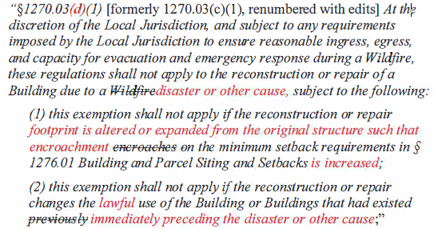

Board response: The regulatory exemption for wildfire rebuilds was a previous emergency regulatory action and is outside the scope of the proposed action. Please see General Response to Exceptions and Exemptions Comments. The comment is not specifically directed at the Board’s proposed action or to the procedures followed by the Board in proposing the action.

Rule text edit: No

Comment W28-6: Tuolumne County Board of Supervisors
3G. Adopt the revised definitions and proposed definitions for "Fire Authority" and "Inspection Entity," to prevent delays in the processing and approval of the limited development still permitted under the proposed standards.
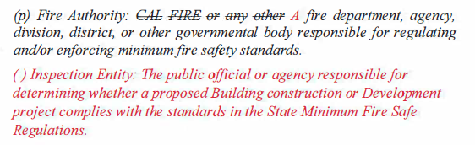
Board response: The Board is not proposing changes to the inspection process, consistent with the narrowed scope of the proposed action as identified within the Supplemental Statement of Reasons published with the “Second 15-Day Notice of Addition of Documents and Information to Rulemaking File and Modified Text” on May 10, 2022. The comment is not specifically directed at the Board’s proposed action or to the procedures followed by the Board in proposing the action.

Rule text edit: No

Comment W28-7: Tuolumne County Board of Supervisors
This letter contains comments on pp.9-11 that are limited in scope to Articles 2-4 of the regulations. The Board is no longer proposing to revise Articles 2-4, consistent with the narrowed scope of the proposed action as identified within the Supplemental Statement of Reasons published with the “Second 15-Day Notice of Addition of Documents and Information to Rulemaking File and Modified Text” on May 10, 2022. The comment is not specifically directed at the Board’s proposed action or to the procedures followed by the Board in proposing the action.

Comment W28-8: Tuolumne County Board of Supervisors
5. Miscellaneous Comments & Suggested Solutions
5A. The BOF's intent should not be to limit construction and development, but rather to reduce fire risk as much as possible and increase fire safety to the extent practical. All risk cannot be eliminated, and the realities of existing land use and ownership patterns, environmental features, and practical cost constraints must be acknowledged and recognized.
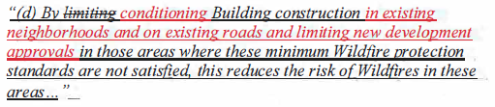
Board response: The Board is no longer proposing to adopt this section, consistent with the narrowed scope of the proposed action as identified within the Supplemental Statement of Reasons published with the “Second 15-Day Notice of Addition of Documents and Information to Rulemaking File and Modified Text” on May 10, 2022. The comment is not specifically directed at the Board’s proposed action or to the procedures followed by the Board in proposing the action.

Comment W28-9: Tuolumne County Board of Supervisors
5B. The definition of a Driveway may not allow for the density outright permitted on multifamily residential parcels or where density has been increased to comply with state housing directives. The result would require these types of parcels to upgrade a Driveway to a Road, which is an unnecessary burden on housing development and in direct conflict with State housing directives. A medication to the definition of a Driveway would increase the consistency between state housing directives and multifamily residential permitted uses. Other proposed changes below are consistent with RCRC's suggestions.
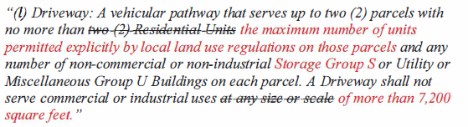
5C. To be consistent with the definition of Driveway, the following modification to the definition of Road is proposed:
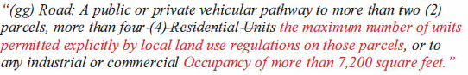

Board response: Please see response to W30-7.

Rule text edit: No

Comment W28-10: Tuolumne County Board of Supervisors
5D. Ambiguity in proposed section § 1270.03 renders it difficult, if not impracticable, to apply. Add language to subsection (a)(4) to clarify the application of this standard.
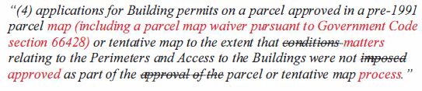
Board response: Please see response to W30-27

Rule text edit: No

Comment W28-11: Tuolumne County Board of Supervisors
This letter contains comments on pp.12-13 that are general in nature; the comments are either not specific or are unnecessarily redundant with more specific comments presented earlier in the letter.

Attachments 1-6: Maps titled “Areas Potentially Subject to Proposed Board of Forestry Regulations in Tuolumne County”

These attachments are not specifically directed at the Board’s proposed action or to the procedures followed by the Board in proposing the action.

Comment W29-1: Santa Clara Valley Open Space Authority
The first four paragraphs and last paragraph of this letter are general in nature; the comments are either not specific or are unnecessarily redundant with more specific comments presented elsewhere in the letter.
Development
- Clarification of definitions in the regulations to remove ambiguity in the language, including the definition of “development” and “construction” to clearly exempt low intensity public recreational facilities (such as restrooms, trailheads, parking lots, trail bridges, and shade structures) from regulatory requirements that seem intended to apply to private residential, commercial, and industrial development.
- Clarification for how proposed regulations apply to existing development, structures and roads and what level of improvements under the new requirements would need to be undertaken. Similarly, what level of “new” construction would trigger the new regulations, such as remodeling of an existing residential or commercial structure or repairs or modifications to other existing open space facilities.
- Clarification under Section 1270.02 “Purpose” to specify what building construction or development is not included in the new regulations such as anything that existed prior to the effective date of these regulations.
- Also, under Section 1270.02 (f) consider amending how the regulations apply as shown:
“These regulations shall not apply to Greenbelts, Greenways, Roads or parcels used solely for Agriculture, mining, the management of timberland and harvesting of forest products, or Outdoor Recreation on lands owned or leased by state or local public agencies. (see suggested new definition for “outdoor recreation” below)

Board response: In the 15 day noticed rule text published on May 10, 2022, the Board proposes to retain the existing definition of “development,” and no longer proposes a definition for “building construction,” consistent with the narrowed scope of the proposed action as identified within the Supplemental Statement of Reasons published with the “Second 15-Day Notice of Addition of Documents and Information to Rulemaking File and Modified Text” on May 10, 2022.

The Board is no longer proposing different standards for new or existing development, consistent with the narrowed scope of the proposed action as identified within the Supplemental Statement of Reasons published with the “Second 15-Day Notice of Addition of Documents and Information to Rulemaking File and Modified Text” on May 10, 2022.

The Board is no longer proposing changes to the applicability of these regulations, consistent with the narrowed scope of the proposed action as identified within the Supplemental Statement of Reasons published with the “Second 15-Day Notice of Addition of Documents and Information to Rulemaking File and Modified Text” on May 10, 2022.

Rule text edit: No

Comment W29-2: Santa Clara Valley Open Space Authority
Road and Trails/Bridges
- Clarification related to road and trail management and when the proposed regulations will be triggered for future maintenance and operations of our miles and miles of roads and trails.
- Clarification for bridge construction as being for vehicular bridges only and how to address modifications for safety or repair to existing bridges.
- Clarification of when clear width requirements do and do not need to be met over existing and proposed roads. Consider eliminating clear width requirements where doing so will have a negative impact on natural and cultural resources.
Board response: Please see “General Response to Comments Regarding Existing Roads”.

Rule text edit: No

Comment W29-3: Santa Clara Valley Open Space Authority
Outdoor Recreation
Consider adding a definition for “Outdoor Recreation: Activities and non-residential uses compatible with the natural environment, including passive parks, campgrounds, picnic areas, ranger outposts, trails and trail heads and related parking, public restrooms, visitor centers, signage, kiosks, and information booths.”
Board response: The term “outdoor recreation” is not used in these regulations, so a definition is not necessary.

Rule text edit: No

Comment W29-4: Santa Clara Valley Open Space Authority
Enforcement
Clarification for how the regulations will be enforced and to make it easier for local jurisdictions to adapt the regulations to existing code requirements, thereby removing ambiguity for agencies and individuals to comply and get permits, as may be needed.

Board response: The Board is no longer proposing changes to the inspection and enforcement authorities, consistent with the narrowed scope of the proposed action as identified within the Supplemental Statement of Reasons published with the “Second 15-Day Notice of Addition of Documents and Information to Rulemaking File and Modified Text” on May 10, 2022.

Rule text edit: No

Comment W29-5: Santa Clara Valley Open Space Authority

Resource Protection/Environmental Impact
• The proposed regulations may be in direct conflict with sensitive natural and cultural resource protection requirements including limits of species take as prescribed by regulatory agencies and other constraints. Please address how and when these regulations take precedence over other, conflicting local, state, and federal requirements.

• It is not clear how the passage of these regulations relates to BOF requirements for compliance with the California Environmental Quality Act (CEQA). The scale and magnitude of the impact of these regulations to natural and cultural resources could be significant, and local agency actions related to these regulations may also result in significant environmental impacts. This needs to be fully considered as part of the implementation of these regulations.

Board response: Please see General CEQA Response

Rule text edit: No

Comment W29-6: Santa Clara Valley Open Space Authority

Fiscal Impact and Support
Based on the final language of the proposed regulations and without the recommended clarifications, there may be a significant fiscal impact to agencies that manage land as firebreaks and that serve as resilient buffers between the urban wildland interface. These requirements may remove our critical resources needed to implement fuel management strategies that we currently undertake and are considering as part of a Fuel Management Plan underway. The BOF should consider the fiscal impact of these regulations and provide funding assistance as part of successful implementation.

Board response: Please see the Economic and Fiscal Impact Statement

Rule text edit: No

Comment W30-1: Rural County Representatives of California
The first three paragraphs of this letter are introductory/conclusive in nature; the comments are either not specific or unnecessarily redundant with more specific comments presented elsewhere in the letter.

Paragraphs 4 and 5 of this letter are limited in scope to Articles 2-4 of the regulations. The Board is no longer proposing to revise Articles 2-4, consistent with the narrowed scope of the proposed action as identified within the Supplemental Statement of Reasons published with the “Second 15-Day Notice of Addition of Documents and Information to Rulemaking File and Modified Text” on May 10, 2022.

The ostensible exemptions of wildfire rebuilds and accessory dwelling units from these requirements are fatally unclear. While certain provisions of the regulations purport to exempt these buildings from the regulations (§ 1270.03), other provisions appear to override or limit those exemptions and impose substantial burdens on these homeowners. (See, e.g., § 1273.00(d), providing that "[n]otwithstanding any other provision in this Subchapter, Building construction is prohibited..." and § 1273.12(d), establishing special requirements for roads used to access buildings being reconstructed after a wildfire - which would be meaningless if such reconstruction was actually exempt from the regulations.) These exemptions are confusing at best, and at worst deceptive to the regulated public.

Moreover, to the extent such exemptions work at all, they are overly narrow.
The exemption for rebuilds covers only structures lost due to wildfire, and
consequently owners whose homes or businesses were lost due to other
causes (e.g., flood, mudslide, house fire, etc.) would be subject to the full
panoply of requirements applicable to new construction. Also, even wildfire
rebuilds are not exempt if they cannot meet the setback requirements - as is
the case on many smaller lots. Rebuilding an existing home or business creates
no new impact, no heightened fire risk, and no increased fire serve need. There
is no nexus to require upgrades to existing public roads as a condition of rebuilding these structures.

Board response: The regulatory exemption for wildfire rebuilds was a previous emergency regulatory action and is outside the scope of the proposed action. Please see General Response to Exceptions and Exemptions Comments.

Rule text edit: No

Comment W30-2: Rural County Representatives of California
The proposed regulations will have significant impacts on the physical environment, by incentivizing and encouraging road improvements statewide, and substantial economic impacts on affected property owners and small businesses. The Board has a legal obligation to meaningfully evaluate and consider these impacts under the California Environmental Quality Act and the Administrative Procedures Act - but has made no serious effort to do so.

Board response: Please see the Economic and Fiscal Impact Statement and General CEQA Response

Rule text edit: No

Comment W30-3: Rural County Representatives of California
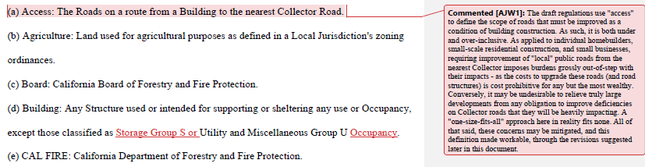
Board response: The Board is no longer proposing a definition for the term “Access,” consistent with the narrowed scope of the proposed action as identified within the Supplemental Statement of Reasons published with the “Second 15-Day Notice of Addition of Documents and Information to Rulemaking File and Modified Text” on May 10, 2022.

Where the Board intends to exemption Storage Group S occupancies from these regulations, it does so (1276.02(c)(2)). To exempt Storage Group S from the definition of “building” would change the application of these regulations, and the Board is no longer proposing those changes, consistent with the narrowed scope of the proposed action as identified within the Supplemental Statement of Reasons published with the “Second 15-Day Notice of Addition of Documents and Information to Rulemaking File and Modified Text” on May 10, 2022.

Rule text edit: No

Comment W30-4: Rural County Representatives of California
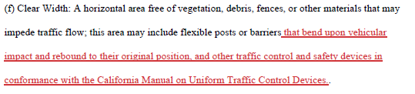
Board response: The Board is no longer proposing a definition for “clear width,” the narrowed scope of the proposed action as identified within the Supplemental Statement of Reasons published with the “Second 15-Day Notice of Addition of Documents and Information to Rulemaking File and Modified Text” on May 10, 2022.

Rule text edit: No

Comment W30-5: Rural County Representatives of California
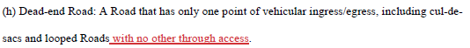
Board response: The Board proposed to change the definition of “dead end road” to read “a road that has only one point of vehicular ingress/egress, including cul de sacs and Roads that loop back on themselves” in the 15 day noticed rule text published on May 10, 2022.

Rule text edit: Yes

Comment W30-6: Rural County Representatives of California
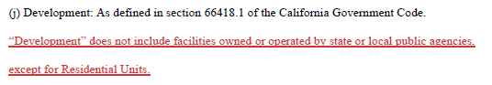
Board response: The Board is not proposing changes to the definition of “development.”

Rule text edit: No

Comment W30-7: Rural County Representatives of California
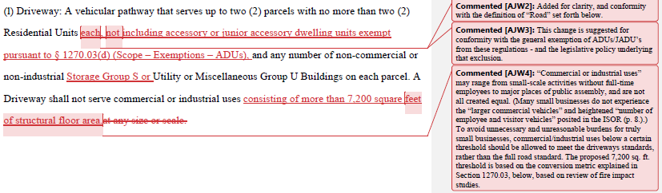
Board response: The exemption for accessory or junior accessory dwelling units was a previous emergency regulatory action and is outside the scope of the proposed action. The definition for “road,” as it currently exists, specifies that a road serves commercial and industrial uses, so to clarify that a driveway cannot serve a commercial or industrial use is reinforcing existing law. The Board has not been presented with evidence that a commercial or industrial use of 7,200 square feet presents a significantly greater fire risk such that smaller commercial or industrial uses need only be served by a driveway. Regarding Storage Group S, the Board is not proposing any further exemptions from the definition of a driveway than what is currently allowed in 1271.00.

Rule text edit: No

Comment W30-8: Rural County Representatives of California
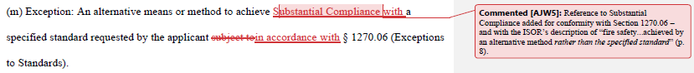
Board response: The Board is no longer proposing to use the term “substantial compliance,” consistent with the narrowed scope of the proposed action as identified within the Supplemental Statement of Reasons published with the “Second 15-Day Notice of Addition of Documents and Information to Rulemaking File and Modified Text” on May 10, 2022.

Rule text edit: No

Comment W30-9: Rural County Representatives of California
Board response: The proposed rule text does not use the term “feasible,” so a definition is not necessary.

Rule text edit: No

Comment W30-10: Rural County Representatives of California
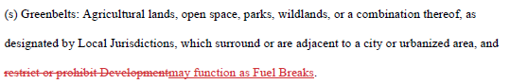
Board response: The Board proposes to adopt this amendment.

Rule text edit: Yes.

Comment W30-11: Rural County Representatives of California
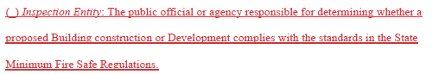
Board response: The Board is no longer proposing changes the inspection process, consistent with the narrowed scope of the proposed action as identified within the Supplemental Statement of Reasons published with the “Second 15-Day Notice of Addition of Documents and Information to Rulemaking File and Modified Text” on May 10, 2022.

Rule text edit: No

Comment W30-12: Rural County Representatives of California
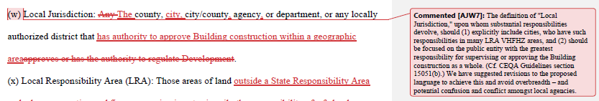
Board response: This proposed change would limit the type of development projects the local jurisdictions could be responsible for approving or regulating in regards to the application of these regulations. “Development” is a broader term than “Building construction,” and these regulations do apply to development (i.e., a subdivision) as well as building construction (i.e., a single building permit). Therefor, the local jurisdiction must be an agency that has overall authority for development, not just building construction.

Rule text edit: No

Comment W20-13: Rural County Representatives of California
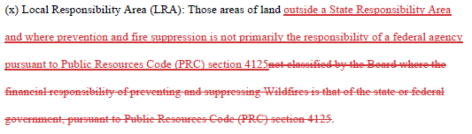
Board response: The Board is no longer proposing to adopt a definition for LRA, consistent with the narrowed scope of the proposed action as identified within the Supplemental Statement of Reasons published with the “Second 15-Day Notice of Addition of Documents and Information to Rulemaking File and Modified Text” on May 10, 2022.

Rule text edit: No

Comment W30-14: Rural County Representatives of California
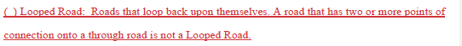
Board response: Please see response to W30-5

Rule text edit: Yes

Comment W30-15: Rural County Representatives of California
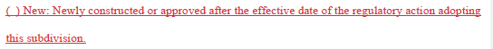
Board response: The Board is no longer proposing changes to the applicability of the road standards, consistent with the narrowed scope of the proposed action as identified within the Supplemental Statement of Reasons published with the “Second 15-Day Notice of Addition of Documents and Information to Rulemaking File and Modified Text” on May 10, 2022.

Rule text edit: No

Comment W30-16: Rural County Representatives of California
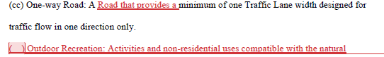
Board response: The Board proposes to adopt this change in the 15 day noticed rule text published on May 10, 2022.

Rule text edit: Yes

Comment W30-17: Rural County Representatives of California
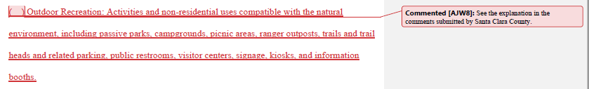
Board response: The Board does not use the term “outdoor recreation” in these regulations, so a definition is unnecessary.

Rule text edit: No

Comment W30-18: Rural County Representatives of California
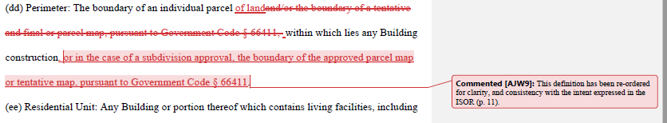
Board response: The Board is no longer proposing to adopt the definition of
“perimeter”, consistent with the narrowed scope of the proposed action as identified within the Supplemental Statement of Reasons published with the “Second 15-Day Notice of Addition of Documents and Information to Rulemaking File and Modified Text” on May 10, 2022.

Rule text edit: No

Comment W30-19: Rural County Representatives of California
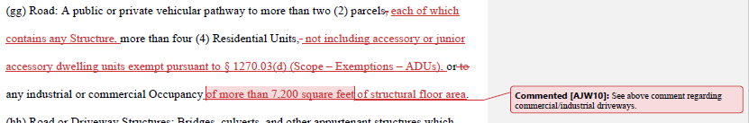
Board response: Please see response to W30-7

Rule text edit: No

Comment W30-20: Rural County Representatives of California
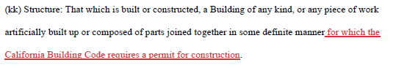
Board response: The term “structure” is used more broadly in the regulations than would be allowable by adding the proposed phrase to the definition of “structure.” For example, the term “structure” is used in the term “road and driveway structure,” which are not typically pieces of infrastructure that require a building permit. Adding the suggested phrase to the definition of structure would cause inconsistencies between the defined term and how it is used in the rule text.

Rule text edit: No

Comment W30-21: Rural County Representatives of California
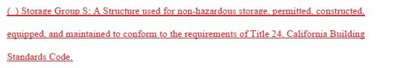
Board response: The proposed regulations use the term “Storage Group S” once (in 1276.02(c)(2)) and the general context in which it is used makes it clear to the regulated public what the term is referring to.

Rule text edit: No

Comment W30-22: Rural County Representatives of California
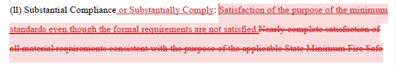
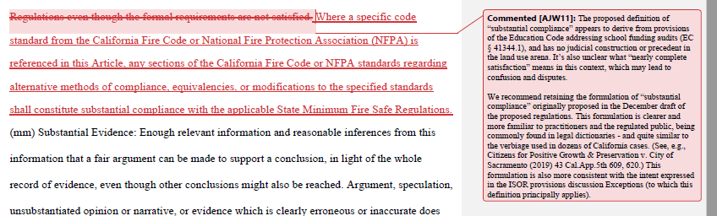
Board response: The Board is no longer proposing to adopt the term “substantial compliance,” consistent with the narrowed scope of the proposed action as identified within the Supplemental Statement of Reasons published with the “Second 15-Day Notice of Addition of Documents and Information to Rulemaking File and Modified Text” on May 10, 2022.

Rule text edit: No

Comment W20-23: Rural County Representatives of California
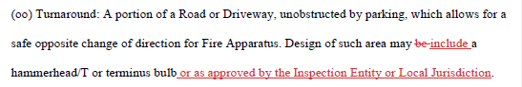
Board response: The 15 day noticed rule text published on May 10, 2022, deleted references to specific turnaround design in the definition of “turnaround.”

Rule text edit: Yes

Comment W30-24: Rural County Representatives of California
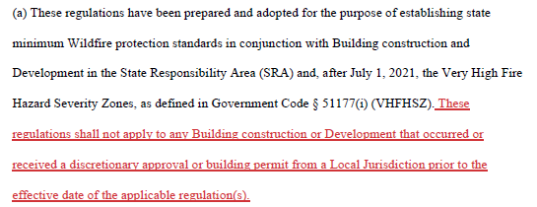
Board response: The scope of the proposed action does not include exempting activities from being subject to the regulations. The comment is outside the scope of the proposed action.

Rule text edit: No

Comment W30-25: Rural County Representatives of California
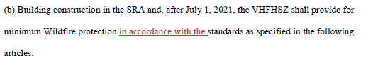
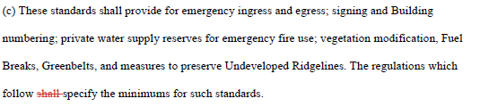
Board response: The Board is no longer proposing these changes to this section, consistent with the narrowed scope of the proposed action as identified within the Supplemental Statement of Reasons published with the “Second 15-Day Notice of Addition of Documents and Information to Rulemaking File and Modified Text” on May 10, 2022.

Rule text edit: No

Comment W30-26: Rural County Representatives of California
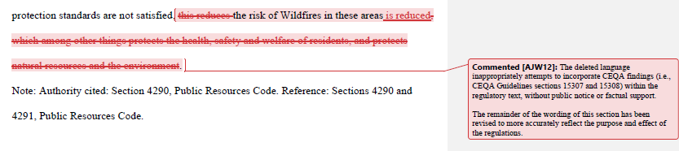
Board response: The Board is no longer proposing to adopt this section, consistent with the narrowed scope of the proposed action as identified within the Supplemental Statement of Reasons published with the “Second 15-Day Notice of Addition of Documents and Information to Rulemaking File and Modified Text” on May 10, 2022.

Rule text edit: No

Comment W30-27: Rural County Representatives of California
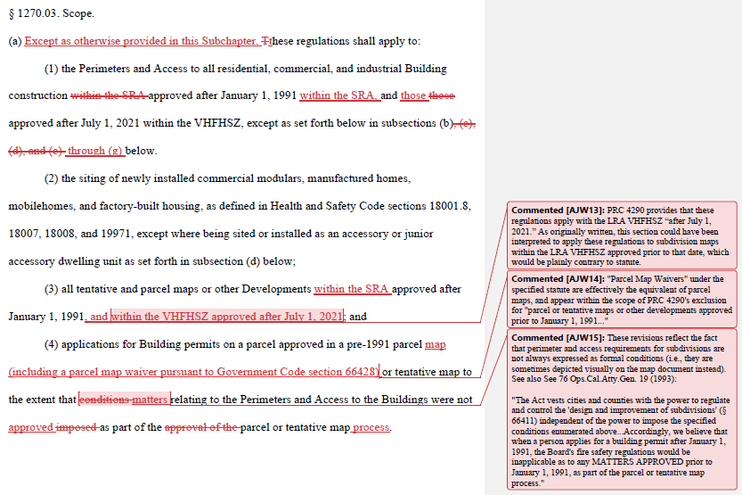
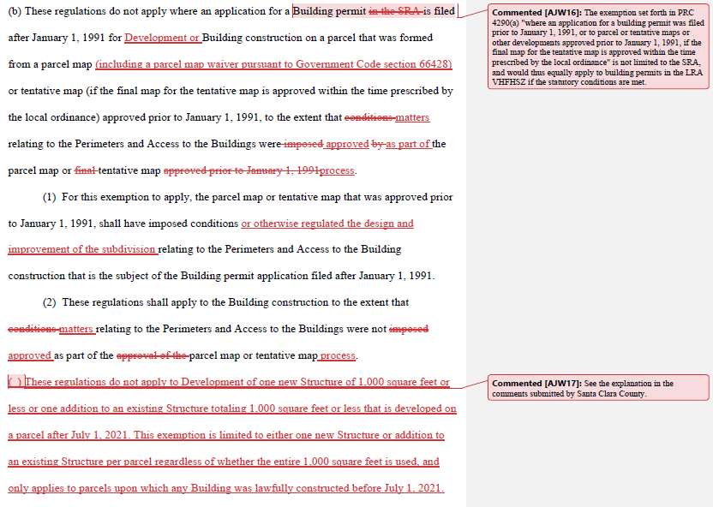
Board response: The Board is not proposing changes to the scope of these regulations. The comment is not specifically directed at the Board’s proposed action or to the procedures followed by the Board in proposing the action. Exemptions from the regulations are not part of the proposed action.

Rule text edit: No

Comment W30-28: Rural County Representatives of California

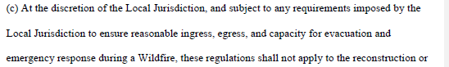
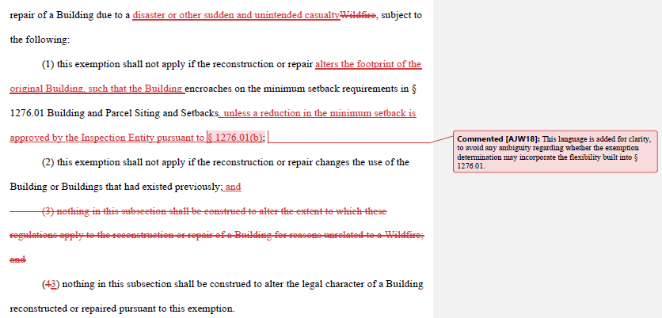
Board response: The regulatory exemption for wildfire rebuilds was a previous emergency regulatory action and is outside the scope of the proposed action. Please see General Response to Exceptions and Exemptions Comments. The comment is not specifically directed at the Board’s proposed action or to the procedures followed by the Board in proposing the action.

Rule text edit: No

Comment W30-29: Rural County Representatives of California
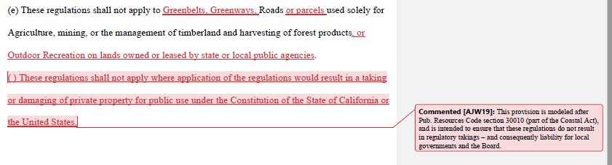
Board response: The commenter has provided no judicial determination as to the unconstitutionality of PRC § 4290, the existing Fire Safe Regulations, or the proposed rulemaking language, and the Board is unaware of any. The proposed language regarding constitutional matters is outside the scope of the Board’s authority and is not necessary or appropriate to effectuate the purpose of the statute. Please see General Response to Constitutionality Comment.

Rule text edit: No

Comment W30-30: Rural County Representatives of California
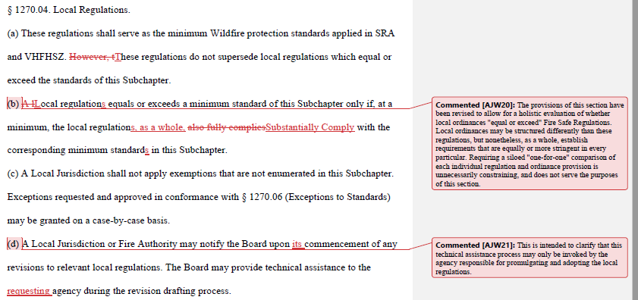
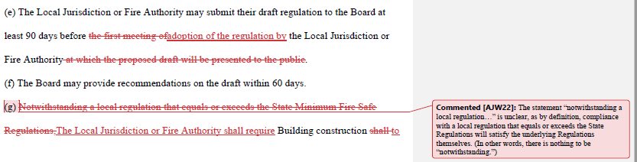
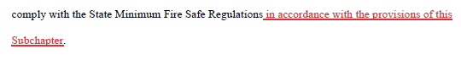
Board response: In the 15 day noticed rule text published January 3, 2022, the Board proposed to adopt a different regulatory scheme in this section.

Rule text edit: Yes

Comment W30-31: Rural County Representatives of California
1270.5. Inspections.
(a)
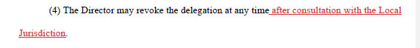
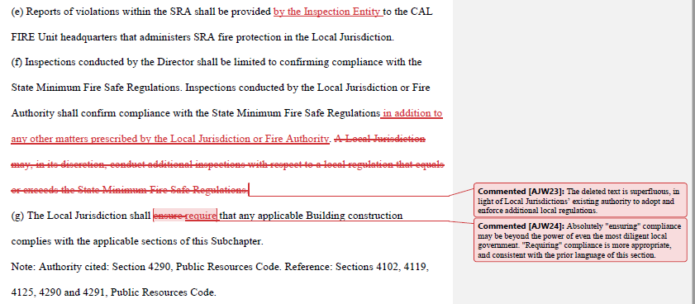
Board response: The Board is no longer proposing changes to this section, consistent with the narrowed scope of the proposed action as identified within the Supplemental Statement of Reasons published with the “Second 15-Day Notice of Addition of Documents and Information to Rulemaking File and Modified Text” on May 10, 2022.

Rule text edit: No

Comment W30-32: Rural County Representatives of California
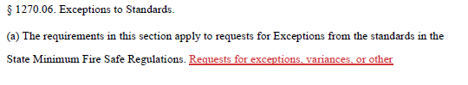
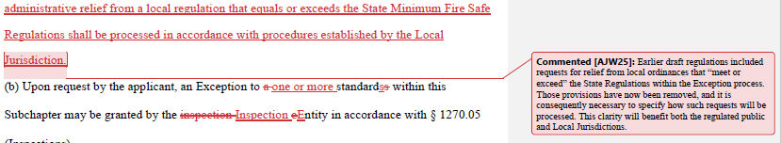
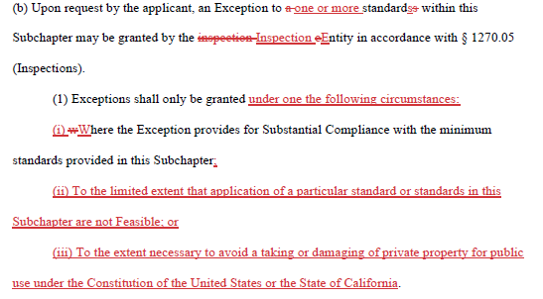
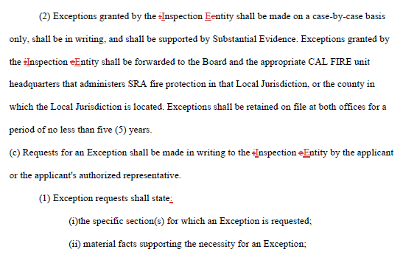
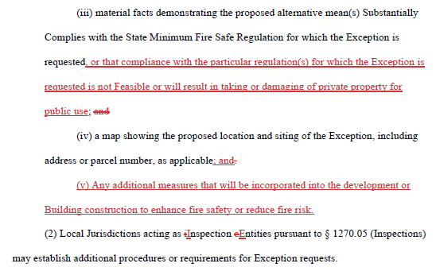
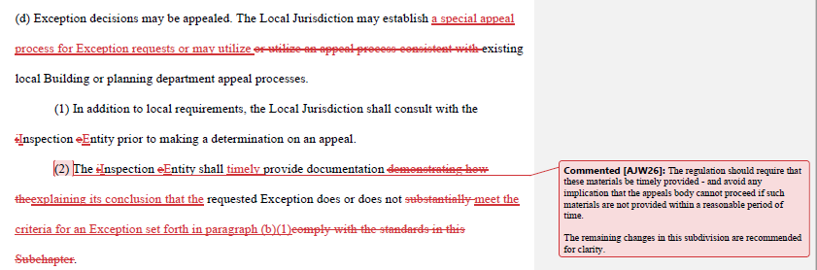
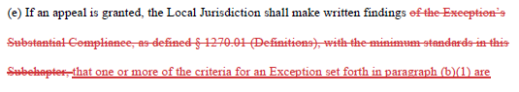
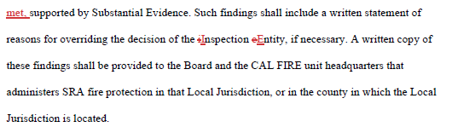
Board response: The Board is no longer proposing changes to this section, consistent with the narrowed scope of the proposed action as identified within the Supplemental Statement of Reasons published with the “Second 15-Day Notice of Addition of Documents and Information to Rulemaking File and Modified Text” on May 10, 2022.

Rule text edit: No

Comment W30-33: Rural County Representatives of California
This letter contains comments on pp.20-49 that are is limited in scope to Articles 2-4 of the regulations. The Board is no longer proposing to revise Articles 2-4, consistent with the narrowed scope of the proposed action as identified within the Supplemental Statement of Reasons published with the “Second 15-Day Notice of Addition of Documents and Information to Rulemaking File and Modified Text” on May 10, 2022.

Comment W30-34: Rural County Representatives of California
1276.02. Ridgelines.
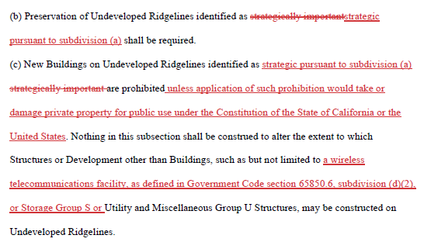
Board response: In the 15 day noticed rule text published May 10, 2022, the Board proposed to adopt “(b) Preservation of Undeveloped Ridgelines identified as strategically important shall be required pursuant to this section.” which provides for similar clarity as the letter writer’s proposal.

In the same 15 day noticed rule text, the Board proposed to adopt 1276.02(c)(2) which reads “Nothing in this subsection shall be construed to alter the extent to which utility infrastructure, including but not limited to wireless telecommunications facilities, as defined in Government Code section 65850.6, subdivision (d)(2), or Storage Group S or Utility and Miscellaneous Group U Structures, may be constructed on Undeveloped Ridgelines,” as proposed by the letter writer.

The commenter has provided no judicial determination as to the unconstitutionality of PRC § 4290, the existing Fire Safe Regulations, or the proposed rulemaking language, and the Board is unaware of any. The proposed language regarding constitutional matters is outside the scope of the Board’s authority and is not necessary or appropriate to effectuate the purpose of the statute. Please see General Response to Constitutionality Comment.

Rule text edit: Yes

Comment W30-35: Rural County Representatives of California
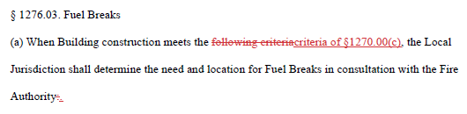
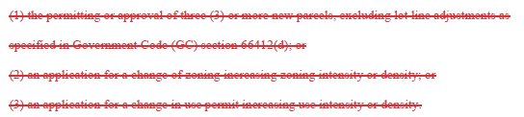
Board response: In the 15 day noticed rule text published on May 10, 2022, the Board proposed to delete 1270.00(c), so (a)(1)-(3) in this section are necessary.

Rule text edit: No

Comment W30-36: Rural County Representatives of California
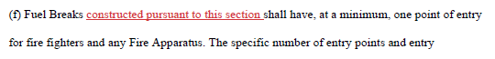
Board response: The applicability of the regulations is explicit within the existing regulations in section 1270.02 (revised to 1270.03). It would be overly redundant to write “constructed pursuant to this section” in every section of code.

Rule text edit: No

Comment W30-37: Rural County Representatives of California
1276.04. Greenbelts, Greenways, Open Spaces and Parks.
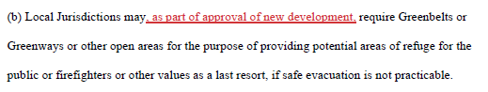
Board response: In the 15 day noticed rule text published May 10, 2022, the Board proposed deleting this section.

Rule text edit: Yes

Comment W31-1: San Diego County Department of Public Works
The following are comments from the County of San Diego Department of Public Works Field Engineering Division:

This DRAFT regulation is applicable to Roads and access ways constructed after 1991. At that time the County Road Register noted that the total County Maintained miles was 1,868.36. The current reported County Maintained mileage is 1945.5 which gives a difference of 77.14 miles that have been added and potential more miles when you include the deletion of miles that occurred during that period. This equates to 3.9% of the network. Items of note to be considered and that may require revision are the following:

- Page 23 – Inside radius of a curve, not within an intersection or knuckle, shall be no less than 50’
- Page 30 – Roads and Bridges shall have a weight capacity of 75,000 pounds (allowance for lesser capacity are included)
- Page 32 – Bridges shall be constructed on non‐combustible material
- Page 32 – Road grades shall not exceed 16%
- Page 32 – Road grade transitions must accommodate maximum approach angles of 12 degrees
- Page 33 – Bidirectional Roads shall provide a minimum of (2) 10’ lanes
- Page 35 – Roads shall have an minimum of 13’ 6” of unobstructed vertical clearance
- Page 36 – One‐Way Roads shall not exceed 2,640’
- Page 37 – Maximum length of dead‐end Roads:
  - 800’ for parcels less than 1 acre
  - 1,320’ for parcels up to 4.99 acres
  - 2,640’ for parcels 5 acres and above
- Page 38 – Turnouts shall be minimum of 12’ wide by 22’ long with 25’ tapers on each end
- Page 38 – Turnouts shall be no more than 400’ apart
- Page 47 – Existing roads shall have a minimum requirement of one lane of travel at least 14’ wide
- Page 47 – Existing roads shall have no more that 50% of its length be Native Surface
- Page 48 – Secondary roads shall meeting the standard of new roads in this regulation

It is unclear what the above impact is to the County Maintained network without a deep dive into roads or bridges constructed after 1991 and or weather some of these regulations may be applicable to the entire County Maintained network.

Board response: The Board no longer proposes changes to the sections described in this comment, consistent with the narrowed scope of the proposed action as identified within the Supplemental Statement of Reasons published with the “Second 15-Day Notice of Addition of Documents and Information to Rulemaking File and Modified Text” on May 10, 2022. The comment is not specifically directed at the Board’s proposed action or to the procedures followed by the Board in proposing the action.

Rule text edit: No

Comment W32-1: Plumas County Board of Supervisors
The first six paragraphs and last paragraph of this letter are introductory/conclusive in nature; the comments are not specifically directed at the Board’s proposed action or to the procedures followed by the Board in proposing the action.

Pp. 2-5 of this letter contain comments that are limited in scope to Articles 2-4 of the regulation. The Board is no longer proposing to revise Articles 2-4, consistent with the narrowed scope of the proposed action as identified within the Supplemental Statement of Reasons published with the “Second 15-Day Notice of Addition of Documents and Information to Rulemaking File and Modified Text” on May 10, 2022. The comment is not specifically directed at the Board’s proposed action or to the procedures followed by the Board in proposing the action.

Comment W32-2: Plumas County Board of Supervisors
C. The requirement for 30-foot setbacks on all parcels, including wildfire rebuilds, regardless of parcel size or other mitigating factors:
The "one-size-fits-all" minimum setback requirement potentially renders undevelopable any parcel less than one-half acre in size and parcels in older subdivisions with one or more narrow or otherwise constraining dimension(s). There are many historical townsite mapped communities in Plumas County where this situation occurs. This standard disproportionately affects the County's most populated and higher density communities where smaller parcels are located. These higher density "Towns" are also the most suitable for higher density development due to smaller lots, local businesses and public agencies providing essential services, and special districts providing services such as water, sewer, and fire protection. The goals and policies of the Plumas County 2035 General Plan encourage compact development.
The following communities in the unincorporated area of Plumas County are designated as Single-Family Residential with parcel sizes one-half acre or less in size:

• Chester
• Lake Almanor Peninsula/Hamilton Branch
• Greenville
• East Quincy/Quincy
• Graeagle
• Delleker
• Crescent Mills
• Taylorsville
• Clio
• Beckworth
• Vinton/Chilcoot
• La Porte
• Greenhorn Ranch
• Lake Almanor West

Board response: The comments are not specifically directed at the Board’s proposed action or to the procedures followed by the Board in proposing the action. Regarding setbacks, Section 1276.01(b) provides flexibility to local jurisdictions regarding alternative methods of reducing structure to structure ignition if a 30 foot setback is not possible.

Rule text edit: No

Comment W32-3: Plumas County Board of Supervisors
Attachment 1: Plumas County 2035 General Plan excerpt.
II. Direct Conflict with Plumas County 2035 General Plan
Table 1-3. Land Use Designations and Permissible Densities contains the following provision under all General Plan Designations that allow dwelling units:
"A legally existing parcel is allowed one dwelling unit, if zoning and building standards can be met. "
The proposed Regulations would impose constraints on building dwelling units on legally existing parcels and would lead to denial of some building permits. As the proposed Regulations are not zoning and building standards under control by the County, this would create a direct conflict with the Plumas County 2035 General Plan.

Board response: The comments are not specifically directed at the Board’s proposed action or to the procedures followed by the Board in proposing the action.

Rule text edit: No

Comment W32-4: Plumas County Board of Supervisors
III. Other Unintended Consequences
- Local Regulations
Sec. 1270.04 grants a local jurisdiction the option of adopting a more restrictive local ordinance; however, other sub-sections of Sec. 1270.04 grants sole authority to Cal Fire or "Director" later defined as Department of Forestry. As final authority is with either Cal Fire or the Director, it is possible that the local jurisdiction could have any parts of the ordinances negated or overturned. As stated above, local jurisdictions must rely on certainty in regulation in order to provide information to landowners and potential investors and well as to reliably enforce land use regulations when approving development.
Many sections in the proposed Regulations mention inspections performed by the local jurisdiction, but with no mention of how a jurisdiction is to be compensated for these services. Plumas County does not employ Civil Engineers or other suitably qualified personnel to specifically perform many of the inspections required under these regulations. The County's budget cannot be expected to absorb the costs of hiring inspection personnel as required under the proposed Regulations.
Due to the new Regulations regarding improvements to Access prior to issuance of permits for Building Construction, in many cases an applicant for a building permit would need to complete the necessary improvements under the Regulations and provide verification that the project has received approval from Cal Fire prior to submitting an application for a building permit. This lag in approval times has the potential to delay ministerial building permit processing with direct economic impacts.

Board response: In the 15 day notice of proposed rule making published on May 10, 2022, references to the director in 1270.04 were deleted. The comments are not specifically directed at the Board’s proposed action or to the procedures followed by the Board in proposing the action.

Rule text edit: No

Comment W32-5: Plumas County Board of Supervisors
Paragraph B of section III of this letter is limited in scope to Articles 2-4 of the regulation. The Board is no longer proposing to revise Articles 2-4, consistent with the narrowed scope of the proposed action as identified within the Supplemental Statement of Reasons published with the “Second 15-Day Notice of Addition of Documents and Information to Rulemaking File and Modified Text” on May 10, 2022. The comment is not specifically directed at the Board’s proposed action or to the procedures followed by the Board in proposing the action.

Comment W32-6: Plumas County Board of Supervisors
C. Illegal Conversion of Structures
Construction of new dwellings that are required to be equipped with NFPA 13D residential fire sprinkler systems and built to 2019 CBC and CRC Wildland Urban Interface standards are being heavily restricted, while accessory structures are not and, in fact, are exemption and allowed without limit. Accessory structures are not required to meet the same regulations for residential fire sprinkler systems and the Wildland Urban Interface standards. Therefore, by usage, they can be more of a liability than dwellings. This leads to a Code Enforcement component with illegal conversion of structures to other uses. Allowing accessory structures, but not dwellings in some instances on a property could create situations where accessory use structures are built with building permits and then converted to dwellings without building permits. These unpermitted conversions would also not be equipped with residential fire sprinklers or meet the standards of the Wildland Urban Interface codes. This would be in conflict with the intent of the Regulations.

Board response: The comment is not specifically directed at the Board’s proposed action or to the procedures followed by the Board in proposing the action.

Rule text edit: No

Comment W32-7: Plumas County Board of Supervisors
D. Building and Parcel Siting and Setbacks
Sec. 1276.01 mentions some reasons for providing Exceptions to the thirty foot setback, but specific measures listed in the section state that the following applies: Reduction of Structure to Structure ignition by incorporating features such as, but not limited to: non-combustible block walls or fences; or five (5) feet of non-combustible material extending five ( 5) feet horizontally from the furthest extent of the Building; or installing hardscape landscaping or reducing exposed windows on the side of the Structure with less than thirty (30) foot setback; or additional structure hardening that exceeds the requirements of the California Building Code.
This section can be seen to be in direct conflict with code requirements to provide openings and windows for light and ventilation. CBC R303.l requires that windows and natural ventilation in an amount equal to 8% of the floor area be provided. Bedrooms are required to have egress for emergency escape and rescue (R310.1- R310.6). If the standards of the CBC need amendment, there is a process for that which should be separate from the Regulations. Mixing and matching requirements was intended to be corrected through this process. The proposed Regulations impose requirements outside the existing CBC.

Board response: The 30 foot setback is an existing requirement (see § 1276.01). There may be instances where a 30 foot setback is not practical for reasons of site design or parcel proportions. In those instances, § 1276.01(b) allows for reductions to setback distances that provide for the “same practical effect” of a 30 foot setback. It is not required that a reduction in setback be accompanied by a reduction in vulnerable windows.

Rule text edit: No

Comment W32-8: Plumas County Board of Supervisors
E. The Regulations require an economic impact assessment under the Administrative Procedures Act, including an evaluation of effect on housing costs.

The Administrative Procedures Act (APA) requires administrative agencies to prepare an economic impact assessment of proposed regulations, including consideration of the effect of the proposed regulatory action on housing costs (Government Code Sections 11346.2(b)(2)-(5), 11346.3, 11346.5(a)(7)-(12)). According to the proposed rules, the proposed action "Does not impact housing cost" and "will not have a significant adverse economic impact directly affecting business." Contrary to these statements, the proposed Regulations will likely impact housing costs, as well as housing availability, and have a significant adverse economic impact directly affecting business and Plumas County.

Board response: Please see the Economic and Fiscal Impact Statement

Rule text edit: No

Comment W33-1: Calaveras County Board of Supervisors
The first two paragraphs of this letter are introductory/conclusive in nature; the comments are not specifically directed at the Board’s proposed action or to the procedures followed by the Board in proposing the action.
• Of the approximately 1800 miles of road in Calaveras County, approximately 1200 miles are privately owned and/or maintained. The proposed "existing roads" provisions would create no-build zones in areas served by dirt roads, or by roads less than 14-feet wide or with a grade exceeding 25 percent. In areas where it is possible for such roads to be improved, property owners would be required to make improvements in areas of the roadway that are not contained on their own parcels. This, in turn, would require property owners seeking to improve their lands through ministerial building permits to successfully acquire legal rights from their neighbors, likely at a significantly higher cost than they would have otherwise have had to incur.
• The asserted "exemptions" for wildfire rebuilds and accessory dwelling units are unclear. While certain provisions of the regulations purport to exempt these buildings from the regulations, other provisions appear to override or limit those exemptions and impose substantial burdens on these homeowners.
• Such exemptions - to the extent they work at all - are overly narrow. The rebuild exemption covers only structures lost due to wildfire, and consequently owners whose homes or businesses were lost due to other causes (e.g., flood, mudslide, house fire, etc.} would be subject to the full suite of requirements. In addition, even some wildfire rebuilds would not be exempt if they could not meet the setback requirements - as is the case on many smaller lots. The replacement value assigned to structures lost due to disasters other than wildfire is unlikely to cover the cost of complying with these standards in many areas of this County.

Board response: The Board is no longer proposing separate standards for existing roads, consistent with the narrowed scope of the proposed action as identified within the Supplemental Statement of Reasons published with the “Second 15-Day Notice of Addition of Documents and Information to Rulemaking File and Modified Text” on May 10, 2022. The regulatory exemption for wildfire rebuilds was a previous emergency regulatory action and is outside the scope of the proposed action. Please see General Response to Exceptions and Exemptions Comments. The comment is not specifically directed at the Board’s proposed action or to the procedures followed by the Board in proposing the action.

Rule text edit: No

Comment W33-2: Calaveras County Board of Supervisors
Paragraphs 6 and 7 of this letter are limited in scope to Articles 2-4 of the regulation. The Board is no longer proposing to revise Articles 2-4, consistent with the narrowed scope of the proposed action as identified within the Supplemental Statement of Reasons published with the “Second 15-Day Notice of Addition of Documents and Information to Rulemaking File and Modified Text” on May 10, 2022. The comment is not specifically directed at the Board’s proposed action or to the procedures followed by the Board in proposing the action.

Comment W33-3: Calaveras County Board of Supervisors
• Proposed Section 1270.03 is vague as to whether agricultural parcel use is exempted from the entire regulation or merely the road provisions. Calaveras County is an agricultural county. Should agricultural operations be required to comply with the proposed standards, unforeseen and unstudied significant financial impacts to agricultural business operations in Calaveras County could result.
• The Board of Forestry's role in the process by which exceptions can be authorized is not clear. Local jurisdictions need to know if the Board of Forestry can unilaterally reject an exception once filed and, if so, if a county or builder will have an opportunity to demonstrate that the project is in substantial compliance with the new regulations.

Board response: The Board is not proposing changes to the application of these regulations to roads used exclusively for agricultural uses. The comment is not specifically directed at the Board’s proposed action or to the procedures followed by the Board in proposing the action.

Rule text edit: No

Comment W33-4: Calaveras County Board of Supervisors
The Board of Forestry has failed to evaluate the economic or environmental impacts of these proposals, as required by state law. The Administrative Procedures Act (APA) requires administrative agencies to prepare an economic impact assessment of proposed regulations, including consideration of the effect of the proposed regulatory action on housing costs (Govt. Code§§ 11346.2(b)(2)-(5), 11346.3, 11346.5(a)(7)-(12)). According to the proposed rules, the proposed action "Does not impact housing cost" and, "will not have a significant adverse economic impact directly affecting business."

Board response: Please see the Economic and Fiscal Impact Statement

Rule text edit: No

Comment W34-1: Santa Barbara County Fire Department
Thank you for the opportunity to review and comment on the Notice of Proposed Action "State Minimum Fire Safe Regulations, 2021."
The Santa Barbara County Fire Department has reviewed the draft regulations and concur with the majority of proposed changes. The current Santa Barbara County Fire Department Development Standards meet or exceed the proposed regulations with the exception of proposed §1273.08. Our current Development Standard for Fire Apparatus Access, Sectionl.8- Dead-end Roads meets the current Title 14 standard including the maximum length of dead-end roads for parcels zoned 20 acres or larger not to exceed 5,280 feet in length. There are many areas within Santa Barbara County where topography, hazard conditions, parcel size and configuration, and public land and private property ownership patterns necessitate the ability to consider dead-end roads longer than the proposed maximum of 2,640 feet for parcels zoned for 5 acres or larger. Santa Barbara County Fire recommends maintaining the standard as currently approved.
In addition, Santa Barbara County Fire enthusiastically supports the proposed changes and additions to § 1276.03- Fuel Breaks, § 1276.04 Greenbelts, Greenways, Open Spaces and Parks, and§ 1276.05 Maintenance of Fuel Breaks. These proposed regulations are consistent with the goals and objectives of the State Strategic Fire Plan and the Santa Barbara County Unit Strategic Fire Plan. There are numerous existing developments within Santa Barbara County that were not required to incorporate fuel breaks or greenbelts in their design. These developments in many cases require subsequent vegetation management efforts be undertaken to mitigate wildfire risk. These efforts typically fall to the Operational Area fire agencies, including Santa Barbara County Fire, to plan, fund and implement. Often these projects are challenged by property ownership issues, topographic conditions, and environmental constraints. The proposed regulations will alleviate some of that burden and ensure that future developments incorporate wildfire risk mitigation, including vegetation management, to protect the community and provide a safer environment for firefighters during a wildfire.
Thank you again for the opportunity to review and comment on the proposed State Minimum Fire Safe Regulations, 2021.
If you have any questions please feel free to give me a call at 805-896-6402.

Board response: The Board appreciates the letter writer’s support. The comments in these comment bubbles are general in nature and do not propose specific changes to the rule text or the additional documents noticed within the 45-day notice.

Rule text edit: No

Comment W35-1: County of Mendocino Executive Office

The first four paragraphs of this letter are introductory/conclusive in nature; the comments are not specifically directed at the Board’s proposed action or to the procedures followed by the Board in proposing the action.
Mendocino County has the following top-level concerns with the regulations:
- The proposed "existing roads" provisions would create no build zones in areas served by dirt roads or roads less than 14-feet wide or having over 25 percent grade.
- Even modest residential lot splits (three or more parcels, for example) or business expansion would trigger requirements to bring potentially miles of public roads and bridges fully up to current standards, at the landowner's expense.
Board response: The Board is no longer proposing these changes, consistent with the narrowed scope of the proposed action as identified within the Supplemental Statement of Reasons published with the “Second 15-Day Notice of Addition of Documents and Information to Rulemaking File and Modified Text” on May 10, 2022. The comment is not specifically directed at the Board’s proposed action or to the procedures followed by the Board in proposing the action.

Rule text edit: No

Comment W35-2: County of Mendocino Executive Office
- The asserted "exemptions" for wildfire rebuilds and accessory dwelling units are unclear. While certain provisions of the regulations purport to exempt these buildings from the regulations, other provisions appear to override or limit those exemptions and impose substantial burdens on these homeowners.
- Such exemptions – to the extent they work at all – are overly narrow. The rebuild exemption covers only structures lost due to wildfire, and consequently owners whose homes or businesses were lost due to other causes (e.g., flood, mudslide, house fire, etc.) would be subject to the full suite of requirements. In addition, even some wildfire rebuilds would not be exempt if they could not meet the setback requirements – as is the case on many smaller lots.
Board response: The regulatory exemption for wildfire rebuilds was a previous emergency regulatory action and is outside the scope of the proposed action. Please see General Response to Exceptions and Exemptions Comments. The comment is not specifically directed at the Board’s proposed action or to the procedures followed by the Board in proposing the action.

Rule text edit: No

Comment W35-4: County of Mendocino Executive Office
- The Board of Forestry has failed to evaluate the economic or environmental impacts of these proposals, as required by state law. The Administrative Procedures Act (APA) requires administrative agencies to prepare an economic impact assessment of proposed regulations, including consideration of the effect of the proposed regulatory action on housing costs (Government Code Sections 11346.2(b)(2)-(5), 11346.3, 11346.5(a)(7)-(12)). According to the proposed rules, the proposed action “Does not impact housing cost” and, “will not have a significant adverse economic impact directly affecting business.”
- The County’s Housing Element is one of the seven required elements in the County’s General Plan. It is designed to facilitate the development of housing adequate to meet the needs of all County residents. According to our County’s General Plan Housing Element, it calls for an average annual population growth rate of 1.2% through 2030, which may not appear to be significant by urban standards, but where the County of Mendocino is already experiencing a housing shortage, the proposed regulations will further exacerbate our local housing crisis and may result in the County not being able to meet its Regional Housing Needs Assessment (RHNA) target numbers. Further, adding to our housing crisis, the County’s Housing Element identified the median household income (2017) for the unincorporated areas of the County as a whole as $46,528.00, with a poverty rate of 19.12%. It is our hope that the Board of Forestry will take this into consideration when examining the potential impacts to rural counties that must meet their RHNA numbers and implement their Housing Elements as required by State statute (See bullet item above).
Board response: Please see General CEQA Response and the Economic and Fiscal Impact Statement . The comment is not specifically directed at the Board’s proposed action or to the procedures followed by the Board in proposing the action.

Rule text edit: No

Comment W36-1: Town of Mammoth Lakes
The first five paragraphs of this letter are introductory/conclusive in nature; the comments are not specifically directed at the Board’s proposed action or to the procedures followed by the Board in proposing the action.

The specific comments in this letter labeled 1A – 3D are limited in scope to Articles 2-4 of the regulation. The Board is no longer proposing to revise Articles 2-4, consistent with the narrowed scope of the proposed action as identified within the Supplemental Statement of Reasons published with the “Second 15-Day Notice of Addition of Documents and Information to Rulemaking File and Modified Text” on May 10, 2022. The comment is not specifically directed at the Board’s proposed action or to the procedures followed by the Board in proposing the action.

Comment W36-2: Town of Mammoth Lakes
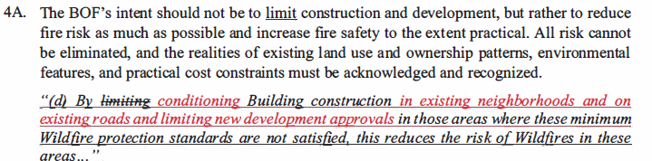
Board response: The Board is no longer proposing to adopt this section, consistent with the narrowed scope of the proposed action as identified within the Supplemental Statement of Reasons published with the “Second 15-Day Notice of Addition of Documents and Information to Rulemaking File and Modified Text” on May 10, 2022. The comment is not specifically directed at the Board’s proposed action or to the procedures followed by the Board in proposing the action.

Rule text edit: No

Comment W36-3: Town of Mammoth Lakes

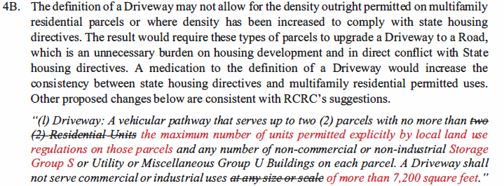
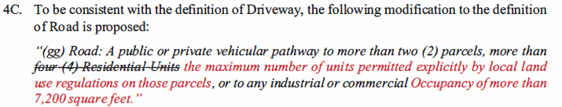
Board response: Please see response to W30-7.

Rule text edit: No

Comment W36-4: Town of Mammoth Lakes

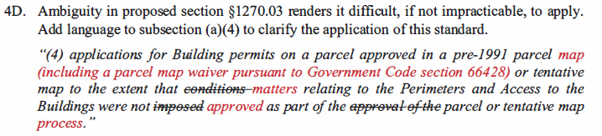
Board response: The Board is not proposing changes to this section, consistent with the narrowed scope of the proposed action as identified within the Supplemental Statement of Reasons published with the “Second 15-Day Notice of Addition of Documents and Information to Rulemaking File and Modified Text” on May 10, 2022. The comment is not specifically directed at the Board’s proposed action or to the procedures followed by the Board in proposing the action.

Rule text edit: No

Comment W36-5: Town of Mammoth Lakes
4E. The regulations will exacerbate climate change impacts by imposing requirements that promote low density, dispersed development patterns on large-lot, rural parcels outside of community areas, thereby increasing the need for vehicle travel. Vehicle-miles traveled ("VMT") is one of the primary contributors to greenhouse gas emissions in Mono County. The Governor has signed several state policies urging state agencies to consider the climate change impacts of VMT. For example, in the Governor's Executive Order N-19-19, section 2.b directs the State Transportation Agency to "[r]educe vehicle miles traveled by strategically directing discretionary transportation investments in support of housing production near available jobs and in accordance with the state's smart growth principles." The proposed regulations do not account for their impact on development patterns that increase VMT in rural counties like Mono.

Board response: The comment is not specifically directed at the Board’s proposed action or to the procedures followed by the Board in proposing the action.

Rule text edit: No

Comment W37-1: Monterey County Board of Supervisors
The first three paragraphs and last paragraph of this letter are introductory/conclusive in nature; the comments are not specifically directed at the Board’s proposed action or to the procedures followed by the Board in proposing the action.

We provide the following specific comments on the draft regulations:

Regulatory Package-County of Monterey staff have participated in RCRC's thorough review of the draft and the County generally supports RCRC's suggestions to clarify the draft regulations and make them more workable for local governments to apply. We are providing a summary of some of our larger concerns in this letter:

Article 1-the regulations should have an effective date that provides time for applicants to design their projects to the new regulations once approved in final form.

Definitions-we suggested modifications to many definitions and added definitions for a few key words used in the regulations, including a definition for Inspection Entity.

Section 1270.06-the regulations should recognize feasibility and property rights in the exception process. We have recommended changes to include consideration of these topics into the draft regulations.

Board response: Please see response to W30.

Rule text edit: No

Comment W37-2: Monterey County Board of Supervisors
The suggested changes in paragraphs 8-14 of this letter are limited in scope to Articles 2-4 of the regulations. The Board is no longer proposing to revise Articles 2-4, consistent with the narrowed scope of the proposed action as identified within the Supplemental Statement of Reasons published with the “Second 15-Day Notice of Addition of Documents and Information to Rulemaking File and Modified Text” on May 10, 2022. The comment is not specifically directed at the Board’s proposed action or to the procedures followed by the Board in proposing the action.

Comment W37-3: Monterey County Board of Supervisors
We also have identified that these regulations would result in physical changes to the environment and may have a significant effect on the environment. For example, the regulations may lead to additional road construction with its attendant potential environmental impacts. Accordingly, the BOF should prepare an Initial Study under the California Environmental Quality Act to analyze the potential environmental impacts of the proposed regulations and determine if the regulations can qualify for a Negative Declaration or would require preparation of an Environmental Impact Report.
We ask that the regulations be modified to reflect the comments received from the counties that will need to implement these regulations on a daily basis. Another round of public review should be provided for revisions to these important regulations.

Board response: Please see General CEQA Response

Rule text edit: No

Comment W38-1: Tulare County Board of Supervisors
The first four paragraphs and last paragraph of this letter are introductory/conclusive in nature; the comments are not specifically directed at the Board’s proposed action or to the procedures followed by the Board in proposing the action.

Comment W38-2: Tulare County Board of Supervisors
(d) Building: Any Structure used or intended for supporting or sheltering any use or Occupancy, except those classified as Storage Group S or Utility and Miscellaneous Group U Occupancy.

Board response: Where the Board intends to exemption Storage Group S occupancies from these regulations, it does so (1276.02(c)(2)). To exempt Storage Group S from the definition of “building” would change the application of these regulations, and the Board is no longer proposing those changes, consistent with the narrowed scope of the proposed action as identified within the Supplemental Statement of Reasons published with the “Second 15-Day Notice of Addition of Documents and Information to Rulemaking File and Modified Text” on May 10, 2022. The comment is not specifically directed at the Board’s proposed action or to the procedures followed by the Board in proposing the action.

Rule text edit: No

Comment W38-3: Tulare County Board of Supervisors
(f) Clear Width: A horizontal area free of vegetation, debris, fences, or other materials that may impede traffic flow; this area may include flexible posts or barriers that bend upon vehicular impact and rebound to their original position.
Board response: Please see response to W30-4.

Rule text edit: No

Comment W38-4: Tulare County Board of Supervisors
(j) Development: As defined in section 66418.1 of the California Government Code. “Development” does not include facilities owned or operated by state or local public agencies, except for Residential Units.

Board response: Please see response to W30-6

Rule text edit: No

Comment W38-5: Tulare County Board of Supervisors
(l) Driveway: A vehicular pathway that serves up to two (2) parcels with no more than two (2) Residential Units each, not including accessory or junior accessory dwelling units exempt pursuant to 1270.03(d) (Scope – Exemptions – ADUs), and any number of non-commercial or non-industrial Storage Group S or Utility or Miscellaneous Group U Buildings on each parcel. A Driveway shall not serve commercial or industrial uses of more than 7,200 square feet.at any size or scale.

Board response: Please see response to W30-7

Rule text edit: No

Comment W38-6: Tulare County Board of Supervisors
(m) Exception: An alternative means or method to achieve Substantial Compliance with a specified standard requested by the applicant subject to § 1270.06 (Exceptions to Standards).

Board response: Please see response to W30-8

Rule text edit: No

Comment W38-7: Tulare County Board of Supervisors
( ) Feasible: Capable of being accomplished in a successful manner within a reasonable period of
time, taking into account economic, environmental, legal, and technological factors.

Board response: Please see response to W30-9

Rule text edit: No

Comment W38-8: Tulare County Board of Supervisors
(s) Greenbelts: Agricultural lands, open space, parks, wildlands, or a combination thereof, as designated by Local Jurisdictions, which are in, surround or are near areas subject to these regulations that may function as Fuel Breaks or are adjacent to a city or urbanized area, and where Development is restricted or prohibited.adjacent to a city or urbanized area, and restrict or prohibit Development.
Board response: Please see response to W30-10.

Rule text edit: No

Comment W38-9: Tulare County Board of Supervisors
(_) Inspection Entity: The public official or agency responsible for determining whether a proposed Building construction or Development complies with the standards in the State Minimum Fire Safe Regulations.

Board response: Please see response to W30-11.

Rule text edit: No

Comment W38-10: Tulare County Board of Supervisors
(w) Local Jurisdiction: Any The county, city, city/county agency or department, or any locally authorized district that has authority to approve Building construction within a geographic areaapproves or has the authority to regulate Development.

Board response: Please see response to W30-12

Rule text edit: No

Comment W38-11: Tulare County Board of Supervisors
(x) Local Responsibility Area (LRA): Those areas of land outside a State Responsibility Area and where prevention and fire suppression is not primarily the responsibility of a federal agency pursuant to Public Resources Code (PRC) section 4125not classified by the Board where the financial responsibility of preventing and suppressing Wildfires is that of the state or federal government, pursuant to Public Resources Code (PRC) section 4125.

Board response: Please see response to W30-13

Rule text edit: No

Comment W38-12: Tulare County Board of Supervisors
( ) Looped Road: Roads that loop back upon themselves. A road that has two or more points of connection onto a through road is not a Looped Road.

Board response: Please see response to W30-14

Rule text edit: No

Comment W38-13: Tulare County Board of Supervisors
( ) New: Newly constructed or approved after the effective date of the regulations adopting this subdivision.

Board response: Please see response to W30-15

Rule text edit: No

Comment W38-14: Tulare County Board of Supervisors
(cc) One-way Road: A Road that provides a minimum of one Traffic Lane width designed for traffic flow in one direction only.

Board response: Please see response to W30-16.

Rule text edit: No

Comment W38-15: Tulare County Board of Supervisors
( ) Outdoor Recreation: Activities and non-residential uses compatible with the natural
environment, including passive parks, campgrounds, picnic areas, ranger outposts, trails and trail heads and related parking, public restrooms, visitor centers, signage, kiosks, and information booths.

Board response: Please see response to W30-17

Rule text edit: No

Comment W38-16: Tulare County Board of Supervisors
(dd) Perimeter: The boundary of an individual parcel of landand/or the boundary of a tentative and final or parcel map, pursuant to Government Code § 66411, within which lies any Building construction, or in the case of a subdivision approval, the boundary of the approved tentative or parcel map, pursuant to Government Code § 66411.

Board response: Please see response to W30-18

Rule text edit: No

Comment W38-17: Tulare County Board of Supervisors
(gg) Road: A public or private vehicular pathway to more than two (2) parcels, each of which contains any Structure, more than four (4) Residential Units, not including accessory or junior accessory dwelling units exempt pursuant to § 1270.03(d) (Scope – Exemptions – ADUs), or to any industrial or commercial Occupancy of more than 7,200 square feet..

Board response: Please see response to W30-19

Rule text edit: No

Comment W38-18: Tulare County Board of Supervisors
(kk) Structure: That which is built or constructed, a Building of any kind, or any piece of work artificially built up or composed of parts joined together in some definite manner for which the California Building Code requires a permit for construction.

Board response: Please see response to W30-20

Rule text edit: No

Comment W38-19: Tulare County Board of Supervisors
( ) Storage Group S: A Structure used for non-hazardous storage, permitted, constructed, equipped, and maintained to conform to the requirements of Title 24, California Building Standards Code.

Board response: Please see response to W30-21

Rule text edit: No

Comment W38-20: Tulare County Board of Supervisors
(ll) Substantial Compliance or Substantially Comply: Satisfaction of the purpose of the minimum standards even though the formal requirements are not satisfied.Nearly complete satisfaction of all material requirements consistent with the purpose of the applicable State Minimum Fire Safe Regulations even though the formal requirements are not satisfied. Where a specific code standard from the California Fire Code or National Fire Protection Association (NFPA) is referenced in this Article, any sections of the California Fire Code or NFPA standards regarding alternative methods of compliance, equivalencies, or modifications to the specified standards shall constitute substantial compliance with the applicable State Minimum Fire Safe Regulations.

Board response: Please see response to W30-22

Rule text edit: No

Comment W38-21: Tulare County Board of Supervisors
(oo) Turnaround: A portion of a Road or Driveway, unobstructed by parking, which allows for a safe opposite change of direction for Fire Apparatus. Design of such area may be a hammerhead/T or terminus bulb or as approved by the Local Jurisdiction.

Board response: Please see response to W30-23

Rule text edit: No

Comment W38-22: Tulare County Board of Supervisors
§ 1270.02. Purpose.
(a) These regulations have been prepared and adopted for the purpose of establishing state minimum Wildfire protection standards in conjunction with Building construction and Development in the State Responsibility Area (SRA) and, after July 1, 2021, the Very High Fire Hazard Severity Zones, as defined in Government Code § 51177(i) (VHFHSZ). These regulations shall not apply to any Building construction or Development that occurred or received a discretionary approval or building permit from a local jurisdiction prior to the effective date of the applicable regulation(s).

(b) Building construction in the SRA and, after July 1, 2021, the VHFHSZ shall provide for minimum Wildfire protection in accordance with the standards as specified in the following articles.
(d) By limiting Building construction in those areas where these minimum Wildfire protection standards are not satisfied, this reduces the risk of Wildfires in these areas, which among other things protects the health, safety and welfare of residents, and protects natural resources and the environment.

Board response: Please see responses to W30-24 through W30-26

Rule text edit: No

Comment W38-23: Tulare County Board of Supervisors
§ 1270.03. Scope.
These regulations shall apply to:
(1) The Perimeters and Access to all residential, commercial, and industrial Building construction within the SRA approved after January 1, 1991 within the SRA, and those approved after July 1, 2021 within the VHFHSZ, except as set forth below in subsections (b), (c), (d), and (e) through (g) below.
(3) all tentative and parcel maps or other Developments within the SRA approved after January 1, 1991, and within the VHFHSZ approved after July 1, 2021; and
(4) applications for Building permits on a parcel approved in a pre-1991 parcel map (including a parcel map waiver pursuant to Government Code section 66428) or tentative map to the extent that conditions matters relating to the Perimeters and Access to the Buildings were not approved imposed as part of the approval of the parcel or tentative map process.

Board response: Please see response to W30-27

Rule text edit: No

Comment W38-23: Tulare County Board of Supervisors
(b) These regulations do not apply where an application for a Building permit in the SRA is filed after January 1, 1991 for Development or Building construction on a parcel that was formed from a parcel map (including a parcel map waiver pursuant to Government Code section 66428) or tentative map (if the final map for the tentative map is approved within the time prescribed by the local ordinance) approved prior to January 1, 1991, to the extent that conditions matters relating to the Perimeters and Access to the Buildings were imposed approved by as part of the parcel map or final tentative map approved prior to January 1, 1991process.

(1) For this exemption to apply, the parcel map or tentative map that was approved prior to January 1, 1991, shall have imposed conditions or otherwise regulated the design and improvement of the subdivision relating to the Perimeters and Access to the Building construction that is the subject of the Building permit application filed after January 1, 1991.
(2) These regulations shall apply to the Building construction to the extent that conditions matters relating to the Perimeters and Access to the Buildings were not imposed approved as part of the approval of the parcel map or tentative map process.
( ) These regulations do not apply to Development of one new Structure of 1,000 square feet or less or one addition to an existing Structure totaling 1,000 square feet or less that is developed on a parcel after July 1, 2021. This exemption is limited to either one new Structure or addition to an existing Structure per parcel regardless of whether the entire 1,000 square feet is used, and only applies to parcels that were already developed with at least one legal Structure before July 1, 2021.upon which any Building was lawfully constructed before July 1, 2021.

Board response: Please see response to W30-28

Rule text edit: No

Comment W38-24: Tulare County Board of Supervisors
(c) At the discretion of the Local Jurisdiction, and subject to any requirements imposed by the Local Jurisdiction to ensure reasonable ingress, egress, and capacity for evacuation and emergency response during a Wildfire, these regulations shall not apply to the reconstruction or repair of a Building due to a disaster or other causeWildfire, subject to the following:
(1) this exemption shall not apply if the reconstruction or repair encroaches on the minimum setback requirements in § 1276.01 Building and Parcel Siting and Setbacks, unless a reduction in the minimum setback is approved by the inspection entity pursuant to § 1276.01(b);
(2) this exemption shall not apply if the reconstruction or repair changes the use of the Building or Buildings that had existed previously; and
(3) nothing in this subsection shall be construed to alter the extent to which these

regulations apply to the reconstruction or repair of a Building for reasons unrelated to a Wildfire; and

Board response: Please see response to W30-29

Rule text edit: No

Comment W38-25: Tulare County Board of Supervisors
(e) These regulations shall not apply to Greenbelts, Greenways, Roads or parcels used solely for Agriculture, mining, or the management of timberland and harvesting of forest products, or Outdoor Recreation on lands owned or leased by state or local public agencies.

( ) These regulations shall not apply where application of the regulations would take or damage private property for public use, without the payment of just compensation therefor, under the Constitution of the State of California or the United States.

Board response: Please see response to W30-30

Rule text edit: No

Comment W38-26: Tulare County Board of Supervisors
1270.04 Local Regulations.
(b) A lLocal regulations equals or exceeds a minimum standard of this Subchapter only if, at a minimum, the local regulations, as a whole, also fully compliesSubstantially Comply with the corresponding minimum standards in this Subchapter.
(d) A Local Jurisdiction or Fire Authority may notify the Board upon its commencement of any revisions to relevant local regulations. The Board may provide technical assistance to the requesting agency during the revision drafting process.

(g) Notwithstanding a local regulation that equals or exceeds the State Minimum Fire Safe Regulations,The Local Jurisdiction or Fire Authority shall require Building construction shall to comply with the State Minimum Fire Safe Regulations in accordance with the provisions of this Subchapter.

Board response: Please see response to W30-31

Rule text edit: No

Comment W38-27: Tulare County Board of Supervisors
1270.05. Inspections.
(f) Inspections conducted by the Director shall be limited to confirming compliance with the State Minimum Fire Safe Regulations. Inspections conducted by the Local Jurisdiction or Fire Authority shall confirm compliance with the State Minimum Fire Safe Regulations. A Local Jurisdiction may, in its discretion, conduct additional inspections with respect to a local regulation that equals or exceeds the State Minimum Fire Safe Regulations.
(g) The Local Jurisdiction shall ensure require that any applicable Building construction
complies with the applicable sections of this Subchapter.

Board response: Please see response to W30-32

Rule text edit: No

Comment W38-28: Tulare County Board of Supervisors
1270.06. Exceptions to Standards.
(a) The requirements in this section apply to requests for Exceptions from the standards in the State Minimum Fire Safe Regulations. Requests for exceptions, variances, or other administrative relief from a local regulation that equals or exceeds the State Minimum Fire Safe Regulations shall be processed in accordance with procedures established by the Local Jurisdiction.
(1) Exceptions shall only be granted where the Exception provides for Substantial Compliance with the minimum standards provided in this Subchapter, or to the limited extent that application of a particular standard or standards in this Subchapter are not Feasible.
(c) Requests for an Exception shall be made in writing to the inspection entity by the applicant or the applicant's authorized representative.

(1) Exception requests shall state:
- the specific section(s) for which an Exception is requested;

- material facts supporting the necessity for an Exception;

(iii) material facts demonstrating the proposed alternative mean(s) Substantially Complies with the State Minimum Fire Safe Regulation for which the Exception is requested, or that compliance with the particular regulation(s) for which the Exception is requested is not Feasible; and
- Exception decisions may be appealed. The Local Jurisdiction may establish or utilize an appeal process consistent with existing local Building or planning department appeal processes.
  - In addition to local requirements, the Local Jurisdiction shall consult with the inspection entity prior to making a determination on an appeal.
  - The inspection entity shall timely provide documentation demonstrating how theexplaining its conclusion that the requested Exception does or does not substantially Substantially comply Comply with the standards in this Subchapter or that application of a particular standard or standards in this Subchapter is or is not Feasible.

(e) If an appeal is granted, the Local Jurisdiction shall make written findings of the Exception’s Substantial Compliance, as defined § 1270.01 (Definitions), with the minimum standards in this Subchapter, or that application of the minimum standards is not Feasible, supported by Substantial Evidence.
Board response: Please see response to W30-33

Rule text edit: No

Comment W38-28: Tulare County Board of Supervisors
This letter contains specific suggestions on pp.19-49 that are limited in scope to Articles 2-4 of the regulations. The Board is no longer proposing to revise Articles 2-4, consistent with the narrowed scope of the proposed action as identified within the Supplemental Statement of Reasons published with the “Second 15-Day Notice of Addition of Documents and Information to Rulemaking File and Modified Text” on May 10, 2022. The comment is not specifically directed at the Board’s proposed action or to the procedures followed by the Board in proposing the action.

Comment W38-29: Tulare County Board of Supervisors
§ 1276.03. Fuel Breaks
(a) When Building construction meets the following criteriacriteria of §1270.00(c), the Local Jurisdiction shall determine the need and location for Fuel Breaks in consultation with the Fire Authority:.
(1) the permitting or approval of three (3) or more new parcels, excluding lot line adjustments as
specified in Government Code (GC) section 66412(d); or

(2) an application for a change of zoning increasing zoning intensity or density; or
(3) an application for a change in use permit increasing use intensity or density.

(f) Fuel Breaks constructed pursuant to this section shall have, at a minimum, one point of entry for fire fighters and any Fire Apparatus. The specific number of entry points and entry requirements shall be determined by the Local Jurisdiction in consultation with the Fire Authority.
(g) A Fuel Break directly adjacent to a new or Existing Road may be considered Substantial
Compliance with standards set forth in Article 2 where the Local Jurisdiction determines that the Fuel Break increases access for emergency wildland fire equipment, furthers safe civilian evacuation, and contains fuel modification sufficient for civilian and fire fighter safety.

Board response: Please see response to W30-36

Rule text edit: No

Comment W39-1: East Bay Regional Parks District
The first three paragraphs and last paragraph of this letter are introductory/conclusive in nature; t the comments are not specifically directed at the Board’s proposed action or to the procedures followed by the Board in proposing the action.

EBRPD’s main concern with the Regulations is the potential to create an unintended and undue burden on taxpayer funded public open space. Approximately sixty percent of EBRPD parkland falls within areas designated as State Responsibility Areas (SRAs) or Local Responsibility Area Very High Fire Severity Zone (LRA VHFSZ). A substantial portion of existing and potential future EBRPD structures would fall under the purview of the Regulations as currently drafted. However, park facilities are inherently different from private development. Park buildings, restrooms, vendor stands, picnic areas and shade structures are spread throughout what is usually a large parcel of land, and most of our high occupancy buildings are already served by existing paved roads accessible to emergency vehicles. As written, the Regulations may require intensive upgrades to more remote park infrastructure, which by definition sees substantially less public and employee use. EBRPD’s review of the Regulations found other areas of concern including:

Definitions: The current definitions in the Regulations should be clarified to avoid unintended negative impacts to many of EBRPD’s parklands. For example, the term “building construction” should be defined to specify that it does not include reconstruction or renovation of existing non-residential buildings. Also, the application of the Regulations to unpaved roads should be clarified. Many of the EBRPD’s trails are former dirt ranch roads and are regularly used by staff vehicles. The replacement and/or renovation of existing non-residential buildings in SRA and LRA VHFSZ areas could necessitate the improvement of 26.5 miles of paved road and 119 miles of unpaved roads, an infeasible upgrade, and may not meet the intent of the Regulations especially on unpaved roads in remote areas where there is low-intensity use. EBRPD recommends an express exemption for open space should be established, similar to the current exemption for agriculture, mining and timberland. At a minimum, clarification of the definitions, including Building, Development and Roads, needs to be made in order to clarify the intent and scope of these Regulations.

Board response: The Board is no longer proposing the defined term “building construction,” consistent with the narrowed scope of the proposed action as identified within the Supplemental Statement of Reasons published with the “Second 15-Day Notice of Addition of Documents and Information to Rulemaking File and Modified Text” on May 10, 2022. The comment is not specifically directed at the Board’s proposed action or to the procedures followed by the Board in proposing the action. The scope of the proposed action does not include exempting activities from being subject to the regulations. The comment is outside the scope of the proposed action.

Rule text edit: No

Comment W39-2: East Bay Regional Parks District
Interpretation of the Regulations: The enforcement of these Regulations will be at the local building department level, with plan review and building permits issued by local jurisdictions’ Planning and Building departments. As noted earlier, EBRPD falls within 37 different jurisdictions. Each one may interpret these Regulations differently. For example, while EBRPD would classify the majority of our structures as Utility and Miscellaneous Group U, when applying for building permits that classification may not be consistently applied across jurisdictions. Additionally, the Regulations give each local jurisdiction the ability to adopt more stringent regulations. Being required to comply with potentially 37 different sets of regulations would create significant hardship and could conflict with EBRPD’s statutory charge to manage and operate open space.

Board response: The comment is not specifically directed at the Board’s proposed action or to the procedures followed by the Board in proposing the action.

Rule text edit: No

Comment W39-3: East Bay Regional Parks District
Impacts to Natural and Cultural Resources: Road width requirements on existing roads, including the requirement to establish secondary access roads, could expose EBRPD to liability under the Federal Endangered Species Act, the California Endangered Species Act, the Clean Water Act, CEQA and other environmental laws. Additionally, these requirements would be contrary to the agency’s mission of preserving open space for public enjoyment and the protection of animals and
plants, endangered or not, who make the East Bay their home.

Board response: Please see General CEQA Response

Rule text edit: No

Comment W39-4: East Bay Regional Parks District
EBRPD supports the intention and spirit of the Regulations. We work daily to reduce the risk of wildfire. EBRPD’s 125,000 acres and the nature of parkland construction projects make it fundamentally different from housing, commercial or industrial development. Open space agencies require a different set of regulations to ensure taxpayer funded resources are spent wisely. Public open space agencies should be exempted from the Regulations. It is EBRPD’s preference the exemption be added directly under section § 1270.3. Alternatively, we request it be made clear in the text that the Regulations only apply to traditional development projects and not smaller scale park projects on large land parcels.

Board response: The scope of the proposed action does not include exempting activities from being subject to the regulations. The comment is outside the scope of the proposed action.

Rule text edit: No

Comment W40-1: Del Norte County Board of Supervisors
The first and last paragraphs of this letter are introductory/conclusive in nature; the comments are not specifically directed at the Board’s proposed action or to the procedures followed by the Board in proposing the action.

The draft regulations provide no grace period or guidance for projects that are currently in the review process. For clarity, we recommend that the requirements apply to projects submitted on or after that date. Many applications already being processed have been designed based upon the current standards. Requiring changes during-mid review would be an additional burden to property owners.

Board response: The Board is no longer proposing changes to the requirements in Articles 2-4, consistent with the narrowed scope of the proposed action as identified within the Supplemental Statement of Reasons published with the “Second 15-Day Notice of Addition of Documents and Information to Rulemaking File and Modified Text” on May 10, 2022. The comment is not specifically directed at the Board’s proposed action or to the procedures followed by the Board in proposing the action.

Rule text edit: No

Comment W40-2: Del Norte County Board of Supervisors
The comments in paragraphs three and four of this letter are limited in scope to Articles 2-4 of the regulations. The Board is no longer proposing to revise Articles 2-4, consistent with the narrowed scope of the proposed action as identified within the Supplemental Statement of Reasons published with the “Second 15-Day Notice of Addition of Documents and Information to Rulemaking File and Modified Text” on May 10, 2022. The comment is not specifically directed at the Board’s proposed action or to the procedures followed by the Board in proposing the action.

Comment W40-3: Del Norte County Board of Supervisors
As pointed out in Del Norte County's previous comments, having adequate land available for housing is a top mandate from another state regulatory agency that must be met. Our County does not have a sufficient dataset of road conditions, including road widths, to determine what impacts the regulations will have on infill development which is the primary current means for meeting our regional housing needs. This is a grave concern to Del Norte County as over 80% of our land is in public ownership. A significant share of the remaining land is either timberland, agricultural, or sensitive habitat areas unsuitable for development. The inclusion of more commonly used metrics with average daily trips, vehicle density per mile or vehicle miles travelled would help us evaluate the impacts if we are going to meet the needs of our community and other State mandates.
In addition to the potential loss of developable land, the implementation of the regulations will make it more costly to develop when local jurisdictions are being tasked with finding solutions to the housing crisis. The proposed regulations would summarily deem many miles of existing public roads throughout the state in noncompliance and would require immense, costly upgrades as a condition of building or rebuilding a single residential unit - at the property owner's expense. Even more onerous - and often infeasible - improvement requirements would apply to the creation of even a single new parcel, no matter how large, or any change to a use permit or zoning, no matter how minor. Such requirements will certainly affect the state's ability to address the housing crisis, especially in more rural, less economically advantaged parts of California. County staff have not been able to estimate the number of housing units these regulations will affect - but it will unquestionably be large, given that these restrictions apply to an area containing approximately one-quarter of California's housing stock.
Del Norte County is rich in natural resources. We are concerned about the environmental impacts of changing the width or grade of a road that have not been considered during the BOF's process. Additionally, even if upgrading a road is feasible and not environmentally damaging, the costs are extraordinary and unreasonable for a small business or property owner to bear. BOF staff has repeatedly stated that the full impacts of the regulations are unknown, and that additional information is needed, but the process has been nonetheless rushed forward. There is clearly a need to broaden the drafting discussion to include the full range of subject matter experts with "on-the­ground" experience in local land use planning and administration throughout California. It is critical if rural Del Norte can meet the ever-growing demand housing.

Board response: The Board is no longer proposing changes to the road requirements, consistent with the narrowed scope of the proposed action as identified within the Supplemental Statement of Reasons published with the “Second 15-Day Notice of Addition of Documents and Information to Rulemaking File and Modified Text” on May 10, 2022. The comment is not specifically directed at the Board’s proposed action or to the procedures followed by the Board in proposing the action.

Rule text edit: No

Comment W41-1: Siskiyou County Board of Supervisors
The first four paragraphs of this letter are introductory/conclusive in nature; the comments are not specifically directed at the Board’s proposed action or to the procedures followed by the Board in proposing the action.

Comment W41-2: Siskiyou County Board of Supervisors
Siskiyou County has the following top level concerns with the regulations:
• The proposed "existing roads" provisions would create no build zones in areas served by dirt roads, or roads less than 14-feet wide or having over 25 percent grade.
• Even modest residential lot splits (three or more parcels, for example) or business expansion would trigger requirements to bring potentially miles of public roads and bridges fully up to current standards, at the landowner's expense.
• The asserted "exemptions" for wildfire rebuilds and accessory dwelling units are unclear. While certain provisions of the regulations purport to exempt these buildings from the regulations, other provisions appear to override or limit those exemptions and impose substantial burdens on these homeowners.
• Such exemptions - to the extent they work at all - are overly narrow. The rebuild exemption covers only structures lost due to wildfire, and consequently owners whose homes or businesses were lost due to other causes (e.g., flood, mudslide, house fire, etc.) would be subject to the full suite of requirements. In addition, even some wildfire rebuilds would not be exempt if they could not meet the setback requirements - as is the case on many smaller lots.
• The Board of Forestry has failed to evaluate the economic or environmental impacts of these proposals, as required by state law. The Administrative Procedures Act (APA) requires administrative agencies to prepare an economic impact assessment of proposed regulations, including consideration of the effect of the proposed regulatory action on
Housing costs (Government Code Sections 11346.2(b)(2) -(5), 11346.3, 11346.5(a)(7) -(12)). According to the proposed rules, the proposed action "Does not impact housing cost" and, "will not have a significant adverse economic impact directly affecting business."
Board response: Please see response to W35

Rule text edit: No

Comment W42-3: City of Grass Valley Community Development Department
The City of Grass Valley has significant concerns with the proposed regulations and respectfully request the Board reconsider the standards in areas previously subject to Local Responsibility Areas. The primary area of concern is the 30' building setback from all property lines. The typical building setback for most cities range from 5' to 20'. These issues are particularly challenging for historical communities like the City of Grass Valley. Though there are some exceptions to the setbacks, the regulations would result in additional standards that will increase the costs of housing and development. Further, the proposed regulations create an additional bureaucratic step, which may create delays and impose additional costs for developers of much-needed housing. All development in the City must already meet standards set in the California Building Code, including the California Fire Code. The proposed Fire Safe Regulations will require City staff and residents to apply additional standards for development in affected areas.
Ultimately, these standards are an example of another contradictory state regulation that will have a direct impact on the cost of affordable housing and will negatively impact economic development efforts for many cities. This further conflicts with the City's Housing Element, and the Governor' s and state legislative efforts that are strongly emphasizing the need for more affordable housing. It is perplexing that the state fails to understand the cumulative effects of all the state regulations the past 15 years that relate to the construction of housing and the incremental costs this creates on affordability. This lack of understanding that each regulation has a direct impact to construction costs of housing and is frustrating efforts to build affordable housing.
Board response: Please see response to W32-7

Rule text edit: No

Comment W43-1: Placer County Board of Supervisors
The first two paragraphs of this letter are introductory/conclusive in nature; the comments are not specifically directed at the Board’s proposed action or to the procedures followed by the Board in proposing the action.
The proposed regulations would summarily deem many miles of existing public roads throughout the state "substandard,' and would require immensely costly upgrades as a condition of building or rebuilding a single residential unit at the property owner's expense.
Even more onerous and often infeasible improvement requirements would apply to the creation of even a single new parcel, no matter how large, or any change to a use permit or zoning, no matter how minor. Such requirements will certainly affect the state's ability to address the housing crisis, especially in more rural, less economically advantaged parts of California. It is not known the number of housing units these regulations would prevent or render unaffordable but it will unquestionably be large, given that these restrictions apply to an area containing approximately one quarter of California's housing stock.
In addition to the effects on housing, the proposed regulations would apply the same restrictions and improvement requirements to any business that proposes to increase service capacity, such as adding an outside seating area to accommodate social distancing requirements. This will seriously threaten many of the remaining small businesses that have been struggling to survive during the pandemic and will harm any prospect of business growth in large swaths of the state.

More broadly, this regulatory proposal ignores the realities on the ground. There are unacknowledged environmental impacts of changing the width or grade of a road that have not been meaningfully considered at any point during BOF's process. Additionally, even if upgrading a road is feasible and not environmentally damaging, the costs are extraordinary and unreasonable for a small business or property owner to bear.
BOF staff have repeatedly stated that the full impacts of the regulations are unknown, and that additional information is needed. There is clearly a need to broaden the drafting discussion to include the full range of subject matter experts with "on-the-ground" experience in local land use planning and administration.
Numerous representatives of local governments, local fire officials, and statewide associations have all called on the BOF Board to slow the process down and engage in meaningful stakeholder conversations before moving forward. We hope the BOF considers moving forward in this manner.
The proposed changes to the Fire Safe Regulations are lengthy, complex, and far reaching, yet the BOF Board is poised to decide on a proposal that was first released in draft form December 1, 2020. Placer County strongly urges the BOF take the necessary time to truly partner with local governments and allow a robust discussion with all interested parties on possible revisions to the fire safe standards in the future. Please do not hesitate to contact us if the County can assist you in any way with this important effort.

Board response: The Board is no longer proposing changes to the road standards, consistent with the narrowed scope of the proposed action as identified within the Supplemental Statement of Reasons published with the “Second 15-Day Notice of Addition of Documents and Information to Rulemaking File and Modified Text” on May 10, 2022. The comment is not specifically directed at the Board’s proposed action or to the procedures followed by the Board in proposing the action.

Please also see response to W180.

Rule text edit: No

Comment W44-1: Placer County Community Development Resource Agency
The first six paragraphs and last paragraph of this letter are introductory/conclusive in nature; the comments are not specifically directed at the Board’s proposed action or to the procedures followed by the Board in proposing the action.

We respectfully ask that the following specific comments be considered and addressed:
1. The definition of Dead-end Road states, “A Road that has only one point of vehicular ingress/egress, including cul-de-sacs and looped Roads.” This definition is vague and open to various interpretations since many subdivisions have only one point of ingress/egress from a collector but have a series of local roads that branch off one ingress/egress point. The definition should be clarified to allow the measurement of a dead-end road to take the shortest path from any through roads, including collector and local roads, when measuring the length.

Board response: The requirements for measuring the length of a dead-end road are found in § 1273.08. The Board is no longer proposing changes to that section, consistent with the narrowed scope of the proposed action as identified within the Supplemental Statement of Reasons published with the “Second 15-Day Notice of Addition of Documents and Information to Rulemaking File and Modified Text” on May 10, 2022. The comment is not specifically directed at the Board’s proposed action or to the procedures followed by the Board in proposing the action.

Rule text edit: No

Comment W44-2: Placer County Community Development Resource Agency
2. The definition of Residential Unit should be modified. As written, it currently states: “Manufactured homes, mobile homes, and factory-built housing are considered residential units, unless being sited or installed as an accessory or junior accessory dwelling unit in accordance with § 1270.03(d) (Scope – Exemptions – ADUs).” Although the intent was likely to exclude accessory or junior accessory dwelling units (A/JADUs) within this definition, as written it may have unintended consequences unless the A/JADUs are manufactured, mobile, and factory-built homes. Section 65852.2 of the Government Code does not differentiate and the California Health and Safety Code (HSC), Section 65583(c)(7), requires that cities and counties develop a plan that incentivizes and promotes the creation of A/JADUs that can be offered at affordable rent for very low to moderate-income households. The current Residential Unit definition as written essentially defines “affordable” as only manufactured, mobile, or factory built. Since we know that will not always be the case, please revise the definition of Residential Unit to also exclude all ADUs and JADUs that are built from the ground up, or “stick built,” are also excluded from the definition.

Board response: The regulatory exemption for wildfire rebuilds was a previous emergency regulatory action and is outside the scope of the proposed action. Please see General Response to Exceptions and Exemptions Comments. The comment is not specifically directed at the Board’s proposed action or to the procedures followed by the Board in proposing the action.

Rule text edit: No

Comment W44-3: Placer County Community Development Resource Agency
The specific comments in this letter labeled 3 – 8 are limited in scope to Articles 2-4 of the regulations. The Board is no longer proposing to revise Articles 2-4, consistent with the narrowed scope of the proposed action as identified within the Supplemental Statement of Reasons published with the “Second 15-Day Notice of Addition of Documents and Information to Rulemaking File and Modified Text” on May 10, 2022. The comment is not specifically directed at the Board’s proposed action or to the procedures followed by the Board in proposing the action.

Comment W44-4: Placer County Community Development Resource Agency
Placer County has recently developed a list of potential wildfire strategies that can be found in the Placer County Sustainability Plan which is available online here: Microsoft Word - PCSP- ADOPTION-DRAFT_clean.docx (ca.gov).
Chapter 5 Building Resiliency, Wildfire (WF), contains the following relevant WF strategies:

- Strategy WF-5: Provide multiple points of ingress and egress to improve evacuation and emergency response access.
- Strategy WF-7: Provide fire-safe improvements including hardening of the home, installation of sprinklers, and fire-safe exterior materials.
- Strategy WF-9: Coordinate with the Placer County Fire Safe Alliance and local Fire Safe Councils to join the Placer County Fire-wise Communities program
Strategies such as these that provide alternative mitigation should be acknowledged as allowable substitutes for otherwise expensive and infeasible road and access improvements.

Board response: The comment is not specifically directed at the Board’s proposed action or to the procedures followed by the Board in proposing the action.

Rule text edit: No

Comment W45-1: Mono County Board of Supervisors
The first six and last three paragraphs of this letter are introductory/conclusive in nature; the comments are not specifically directed at the Board’s proposed action or to the procedures followed by the Board in proposing the action.

The specific comments in this letter labeled 1 – 2B, 2D – 2E, and all of Section 4 are limited in scope to Articles 2-4 of the regulations. The Board is no longer proposing to revise Articles 2-4, consistent with the narrowed scope of the proposed action as identified within the Supplemental Statement of Reasons published with the “Second 15-Day Notice of Addition of Documents and Information to Rulemaking File and Modified Text” on May 10, 2022. The comment is not specifically directed at the Board’s proposed action or to the procedures followed by the Board in proposing the action.

Comment W45-2: Mono County Board of Supervisors
If the BOF rejects eliminating §1273.00(d) and §1273.12(b), then the County advocates for the following:
2C. Add a new section to §1270.03 “Scope” exempting scenarios where application of the MFSR standards would result in a taking.
“(g) These regulations shall not apply where application of the regulations would result in a taking or damage private property for public use, without the payment of just compensation therefor under the Constitution of the State of California or the United States.”5
⁵ Aligns with language suggested by RCRC.

Board response: The commenter has provided no judicial determination as to the unconstitutionality of PRC § 4290, the existing Fire Safe Regulations, or the proposed rulemaking language, and the Board is unaware of any. The proposed language regarding constitutional matters is outside the scope of the Board’s authority and is not necessary or appropriate to effectuate the purpose of the statute. Please see General Response to Constitutionality Comment.

Rule text edit: No

Comment W45-3: Mono County Board of Supervisors
The comments in paragraphs 1-5 of Section II of this letter are general in nature or unnecessarily redundant and are followed by more specific comments in subsequent paragraphs.

Suggested Solutions
3A. A one-size-fits-all approach does not work; additional flexibility needs to be
built into the minimum setback requirements. Recognize that past land divisions have created existing parcel patterns and ownership that have practical implications on the ability to increase setbacks. Reinstate the setback standards prior to the September 6, 2019, update to the MSFR which applied 30’ setbacks only to parcels one-acre or greater in size. Even these prior setback standards, which acknowledged the realities of smaller parcels, resulted in challenges and
constraints within Mono County communities.
3B. Add an administrative variance procedure that allows local land use jurisdictions to reduce setbacks for parcels constrained by size, dimensions, or landforms or other environmental factors to the minimum permitted by local zoning codes provided one or more of the criteria in §1276.01(b) are met.
3C. In §1276.01(b)(4), define measures that exceed the requirements in the California Building Code, California Code of Regulations Title 24, Part 2, Chapter 7A for WUI standards.
If the BOF rejects reinstating the previous standards, then the County suggests retaining points B and C above in addition to the following:
3D. Add specified timeframes to §1270.06 “Exceptions to Standards” within which the inspection authority must respond to a request for an exception, otherwise the exception is deemed granted. To be consistent with ministerial building permit plan checks timeframes in Mono County, the deemed granted timeframe should be less than 30 days. Longer timeframes have the potential to delay ministerial building permit processing.
“§1270.06(d) Approvals or denials of an exception request shall be made in writing to the applicant or the applicant’s authorized representative within 30 days of the postal or electronic mailing date. If the exception is denied, the written response shall state the basis for denial. If no response is provided, the exception is deemed approved upon expiration of the 30-day response period.”
3E. A transition period in alignment with the adoption date of the 2021 MFSRs is needed to ensure a smooth transition for projects currently being processed and those that are currently in the design phase. The County suggests that the MFSRs should apply to new proposals submitted after the approval date of the 2021 MFSRs, to allow projects with applications submitted prior to the approval date to proceed unencumbered by the new regulations.
3F. The 30-foot setbacks should not apply to wildfire rebuilds in subdivisions created before these regulations were adopted (i.e., subdivisions created prior to 2020/2021) to enable homeless and displaced residents to shelter their families as quickly as possible and avoid other social and mental health crises that may otherwise result. Mono County provides for wildfire rebuilds and nonconforming structures to be rebuilt as they were originally permitted, provided the nonconformity is not increased or exacerbated.
Modify §1270.03(c)(1) to allow for a non-conforming structure exemption for rebuilds.
“§1270.03(d)(1) [formerly 1270.03(c)(1), renumbered with edits] At the discretion of the Local Jurisdiction, and subject to any requirements imposed by the Local Jurisdiction to ensure reasonable ingress, egress, and capacity for evacuation and emergency response during a Wildfire, these regulations shall not apply to the reconstruction or repair of a Building due to a Wildfiredisaster or other cause, subject to the following:
  - this exemption shall not apply if the reconstruction or repair footprint is altered or expanded from the original structure such that encroachment encroaches on the minimum setback requirements in § 1276.01 Building and Parcel Siting and Setbacks is increased;
  - this exemption shall not apply if the reconstruction or repair changes the lawful use of the Building or Buildings that had existed previously immediately preceding the disaster or other cause;”
3G. Adopt the proposed definition for “Inspection Entity,” to prevent delays in the processing and approval of the limited development still permitted under the proposed standards.
( ) Inspection Entity: The public official or agency responsible for determining whether a proposed Building construction or Development project complies with the standards in the State Minimum Fire Safe Regulations.7
⁷ Aligns with the definition suggested by CSC and RCRC.

5. Miscellaneous Comments & Suggested Solutions
5A. The BOF’s intent should not be to limit construction and development, but
rather to reduce fire risk as much as possible and increase fire safety to the extent practical. All risk cannot be eliminated, and the realities of existing land use and ownership patterns, environmental features, and practical cost constraints must be acknowledged and recognized.
“(d) By limiting conditioning Building construction in existing neighborhoods and on existing roads and limiting new development approvals in those areas where these minimum Wildfire protection standards are not satisfied, this reduces the risk of Wildfires in these areas…”
5B. The definition of a Driveway may not allow for the density outright permitted on multifamily residential parcels or where density has been increased to comply with state housing directives. The result would require these types of parcels to upgrade a Driveway to a Road, which is an unnecessary burden on housing development and in direct conflict with State housing directives. A modification to the definition of a Driveway would increase the consistency between state housing directives and multifamily residential permitted uses. Other proposed changes below are consistent with RCRC’s suggestions.
“(l) Driveway: A vehicular pathway that serves up to two (2) parcels with no more than two (2) Residential Units the maximum number of units permitted explicitly by local land use regulations on those parcels and any number of non- commercial or non-industrial Storage Group S or Utility or Miscellaneous Group U Buildings on each parcel. A Driveway shall not serve commercial or industrial uses at any size or scale of more than 7,200 square feet.”\

5C. To be consistent with the definition of Driveway, the following modification to
the definition of Road is proposed:
“(gg) Road: A public or private vehicular pathway to more than two (2) parcels, more than four (4) Residential Units the maximum number of units permitted explicitly by local land use regulations on those parcels, or to any industrial or commercial Occupancy of more than 7,200 square feet.”9
5D. Ambiguity in proposed section §1270.03 renders it difficult, if not impracticable, to apply. Add language to subsection (a)(4) to clarify the application of this standard.
“(4) applications for Building permits on a parcel approved in a pre-1991 parcel map (including a parcel map waiver pursuant to Government Code section 66428) or tentative map to the extent that conditions matters relating to the Perimeters and Access to the Buildings were not imposed approved as part of the approval of the parcel or tentative map process.”10
⁹ Partially aligns with language suggested by RCRC.
¹⁰ Aligns with language suggested by RCRC.

Board response: Please see responses to W28 and W30.

Rule text edit: No

Comment W45-4: Mono County Board of Supervisors
In addition, the County is concerned that the proposed MFSRs, particularly those mentioned above, could have the following effects, all of which could be alleviated by the suggestions already provided:
- The ripple effect of reduced revenue on already struggling special districts due to reduced development and population base could result in bankruptcy, eliminating the ability to provide services such as fire protection. The irony is that these special districts are in our higher density community areas where increased development is appropriate and encouraged, but also the most likely to be impacted by the setback and road requirements, as opposed to large, rural lots on well and septic systems.
- The demise of local fire districts would impair fire response, not enhance it. Nearly all fire districts are run by volunteers in Mono County and have extremely limited funding and staffing capacity.
- Where it is even feasible, upgrading roads to new standards may result in unknown environmental impacts to special status species, wetlands, riparian areas, geologic hazards, tribal cultural resources, and other sensitive resources that may have been avoided by the original construction design.
- The regulations will result in significant new expectations of CAL FIRE. Mono County already struggles to extract timely responses from CAL FIRE in response to development proposals, including ministerial building permits. We have received responses from CAL FIRE staff that their expertise lies in fighting wildland fires, not evaluating proposed development projects for compliance with fire safe standards. The regulations as proposed will raise a constant barrage of questions about how to interpret and approve standards, and CAL FIRE must have the staff, capacity, training, and willingness to respond in a timely manner otherwise the entire regulatory system falls apart.

• The regulations will exacerbate climate change impacts by imposing requirements that promote low density, dispersed development patterns on large-lot, rural parcels outside of community areas, thereby increasing the need for vehicle travel. Vehicle-miles traveled (“VMT”) is one of the primary contributors to greenhouse gas emissions in Mono County. The Governor has signed several state policies urging state agencies to consider the climate change impacts of VMT. For example, in the Governor’s Executive Order N-19-19, section 2.b. directs the State Transportation Agency to “[r]educe vehicle miles traveled by strategically directing discretionary transportation investments in support of housing production near available jobs and in accordance with the state’s smart growth principles.” The proposed regulations do not account for their impact on development patterns that increase VMT in rural counties like Mono.
• The same smart growth principles referenced in Executive Order N-19-19 are thwarted by the proposed regulations. By imposing requirements that result in more dispersed development patterns and encouraging development away from existing job centers, it is increasingly difficult to meet the housing needed to support the work force in Mono County. In particular, regulations that impose a de facto moratorium on development within Mono County’s limited development areas exacerbate an already very strained housing market and the ability to increase housing stock for lower-income workers. These regulations will prevent Mono County from working towards a balance between availability and location of jobs and housing.

Board response: The comment is not specifically directed at the Board’s proposed action or to the procedures followed by the Board in proposing the action.

Rule text edit: No

Comment W45-5: Mono County Board of Supervisors
III. Cooperation and Collaboration Between Jurisdictions
This regulatory system is a cooperative effort between the BOF, CAL FIRE staff, and local governments with the common goal of protecting our communities from fire hazards. In the spirit of improving that cooperation, the County raises the following points in the hopes that the BOF will seriously consider the input by Mono County, RCRC, and other local jurisdictions, all of whom are directly affected by the practical consequences of these proposed regulations:
- Leaving unaddressed the presumably unintended consequences and state-level policy conflicts being raised by local jurisdictions is not a good faith effort.
- Rapid and reactionary policymaking in response to recent wildfires that fail to appropriately weigh the costs and implications of those regulatory changes is unwise and results in unintended consequences. Reactionary policy making, as opposed to a deliberative and thoughtful process that incorporates local government comments about practical impacts, is simply poor governance.
- Despite a significant number of thoughtful comments from counties/ local jurisdictions to date in this process, recent drafts have reflected only minor technical updates and have not addressed repeated concerns or proposed language edits. This undermines the public process of engagement and participation with the goal of improving the proposed language and final regulations.
- Suggested Solution: Consider the input from local jurisdictions and RCRC and make changes where warranted and recognize the practicalities of existing development patterns and environmental constraints. Take the time to craft thoughtful policy and regulatory solutions to enhance community fire safety with meaningful input from local jurisdictions.

Attachment 1: Transcript of Mono County’s verbal comments at March 22 Board of Forestry and Fire Protection meeting

Board response: Please see response W180-1. These attachments are not specifically directed at the Board’s proposed action or to the procedures followed by the Board in proposing the action.

Rule text edit: No

Comment W45-6: Mono County Board of Supervisors
Attachment 2: Mono County’s Redline Edits to the Proposed 2021 MSFR
The first seven paragraphs of this attachment are introductory/conclusive in nature; the comments are not specifically directed at the Board’s proposed action or to the procedures followed by the Board in proposing the action.

(d) Building: Any Structure used or intended for supporting or sheltering any use or Occupancy, except those classified as Utility and Miscellaneous Group U Occupancy.1
¹ Aligns with language suggested by the County of Santa Clara (“CSC”).

Board response: Where the Board intends to exemption Storage Group S occupancies from these regulations, it does so (1276.02(c)(2)). To exempt Storage Group S from the definition of “building” would change the application of these regulations, and the Board is no longer proposing those changes, consistent with the narrowed scope of the proposed action as identified within the Supplemental Statement of Reasons published with the “Second 15-Day Notice of Addition of Documents and Information to Rulemaking File and Modified Text” on May 10, 2022. The comment is not specifically directed at the Board’s proposed action or to the procedures followed by the Board in proposing the action.

Rule text edit: No

Comment W45-7: Mono County Board of Supervisors
(f) Clear Width: A horizontal area free of vegetation, debris, fences, or other materials that may impede traffic flow; this area may include flexible posts or barriers that bend upon vehicular
impact and rebound to their original position.2
² Aligns with language suggested by CSC and partially aligns with language suggested by Rural County Representatives of California (“RCRC”) (draft as of June 16, 2021).

Board response: Please see response to W23(b)-3

Rule text edit: No

Comment W45-8: Mono County Board of Supervisors
(j) Development: As defined in section 66418.1 of the California Government Code A subdivision of land, or the use or development of land for which the California Building Code requires a permit for construction. Does not include facilities owned or operated by state or local public agencies except for Residential Units.³
³ Aligns with language suggested by CSC.

Board response: Please see response to W23(b)-4

Rule text edit: No

Comment W45-9: Mono County Board of Supervisors
(l) Driveway: A vehicular pathway that serves up to two (2) parcels with no more than two (2) Residential Units the maximum number of units permitted outright by local land use regulations on those parcels and any number of non-commercial or non-industrial Storage Group S or Utility or Miscellaneous Group U Buildings on each parcel. A Driveway shall not serve commercial or industrial uses at any size or scale of more than 7,200 square feet.⁴
⁴ Partially aligns with language suggested by RCRC. Mono County suggested the language regarding “the maximum number of units permitted outright by local land use regulations on those parcels.”

Board response: Please see response to W28 and W30.

Rule text edit: No

Comment W45-10: Mono County Board of Supervisors
(m) Exception: An alternative means or method to achieve Substantial Compliance with a specified standard requested by the applicant in accordance with § 1270.06 (Exceptions to Standards).5
⁵ Aligns with language suggested by RCRC.
Board response: Please see response to W30-8

Rule text edit: No

Comment W45-11: Mono County Board of Supervisors
(_) Feasible: Capable of being accomplished in a successful manner within a reasonable period of time, taking into account economic, environmental, legal, and technological factors.⁶
⁶ Aligns with language suggested by CSC and RCRC.
Board response: Please see response to W30-9

Rule text edit: No

Comment W45-12: Mono County Board of Supervisors
(p) Fire Authority: CAL FIRE or any other A fire department, agency, division, district, or other governmental body responsible for regulating and/or enforcing minimum fire safety standards.

Board response: Please see response to W23(b)-6

Rule text edit: No

Comment W45-13: Mono County Board of Supervisors
(s) Greenbelts: Agricultural lands, open space, parks, wildlands, or a combination thereof, as designated by Local Jurisdictions, which surround or are adjacent near areas subject to these regulations that may function as Fuel Breaks. to a city or urbanized area, and restrict or prohibit Development.

Board response: Please see response to W23(b)-7.

Rule text edit: No

Comment W45-14: Mono County Board of Supervisors
(_) Inspection Entity: The public official or agency responsible for determining whether a proposed Building construction or Development project complies with the standards in the State Minimum Fire Safe Regulations.7
⁷ Aligns with language suggested by CSC and RCRC.

Board response: Please see response to W23(b)-8

Rule text edit: No

Comment W45-15: Mono County Board of Supervisors
(w) Local Jurisdiction: AnyThe county, city, city/county agency or department, or any locally

authorized district that has the authority to regulate Development approve Building construction within a geographic areaapproves or has the authority to regulate Development.8
⁸ Aligns with language suggested by RCRC.

Board response: Please see response to W30-12

Rule text edit: No

Comment W45-16: Mono County Board of Supervisors
(x) Local Responsibility Area (LRA): Those areas of land outside a State Responsibility Area and where prevention and fire suppression is not primarily the responsibility of a federal agency not classified by the Board where the financial responsibility of preventing and suppressing Wildfires is that of the state or federal government, pursuant to Public Resources Code (PRC) section 4125. ⁹
⁹ Aligns with language suggested by CSC and RCRC.

Board response: Please see response to W30-13

Rule text edit: No

Comment W45-17: Mono County Board of Supervisors
( ) New: Newly constructed or approved after the effective date of the regulations adopting this subdivision. ¹⁰
¹⁰ Aligns with language suggested by RCRC.
Board response: Please see response to W30-15

Rule text edit: No

Comment W45-18: Mono County Board of Supervisors
(bb) Occupancy: The purpose for which a Building, or part thereof, is lawfully used or intended to be used incompliance with the California Building Code .¹¹
¹¹ Aligns with language suggested by CSC.

Board response: Please see response to W23(b)-10

Rule text edit: No

Comment W45-19: Mono County Board of Supervisors
(cc) One-way Road: A Road that provides a minimum of one Traffic Lane width designed for traffic flow in one direction only.¹²
¹² Aligns with language suggested by CSC and RCRC.

Board response: Please see response to W23(b)-11

Rule text edit: Yes

Comment W45-20: Mono County Board of Supervisors
( ) Outdoor Recreation: Activities and non-residential uses compatible with the natural environment, including passive parks, campgrounds, picnic areas, ranger outposts, trails and trail heads and related parking, public restrooms, visitor centers, signage, kiosks, and information booths.13
¹³ Aligns with language suggested by CSC and RCRC.
Board response: Please see response to W23(b)-12

Rule text edit: No

Comment W45-21: Mono County Board of Supervisors
(dd) Perimeter: The boundary of an individual parcel of land, and/or within which lies any Building Construction or in the case of subdivision approval, the boundary of the approved tentative and final or parcel map, pursuant to Government Code § 66411.¹⁴
¹⁴ Aligns with language suggested by RCRC.

Board response: Please see response to W23(b)-13

Rule text edit: No

Comment W45-22: Mono County Board of Supervisors
(ee) Residential Unit: Any lawfully constructed Building or portion thereof which contains living facilities, including provisions for sleeping, eating, cooking and/or sanitation for one or more persons. Manufactured homes, mobile homes, and factory-built housing are considered residential units, unless being sited or installed as an accessory or junior accessory dwelling unit
in accordance with § 1270.03(d) (Scope – Exemptions – ADUs).15

¹⁵ Aligns with language suggested by CSC.

Board response: Please see response to W18-12

Rule text edit: No

Comment W45-23: Mono County Board of Supervisors
(4) Residential Units the maximum number of units permitted outright by local land use regulations on those parcels, or to any industrial or commercial Occupancy of more than 7,200 square feet.16

¹⁶ Partially aligns with language suggested by RCRC. Mono County suggested the language regarding “the maximum number of units permitted outright by local land use regulations on those parcels.”

Board response: Please see response to W30.

Rule text edit: No

Comment W45-24: Mono County Board of Supervisors
(kk) Structure: That which is built or constructed, a Building of any kind, or any piece of work artificially built up or composed of parts joined together in some definite manner for which the California Building Code requires a permit for construction.17
¹⁷ Aligns with language suggested by CSC and RCRC.

Board response: Please see response to W23(b)-16

Rule text edit: No

Comment W45-25: Mono County Board of Supervisors
(ll) Substantial Compliance or Substantially Comply: Nearly complete satisfaction of all material requirements consistent with Satisfaction of the purpose of the applicable State Minimum Fire Safe Regulations minimum standards even though the formal requirements are not satisfied.Where a specific code standard from the California Fire Code or National Fire Protection Association (NFPA) is referenced in this Article, any sections of the California Fire Code or NFPA standards regarding alternative methods of compliance, equivalencies, or modifications to the specified standards shall constitute substantial compliance with the applicable State Minimum Fire Safe Regulations.18
¹⁸ Aligns with language suggested by RCRC.
Board response: Please see response to W23(b)-17

Rule text edit: No

Comment W45-26: Mono County Board of Supervisors
(oo) Turnaround: A portion of a Road or Driveway, unobstructed by parking, which allows for a safe opposite change of direction for Fire Apparatus. Design of such area may be a hammerhead/T or terminus bulb or as approved by the Local Jurisdiction.19
¹⁹ Partially aligns with language suggested by RCRC.

Board response: Please see response to W23(b)-18

Rule text edit: Yes

Comment W45-27: Mono County Board of Supervisors
§ 1270.02. Purpose.
(a) These regulations have been prepared and adopted for the purpose of establishing state minimum Wildfire protection standards in conjunction with Building construction and Development in the State Responsibility Area (SRA) and, after July 1, 2021, the Very High Fire Hazard Severity Zones, as defined in Government Code § 51177(i) (VHFHSZ). These regulations are shall not apply to any Building construction or Development that occurred or received a discretionary approval or building permit from a local jurisdiction prior to the effective date of the applicable regulation(s).
²⁰
²⁰ Aligns with language suggested by CSC and RCRC.

(b) Building construction in the SRA and, after July 1, 2021, the VHFHSZ shall provide for minimum Wildfire protection in accordance with the standards as specified in the following articles.21
²¹ Partially aligns with language suggested by RCRC.
(d) By limiting conditioning Building construction in existing neighborhoods and on existing roads and limiting new development approvals in those areas where these minimum Wildfire protection standards are not satisfied, this reduces the risk of Wildfires in these areas, which among other things protects the health, safety and welfare of residents, and protects natural resources and the environment.

Board response: The Board is no longer proposing these changes to this section, consistent with the narrowed scope of the proposed action as identified within the Supplemental Statement of Reasons published with the “Second 15-Day Notice of Addition of Documents and Information to Rulemaking File and Modified Text” on May 10, 2022.

Rule text edit: No

Comment W45-28: Mono County Board of Supervisors
§ 1270.03. Scope.
These regulations shall apply to:
  - the Perimeters and Access to all residential, commercial, and industrial Building construction within the SRA approved after January 1, 1991 and those approved after July 1, 2021 within the VHFHSZ, except as set forth below in subsections (b), (c), (d), and (e) through (g) below. ²²
²² Aligns with language suggested by CSC and partially aligns with language suggested by RCRC.
(3) all tentative and parcel maps or other Developments within the SRA approved after January 1, 1991, and within the VHFHSZ approved after July 1, 2021; and23
²³ Aligns with language suggested by CSC and RCRC.
(4) applications for Building permits on a parcel approved in a pre-1991 parcel map (including a parcel map waiver pursuant to Government Code section 66428) or tentative map to the extent that conditionsmatters relating to the Perimeters and Access to the Buildings were not imposedapproved as part of the approval of the parcel or tentative map process.24
24 Aligns with language suggested by RCRC.

Board response: See response to W30-27

Rule text edit: No

Comment W45-29: Mono County Board of Supervisors
(b) These regulations do not apply where an application for a Building permit in the SRA is filed after January 1, 1991 for Development or Building construction on a parcel that was formed from a parcel map (including a parcel map waiver pursuant to Government Code section 66428) or tentative map (if the final map for the tentative map is approved within the time prescribed by the local ordinance) approved prior to January 1, 1991, to the extent that conditions matters relating to the Perimeters and Access to the Buildings were imposed by approved as part of the parcel map or final tentative map process approved prior to January 1, 1991.25
²⁵ Aligns with language suggested by RCRC.
(1) For this exemption to apply, the parcel map or tentative map that was approved prior to January 1, 1991, shall have imposed conditions or otherwise regulated the design and improvement of the subdivision relating to the Perimeters and Access to the Building
construction that is the subject of the Building permit application filed after January 1, 1991.26
²⁶ Aligns with language suggested by RCRC.
(2) These regulations shall apply to the Building construction to the extent that conditions matters relating to the Perimeters and Access to the Buildings were not imposed approved as part of the approval of the parcel map or tentative map process.27
²⁷ Aligns with language suggested by RCRC.
(c) These regulations do not apply to Development of one new Structure of 1,000 square feet or less or one addition to an existing Structure totaling 1,000 square feet or less that is developed on a parcel after July 1, 2021. This exemption is limited to either one new Structure or addition to an existing Structure per parcel regardless of whether the entire 1,000 square feet is used, and only applies to parcels that were already developed with at least one legal structure before July 1, 2021.²⁸
²⁸ Aligns with language suggested by CSC and partially aligns with language suggested by RCRC.

Board response: See response to W30-28

Rule text edit: No

Comment W45-30: Mono County Board of Supervisors
(d) At the discretion of the Local Jurisdiction, and subject to any requirements imposed by the Local Jurisdiction to ensure reasonable ingress, egress, and capacity for evacuation and emergency response during a Wildfire, these regulations shall not apply to the reconstruction or repair of a Building due to a Wildfire disaster or other cause, subject to the following:29
(1) this exemption shall not apply if the reconstruction or repair footprint is altered or expanded from the original structure such that encroachment encroaches on the minimum setback requirements in § 1276.01 Building and Parcel Siting and Setbacks is increased;
(2) this exemption shall not apply if the reconstruction or repair changes the lawful use of the Building or Buildings that had existed previously immediately preceding the disaster, or other cause;
²⁹ Partially aligns with language suggested by RCRC.
(3) nothing in this subsection shall be construed to alter the extent to which these
regulations apply to the reconstruction or repair of a Building for reasons unrelated to a Wildfire;
and30
(4 3) nothing in this subsection shall be construed to alter the legal character of a
Building reconstructed or repaired pursuant to this exemption.
(d e) These regulations do not apply to the creation of accessory or junior accessory dwelling units that comply with Government Code sections 65852.2 or 65852.22, or any local ordinances enacted thereunder, as applicable, including any local ordinances requiring provisions for fire and life safety.

³⁰ Aligns with language suggested by RCRC.

Board response: See response to W30-29

Rule text edit: No

Comment W45-31: Mono County Board of Supervisors
(e f) These regulations shall not apply to Greenbelts, Greenways, Roads or parcels used solely for Agriculture, mining, or the management of timberland and harvesting of forest products, or Outdoor Recreation on lands owned or leased by state or local public agencies.31
(g) These regulations shall not apply where application of the regulations would result in a taking or damage private property for public use, without the payment of just compensation therefor under the Constitution of the State of California or the United States.32
³¹ Aligns with language suggested by CSC and RCRC.
³² Aligns with language suggested by RCRC.
Board response: See response to W30-30

Rule text edit: No

Comment W45-32: Mono County Board of Supervisors
(b) A local regulation Local regulation equals or exceeds a minimum standard of this Subchapter only if, at a minimum, the local regulation also fully complies regulation, as a whole, Substantially Complies with the corresponding minimum standards in this Subchapter.33

(c) A Local Jurisdiction shall not apply exemptions that are not enumerated in this Subchapter. Exceptions requested and approved in conformance with § 1270.06 (Exceptions to Standards) may be granted on a case-by-case basis.
(d) A Local Jurisdiction or Fire Authority may notify the Board upon its commencement of any revisions to relevant local regulations. The Board may provide technical assistance to the requesting agency during the revision drafting process.³⁴
³³ Aligns with language suggested by RCRC.
³⁴ Aligns with language suggested by RCRC.
(g) The Local Jurisdiction shall ensure require that any applicable Building construction complies with the applicable sections of this Subchapter.³⁵
³⁵Aligns with language suggested by RCRC.

Board response: See response to W30-31

Rule text edit: No

Comment W45-33: Mono County Board of Supervisors
§ 1270.06. Exceptions to Standards.
(a) The requirements in this section apply to requests for Exceptions from the standards in the State Minimum Fire Safe Regulations. Requests for exceptions, variances, or other administrative relief from a local regulation that equals or exceeds the State Minimum Fire Safe Regulations shall be processed in accordance with procedures established by the Local
Jurisdiction.36
(b) Upon request by the applicant, an Exception to a standards within this Subchapter may be granted by the inspection entity in accordance with § 1270.05 (Inspections).37
(1) Exceptions shall only be granted where the Exception provides for Substantial Compliance with the minimum standards provided in this Subchapter, or to the limited extent that application of a particular standard or standards in this Subchapter are not Feasible.38
(c) Requests for an Exception shall be made in writing to the inspection entity by the applicant or the applicant's authorized representative.

(1) Exception requests shall state
- the specific section(s) for which an Exception is requested;

- material facts supporting the necessity for an Exception;

- material facts demonstrating the proposed alternative mean(s) is in Substantially Complies with the State Minimum Fire Safe Regulation for which the Exception is requested or that compliance with the particular regulation(s) for which the
Exception is requested is not Feasible; and39
³⁶ Aligns with language suggested by RCRC.
³⁷ Partially aligns with language suggested by RCRC.
³⁸ Aligns with language suggested by CSC.
³⁹ Aligns with language suggested by CSC and RCRC.

(d) Approvals or denials of an exception request shall be made in writing to the applicant or the applicant’s authorized representative within 30 days of the postal or electronic mailing date. If the exception is denied, the written response shall state the basis for denial. If no response is provided, the exception is deemed approved upon expiration of the 30-day response period.
- Exception decisions may be appealed. The Local Jurisdiction may establish or utilize an appeal process consistent with existing local Building or planning department appeal processes.
(1) In addition to local requirements, the Local Jurisdiction shall consult with the inspection entity prior to making a determination on an appeal.
  - The Inspection Entity shall timely provide documentation demonstrating how explaining its conclusion that the requested Exception does or does not Substantially Comply with the standards in this Subchapter or is not Feasible.40
⁴⁰ Partially aligns with language suggested by RCRC.

Board response: See response to W30-33

Rule text edit: No

Comment W45-34: Mono County Board of Supervisors
This letter contains comments on pp.35-63 which are limited in scope to Articles 2-4 of the regulations. The Board is no longer proposing to revise Articles 2-4, consistent with the narrowed scope of the proposed action as identified within the Supplemental Statement of Reasons published with the “Second 15-Day Notice of Addition of Documents and Information to Rulemaking File and Modified Text” on May 10, 2022. The comment is not specifically directed at the Board’s proposed action or to the procedures followed by the Board in proposing the action.

Comment W45-35: Mono County Board of Supervisors
§ 1276.00. Applicability
(c) Any addition or modification to a lawfully constructed Residential Unit that existed on a parcel before July 1, 2021 that does not meet the requirements of § 1276.01 (Building and Parcel Siting and Setbacks) or § 1276.02(c) (Ridgelines) shall be limited to a cumulative 1,000 square feet after July 1, 2021, provided the addition or modification complies with the requirement in § 1276.01(b), where applicable.

Board response: The Board is not proposing changes to this section consistent with the narrowed scope of the proposed action as identified within the Supplemental Statement of Reasons published with the “Second 15-Day Notice of Addition of Documents and Information to Rulemaking File and Modified Text” on May 10, 2022. The comment is not specifically directed at the Board’s proposed action or to the procedures followed by the Board in proposing the action.

Rule text edit: No

Comment W45-36: Mono County Board of Supervisors
§ 1276.01. Building and Parcel Siting and Setbacks.
(a) Pertaining to all applications accepted for processing on or after July 1, 2021, Aall parcels 1 acre and larger shall provide a minimum thirty (30) foot setback for all new Buildings and additions to Existing Buildings from all property lines and/or the center of a Road, except as provided for in subsection (b) and § 1276.00(c). This requirement does not apply to Buildings and additions that are entirely below ground.67
(b) A reduction in the minimum setback shall be based upon practical reasons, which may include but are not limited to, parcel dimensions or size; topographic limitations; development density requirements or other development patterns that promote low-carbon emission outcomes; sensitive habitat; or other site constraints, subject to an administrative approval process defined by the local jurisdiction. and shall When a reduction in the minimum setback is approved, the Building construction shall to the extent Feasible reduce Structure-to-Structure ignition by incorporating features such as, but not limited to:68
⁶⁷ Aligns partially with suggested language from CSC and RCRC.
⁶⁸ Aligns partially with suggested language from RCRC. Mono County requests the addition of “subject to an administrative approval process defined by the local jurisdiction.”

(c) For any Building or Structure lawfully constructed before July 1, 2021 that lies within the thirty (30) foot setback, the footprint of the Building or Structure may be expanded within the setback area by a maximum of 1,000 cumulative square feet after July 1, 2021 provided the expansion would not result in further encroachment toward the Road.69
⁶⁹ Aligns with language suggested by CSC.

Board response: Please see responses to W23(b)-31 and 32.

Rule text edit: No

Comment W45-37: Mono County Board of Supervisors
1276.02. Ridgelines.
(c) New Buildings on Undeveloped Ridgelines identified as strategically important are prohibited unless such prohibition would take or damage private property for public use, without the payment of just compensation therefor, under the Constitution of the State of California or the United States. Nothing in this subsection shall be construed to alter the extent to which Structures or Development other than Buildings, such as but not limited to Utility and Miscellaneous Group U Structures, may be constructed on Undeveloped Ridgelines.70
⁷⁰ Partially aligns with language suggested by RCRC.

Board response: Please see response to W30-35.

Rule text edit: No

Comment W45-38: Mono County Board of Supervisors
§ 1276.03. Fuel Breaks
(a) When Building construction meets the following criteria, of § 1270.00(c), the Local
Jurisdiction shall determine the need and location for Fuel Breaks in consultation with the Fire Authority:.71
(1) the permitting or approval of three (3) or more new parcels, excluding lot line adjustments as specified in Government Code (GC) section 66412(d); or72
(2) an application for a change of zoning increasing zoning intensity or density; or73
(3) an application for a change in use permit increasing use intensity or density⁷⁴

⁷¹ Aligns with language suggested by RCRC.
⁷² Aligns with language suggested by RCRC.
⁷³ Aligns with language suggested by RCRC.
⁷⁴ Aligns with language suggested by RCRC.

(g) A Fuel Break directly adjacent to a new or Existing Road may be considered Substantial Compliance with standards set forth in Article 2 where the Local Jurisdiction determines that the Fuel Break increases access for emergency wildland fire equipment, furthers safe civilian evacuation, and contains fuel modification sufficient for civilian and fire fighter safety.75
⁷⁵ Aligns with language suggested by RCRC.

Board response: Please see response to W35-37.

Additionally, the Board is no longer proposing changes to the standards for roads, consistent with the narrowed scope of the proposed action as identified within the Supplemental Statement of Reasons published with the “Second 15-Day Notice of Addition of Documents and Information to Rulemaking File and Modified Text” on May 10, 2022. The comment is not specifically directed at the Board’s proposed action or to the procedures followed by the Board in proposing the action. Allowing a fuel break in lieu of meeting the road requirements is outside the scope of this proposed action.

Rule text edit: No

Comment W46-1: Plumas Association of Realtors
The Board of Directors of the Plumas Association of REAL TORS® supports the response to the proposed minimum Fire Safe regulations as presented by
Plumas County Supervisor Jeff Engel.
Engel's letter points out various conflicts with local land use regulations and
Plumas County's general plan. We appreciate his attention to what works for Plumas County.
We want to go on record as being in agreement with all of the issues addressed in Engel's response.

Board response: Please see responses to W32.

Rule text edit: No

Comment W47-1: California Fire Chiefs Association
The first two paragraphs of this letter are introductory/conclusive in nature; the comments are not specifically directed at the Board’s proposed action or to the procedures followed by the Board in proposing the action.

Section “A. Potential Impacts and General Comments” of this letter is general in nature; the comments are not specifically directed at the Board’s proposed action or to the procedures followed by the Board in proposing the action.

Comment W47-2: California Fire Chiefs Association

Section 1270.01 Definitions:
(b) Agriculture. The Board may want to consider adding City or County owned, State owned, University of California, California State University properties, and other that do not fall under the Local Jurisdiction’s zoning ordinances.

Board response: Changes to the definition of “agriculture” are outside the scope of this proposed rulemaking, consistent with the narrowed scope of the proposed action as identified within the Supplemental Statement of Reasons published with the “Second 15-Day Notice of Addition of Documents and Information to Rulemaking File and Modified Text” on May 10, 2022. The comment is not specifically directed at the Board’s proposed action or to the procedures followed by the Board in proposing the action.

Rule text edit: No

Comment W47-3: California Fire Chiefs Association
(d) Building. The definition contains exemptions for “Utility” and “Miscellaneous Group U”, these two terms are not defined and could be very large buildings as well as contain very large fuel loads. These general terms could open the door to unintended buildings being exempted or unintended consequences. Additionally, Group U occupancies are defined in both the California Fire Code and Buildings Code, suggest reference be made to the CCR, Title 24, Part 2 and Part 9.

Board response: The term “Utility and Miscellaneous Group U” is defined in 1270.01(jj)

Rule text edit: No

Comment W47-4: California Fire Chiefs Association
(f) Clear Width. The Board may want to consider other terrain obstructions in the definition (e.g. large rocks/boulders, hillside, cliff, etc.).

Board response: The board is no longer proposing a definition for “clear width,” consistent with the narrowed scope of the proposed action as identified within the Supplemental Statement of Reasons published with the “Second 15-Day Notice of Addition of Documents and Information to Rulemaking File and Modified Text” on May 10, 2022. The comment is not specifically directed at the Board’s proposed action or to the procedures followed by the Board in proposing the action.

Rule text edit: No

Comment W47-5: California Fire Chiefs Association
(l) Driveway. The proposed definition prohibits driveways from serving commercial buildings including those smaller buildings such as a 7/11, coffee shop, auto repair, etc. Provide clarification that it is the intent for all commercial buildings to be served by a local road or road as defined.

Board response: The existing definition of “road” states “Vehicular…access to any industrial or commercial occupancy.” (see 1271.00). The Board is not proposing to change that applicability. The comment is not specifically directed at the Board’s proposed action or to the procedures followed by the Board in proposing the action.

Rule text edit: No

Comment W45-6: California Fire Chiefs Association
(y) Local Road. Does this conflict with Road? why is this definition needed? This definition causes confusion with the defined term of Road. See additional comments for the proposed definition of
Driveway and Road.

Board response: The board is no longer proposing a definition for “local road,” consistent with the narrowed scope of the proposed action as identified within the Supplemental Statement of Reasons published with the “Second 15-Day Notice of Addition of Documents and Information to Rulemaking File and Modified Text” on May 10, 2022. The comment is not specifically directed at the Board’s proposed action or to the procedures followed by the Board in proposing the action.

Rule text edit: No

Comment W47-7: California Fire Chiefs Association
(z) Municipal-Type Water System. Although word for word from NFPA 1142, are there other standards that should be considered or referenced (e.g. the Ca. Public Utilities Commission (PUC) regulations, American Water Works Association (AWWA)).

Board response: The comment is not specifically directed at the Board’s proposed action or to the procedures followed by the Board in proposing the action.

Rule text edit: No

Comment W47-8: California Fire Chiefs Association
(ee) Residential Unit. This definition would exempt Accessory Dwelling Units (ADUs) that are conventionally constructed. The second sentence addresses ADUs specific to Manufactured Homes, Mobile homes, and Factory-built Homes. Additionally, the definition appears to include a detached game room, pool house, etc. that are not intended to be lived in as a residence, however, they are typically classified as a Group R occupancy in accordance with the California Building or Residential Code.

Board response: The regulatory exemption for ADUs was a previous emergency regulatory action and is outside the scope of the proposed action. Please see General Response to Exceptions and Exemptions Comments. Please see General Response to Exceptions and Exemptions Comments. Please see General Response to Exceptions and Exemptions Comments. The comment is not specifically directed at the Board’s proposed action or to the procedures followed by the Board in proposing the action.

Rule text edit: No

Comment W47-9: California Fire Chiefs Association
(gg) Road. Does this conflict with Local Road? This definition causes confusion with the defined term of Local Road. See additional comments for the proposed definition of Driveway and Road.

Board response: The board is no longer proposing a definition for “local road,” consistent with the narrowed scope of the proposed action as identified within the Supplemental Statement of Reasons published with the “Second 15-Day Notice of Addition of Documents and Information to Rulemaking File and Modified Text” on May 10, 2022. The comment is not specifically directed at the Board’s proposed action or to the procedures followed by the Board in proposing the action

Rule text edit: No

Comment W47-10: California Fire Chiefs Association
Section 1270.02 Purpose.
Subsection (a) establishes standards for the SRA, please provide clarification if these standards apply to the entire SRA or only the Moderate, High and Very High Fire Severity Zones. This has been the practice in the past regarding applying the current Fire Safe Regulations, however, there is nothing in the Fire Safe Regulations that specify such (example CCR, Title 24, Part 2 Chapter 7A and Part 9, Chapter 49 are scoped for SRA Moderate, High and Very High Fire Severity Zones).

Subsections (a) and (b) appear to require that these regulations apply in the SRA regardless of when the tentative map, parcel map, or building construction was approved or commenced. This comment relates to projects approved prior to January 1, 1991 and specifically those approved between January 1, 1991 and when the regulations are approved and become effective, as these projects were under a different standard.
It is not clear that these regulations are intended to be retroactive or not. Additionally, Section 1270.03(3) appears to make it clear that these regulations would apply even though the project was approved prior.

Furthermore, subsections (a), (b) have an effective date of July 1, 2021 that would create retroactive application of these regulations for building construction in the LRA. Projects that were either in the process of or were approved by the Local Jurisdiction/Fire Authority prior to the actual adoption by the Board, approved by the Office of Administrative Law, and in accordance with the California Administrative Procedures Act would now need to comply with these regulations.

Board response: The Board is not proposing changes to the applicability of these regulations, consistent with the narrowed scope of the proposed action as identified within the Supplemental Statement of Reasons published with the “Second 15-Day Notice of Addition of Documents and Information to Rulemaking File and Modified Text” on May 10, 2022. The comment is not specifically directed at the Board’s proposed action or to the procedures followed by the Board in proposing the action.

Rule text edit: No

Comment W47-11: California Fire Chiefs Association
Subsection (c) uses the term “private water supply” should this be revised to include “municipal water supply” or just the term “water supply” (striking out “private” as Section 1275.01 addresses all types of water supplies).

Board response: The Board is not proposing changes to the water supply requirements, consistent with the narrowed scope of the proposed action as identified within the Supplemental Statement of Reasons published with the “Second 15-Day Notice of Addition of Documents and Information to Rulemaking File and Modified Text” on May 10, 2022. The comment is not specifically directed at the Board’s proposed action or to the procedures followed by the Board in proposing the action.

Rule text edit: No

Comment W47-12: California Fire Chiefs Association
Section 1270.03 Scope.
Subsection (a):(1), (3) See comment to Section 1270.02 (a) and (b) regarding the proposed effective date of July 1, 2021.
Subsection (a):(3) and (4) appear to be applicable to both the SRA and the LRA, however, as stated in the 1270.02 Purpose, these regulations would not be applicable. We recommend clarifying these subsections to be specific to the SRA and create new subsections specific to the LRA with the applicable effective date. See additional comments made to 1270.02 regarding the effective dates for both the LRA and SRA.

Subsections (b), (b)(1), and (b)(2) should be made specific to the SRA. See comments made to Section 1270.02 (a) and (b) regarding the effective dates for both the LRA and SRA.

Subsection (c)(1) is inconsistent with current regulations, policy, or practicality for reconstruction or repair as well as reconstruction or repair of existing buildings due to flood, earthquake, other natural disasters, and building fire(s) not related to a wildland fire. Buildings that were once approved within a 30’ setback would not be able to reconstruct, specifically, in the LRA where the 30-foot setback requirement never applied as the Title 14 regulations were not applicable or clarify that “practical reasons” apply to reduce the minimum setback as permitted in Section 1276.01(b).

Subsection (c)(3) seems to be in conflict with property owner’s rights and possible California laws, please provide clarification where the Board authority resides for this retroactive application of these regulations and include within these regulations such reference for the Local Jurisdiction or Fire Authority to enforce. Without such reference or guidance enforcement of the Fire Safe Regulations will be unenforceable in many cases.

Board response: The Board is not proposing changes to this section, consistent with the narrowed scope of the proposed action as identified within the Supplemental Statement of Reasons published with the “Second 15-Day Notice of Addition of Documents and Information to Rulemaking File and Modified Text” on May 10, 2022. The comment is not specifically directed at the Board’s proposed action or to the procedures followed by the Board in proposing the action.

Rule text edit: No

Comment W47-13: California Fire Chiefs Association

Section 1270.04 Local Regulations.
Subsection (a) should be revised to provide clarification if these standards apply to the entire SRA or only the Moderate, High and Very High Fire Severity Zones. This has been the practice in the past regarding applying the current Fire Safe Regulations, however, there is nothing in the Fire Safe Regulations that specify such (example CCR, Title 24, Part 2 Chapter 7A and Part 9, Chapter 49 are scoped for SRA Moderate, High and Very High Fire Severity Zones). Additionally, it should also state “LRA” for the VHFHSZ to reduce confusion.

Subsection (c) should also include the Fire Authority not only the Local Jurisdiction to reduce confusion and conflict between the Local Jurisdiction and the Fire Authority. Additionally, see comments to Subsection 1270.06.

Subsections (d) through (f) should be removed from this rulemaking as they are not regulatory and only add confusion. These provisions would be better served by Board outreach through Board Policy, Information Bulletins, or CAL FIREs Land Use Planning Program, etc. Should these provisions become a mandatory proposal in the future additional comment would be provided at that time.

Subsection (g) has been stated in Section 1270.04(a) and is not necessary. If to be maintained, we recommend that (g) be included in (a).

Board response: The Board is no longer proposing these changes to 1270.04, consistent with the narrowed scope of the proposed action as identified within the Supplemental Statement of Reasons published with the “Second 15-Day Notice of Addition of Documents and Information to Rulemaking File and Modified Text” on May 10, 2022. The comment is not specifically directed at the Board’s proposed action or to the procedures followed by the Board in proposing the action.

Rule text edit: No

Comment W47-14: California Fire Chiefs Association
Section 1270.05 Inspections.
To reduce confusion as to who inspections are performed by or who enforces the Fire Safe Regulations, this entire Section and Subsections should be revised to be the Fire Authority not the Local Jurisdiction. If the intent is that the Local Jurisdiction is all encompassing and to determine specifically who enforces these regulations, there should be reference to the Fire Authority.
Typically, the Fire Authority is the inspection/enforcing entity, however, the newly proposed definition of Local Jurisdiction would remove the Fire Authority (this is a common theme throughout these proposed regulations, it is also commented on in our general comments and other sections in this proposed rulemaking). Additionally, as the majority of these regulations in the past as well as currently are enforced by the Fire Authority it should be made clear who takes lead. Also see
comments made to Section 1270.06.
Subsection (b) should be made specific to the SRA, as currently proposed it applies to all SRA and LRA.
Subsection (c) should be revised to be specific to the LRA VHFHSZ. Without including LRA it causes confusion for the SRA as to what applies in the Moderate or High Fire Hazard Severity Zones.
Subsection (f) should be made specific to the SRA, we are unaware of any statutory authority for the Director (as defined in these regulations) to have inspection authority in the LRA.
Subsection (g) has been stated in Section 1270.04(a) and is not necessary.

Board response: The Board is not proposing changes to this section, consistent with the narrowed scope of the proposed action as identified within the Supplemental Statement of Reasons published with the “Second 15-Day Notice of Addition of Documents and Information to Rulemaking File and Modified Text” on May 10, 2022. The comment is not specifically directed at the Board’s proposed action or to the procedures followed by the Board in proposing the action.

Rule text edit: No

Comment W47-15: California Fire Chiefs Association
Section 1270.06 Exception to Standards.
Please clarify throughout 1270.06 who or what the “Inspection Entity” is as this term is not defined, although referenced to be in accordance with Section 1270.05. Typically, the Fire Authority is the inspection/enforcing entity, however, the newly proposed definition of Local Jurisdiction would remove the Fire Authority (this is a common theme throughout these proposed regulations, it is also commented on in our general comments and other sections in this proposed rulemaking).
Additionally, as the majority of these regulations in the past, as well as currently are enforced by the Fire Authority it should be made clear who takes lead. Also see comments made to Section 1270.05.

Subsection (b)(2) includes an existing provision being carried forward for reporting exemptions to the Board and the Unit that administers the SRA fire protection. This Subsection should be revised in the beginning of it to be specific to exemptions granted in the SRA. As currently written, it appears that exemptions granted in the LRA would need to be forwarded as well. We are unaware of any statutory authority of the Board to require such reporting of exemptions in the LRA. Additionally, it is not clear as to the intent of such reporting exemptions in the SRA and recommend not maintaining this provision.

Subsection (c)(2) should be revised to Local Jurisdiction or Fire Authority. This change in terms of who further confuses these regulations, see additional comment s made to Subsections 1270.05 and 1270.06.
Subsection (d) and (d)(1) is to broad, it provides the Local Jurisdiction broad authority in areas where the Local Jurisdiction may be in conflict with the Fire Authority (e.g. firefighter safety, occupant safety, fire safety standards, wildland fire prevention standard, etc.). This Subsection should be revised to make clear that the Fire Authority is part of the appeals process. In addition, who is the “inspection entity” and why is consultation required?

Subsection (e) includes an existing provision being carried forward for reporting overriding exemption requests to the Board and the Unit that administers the SRA fire protection. This Subsection should be revised in the beginning of it to be specific to the SRA. As currently written, it appears that overriding exemptions in the LRA would need to be forwarded as well. We are unaware of any statutory authority of the Board to require such reporting of exemptions in the LRA. Additionally, it is not clear as to the intent of such reporting exemptions in the SRA and recommend not maintaining this provision.

Board response: The Board is not proposing changes to this section, consistent with the narrowed scope of the proposed action as identified within the Supplemental Statement of Reasons published with the “Second 15-Day Notice of Addition of Documents and Information to Rulemaking File and Modified Text” on May 10, 2022. The comment is not specifically directed at the Board’s proposed action or to the procedures followed by the Board in proposing the action.

Rule text edit: No

Comment W47-16: California Fire Chiefs Association
1270.07 Distance Measurements. It is not clear why this provision is being maintained as it conflicts with how measurements are made for determining the radius of curves, the distance from the property line to a building and other such horizontal measurements where on a hill or cliff.
However, measurements for the length of distance/travel (e.g. road, driveway, dead end road lengths when turnarounds, or turnouts) such definition may be necessary and should be located or specific to those conditions.

Board response: The Board is not proposing changes to this section, except to renumber it. The comment is not specifically directed at the Board’s proposed action or to the procedures followed by the Board in proposing the action.

Rule text edit: No

Comment W47-17: California Fire Chiefs Association
Section 1271.00 and 1272.00
It is recommended that a “Reserved” section be created for both 1271.00 and 1272.00 as these sections do not appear in the proposed regulations and lead to confusion (as if there is was something missing).

Board response: The comment is not specifically directed at the Board’s proposed action or to the procedures followed by the Board in proposing the action.

Rule text edit: No

Comment W47-18: California Fire Chiefs Association

This letter contains comments on pp.6-10 that are limited in scope to Articles 2-4 of the regulations. The Board is no longer proposing to revise Articles 2-4, consistent with the narrowed scope of the proposed action as identified within the Supplemental Statement of Reasons published with the “Second 15-Day Notice of Addition of Documents and Information to Rulemaking File and Modified Text” on May 10, 2022. The comment is not specifically directed at the Board’s proposed action or to the procedures followed by the Board in proposing the action.

Comment W47-19: California Fire Chiefs Association
Sections 1276.02 Ridgelines, 1276.03 Fuel Breaks, and 1276.05 Maintenance of Fuel Breaks, should all be revised where provisions that the Local Jurisdiction provides approval, it should be in consultation with the Fire Authority. We request that all locations in these Section be revised to include the addition of “…in consultation with the Fire Authority…”

Board response: In the 15 day notice of proposed rulemaking published on May 10, 2022, the Board proposes to add “in consultation with the Fire Authority” to 1276.03(a).

Rule text edit: Yes

Comment W48-1: Tuolumne County Farm Bureau
We would like to write this letter in support of the Tuolumne County Board of Supervisors comments on the Notice of Proposed Action “State Minimum Fire Safe Regulations, 2021.” The Tuolumne County Farm Bureau is a long standing organization in the county with many members. This proposed language could have severe ramifications for our members. We feel the Board of Supervisors addressed many of our concerns.

Please review the attached comments from the Tuolumne County Board of Supervisors. These comments reflect our views and concerns with the proposed language.

Attachment 1: Tuolumne County Board of Supervisors 45-day comment letter.

Board response: Please see responses to W28.

Comment W49-1: Mono County Local Transportation Commission
The first three and last three paragraphs of this letter are introductory/conclusive in nature; the comments are not specifically directed at the Board’s proposed action or to the procedures followed by the Board in proposing the action.

This letter contains comments on pp. 2-4 and 5-7 that are limited in scope to Articles 2-4 of the regulations. The Board is no longer proposing to revise Articles 2-4, consistent with the narrowed scope of the proposed action as identified within the Supplemental Statement of Reasons published with the “Second 15-Day Notice of Addition of Documents and Information to Rulemaking File and Modified Text” on May 10, 2022. The comment is not specifically directed at the Board’s proposed action or to the procedures followed by the Board in proposing the action.

Comment W49-2: Mono County Local Transportation Commission
If the BOF rejects eliminating §1273.00(d) and §1273.12(b), then the MCLTC advocates for the following:
2C. Add a new section to §1270.03 “Scope” exempting scenarios where application of the MFSR standards would result in a taking.
“(g) These regulations shall not apply where application of the regulations would result in a taking or damage private property for public use, without the payment of just compensation therefor under the Constitution of the State of California or the United States.”

Board response: The commenter has provided no judicial determination as to the unconstitutionality of PRC § 4290, the existing Fire Safe Regulations, or the proposed rulemaking language, and the Board is unaware of any. The proposed language regarding constitutional matters is outside the scope of the Board’s authority and is not necessary or appropriate to effectuate the purpose of the statute. Please see General Response to Constitutionality Comment.

Rule text edit: No

Comment W49-3: Mono County Local Transportation Commission
Miscellaneous Comments & Suggested Solutions
4A. The BOF’s intent should not be to limit construction and development, but rather to reduce fire risk as much as possible and increase fire safety to the extent practical. All risk cannot be eliminated, and the realities of existing land use and ownership patterns, environmental features, and practical cost constraints must be acknowledged and recognized.
“(d) By limiting conditioning Building construction in existing neighborhoods and on existing roads and limiting new development approvals in those areas where these minimum Wildfire protection standards are not satisfied, this
reduces the risk of Wildfires in these areas…”

Board response: The Board is no longer proposing to adopt this section, consistent with the narrowed scope of the proposed action as identified within the Supplemental Statement of Reasons published with the “Second 15-Day Notice of Addition of Documents and Information to Rulemaking File and Modified Text” on May 10, 2022. The comment is not specifically directed at the Board’s proposed action or to the procedures followed by the Board in proposing the action.

Rule text edit: No

Comment W49-4: Mono County Local Transportation Commission

4B. The definition of a Driveway may not allow for the density outright permitted on multifamily residential parcels or where density has been increased to comply with state housing directives. The result would require these types of parcels to upgrade a Driveway to a Road, which is an unnecessary burden on housing development and in direct conflict with State housing directives. A medication to the definition of a Driveway would increase the consistency between state housing directives and multifamily residential permitted uses. Other proposed changes below are consistent with RCRC’s suggestions.
“(l) Driveway: A vehicular pathway that serves up to two (2) parcels with no more than two (2) Residential Units the maximum number of units permitted explicitly by local land use regulations on those parcels and any number of non- commercial or non-industrial Storage Group S or Utility or Miscellaneous Group U Buildings on each parcel. A Driveway shall not serve commercial or industrial uses at any size or scale of more than 7,200 square feet.”

4C. To be consistent with the definition of Driveway, the following modification to
the definition of Road is proposed:

“(gg) Road: A public or private vehicular pathway to more than two (2)
parcels, more than four (4) Residential Units the maximum number of units permitted explicitly by local land use regulations on those parcels, or to any
industrial or commercial Occupancy of more than 7,200 square feet.”

Board response: Please see response to W28 and W30

Comment W49-5: Mono County Local Transportation Commission
4D. Ambiguity in proposed section §1270.03 renders it difficult, if not
impracticable, to apply. Add language to subsection (a)(4) to clarify the application of this standard.
“(4) applications for Building permits on a parcel approved in a pre-1991 parcel map (including a parcel map waiver pursuant to Government Code section 66428) or tentative map to the extent that conditions matters relating to the Perimeters and Access to the Buildings were not imposed approved as part
of the approval of the parcel or tentative map process.”

Board response: The Board is not proposing changes to this section, consistent with the narrowed scope of the proposed action as identified within the Supplemental Statement of Reasons published with the “Second 15-Day Notice of Addition of Documents and Information to Rulemaking File and Modified Text” on May 10, 2022. The comment is not specifically directed at the Board’s proposed action or to the procedures followed by the Board in proposing the action.

Rule text edit: No

Comment W49-6: Mono County Local Transportation Commission

4E. The regulations will exacerbate climate change impacts by imposing requirements that promote low density, dispersed development patterns on large-lot, rural parcels outside of community areas, thereby increasing the need for vehicle travel. Vehicle-miles traveled (“VMT”) is one of the primary contributors to greenhouse gas emissions in Mono County. The Governor has signed several state policies urging state agencies to consider the climate change impacts of VMT. For example, in the Governor’s Executive Order N-19-19, section 2.b directs the State Transportation Agency to “[r]educe vehicle miles traveled by strategically directing discretionary transportation investments in support of housing production near available jobs and in accordance with the state’s smart growth principles.” The proposed regulations do not account for their impact on development patterns that increase VMT in rural counties like Mono.

Board response: The comment is not specifically directed at the Board’s proposed action or to the procedures followed by the Board in proposing the action.

Rule text edit: No

Comment W50-1: California Cattlemen’s Association

The first paragraph of this letter is introductory/conclusive in nature; the comments are not specifically directed at the Board’s proposed action or to the procedures followed by the Board in proposing the action.

Comment W50-2: California Cattlemen’s Association
Nevertheless, CCA is concerned that the proposed revisions to the State Minimum Fire Safe Regulations are too inflexible to be workable in many communities, present an undue financial burden to landowners and local governments, and exacerbate existing challenges such as the state’s housing crisis. Consequently, CCA urges the Board not to move forward with the proposed amendments to the State Minimum Fire Safe Regulation and to instead collaborate with local leaders throughout the SRA and VHFHSZ to identify and craft regulatory solutions that are workable for local agencies and residents within those areas.

CCA has heard from numerous members – and even local government leaders – that the proposed amendments to the State Minimum Fire Safe Regulations would be completely unworkable in many rural areas. In many circumstances, the regulations would require costly improvements to be made not only for new roadways, but for existing roadways and even driveways, forcing landowners and local governments to incur significant costs. Additionally, the proposed amendments would establish onerous restrictions regarding the construction of new residences, businesses, and others structures – and in some rural areas these requirements would render vast areas of land entirely unbuildable. Moreover, as highlighted by the Sierra County Board of Supervisors, many roads, bridges, buildings and other structures within the SRA and VHFHSZ have historic significance, and many even appear on the National Register of Historic Places. The proposed amendments may necessitate improvements to developments which would jeopardize those structures’ historic significance.

The proposed amendments will in some circumstances price homeowners out of planned improvements. When homes are destroyed by wildfire (or other causes), the reconstruction requirements in the proposed amendments will in some cases prove prohibitively expensive, forcing homeowners out of the communities in which they have long lived. Moreover, additional costs associated with new construction and reconstruction will decrease housing availability and increase housing costs, exacerbating the state’s ongoing housing crisis.

CCA appreciates that much must be done to ensure that our communities – especially those within the SRA and VHFHSZ – are more resilient to the threats posed by California’s historic, catastrophic wildfires. However, those solutions must be practically and financially feasible for local governments and for landowners. Consequently, CCA urges the Board to reject the proposed amendments and to instead draft alternate Minimum Fire Safe Regulations in close collaboration with local governments.

Board response: The comment is not specifically directed at the Board’s proposed action or to the procedures followed by the Board in proposing the action.

Rule text edit: No

Comment W51-1: Ventura County Fire Protection District
The Ventura County Fire Protection District has reviewed the proposed draft State Minimum Fire Safe Regulations to be contained in Title 14 of the California Code of Regulations. Below are the Fire District’s comments/concerns.

1. Throughout the draft regulations authority appears to fall to the Local Jurisdiction, which as defined in the regulations, does not clearly include the local Fire Authority. The overall arching authority for enforcement of these regulations is unclear.

Board response: The Board is not proposing changes to the enforcement authorities related to these regulations, consistent with the narrowed scope of the proposed action as identified within the Supplemental Statement of Reasons published with the “Second 15-Day Notice of Addition of Documents and Information to Rulemaking File and Modified Text” on May 10, 2022. The comment is not specifically directed at the Board’s proposed action or to the procedures followed by the Board in proposing the action.

Rule text edit: No

Comment W51-2: Ventura County Fire Protection District
The remainder of the comments in this letter are limited in scope to Articles 2-4 of the regulations. The Board is no longer proposing to revise Articles 2-4, consistent with the narrowed scope of the proposed action as identified within the Supplemental Statement of Reasons published with the “Second 15-Day Notice of Addition of Documents and Information to Rulemaking File and Modified Text” on May 10, 2022. The comment is not specifically directed at the Board’s proposed action or to the procedures followed by the Board in proposing the action.

Comment W52-1: Nevada County Contractors Association
The first three paragraphs of this letter are introductory/conclusive in nature; the comments are not specifically directed at the Board’s proposed action or to the procedures followed by the Board in proposing the action.

We have the following specific concerns with the regulations:
Except where exempt, all new building construction must comply, and the proposed regulations would make many by‐right uses unable to proceed. What happens to those parcels that become unbuildable?

Taking away local discretion and flexibility
Local jurisdictions are responsible for implementing regulations and have the most experience in dealing with the interpretation of regulations in their areas and in coordination with other competing state and local regulations. Exemptions are allowed only when there is substantial compliance and must be filed with both the BOF and Cal Fire without clear understanding of the review or comment period or other requirements for this action. These requirements will have a significant impact on the length of time to process a building permit further exacerbating the cost and time to build much needed housing.

Fire Rebuilds
The asserted "exemptions" for wildfire rebuilds and accessory dwelling units are unclear. While certain provisions of the regulations purport to exempt these buildings from the regulations, other provisions appear to override or limit those exemptions and impose substantial burdens on these homeowners. Such exemptions – to the extent they work at all – are overly narrow. The rebuild exemption covers only structures lost due to wildfire, and consequently owners whose homes or businesses were lost due to other causes (e.g., flood, mudslide, house fire, etc.) would be subject to the full suite of requirements.

In addition, even some wildfire rebuilds would not be exempt if they could not meet the setback requirements – as is the case on many smaller lots. Many rebuilds are structures being built back on lots that either do not allow for this setback or the previous house footprint would not comply. Existing infrastructure is in place for the previous location and limits the
placement of the rebuild.

Board response: The regulatory exemption for wildfire rebuilds was a previous emergency regulatory action and is outside the scope of the proposed action. Please see General Response to Exceptions and Exemptions Comments. The comment is not specifically directed at the Board’s proposed action or to the procedures followed by the Board in proposing the action.

Rule text edit: No

Comment W52-2: Nevada County Contractors Association
This letter contains comments on pp.2-3 that are limited in scope to Articles 2-4 of the regulations. The Board is no longer proposing to revise Articles 2-4, consistent with the narrowed scope of the proposed action as identified within the Supplemental Statement of Reasons published with the “Second 15-Day Notice of Addition of Documents and Information to Rulemaking File and Modified Text” on May 10, 2022. The comment is not specifically directed at the Board’s proposed action or to the procedures followed by the Board in proposing the action.

Comment W52-3: Nevada County Contractors Association
Setbacks
All parcels shall have a minimum 30‐foot rear, side, and front yard setback; unless non‐ combustible walls, non‐ vegetated landscaping, and/or other fire hardening. The current language is vague and could result in delays in reviews and unclear direction to the public as to what they must do. Those requirements would constrain development of Multi Family and Affordable Housing which would further exacerbate California's housing crisis.

Board response: The Board is not proposing changes to the setback requirements in this proposed action. The comment is not specifically directed at the Board’s proposed action or to the procedures followed by the Board in proposing the action.

Rule text edit: No

Comment W53-1: City of Auburn
The first two paragraphs of this letter are introductory/conclusive in nature; the comments are not specifically directed at the Board’s proposed action or to the procedures followed by the Board in proposing the action.

Comment W53-2: City of Auburn
As you know, the City is operating under a mandate from the State to streamline permitting of development projects, meet its Regional Housing Needs Allocation, and generally provide a greater level of housing for the community. Additionally, the City has taken steps to be further restrictive within our boundaries. To that end, the City recently updated its Housing Element, which was approved by the Department of Housing and Community Development. The City has invested substantial commitment and resources in reducing the fire risk. Some examples include a Wildland Urban Interface Strategic Plan, Wildland Urban Interface Inspection Program, and a Home Hardening Structure Ignition Evaluation Program. The City’s primary concern is maintaining local control of how we implement codes on ordinances.

As you can see from the attached map, a significant portion of the City’s jurisdiction is within very high fire hazard severity zones. As a historical mining community, incorporated in 1888, most existing lots cannot possibly meet the standards outlined in the Fire Safe Regulations. For example, most lots are unable to accommodate 30-foot front, side, and rear setback requirements. As such, the City has an opportunity for infill within specific areas. The proposed regulations will make much of the “infill” development currently possible within the City cost-prohibitive and will create conflict for State mandates. The City is mindful of the risks associated with our High Fire Severity Zone and continues to work toward reducing our risk through programs and initiatives.

In addition, the proposed Fire Safe Regulations impose added levels of unnecessary bureaucracy the City and its residents must contend with when attempting to build much-needed housing.
Examples include submitting all permits, parcel maps, use permits, and others. All development in the City is required to meet standards set in the California Building Code, and the California Fire Code. The proposed Fire Safe Regulations are administratively excessive and are not in line with the best practices within the jurisdiction. The City does support much of the language and concepts to maintain public safety. However, reporting to CAL FIRE on every project is excessive. Finally, language that gives CAL FIRE inspection authority over Cities with High Fire Severity is impractical and unnecessarily redundant.

In conclusion, we ask that you further consider how the proposed Fire Safe Regulations can be better balanced against the State mandate and local control to alleviate additional administrative burdens on the City and its residents. Again, I appreciate your consideration and am available if you have additional questions or concerns.

Board response: Without more specific information about the impacts of the proposed regulations, the Board cannot offer specific changes to the proposed action to alleviate the letter writer’s concern. The comment is not specifically directed at the Board’s proposed action or to the procedures followed by the Board in proposing the action.

Rule text edit: No

Comment W54-1: Shasta County Administrative Office
The first four and last three paragraphs of this letter are introductory/conclusive in nature; the comments are not specifically directed at the Board’s proposed action or to the procedures followed by the Board in proposing the action.

Comment W54-2: Shasta County Administrative Office

Shasta County has the following top-level concerns with the regulations:

The proposed "existing roads" provisions would create no build zones in areas served by dirt roads, or roads less than 14-feet wide or having over 25 percent grade.
Even modest residential lot splits (three or more parcels) or business expansion would trigger requirements to bring potentially miles of public roads and bridges fully up to current standards, at the landowner's expense.
The asserted "exemptions" for wildfire rebuilds and accessory dwelling units are unclear. While certain provisions of the regulations purport to exempt these buildings from the regulations, other provisions appear to override or limit those exemptions and impose substantial burdens on these homeowners.
Wildlife rebuild exemptions - to the extent they work at all - are overly narrow. The rebuild exemption covers only structures lost due to wildfire, and consequently owners whose homes or businesses were lost due to other causes (e.g., flood, mudslide, house fire, etc.) would be subject to the full suite of requirements. In addition, even some wildfire rebuilds would not be exempt if they could not meet the setback requirements - as would be the
case on many smaller lots.
The Board of Forestry has failed to evaluate the economic or environmental impacts of these proposals, as required by. state law. The Administrative Procedures Act (APA) requires administrative agencies to prepare an economic impact assessment of proposed regulations, including consideration of the effect of the proposed regulatory action on housing costs (Government Code Sections 11346.2(b)(2)-(5), 11346.3, 11346.5(a)(7)-(12)). According to the proposed rules, the proposed action "Does not impact housing cost" and, "will not have a significant adverse economic impact directly affecting business." However, no assessment of the potential impacts of the proposed regulations and no basis for the conclusion that the proposed regulations would not result in any such impacts is provided.

Board response: Please see response to W35. Please see the Economic and Fiscal Impact Statement and the General CEQA Response

Rule text edit: No

Comment W54-3: Shasta County Administrative Office
More specifically, please see below for excerpts from some sections:
- Section 1270.01.(a) -Access:

The use of distance to a Collector Road in the proposed definition of Access is highly burdensome for rural development and will trigger significant improvements to public roads, including historic access corridors that were established and accepted by the local jurisdiction decades before minimum fire safe regulations were in effect. Shasta County has few Collector Roads that meet the standards in the draft regulations. We request that Access be redefined as: "The Roads on a route from a Building to the nearest public Road."

Requested Language:
§ 1270.01. Definitions
The following definitions are applicable to this Subchapter.
  - Access: The Roads on a route from a Building to the nearest- public Road.

Board response: The board is no longer proposing a definition for the term “Access,” consistent with the narrowed scope of the proposed action as identified within the Supplemental Statement of Reasons published with the “Second 15-Day Notice of Addition of Documents and Information to Rulemaking File and Modified Text” on May 10, 2022. The comment is not specifically directed at the Board’s proposed action or to the procedures followed by the Board in proposing the action.

Rule text edit: No

Comment W54-4: Shasta County Administrative Office
Section 1270.01.(II) - Substantial Compliance:

The definition of Substantial Compliance is vague and subjective, requiring the local jurisdiction to interpret the threshold of what constitutes "nearly complete." We request deleting the term "nearly complete," leaving the decision on determining consistency with the purpose of the applicable FSR to the Fire authority and/or local jurisdiction.

Requested Language:
§ 1270.01. Definitions
(II) Substantial Compliance: Nearly complete The Fire Authority shall determine the extent to which satisfaction of all material requirements have been substantially satisfied consistent with the purpose of the applicable State Minimum Fire Safe Regulations even though the formal requirements are not satisfied.

Board response: The board is no longer proposing a definition for the term “substantial compliance,” consistent with the narrowed scope of the proposed action as identified within the Supplemental Statement of Reasons published with the “Second 15-Day Notice of Addition of Documents and Information to Rulemaking File and Modified Text” on May 10, 2022. The comment is not specifically directed at the Board’s proposed action or to the procedures followed by the Board in proposing the action.

Rule text edit: No

Comment W54-5: Shasta County Administrative Office
Section 1270.03 - Effective Date:
The draft regulations are currently anticipated to take effect on July 1, 2021, with no grace period or consideration for projects currently pending. We request the requirements be applied only to new discretionary or ministerial applications submitted after the effective date, or alternatively that pending applications be
provided a reasonable period of time in which to come into compliance.

Requested Language:
§ 1270.03. Scope.
These regulations shall apply to:
  - The Perimeters and Access to all residential, commercial, and industrial Building construction within the SRA approved after January 1, 1991 and those approvedpermit applications submitted after July 1, 2021 within the VHFHSZ except as set forth below in subsections (b), (c), (d), and (e) below.

Board response: The Board is not proposing changes to the applicability of these regulations. The comment is not specifically directed at the Board’s proposed action or to the procedures followed by the Board in proposing the action.

Rule text edit: No

Comment W54-6: Shasta County Administrative Office
This letter contains comments on pp.4-6 are limited in scope to Articles 2-4 of the regulations. The Board is no longer proposing to revise Articles 2-4, consistent with the narrowed scope of the proposed action as identified within the Supplemental Statement of Reasons published with the “Second 15-Day Notice of Addition of Documents and Information to Rulemaking File and Modified Text” on May 10, 2022. The comment is not specifically directed at the Board’s proposed action or to the procedures followed by the Board in proposing the action.

Comment W55-1: Sierra County Board of Supervisors
The first three paragraphs and last paragraph of this letter are introductory/conclusive in nature; the comments are not specifically directed at the Board’s proposed action or to the procedures followed by the Board in proposing the action.

Comment W55-2: Sierra County Board of Supervisors

Section 1270.01.(a) – Access:
The use of distance to a Collector Road in the proposed definition of Access is highly burdensome for rural development and will trigger significant improvements to public roads, including historic access corridors that were established and accepted by the local jurisdiction decades before minimum fire safe regulations were in effect. Sierra County has very few Collector Roads that meet the standards in the draft regulations. We request that Access be redefined as: “The Roads on a route from a building to the nearest public road.”

Board response: Please see response to W54

Comment W55-3: Sierra County Board of Supervisors

Section 1270.01.(II) – Substantial Compliance:
The definition of Substantial Compliance is vague and subjective, requiring the local jurisdiction to interpret the threshold of what constitutes “nearly complete.” We request deleting the term “nearly complete,” leaving the purpose of the applicable FSR to the local jurisdiction.

Board response: Please see response to W54

Comment W55-4: Sierra County Board of Supervisors

Section 1270.03 – Effective Date:
The draft regulations are currently anticipated to take effect on July 1, 2021, with no grace period or consideration for projects currently pending. We request that the requirements be applied only to new discretionary or ministerial applications submitted after the effective date, or alternatively that pending applications be provided a reasonable period of time in which to come into compliance.

Board response: Please see response to W54

Comment W55-5: Sierra County Board of Supervisors

Section 1270.06(d) – Appeals:
Any appeal of an Exception to Standards would require a consultation with the Inspection Entity before a decision could be made on the appeal. This would create an extra step in the County appeal process and introduces new evidence after the fact, which would be unknown to the maker of the decision being appealed. We request that any consultation be made prior to the decision and that the Findings become a part of the decision that is then heard upon appeal.

Board response: The board is not proposing changes to this section, consistent with the narrowed scope of the proposed action as identified within the Supplemental Statement of Reasons published with the “Second 15-Day Notice of Addition of Documents and Information to Rulemaking File and Modified Text” on May 10, 2022. The comment is not specifically directed at the Board’s proposed action or to the procedures followed by the Board in proposing the action.

Comment W55-6: Sierra County Board of Supervisors

Section 1276.02(a) and (b) – Ridgelines:
These provisions require that local jurisdictions designated strategic Ridgelines where most new building construction would be prohibited. As indicated in the proposed regulations, not all ridgelines are strategic. Similarly, there are other areas in addition to ridgelines that provide important fire breaks and where fuel management is critical.

Board response: Pursuant to PRC 4290(c), the Board is required to write regulations to preserved undeveloped ridgelines. The Board recognizes that there are other areas important for fire breaks and fuel management, but PRC 4290(c) specifies ridgelines.

Rule text edit: No

Comment W55-7: Sierra County Board of Supervisors
Finally, this is a significant deviation from past practices and as direct and cumulative impacts, particularly to Sierra County communities and land use programs contained within the County General Plan. These impacts cannot be understated and as a result, it is clear this set of proposed amendments, as written, id a project and requires an initial study and a complete environmental document. This is not a set of rules that can possibly be supported as an exemption from CEQA.

Board response: Please see General CEQA Response

Comment W56-1: Madera County Board of Supervisors
The first four paragraphs and last paragraph of this letter are introductory/conclusive in nature; the comments are not specifically directed at the Board’s proposed action or to the procedures followed by the Board in proposing the action.

Comment W56-2: Madera County Board of Supervisors
Madera County has the following top-level concerns with the proposed regulations:

• The proposed "existing roads" provisions would create no build zones in areas served by dirt roads, or roads less than 14-feet wide or having over 25 percent grade. Dirt roads are utilized in these areas due to their rural nature, and the overwhelming cost involved in converting and maintaining roadways from dirt to paved surfaces that are not high ranking in the County's pavement management system.
• Even modest residential lot splits (three or more parcels, for example) or business expansion would trigger requirements to bring potentially miles of public roads and bridges fully up to current standards, at the landowner's expense.
• The asserted "exemptions" for wildfire rebuilds and accessory dwelling units are unclear. While certain provisions of the regulations purport to exempt these buildings from the regulations, other provisions appear to override or limit those exemptions and impose substantial burdens on these homeowners.
• Such exemptions - to the extent they work at all - are overly narrow. The rebuild exemption covers only structures lost due to wildfire, and consequently owners whose homes or businesses were lost due to other causes (e.g., flood, mudslide, house fire, etc.) would be subject to the full suite of requirements. In addition, even some wildfire rebuilds would not be exempt if they could not meet the setback requirements - as is the case on many smaller lots.

Board response: Please see response to W35.

Comment W56-3: Madera County Board of Supervisors
The Board of Forestry has failed to evaluate the economic or environmental impacts of these proposals, as required by state law. The Administrative Procedures Act (APA) requires administrative agencies to prepare an economic impact assessment of proposed regulations, including consideration of the effect of the proposed regulatory action on housing costs (Government Code Sections 11346.2(b)(2)-(S), 11346.3, 11346.5(a)(7)-(12)). According to the proposed rules, the proposed action "Does not impact housing cost" and, "will not have a significant adverse economic impact directly affecting business."

Board response: Please see the Economic and Fiscal Impact Statement

Rule text edit: No

Comment W57-1: San Mateo Consolidated Fire Department

The first two paragraphs of this letter are introductory/conclusive in nature; the comments are not specifically directed at the Board’s proposed action or to the procedures followed by the Board in proposing the action.

Section “A. Potential Impacts and General Comments” of this letter is general in nature; the comments are not specifically directed at the Board’s proposed action or to the procedures followed by the Board in proposing the action.

Comment W57-2: San Mateo Consolidated Fire Department
Section 1270.01 Definitions:
(d) Building. The definition contains exemptions for “Utility” and “Miscellaneous Group U”, these two terms are not defined and could be very large buildings as well as contain very large fuel loads. These general terms could open the door to unintended buildings being exempted or unintended consequences. Additionally, Group U occupancies are defined in both the California Fire Co suggest reference be made to the CCR,Title 24, Part 2 and Part 9.

(f) Clear Width. The Board may want to consider other terrain obstructions in the definition (e.g. large rocks/boulders, hillside, cliff, etc.).

(y) Local Road. Does this conflict with Road? why is this definition needed? This definition causes confusion with the defined term of Road. See additional comments for the proposed definition of Road.

(gg) Road. Does this conflict with Local Road? This definition causes confusion with the defined term of Local Road. See additional comments for the proposed definition of Road.

(z) Municipal-Type Water System. Although word for word from NFPA 1142, are there other standards that should be considered or referenced (e.g. the Ca. Public Utilities Commission (PUC) regulations, American Water Works Association (AWWA)).

(ee) Residential Unit. This definition would exempt Accessory Dwelling Units (ADUs) that are conventionally constructed. The second sentence addresses ADUs specific to Manufactured Homes, Mobilehomes, and Factory-built Homes. Additionally, the definition appears to include a detached game room, pool house, etc. that are not intended to be lived in as a residence, however, they are typically classified as a Group R occupancy in accordance with the California Building or Residential Code.

Board response: Please see response to W47

Comment W57-3: San Mateo Consolidated Fire Department
Section 1270.02 Purpose.
Subsection (a) establishes standards for the SRA, please provide clarification if these standards apply to the entire SRA or only the Moderate, High and Very High Fire Severity Zones. This has been the practice in the past regarding applying the current Fire Safe Regulations, however, there is nothing in the Fire Safe Regulations that specify such (example CCR, Title 24, Part 2 Chapter 7A and Part 9, Chapter 49 are scoped for SRA Moderate, High and Very High Fire Severity Zones).

Subsections (a) and (b) appear to require that these regulations apply in the SRA regardless of when the tentative map, parcel map, or building construction was approved or commenced. This comment relates to projects approved prior to January 1, 1991 and when the regulations are approved and become effective, as these projects were under a different standard.

It is not clear that these regulations are intended to be retroactive or not. Additionally, Section 1270.03(3) appears to make it clear that these regulations would apply even though the project was approved prior to implementation.

Furthermore, subsections (a), (b) have an effective date of July 1, 2021 that would create retroactive application of these regulations for building construction in the LRA. Projects that were either in the process of or were approved by the Local Jurisdiction/Fire Authority prior to the actual adoption by the Board, approved by the Office of Administrative Law, and in accordance with the California Administrative Procedures Act would now need to comply with these regulations. This would add unnecessary cost and delays to projects, including
housing so desperately needed by the urban areas affected by this proposed regulation.

Subsection (c) uses the term “private water supply” should this be revised to include
“municipal water supply” or just the term “water supply” (striking out “private” as Section 1275.01 addresses all types of water supplies).

Board response: Please see response to W47

Comment W57-4: San Mateo Consolidated Fire Department
Section 1270.03 Scope.
Subsection (a):(1), (3) See comment to Section 1270.02 (a) and (b) regarding the proposed effective date of July 1, 2021.
Subsection (a):(3) and (4) appear to be applicable to both the SRA and the LRA, however, as stated in the 1270.02 Purpose, these regulations would not be applicable. We recommend clarifying these subsections to be specific to the SRA and create new subsections specific to the LRA with the applicable effective date. See additional comments made to 1270.02 regarding the effective dates for both the LRA and SRA.
Subsections (b), (b)(1), and (b)(2) should be made specific to the SRA. See comments made to Section 1270.02 (a) and (b) regarding the effective dates for both the LRA and SRA.
Subsection (c)(1) is inconsistent with current regulations, policy, or practice for reconstruction or repair as well as reconstruction or repair of existing buildings due to flood, earthquake, other natural disasters, and building fire(s) not related to a wildland fire. Buildings that were once approved within a 30’ setback would not be able to reconstruct, specifically, in the LRA where the 30-foot setback requirement never applied as the Title 14 regulations were not applicable or clarify that “practical reasons” apply to reduce the minimum setback as permitted in Section 1276.01(b).

Subsection (c)(3) seems to be in conflict with property owner’s rights and possible California laws, please provide clarification where the Board authority resides for this retroactive application of these regulations and include within these regulations such reference for the Local Jurisdiction or Fire Authority to enforce. Without such reference or guidance enforcement of the Fire Safe Regulations will be unenforceable in many cases.

Board response: Please see response to W47

Comment W57-5: San Mateo Consolidated Fire Department
Section 1270.04 Local Regulations.
Subsection (a) should be revised to provide clarification if these standards apply to the entire SRA or only the Moderate, High and Very High Fire Severity Zones. This has been the practice in the past regarding applying the current Fire Safe Regulations, however, there is nothing in the Fire Safe Regulations that specify such (example CCR, Title 24, Part 2 Chapter 7A and Part 9, Chapter 49 are scoped for SRA Moderate, High and Very High Fire Severity Zones). Additionally, it should also state “LRA” for the VHFHSZ to reduce confusion.
Subsection (c) should also include the Fire Authority not only the Local Jurisdiction to reduce confusion and conflict between the Local Jurisdiction and the Fire Authority. Additionally, see comments to Subsection 1270.06.

Subsections (d) through (f) should be removed from this rulemaking as they are not
regulatory and only add confusion. These provisions would be better served by Boa outreach through Board Policy, Information Bulletins, or CAL FIREs Land Use Planning Program, etc. Should these provisions b in the future additional comment would be provided at that time.

Subsection (g) has been stated in Section 1270.04(a) and is not necessary. If to be maintained, we recommend that (g) be included in (a).

Board response: Please see response to W47

Comment W57-6: San Mateo Consolidated Fire Department
Section 1270.05 Inspections.
To reduce confusion as to who performs inspections and/or who enforces the Fire Safe Regulations, this entire Section and Subsections should be revised to be the Fire Authority not the Local Jurisdiction. If the intent is that the Local Jurisdiction is all encompassing and to determine specifically who enforces these regulations, there should be reference to the Fire Authority. Typically, the Fire Authority is the inspection/enforcing entity, however, the newly proposed definition of Local Jurisdiction would remove the Fire Authority (this is a common theme throughout these proposed regulations, it is also commented on in our general comments and other sections in this proposed rulemaking). Additionally, as the majority of these regulations in the past as well as currently are enforced by the Fire Authority it should be made clear who takes lead. Also see comments made to Section 1270.06.
Subsection (b) should be made specific to the SRA, as currently proposed it applies to all SRA and LRA.
Subsection (c) should be revised to be specific to the LRA VHFHSZ. Without including LRA it causes confusion for the SRA as to what applies in the Moderate or High Fire Hazard Severity Zones.
Subsection (f) should be made specific to the SRA, we are unaware of any statutory authority for the Director (as defined in these regulations) to have inspection authority in the LRA.
Subsection (g) has been stated in Section 1270.04(a) and is not necessary.
Board response: Please see response to W47

Comment W57-7: San Mateo Consolidated Fire Department
Section 1270.06 Exception to Standards.
Please clarify throughout 1270.06 who or what the “Inspection Entity” is as this term is not defined, although referenced to be in accordance with Section 1270.05. Typically, the Fire Authority is the inspection/enforcing entity, however, the newly proposed definition of Local Jurisdiction would remove the Fire Authority (this is a common theme throughout these proposed regulations, it is also commented on in our general comments and other sections in this proposed rulemaking). Additionally, as the majority of these regulations in the past, as well as currently are enforced by the Fire Authority it should be made clear who takes lead. Also see comments made to Section 1270.05.

Subsection (b)(2) includes an existing provision being carried forward for reporting
exemptions to the Board and the Unit that administers the SRA fire protection. This Subsection should be revised in the beginning of it to be specific to exemptions granted in the SRA. As currently written, it appears that exemptions granted in the LRA would need to be forwarded as well. We are unaware of any statutory authority of the Board to require such reporting of exemptions in the LRA. Additionally, it is not clear as to the intent of such reporting exemptions in the SRA and recommend not maintaining this provision.

Subsection (c)(2) should be revised to Local Jurisdiction or Fire Authority. This change in terms of who further confuses these regulations, see additional comment s made to Subsections 1270.05 and 1270.06.
Subsection (d) and (d)(1) is to broad, it provides the Local Jurisdiction broad authority in areas where the Local Jurisdiction may be in conflict with the Fire Authority (e.g. firefighter safety, occupant safety, fire safety standards, wildland fire prevention standard, etc.). This Subsection should be revised to make clear that the Fire Authority is part of the appeal process. In addition, who is the “inspection entity” and why is consultation required?

Subsection (e) includes an existing provision being carried forward for reporting overriding exemption requests to the Board and the Unit that administers the SRA fire protection. This Subsection should be revised in the beginning of it to be specific to the SRA. As currently written, it appears that overriding exemptions in the LRA would need to be forwarded as well. We are unaware of any statutory authority of the Board to require such reporting of exemptions in the LRA. Additionally, it is not clear as to the intent of such reporting exemptions in the SRA and recommend not maintaining this provision.

Board response: Please see response to W47

Comment W57-8: San Mateo Consolidated Fire Department
1270.07 Distance Measurements. It is not clear why this provision is being maintained as it conflicts with how measurements are made for determining the radius of curves, the distance from the property line to a building and other such horizontal measurements where on a hill or cliff.

Board response: Please see response to W47.

Comment W57-9: San Mateo Consolidated Fire Department
Section 1271.00 and 1272.00
It is recommended that a “Reserved” section be created for both 1271.00 and 1272.00 as these sections do not appear in the proposed regulations and lead to confusion (as if there is was something missing).

Board response: Please see response to W47

Comment 57-10: San Mateo Consolidated Fire Department
This letter contains comments on pp.6-9 that are limited in scope to Articles 2-4 of the regulations. The Board is no longer proposing to revise Articles 2-4, consistent with the narrowed scope of the proposed action as identified within the Supplemental Statement of Reasons published with the “Second 15-Day Notice of Addition of Documents and Information to Rulemaking File and Modified Text” on May 10, 2022. The comment is not specifically directed at the Board’s proposed action or to the procedures followed by the Board in proposing the action.

Comment W57-11: San Mateo Consolidated Fire Department
Sections 1276.02 Ridgelines, 1276.03 Fuel Breaks, and 1276.05 Maintenance of Fuel Breaks, should all be revised where provisions that the Local Jurisdiction provides approval, it should be in consultation with the Fire Authority. We request that all locations in these Section be revised to include the addition of “…in consultation with the Fire Authority…”
Board response: Please see response to W47

Rule text edit: No

Comment W58-1: San Mateo Resource Conservation District
The San Mateo Resource Conservation District (SMRCD) is a public special district that provides comprehensive, non-regulatory services to protect, conserve, and restore natural resources. Serving as local hubs for conservation efforts, RCDs across California work in partnership with landowners and managers, technical advisors, area jurisdictions, government agencies, and others. For more information visit www.sanmateorcd.org.

Part of SMRCD’s work includes improving public and private roads to achieve environmental resource management goals. This includes improving road drainage infrastructure to reduce sedimentation into waterways, improving stream crossings for migratory fish, and improving roads for access and defensible space during emergencies. We request that the Board of Forestry make provisions in the proposed rule change text to allow critical projects benefiting public resources like water and endangered species habitat to continue without new layers of bureaucracy or expense. These projects are most often implemented using public grant funding for environmental protection and enhancement. SMRCD is concerned that such projects would be limited by these regulations if environmental protection projects are required to bring road networks or segments up to code, which public grant programs targeting environmental protections are unlikely to fund.

Board response: The Board is not proposing changes to the applicability of these regulations. The comment is not specifically directed at the Board’s proposed action or to the procedures followed by the Board in proposing the action.

Rule text edit: No

Comment W59-1: City of Sonora (1)
The first two pages and last six paragraphs of this letter are introductory/conclusive in nature; the comments are not specifically directed at the Board’s proposed action or to the procedures followed by the Board in proposing the action.

This letter contains comments on pp.3-5 and 6-7 that are limited in scope to Articles 2-4 of the regulations. The Board is no longer proposing to revise Articles 2-4, consistent with the narrowed scope of the proposed action as identified within the Supplemental Statement of Reasons published with the “Second 15-Day Notice of Addition of Documents and Information to Rulemaking File and Modified Text” on May 10, 2022. The comment is not specifically directed at the Board’s proposed action or to the procedures followed by the Board in proposing the action.

Comment W59-2: City of Sonora
3. The requirement for 30-foot setbacks on all parcels, including wildfire rebuilds, regardless of size:
3A. Modify§ 1270.03( c) (1) to allow for a non-conforming structure exemption for rebuilds.
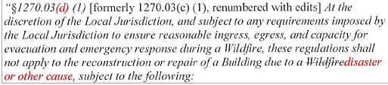
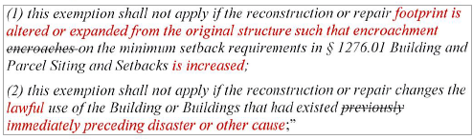
Board response: The regulatory exemption for wildfire rebuilds was a previous emergency regulatory action and is outside the scope of the proposed action. Please see General Response to Exceptions and Exemptions Comments. The comment is not specifically directed at the Board’s proposed action or to the procedures followed by the Board in proposing the action.

Rule text edit: No

Comment W59-3: City of Sonora
3B. Adopt the revised definitions and proposed definitions for "Fire Authority" and "Inspection Entity," to prevent delays in the processing and approval of the limited development still permitted under the proposed standards.
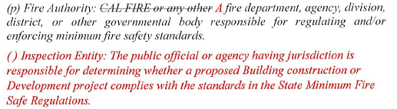
Board response: Please see response to W30-11

Rule text edit: No

Comment W59-4: City of Sonora
The Board of Forestry could include unimproved parcels in the Resource Code 4291. This would greatly affect the needed requirements of vacant lots to complete defensible space requirements, which is the biggest threat regarding over-grown vegetation in high fire risk areas in the LRA.

Board response: Public Resources Code 4291 is outside the scope of this proposed action. The comment is not specifically directed at the Board’s proposed action or to the procedures followed by the Board in proposing the action.

Rule text edit: No

Comment W60-1: City of Sonora (2)
[attached comments from City Engineer sent via email to Community Development Director and included with the City’s submitted comment letter above]
1. General Overview-Application. I have read the proposed regulations a number of times, and in general, the regulations as written appear to be very confusing as to application and requirements for existing parcels and projects previously approved. In applications for building permits, there are confusing provisions for application of the regulations (Scope 1270.03), with a description of exemptions to the regulations, and yet there are interpretive exceptions to the exemptions.
The City of Sonora is mostly in a VHFHSZ zone (Very High Fire Hazard Severity Zone) and within a LRA (Local Responsibility Area) with the requirement that the new regulations take effect after July 0 1, 2021. However in the SRA (State Responsibility Area) and in some of the exceptions to the exemptions, the effect of the regulations go back to 1991 and prior. This item needs to be clarified. In my experience, the effective date of new regulations should be after the date of adoption.

Board response: The Board is not proposing changes to the applicability or effective date of the regulations. The comment is not specifically directed at the Board’s proposed action or to the procedures followed by the Board in proposing the action.

Rule text edit: No

Comment W60-2: City of Sonora (2)
Paragraphs 3-6 of this letter are limited in scope to Articles 2-4 of the regulations. The Board is no longer proposing to revise Articles 2-4, consistent with the narrowed scope of the proposed action as identified within the Supplemental Statement of Reasons published with the “Second 15-Day Notice of Addition of Documents and Information to Rulemaking File and Modified Text” on May 10, 2022. The comment is not specifically directed at the Board’s proposed action or to the procedures followed by the Board in proposing the action.

Comment W60-3: City of Sonora (2)
Building and Parcel Siting and Setbacks (Section 1276.01) The requirement for a 30' setback from all parcels boundaries for new construction under a building permit would render many existing vacant parcels in the City of Sonora as unbuildable. Minimum parcel size in the City under R-1 zoning is 6000 SF with a 60' frontage, 5000 SF and 50' frontage in R-2 and R-3. We also have many pre­ existing nonconforming parcels with 50' or less frontage.
A 30' setback from sidelines and frontage setback on many minimum sized residential is not possible and the alternatives provided just add requirements and costs to new construction which are beyond the current zoning and building regulations. I believe we ought to stick with our c1ment zoning setbacks, and provide incentives to owners for the additional requirements for wildfire safety.
Generally, the provisions in regard to Setbacks, Ridgeline Development, Fuel Breaks, and Greenbelts amount to a State takeover of local planning in zoning and General Plan enforcement.
- Summary
In summary, I would recommend a very thorough review and revision of the regulations prior to adoption, along with an assessment of the economic impact on the local agencies and the public. The regulations should be revised for clarity and perhaps be less regulatory with more incentive provisions for existing and new construction. As presently written, the regulations are confusing as to application and requirements, and may very well limit badly needed new residential construction within the local agencies.

Board response: Please see response to W52-3

Rule text edit: No

Comment W61-1: San Luis Obispo County Board of Supervisors
The first three and last two paragraphs of this letter are introductory/conclusive in nature; the comments are not specifically directed at the Board’s proposed action or to the procedures followed by the Board in proposing the action.

Fairness
Successful implementation of any regulation depends upon feasibility of compliance and an inherent fairness based on a project's impacts. In the constitutional context, this is often referred to as having a nexus and rough proportionality. Simply put, many of the proposed regulations impose very significant access requirements for relatively modest development. For example, a minor expansion of a winery would trigger requirements to potentially bring miles of rural public roads into compliance by increasing the width to 20 or more feet. (See Section 1273.05 of the draft State Minimum Fire Safe Regulations, 2021). Many of such roads have physical constraints that would not allow such widening to occur. As another example, a building permit to construct a single-family residence would trigger the same onerous requirements, effectively prohibiting such minor development. Strictly construed, applying the draft regulations to the variety of development that is proposed within San Luis Obispo County will result in the imposition of infeasible requirements which do not proportionately relate to the level of impact or increased risk that the development presents to the community. Likewise, the regulations do not provide sufficient flexibility for consideration of alternative means of mitigating such risk.

Board response: The Board is no longer proposing changes to 1273.05, consistent with the narrowed scope of the proposed action as identified within the Supplemental Statement of Reasons published with the “Second 15-Day Notice of Addition of Documents and Information to Rulemaking File and Modified Text” on May 10, 2022. The comment is not specifically directed at the Board’s proposed action or to the procedures followed by the Board in proposing the action.

Rule text edit: No

Comment W61-2: San Luis Obispo County Board of Supervisors
Exceptions
Historically, the State Minimum Fire Safe Regulations have provided local authorities with a certain level of discretion and make certain exceptions based on case-by-case situations. The current regulations would be those in "substantial compliance" with the regulations which, as Monterey County noted in their letter, is not a real exception at all. While we understand the BOF's motivation to somewhat cull local discretion, that discretion is an integral component for the County of San Luis Obispo to successfully implement the State's regulations. Again, it is impossible to establish workable one size fits all standards, and a local jurisdiction should be able, with the approval of the local fire authorities (which in the case of San Luis Obispo County is CAL Fire), to permit alternate means of compliance with these standards utilizing factors such as fire evacuation and/or shelter plans, alternate access, other road improvements, and design modification.

Board response: The Board is no longer proposing to use the term “substantial compliance,” consistent with the narrowed scope of the proposed action as identified within the Supplemental Statement of Reasons published with the “Second 15-Day Notice of Addition of Documents and Information to Rulemaking File and Modified Text” on May 10, 2022. The comment is not specifically directed at the Board’s proposed action or to the procedures followed by the Board in proposing the action.

Rule text edit: No

Comment W61-3: San Luis Obispo County Board of Supervisors
Environmental Impacts
Elements of the draft regulations, particularly mandated off-site road improvements, would result in potentially significant physical changes to the environment. As these regulations apply to development that is currently permitted ministerially, such as individual building construction the County of San Luis Obispo is concerned that the impacts of the proposed regulations are not being appropriately evaluated as required by the California Environmental Quality Act (CEQA). The BOF should take appropriate action to ensure that adoption and implementation of the draft regulations will be CEQA compliant.

Board response: Please see General CEQA Response

Rule text edit: No

Comment W62-1: Building Industry Association of Southern California
The first page of this letter are introductory/conclusive in nature; the comments are not specifically directed at the Board’s proposed action or to the procedures followed by the Board in proposing the action.

Comment W62-2: Building Industry Association of Southern California
Extend Public Comment Period and Expand Local Input. The draft regulations do not reflect critical input from local fire authorities, counties and cities that provide the frontline defense against fires. As drafted, the regulations would be impossible or onerous to implement in many areas of the state—creating confusion, duplication and inconsistencies with existing requirements. While the overall intent of the regulations is commendable, the purpose will be thwarted unless and until the regulations are updated and corrected based on additional local involvement. It is essential that the comment period be extended by at least 45 days, with additional workshops and engagement opportunities provided for direct fire authority and local agency involvement.

Board response: The request for extension is unrelated to any new issue related to the proposed regulations. The request for an extension on review is not practical and would unduly delay action on the regulation.

Rule text edit: No

Comment W62-3: Building Industry Association of Southern California
Avoid “one size fits all” approach. The Proposed Regulations impose a “one size fits all” approach that does not apply throughout the state. For example, master-planned communities in Los Angeles County are designed “ground up,” with comprehensive fire protection measures, emergency access, roads and infrastructure that meet rigorous LA County Fire standards—some of the strongest in the nation. Many of the Proposed Regulations’ requirements can be satisfied at the community-scale within master-planned communities without burdening individual homes or neighborhood roadways.

Board response: Please see response to W180

Rule text edit: No

Comment W62-4: Building Industry Association of Southern California
Ridgeline protection measures must be considered after mass grading. The Proposed Regulations mandate that local agencies identify and preserve strategic ridgelines for fire safety reasons. This measure should be narrowly applied where ridgeline protection is the only feasible fire safety measure and where new housing construction would not be impacted. Even where applied, such ridgelines must be determined after mass grading for approved projects and areas designated for development. It would be meaningless to identify ridgeline protections before mass grading because the slopes/ridges may be fundamentally altered or eliminated by grading.

Board response: Please see response to W100-7

Rule text edit: No

Comment W62-5: Building Industry Association of Southern California
Adopt regulations that are modeled after existing requirements. The Proposed Regulations create a new set of requirements that are duplicative and result in potential ambiguity or inconsistency with existing codes and standards. Instead, the Proposed Regulations should be tied to existing California and/or International codes and National standards adopted by the State and NFPA Standards.

Board response: Please see response to W72-8

Rule text edit: No

Comment W62-6: Building Industry Association of Southern California
Fuel modification rules should not impact sensitive habitat. The proposed fuel modification requirements do not include any exceptions for conflicts with biological or regulatory mitigation requirements (e.g., endangered species habitat). The regulations must provide alternative compliance options where fuel breaks would conflict with endangered species habitat, wildlife preserves or other areas governed by existing biological or regulatory requirements.

Board response: Please see response to W100-5

Rule text edit: No

Comment W62-7: Building Industry Association of Southern California
Respect local authority and expertise over wildfire issues. The Proposed Regulations provide few, if any, exceptions to several of the requirements regarding roads, access, fuel breaks, etc. The Proposed Regulations’ “Substantial Compliance” exception is narrow and overly restrictive. Instead, the Proposed Regulations should include exceptions for local fire authorities, who have expertise in fire suppression methods in their respective areas, to determine whether these requirements are effectively satisfied, while ensuring that the intent of the new regulations are upheld.

Board response: The Board no longer proposed use of the term “Substantial Compliance” or the processes it described. consistent with the narrowed scope of the proposed action as identified within the Supplemental Statement of Reasons published with the “Second 15-Day Notice of Addition of Documents and Information to Rulemaking File and Modified Text” on May 10, 2022. The comment is not specifically directed at the Board’s proposed action or to the procedures followed by the Board in proposing the action

Rule text edit: No

Comment W62-8: Building Industry Association of Southern California
Avoid overly burdensome road and access requirements by accounting for variability in development. The Proposed Regulations’ access and road requirements are overbroad and overly restrictive in certain areas where adequate infrastructure supports emergency response. The regulations should account for different types of development.

Board response: The Board is no longer proposing substantive revisions to prescriptive road requirements consistent with the narrowed scope of the proposed action as identified within the Supplemental Statement of Reasons published with the “Second 15-Day Notice of Addition of Documents and Information to Rulemaking File and Modified Text” on May 10, 2022. The comment is not specifically directed at the Board’s proposed action or to the procedures followed by the Board in proposing the action
Rule text edit: No

Comment W62-9: Building Industry Association of Southern California

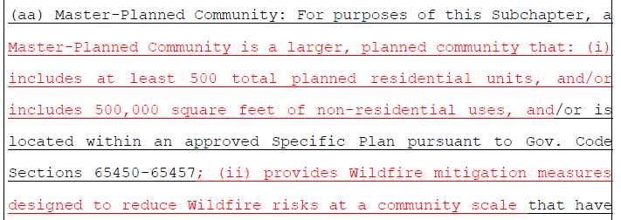
Board response: Please see response to W116

Rule text edit: No

Comment W63-1: Los Angeles County Department of Regional Planning
The first four paragraphs and last paragraph of this letter are introductory/conclusive in nature; the comments are not specifically directed at the Board’s proposed action or to the procedures followed by the Board in proposing the action.

The comments in paragraphs 5, 10 and 12 of this letter are limited in scope to Articles 2-4 of the regulations. The Board is no longer proposing to revise Articles 2-4, consistent with the narrowed scope of the proposed action as identified within the Supplemental Statement of Reasons published with the “Second 15-Day Notice of Addition of Documents and Information to Rulemaking File and Modified Text” on May 10, 2022. The comment is not specifically directed at the Board’s proposed action or to the procedures followed by the Board in proposing the action.

Comment W63-2: Los Angeles County Department of Regional Planning
Since local fire agencies will be responsible for enforcing these regulations, consistency in language and terminology to the California Fire Code is critical. Please align these regulations with the terminology from the California Fire Code, including a definition of “Alternative Means and/or Methods”, a recognized term, to allow local deviation or interpretation consistent with the California Fire Code.

Board response: Where possible, the rulemaking package aligns terminology with the California Fire Code. The Board is not proposing changes to the process allowing local deviation or interpretation from the Fire Safe Regulations (see, e.g., existing definition for “same practical effect,” 1271.00 or 1270.01(aa) in the final rule text), consistent with the narrowed scope of the proposed action as identified within the Supplemental Statement of Reasons published with the “Second 15-Day Notice of Addition of Documents and Information to Rulemaking File and Modified Text” on May 10, 2022. The comment is not specifically directed at the Board’s proposed action or to the procedures followed by the Board in proposing the action.

Rule text edit: No

Comment W63-3: Los Angeles County Department of Regional Planning
The definition of “development” should not reference the California Government Code. The definition cited in the draft regulations only pertains to parcels subdivided according to the Subdivision Map Act. It does not address development occurring on existing legal lots not created through the subdivision process. This is an example of BOF staff not understanding the development process, despite this issue being raised to BOF staff in previous public workshops. The correct code reference for “development” should be to the California Fire Code.

Board response: The Board is not proposing changes to the definition of “development,” consistent with the narrowed scope of the proposed action as identified within the Supplemental Statement of Reasons published with the “Second 15-Day Notice of Addition of Documents and Information to Rulemaking File and Modified Text” on May 10, 2022. The comment is not specifically directed at the Board’s proposed action or to the procedures followed by the Board in proposing the action.

Rule text edit: no

Comment W63-4: Los Angeles County Department of Regional Planning
It is unclear whether the application of these regulations after July 1, 2021 in the VHFHSZ is for SRA only, or whether it include LRA areas also. If the intent is to include VHFHSZs in LRAs, then it is critical the following language be used:
- The LRA VHFHSZ approved after July 1, 2021, except:
  - Where a parcel was formed from a vesting subdivision map that was approved prior to July 1, 2021 and both of the following are true:
    - (A) The Final Map is/was approved within the time prescribed by local ordinance and any extensions provided by State legislation.
    - (B) Conditions relating to the Perimeters and Access to the buildings were imposed as part of the vesting subdivision map prior to July 1, 2021.

Board response: The Board is not proposing changes to the application of these regulations, consistent with the narrowed scope of the proposed action as identified within the Supplemental Statement of Reasons published with the “Second 15-Day Notice of Addition of Documents and Information to Rulemaking File and Modified Text” on May 10, 2022. The comment is not specifically directed at the Board’s proposed action or to the procedures followed by the Board in proposing the action.

Rule text edit: No

Comment W63-5: Los Angeles County Department of Regional Planning
The regulations use “tentative map” incorrectly throughout. A “tentative map” refers to one step in the subdivision process and is not a type of map. All references to “tentative map” should be changed to “subdivision map” or “vesting map”.

Board response: The Board is not proposing changes to the use of the term “tentative map,” consistent with the narrowed scope of the proposed action as identified within the Supplemental Statement of Reasons published with the “Second 15-Day Notice of Addition of Documents and Information to Rulemaking File and Modified Text” on May 10, 2022. The comment is not specifically directed at the Board’s proposed action or to the procedures followed by the Board in proposing the action.

Rule text edit: No

Comment W63-6: Los Angeles County Department of Regional Planning
Please create an exemption or variance process to these regulations where application of the regulations would result in a taking of private property.

Board response: The commenter has provided no judicial determination as to the unconstitutionality of PRC § 4290, the existing Fire Safe Regulations, or the proposed rulemaking language, and the Board is unaware of any. The proposed language regarding constitutional matters is outside the scope of the Board’s authority and is not necessary or appropriate to effectuate the purpose of the statute. Please see General Response to Constitutionality Comment.

Rule text edit: No

Comment W63-7: Los Angeles County Department of Regional Planning
Change the definition of Local Responsibility Area to be consistent with Public Resources Code Section 4125.

Board response: The Board is no longer proposing to adopt a definition for “Local Responsibility Area,” consistent with the narrowed scope of the proposed action as identified within the Supplemental Statement of Reasons published with the “Second 15-Day Notice of Addition of Documents and Information to Rulemaking File and Modified Text” on May 10, 2022. The comment is not specifically directed at the Board’s proposed action or to the procedures followed by the Board in proposing the action.

Rule text edit: No

Comment W63-8: Los Angeles County Department of Regional Planning
The definition of “driveway” does not consider private access easements that may pre-date 1991 which provide vehicular access to more than two parcels. This is a common occurrence in areas within the Santa Monica Mountains, Antelope Valley, Santa Clarita Valley, and the Angeles National Forest, where development occurred decades ago, and was not dictated by the Subdivision Map Act.

Board response: The Board is proposing to delete “more than two parcels” from the definition of “driveway” to add greater clarity regarding when the standards for roads versus driveways apply to a vehicular pathway. The State Minimum Fire Safe Regulations apply to public and private roads and driveways.

Rule text edit: Yes

Comment W63-9: Los Angeles County Department of Regional Planning
The required 30’ setbacks on all parcels, including wildfire rebuilds, will not work in Los Angeles County. There are numerous existing legal lots in the Santa Monica Mountains Coastal Zone that would not be able to be rebuilt. Additionally, there are new subdivisions being planned in the Santa Clarita Valley that support higher density single family housing as an opportunity to address the State’s housing crisis. A one-size fits all standard across the State, let alone Los Angeles County, does not take into consideration myriad other competing issues, such as access to jobs, availability of housing, environmental restrictions, and general topography. Again, this one-size fits all approach may minimize the economic value of private property to the point of a taking.

Board response: The requirement that all parcels provide for a minimum 30 foot setback is an existing requirement. Section 1276.01(b) allows for alternative methods to reduce structure to structure ignition in the event a 30 foot setback cannot be achieved.

Rule text edit: No

Comment W64-1: League of California Cities
The first four paragraphs and last paragraph of this letter are introductory/conclusive in nature; the comments are not specifically directed at the Board’s proposed action or to the procedures followed by the Board in proposing the action.

Comment W64-2: League of California Cities
1. Section 1270.06. Exception to Standards. The Subdivision Map Act1 vests in local agencies the regulation and control of the design and improvement of subdivisions. Each local agency must adopt an ordinance that regulates and controls the initial design and improvement of land for which the Act requires a tentative and final or parcel map. A map is required to divide land for the purposes of sale, lease or financing. Control is exercised through the imposition of conditions that ensure local ordinance that implements the Act.
A local agency may not refuse to approve a final map because the subdivider has failed to meet a condition which requires the subdivider to construct or install offsite improvements on land in which neither the subdivider nor the local agency has sufficient title or interest to permit the improvements to be made. In such cases, unless the local agency chooses to acquire the land, the local agency must relieve the subdivider of the condition.
Proposal: Add an exception to Section 1270.06 that would allow the Inspection Entity to grant an exception to a standard which requires the applicant to make changes to land in which neither the applicant nor the Inspection Entity has sufficient title or interest to permit the changes to be made unless the State chooses interest in land that would allow for compliance with the standard.

Board response: The Board is not proposing to add additional purposes for granting an exception to the regulations. The comment is not specifically directed at the Board’s proposed action or to the procedures followed by the Board in proposing the action.

Rule text edit: No

Comment W64-3: League of California Cities
The comment labeled (2.) in this letter is limited in scope to Articles 2-4 of the regulations. The Board is no longer proposing to revise Articles 2-4, consistent with the narrowed scope of the proposed action as identified within the Supplemental Statement of Reasons published with the “Second 15-Day Notice of Addition of Documents and Information to Rulemaking File and Modified Text” on May 10, 2022. The comment is not specifically directed at the Board’s proposed action or to the procedures followed by the Board in proposing the action.

Comment W65-4: League of California Cities
3. Section 1270.01(ee): Definition of Residential Unit. Section 1270.03(c) states that the regulations do not apply to the creation of accessory or junior accessory dwelling units that comply with Government Code sections 65852.2 or 65852.22 or any local ordinances enacted thereunder. If this is the intent of this section, we request that it be made more explicit.
Proposal: Amend Section 1270.01(ee):
1270.01(ee) Residential Unit: Any Building or portion thereof which contains living facilities, including provisions for sleeping, eating, cooking and/or sanitation for one or more persons except for accessory or junior accessory dwelling units that comply with Government Code sections 65852.2 or 65852.22 or any local ordinances enacted thereunder. Manufactured homes, mobile homes, and factory-built housing are considered residential units, unless being sited or installed as an accessory or junior dwelling unit in accordance with § 1270.03(d) (Scope – Exemptions – ADUs).

Board response: The regulatory exemption for ADUs was a previous emergency regulatory action and is outside the scope of the proposed action. Please see General Response to Exceptions and Exemptions Comments. The comment is not specifically directed at the Board’s proposed action or to the procedures followed by the Board in proposing the action.

Rule text edit: No

Comment W64-5: League of California Cities

The last two paragraphs of this letter contains comments that are not relevant to the topic of this rulemaking. The comment is not specifically directed at the Board’s proposed action or to the procedures followed by the Board in proposing the action.

Comment W65-1: California Farm Bureau Federation
On behalf of the following organizations we are submitting comments relative to the California Board of Forestry and Fire Protection (Board) Draft Minimum Fire Safe Standard Regulations (Regulation). The above organizations have reviewed the revised Regulation and are deeply concerned that certain components will have profound impacts on future local land-use decisions and California’s commercial agriculture industry. We understand the significant wildfire challenges facing California, and our coalition members represent the communities and individuals who are also the wildfire victims. We appreciate the attention of the Board in protecting the environment, communities, and private citizens from future wildfire catastrophes. This Regulation, however, needs further consideration and we respectfully request the Board to address not only our specific issues, but also those that have been raised by local government and other commenting parties. For the reasons outlined below, the Board should provide an extension to the comment period for the Regulation, not to exceed at least ninety (90) days, so that the Board can respond accordingly.

Board response: The request for extension is unrelated to any new or previously unknown issue related to the proposed regulations. The request for an extension on review is not practical and would unduly delay action on the regulation.

Rule text edit: No

Comment W65-2: California Farm Bureau Federation
Section 1270.01 – Definitions
The Regulation contains two definitions for agriculture, as specified in §1270.01(b) and §1270.01(s). As stated in the Regulation:
§1270.01(b) Agriculture: Land used for agricultural purposes as defined in a Local Jurisdiction’s zoning ordinances.

§1270.01(s) Greenbelts: Agricultural lands, open space, parks, wildlands, or a combination thereof, as designated by Local Jurisdictions, which surround or are adjacent to a city or urbanized area, and restrict or prohibit Development.
By incorporating agricultural lands (or agriculture) into the Regulation’s operational definition of greenbelt, this subjects prime agricultural lands to new and significant impacts from wildfire mitigation strategies, discussed below.

Board response: The Board is not proposing changes to the definition of “agriculture.” In the 15 day rule text published on May 10, 2022, the Board deleted the term “agricultural lands” from the definition of “Greenbelts.”

Rule text edit: Yes

Comment W65-3: California Farm Bureau Federation
Sections 1276.03, 1276.04 and 1276.05 – Impacted Agricultural Lands (Greenbelts)
Agricultural lands are privately owned and utilized to produce commercial agricultural commodities. Lands such as open space and parklands, which are largely publicly owned and maintained for various recreational, esthetic, or environmental purposes, do not contain substantial commercial or manufacturing infrastructure, such as irrigation lines, trellising, crops, barns, or other components related to an agricultural business. The existence of such commercial or manufacturing infrastructure creates a significant area of conflict with the Regulation, as does the private property ownership of the land.
Greenbelts, as defined by the Regulation, are subject to the following sections: §1276.03 – Fuel Breaks,
§1276.04 – Greenbelts, Greenways, Open Spaces, and Parks, and §1276.05 – Maintenance of Fuel Breaks.
Section 1276.03(c)(4) provides permissive authority for a local entity to require fuel breaks at required locations, including but not limited to, within greenbelts. The Regulation empowers a local jurisdiction to establish fuel breaks that could likely result in the removal of orchards, vineyards and other such incompatible uses related to production agricultural. It is our understanding that a vineyard, or portion thereof, would be removed for the creation of the community fuel break. Further, the establishment of a fuel break on agricultural land is not predicated on whether there is building construction, a modification of parcels, or zoning density near that property, as is stated in §1276.03(a) (1-3).
Section 1276.03(c)(4) creates a new local authority, unbound and unchecked, for the purpose of creating fuel breaks as determined necessary by the local jurisdiction. If a local jurisdiction determines that a fuel break is necessary on agricultural lands to achieve a strategic wildfire mitigation objective, then that agricultural property becomes burdened with the creation of a community fuel break.
Privately owned agricultural land stands to lose considerable economic value in addition to the financial loss related to commodity production.
The scenario for agricultural lands is worsened by §1276.05, relating to maintenance of the fuel break. Provided by the Regulation, the private agricultural landowner, now burdened with the existence of the new fuel break on their private property, is also bound to maintain the fuel break. Local jurisdictions are empowered to bind the private property for which the fuel break is established, ensure adequate maintenance levels, and may include contractual agreements, levying of taxes, fees or assessments, or some other funding mechanism. The creation of the fuel break becomes a new easement on the agricultural land (like a utility right-of way for an electrical or water utility company). The creation of a fuel break on agricultural land arguably deprives the private landowner of the ability to utilize that land for their productive purpose. This is completely unacceptable, and then to further require that private agricultural landowner be made responsible for the maintenance of the fuel break in perpetuity is indefensible. Private agricultural landowners are then left in the untenable situation of having to defend their right-to-farm over the protection of a community’s health and safety.
Lastly, §1276.04 is also incompatible with commercial agriculture. Specifically, paragraph (b) authorizes a local jurisdiction permissive authority to require that greenbelts (i.e. agricultural lands) be utilized as evacuation areas of last resort. California’s farming and ranching community would never turn away an evacuee from a wildfire, but to place the burden of a “last-resort” evacuation site on farmers or ranchers is unspeakable. We know of first responders who took shelter in our vineyards during the Napa and Sonoma wildfires, to which we clearly have no objection and are proud to have done so. But,
agricultural lands should not become a “last resort” area of refuge and may further complicate evacuation of livestock, employees, and farm equipment for the agricultural operation. Fundamentally, a local jurisdiction should not have the authority to designate private property as the “last resort refuge” for any catastrophic emergency. Agricultural land, greenbelts, greenways, open space, and parklands do not guarantee the protection of any individual seeking refuge from a wildfire. We understand, perhaps, the rationale of establishing evacuation areas of last resort, but fail to understand the absolute necessity for establishing the requirement within this Regulation.

Due to the complexities and nuances associated to privately held agricultural land, we request that the Board strike agricultural lands from its definition of greenbelts. While greenbelts, and agricultural lands, serve similar purposes in minimizing urban sprawl and development, the functionality of these lands are very different and further conflicts with the Regulation. Private agricultural lands are not intended, nor should be required, to become regulatorily authorized fuel breaks, a new mechanism to raise revenue, or a last resort refuge from wildfire.

§1270.01 – Definition of “Development” Applicability to Agricultural Lands
The Regulation defines development by referencing California Government Code §66418.1.
California Government Code §66418.1: “Development” means the uses to which the land which is the subject of a map shall be put, the buildings to be constructed on it, and all alterations of the land and construction incident thereto.
The coalition is deeply concerned that cross-referencing California Government Code §66418.1 to provide a definition for development may have profound consequences for the continuation of common agricultural activities.
The term Development, as defined by California Government Code and referenced by the Regulation, is incorporated into the Regulation’s definition of greenbelts, as defined.
§1270.01(s) Greenbelts: Agricultural lands, open space, parks, wildlands, or a combination thereof, as designated by Local Jurisdictions, which surround or are adjacent to a city or urbanized area, and restrict or prohibit Development.
The reference to Development presents significant ambiguity for a commercial agricultural enterprise and the operation of that entity. If the greenbelt (agricultural lands) is defined as to restrict or prohibit Development, does this mean that any alterations of that agricultural land are also prohibited.
Agricultural lands are altered almost daily, depending upon the type of commodity being grown, for purposes of aeration, irrigation and replanting or removal of vegetation. Given that the term Development fails to articulate what is also meant by alteration, this presents a potentially significant problem.
Again, the Regulation clearly states that Greenbelts (agricultural lands) …restrict or prohibit Development (as defined by California Government Code). Should agricultural lands be altered for the installation of a new irrigation system, the removal or addition of a new vineyard, or the creation of a new stock-pond, it’s logical to assume that the commercial agricultural enterprise would be in violation of the Regulation. This ambiguity greatly empowers a local jurisdiction to make determinations relative to common everyday activities that occur on commercial agricultural lands, and could further prevent certain activities under the premise that the agricultural land is being altered.
The coalition, again, requests that the Board strike agricultural lands from the Regulation’s definition of greenbelt. Should the Board choose not to strike the term agricultural lands, we respectfully ask that the following verbiage be included so as common practices conducted by a commercial agricultural enterprise can continue unabated.
(s) Greenbelts: Agricultural lands, open space, parks, wildlands, or a combination thereof, as designated by Local Jurisdictions, which surround or are adjacent to a city or urbanized area, and restrict or prohibit Development, nothing in this definition shall be construed to prohibit any activities occurring on agricultural lands that are necessary for the production of agricultural commodities or raising of livestock.

Board response: In the 15 day noticed rule text published on May 10, 2022, the Board deletes “agricultural lands” from the definition of “greenbelts.”

Rule text edit: Yes

Comment W65-4: California Farm Bureau Federation
§1270.02 – Purpose
The coalition appreciates the dedicated efforts of the Board and staff on the multitude of issues that come before it. The development of the Regulation comes at a critical time for California, and we understand the significance that the Regulation may have on preventing future loss associated to wildfire. It’s critical that the Regulation address various standards for emergency ingress and egress, water supplies, defensible space, fuel breaks, greenbelts, and ridgelines so that minimum standards can be met and/or exceeded by local communities.
Our coalition, however, was deeply troubled with the statement in §1270.02(d), which states:
(d) By limiting Building construction in those areas where these minimum Wildfire protection standards are not satisfied, this reduces the risk of Wildfires in these areas, which among other things protects the health, safety and welfare of residents, and protects natural resources and the environment.
There are several causes of wildfire, both manmade and natural. While limiting building construction in the wildland urban interface could be a factor in reducing future risk, it’s a strategy that ignores the existing wildfire risk to communities. Land use decisions and development is only one strategy that may reduce wildfire risk, and never before have we experienced the Board make such an affirmative statement that ignores other risk factors, such as climate change, drought, past fire suppression and forest management strategies, pests and tree mortality. Vegetation management, if done strategically and consistently, is a far more successful strategy than a managed retreat from the wildland urban interface.
Community wildfire risk is driven by a multitude of factors that may or may not further exacerbate that risk. It’s not uncommon that inadequate fire suppression infrastructure, such as too few hydrants or fire stations in a community, is also considered a significant determinant of wildfire risk. In certain areas of the state, utility infrastructure (which is excluded from the Regulation’s definition of “Building”) is also an inherent risk and has been responsible for some of California’s deadliest and most destructive wildfires on record. The statement provides an all too simplistic strategy that completely ignores other wildfire risk factors, and should be modified to acknowledge a much broader portfolio of risk assessment.

Board response: The Board is no longer proposing to adopt this section, consistent with the narrowed scope of the proposed action as identified within the Supplemental Statement of Reasons published with the “Second 15-Day Notice of Addition of Documents and Information to Rulemaking File and Modified Text” on May 10, 2022. The comment is not specifically directed at the Board’s proposed action or to the procedures followed by the Board in proposing the action.

Rule text edit: No

Comment W65-5: California Farm Bureau Federation
§1270.03 – Scope: Agricultural Road Exclusion
The coalition appreciates the consideration of the Board to exclude roads used solely for agricultural purposes from the Regulation. We do ask that the Board provide explicit clarity as to the various sections of the road rules that are not intended to apply to agriculture. Given that the Regulation will be subject to various legal interpretations from responsible local jurisdictions, this specificity will provide certainty and consistency of implementation. Further, we believe that the clarity reinforces the authority of the Board to grant or deny exclusions from the Regulation as necessary.

We recommend the following amendment(s) to §1270.03(e) as provided:
(e) These regulations shall not apply to Roads used solely for Agriculture, mining, or the management of timberland and harvesting of forest products. Sections 1273.00, 1273.01, 1273.02, 1273.03, 1273.04, 1273.05, 1273.06, 1273.07, 1273.08, 1273.09, 1273.10, 1273.12, 1273.13 are not applicable to above mentioned activities.

Board response: The Board is not proposing changes to 1270.03(e) regarding the application of these regulations to agriculture, as defined. The comment is not specifically directed at the Board’s proposed action or to the procedures followed by the Board in proposing the action.

Rule text edit: No

Comment W65-6: California Farm Bureau Federation
This letter contains comments on pp.5-7 that are limited in scope to Articles 2-4 of the regulations. The Board is no longer proposing to revise Articles 2-4, consistent with the narrowed scope of the proposed action as identified within the Supplemental Statement of Reasons published with the “Second 15-Day Notice of Addition of Documents and Information to Rulemaking File and Modified Text” on May 10, 2022. The comment is not specifically directed at the Board’s proposed action or to the procedures followed by the Board in proposing the action.

The last paragraph of this letter is conclusive in nature; the comments are either not specific or are unnecessarily redundant with more specific comments presented elsewhere in the letter.

Comment W66-1: Los Angeles County Business Federation
The first six and last two paragraphs of this letter are introductory/conclusive and general in nature; the comments are not specifically directed at the Board’s proposed action or to the procedures followed by the Board in proposing the action.

Comment W66-2: Los Angeles County Business Federation
BizFed respectfully requests that the Board of Forestry make the following changes to the Draft Rules:
- More Public Input and Workshops are Needed. The Draft Rules are nearly 70-pages long and are filled with complicated and confusing technical requirements. The Board of Forestry needs to provide additional workshops to explain the Draft Rules and extend the public comment period by at least 45 days in order to receive meaningful public feedback.
- Allow local fire authority exemptions where development satisfies the purpose of state standards. The Draft Rules impose a “one size fits all” approach that does not take into account local conditions or different types of developments. The Draft Rules should allow exceptions for situations where the local fire authority determines that alternative means of compliance satisfy the purpose and intent of the relevant standard. This is consistent with our position on SB 12 (McGuire)
- Revise the Draft Rules to ensure consistency with existing codes. The Draft Rules appear to us to conflict with existing rules adopted by the State, as well as codes developed by the International Code Council and National Fire Protection Association. This is also consistent with BizFed’s position on SB 12 (McGuire)

Board response: Please see response W180

Rule text edit: No

Comment W67-1: Deborah Eppstein (2)
In addition to the comments I submitted on June 14 to the Board of Forestry, there is another technical mistake; corrections shown in red.
§ 1270.05(c) “Inspections in the VHFHSZ in the LRA shall be made by the Local Jurisdiction or Fire Authority” Otherwise it conflicts with the requirement for inspections in the SRA to be by CalFire under § 1270.05(a) and (b). However, this requirement for inspection for the VHFHSZ in the LRA is completely circular and thus is meaningless.
The Board of Forestry needs to have ultimate inspection authority for both the SRA and LRA if the exception process is not restricted as I previously proposed to a small percentage (propose 10%) or length (proposed 200 ft), whichever is less.

Board response: The Board is not proposing changes to the inspection authorities, consistent with the narrowed scope of the proposed action as identified within the Supplemental Statement of Reasons published with the “Second 15-Day Notice of Addition of Documents and Information to Rulemaking File and Modified Text” on May 10, 2022. The comment is not specifically directed at the Board’s proposed action or to the procedures followed by the Board in proposing the action.

Rule text edit: No

Comment W68-1: California Senate Housing Committee
First off, thank you for taking on the issue of development in high fire regions.
We are deeply concerned that the proposed State Fire Safe Regulations, currently under consideration by the Board of Forestry, may threaten the state’s recovery from the COVID-19 pandemic and obstruct our continued efforts to ensure that every Californian has a place to call home.
California is facing dueling unprecedented crises. Before the COVID-19 pandemic, California ranked 49th in the country in housing units per resident, and suffered the third highest per capita rate of homelessness in the nation. The global pandemic has only increased the pressure on an already tenuous structure that lacked enough resources for individuals struggling to maintain housing. Over the last several years, we have enacted numerous policies to remove barriers to residential development, increase home affordability, and expand housing stock.
Simultaneously, the size and scope of wildfires in this state have changed; they’re larger, more destructive, and deadlier now than at any other time in modern history. We can no longer afford to focus solely on what materials we build with; the state must also evaluate where we build, especially in high fire areas.
The Board’s draft proposal places substantial new restrictions on home construction in all “state responsibility areas” and all “very high fire hazard severity zones” – areas that presently contain approximately one-quarter of California’s housing stock. These regulations would prohibit any future building construction on property served by a road that does not meet current standards, potentially putting large swaths of the state off limits to development. This one-size-fits-all approach does not take into consideration whether new construction is a single home or an entire subdivision. The Board should be looking at models that account for the different risks posed by different sized developments, such as the stringent fire safety standards contained in SB 12, currently being considered by the Legislature.
SB 12 sets up a transformational process for the State Fire Marshal to establish bold new standards that ensure developments as a whole are designed to withstand wildfire, not just buildings within these developments. Crucially, these standards are tiered so that the standards get increasingly stronger as developments get larger. This legislation recognizes that larger developments put more people in the WUI and so they must meet higher standards than smaller developments. And if developers cannot meet those standards, they can’t build.
We vigorously support the Board's goal of innovating fire safety and fire planning in California's highest wildfire risk areas; however, these improvements must be balanced with the need for strategic housing development and account for the differences in the size of developments.
Cataclysmic fire seasons, sea-level rise and looming earthquake devastation are part of the new fabric of California, and cannot be siloed or conflict with our governmental responsibilities to meet the most basic needs of our constituents.
We understand that the Board plans to hear final comments at its meeting on June 22, 2021. We strongly urge you to consider delaying this action, and to instead continue to work with local government and housing stakeholders to develop a balanced regulatory package that takes a holistic approach to housing development and wildfire safety, similar to efforts currently working through the Legislature.

Board response: The Board appreciates the Committee’s input into the regulations. Please see response W180.

Rule text edit: No

Comment W69-1: San Diego County Planning and Development Services
The first paragraph and last two paragraphs of this letter are introductory/conclusive in nature; the comments are not specifically directed at the Board’s proposed action or to the procedures followed by the Board in proposing the action.

Comment W69-2: San Diego County Planning and Development Services
- Clarify Application of the Proposed Regulations
Section 1270.03 states that the Regulations apply to "the Perimeters and Access to all residential, commercial and industrial Building construction" in the State Responsibility Area (SRA) and Very High Fire Hazard Severity Zones (VHFHSZ). Section 1270.01 (d) has a definition for "Building." However, the definitions do not provide for what constitutes "building construction" for which the Regulations apply. While the proposed Regulations appear to be directed to new construction, that is not currently specified. Specifically, there is no definition for construction or details regarding how the Regulations might apply to maintenance, repair, or improvements to existing buildings. Without a definition for "construction" or "Building construction," the Regulations could be interpreted to apply to any construction on an existing building, even minor construction such as roof-mounted solar panels.
The County requests the Board clarify whether the Regulations apply to construction for the maintenance, repair, or improvement of existing buildings. The County is concerned about the potential costs to homeowners, which may discourage these types of investments. For example, a homeowner interested in replacing a roof with a more fire-resistant roof type could interpret Section 1273.00(d) as requiring on or offsite access improvements because a roof replacement could be considered "building construction." The homeowner might be discouraged from making the improvement, despite the fire safety benefits, because of the costs for on or offsite improvements.
The County also requests the Regulations clarify whether or not they apply to construction to expand an existing building without expanding the intensity of the use. The Regulations would permit the construction of an accessory or junior accessory dwelling unit (ADU). However, a similar-sized addition to a home that is not an ADU could require the owner to make improvements based on these Regulations because they lack a definition of what constitutes "building construction." For wildfire risks and impacts, the County requests additional clarification on the difference between allowing the construction of an ADU or a minor residential addition. Similarly, minor additions to commercial property could be allowed provided there is no increase to the intensity of use. Therefore, if the Board intends for the Regulations to apply to construction projects that expand an existing building without expanding the intensity of the use, the County recommends the Board establish a threshold for applicability of the Regulations based on a square footage or percentage increase, whereby any improvement to an existing building over a certain threshold requires compliance with the Regulations, and any improvement below that threshold is exempt from the Regulations. For example, the County's 2020 Consolidated Fire Code may require an automatic sprinkler system to be installed throughout an existing building when a proposed addition to that existing building is more than 50% of the existing building's size. This 50% threshold allows minor addition projects to proceed without increasing the costs for the property owner.

Board response: The Board is not making changes to the applicability of these regulations, consistent with the narrowed scope of the proposed action as identified within the Supplemental Statement of Reasons published with the “Second 15-Day Notice of Addition of Documents and Information to Rulemaking File and Modified Text” on May 10, 2022. The comment is not specifically directed at the Board’s proposed action or to the procedures followed by the Board in proposing the action. The regulatory exemption for ADUs was a previous emergency regulatory action and is outside the scope of the proposed action. Please see General Response to Exceptions and Exemptions Comments. The comment is not specifically directed at the Board’s proposed action or to the procedures followed by the Board in proposing the action.

Rule text edit: No

Comment W69-3: San Diego County Planning and Development Services
2. Exempt Any Natural Disaster
Section 1270.03(c) allows a local jurisdiction to determine if the Regulations shall apply to the reconstruction or repair of a building due to wildfire, defined in Section 1270.01 (uu). However, Section 1270.03(c)(3) states that the Regulations may apply to reconstruction or repair of a building for reasons unrelated to wildfire. The County requests the Board amend Section 1270.03(c) to allow a local jurisdiction to determine if the Regulations may apply to the reconstruction or repair of a building due to any natural disaster, rather than limiting it to wildfire. A definition of "Natural Disaster" could be added to Section 1270.01 to clarify when the local jurisdiction can make such a determination.

Board response: The regulatory exemption for wildfires was a previous emergency regulatory action and is outside the scope of the proposed action. Please see General Response to Exceptions and Exemptions Comments. The comment is not specifically directed at the Board’s proposed action or to the procedures followed by the Board in proposing the action.

Rule text edit: No

Comment W69-4: San Diego County Planning and Development Services

3. Clarify Exception and Appeal Reporting Process
Section 1270.06 allows the inspection entity to make case-by-case exceptions to the Regulations if there is substantial compliance with the minimum standards. Approved exceptions must be reported to the Board and the CAL FIRE unit headquarters and shall be supported by substantial evidence. Additionally, exception decisions may be appealed, and if an appeal is granted, findings must be reported to the Board and the CAL FIRE unit headquarters. This process appears to apply to any exception to any standard of the Regulations. The County requests that local jurisdictions be granted authority to approve minor exceptions, such as a road or driveway turnout that does not quite meet the dimension requirements, without reporting to the Board or CAL FIRE unit headquarters. If this requested change is made, the Regulations should clarify what may be considered a "minor" exception. In addition, the County requests that the Regulations further detail the expected process for the reporting of exceptions and appeals. For example, it is unclear whether only an applicant may appeal, or neighbors or other interested parties may also appeal.

Board response: The Bord is no longer proposing to use the term “substantial compliance” or changes to the inspection and exception processes, consistent with the narrowed scope of the proposed action as identified within the Supplemental Statement of Reasons published with the “Second 15-Day Notice of Addition of Documents and Information to Rulemaking File and Modified Text” on May 10, 2022. The comment is not specifically directed at the Board’s proposed action or to the procedures followed by the Board in proposing the action.

Rule text edit: No

Comment W 70-1: Modoc County Board of Supervisors
The first five paragraphs and last paragraph of this letter are introductory/conclusive in nature; the comments are not specifically directed at the Board’s proposed action or to the procedures followed by the Board in proposing the action.

Comment W70-2: Modoc County Board of Supervisors
Modoc County has the following top level concerns with the regulations:
- First and foremost, the Board of Forestry has failed to evaluate the economic or environmental impacts of these proposals, as required by state law. The Administrative Procedures Act (APA) requires administrative agencies to prepare an economic impact assessment of proposed regulations, including consideration of the effect of the proposed regulatory action on housing costs (Government Code Sections 11346.2(b)(2)-(5), 11346.3, 11346.5(a)(7)-(12)). According to the proposed rules, the proposed action “Does not impact housing cost” and, “will not have a significant adverse economic impact directly affecting business.”

- The proposed "existing roads" provisions would create no build zones in areas served by dirt roads, or roads less than 14-feet wide or having over 25 percent grade.

- Even modest residential lot splits (three or more parcels, for example) or business expansion would trigger requirements to bring potentially miles of public roads and bridges fully up to current standards, at the landowner's expense.

- The asserted "exemptions" for wildfire rebuilds and accessory dwelling units are unclear. While certain provisions of the regulations purport to exempt these buildings from the regulations, other provisions appear to override or limit those exemptions and impose substantial burdens on these homeowners.

- Such exemptions – to the extent they work at all – are overly narrow. The rebuild exemption covers only structures lost due to wildfire, and consequently owners whose homes or businesses were lost due to other causes (e.g., flood, mudslide, house fire, etc.) would be subject to the full suite of requirements. In addition, even some wildfire rebuilds would not be exempt if they could not meet the setback requirements – as is the case on many smaller lots.

Board response: Please see response to W35.

Rule text edit: No

Comment W70-3: Modoc County Board of Supervisors
The County respectfully requests the Board of Forestry consider the following actions to mitigate unknown and unintended consequences of the Draft State Minimum Fire Safe Regulations, 2021:
- Prepare an Environmental Impact Report (EIR) that thoroughly assesses the potential impacts of the regulation, mitigations to reduce or eliminate negative impacts, and alternatives for protecting the health, safety and welfare of residents and first responders, natural resources, and the environment.
- Prepare an economic impact statement that discloses the changes in housing costs, employment, levels of business activity, and other factors affecting the health and sustainability of Modoc County
- Modoc County supports the consideration of principles outlined by the Western Region Cohesive Strategy when modifying the Draft State Minimum Fire Safe Regulations, 2021, including:
  - Reducing risk to firefighters and the public is the first priority
  - Sound risk management is the foundation for all management activities
  - Actively manage the land to make it more resilient to disturbance
  - Rigorous wildfire prevention programs
  - Fire management decision are based on the best available science and used to evaluate risk versus gain

Board response: Please see the Economic and Fiscal Impact Statement and General CEQA Response

Rule text edit: No

Comment W71-1: Resource Conservation District of Santa Cruz County
The Resource Conservation District of Santa Cruz County (RCDSCC) is a non-regulatory public special district that provides technical and monetary assistance services directly to public and private landowners to protect, conserve, and restore natural resources. Serving as local hubs for conservation efforts, RCDs across California work in partnership with landowners and managers, technical advisors, area jurisdictions, government agencies, and others. For more information visit www.rcdsantacruz.org
As part our efforts to enhance water quality in impaired watersheds in Santa Cruz County, RCDSCC works with willing landowners on a voluntary basis to upgrade public and private roads to achieve environmental resource management goals, often funded through public grant programs. This includes renovations to road drainage infrastructure to reduce sedimentation into waterways, improving stream crossings for migratory fish, and improving roads for access and defensible space during emergencies. Much of this work is accomplished through the RCDSCC Partners in Restoration Permit Coordination program which includes a programmatic permit from multiple agencies to expedite work that improves water quality and other public benefits.
RCDSCC is concerned that projects benefiting public resources like water and endangered species habitat could be limited by these regulations if environmental protection projects involving rural roads are required to bring road networks or road segments up to these new standards, which public grant funding programs will not typically fund. The RCDSCC seeks clarification for how the proposed regulations apply to existing roads and what level of “new” construction or road improvements would trigger the new regulations. We are seeking assurance that activities like replacing culverts for improved fish passage or installing rolling dips to reduce sedimentation into waterways would not trigger the entire roadway (or segment of roadway) needing to be upgraded to meet these requirements, which could pose a significant barrier for cooperating landowners. Thank you for your consideration.

Board response: The Board is not proposing changes to the standards for new versus existing roads, consistent with the narrowed scope of the proposed action as identified within the Supplemental Statement of Reasons published with the “Second 15-Day Notice of Addition of Documents and Information to Rulemaking File and Modified Text” on May 10, 2022. The comment is not specifically directed at the Board’s proposed action or to the procedures followed by the Board in proposing the action.

Rule text edit: No

Comment W72-1: City of Belmont
The first two paragraphs of this letter are introductory/conclusive in nature; the comments are not specifically directed at the Board’s proposed action or to the procedures followed by the Board in proposing the action.

Comment W72-2: City of Belmont
Potential Impacts and General Comments:
- For such a large and substantial revision to the FSR, we feel it premature for an exclusive 45-day public comment period. We believe that additional Board committees/workgroups are needed to vet the proposal to local government (especially in urban areas), the public, and the fire service to review, comment, and further refine the rulemaking package. It does not appear that much of the fire service input and/or involvement to date has been adequately addressed in the development of the proposed regulations.

Board response: Please see response W180.

Rule text edit: No

Comment W72-3: City of Belmont
- The effective date of these regulations does not account for the ability of Local Government to amend their local ordinance(s) that may be impacted or be in conflict. Additionally, there is no time for training of staff or vetting the revised FSR to the impacted stakeholders and community (e.g. Building Industry Assoc., developers, builders, designers, home/property owners, HOAs, etc.) These new and revised regulations should include an effective date that is projected a minimum of 180 days after adoption by the Board, similar to that of the adoption and effective date of California Code of Regulations (CCR), Title 24 California Building Standards Code, (see Health and Safety Code 18937).

Board response: The Board is not proposing changes to the applicability of these regulations, consistent with the narrowed scope of the proposed action as identified within the Supplemental Statement of Reasons published with the “Second 15-Day Notice of Addition of Documents and Information to Rulemaking File and Modified Text” on May 10, 2022. The comment is not specifically directed at the Board’s proposed action or to the procedures followed by the Board in proposing the action. As statewide minimum standards, these regulations supersede any local ordinance, except where that local ordinance equals or exceeds the state minimum (see PRC 4290(c)). It is not required that a local jurisdiction amend their local ordinances in order for the State Minimum Fire Safe Regulations to take effect.

Rule text edit: No

Comment W72-4: City of Belmont

- Potential impact on recently updated General Plans and specifically the associated Safety Element(s) therein which may require policy amendments, and potential modification of local ordinance(s) in response to the proposed regulations.

Board response: The comment is not specifically directed at the Board’s proposed action or to the procedures followed by the Board in proposing the action.

Rule text edit: No

Comment W72-5: City of Belmont

- Political impact of not allowing construction in given areas that were once approved to be constructed on (see Section 1270.02(d) and other provisions in this rulemaking that would implement 1270.02(d)).

Board response: In the 15 day noticed rule text published on May 10, 2022, the Board rephrased 1270.02(d) and it no longer references limiting building construction. The comment is not specifically directed at the Board’s proposed action or to the procedures followed by the Board in proposing the action.

Rule text edit: Yes

Comment W72-6: City of Belmont

Application of these regulations are not clear as to the specific date of application for the Local Responsibility Area (LRA) Very High Fire Hazard Severity Zone(s) VHFHSZ as opposed to the application for the State Responsibility Areas (SRA). The SRA provisions have existing language based on specified triggers for parcels created both prior to, and after January 1, 1991 whereas the LRA does not. The concern and lack of clarity should be addressed for the LRA in a similar manner as that of the SRA. Additionally, Section 1270.03(a) through (b) appear to apply to the SRA but it is not noted and could be interpreted to apply to LRA which would be problematic at best.

Board response: The Board is not proposing changes to the application of these regulations, consistent with the narrowed scope of the proposed action as identified within the Supplemental Statement of Reasons published with the “Second 15-Day Notice of Addition of Documents and Information to Rulemaking File and Modified Text” on May 10, 2022. The comment is not specifically directed at the Board’s proposed action or to the procedures followed by the Board in proposing the action.

Rule text edit: No

Comment W72-7: City of Belmont

- It is not clear in the application and scope as well as other areas why the “Local Jurisdiction” is the enforcing agency and not the “Fire Authority” (terms as defined therein). The FSR are for fire safety and the enforcing authority should be left to the Fire Authority, or at a minimum in consultation, to prevent confusion within the jurisdiction or for the stakeholders, property owners, developers, etc. It is typical that planning departments, transportation departments, and other local jurisdiction departments use the FSR provisions as regulation or guidelines for their purposes - but ultimately the Fire Authority is typically the enforcing agency.

Board response: A “fire authority” is included in the definition of “local jurisdiction.” The Board is not proposing changes to which governmental agency is responsible for the enforcement of these regulations. The definition of “local jurisdiction” allows for local flexibility regarding which agency is responsible for inspections and enforcements. It would be overly prescriptive for the Board to require the fire authority to be the exclusive inspection and enforcement agency throughout the state.

Rule text edit: No

Comment W72-8: City of Belmont

- The provisions contained in the initial drafts as well as the current proposed 45-day rulemaking appear to be written in areas for planning and transportation departments, while the Fire Service ultimately ends up the enforcing agency, however, improvements have been made for fire service but are still inadequate or unclear.

- These regulations should be modeled/formatted after the existing California and/or International codes and National standards adopted by the state (e.g. the California Fire Code (based on the International Fire Code) and the referenced NFPA Standards including but limited to NFPA 1142).

Board response: Where possible, the Board’s regulations align with the codes adopted by other state agencies. Without more specific direction regarding where these regulations are out of alignment with these codes, the Board cannot offer a specific rule change or response. The comment is not specifically directed at the Board’s proposed action or to the procedures followed by the Board in proposing the action.

Rule text edit: No

Comment W72-9: City of Belmont

- There appears to be provisions that place a state mandate on local government compliance without specific provisions to recover costs or any statutory authority for the Board to potentially (the term used in these provisions use “may…” prior drafts used the term “shall”) require such provisions of local government (e.g. proposed section 1270.04 item (d) through (g)). Furthermore, these provisions are not necessary and only adds confusion.

Board response: The Board is no longer proposing these changes to 1270.04.

Rule text edit: Yes

Comment W72-10: City of Belmont

- Exemption(s) to the FSR provisions (section 1270.06) are confusing and potentially an overregulation by the Board, specifically relating to the LRA or contract counties (Schedule A). Additionally, it is not clear if this applies to the LRA (in most of the LRA there is no CAL FIRE “Unit” as referenced in 1270.06).

Board response: The Board is no longer proposing changes to 1270.06, consistent with the narrowed scope of the proposed action as identified within the Supplemental Statement of Reasons published with the “Second 15-Day Notice of Addition of Documents and Information to Rulemaking File and Modified Text” on May 10, 2022. The comment is not specifically directed at the Board’s proposed action or to the procedures followed by the Board in proposing the action.

Rule text edit: No

Comment W72-11: City of Belmont

- These regulations appear to have no correlation with CCR, Title 24, Part 2, California Building Code Chapter 7A and Part 9, California Fire Code Chapter 49 scoping provisions of the Wildland Fire Building Construction Standards which are more specific than the proposed regulation.

Board response: PRC 4290(a) specifically states “The board may not adopt building standards, as defined in Section 18909 of the Health and Safety Code, under the authority of this section.” Where possible, the Board aligns these proposed standards with relevant requirements in the Fire Code.

Rule text edit: No

Comment W72-12: City of Belmont

- Provisions in the proposed regulations appear to prohibit construction on parcels based on existing roads that cannot be improved or parcels that once may have complied with existing local regulations for length of road (e.g. dead-end roads). If adequate infrastructure exists, and appropriate zoning/construction permits are obtained, parcel owners should not be precluded from seeking fair economic value for their property as a consequence of these regulations.

Board response: The Board is not proposing changes to the road standards or their applicability, consistent with the narrowed scope of the proposed action as identified within the Supplemental Statement of Reasons published with the “Second 15-Day Notice of Addition of Documents and Information to Rulemaking File and Modified Text” on May 10, 2022. The comment is not specifically directed at the Board’s proposed action or to the procedures followed by the Board in proposing the action.

Rule text edit: No

Comment W72-13: City of Belmont
Comments to specific Sections:
  - Section 1270.01 Definitions:
(d) Building. The definition contains exemptions for “Utility” and “Miscellaneous Group U”, these two terms are not defined and could exempt very large buildings that contain very large fuel loads. These general terms could open the door to unintended buildings being exempted or unintended consequences. Additionally, Group U occupancies are defined in both the California Fire Code and Buildings Code, suggest reference be made to the CCR, Title 24, Part 2 and Part 9.
(f) Clear Width. The Board may want to consider other terrain obstructions in the definition (e.g. large rocks/boulders, hillside, cliff, etc.).
- Local Road. Does this conflict with Road? why is this definition needed? This definition causes confusion with the defined term of Road. See additional comments for the proposed definition of Road.

- Municipal-Type Water System. Although word for word from NFPA 1142, are there other standards that should be considered or referenced (e.g. the Ca. Public Utilities Commission (PUC) regulations, American Water Works Association (AWWA)).
(ee) Residential Unit. This definition would exempt Accessory Dwelling Units (ADUs) that are conventionally constructed. The second sentence addresses ADUs specific to Manufactured Homes, Mobilehomes, and Factory-built Homes. Additionally, the definition appears to include a detached game room, pool house, etc. that are not intended to be lived in as a residence, however, they are typically classified as a Group R occupancy in accordance with the California Building or Residential Code.
(gg) Road. Does this conflict with Local Road? This definition causes confusion with the defined term of Local Road. See additional comments for the proposed definition of Road.

Board response: Please see response to W47

Rule text edit: No

Comment W72-14: City of Belmont
Section 1270.02 Purpose
Subsection (a) established standards for the SRA; please provide clarification if these standards apply to the entire SRA or only the Moderate, High and Very High Fire Severity Zones. This has been the practice in the past regarding applying the current Fire Safe Regulations, however, there is nothing in the Fire Safe Regulations that specify such (example CCR, Title 24, Part 2 Chapter 7A and Part 9, Chapter 49 are scoped for SRA Moderate, High and Very High Fire Severity Zones).

Subsections (a) and (b) appear to require that these regulations apply in the SRA regardless of when the tentative map, parcel map, or building construction was approved or commenced. This comment relates to projects approved prior to January 1, 1991 and specifically those approved between January 1, 1991 and when the regulations are approved and become effective, as these projects were under a different standard. It is not clear that these regulations are intended to be retroactive or not. Additionally, Section 1270.03(3) appears to make it clear that these regulations would apply even though the project was approved prior to implementation.
Furthermore, subsections (a), (b) have an effective date of July 1, 2021 that would create retroactive application of these regulations for building construction in the LRA. Projects that were either in the process of or were approved by the Local Jurisdiction/Fire Authority prior to the actual adoption by the Board, approved by the Office of Administrative Law, and in accordance with the California Administrative Procedures Act would now need to comply with these regulations. This action would add unnecessary cost and delays to projects, including jeopardizing multi-family market-rate and affordable housing so desperately needed in regional urban areas affected by this proposed regulation.
Subsection (c) uses the term “private water supply” should this be revised to include “municipal water supply” or just the term “water supply” (striking out “private” as Section 1275.01 addresses all types of water supplies).

Board response: Please see response to W47

Rule text edit: No

Comment W72-15: City of Belmont
Section 1270.03 Scope
Subsection (a):(1), (3) See comment to Section 1270.02 (a) and (b) regarding the proposed effective date of July 1, 2021.
Subsection (a):(3) and (4) appear to be applicable to both the SRA and the LRA, however, as stated in the 1270.02 Purpose, these regulations would not be applicable. We recommend clarifying these subsections to be specific to the SRA and create new subsections specific to the LRA with the applicable effective date. See additional comments made to 1270.02 regarding the effective dates for both the LRA and SRA.

Subsections (b), (b)(1), and (b)(2) should be made specific to the SRA. See comments made to Section 1270.02 (a) and (b) regarding the effective dates for both the LRA and SRA.
Subsection (c)(1) is inconsistent with current regulations, policy, or practice for reconstruction or repair as well as reconstruction or repair of existing buildings due to flood, earthquake, other natural disasters, and building fire(s) not related to a wildland fire. Buildings that were once approved within a 30’ setback would not be able to reconstruct, specifically, in the LRA where the 30-foot setback requirement never applied as the Title 14 regulations were not applicable or clarify that “practical reasons” apply to reduce the minimum setback as permitted in Section 1276.01(b).
Subsection (c)(3) seems to be in conflict with property owner’s rights and possible California laws. Please provide clarification where the Board authority resides for this retroactive application of these regulations and include within these regulations such reference for the Local Jurisdiction or Fire Authority to enforce.
Without such reference or guidance, enforcement of the Fire Safe Regulations will be unenforceable in many cases.

Board response: Please see response to W47

Rule text edit: No

Comment W72-16: City of Belmont
Section 1270.04 Local Regulations.
Subsection (a) should be revised to apply to the entire SRA or only the Moderate, High and Very High Fire Severity Zones. This has been the practice in the past regarding applying the current Fire Safe Regulations, however, there is nothing in the Fire Safe Regulations that specify such (example CCR, Title 24, Part 2 Chapter 7A and Part 9, Chapter 49 are scoped for SRA Moderate, High and Very High Fire Severity Zones) standards. Additionally, it should also state “LRA” for the VHFHSZ to reduce confusion.
Subsection (c) should reference both the Fire Authority and the Local Jurisdiction to reduce confusion and conflict between the Local Jurisdiction and the Fire Authority. Additionally, see comments to Subsection 1270.06.
Subsections (d) through (f) should be removed from this rulemaking as they are not regulatory and only add confusion. These provisions would be better served by Board outreach through Board Policy, Information Bulletins, or CAL FIREs Land Use Planning Program, etc. Should these provisions become a mandatory proposal in the future, additional comment would be provided at that time.
Subsection (g) has been stated in Sect ry. If to be maintained, we recommend that (g) be included in (a).

Board response: Please see response to W47

Rule text edit: No

Comment W72-17: City of Belmont
Section 1270.05 Inspections
To reduce confusion as to who performs inspections and/or who enforces the Fire Safe Regulations, this entire Section and Subsections should be revised to be the Fire Authority, not the Local Jurisdiction. If the intent is that the Local Jurisdiction is all encompassing and to determine specifically who enforces these regulations, there should be reference to the Fire Authority. Typically, the Fire Authority is the inspection/enforcing entity, however, the newly proposed definition of Local Jurisdiction would remove the Fire Authority (this is a common theme throughout these proposed regulations, it is also commented on in our general comments and other sections in this proposed rulemaking). Additionally, as the majority of these regulations both in the past and under current practice are enforced by the Fire Authority it should be made clear who takes the lead. Also see comments made to Section 1270.06.
Subsection (b) should be made specific to the SRA, as currently proposed it applies to all SRA and LRA.
Subsection (c) should be revised to be specific to the LRA VHFHSZ. Without including LRA it causes confusion for the SRA as to what applies in the Moderate or High Fire Hazard Severity Zones.
Subsection (f) should be made specific to the SRA; we are unaware of any statutory authority for the Director (as defined in these regulations) to have inspection authority in the LRA.
Subsection (g) has been stated in Section 1270.04(a) and is not necessary.

Board response: Please see response to W47

Rule text edit: No

Comment W72-18: City of Belmont
Section 1270.06 Exception to Standards.
Please clarify throughout 1270.06 who or what the “Inspection Entity” is as this term is not defined, although referenced to be in accordance with Section 1270.05. Typically, the Fire Authority is the inspection/enforcing entity, however, the newly proposed definition of Local Jurisdiction would remove the Fire Authority (this is a common theme throughout these proposed regulations, it is also commented on in our general comments and other sections in this proposed rulemaking). Additionally, as the majority of these regulations, both past and present, are enforced by the Fire Authority it should be made clear who takes the lead. Also see comments made to Section 1270.05.
Subsection (b)(2) includes an existing provision being carried forward for reporting exemptions to the Board and the Unit that administers the SRA fire protection. This Subsection should be revised to be specific to exemptions granted in the SRA. As currently written, it appears that exemptions granted in the LRA would need to be forwarded as well. We are unaware of any statutory authority of the Board to require such reporting of exemptions in the LRA. Additionally, it is not clear as to the intent of such reporting exemptions in the SRA and recommend not maintaining this provision.
Subsection (c)(2) should be revised to “Local Jurisdiction or Fire Authority”. This change in terms (and review authority) further confuses these regulations, see additional comments made to Subsections 1270.05 and 1270.06.
Subsection (d) and (d)(1) is too broad, and it provides the Local Jurisdiction broad authority in areas where the Local Jurisdiction may be in conflict with the Fire Authority (e.g. firefighter safety, occupant safety, fire safety standards, wildland fire prevention standard, etc.). This Subsection should be revised to make clear that the Fire Authority is part of the appeals process. In addition, who is the “inspection entity” and why is consultation required?
Subsection (e) includes an existing provision being carried forward for reporting overriding exemption requests to the Board and the Unit that administers the SRA fire protection. This Subsection should be revised to be specific to the SRA. As currently written, it appears that overriding exemptions in the LRA would need to be forwarded as well. We are unaware of any statutory authority of the Board to require such reporting of exemptions in the LRA. Additionally, it is not clear as to the intent of such reporting exemptions in the SRA and recommend not maintaining this provision.

Board response: Please see response to W47

Rule text edit: No

Comment W72-19: City of Belmont
1270.07 Distance Measurements. It is not clear why this provision is being maintained as it conflicts with how measurements are made for determining the radius of curves, the distance from the property line to a building and other such horizontal measurements where on a hill or cliff.

Board response: Please see response to W47

Rule text edit: No

Comment W72-20: City of Belmont
Section 1271.00 and 1272.00
It is recommended that a “Reserved” section be created for both 1271.00 and 1272.00 as these sections do not appear in the proposed regulations and lead to confusion (as if there is was something missing).

Board response: Please see response to W47

Rule text edit: No

Comment W72-21: City of Belmont
This letter contains comments on pp.6-9 that are limited in scope to Articles 2-4 of the regulation. The Board is no longer proposing to revise Articles 2-4, consistent with the narrowed scope of the proposed action as identified within the Supplemental Statement of Reasons published with the “Second 15-Day Notice of Addition of Documents and Information to Rulemaking File and Modified Text” on May 10, 2022. The comment is not specifically directed at the Board’s proposed action or to the procedures followed by the Board in proposing the action.

Comment W72-22: City of Belmont
26. Sections 1276.02 Ridgelines, 1276.03 Fuel Breaks, and 1276.05 Maintenance of Fuel Breaks, should all be revised where provisions that the Local Jurisdiction provides approval, it should be in consultation with the quest that all locations in these Sections be revised to include the addition of “…in consultation with the Fire Authority…”

Board response: Please see response to W47

Rule text edit: No

Comment W73-1: Los Angeles County Fire Department
The first four pages of this letter contain comments that are introductory/conclusive in nature; the comments are not specifically directed at the Board’s proposed action or to the procedures followed by the Board in proposing the action.

Comment W73-2: Los Angeles County Fire Department
Please pull this rulemaking package from the formal process and convene true stakeholder workgroups for the various articles of these regulations. We ask that the Board first, however, carefully determine what local agency/agencies will be charged with the responsibility to enforce these regulations, and what other agencies may need to be involved in consultation, and ensure that, among others, those agencies are well represented in said workgroups. That determination should [rightfully] heavily impact how these regulations are written, as different disciplines have greatly different languages, terminologies, and organizational conventions for the codes they are tasked to enforce. Please, during said determination, consider the purpose of these regulations, and what discipline is, or disciplines are, best able to make the decisions necessary during the enforcement processes.

Board response: Please see response to W180.

Rule text edit: No

Comment W73-3: Los Angeles County Fire Department
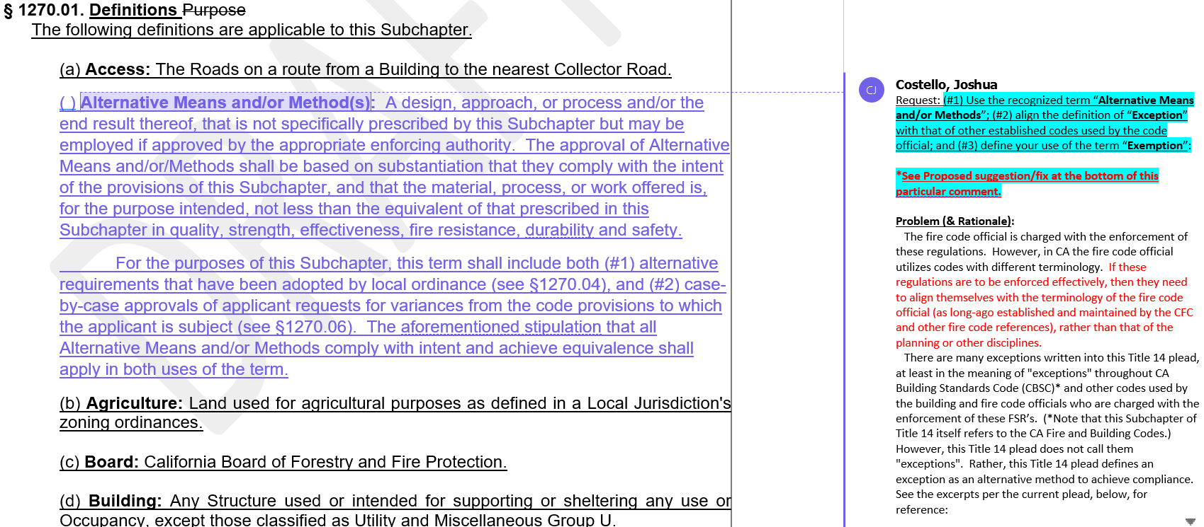
Board response: The Board does not use the term “alternative means and methods” in these regulations, so a definition is not necessary.

Rule text edit: No

Comment W73-4: Los Angeles County Fire Department
Board response: The Board is no longer proposing a definition for “clear width,” consistent with the narrowed scope of the proposed action as identified within the Supplemental Statement of Reasons published with the “Second 15-Day Notice of Addition of Documents and Information to Rulemaking File and Modified Text” on May 10, 2022. The comment is not specifically directed at the Board’s proposed action or to the procedures followed by the Board in proposing the action.

Rule text edit: No

Comment W73-5: Los Angeles County Fire Department

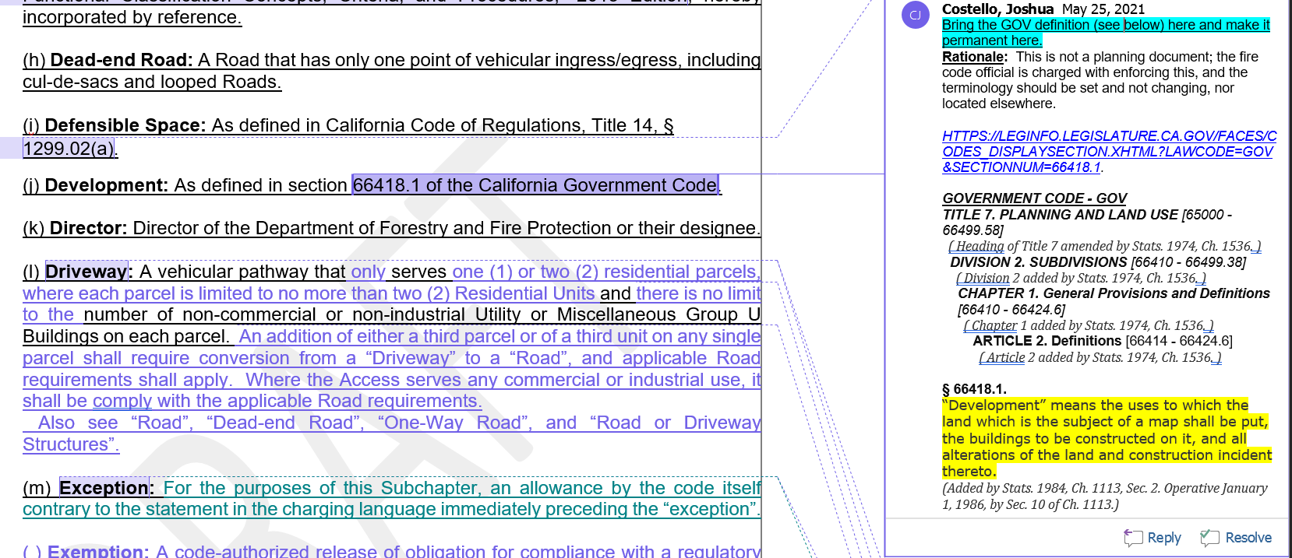
Board response: The Board is not proposing changes to the definition of “development.” The comment is not specifically directed at the Board’s proposed action or to the procedures followed by the Board in proposing the action.

Rule text edit: No

Comment W73-6: Los Angeles County Fire Department
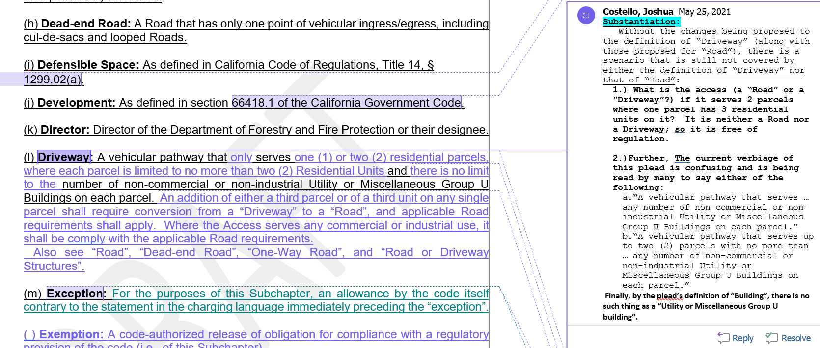

Board response: The Board is proposing to revise the definition of “Driveway” to delete references to the number of parcels a driveway might serve. This reduces confusion and adds clarity regarding when a vehicular pathway is required to meet the standards for roads versus driveways. The letter writer’s proposal does not provide greater clarity than the Board’s proposal.

Rule text edit: No

Comment W73-7: Los Angeles County Fire Department
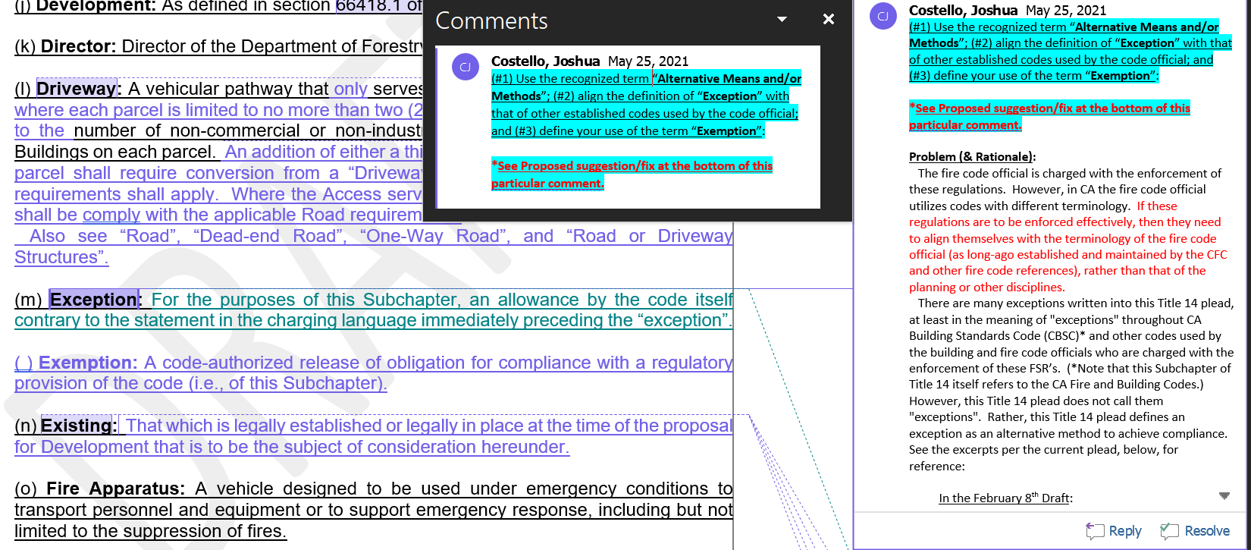
Board response: The Board is not proposing changes to the definition of “exception” and is not proposing to adopt a definition for “exemption.” The term “exemption” is used once in these regulations and the context for its use provides sufficient clarity to the regulated public regarding how the term is used. A definition is not necessary to effectuate the purpose of 1270.05(c).

Rule text edit: No

Comment W73-8: Los Angeles County Fire Department
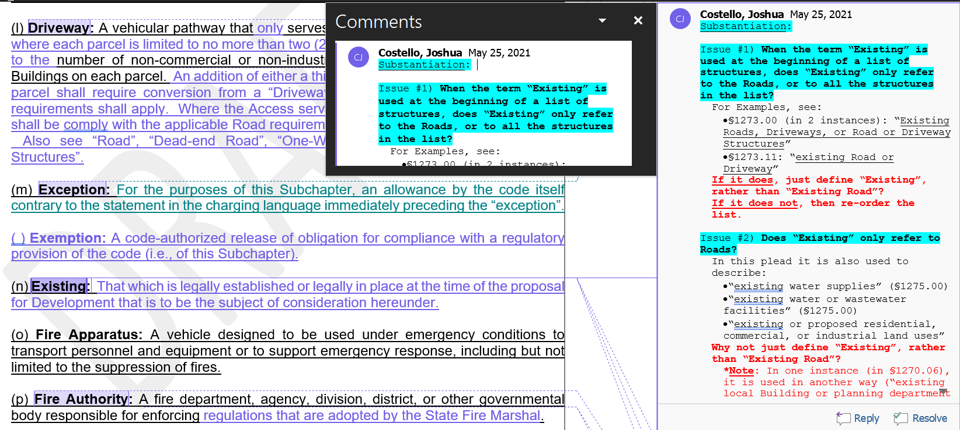
Board response: The Board is no longer proposing a definition for the term “existing,” consistent with the narrowed scope of the proposed action as identified within the Supplemental Statement of Reasons published with the “Second 15-Day Notice of Addition of Documents and Information to Rulemaking File and Modified Text” on May 10, 2022. The comment is not specifically directed at the Board’s proposed action or to the procedures followed by the Board in proposing the action.

Rule text edit: No

Comment W73-9: Los Angeles County Fire Department
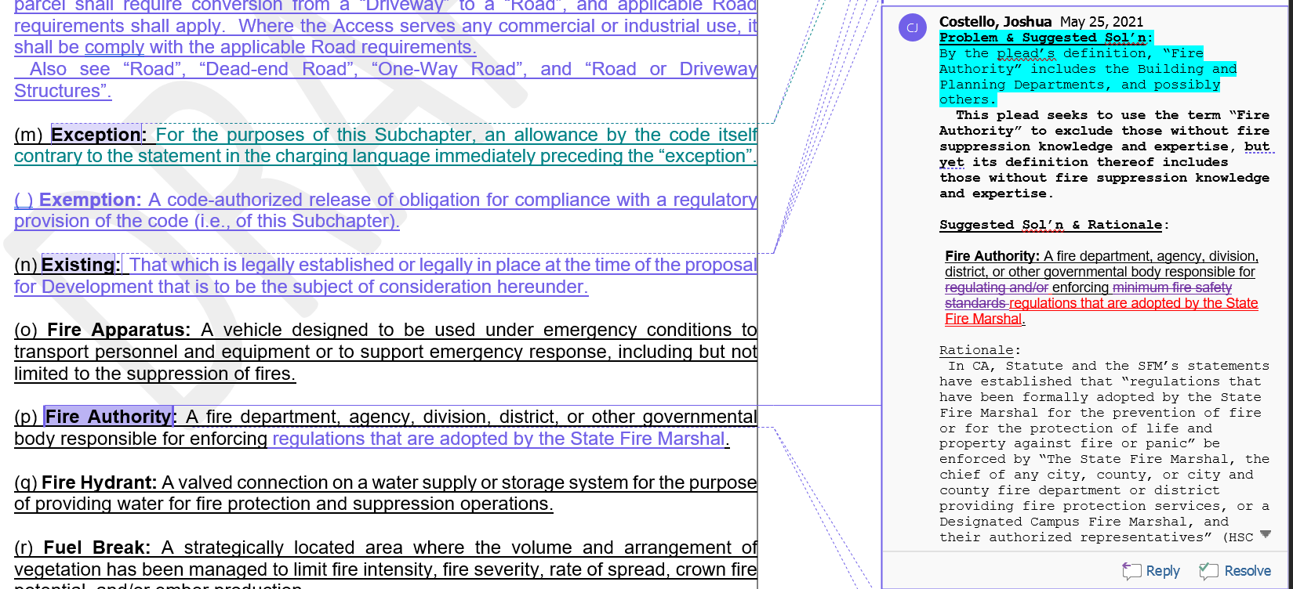
Board response: It is outside the scope of these regulations to define the government agency who is responsible for enforcing regulations adopted by the State Fire Marshal. The definition of “fire authority” includes governmental bodies responsible for regulating or enforcing minimum fire safety standards, as those are the regulations adopted by the Board (PRC 4290(a) “The board shall adopt regulations implementing minimum fire safety standards…”).

Rule text edit: No

Comment W73-10: Los Angeles County Fire Department
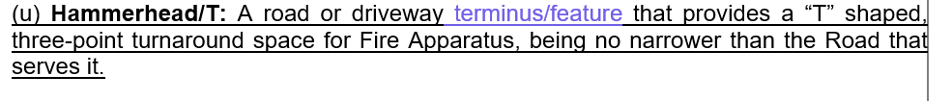
Board response: The Board is proposing to rephrase the definition of “hammerhead/T” for greater clarity. This proposal does not add greater clarity than that proposed by the Board in the proposed rule text.

Rule text edit: No

Comment W73-11: Los Angeles County Fire Department
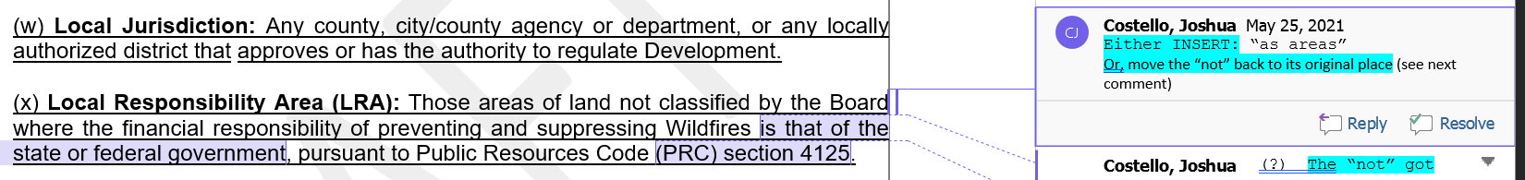
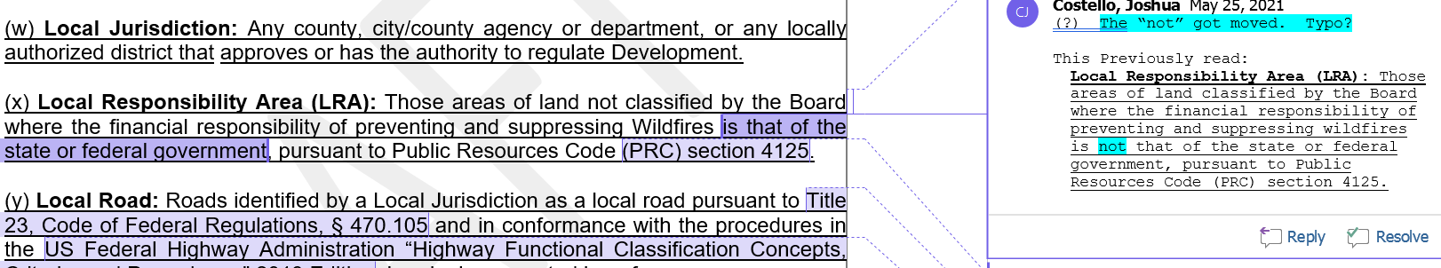
Board response: The Board is no longer proposing to adopt a definition for “Local Responsibility Area,” consistent with the narrowed scope of the proposed action as identified within the Supplemental Statement of Reasons published with the “Second 15-Day Notice of Addition of Documents and Information to Rulemaking File and Modified Text” on May 10, 2022. The comment is not specifically directed at the Board’s proposed action or to the procedures followed by the Board in proposing the action.

Rule text edit: No

Comment W73-12: Los Angeles County Fire Department
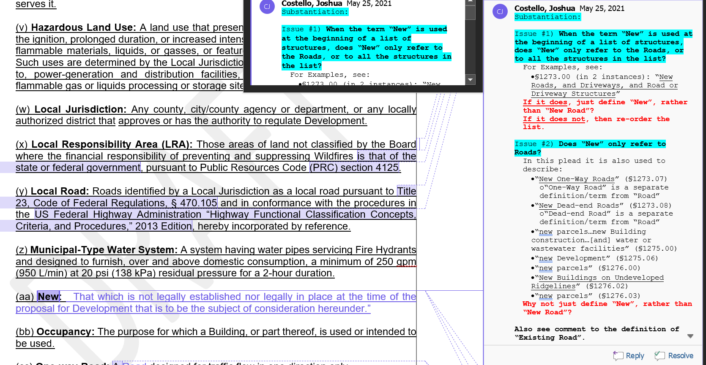
Board response: The Board is not proposing to adopt a definition for the term “new,” consistent with the narrowed scope of the proposed action as identified within the Supplemental Statement of Reasons published with the “Second 15-Day Notice of Addition of Documents and Information to Rulemaking File and Modified Text” on May 10, 2022. The comment is not specifically directed at the Board’s proposed action or to the procedures followed by the Board in proposing the action.

Rule text edit: No

Comment W73-13: Los Angeles County Fire Department
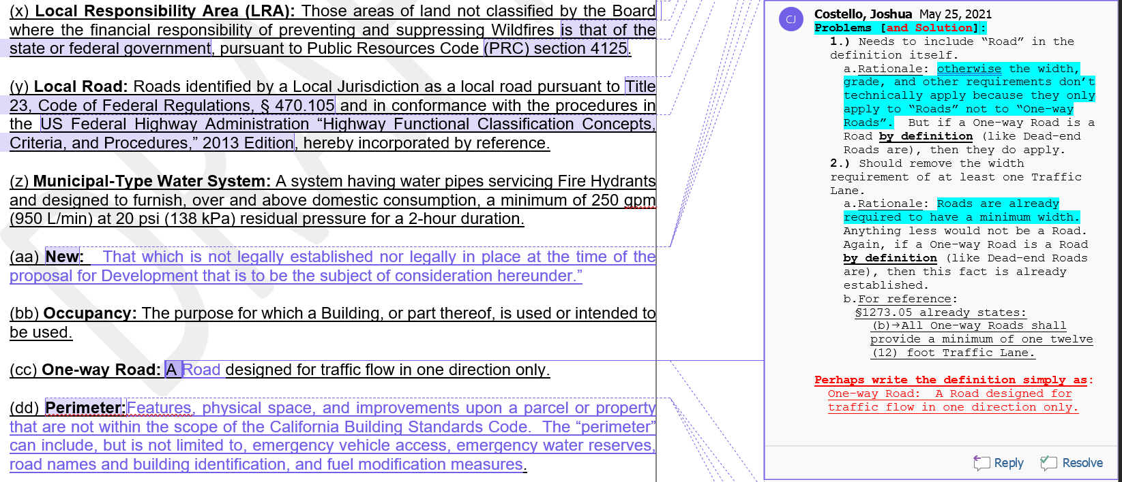
Board response: The Board proposed to adopt this change in the 15 day noticed rule text published May 10, 2022.

Rule text edit: Yes

Comment W73-14: Los Angeles County Fire Department
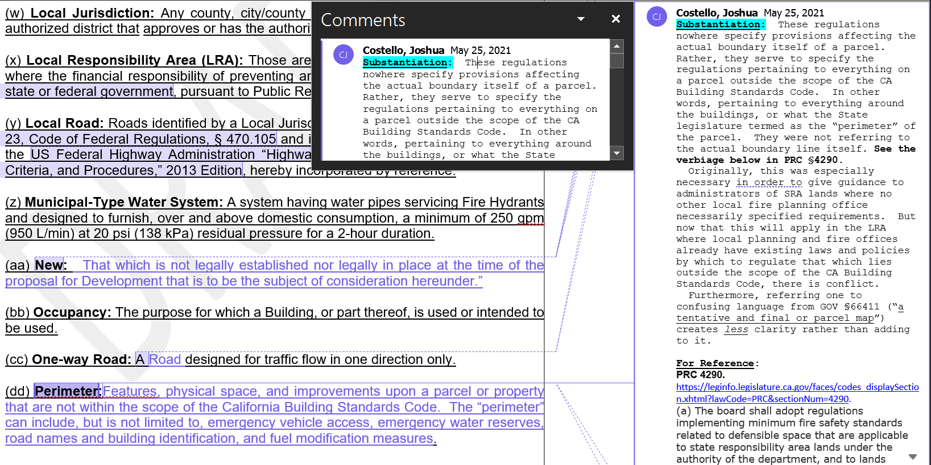
Board response: The Board is no longer proposing a definition for “perimeter,” consistent with the narrowed scope of the proposed action as identified within the Supplemental Statement of Reasons published with the “Second 15-Day Notice of Addition of Documents and Information to Rulemaking File and Modified Text” on May 10, 2022. The comment is not specifically directed at the Board’s proposed action or to the procedures followed by the Board in proposing the action.

Rule text edit: No

Comment W73-15: Los Angeles County Fire Department
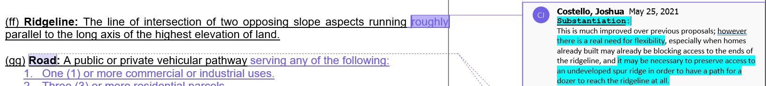
Board response: The Board proposed a change to the definition of “ridgelines” to include “or an area of higher ground separating two adjacent streams or watersheds,” which would capture the situation described by the letter writer.

Rule text edit: No

Comment W73-16: Los Angeles County Fire Department
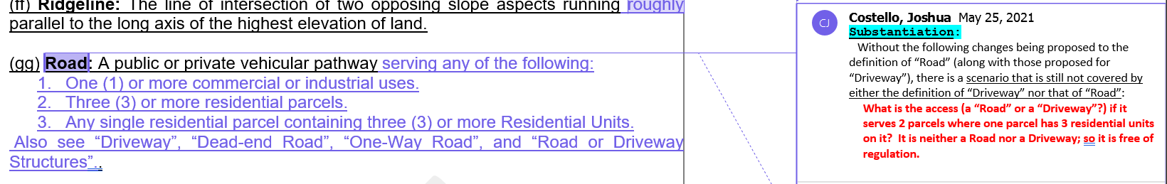
Board response: The Board is proposing to delete references to parcels in the definition of “road” and “driveway,” which addresses the letter writer’s concern.

Rule text edit: No

Comment W73-17: Los Angeles County Fire Department
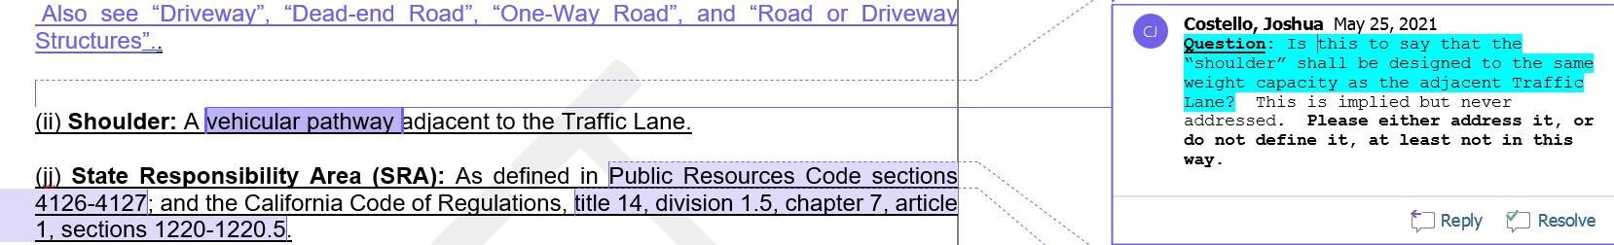
Board response: The Board does not propose any specific standards for shoulders. The Board is not proposing any changes to the definition of “Road or driveway structures.”

Rule text edit: No

Comment W73-18: Los Angeles County Fire Department
The letter writer proposes to delete the term “substantial compliance”

Board response: The Board is no longer proposing to adopt a definition for “substantial compliance,” consistent with the narrowed scope of the proposed action as identified within the Supplemental Statement of Reasons published with the “Second 15-Day Notice of Addition of Documents and Information to Rulemaking File and Modified Text” on May 10, 2022. The comment is not specifically directed at the Board’s proposed action or to the procedures followed by the Board in proposing the action.

Rule text edit: No

Comment W73-19: Los Angeles County Fire Department

Board response: The Board is not proposing changes to the definition of “traffic lane.”

Rule text edit: No

Comment W73-20: Los Angeles County Fire Department
Board response: The Board proposes to delete this sentence from the definition of Turnaround in the 15 day notice of proposed rulemaking published on May 10, 2022.

Rule text edit: No

Comment W73-21: Los Angeles County Fire Department
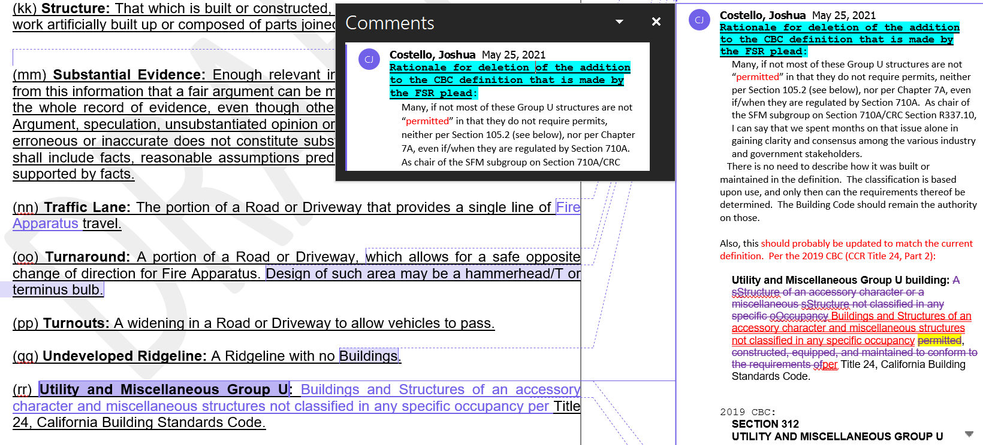
Board response: The Board is not proposing any changes to the definition of “Utility and Miscellaneous Group U.”

Rule text edit: No

Comment W73-22: Los Angeles County Fire Department
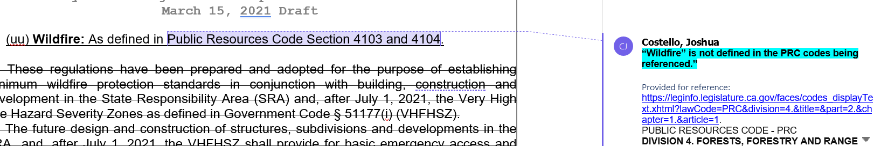
Board response: The Board proposes to revise the definition of “wildfire” to address the letter writer’s concern.

Rule text edit: Yes

Comment W73-23: Los Angeles County Fire Department
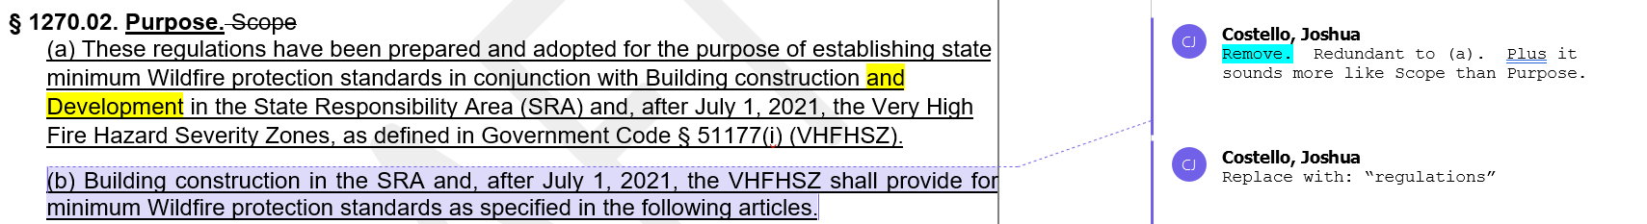
Board response: The Board is no longer proposing changes to 1270.02(b), consistent with the narrowed scope of the proposed action as identified within the Supplemental Statement of Reasons published with the “Second 15-Day Notice of Addition of Documents and Information to Rulemaking File and Modified Text” on May 10, 2022. The comment is not specifically directed at the Board’s proposed action or to the procedures followed by the Board in proposing the action.

Rule text edit: No

Comment W73-24: Los Angeles County Fire Department
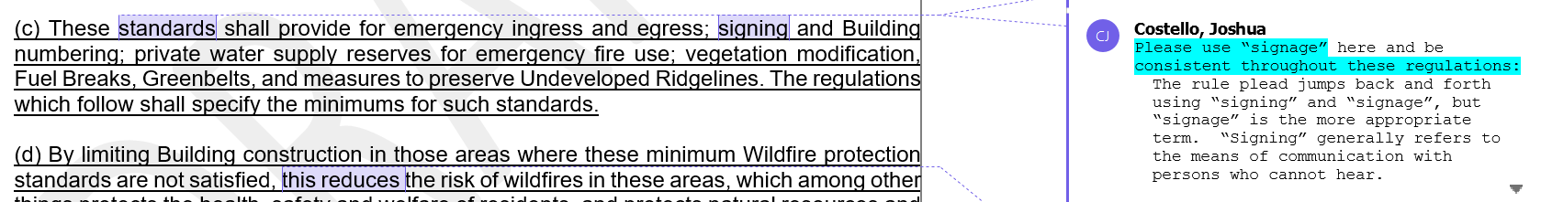
Board response: The Board is only proposing changes to 1270.02(c) necessary to include the new standards for fuel breaks and ridgelines, consistent with the narrowed scope of the proposed action as identified within the Supplemental Statement of Reasons published with the “Second 15-Day Notice of Addition of Documents and Information to Rulemaking File and Modified Text” on May 10, 2022. The comment is not specifically directed at the Board’s proposed action or to the procedures followed by the Board in proposing the action.

Rule text edit: No

Comment W73-25: Los Angeles County Fire Department
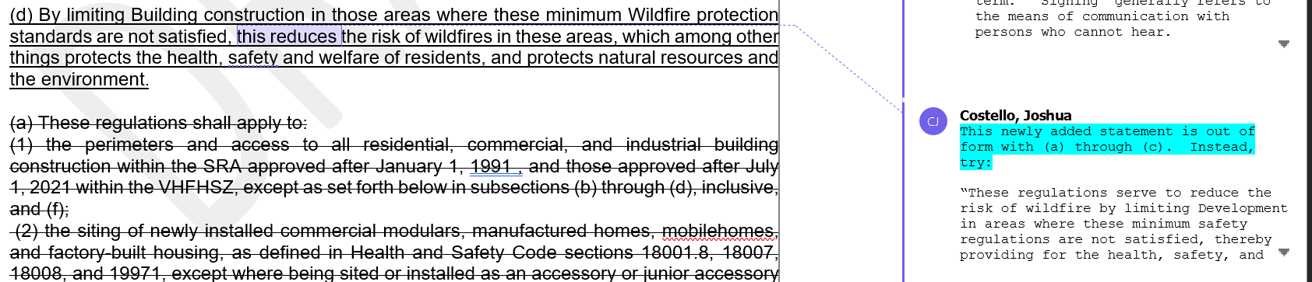
Board response: The Board proposes to adopt similar language as the letter writer in 1270.02(d) in the 15 day noticed rule text published on May 10, 2022.

Rule text edit: Yes

Comment W73-26: Los Angeles County Fire Department
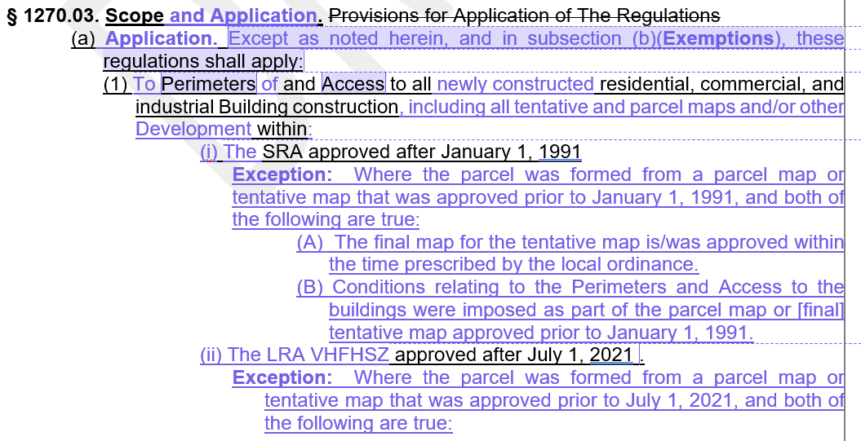
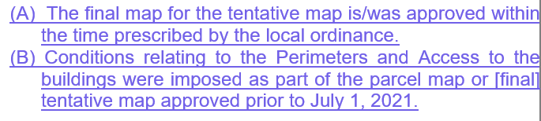
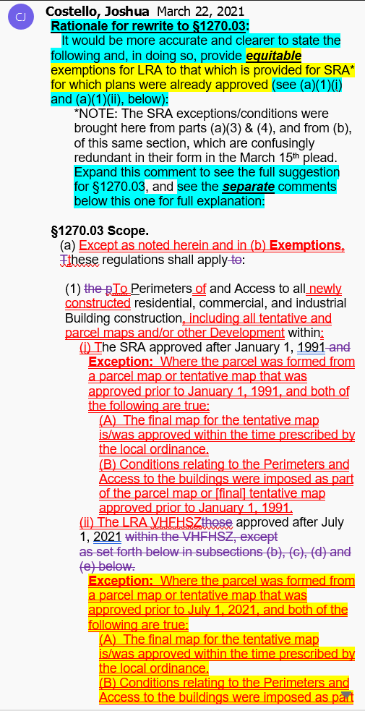
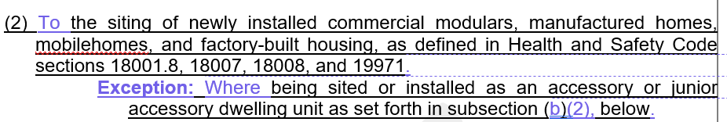
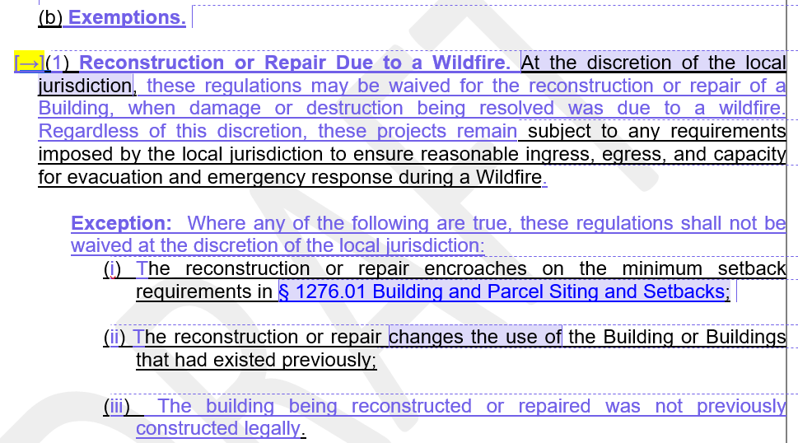
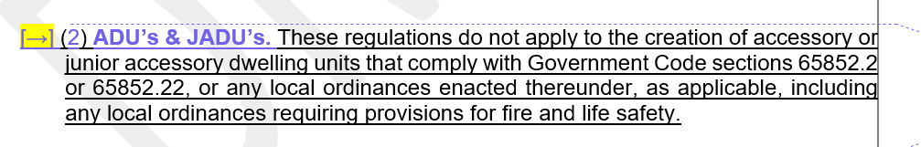
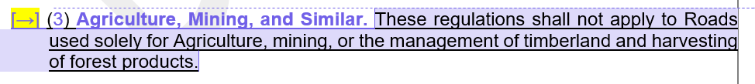
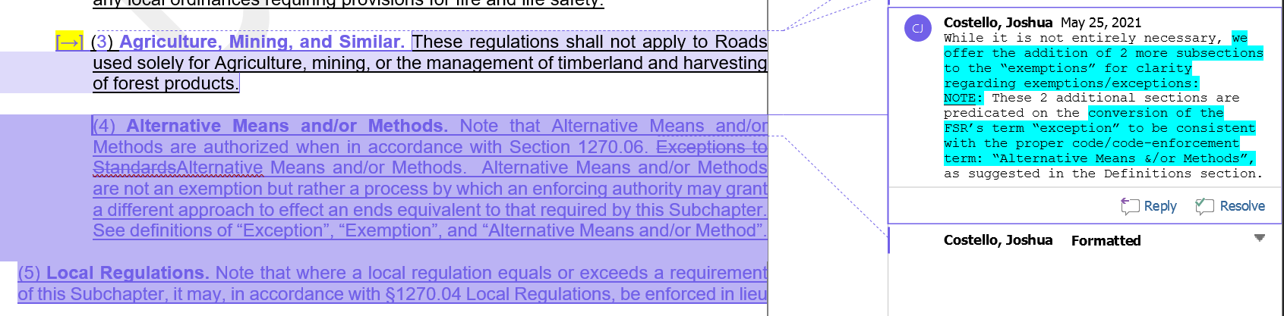
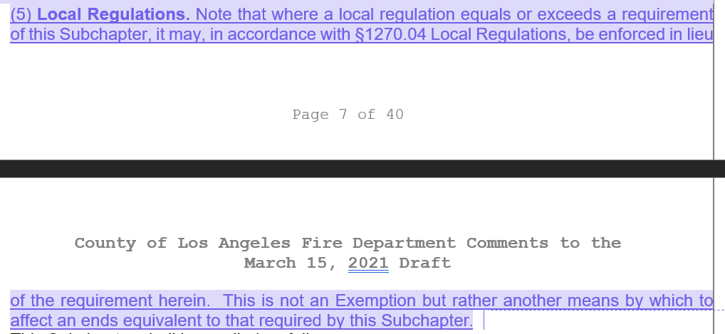
Board response: The Board is no longer proposing changes to 1270.03, consistent with the narrowed scope of the proposed action as identified within the Supplemental Statement of Reasons published with the “Second 15-Day Notice of Addition of Documents and Information to Rulemaking File and Modified Text” on May 10, 2022. The comment is not specifically directed at the Board’s proposed action or to the procedures followed by the Board in proposing the action. The regulatory exemption for wildfire rebuilds and ADUs was a previous emergency regulatory action and is outside the scope of the proposed action. Please see General Response to Exceptions and Exemptions Comments. The comment is not specifically directed at the Board’s proposed action or to the procedures followed by the Board in proposing the action.

Rule text edit: No

Comment W73-27: Los Angeles County Fire Department
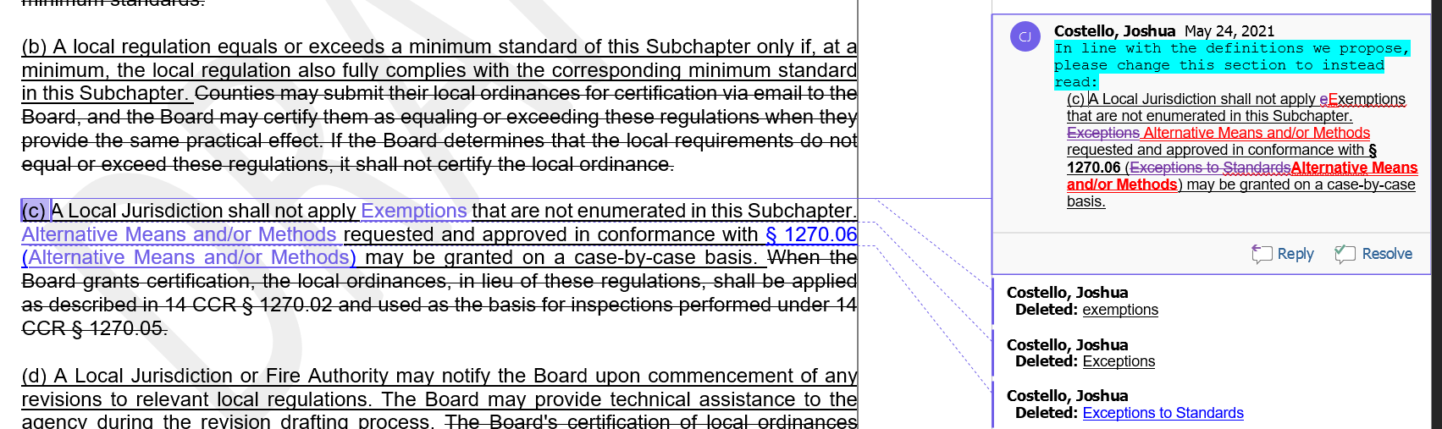
Board response: The Board is not proposing definitions for the terms “exemptions,” “alternative means and/or methods,” “perimeters,” or “access.” The use of those terms in these sections, as proposed by the letter writer, does not provide any additional clarity to these proposed sections.

Rule text edit: No

Comment W73-28: Los Angeles County Fire Department
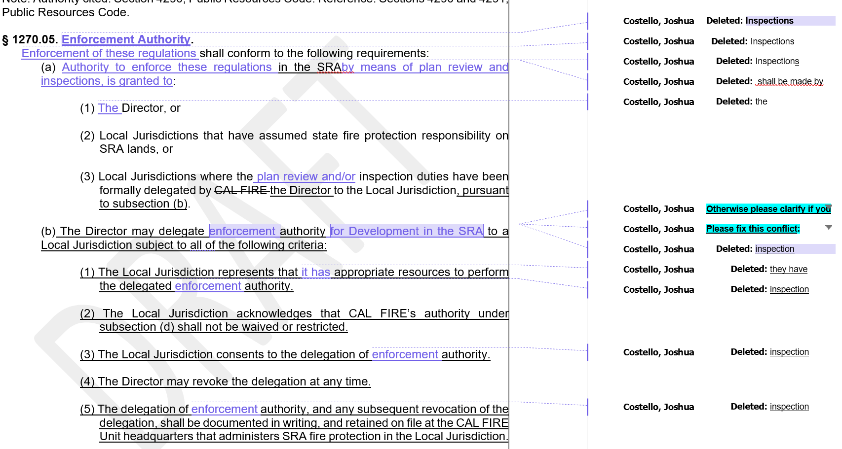
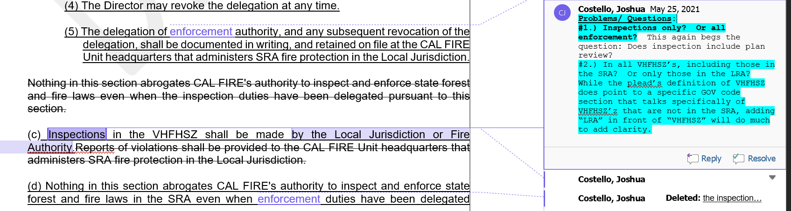
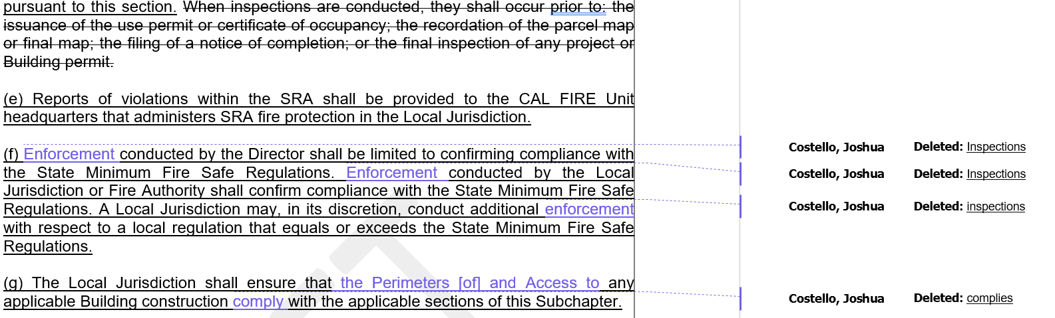
Board response: The Board is not proposing changes to 1270.06 Inspections, consistent with the narrowed scope of the proposed action as identified within the Supplemental Statement of Reasons published with the “Second 15-Day Notice of Addition of Documents and Information to Rulemaking File and Modified Text” on May 10, 2022. The comment is not specifically directed at the Board’s proposed action or to the procedures followed by the Board in proposing the action.

Rule text edit: No

Comment W73-29: Los Angeles County Fire Department
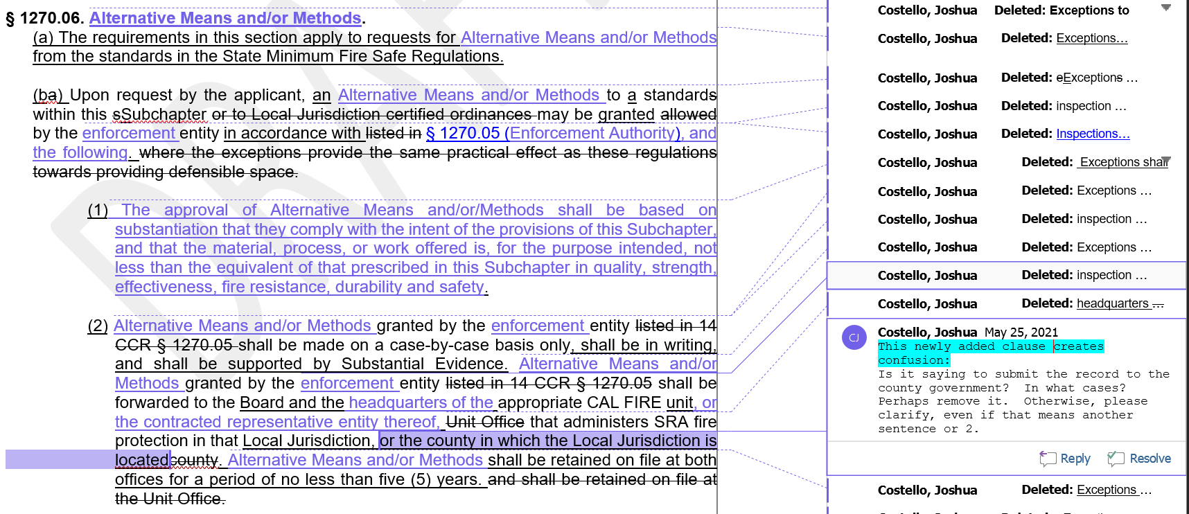
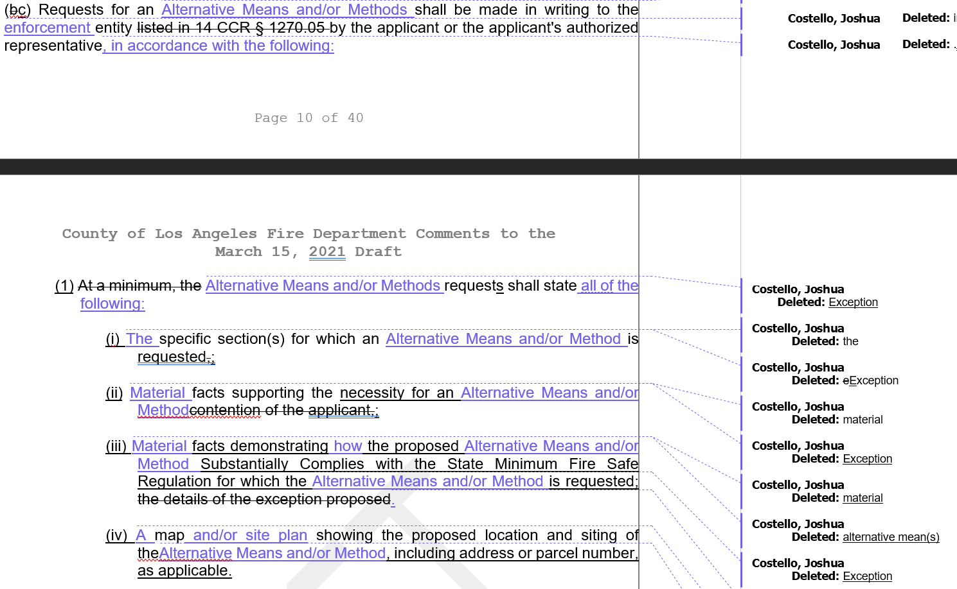
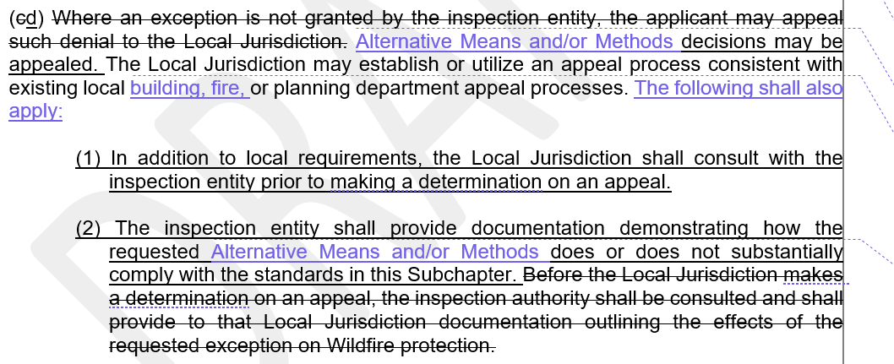
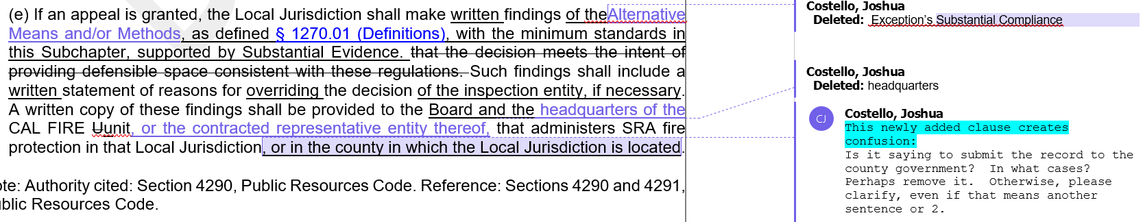
Board response: The Board is not proposing changes to 1270.07 Inspections, consistent with the narrowed scope of the proposed action as identified within the Supplemental Statement of Reasons published with the “Second 15-Day Notice of Addition of Documents and Information to Rulemaking File and Modified Text” on May 10, 2022. The comment is not specifically directed at the Board’s proposed action or to the procedures followed by the Board in proposing the action.

Rule text edit: No

Comment W73-30: Los Angeles County Fire Department
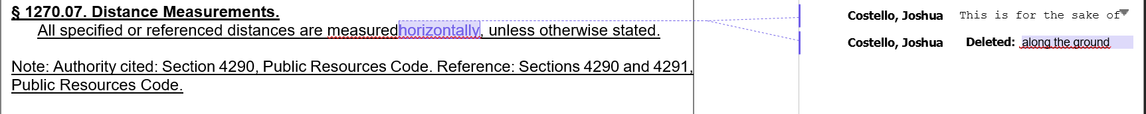
Board response: The Board is not proposing changes to 1270.08.

Rule text edit: No

Comment W73-31: Los Angeles County Fire Department
The comments on pp. 12-47 of the rule text portion of this letter are limited in scope to Articles 2-4 of the regulation. The Board is no longer proposing to revise Articles 2-4, consistent with the narrowed scope of the proposed action as identified within the Supplemental Statement of Reasons published with the “Second 15-Day Notice of Addition of Documents and Information to Rulemaking File and Modified Text” on May 10, 2022. The comment is not specifically directed at the Board’s proposed action or to the procedures followed by the Board in proposing the action.

Comment W73-32: Los Angeles County Fire Department
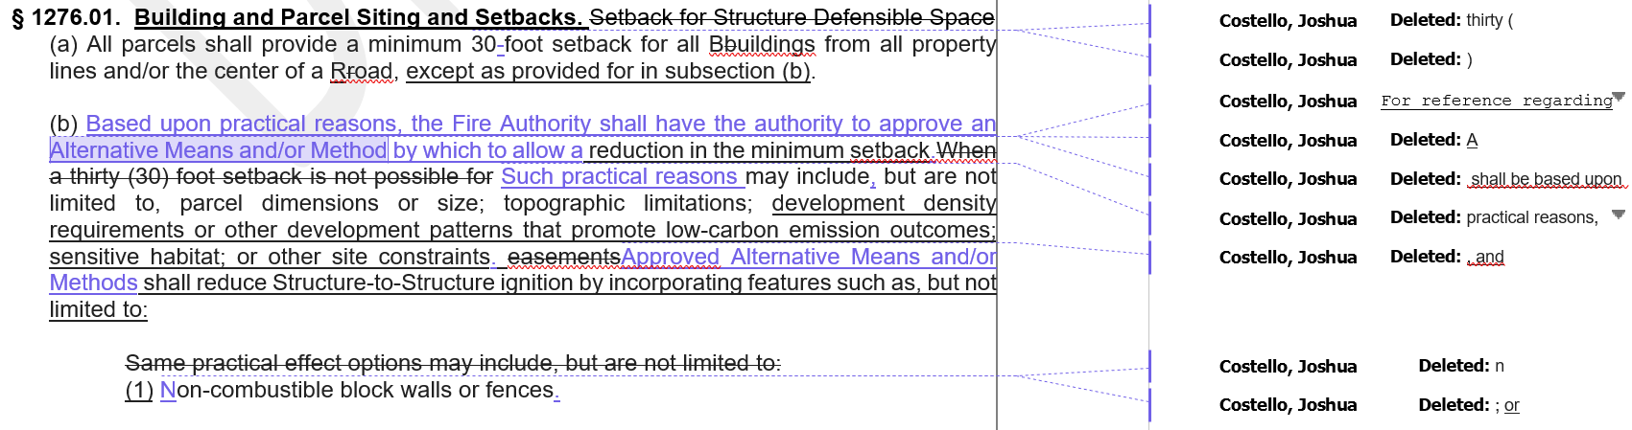
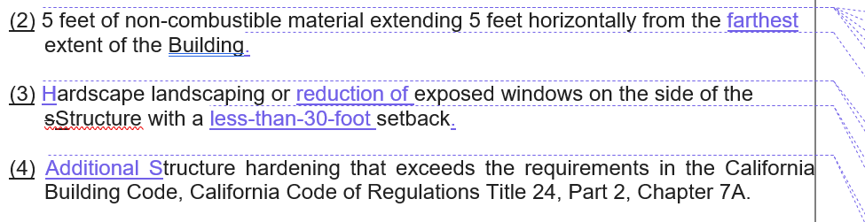
Board response: The Board is not proposing a definition for the term “alternative means and/or methods,” so it’s use in these sections does not provide additional clarity. The Board revised 1276.01 to resolve the issues of clarity raised here by the letter writer.

Rule text edit: Yes

Comment W73-33: Los Angeles County Fire Department
1276.02. Ridgelines.
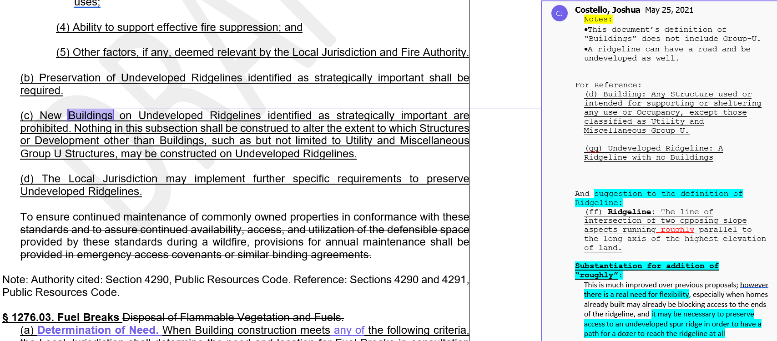
Board response: The comment is not specifically directed at the Board’s proposed action or to the procedures followed by the Board in proposing the action.

Rule text edit: No

Comment W73-34: Los Angeles County Fire Department
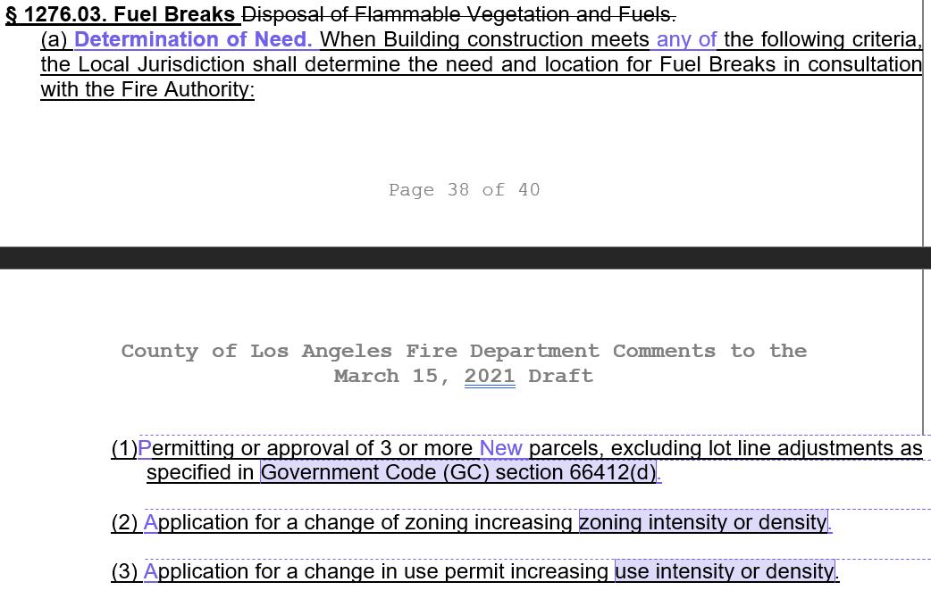
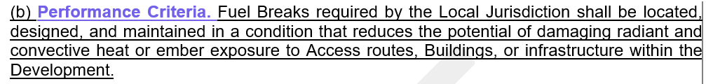
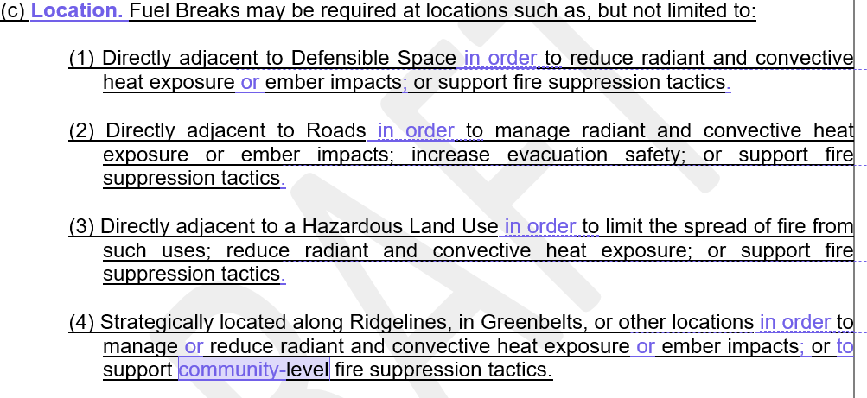
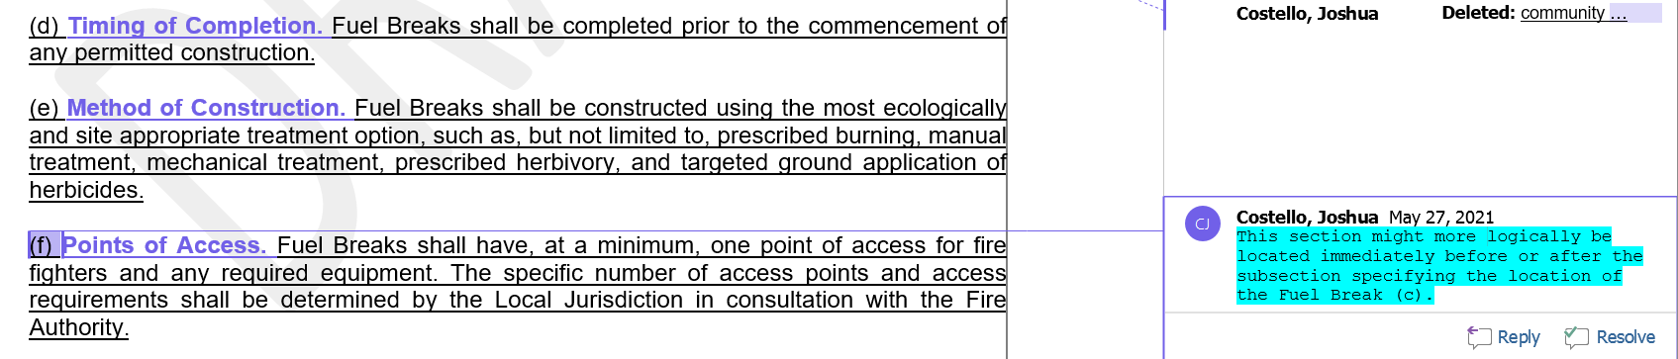
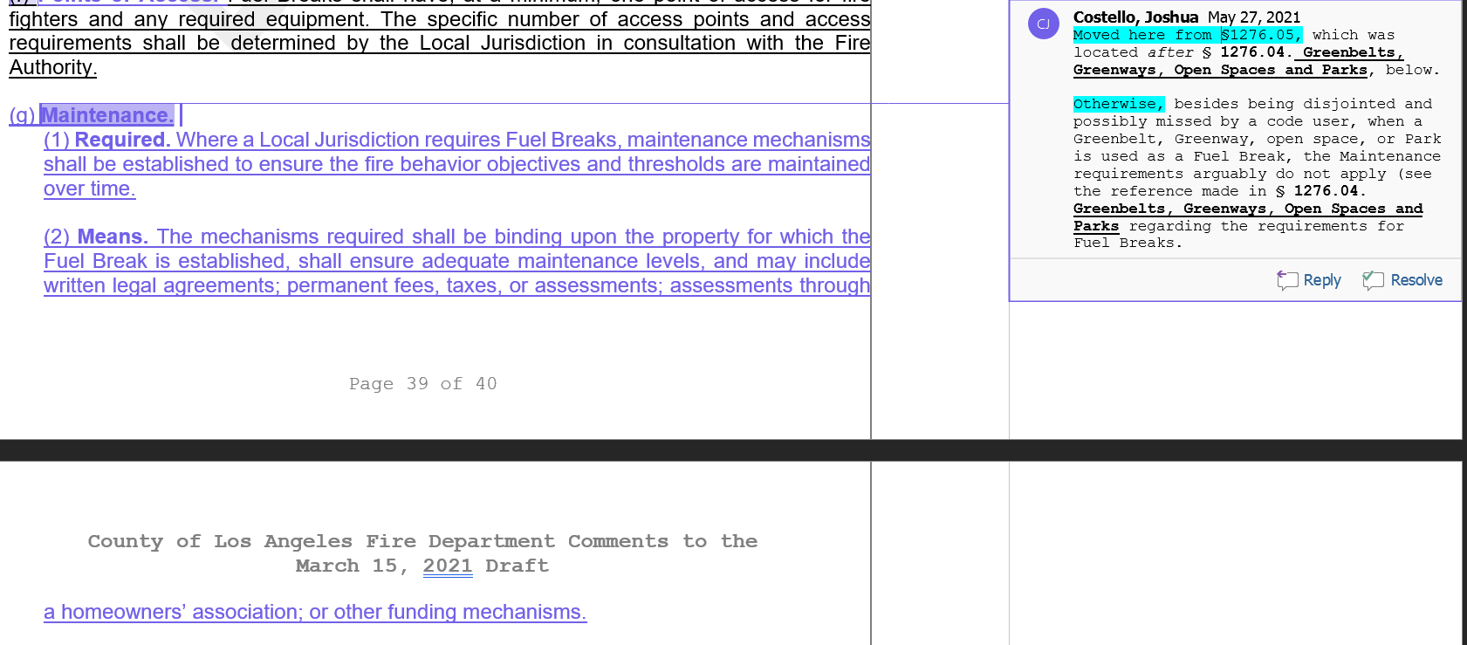
Board response: These changes are purely stylistic and does not add any additional clarity to the proposed rulemaking.

Rule text edit: No

Comment W73-35: Los Angeles County Fire Department
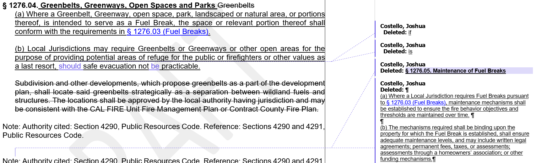
Board response: The Board is no longer proposing to adopt 1276.04(b).

Rule text edit: No

Comment W73-36: Los Angeles County Fire Department
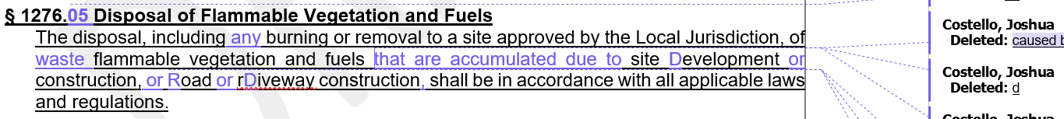
Board response: These changes are purely stylistic and does not add any additional clarity to the proposed rulemaking.

Rule text edit: No

Comment W74-1: Wanger Jones Helsley, PC
via the Rural County Representatives of California

The proposed action has been substantially changed, in accordance with the narrowed scope of the proposed action as identified within the Supplemental Statement of Reasons published with the “Second 15-Day Notice of Addition of Documents and Information to Rulemaking File and Modified Text” on May 10, 2022, and these changes have resolved the commenter’s objections and recommendations. These comments are not specifically directed at the Board’s amended proposed action or to the procedures followed by the Board in proposing the action. Further, in its comments dated May 27, 2022, to the amended proposed action, the commenter raised no objections or recommendations and “urge[d] the Board to adopt the current draft” of the “State Minimum Fire Safe Regulations, 2021.” (See response to W230)

Comment W75-1: Channel Law Group
The Board is no longer proposing revisions to the prescriptive or performance standards related to Safe Access and Egress, Road Width, Dead-end Roads, Road Surface, Road Grade, Road, Curve Radius, Turnarounds, Turnouts, One-way Roads, Bridges or Elevated Structures on Roads and Driveways, or a distinction between “new” and “existing” roads consistent with the narrowed scope of the proposed action as identified within the Supplemental Statement of Reasons published with the “Second 15-Day Notice of Addition of Documents and Information to Rulemaking File and Modified Text” on May 10, 2022. These comments are not specifically directed at the Board’s proposed action or to the procedures followed by the Board in proposing the action.

The regulatory exemption for wildfire rebuilds and ADUs was a previous emergency regulatory action and is outside the scope of the proposed action. Please see General Response to Exceptions and Exemptions Comments.

The Board has conducted all aspects of the proposed action in compliance with the Administrative Procedure Act, including the consideration of alternatives to the prosed action, including any that may lessen any adverse impact on a small business. As identified within the Notice of Proposed Action (as published within the California Regulatory Notice Register 2021, Number 17-Z), no reasonable alternative considered by the Board or that has otherwise been identified and brought to the attention of the agency would be more effective in carrying out the purpose for which the action is proposed, would be as effective and less burdensome to affected private persons than the proposed action, or would be more cost effective to affected private persons and equally effective in implementing the statutory policy or other provision of law.

The comment additionally provides attachments which appear to be intended to supplement the above comment, but which are not specifically directed at the Board’s proposed action or to the procedures followed by the Board in proposing the action.

See also General Response to Comments Regarding Existing Roads and General Response to California Environmental Quality Act (CEQA) Comments.

Comment W76-1: Fire Safe Council for Monterey County
The Fire Safe Council for Monterey County (FSCMC} is a non-profit that serves our local communities and individual property owners by creating awareness, presenting information, facilitating access to available resources and providing assistance with coordinating efforts to better prepare for wildfire. FSCMC has joined forces with the National Fire Protection Association's Firewise USA• recognition program to help neighbors to reduce wildfire risks at the local level.

FSCMC respectfully submits that the Board's proposed fire safe regulations are unnecessarily prohibitive, and do not consider the multitude of measures that are available to our communities to successfully reduce wildfire risk. Of utmost concern is that the regulations are punitive in nature since the rigidity of these regulations would prohibit development in our communities and would open a floodgate of takings claims. For example, to require that small businesses or individuals seeking to build on existing lots of record to also improve off-site roads is an overwhelming burden.

Moreover, the proposed regulations undermine the State's own existing regulations by failing to make exception for property owners or small businesses that have properties within already approved subdivisions that fully complied with the State's existing regulations. How can the Board place on individual homeowners and businesses the impossible task of building or improving offsite roads especially when those offsite roads meet current standards?

The regulations must exempt existing lots of record, or at the very least establish a mechanism that scales any road, or offsite, improvement requirements to the size of a project. California law is well established regarding proportionality and fair share requirements.

Therefore, we strongly urge the Board to limit application of any proposed regulations to new subdivisions or new large developments.

If you feel compelled to adopt some new regulations for existing undeveloped lots of record, you must limit the scope of any new regulations so that any requirements for property owners or small businesses on existing lots of record include only onsite improvements (i.e. onsite fuel reduction or fire breaks, home hardening).

Board response: The Board is not proposing changes to the applicability of these regulations, consistent with the narrowed scope of the proposed action as identified within the Supplemental Statement of Reasons published with the “Second 15-Day Notice of Addition of Documents and Information to Rulemaking File and Modified Text” on May 10, 2022.

Rule text edit: No

Comment W76-2: Fire Safe Council for Monterey County
We also consider it essential that the Board provide greater flexibility in its regulations. A "one-size-fits-all" approach is simply unachievable. Please allow our neighborhoods to continue to work together with fire officials to obtain their own wildfire risk assessment and to pursue an action plan that addresses specific needs of the neighborhood to make their properties safer during wildfire season. Also, please consider that the addition of a new home in a rural community may actually improve the ability to fight fires in an existing rural community. The current standards and requirements are much greater, currently, than standards were decades ago, so it is often the case that a new home in an existing rural community could actually increase the ability for fire personnel to defend that existing community.
Finally, by considering new regulations to be applied only to new subdivisions, and by allowing greater flexibility towards the achievement of greater safety, these will serve the legislative purpose of addressing wildfire risk in a manner that does not frustrate the Legislature's mandate to address the housing needs in our State.
The Board must recognize that elimination of wildfire risk in SRA and LRA areas is not possible. However, regulations that consider the level of risk (i.e. medium, high and very high-risk areas), and the variety of factors creating such risks, and the variety of measures available to reduce such risks, will prove to be a more successful approach to creating safer communities and more diverse environment.
Thank you for this opportunity to provide comment. We are in this effort together. Please work with us, with the communities throughout California, as we all continue to reduce the risk to loss of life and property due to wildfire.

Board response: PRC 4290 authorizes the Board to write “minimum standards…applicable to all construction.” The most practical way to implement this statute is to develop statewide minimum standards while allowing local jurisdictions to writer stricter standards if they prefer. This establishes a known safety baseline that is achieved across the state. For situations such as historical monuments, topography, or easements, the exception process within revised § 1270.07 allows for a case-by-case exclusion from the Fire Safe Regulations.

Rule text edit: No

Comment W77-1: Doug LaMalfa and Tom McClintock

The first four paragraphs and last paragraph of this letter are introductory/conclusive in nature; the comments are not specifically directed at the Board’s proposed action or to the procedures followed by the Board in proposing the action.
Additionally, serious concerns have been raised regarding the ability for rural areas to comply with the following regulation changes:
- Except where exempt, all new building construction must comply, and the proposed regulations would make many by-right uses unable to proceed.
- Exemptions only apply for Wildfire rebuilds, but other disasters such as individual fires, earthquakes, and other types of disasters cause the need for rebuilds.
- Exemptions are allowed only when there is substantial compliance and must be filed with both the BOF and Cal Fire without clear understanding of the review or comment period or other requirements for this action.
Board response: The Board is not proposing changes to the applicability of these regulations described above, consistent with the narrowed scope of the proposed action as identified within the Supplemental Statement of Reasons published with the “Second 15-Day Notice of Addition of Documents and Information to Rulemaking File and Modified Text” on May 10, 2022.

The regulatory exemption for wildfire rebuilds was a previous emergency regulatory action and is outside the scope of the proposed action. Please see General Response to Exceptions and Exemptions Comments.

The Board is no longer proposing to use the term “substantial compliance,” consistent with the narrowed scope of the proposed action as identified within the Supplemental Statement of Reasons published with the “Second 15-Day Notice of Addition of Documents and Information to Rulemaking File and Modified Text” on May 10, 2022.

Rule text edit: No

Comment W77-2: Doug LaMalfa and Tom McClintock
Applies to all new roads and driveways, as well as existing roads and driveways that: (1) involve parcel splits or LLAs that serve 3 or more parcels; (2) involve a zone change that increases intensity or density; or (3) involves a use permit that increases density or intensity. This is a substantial change from existing regulations and has potentially significant consequences.

Building construction is prohibited where roads do not meet the minimum requirements without consideration for existing conditions or funding for the maintenance and improvements that these regulations would place on local jurisdictions and landowners.
Board response: The Board is no longer proposing changes to the road standards or their applicability, consistent with the narrowed scope of the proposed action as identified within the Supplemental Statement of Reasons published with the “Second 15-Day Notice of Addition of Documents and Information to Rulemaking File and Modified Text” on May 10, 2022.
Rule text edit: No

Comment W77-3: Doug LaMalfa and Tom McClintock
Page 2 of this letter contains comments that are limited in scope to Articles 2-4 of the regulation. The Board is no longer proposing to revise Articles 2-4, consistent with the narrowed scope of the proposed action as identified within the Supplemental Statement of Reasons published with the “Second 15-Day Notice of Addition of Documents and Information to Rulemaking File and Modified Text” on May 10, 2022.

Comment W77-4: Doug LaMalfa and Tom McClintock
All parcels shall have a minimum 30-foot rear, side, and front yard setback; unless non- combustible walls, non-vegetated landscaping, and/or other fire hardening. The current language is vague and could result in delays in reviews and unclear direction to the public as to what they must do.

Board response: The letter writer’s suggestions are reflected in the version of the rule text published for 15-day noticing on May 10, 2022.

Rule text edit: Yes

Comment W77-5: Doug LaMalfa and Tom McClintock

The cost of the improvements and associated CEQA review for improvements that would be required for off-site for projects subject to the proposed regulations would be extremely costly further exacerbate the lack and affordability of housing across California.

Board response: The Board is no longer proposing changes to the road standards or their applicability, consistent with the narrowed scope of the proposed action as identified within the Supplemental Statement of Reasons published with the “Second 15-Day Notice of Addition of Documents and Information to Rulemaking File and Modified Text” on May 10, 2022.

Rule text edit: No

Comment W78-1: George Caloyannidis
The first paragraph of this letter is introductory/conclusive in nature; the comments are not specifically directed at the Board’s proposed action or to the procedures followed by the Board in proposing the action.

This letter includes comments on pp.1-3 that are limited in scope to Articles 2-4 of the regulation. The Board is no longer proposing to revise Articles 2-4, consistent with the narrowed scope of the proposed action as identified within the Supplemental Statement of Reasons published with the “Second 15-Day Notice of Addition of Documents and Information to Rulemaking File and Modified Text” on May 10, 2022.
EXEMPTIONS:
All existing commercial/industrial permitted facilities as of the adoption of the proposed standards shall be exempt. Facilities which have incurred partial or complete destruction must be permitted to rebuild the same facilities in compliance with their existing use permits at the time of loss.
All additional use permits and improvements to existing facilities must comply with the additional mitigations in these regulations as of the time of their adoption. This shall include projects "in the pipeline".
The Board must consider the enormous fast track permit approvals Napa County has instituted in the past two years. It will help it ascertain the agenda governing its proposed exemptions.

Attachments, pp.5-7: photographs of trucks on roads of various widths.

Board response: The Board is not proposing changes to the applicability of these regulations, consistent with the narrowed scope of the proposed action as identified within the Supplemental Statement of Reasons published with the “Second 15-Day Notice of Addition of Documents and Information to Rulemaking File and Modified Text” on May 10, 2022.

These attachments are not specifically directed at the Board’s proposed action or to the procedures followed by the Board in proposing the action.

Rule text edit: No

Comment W79-1: Robert Peterson
The first three paragraphs of this letter contain comments that are introductory in nature; the comments are either not specific or unnecessarily redundant with more specific comments presented elsewhere in the letter.

For these reasons, I suggest the broadest possible exemption for preexisting
structures. Limiting the exemption only to damage related to wildfires is too narrow and will result in arbitrary distinctions.

If the exemption is to apply only to damage related to “wildfire,” then “wildfire” must
be defined with some precision. Serious consequences flow from whether the damage
relates to a wildfire, some other cause, or a combination of causes.

Board response: The Board is not proposing changes to the applicability of these regulations, consistent with the narrowed scope of the proposed action as identified within the Supplemental Statement of Reasons published with the “Second 15-Day Notice of Addition of Documents and Information to Rulemaking File and Modified Text” on May 10, 2022.

Rule text edit: No

Comment W80-1: Bennett Valley Residents for Fire Safe Development
The first two paragraphs of this letter are introductory/conclusive in nature; the comments are either not specific or unnecessarily redundant with more specific comments presented elsewhere in the letter.

Paragraph 3 of this letter is limited in scope to Articles 2-4 of the regulation. The Board is no longer proposing to revise Articles 2-4, consistent with the narrowed scope of the proposed action as identified within the Supplemental Statement of Reasons published with the “Second 15-Day Notice of Addition of Documents and Information to Rulemaking File and Modified Text” on May 10, 2022.

Local jurisdictions can avoid even the proposed weak standards. The exception process (§ 1270.06) can and has been abused to allow development on roads much narrower than 14 feet— even 10 or fewer feet. Including an exception process in the regulations violates the legislative command in PRC § 4290(a) that directs the BOF to “adopt regulations implementing minimum fire safety standards . . . .” Emphasis added. The proposed rules lack minimum fire safety standards for existing roads, and facilitate development on substandard existing roads.
Any regulatory program needs a robust enforcement mechanism, especially one with a loose exception provision. Without genuine enforcement the regulations, as a practical matter, are mere guidelines or advice. Here there is no real-world enforcement of the regulations. The natural entity to enforce any regulation is the agency that promulgates it. Examples are legion. The federal Environmental Protection Agency enforces its own rules. As does the California Environmental Protection Agency. As does the Bay Area Air Quality Management District.
In § 1270.05(d) of the proposed rules, BOF passes the enforcement buck to Cal Fire. And Cal Fire has a long history, which I have experienced, of steadfastly refusing to enforce the plain meaning of the rules. Cal Fire may be reluctant to step into conflicts with delegated local inspection authorities because Cal Fire officials have to work with them during emergency wildfire situations. This is understandable. Cal Fire said this in the attached September 1, 2020 letter. So why would any responsible regulator establish such an awkward and ill-advised enforcement mechanism? Any situation where the entity that is required by law to enforce a regulation is reluctant to do so because of conflicts of interest is untenable. Yet that’s what the current rules provide. This problem has been raised repeatedly with the BOF, and nothing changes in this proposal.

Board response: The Board is not proposing changes to the applicability of these regulations, consistent with the narrowed scope of the proposed action as identified within the Supplemental Statement of Reasons published with the “Second 15-Day Notice of Addition of Documents and Information to Rulemaking File and Modified Text” on May 10, 2022.

This comment by the letter writer does not include recommendations or objections directed at the proposed rulemaking or the procedures following by the agency in proposing or adopting the action. The Board has no response to the letter writer’s comments regarding enforcement of these regulations, which are beyond the scope of the proposed action as the Board neither implements nor enforces the regulations.

Rule text edit: No

Comment W80-2: Bennett Valley Residents for Fire Safe Development

Paragraph 7 is a discussion of prior correspondence between Bennett Valley Residents for Fire Safe Development, CAL FIRE and the Board of Forestry and Fire Protection and does not provide specific comments on the proposed regulations.

Comment W80-3: Bennett Valley Residents for Fire Safe Development

Effective enforcement is essential, and the rules must be revised to include genuine enforcement.
While not sufficient in itself, I request that the regulations include a provision whereby the prevailing party in an enforcement action can recover reasonable attorneys' fees and costs pursuant to a court order. This would allow ordinary citizens and community groups to enforce the regulations when Cal Fire and the BOF refuse to do so. Allowing a prevailing party to recover attorneys’ fees is common in federal law, including, e.g., the Endangered Species Act (16 U.S.C. § 1540(g)(4)), Clean Air Act (42 U.S.C. § 7607(f)), and Clean Water Act (33 U.S.C.
§ 1365(d)). Even county ordinances contain such provisions. Sonoma County Code § 1-7.2 entitles a prevailing party to attorneys' fees in suits concerning violation of certain building, zoning, and public health regulations.
An attorneys’ fee provision would be of no concern to local jurisdictions that faithfully implement the regulations. Fees are only awarded to prevailing parties. Such a provision benefits this regulatory program because private citizens can force rogue jurisdictions to comply with the regulations without cost to the BOF or Cal Fire.

Board response: Government Code section 11346.9(a)(3) requires a rulemaking agency to submit a final statement of reasons that includes “A summary of each objection or recommendation made regarding the specific adoption, amendment, or repeal proposed, together with an explanation of how the proposed action has been changed to accommodate each objection or recommendation, or the reasons for making no change.” The code continues “This requirement applies only to objections or recommendations specifically directed at the agency’s proposed action or to the procedures followed by the agency in proposing or adopting the action.” This comment by the letter writer does not include recommendations or objections directed at the proposed rulemaking or the procedures following by the agency in proposing or adopting the action. The Board has no response to the comment as the letter writer’s suggestion is outside the scope of the Board’s authority.

Rule text edit: No

Comment W80-4: Bennett Valley Residents for Fire Safe Development

Finally, the Notice of Proposed Action (p. 3), states the purpose of the rule is to “Apply field-tested methods and industry-accepted computer-aided modeling to ingress and egress requirements.” This does not exist in the rule, so far as I can tell, but should be. Please explain what this means. Moreover, the “problem” and “purpose” fail to align on important issues. For example, under purpose “specify the conditions under which an existing road is subject to these minimum fire safety regulations" is not explained. There is no rationale in PRC § 4290 to justify different road standards for existing and new roads. The 1993 Attorney General opinion clearly determined that the regulations apply to existing roads. Neither PRC § 4290 nor the 1993 Attorney General opinion suggested allowing weaker standards for existing roads. PRC § 4290 commands th-levee BOF to promulgate minimum fire safety standards that apply to the perimeters and access for all residential, commercial and industrial building construction. The plain language suggests one minimum, not two or more different minima.

Board response: The Board is no longer proposing to revise the road standards in Article 2, consistent with the narrowed scope of the proposed action as identified within the Supplemental Statement of Reasons published with the “Second 15-Day Notice of Addition of Documents and Information to Rulemaking File and Modified Text” on May 10, 2022.

Rule text edit: No

Comment W81-1: Norman Manzer
I am in receipt of this document sent to you by George Caloyinnidis, PhD., and I wish to support Dr. Caloyinnidis's request of adoption of your proposed State Minimum Fire Safe Regulations. While the County of Napa is not in support of your proposed regulations, as a rural resident of Napa County I urge you to adopt your proposals for the safety of everyone.
Please adopt these regulations as proposed.

Attachment 1: 45-day comment letter from George Caloyannidis.

Board response: Please see response to W78.

Rule text edit: No

Comment W82-1: Mark Barsanti
I am writing in regards to the new draft of the California Fire Safe Standards. I own a rural property in Humboldt Count the intention of building a home on this property. The driveway to my property is located approximately 0.75 miles from Highway 299 along this private road. The private road then reconnects to a different county road 10 miles beyond my driveway. My understanding is that the new fire safe standards will change what is required in terms of grade and width for private roads such as the one leading to my property. I am unclear as to whether the entire road would have to be brought up to this standard or just the portion of the road leading back to the highway. Bringing the 0.75 miles of road back to the highway up to standard would be doable for me, however, the entire 10 mile stretch of road would be cost prohibitive and greatly devalue the property I own. With the housing shortage in California and regulatory climate that already exists, I would encourage the board to strike a balance between fire safety and project cost mitigation as to not further compound the housing and construction obstacles in our State.

Board response: The Board is no longer proposing to revise the road standards in Article 2, consistent with the narrowed scope of the proposed action as identified within the Supplemental Statement of Reasons published with the “Second 15-Day Notice of Addition of Documents and Information to Rulemaking File and Modified Text” on May 10, 2022.

Rule text edit: No

Comment W83-1: Center for Biological Diversity

The first three paragraphs and last paragraph of this letter are introductory/conclusive in nature; the comments are either not specific or unnecessarily redundant with more specific comments presented elsewhere in the letter.

Paragraph four of this letter is limited in scope to Articles 2-4 of the regulations. The Board is no longer proposing to revise Articles 2-4, consistent with the narrowed scope of the proposed action as identified within the Supplemental Statement of Reasons published with the “Second 15-Day Notice of Addition of Documents and Information to Rulemaking File and Modified Text” on May 10, 2022.

The Center is also concerned that the Board has not committed to conducting
environmental review of the Proposed Regulations. Under CEQA, a lead agency must consider all “reasonably foreseeable” potential environmental impacts from a project; if there is “a fair argument that a project may have a significant effect on the environment,” the lead agency must prepare an environmental impact report. CEQA Guidelines § 15064(f)(1); see also No Oil, Inc. v. City of Los Angeles (1974) 13 Cal.3d 68, 75. A lead agency must consider all reasonably foreseeable indirect physical changes in the environment. CEQA Guidelines § 15064(d); see also, e.g., City of Livermore v LAFCO (1986) 184 Cal.App.3d 531 (EIR required for revision of LAFCO sphere-of-influence guidelines because change in policies could affect location of development). CEQA also requires consideration of cumulative impacts. See CEQA Guidelines §§ 15064(h)(1), § 15065(a)(3).

The Center urges the Board to: (1) acknowledge the overwhelming evidence that development in California’s wildfire-prone areas increases wildfire risk and hazard; (2) revise the Proposed Rules to ensure that they serve only to strengthen—and not to weaken or relax— the existing rules, including their application to existing roads and infrastructure; and (3) ensure compliance with CEQA’s requirements for environmental review.

Attachment 1: Built to Burn: California’s Wildlands Developments Are Playing With Fire, a February 2021 report by the Center for Biological Diversity.

Attachment 2: California Natural Resources Agency Final Statement of Reasons for Regulatory Action – Amendments to the State CEQA Guidelines, November 2018.

Board response: Please see General CEQA Response.

The Board is not proposing changes to the applicability of the regulations, consistent with the narrowed scope of the proposed action as identified within the Supplemental Statement of Reasons published with the “Second 15-Day Notice of Addition of Documents and Information to Rulemaking File and Modified Text” on May 10, 2022.

These attachments are not specifically directed at the Board’s proposed action or to the procedures followed by the Board in proposing the action.

Rule text edit: No

Comment W84-1: Napa Valley Coalition for Fire Resiliency
The first two paragraphs and last paragraph of this letter are introductory/conclusive in nature; the comments are either not specific or unnecessarily redundant with more specific comments presented elsewhere in the letter.

For this reason, more time and consideration are needed before these critical regulations are adopted.

We, the Coalition, stand behind all rules and regulations that reduce fire threats, but are very strongly opposed to these Proposed Regulations as currently drafted. As a result, we request that BOF (1) extend the comment period for the Proposed Revisions by at least ninety (90) days for the BOF to review and respond to thoughtful public comments; (2) during the extension, consider the requests by the Napa County Board of Supervisors (the “Napa BOS”) in the letter attached as Addendum A; and (3) during the extension, analyze the environmental effects of these Proposed Revisions pursuant to CEQA.

Board response: Please see response to Napa Valley Coalition for Fire Resiliency Attachment. Please see General CEQA Response.

Rule text edit: No

Comment W84-2: Napa Valley Coalition for Fire Resiliency
1. R equest for an Extension of Time

The manner in which the Proposed Revisions mitigate California’s fire risks is a topic worthy of thoughtful and considerable debate. Frankly, a 45-day comment period for the current iteration of the Proposed Revisions is insufficient in light of the potential health and safety effects of the rules. We strongly urge the BOF to extend the comment period for the Proposed Revisions to allow sufficient opportunity to better understand various approaches to fire prevention, along with potential unintended consequences of the Proposed Revisions stated in feedback from counties, residents, and business owners.

As a preliminary matter, local jurisdictions are questioning the prudence of a one-size-fits-all approach to fire prevention across disparate counties. Napa and at least twenty-two (22) other counties have presented strong arguments for more local control of fire prevention techniques, with decisions based on a range of prevention methods in addition to modifications to road standards—defensible space, development site restrictions, construction material selection, vegetation management, water supply improvements, among others—that are tailored to the risks and issues faced by different areas of the State.

There is no debate that the highest priority for new regulations is ensuring public safety and the maximum effectiveness of fire prevention and mitigation measures.. However, potential adverse effects of new requirements could also negatively impact public wellbeing, including: the possibility of larger wildfires with the absence of fuel management and fire breaks; disruptions to housing and business development; takings lawsuits brought by impacted landowners; adverse environmental consequences of road improvements; and weakened insurance policy coverage.

Additional time is urgently needed to examine the effects of the Proposed Revisions in all these areas, which must be better understood before issuing the Proposed Revisions.

We understand that pursuant to Public Resources Code (PRC) Section 4290, as amended by SB 901, the BOF is required to “adopt regulations implementing minimum fire safety standards related to defensible space” and to more frequently update regulations relating to fuel breaks and greenbelts near communities to reduce fire risk and improve fire protection. Yet these Proposed Revisions miss the intent of the BOF’s explicit mission. The Proposed Revisions disproportionately require standards and financial improvements that target investment in infrastructure instead of attention to fire fuel load reduction or wildfire suppression and home hardening techniques.

Board response: The request for extension is unrelated to any new issue related to the proposed regulations. The request for an extension on review is not practical and would unduly delay action on the regulation.

PRC 4290 authorizes the Board to write “minimum standards…applicable to all construction.” The most practical way to implement this statute is to develop statewide minimum standards while allowing local jurisdictions to writer stricter standards if they prefer. This establishes a known safety baseline that is achieved across the state. For situations such as historical monuments, topography, or easements, the exception process allows for a case by case exclusion from the Fire Safe Regulations.

The Board is no longer proposing to revise the infrastructure standards in Articles 2-4, consistent with the narrowed scope of the proposed action as identified within the Supplemental Statement of Reasons published with the “Second 15-Day Notice of Addition of Documents and Information to Rulemaking File and Modified Text” on May 10, 2022.

Rule text edit: No

Comment W84-3: Napa Valley Coalition for Fire Resiliency
2. N apa County Board of Supervisors’ Modifications
The Coalition strongly supports the suggested modifications as described in the attached letter from the Napa BOS and respectfully requests your consideration. While we concur with the Napa BOS that all of the Napa BOS’ suggested revisions should be adopted, several revisions are imperative to amend and vital in protecting against unfair results and literal property “takings”, as described below.
The Proposed Revisions should grant local jurisdictions flexibility to adopt fire safety standards and processes that are consistent with other standards and processes that the local jurisdiction has implemented and that respond to the needs of that particular jurisdiction. Furthering this policy, Napa BOS proposes, and we support, the changes to the Proposed Revisions described in recommendation #2 of the attached letter, which revise the definition of “Substantial Compliance” in a manner that allows local decision- making in the exception process, and changes described in recommendation #8 of the attached letter, which provide an exception from ridgeline restrictions for local jurisdictions that have prepared a Community Wildfire Protection Plan.

With regard to the proposed ridgeline restrictions, we would also urge greater flexibility. We know from fire ecology that wildfire spreads rapidly on steep slopes, and that a well- managed ridgeline may serve as a necessary firebreak. Rather than restricting development on ridgelines, we would propose that any ridgeline development should be accompanied by fuel load reductions and other fire management devices to help prevent the spread of wildfire along ridgelines. The regulation could be tailored to operate in a manner similar to Napa County’s Viewshed Ordinance: not a prohibition on development, but rather a series of guidelines for how ridgeline development must be implemented in order to ameliorate wildfire risks and improve the local ecology, thus representing a net benefit over non-development.

The Proposed Revisions should ensure that existing homeowners are not effectively barred from ordinary renovations and home improvement projects as a result of the enormous costs of compliance with the Proposed Revisions. Compliance with the Proposed Revisions is triggered by, among other things, a use or a building permit that would increase intensity or density, whether the project involves the addition of a bedroom or the construction of a new multifamily apartment building. Since compliance with access road standards in the Proposed Revisions potentially demands upgrades from a construction site to a “Collector Road” and since Napa County has few “Collector Roads” that meet the standards of the Proposed Revisions, the costs of compliance with the Proposed Revisions could be enormous and lack the legal nexus for minor projects. The result of this may well be unpermitted construction or decisions not to improve existing structures that desperately should be improved, all to avoid high costs of compliance with the Proposed Revisions. To remedy these effects, Napa BOS has proposed, and we strongly support, recommendations #5 and #1 in the attached letter, which insert a de minimis exception for density and intensity increases and which remove the use of “Collector Road” in the Proposed Revisions, respectively.

We agree that, depending upon the number of housing units served by existing access routes to parcels in Napa County, these access routes may need enhancements for public safety. However, any enhancements should be under the purview of the local jurisdiction for individual compliance and should consider fuel reduction treatments (e.g., grazing, mechanical, burning or application of prophylactic long-term fire retardants) along the access routes to meet the same overall and practical effect, in lieu of substantial compliance, with the standards in the Proposed Revisions.

The Proposed Revisions should consider the limitations of CALFIRE’s “Very High Fire Hazard Severity Zone” maps. These maps are based upon macro level topography and fuel type. They do not reflect recent wildfires (loss of fuels), do not reflect proactive efforts by property owners, and are not updated on a regular basis. The maps also provide a false sense of security that wildfires may not cause devastation in High, Moderate or unclassified lands. To help resolve this situation, AB38 (2020) and SB901 (2018) charged the Office of Planning and Research (OPR) to evolve from “Hazard” maps to true “Risk” maps so that property owners can use science to prioritize fuel reduction and home hardening activities. These new “Risk” maps will show dynamic factors that better reflect the risk of living in a wildland fire environment. True “Risk” values are being developed and any proposed rulemaking should be deferred to coincide with those developments.

The Proposed Revisions should be sensitive to the fact that a wide range of development projects, in many instances spanning years, will be detrimentally affected and, in some cases, barred as a result of the Proposed Revisions. As a matter of fairness and good governance, the BOF should grandfather projects that have received entitlements prior to the effective date of the Proposed Revisions or should grant some other form of leniency to ongoing projects.

Board response: Please see response to Napa Valley Coalition for Fire Resiliency Attachment.

Rule text edit: No

Comment W84-4: Napa Valley Coalition for Fire Resiliency
3. T he Lead Agency Must perform CEQA
Section 15378 of the CEQA Guidelines provides the following definition of a project: (a) “Project” means the whole of an action, which has a potential for resulting in either a direct physical change in the environment, or a reasonably foreseeable indirect physical change in the environment, and that is any of the following: (1) An activity directly undertaken by any public agency including but not limited to public works construction and related activities clearing or grading of land, improvement to existing public structures, enactment and amendment of zoning ordinances, and the adoption and amendment of local General Plans or elements thereof pursuant to Government Code Sections 65100-65700. (2) An activity undertaken by a person which is supported in whole or in part through public agency contacts, grants subsidies, or other forms of assistance from one or more public agencies. (3) An activity involving the issuance to a person of a lease, permit, license, certificate, or other entitlement for use by one or more public agencies. The term “project” refers to the whole of an action and to the underlying physical activity being approved, not to each government approval (CEQA Guidelines Section 15378(c)). Thus, the environmental effects from this action must be analyzed pursuant to the California Environmental Quality Act, or CEQA.

Attachment 1: Napa County Board of Supervisors 45-day comment letter.

Board response: Please see General CEQA Response. Please also see response to Napa Valley Coalition for Fire Resiliency Attachment.

Rule text edit: No

Comment W84-A1-1: Napa Valley Coalition for Fire Resiliency Attachment
Note: the Napa Valley Coalition for Fire Resiliency attached the following to their comment, which is a comment on the proposed action from the Napa County Board of Supervisors but which was not received by the Board independently of the Napa Valley Coalition for Fire Resiliency comment during the public comment period or public hearing.

Napa County has experienced significant loss of life and property in recent years due to wildfire. Since 2017, nearly a dozen people have died in fires and over 10% of our housing in the unincorporated area has been destroyed. Last year alone, over 40% of the County burned. We acknowledge the critical need to strengthen measures to ensure the safety of our residents, workers, and visitors. At the same time, we also need to ensure that our families displaced by wildfires are allowed to rebuild their homes, our existing communities and institutions are able to be maintained and allowed to responsibly grow in the future, and our investment in the safe economic redevelopment of Lake Berryessa recreation is realized. Reasonable standards are needed to both protect the public and reduce the potential for widespread destruction. Our specific comments on the draft regulations are as follows:
1. Section 1270.01.(a) – Access:
The use of distance to a Collector Road in the proposed definition of Access is highly burdensome for rural development and will trigger significant improvements to public roads, including historic access corridors that were established and accepted by the local jurisdiction decades before minimum fire safe regulations were in effect. Napa
County has very few Collector Roads that meet the standards in the draft regulations. We request that Access be redefined as: “The Roads on a route from a Building to the nearest public Road.”

Board response: The Board is not proposing a definition of access within these regulations, consistent with the narrowed scope of the proposed action as identified within the Supplemental Statement of Reasons published with the “Second 15-Day Notice of Addition of Documents and Information to Rulemaking File and Modified Text” on May 10, 2022.

Rule text edit: No

Comment W84-A1-2: Napa Valley Coalition for Fire Resiliency Attachment
2. Section 1270.01.(ll) – Substantial Compliance:
The definition of Substantial Compliance is vague and subjective, requiring the local jurisdiction to interpret the threshold of what constitutes “nearly complete.” We request deleting the term “nearly complete,” leaving the decision on determining consistency with the purpose of the applicable FSR to the Fire authority and/or local jurisdiction.

Board response: The Board is not proposing the use of the term “Substantial Compliance” within these regulations, consistent with the narrowed scope of the proposed action as identified within the Supplemental Statement of Reasons published with the “Second 15-Day Notice of Addition of Documents and Information to Rulemaking File and Modified Text” on May 10, 2022.

Rule text edit: No

Comment W84-A1-3: Napa Valley Coalition for Fire Resiliency Attachment
3. Section 1270.03 - Effective Date:
The draft regulations are currently anticipated to take effect on July 1, 2021, with no grace period or consideration for projects currently pending. We request that the requirements be applied only to new discretionary or ministerial applications submitted after the effective date, or alternatively that pending applications be provided a reasonable period of time in which to come into compliance.

Board response: The effectiveness of the regulations is determined by the authorizing statute, PRC 4290.

Rule text edit: No

Comment W84-A1-4: Napa Valley Coalition for Fire Resiliency Attachment
4. Section 1270.06.(d) – Appeals:
Any appeal of an Exception to Standards would require a consultation with the Inspection Entity before a decision could be made on the appeal. This would create an extra step in the County appeal process and introduces new evidence after the fact, which would be unknown to the maker of the decision being appealed. We request that any consultation be made prior to the decision and that the Findings become a part of the decision that is then heard upon appeal.

Board response: The Board is no longer proposing amendments to appeals within the exception process of 1270.05 within these regulations, consistent with the narrowed scope of the proposed action as identified within the Supplemental Statement of Reasons published with the “Second 15-Day Notice of Addition of Documents and Information to Rulemaking File and Modified Text” on May 10, 2022.

Rule text edit: No

Comment W84-A1-5: Napa Valley Coalition for Fire Resiliency Attachment
5. Section 1273.(c) – Scope:
The new standards would apply to existing roads or driveways whenever there is a change in zoning or use permit that increases intensity or density. As written, that could be the addition of even one person, which then could require a disproportionate cost of improvements. We request that the language be revised to define a de minimus threshold for intensity and density, such as equivalency equal to the four residences currently exempted in the draft regulations (the creation of two new parcels each of which may contain two new residences).

Board response: Please see General Response to Comments Regarding Existing Roads

Rule text edit: No

Comment W84-A1-6: Napa Valley Coalition for Fire Resiliency Attachment
6. Section 1273.08.(a).(3) – Dead-End Roads:
The maximum length of dead-end roads serving parcels zoned for more than five acres to 2,640 feet (one-half mile). This would vastly expand the number of existing dead-end roads and affect hundreds of landowners not currently subject to this requirement. We request that the current maximum length of 5,280 feet for dead-end roads serving parcels zoned for 20 acres or more be retained.

Board response: The Board is no longer proposing amendments to dead end roads described by the commenter within these regulations, consistent with the narrowed scope of the proposed action as identified within the Supplemental Statement of Reasons published with the “Second 15-Day Notice of Addition of Documents and Information to Rulemaking File and Modified Text” on May 10, 2022.

Rule text edit: No

Comment W84-A1-7: Napa Valley Coalition for Fire Resiliency Attachment
7. Section 1273.12.(b) – Rebuilding After A Wildfire:
Section 1270.03.(c) of the proposed draft regulations exempts the reconstruction or repair of a building due to wildfire from these regulations, so long as the work complies with all of the following: (1) setbacks are not encroached upon; (2) the use of the building does not change; (3) the damage was caused by a wildfire; and (4) the legal character of the building is not altered. However, Section 1273.12.(b) states that all structures rebuilt after a wildfire are required to provide a driveway at least 14 feet in width for a distance of 22 feet, at an interval of every 400 feet. Alternatively, opportunities for vehicles to pass each other must be provided at reasonable intervals. The two sections are clearly in conflict. Since 2017, 1,329 homes have been destroyed in Napa County by wildfire. To date, 994 owners of destroyed homes have not yet filed an application to rebuild. In fact, 359 properties have not completed Phase 2 ash and debris clean up from the 2020 Hennessey and Glass fires. The proposed requirement will prevent these families from returning to their homes and businesses, create significant new obstacles to disaster-stricken areas struggling to recover, and could financially devastate community water, fire, and wastewater services that depend on re-establishing the number of users. Insurance is unlikely to cover the additional costs of access improvements and the proposed regulations will create another substantial barrier to bringing our residents home. We request that the internal consistency be corrected by clearly exempting reconstruction that complies with the requirements of Section 1270.03.(c). In addition, we also request that the reconstruction exemption be applied to all disasters, and not limited just to wildfire. Owners of structures that are devastated by earthquake, flood, landslide, or other event should have the same opportunity to rebuild as those affected by wildfire.

Board response: Wildfire rebuilds were a previous and unrelated emergency rulemaking and are unrelated to the proposed action.

Rule text edit: No

Comment W84-A1-8: Napa Valley Coalition for Fire Resiliency Attachment
8. Section 1276.02.(a) and (b) – Ridgelines:
These provisions require that local jurisdictions designate Strategic Ridgelines where most new building construction would be prohibited. Earlier this year, the Napa Community Firewise Foundation completed an extensive process for developing a Community Wildfire Protection Plan (CWPP), in accordance with Federal Emergency Management Agency (FEMA) and US Fire Administration guidelines. Specifically, the CWPP does the following:
• Identifies areas of high hazard in which topography, fuel and weather create the potential for extreme fire behavior regardless of socio-political boundaries.
• Identifies where there is interest, willingness to participate and resources for preparedness and mitigation
activities.
• Addresses structure ignitibility.
• Protects at-risk communities and essential infrastructure.
• Prioritizes fuel reduction and recommends types and methods of treatment.
• Contributes to effective strategies for community outreach and education.
As indicated in the proposed regulations, not all ridgelines are strategic. Similarly, there are other areas in addition to ridgelines that provide important fire breaks and where fuel management is critical. Creating a new assessment of ridgelines appears redundant, when there is already a countywide plan that was prepared with dozens of stakeholders and has received millions of dollars in County funding to implement. We request that a CWPP be considered as fulfilling the requirement of identifying strategic ridgelines and that Local Jurisdictions that have prepared a CWPP be exempted from this provision.
Board Response: The proposed action does not include the consideration of CWPPs in any capacity. The comment is outside the scope of the proposed action.

Rule Text Change: No

Comment W85-1: Ken and Karen Adelson
We reside on Sonoma Mountain Road, Santa Rosa.

We write to urge that the Board not weaken minimum fire safe road regulations and that it conduct an evaluation of road capacity studies and perform a full environmental impacts analysis. We understand that a Fire Chiefs Working Group convened in 2020 to make recommendations on the revised regulations, including (i) endorsing the minimum road width for concurrent ingress and egress at the then current 20‐foot standard, (ii) against reducing the maximum permitted length of dead‐end roads to one‐half mile, and (iii) in favor of reducing or limiting development in these areas.

We further understand that the Board rejected these Fire Chiefs’ recommendations and instead reduced the 20‐foot road width to 14 feet and eliminated the permitted length of dead‐end roads.

We strongly urge the Board to accept the Fire Chiefs’ recommendations. We reside in an area that is subject to wildfires, where in fact wildfires have occurred in 2017 and each year since then. The Board’s rejections of the Fire Chiefs’ recommendations will expose hundreds of thousands of residents, visitors and structures to horrendous losses.
These risks clearly outweigh whatever led to the rejection of the Fire Chiefs’ recommendations.

Board response: The Board is no longer proposing to revise Articles 2-4, consistent with the narrowed scope of the proposed action as identified within the Supplemental Statement of Reasons published with the “Second 15-Day Notice of Addition of Documents and Information to Rulemaking File and Modified Text” on May 10, 2022.

Please see response to W88.

Rule text edit: No

Comment W86-1: State Alliance for Firesafe Road Regulations (1)
The first two paragraphs of this letter are introductory/conclusive in nature; the comments are either not specific or unnecessarily redundant with more specific comments presented elsewhere in the letter.

Comment W86-2: State Alliance for Firesafe Road Regulations (1)
Paragraphs 2-7 of this letter contain comments that are limited in scope to Articles 2-4 of the regulations. The Board is no longer proposing to revise Articles 2-4, consistent with the narrowed scope of the proposed action as identified within the Supplemental Statement of Reasons published with the “Second 15-Day Notice of Addition of Documents and Information to Rulemaking File and Modified Text” on May 10, 2022.

Comment W86-3: State Alliance for Firesafe Road Regulations (1)
Furthermore, the proposal completely exempts Accessory Dwelling Units (Granny Flats/Secondary Dwelling Units) from all fire safe regulations, allowing a doubling of residences on already substandard roads.

Board response: The Board is not proposing changes to the applicability of these regulations, consistent with the narrowed scope of the proposed action as identified within the Supplemental Statement of Reasons published with the “Second 15-Day Notice of Addition of Documents and Information to Rulemaking File and Modified Text” on May 10, 2022.

Rule text edit: No

Comment W86-4: State Alliance for Firesafe Road Regulations (1)
SB 901 requires the BOF to extend the fire-safe regulations by July 1, 2021 to include very high fire hazard severity zones within the Local Responsibility Area (LRA). The proposal would allow increased development and population density in high fire-prone communities and wildlands in both LRAs and SRAs, resulting in significant adverse impacts to public safety and the environment. Loopholes would even allow “new roads” to be considered “existing roads,” thus avoiding all regulations applicable to newly built roads. If current sprawl-inducing land-use practices continue, instead of focusing on increasing affordable housing near city centers, 640,000 to 1.2 million new homes would be built in the state’s highest wildfire-risk areas by 2050 (Mann et al. 2014).

Board response: The Board is not proposing changes to the applicability of these regulations, consistent with the narrowed scope of the proposed action as identified within the Supplemental Statement of Reasons published with the “Second 15-Day Notice of Addition of Documents and Information to Rulemaking File and Modified Text” on May 10, 2022.

Rule text edit: No

Comment W86-5: State Alliance for Firesafe Road Regulations (1)
Paragraphs 9 and 10 of this letter are general in nature; the comments are either not specific or are unnecessarily redundant with more specific comments presented elsewhere in the letter.

Comment W86-6: State Alliance for Firesafe Road Regulations (1)
At an August 18, 2020 workshop, BOF indicated the proposal’s potentially significant environmental impacts would be reviewed using an Environmental Impact Report. It appears the BOF is poised to determine the draft regulations are either not a project under CEQA or categorically exempt. Neither of these CEQA determinations is supported in law.
Incredibly, the BOF has indicated it does not intend to prepare an Environmental Impact Report to analyze the effects of increased wildfire risks and sprawl. No exemption can suffice to avoid environmental review here. The BOF must prepare a comprehensive Environmental Impact Report for the proposal, as it initially announced it would, to analyze the proposal’s detrimental effects to public safety, biological resources including California’s already threatened native flora and fauna, climate resilience, vulnerable populations, emergency access, evacuation plans, and cumulative impacts. In addition, because the environmental impacts of BOF’s temporary exclusion for accessory dwelling units included in its July 2020 emergency regulations were not analyzed, that exemption should now be analyzed as well.
The current proposal would be devastating to public safety and the environment. We urge the BOF to undertake thorough environmental review and refocus its efforts to ensure the proposed regulations meet the intent of its enabling legislation and enhance public safety rather than rolling back so many sensible safety standards.

Board response: Please see General CEQA Response.

Rule text edit: No

Comment W87-1: State Alliance for Firesafe Road Regulations (2)
The first 11 paragraphs of this letter are introductory/conclusive in nature (the comments are either not specific or unnecessarily redundant with more specific comments presented elsewhere in the letter) or are limited in scope to articles 2-4 of the regulations. The Board is no longer proposing to revise Articles 2-4, consistent with the narrowed scope of the proposed action as identified within the Supplemental Statement of Reasons published with the “Second 15-Day Notice of Addition of Documents and Information to Rulemaking File and Modified Text” on May 10, 2022.

Comment W87-2: State Alliance for Firesafe Road Regulations (2)
In the process of amending the current regulations, the BOF acquiesced to pressure from industry and local jurisdictions that prioritize development rights over public safety. We strongly oppose the new 2021 Proposal for State Minimum Fire Safe Regulations and request a full Environmental Impact Report and revised Fire Safe Regulations that meet public safety objectives.
ENVIRONMENTAL IMPACT REPORT IS REQUIRED: The BOF must address the underlying changes to our natural systems by implementing regulations for fire safe roads. The undersigned hereby request that the BOF prepare an Environmental Impact Report that analyzes the effects of the new 2021 Proposal relative to increased wildfire risks and reduced abilities of firefighters to access fire sites and for civilians to concurrently evacuate. In reviewing the changes to baseline conditions and the cumulative detrimental effects of the 2021 proposed regulations, the BOF must analyze alternatives in order to fulfill the original objectives of ensuring the safety of firefighters and the public through adequate emergency access routes with concurrent evacuation. An EIR must also assess impacts to vulnerable populations, and greenhouse gas emissions.
Board response: Please see General CEQA Response.

The Board is no longer proposing changes Articles 2-4, consistent with the narrowed scope of the proposed action as identified within the Supplemental Statement of Reasons published with the “Second 15-Day Notice of Addition of Documents and Information to Rulemaking File and Modified Text” on May 10, 2022.

Rule text edit: No

Comment W87-3: State Alliance for Firesafe Road Regulations (2)
Paragraphs 12-13 of this letter and the accompanying table and images contain comments that are limited in scope to Articles 2-4 of the regulations. The Board is no longer proposing to revise Articles 2-4, consistent with the narrowed scope of the proposed action as identified within the Supplemental Statement of Reasons published with the “Second 15-Day Notice of Addition of Documents and Information to Rulemaking File and Modified Text” on May 10, 2022.

Comment W88-1: Wildfire Professionals
The undersigned wildfire professionals strongly oppose the proposed 2021 Minimum Fire-Safe Regulations based on both our practical application of fire codes and ordinances and our past career experiences. The existing rules and regulations (2020) provide reasonable protection and could use some strengthening (e.g. shorter dead- end road limits), however the proposed changes frankly put lives at risk. They fail to provide adequate standards or State oversight and enforcement to ensure the safety of firefighters and civilians for firefighting and evacuation. Compared to the current 2020 regulations dating back to 1991, we believe the proposed regulations are significantly weaker for new development relying on substandard existing road infrastructure. These proposed safety standards are regressive, especially when there is overwhelming evidence that development in California’s wildfire-prone areas increases wildfire risk and hazard. The lack of adequate ingress and egress for residents and first responders significantly contributed to the recent losses of lives and properties in California’s wildfires.

Paragraphs 2, 5 and 6 of this letter are limited in scope to Articles 2-4 of the regulations. The Board is no longer proposing to revise Articles 2-4.

We ask for a continued focus on public safety, as was the original intent of the legislation that enacted these fire safe regulations in 1991. It is concerning that the BOF did not conduct a data-supported analysis of existing road and infrastructure capacity to assess potential impacts to wildfire emergency response and evacuation plans, and the increase in ignition sources that will occur by providing both exemptions and exceptions to thousands of parcels. An analysis should include quantifying the potential increase in population and intensity of use in the SRA and VHFHSZ LRA as a result of exempting ADUs and the liberal exception process that will free up parcels to new development, including commercial. The BOF does not acknowledge or integrate the science that consistently shows that new development in wildfire-prone areas increases the risk of wildfire ignitions, nor did it account for an increase in development by weakening the regulations on existing infrastructure. Many communities in the highest fire severity zones were not planned to safely support their current housing, commercial and industrial intensity and density, let alone the proposed development that may be added. A full Environmental Impact Review (EIR) process would greatly inform future regulations designed to improve wildfire safety and protect California residents, first responders and our public trust resources (water, wildlife, air quality, soil quality, etc.). An EIR is appropriate and necessary to support regulations as critical as the proposed minimum fire safe regulations.

Board response:
The Board is no longer proposing changes to the applicability of these regulations or the standards in Articles 2-4, consistent with the narrowed scope of the proposed action as identified within the Supplemental Statement of Reasons published with the “Second 15-Day Notice of Addition of Documents and Information to Rulemaking File and Modified Text” on May 10, 2022.

Please see General CEQA Response.

Rule text edit: No

Comment W88-2: Wildfire Professionals
The December 22, 2020 draft regulations reflect the improvements that should be made to the current regulations. The draft included the recommendations from a Fire Chiefs Working Group to maintain the current 20-foot road width standard and reduce the maximum permitted length of all dead-end roads to one-half mile. Political pressure influenced the BOF to rewrite and weaken the current standards contrary to the mandate of SB 901 by reducing the 20-foot road width to 14 feet except for very large developments, and eliminating the dead-end road standard for existing roads. Firefighting equipment 9 feet wide cannot possibly pass 6-foot-wide passenger vehicles on a 14-foot-wide road.
Additionally, local jurisdictions are given broad discretion and authority to further reduce the road width standard, thereby further endangering both the public and our emergency responders. Local jurisdictions can make judgments that could approve new commercial and residential development on 6-mile dead-end roads or longer, 10-12 ft wide with no turnarounds, and no requirement to upgrade the subpar road. For example, the local jurisdiction can determine that the "intensity of use" or increase in population density is not significant using any metric they fashion, and conclude no improvements to the existing road system are needed. This ignores the fact that baseline data if analyzed would demonstrate that evacuation and ingress is currently hazardous and adding population will increase those hazards. There is also a loophole to build a new substandard road (not 20 feet wide) for an exempted project, then a year later call it an "existing road" and approve more development that will not require bringing that just built (but now existing) road up to standards. And the BOF is clearly out of the oversight and enforcement business.
Under current regulations since 1991, local jurisdictions can pose standards that exceed State Fire Code Standards, but lack the authority to pose standards that are less than the State Fire Code Standards. Under the proposal, local jurisdictions will be able to ignore even the minimum standards. The proposed regulations remove any restrictions on development on existing dead-end roads in wildfire-prone areas, which contradicts the BOFs stated purpose to “increase the safety of people and property.” (Initial Statement of Reasons, p. 4.) The proposed regulations even remove the requirement for safe concurrent ingress of fire apparatus and evacuation of civilians on existing roads. Further, the California Fire Code defines access as a road that provides fire apparatus access from a fire station to a facility, building or portion thereof, whereas the proposed regulations would redefine access from the Building to the nearest Collector Road, leaving more discretion to the local jurisdictions. Of note, the National Fire Protection Association develops standards for the wildland urban interface areas, including Standard 1144 that sets a minimum roadway of 12 feet for each lane of travel. We encourage the BOF to retain the existing standards until further study, review and public input can inform future proposals.
As wildfire professionals, we rely on the State Fire Protection Codes, regulations and common sense to make fact-based judgments and guide our fire safe planning recommendations. The proposed regulations will serve to undermine our professional work to protect public safety and property. Most counties do not even have requirements for an analysis and assessment of wildfire safety risks and appropriate mitigation to ensure safe development, including scenarios where roads must be ungraded or unsafe development should not occur. Therefore, there are State regulations to set minimum fire safe standards. Local jurisdictions will be provided with loopholes to approve more development and not meet State minimum fire safe standards, which in fact put more people in harm’s way. When preparing a wildfire plan, we often ask ourselves: What if our families were in the proposed development during a worst case catastrophic wildfire? In effect, the BOF, which is obligated to provide adequate public safety regulations, is abdicating its important oversight role with this weakened 2021 proposal. We are then compelled to ask: Who will be held liable for the increased hazards, risks and loss of lives and property?

Board response: The Board is no longer proposing changes to the applicability of these regulations or the standards in Articles 2-4, consistent with the narrowed scope of the proposed action as identified within the Supplemental Statement of Reasons published with the “Second 15-Day Notice of Addition of Documents and Information to Rulemaking File and Modified Text” on May 10, 2022.

Rule text edit: No

Comment W88-3: Wildfire Professionals
The last two paragraphs of this letter are conclusive in nature; the comments are either not specific or unnecessarily redundant with more specific comments presented elsewhere in the letter.

Comment W89-1: John Crivello
- The present fire safety zones in urban areas may have been determined from aerial photos? In any event, many property owners have more than met fire safety standards and continue to be designated in a fire hazard area? I request that incentives be incorporated in the fire standards that allow property owners to coordinate with local fire departments to cooperate in eliminating fire hazards. We request regulation that would allow individual properties, safe from fire hazards, to be exempted from the fire hazard designation. Additionally we request opportunities to individuals, neighbors, or communities to act cooperatively in protecting their own properties and/or neighborhoods. This is a fair and reasonable method of proactively improving fire safety.
- I have a home that is in an extreme fire safety hazard due to a large open space with five feet of the house. I have approach the Fire Department and the property owner to remove dead and down trees and brush in the vicinity of our house, but to no avail. Please consider rules wherein an individual property owner can address the fire hazard from an adjoining property. Such regulations would necessitate written approval of the affected property owners and/or approval, inspection and oversight of the local fire Department It is reasonable and practical to request that fire hazards safety regulations have a positively affect to improve and promote fire safety. I am hopeful the Board of Forestry and Fire Protection not only equest comments put actively pursues and considers them. Accordingly, I request a responding to this request.

Board response: The Board is no longer proposing changes to the applicability of these regulations, consistent with the narrowed scope of the proposed action as identified within the Supplemental Statement of Reasons published with the “Second 15-Day Notice of Addition of Documents and Information to Rulemaking File and Modified Text” on May 10, 2022.

This comment by the letter writer does not include recommendations or objections directed at the proposed rulemaking or the procedures following by the agency in proposing or adopting the action. The letter writer’s suggestions regarding Fire Hazard Severity Zone designations are outside the scope of this rulemaking and as such the Board has no response.

Rule text edit: No

Comment W90-1: Tamara Stolzenthaler
Your new fire safe regulations are in contradiction to several standing key principles and laws. This regulation increases bureaucratic and economic burden rather than reducing fire; while significantly affecting the value of personal property and negatively altering the environment of CA to a significant extent.
1. CEQUA, and the Clean Water Act: Requiring re-development of wider roads and massive clearing of land in forest areas statewide will lead to massive erosion into waterways. Many of these forested areas have waterways permitted as drinking water sources.
2. Right to own property: This regulation will render thousands of rural properties worthless and indebted. This regulation effects our local CZU families who are desperately trying to rebuild after disaster. Our property sits at the end of miles of narrow roads - property owners, including the county of Santa Cruz, are not going to rebuild roads in our common right of way, it is absolutely unaffordable. There is no policy or system to fund or to force a landowner to rebuild a road in the common private roadway that leads to your home, hence this regulation in unattainable. We have worked for 35 with our own hands to build the house in this rural area; and to commute to work every single day to pay for it: who are you to say that we have to reconstruct 6 miles of roads to add on a room or rebuild after fire or just leave this property with zero value.
3. Right to housing: Santa Cruz county has a severe housing shortage. We have CZU fire victims seeking housing and none is available. This regulation will definitely reduce housing. Many of these rural areas at the end of long roads are lower income, such as Lompico so we have no means to pay for millionaire upgrades you seek.
4. Right to public notice: your Cal Fire and Board of Forestry website and emails are a maze of confusing and unclear information concerning public comment dates and the specifics of this regulation. This policy directly affects hunds of families in this neighborhood; yet none know of this proposed regulation. CA law requires you to post this rule in the newspaper, where was that? You intentionally did not inform those concerned about their private property and took steps to mislead and hide this regulation and comment period.
Please re-write this proposed regulation to benefit the environment and reduce burden on lower income, rural communities and extend public outreach so that the public is allowed to comment.
Board response: The Board is no longer proposing changes to the applicability of these regulations or the standards in Articles 2-4, consistent with the narrowed scope of the proposed action as identified within the Supplemental Statement of Reasons published with the “Second 15-Day Notice of Addition of Documents and Information to Rulemaking File and Modified Text” on May 10, 2022.

The Board has complied with all applicable public noticing requirements of the Administrative Procedures Act as specified in sections 11340-11361 of the Government Code.

Please see General CEQA Response.

Rule text edit: No

Comment W91-1: John and Waltzie Janeski
The first paragraph of this letter is introductory/conclusive in nature; the comments are either not specific or unnecessarily redundant with more specific comments presented elsewhere in the letter.

Comment W91-2: John and Waltzie Janeski
We believe that the regulations should NOT apply to the renovation or reconstruction of an existing residence as long as the number of residences on the property remains unchanged. Replacing an older residence with one that satisfies current building code would be beneficial in that it would reduce the potential effect of a wildfire and probably decrease the need for fire service. As they stand now, the regulations essentially prohibit such improvements on a very large number of parcels throughout the state thereby requiring them to remain substandard.

Moreover, construction on properties with single residences should NOT be subject to requirements that are beyond the control of the landowner. Maintaining clearance, having an appropriate water supply, building a hardened structure, and upgrading a driveway on their property are improvements that increase cost, but are within the landowner's control. Modifying an access route through other landowners' properties is something over which one has no control. With the current regulations, landowners could be denied the opportunity to upgrade their homes unless changes are made to properties owned by others.

Board response: The Board is no longer proposing changes to the applicability of these regulations or the standards in Articles 2-4, consistent with the narrowed scope of the proposed action as identified within the Supplemental Statement of Reasons published with the “Second 15-Day Notice of Addition of Documents and Information to Rulemaking File and Modified Text” on May 10, 2022.

Rule text edit: No

Comment W91-3: John and Waltzie Janeski
Paragraphs 4-6 of this letter are limited in scope to Articles 2-4 of the regulations. The Board is no longer proposing to revise Articles 2-4. Paragraph 5 of this letter is general in nature and comments only on the nature of the Fire Hazard Severity Zone classifications.

Comment W92-1: Law Office of Tina Wallis
Except for paragraph 7, the entirety of this letter is limited in scope to Articles 2-4 of the regulations. The Board is no longer proposing to revise Articles 2-4.

We also request that the BOF add an exception to Proposed Regulation section 1270.04 subsection (c), clarifying that any exception or determination of compliance issued by a Local Jurisdiction for an existing road that was issued before the effective date of the Proposed Regulations shall continue to be effective as to that existing road.

Board response: The Board is no longer proposing changes to Articles 2-4, consistent with the narrowed scope of the proposed action as identified within the Supplemental Statement of Reasons published with the “Second 15-Day Notice of Addition of Documents and Information to Rulemaking File and Modified Text” on May 10, 2022.

The effectiveness of the regulations are described within the authorizing statute PRC 4290, which provides no opportunity for retroactivity. The request for such a provision is beyond the scope of the proposed action and the Board’s authority.

Rule text edit: No

Comment W92-1: Stuart and Carol Funk
The first two paragraphs of this letter are introductory/conclusive in nature; the comments are not specifically directed at the Board’s proposed action or to the procedures followed by the Board in proposing the action.

The regulations as written are an environmental nightmare in the making and in direct
violation of CEQA. The road standards alone will require that massive cuts and fills be constructed for a simple rural driveway. Countless heritage trees along with acres of native vegetation will be scraped from the land and forever lost leaving huge scars in the landscape for each driveway serving a single home. The cost to property owners may well bankrupt their project. Defeated, overburdened owners may need to sell their properties if they can find a willing buyer who has the funds and staying power to battle through these requirements. Certainly, there will be a huge negative impact on the real estate market and thousands of families will be negatively impacted. Those fire victims who do not have the ability or means to rebuild their destroyed homes before the expiration of some arbitrary timeline set by the BOF will be left out in the cold yet again. No doubt, the loss in property value will not be reflected in their property tax bills.
Enhanced easements necessary to comply with the road regulations may not be obtainable from neighbors or overly costly. Neighborhood squabbles and land squeezes will ensue. As history has proven, certain political entities and special interest groups will use the BOF regulations to restrict property rights. To be clear, fire mitigation measures such as reducing the vegetation fuel loads has not been an option for owners in some counties where the officials have used the endangered species act, grading ordinances, water and air quality and other environmental regulations to prohibit property owners from performing the necessary fuel modification work.
As is already the case, these new BOF regulations will have yet another chilling impact on the availability and/or cost of property insurance. There will be huge impacts on the numbers of available housing units and affordable housing numbers. To date, I am unaware of any economic impact study that has been completed by BOF. These regulations are overbearing, are not evidence based, are economically unfeasible.
Numerous stakeholders who have had the benefit of reading all or a portion of the BOF proposals believe the regulations, as written, will not necessarily provide the enhanced fire protection claimed by the BOF. Many counties, such as Napa County, already have sufficient fire regulations in place. As well, many California county roads cannot currently meet these standards and to do so would place an unnecessary burden on those counties.
Due to the lack of timely public notice to stakeholders allowing them time for public input to the Board along with the Board’s non-compliance with CEQA laws and providing any official economic impact report or studies, the below signed party requests that BOF postpone the June 22, 2021 BOF hearings on these matters until the proper process can be respected.

Board response: The Board is no longer proposing changes to the applicability of these regulations or the standards in Articles 2-4, consistent with the narrowed scope of the proposed action as identified within the Supplemental Statement of Reasons published with the “Second 15-Day Notice of Addition of Documents and Information to Rulemaking File and Modified Text” on May 10, 2022.

The request for extension is unrelated to any new issue related to the proposed regulations. The request for an extension on review is not practical and would unduly delay action on the regulation. The Board has complied with all appliable public noticing requirements of the Administrative Procedures Act as specified in sections 11340-11361 of the Government Code.

Please see General CEQA Response.

Rule text edit: No

Comment W93-1: Margaret Belska (1)
§ 1270.06. Exceptions to Standards
(c) Requests for an Exception shall be made in writing to the inspection entity

When the Local Jurisdiction is not the Inspection Entity, the Exception request is to be submitted to the Director of CALFIRE, however, it is not clear how this can be done. There is no contact information provided on the CALFIRE website for the Director. When I inquired about making a request for Exception, I was told to submit it to my local CALFIRE representative instead.

I was also told that CALFIRE has a standing policy to only consider Exceptions regarding grade, and that they would not approve any other requests for Exception. If that is the case, then the Exception process defined in § 1270.06 is, essentially, useless. All requests not related to grade will be automatically denied. This process, then, just costs applicants time and work and/or money, resulting in nothing. If CALFIRE has a policy that it will not grant exceptions, then this step should be skipped and applications should be allowed to go directly to Local Jurisdiction
appeal.

Board response: The Board is no longer proposing amendments to information on the inspection authority or their role in the exception process, consistent with the narrowed scope of the proposed action as identified within the Supplemental Statement of Reasons published with the “Second 15-Day Notice of Addition of Documents and Information to Rulemaking File and Modified Text” on May 10, 2022. The anecdotal information provided by the commenter is unrelated to the proposed action.

Rule text edit: No

Comment W93-2: Margaret Belska (1)
§ 1270.06. Exceptions to Standards
(d) Exception decisions may be appealed. The Local Jurisdiction may establish or utilize an appeal process consistent with existing local Building or planning department appeal processes.

The Appeal process utilized by the Local Jurisdiction must adhere to the time limits set forth in the Permit Streamlining Act. Currently Local Jurisdictions are claiming that appeals for exception are not covered by the Permit Streamlining Act and therefore can take as long as the Local Jurisdiction choses. This is a loophole that could cause significant delays in applications.

Board response: The Board does not enforce nor implement these regulations and policies of local jurisdictions for their implementation and enforcement are beyond the scope of the proposed action.

Rule text edit: No

Comment W93-3: Margaret Belska (1)
The last four paragraphs of this letter are limited in scope to Articles 2-4 of the regulations. The Board is no longer proposing to revise Articles 2-4, consistent with the narrowed scope of the proposed action as identified within the Supplemental Statement of Reasons published with the “Second 15-Day Notice of Addition of Documents and Information to Rulemaking File and Modified Text” on May 10, 2022.

Comment W94-1: American Institute of Architects California

The first two paragraphs of this letter are introductory/conclusive in nature; the comments are not specifically directed at the Board’s proposed action or to the procedures followed by the Board in proposing the action.

California has thousands of rural neighborhoods and communities that have been developed over many years. New development – even under existing standards – can reduce the risk of loss of life and property due to a wildfire. A new home is often bringing in a new paved driveway, fire hydrant, increased all-weather access, and more. These already required items can improve a Fire Department’s access to an existing area, improving their ability to defend life and property. If the new regulations render many parcels effectively unbuildable due to imposition of tighter standards and requirements that simply cannot be addressed at the individual existing lot level, they will be counter to your intended objective.

We believe that the concerns that have been raised in this regard by a number of our members, and echoed in detailed concerns and recommendations presented by many rural counties, fire professionals across the state, and other interested parties, suggest that there are portions of the present proposal that should not be adopted in their present form.

To proceed without significant revision would stifle the creation of urgently needed additional housing, dampen urban and rural economic revitalization, significantly impact property owner rights, and discourage or outright prevent private investments that need to shape the building infrastructure for California’s sustainable and resilient future.

For these reasons, AIA California strongly and respectfully recommends that the Board of Forestry and Fire Protection not move forward with these proposed regulations at this time so that appropriate adjustments can be carefully crafted.

Board response: The Board is no longer proposing to revise Articles 2-4, consistent with the narrowed scope of the proposed action as identified within the Supplemental Statement of Reasons published with the “Second 15-Day Notice of Addition of Documents and Information to Rulemaking File and Modified Text” on May 10, 2022.

Rule text edit: No

Comment W95-1: Jacqueline Zischke
The first two paragraphs and last paragraph of this letter are introductory/conclusive in nature; the comments are not specifically directed at the Board’s proposed action or to the procedures followed by the Board in proposing the action.

Comment W95-2: Jacqueline Zischke
The Proposed Regulations Should Not Apply To Already Approved Subdivisions in the State Responsibility Area That Have Complied With Existing Regulations.
The proposed regulations were prompted by new legislation calling for the Board to adopt minimum fire safety standards that are applicable to lands classified and designated as very high fire hazard severity zones (“VHFHSZ”). The Legislature did not direct the Board to impose more restrictive standards within the State Responsibility Areas (SRAs), only that the Board periodically update the regulations for fuel breaks and greenbelts near communities to provide for greater fire safety within the SRA and VHFHSZ areas. There is no evidence to support any legislative intent that the BOF’s proposed regulations be applied retroactively in the SRAs; to the contrary, the Legislature was careful to grandfather already approved parcel or tentative maps when it first adopted Public Resources Code (PRC) Section 4290 recognizing the hardships caused by retroactive application of these fire safe regulations. Also, the language of PRC Section 4290(b), which requires measures to preserve undeveloped ridgelines pertain to fuel breaks and greenbelts are to occur “near” communities1, and not within already existing communities. Thus, to impose ridgeline regulations within already existing communities (already approved subdivisions) would be contrary to PRC Section 4290.

Moreover, the stricter regulations that are being proposed in the SRAs are not reasonably necessary rendering the regulations void if adopted. During the Board of Forestry joint committee workshops, we did not hear any explanation as to why the stricter standards being proposed were necessary. To the contrary, discussions revealed that the proposed regulations were not needed. For example, the reasoning provided for the stricter dead-end road standards proposed under Section 1273.08 were based on BOF staff’s expressed frustration regarding lack of compliance with existing standards.

Similarly, the stricter standards such as those under Article II governing ingress and egress should not apply to already approved subdivisions that have complied with the Board's existing fire safe regulations. These stricter standards should only apply to new projects that require a tentative map and final map; or for large projects that can feasibly do so. Otherwise, as pointed out by many local jurisdictions, these regulations will frustrate the development of much needed housing and expose the State and local jurisdictions to takings lawsuits. We therefore request that the Board revise the definition of Perimeter to delete the language “and/or the boundary of a tentative and final or parcel map”, so that any improvements for Building construction would be required only within “the boundary of an individual parcel”. 2

Overall, to require a property owner to comply with stricter offsite road requirements or to upgrade offsite roads and other improvements within subdivisions (which the BOF has defined as Perimeter), creates a financial hardship that simply renders the regulations infeasible. Even subdividers who have already made substantial financial investment in constructing roads and other infrastructure could not sustain such requirements to upgrade roads. Road widening requires tree removal, extensive grading, and the need to address relate impacts such as drainage and
erosion. By imposing such infeasible standards to private development only serves one purpose – to put a halt on housing construction, which violates the State housing laws (and the BOF’s recent adoption of an exemption for accessory dwelling units does not cure this problem.)

1 A local example of wildfire prevention efforts undertaken by the County of Monterey includes the removal of vegetation around Jacks Peak Park to address fire risks posed by hikers using Jack Peaks trails near surrounding residential communities. (See attached article from the Salinas Valley Tribute dated June 13, 2021)
2 This is also consistent with the existing definition of defensible space under Section 1271.00, which is defined as “The area within the perimeter of a parcel, development, neighborhood or community where basic wildland fire protection practices and measures are implemented, providing the key point of defense from an approaching wildfire or defense against encroaching wildfires or escaping structure fires. The perimeter as used in this regulation is the area encompassing the parcel or parcels proposed for construction and/or development, excluding the physical structure itself. The area is characterized by the establishment and maintenance of emergency vehicle access, emergency water reserves, road names and building identification, and fuel modification measures. (See 14 CCR 1271, emphasis added.)

Board response: The Board no longer proposes the stricter standards described above for the SRA, consistent with the narrowed scope of the proposed action as identified within the Supplemental Statement of Reasons published with the “Second 15-Day Notice of Addition of Documents and Information to Rulemaking File and Modified Text” on May 10, 2022.

Rule text edit: No

Comment W95-3: Jacqueline Zischke
The Proposed Regulations Should Not Apply To Already Approved Subdivisions in the VHFHSZ.
Even for properties in the very high fire hazard severity zones that will now be governed by the fire safe regulations, the BOF has not developed regulations that allows for any flexibility for an assessment of fire safety on a case by case basis. Instead, the proposed regulations impose strict requirements based on faulty assumptions, for example that roads leading to existing lots of record in VHFHSZ “might” be unsafely narrow. Such assumptions ignore the fact that subdivisions that have been approved in these VHFHSZ areas have been subject to review by the local jurisdictions and fire authorities and reviewed under the Californian Environmental Quality Act at least over the past fifty years.

Moreover, the proposed regulations purport to create an exception from these strict requirements based on “substantial compliance”. However, the requirements for a showing of substantial compliance are overly restrictive because it requires “nearly complete satisfaction of all material requirement”. The BOF should be developing regulations (and creating exceptions) for VHFHSZ that are based on and proportionate to the actual effect of proposed development on fire safety.

The BOF staff should recognize that development in many respects benefits the environment in terms of fire safety. Specifically, the finding in 1270.02(d) that limiting building construction in areas where development cannot meet the proposed standards reduces the risk of wildfires is unsupported by the evidence.

Board response: The Board no longer proposes the stricter standards described above for the SRA nor does it propose the term “substantial compliance”, consistent with the narrowed scope of the proposed action as identified within the Supplemental Statement of Reasons published with the “Second 15-Day Notice of Addition of Documents and Information to Rulemaking File and Modified Text” on May 10, 2022.

Rule text edit: No

Comment W95-4: Jacqueline Zischke
The Proposed Regulations Related to Ridgelines violate PRC Section 4290.
The legislative mandate under PRC Section 4290 requires the Board of Forestry to adopt measures to preserve undeveloped ridgelines to reduce fire risk and improve fire protection. PRC Section 4290(b) states as follows:
(b) The board shall, on and after July 1, 2021, periodically update regulations for fuel breaks and greenbelts near communities to provide greater fire safety for the perimeters to all residential, commercial, and industrial building construction within state responsibility areas and lands classified and designated as very high fire hazard severity zones, as defined in subdivision (i) of Section 51177 of the Government Code, after July 1, 2021. These regulations shall include measures to preserve undeveloped ridgelines to reduce fire risk and improve fire protection. The board shall, by regulation, define “ridgeline” for purposes of this subdivision. (Emphasis added).
In response to PRC 4290(b), the BOF has included in it proposed regulations a broad definition for ridgeline to mean “The line of intersection of two opposing slope aspects running parallel to the long axis of the highest elevation of land.” (See proposed Section 1270.01(ff)). The proposed regulations then include a process whereby the local jurisdiction would be required to identify strategic ridgelines by considering such factors as topography, vegetation, proximity to development (existing or proposed), ability to support effective fire suppression, and other factors deemed relevant by the local jurisdiction and fire authority. (See proposed regulation 1276.02 (a).) Once these strategic ridgelines are identified, the proposed regulations provide that “preservation of Undeveloped Ridgelines identified as strategically important shall be required”, and that “New Buildings on Undeveloped Ridgelines identified as strategically important are prohibited.” (See (See 1276.02(a); 1276.02(c).) The term “Undeveloped Ridgelines” has been defined in the proposed regulations to mean a “Ridgeline with no Buildings”. (See 1270.01(qq).) Unfortunately, these proposed regulations impermissibly exceed the BOF delegated authority, and are contrary to the plain language and intent of PRC 4290.

Board response: As the commenter notes, PRC 4290 requires the Board to adopt regulations for the preservation of undeveloped ridgelines for the purposes of reducing fire risk and improving fire protection. The proposed action is the amendment and adoption of regulations to implement this requirement and create a process to accomplish the purpose of PRC 4290.

Rule text edit: No

Comment W95-5: Jacqueline Zischke
PRC Section 4290 Does Not Authorize The BOF To Adopt Regulations That Prohibit Ridgeline Development.
Proposed Section 1276.02(c) prohibiting building development in undeveloped ridgelines is contrary to the Legislative mandate under PRC 4290 directing the BOF to develop measures to preserve undeveloped ridgelines. As shown above, the language under subsection (b) of PRC 4290 related to ridgelines calls for the BOF to periodically update regulations for fuel breaks and greenbelts, and that these regulations “shall include measures to preserve undeveloped ridgelines to reduce fire risk and improve fire protection”. Instead of developing regulations for fuel breaks and greenbelts designed to protect undeveloped ridgelines, the proposed regulations under 1276.02(c) includes an outright prohibition against building development. If the Legislature had intended that ridgeline development be prohibited, it would have so stated in Section 4290.

The problem appears to stem from BOF staff’s erroneous interpretation of the language in PRC Section 4290. During the public workshops, BOF staff stated their interpretation that the word ‘preserve” in Section 4290 means to prohibit development in such ridgeline areas. During the joint committee workshops, some Board members expressed concern that the BOF staff’s interpretation was inconsistent with the language of Section 4290. BOF staff had “agreed to disagree” on this interpretation.
Contrary to staff’s interpretation, the term “preserve” in PRC 4290 means to protect undeveloped ridgelines from fire, not to maintain ridgelines in their natural state without any building development. Of course, fuel breaks, greenbelts, and other fuel reduction efforts associated with development can be accomplished to not only protect undeveloped ridgelines from fire, but also to improve fire safety over existing conditions. For example, the siting of fuel breaks and greenbelts as part of building development within a strategic ridgeline (or in proximity to a strategic ridgeline as part of development that is not located on a ridgeline) could all serve to protect undeveloped ridgelines from fire. Such fuel breaks would resolve most areas of the State, as recognized by the Legislature in adopting its amendments to Section 4290. The flaw in staff’s interpretation is that the very development that staff seeks to prohibit could provide the very fire protections that will benefit undeveloped ridgelines.
We request that the BOF direct its staff to develop the regulations as intended by the Legislature. For example, the proposed regulations under Section 1276.03(c)(4) states that “Fuel Breaks may be required at locations such as, but not limited to… 4). Strategically located along
Ridgelines, in Greenbelts, or other locations to reduce radiant and convective heat exposure, ember impacts, or support community level fire suppression tactics.” We request that language be added to this section that “Fuel Breaks and greenbelts may be required near communities to preserve undeveloped ridgelines.”
We also request that the BOF reject the proposed changes to the definition of “Greenbelt”, which further reveals the BOF regulations have been developed with anti-development sentiments that ignores fire protection. The existing definition of Greenbelt includes land-uses that are designed for a use other than fire protection, but which serve to slow or resist the spread of wildfire. This includes some developments and facilities such as parking lots, or golf courses. However, the proposed regulations remove any development such as parking lots and golf courses within the definition of Greenbelts, and restricts the definition of Greenbelts to agricultural lands, open space, parks, wildlands. Carmel Development Company’s experience in developing residential communities in the Monterey area includes the development of the Tehama Golf Course, which is a prime example of a land-use that protects against the spread of wildfire and provides an area for refuge for the public or firefighters. The BOF’s removal of these type of development or facilities from this definition is arbitrary and goes against the very purpose of the regulations. Overall, the BOF’s proposed regulations appear to make a concerted effort to prohibit development even though development can play a vital role in improving wildfire safety.

Board response: PRC 4290(b) explicitly authorizes the Board to adopt regulations for the preservation of undeveloped ridgelines for the purposes of reducing fire risk and improving fire protection. The proposed 14 CCR § 1276.02 provide a process and procedure whereby ridgelines which have the capacity to reduce fire risk and improve fire protection must be identified and then those development activities which pose the greatest threat to fire risk and protection, primarily residential construction, are prohibited, thereby fulfilling the Boards obligation to adopt regulations for the preservation of undeveloped ridgelines for the purposes of reducing fire risk and improving fire protection. The commenters suggestion that the promotion of development on ridgelines plays a vital role in improving wildfire safety does not conform to the statutory obligations of the Board described above.

Rule text edit: No

Comment W95-6: Jacqueline Zischke

The Proposed Definition of “Undeveloped Ridgeline” Exceeds the BOF Authority and is Contrary to The Plain Language and Purpose of PRC Section 4290.
The proposed regulations at Section 1270.01(qq) includes a definition for “undeveloped ridgeline”, which is defined as “a Ridgeline with no Buildings.” However, the Legislature did not authorize the BOF to define the term “undeveloped ridgeline”, but rather directed the BOF to define “ridgeline” for purposes of subdivision (b) of Section 4290. (See PRC Section 4290(b).) Thus, the proposed definition under Section 1270.01(qq) is improper.
Moreover, the distorted definition of “undeveloped ridgeline” to include ridgeline areas that have in fact been developed (for example with graded building envelopes and developed infrastructure) undermines the plain meaning of the word “undeveloped” expressly used by the Legislature in PRC 4290. Statutes such as PRC 4290 are to be read as a whole, in context, and import must be given to every word of the statute. The BOF does not have authority to create new definitions that either contradict the language in PRC 4290, or render language in PRC 4290 as surplusage. We request that the Board remove its definition of “undeveloped ridgelines” and reconsider its definition of “ridgeline” so that it is consistent with the purpose and language of PRC 4290. We also request that the Board remove the term “Undeveloped Ridgelines” from the purpose section of the regulations under Section 1270.02(c).

Board response: PRC 4290(b) explicitly authorizes the Board to adopt regulations for the preservation of undeveloped ridgelines for the purposes of reducing fire risk and improving fire protection. The proposed 14 CCR § 1276.02 provide a process and procedure whereby ridgelines which have the capacity to reduce fire risk and improve fire protection must be identified and then those development activities which pose the greatest threat to fire risk and protection, primarily residential construction, are prohibited, thereby fulfilling the Boards obligation to adopt regulations for the preservation of undeveloped ridgelines for the purposes of reducing fire risk and improving fire protection.

Rule text edit: No

Comment W95-7: Jacqueline Zischke
The Proposed Regulations Must Be Analyzed Under the Requirements of The California Environmental Quality Act
The proposed regulations constitute a project subject to review under the California Environmental Quality Act. (PRC Section 21082; 14 CCR 15022) None of the exemptions under CEQA apply to this project. The proposed regulations would require mandatory widening of roads and other road, driveway and fire protection improvements throughout the State, which will have
significant adverse impacts to biological resources, aesthetics, drainage and erosion, and other impacts. Because the proposed regulations will result in physical changes that may have a significant adverse impact on the environment, the BOF must prepare an Environmental Impact Report analyzing these potential environmental impacts before the Board approves the proposed regulations.

CEQA provides a valuable tool that will allow the Board to analyze the environmental impacts of the proposed regulations, address the potentially significant environmentally impacts, and to analyze various mitigation measures and alternatives that could reduce or avoid environmental impacts while attaining the basic objectives of the Legislative purpose under 4290. We encourage the BOF to begin the CEQA process immediately.

Attachment 1: “Goats return to help with wildfire prevention in Monterey County,” Bay City News, June 2021.

Board response: Please see General CEQA Response.

Rule text edit: No

Comment W96-1: Forbestown Ridge Fire Safe Council
We are writing to voice our strong opposition to the draft regulations as written in Title 14 of the California Code of Regulations, Division 1.5, Chapter 7 Subchapter 2, Articles 1-5, currently in the formal rulemaking public comment period. The proposed regulations would severely inhibit the building, re-building, expansion, and property transactions processes for residents living in high fire severity zones within the unincorporated county.
In our area we have seen unprecedented demand for housing, specifically affordable housing, and the proposed regulations place significant burdens on the building industry and the ability to meet demand. In fact, this may force people to circumvent the permitting process and build structures illegally, which places undue burdens on the county to enforce and potentially endangers their neighbors. The regulations are particularly onerous for those who live in counties, such as Butte, which have experienced an unprecedented loss of housing due to catastrophic fires.
We urge you to consider these comments and make changes to the proposed regulations to be more inclusive of concerns raised by local government agencies and the public.
Board response: The Board appreciates the participation from the commenter, however the comment is not specifically directed at the Board’s proposed action or to the procedures followed by the Board in proposing the action. Without further specific information on which provisions are too onerous, the Board is unable to respond to this comment.

Rule text edit: No

Comment W97-1: Frank Stewart
This letter is in support of the June 8, 2021 response letter of the Butte County Board of Supervisors and June 7, 2021 response letter of Peggy Moak, County Coordinator of the Butte County Forest Advisory Committee relating to the Notice of Proposed Action to adopt the draft Fire Safe Regulations, specifically Title 14 of the California Code of Regulations (14CCR), Division 1.5, Chapter 7 Subchapter 2, Articles 1-5 currently in the formal rulemaking public comment period.
I am a Registered Professional Forester (RPF-235 ) who has had the opportunity to live and professionally work in and around Butte County for over 50 years and I agree that "local jurisdictions are responsible for implementing regulations and have the most experience in dealing with the interpretation of regulations in their area and in coordination with other competing states and local regulations." With this draft release of the new regulations Butte County has prepared and presented a redlined version of the proposed regulations with comments and concerns.
Between the two letters considerable concerns have been presented and I look forward to your response and I suggest the most productive responses process would be through a public meeting or two that the public can participate.

Board response: See response to W18 and W19

Rule text edit: No

Comment W98-1: Growers-Vintners for Responsible Agriculture
The first and last paragraphs of this letter are introductory/conclusive and general in nature; the comments are not specifically directed at the Board’s proposed action or to the procedures followed by the Board in proposing the action.

Board response: No

Rule text edit: No

Comment W98-2: Growers-Vintners for Responsible Agriculture
We are aware and have read the letter sent to you dated March 17, 2021 from the Napa County Board of Supervisors. This letter expresses concerns and has comments on several Sections of your draft document. If one were to study the basis of the County’s concerns and comments, you can see that they come from only one point of view. The County’s point of view seems to address only the business and economic aspects of the issue, without much concern for the public health, safety and welfare of its residents and citizens. Based upon this, our organization does not agree with most of the County’s concerns.
There is one comment made in the County’s letter that we partially agree with. We think their comment made to Section 1273.12.(b) has some merit, as we would also prefer that any residence existing before the fire be able to be rebuilt without additional requirements, so long as there is no intensification of use (there is no increase in bedroom or bathroom number, for example) and the footprint of the residence does not change. You might consider creating Section 1270.6.(a).(3) to develop an exception for rebuilding a residence existing before a fire, without expansion, that includes provisions that a rebuilt structure must comply with currently existing fire safety regulations such as sprinkler systems, etc. We do not agree with an exception for any commercial business that has visitation or a hospitality component to it. These commercial enterprises should be required to update all new requirements for fire safety so that the public safety is improved.
In the case of new developments on existing roads, whether residential or commercial; any new development on an existing road should necessitate the same improvements to the existing road that are required for new developments on new roads. After all, the goals of the State minimum fire safe regulations should have the health and safety of the community and its citizens as a top priority. Any new development on an existing road in a fire prone area should require the same measures as those on a new road in a similar area.
We want to express our support for the State Board of Forestry and Fire Protection’s steps to strengthen the “State Minimum Fire Safe Regulations, 2021”, but want to encourage the Board to include these important measures to all development on rural roads, existing and new. Although the recommended changes will not stop fires in our State, they do go a long way in ensuring that our inevitable wildfires will be less destructive. The proposed regulations improve the protections for residences and businesses within the SRA and the VHFHSZ zones by creating defensible spaces, fire breaks, and roads for ingress and egress for emergency response vehicles going into the fire areas, while allowing adequate evacuation routes for the public. After all, the concerns for the public health, safety and welfare should be the top priority in cases of emergencies.
Board response: The regulatory exemption for wildfire rebuilds was a previous emergency regulatory action and is outside the scope of the proposed action. Please see General Response to Exceptions and Exemptions Comments. Furthermore, the proposed action does not include creating additional exemptions from the existing regulations.

The Board no longer proposes a distinction between “new” and “existing” roads, consistent with the narrowed scope of the proposed action as identified within the Supplemental Statement of Reasons published with the “Second 15-Day Notice of Addition of Documents and Information to Rulemaking File and Modified Text” on May 10, 2022.

Rule text edit: No

Comment W99-1: North State Building Industry Association
The first two and last two paragraphs of this letter are introductory/conclusive and general in nature; the comments are specifically directed at the Board’s proposed action or to the procedures followed by the Board in proposing the action..

Comment W99-2: North State Building Industry Association
We are concerned that the Draft does not account for or otherwise recognize the tremendous fire safety benefits that accrue from the comprehensive analysis and planning that underlie development in El Dorado County, where the overwhelming majority of new homes are constructed along the Highway 50 corridor within Specific Plans that must comply with existing state and local requirements designed to minimize the devastating effects of wildland fire events. These communities, such as Serrano or Bass Lake Hills and others, are large-scale mixed use/ multi-phase project comprised of many homes and thousands of square feet of commercial and industrial facilities that take years to build out and are a part of the long-term development plan for the County, known as the General Plan.

One of our chief concerns is that the Draft sets forth requirements that apply at two points in the land use entitlement process: approval of a tentative map, and approval of an individual building permit. There are many approvals that a developer must obtain before these stages - especially approvals that incorporate community-scale wildfire risk reduction standards. If the approval of any these Specific Plans provides wildfire protection consistent with the current SRA Fire Safe Regulations or the standards of the Draft, then it would be redundant to apply the Draft to each subsequent subdivision approval or individual building permit issuance within that Specific Plan. California's land use entitlement is extremely complex. Therefore, the Draft should not approach wildfire protection as a one-size fits all regulation. Imposing requirements on a lot­by-lot basis not only exacerbates the housing crisis by leaving lots unbuildable and in its unmanaged vegetative state, but it also increases wildfire risks to the broader community. A new structure built according to the latest code and defensible space requirements ls considerably less likely to burn than unmanaged vegetation. Wildfire smoke also produces health risks for people occupying much more distant areas and significantly increases California's greenhouse gas emissions.

Board response: The statutorily prescribed scope of the regulations only exclude individual building permits where an application was filed prior to January 1, 1991 (PRC 4290(a)). It is beyond the authority of the Board to expand this exclusion beyond that date. Furthermore, the proposed action does not include creating additional exemptions from the existing regulations, doing so is outside the cope of the proposed action.

Rule text edit: No

Comment W99-3: North State Building Industry Association
Another major concern we have is the retroactive nature of these proposed requirements when applied to road and access requirements. Of immediate note, there are road improvements in some of these Specific Plans that were only just recently completed. While they met the requirements of both the current SRA Fire Safe Regulations and the local fire authority, they will not meet the requirements of the Draft. The fire departments in El Dorado County work closely with the development. They are heavily involved in the planning process and must approve of both planning documents and building permits. Yet if the Draft goes into effect as currently written, it will immediately become applicable to home construction on each of the lots within the subdivision. We believe that if a subdivision is approved under either the current SRA Fire Safe Regulations or the State Minimum Fire Safe Regulations, the version of these regulations in effect when the tentative map application was submitted should be the version that applies to building construction on lots within the subdivision. The same should be true of Specific Plans: if they comply with either the SRA Fire Safe Regulations or the State Minimum Fire Safe Regulations at the time of entitlement, subsequent approvals should not be subject to a version different from those in effect when the community was approved. This change would also avoid the highly concerning prospect of conflicting state and local requirements for approval at different stages of development.
We also believe strongly that the Draft should account for variability in development. The Draft's road and access requirements are overbroad and overly restrictive. For example, although perimeter roads and thoroughfares in master-planned communities could fully accommodate large fire apparatus and emergency access, the same standards should not be imposed on interior neighborhood roads that are not central to emergency access and response. The local Fire Authority should be given the ability to exercise flexibility and professional judgment to determine/ conclude whether any road, access or secondary route substantially complies with the requirements of the Draft. We support CBIA's proposed language on this matter and share their concern with the proposed rules regarding roads outside the perimeter of the development, which would require the applicant to comply with an unconstitutional condition that places a burden beyond the applicant's fair share and lacks a reasonable relationship to the impact flowing from a development.

Board response: The Board is no longer proposing amendments to the road construction standards described above, consistent with the narrowed scope of the proposed action as identified within the Supplemental Statement of Reasons published with the “Second 15-Day Notice of Addition of Documents and Information to Rulemaking File and Modified Text” on May 10, 2022.

Rule text edit: No

Comment W99-4: North State Building Industry Association
Additionally, the Draft's language regarding fuel-breaks and setbacks are concerning for many of the same reasons already laid out. Taking a more holistic view of fire safety, rather than going lot by lot, is both a more effective and less financially onerous approach. That is why we believe fuel breaks should be around the perimeter of the community protecting the community as a whole and not focused on interior areas or interior buildings and an additional exception should be included in the Draft language regarding setbacks that includes Specific Plans that incorporate community-wide fire protection measures that reduce the risk of structure-to­structure ignition for structures within the interior of the master-planned community. Additionally, where required fuel breaks would interfere with endangered or protected species habitat, regulatory or biological preservation areas, or other areas containing high value wildlife habitat, local jurisdictions should be authorized to approve alternative methods of wildfire protection to avoid impacting such resources.

Board response: The proposed action does not include regulating master planned communities, nor providing exemptions from the regulations for certain activities. The comment related to these issues is outside the scope of the rulemaking and are not specifically directed at the Board’s proposed action or to the procedures followed by the Board in proposing the action.

Regarding fuelbreaks, the proposed action requires that the local jurisdiction, in consultation with the fire authority, determination of the need and location for fuel breaks, consistent with the commenter’s suggestion.

Rule text edit: No

Comment W100-1: California Building Industry Association
The first nine paragraphs and last paragraph of this letter are introductory/conclusive and general in nature; the comments are not specifically directed at the Board’s proposed action or to the procedures followed by the Board in proposing the action.

Comment W100-2: California Building Industry Association
Grandfathering
The complex and serial nature of California’s land use approval process raises additional concerns when applied to road and access requirements. Of immediate note, there are urban subdivisions for which the road improvements were completed just this month. While they met the requirements of the SRA Fire Safe Regulations, and received support from the local fire authority, they will not meet the requirements of the Draft. The local fire authority supports the project and believes that the roads, as constructed, do not limit access or present any problems for their fire apparatus. Yet when the Draft goes into effect, it will immediately become applicable to home construction on each of the lots within the subdivision. We assert that if a subdivision is approved under either the SRA Fire Safe Regulations or the State Minimum Fire Safe Regulations, the version of these regulations in effect when the tentative map application was submitted should be the version that applies to building construction on lots within the subdivision. The same should be true of master-planned communities: if they comply with either the SRA Fire Safe Regulations or the State Minimum Fire Safe Regulations at the time of entitlement, subsequent approvals should not be subject to a version different from those in effect when the community was approved.
Applying new standards retroactively would render many thousands of approved (or even developed) lots unbuildable despite prior review for fire safety and large investments in planning, engineering and infrastructure. The loss of otherwise approved and buildable lots, many in suburban locations, is especially egregious in the midst of the current housing crisis where availability of lots is a key constraint.
Board response: The Board is no longer proposing amendments to the road construction standards described above, consistent with the narrowed scope of the proposed action as identified within the Supplemental Statement of Reasons published with the “Second 15-Day Notice of Addition of Documents and Information to Rulemaking File and Modified Text” on May 10, 2022.

Regarding master planned communities, the proposed action does not include regulating master planned communities, nor providing exemptions from the regulations for certain activities. The comment related to these issues is outside the scope of the rulemaking and are not specifically directed at the Board’s proposed action or to the procedures followed by the Board in proposing the action.

Rule text edit: No

Comment W100-3: California Building Industry Association
Roads and Access - Flexibility
The Draft should account for variability in development. The Draft’s road and access requirements are overbroad and overly restrictive. For example, although perimeter roads and thoroughfares in master-planned communities could fully accommodate large fire apparatus and emergency access, the same standards should not be imposed on interior neighborhood roads that are not central to emergency access and response. Since master-planned communities will have a community-wide fire protection plan, the local Fire Authority should be given the ability to exercise flexibility and professional judgment to determine / conclude whether any road, access or secondary route substantially complies with the requirements of the Draft.
In addition, the Scope of the Draft (Section 1270.03(e)) should also be limited to acknowledge other constraints on roads as follows:
(e) These regulations shall not apply to Roads used solely almost exclusively for Agriculture, mining, open space management, natural resources or endangered species habitat management, or the management of timberland and harvesting of forest products.
Board response: The existing regulations and proposed action include provisions for exceptions to these standards in revised section 1270.07 order to account precisely for the variability across the state that is described by the commenter.

Regarding additional exemptions, the proposed action does not include providing exemptions from the existing regulations for certain activities. The comment related to these issues is outside the scope of the rulemaking and are not specifically directed at the Board’s proposed action or to the procedures followed by the Board in proposing the action.

Rule text edit: No

Comment W100-4: California Building Industry Association
This letter contains comments on pp. 4-6 that are limited in scope to Articles 2-4 of the regulations. The Board is no longer proposing to revise Articles 2-4.

Board response: The Board is no longer proposing amendments described above, consistent with the narrowed scope of the proposed action as identified within the Supplemental Statement of Reasons published with the “Second 15-Day Notice of Addition of Documents and Information to Rulemaking File and Modified Text” on May 10, 2022.

Rule text edit: No

Comment W100-5: California Building Industry Association
Fuel modification, road and access rules should not impact sensitive habitat. The proposed fuel modification, road and access requirements do not include any exceptions for conflicts with biological or regulatory mitigation requirements (e.g., endangered species habitat). The regulations should provide alternative compliance options where fuel breaks, road and access or other requirements would conflict with endangered species habitat, wildlife preserves, or other areas governed by existing biological or regulatory requirements.

Board response: The proposed action does not seek to alter, amend, or in any way affect other existing legal schemes which are outside the scope of the proposed action and, more importantly, outside of the Board’s authority. The existing regulations include an exception process to address situations where the minimum standards can not be achieved, exactly as described above.

Rule text edit: No

Comment W100-6: California Building Industry Association
Fuel Breaks should not be applied when approving Building construction within master-planned communities
For master-planned communities, fuel breaks should be imposed at the community-wide level, not at the parcel-level. Fuel breaks should be around the perimeter of the community protecting the community as a whole and not focused on interior areas or interior buildings.
Additionally, where required fuel breaks would interfere with endangered or protected species habitat, regulatory or biological preservation areas, or other areas containing high value wildlife habitat, local jurisdictions should be authorized to approve alternative methods of wildfire protection to avoid impacting such resources.

Board response: Regarding master planned communities, the proposed action does not include regulating master planned communities, nor providing exemptions from the regulations for certain activities. The comment related to these issues is outside the scope of the rulemaking and are not specifically directed at the Board’s proposed action or to the procedures followed by the Board in proposing the action.

The proposed action does not seek to alter, amend, or in any way affect other existing legal schemes which are outside the scope of the proposed action and, more importantly, outside of the Board’s authority. The existing regulations include an exception process to address situations where the minimum standards cannot be achieved, exactly as described above.

Regarding fuelbreaks, the proposed action requires that the local jurisdiction, in consultation with the fire authority, determination of the need and location for fuel breaks, consistent with the commenter’s suggestion.

Rule text edit: No

Comment W100-7: California Building Industry Association
Ridgeline protection measures should be considered after mass grading.
The Draft mandates that local agencies identify and preserve strategic ridgelines for fire safety reasons. This measure should be narrowly applied where ridgeline protection is the only feasible fire safety measure and where new housing construction would not be impacted. We respectfully request that such ridgelines be determined after mass grading for approved projects and areas designated for development. It would be meaningless to identify ridgeline protections before mass grading because the slopes/ridges may be fundamentally altered or eliminated by grading and the grading itself is one way to reduce wildfire risk. Also, we believe that fuel breaks, greenbelts, greenways, open space and roads (as explained below) should be expressly allowed on strategic ridgelines. Additionally, while we agree that when identifying strategic ridgelines pursuant to Section 1276.02 the ability to support effective fire suppression is an important factor, we believe that item (6) “Other factors…” could sweep in interests unrelated to fire safety and should be deleted.

Board response: It is meaningless to prohibit the designation of strategic ridgelines until after mass grading has occurred as these events may occur at any time in the future, creating a situation in which the designation of a strategic ridgeline would be impossible, as at some unknown point in the future mass grading to eliminate fire risk may occur. The provisions regarding mass grading explicitly allow the approval of buildings on strategic ridgelines where development activities such as mass grading result in the elimination of ridgeline fire risks and provide the clarity necessary for effective regulation.

Rule text edit: No

Comment W100-8: California Building Industry Association
Setbacks
We believe an additional exception should be included in Section 1276.01 (b) to include master-planned communities that incorporate community-wide fire protection measures that reduce the risk of structure-to-structure ignition for structures within the master-planned community.
Board response: Regarding master planned communities, the proposed action does not include regulating master planned communities, nor providing exemptions from the regulations for certain activities. The comment related to these issues is outside the scope of the rulemaking and are not specifically directed at the Board’s proposed action or to the procedures followed by the Board in proposing the action

Rule text edit: No

Comment W100-9: California Building Industry Association
Definition of Hazardous Land Use
Our concern with the definition of Hazardous Land Use found in Section 1270.01(v) is its inclusion of power-generation and distribution facilities. New homes are legally required to include either rooftop photovoltaic energy systems or obtain power from a community solar facility. These are power generation facilities. Both community solar and rooftop systems, include pad-mounted transformers that are part of the distribution facilities. In addition, new utility substations are built in conjunction with new towns or cities as contemplated in master- planned communities. These power-generation and distribution facilities are constructed so that their transmission lines are buried underground, and substations allow for grid management (loss of power on a smaller and more specific scale) in a way that is safer than maintaining the old facilities. Therefore, we believe that photovoltaic energy systems, their associated pad-mounted transformers and new substations should be excluded from the definition of Hazardous Land Use.
Board response: Hazardous land use, as defined by revised 1270.01(r) requires that Local Jurisdictions determine land use and does not require that power-generation and distribution facilities. It is possible that the construction activities and land uses identified by the commenter may not be designated as hazardous land use by their local jurisdiction, but a basic understanding of thermodynamics, energy storage, and the interface with flammable materials such as vegetation and homes would likely lead to the conclusion that energy distribution and transmission, the majority of which does not occur underground in California, presents an elevated potential for the ignition, prolonged duration, or increased intensity of a wildfire, consistent with the definition of land use, ultimately leading to the inclusion of those land uses in the list of potentially hazardous land uses.

Rule text edit: No

Comment W100-10: California Building Industry Association
Curing Circular Definitions
Many of the definitions appearing in the Draft contain words that include defined terms that send the reader to other defined terms that include other defined terms that eventually return the reader to the term at which the process all began. Perhaps the best way to illustrate this is with an example. (All words that are defined are capitalized.)
Section 1276.02(b) and (c), prohibit new Buildings on Undeveloped Ridgelines.
However, suppose a developer wanted to know whether a road could be built on an Undeveloped Ridgeline. Is a road a “Building”? This is relevant to the determination of whether the Ridgeline is strategic since a road provides the ridgeline with the “ability to support effective fire suppression”. See, 1276.02(a)(4) and (5).
A “Building” is defined as “any Structure used or intended for supporting or sheltering any use or Occupancy, except those classified as Utility and Miscellaneous Group U.” A “Structure” is “that which is built or constructed, a Building [this sends one back to Building] of any kind, or any piece of work artificially built up or composed of parts joined together in some definite manner.” A road is a piece of work artificially built up and is also composed of parts joined together in some definite manner. So, a road seems to be a structure. So, does it support any use or Occupancy?
Occupancy is defined as “the purpose for which a Building, or part thereof, is used or intended to be used.” Back to where we started (Building). If a road is a structure, then it’s a building and its use is to accommodate vehicles.
Perhaps the exception for Utility or Miscellaneous Group U items will help. Utility and Miscellaneous Group U is defined as “a Structure [back to Structure] of an accessory character or miscellaneous Structure[back to Structure] not classified in any specific Occupancy [back to Occupancy] permitted, constructed, equipped and maintained to conform to the requirements of Title 24, California Building Standards Code. At this point, it is at best unclear whether the term “Building” includes roads. Therefore, in connection with the issues made manifest by the foregoing example, we respectfully request that the definition of Structure expressly exempt roads.

Moreover, we respectfully urge the Board to clarify and eliminate the duplication inherent in all definitions which appear in the Draft. See, California Government section 11349.1(a).
Board response: Neither the explicit definitions provided within the regulations, nor the plain English understanding of the terms, support the commenters supposition that a road could be interpreted to constitute a Building.

While the regulations do rely on a large number of definitions, all are necessary in order to improve the clarity of the regulations in order to achieve minimum fire safety. The proposed action does not include amendment of any of the terms described in the comment above. The comment related to these terms is outside the scope of the rulemaking and are not specifically directed at the Board’s proposed action or to the procedures followed by the Board in proposing the action

Finally, any duplication of existing state statute which occurs within the regulations, is necessary to satisfy the clarity standard of Government Code Section 11439.1(a)(3), consistent with the regulations governing such matters within 1 CCR § 12(b)(1).

Rule text edit: No

Comment W100-11: California Building Industry Association
Same Practical Effect v. Substantial Compliance
This newly added definition for “Substantial Compliance” would remove the concept of having the “same practical effect” which is currently the practice. “Same practical effect” does not limit the methodology that could be used to provide the same level of safety and security to the structures, residents and firefighters; but, we believe that “Substantial Compliance” requires that the majority of the requirements be rigidly followed. Our concern is that if a requirement were measured by its performance it should not matter how it is achieved.
For example, if there is a requirement of 100 feet of defensible space, but 100 feet is not available, the same level of protection may be provided by 80 feet of defensible space with a cement block wall. Under a strict “Substantial Compliance” standard, performance-based alternatives with a safe alternative equal to or greater than the required method could not be considered. Therefore, we believe that the “same practical effect” should be incorporated into the definition of Substantial Compliance.
Finally, the Draft provides few, if any, exceptions to several of the requirements regarding roads, access, fuel breaks, etc. The Draft’s “Substantial Compliance” exception is narrow and overly restrictive. Instead, the Draft should include exceptions for local fire authorities, who have expertise in fire suppression methods in their respective areas, to determine whether these requirements are effectively satisfied, while ensuring that the intent of the new regulations are upheld.
Suggested amendment:
(11) Substantial Compliance: Nearly complete satisfaction of or having the same practical effect as all material requirements consistent with the purpose of the applicable State Minimum Fire Safe Regulations even though the formal requirements are not satisfied. Substantial compliance shall be determined by the local Fire Authority.

Board response: The Board no longer proposes use of the term “Substantial Compliance” consistent with the narrowed scope of the proposed action as identified within the Supplemental Statement of Reasons published with the “Second 15-Day Notice of Addition of Documents and Information to Rulemaking File and Modified Text” on May 10, 2022.

Rule text edit: No

Comment W100-12: California Building Industry Association
With respect to housing costs, the 45-day notice provides: HOUSING COSTS (pursuant to Gov § 11346.5(a)(12)) The proposed action does not impact housing costs.
The Draft affects the development and construction of housing for approximately 32% of the state (SRA and Very High Fire Hazard Severity Zones within the current LRA). CalFire will be issuing new maps which will expand the VHFHSZ in October as they mentioned in a presentation to the Board of Forestry in April. Yet, the Board has made no attempt to quantify the increased cost of housing that will be required due to the changes in road and access requirements (at a cost of at least $1.8-7.7 million per mile in rural areas and $2.6-54.4 million per mile in urban areas)4, fire breaks, greenbelts, and the prohibition of building on undeveloped ridgelines (all of which decreases the amount of buildable land and thereby increases the land cost per buildable lot). Some of the design specifications for roads (e.g., curb radii, turn arounds, turn outs, etc.) will also eliminate some lots.
There are at least 500,000 lots in the planning pipeline currently that have at least submitted an application for a subdivision map. Thirty-two percent or roughly 160,000 lots are likely in an area regulated by the Draft.5 The elimination of 32% of the lot supply will necessitate spreading the fixed cost of those lots across a smaller number of lots. Using a statewide average of $81,398 per lot for undeveloped lots6, we estimate that the Draft will add $26,047 to the cost of each lot. Not including cost of funds, we estimate that the Draft will increase housing costs by at least $26,047 per home. In California, a $1,000 cost increase prices 12,361 California households out of the market.7
We believe that the regulatory package should acknowledge the significant increase to the cost of housing that will be incurred due to the Draft.
4 See, https://www.strongtowns.org/journal/2020/1/27/how‐much‐does‐a‐mile‐of‐road‐ actually‐cost. These costs are in 2014 dollars and road construction costs in California have increased since then. These costs are for minor arterial lane additions or minor arterial alignments. Additionally, these costs are just construction costs and do not include the cost (including delay costs) associated with complying with California’s environmental and permitting process.

5 SRA and LRA VHFHZ areas combined represent 32% of California.
6 The industry rule of thumb is that undeveloped lots cost 10% of the sales price and the median cost of housing in California has now reached $813,980.
7 https://eyeonhousing.org/2021/03/nahb‐2021‐priced‐out‐estimates/
Board response: The Board no longer proposes amendments to road standards consistent with the narrowed scope of the proposed action as identified within the Supplemental Statement of Reasons published with the “Second 15-Day Notice of Addition of Documents and Information to Rulemaking File and Modified Text” on May 10, 2022. The proposed action does not include amendment of the VHFHSZ maps. Related comments are outside the scope of the proposed action.

Rule text edit: No

Comment W101-1: Becky Steinbruner (1)
1) Page 9:
(d) By limiting Building construction in those areas where these minimum Wildfire protection standards are not satisfied, this reduces the risk of Wildfires in these areas, which among other things protects the health, safety and welfare of residents, and protects natural resources and the environment.
This is a taking of private property and fails to recognize and acknowledge that property owners are capable of using progressive fire-resistant building materials and methods that will lessen fire risk, and can create non-flammable and /or green buffer zones to reduce the risk of wildfires in these areas. This also protects health, safety and welfare of residents and protects natural resources and the environment via responsible stewardship practices.
Board response: The commenter has provided no judicial determination as to the unconstitutionality of PRC § 4290, the existing Fire Safe Regulations, or the proposed rulemaking language, and the Board is unaware of any. Nor has the commenter provided any evidence that the Board, a local agency, or any other party has been granted the authority to determine the constitutionality of PRC § 4290, the Fire Safe Regulations, or the proposed rulemaking language, and the Board is not aware of any. The proposed language regarding constitutional matters is outside the scope of the Board’s authority and is not necessary or appropriate to effectuate the purpose of the statute. Please see General Response to Constitutionality Comment.

Rule text edit: No

Comment W101-2: Becky Steinbruner (1)
2) Page 13:
(c) At the discretion of the Local Jurisdiction, and subject to any requirements imposed by the Local Jurisdiction to ensure reasonable ingress, egress, and capacity for evacuation and emergency response during a Wildfire, these regulations shall not apply to the reconstruction or repair of a Building due to a Wildfire, subject to the following:

(1) this exemption shall not apply if the reconstruction or repair encroaches on the minimum setback requirements in § 1276.01 Building and Parcel Siting and Setbacks;
(2) this exemption shall not apply if the reconstruction or repair changes the use of the Building or Buildings that had existed previously;
It is not reasonable to in essence place a broad deed restriction on all rural properties that are rebuilt after a wildland fire, with the threat that if a property use changes in the future, these Fire Safe Regulations would become effective and mandate potentially infeasible conditions to be met.
Board response: The exemption related to wildfire rebuilds was a previous emergency regulation and is unrelated to the proposed action.

Rule text edit: No

Comment W101-3: Becky Steinbruner (1)
3) Page 16:
(e) The Local Jurisdiction or Fire Authority may submit their draft regulation to the Board at least 90 days before the first meeting of the Local Jurisdiction or Fire Authority at which the proposed draft will be presented to the public.
(f) The Board may provide recommendations on the draft within 60 days.
(g) Notwithstanding a local regulation that equals or exceeds the State Minimum Fire Safe Regulations, Building construction shall comply with the State Minimum Fire Safe Regulations.
The new language appears to provide local jurisdictions the discretion of developing appropriate regulations for their areas, using the vague "may" at all points, however, imposes a heavy hammer in (g) by mandating local regulatons shall comply with the State's regulations. Therefore, local discretion is lost.

Board response: The basic hierarchy of law in the state does not allow local ordinance to supercede state law. The proposed action acknowledges this while providing local jurisdictions the flexibility to adopt standards which meet or exceed the state law and promote improved fire safety at both the state and local levels, which may require additional measures in order to address variability across the landscape.

Rule text edit: No

Comment W101-4: Becky Steinbruner (1)
How would CAL FIRE units acknowledge FireWise and FireSafe volunteer inspectors as credible inspection authorities in the SRA areas? CAL FIRE repeatedly claims there are not resources available to help property owners with risk assessments necessary to apply for NFPA FireWise Community status. Will CAL FIRE recognize FireWise Communities and their grassroots efforts that could include self-inspections?
Board response The Board does not implement or enforce these regulations nor does the proposed action include anything related to FireWise or FireSafe volunteer inspectors. This is outside the scope of the proposed action.

Rule text edit: No

Comment W101-5: Becky Steinbruner (1)
5) Page 18:
(e) Reports of violations within the SRA shall be provided to the CAL FIRE Unit headquarters that administers SRA fire protection in the Local Jurisdiction.
What will be the result of reported violations? What is the process for addressing violations and appeals of reported violations? This needs to be clearly stated.
Board response: The Board does not implement nor enforce these regulations, nor does the proposed action include amendments regarding punitive measures. The comment is outside the scope of the proposed action.

Rule text edit: No

Comment W101-6: Becky Steinbruner (1)
6) Page 18:
(f) Inspections conducted by the Director shall be limited to confirming compliance with the State Minimum Fire Safe Regulations. Inspections conducted by the Local Jurisdiction or Fire Authority shall confirm compliance with the State Minimum Fire Safe Regulations. A Local Jurisdiction may, in its discretion, conduct additional inspections with respect to a local regulation that equals or exceeds the State Minimum Fire Safe Regulations.
(g) The Local Jurisdiction shall ensure that any applicable Building construction complies with the applicable sections of this Subchapter.
What is to trigger an inspection? There should be clear statement of cause for inspection and if there are recurring requirements for successive inspections once new construction or rebuild construction is complete. Otherwise, CAL FIRE could become a arbitor for neighborhood disputes and cause a threat to property owners to live in fear of unwarranted inspections and government agency meddling.
Board response: Inspections, when they occur, must occur prior to the issuance of the use permit or certificate of Occupancy; the recordation of the parcel map or final map; the filing of a notice of completion; or the final inspection of any project or Building permit, as described in the existing regulations and revised 1270.06(f).

Rule text edit: No

Comment W101-7: Becky Steinbruner (1)
7) Pages 19 & 20:
(1) Exceptions shall only be granted where the Exception provides for Substantial Compliance with the minimum standards provided in this
Subchapter.
(2) Exceptions granted by the inspection entity listed in 14 CCR § 1270.05 shall be made on a case-by-case basis only, shall be in writing, and shall be supported by Substantial Evidence. Exceptions granted by the inspection entity listed in 14 CCR § 1270.05 shall be forwarded to the Board and the appropriate CAL FIRE unit headquarters Unit Office that administers SRA fire protection in that Local Jurisdiction, or the county in which the Local Jurisdiction is locatedcounty. Exceptions shall be retained on file at both offices for a period of no less than five (5) years. and shall be retained on file at the Unit Office.

(bc) Requests for an eException shall be made in writing to the inspection entity listed in 14 CCR § 1270.05 by the applicant or the applicant's authorized representative.
(1) At a minimum, the Exception requests shall state

(i)the specific section(s) for which an eException is
requested,;
(ii) material facts supporting the necessity for an Exception
contention of the applicant,;

(iii) material facts demonstrating the proposed alternative mean(s) Substantially Complies with the State Minimum Fire Safe Regulation for which the Exception is requested; the details of the exception proposed, and

(iv) a map showing the proposed location and siting of the eException, including address or parcel number, as applicable.

(2) Local Jurisdictions acting as inspection entities pursuant to listed in § 1270.05 (Inspections) may establish additional procedures or requirements for eException requests.

(cd) Where an exception is not granted by the inspection entity, the applicant may appeal such denial to the Local Jurisdiction. Exception
decisions may be appealed. The Local Jurisdiction may establish or utilize an appeal process consistent with existing local Building or planning
department appeal processes.

(1) In addition to local requirements, the Local Jurisdiction shall consult with the inspection entity prior to making a determination on an
appeal.
(2) The inspection entity shall provide documentation demonstrating how the requested Exception does or does not substantially comply with the standards in this Subchapter.
A requirement that the property owner provide "findings of material fact" will place expensive burden of proof upon property owners who may need an exception to rebuild in the future. Santa Cruz County recently began requiring property owners whose appeals require "findings of material fact" for assessment appeals to pay hourly rates of County Counsel time, currently set at $250-
$350/hour. This requirement, which seems to address the legal liability issues inherent of granting an exception, would effectively increase building costs and burden property owners to the point that development is infeasible for the common person, making future development in rural areas only attainable for the very wealthy.
Board response: The Board is no longer proposing changes to the exception process described above, consistent with the narrowed scope of the proposed action as identified within the Supplemental Statement of Reasons published with the “Second 15-Day Notice of Addition of Documents and Information to Rulemaking File and Modified Text” on May 10, 2022.

Rule text edit: No

Comment W101-8: Becky Steinbruner (1)
8) Page 21:
(e) If an appeal is granted, the Local Jurisdiction shall make written findings of the Exception’s Substantial Compliance, as defined § 1270.01 (Definitions), with the minimum standards in this Subchapter, supported by Substantial Evidence.

The term and definition of "Substantial Compliance" is missing from the Section 1270.01 (Definitions) and needs to be included. Here is the Legal Definition of "substantial compliance" from Merriam Webster:
Legal Definition of substantial compliance
: compliance with the substantial or essential requirements of something (as a statute or contract) that satisfies its purpose or objective even though its formal requirements are not complied with
Therefore, it is important to clearly state the purposes of all proposed Fire Safe regulations in order to assist local jurisdictions in more uniformly applying the intent of the Board's regulatory actions.
Board response: The Board is no longer proposing changes to the exception process described above, consistent with the narrowed scope of the proposed action as identified within the Supplemental Statement of Reasons published with the “Second 15-Day Notice of Addition of Documents and Information to Rulemaking File and Modified Text” on May 10, 2022.

Rule text edit: No

Comment W101-9: Becky Steinbruner (1)
This letter contains comments on pp.7-9 that are limited in scope to Articles 2-4. The Board is no longer proposing to revise Articles 2-4.

Comment W101-10: Becky Steinbruner (1)
13) Pages 63 & 64:
§ 1276.02. Ridgelines. Maintenance of Defensible Space Measures.
This is a taking of private property,(clearly mandated in (c)) and places the onerous task and liability of doing so on local jurisdictions, with the threat of State intervention. Residential development should not be prohibited on ridgelines if the Board of Forestry is willing to allow utility and miscellaneous Group U structures to be constructed on ridgelines.
Board response: The commenter has provided no judicial determination as to the unconstitutionality of PRC § 4290, the existing Fire Safe Regulations, or the proposed rulemaking language, and the Board is unaware of any. Nor has the commenter provided any evidence that the Board, a local agency, or any other party has been granted the authority to determine the constitutionality of PRC § 4290, the Fire Safe Regulations, or the proposed rulemaking language, and the Board is not aware of any. The proposed language regarding constitutional matters is outside the scope of the Board’s authority and is not necessary or appropriate to effectuate the purpose of the statute. Please see General Response to Constitutionality Comment.

Rule text edit: No

Comment W102-1: Shaw Real Estate and Development
The first three and last two paragraphs of this letter are introductory/conclusive in nature; the comments are not specifically directed at the Board’s proposed action or to the procedures followed by the Board in proposing the action.

Comment W102-2: Shaw Real Estate and Development
- The proposed "existing roads" provisions would create “unequitable” no build zones in existing areas served by existing dirt roads, or roads less than 14‐feet wide or having over 25 percent grade. So in effect, if the owners of existing homes and improvements wish to update their home or through no fault of their own suffer some sort of casualty requiring the issuance of a Building Permit, the proposed regulations would exact unfair requirements and a deprivation of the property rights that they currently enjoy. Accordingly, I believe that would constitute a “taking” under the circumstances owing due compensation.

- Even modest residential lot splits (three or more parcels, for example) or normal business expansions would trigger requirements to bring potentially miles of public roads and bridges fully up to current standards, at the landowner's expense. It is not the obligation of the respective citizens to correct these existing deficiencies in the public roadways.

- The asserted "exemptions" for wildfire rebuilds and accessory dwelling units are unclear. While certain provisions of the regulations purport to exempt these buildings from the regulations, other provisions appear to override or limit those exemptions and impose substantial financial burdens on these existing homeowners who are quietly enjoying their ownership “bundle of rights”.

- The stated exemptions, to the extent they may function to some degree are very ridged and narrow. The rebuild exemption covers only structures lost due to wildfire, and consequently owners whose homes or businesses were lost due to other causes (e.g., flood, mudslide, house fire, etc.) would be subject to the full host of “NEW” requirements.

Board response: The commenter has provided no judicial determination as to the unconstitutionality of PRC § 4290, the existing Fire Safe Regulations, or the proposed rulemaking language, and the Board is unaware of any. Nor has the commenter provided any evidence that the Board, a local agency, or any other party has been granted the authority to determine the constitutionality of PRC § 4290, the Fire Safe Regulations, or the proposed rulemaking language, and the Board is not aware of any. The proposed language regarding constitutional matters is outside the scope of the Board’s authority and is not necessary or appropriate to effectuate the purpose of the statute. Please see General Response to Constitutionality Comment.

Additionally, the Board is no longer proposing changes to the road standards described above, consistent with the narrowed scope of the proposed action as identified within the Supplemental Statement of Reasons published with the “Second 15-Day Notice of Addition of Documents and Information to Rulemaking File and Modified Text” on May 10, 2022.
Furthermore, the provisions related to wildfire exemptions was a previous emergency regulation and is unrelated to the proposed action. The commend is outside the scope of the proposed action

Rule text edit: No

Comment W102-3: Shaw Real Estate and Development
The Board of Forestry has failed to evaluate the economic or environmental impacts of these proposals, as required by state law. I believe that the adoption and imposition of these regulations, as written, may, or should be considered a “project” under Section 15378 of the CEQA guidelines. For example, requiring an individual to make “physical improvements” on and within a public right of way for compliance with these proposed regulations has the potential to cause a direct or indirect physical change to the environment.
Board response: The Board has complied with all requirements regarding economic and fiscal impact analysis and has made those materials available throughout the duration of rulemaking. Additionally, please see General CEQA Response.

Rule text edit: No

Comment W102-4: Shaw Real Estate and Development
The Administrative Procedures Act (APA) requires administrative agencies to prepare an economic impact assessment of proposed regulations, including consideration of the effect of the proposed regulatory action on housing costs (Government Code Sections 11346.2(b)(2)‐(5), 11346.3, 11346.5(a)(7)‐(12)). According to the proposed rules, the proposed action “Does not impact housing cost” and, “will not have a significant adverse economic impact directly affecting business.”

Board response: The commenter simply reflects the Board summary of certain economic impact analysis. The comment is not specifically directed at the Board’s proposed action or to the procedures followed by the Board in proposing the action.

Rule text edit: No

Comment W103-1: Nevada County Cannabis Alliance
The Nevada County Cannabis Alliance represents over 200 cannabis farmers who are cultivating small cannabis farms. Our farms, which do not exceed 10,000 square feet are considered micro farming by traditional agriculture standards. Cultivation at our scale often includes less than four employees and the majority of our members farm on the agriculture zoned land on which they are homesteading.

Nevada County cannabis farmers must adhere to Public Resource Code Section 4290 and 4291, California Fire Code and California Building Code Fire standards for commercial businesses. In addition to yearly reviews and inspections by the Fire Chief and the Fire Marshall, requirements includes:
- Emergency water tanks and fire hydrants.
- Automatic fire alarms for all commercial buildings.
- Fuel modification standards.
- Knox box access.
- Fire access standards with a hammerhead T for turnaround space and turnouts.

While the proposed regulations may be beneficial for industrial commercial operations, regulating to those standards for our small farms on agricultural/residential parcels is excessive. Imposing 20’ roadway standards on our small rural farmers will limit these businesses' chance of being economically viable. We believe the current fire requirements are appropriate to provide access and resources to the fire department in case of an emergency.
Please exempt the cultivation of cannabis alongside agriculture, timber and mining in section 1270.30 (e). Additionally we request an extension on the rulemaking so that the implications of the proposed rules on small farming businesses in rural California can be fully assessed. We also support more collaboration with local jurisdictions to ensure balance between local objectives.

Board response: The request for extension is unrelated to any new issue related to the proposed regulations. The request for an extension on review is not practical and would unduly delay action on the regulation.

Rule text edit: No

Comment W104-1: Barry Fitzgerald
The implicit taking of homes and property after being legally built but potentially burned in a fire, would require abundant compensation well above current market price to allow owners to buy into more expensive flat land property.
A far better approach is mandating and supporting clearing of access roads public and private as well as supporting Firewise style training for protections around the home.
This year I have expanded my efforts to trim up and burn trees across my 5 acre property. I am not finished but it has dramatically changed my already lower risks. I plan also to be spraying Phos-Chek on house and near trees. We have gotten some excellent group guidance from the local Firewise organizers.
While evacuation is the preferred protection, having a Plan B and C will greatly improve safety. Having a local water source far in excess of the 5000 gallons mandated and ways of deploying it should be one of the alternatives to the expensive road proposals.
Training people on shelter in place in the case they have no choice, should be taught. Perhaps underground shelters and/or portable fire shelters.
The alternative of making unusable the wild land means all fire maintenance will cease. Bush growth and low tree limbs will increase fuels and eliminate fire breaks. There will be no residents to maintain this clearing activity.
Board response: The actions or recommendations described within this comment are outside the scope of the proposed rulemaking and does not appear to be directed at any specific portion of rulemaking.

Rule text edit: No

Comment W105-1: Becky Steinbruner (2)
I have listened to the Board of Forestry meeting and public hearing this morning via telephone. I could not find any information about how to "raise a hand" during this morning's meeting for telephone participants.

I would now like to voice support for the Board to look at incentives for property owners in the SRA and LRA to improve fire defensible space, rainwater catchment systems for fire suppression sprinkler systems water supplies, and to fund the FireWise communities and FireSafe Councils to help these people.

Please relay these thoughts to the Board, as I am not able to speak now during public comment.
Board response: The actions or recommendations described within this comment are outside the scope of the proposed rulemaking and does not appear to be directed at any specific portion of rulemaking.

Rule text edit: No

Comment W106-1: California Department of Forestry and Fire Protection
The Department is appreciative of the opportunity to work with Board staff in the development of the updated permanent State Minimum Fire Safe Regulations, 2021 (California Code of Regulations, Title 14, Section 1270).
As the Board has been reviewing and updating the Regulations over the past year, we have been a part of the process and given input as appropriate. After review of the latest draft we have some areas of concern and questions that we see as potential threats to public safety.
We appreciate the challenge the Board has faced in balancing development with wildfire safety, but in general we believe there remain areas of the draft regulations that could lead to significant wildfire hazards and dangerous situations. As is stated in the regulations purpose, it is critical to ensure that every measure is taken in development to reduce the risk of wildfire and provide for the safety of residents.
As such, we have a few areas where we believe clarification is needed including the following sections:
§1273.08. Maximum Length of New Dead-End Roads - The Department supports this change in applicability with one point of clarification. The title of §1273.08 states “new”, but the application per §1273.00(c) would apply to existing roads under the three circumstances listed. We support the application, but would recommend making it clearer that there are circumstances when this section would apply to existing dead-end roads.
§1273.11. Gates – In subsection (d), we believe the wording in current regulations is superior in providing for a performance-based requirement of gate operation versus mandating direction of travel.
We thank the Board for your collaborative efforts in this regulatory process. We will continue to be a resource to you and your staff during this process to ensure that these regulations meet the intent of the statutes and provide safe development in the State Responsibility Area against wildfires.
If you have any questions please contact Assistant Deputy Director Daniel Berlant, who, along with his staff, looks forwards to continuing to work towards a permanent update to the Fire Safe Regulations.
Board response: The Board is no longer proposing the amendments described above, consistent with the narrowed scope of the proposed action as identified within the Supplemental Statement of Reasons published with the “Second 15-Day Notice of Addition of Documents and Information to Rulemaking File and Modified Text” on May 10, 2022.

Rule text edit: No

Comment W107-1: Jennifer Wilson
As someone who lives off a private road, Fern Flat, in a rural area of Santa Cruz County, I am in agreement with the requirements detailed in the regulations to improve ingress/egress and facilitating in general Cal Fire’s ability to quickly and safely respond to a fire. My concern, in general, is how these requirements are uniformly and fairly implemented so that we actually achieve the intended results.
- For example: the minimum 14’ roadway width. We’d all agree this would be great, and our road association can continue to maintain our private road to meet this requirement—but there are multiple locations on each of the Santa Cruz County roads leading up to our private road that are less than 14-feet wide. Is there a method for ensuring that publicly maintained roads receive the support and resources (political, financial, etc) they need to meet the requirements? If the “beginning” access creates a bottleneck on the road, then no amount of work after the bottleneck is going to achieve the intended result of facilitating simultaneous ingress and egress.
- Another example: water availability in areas where “municipal type water hydrants” are not feasible. Could there be a system for providing resources to create a system with 250 gpm for 2 hours to people or groups interested in doing so? The intent is to ensure that those fighting the fire have the resources they need, and this might be a way achieve the intended result of there being 30,000 gallons of water available when it is needed.
Unfortunately local governments, and Santa Cruz County public works in particular—thinking about the road requirements—already do not have the resources to provide the basic services with which they are tasked. Providing more regulations –such as a roads with good clearance and surfacing—may be needed and seem like a totally reasonable request, but it will likely be impossible to achieve without additional resources to go along with the new requirements.
Additionally, the comments that you will undoubtedly get from other landowners throughout the state that will also be impacted will ultimately all go back to the resources of time and money. I don’t think anyone would disagree with making where they live safer, they just fear the potential economic consequences, particularly in these already challenging times. So, if there way a way to provide resources to go along with the requirements, that would be a benefit to everyone!

Board response: The Board is no longer proposing the amendments described above, consistent with the narrowed scope of the proposed action as identified within the Supplemental Statement of Reasons published with the “Second 15-Day Notice of Addition of Documents and Information to Rulemaking File and Modified Text” on May 10, 2022.
Rule text edit: No

Comment W108-1: Becky Steinbruner (3)
You heard from a Santa Cruz County CZU Fire area resident this morning, who talked about his community losing their secondary access when State Parks refused to re-establish the secondary access road through to this community.
That road closure was the direct cause of the only death in the CZU Fire.
Government agencies must be made to repair or construct secondary access roads to their lands, just as the proposed Fire Safe Regulations would force other property owners to do.
It is possible that these secondary road access points would assist responding units as well as evacuation of those lands in emergencies.
I was not able to speak at your meeting at all this morning, as there was no instruction for telephone participants. I am unable to participate via computer webinar access platforms.
Board response: The comment is unrelated to the proposed action.

Rule text edit: No

Comment W109-1: RSA Civil Engineering
RSA+ is a civil engineering consultant in County of Napa. We design driveways and access roads for commercial and residential development. Our work also includes providing civil consulting services for property owners rebuilding after recent fire events in County of Napa.
I have reviewed the Draft State Minimum Fire Safe Regulations, 2021 and has the following comments:
- 1270.01 (a) Access – Revise the definition of “Access” to be from a Building to the nearest local road, City or County Right of Way. This would avoid private developments, such as residences, being burdened with the costs and responsibilities of upgrading public roads.

- 1270.01 (gg) Road – Revise the definition of “Driveway” and “Road” so that industrial or commercial occupancy on an access that has cumulative traffic of less than 40 ADT be accessed by a driveway as defined in 1270.01 (l). The limit of 40 ADT is consistent with the traffic generated by 2 parcels with 2 residential parcels.

- 1273.08 Maximum Lengths of New Dead‐end Roads – increase the length of dead‐end roads on parcels of 5 acres or more to ¾ mile or 3,960 feet. This would be a less impactful than the significant and burdensome reduction to 2,640 feet.

- 1273.12 Standards for Existing Roads (3) Turnouts. Revise this section to allow existing 20 foot wide turnouts that were constructed under earlier versions of the Fire Safe Regulations to meet the requirements for a turnout on an existing road.

Board response: Additionally, the Board is no longer proposing changes to the road standards described above, consistent with the narrowed scope of the proposed action as identified within the Supplemental Statement of Reasons published with the “Second 15-Day Notice of Addition of Documents and Information to Rulemaking File and Modified Text” on May 10, 2022.

Rule text edit: No

Comment W110-1: Margaret Belska (2)
As mentioned during the hearing, there seem to be a lot of requests for extensions in time for releasing a new regulation. However, many single‐home residential developments were already many months, many revisions, and many thousands of dollars into the permitting process when they were ground to a halt earlier this year by this regulation. If a new revision isn’t going to be published for another 6 months or a year, an exception must be made for project applications that were submitted before these issues were raised. It is a violation of civil rights for permit applications to take years on end. Since many of these projects are blocked due to prohibitively expensive improvement requirements on existing roads, applicants cannot fulfil these requirements and will have their applications expire. This will lead to large losses of both time and money. The issues at stake in the new State Minimum Fire Safe Regulations are clearly important and must be carefully considered. However, while this is being worked out, provisions must be made for landowners who are suddenly stuck in limbo. New requirements, especially impossible‐to‐meet ones, should not be placed on applicants mid‐process.
Secondly, it may be beneficial to differentiate new development which is in‐fill in existing rural neighborhoods vs. new developments in completely undeveloped areas. Vacant parcels in existing neighborhoods can actually increase fire danger. Allowing new, in‐fill development, which will add fire prevention and firefighting infrastructure such as water tanks, hydrants, fire truck turnouts and turnarounds, and controlled vegetation, will increase not decrease the fire safety and defensibility of the surrounding neighborhood. As pointed out by several speakers, there are already thousands of homes sited on roads that do not meet the Fire Safe requirements. Nothing in the requirements will help increase the fire safety of those existing homes. Prohibiting development of the remaining vacant parcels will not make those neighborhoods any safer, and unfairly targets landowners who were not as quick to build.
Board response: The proposed action does not seek to provide exemptions from the regulations for additional activities or processes, nor does the proposed action seek to differentiate in-fill versus undeveloped areas. The comment is outside the scope of the proposed action and the scope of the regulations is prescribed within the authorizing PRC 4290

Rule text edit: No.

VERBAL COMMENTS AND RESPONSES RESULTING FROM PUBLIC HEARING CONDUCTED JUNE 22, 2021

S1: Daniel Berlant, CAL FIRE
The Department would like to thank the Board and Board staff for the opportunity to participate. The Department has a few areas that need further clarification, including § 1273.08 and 1273.11. We do thank the Board for your collaborations in the development of this process and we'll continue to be a resource for you and your staff throughout this process and in these regulations, in order for us both to be able to meet the intent of the statute and provide safe development within the State Responsibility Area against wildfires. I thank you for your time and look forward to the continued effort.

Board response: The Board appreciates the Department’s input and collaboration on these regulations. The identified sections of concern, §§ 1273.08 and 1273.11, are no longer proposed to be amended in this rule package.

Rule text edit: No

S2: Robert Cain, Santa Clara County Associate Planner
Thank you for the opportunity to comment. Our county wholeheartedly supports the Board of Forestry’s efforts to make residences safer from wildfires and we fully support the goal. We ask you to review letters submitted by our Chief Executive Officer and the Chair of the Board of Supervisors. Concerns remain regarding the devastating impact on the ability of property owners to construct single family homes on existing legal lots. As written the amendments would make residential construction other than ADUs very difficult and extremely costly due to road access requirements. We are also concerned about the impact to county public facilities, especially low impact facilities such as parks. We have therefor proposed State and local public facilities be categorically exempt from the regulations. We respectfully request that you consider adopting some of our proposed changes before moving forward. Thank you.

Board response: The Board appreciates Santa Clara County’s input. Please see written responses to W23(a) and W23(b).

Rule text edit: No

S3: Robert Macauley, Madera County supervisor Tom Wheeler chief of staff
We support RCRC and their comment letters. We would also like that that the Madera County Transportation Commission works very closely with our public works team to address existing issues of egress and ingress in the county. We do feel that this is a preferred method of addressing those issues without compromising the state’s objective of providing more affordable housing the area. Thank you for the opportunity to comment.
Board response: The Board appreciates the speaker’s input. Please see written responses to W30 and W56.

Rule text edit: No

S4: Lizanne Reynolds, Santa Clara County Counsel
We have the same goals of the Board to reduce the risk of wildfire and improve wildfire safety to accomplish these goals. However, the regulations need to be achievable. If they are not, they will suffer the same fate as the 1991 regulations, which unfortunately was to be widely disregarded. We submitted a detailed comment letter on the proposed regulations on June 4th. Those comments focus on three things: that many ambiguities still exist; make the regulations truly implementable and feasible; minimize lawsuits and conflicts with other laws. Amendments to the regulations can address all of these issues while still allowing the Board to fulfill its statutory duty to adopt regulations that improve wildfire protection. We have provided concrete proposals to address these issues and we respectfully request that you consider those options. Thank you.

Board response: The Board appreciates the Santa Clara County’s input. Please see written responses to W23(a) and 23(b)

Rule text edit: No

S5: Donna Plunkett, Santa Clara Valley Open Space Authority
We submitted a letter with written comments and applaud the Board and staff and their efforts to update and strengthen the regulations. We respectfully request that the Board consider all comments and provide an updated set of regulations prior to their approval to summarize some of the key suggestions and recommendations that we have.
Specifically, clarification on the definitions of development and how those will be construed for lands such as ours, clarification of how the proposed regulations apply to existing development, structures, and roads, matches, proposed development, also, clarifications with regards to how these regulations will apply to roads, but also trails and bridges on public lands, clarifications for bridge construction as being either for vehicular bridges or only for or for other bridges as well.
Consider adding a definition for outdoor recreation and that was also provided in our letter as well.
Further, we would like to understand how environmental impacts are going to be assessed as part of these regulations. Some of these are in direct conflict with regulations that we're required to adhere to by other regulatory agencies regarding habitat protection, and species take issues.

Similarly, how the California Environmental Quality Act will be engaged as part of this process. And then finally, we would like to understand more about the fiscal impact analysis that's being undertaken, and what level of support, and there might be to implement some of these regulations. Thank you very much for your time today.

Board response: The Board appreciates the comments provided by the Santa Clara Open Space Authority. Please see written responses to W29, General CEQA response, and the Economic and Fiscal Impact Analysis.

Rule text edit: No

S6: Chuck Wagner, vineyard in Napa Valley
The state should establish guidelines but individual localities are better suited to determine what is most effective for their particular area. If regulations are to be managed A to Z by the state, then the process will become overly cumbersome, time consuming, and affect the environment. Extend the deadline on forming these newly proposed regulations and consider them in light of the issues that have been outlined today. Thank you.

Board response: PRC 4290(a) specifically instructs that the Board “shall adopt regulations implementing minimum fire safety standards.” Adopting guidelines would not fulfill the Board’s statutory duty to adopt regulatory minimums.

Rule text edit: No

S7: Craig Griesbach, Nevada County Building Official
These revised regulations will have a significant impact on future development in Nevada County as well as many other rural jurisdictions in the state. 42% of vacant parcels in Nevada County will be negatively impacted by the proposed revised regulations. Our primary concerns remain as follows:
The definition of access includes from a building to a collector road, which is too restrictive as most roads in Nevada County are not collectors, but rather local roads. This could result in significant cost to improve many of our local roads.
The definition of dead end road includes loop roads as dead-ends, which is not correct. This could drastically increase cost to develop parcels and make certain parcels unavailable.
The definition of driveway does not include commercial or industrial sites. The cost and property needed to construct a road is substantially more, with the potential to affect many rural commercial businesses.
As shown in the revised regulations, only buildings lost to wildfires are exempt from these standards, but there are other disasters such as earthquakes, wind damage, and snow damage that are common in Nevada County.
Limiting the acceptable road and driveway grades to 20% versus the current 25% slope currently allowed could results in many parcels being unbuildable.
We urge your Board to consider these concerns prior to making a final determination regarding these revised regulations.
Board response: The definition for “road,” as it currently exists, specifies that a road serves commercial and industrial uses, so to clarify that a driveway cannot serve a commercial or industrial use is reinforcing existing law.

These comments address revisions to the definitions of access and dead end roads, as well as wildfire rebuild exemptions and Article 2, Ingress and Egress. The Board is no longer considering changes to these definitions exemption nor are they considering any changes to Article 2 consistent with the narrowed scope of the proposed action as identified within the Supplemental Statement of Reasons published with the “Second 15-Day Notice of Addition of Documents and Information to Rulemaking File and Modified Text” on May 10, 2022.

The regulatory exemption for wildfire rebuilds was a previous emergency regulatory action and is outside the scope of the proposed action. Please see General Response to Exceptions and Exemptions Comments.

Please see responses to W26.

As a note, the current limit for road and driveway grades is 16% (see § 1273.03).

Rule text edit: No

S8: Jennifer Halferty, Mono County Board of Supervisors
Thank you, we did submit comments on a letter dated June 8th. Overall, the proposed minimum fire safe regulations draft changes would severely limit any new development in Mono County. There are three primary sections of the proposed regulations that are particularly inflexible and harmful to rural communities like mine. First the new proposed standards in 1273 for upgrading existing roads will impose a de facto moratorium on any new development or would result in significant portions of the limited land area of the county that is available for potential development.
Second, the 30 foot setback requirement for all parcels, including wildfire rebuilds, regardless of size, will push development outside of existing communities to larger, rural lots that lack in basic services, which is in direct conflict with the county’s compact development policies, our general plan, and state housing and planning directives for increasing density and infill.
Third, the application of new road and dead end road standards to secondary routes for existing routes under 1273.12 is counter productive to county and community based efforts to increase the fire safety of communities for subdivisions and parcels created before the modern minimum fire safe regulations.
Overall, in addition to these concerns, there are a number of unintended consequences of the proposed changes, new impacts to sensitive environmental areas required by road upgrades, increase in vehicle miles traveled and greenhouse gasses resulting from requiring development to move into undeveloped and more remote areas, thereby exacerbating climate change and moving the state away from its greenhouse gas goals. Mono County urges the Board of Forestry to adopt changes proposed by Mono County and other similar entities like RCRC. Thank you.

Board response: The Board appreciates Mono County’s input. The commenter’s first and third points address Article 2, Emergency Access and Egress. The Board is no longer proposing changes to Article 2 consistent with the narrowed scope of the proposed action as identified within the Supplemental Statement of Reasons published with the “Second 15-Day Notice of Addition of Documents and Information to Rulemaking File and Modified Text” on May 10, 2022. Regarding the commenter’s second point, the 30 foot setback is an existing requirement (see § 1276.01). There may be instances where a 30 foot setback is not practical for reasons of site design or parcel proportions. In those instances, § 1276.01(b) allows for reductions to setback distances that provide for the “same practical effect” of a 30 foot setback. Regarding wildfire rebuilds, the regulatory exemption for wildfire rebuilds was a previous emergency regulatory action and is outside the scope of the proposed action. Please see General Response to Exceptions and Exemptions Comments. Please see response to W45 and W49.

Rule text edit: No

S9: Kellie Anderson, resident
I fully support, as, do my neighbors, increased minimum road standards for fire protection and I'd like to tell you why would not hinder rebuilding your home, at least in our community, because the surface of the land is completely destroyed. There are no trees. There's nothing to get in the way of achieving required road width, so I don't think that that holds a candle when they say that would hinder rebuilding. These proposed standards really do make sense. And we need to realize that it may be difficult for our local municipalities to implement them. But that's their job.

Board response: The Board thanks the commenter for her input.

Rule text edit: No

S10: Arthur Wylene, RCRC
I hope that the board members, or at least your staff, have had the opportunity to review the letter submitted by our litigation council, Wagner Jones regarding board’s failure to comply with the Administrative Procedures Act and California Environmental Quality Act and the risk that this poses should you continue to proceed down this path. Rather than repeating litigation threats, which I trust are well understood, I will use my three minutes this morning to talk about why CEQA and the APA are important, what the board has lost by failing to comply with these requirements and what you will gain by doing the right thing. CEQA and the APA exist to promote conscientious decision making to ensure that administrative agencies acknowledge the environmental and economic effect of their actions and mitigate those impacts to the extent feasible. We understand the need for improved fire safety and want to work with the board to develop a strong, balanced and reasonable set of regulations that can be successfully implemented on the ground. However, the Board cannot achieve balance of any kind, if it refuses to acknowledge the tradeoffs and impacts of the protections. When your documents include statements like the proposed action does not impact housing costs, you are deprived of any ability to have a serious conversation about the actual effects of your actions on California's housing crisis. I've heard suggested that the Board cannot consider anything other than fire safety when developing its regulations. I hope it is now clear that not only can the board consider other economic, environmental values, you are fundamentally obligated to do so, requires you to give serious evidence based consideration, economic and housing impact, and other mandates, consideration, and mitigation of environmental effects. These requirements don't just exist to allow stakeholders to sue, although they will serve that purpose, if necessary, but rather because such well rounded and well considered decision making is the right thing to do, this is not just a legal obligation. It's a moral obligation of those who would lead. If you govern myopically, you will not govern well. We urge the Board to take the draft regulations back to the drawing board and work with local jurisdictions interactively in real time to develop a proposal to achieve increased fire safety without unnecessary and unmitigated economic environmental impacts.

Board Response: Please see response to W30.

Rule Text Change: No

S11: Matthew Ramirez, EPIC
We discuss in a written comment letter submitted with other organizations, we support continued focus on public safety, as was the original intent legislation enacted these fire safe regulations in 1991. We oppose the 2021 proposal as drastically weakening road safety regulations for new development and fire prone communities. The BOF must conduct robust and data support analyzes that road infrastructure capacity, to assess potential impacts to wildfire emergency response and evacuation plans, and increase an ignition sources by unlocking thousands of parcels to development. The 2021 proposal does not meet science based objectives. Instead, it fails to provide for safe concurrent ingress and egress. Firefighting equipment nine feet wide cannot possibly past six foot wide passenger vehicles on a 14 foot wide road. Firefighting equipment and fleeing civilians are longer be able to simultaneously negotiate roads during wildfire conditions.
The proposal unequivocally lacks an adequate analysis of the impacts related to wildlife emergency response or evacuation plans. Equally important by cutting the current road standards, the 2021 proposal encourages development projects to build on unsafe, sub standard roads. This opens up the vast number of parcels new residential, commercial and industrial development and severe fire prone areas. Climate change with an increasingly dry landscape, exacerbate about ongoing drought conditions and longer fire seasons, should not be the primary driver of policy in high fire severity zones. And not the short-term financial interests of industrial commercial or residential development.
We strongly oppose the new 2021 proposal. We hereby request the BOF prepare an environmental impact report, analyzing the effects of the new 2021 proposal, relative to increase wildfire risks, and the reduced ability of firefighters to access fire sites and for civilians to concurrently evacuate, and you're doing the changes to baseline conditions and the cumulative and detrimental effects of the 2021 proposed regulations. The BOF must analyze alternatives, in order to fulfill the original objectives of ensuring the safety firefighters, and the public, through adequate Emergency Access routes with concurrent evacuations.
An EIR must also assess impacts to biological resources, vulnerable populations, and greenhouse gas emissions.
When development metastasizes into fire prone committees and landscapes, the problem of large fire dramatically increases. Human sources, including power lines, car sparks, cigarettes, and electrical equipment, have caused nearly all the contemporary wildfires in California. Building new developments in high fire risk areas about adequate controls, increases the conditions and places more people and the environment in great danger. Thank you for your time and consideration.

Board Response: The commenter referenced changes to Article 2, Emergency Access and Egress. The Board no longer proposes changes to Article 2, Emergency Access and Egress consistent with the narrowed scope of the proposed action as identified within the Supplemental Statement of Reasons published with the “Second 15-Day Notice of Addition of Documents and Information to Rulemaking File and Modified Text” on May 10, 2022. Regarding the Board’s CEQA compliance, please review General CEQA Response.

Rule Text Change: No

S12: Wendy-Sue Rosen, State Alliance for Firesafe Road Regulations
The Fire Chiefs Working Group working group gave recommendations into what would be fire safe, and those regulations have not been implemented into this draft. As a matter of fact, in December, their recommendations were included in a draft. And, in January, those recommendations were, for some reason, removed from the draft. And every subsequent draft, since January has gotten less and less, safe, and further, and further away, from the fire chiefs working group. If we're going to address the climate crisis, the issues with admissions in fire, high fire hazard severity zones, we need to make these areas more safe, not less safe. We ask that you conduct a full environmental impact report. It seems that the government agencies are not communicating with each other. The Insurance Commissioner has just come out with the recommendations to no longer allow development and high fire hazard severity zones. Because insurers are no longer going to insure these areas. We need to make sure that our government agencies are working together to make our area safer for the citizenry and for firefighters and not less safe, not weakening standards. The mandate was to strengthen the standards. This legislation in enabling this action was to make areas safer, not weaker. So, again, we ask that you conduct a full environmental Impact Report to look at alternatives, to ensure that we're meeting the mandate as fire safe regulations that actually are fire safe. Thank you.

Board Response: The commenter references changes to Article 2 of the regulations. The Board no longer proposes changes to Article 2, Emergency Access and Egress consistent with the narrowed scope of the proposed action as identified within the Supplemental Statement of Reasons published with the “Second 15-Day Notice of Addition of Documents and Information to Rulemaking File and Modified Text” on May 10, 2022. Regarding the Board’s CEQA compliance, please see General CEQA Response. Additional information can be found in the responses to W86 and W87.

Rule Text Change: No

S13: Gabriel Reza, California Fire Chiefs Association
Though we support the goals and intentions of this proposal in its current written state, we cannot support for such a large substantial revision to the fire safe regulations, we feel, and believe it is too soon and premature to start a 45 day public comment period. We believe that additional board committee workgroups are needed to vet the proposal to local government, the public, and specifically the fire service to review, comment, and further refine the rulemaking package, as it does not appear that much of the fire service input or involvement was adequately addressed in the development of the proposed regulations. Both our North and South committee co-chairs, as well as our WUI Committee, North and South chairs have composed a letter, just shy of 10 pages with addressing all the concerns regarding definitions, inspections, authority, turn around, driveway, surfaces. All of those are detailed in our letter that we submitted yesterday, June 21st. We feel that more comments need to be addressed and cannot support this proposal at this time. Thank you for your consideration.

Board Response: Please see the Board’s response to W47.

Rule Text Change: No

S14: Bob Roper, resident
I'm here today to respectfully request at least a 90 day extension that proposed revision to the rulemaking process. At this point in our lives, no one can say that wildfires are not adversely affecting everybody. And the one encouraging thing today, with all the devastation we've encountered is the public key. Is that heightened aware awareness level that we've never seen before? The time is right for new rules, but they need to be done in a proper way. What we need to do is make sure that we involve the public into this process, to make sure that they become a partner, because we've all seen that with the California’s exceptional fire response. The problem's much bigger than what the fire service can do alone, we need the public involved. We also need to make sure that the proposed regulations have a comprehensive review by the business community, the housing markets, local government, environmental interests, and the insurance industry.
Local governments especially need to voice any concerns so that they can share economic vitality and public safety. We've all seen what the pandemic has done to our lives over the past year and a half. This has also affected our review process of many of the public agencies and the fire service. And so, by having, given that, the process, an extension of time, it allows interested parties to come forward, to build common bond, so that we can make sure that we get the buy in, that we need. The 90 day extension request allows better communications between your board, the public, the fire service, so that whatever we do, meet the intent of what firefighter's see out in the field, which is reality. Thank you for considering this request.

Board Response: The request for extension is unrelated to any new issue related to the proposed regulations. The request for a three month extension on review is not practical and would unduly delay action on the regulation. Please see response to W180-1.

Rule Text Change: No

S15: Deborah Eppstein, resident
Thank you. I've submitted comments on June 14th, both technical and more substantive. I hope you have time to review them on the technical comments. Just the one I'll mention now is existing versus new roads, full of loopholes that allows newly built roads to be made sub par, and then allowing new development on these newly built sub par roads It is really unconscionable that the requirement for safe concurrent fire apparatus ingress and civilian evacuation was removed. This is a huge regression in public safety. Please add that requirement back in and also, to do that, you would need to increase the minimum road width for existing roads to 16 feet plus shoulders to allow most vehicles to pass. Concerning the dead-end road limitations, you know, the Fire chiefs working group really felt that was an important safety requirement, and I think the one mile limit should be added back in for existing roads, the minimum above the threshold. There are real examples of falling trees blocking the only evacuation route on dead-end road, resulting in people needing to be helicopter down. Likewise, a turnaround requirement, as in the current draft, should be added. Any commercial or industrial development, which requires a road, should all be at the higher threshold, also should be all parcels with more than two residential units each. Another huge loophole is the exemptions – exceptions - sorry. With no oversight by Board of Forestry for the SRA Cal Fire has stated, they don't get involved in local disputes. You know, their job is to fight fires and they need to work with local jurisdictions. So there really is no oversight of that. And we have seen whole roads have an exception supplied to them, allowing a 10 to 12 foot wide road, to be deemed equivalent to a 20 foot wide road. I suggested that we limit exceptions to a portion of the road. No more than 10% or 200 feet with this limit. It's violating PRC 4290 because it allows local jurisdictions to avoid the minimum regulations. And in closing many people have spoken to the regulations to make certain parcels undeveloped. But that's exactly what is needed, continuing to allow development on sub par roads and fire prone areas as contrary to public safety. People are known to be the cause of most wildfires. And this development will only lead to more wildfires with more loss of life and structures. California needs to face reality and start promoting such unsafe development. And finally, as several, as I said, the Board of Forest and needs to conduct a full, EIR.

Board Response: The speaker addresses Article 2, Emergency Access and Egress. The Board is no longer proposing changes to Article 2 consistent with the narrowed scope of the proposed action as identified within the Supplemental Statement of Reasons published with the “Second 15-Day Notice of Addition of Documents and Information to Rulemaking File and Modified Text” on May 10, 2022.

For information regarding the Board’s CEQA compliance, please see General CEQA Response.

Rule Text Change: No

S16: Diana Gamzon, Nevada County Cannabis Alliance
I'm the Executive director of the Nevada County Cannabis Alliance. We support the intentions of this proposal, though we do have some concerns about the impacts to rural small businesses. The Nevada County Canvas Alliance represents over 200 cannabis farmers for cultivating small cannabis farms. Our farms, which do not exceed 10000 square feet, are considered, are considered micro farming by traditional agriculture standards. Cultivation at our scale often includes less than four employees. And the majority of our members Farm on Agricultural Zone lands on which they are homesteading. Nevada County Cannabis Farmers must adhere to Public Resource Code Section 4291, California Fire Code, and California Building Code Fire Standards for all four commercial businesses. In addition to yearly reviews and inspections by the fire chief and fire marshal, requirements also include emergency water tanks and fire hydrants on our properties, automatic fire alarms for all commercial buildings, modification access Knox box, and access, access standards with Hammerhead T for turnaround space and turnaround for accessibility. While the proposed regulations may be beneficial for industrial, commercial operations, regulating to these standards for our small farms on agricultural residential parcels is excessive.
Imposing 20 foot road standards on our small rural farmers will limit these businesses chance of being economically viable. We believe the current commercial fire requirements are appropriate for our small farms to provide access and resources to the fire departments in case of an emergency. Please exempt the cultivation of cannabis alongside agriculture, Timber and mining.
Additionally, we request an extension on the rulemaking, so that the implications of the proposed rules on small farming businesses, and rural California, can be fully assessed, and that there can be proper discussions with local jurisdictions. Thank you for the consideration.

Board Response: The speaker addresses Article 2, Emergency Access and Egress. The Board is no longer proposing changes to Article 2 consistent with the narrowed scope of the proposed action as identified within the Supplemental Statement of Reasons published with the “Second 15-Day Notice of Addition of Documents and Information to Rulemaking File and Modified Text” on May 10, 2022.

Regarding the exemption for cannabis cultivation, the Board is not proposing changes to the defined term “Agriculture,” which leaves the determination of what qualifies as agriculture to the local jurisdiction in order to accommodate local zoning and land use practices.

The request for extension is unrelated to any new issue related to the proposed regulations. The request for an extension on review is not practical and would unduly delay action on the regulation. Please see response to W180-1.

Rule Text Change: No

S17: Tracy Rhine, RCRC
Good morning, members and staff, Tracy Rhine on behalf of the Rural County Representatives of California, the California Association of Counties, and Urban Counties of California, representing the elected officials of all the counties. As you know, we've been involved in this rulemaking process as well as the preceding Emergency Regulations, for nearly a year and a half now. We've been very vocal about the need to include a more transparent, well rounded process in crafting the regulatory path. Unfortunately, it appears the Board has decided to continue down the path of originally planned, presented here today in the form of a very problematic set of rules that will have devastating consequences, both housing and industry, and the LRA and the SRA. As outlined in our letter, we're especially concerned with the prohibition on any building in areas that do not meet specified standard. This also applies, as we read the rule package, to the victims of wildfire trying to rebuild their homes, which, based on the previous board, member comments, is something we all agree, is not a goal. Additionally, to the extent that there is some type of exemption for rebuild, it applies narrowly only to structures destroyed by wildfire. Rebuilding a home or business after it is destroyed by any means, such as a flood or electrical fire that represent new impacts or increased fire risk and should similarly be exempted from all requirements. These regulations create burdens on homeowners and businesses that are overly onerous. Moreover, these rules that balance and do not take into consideration the state's competing objectives are creating more housing and increasing wildfire safety. As we had requested throughout the process, we would like to see the board move to create a multi-disciplinary working group that includes local governments and land use and fire experts to create a more balanced approach to these regulations. I think it has been made apparent by the level of public input today that these regulations are not ready to move forward, and much work is needed to find an equitable approach to fire safety and land use in the state. Thank you.

Board Response: The speaker addresses Article 2, Emergency Access and Egress. The Board is no longer proposing changes to Article 2 consistent with the narrowed scope of the proposed action as identified within the Supplemental Statement of Reasons published with the “Second 15-Day Notice of Addition of Documents and Information to Rulemaking File and Modified Text” on May 10, 2022. The speaker also addresses an exemption for wildfire rebuilds. The regulatory exemption for wildfire rebuilds was a previous emergency regulatory action and is outside the scope of the proposed action. Please see General Response to Exceptions and Exemptions Comments.

Please also see response to W180-1

Rule Text Change: No

S18: Tom Wheeler, Madera County Board of Supervisors
You’re really making a mistake on these rules, you're doing now. You're not involving the counties that you're affecting. You need to get ahold of all of our, our staff, our supervisors, who lives in these areas that can help you make these rules, and make them, that there would be enforceable by all of them. We need, at 90 days, at least, extension, for you guys to do this, right? You have to do an EIR just like anybody else that does a big project like this. This is a major impact on it. You can already, we've already with all the new state rules has come up before how it for building houses. You've already eliminated low-income, medium income homes just for all the rules. I mean, I get complaints all the time from people going down and get the permits, and what they cost to do it, to get to permit for all the stuff they have to do now. And so, so when you make these rules, you got to see how it's affecting everyone. I don't think you have done that. And I think that you've really got to look into extending this and get you some staff members to get ahold of all 38 county rural counties and talk to their staff and see what we can do to help improve. What rules that we need that will help us. This, these, some of these things you're doing today are trying to do is really, really bad. So, thank you very much. And please do 90 day extension. Do if you don't do you think you have to be compelled to do full blown EIR and join the rest of us what we all got to do. Thank you very much, and have a great day.

Board Response: For information regarding the Board’s CEQA compliance, please see General CEQA Response. Please see responses to W56 and S14.

Rule text edit: No

S19: Janis Watkins, Sonoma County Conservation Action
Janice Watkins, representing Sonoma County Conservation Action. It’s the largest environmental organizations in Sonoma County with 3000 members. We previously sent in a letter. Our founder, Bill Court, was instrumental in state land use policy, specifically the protection of public access, to the coast via the Coastal Act of 1976. This too is a land use issue. I implore you to adopt the most robust, far safe road regulations. If people and developers must build in the WUI despite the risk, which I myself ignored, please require truly fire safe roads, thank you.

Board Response: The comment is not specifically directed at the Board’s proposed action or to the procedures followed by the Board in proposing the action.

Rule text edit: No

S20: Forest Martinez-McKinney, resident
Hi, thank you for taking the time and offering this public comment period. I'd just like to say I'm a fire victim from CZU wildfire, and my home is on what is considered a dead-end road. It's a dead-end road because California's state parks walked our road and turned it into a trail. So these regulations and state parks, being things completely out of my control, would in effect, basically take my home. So I just wanted to let you guys know that.

Board Response: Thank you for your input. This speaker addresses Article 2, Emergency Access and Egress. The Board is no longer proposing changes to Article 2 consistent with the narrowed scope of the proposed action as identified within the Supplemental Statement of Reasons published with the “Second 15-Day Notice of Addition of Documents and Information to Rulemaking File and Modified Text” on May 10, 2022.

Rule text edit: No

S21: Margaret Belska, resident
Hi, my name is Margaret Belska, I am a land owner on one of these impacted roads. So, I'm hearing a lot of requests for extensions in time for releasing the new regulation. However, many single home residential developments were already many months and many revisions into the permitting process when they were literally ground to a halt early earlier this year by this regulation. So if a new revision isn't going to be published for another six months, or a year or longer, an exception must be made for project applications that were submitted before these issues were raised. According to the Permit Streamlining Act, it's our right to have a speedy application process. Our applications literally just stalled with no end in sight until this issue is resolved this is a violation of our civil rights. I do understand that more time may be needed to create a well balanced regulation, however, some consideration must be taken regarding how to deal with the projects that are currently in process that are basically on hold while these issues get resolved. Thank you.

Board Response: Please see responses to W93 and W110.

Rule Text Edit: No

S22: Robert Marshall, Santa Mateo Consolidated Fire Department
Thank you. Good morning to the board and staff members. Appreciate the opportunity to give some feedback on this. My name is Robert Marshall, and I’m the fire marshal with San Mateo Consolidated Fire Department. We serve Foster City, the city of San Mateo and the city of Belmont. Belmont and San Mateo both have local very high fire hazard severity zones within the jurisdiction. And I'm really concerned with these regulations in that there isn't a lot of clarity about what applies to Local Responsibility Area and what applies to State Responsibility Area. You've heard a lot of the other things that I was going to say, but I hadn't heard anybody talk about the local impacts. We have quite a few roads that are going to be impacted by this moving forward. It will make large swaths of both cities undevelopable based on how the regulations are currently written. So we, San Mateo, would encourage you to take a step back, go back to the drawing board with several of these regulations, and allow us to move forward with something that works for us all. I think we all agree that something does need to be done, but particularly when you look at some of the legislation that's moving forward now, that would potentially include the moderate and high fire hazard severity zones. This could really impact housing in one of the worst areas for housing in the state. So, we encourage you to continue the work on this, not move these regulations forward, just yet, until we can come up with regulations that that makes sense to everybody. We have submitted written comments, and I know that two of the three cities in my jurisdiction have also submitted written comments. So we hope you take a look at those as well, and take them into consideration. Thank you for your time today, and back to you guys.

Board Response: The Board is not proposing changes to § 1270.02(a) or (b), or § 1270.03(a)(1), all of which are subsections specifying that these regulations apply in their entirety to SRA and VHFHSZ. Those sections achieve appropriate clarity regarding the geographic applicability of these regulations.

Please see responses to W57

Rule Text Edit: No

S23: Michael Waxer, Monterey County Fire Safe Council
It's a wonderful opportunity to hear this, the public comments today and the Board members, I'm sure we’ll find it interesting to hear kind of the broad range of comments all across the board. The Fire Safe Council of Monterey County, of which I'm a board member, we submitted comments. And it's interesting, because there's no question that everyone I've heard today and I'm sure all the comments received, I think we all have the same goal in mind, as does your board as well, which is we want to we want to try to, you know, make things safer. The Fire Safe Council of Monterey County, and I think many others, I think are trying to make the point that the last few homes in a rural community are not really the problem. Making regulations of how you create a new community that I think is a legitimate discussion on, on how we design our future communities in rural areas in particular with, you know, multiple access routes, for example. So we think the focus of trying to apply standards to the remaining lots of record is not the correct way to go. We actually think that having regulations, when you design new neighborhoods is very legitimate to discuss. We further believe that as if the board can perhaps work with other entities and incentivize existing homes to do home hardening and do defensible space, which are all absolutely required items for new development. But existing homes don't have a requirement for example to retrofit to a A Class A assembly, a non combustible roof with the proper vent screens and gutter control and et cetera, et cetera. So, it seems to us that that's incentives that could be put in place, perhaps even just directly with local jurisdictions, that would actually be of a much greater fire safe direction. Because the thousands and thousands of existing homes are, are at a much lower standard than new homes under existing regulations.
Thank you for your time.

Board Response: Thank you for your comment. Please see response to W76.

Rule Text Edit: No

S24: Dave Reid, Santa Cruz Office of Response, Recovery, and Resilience
First off, I want to appreciate and acknowledge the difficulty of what you're discussing here, and trying to come up with regulations that apply statewide. I think there's been a lot of great comments today on the challenges that that are before you. I think, as, as the most recent speaker has mentioned, and others as well, the existing development patterns at Santa Cruz County make applying some of the restrictions and some of the proposed regulations very, very challenging, and so maintaining some local control and local discretion and reasonable means measures provisions in the regulations are critical to allowing local fire jurisdictions and fire marshals to make reasoned and measured recommendations on making incremental safety improvements to either fire, rebuild or redevelopment of existing or new developments in we area. So, maintaining that local discretion to address the very nuanced issues that are, that are diverse state, jurisdictions, face is critical. The other piece that I will just highlight, is that we agree, again, with the former speaker, around really identifying ways to improve new development in these high fire risk areas and focusing on the road development network and the building types there, because those are obviously places where we want to make sure that they build safely when it's new construction. And then, you know, we need to definitely focus on the 50% of our population in Santa Cruz County that lives in this environment, that live in legacy development areas. And how do we make those home safer through the home hardening efforts? So, focusing our efforts at a regulatory level, both at the state level where you sit, and at the local level, where we sit to help improve the safety of those existing homes, is, is probably a far more effective strategy for all of us, instead of creating punitive or very difficult to manage statewide guidance without local control. But I know that this is an important conversation, and I appreciate the time.

Board Response: Thank you for your comment.

S25: Laura Page, Congressman LaMalfa’s Senior Advisor
I wanted to bring to the Board's attention, some of the comments that were made, in the June 15 letter to the board, from Congressman LaMalfa and Congressman Tom McClintock. With respect to these draft Fire Safe Regulations, the Congressman feels that the changes proposed will significantly increase the cost of rebuilding and ensuring houses for the constituents in district one and in some cases completely prohibit them from rebuilding post fire. He does understand that the changes proposed are being made in the interest of public safety, but it is imperative that the communities that will be impacted are consulted and there are concerns addressed before the regulation is implemented. The proposed changes will affect the ability of the constituents to build, rebuild, rebuild, post fire, to expand our homes footprint and even to sell unimproved land. The cost of building or rebuilding and developing would be completely cost prohibitive under the proposed regulations, particularly due to the requirements for road upgrades. The Congressman requests that the Board extend the timeline for comments. Take more time speaking with the communities that would be affected by these policies, and make changes to the proposed regulations that incorporate the feedback from the areas impacted. Municipalities and local governments in the Congressman's district have submitted grave concerns. And, as of this date, have received little to no feedback on their concerns. Thank you so much for taking the time to listen to everyone today, and we appreciate your work on these efforts.

Board Response: Thank you for your comments. Please see response to W77.

Rule text edit: No

S26: Mark Christian, American Institute of Architects California
Mark Christian, with the American Institute of Architects, California. I'll be very brief. Yesterday, AIA California and several of our local chapters submitted a letter. I will just defer to the written comments in our letter, except, I'd like to say that many of these reasons stated today, urging the board, not to move forward with the regulations are ones that we agree with, dealing with existing, lots of record, for example. We agree with a lot of the comments, especially the comments, made by Michael Waxer. Thank you very much.

Board Response: Thank you for your comments. Please see response to W94.

Rule text edit: No

S27: Stacy Saetta, resident
Thank you very much. We are homeowners in Santa Cruz County. And we object to the proposed a 2021 Fire Safe Regulations, which if finalized will require residents to endure the complete financial burden of paying for infrastructure upgrades to improve wildfire safety. We currently are thriving, rural residential community of only 500 homes. Given the need to conserve water resources in this area, there is no likelihood of significant new housing developments in the future. Under the proposed regulations, the entire cost of any upgrades will fall on the few residents who live here. In the case of Lompico Canyon Road, lighting alone will require moving utility poles, cutting into privately owned parcels and reinforcing hillsides. There's no way the cost for these expensive upgrades can be born only by our small community. Once enacted, the proposed regulations will do only one thing. Rather than make when people say for the regulations will turn Lompico into a dead zone, either we pay up or more likely abandon our now unsaleable homes. The proposed regulations failed to describe a process for community participation. We just finished spending thousands of dollars clearing our own property so that in the event firefighters try to save our house, they do so with as much safety as we can afford to provide. If we are to pay additional funds toward fire safety, we should be doing so in the spirit of collaboration with reasonableness, and not as punishment for choosing to live in the mountains or living here. Because it is affordable despite that the same roads are used by visitors to enjoy the beauty of the Santa Cruz Mountains and government agencies to access Loch Lomond Reservoir, which serves the water needs of the city of Santa Cruz. No mention is made for local, state, and federal agencies to share in the costs associated with upgrading the roads. How can any roadblocks work be done without funding from government? Your proposed regulations asked for the impossible and as applied to let Lompico, will devalue our property immediately. This is a constitutionally impermissible taking of our property without due process. We are willing to do a reasonable, fair share but we wanted to do so as participants, not because we are threatened into compliance. We ask that you vote no if approval of the regulations as proposed comes across your agenda, and that you review and revise them with these considerations in mind. And thank you very much for this opportunity.

Board Response: This speaker addresses changes to Article 2, Emergency Access and Egress. The Board is no longer proposing changes to Article 2 consistent with the narrowed scope of the proposed action as identified within the Supplemental Statement of Reasons published with the “Second 15-Day Notice of Addition of Documents and Information to Rulemaking File and Modified Text” on May 10, 2022.

Rule Text Edit: No

S28: Dan Silver, Endangered Habitats League
Good morning, Chair of the board, and board members. Dan Silver, Endangered Habitats League. My family has also lost two homes in wildfires, and we have suffered through several fraught evacuation experiences. We do not support these proposals, because they weaken safety standards. Dead-end Road lengths should be shortened, not lengthened. Shortening is consistent with the fire chiefs’ recommendation, who wrote standards that should not be weakened. It is unconscionable to put more and more new development at risk of evacuation failure. We need to curtail not facilitate expansion of the urban wildland interface. Construction standards are fine, but they are not enough. They do not ensure safe evacuation nor even if the house will survive. Please get these on the right track for fire safety. Thank you.

Board Response: Thank you for your comment. This speaker addresses Article 2, Emergency Access and Egress. The Board is no longer proposing changes to Article 2 consistent with the narrowed scope of the proposed action as identified within the Supplemental Statement of Reasons published with the “Second 15-Day Notice of Addition of Documents and Information to Rulemaking File and Modified Text” on May 10, 2022.

S29: Dee Swanhuyser, resident
Thank you. I live in Sonoma County in a forested area, and I have formed a couple of organizations to work towards fire or wildfire resilience and the health of our forests over the last 20 years. But, today, I'm specifically mentioning CAL FIRE’s Fire Hazard Severity Zone Map. It definitely needs to be updated before you update your State Minimum Fire Safe Regulations. So you have current data to inform you of where the severity zones are, how, how they have been expanded exponentially. We have not updated this map since 2007. When is the map going to be updated? Which Cal Fire staff are working on this update? Is it FRAP? And I would like to talk with someone who is involved. Please let me know who I should contact and provide me with the contact information. And thank you very much, and I support many of the comments about needing to take more time and deliberation. Involve more people in this decision before before you take any votes. Thank you.

Board Response: Thank you for your comment. This comment does not provide any specific comments relevant to the Board’s proposed action.

Rule Text Edit: No

S30: Marylee Guinon, resident
Thank you, Board and thank you to the staff and the consultants for all the diligent work that was put into this. I will try to be brief and say something different than others.
I sincerely ask that the Board of Forestry conduct a robust analysis of the baseline conditions, and prepare an EIR. Some of the questions I have:
- How many existing roads are sub standard, including dead-end road length, width, and grade. What is the current ability to evacuate communities reliant upon existing road infrastructure.
- What is the fire history of these communities, and how does that inform evacuation warning and evacuation times?
- How does the wildfire science inform this analysis, including potential impacts to disadvantaged populations, natural habitats hazards, among others?
- What are the baseline conditions? I don't believe that's been answered, some other questions I have.
- How many parcels will be unlocked to development under the exemptions provided in the proposal, any exceptions that gave a significant authority, to local jurisdictions to further relax regulations?
- What increase in population ignition sources and site intensity will occur as a result of the proposal?
- What is the impact of the proposed regulations changing the definition of fire apparatus access, from the structure to the fire house is defined by California Fire Code, to structure to collector Road.
- What is the impact of removing safe concurrent access, language from the rules, applying to existing roads?
- How many counties require wildfire planning by qualified professionals for new development? And how will the work of these professionals be impacted by a regression and the roads standards on existing roads?
- What are the impacts created by the Board of Forestry removing itself from the inspection and enforcement process?
I have continually asked throughout this whole process if the RCRC and some other local jurisdictions that have spoken up are correct, and the current 2020 regulations will smart development in high fire prone communities, what will the impacts to the environment be by upgrading the unsafe roads if these upgrades will not happen. And, lastly, if the State regresses on Public Safety, who will be held liable? Thank you very much. And again, I really commend the Board members and staff and the consultants in their hard work on this. Thank you.

Board Response: Please see response to W86 and W87

Rule text edit: No

S31: Marco Mack, Santa Cruz County Central Fire District
I'm deputy Fire Marshal for Santa Cruz County Central Fire District. My input is from the position of being a fire department plan, reviewer for new development. My recommendations were included in the California Fire Chiefs Association Fire Prevention Officers input, plus this one additional recommendation, requesting that you separate the new development requirements from the existing requirements. Move ahead with the process toward getting new development components forward and then go back to the existing requirements and start that process over again for the public and for the fire departments. Six months ago, the board was originally evaluating existing roads, all the way back to the fire station and there are significant implications in that whole process that the Board has been trying to deal with over the last six months. There's public roads and private roads. My experience is that many residents don't realize that private roads are an easement that they have across someone else's parcel. So there needs to be some type of a mechanism in place that residents would have a pathway to be able to work together to reduce that risk. One idea would be the unincorporated area some type of association, co-ordination, or local government entity to be able to do that. And I think that is part of this process. That's challenging, is there needs to be a pathway for residents to deal with existing roads where they have an easement across someone else's property. That's my input. I support the efforts on what you're doing and look forward to seeing how this progresses.

Board Response: Regarding the speaker’s suggestion to move requirements for new projects forward, then go back to the existing regulations and review them for existing projects, the Board has functionally performed this action. The Board no longer proposes changes to Article 2, Emergency Access and Egress, consistent with the narrowed scope of the proposed action as identified within the Supplemental Statement of Reasons published with the “Second 15-Day Notice of Addition of Documents and Information to Rulemaking File and Modified Text” on May 10, 2022, including proposed changes to the requirements for new versus existing roads. All infrastructure must meet the same requirements, as expressed in existing law.

Regarding mechanisms for residents to work together to reduce fire risk, that is beyond the scope of this proposed rulemaking. The Board generally supports community collaboration to improve local fire safety.

S32: Oz Erickson, resident
My family and I own 60 acres of Napa County in three different lots. If you pull up the Glass Fire on Google, and take Compass to measure its perimeter, you will note that my house is in the exact middle of the fire on September 28th at 2AM. Two witnesses who are on the property saw 100 foot wall of flames came down the east side of Spring Mountain, and attack the south side of my property. The flames burned to within four feet of my well, several hours later, flames came directly down the hill immediately north of my house. They burned the fence 330 feet from my main house, the following day, a 200 foot wall of flames coming from the south of my property, up from Highway 21. These flames burned 200 foot tall redwoods, and they came within four feet of a thousand gallon propane tank. My main house survived, my guest house survived when nothing except trees and brush burned? Why did I survive? It's because I engaged in extensive fire protection. I cleared all the brush surrounding my core property, I installed a 38 KW generator, I bought an expense. Some big plastic tanks, filled them with water during the rainy season. I installed a cheap steel rain sprinkler system that covered all my buildings. When the fire hit and PG&E cut power, my generator kicked on running my fire system, my sprinklers soaked my property, and the flames jumped right over my totally soaked buildings. The flames savagely burned all the other 55 acres but spared my house. Firemen came up three days after the fire and told me I had the best fire prevention system they had ever seen. My point in writing this is not to brag, but to point out the correct solution. The BOF should be approving hardening, fire suppression, requiring the clearing brush, mandating the installation of inflammable vegetation around houses. Ordering that water be stored on site, can be accessed by fire departments, et cetera, et cetera. The BOF should not forbid construction in remote areas. If there are no roads to remote areas when a fire starts, a 450 gallon fire truck isn’t going to put the fire out, or a 650 gallon helicopter. They are not. But 25,000 or 45,000 gallons of immediately available water from a swimming pool ponds, storage tanks, and cleared area that are suitable for it will be incredibly value. I urge you to make the appropriate solutions to the problem not mandate inexpert very expensive solutions that won't work. Thank you.

Board Response: Home hardening, fire suppression, brushing clearing, and mandating the installation of inflammable vegetation around houses are outside the scope of this proposed rulemaking. Home hardening and fire suppression are under the authority of the Office of the State Fire Marshal and the Department. This comment does not propose any specific objections or recommendations regarding the specific proposal. The Board thanks you for your input.

Rule text edit: No.

S33: Patricia Damery, resident
I live in Napa County and I have also gone through evacuations. Our property is not burned, but we have put a lot of work into clearing around our home. We don't have nearly the resources of the last speaker. We do have a Firewise group now. I am very concerned about the current weakening the safety standards that are being put forward.
We cannot trust our county to make decisions, our county is very dependent on development funds. And they make decisions by giving road exceptions with the same practical effect. Even to the point of ignoring their most recent evacuation history as the Atlas Peak fire, on a 6.5 mile dead end road and, the permitting of a large winery and event center at the end of it. I think we need the state to make regulations and co-ordinate with the insurance agency, which is going to make the decisions for us.
If we don't do something, climate change will also make huge decisions for us. I think many of us build our homes in remote areas 30, 40 years ago, and we had no imagination what was going to happen. We don't know where we're going. So, I really think we need to have a full EIR on the impact of the amendments that are being put forward here. Thank you.

Board Response: This speaker does not offer a specific objection or recommendation regarding this specific rulemaking. For more information regarding CEQA compliance, please see General CEQA Response

Rule text edit: No

S34: Katherine Philippakis, Napa Valley Coalition for Resiliency
Our members are members of the Napa Valley Coalition for Resiliency who submitted the 17th. And I'm speaking on behalf of the Coalition. Thank you for the opportunity to speak today. Initially, we would ask that you continue at least 90 days, so that there's greater opportunity for comment by the public and even more importantly, by members of the wildfire science communities. You are well served the land use planning experts on your advisory team. There is not sufficient input from members of the scientific community with expertise on wildfire prevention and management, and I think we've heard some very helpful comments today from members of those communities. It is important that you receive input from those communities before you finalize the regulations. We would ask that the regulations be revised to show greater deference to local communities, to create their own management plans and to determine the applicability of regulations on a case by case basis. The proposed regulations will likely have the effect of prohibiting development due to the feasibility of cost of implementing the measures, this will not result in improved wildfire prevention safety, because it's not that development occurs with the improvements will be made that would help prevent and manage wildfires. The best protection against wildfires is the management of the land and the measures that include fuel load reduction, defensible space, use of non combustible materials and improved water storage systems. It is not simply a matter of creating wider roads and the local jurisdictions grants exceptions to the standards. Finally, as we citizens have seen the impact of wildfires in 2017, and again last year, we ask that you adopt the recommendations of our County Board of Supervisors. Thank you.

Board Response: Please see response to W84.

Rule text edit: No

S35: Ryan Campbell, Tuolumne County Board of Supervisors
Thank you very much for this opportunity to speak. My name is Ryan Campbell and Chairman of the Tuolumne County Board of Supervisors. It's good to have an opportunity to hear from the other counties. We share many of the concerns that have been expressed today so I won't go over too many specifics, but the primary concerns that we are focused on is the definition of Cul de sacs and how those are classified, and also substandard roads. We have 610 miles of County maintained roads in Tuolumne County, much of which would be defined as sub standard by the rules that are outlined here. And so it would have a great deal of impact on the existing property owners in those areas. We're concerned about the future possibilities for development, economic advancement in Tuolumne County if these regulations go forward, in the draft that they're currently in. Tuolumne County has forwarded a draft of some of the changes that we would recommend, and we certainly hope that the board will review those, and take our concerns into consideration. With that, I will yield the balance of my time. Thank you very much for the opportunity to speak on this.

Board Response: The Board appreciates your input. This speaker is addressing Article 2, Emergency Access and Egress. The Board is no longer proposing changes to Article 2, consistent with the narrowed scope of the proposed action as identified within the Supplemental Statement of Reasons published with the “Second 15-Day Notice of Addition of Documents and Information to Rulemaking File and Modified Text” on May 10, 2022. Please also see response to W28.

Rule Text Edit: No

S36: Margaret Belska, resident
Hi, thank you for giving me an opportunity to speak again. So just listening to all of the other speakers, no, there was a lot of concern raised about additional development causing more fire hazard. However, in cases of infill where you have one vacant parcel, that's surrounded by developed parcels, that vacant parcel can actually be a substantial fire risk. And it's actually beneficial to develop that parcel, put in the infrastructure, the fire suppression infrastructure, the hydrants, the water tanks, and all of those items that are either required during the development, thereby, actually increasing the fire safety of the entire surrounding neighborhood. So I would suggest that perhaps it would be beneficial for the regulation to differentiate between new development which is infill in existing rural neighborhoods versus new development in completely undeveloped areas. Thank you.

Board Response: The current regulations, and the authorizing statute, do not differentiate between new development in infill versus new development in completely undeveloped areas, and the Board is not proposing any changes to that applicability. Please see written responses to W93 and W110.

Rule text edit: No

S37: Mark Barsanti, resident
So I own a real property in Humboldt County. It's located on a private road, and we've always had the intention of building our forever home on this property. The driveway to my property is located approximately three quarters of a mile from Highway 299 along this private road. The private road then reconnects to a different county road, 10 miles beyond my driveway in the other direction. My understanding is that this sort of road is going to be subject to the new standards, obviously. But after reading through that draft of the standards, it's unclear to me as to whether the entire private road would have to be brought up to this new standard, or just the three quarters of a mile leading back to the highway. So, in other words, if I turn left out of my driveway with that part of the private road, be subject to the same standard as if I turn right out of my driveway. I've asked a number of different people, and I still really haven't gotten a clear answer to that question. Um, so, if I was only going to have to bring three quarters of a mile road up to the standard, I could develop my property, is, I've always plan. But if I was responsible for developing 10 miles of road, obviously, that would be cost prohibitive and would greatly devalue a property. So, I guess, I would just encourage the Board, too, um, acknowledge the regulatory climates and obstacles to construction that already exist in California. I know a lot of people leaving the State because of how expensive it is to build here, and how expensive housing is, and just really try to find that balance between fire safety and project cost mitigation. So, as to not further compound the housing and construction obstacles that exist in our state. Also, you know, just it feels to me like not a lot of people are fully aware of these changes that are taking place.
It seems like a very, very large, very big changes that are being proposed, at least in Humboldt County. Nobody seems to really understand what's coming down the pike. So just anything that can be done to get this information out to the authorities in the various counties, I think, is a really, really big first step. So I would just encourage the board to pump the brakes, and, you know, really, really try to involve as many people and expand, to make sure that everybody has had a chance to be aware of these standards. And we're gathering input from as many sources as possible. Thank you.

Board response: The speaker’s comments address Article 2, Emergency Access and Egress. The Board no longer proposes changes to Article 2 consistent with the narrowed scope of the proposed action as identified within the Supplemental Statement of Reasons published with the “Second 15-Day Notice of Addition of Documents and Information to Rulemaking File and Modified Text” on May 10, 2022.

Rule Text Edit: No

S38: Mike Novo, Monterey County Planning
I'm Mike Novo, I work for Monterey County Housing and Community Development Department. We've been participating through all the workshops. We appreciate all the work that your staff has done. Monterey County has submitted a letter from our Board of Supervisors requesting specific actions on the regulations. I won't go into details on that, I just want to point that out. The County has also been working with the Rural County Representatives of California to provide an edited version of the regulations. As you're all aware, local jurisdictions will have to implement these regulations, and we've provided a set of markup regulations that we think will provide a more implementable set of regulations that still protect the public health and safety. So, we'll hope you consider those before you take any action on today's draft regulations. Thank you.

Board Response: Please see written responses to W37.

Rule Text Edit: No

S39: Paula Daneluk, Butte County Development Department
Paula Daneluk, Director of Development Services for Butte County. Like many of the other county representatives that you've heard, our Board of Supervisors did a letter along with red line version corrections and changes to these regulations. We thank the staff for their efforts on this, but we do request that the board take the time to review all of the various documents that have been submitted during this rulemaking process. And to consider the changes that experts from around the state are urging you to make to the regulations prior to adopting them. These regulations still need a lot of work before they are applied on a statewide basis and impact all of the rural communities who are not able to rebuild after fire events, or would be greatly impacted as to how those results would happen. Cities across the state are extremely impacted right now with recovery from previous disasters, as well as the situation that we've all been living through and the rush to put these regulations in place is something that we would ask that you slow down and consider the volumes that you have received and written. Thank you.

Board response: The Board appreciates your input. Please see written responses to W19.

S40: Kristina Herbert, attorney
I'm a wildfire attorney representing several victims from the 2017 fires and I have a question and a comment. Everything I've read so far, it does seem that those impacted by the 2017 fires - their rebuilds would be exempt. These regulations discuss today, but I wanted to join today's hearing. Just to confirm that that is correct. Because it's such an important issue for those that are victims of the 2017.

Board response: This speaker addresses an exemption for wildfire rebuilds from compliance with the regulations. The regulatory exemption for wildfire rebuilds was a previous emergency regulatory action and is outside the scope of the proposed action. Please see General Response to Exceptions and Exemptions Comments.

Rule text edit: No

WRITTEN COMMENTS AND RESPONSES RESULTING FROM 15-DAY NOTICE OF PROPOSED RULEMAKING PUBLISHED JANUARY 3, 2021

Comment W111: Multiple Writers
Johanna de Woestijne, Theo Rosenstein, Lori Vest, Jeffrey Stone, David Rosenstein, Lisa Kellman, Shirley Vernale, Sattie Clark, Kate Robinson, Anne Marie Weibel, Alexander Matthews, Wega Koss, Nathan Hinsley, Mauricio Carvajal, Denise Lytle, Sharon Paltin, Ann Kilby, Bonnie MacRaith, Claudia Correia, Linda Morgan, Elaine Fischer, Gary Bailey, Patti Johnson, Marc Kiefer, Petra Jaerling, Jessica Heiden, Mary Johannsen, Tracy Cole, Allan Chen, Marty Bostic, Ellen Hall, Tiffany Perez, Dobby Sommer, Amber Sumrall, Avery Judkins, George Clark, Maryann Staron, Lynn Matarelli, Jack Hud, Ralph Penfield, Heidi Ahlstrand, Caroline Sevilla, Isabel Cervera, Karen D. Felts, Silvia Bertano, Martin Marcus, Lauren Schiffman, Judy Ress, Phillip Ratcliff, Utkarsh Nath, William Callahan, John Oda, Bobbie Flowers, Peter Lee, Eillen Jennis-Sauppe, John Livingston, Elaine Becker, Shenandoah Marr, Carol Taggart, Ellen Horstman, J.T. Smith, Dr. Kristi Dunn, Carol Mone, Cecilia Mcgehee, Mary Casabona, Jody Gibson, Lanelle Lovelace, Sandy Kavoyiami, Claire Perricelli, Laurie Fraker, Robyn Reichert, Dale Riehart, Deborah Dahlgren, James Monroe, John Martinez, David Rippberger, John Maybury, Valeriya Efimoral, Laura Simpson, MP Hamill, Lisa Krausz, Carla Davis, Thomas Ervin, Diane Clouse, Steve Clouse, Carol Collins, Kermit Cuff, Brandie Deal, Jean Cheesman, Barbara Mauk, Carol Jurczewski, Helen Briner, Chris Drumright, Kathi A. Ridgway, Terrie Williams, Susan Thurairatnam, Asano Fertig, Pilar Barranco, Margaret Hague, Michelle Waters, Eliot Tigerlily, Julie Smith, Kelly Saunders, Ken Martin, Nicolas Duon, Fay Forman, David Burtis, Jeff & Karen Hay, Ildiko Cziglenyi, Nathan Vogel, Jessica Wodinsky, Katherine Roberts, Andy Lupenko, Bruce Hlodnicki, Barbara Goodell, Matthew Ramirez, Marsha Lowry, Anna Brewer, James Klein, Virgene Link-New, Gene Parsons, Martin Horwitz, Karl Findling, Mark Reback, Ursula Schilg, Caryn Graves, James Maurer, Michael Sarabia, Scott Gibson, Jorge De Cecco, Natalie Alexander, Bernard Hochendoner, Stephanie Morian, Diane Kent, Twyla Meyer, Rudy Ramp, JL Angell, Karynn Merkel, Lorenz Steininger, Heather Cross, Jess O’ Brien, Aaron Thompson, Thomas Wheeler, Rhiannon Lewis-Stephenson, Richard Kite, Jesse Williams, Marco Pardi, Jan Modjeski, Anita Wisch, Vic Bostock, Katrina Child, Kellen Dunn, Sarah Stewart, Richard Stern, & Lourdes Best

There are a few letters in which the first or last few sentences of the letters are introductory/conclusive in nature; the comments are not specifically directed at the Board’s proposed action or to the procedures followed by the Board in proposing the action.

I write to oppose the new relaxed State Minimum Fire Safe Regulations because I believe that they endanger public health and safety. The purpose of these regulations is to “provide for safe and concurrent fire apparatus access and civilian evacuation.” However, by severely weakening these regulations the Board of Forestry has abdicated its duty to protect public safety. At a time when California’s fire season has become more severe and lasts longer, this is completely unacceptable.

The new weakened regulations eliminated the dead end road limitation allowing new development to extend far into previously undeveloped fire prone areas. They also changed the minimum road width for new development from 20 feet to 14 feet. These changes together will create more dangerous evacuation situations and will cost Californians their lives. As such, I request that the Board of Forestry retain the existing 2020 standards until a robust analysis is conducted, and include a requirement for fire safe analysis for all new building construction.
If the Board of Forestry insists on continuing down this dangerous path, I request that the Board of Forestry conduct a robust CEQA analysis that fully considers the negative environmental consequences of these new regulations. For instance, the Environmental Analysis should quantify the potential increase in population living in fire prone areas and the potential increase of intensity of use in the fire prone areas as a result of these weakened regulations. I believe that if a robust environmental analysis is conducted the folly of these new relaxed regulations will become undeniable.

Board response: The Board is no longer proposing changes to the requirements for road standards, consistent with the narrowed scope of the proposed action as identified within the Supplemental Statement of Reasons published with the “Second 15-Day Notice of Addition of Documents and Information to Rulemaking File and Modified Text” on May 10, 2022. The comments are not specifically directed at the Board’s proposed action or to the procedures followed by the Board in proposing the action.

Please also see General CEQA Response.

Rule text edit: No

Comment W112-1: Denis Zaff
The first nine paragraphs of this letter are introductory/conclusive in nature; the comments are not specifically directed at the Board’s proposed action or to the procedures followed by the Board in proposing the action.

Comment W112-2: Denis Zaff
a) Amend § 1270.01. “Definitions” with a dedicated entry for “Conditions relating
the Perimeters and Access to the Buildings”. This definition ideally should set a
clear list of conditions to be used for the purposes of defining eligibility for
grandfathering.
b) Further clarifying §1270.03 as to which of such conditions are absolutely
necessary, and which should be disregarded for purposes of defining eligibility for
Grandfathering.

Board response: The Board does not propose “grandfathering” of construction. The State Minimum Fire Safe Regulations apply to all construction in the SRA and VHFHSZ pursuant to the scope provided by PRC § 4290.

Rule text edit: No

Comment W112-3: Denis Zaff
Paragraphs 11-13 of this letter are not specifically directed at the Board’s proposed action or to the procedures followed by the Board in proposing the action..

Comment W112-4: Denis Zaff
§ 1270.05 (f)
[…]The local AHJ shall confirm compliance with the State Minimum Fire Safe
Regulations and may, in its discretion, conduct additional inspections with respect
to a local regulation that equals or exceeds the State Minimum Fire Safe Regulations
[…].
Suggested edit:
[…]The local AHJ shall confirm compliance with the State Minimum Fire Safe
Regulations and may, in its discretion or at the request of the public, conduct
additional inspections with respect to a local regulation that equals or exceeds the
State Minimum Fire Safe Regulations […].

Board response: The Board no longer proposes the changes described in this comment to § 1270.05(f) (in the final rule text, this is § 1270.06(f)), consistent with the narrowed scope of the proposed action as identified within the Supplemental Statement of Reasons published with the “Second 15-Day Notice of Addition of Documents and Information to Rulemaking File and Modified Text” on May 10, 2022. The comment is not specifically directed at the Board’s proposed action or to the procedures followed by the Board in proposing the action.

Rule text edit: No

Comment W112-5: Denis Zaff
§ 1270.06. (b):
Upon request by the applicant, and at the discretion of the AHJ, an Exception to a
standard within this Subchapter may be considered by the AHJ in accordance with §
1270.05 (Inspections).
Suggested edit:
Upon request by the applicant, an Exception to a standard within this Subchapter
must be considered by the AHJ in accordance with § 1270.05 (Inspections) and The
Permit Streamlining Act (California Government Code §65920 et seq).

Board response: The Board no longer proposes this change to § 1270.06(b) (in the final rule text, this is § 1270.07(b)), consistent with the narrowed scope of the proposed action as identified within the Supplemental Statement of Reasons published with the “Second 15-Day Notice of Addition of Documents and Information to Rulemaking File and Modified Text” on May 10, 2022. The comment is not specifically directed at the Board’s proposed action or to the procedures followed by the Board in proposing the action.

Rule text edit: No

Comment W112-6: Denis Zaff
§ 1270.06. (d)
Further, it is best to completely remove the language “The decision by an AHJ not to
consider an Exception request may not be appealed” from § 1270.06. (d). This
language also gives individual officers ample room for a potential abuse of power: if
an officer – for any reason, including their personal dislike of an applicant – decides
not to consider a request, nothing can be done to counterbalance that unlimited
power.

Board response: The Board no longer proposes this change to § 1270.06(d) (§ 1270.07(d) in the final rule text), consistent with the narrowed scope of the proposed action as identified within the Supplemental Statement of Reasons published with the “Second 15-Day Notice of Addition of Documents and Information to Rulemaking File and Modified Text” on May 10, 2022. The comment is not specifically directed at the Board’s proposed action or to the procedures followed by the Board in proposing the action.

Rule text edit: No

Comment W112-7: Denis Zaff
Grandfathering clause §1270.03 (3) b.
The grandfathering clause only considers lots formed before Jan 1, 1991 via
properly registered Subdivision Maps in accordance with the Subdivision Map Act.
The scope is further limited to only maps that impose “conditions relating to access
and perimeter”, which has not been very well defined as noted above. In late 1800’s
and early 1900’s, a great number of legal parcels were formed via deeds of sale. This
method is especially pronounced in unincorporated areas, which are now usually
falling under the SRA. Including these parcels in the scope of the grandfathering
clause will make the law more effective in providing equitable treatment to all
landowners regardless of the methods of parcel formation that were used over a
century ago.
Proposed draft:
§1270.03 (3) (b)
These regulations do not apply where an application for a Building permit in the
SRA is filed after January 1, 1991 for Building Construction on a parcel that was
formed from a parcel map or tentative map approved prior to January 1, 1991 (if the
final map for the tentative map is approved within the time prescribed by the local
ordinance). This exemption shall apply only to the extent that the parcel map or
tentative map that was approved prior to January 1, 1991, shall have imposed
conditions relating to the Perimeters and Access to the Building Construction that is
the subject of the Building permit application filed after January 1, 1991.
Suggested edit:
§1270.03 (3) (b)
These regulations do not apply where an application for a Building permit in the
SRA is filed after January 1, 1991 for Building Construction on a parcel that was
formed by a deed of sale, or from a parcel map or tentative map approved prior to
January 1, 1991 (if the final map for the tentative map is approved within the time
prescribed by the local ordinance). If a parcel was formed from a parcel map or
tentative map approved prior to January 1, 1991, this exemption shall apply only
to the extent that the parcel map or tentative map that was approved prior to
January 1, 1991, imposed certain conditions relating to the Perimeters and Access
to the Building Construction that is the subject of the Building permit application
filed after January 1, 1991.

Board response: The purpose or scope of the proposed action does not include expanding the scope of activities which may be statutorily exempt, as provided for in PRC § 4290(a), from the regulations. This comment is outside the scope of the proposed action. Additionally, the Board is not proposing the changes described above to the existing regulatory text in this section, consistent with the narrowed scope of the proposed action as identified within the Supplemental Statement of Reasons published with the “Second 15-Day Notice of Addition of Documents and Information to Rulemaking File and Modified Text” on May 10, 2022. The comment is not specifically directed at the Board’s proposed action or to the procedures followed by the Board in proposing the action.

Rule text edit: No

Comment W112-8: Denis Zaff
Requirement to work out concrete action plans to resolve non-standard
compliance cases
The law in its present form as well as the proposed draft do not provide for avenues
to resolve non-standard cases. Under the current law, fire officials are not obligated
to work with the applicants to achieve any resolution in cases that are denied.
Modern construction technologies and materials as well as fire protection methods
allow to engineer and design buildings that are both fire proof and fire safe. It is
desirable that the law would provide definite avenues to achieve compliance
through alternative means in all cases. One way to do this would be through
requiring AHJ’s to provide a clear set of actions and engineering and design
approaches that would be an alternative roadmap to compliance.

Board response: § 1270.07 (as revised) provides an avenue for project applicants to resolve cases where strict compliance with the State Minimum Fire Safe Regulations is unachievable, but which still achieves a minimum level of fire safety and defensible space. Providing minimum requirements, as established in the State Minimum Fire Safe Regulations, and flexibility to local jurisdictions through § 1270.07, provides the greatest amount of flexibility to local jurisdictions to implement these regulations. If an applicant is unable to propose a project design which does not conform to a minimum level of fire safety, that project would not be consistent with the purpose of PRC § 4290. If a project proponent is able to design a building that is both fire proof and fire safe, as suggested by the commenter, consistent with the intent of the regulations, it would be possible, and likely, that the project would be approved consistent with 14 CCR § 1270.07(a) or (e). The Board does not have the authority to create new local or state programs related to engineering and design of fire safe construction, nor has the legislature provided any source of funding for such a program in conjunction with the proposed action. Additionally, PRC 4290 specifically states that the Board may not adopt building standards. Requiring certain construction technologies and materials would be beyond the scope of the Board’s authority.

Rule text edit: No

Comment W113-1: Los Angeles County Fire Department
The first two paragraphs and last two paragraphs of this letter are introductory/conclusive in nature; the comments are not specifically directed at the Board’s proposed action or to the procedures followed by the Board in proposing the action.
• Access - what is the difference between access and ingress / egress (which is not
defined). The use of Road, Route and Collector Road (is not really defined) in one
definition at best is very confusing. To also say "compliant with this standard" includes
many items. Does an existing road need to be compliant with all of the aspects of this
Document?

Board response: The Board is no longer proposing changes to the definition of “Access,” consistent with the narrowed scope of the proposed action as identified within the Supplemental Statement of Reasons published with the “Second 15-Day Notice of Addition of Documents and Information to Rulemaking File and Modified Text” on May 10, 2022. The comment is not specifically directed at the Board’s proposed action or to the procedures followed by the Board in proposing the action.

Rule text edit: No

Comment 113 -2: Los Angeles County Fire Department
• LRA - Why are we defining LRA when we hide behind VHFHSZ instead of using the
correct term? It appears like there is an intentional lack of the use of LRA

Board response: The Board is no longer proposing the defined term “LRA,” to be consistent with the authorizing statute. PRC 4290 requires these regulations be applicable “within lands classified and designated as very high fire hazard severity zones, as defined in subdivision (i) of Section 51177 of the Government Code.” Pursuant to that authority, the Board has chosen to use the term VHFHSZ throughout the regulations.

Rule text edit: No

Comment W113-3: Los Angeles County Fire Department
• Local Road - Define it here do not make us go to another document. So once again
the AHJ will decide what is a local road? Not by a definition?

Board response: The Board is no longer proposing to add a definition for “Local Road,” consistent with the narrowed scope of the proposed action as identified within the Supplemental Statement of Reasons published with the “Second 15-Day Notice of Addition of Documents and Information to Rulemaking File and Modified Text” on May 10, 2022.

Rule text edit: No

Comment W113-4: Los Angeles County Fire Department
• Municipal Type Water system - What is municipal type? What about a mutual water
district? Is that the same thing? Where did the 250 GPM at 20 PSI for 2 hours come
from? This far below what the Fire Code requires.

Board response: A definition for “Municipal-Type Water System” was added to provide greater clarity regarding the regulated water systems in Article 4. This is the same definition used in the NFPA 1142 Standard on Water Supplies for Suburban and Rural Fire Fighting, 2017 Edition - Chapter 3 Definitions, section 3.3.16, a document incorporated by reference into these regulations. This is a well-known “model code” standard frequently used by fire authorities to determine the requirements for water supply systems.

Rule text edit: No

Comment W113-5: Los Angeles County Fire Department
• New - Was Road supposed to still be there? What happens when a new road is
installed with no buildings at the same time, is it not a new road?

Board response: The Board is no longer proposing a definition for “New,” consistent with the narrowed scope of the proposed action as identified within the Supplemental Statement of Reasons published with the “Second 15-Day Notice of Addition of Documents and Information to Rulemaking File and Modified Text” on May 10, 2022. The comment is not specifically directed at the Board’s proposed action or to the procedures followed by the Board in proposing the action.

Rule text edit: No

Comment W113-6: Los Angeles County Fire Department
• Perimeter - why does there have to be a structure? Isn't a perimeter a perimeter?

Board response: The Board is no longer proposing a definition for “Perimeter,” consistent with the narrowed scope of the proposed action as identified within the Supplemental Statement of Reasons published with the “Second 15-Day Notice of Addition of Documents and Information to Rulemaking File and Modified Text” on May 10, 2022. The comment is not specifically directed at the Board’s proposed action or to the procedures followed by the Board in proposing the action.

Rule text edit: No

Comment W113-7: Los Angeles County Fire Department
• Repair - what percentage of repair or renewal will keep it a repair as opposed to
reconstruction or new construction?

Board response: The Board is no longer proposing a definition for the word “Repair,” consistent with the narrowed scope of the proposed action as identified within the Supplemental Statement of Reasons published with the “Second 15-Day Notice of Addition of Documents and Information to Rulemaking File and Modified Text” on May 10, 2022. The comment is not specifically directed at the Board’s proposed action or to the procedures followed by the Board in proposing the action.

Rule text edit: No

Comment W113-8: Los Angeles County Fire Department
• Residential Unit - Why are manufactured homes called out, by definition they are
residential units. How can an ADU not be a residential unit? If they are not residential
unit what are they?

Board response: The existing definition of “Residential Unit” includes manufactured homes. This additional specific language provides additional clarity to the regulated public. ADUs are no longer exempted from the definition of a Residential Unit. The regulatory exemption for ADUs was a previous emergency regulatory action and is outside the scope of the proposed action. Please see General Response to Exceptions and Exemptions Comments.

Rule text edit: No

Comment W113-9: Los Angeles County Fire Department
• Road - What is a pathway? Not defined. Why 4 units, how was that decided?

Board response: The term “pathway” is not a term of art nor is it used outside of its plain English meaning. This plain English term does not require additional clarity through a regulatory definition. The existing Fire Safe Regulations define a Road as vehicular access to more than four residential units; the Board is not proposing changes to that threshold.

Comment W113-10: Los Angeles County Fire Department
• Shoulder - Need to use a public works definition

Board response: Without more specificity regarding the need for a public works definition, the proposed definition of “shoulder” provides sufficient regulatory clarity.

Rule text edit: No

Comment W113-11: Los Angeles County Fire Department
• SRA - define it here, bring it in

Board response: The Board proposes a definition of “SRA” in § 1270.01 Definitions.

Rule text edit: Yes, please see revisions to § 1270.01(cc)

Comment W113-12: Los Angeles County Fire Department
• Structure - pretty weak, any piece of work?

Board response: The Board is not proposing any changes to the definition of “Structure.”

Rule text edit: No

Comment W113-13: Los Angeles County Fire Department
• Substantial Compliance - This needs to be removed. First it is very confusing. You
are either compliant with the guidelines or you are not. If you provide wiggle room it
will always be taken because developers can. Should, shall or must has to be used.

Board response: The Board is no longer proposing a definition for “Substantial Compliance,” consistent with the narrowed scope of the proposed action as identified within the Supplemental Statement of Reasons published with the “Second 15-Day Notice of Addition of Documents and Information to Rulemaking File and Modified Text” on May 10, 2022. The comment is not specifically directed at the Board’s proposed action or to the procedures followed by the Board in proposing the action.

Rule text edit: Yes.

Comment W113-14: Los Angeles County Fire Department
• Substantial Evidence - Why is this here? What does it relate to? "Evidence that is
clearly erroneous "if its erroneous than it is not evidence. Reasonable assumptions,
again, this type of phrase how is this relevant, we need black and white

Board response: The Board is no longer proposing a definition for “Substantial Evidence,” consistent with the narrowed scope of the proposed action as identified within the Supplemental Statement of Reasons published with the “Second 15-Day Notice of Addition of Documents and Information to Rulemaking File and Modified Text” on May 10, 2022. The comment is not specifically directed at the Board’s proposed action or to the procedures followed by the Board in proposing the action.

Rule text edit: Yes.

Comment W113-15: Los Angeles County Fire Department
• Traffic Lane - What is a "what is a single line of vehicle travel, what is a line?

Board response: The Board is not proposing changes to the definition of “Traffic Lane.” Merriam-Webster defines a line as “something that is distinct, elongated, and narrow,” as well as “the course or direction of something in motion” (https://www.merriam-webster.com/dictionary/line, accessed July 2, 2022). The Board believes this plain English definition conveys the necessary clarity to effectuate the purpose of this standard.

Rule text edit: No

Comment W113-16: Los Angeles County Fire Department
• Undeveloped Ridgeline - Can there be "U" buildings, since we have called them out
before/

Board response: § 1276.02(c)(2) specifies that utility infrastructure, Storage Group S, or Utility and Miscellaneous Group U buildings are not prohibited on Undeveloped Ridgelines.

Rule text edit: Yes

Comment W113-17: Los Angeles County Fire Department
• VHFHSZ - Define it here

Board response: “Very High Fire Hazard Severity Zone” is defined in § 1270.01(mm).

Rule text edit: Yes

Comment W113-18: Los Angeles County Fire Department
The following words are used in the regulation and we feel should be defined, not used or another word should be used in its place for better clarity for the user.
• Activities - p 17
• Local - is Local LRA? p 18
• New roads / new driveways / new elevated surfaces I new appurtenant - p 27 why do
we used the term "new" we will not be looking at It if it is existing. If this important than
we need to define.
• Non-erodible - what are these surfaces p 36
• Elevated structure - p 38
• Bidirectional roads - is that a two-way road? P39

Board response:
• Activities - p 17
The Board is no longer proposing to adopt the referenced term within the referenced location subsection § 1270.03(i).

• Local - is Local LRA? p 18
“Local” as it is applied in this subchapter refers to the SRA and LRA.

• New roads / new driveways / new elevated surfaces I new appurtenant - p 27 why do
we used the term "new" we will not be looking at It if it is existing. If this important than
we need to define.
The Board is no longer proposing different standards for new and existing infrastructure, consistent with the narrowed scope of the proposed action as identified within the Supplemental Statement of Reasons published with the “Second 15-Day Notice of Addition of Documents and Information to Rulemaking File and Modified Text” on May 10, 2022. The comment is not specifically directed at the Board’s proposed action or to the procedures followed by the Board in proposing the action.

• Non-erodible - what are these surfaces p 36
The Board is no longer proposing changes to § 1273.02 as described within the comment above, consistent with the narrowed scope of the proposed action as identified within the Supplemental Statement of Reasons published with the “Second 15-Day Notice of Addition of Documents and Information to Rulemaking File and Modified Text” on May 10, 2022. The comment is not specifically directed at the Board’s proposed action or to the procedures followed by the Board in proposing the action.

• Elevated structure - p 38
The Board is no longer proposing changes to § 1273.03 as described within the comment, consistent with the narrowed scope of the proposed action as identified within the Supplemental Statement of Reasons published with the “Second 15-Day Notice of Addition of Documents and Information to Rulemaking File and Modified Text” on May 10, 2022. The comment is not specifically directed at the Board’s proposed action or to the procedures followed by the Board in proposing the action.

• Bidirectional roads - is that a two-way road? P39
The Board is no longer proposing changes to § 1273.05 as described within the comment, consistent with the narrowed scope of the proposed action as identified within the Supplemental Statement of Reasons published with the “Second 15-Day Notice of Addition of Documents and Information to Rulemaking File and Modified Text” on May 10, 2022. The comment is not specifically directed at the Board’s proposed action or to the procedures followed by the Board in proposing the action.

Rule text edit: No

Comment W114-1: Ventura County Fire Protection District
The first two paragraphs and last paragraph of this letter are introductory/conclusive in nature; the comments are not specifically directed at the Board’s proposed action or to the procedures followed by the Board in proposing the action.

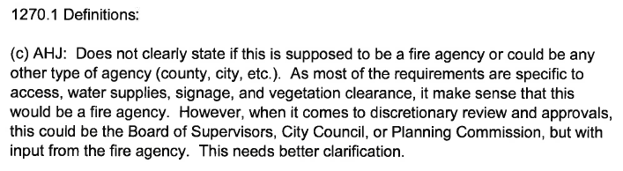

Board response: In the Board’s 15 day notice published on May 10, 2022, the Board proposed deleting this definition and relying on the existing definition of “Local Jurisdiction.”

Rule text edit: Yes

Comment W114-2: Ventura County Fire Protection District

Board response: The Board is no longer proposing a definition for “clear width,” consistent with the narrowed scope of the proposed action as identified within the Supplemental Statement of Reasons published with the “Second 15-Day Notice of Addition of Documents and Information to Rulemaking File and Modified Text” on May 10, 2022. The comment is not specifically directed at the Board’s proposed action or to the procedures followed by the Board in proposing the action.

Rule text edit: No

Comment W114-3: Ventura County Fire Protection District
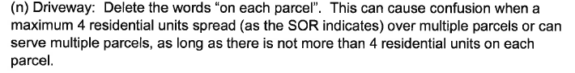

Board response: The Board does propose such a change in the 15 day noticed rule text published January 2, 2022, which this commenter is responding to. The proposed deletion in the 15 day noticed rule text is indicated by double strikeout on page 3, lines 16-17.

Rule text edit: No

Comment W114 -4: Ventura County Fire Protection District
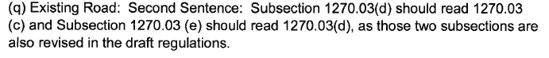
Board response: The Board no longer proposes a definition for “Existing Road,” consistent with the narrowed scope of the proposed action as identified within the Supplemental Statement of Reasons published with the “Second 15-Day Notice of Addition of Documents and Information to Rulemaking File and Modified Text” on May 10, 2022. The comment is not specifically directed at the Board’s proposed action or to the procedures followed by the Board in proposing the action.

Rule text edit: No

Comment W114 -5: Ventura County Fire Protection District
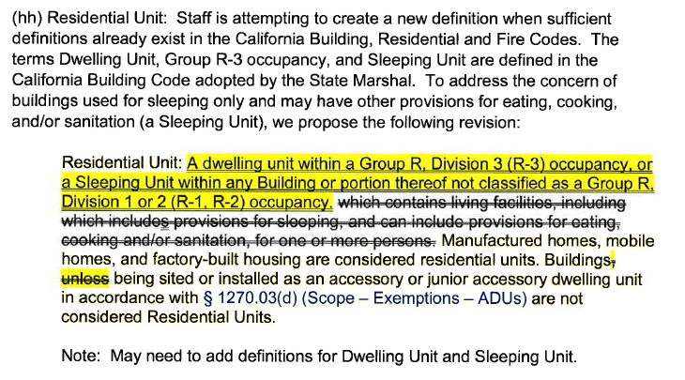

Board response: The existing definition of Residential Unit provides sufficient clarity to the regulated public. The Board is no longer proposing any changes to the definition, except to remove the references to “mandatory measures required in 14 CCR § 1270.01(c)” for additional clarity. As the letter writer indicates, to apply their proposed definition of “Residential Unit” may require additional definitions for “Dwelling Unit” and “Sleeping Unit.” Revising the definition of “Residential Unit” in such a manner would not provide the same level of clarity as the existing language.

Rule text edit: No

Comment W114 -6: Ventura County Fire Protection District
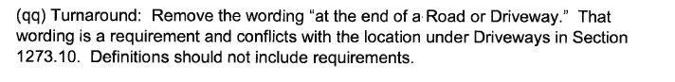

Board response: The Board is no longer proposing changes to the definition of “Turnaround.” consistent with the narrowed scope of the proposed action as identified within the Supplemental Statement of Reasons published with the “Second 15-Day Notice of Addition of Documents and Information to Rulemaking File and Modified Text” on May 10, 2022. The comment is not specifically directed at the Board’s proposed action or to the procedures followed by the Board in proposing the action.

Rule text edit: No

Comment W114 -7: Ventura County Fire Protection District
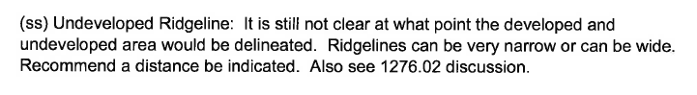

Board response: In § 1276.02, the Board requires that local jurisdictions identify strategic ridgelines. This identification includes an assessment of the “proximity to an existing or proposed residential, commercial, or industrial land uses” (§ 1276.02(a)(3)). New Buildings on Undeveloped Ridgelines that are identified as Strategic are prohibited, as proposed in § 1276.02(b) and (c). As the letter writer indicates, ridgelines can be of varying sizes and have unique topographic features; it would be impossible for the Board to regulate a distance where a ridgeline might be developed versus undeveloped that would be effective for all the ridgelines across the state. Requiring this identification be made by the local jurisdiction provides for the most effective ridgeline preservation.

Rule text edit: No

Comment W114 -8: Ventura County Fire Protection District
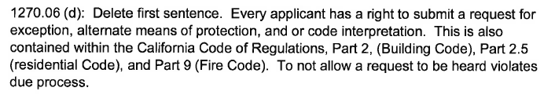

Board response: The Board is no longer proposing this change to § 1270.06(d), consistent with the narrowed scope of the proposed action as identified within the Supplemental Statement of Reasons published with the “Second 15-Day Notice of Addition of Documents and Information to Rulemaking File and Modified Text” on May 10, 2022. The comment is not specifically directed at the Board’s proposed action or to the procedures followed by the Board in proposing the action.

Rule text edit: No

Comment W114 -9: Ventura County Fire Protection District
Paragraphs 11-34 of this letter are limited in scope to Articles 2-4 of the regulation. The Board is no longer proposing to revise Articles 2-4, consistent with the narrowed scope of the proposed action as identified within the Supplemental Statement of Reasons published with the “Second 15-Day Notice of Addition of Documents and Information to Rulemaking File and Modified Text” on May 10, 2022. The comment is not specifically directed at the Board’s proposed action or to the procedures followed by the Board in proposing the action.

Comment W114 -10: Ventura County Fire Protection District

Board response: The Board is appreciative of this note regarding section numbering. I the final proposed rule text the Board will review and correct any numbering errors.

Rule text edit: No

Comment W114 -11: Ventura County Fire Protection District
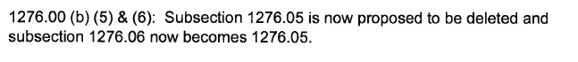

Board response: The Board is appreciative of this note regarding section numbering. I the final proposed rule text the Board will review and correct any numbering errors.

Rule text edit: No

Comment W114 -12: Ventura County Fire Protection District
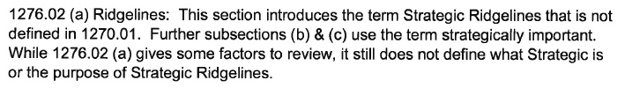

Board response: Strategic ridgeline is defined within the proposed 14 CCR § 1270.01(dd).

Rule text edit: Yes

Comment W114 -13: Ventura County Fire Protection District

Board response: Please see response to W242-19.

Rule text edit: No

Comment W115-1: Tuolumne Utilities District
The first paragraph and last two paragraphs of this letter are introductory/conclusive in nature; the comments are not specifically directed at the Board’s proposed action or to the procedures followed by the Board in proposing the action.

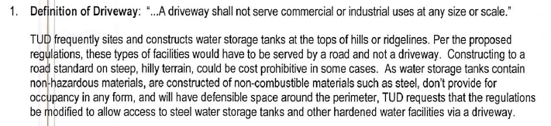

Board response: The existing definition of “road” includes “access to any commercial or industrial occupancy.” The Board’s proposed change to the term “driveway” reinforces this requirement in order to reduce ambiguity. The application of “road” (as defined in 14 CCR § 1270.01) standards to industrial or commercial uses is necessary to achieve minimum fire safety in order to accommodate the larger commercial vehicles and the number of employee and visitor vehicles that travel to and from commercial or industrial uses. The access to any water storage facility which supported a residential use may, under certain circumstances, constitute a driveway pursuant to 14 CCR § 1270.01(i), rather than a “road” as the commenter suggests. Furthermore, the exception process within proposed 14 CCR § 1270.07 is intended to allow flexibility where through exceptions which provide the same practical effect in providing defensible space.

Rule text edit: No

Comment W115 -2: Tuolumne Utilities District
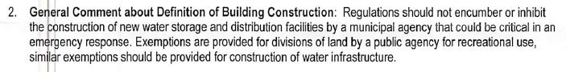

Board response: The Board is not proposing an exemption for a division of land by a public agency for recreational use, nor does the scope of the proposed action include exempting activities from being subject to the regulations. The comment is outside the scope of the proposed action.

Rule text edit: No

Comment W115 -3: Tuolumne Utilities District
Paragraphs 4-7 are limited in scope to Articles 2-4 of the regulation. The Board is no longer proposing to revise Articles 2-4, consistent with the narrowed scope of the proposed action as identified within the Supplemental Statement of Reasons published with the “Second 15-Day Notice of Addition of Documents and Information to Rulemaking File and Modified Text” on May 10, 2022. The comments are not specifically directed at the Board’s proposed action or to the procedures followed by the Board in proposing the action.

Comment W115 -4: Tuolumne Utilities District
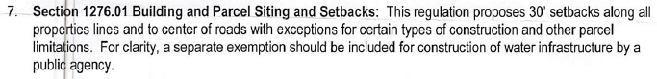
Board response: The scope of the proposed action does not include exempting activities from being subject to the regulations. The comment is outside the scope of the proposed action.

Rule text edit: No

Comment W115 -5: Tuolumne Utilities District
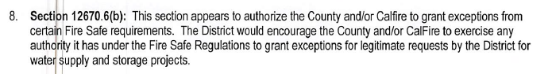

Board response: It is unclear which section the letter writer is referring to. If the letter writer is referring to § 1270.06(b), the Board is proposing minimal changes to this section for clarity. There is nothing in this proposal that limits the authority of the County and/or CAL FIRE to issue exceptions for water supply and storage projects.

Rule text edit: No

Comment W115 -6: Tuolumne Utilities District
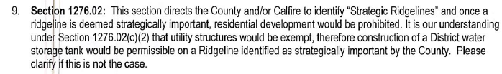

Board response: § 1276.02(c)(2) allows for utility infrastructure, storage group S and utility or miscellaneous group U structures to be constructed undeveloped ridgelines identified as strategic.

Rule text edit: No

Comment W116-1: Coalition of California Home Builders and Businesses
The first three pages of this letter are introductory in nature; the comments are either not specific or are not specifically directed at the Board’s proposed action or to the procedures followed by the Board in proposing the action.
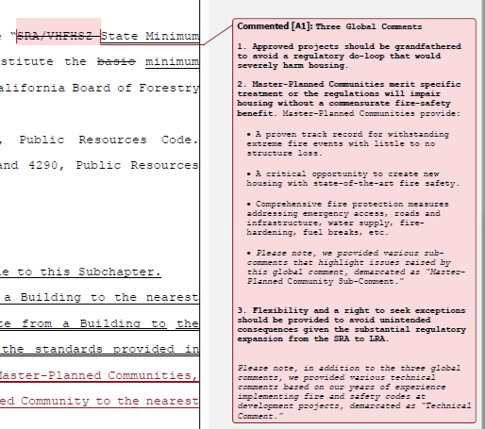

Board response: Article 1 provides sufficient clarify regarding the applicability of these regulations to approved projects.
Regarding Master-Planned Communities, no specific definition for “master planned communities” exist in general planning and zoning law nor does the scope of the proposed action include the clarifying separate standards or requirements for such areas. The Board is specifically instructed in PRC 4290 to write minimum fire safety standards applicable to all building construction.
The requirements for requesting an exception can be found in § 1270.07.

Rule text edit: No

Comment W116-2: Coalition of California Home Builders and Businesses

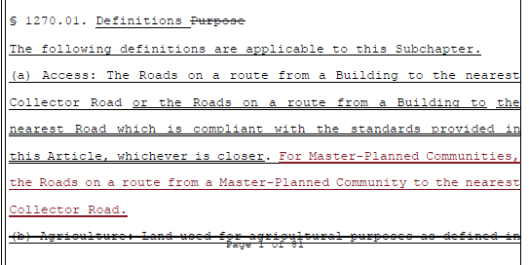

Board response: The Board is no longer proposing a definition for access, consistent with the narrowed scope of the proposed action as identified within the Supplemental Statement of Reasons published with the “Second 15-Day Notice of Addition of Documents and Information to Rulemaking File and Modified Text” on May 10, 2022. The comment is not specifically directed at the Board’s proposed action or to the procedures followed by the Board in proposing the action.

Rule text edit: No

Comment W116-3: Coalition of California Home Builders and Businesses

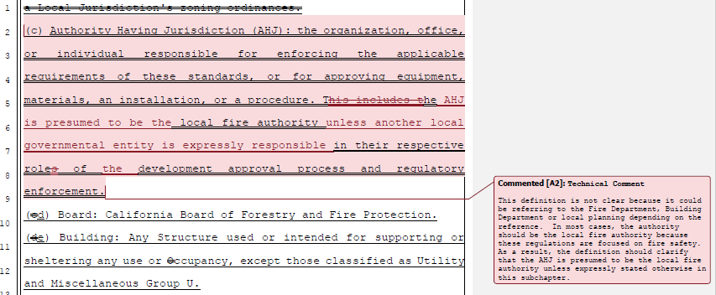

Board response: The Board is no longer proposing a definition for Authority Having Jurisdiction, consistent with the narrowed scope of the proposed action as identified within the Supplemental Statement of Reasons published with the “Second 15-Day Notice of Addition of Documents and Information to Rulemaking File and Modified Text” on May 10, 2022. The comment is not specifically directed at the Board’s proposed action or to the procedures followed by the Board in proposing the action.

Rule text edit: No

Comment W116-4: Coalition of California Home Builders and Businesses

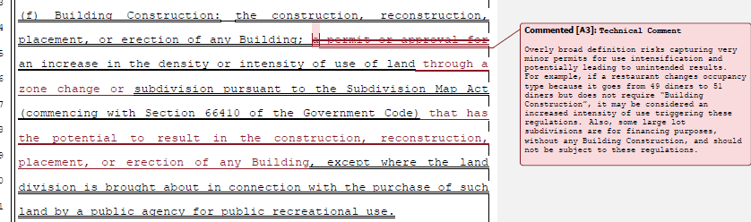

Board response: The Board is no longer proposing a definition for Building Construction, consistent with the narrowed scope of the proposed action as identified within the Supplemental Statement of Reasons published with the “Second 15-Day Notice of Addition of Documents and Information to Rulemaking File and Modified Text” on May 10, 2022. The comment is not specifically directed at the Board’s proposed action or to the procedures followed by the Board in proposing the action.

Rule text edit: No

Comment W116-5: Coalition of California Home Builders and Businesses

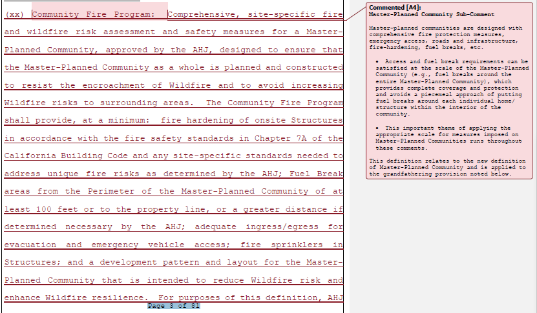
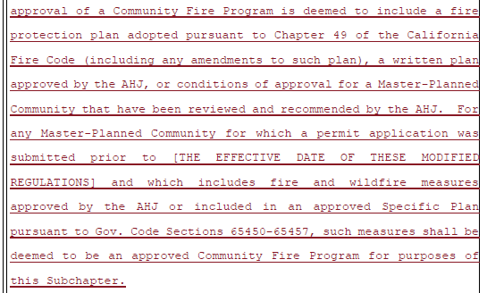

Board response: Regulating a “community fire program” is outside the scope of the Board’s proposed rulemaking.

Rule text edit: No

Comment W116-6: Coalition of California Home Builders and Businesses

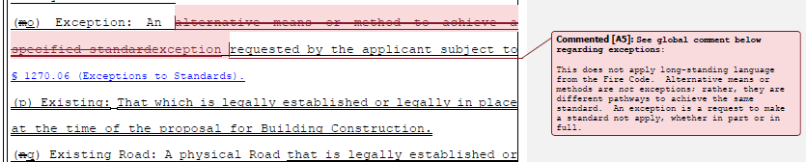

Board response: The Board is no longer proposing changing the definition of “Exception,” consistent with the narrowed scope of the proposed action as identified within the Supplemental Statement of Reasons published with the “Second 15-Day Notice of Addition of Documents and Information to Rulemaking File and Modified Text” on May 10, 2022. The comment is not specifically directed at the Board’s proposed action or to the procedures followed by the Board in proposing the action.

Rule text edit: No.

Comment W116-7: Coalition of California Home Builders and Businesses

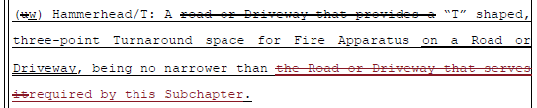

Board response: The Board is not proposing any changes to the definition of “Hammerhead/T.” This subchapter does not propose width requirements specific to Hammerhead/Ts. The letter writer’s proposed change would result in Hammerhead/Ts that did not have any width requirements, which would not provide for safe ingress/egress. By specifying that the Hammerhead/T be no narrower than the Road or Driveway that serves it, these regulations ensure that a Hammerhead/T is wide enough for emergency equipment serving a Road or Driveway.

Rule text edit: No

Comment W116-8: Coalition of California Home Builders and Businesses

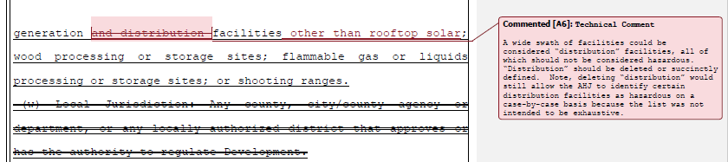

Board response: The definition of “hazardous uses” establishes that such uses may include “power generation and distribution facilities,” which provides the local jurisdiction with the authority to determine that a power distribution facility does not qualify as a hazardous land use. This definition does not require that power distribution facilities be considered a hazardous land use. Regarding the suggestion addition of “other than rooftop solar,” to the Board’s knowledge rooftop solar is not a specific land use, and so it is not necessary to specify whether rooftop solar is or is not a hazardous land use.

Rule text edit: No

Comment W116-9: Coalition of California Home Builders and Businesses

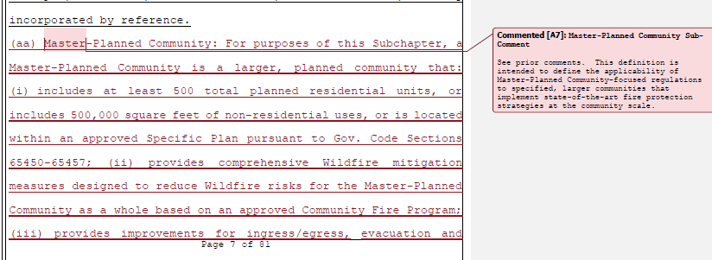
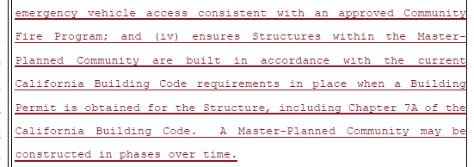

Board response: The scope of the proposed action do not include clarifying separate standards, requirements, or regulations for “master planned communities” The Board is specifically instructed in PRC 4290 to write minimum fire safety standards applicable to all building construction.

Rule text edit: No

Comment W116–10: Coalition of California Home Builders and Businesses

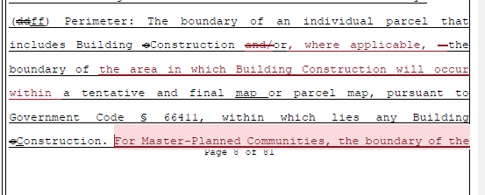
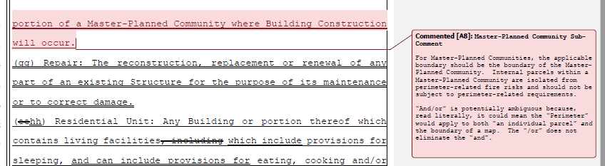

Board response: The Board is no longer proposing a definition for “perimeter,” consistent with the narrowed scope of the proposed action as identified within the Supplemental Statement of Reasons published with the “Second 15-Day Notice of Addition of Documents and Information to Rulemaking File and Modified Text” on May 10, 2022. The comment is not specifically directed at the Board’s proposed action or to the procedures followed by the Board in proposing the action.

Rule text edit: No

Comment W116 -11: Coalition of California Home Builders and Businesses
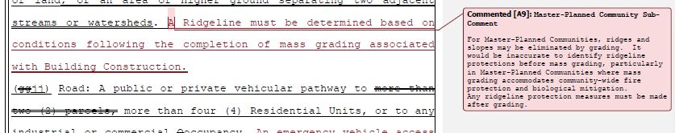

Board response: Mass grading may eliminate the fire risk posed by ridgelines and development after mass grading could be allowable on what used to be a ridgeline. In the 15 day notice published May 10, 2022, the Board proposed a new subsection 1276.02(c)(3) that allows local jurisdictions to allow buildings on strategic ridgelines “where Development activities such as mass grading will significantly alter the topography that results in the elimination of Ridgeline fire risks.”

Rule text edit: Yes

Comment W116-12: Coalition of California Home Builders and Businesses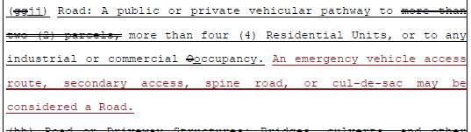

Board response: The conditions provided by the definition of “road” provide suitable and appropriate clarity to the regulated public. The examples provided by the comment are unrelated to the condition provided by the definition (i.e. pathway serving a certain number of residential units or any industrial or commercial occupancy), do not improve the clarity of the provision, and may create issues of consistency.

Rule text edit: No

Comment W116-13: Coalition of California Home Builders and Businesses
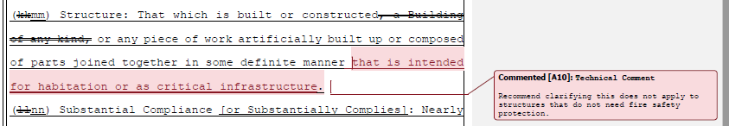

Board response: Structures that are intended for habitation are captured in the definition of “Building,” which is defined as “Any structure used or intended for supporting or sheltering any use or occupancy, except Utility and Miscellaneous Group U buildings.” Where there are requirements for Structures, the requirements specify the type of Structure to which it is relevant (see, for example, § 1273.07 Road and Driveway Structures). Limiting the definition of “structure” to critical infrastructure only would create internal inconsistencies in the regulations.

Rule text edit: No

Comment W116-14: Coalition of California Home Builders and Businesses

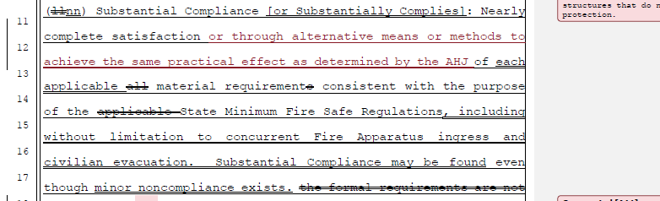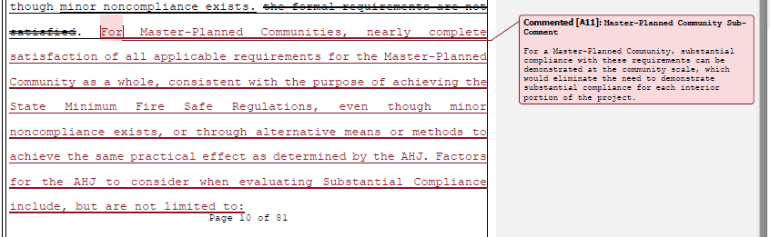
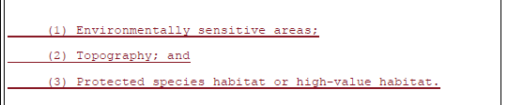
Board response: The Board is no longer proposing a definition for “Substantial Compliance,” consistent with the narrowed scope of the proposed action as identified within the Supplemental Statement of Reasons published with the “Second 15-Day Notice of Addition of Documents and Information to Rulemaking File and Modified Text” on May 10, 2022. The comment is not specifically directed at the Board’s proposed action or to the procedures followed by the Board in proposing the action.

Rule text edit: No

Comment W116-15: Coalition of California Home Builders and Businesses

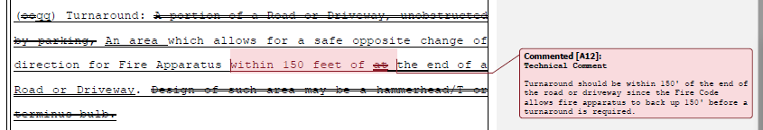

Board response: Requiring a turnaround at the end of a road or driveway limits the length the fire apparatus needs to back up, which provides a greater level of safety than the letter writer’s proposal.

Rule text edit: No

Comment W116-16: Coalition of California Home Builders and Businesses

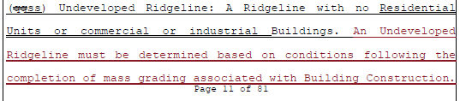
Board response: Please see response to W116-11

Rule text edit: No

Comment W116-17: Coalition of California Home Builders and Businesses

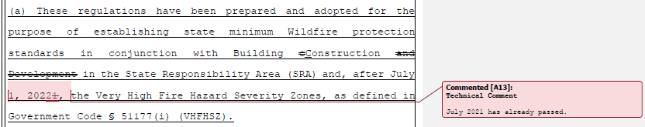

Board response: PRC 4291 states “These regulations apply to the perimeters and access to all residential, commercial, and industrial building construction…within lands classified and designated as very high fire hazard severity zones, as defined in subdivision (i) of Section 51177 of the Government Code after July 1, 2021.” This effectiveness is also explicit within the existing language of 14 CCR § 1270.01. The existing regulations have been effective in the VHFHSZ since July 1, 2021.

Rule text edit: No

Comment W116-18: Coalition of California Home Builders and Businesses
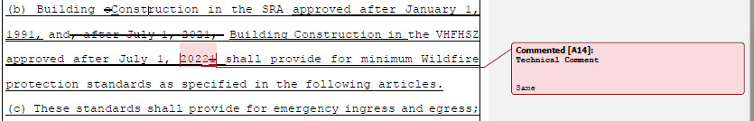
Board response: See response to W116-17

Rule text edit: No

Comment W116-19: Coalition of California Home Builders and Businesses
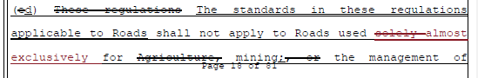
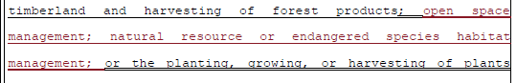

Board response: The term “almost exclusively” introduces uncertainty into the regulations as to what frequency of road use (for example, agriculture versus other uses) would qualify as “almost exclusively.” The term “solely” provides greater specificity as to what roads are exempt from these regulations. Regarding the additional types of roads uses the letter writer proposes to be exempt from these regulations, it is not the Board’s understanding that those types of uses generally require the types of permitting or development activities described in §§ 1270.02. 1270.03, and 1270.04 and so would not be subject to these regulations.

Rule text edit: No

Comment W116-20: Coalition of California Home Builders and Businesses
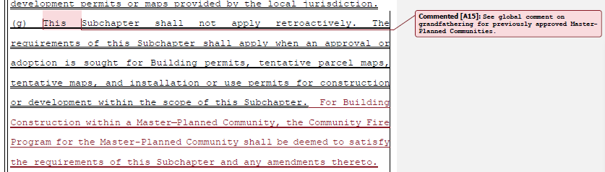

Board response: The Board is no longer proposing § 1270.03(g), consistent with the narrowed scope of the proposed action as identified within the Supplemental Statement of Reasons published with the “Second 15-Day Notice of Addition of Documents and Information to Rulemaking File and Modified Text” on May 10, 2022. The comment is not specifically directed at the Board’s proposed action or to the procedures followed by the Board in proposing the action.

Rule text edit: No

Comment W116-21: Coalition of California Home Builders and Businesses
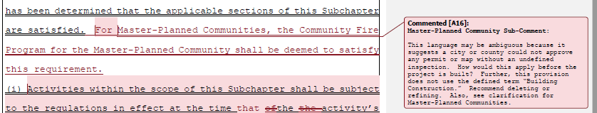

Board response: The Board is no longer proposing § 1270.03(h), consistent with the narrowed scope of the proposed action as identified within the Supplemental Statement of Reasons published with the “Second 15-Day Notice of Addition of Documents and Information to Rulemaking File and Modified Text” on May 10, 2022. The comment is not specifically directed at the Board’s proposed action or to the procedures followed by the Board in proposing the action.

Rule text edit: No

Comment W116-22: Coalition of California Home Builders and Businesses
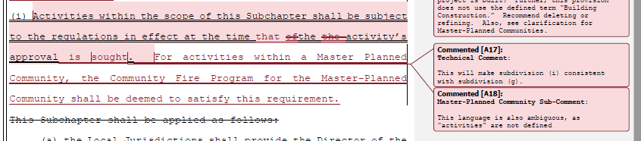

Board response: The Board is no longer proposing § 1270.03(i), consistent with the narrowed scope of the proposed action as identified within the Supplemental Statement of Reasons published with the “Second 15-Day Notice of Addition of Documents and Information to Rulemaking File and Modified Text” on May 10, 2022. The comment is not specifically directed at the Board’s proposed action or to the procedures followed by the Board in proposing the action.

Rule text edit: No

Comment W116-23: Coalition of California Home Builders and Businesses
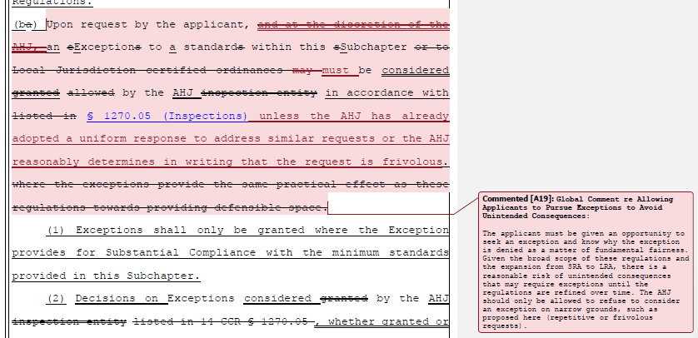

Board response: The Board deleted the phrase “and at the discretion of the AHJ” in this subsection in the 15 day noticed rule text published on May 10, 2022. The term “must” introduces regulatory confusion, whereas “may” provides for the flexibility that the letter writer proposes to adopt in their suggested language. The term “may” allows the local jurisdiction to consider the request, or to respond to the request with an adopted, uniform response such as the letter writer proposes.

Rule text edit: Yes.

Comment W116-24: Coalition of California Home Builders and Businesses

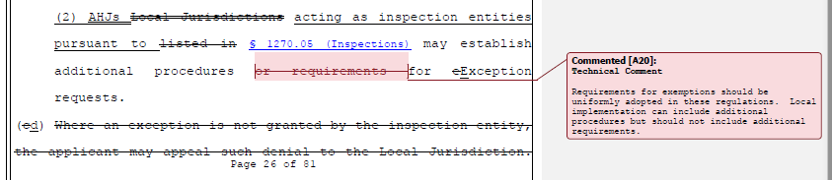

Board response: PRC 4290(c) specifies “These regulations do not supersede local regulations which equal or exceed minimum regulations adopted by the state.” Local jurisdictions retain the authority to adopt stricter requirements than those in the State Minimum Fire Safe Regulations.

Rule text edit: No

Comment W116-25: Coalition of California Home Builders and Businesses
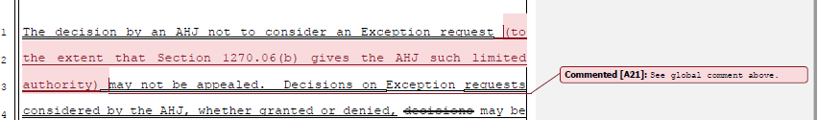

Board response: The Board is no longer proposing the language the letter writer is proposing to revise.

Rule text edit: No

Comment W116-26: Coalition of California Home Builders and Businesses
The comments pertaining to pp. 29-76 of the rule text are limited in scope to Articles 2-4. The Board is no longer proposing to revise Articles 2-4 as described by the comment.

Comment W116-27: Coalition of California Home Builders and Businesses
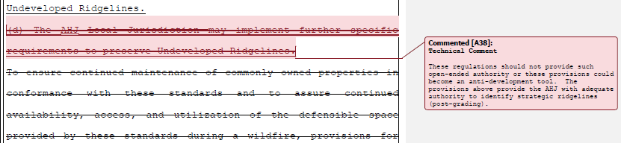

Board response: PRC 4290(c) specifies “These regulations do not supersede local regulations which equal or exceed minimum regulations adopted by the state.” Local jurisdictions retain the authority to adopt stricter requirements than those in the State Minimum Fire Safe Regulations.

Rule text edit: No

Comment W116-28: Coalition of California Home Builders and Businesses
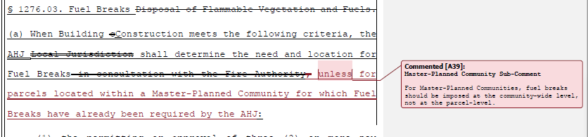
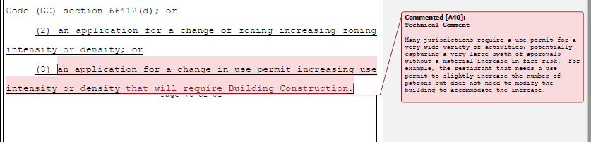

Board response: See W116-9 regarding master planned communities. Regarding the proposal to add “that will require Building Construction,” “building construction” is no longer a proposed defined term in the regulations, so its use here would be confusing. § 1276.03(a) specifies that the Local Jurisdiction “shall determine the need and location for Fuel Breaks….,” which would allow the local jurisdiction to review a proposal like the letter writer’s hypothetical and determine that Fuel Breaks are not needed, if appropriate.

Rule text edit: No

Comment W116-29: Coalition of California Home Builders and Businesses
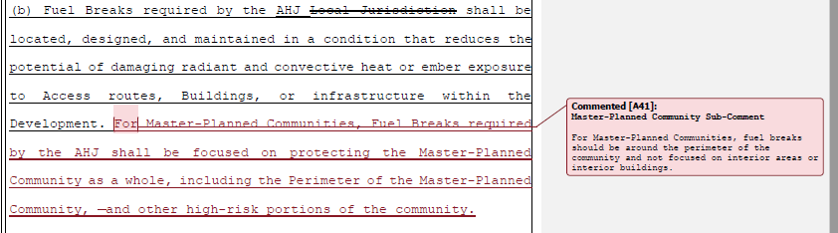

Board response: Please see response to W116-9 regarding Master Planned Communities.

Rule text edit: No

Comment W116-30: Coalition of California Home Builders and Businesses
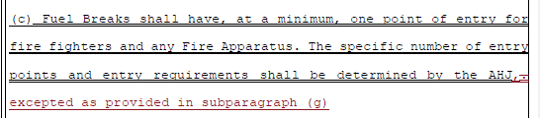
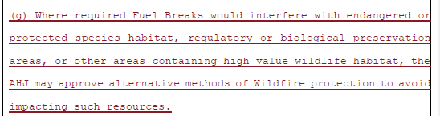

Board response: 1276.03(a) already provides this flexibility to the local jurisdiction. It states, in part, “the local jurisdiction shall determine the need and location for fuel breaks,” and subsection (f) already requires “fuel breaks shall be constructed using the most ecologically and site appropriate treatment option.” Taken together, these subsections broadly provide the authority proposed by the letter writer in subsection (g). Using subsections (a) and (f), the local authority can evaluate the biological resources in the area, such as endangered or protected species habitat, preservation areas, or other high value wildlife, and determine the most appropriate location for a fuel break that ensures protection of those resources. Furthermore, the proposed action is not related to, nor does it seek to affect in any way, other extant provisions of law related to biological or environmental resources, such as the California Endangered Species Act (Chapter 1.5, Division 3, Fish and Game Code), California Environmental Quality Act (Division 13, Public Resources Code), Water Quality Control Act (Division 7, Water Code).

Rule text edit: No

Comment W116-31: Coalition of California Home Builders and Businesses
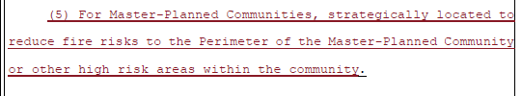

Board response: Please see W116-9 regarding master planned communities.

Rule text edit: No

Comment W116-32: Coalition of California Home Builders and Businesses
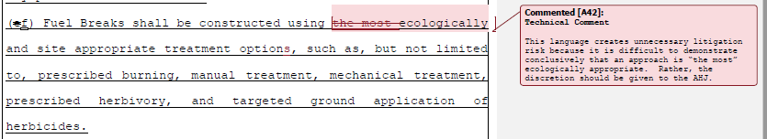
Board response: The proposed language ensures the protection of natural resources and the environment, consistent with proposed revisions to 14 CCR § 1270.02(d).

Rule text edit: No

Comment W116-33: Coalition of California Home Builders and Businesses
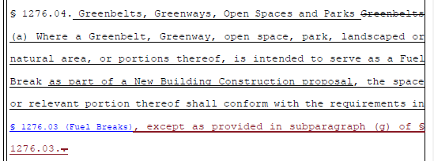

Board response: Please see response to W116-9

Rule text edit: No

Comment W116-34: Coalition of California Home Builders and Businesses
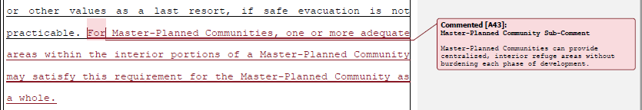

Board response: Please see response to W116-9 regarding master planned communities.

Rule text edit: No

Comment W116-35: Coalition of California Home Builders and Businesses
Pages 88-540 of this comment provide supporting data and are not specifically directed at the Board’s proposed action or to the procedures followed by the Board in proposing the action.

Comment W117-1: Larry Hanson
The first three paragraphs of this comment provide supporting data and not specifically directed at the Board’s proposed action or to the procedures followed by the Board in proposing the action.

Specific problems with December adopted plan
• Removed significant road standards for existing roads: it is now impossible with the approved language to meet the intent of the regulations, “…to provide for safe and concurrent fire apparatus access and civilian evacuation”. Hence, a new high-density residential and/or intensive commercial development could be built on
a 14-foot wide (or 10-foot wide with allowed exceptions) mountain road with no shoulders and steep drop-offs and on a 12-mile dead-end road in a high fire risk area, with grades exceeding 25%.

Board response: The Board is no longer proposing changes to the standards for existing roads, consistent with the narrowed scope of the proposed action as identified within the Supplemental Statement of Reasons published with the “Second 15-Day Notice of Addition of Documents and Information to Rulemaking File and Modified Text” on May 10, 2022. The comment is not specifically directed at the Board’s proposed action or to the procedures followed by the Board in proposing the action.

Rule text edit: No

Comment W117-2: Larry Hanson
* Completely eliminated the dead-end road limitation for all new development on existing roads, recommended by the Fire Chief’s working group, even for multi-unit residential and commercial development. (The Fire Chiefs recommended a one half mile limitation.)

Board response: The Board is no longer proposing changes to the dead end road limitation, consistent with the narrowed scope of the proposed action as identified within the Supplemental Statement of Reasons published with the “Second 15-Day Notice of Addition of Documents and Information to Rulemaking File and Modified Text” on May 10, 2022. The comment is not specifically directed at the Board’s proposed action or to the procedures followed by the Board in proposing the action.

Rule text edit: No

Comment W117-3: Larry Hanson
• Gutted weight requirements for existing bridges, which will lead to dangerous traffic bottlenecks. Firefighting equipment and Firefighters conducting evacuations during a conflagration will not be able to access large new developments enabled by this proposal or to strategically access structures and wildlands to fight fires.

Board response: The Board is no longer proposing changes to the weight limits for existing bridges, consistent with the narrowed scope of the proposed action as identified within the Supplemental Statement of Reasons published with the “Second 15-Day Notice of Addition of Documents and Information to Rulemaking File and Modified Text” on May 10, 2022. The comment is not specifically directed at the Board’s proposed action or to the procedures followed by the Board in proposing the action.

Rule text edit: No

Comment W117-4: Larry Hanson
• Unlimited discretion given to local jurisdictions through the exception process and other loopholes; such authority weakens the State regulations for all new building construction.

Board response: The Board is no longer proposes changes to the exception process consistent with the narrowed scope of the proposed action as identified within the Supplemental Statement of Reasons published with the “Second 15-Day Notice of Addition of Documents and Information to Rulemaking File and Modified Text” on May 10, 2022. The comment is not specifically directed at the Board’s proposed action or to the procedures followed by the Board in proposing the action.

Rule text edit: No

Comment W117-5: Larry Hanson
• Compromised ridgeline protections: A fire safe standard in April draft regs: “New Buildings on Undeveloped Ridgelines identified as strategically important to fight fires are prohibited” was changed to limit only Residential Units. State regulations should prohibit commercial and industrial building construction on ridgelines to comply with the intent of the mandating legislation (SB 901).

Board response: The Board made this change in the 15 day noticed rule text published on May 10, 2022.

Rule text edit: Yes

Comment W117-6: Larry Hanson
A CEQA analysis should include quantifying the potential increase in population and intensity of use in the fire danger areas as a result of the liberal exception process that will now free up parcels to new building construction, including commercial. Demand a robust CEQA analysis.

Board response: Please see General CEQA Response

Rule text edit: No

Comment W118-1: John Stonebraker
The latest Fire Safe Regulations are a modest walkback from the overreach the Board majority voted to proceed with last March. The effect will still be to stifle development in the rural SRA and in municipalities within the VHFHSZ by making expensive road construction and maintenance prerequisite to commercial, industrial, and most residential improvements.
The claim in 1270.02(d) is not stipulated. Deterring residents from, for example, replacing a pre‐HUD singlewide with a Chapter 7A‐compliant site‐built home does not protect us ‐‐ it endangers us. Stimulating road construction leads to erosion, water quality issues, air quality issues, and the loss of healthy trees ‐‐ it does not protect natural resources.
There are ways to achieve the purported intent without obsessing about whether residents can evacuate past your fire apparatus.
I evacuated from the Camp Fire by bicycle, down an unpaved 1870s stage road and through Centerville where locals saved historic structures and residences while CDF apparatus failed to show up. My perspective on the practicalities of evacuation and the trade‐offs at stake may differ from the perspective inside BOF.
Section 1270.08 carves out a narrow exemption for like‐for‐like reconstruction of Buildings after Wildfire but fails to consider reconstruction of communities after Wildfire. Writing from one of the homes in Magalia that survived the Camp Fire, we need more housing to revitalize our community and bring back business and restore service and quality of life. We don't want to restrict new housing to exactly the vacant lots that had homes on them before or prohibit duplexes on lots that were single‐family. Our arterial and collectors are built to handle
2000 more homes than exist here currently. I can understand not wanting to overburden mountain roads with more vehicle traffic than they were designed for, but that is not the case here or in other depopulated communities, and these regulations fail to differentiate.

Board response: The Board is no longer proposing changes to the road standards or their applicability, consistent with the narrowed scope of the proposed action as identified within the Supplemental Statement of Reasons published with the “Second 15-Day Notice of Addition of Documents and Information to Rulemaking File and Modified Text” on May 10, 2022. The comment is not specifically directed at the Board’s proposed action or to the procedures followed by the Board in proposing the action.

The regulatory exemption for wildfire rebuilds was a previous emergency regulatory action and is outside the scope of the proposed action. Please see General Response to Exceptions and Exemptions Comments.

Rule text edit: No

Comment W118-2: John Stonebraker
The legislature has granted the Board authority to regulate road standards for fire equipment access, which does not necessarily require concurrent resident egress by passenger vehicle, and to regulate building construction, which does not necessarily mean Development per GOV 65927 even if Section 1270.01(f) here attempts to conflate them.

Prohibiting Building Construction on single‐access road systems longer than 2640' is a regulatory taking from countless ranches.

Board response: The Board is no longer proposing changes to the definition of “defensible space,” nor to the dead-end road length limits, consistent with the narrowed scope of the proposed action as identified within the Supplemental Statement of Reasons published with the “Second 15-Day Notice of Addition of Documents and Information to Rulemaking File and Modified Text” on May 10, 2022. The comment is not specifically directed at the Board’s proposed action or to the procedures followed by the Board in proposing the action.

Rule text edit: No

Comment W118-3: John Stonebraker

After numerous revisions, it is still not clear whether an otherwise compliant road with an unpaved, gated back exit counts as Dead‐End.

Board response: The definition of Dead-end Road is provided within 14 CCR § 1270.01(e). The definition is not dependent upon conditions related to paving, gates, or front/back status.

Rule text edit: No

Comment W118-4: John Stonebraker
The weight a Driveway can support depends on the contact patch. While Roads are expected to support specifically a Fire Apparatus, Driveways are expected to support an unspecified configuration of weight. Some structures like corrugated culverts along roadside drainage ditches, may not support this raw load while easily able to support one axle of an 18‐ton Apparatus.

There is no exception for very short Driveways where a structure fire could be addressed by an Apparatus on the Road. This is particularly relevant for properties with a waterway between the Building and the Road.

Board response: The scope of the proposed action does not include exempting activities from being subject to the regulations. The comment is outside the scope of the proposed action.

Rule text edit: No

Comment W119-1: California Department of Food and Agriculture
Please accept the following public comment on behalf of the CDFA:
It had been the intention of the Board of Forestry to exempt agricultural transportation and related activities of agricultural products from the standards. While activities related to the cultivation of plants are specifically excluded, section 1270.03 (d) is silent with respect to animals, and accordingly, it should be amended as follows:
“The standards in these regulations applicable to Roads shall not apply to Roads used solely for Agriculture, mining; the management of timberland and harvesting of forest products; or the planting, growing, or harvesting of plants (including related activities such as processing, storage, and transportation) for the marketing of the resulting products; or, the transportation of livestock, including equine and poultry.”

Board response: The Board is no longer proposing changes to this section, consistent with the narrowed scope of the proposed action as identified within the Supplemental Statement of Reasons published with the “Second 15-Day Notice of Addition of Documents and Information to Rulemaking File and Modified Text” on May 10, 2022. The comment is not specifically directed at the Board’s proposed action or to the procedures followed by the Board in proposing the action.

Rule text edit: No

Comment W120-1: Greg Popovich
I am a property owner in both Tuolumne and Calaveras County. I have made my modest living from the development of rural properties and am gravely concerned by the proposed rules what will constitute a moratorium on building on the majority, if not all, of my pieces of land. These excessive requirements can render worthless everything that I have built over my lifetime.

The proposed rules substantially increase costs to meet the new road standards and
improvements to build a single family home. This is in addition to the already steep price of construction in California, which can not be absorbed in the foothills. The home prices do not support additional requirements. The rules will create a burden on all homes and
the ability to buy and afford a home in the future.

As an immediate remedy other methods of fire prevention in the foothill areas will be
much more effective and not destroy the livelihoods of many small builders and the
ability for the public to afford a home. Other methods include fuel reduction via
mastication, reduction of ladder fuels, and better forest management of dead, dying and over saturated fuel areas. Biomass reduction in the foothills is crucial to a healthy forest
and healthy fire safe community. Overgrowth along roads in the foothill region is
prevalent. By eliminating all of the dead, dying and dense fuels along roadways will
widen the access, create safer roadways in addition to the added benefit of not stopping or making building uncostly in the foothill regions. County, State and Federal Grants
should be employed to accomplish these goals of fuel reduction and clearing and not
levy the burden on the small operator, homeowner or potential homeowner.

If these burdens, as proposed, become obstructions and undue burdens to building of
homes I will need to spend all of my time advocating for fair and just remedies for what
appears to be a taking of land from the private sector. Placing these overreaching and
very costly requirements on property owners can not progress and must be stopped.
The common builder, homeowner and potential homeowner did not create these issues
of high fuel and volatile forests and lands. The managing entities did. This is not just or
fair. It is criminal.

Board response: The Board no longer proposes changes to new road standards, consistent with the narrowed scope of the proposed action as identified within the Supplemental Statement of Reasons published with the “Second 15-Day Notice of Addition of Documents and Information to Rulemaking File and Modified Text” on May 10, 2022. The comment is not specifically directed at the Board’s proposed action or to the procedures followed by the Board in proposing the action.

Rule text edit: No

Comment W121-1: CAL FIRE Riverside
1. §1275.01(b) indicates that when a municipal‐type water supply is unavailable, NFPA 1142 shall be utilized. §1275.04(c) indicates that when there is not a municipal‐type water system, a performance‐based design water supply alternative approved by the AHJ shall be designed and installed to meet the minimum fire flow water supply requirements of 250 gallons per minute for 2 hours. These sections appear to conflict with each other. Please provide clarification on application and/or modify to resolve. Note that a 30,000 gallon tank (250 gpm for 2 hours) is significantly larger (approx. 9 times) than the tank size required by the current Fire Safe Regulations (NFPA 1142) for construction of a typical (1 story, 2000sf, Type VB) single family home with no exposures and no municipal‐type water supply available.

Board response: The Board is no longer proposing changes to 1275.01, consistent with the narrowed scope of the proposed action as identified within the Supplemental Statement of Reasons published with the “Second 15-Day Notice of Addition of Documents and Information to Rulemaking File and Modified Text” on May 10, 2022. The comment is not specifically directed at the Board’s proposed action or to the procedures followed by the Board in proposing the action.

Rule text edit: No

Comment W122-1: Mountain Gate Open Space Maintenance Association
In recent years, California wildfires have destroyed countless homes and natural habitat and taken far too many lives. The state must take actions that make wildfire-prone communities safer. The 2021 Board of Forestry and Fire Protection's (BOF) proposed minimum fire safe road regulations for existing roads do just the opposite. The BOF is ignoring common-sense wildfire safety standards for safe concurrent ingress and egress.
For 30 years, the BOF minimum fire safe standards have applied to all new residential, commercial, and industrial development in the State Responsibility Area and in July 2021 extended to the Local Responsibility Area. In response to climate change and land use patterns that have led to increasingly destructive wildfires, recent legislation (SB 901) required the BOF to extend the fire safe regulations to include Very High Fire Hazard Severity Zones to provide for basic emergency access and perimeter wildfire protection.
But instead of strengthening the current minimum fire safe road standards as recommended by the Fire Chiefs Working Group, the current proposal drastically weakens road safety regulations, thereby endangering both the public and firefighters and promoting new development in fire-prone areas. More wildland development means greater risk of fire, disruption of natural habitat and other environmental impacts. The BOF should not be prioritizing development over public safety and the health of our communities.
The BOF has an opportunity to strengthen the minimum fire safe road regulations. If it does not, the BOF must focus on public safety and conduct robust and data-supported analyses of road and infrastructure capacity to assess potential impacts to wildfire emergency response and evacuation. Moreover, the BOF must undertake an Environmental Impact Report that analyzes all potential significant impacts from these weaker regulations.

Board response: The Board is no longer proposing changes to the road standards, consistent with the narrowed scope of the proposed action as identified within the Supplemental Statement of Reasons published with the “Second 15-Day Notice of Addition of Documents and Information to Rulemaking File and Modified Text” on May 10, 2022. The comment is not specifically directed at the Board’s proposed action or to the procedures followed by the Board in proposing the action. Please see General CEQA Response

Rule text edit: No

Comment W123-1: Mahaman Development
The first 16 paragraphs of this comment are introductory/conclusive in nature; the comments are not specifically directed at the Board’s proposed action or to the procedures followed by the Board in proposing the action.

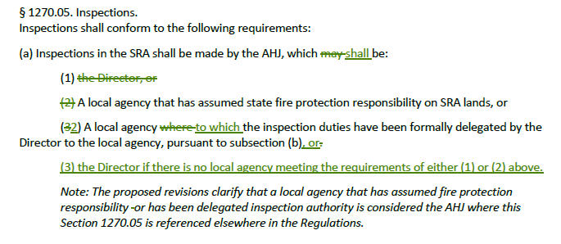

Board response: The Department of Forestry and Fire Protection is the primary agency with inspection authority in the SRA. That inspection authority may be delegated to local agencies in certain conditions, but the Department never abrogates its inspection authority. The letter writer’s proposed change does not provide greater clarity to this point than the existing rule text.

Rule text edit: No

Comment W123-2: Mahaman Development
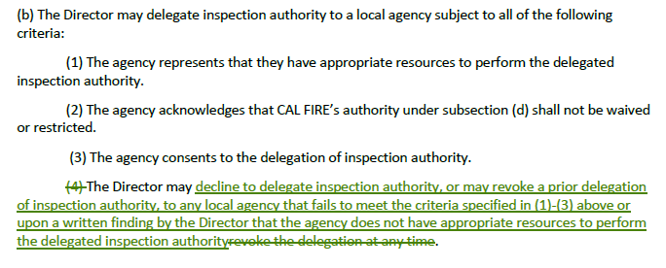
Board response: The letter writer’s proposed text limits the occasions under which the Director may revoke or decline delegation authorities. Consistent with PRC 4102 and 4125(a), CAL FIRE maintains inspection authority in the SRA and may exercise this authority at any time.

Rule text edit: No

Comment W123-3: Mahaman Development
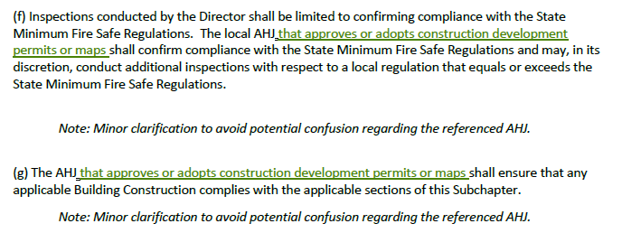
Board response: In the 15 day noticed rule text, published on May 10, 2022, the Board changed references to an “AHJ” to “Local Jurisdiction.” This change provides the needed clarity suggested by the letter writer.

Rule text edit: No

Comment W123-4: Mahaman Development
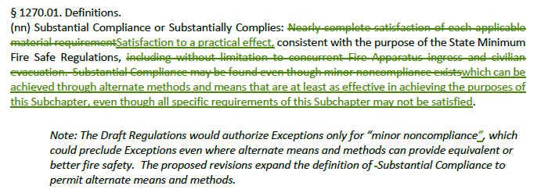
Board response: The Board is no longer proposing a definition for “substantial compliance,” consistent with the narrowed scope of the proposed action as identified within the Supplemental Statement of Reasons published with the “Second 15-Day Notice of Addition of Documents and Information to Rulemaking File and Modified Text” on May 10, 2022. The comment is not specifically directed at the Board’s proposed action or to the procedures followed by the Board in proposing the action.

Rule text edit: No

Comment W123-5: Mahaman Development
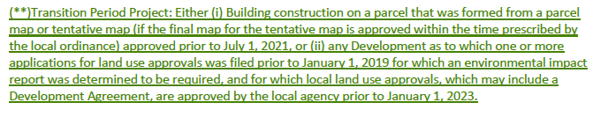
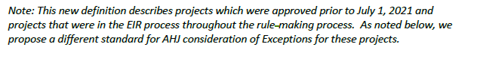
Board response: PRC 4290 requires the Board to write regulations applicable to all construction in the SRA after January 1, 1991, and all construction in the VHFHSZ after July 1, 2021. A 1993 Attorney General Opinion ((76 Ops.Cal Atty.19, No. 92-807)) further described the applicability of these regulations in the SRA as it relates to parcel maps approved prior to January 1, 1991. There are no similar opinions or statutes that allow for these regulations to be applied differently in the VHFHSZ. The effective dates for proposed by the letter writer are arbitrary and conflict with PRC 4290. It is outside the Board’s authority to establish different effective dates than that is prescribed in statute.

Rule text edit: No

Comment W123-6: Mahaman Development
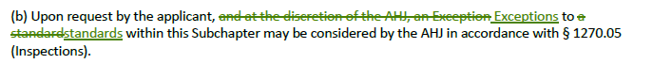

Board response: In the 15 day noticed rule text published on May 10, 2022, the Board deleted the phrase “and at the discretion of the AHJ.”

Rule text edit: Yes

Comment W123-7: Mahaman Development
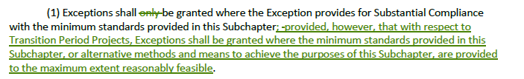
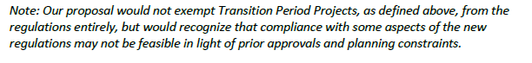
Board response: Please see response to 123-5 regarding Transition Period Projects.

Rule text edit: No

Comment W123-8: Mahaman Development
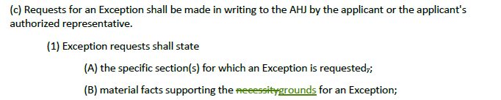

Board response: The term “necessity” provides greater clarity and specificity to the regulated public than the term “grounds” in this context. The applicant must provide a reason why an exception is necessary – ie, a reason why they cannot achieve a specified standard – and the term “grounds” is more broad and would allow for exception requests where the applicant perhaps could meet the minimum standard, but prefers an exception.

Rule text edit: No

Comment W123-9: Mahaman Development

Board response: In the 15 day noticed rule text published on May 10, 2022, the Board removed the statement the letter writer proposes to delete to improve the clarity of the regulations.

Rule text edit: Yes

Comment W123-10: Mahaman Development
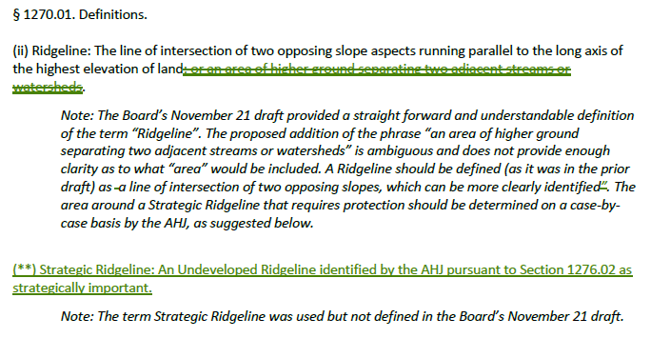

Board response: The Board is no longer proposing a definition for “Existing,” consistent with the narrowed scope of the proposed action as identified within the Supplemental Statement of Reasons published with the “Second 15-Day Notice of Addition of Documents and Information to Rulemaking File and Modified Text” on May 10, 2022. The comment is not specifically directed at the Board’s proposed action or to the procedures followed by the Board in proposing the action.

Regarding the proposed deletion of commercial or industrial buildings from this definition, an area that is undeveloped is generally understood to have limited human visitation and habitation. An area that has buildings with commercial or industrial occupancies is generally understood to be a “developed” area. The Board’s authority in PRC 4290 is to “preserve undeveloped ridgelines,” and ridgelines with commercial or industrial occupancies qualify as “developed,” and therefor do not qualify for the preservation required by PRC 4290.

Regarding the phrase “that extend above the elevation of the Ridgeline,” this phrase is unnecessary because the definition of “ridgeline” already specifies the area where these buildings might be located – the line of intersection of two opposing slopes, or higher ground separating two adjacent streams or watersheds.

Rule text edit: No

Comment W123-11: Mahaman Development
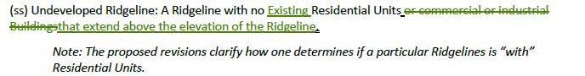

Board response: The Board is no longer proposing a definition for “Existing,” consistent with the narrowed scope of the proposed action as identified within the Supplemental Statement of Reasons published with the “Second 15-Day Notice of Addition of Documents and Information to Rulemaking File and Modified Text” on May 10, 2022.

Regarding the proposed deletion of commercial or industrial buildings from this definition, an area that is undeveloped is generally understood to have limited human visitation and habitation. An area that has buildings with commercial or industrial occupancies is generally understood to be a “developed” area. The Board’s authority in PRC 4290 is to “preserve undeveloped ridgelines,” and the Board has determined that ridgelines with commercial or industrial occupancies qualify as “developed,” and therefor do not qualify for the preservation required by PRC 4290.

Regarding the phrase “that extend above the elevation of the Ridgeline,” this phrase is unnecessary because the definition of “ridgeline” already specifies the area where these buildings might be located – the line of intersection of two opposing slopes, or higher ground separating two adjacent streams or watersheds.

Rule text edit: No

Comment W123-12: Mahaman Development
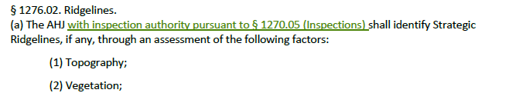

Board response: In the 15 day noticed rule text published May 10, 2022, the Board proposed to replace the term “AHJ” with “local jurisdiction,” which provides the necessary clarity suggested by the letter writer. The letter writer’s suggestion to only allow the inspection authority to determine strategic ridgelines unnecessarily limits the ability of the local jurisdiction to use the professional judgement of other officials in the decision making process, such as land use specialists, open space preservationists, other fire protection agencies, and others. The Board’s proposal to replace AHJ with “local jurisdictions” provides the needed flexibility to local governments to use the most appropriate professionals in deciding which ridgelines are strategic.

Rule text edit: No

Comment W123-13: Mahaman Development
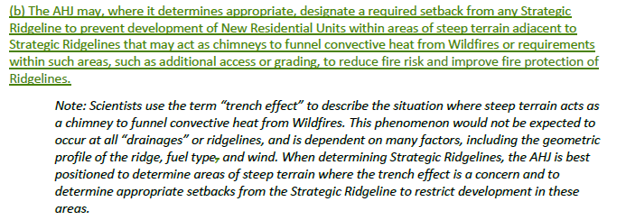
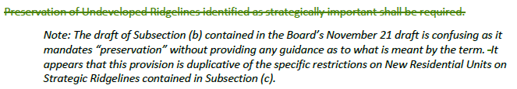
Board response: In the 15 day noticed rule text published May 10, 2022, the Board proposed to add the following requirement to 1276.02(c)(1): “New Residential Units are prohibited within or at the top of drainages or other topographic features common to Ridgelines that act as chimneys to funnel convective heat from Wildfires.” This proposal accomplishes the goal suggested by the letter writer, to protect residential units from the convective heat caused by topographic “chimneys,” but provides greater protection by establishing a statewide prohibition of residential units in those areas.

In the 15 day noticed rule text published May 10, 2022, the Board proposed to add “the phrase “pursuant to this section” to 1276.02(b). This provides greater specificity to the subsection regarding guidance for how to preserve undeveloped ridgelines as required by PRC 4290.

Rule text edit: Yes

Comment W123-14: Mahaman Development
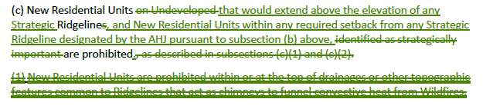
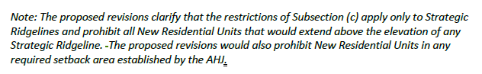

Board response: The Board’s proposal specifies that new residential units are prohibited on undeveloped ridgelines that are designated as strategic. If a ridgeline is undeveloped, but not identified as strategic, the Board’s proposal would allow residential units to be constructed on it.

Rule text edit: No

Comment W123-15: Mahaman Development
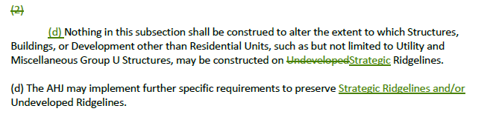

Board response: Specifying “strategic” instead of “undeveloped” in subsection (c)(2) would result in confusion regarding whether utility infrastructure and other similar occupancies are allowable on undeveloped ridgelines that are not designated as strategic. The Board’s language is clearer in stating that certain infrastructure and occupancies are allowable on undeveloped ridgelines, whether they are determined to be strategic or not.

Regarding the letter writer’s proposal in subsection (d), statute requires the Board to preserve undeveloped ridgelines. Here, the Board uses the term “undeveloped” to remain consistent with that authority. Specifically allowing a local jurisdiction to implement further restrictions on ridgelines that are determined to be strategic but are not undeveloped would be overstepping the Board’s authority.

Rule text edit: No

Comment W124-1: Nevada County Cannabis Alliance
The first and last paragraph of this comment are introductory in nature; the comments are not specifically directed at the Board’s proposed action or to the procedures followed by the Board in proposing the action..

Our organization is concerned that there is a lack of definition for the word “commercial” in the proposed State Minimum Fire Safe Regulations. Page 3, Line 19 and 20, reads, “a driveway shall not serve commercial or industrial uses at any size or scale." However, on page 16, line 16 - 19 reads "The standards in these regulations applicable to Roads shall not apply to Roads used solely for mining, the management of timberland and harvesting of forest products; or the planting, growing, or harvesting of plants (including related activities such as processing, storage, and transportation) for the marketing of the resulting products."

For the proposed State Minimum Fire Safe regulations to be correctly interpreted at the local level, it would be helpful to add a definition of “commercial” and expressly exclude the exemptions listed on page 16 lines 16 - 19 from that definition.

Board response: The term “commercial” is neither a term of art nor is it used outside of its commonly understood meaning within these regulations and has appeared within the existing regulatory scheme for the last three decades without issue. Additionally, the scope of the proposed action does not include exempting activities from being subject to the regulations. The comment is outside the scope of the proposed action.

Rule text edit: No

Comment W125-1: Bruce Campbell
The first four paragraphs and last paragraph of this comment are introductory/conclusive in nature. These comments are not specifically directed at the Board’s proposed action or to the procedures followed by the Board in proposing the action

1. page 1 of 76 shows the crossing out of the “Land used for agricultural purposes”, so apparently there is no minimum fire protection for Ag areas under the newly proposed regs;
2. other people who are not important enough to be guaranteed even minimum fire protection, such as those who live in 1, 2, or 3 residential units off of a driveway, people in areas where plants are grown and processed, etc.

Board response: Pursuant to 1270.03(d) (existing 1270.02(f)), the standards in these Articles are not applicable to roads used exclusively for agricultural use. Agricultural uses pose a minimal fire risk, so minimum standards for development such as the road standards in Article 2 are not necessary in those environments. In general, agricultural areas are outside of the SRA and VHFHSZ as well, so these regulations would not be applicable in those areas pursuant to PRC 4290.

The Board has established minimum fire protection standards for people living in 1, 2, or 3 residential uses off a driveway, such as the standards for the driveway, the roads leading to the driveway, and setback requirements. Regarding fire protections for “people in areas where plants are grown and processed,” if those people are living on land that is not determined to be agriculture, the road networks leading to those people’s residential units are required to meet the minimum standards in these Articles. Without greater specificity regarding the letter writer’s concern for people who live in those areas, the Board cannot offer any specific edits to the rule text.

Rule text edit: No

Comment W125-2: Bruce Campbell
3. an “existing road” in current regs would have to have been “constructed and used by vehicles prior to a Development proposal”, but that wording is eliminated in the proposed regs apparently to please developers;

Board response: The Board is no longer proposing changes to existing road standards, consistent with the narrowed scope of the proposed action as identified within the Supplemental Statement of Reasons published with the “Second 15-Day Notice of Addition of Documents and Information to Rulemaking File and Modified Text” on May 10, 2022. The comment is not specifically directed at the Board’s proposed action or to the procedures followed by the Board in proposing the action

Rule text edit: No

Comment W125-3: Bruce Campbell
4. perhaps the most dangerous rule change is the total elimination of the section that says “(p) Fire Authority: A fire department, agency, division, district or other governmental body responsible for regulating and/or enforcing minimum fire safety standards.” Having a possible “fire apparatus vehicle” available is a poor substitute for being looked after by trained fire authorities with experience and jurisdiction in an area;

Board response: In the 15 day noticed rule text published on May 10, 2022, the Board proposes to add this definition back in.

Rule text edit: Yes

Comment W125-4: Bruce Campbell
Paragraphs 9-13 of this comment are limited in scope to Articles 2-4 of the regulation. The Board is no longer proposing to revise Articles 2-4, consistent with the narrowed scope of the proposed action as identified within the Supplemental Statement of Reasons published with the “Second 15-Day Notice of Addition of Documents and Information to Rulemaking File and Modified Text” on May 10, 2022. The comment is not specifically directed at the Board’s proposed action or to the procedures followed by the Board in proposing the action

Comment W126-1: Rural County Representatives of California
The first four pages of this comment are introductory/conclusive in nature; the comments are not specifically directed at the Board’s proposed action or to the procedures followed by the Board in proposing the action. The comment is not specifically directed at the Board’s proposed action or to the procedures followed by the Board in proposing the action

Comment W126-2: Rural County Representatives of California
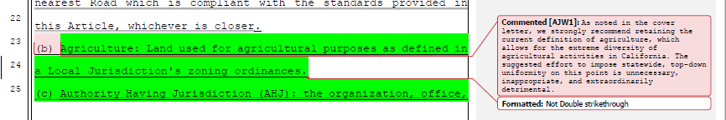
Board response: In the 15 day noticed rule text published on May 10, 2022, the Board proposes to retain this definition of “agriculture.”

Rule text edit: Yes

Comment W126-3: Rural County Representatives of California
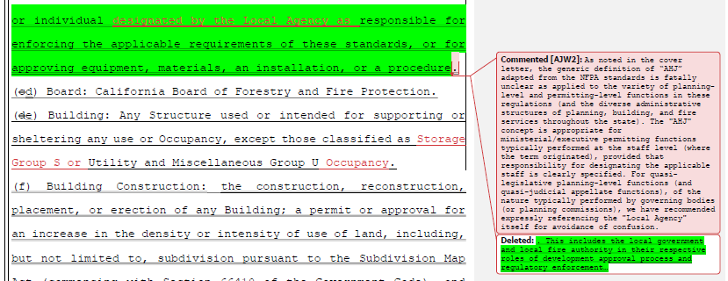
Board response: In the 15 day noticed rule text published on May 10, 2022, the Board deleted the term “AHJ” and use “local jurisdiction” in its place.

Rule text edit: Yes

Comment W126-4: Rural County Representatives of California
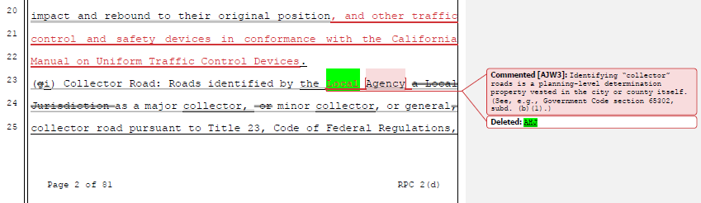
Board response: In the 15 day noticed rule text published on May 10, 2022, the Board deleted the definitions of “clear width” and “collector road.”

Rule text edit: Yes

Comment W126-5: Rural County Representatives of California
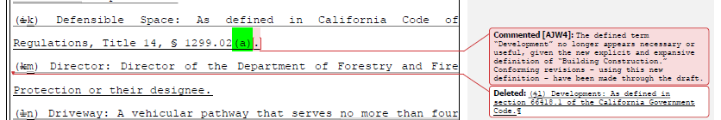
Board response: In the 15 day noticed rule text published on May 10, 2022, the Board deleted the definition of “building construction” and retain the definition of “development” to address the issue raised by the letter writer.

Rule text edit: Yes

Comment W126-6: Rural County Representatives of California
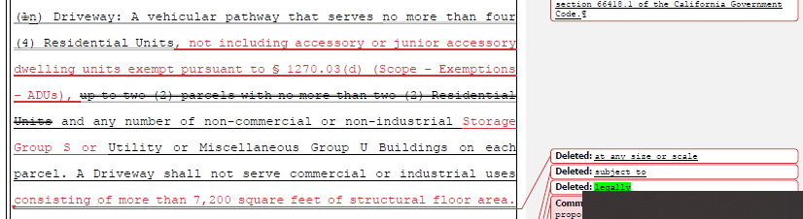
Board response: The exemption for accessory or junior accessory dwelling units was a previous emergency regulatory action and is outside the scope of the proposed action. The definition for “road,” as it currently exists, specifies that a road serves commercial and industrial uses, so to clarify that a driveway cannot serve a commercial or industrial use is reinforcing existing law. The Board has not been presented with evidence that a commercial or industrial use of 7,200 square feet presents a significantly greater fire risk such that smaller commercial or industrial uses need only be served by a driveway.

Rule text edit: No

Comment W126-7: Rural County Representatives of California
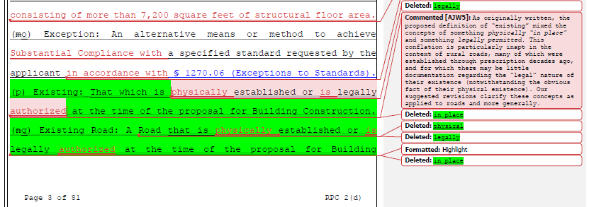
Board response: The Board is no longer proposing definitions for “existing” or “existing road,” or changes to the definition of “exception,” consistent with the narrowed scope of the proposed action as identified within the Supplemental Statement of Reasons published with the “Second 15-Day Notice of Addition of Documents and Information to Rulemaking File and Modified Text” on May 10, 2022. The comment is not specifically directed at the Board’s proposed action or to the procedures followed by the Board in proposing the action.

Rule text edit: No

Comment W126-8: Rural County Representatives of California
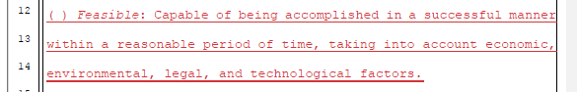
Board response: The Board does not use the term “feasible” in these proposed regulations, so a definition is not necessary.

Rule text edit: No

Comment W126-9: Rural County Representatives of California
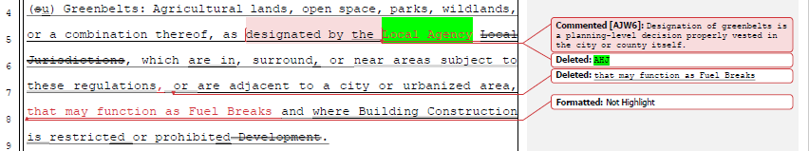
Board response: In the 15 day noticed rule text published on May 10, 2022, the Board replaced the term “AHJ” with “local jurisdiction,” which addresses the letter writer’s concern regarding the appropriate authority to be designating greenbelts.

Regarding the insertion of the phrase “that may function as Fuel Breaks,” there are a variety of reasons why greenbelts may be considered by a local jurisdiction, including habitat restoration, aesthetics, recreation, and fire safety. It would unduly limit a local jurisdiction’s ability to designate greenbelts for those purposes if the definition here only limited greenbelts to those that function as fuel breaks. Specific requirements for greenbelts that do function as fuel breaks are enumerated in 1276.04.

Rule text edit: Yes

Comment W126-10: Rural County Representatives of California
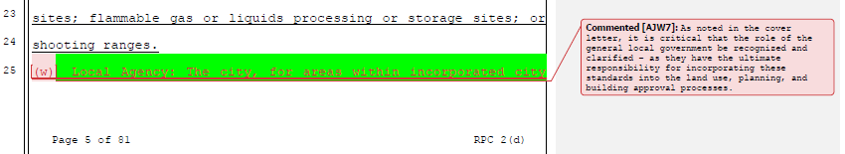

Board response: In the 15 day noticed rule text published on May 10, 2022, the Board deleted the term “AHJ” and use the previously defined term “local jurisdiction” instead, which addresses the issues related to local government presented by the letter writer in this comment.

Rule text edit: Yes

Comment W126-11: Rural County Representatives of California
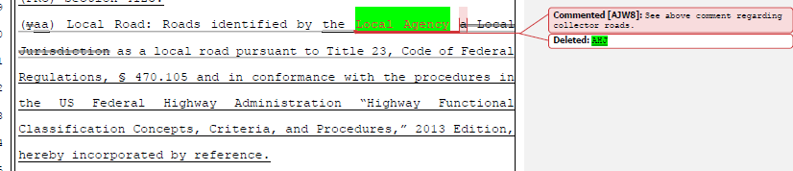
Board response: In the 15 day noticed rule text published on May 10, 2022, the Board deleted the term “AHJ” and use the previously defined term “local jurisdiction” instead, which addresses the issues presented by the letter writer in this comment.

Rule text edit: Yes

Comment W126-12: Rural County Representatives of California
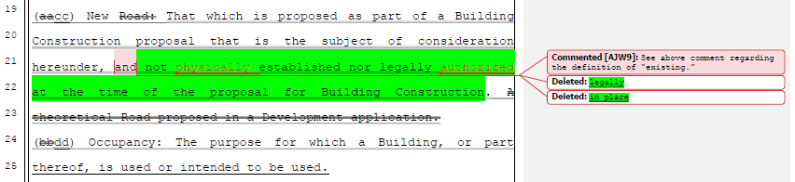
Board response: The Board no longer proposes a definition for “new road,” consistent with the narrowed scope of the proposed action as identified within the Supplemental Statement of Reasons published with the “Second 15-Day Notice of Addition of Documents and Information to Rulemaking File and Modified Text” on May 10, 2022. The comment is not specifically directed at the Board’s proposed action or to the procedures followed by the Board in proposing the action.

Rule text edit: No

Comment W126-13: Rural County Representatives of California
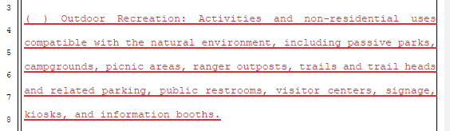
Board response: The Board does not use the term “Outdoor Recreation” in these regulations so a definition is unnecessary.

Rule text edit: No

Comment W126-14: Rural County Representatives of California
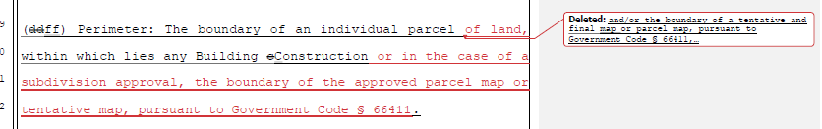
Board response: The Board is no longer proposing a definition for the term “perimeter,” consistent with the narrowed scope of the proposed action as identified within the Supplemental Statement of Reasons published with the “Second 15-Day Notice of Addition of Documents and Information to Rulemaking File and Modified Text” on May 10, 2022. The comment is not specifically directed at the Board’s proposed action or to the procedures followed by the Board in proposing the action.

Rule text edit: No

Comment W126-15: Rural County Representatives of California
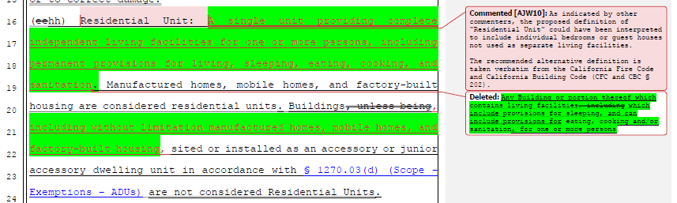
Board response: The Board disagrees that the existing definition of “residential unit” can be interpreted to include individual bedrooms. The definition of residential unit specifies that the building or portion thereof “contains living facilities,” include provisions for sleeping, eating, cooking, and/or sanitation. A single bedroom does not include such provisions. As the letter writer describes, a guesthouse that is not used as a separate living facility does not meet this definition.

Rule text edit: No

Comment W126-16: Rural County Representatives of California
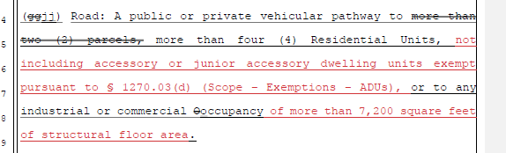
Board response: Please see response to 126-6

Rule text edit: No

Comment W126-17: Rural County Representatives of California
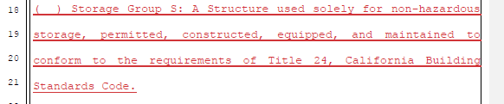
Board response: Please see response to W30-21

Rule text edit: No

Comment W126-18: Rural County Representatives of California
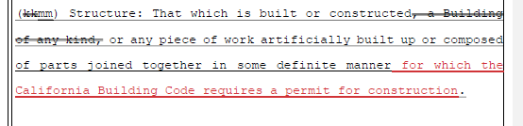
Board response: The term “structure” is defined broadly in these regulations and intentionally includes built or constructed objects that do not require a construction permit. For example, the definition of “defensible space” generally describes structure fires – many structures that do not require permits may catch on fire. The definition for “Same Practical Effect” also uses the term “structure” in the context of providing enough water supply to defend a structure from wildfire. The structure in question in need of defense may not be one that required a permit. Limiting the definition of “Structure” to only those requiring a building permit would be in conflict with the way the term is used in the regulations.

Rule text edit: No

Comment W126-19: Rural County Representatives of California
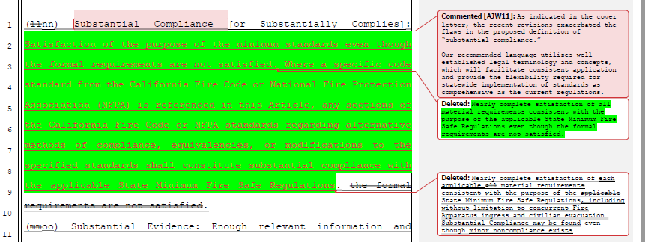
Board response: The Board is no longer proposing a definition for the term “substantial compliance,” consistent with the narrowed scope of the proposed action as identified within the Supplemental Statement of Reasons published with the “Second 15-Day Notice of Addition of Documents and Information to Rulemaking File and Modified Text” on May 10, 2022. The comment is not specifically directed at the Board’s proposed action or to the procedures followed by the Board in proposing the action.

Rule text edit: No

Comment W126-20: Rural County Representatives of California
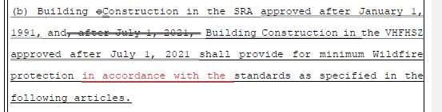
Board response: The letter writer’s proposed change does not provide any additional clarity to the regulatory text.

Rule text edit: No

Comment W126-21: Rural County Representatives of California
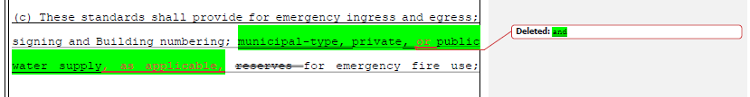
Board response: The Board is not proposing a change to 1270.02(c) regarding water supply terminology and is retaining the phrase “private water supply reserves for emergency fire use.” The comment is not specifically directed at the Board’s proposed action or to the procedures followed by the Board in proposing the action

Rule text edit: No

Comment W126-22: Rural County Representatives of California
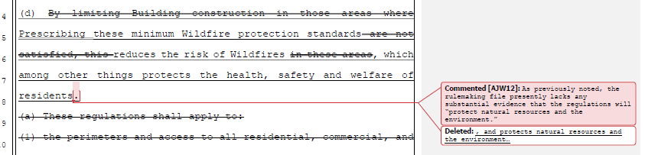
Board response: This comment does not provide a specific objection or recommendation to regarding the proposed adoption (GC 11346.9(a)(3)). Please see General CEQA Response

Rule text edit: No

Comment W126-23: Rural County Representatives of California
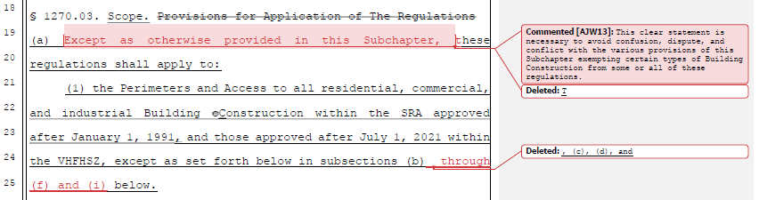
Board response: These regulations previously included exemptions that were the subject of a previous emergency regulatory action and are outside the scope of the proposed action and are no longer part of this regulatory proposal. The only exemption from these regulations in this proposed rulemaking is the existing exemption in 1270.03(b), which the proposed rulemaking clearly references on page 11, lines 15-16, “except as set forth below in subsection (b).” The letter writer’s proposal does not add any additional clarity. Regarding the letter writer’s proposed change to lines 24-25 in their comment, there are no subsections past (d) in 1270.03.

Rule text edit: No

Comment W126-24: Rural County Representatives of California
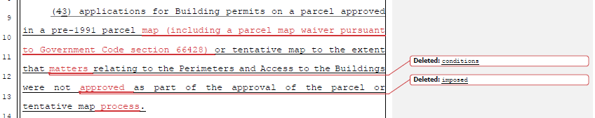
Board response: This comment is irrelevant; the Board is not proposing any changes to this subsection in the proposed regulatory action.

Rule text edit: No

Comment W126-25: Rural County Representatives of California
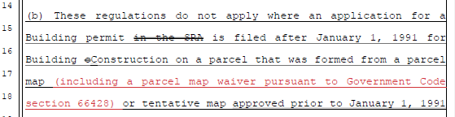

Board response: The scope of the proposed action does not include exempting activities from being subject to the regulations. The comment is outside the scope of the proposed action.

Rule text edit: No

Comment W126-26: Rural County Representatives of California
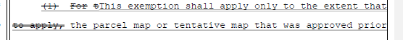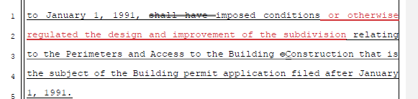
Board response: The Board is no longer proposing to adopt this subsection, as identified in the 15 day noticed rule text published on May 10, 2022. The comment is not specifically directed at the Board’s proposed action or to the procedures followed by the Board in proposing the action.

Rule text edit: No

Comment W126-27: Rural County Representatives of California
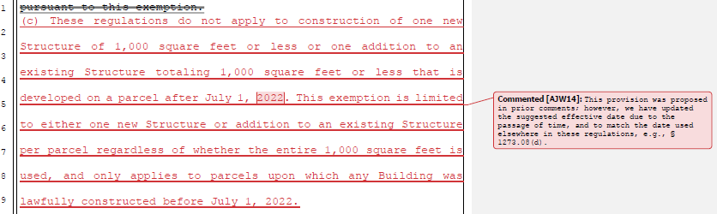
Board response: PRC 4290 requires the Board to write regulations applicable to “all residential, commercial, and industrial building construction.” This exemption would not fulfill the Board’s mandate to apply these regulations to all building construction. Additionally, the scope of the proposed action does not include exempting activities from being subject to the regulations. The comment is outside the scope of the proposed action.

Rule text edit: No

Comment W126-28: Rural County Representatives of California
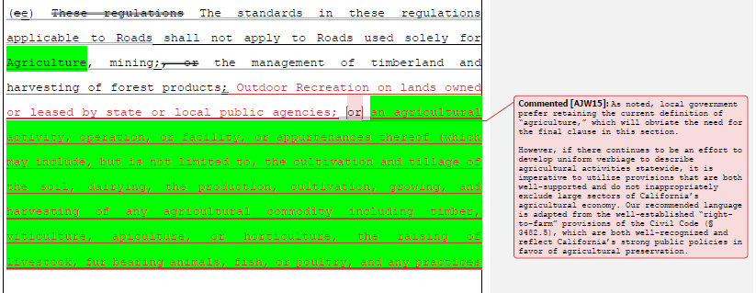
Board response: The Board is no longer proposing changes to the definition of “agriculture,” as described in the 15 day noticed rule text published on May 10, 2022. Regarding the letter writer’s proposal to exempt roads used for “outdoor recreation on lands owned or leased by state or local public agencies,” these regulations have been in place for over 30 years without such an exemption for roads used for outdoor recreation. The scope of the proposed action does not include exempting activities from being subject to the regulations. The comment is outside the scope of the proposed action.

Rule text edit: No

Comment W126-29: Rural County Representatives of California
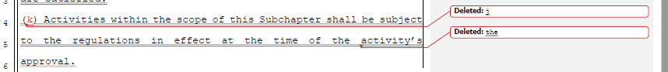
Board response: This subsection is no longer proposed, consistent with the narrowed scope of the proposed action as identified within the Supplemental Statement of Reasons published with the “Second 15-Day Notice of Addition of Documents and Information to Rulemaking File and Modified Text” on May 10, 2022. The comment is not specifically directed at the Board’s proposed action or to the procedures followed by the Board in proposing the action

Rule text edit: No

Comment W126-30: Rural County Representatives of California
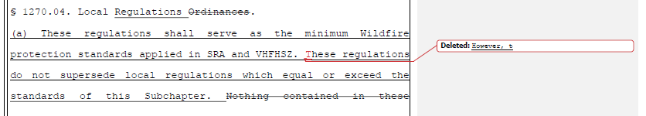
Board response: This change is purely stylistic and does not add any additional clarity to the proposed rulemaking.

Rule text edit: No

Comment W126-31: Rural County Representatives of California
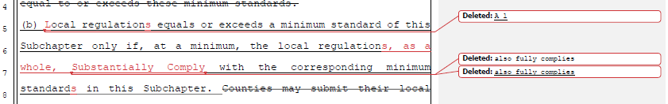
Board response: The Board is no longer proposing to define the term “substantially comply,” consistent with the narrowed scope of the proposed action as identified within the Supplemental Statement of Reasons published with the “Second 15-Day Notice of Addition of Documents and Information to Rulemaking File and Modified Text” on May 10, 2022. In addition, “substantial compliance” would not meet the authority in PRC 4290(c), where a local regulations may only supersede the state minimums where the local regulation “equal[s] or exceed[s] minimum regulations adopted by the state.” “Substantial compliance” does not meet the requirement to “equal or exceed” the state minimum.

Rule text edit: No

Comment W126-32: Rural County Representatives of California
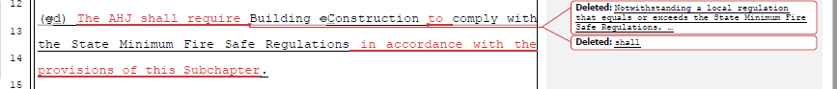
Board response: The Board is no longer using the term “AHJ” or “building construction” consistent with the narrowed scope of the proposed action as identified within the Supplemental Statement of Reasons published with the “Second 15-Day Notice of Addition of Documents and Information to Rulemaking File and Modified Text” on May 10, 2022. The letter writer’s proposed change does not add any additional clarity to the proposed rule text in 1270.05(d), and in fact changes the nature of the proposed regulation. Subsection (d) is intended to specify that regardless of any local regulation that equals or exceeds the state minimums, construction must meet the state minimums. This is consistent with PRC 4290(c), which states that a local regulation cannot supersede the state minimums if they do not “equal or exceed minimum regulations adopted by the state.” Therefore, it so follows that if construction is meeting a standard in a local ordinance that equals or exceeds the state minimums, they are naturally also meeting the minimum requirements set by the state. This language helps assist local jurisdictions in determining if their local regulations equal or exceed the state minimums – if compliance with the local regulation does not result in compliance with the state minimum, then the local regulation does not equal or exceed the state minimums. The letter writer’s proposed change deletes this clarity from the proposed regulations and makes the regulations inconsistent with statute and internally inconsistent.

Rule text edit: No

Comment W126-33: Rural County Representatives of California
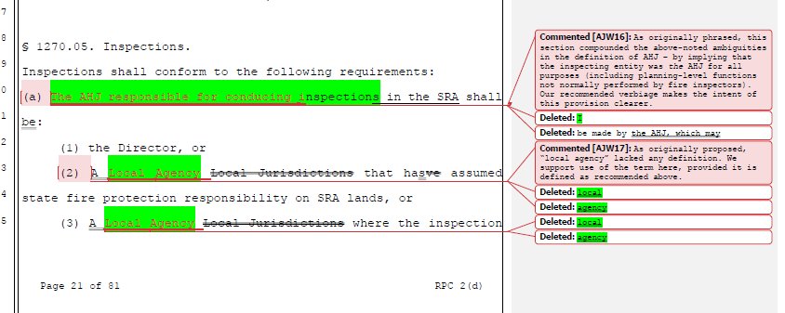
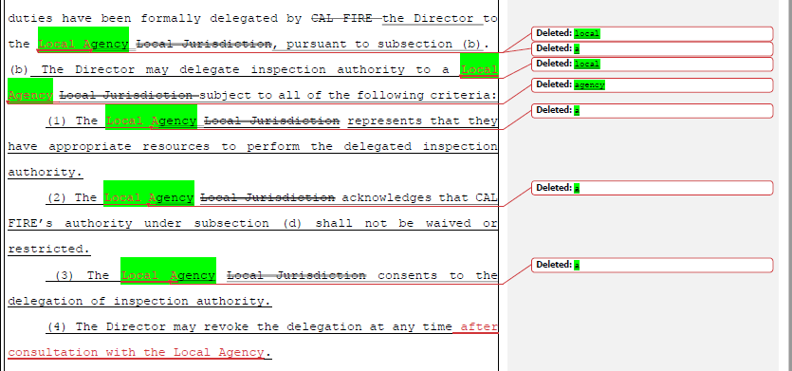
Board response: The Board is no longer proposing to use the term “AHJ,” consistent with the narrowed scope of the proposed action as identified within the Supplemental Statement of Reasons published with the “Second 15-Day Notice of Addition of Documents and Information to Rulemaking File and Modified Text” on May 10, 2022. The comment is not specifically directed at the Board’s proposed action or to the procedures followed by the Board in proposing the action. As such, this comment is irrelevant.

Rule text edit: No

Comment W126-34: Rural County Representatives of California
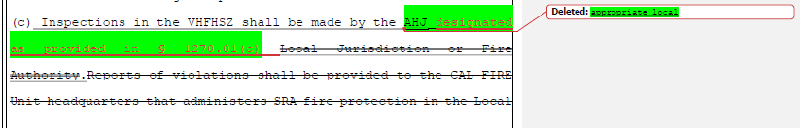
Board response: The Board is no longer proposing to use the term “AHJ,” consistent with the narrowed scope of the proposed action as identified within the Supplemental Statement of Reasons published with the “Second 15-Day Notice of Addition of Documents and Information to Rulemaking File and Modified Text” on May 10, 2022. The comment is not specifically directed at the Board’s proposed action or to the procedures followed by the Board in proposing the action. As such, this comment is irrelevant.

Rule text edit: No

Comment W126-35: Rural County Representatives of California
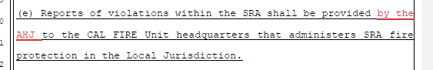
Board response: The Board is no longer proposing to use the term “AHJ,” consistent with the narrowed scope of the proposed action as identified within the Supplemental Statement of Reasons published with the “Second 15-Day Notice of Addition of Documents and Information to Rulemaking File and Modified Text” on May 10, 2022. The comment is not specifically directed at the Board’s proposed action or to the procedures followed by the Board in proposing the action. As such, this comment is irrelevant.

Rule text edit: No

Comment W126-36: Rural County Representatives of California
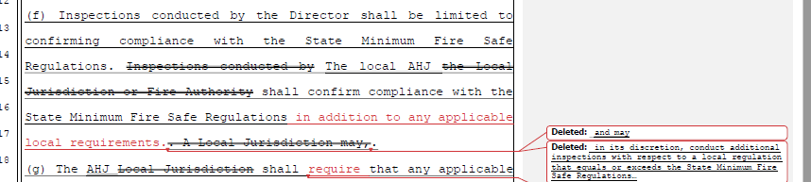
Board response: The Board is no longer proposing these sections, consistent with the narrowed scope of the proposed action as identified within the Supplemental Statement of Reasons published with the “Second 15-Day Notice of Addition of Documents and Information to Rulemaking File and Modified Text” on May 10, 2022. The comment is not specifically directed at the Board’s proposed action or to the procedures followed by the Board in proposing the action. As such, this comment is irrelevant.

Rule text edit: No

Comment W126-37: Rural County Representatives of California
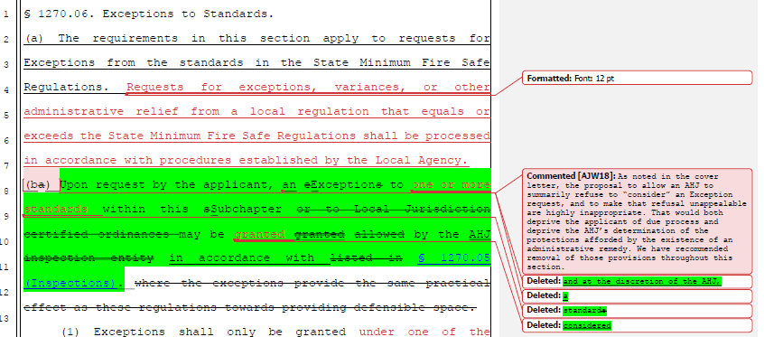
Board response: The Board is no longer making this proposed change to 1270.06(a) or (b), consistent with the narrowed scope of the proposed action as identified within the Supplemental Statement of Reasons published with the “Second 15-Day Notice of Addition of Documents and Information to Rulemaking File and Modified Text” on May 10, 2022. The comment is not specifically directed at the Board’s proposed action or to the procedures followed by the Board in proposing the action.

Rule text edit: No

Comment W126-38: Rural County Representatives of California
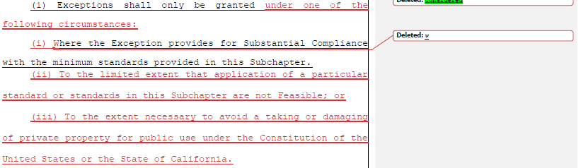
Board response: The Board is no longer making this proposed change to 1270.06(b), consistent with the narrowed scope of the proposed action as identified within the Supplemental Statement of Reasons published with the “Second 15-Day Notice of Addition of Documents and Information to Rulemaking File and Modified Text” on May 10, 2022. The comment is not specifically directed at the Board’s proposed action or to the procedures followed by the Board in proposing the action

Rule text edit: No

Comment W126-38: Rural County Representatives of California
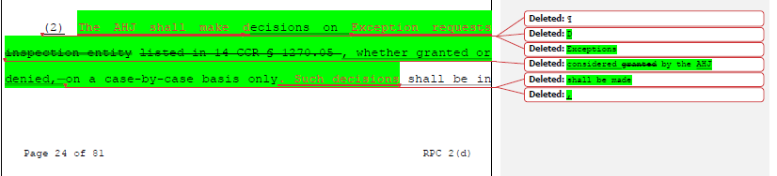
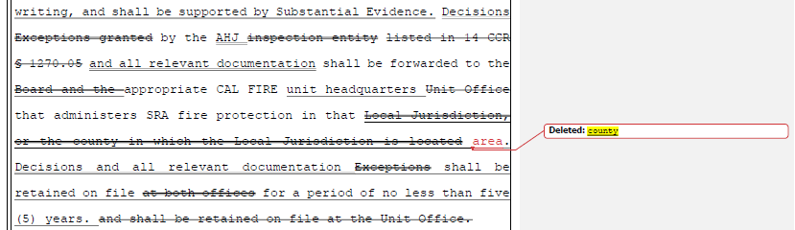
Board response: The Board is no longer making this proposed change to 1270.06, consistent with the narrowed scope of the proposed action as identified within the Supplemental Statement of Reasons published with the “Second 15-Day Notice of Addition of Documents and Information to Rulemaking File and Modified Text” on May 10, 2022. The comment is not specifically directed at the Board’s proposed action or to the procedures followed by the Board in proposing the action.

Rule text edit: No

Comment W126-39: Rural County Representatives of California
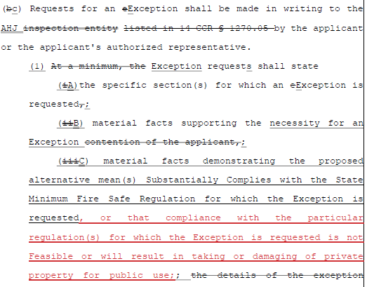
Board response: The Board is no longer making this proposed change to 1270.06, consistent with the narrowed scope of the proposed action as identified within the Supplemental Statement of Reasons published with the “Second 15-Day Notice of Addition of Documents and Information to Rulemaking File and Modified Text” on May 10, 2022. The comment is not specifically directed at the Board’s proposed action or to the procedures followed by the Board in proposing the action.

Rule text edit: No

Comment W126-40: Rural County Representatives of California

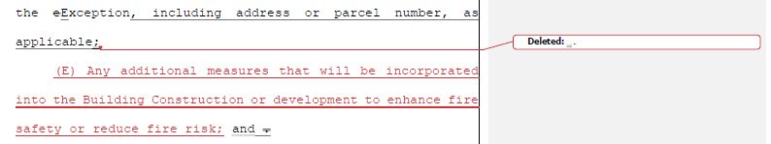
Board response: The Board is no longer making this proposed change to 1270.06(b), consistent with the narrowed scope of the proposed action as identified within the Supplemental Statement of Reasons published with the “Second 15-Day Notice of Addition of Documents and Information to Rulemaking File and Modified Text” on May 10, 2022. The comment is not specifically directed at the Board’s proposed action or to the procedures followed by the Board in proposing the action.

Rule text edit: No

Comment W126-41: Rural County Representatives of California
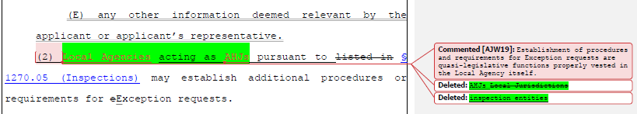
Board response: The Board is no longer using the term “AHJ,” consistent with the narrowed scope of the proposed action as identified within the Supplemental Statement of Reasons published with the “Second 15-Day Notice of Addition of Documents and Information to Rulemaking File and Modified Text” on May 10, 2022. The Board is instead using the term “local jurisdictions,” which addresses the letter writer’s proposed change.

Rule text edit: No

Comment W126-42: Rural County Representatives of California
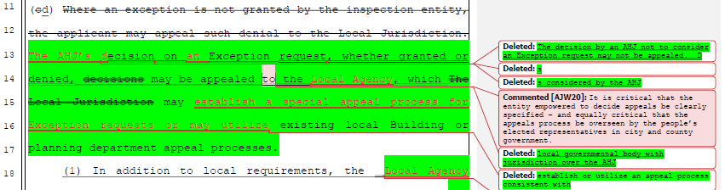
Board response: The Board is no longer making this proposed change to 1270.06, consistent with the narrowed scope of the proposed action as identified within the Supplemental Statement of Reasons published with the “Second 15-Day Notice of Addition of Documents and Information to Rulemaking File and Modified Text” on May 10, 2022. The comment is not specifically directed at the Board’s proposed action or to the procedures followed by the Board in proposing the action.

Rule text edit: No

Comment W126-43: Rural County Representatives of California
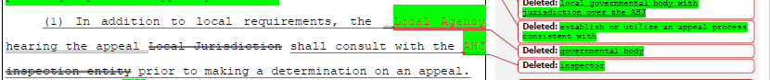
Board response: The Board is no longer making this proposed change to 1270.06, consistent with the narrowed scope of the proposed action as identified within the Supplemental Statement of Reasons published with the “Second 15-Day Notice of Addition of Documents and Information to Rulemaking File and Modified Text” on May 10, 2022. The comment is not specifically directed at the Board’s proposed action or to the procedures followed by the Board in proposing the action.

Rule text edit: No

Comment W126-44: Rural County Representatives of California
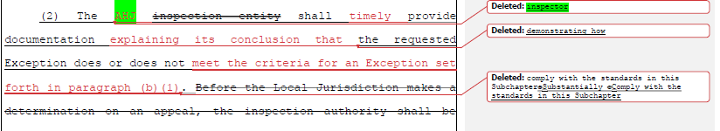
Board response: The Board is no longer making this proposed change to 1270.06, consistent with the narrowed scope of the proposed action as identified within the Supplemental Statement of Reasons published with the “Second 15-Day Notice of Addition of Documents and Information to Rulemaking File and Modified Text” on May 10, 2022. The comment is not specifically directed at the Board’s proposed action or to the procedures followed by the Board in proposing the action.

Rule text edit: No

Comment W126-45: Rural County Representatives of California
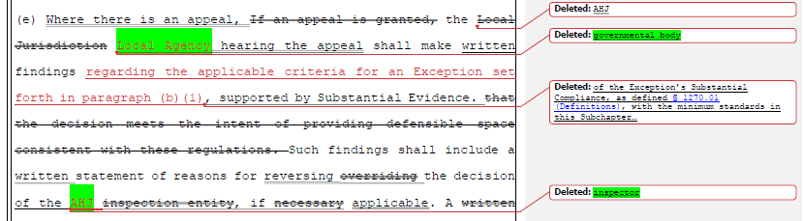
Board response: The Board is no longer making this proposed change to 1270.06, consistent with the narrowed scope of the proposed action as identified within the Supplemental Statement of Reasons published with the “Second 15-Day Notice of Addition of Documents and Information to Rulemaking File and Modified Text” on May 10, 2022. The comment is not specifically directed at the Board’s proposed action or to the procedures followed by the Board in proposing the action.

Rule text edit: No

Comment W126-46: Rural County Representatives of California

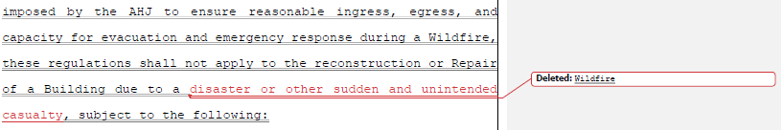
Board response: The regulatory exemption for wildfire rebuilds was a previous emergency regulatory action and is outside the scope of the proposed action. Please see General Response to Exceptions and Exemptions Comments.

Rule text edit: No

Comment W126-47: Rural County Representatives of California
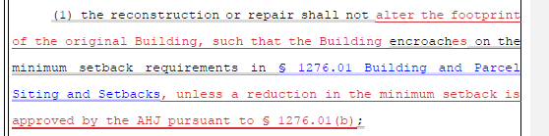
Board response: The regulatory exemption for wildfire rebuilds was a previous emergency regulatory action and is outside the scope of the proposed action. Please see General Response to Exceptions and Exemptions Comments.

Rule text edit: No

Comment W126-48: Rural County Representatives of California
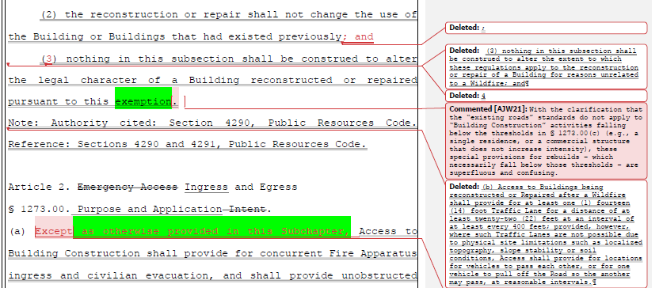
Board response: The regulatory exemption for wildfire rebuilds was a previous emergency regulatory action and is outside the scope of the proposed action. Please see General Response to Exceptions and Exemptions Comments.

Rule text edit: No

Comment W126-49: Rural County Representatives of California
The letter writer’s suggested changes to pp.28-73 of the rule text are limited in scope to Articles 2-4 of the regulation. The Board is no longer proposing to revise Articles 2-4, consistent with the narrowed scope of the proposed action as identified within the Supplemental Statement of Reasons published with the “Second 15-Day Notice of Addition of Documents and Information to Rulemaking File and Modified Text” on May 10, 2022. The comment is not specifically directed at the Board’s proposed action or to the procedures followed by the Board in proposing the action.

Comment W126-50: Rural County Representatives of California
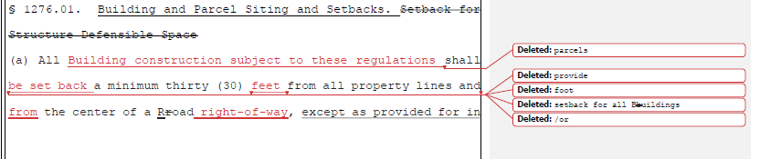
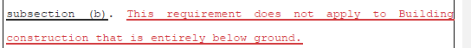
Board response: The Board is not proposing any changes to 1276.01(a). The comment is not specifically directed at the Board’s proposed action or to the procedures followed by the Board in proposing the action.

Rule text edit: No

Comment W126-51: Rural County Representatives of California
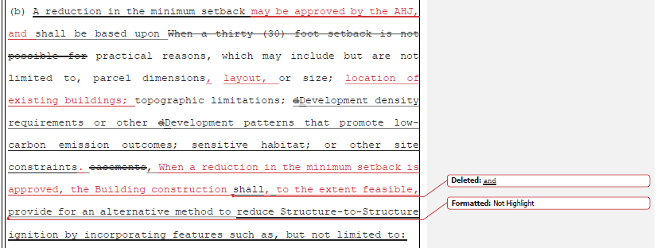
Board response: The Board is no longer proposing to use the term “AHJ.” By providing for a setback of less than 30 feet in subsection (b), the regulations inherently give the local jurisdiction the ability to approve such setbacks. It is not necessary to specify that those setbacks may be approved by the local jurisdiction.

It is not necessary to specify parcel layout or location of existing buildings in the list of reasons why a less than 30 foot setback may be approved. The regulation states “…or other site constraints” which could include the parcel layout or existing buildings. It would be overly burdensome for the Board to attempt to enumerate every site condition that may warrant a less than 30 foot setback. The letter writer’s suggestions do not add any additional clarity to the regulation.

The letter writer’s proposal that after the reduction in setback is approved, the building construction shall meet certain standards changes the intent of the proposed regulatory language. The intent of the proposed language is for the setback reduction and the alternative standards shall be approved at the same time – i.e., the reduction in setback cannot be approved without an alternative method to prevent structure to structure ignition. The alternative method is not a secondary approval to the reduction of the setback. The letter writer’s proposal changes this so that the setback reduction is approved first, then alternative methods are applied. This provides opportunities for the project proponent to receive approval for the setback reduction and then neglect to install alternative methods of reducing structure to structure ignition, which is not the intent of this section.

Rule text edit: No

Comment W126-52: Rural County Representatives of California
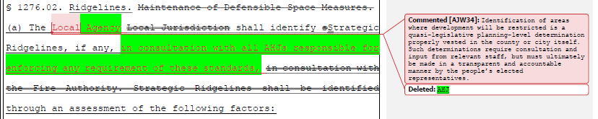
Board response: The Board is no longer proposing to use the term “AHJ” and instead is using the term “local jurisdiction,” which addresses the letter writer’s concern.

Rule text edit: No

Comment W126-53: Rural County Representatives of California
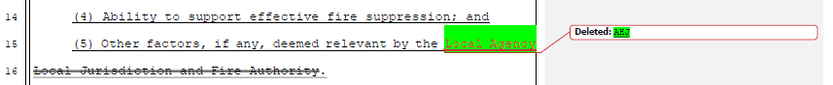
Board response: The Board is no longer proposing to use the term “AHJ” and instead is using the term “local jurisdiction,” which functionally resolves the letter writer’s concern.

Rule text edit: No

Comment W126-54: Rural County Representatives of California
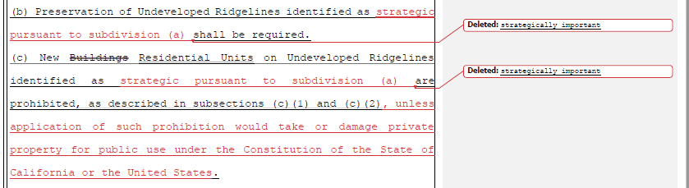
Board response: The proposed regulation and the term “strategically important” provide sufficient clarity to effectuate the purpose of the statute. The commenter has provided no judicial determination as to the unconstitutionality of PRC § 4290, the existing Fire Safe Regulations, or the proposed rulemaking language, and the Board is unaware of any. The proposed language regarding constitutional matters is outside the scope of the Board’s authority and is not necessary or appropriate to effectuate the purpose of the statute. Please see General Response to Constitutionality Comment.

Rule text edit: No

Comment W126-55: Rural County Representatives of California
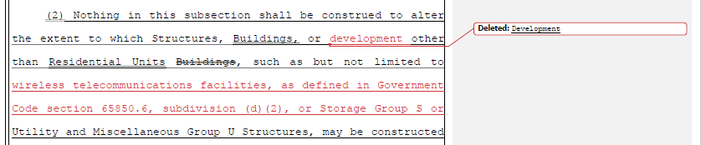
Board response: This subsection was revised in the 15 day noticed rule text published on May 10, 2022, for greater clarity and flexibility for local jurisdictions. The proposed rule text reads “Nothing in this subsection shall be construed to alter the extent to which utility infrastructure, including but not limited to wireless telecommunications facilities, as defined in Government Code section 65850.6, subdivision (d)(2), or Storage Group S or Utility and Miscellaneous Group U Structures, may be constructed on Undeveloped Ridgelines.” This proposal is less ambiguous than had been previously proposed, and also addresses the concern of the letter writer regarding the siting of telecommunications equipment and Group S structures on undeveloped ridgelines.

Rule text edit: No

Comment W126-56: Rural County Representatives of California
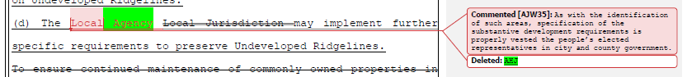
Board response: The Board is no longer using the term “AHJ” and instead is using the term “local jurisdiction,” which addresses the letter writer’s concern regarding local government.

Rule text edit: No

Comment W126-57: Rural County Representatives of California
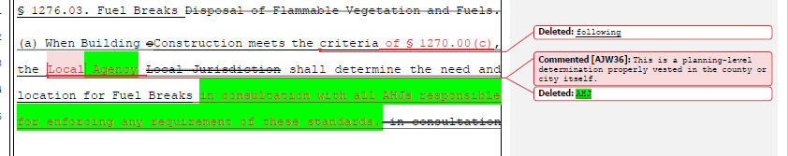
Board response: The Board is no longer using the term “AHJ” and instead is using the term “local jurisdiction,” which addresses the letter writer’s concern regarding local government.

Rule text edit: No

Comment W126-58: Rural County Representatives of California
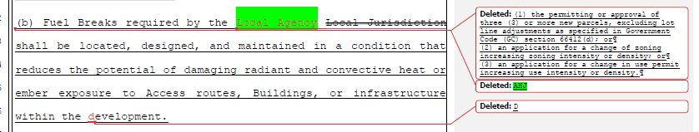
Board response: The Board is no longer using the term “AHJ” and instead is using the term “local jurisdiction,” which addresses the letter writer’s concern. Additionally, the commenter suggests the elimination of the conditions of 1276.03(a)(1)-(3) which describe when a local jurisdiction is required to make a certain determination regarding fuel breaks, however these conditions provide improved clarity to the local jurisdictions on when the need for a fuel break should be evaluated to achieve minimum fire safety, rather than requiring either constant, or simply one-time evaluation of fuel break necessity, as is suggested by the commenter.

Rule text edit: No

Comment W126-59: Rural County Representatives of California
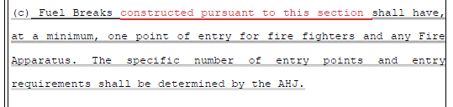
Board response: The phrase “constructed pursuant to this section” is redundant. The proposed regulations do not imply that these requirements are applicable to fuel breaks conducted under conditions or requirements.

Rule text edit: No

Comment W1126-60: Rural County Representatives of California
Board response: The Board is no longer using the term “AHJ” and instead is using the term “local jurisdiction,” which addresses the letter writer’s comment. The phrase “constructed pursuant to this section” is redundant. The proposed regulations do not imply that these requirements are applicable to fuel breaks conducted under conditions or requirements.

Rule text edit: No

Comment W126-61: Rural County Representatives of California
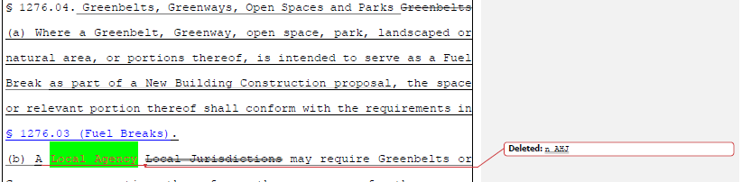
Board response: The Board is no longer using the term “AHJ” and instead is using the term “local jurisdiction,” which addresses the letter writer’s comment.

Rule text edit: No

Comment W126-62: Rural County Representatives of California
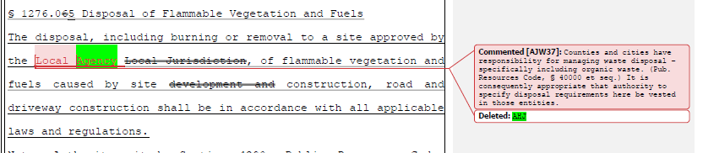
Board response: The Board is no longer using the term “AHJ” and instead is using the term “local jurisdiction,” which addresses the letter writer’s concern.

Rule text edit: No

Comment W126-63: Rural County Representatives of California
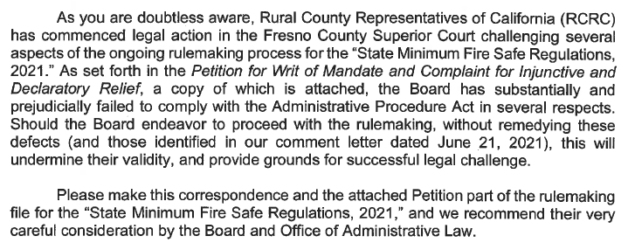
Board response: All written comments submitted to the Board in connection with the adoption, amendment, or repeal of the regulation will be included in the rulemaking file, pursuant to Government Code 11347.3(b)(6).

Rule text edit: No

Comment W127-1: CAL FIRE
The first two paragraphs and last paragraph of this comment are introductory/conclusive in nature; the comments not specifically directed at the Board’s proposed action or to the procedures followed by the Board in proposing the action.

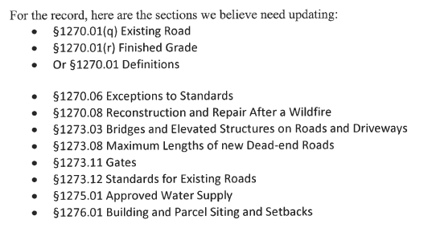
Board response: Without more specific details regarding the desired updates to these sections, the Board has no specific response to the Department’s proposal.

Regarding the terms “existing road” and “finished grade,” those terms are no longer used, consistent with the narrowed scope of the proposed action as identified within the Supplemental Statement of Reasons published with the “Second 15-Day Notice of Addition of Documents and Information to Rulemaking File and Modified Text” on May 10, 2022. The comment is not specifically directed at the Board’s proposed action or to the procedures followed by the Board in proposing the action

Regarding section 1270.06 Exceptions to Standards, there are no further changes to this section consistent with the narrowed scope of the proposed action as identified within the Supplemental Statement of Reasons published with the “Second 15-Day Notice of Addition of Documents and Information to Rulemaking File and Modified Text” on May 10, 2022. The comment is not specifically directed at the Board’s proposed action or to the procedures followed by the Board in proposing the action.

Regarding sections 1273.03, .08, .11, and .12, as well as 1275.01, the Board is no longer proposing changes to those sections consistent with the narrowed scope of the proposed action as identified within the Supplemental Statement of Reasons published with the “Second 15-Day Notice of Addition of Documents and Information to Rulemaking File and Modified Text” on May 10, 2022.- The comment is not specifically directed at the Board’s proposed action or to the procedures followed by the Board in proposing the action.

Without more specific details regarding the Department’s objection to 1276.01, the Board cannot offer proposed changes or a specific response to this objection.

Rule text edit: No

Comment W128-1: Insurance Commissioner Ricardo Lara
The first paragraph and last three paragraphs of this comment are introductory/conclusive in nature; the comments are not specifically directed at the Board’s proposed action or to the procedures followed by the Board in proposing the action.

The proposed regulations would establish important road standards for new roads and driveways, which is important for both the evacuation of residents from areas threatened by a wildfire and also the accessibility of fire-fighting trucks and equipment. The accessibility of a property to firefighting professionals can reduce the risk of loss to the property. However, your draft regulations do not apply to upgrading existing roads and, if those existing roads are not upgraded for new developments, the result could likely be fewer insurance options and more expensive insurance for new and existing homes built along those existing roads. In areas with high wildfire hazard, road accessibility is also important to promote the safety of evacuees, firefighting professionals, and emergency services.

Board response: The Board is no longer proposing changes to the standards for existing roads, consistent with the narrowed scope of the proposed action as identified within the Supplemental Statement of Reasons published with the “Second 15-Day Notice of Addition of Documents and Information to Rulemaking File and Modified Text” on May 10, 2022. The comment is not specifically directed at the Board’s proposed action or to the procedures followed by the Board in proposing the action

Rule text edit: No

Comment W128-2: Insurance Commissioner Ricardo Lara
Several insurance rate filings submitted to the Department of Insurance (Department) include the use of wildfire risk scores as one part of the calculation of an individual property’s premium. One of the most common variables used in wildfire risk scores is “access”, a metric that takes into consideration the accessibility of roads in the geographic area of a particular property. For example, many wildfire risk scores include the variables of “access”, “slope” and “fuel” meaning that the determination of access is one of only three factors in determining the property’s wildfire risk score. Although specific approaches may vary among insurance companies, the classification of roads leading into and out of a property is a very common factor. Therefore, the road standards in the current draft regulations for those roads in high wildfire hazard areas could likely have a major impact on insurance options and pricing for homeowners and businesses in these areas.
Furthermore, of those three common variables (access, slope, and fuel), the homeowner and businessowner have the least control – if any – over access. The homeowner and businessowner cannot, for example, pave wider roads or convert a cul-de-sac or dead end into a through road. As a result, the Board should take all feasible steps to require improved road access for existing roads for all new developments.
Board response: The Board is no longer proposing changes to the road standards, consistent with the narrowed scope of the proposed action as identified within the Supplemental Statement of Reasons published with the “Second 15-Day Notice of Addition of Documents and Information to Rulemaking File and Modified Text” on May 10, 2022. The comment is not specifically directed at the Board’s proposed action or to the procedures followed by the Board in proposing the action

Rule text edit: No

Comment W129-1: Preserve Rural Sonoma County
The first three, fifth, and last paragraphs of this comment are introductory/conclusive in nature; the comments are not specifically directed at the Board’s proposed action or to the procedures followed by the Board in proposing the action.

The public has relied on the State BOF to uphold long-standing regulations focused on concurrent ingress of fire equipment and resident/worker egress from fire prone areas. Now, in 2022, the BOF appears to have succumbed to lobbying by RCRC, with the December 2021 draft proposing to gut fire safe road regulations, giving authority, discretion and oversight to local governments. This change in direction severely jeopardizes public safety, as the Sonoma County Board of Supervisors has shown no willingness to comply with current fire safe regulations, even opposing the recommendations of the Fire Chief’s Working Group.

Board response: The Board is no longer proposing changes to the road standards, consistent with the narrowed scope of the proposed action as identified within the Supplemental Statement of Reasons published with the “Second 15-Day Notice of Addition of Documents and Information to Rulemaking File and Modified Text” on May 10, 2022. The comment is not specifically directed at the Board’s proposed action or to the procedures followed by the Board in proposing the action

Rule text edit: No

Comment W129-2: Preserve Rural Sonoma County
PRSC requests the BOF heed the sage advice in the January 3, 2022 Wildfire Professionals letter re-draft the Minimum Fire Safe Regulations to meet public safety and environmental compliance goals.

Board response: The Board is no longer proposing changes to the road standards, consistent with the narrowed scope of the proposed action as identified within the Supplemental Statement of Reasons published with the “Second 15-Day Notice of Addition of Documents and Information to Rulemaking File and Modified Text” on May 10, 2022. The comment is not specifically directed at the Board’s proposed action or to the procedures followed by the Board in proposing the action. Environmental compliance goals are outside the scope of this rulemaking, but the letter writer may be interested in reviewing General CEQA response.

Rule text edit: No

Comment W130-1: California Farm Bureau
The first paragraph and last two paragraphs of this comment are introductory/conclusive in nature; the comments are not specifically directed at the Board’s proposed action or to the procedures followed by the Board in proposing the action.

Section 1270.01 – Definitions
We appreciate the inclusion and recognition of agriculture’s unique needs within the fire safe standards. However, we would like to express concern regarding potential limits in the current definition of agriculture used in §1270.01(b) Agriculture: Land used for agricultural purposes as defined in a Local Jurisdiction's zoning ordinances. While we respect local control in land use policies and practices, state law has a far more comprehensive definition of agriculture (which includes but is not limited to livestock grazing, apiculture, nurseries and visitor-serving or necessary, appurtenant agricultural facilities).
We encourage the Board to consider all facets of agricultural production and draft standards that are framed to be inclusive of all of agriculture. Because §1270.01(w) Local Jurisdiction: Any county, city/county agency or department, or any locally authorized district that approves or has the authority to regulate Development allows for a wide variety of quasi-government groups to be deemed a “Local Jurisdiction”, the definition of “Agriculture” by such entity could be drastically different from the accepted and recognized state definition and norms of what is considered agriculture. This creates an opportunity for confusion and unequal application of the Regulations across the state. Thus, we request that the Board add in language to the definition of Agriculture that makes it clear that restrictive Local Jurisdiction’s definition will not be leveraged to limit legitimate agriculture activities.

Board response: The Board is no longer proposing changes to the definition of “agriculture,” consistent with the narrowed scope of the proposed action as identified within the Supplemental Statement of Reasons published with the “Second 15-Day Notice of Addition of Documents and Information to Rulemaking File and Modified Text” on May 10, 2022. The comment is not specifically directed at the Board’s proposed action or to the procedures followed by the Board in proposing the action.

Rule text edit: No

Comment W130-2: California Farm Bureau
Section 1273.00(a)-(d) – Purpose and Application
We raise new objections to §1273.00 Purpose and Application which states that the Regulations apply to all New Roads, and to “all Existing Roads, Driveways or Road or Driveway Structures within a Perimeter.” We interpret this to mean that agriculture operations would be required to survey and inspect every path of ingress and egress on their properties that currently exist and either meet new provisions or seek exceptions from Local Jurisdictions. Either choice presents incredible investments in time and resources. Further, the Regulations create confusion whereby a specific exemption is provided for roads used for agriculture purposes but does not make clear that Existing Roads within a Perimeter are subject to the regulations if they lead to a homestead on a farm, for example. Would that road be an exempted agriculture road or a covered Existing Road? Similarly, we raise objections to §1273.13 Secondary Routes for Existing Roads which would require, at a prohibitive cost, for a secondary access road to meet a full road standard. This shows a lack of understanding of how secondary roads are utilized within a Perimeter by business and property owners currently, and adds an unnecessary cost to land ownership.

Board response: The Board is no longer proposing changes to the road standards, consistent with the narrowed scope of the proposed action as identified within the Supplemental Statement of Reasons published with the “Second 15-Day Notice of Addition of Documents and Information to Rulemaking File and Modified Text” on May 10, 2022. The comment is not specifically directed at the Board’s proposed action or to the procedures followed by the Board in proposing the action.

Rule text edit: No

Comment W130-3: California Farm Bureau
Sections 1276.03, 1276.04 and 1276.05 – Impacted Agricultural Lands (Greenbelts)
We reiterate our previous objection to maintaining “agricultural lands” in §1270.01(s) Greenbelts: Agricultural lands, open space, parks, wildlands, or a combination thereof, as designated by Local Jurisdictions, which surround or are adjacent to a city or urbanized area, and restrict or prohibit Development. As stated previously, incorporating agricultural lands (or agriculture) into the Regulation’s operational definition of greenbelt, places prime agricultural lands into a new and significant regulatory scenario that impacts wildfire mitigation strategies, discussed below.

Agricultural lands are privately owned and utilized to produce commercial agricultural commodities. Lands such as open space and parklands, which are largely publicly owned and maintained for various recreational, esthetic, or environmental purposes, do not contain substantial commercial or manufacturing infrastructure, such as irrigation lines, trellising, crops, barns, or other components related to an agricultural business. The existence of such commercial or manufacturing infrastructure creates a significant area of conflict with the Regulation, as does the private property ownership of the land.
Greenbelts, as defined by the Regulation, are subject to the following sections: §1276.03 – Fuel Breaks, §1276.04 – Greenbelts, Greenways, Open Spaces, and Parks, and §1276.05 – Maintenance of Fuel Breaks.

Section 1276.03(c)(4) provides permissive authority for a local entity to require fuel breaks at required locations, including but not limited to, within greenbelts. The Regulation empowers a local jurisdiction to establish fuel breaks that could likely result in the removal of orchards, vineyards and row crop field uses related to production agricultural. It is our understanding that a vineyard, or portion thereof, would be removed for the creation of the community fuel break. Further, the establishment of a fuel break on agricultural land is not predicated on whether there is building construction, a modification of parcels, or zoning density near that property, as is stated in §1276.03(a) (1-3).

Fundamentally, a local jurisdiction should not have the authority to designate private property as the “last resort refuge” for any catastrophic emergency. Agricultural land, greenbelts, greenways, open space, and parklands do not guarantee the protection of any individual seeking refuge from a wildfire.

Board response: In general, the Board agrees with the concerns raised by the letter writer and has amended the requirements for greenbelts to exclude agriculture in the 15 day noticed rule text published May 10, 2022.

Rule text edit: Yes

Comment W130-4: California Farm Bureau
Section 1276.03(c)(4) creates a new local authority, unbound and unchecked, for the purpose of creating fuel breaks as determined necessary by the local jurisdiction. If a local jurisdiction determines that a fuel break is necessary on agricultural lands to achieve a strategic wildfire mitigation objective, then that agricultural property becomes burdened with the creation of a community fuel break. Privately owned agricultural land stands to lose considerable economic value in addition to the financial loss related to commodity production.

Board response: The Board is no longer proposing section 1276.03(c)(4). The comment is not specifically directed at the Board’s proposed action or to the procedures followed by the Board in proposing the action.

Rule text edit: Yes

Comment W130-5: California Farm Bureau
The scenario for agricultural lands is worsened by §1276.05, relating to maintenance of the fuel break. Provided by the Regulation, the private agricultural landowner, now burdened with the existence of the new fuel break on their private property, is also bound to maintain the fuel break. Local jurisdictions are empowered to bind the private property for which the fuel break is established, ensure adequate maintenance levels, and may include contractual agreements, levying of taxes, fees or assessments, or some other funding mechanism. The creation of the fuel break becomes a new easement on the agricultural land (like a utility right-of way for an electrical or water utility company). The creation of a fuel break on agricultural land arguably deprives the private landowner of the ability to utilize that land for their productive purpose. This is completely unacceptable, and then to further require that private agricultural landowner be made responsible for the maintenance of the fuel break in perpetuity is indefensible. Private agricultural landowners are then left in the untenable situation of having to defend their right-to-farm over the protection of a community’s health and safety.

Board response: Please see response to W65-3

Rule text edit: Yes

Comment W130-6: California Farm Bureau
Lastly, §1276.04 is also incompatible with commercial agriculture. Specifically, paragraph (b) authorizes a local jurisdiction permissive authority to require that greenbelts (i.e. agricultural lands) be utilized as evacuation areas of last resort. California’s farming and ranching community would never turn away an evacuee from a wildfire, but to place the burden of a “last-resort” evacuation site on farmers or ranchers is unspeakable. We know of first responders who took shelter in vineyards during the Napa and Sonoma wildfires, to which there is no objection. But, agricultural lands should not become a “last resort” area of refuge and may further complicate evacuation of livestock, employees, and farm equipment for the agricultural operation. This also places many food safety measures in jeopardy of adulteration and possible loss of entire crops.
Fundamentally, a local jurisdiction should not have the authority to designate private property as the “last resort refuge” for any catastrophic emergency. Agricultural land, greenbelts, greenways, open space, and parklands do not guarantee the protection of any individual seeking refuge from a wildfire.
We understand, perhaps, the rationale of establishing evacuation areas of last resort, but fail to understand the absolute necessity for establishing the requirement within this Regulation.
Due to the complexities and nuances associated to privately held agricultural land, we request that the Board strike agricultural lands from its definition of greenbelts. While greenbelts, and agricultural lands, serve similar purposes in minimizing urban sprawl and development, the functionality of these lands are very different and further conflicts with the Regulation. Private agricultural lands are not intended, nor should be required, to become regulatorily authorized fuel breaks, a new mechanism to raise revenue, or a last resort refuge from wildfire.
Board response: Please see response to W64-3

Rule text edit: Yes

Comment W131-1: Del Norte County Board of Supervisors
The first two and last two paragraphs of this comment are introductory/conclusive in nature; the comments are not specifically directed at the Board’s proposed action or to the procedures followed by the Board in proposing the action.

I. General
a. The DRAFT Regulations do not state who has the authority to determine if a
regulation is "Not Practical [or Not Practicable]." Incorporating into the DRAFT
Regulations: "The Agency Having Jurisdiction shall determine when a regulation
is Not Practical [or Not Practicable]." would resolve this deficiency.

Board response: The entity described within 14 CCR § 1270.06 has the responsibility for implementing and enforcing these regulations. Additionally, the process for requesting an exception or alternative to the minimum standards within the regulations, even those which may be based upon what is practical, such as those within 14 CCR § 1276.01, are described in detail within the proposed 14 CCR § 1270.07. As identified within that section, the inspection entity described within the revised 14 CCR § 1270.06 is responsible for those processes.

Rule text edit: No

Comment W131-2: Del Norte County Board of Supervisors

b. The DRAFT Regulations do not incorporate early notification and warning
systems as a potential mitigation. Del Norte County is prone to tsunamis and
utilizes a tsunami siren as an audio warning that can reach everyone in the evacuation zone, with the exception of individuals with hearing impairments,
regardless of their access to technology. Would a statewide wildfire siren system
or similar technology such as Everbridge be a more cost-effective mitigation
strategy than implementation of some of the restrictions on development in the
DRAFT Regulations?

Board response: The Board is authorized to establish state minimum fire safety standards applicable to construction. An early warning system is outside the scope of the proposed regulations.

Rule text edit: No

Comment W131-3: Del Norte County Board of Supervisors
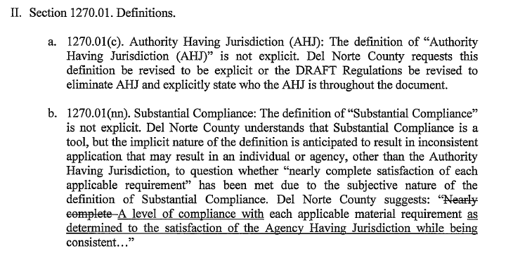
Board response: The Board is no longer proposing definitions for “AHJ” or “Substantial compliance,” consistent with the narrowed scope of the proposed action as identified within the Supplemental Statement of Reasons published with the “Second 15-Day Notice of Addition of Documents and Information to Rulemaking File and Modified Text” on May 10, 2022. The comment is not specifically directed at the Board’s proposed action or to the procedures followed by the Board in proposing the action.

Rule text edit: No

Comment W131-4: Del Norte County Board of Supervisors
III. Section 1270.03. Scope.
a. Section 1270.03(d) omits exemptions for critical agricultural activities that are a
necessity for the health and welfare of our community, region, and nation.
Previous versions of the regulations exempted animal-based agriculture, and this
version does not exempt animal-based agriculture. Del Norte County Fire Safe
Regulations presently do not apply to roads used for agriculture and under one
ownership. The present exemption includes farmers and ranchers and has been
successfully implemented in Del Norte County, whereas the DRAFT Regulations
do not.
b. It is unclear if cannabis is considered a plant when reviewing this section. All
legal cannabis activities have been permitted after January 1, 1991. Why should
cannabis not comply with the DRAFT Regulations? In most instances cannabis is
not a necessity, why is it potentially proposed to be exempt from contributing to a
safe and reliable transportation network?

Board response: The Board agrees with the County regarding the definition of “Agriculture” and has retained the existing definition of “agriculture” in the 15 day noticed rule text published on May 10, 2022. Regarding cannabis, if cannabis is not considered agriculture by a County (pursuant to the definition of “agriculture”), then these regulations do apply to cannabis cultivation.

Rule text edit: Yes

Comment W131-5: Del Norte County Board of Supervisors

b. A transition period in alignment with the adoption date of the DRAFT
Regulations is needed to ensure a smooth transition for projects currently being
processed and those currently in the design phase. Application of new standards
to building permits that have already been accepted as complete and are in the
plan check process may necessitate expensive re-design that was not due to any
fault of the applicant.
c. Ambiguity in proposed section § 1270.03 relating to parcels approved in a pre-
1991 parcel or tentative map renders it difficult, if not impracticable, to apply.
This section can be interpreted in two ways, that this exemption applies to 1) all
pre-1991 maps or 2) only to pre-1991 maps on parcels that have constructed the
infrastructure required by the map. Del Norte County recommends that the
language of this exemption be updated to apply to all parcels with pre-1991 maps.

Board response: The Board is not proposing changes to the standards required by Articles 2, 3, or 4, consistent with the narrowed scope of the proposed action as identified within the Supplemental Statement of Reasons published with the “Second 15-Day Notice of Addition of Documents and Information to Rulemaking File and Modified Text” on May 10, 2022. The changes to Article 5 regarding the designation of Strategic Ridgelines and the creation of fuel breaks and greenbelts are subject to the applicability as provided in the authorizing statute (PRC 4290), such that, with limited exception, the regulations apply to all building construction in SRA areas approved after January 1, 1991, and within VHFHSZ lands after July 1, 2021.

Section 1270.03(a)(4) applies to pre-1991 parcel maps where there were no conditions applied to the map relating to the perimeters and access to the building. The Board is not proposing any changes to regulations related to pre-1991 parcel maps or permits.

Rule text edit: No

Comment W131-6: Del Norte County Board of Supervisors
IV. Section 1270.06. Exceptions to Standards.
a. 12706. Del Norte County remains concerned that the limited standard for an
exception as presently written would expose the County to potential liability,
including a potential takings' challenge if a denial of an exception would lead to
denial of all development on a parcel. The regulations should recognize
feasibility and property rights in the exception process. Additionally, Subsection
(d) does not allow due process when the AHJ decides not to consider an exception
Request.

Board response: The Board is no longer proposing changes to this section consistent with the narrowed scope of the proposed action as identified within the Supplemental Statement of Reasons published with the “Second 15-Day Notice of Addition of Documents and Information to Rulemaking File and Modified Text” on May 10, 2022. The comment is not specifically directed at the Board’s proposed action or to the procedures followed by the Board in proposing the action

The commenter has provided no judicial determination as to the unconstitutionality of PRC § 4290, the existing Fire Safe Regulations, or the proposed rulemaking language, and the Board is unaware of any. The proposed language regarding constitutional matters is outside the scope of the Board’s authority and is not necessary or appropriate to effectuate the purpose of the statute. Please see General Response to Constitutionality Comment.

Rule text edit: No

Comment W131-7: Del Norte County Board of Supervisors
Paragraphs 12-15 of this letter are limited in scope to Articles 2-4 of the regulation. The Board is no longer proposing to revise Articles 2-4 consistent with the narrowed scope of the proposed action as identified within the Supplemental Statement of Reasons published with the “Second 15-Day Notice of Addition of Documents and Information to Rulemaking File and Modified Text” on May 10, 2022. The comment is not specifically directed at the Board’s proposed action or to the procedures followed by the Board in proposing the action.

Comment W131-8: Del Norte County Board of Supervisors
Section 1276.01 Building and Parcel Siting and Setbacks.
a. 1276.01 (b). We recommend that this section be developed with the expertise of
the Office of the Fire Marshall. Specifically, under (1) noncombustible block
walls are only effective when they exceed the height of the vegetation. Under (2)
five feet of noncombustible material will be mandated under the current revisions
to PRC 4290 as required under AB 3074. Subsection (3) should be further
developed to determine what risks are specifically being addressed. Requiring two
panes of tempered glass could be an effective strategy where 30 feet of clearance
or building separation cannot be achieved.

Board response: Board staff did consult with the Office of the State Fire Marshal staff in amending 1276.01 and developed the changes proposed in the 15 day noticed rule text published on May 10, 2022. Additionally, pursuant to GOV 11359(a), no proposed regulations which is intended to promote fire and panic safety or provide fire protection and prevention, including fire suppression systems, equipment, or alarm regulation, is valid or effective unless it is submitted by, or approved in writing by, the State Fire Marshal before transmittal to the Secretary of State or the Office of Administrative Law. The purpose of the regulations being developed under PRC 4291 pursuant to AB 3074 is to create a 5 foot “ember resistant zone” around buildings and structures in the SRA and VHFHSZ and is unrelated to the proposed action. The comment is outside the scope of the proposed action and not specifically directed at the Board’s proposed action or to the procedures followed by the Board in proposing the action.

Rule text edit: No

Comment W132-1: Senator Henry Stern
The first three paragraphs of this comment are introductory/conclusive in nature; the comments are not specifically directed at the Board’s proposed action or to the procedures followed by the Board in proposing the action.

We understand that the state is facing a housing crisis. We know that recent wildfires have exacerbated that crisis in many locations in the state. While we support efforts to address the housing crisis, the solution is not continuing to authorize additional high-end development in high fire hazard severity areas with subpar roads. Adding housing density in inappropriate locations could result in longer evacuation times for everyone.
To be clear, we support the Board’s efforts to clarify the proposed regulations and make them more enforceable. We also support much of the Board’s requirements in the event of new development. However, we remain very concerned about the Board authorizing existing substandard driveways and roads to continue in use “as is”, whether the trigger for requiring upgrades to roads and bridges is too high, the apparent ease of obtaining exceptions without appropriate transparency and oversight, and what may be inappropriate delegation to local authorities to determine the status of undeveloped ridgelines, among other things.
While we appreciate that the Board wants to continue to proceed rapidly, we encourage the Board to provide sufficient time for experts to understand the ramifications of the proposed revisions. We recommend that another workshop to specifically address the changes in these regulations be held, and that the Board expand outreach efforts in southern California given concerns raised by our constituents. We encourage the Board to consider the recommendations made by fire professionals to strengthen the revised proposal to advance our shared goal of ensuring both public and firefighter health and safety. As we wrote in our earlier letter, we can and should work together to find solutions that allow more housing without sacrificing fire safety at the same time.

Board response: The Board thanks the Senator for his comment and appreciates his involvement in this process. The Board is no longer proposing changes to the road standards in these regulations, consistent with the narrowed scope of the proposed action as identified within the Supplemental Statement of Reasons published with the “Second 15-Day Notice of Addition of Documents and Information to Rulemaking File and Modified Text” on May 10, 2022. The comment is not specifically directed at the Board’s proposed action or to the procedures followed by the Board in proposing the action.

Rule text edit: No

Comment W133-1: Santa Barbara County Fire Department (submitted by Santa Barbara County Executive Office)
The first three paragraphs of this comment are introductory/conclusive in nature; the comments are not specifically directed at the Board’s proposed action or to the procedures followed by the Board in proposing the action.

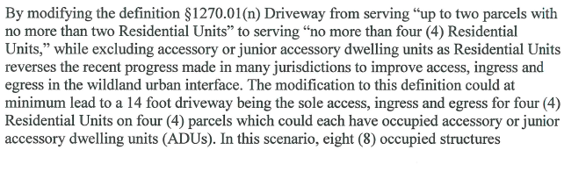
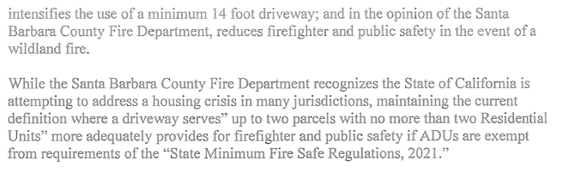
Board response: The Board’s proposal in the 15 day noticed rule text published on May 10, 2022 defines a driveway as “A vehicular pathway that serves no more than four (4) Residential Units and any number of non-commercial or non-industrial Utility or Miscellaneous Group U Buildings on each parcel. A Driveway shall not serve commercial or industrial uses at any size or scale,” and the definition of “residential unit” no longer exemptions junior accessory or accessory dwelling units. The proposed definitions of driveway and residential units will not result in a driveway serving 8 occupied structures as suggested by the letter writer.

Rule text edit: No

Comment W134-1: Santa Barbara County Department of Planning and Development (Submitted by Santa Barbara County Executive Office)
The first three paragraphs of this comment are introductory/conclusive in nature; the comments are not specifically directed at the Board’s proposed action or to the procedures followed by the Board in proposing the action.

1. § 1270.01(f) Building Construction
The definition of building construction includes “construction, reconstruction, replacement, or erection of any Building” but does not indicate, in the definition or subsequently in the applicability section of the FSR, whether the FSR would apply to additions to existing buildings. If the FSR would apply to building additions, are there criteria to determine when the FSR would apply?

Board response: The Board is no longer proposing a definition for “building construction,” consistent with the narrowed scope of the proposed action as identified within the Supplemental Statement of Reasons published with the “Second 15-Day Notice of Addition of Documents and Information to Rulemaking File and Modified Text” on May 10, 2022. The comment is not specifically directed at the Board’s proposed action or to the procedures followed by the Board in proposing the action

Rule text edit: No

Comment W134-2: Santa Barbara County Department of Planning and Development
2. § 1270.01(q) Existing Road
As drafted, the revised definition of “existing road” is unclear, in particular, the references to § 1270.03(d) and § 1270.03(e) in the second sentence, and the third sentence in general.

Board response: The Board is no longer proposing a definition for “existing road,” consistent with the narrowed scope of the proposed action as identified within the Supplemental Statement of Reasons published with the “Second 15-Day Notice of Addition of Documents and Information to Rulemaking File and Modified Text” on May 10, 2022. The comment is not specifically directed at the Board’s proposed action or to the procedures followed by the Board in proposing the action.

Rule text edit: No

Comment W134-3: Santa Barbara County Department of Planning and Development
3. § 1270.01(hh) Residential Unit
Beginning with the definition of “residential unit,” the FSR does not appear to regulate accessory and junior accessory dwelling units. By not considering them residential units, the potential impacts to fire safety by not imposing FSR on these dwellings will affect not only the safety of the occupants of accessory and junior accessory dwelling units but occupants of the neighborhoods and communities in which they are located as well as first responders.

Board response: The definition of “residential unit” does not explicitly exclude accessory dwelling units, including junior accessory dwelling units. The regulatory exemption for ADUs was a previous emergency regulatory action and is outside the scope of the proposed action. Please see General Response to Exceptions and Exemptions Comments.

Rule text edit: No

Comment W134-4: Santa Barbara County Department of Planning and Development
4. § 1270.03(a)(1) Scope and Applicability
This section states that the FSR shall apply to new building construction approved after January 1, 1991, within the SRA (State Responsibility Area) and to new building construction approved after July 1, 2021, within the VHFHSZ (Very High Fire Hazard Severity Zone). As written, this section appears to apply the FSR to development in all of the fire hazard severity zones within the SRA (moderate, high, and very high) and to all VHFHSZ (i.e., within the SRA and the Local Responsibility Area, or LRA). If this interpretation is incorrect, please clarify this section of the FSR.

Board response: This interpretation is correct.

Rule text edit: No

Comment W134-5: Santa Barbara County Department of Planning and Development
5. § 1270.03(d) Scope and Applicability
The Board of Forestry revised § 1270.03(d) to clarify that the FSR road standards would not apply to roads used solely for “the planting, growing, or harvesting of plants (including related activities such as processing, storage, and transportation) for the marketing of the resulting products.” This language replaced “agriculture” and P&D supports the change. However, agriculture also includes livestock grazing, which makes up a significant proportion of Santa Barbara County’s agricultural lands. Livestock grazing appears to qualify as a low intensity use for which the FSR road standards
should not apply. P&D requests that livestock grazing be included in this subsection of uses to which the FSR road regulations would not apply.

Board response: In the 15 day noticed rule text published on May 10, 2022, the Board proposes to delete the language regarding the “planting, growing, or harvesting of plants…” and retain the existing definition of “agriculture,” which requires the determination of what qualifies as “agriculture” be made by the local jurisdiction. This addresses the letter writer’s concern.

Rule text edit: No

Comment W134-6: Santa Barbara County Department of Planning and Development
6. § 1270.03(f), -(g) and -(h) Consideration of “Development”
§ 1270.03(f), -(g) and -(h) provide additional direction regarding the authority of the Director (of the Board of Forestry) and the Authority Having Jurisdiction (AHJ) when making decisions regarding the applicability of the FSR. These subsections refer to both “construction” and “development,” yet appear to conflict with § 1270.02(a), which states the purpose of the regulations is to “[establish] state minimum Wildfire protection standards in conjunction with Building Construction” not “development.” “Development,” as defined in the FSR, is much more extensive than building construction or parcel and tract maps, to which most of the FSR would apply.

Board response: The Board is no longer proposing sections 1270.03(f), (g), and (h), consistent with the narrowed scope of the proposed action as identified within the Supplemental Statement of Reasons published with the “Second 15-Day Notice of Addition of Documents and Information to Rulemaking File and Modified Text” on May 10, 2022. The comment is not specifically directed at the Board’s proposed action or to the procedures followed by the Board in proposing the action.

Rule text edit: Yes

Comment W134-7: Santa Barbara County Department of Planning and Development
The suggestions numbered 7-9 in this letter are limited in scope to Articles 2-4 of the regulations. The Board is no longer proposing to revise Articles 2-4, consistent with the narrowed scope of the proposed action as identified within the Supplemental Statement of Reasons published with the “Second 15-Day Notice of Addition of Documents and Information to Rulemaking File and Modified Text” on May 10, 2022. The comment is not specifically directed at the Board’s proposed action or to the procedures followed by the Board in proposing the action.

Comment W134-8: Santa Barbara County Department of Planning and Development
10. § 1276.00 Applicability
Please correct the numbering and organizational errors within § 1276.00(a) and -(b).

Board response: These errors were corrected in the 15 day noticed rule text published on May 10, 2022.

Rule text edit: Yes

Comment W135-1: Center for Biological Diversity
The first five paragraphs of this comment are introductory/conclusive in nature; the comments are not specifically directed at the Board’s proposed action or to the procedures followed by the Board in proposing the action.

First, the Regulations qualify as a discretionary activity of a public agency. Under
CEQA, a “discretionary” decision is one “which requires the exercise of judgment or
deliberation when the public agency or body decides to approve or disapprove a particular activity, as distinguished from situations where the public agency or body merely has to determine whether there has been conformity with applicable statutes, ordinances, [or] regulations.” (14 Cal. Code Regs. § 15357.) Courts apply a “functional” test to determine whether an action is discretionary, focusing on whether “the agency has the authority to shape or condition the project in ways that are responsive to environmental concerns.” (Friends of Juana Briones House v. City of Palo Alto (2010) 190 Cal.App.4th 286, 302.)

Here, the Regulations entail the exercise of judgment or deliberation by the Board and
have the effect of approving and/or disapproving certain activities, as opposed to simply
determining conformity with applicable statutes or ordinances. Even if the Regulations somehow qualified as “hybrid” between a ministerial and discretionary decision, CEQA would still apply. (See Friends of Westwood, 191 Cal.App.3d 259, 271 [CEQA extends “to hybrid projects of a mixed ministerial-discretionary character; doubt whether a project is ministerial or discretionary should be resolved in favor of the latter characterization.”].)

Board response: Please see General CEQA Response

Rule text edit: No

Comment W136-1: Environmental and Community Organizations

The undersigned organizations, who represent millions of members and supporters of adequate minimum fire safe regulations across California, oppose the Board of Forestry and Fire Protection’s (BOF) December 2021 revised draft regulations. The revised regulations would dramatically weaken fire safe road standards for new construction in fire-prone communities.
Many of our organizations opposed the April 2021 draft regulations. The December 2021 revision fails to address any of the serious concerns raised with the April 2021 draft, and further weakens the regulations, endangering members of the public, firefighters and other first responders.
The December 2021 regulations:
- Completely eliminate dead-end road limitations for all new development on existing roads, even for multi-unit residential and commercial development.
- Remove most prior road standards for existing roads, including width and grade; it will now be impossible to meet the regulations’ intent “to provide for safe and concurrent fire apparatus access and civilian evacuation.”
- Remove all weight requirements for existing bridges.
- Provide local jurisdictions with unlimited discretion to modify the regulations through exceptions and loopholes.
Board response: The Board is no longer proposing the changes described in this comment, consistent with the narrowed scope of the proposed action as identified within the Supplemental Statement of Reasons published with the “Second 15-Day Notice of Addition of Documents and Information to Rulemaking File and Modified Text” on May 10, 2022. The comment is not specifically directed at the Board’s proposed action or to the procedures followed by the Board in proposing the action.

Rule text edit: No

Comment W136-2: Environmental and Community Organizations

Public safety has been the paramount intent of the fire safe regulations for more than thirty years. As a practical matter, this will no longer be the case if the revised regulations are adopted. The December 2021 revised regulations eliminate the requirement for concurrent safe access for fire apparatus and civilian evacuation on existing roads, precisely where new development most often occurs. The December 2021 draft fails to implement the intent of SB 901 (2018), which mandates that BOF expand minimum fire safe regulations to include very high fire hazard severity zones (VHFHSZ) in the Local Responsibility Area (LRA). Instead, the BOF radically weakened regulations statewide, and failed to analyze the massive adverse environmental effects as required by the California Environmental Quality Act (CEQA).

Board response: The Board is no longer proposing the changes described in this comment, consistent with the narrowed scope of the proposed action as identified within the Supplemental Statement of Reasons published with the “Second 15-Day Notice of Addition of Documents and Information to Rulemaking File and Modified Text” on May 10, 2022. The comment is not specifically directed at the Board’s proposed action or to the procedures followed by the Board in proposing the action. Please see General CEQA Response

Rule text edit: No

Comment W136-3: Environmental and Community Organizations

Since 1991 the BOF has required minimum fire safe access standards to apply to all new residential, commercial, and industrial development within State Responsibility Areas (SRAs). Among other requirements, the 2020 regulations require roads to be at least 20 feet wide, have adequate surfaces, and avoid steep grades. The length of dead-end roads is limited to one mile. The sole exemptions from the existing 2020 standards are for post-fire rebuilds and roads used exclusively for agriculture, timber harvesting, or mining. The BOF and Office of the Attorney General have confirmed that these regulations apply to all roads including those built before 1991, where the vast majority of new development occurs.
In November 2020, the BOF consulted with a Fire Chiefs Working Group. The Fire Chiefs focused on safety, and suggested shortening the maximum length for dead-end roads from one mile to one-half mile to “provide for greater fire safety than the current standards.” (BOF, Initial Statement of Reasons, p. 28). The Fire Chiefs found that “when completing an on-line search for the maximum length of a Dead-end Road allowed throughout the country, it was difficult to identify any standard that allowed roads longer than ½ mile in length, and most agencies’ maximum allowable lengths were less.” The December 2020 draft of the proposed revisions would have reduced the maximum length of all dead-end roads to one-half mile as the Fire Chiefs recommended, and would have retained the existing 20-foot road width standard. The December 2021 regulations ignore the recommendation to limit dead-end roads to one-half mile and even abandons the current one-mile limitation. Instead, the December 2021 revised regulations would allow development anywhere on existing dead-end roads without respect to their length.
Even for very large developments, the December 2021 revised regulations would only require existing roads to be 14 feet wide (with no shoulder requirements), instead of 20 feet as in the 2020 regulations. If the December 2021 revised draft is approved, these changes could unlock thousands of parcels for residential, commercial, and industrial development on existing roads, but would no longer require that firefighters and fleeing civilians are able to pass one another on narrow roads nor have unobstructed traffic circulation during a wildfire. While the revised 2021 regulations claim to require concurrent ingress and egress, they fail to provide it—a fire apparatus that is 8-9 feet wide cannot possibly pass 6-foot-wide passenger vehicles nor could two 8-9 foot-wide firefighting trucks pass one another on a 14-foot-wide road without shoulders. Although the December 2021 version reinserted a goal of “concurrent ingress and egress”—impossible for the revised regulations to meet as written—it omits the word “safe,” undermining the purpose of the regulations.
Moreover, the inadequate 14-foot standard can be reduced with loophole “exceptions” by local jurisdictions to approve roadways of only 8- to 10-feet in width. There are no provisions to limit the scope of exceptions. For example, the regulations could limit exceptions to 10 percent of the required minimum, or to apply only at roadway pinch points where some geographic physical constraint does not permit the minimum width to be met. This is a recipe for certain disaster for both civilians and firefighters during a wildfire emergency. And under the proposed regulations, local jurisdictions have virtually unfettered discretion to dilute fire safety standards, rendering them unenforceable suggestions. This violates the mandate of Public Resources Code 4290 adopted for the purpose of establishing minimum wildfire protection standards.
Board response: The Board is no longer proposing the changes described in this comment, consistent with the narrowed scope of the proposed action as identified within the Supplemental Statement of Reasons published with the “Second 15-Day Notice of Addition of Documents and Information to Rulemaking File and Modified Text” on May 10, 2022. The comment is not specifically directed at the Board’s proposed action or to the procedures followed by the Board in proposing the action.

Rule text edit: No

Comment W136-4: Environmental and Community Organizations

The December 2021 regulations do not provide adequate roadway standards, including turnarounds, curves, and grade limitations to ensure the safe operation of fire equipment. The December 2021 regulations have no grade limitation and only stipulate that grades cannot exceed 25 percent for more than 500 feet. Existing regulations ban development projects on unsafe substandard roads in fire-prone areas. But the December 2021 regulations encourage development projects on those very roads.
Board response: The Board is no longer proposing the changes described in this comment, consistent with the narrowed scope of the proposed action as identified within the Supplemental Statement of Reasons published with the “Second 15-Day Notice of Addition of Documents and Information to Rulemaking File and Modified Text” on May 10, 2022. The comment is not specifically directed at the Board’s proposed action or to the procedures followed by the Board in proposing the action.

Rule text edit: No

Comment W136-5: Environmental and Community Organizations

During a wildfire, a single fallen tree on a dead-end road can trap residents in a conflagration. We sadly witnessed the devastation to human life and property that dire evacuation scenarios caused in the City of Paradise, California, during the 2018 Camp Fire. Ignoring the advice of our Fire Chiefs and Fire Marshals to reduce dead-end road lengths to a maximum of one-half mile and instead removing all dead-end road length limitations makes another such catastrophe far more likely. Growth-inducing impacts could foster economic growth, increased population, and the construction of additional housing. CEQA requires that these impacts be studied to allow decision makers and the public to understand the implications of the decision.
The December 2021 regulations would allow increased development and greater population density in high fire-prone communities and wildlands in both LRAs and SRAs, resulting in significant adverse impacts to public safety and the environment. Loopholes would even allow “new roads” to be considered “existing roads,” thus avoiding all regulations applicable to newly built roads. If current sprawl-inducing land-use practices continue, 640,000 to 1.2 million new homes may be built in the state’s highest wildfire-risk areas by 2050 (Mann et al. 2014). Instead, regulations should encourage policies to focus development of increased affordable housing near city centers.
Board response: The Board is no longer proposing the changes described in this comment, consistent with the narrowed scope of the proposed action as identified within the Supplemental Statement of Reasons published with the “Second 15-Day Notice of Addition of Documents and Information to Rulemaking File and Modified Text” on May 10, 2022. The comment is not specifically directed at the Board’s proposed action or to the procedures followed by the Board in proposing the action. Please see General CEQA Response

Rule text edit: No

Comment W136-6: Environmental and Community Organizations

Abundant scientific evidence shows that when development encroaches into fire hazard severity zones, the probability of large conflagrations dramatically increases. Human sources such as power lines, car sparks, cigarettes, and electrical equipment caused nearly all contemporary wildfires in California (Radeloff et al. 2018, Syphard et al. 2007; Balch et al. 2017). Permitting new development in high fire-risk areas will increase ignitions and places more people in danger. Since 2015, almost 200 people in California have been killed in wildfires, more than 50,000 structures have burned, hundreds of thousands of residents have been forced to evacuate their homes, millions have endured power outages, and tens of millions have been exposed to unhealthy levels of air pollution.
Wildfire impacts disproportionately affect vulnerable communities with less capacity to adapt, respond, and recover. Low-income and minority communities, especially Native American, Black, Latino and Southeast Asian communities, are the most marginalized when wildfires occur, in part because they have fewer resources to safely evacuate, to buy fire insurance, to implement defensible space around their homes, or to rebuild. Vulnerable communities also have less access to disaster relief during recovery (Fothergill and Peak 2004; Morris 2018; Harnett 2018; Davies 2018; Richards 2019). Health impacts from wildfires, particularly from increased air pollution due to fine particulates (PM2.5) in smoke, also disproportionately affect vulnerable and low-income communities, people of color, children, the elderly, and people with pre-existing medical conditions (Künzli et al. 2006; Delfino et al. 2009; Reid et al. 2016; Hutchinson et al. 2018; Jones et al. 2020).

Board response: This comment does not offer any specific objection or recommendation made regarding the specific adoption, amendment, or repeal proposed in this rulemaking action (GC 11346.9). The Board has no response to this comment.

Rule text edit: No

Comment W136-7: Environmental and Community Organizations

At an August 18, 2020 workshop, the BOF indicated the proposal’s potentially significant environmental impacts would be reviewed using an Environmental Impact Report (EIR), but has made no mention of an environmental process since then. The BOF must prepare an EIR to analyze the effects of increased wildfire risks and sprawl, and the growth-inducing effects of the proposed regulations. The BOF appears poised to declare that either the draft regulations are not a CEQA project or they are categorically exempt from review, but it has yet to provide any legal basis to support evading environmental review through either tactic.
No exemption exists to avoid environmental review here. The BOF must prepare a comprehensive EIR to analyze the proposal’s detrimental effects to public safety, biological resources (including California’s already threatened native flora and fauna), climate resilience, vulnerable populations, emergency access, evacuation plans, and cumulative impacts.
The December 2021 draft, if approved, would have devastating public safety and environmental consequences as they roll back decades of sensible safety standards. We urge the BOF to ensure the proposed regulations are revised to meet the public safety intent of their enabling legislation, and undertake an appropriately thorough environmental review of the many obvious significant impacts they would cause if adopted as currently proposed.
Thank you for your consideration of these comments.

Board response: Please see General CEQA Response

Rule text edit: No

Comment W137-1: Forests Unlimited
The first two paragraphs of this letter are introductory/conclusive in nature; the comments are not specifically directed at the Board’s proposed action or to the procedures followed by the Board in proposing the action.

Comment W137-2: Forests Unlimited
Summary of Concerns: We are writing to object to the 2021 State minimum fire safe
regulations because they weaken current standards:
(1) The December 2021 revised regulations weaken the existing 2020 fire safe standards for all existing roads (where most development occurs) and fly in the face of public safety.
(2) The December 2021 regulations do not meet the intent of its enacting legislation to,
“…provide for safe and concurrent fire apparatus access and civilian evacuation.”
(3) We believe that the liberal exception process in the regulations will free up numerous parcels to new construction, including residential, commercial, and industrial. Thus we demand that a robust CEQA analysis be conducted to evaluate and quantify the potential increase in population and intensity of use in the fire danger areas as a result of this new construction.
Numerous Environmental and Community Leaders join us in opposing the Board of Forestry and Fire Protection's (BOF) further weakening of State minimum fire safe regulations. The most recent December 2021 revision is even worse than the April 2021 draft that many of us opposed (See letter here).

Board response: The Board is no longer proposing the changes discussed by the letter writer, consistent with the narrowed scope of the proposed action as identified within the Supplemental Statement of Reasons published with the “Second 15-Day Notice of Addition of Documents and Information to Rulemaking File and Modified Text” on May 10, 2022. The comment is not specifically directed at the Board’s proposed action or to the procedures followed by the Board in proposing the action.

Rule text edit: No

Comment W137-3: Forests Unlimited
Specific Problems with the December 2021 Revised Regulations
ꞏ Completely eliminates dead-end road limitations for all new development on existing roads even for multi-unit residential and commercial development. (California Fire Chiefs recommended a ½ mile limitation.)
ꞏ Removes significant road standards for existing roads: it is now impossible with the
approved language to meet the intent of the regulations, “…to provide for safe and concurrent fire apparatus access and civilian evacuation.” Hence, a new high-density residential and/or intensive commercial development could be built on a 14-foot wide (or 10-foot wide with allowed exceptions) mountain road (instead of 20 feet as recommended) with no shoulders and steep drop-offs and on a 12-mile dead-end road in a high fire risk area, with grades exceeding 25%.
ꞏ Guts weight requirements for existing bridges, which will lead to dangerous traffic
bottlenecks. Firefighting equipment and Firefighters conducting evacuations during a
conflagration will not be able to access large new developments enabled by this proposal or to strategically access structures and wildlands to fight fires.
ꞏ Gives unlimited discretion to local jurisdictions through the exception process and other loopholes; such authority weakens the State regulations for all new building construction.
ꞏ Compromises ridgeline protections: The April Fire Safe regulations state: “New Buildings on Undeveloped Ridgelines identified as strategically important to fight fires are prohibited.”
This was changed to limit only Residential Units. State regulations should prohibit commercial and industrial building construction on ridgelines to comply with the intent of the mandating legislation.

Board response: The Board is no longer proposing changes to the road, bridge, or exception process requirements, consistent with the narrowed scope of the proposed action as identified within the Supplemental Statement of Reasons published with the “Second 15-Day Notice of Addition of Documents and Information to Rulemaking File and Modified Text” on May 10, 2022. The comment is not specifically directed at the Board’s proposed action or to the procedures followed by the Board in proposing the action.

Regarding ridgelines, in the 15 day noticed rule text published on May 10, 2022, the Board does propose to limit all buildings, except those described in 1276.02(c)(2) and (3), from construction on ridgelines designated as strategically important.

Rule text edit: Yes

Comment W137-4: Forests Unlimited
Growth Inducing Impacts
The December 2021 draft regulations will promote development on substandard and dead-end roadways, without fire safe measures, where evacuations are already problematic. These developments further increase wildfire risk to lives and property, reduce the ability of responders to defend property, strain firefighting budgets, and may jeopardize homeowners’ ability to obtain property insurance.

Fire Experts Speaks Out
This powerful letter (linked here) from 21 senior fire professionals urges the BOF to preserve the 2020 regulations to protect both residents and firefighters, warning that the December 2021 revised regulations fail to provide adequate standards or State oversight and enforcement to ensure the safety of firefighters and civilians for firefighting and evacuation.

Board response: The Board is no longer proposing changes to the road requirements, consistent with the narrowed scope of the proposed action as identified within the Supplemental Statement of Reasons published with the “Second 15-Day Notice of Addition of Documents and Information to Rulemaking File and Modified Text” on May 10, 2022. The comment is not specifically directed at the Board’s proposed action or to the procedures followed by the Board in proposing the action.

Rule text edit: No

Comment W137-6: Forests Unlimited
Inadequate Environmental Review
The BOF did not conduct a data-supported analysis of existing road and infrastructure
capacity to assess potential significant negative impacts to wildfire emergency response and evacuation plans, and the increase in ignition sources that will occur by providing both exemptions and exceptions to thousands of parcels.
Board response: Please see General CEQA Response

Rule text edit: No

Comment W138-1: Winegrowers of Napa County
Winegrowers is a non-profit organization of winery, vineyard and grape growing members with the mission to advance policy that preserves sustainable agriculture as the highest and best use of the natural resources while protecting the ability of wineries to produce, market, and sell wine. We appreciate the opportunity to submit this comment letter on the Proposed Draft Revisions to the State Minimum Fire Safe Regulations being considered by the Board of Forestry and Fire Protection
(the “Board”).
Winegrowers acknowledges and appreciates that the Board revised the Draft Revisions to the State Minimum Fire Safe Regulations that were considered during the Board’s meeting on June 22, 2021. Our view is that the revised Draft Regulations published this year are a significant improvement. Notwithstanding these changes, Winegrowers agrees with Napa County and the Napa Valley Coalition for Fire Resiliency that further changes to the Regulations are needed. Rather than restating the comments of Napa County and the Coalition, Winegrowers expresses its support for the positions of those commentors as to agricultural lands and uses, especially in the following areas:
• The Regulations must not require improvement of public roads, which would unfairly and significantly burden individual rural property owners to improve public serving
infrastructure.
• Napa County, and other local agencies, must retain local oversight to review and approve any exceptions to the standards in the Regulations. Napa County is most familiar with preventing and fighting wildfires in its jurisdiction and therefore, is best positioned to evaluate each project.
• The effective date of the Regulations must be clear, but the current draft provisions include reference to July 2021. The Regulations should be forward-looking and should exempt completed construction applications that are already in process.
Thank you again for considering these comments.

Board response: Regarding the improvement of public roads, these regulations have been applicable to public and private roads since they were first adopted in 1991, consistent with the scope of the authorizing statute which does not distinguish public or private means of access. The regulations are subject to the applicability as provided in the authorizing statute (PRC 4290), such that, with limited exception, the regulations apply to all building construction in SRA areas approved after January 1, 1991, and within VHFHSZ lands after July 1, 2021.

It is the agency with firefighting responsibility within a given area which is the most familiar with preventing and fighting wildfires in a in that area. In the SRA, this firefighting agency is CAL FIRE, consistent with Chapter 1 of Part 2 of Division 4 of the Public Resources Code, and inspection authority is thus given to the Director of the agency. Within the VHFHSZ, firefighting governance is as diverse as the state, and so inspection authority is required of the Local Jurisdiction, as per revised 14 CCR § 1270.06(c). Regarding local oversight to review and approve exceptions, there are procedures in place for CAL FIRE to delegate inspection and exception approval authority (see 1270.06(a) and 1270.07).

PRC 4290 establishes the applicability of these regulations to the VHFHSZ as of July 1, 2021. It is outside the scope of the Board’s authority to establish a different effective date of these regulations to the VHFHSZ.

Additionally, the scope of the proposed action does not include exempting activities from being subject to the regulations. The comment is outside the scope of the proposed action.

Rule text edit: No

Comment W139-1: Humboldt County Board of Supervisors
The first two paragraphs of this letter are introductory/conclusive in nature; the comments are not specifically directed at the Board’s proposed action or to the procedures followed by the Board in proposing the action.

Comment W139-2: Humboldt County Board of Supervisors
As we have said in our prior comment letters, we are very concerned about the unintended consequences of these new regulations, specifically we are concerned that the current draft FSRs could be interpreted to off-site Access standards to the development of new infill single-family dwellings on existing vacant parcels. Based on the County of Mendocino letter dated June 15, 2021, the BOF does not intend to impose Standards for Existing Roads on infill development as described in the previous sentence. As such, we feel that is very important to the BOF to clearly define at the beginning of each FSR Article, in particular Article 2 – Ingress and Egress, how ever regulation apples to each type of Construction for which the FSRs are applicable. Doing this in a simple and straightforward manner at the beginning of an Article, as is done in Article 5 – Building Siting, Setbacks, and Fuel Modification, could eliminate the need for applicability references later in an Article that may create internal conflicts and confusion.

Board response: The Board is no longer proposing changes to the road standards in Article 2, consistent with the narrowed scope of the proposed action as identified within the Supplemental Statement of Reasons published with the “Second 15-Day Notice of Addition of Documents and Information to Rulemaking File and Modified Text” on May 10, 2022. The comment is not specifically directed at the Board’s proposed action or to the procedures followed by the Board in proposing the action.

Rule text edit: No

Comment W139-3: Humboldt County Board of Supervisors
In our prior comment letters, we have emphasized that the State Responsibility Area (SRA) varies across the state in term of climate, topography, vegetation, and existing development density and that one size fits all regulations, in particular applying road requirements to all infill building construction, will have substantial unintended consequences. The proposed FSRs do not provide local agencies with the flexibility to apply standards in a nuanced manner consistent with the variable wildfire vulnerabilities. The proposed draft now includes great flexibility to meet road standards when Building Construction is a post-fire rebuild, but in no other situation. We recommend that you consider extending this flexibility more broadly and consistently to allow infill development in existing communities to occur in a responsible manner.

Board response: The Board is no longer proposing changes to the road standards, consistent with the narrowed scope of the proposed action as identified within the Supplemental Statement of Reasons published with the “Second 15-Day Notice of Addition of Documents and Information to Rulemaking File and Modified Text” on May 10, 2022. The comment is not specifically directed at the Board’s proposed action or to the procedures followed by the Board in proposing the action.

The regulatory exemption for wildfire rebuilds was a previous emergency regulatory action and is outside the scope of the proposed action. Please see General Response to Exceptions and Exemptions Comments.

The existing and proposed regulations provide a mechanism for local flexibility within 1270.06 which is consistent with PRC 4290.

Rule text edit: No

Comment W139-4: Humboldt County Board of Supervisors
We are also concerned that the FSRs no longer include exemptions to Road standards for some agricultural uses. Scope § 1270.03(d) does not include an exemption from FSR Road standards for agricultural activities that involve the raising and management of animals, such as livestock grazing and dairy farming. Grazing and dairy farming are important types of agriculture in Humboldt County and the state of California and have always been included in this County’s definition of agriculture. In order to limit the potential for unintended consequences, it may be best to broaden this exemption to include farming involving animals and ranching or to retain the prior language which specific that a local jurisdictions’ zoning regulations shall define agriculture for land use purposes.
Board response: In the 15 day noticed rule text published on May 10, 2022, the Board proposes to use the existing definition of “agriculture,” which allows local jurisdictions to determine what activities qualify as “agriculture.” This addresses the letter writer’s concern.

Rule text edit: Yes

Comment W139-5: Humboldt County Board of Supervisors
Section 1273.02, Road and Driveway Surfaces, requires that new and existing road surfaces be non-erodible in order to support the required weight at all times, including during saturated soil conditions. Although it may seem reasonable to require that all roads at least have a gravel surface, it would be infeasible to require that small-scale developments improve and surface potentially miles of existing roads, especially where the nearest source of aggregate may be as much as fifty miles away. When roads are in a saturated conditions wildfire risk is minimal. Also § 1273.03 requires that new bridges and elevated structures be constructed of non-combustible materials. Do you have evidence that wooden timbers in as decking in rail car bridges used in rural road construction have demonstrated and substantive risk? Our experience is that the diameter of timber used in decking in rail car bridges used has not presented a substantial risk and this bridge system is commonly used in our area.
Board response: The Board is no longer proposing changes to section 1273.02, consistent with the narrowed scope of the proposed action as identified within the Supplemental Statement of Reasons published with the “Second 15-Day Notice of Addition of Documents and Information to Rulemaking File and Modified Text” on May 10, 2022. The comment is not specifically directed at the Board’s proposed action or to the procedures followed by the Board in proposing the action.

Rule text edit: No

Comment W139-6: Humboldt County Board of Supervisors
We are also concerned about roles and responsibilities for FSR enforcement with the near universal use of the term Authority Having Jurisdiction (AHJ). The definition of AHJ in § 1270.01(c) is responsible for enforcing the applicable requirements of FSRs or for approving equipment, materials, an installation, or a procedure without identifying who this is. The use of the term AHJ will cause confusion as to which local or state agency is responsible for enforcement and interpretation of any particular aspect of FSR or potentially transfer land use authority away from local land use agencies. As we and other counties have noted it is important a fundamental due process right to have an appeal process for exception requests that meet the requirements of § 1270.06(c), where the AHJ has made the decision “to not consider (the) Exception request.” An additional concern is § 1276.02 Ridgelines, where the AHJ is given the sole authority to identify Strategic Ridgelines which are Undeveloped and where new Residential Units are prohibited. This is a legislative action that should be carried out by a board of supervisors or city council, in close coordination with fire agencies, as part of the public process. Rather than use the term AHJ, it would be best to return to specifically using the terms local agency or jurisdiction, inspection entity, or fire authority.
Board response: In the 15 day noticed rule text published on May 10, 2022, the Board proposes to replace the term “AHJ” with the term “local jurisdiction.” This addresses the letter writer’s concern.

Rule text edit: Yes

Comment W139-7: Humboldt County Board of Supervisors
The definition of Residential Unit is also concerning. Although we do not believe that this is what is intended, the FSR definition could be interpreted to mean that each bedroom within a home is a separate Residential Unit. A bedroom is a portion of a building that contains living facilities which include provisions for sleeping for one or more persons – the only absolute FSR requirement for a Residential Unit. It may be best to include provisions for sleeping, eating, cooking, and sanitation as required components of a Residential Unit. Also the definition of Residential Unit excludes Accessory and Junior Accessory Dwelling Units as defined in FSRs, which includes a reference to specific state laws. However, secondary dwelling units may have been permitted under prior state or local regulations, which may require that they be counted as Residential Units. This definition could also cause confusion when considering homes with detached bedrooms.

Board response: The Board disagrees that the existing definition of “residential unit” can be interpreted to include individual bedrooms. The definition of residential unit specifies that the building or portion thereof “contains living facilities,” including provisions for sleeping, eating, cooking, and/or sanitation. A single bedroom does not include such provisions. As the letter writer describes, a detached bedroom could not be considered a residential unit under this definition.

The definition of “residential unit” no longer excludes junior accessory or accessory dwelling units. A secondary dwelling unit which meets the conditions under the definition of “residential unit”, regardless of whether it was constructed under state laws allowing accessory dwelling units or not, is considered a “residential unit” for the purposes of these regulations.

Rule text edit: No

Comment W139-8: Humboldt County Board of Supervisors
Regarding § 1276.01, Building and Parcel Siting and Setbacks, we recommend that subsection (b) be revised based on the input of the Office of the State Fire Marshal who is responsible for developing a model defensible space program for cities and counties. Specifically, under (1) noncombustible block walls are only effective when they exceed the height of the vegetation. Under (2), five feed of noncombustible material will be mandated under the current revisions to PRC 4291 as required by AB 3074. Subsection (3) should be further developed to determine what risks are specifically being addressed. Requiring two panes of tempered glass could be an effective strategy where 30 feet of clearance or building separation cannot be achieved.

We appreciate BOF’s desire to move forward with all deliberate speed and understand the legislative timeline that you are working with. However, not enough progress has been made to date on developing a workable update to the FSRs. We urge BOF to take the necessary time to truly partner with local governments and allow a robust discussion with all interested parties to support the development of balanced and responsible fire measures designed to protect our vulnerable communities rather that eliminate them.

Board response: Board staff did consult with the Office of the State Fire Marshal staff in amending 1276.01 and developed the changes proposed in the 15 day noticed rule text published on May 10, 2022. Additionally, pursuant to GOV 11359(a), no proposed regulations which is intended to promote fire and panic safety or provide fire protection and prevention, including fire suppression systems, equipment, or alarm regulation, is valid or effective unless it is submitted by, or approved in writing by, the State Fire Marshal before transmittal to the Secretary of State or the Office of Administrative Law. The purpose of the regulations being developed under PRC 4291 pursuant to AB 3074 is to create a 5 foot “ember resistant zone” and is unrelated to the proposed action. The comment is outside the scope of the proposed action and not specifically directed at the Board’s proposed action or to the procedures followed by the Board in proposing the action

Rule text edit: No

Comment W140-1: Butte County Administration
The first two paragraphs of this letter are introductory in nature; the comments are either not specifically directed at the Board’s proposed action or to the procedures followed by the Board in proposing the action.

Comment W140-2: Butte County Administration
The following are recommendations that would provide for minimum wildfire protection standards while allowing for reasonable development where protective measures can be taken.

Section 1270.01 Definitions
The introduction of the new term “Authority Having Jurisdiction (AHJ)” and the sections that refer to this term are unclear and confusing. The potential for poor coordination and lack of clear understanding of who has the ultimate authority to make decisions regarding the proposed regulations will result in difference between jurisdictions, potential legal disagreements, and poor implementation. The various sections that refer to AHJs have conflicting language and in some cases the AHJ changes from one section to the next. Especially troublesome is the language regarding the granting of exceptions as this inconsistency creates a conflict between potential AHJs and should be remedied prior to finalizing the draft MFSRs.
Board response: In the 15 day noticed rule text published on May 10, 2022, the Board proposes to replace the term “AHJ” with the existing term “local jurisdiction,” which addresses the letter writer’s concern.

Rule text edit: Yes

Comment W140-3: Butte County Administration
The draft MFSRs contain a number of terms that are standard in development regulations, but instead of relying on the existing regulations such as the Building Code or the Subdivision Map Act, the MFSR creates a new and differing definition. For example, the draft regulations contain several references to a “tentative” map. The discussions with the BOF staff infers that this would mean subdivision projects as defined by the Subdivision Map Act, but that is not how the regulations are written. This should be clarified: a map is either a parcel map with 4 or fewer parcels or a subdivision map. The term tentative is merely an indicator of where in the land division process a project is. In another section, the draft regulations apply to the creation of less than 4 parcels. Instead of creating new criteria that does not conform to the Subdivision Map Act, the regulations should incorporate these longstanding standards into the draft regulations.

Board response: The Board is no longer proposing the application of these regulations to the creation of fewer than 4 parcels, consistent with the narrowed scope of the proposed action as identified within the Supplemental Statement of Reasons published with the “Second 15-Day Notice of Addition of Documents and Information to Rulemaking File and Modified Text” on May 10, 2022, except to require local jurisdictions to consider the need for fuel breaks for land divisions of 3 or more new parcels. This threshold was decided on after hearing from rural jurisdictions like Nevada County that most development that takes place in their areas does not require tentative and final maps (which are required when dividing land into more than four parcels. The Board is required to write regulations for “fuel breaks and greenbelts near communities to provide greater fire safety for the perimeters to all residential, commercial, and industrial building construction,” and relying on the thresholds in the Subdivision Map Act would not adequately capture the kinds of communities that are being developed in the SRA especially, and the Board would not be fulfilling its mandate to regulate fuel breaks and greenbelts if it set thresholds that were so high that few developments would be require to consider fuel breaks, as fuel breaks and greenbelts are necessary to promote minimum fire safety.

Regarding the use of the term “tentative,” this term is an existing term used in the regulations. The Board intentionally uses the term “tentative” as it is in that stage of the process that conditions such as those required by the Fire Safe Regulations are applied to those certain types of projects.

Rule text edit: No

Comment W140-4: Butte County Administration
The draft provisions, including definitions of “Driveways” and “Roads” is inconsistent with standard planning practices and will create confusion and is an unnecessary burden on housing, particularly multifamily housing development, and stands in direct conflict with State housing directives.

The use of distance to a Collector or a road which is compliant would have a potentially significant burden to both rebuilds and future rural development and could trigger significant improvements to public roads without a corresponding funding source for these improvements. Butte County is currently responding to multiple disasters and the funding for infrastructure repair is limited to replacing what was there before and does not allow for improvements or expansions.

Board response: The Board is no longer proposing these changes, consistent with the narrowed scope of the proposed action as identified within the Supplemental Statement of Reasons published with the “Second 15-Day Notice of Addition of Documents and Information to Rulemaking File and Modified Text” on May 10, 2022. The comment is not specifically directed at the Board’s proposed action or to the procedures followed by the Board in proposing the action.

Rule text edit: No

Comment W140-5: Butte County Administration
The definition of Substantial Compliance is vague and subjective, requiring the local jurisdiction to interpret the regulations which, as currently written, are themselves vague and confusing. Both compliance and exemptions to standards should have a clear process, timeline, and authority stated. These portions of the regulations need to be revised for successful implementation.

Board response: The Board is no longer proposing these changes, consistent with the narrowed scope of the proposed action as identified within the Supplemental Statement of Reasons published with the “Second 15-Day Notice of Addition of Documents and Information to Rulemaking File and Modified Text” on May 10, 2022. The comment is not specifically directed at the Board’s proposed action or to the procedures followed by the Board in proposing the action.

Rule text edit: No

Comment W140-6: Butte County Administration
Section 1270.03 Exemption to Road Standards
The revised regulations changed the exemption for Agriculture purposes to specific language stating, “the planting, growing or harvesting of plants (including related activities such as processing, storage, and transportation)”. The new language is problematic, Processing, for example, is a very broad term and can have quite differing impacts. These terms should be defined in the regulations for clarity.

Board response: In the 15 day noticed rule text published on May 10, 2022, the Board proposes to use the existing definition of “agriculture,” which allows local jurisdictions to determine what activities qualify as “agriculture.” This addresses the letter writer’s concern.

Rule text edit: No

Comment W140-7: Butte County Administration
The “Existing Road” standards are disproportionate to the impact of these minor developments, are unreasonably prohibitive for new housing developments, are in direct conflict with State housing directives to increase housing stock and may not be legally defensible. These requirements may expose counties to legal liability by forcing the imposition of disproportionate exactions under the Nollan-Dolan standards articulated in Dolan v City of Tigard, 512 E.S. 374 (1994). Furthermore, depending on existing road configuration, established right of way, and ownership patterns or environmental constraints adjacent to the road, these increased standards and dimensions may not be possible, which would result in a de-factor moratorium for all properties along the subject road. The burden of these requirements would create further barriers to rebuilds and in effect prevent all but the wealthiest property owners from being able to construct housing in this area.

These improvements could also have significant environmental impacts as roadways are modified to remove the deficiencies to access across varying topography, property configurations, and ownerships. The only option available to local jurisdictions in some cases, such as a public road, may be eminent domain, which is likely to require lengthy processes and may be financially or legally prohibitive. The MFSRs should be revised so that upgrades to existing roads for previously approved projects, permitted by right uses, or projects qualifying for CEQA exemption are not required.

Board response: The Board is no longer proposing these changes, consistent with the narrowed scope of the proposed action as identified within the Supplemental Statement of Reasons published with the “Second 15-Day Notice of Addition of Documents and Information to Rulemaking File and Modified Text” on May 10, 2022. The comment is not specifically directed at the Board’s proposed action or to the procedures followed by the Board in proposing the action.

Rule text edit: No

Comment W140-8: Butte County Administration
Section 1270.08 Reconstruction and Repair After a Wildfire
The regulations contain conflicts with how rebuilds will be handled. In some instances, it allows for a rebuild with specific guidelines such as setbacks and use, but then other sections require wider driveways and other standards that may or may not have been in existing prior to the Wildfire. These conflicts need to be resolved and allow for a clear exemption of these regulations for disaster rebuild and recovery. In addition, the regulations specifically exempt only Wildfire destruction and rebuild, but Wildfire is not the only type of disaster that could destroy property and trigger a rebuild. This section should include any type of disaster including floods, landslides, snow causing a roof to collapse, a tree falling on a building, etc.

Board response: The regulatory exemption for wildfire rebuilds was a previous emergency regulatory action and is outside the scope of the proposed action. Please see General Response to Exceptions and Exemptions Comments.

Rule text edit: No

Comment W140-9: Butte County Administration
The comment is related exclusively to previously proposed changes within section 1273.08 New Dead End Roads.

Board response: The Board is no longer proposing changes to this section, consistent with the narrowed scope of the proposed action as identified within the Supplemental Statement of Reasons published with the “Second 15-Day Notice of Addition of Documents and Information to Rulemaking File and Modified Text” on May 10, 2022. The comment is not specifically directed at the Board’s proposed action or to the procedures followed by the Board in proposing the action.

Rule text edit: No

Comment W140-10: Butte County Administration
Section 1276.02 Ridgelines
Not all ridgelines are strategic. Local planning in this space is needed to determine where the strategic ridgelines are located in coordination with fuel management plans, evacuation routes/plans, and emergency management plans. There are other planning requirements such as community wildfire protection plans, safety element requirements, evacuation modeling/planning that makes the requirements of this section redundant.

Board response: The Board is specifically required by PRC 4290(b) to adopt “measures to preserve undeveloped ridgelines to reduce fire risk and improve fire protection. The board shall, by regulation, define “ridgeline” for purposes of this subdivision.” As such, the Board established a process in 1276.02 for a local jurisdiction to determine where, if any, strategic ridgelines are located in their area. The requirements in 1276.0(a) are flexible enough for the local jurisdiction to consider coordinating the location of strategic ridgelines with things like fuel management plans, evacuation routes, and emergency management plans. A local jurisdiction is welcome to identify strategic ridgelines through a document such as a Community Wildfire Protection Plan, the General Plan Safety Element, or other required documents, but the Board would not be in compliance with PRC 4290 or the APA if it did not clarify the ridgeline identification process itself.

Rule text edit: No

Comment W140-11: Butte County Administration
In conclusion, new regulations are needed to continue addressing, the multitude of disaster possible in California, but they must be deliberate, balanced, based on science and engineering. The fire safe regulations need to be balanced with other competing goals of equally critical importance such as housing and disaster recovery. Butte County does not oppose the need for strong Fire Safe Regulations, but the current draft contains unclear, inconsistent, and problematic provisions. For a successful implementation, these need to be addressed. We strongly urge the Board of Forestry to take the time necessary to thoroughly review and vet the issues that Counties and the public have identified with the proposed draft before adoption.

Board response: This paragraph is conclusive in nature and is not specifically directed at the Board’s proposed action or to the procedures followed by the Board in proposing the action.

Rule text edit: No

Comment W141-1: Michael Burke and Lynn Kennedy
The letter addresses changes to Article 2, Ingress and Egress. The Board is not proposing any changes to Article 2, consistent with the narrowed scope of the proposed action as identified within the Supplemental Statement of Reasons published with the “Second 15-Day Notice of Addition of Documents and Information to Rulemaking File and Modified Text” on May 10, 2022. The comment is not specifically directed at the Board’s proposed action or to the procedures followed by the Board in proposing the action.

Comment W142-1: Alpine County Board of Supervisors
The first two and last two paragraphs of this letter are introductory/conclusive in nature; the comments are not specifically directed at the Board’s proposed action or to the procedures followed by the Board in proposing the action.

Comment W142-2: Alpine County Board of Supervisors
The third paragraph of this letter addresses existing roads. The Board is no longer proposing changes to the regulations regarding existing roads, consistent with the narrowed scope of the proposed action as identified within the Supplemental Statement of Reasons published with the “Second 15-Day Notice of Addition of Documents and Information to Rulemaking File and Modified Text” on May 10, 2022. The comment is not specifically directed at the Board’s proposed action or to the procedures followed by the Board in proposing the action.

Comment W142-3: Alpine County Board of Supervisors
The proposed regulations attempt to usurp the responsibility of local elected bodies for determining where fuel breaks and strategic ridgelines should be placed, and handling any appeals of those decisions.
Board response: The Board disagrees with this interpretation of the proposed regulations. 1276.02(a) specifically requires the local jurisdiction to designate strategic ridgelines, and 1276.03(a) also specifically states that determining the need for fuel breaks is under the authority of the local jurisdiction. The Board does not have any specific regulations regarding the appeals process with regard to determining strategic ridgelines or fuel breaks; without more specific information regarding which section of code the letter writer is referring to, the Board cannot offer a specific response or proposed change.

Rule text edit: No

Comment W143-1: Mono County Community Development Department
The first and last three paragraphs paragraph of this letter are introductory/conclusive in nature; the comments are not specifically directed at the Board’s proposed action or to the procedures followed by the Board in proposing the action.

Comment W143-2: Mono County Community Development Department
I. Article 1 – Administration
A. Clarifying Definitions
• The definition of the “Authority Having Jurisdiction (AHJ)” and the subsequent sections citing the AHJ are unclear and will result in poor coordination between jurisdictions, potential legal disagreements and ultimately, poor implementation. The intended AHJ should be clarified where this term is used prior to adoption of the MFSR. The intended AHJ is clear in §1270.03(e), 1270.03(h), 1270.05, 1270.06, however, all other AHJ references are confusing and need further clarification. Additionally, even in the sections where the AHJ is clearly identified, potential scenarios exist where two different entities qualify as the AHJ. For example, Mono County is the inspection authority under §1270.03(e) and CAL FIRE/BOF is the inspection authority under §1270.05. For granting exceptions, this inconsistency creates a conflict between potential AHJs and should be remedied prior to finalizing the 2022 MFSR.

Board response: In the 15 day noticed rule text published on May 10, 2022, the Board proposes to replace the term “AHJ” with the existing term “local jurisdiction,” which addresses the letter writer’s concern.

Rule text edit: Yes

Comment W143-3: Mono County Community Development Department
The definition of “Building Construction” includes subdivisions which, as the Commission is aware, consists of creating new parcels on a map and may not result in the immediate construction of any structures. To include the creation of parcels on a map in the definition of “building construction” is inconsistent with standard planning practices and will create confusion and often oversight. Mono County has subdivision maps that were finaled 20+ years ago and no structures have yet been built. Where the intent is to apply regulations to subdivisions, it should just be stated as such rather than burying the application to subdivisions in a separate and unexpected definition, which will cause confusion and implementation problems.
Board response: The Board no longer proposes a definition for the term “building construction,” consistent with the narrowed scope of the proposed action as identified within the Supplemental Statement of Reasons published with the “Second 15-Day Notice of Addition of Documents and Information to Rulemaking File and Modified Text” on May 10, 2022. The comment is not specifically directed at the Board’s proposed action or to the procedures followed by the Board in proposing the action.

Rule text edit: No

Comment W143-4: Mono County Community Development Department
The definition of “Driveway” may not allow for the density outright permitted on multifamily residential parcels or where density has been increased to comply with state housing directives. The result would require these types of parcels to upgrade a Driveway to a Road, which is an unnecessary burden on housing development and in direct conflict with State housing directives. A modification to the definition of a Driveway would increase the consistency between state housing directives and multifamily residential permitted uses. Other proposed changes below are consistent with RCRC’s suggestions in its 2021 comment letter.

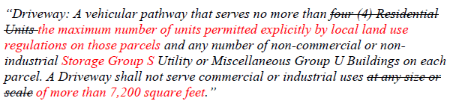
Alt text: The letter writer proposes that the Driveway definition reads as “Driveway: A vehicular pathway that serves no more than the maximum number of units permitted explicitly by local land use regulations on those parcels and any number of non-commercial or non-industrial Storage Group S Utility of Miscellaneous Group U Buildings on each parcel. A Driveway shall not serve commercial or industrial uses of more than 7,200 square feet.”

To be consistent with the definition of Driveway, the following modification to the definition of Road is proposed:
.
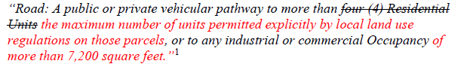
Alt text: “Road: A public or private vehicular pathway to more than the maximum number of units permitted explicitly by local land use regulations on those parcels, or to any industrial or commercial Occupancy of more than 7,200 square feet.”

Board response: Please see responses to W126-6 and W126-16

Rule text edit: No

Comment W143-5: Mono County Community Development Department
The proposed definition of “Residential Unit” is based on the intention of the applicant (i.e., whether they intend to sleep in a space or not), which is often impossible to determine accurately and difficult to enforce, rather than objective physical features of construction. It is also inconsistent with the definition of a “dwelling unit” and therefore a residential occupancy under the California Building Code (CBC). For consistency and to simplify application, which will increase the success of implementation and reduce confusion, use the definition of a “dwelling unit” already established in the CBC: A single unit providing complete independent living facilities for one or more persons, including permanent provisions for living, sleeping, eating, cooking, and sanitation. To further illustrate the point, the current definition could apply to a wood platform with uninsulated walls/roof and no door, similar to a backcountry sleeping shelter, which does not seem appropriate.

Board response: In the 15 day noticed rule text published on May 10, 2022, the Board no longer proposes changes to the definition of “Residential Unit,” which keeps the definition of “Residential Unit” consistent with the California Building Code and addresses the issues raised by the letter writer.

Rule text edit: No

Comment W143-6: Mono County Community Development Department
B. Applicability and Parcels Approved Prior to 1991
A transition period in alignment with the adoption date of the 2022 MFSRs is needed to ensure a smooth transition for projects currently being processed and those that are currently in the design phase. Application of new standards to building permits that have already been accepted as complete and are in the plan check process may necessitate expensive re-design that was not due to any fault of the applicant.
Further, ambiguity in proposed section §1270.03 relating to parcels approved in a pre-1991 parcel or tentative map renders it difficult, if not impracticable, to apply. This section can be interpreted in two ways, that this exemption applies to 1) all pre-1991 maps or 2) only to pre-1991 maps on parcels that have constructed the infrastructure required by the map. Mono County recommends that the language of this exemption be updated to apply to all parcels with pre-1991 maps.

Board response: The Board is not proposing changes to the standards required by Articles 2, 3, or 4, consistent with the narrowed scope of the proposed action as identified within the Supplemental Statement of Reasons published with the “Second 15-Day Notice of Addition of Documents and Information to Rulemaking File and Modified Text” on May 10, 2022, so a transition period is not necessary. The changes to Article 5 regarding the designation of Strategic Ridgelines and the creation of fuel breaks and greenbelts are subject to the applicability as provided in the authorizing statute (PRC 4290), such that, with limited exception, the regulations apply to all building construction in SRA areas approved after January 1, 1991, and within VHFHSZ lands after July 1, 2021.

Section 1270.03(a)(4) applies to pre-1991 parcel maps where there were no conditions applied to the map relating to the perimeters and access to the building. This exemption is outlined as part of a 1993 Attorney General opinion on the subject and the Board lacks the authority to expand the scope of the exemption to all pre-1991 maps. Please see General Response to Comments Regarding Existing Roads.

Rule text edit: No

Rule text edit: No

Comment W143-7: Mono County Community Development Department

C. Exceptions
CAL FIRE is currently the AHJ in Mono County, and applicants and staff find requests for exemptions and will-serve letters for projects under the existing regulations to be extraordinarily onerous due to lack of response. In some cases, building permits have been held up for extended time periods while awaiting a response. The additional approval process associated with exceptions would significantly delay the processing and implementation of planning and building permits for both commercial and residential projects which would negatively impact the County’s economic base, future housing stock, and fire victim housing security.
Suggested Solutions
1A. See proposed language changes included in the “Definitions” section.
1B. Add specified timeframes to §1270.06 “Exceptions to Standards” within which the inspection authority must respond to a request for an exception, otherwise the exception is deemed granted. To be consistent with ministerial building permit plan checks timeframes in Mono County, the deemed granted timeframe should be less than 30 days. Longer timeframes have the potential to delay ministerial building permit processing and efforts to rebuild communities after a wildfire.

(f) Approvals or denials of an exception request shall be made in writing to the applicant or the applicant’s authorized representative within 30 days of the postal or electronic mailing date. If the exception is denied, the written response shall state the basis for denial. If no response is provided, the exception is deemed approved upon expiration of the 30-day response period.
1C. A transition period in alignment with the adoption date of the 2022 MFSRs is needed to ensure a smooth transition for projects currently being processed and those that are currently in the design phase. The County suggests that the MFSRs should apply to new proposals submitted after the approval date of the 2022 MFSRs, to allow projects with applications submitted prior to the approval date to proceed unencumbered by the new regulations.
1D. Update all exemptions for pre-1991 parcels to mean any parcel approved from a pre-1991 parcel or tentative map and strike language referencing to conditions to Perimeters and Access to the Buildings.

§1270.03(a)(3) applications for Building permits on a parcel approved in a pre-1991 parcel or tentative map. to the extent that conditions relating to the Perimeters and Access to the Buildings were not imposed as part of the approval of the parcel or tentative map.
§1270.03.(b) This exemption shall apply only to the extent that the parcel map or tentative map that was approved prior to January 1, 1991. imposed conditions relating to the Perimeters and Access to the Building Construction that is the subject of the Building permit application filed after January 1, 1991.

Board response: The Board is no longer proposing changes to 1270.07 Exceptions, except as consistent with the narrowed scope of the proposed action as identified within the Supplemental Statement of Reasons published with the “Second 15-Day Notice of Addition of Documents and Information to Rulemaking File and Modified Text” on May 10, 2022. The comment is not specifically directed at the Board’s proposed action or to the procedures followed by the Board in proposing the action. Please see response to W123-5 regarding transition periods and pre-1991 parcels.

Rule text edit: No

Comment W143-8: Mono County Community Development Department
The middle of page 4 through the middle of page 13 addresses proposed changes to Article 2, Ingress and Egress. The Board is no longer proposing changes to Article 2, consistent with the narrowed scope of the proposed action as identified within the Supplemental Statement of Reasons published with the “Second 15-Day Notice of Addition of Documents and Information to Rulemaking File and Modified Text” on May 10, 2022. The comment is not specifically directed at the Board’s proposed action or to the procedures followed by the Board in proposing the action.

Comment W143-9: Mono County Community Development Department

IV. Cooperation and Collaboration Between Jurisdictions
This regulatory system is a cooperative effort between the BOF, CAL FIRE staff, and local governments with the common goal of protecting our communities from fire hazards. In the spirit of improving that cooperation, the County raises the following points in the hopes that the BOF will seriously consider the input by Mono County, RCRC, and other local jurisdictions, all of whom are directly affected by the practical consequences of these proposed regulations:
• Leaving unaddressed the presumably unintended consequences and state-level policy conflicts being raised by local jurisdictions is not a good faith effort.
• Rapid and reactionary policymaking in response to recent wildfires that fail to appropriately weigh the costs and implications of those regulatory changes is unwise and results in unintended consequences. Reactionary policy making, as opposed to a deliberative and thoughtful process that incorporates local government comments about practical impacts, is simply poor governance.
• Creating new definitions and standards when existing ones have been adopted and are in use unnecessarily complicates the regulations and hinders successful implementation.
• Mono County staff would be happy to meet with BOF staff. No outreach from BOF staff has been received to date.

Suggested Solution: Consider the input from local jurisdictions and RCRC, make changes where warranted, recognize the practicalities of existing development patterns and environmental constraints, and use existing standards and definitions when possible. Take the time to craft thoughtful policy and regulatory solutions to enhance community fire safety with meaningful input from local jurisdictions.

Board response: As evidenced by the 15 day noticed rule text published on May 10, 2022 and the responses within this document, the Board considered input from local jurisdictions and RCRC to make warranted changes and to use existing standards and definitions in the regulations. The Board significantly narrowed the scope of the proposed rulemaking, as described within the Supplemental Statement of Reasons published with the “Second 15-Day Notice of Addition of Documents and Information to Rulemaking File and Modified Text” on May 10, 2022.

Rule text edit: Yes

Comment W144-1: Tuolumne County Board of Supervisors
The first three and last two paragraphs of this letter are introductory/conclusive in nature; the comments are not specifically directed at the Board’s proposed action or to the procedures followed by the Board in proposing the action.

Comment W144-2: Tuolumne County Board of Supervisors
Section 1270.0l(c), Authority Having Jurisdiction (AHJ):
It is understandable that it was necessary for the BOF to define this term, as the implementation of the new MSFRs hinges on local agency responsibility for review and inspection. However, it is probable that many smaller local agencies do not currently have staff and information resources currently available to them to do a level of analysis of existing road data, which could demand field work to measure roads for compliance to minimum geometric standards, as well as geotechnical work to verify compliance with minimum new structural standards on roads. As such, for the County and many other smaller local agencies, this definition could force local agencies to bear a new financial and staffing burden in the processing of development projects, Alternately, it seems implicit that if the local agency does not have the resources to undertake the necessary extra review and research steps required on the review of "Access" paths on new development projects, it then falls by default to CalFire staff - if available. This scenario is not fully vetted out by the MFSRs but leaves many questions as to the burdens or responsibilities left to local agencies or to CalFire. Certainly, the County would prefer not to have CalFire be a bottleneck in control of its processing of development projects, but the additional (unfunded) impacts on County Fire Prevention, Planning, and Public Works staff are unknown, yet expected to be significant. The County, as well as myriad other local agencies in the state, will also need to bear the significant costs and logistics of revising and adopting Local Ordinance Code to be consistent with the new MFSRs. This is an additional draw-down of scare County resources of staff time and taxpayers' money that could be spent elsewhere.

Board response: In the 15 day noticed rule text published on May 10, 2022, the Board proposes to replace the term “AHJ” with the term “local jurisdiction,” which addresses the letter writer’s concern.

Rule text edit: Yes

Comment W144-3: Tuolumne County Board of Supervisors
Section 1270.02, Purpose, and 1270.03, Scope:
These Sections and Subsections of the MFSRs stipulate that "Building Construction in the SRA approved after January 1, 1991, and Building Construction in the VHFHSZ approved after July 1, 2021 shall provide for minimum Wildfire protection standards as specified in the following articles." This creates an opening where the new MFSRs could be applied retroactively to already-approved development, if, for whatever reason Access is found to be substandard to the new MFSRs. Section 1270.03(g) identifies that the Subchapter cannot apply retroactively; Section 1270.02 should ideally have a similar clause added.

Board response: The Board is not proposing changes to the access standards or section 1270.03(g), consistent with the narrowed scope of the proposed action as identified within the Supplemental Statement of Reasons published with the “Second 15-Day Notice of Addition of Documents and Information to Rulemaking File and Modified Text” on May 10, 2022. The comments are not specifically directed at the Board’s proposed action or to the procedures followed by the Board in proposing the action. PRC 4290 establishes the effective date of these regulations as January 1, 1991 for construction in the SRA and July 1, 2021 for construction in the VHFHSZ. The Board does not have the authority to establish different applicability dates than those in statute.

Rule text edit: No

Comment W145-4: Tuolumne County Board of Supervisors
Section 1270.05, Inspections:
The new MFSRs place the responsibility for inspections in the SRA on the AHJ. As hinted at above, the new Regulations would require mandatory field inspections of the disposition of the road network up to the subject parcel, lot dimensions and setback clearance, and fire water supply at the subject property, for any Building or other Development-related Permit application. These inspections would be the responsibility of the local agency. In the current context of Tuolumne County, the responsibility of this step would fall on the City of Sonora Fire Inspector and the County Fire Prevention Officer, likely in concert with City and County Public Works or Engineering staff, to measure and confirm additional work required by each Permit application, based on the location of its parcel of land and scope of work. There are no funding mechanisms proposed in the new Regulation which offset the cost of this additional staff labor.

Board response: The Board is no longer proposing this revision to 1270.05 Inspections, consistent with the narrowed scope of the proposed action as identified within the Supplemental Statement of Reasons published with the “Second 15-Day Notice of Addition of Documents and Information to Rulemaking File and Modified Text” on May 10, 2022.

Rule text edit: No

Comment W145-5: Tuolumne County Board of Supervisors
Section 1270.08, Reconstruction and Repair After A Wildfire:
The new Regulations would limit some of the rebuilding options (having to do with use of the building or parcel), and may even prohibit rebuilding if the new lot setback requirements of the Regulations are unachievable in reconstruction. Additional road fire access, in abbreviated form, is still made the responsibility of the landowner who is rebuilding or repairing their parcel after a fire but may potentially require miles of road upgrades on land not even belonging to them.

Board response: The regulatory exemption for wildfire rebuilds was a previous emergency regulatory action and is outside the scope of the proposed action. Please see General Response to Exceptions and Exemptions Comments. The comments are not specifically directed at the Board’s proposed action or to the procedures followed by the Board in proposing the action.

Rule text edit: No

Comment W145-6: Tuolumne County Board of Supervisors
The middle of page 3 through the middle of page 5 address Article 2, Ingress and Egress. The Board is no longer proposing changes to Article 2, consistent with the narrowed scope of the proposed action as identified within the Supplemental Statement of Reasons published with the “Second 15-Day Notice of Addition of Documents and Information to Rulemaking File and Modified Text” on May 10, 2022.

Comment W145-7: Tuolumne County Board of Supervisors
Section 1276.01, Building and Parcel Siting and Setbacks:
The Draft MFSRs require that all parcels provide a minimum 30 foot setback for buildings from all property lines and/or the center of a Road, and, in lieu of providing that 30 foot setback on all sides of the building, non-combustible alternative "hardening" measures could be employed. On smaller, more typical residential lots (under half an acre in size), it is physically impossible to provide a 30-foot setback around a single-family residence structure, so theoretically, the "hardening" measures would need to be employed. However, many of the existing urbanized areas in the County where these smaller lots would be seen are subject to historic design review district, which adds another level of design consideration and what is allowable from an aesthetic point of view. Our existing Local Ordinance governing lot setbacks also has a provision to allow an exemption for building setbacks in our Historic Design Preservation districts, which we have in multiple. It would be very discouraging if ultimately, we were forced to construct concrete block walls between the beautiful Gold Rush era Victorian homes in our communities, or in the vicinity of these historic neighborhoods to accommodate a "one size fits all" rulebook for development.

Board response: Section 1276.01(b) provides flexibility to local jurisdictions regarding alternative methods of reducing structure to structure ignition if a 30 foot setback is not possible. While block walls are an option enumerated in 1276.01(b)(1), there are three other options for an alternative method (non combustible material extending five feet from building; hardscape landscaping or reducing exposed windows; the most protective requirements in the California Building Code, Chapter 7A) and section 1276.02(b) also clearly states the local jurisdiction “shall provide for an alternative method to reduce Structure-to-Structure ignition by incorporating features such as, but not limited to” the examples in 1276.01(b)(1)-(4). This allows a local jurisdiction to require different measures that reduce structure to structure ignition than those listed in the regulations.

Rule text edit: No

Comment W146-1: Marylee Guinon
The first page and a half of this letter addresses the California Environmental Quality Act.

Board response: Please see General CEQA Response

Rule text edit: No

Comment W146-2: Marylee Guinon
One of my specific concerns about the December 2021 draft regulations include the further weakening of Ridgeline standards. As directed by SB 901 the Board provided Ridgeline standards. Paragraph 1276.02 Ridgelines of the April 2021 draft specified that “New Buildings on Undeveloped Ridgelines identified as strategically important are Prohibited”. And on Page 71 in the December 2021 draft, that has been changed to only prohibit: “Residential Units, on Undeveloped Ridgelines identified as strategically important are prohibited”. “New Residential Units are prohibited within or at the top of the drainage or other topographic features common to Ridgelines, that act as chimneys to funnel convection heat from Wildfires.”
In Board public meetings, discussions acknowledged that the intention was Not to Limit Utility Infrastructure on Ridgelines (such as communication and utility towers, water towers, or barns – Utility and Miscellaneous Group U Structures). These regulations should categorically account for and prohibit all other commercial and industrial building construction on Ridgelines to comply with the intent of SB 901.
In closing, I urge the BOF Board Members to read SB 901 and PRC 4290. It would emphasize that the mandate enacting these regulations in 1991, and the mandate of SB 901 did not ask the BOF to reduce these regulations to effectively unenforceable guidelines. The State mandates asked the Board to lead in public and firefighter safety, not relinquish its discretion and oversight authority to local jurisdictions. Many local jurisdictions have shown that they prioritize development over safety. We need regulations such as those supported by the Fire Chiefs that prevent new development on unsafe existing roads. The approach you are taking - has not worked well for California.

Board response: In the 15 day noticed rule text published on May 10, 2022, the Board does propose to limit buildings, as described in 1276.02, from construction on ridgelines designated as strategically important.

Rule text edit: Yes

Comment W147-1: Plumas County Board of Supervisors

The first page and a half of this letter and the last four paragraphs are introductory/conclusive in nature; the comments are not specifically directed at the Board’s proposed action or to the procedures followed by the Board in proposing the action.

Comment W147-2: Plumas County Board of Supervisors

The Board of Supervisors continues to expect the Board of Forestry and Fire Protection to consider the comments in the Board of Supervisors letter dated June 15, 2021, including a response to compliance with the Administrative Procedure Act that requires administrative agencies to prepare an economic impact assessment of proposed regulations, including consideration of the effect of the proposed regulatory action on housing costs (Government Code Sections 11346.2(b)(2)-(5), 11346.3, 11346.5(a)(7)-(12)), in addition to the extensive comments consecutively numbered below.

Board response: The Board has prepared the proposed action in compliance with the Administrative Procedure Act (Chapter 3.5, of Part 1, of Division 3, of Title 2 of the Government Code) and has made all materials within the rulemaking file available to the public during the rulemaking.

Rule text edit: No

Comment W147-3: Plumas County Board of Supervisors

Article 1 - Administration
Section 12 70. OJ (b) definition of Agriculture: land used for agricultural purposes as defined in a local jurisdiction 's zoning ordinances.
1. Plumas County concurs with the Rural County Representatives of California (RCRC) that the removal of the definition of "Agriculture" from the proposed regulations, with instead an inflexible uniform statewide descriptor under Section 1270.03(d), is truly a solution in search of a problem. Plumas agrees with RCRC's comments that the flaws in this approach are aptly demonstrated by excluded ranching and livestock raising activities from the agriculture descriptor, which is a major agricultural sector in Plumas and throughout cities and counties California. Therefore, the responsibility for articulating agricultural activities should be returned to local governments with the reinstatement of the defined term "Agriculture."

Board response: Please see W126-2

Rule text edit: Yes

Comment W147-4: Plumas County Board of Supervisors

Section 1270.01(c) definition Authority Having Jurisdiction (AHJ): the organization, office, or individual responsible for enforcing the applicable requirements of these standards, or for approving equipment, materials, an installation, or a procedure.

2. The definition of AHJ is unclear with the phrase, "This includes the local government and local fire authority ... " Does the word "local" also include CAL FIRE in instances where CAL FIRE has the local fire authority? Plumas County requests clarification. The Supplemental Statement of Reasons describes CAL FIRE as being an AHJ.
3. Plumas County agrees with RCRC's comments regarding the citing and application of the term AHJ throughout the proposed regulations as ill-defined and inconsistent and will result in confusion, disagreements, and a lack of coordinated implementation. Further, Plumas County strongly concurs with Mono County's comment letter dated January 18, 2022 and Monterey County's comment letter dated January 11, 2022, that states the term is too vague and the intended AHJ should be made clear and therefore clarified in each instance where the term AHJ is used to identify the actual responsible agency, whether it be CAL FIRE, the local fire agency, or the government agency issuing the building permit.

Board response: Please see responses to W126-3

Rule text edit: Yes

Comment W147-5: Plumas County Board of Supervisors

Section 1270.01 (e) definition of Building: any Structure used or intended for supporting or sheltering any use or Occupancy, except those classified as Utility and Miscellaneous Group U

4. Plumas County does not agree when the construction of new structures like dwelling units - required to be equipped with NFP A 13 D residential fire sprinkler systems and built to 2019 California Building Code (CBC) and CRC Wildland Urban Interface standards-are being heavily restricted, while the allowance of accessory structures (U) is unlimited. Accessory structures are not required to meet the same codes for fire sprinklers and WUI and therefore are more of a hazard than dwellings. Allowing accessory structures and not dwellings on a parcel could create situations where accessory use structures are built with permits and then converted to dwellings without permits, causing code enforcement issues. These unpermitted conversions would also likely not have residential fire sprinklers or meet WUI standards. Plumas County questions why the Board of Forestry and Fire Protection is still essentially allowing accessory use (U) structures in an unlimited way, as it is highly counterintuitive, in conflict, and concerning taking into account the intent of the proposed regulations?

Board response: The exclusion of Utility and Miscellaneous Group U structures exists within the current regulatory definition of “Buildings”. The proposed action does not amend this definition. The comments are not specifically directed at the Board’s proposed action or to the procedures followed by the Board in proposing the action.

Rule text edit: No

Comment W147-6: Plumas County Board of Supervisors

Section 1270.010) definition of Collector Road I Section 1270.0J(aa) definition o{Local Road
5. The proposed regulations repeatedly refer to road classifications under Title 23, Code of Federal (CFR) Section 470.105 and within the US Federal Highway Administration
"Highway Functional Classification, Concepts, Criteria and Procedures," 2013 Edition. These regulations, definitions, and procedures only apply to publicly-owned and maintained roads and do not apply to private roads.
6. Date of publication is not listed for the "Title 23 ... " reference. Suggest including.
7. There is no reference for the reader as to locate the specific US Federal Highway Administration "Highway Functional Classification Concepts, Criteria, and Procedures," 2013 Edition document. Suggest including a reference or link for access to this information.
8. The Federal regulations give a "more or less" traffic type of definition for determining major versus minor collector roads. Plumas County is questioning whether this makes local cities and counties therefore responsible for categorizing the local road systems into minor versus major. The Federal definitions are very loose with limited guidelines and open to broad interpretation.

Board response: The Board is no longer proposing definitions for “Collector road” or “local road,” consistent with the narrowed scope of the proposed action as identified within the Supplemental Statement of Reasons published with the “Second 15-Day Notice of Addition of Documents and Information to Rulemaking File and Modified Text” on May 10, 2022. The comments are not specifically directed at the Board’s proposed action or to the procedures followed by the Board in proposing the action.

Rule text edit: No

Comment W147-7: Plumas County Board of Supervisors
Section 1270. 01 (hh) definition of Residential Unit: any Building or portion thereof which contains living facilities, which include provisions for sleeping, and can include provisions for eating, cooking and/or sanitation, for one or more persons ...
9. As described in the Supplemental Statement of Reasons, the purpose of the proposed revised definition of "Residential Unit" is to capture all types of facilities where people may be sleeping but not necessarily eating, cooking, or sanitizing. Plumas County agrees with Mono County's comment letter dated January 18, 2022, that this change is problematic and will likely lead to unintended consequences of applying the definition to shelters that are not appropriate or intended for the purposes of these regulations, not to mention the glaring inconsistency with the definition of a "dwelling unit," and therefore a residential occupancy, under the CBC. Plumas County recommends, as does Mono County, to globally replace
"Residential Unit" with "Dwelling Unit" in the regulations and use the definition of
"Dwelling Unit" already established in the CBC, that being, "A single unit providing complete independent living facilities for one or more persons, including permanent provisions for living, sleeping, eating, cooking, and sanitation."

Board response: In the 15 day noticed rule text published on May 10, 2022, the Board no longer proposes changes to the definition of “Residential Unit,” which keeps the definition of “Residential Unit” consistent with the California Building Code and resolves the issues raised by the letter writer. The comments are not specifically directed at the Board’s proposed action or to the procedures followed by the Board in proposing the action.

Rule text edit: Yes

Comment W147-8: Plumas County Board of Supervisors
Section 12 70. 05. Inspections

10. In November of 2018 the Board last granted Plumas County certification of a local ordinance in lieu of the Fire Safe Regulations, which is used as the basis for inspections performed under Section 1270.05. With little to no CAL FIRE presence in Plumas County, it was and continues to be difficult for the County to rely on CAL FIRE to perform any type of inspections.
Proposed subsection "(a)" reads, "Inspections in the SRA [State Responsibly Area] shall be made by the AHJ, which may be: (1) the Director, [CAL FIRE] or (2) a local agency that has assumed state fire protection responsibility on SRA lands, or (3) a local agency where the inspection duties have been formally delegated by the Director [CAL FIRE] to the local agency ... "
Plumas County questions why there is no further explanation concerning how a "local agency'' will be compensated for taking on the inspection duties, services, and authority of state regulations? Plumas County struggles with staffing capacity to perform the inspections required, and the County's budget cannot absorb hiring additional specifically skilled personnel.
Plumas County respectfully requests a meeting with CAL FIRE to discuss the inspection authority in the County, and if not the Director [CAL FIRE], then what local agency, under the proposed revised State Minimum Fire Safe Regulations, will be compensated to be the inspection authority on behalf of the state to enforce state regulations, either being the assumed responsible local agency or delegated the responsibility subject to the criteria as set forth in Subsection "(b )" (1) through (5).

Board response: The Board is no longer proposing changes described above to 1270.05 Inspections consistent with the narrowed scope of the proposed action as identified within the Supplemental Statement of Reasons published with the “Second 15-Day Notice of Addition of Documents and Information to Rulemaking File and Modified Text” on May 10, 2022.

Rule text edit: No

Comment W147-9: Plumas County Board of Supervisors
1270.06. Exceptions to Standards

11. Subsection "(a)" reads, "The requirements in this section apply to requests for Exceptions from the standards in the State Minimum Fire Safe Regulations." Suggest making clear that this statement applies to all regulations in Subchapter 2 by adding a clause at the end of the subsection "(a)" sentence that reads, " ... Regulations, including Articles 1 through 5."
12. Under the Supplemental Statement of Reasons, it states that subsection "(b)" was revised to specify that the AHJ has the authority to determine if Exceptions to the standards will be considered, as it was overly burdensome for the Board of Forestry and Fire Protection to require that they consider Exemption requests, and so the authority has now been delegated to the AHJ. Plumas County questions what specific entity is the AHJ under Section 1270.06, if not CAL FIRE?

If the AHJ has the discretion to consider Exceptions under Section 1270.06(b) and Exceptions may be considered by the AHJ in accordance with Section 1270.05 (Inspections); meaning either the Director [CAL FIRE] or a local agency, how is the Board of Forestry and Fire Protection technically still not one of the entities that could be the AHJ authority for Exceptions?

13. Plumas County agrees with Mono County's comment letter dated January 18, 2022, that a specified timeframe is needed under Section 1270.06 which provides clarity for the length of time the AHJ has to respond to an Exemption request. Without certainty of a timeframe, the applicant may be left waiting for an extended period, leading to unreasonable delays associated with the processing of an otherwise routine ministerial building permit.

14. Subsection "(b )(1 )" reads, "Exceptions shall only be granted where the Exception provides for Substantial Compliance with the minimum standards provided in this Subchapter."

Section 1270.01 (nn) defines "Substantial Compliance [ or Substantially Complies]" as
"Nearly complete satisfaction of each applicable mate1ial requirement consistent with the purpose of the State Minimum Fire Safe Regulations, including without limitation to concurrent Fire Apparatus ingress and civilian evacuation. Substantial Compliance may be found even though minor noncompliance exists."
As a fundamental component for Exceptions, "Substantial Compliance" is important to define clearly and Plumas County agrees with Napa County's comment letter dated January 11, 2022, which calls out the definition being" ... vague and subjective ... " and further
" ... requiring the local jurisdiction to interpret the threshold of what constitutes nearly complete satisfaction of each applicable material requirement." Plumas suggests deleting the phrase "Nearly complete" leaving it straightforward as to the "Satisfaction of each applicable material requirement. .. " consistent with the purpose of the proposed regulations to the AHJ.
Further, Plumas County agrees with RCRC's comments in that the revised definition makes achieving" ... concurrent Fire Apparatus ingress and civilian evacuation." an organic component of "Substantial Compliance," thus further impairing any utility of this concept with respect to Road standards.

15. Subsection "( d)" reads, "The decision by an AHJ not to consider an Exception request may not be appealed." What criteria is involved with a decision not to consider an Exception? The proposed regulations are silent on the approach. Plumas County questions this action, as does RCRC, as it impairs the decision-making process by removing an administrative remedy that would otherwise have to be exhausted prior to any legal challenge. Plumas County agrees with Monterey County's comment letter dated January 11, 2022, that this statement does not allow for due process when an AHJ decides " ... to not consider an Exception request. .. " and a form of due process should be included and described in the regulations to be clear.

Board response: The Board is no longer proposing the changes described above to 1270.05 Exceptions consistent with the narrowed scope of the proposed action as identified within the Supplemental Statement of Reasons published with the “Second 15-Day Notice of Addition of Documents and Information to Rulemaking File and Modified Text” on May 10, 2022. The comments are not specifically directed at the Board’s proposed action or to the procedures followed by the Board in proposing the action.

Rule text edit: No

Comment W147-10: Plumas County Board of Supervisors
12 70. 08. Reconstruction and Repair After a Wildfire
16. Plumas County appreciates the consideration to create a new subsection in Article 1 regarding the application of the proposed regulations to the reconstruction or Repair of a Building due to a Wildfire. It unquestionably makes it easier for those impacted by wildfires to find the relevant requirements for rebuilding when the regulations are all in one section.
Further, Plumas County applauds the Board of Forestry and Fire Protection for proposing to eliminate the clauses where the regulations would still apply to a wildfire rebuild if there was an increase in square footage to a Building or construction of new Building( s) that did not exist prior to the wildfire, which are troublesome and part of the existing regulations in effect today.
However, Plumas County questions including "(a)(l)" or the minimum setback requirements in Section 1276.01 as applicable to wildfire rebuilds, as it's an undue burden and will highly likely lead to the unnecessary processing of countless requests in Plumas County to reduce the minimum setback pursuant to Section 1276.0l(b).
Subsection "(a)" reads, "At the discretion of the AHJ, and subject to any requirements imposed by the AHJ to ensure reasonable ingress, egress, and capacity for evacuation and emergency response during a Wildfire, these regulations shall not apply to the reconstruction or Repair of a Building due to a Wildfire, subject to the following: ... " including, (1) shall not encroach on minimum setbacks, (2) shall not change the use to something that had not previously existing, (3) confirming the Building damage was caused by a wildfire, and (4) the legal character of the building is not altered.

17. Subsection "(b)" reads, "Access to Buildings being reconstructed or Repaired after a Wildfire shall provide for at least one (1) fourteen (14) foot Traffic Lane for a distance of at least twenty-two (22) feet at an interval of at least every 400 feet; provided, however, where such Traffic Lanes are not possible due to physical site limitations such as localized topography, slope stability or soil conditions, Access shall provide for locations for vehicles to pass each other, or for one vehicle to pull off the Road so the another may pass, at reasonable intervals."
Plumas County understands all too well and whole-heartedly agrees with Napa County's comment letter dated January 11, 2022, that the proposed minimum Access requirements for wildfire rebuilds will prevent many wildfire survivors from returning to their homes and businesses and imposes additional financial burden on already severely impacted community members. Plumas strongly requests Section 1270.08(b) be deleted altogether or clearly reflect the reconstruction or Repair of Building(s) after a wildfire are not subject to Access requirements, as outlined in subsection "(b )."

Board response: The regulatory exemption for wildfire rebuilds was a previous emergency regulatory action and is outside the scope of the proposed action. Please see General Response to Exceptions and Exemptions Comments. The comments are not specifically directed at the Board’s proposed action or to the procedures followed by the Board in proposing the action.

Rule text edit: No

Comment W147-11: Plumas County Board of Supervisors
The middle of page 7 through the top of page 10 address Articles 2, 3, and 4. The Board is no longer proposing changes to those Articles, consistent with the narrowed scope of the proposed action as identified within the Supplemental Statement of Reasons published with the “Second 15-Day Notice of Addition of Documents and Information to Rulemaking File and Modified Text” on May 10, 2022. The comments are not specifically directed at the Board’s proposed action or to the procedures followed by the Board in proposing the action.

Comment W147-12: Plumas County Board of Supervisors
Article 5 - Building Siting, Setbacks, and Fuel Modification

1276.01. Building and Parcel Siting and Setbacks

28. As described in Subsection "(a)," Plumas County continues to be highly concerned that the "one-size-fits-all" minimum thirty (30) foot setback requirement potentially renders undevelopable any parcel less than one-half acre in size and parcels in older subdivisions with one or more narrow or otherwise constraining dimension(s), unless a reduction in the minimum setback can be achieved through an alternative method as described in Subsection "(b )."
29. It is unclear to Plumas County if the AHJ is the authority to grant the reduction in the minimum setback, as not expressly stated in Subsection "(b);" or if the alternative methods described in Subsection "(b)" (1) through (4) act as prescriptive exceptions and are therefore granted without a formal Exception process.
30. It is unclear to Plumas County whether or not the phrase" ... but not limited to ... " in Subsection "(b )" just before listing the alternatives methods leaves the flexibility of additional alternative methods like those currently in the Plumas County Zoning Code
(Chapter 2 of Title 9) that provide for the same practical effect.
31. Suggest removing the word "block" before "walls" under Subsection "(b )(1 )," as there are other wall types that are non-combustible.

Board response: The comments are not specifically directed at the Board’s proposed action or to the procedures followed by the Board in proposing the action. Regarding setbacks, Section 1276.01(b) provides flexibility to local jurisdictions regarding alternative methods of reducing structure to structure ignition if a 30 foot setback is not possible.

Rule text edit: No

Comment W148-1: County of Nevada Community Development Department
This letter is being submitted on behalf of the County of Nevada regarding proposed revisions to the “State Minimum Fire Safe Regulations, 2021” per the 15-Day Notice published January 3, 2022. While the County of Nevada appreciates the Board of Forestry and Fire Protection’s previous responsiveness to many of our staff’s previous comments, we have several significant concerns that we request be addressed as follows:
- 1270.01(f) regarding the proposed definition of Building Construction:
1. Which is now proposed to include “reconstruction”. As proposed, this definition will result in a significant number of homes in Nevada County not being allowed to rebuild after a natural disaster as many existing roads, many dating back to the 1800’s, do not meet the proposed State Minimum Fire Safe Regulations. In addition, what exactly does
“reconstruction” mean? For example, would these proposed State Minimum Fire Safe
Regulations prohibit any reconstruction of a building, like a bathroom remodel? We
recommend the removal of the word “reconstruction” from the definition.
2. Which is now proposed to include “a permit or approval for an increase in the density or intensity of use of land”. As proposed, this definition will conflict with the CA Subdivision Map Act (CA Government Code Section 66411.1) which limits improvement requirements on parcel maps and only requires a notice to be recorded that the improvements are required, and those improvements are not allowed to be required until the time construction of the improvements is needed. Also, by the proposed definition, improvements would be required when a planning document is approved, when an outdoor event is approved (like a wedding) and potentially when a lot line adjustment or an easement is recorded. In addition, to require compliance with the proposed standards as defined is not reasonable and is why we recommend the removal of the term “a permit or approval for an increase in the density or intensity of use of land” from the definition.

Board response: The Board is no longer proposing a definition for “building construction,” consistent with the narrowed scope of the proposed action as identified within the Supplemental Statement of Reasons published with the “Second 15-Day Notice of Addition of Documents and Information to Rulemaking File and Modified Text” on May 10, 2022. The comments are not specifically directed at the Board’s proposed action or to the procedures followed by the Board in proposing the action.

Rule text edit: No

Comment W148-2: County of Nevada Community Development Department
1270.01(n) regarding the proposed definition of Driveway that does not include commercial and industrial sites. As proposed, commercial, and industrial buildings could only be served by a Road which is more costly to construct and requires more property than a driveway and is not feasible in many areas of Nevada County. We suggest replacing the last sentence as follows: “A Driveway shall not serve commercial or industrial uses at any size or scale over 3,600 square feet.”

Board response: The existing definition of “Road” specifies that a road includes “access to any industrial or commercial occupancy.” The amendment to the definition of a driveway is intended to reinforce this requirement and provide redundancy and consistency between the definitions of “road” and “driveway.”

Rule text edit: No

Comment W148-3: County of Nevada Community Development Department
1270.01(q) regarding the proposed definition of Existing Road:
1. Which specifies that roads must be “legally established or legally in place”. As proposed, this is not an accurate definition of an existing road as many existing roads in Nevada County do not have legal establishment by a court of law or clear easements in place as many were established as early as the 1800’s. We suggest removing this language from the proposed definition.
2. Replace “A Existing Driveway” in the third sentence with “An Existing Driveway.”

Board response: The Board is no longer proposing a definition for “existing road” or “existing driveway” consistent with the narrowed scope of the proposed action as identified within the Supplemental Statement of Reasons published with the “Second 15-Day Notice of Addition of Documents and Information to Rulemaking File and Modified Text” on May 10, 2022. The comments are not specifically directed at the Board’s proposed action or to the procedures followed by the Board in proposing the action.

Rule text edit: No

Comment W148-4: County of Nevada Community Development Department
1270.01(ii) regarding the proposed definition of Ridgeline which includes adding “or an area of higher ground separating two adjacent streams or watersheds”. As proposed, this would include all land in California as all land in California is higher than adjacent streams or watersheds. We recommend removing this language from the proposed definition.

Board response: The phrase “area of higher ground separating two adjacent streams or watersheds” is an Oxford Dictionary definition of the term “ridgeline
and indicates that the term is used within the commonly understood definition of the term.

Rule text edit: No

Comment W148-5: County of Nevada Community Development Department
1270.01(jj) regarding the proposed definition of Road that includes all commercial and industrial sites. We suggest adding “of more than 3,600 square feet” to the end of the definition. See comments on Driveway above for further explanation.

Board response: Please see response to W148-2, W126-6 and W126-16

Rule text edit: No

Comment W148-6: County of Nevada Community Development Department
1270.02(a) regarding the effectiveness date of the standards, we recommend a later date to allow time for applicants to design their projects accordingly. For example, projects can often take years to get through the entitlement process.

Board response: PRC 4290 establishes the effective date of these regulations as January 1, 1991 for construction in the SRA and July 1, 2021 for construction in the VHFHSZ. The Board does not have the authority to establish different applicability dates than those in statute.

Rule text edit: No

Comment W148-7: County of Nevada Community Development Department
1270.03(h) should be deleted because the proposed requirements conflict with the CA Subdivision Map Act (CA Government Code Section 66411.1) which limits improvement requirements on parcel maps and only requires a notice to be recorded that the improvements are required, and those improvements are not allowed to be required until the time construction of the improvements is needed. Also, by this requirement, improvements would be required when a planning document is approved, when an outdoor event is approved (like a wedding) and potentially when a lot line adjustment or an easement is recorded. In addition, to require compliance with the proposed standards is not reasonable and is why we recommend the removal of this bullet item (h).
Board response: The Board is no longer proposes changes to 1270.03 except those necessary to implement SB 901, consistent with the narrowed scope of the proposed action as identified within the Supplemental Statement of Reasons published with the “Second 15-Day Notice of Addition of Documents and Information to Rulemaking File and Modified Text” on May 10, 2022. The comments are not specifically directed at the Board’s proposed action or to the procedures followed by the Board in proposing the action.

Rule text edit: No

Comment W148-8: County of Nevada Community Development Department
1270.06 should provide timelines for processing of exception requests and allow due process when an AHJ decides to not “consider an exception request.”
Board response: The Board is no longer proposing changes to 1270.06 except those necessary to implement SB 901, consistent with the narrowed scope of the proposed action as identified within the Supplemental Statement of Reasons published with the “Second 15-Day Notice of Addition of Documents and Information to Rulemaking File and Modified Text” on May 10, 2022. The comments are not specifically directed at the Board’s proposed action or to the procedures followed by the Board in proposing the action.

Rule text edit: No

Comment W148-9: County of Nevada Community Development Department
1270.08 should be expanded to include any disaster declared by the AHJ, State or Federal government. Only allowing reconstruction and repair after a wildfire is not reasonable as other natural disasters also occur and our citizens should be able to rebuild after those occur. We recommend revising the title and subsequent descriptions in this section to refer to “Reconstruction and Repair After a Declared Disaster.”

Board response: The regulatory exemption for wildfire rebuilds was a previous emergency regulatory action and is outside the scope of the proposed action. Please see General Response to Exceptions and Exemptions Comments. The comments are not specifically directed at the Board’s proposed action or to the procedures followed by the Board in proposing the action.

Rule text edit: No

Comment W148-10: County of Nevada Community Development Department
1273.03(f) needs to include an exemption for historical bridge replacements. Otherwise, the definition of “New Bridges” could be interpreted to include the reconstruction and maintenance of historical bridges.
1273.04(b) needs to be revised to allow Road or Driveway grades up to 25 percent otherwise several existing parcels in Nevada County will be unbuildable since we currently allow 25% slope driveways with additional requirements such as treatment to prevent slippage or extra pullouts.
1273.05(b) regarding bi-directional roads with a center median will create unnecessary wide roads in rural areas where we often have center medians for a very short distance at the entrance to a subdivision. As such we suggest adding “mountable curbs” to the second sentence defining clear width.
1273.08(a) regarding maximum lengths of new dead roads will result in numerous development difficulties as the dead-end road lengths are proposed to be cut in half. We recommend sticking with the existing language because it works. The new proposed dead-end lengths will result in many large properties remaining undeveloped in any way which means that the land will not be managed properly, the opposite of what the proposed standards propose to address.

Board response: The Board is no longer proposing changes to the road or bridge standards, consistent with the narrowed scope of the proposed action as identified within the Supplemental Statement of Reasons published with the “Second 15-Day Notice of Addition of Documents and Information to Rulemaking File and Modified Text” on May 10, 2022. The comments are not specifically directed at the Board’s proposed action or to the procedures followed by the Board in proposing the action.

Rule text edit: No

Comment W148-11: County of Nevada Community Development Department
1274.02(a) needs to exclude Utility and Misc. Group U buildings as the current reference to the CA Fire Code is not sufficient.

Board response: The Board is no longer proposing changes to 1274.02(a), consistent with the narrowed scope of the proposed action as identified within the Supplemental Statement of Reasons published with the “Second 15-Day Notice of Addition of Documents and Information to Rulemaking File and Modified Text” on May 10, 2022. The comments are not specifically directed at the Board’s proposed action or to the procedures followed by the Board in proposing the action.

Rule text edit: No

Comment W149-1: Moira Jacobs
Dear Sirs and Madams,
I firmly object to your plans to further weaken the fire protection standards in our state, and fully support these
comments below.
Thank you,
Moira Jacobs
Santa Rosa, CA
I object to the 2021 State minimum fire safe regulations that weaken current standards, they should be kept strong and enforced. Here are the problems:
(1) The December 2021 revised regulations weaken the existing 2020 fire safe standards for all existing roads (where most development occurs) and fly in the face of public safety.
(2) The December 2021 regulations do not meet the intent of its enacting legislation to, “…provide for safe and concurrent fire apparatus access and civilian evacuation.”
(3) Demand a robust CEQA analysis be conducted and include an evaluation quantifying the potential increase in population and intensity of use in the fire danger areas as a result of the liberal exception process that will now free up parcels to new construction, including residential, commercial and industrial.
Enviro and Community Leaders
Join us in opposing the Board of Forestry and Fire Protection's (BOF) further weakening of State minimum fire safe regulations. The most recent December 2021 revision is even worse than the April 2021 draft that many of us opposed (See letter here).
The Problems with the December 2021 Revised Regulations
- Completely eliminates dead-end road limitations for all new development on existing roads even for multi-unit residential and commercial development. (The Fire Chiefs recommended a ½ mile limitation.)
- Removes significant road standards for existing roads: it is now impossible with the approved language to meet the intent of the regulations, “…to provide for safe and concurrent fire apparatus access and civilian evacuation.” Hence, a new high-density residential and/or intensive commercial development could be built on a 14-foot wide (or 10-foot wide with allowed exceptions) mountain road (instead of 20 feet as recommended) with no shoulders and steep drop-offs and on a 12-mile dead-end road in a high fire risk area, with grades exceeding 25%.
- Guts weight requirements for existing bridges, which will lead to dangerous traffic bottlenecks. Firefighting equipment and Firefighters conducting evacuations during a conflagration will not be able to access large new developments enabled by this proposal or to strategically access structures and wildlands to fight fires.
- Gives unlimited discretion to local jurisdictions through the exception process and other loopholes; such authority weakens the State regulations for all new building construction.
- Compromises ridgeline protections: A fire safe standard in April draft regs: “New Buildings on Undeveloped Ridgelines identified as strategically important to fight fires are prohibited” was changed to limit only Residential Units. State regulations should prohibit commercial and industrial building construction on ridgelines to comply with the intent of the mandating legislation.
Growth Inducing Impacts
The December 2021 draft regulations will promote development on substandard and dead-end roadways, without fire safe measures, where evacuations are already problematic. These developments further increase wildfire risk to lives and property, reduce the ability of responders to defend property, strain firefighting budgets, and may jeopardize your ability to obtain property insurance.
Fire Experts Speaks Out
This powerful letter (linked here) from 21 senior fire professionals urges the BOF to preserve the 2020 regulations to protect both residents and firefighters warning that the December 2021 revised regulations fail to provide adequate standards or State oversight and enforcement to ensure the safety of firefighters and civilians for firefighting and evacuation.
Inadequate Environmental Review
The BOF did not conduct a data-supported analysis of existing road and infrastructure capacity to assess potential significant negative impacts to wildfire emergency response and evacuation plans, and the increase in ignition sources that will occur by providing both exemptions and exceptions to thousands of parcels.

Board response: Please see response to W137

Rule text edit: No

Comment W150-1: Channel Law Group
This letter and all attachments address the California Environmental Quality Act (CEQA), except for the following text on page 3: “As this and our previous letters have demonstrated… (4) to date the Board has failed to comply with both CEQA and GOV §
11346.5(a)(13) requirements to consider alternatives;”

Board response: Please see general CEQA response.

Rule text edit: No

Comment W151-1: Stefan Walker
I am writing to voice my support of proposed language in the Fire Safe Regulations clarifying that the intent of these regulations in NOT to inhibit the small scale development of residential lots on existing roads. As a Realtor with 30 years of experience in the local market, I witness first‐hand on a daily basis the significant impact the shortage of housing is having on all California residents, and especially those with more limited financial resources. I have also witnessed directly the dire financial consequences overly strict codes would have on individual land owners. I represented multiple owners of single‐family residential parcels who saw in‐progress agreements to sell their land derailed upon word of fire codes rendering previously buildable lots undevelopable. These lost sales caused immediate financial hardship for all involved, and potentially devalued their properties as well.
Every single new home built will help ease the housing shortage. I encourage the Board of Forestry ensure that smallscale residential development on existing roads is not negatively impacted by proposed regulations.

Board response: The comments are not specifically directed at the Board’s proposed action or to the procedures followed by the Board in proposing the action. The Board appreciates the support of the letter writer, but without any specific objection or recommendation made regarding the specific adoption, amendment, or repeal proposed, the Board has no further response to this comment.

Rule text edit: No

Comment W152-1: Ventura County Resources Management Agency
Thank you for the opportunity to comment on the revised “Draft State Minimum Fire
Safe Regulations, 2021.” The recently updated Ventura County General Plan supports
regulations to reduce the risk of wildfires, protect life and safety during such events, and
increase the effectiveness of firefighting. A substantial portion of lands within Ventura
County fall within the State Responsibility Area, or the Very High Fire Hazard Severity
Zones of the Local Responsibility Area, to which these draft regulations will apply.
Implementation of the regulations across this broad geographic area is a significant task
that will involve coordination among multiple public entities, affect numerous public and
private property owners and involve various County permitting processes. In this regard,
it is crucial that the regulations provide sufficient clarity and specificity for local
jurisdictions to implement the regulations in a consistent manner. The Ventura County
Planning Division (VCPD) submits the following comments and suggested revisions to
the draft State Minimum Fire Safe Regulations in an effort to ensure local jurisdictions
can effectively implement these forward-thinking regulations:
Potential Constitutional Takings Issues: Many of the proposed regulations will limit
the development potential of real property and redevelopment/further development of
existing improvements. Application of the regulations may in some instances prohibit
vacant parcel development, redevelopment of existing structures and improvements
and/or require substantial and costly upgrades to meet regulation standards. Examples
of regulations that may significantly limit certain development include, but are not limited
to, the following:
- Section 1276.02, which prohibits any new residential units on undeveloped
- ridgelines that have been designated as strategically important;
- Section 1273.07, which limits the maximum length of new one-way roads; and
- Section 1273.12, which imposes width, surfacing and turnout requirements for
- existing roads serving new building construction.

Because the application of these standards could potentially result in an unconstitutional
taking of property in certain instances depending upon the specific facts presented, the
VCPD proposes that the regulations incorporate an exemption clause providing that the
regulations shall not apply to the extent the local agency determines, based on
substantial evidence, that their application would result in a taking of property without
just compensation under the California and U.S. Constitution. The regulations should
specify that this “takings” determination must be based, in part, on relevant information
provided by the applicant as requested by the local agency

Board response: Please see response to W126. The proposed language regarding constitutional matters is outside the scope of the Board’s authority and is not necessary or appropriate to effectuate the purpose of the statute. Additionally, the Board is no longer proposing changes to sections 1273.07 or 1273.12, consistent with the narrowed scope of the proposed action as identified within the Supplemental Statement of Reasons published with the “Second 15-Day Notice of Addition of Documents and Information to Rulemaking File and Modified Text” on May 10, 2022, and thus the comments are not specifically directed at the Board’s proposed action or to the procedures followed by the Board in proposing the action.

Rule text edit: No

Comment W152-2: Ventura County Resources Management Agency
Sec. 1270.03(c); Accessory Dwelling Units: This section provides that the State
Minimum Fire Safe Regulations do not apply to the creation of accessory or junior
accessory dwelling units. The VCPD proposes that this section be extended to include
farmworker dwelling units, animal caretaker units, and other low-income housing
identified in the housing elements of city and county general plans. The State
legislature has declared a housing crisis which local agencies are required to address,
yet the proposed draft State Minimum Fire Safe Regulations may unintentionally
constrain affordable housing.
State housing laws support local farmworker housing that serves low-income
populations, and the production of these units is often already accounted for in housing
elements. As provided in Government Code Section 65583(c)(1), local governments
can employ a variety of development strategies and/or commit to specific program
actions to address adequate housing. Under certain circumstances, a local agency may
credit its adequate sites requirement per income category based on the number of
these units developed in the prior housing element planning period. Additionally, the
recently approved Assembly Bill 1783 (Statutes 2019, chapter 866) provides for
streamlined, ministerial approval of agricultural worker housing that meets the
requirements of Health and Safety Code section 17021.8, including that such
farmworker housing will be located on land zoned primarily for agricultural uses and be
maintained and operated by a qualified affordable housing organization that has been
certified by the Department of Housing and Community Development.
If the proposed access and road standards are applied to farmworker dwellings and
animal caretaker units, development costs for such low-income housing units would
dramatically increase, interfering with the development of much needed housing that
often serves low-income families in agricultural counties such as Ventura County. For
the same policy reasons that accessory and junior accessory dwelling units are exempt
from the requirements of the draft State Minimum Fire Safe Regulations (i.e., to alleviate
a statewide housing crisis), the VCPD recommends that the same exemption be
extended to agricultural worker housing, which is particularly crucial to alleviating
affordable housing shortages in agricultural counties across the state.

Board response: The exemption for ADUs was a previous emergency regulatory action and is outside the scope of the proposed action. The comments are not specifically directed at the Board’s proposed action or to the procedures followed by the Board in proposing the action.

Rule text edit: No

Comment W152-3: Ventura County Resources Management Agency
Sec. 1270.01; Definitions, “Building Construction”: The term “Building
Construction” is defined to include “a permit or approval for an increase in the density or
intensity of use of land.” Similarly, Sec. 1273.00(c)(3); Purpose and Application,
establishes that the road, access and signage standards set forth in the draft State
Minimum Fire Safe Regulations apply to, among other things, “an application for a
change in use permit which proposes to increase use intensity or density.” It is unclear
as the regulations are drafted what these broad terms are intended to encompass. A
permit application which increases the “density or intensity of use of land” or which
“proposes to increase use intensity or density” can be interpreted to include any number
of types of land usage. For example, such descriptions could include a conditional use
permit for outdoor events or a new business opening in an existing building. It is
unclear whether the regulations are intended to encompass permits for such small-scale
projects or development. At the very least, these terms as used in Sections 1270.01
and 1273.00(c)(3) should be further specified. The VCPD further makes the following
suggested revision to Section 1273.00(c)(3) to clarify its application to land use
permitting: (3) an application for a change in the land use and/or the permit which proposes to increase use intensity or density.

Board response: The Board is no longer proposing a definition for the term “building construction” nor the proposed change to 1273.00(c)(3), consistent with the narrowed scope of the proposed action as identified within the Supplemental Statement of Reasons published with the “Second 15-Day Notice of Addition of Documents and Information to Rulemaking File and Modified Text” on May 10, 2022. The comments are not specifically directed at the Board’s proposed action or to the procedures followed by the Board in proposing the action.

Rule text edit: No

Comment W152-4: Ventura County Resources Management Agency
Sec. 1270.08(a)(2); Reconstruction and Repair: In the event of rebuild after a
wildfire, the regulations should allow for less intensive uses, as suggested in the
following revision:
The reconstruction or repair shall not change increase the intensity of the use of
the Building or Buildings that had existed previously.
This proposed change would allow for property owners devasted by wildfire the
opportunity to address financial hardship while still addressing safety concerns during
redevelopment. Ventura County, like numerous other counties across the state, has
been impacted directly with substantial loses due to wildfire and the necessary recovery
support to our residents and property owners warrants flexibility.
Thank you again for the opportunity to comment on the draft regulations and provide
feedback. If you have any questions about this letter, please contact Dave Ward at
Dave.Ward@ventura.org or 805.654.2481.

Board Response: The exemption for wildfire rebuilds was a previous emergency regulatory action and is outside the scope of the proposed action. The comments are not specifically directed at the Board’s proposed action or to the procedures followed by the Board in proposing the action.

Rule text edit: No

Comment W153-1: San Luis Obispo County Board of Supervisors

The first three and last two paragraphs of this letter are introductory/conclusive in nature; the comments are not specifically directed at the Board’s proposed action or to the procedures followed by the Board in proposing the action.

Comment 153 -2: San Luis Obispo County Board of Supervisors

The County of San Luis Obispo has the following specific comments on the draft regulations:
o Article l — the regulations should have an effective date that provides time for applicants to design their projects to the new regulations once approved in final form.

Board response: Please see response to W123-5 regarding Transition Period Projects.

Rule text edit: No

Comment W153-3: San Luis Obispo County Board of Supervisors

- Definitions — we suggested modifications to many definitions and added definitions for a few key words used in the regulations, including a definition for Inspection Entity.

Board response: The letter writer does not provide any specific modifications to definitions or added definitions. Without a specific objection or recommendation made regarding the specific adoption, amendment, or repeal proposed, the Board cannot provide a more detailed response.

Rule text edit: No

Comment W153-4: San Luis Obispo County Board of Supervisors

  - Page 2 of this letter addresses sections in Article 2, Ingress and Egress. The Board is no longer proposing changes to Article 2, consistent with the narrowed scope of the proposed action as identified within the Supplemental Statement of Reasons published with the “Second 15-Day Notice of Addition of Documents and Information to Rulemaking File and Modified Text” on May 10, 2022.

Comment W153-5: San Luis Obispo County Board of Supervisors

Environmental Impacts: Elements of the draft regulations, particularly mandated off-site road improvements, would result in potentially significant physical changes to the environment. As these regulations apply to development that is currently permitted ministerially, such as individual building construction, the County of San Luis Obispo is concerned that the impacts of the proposed regulations are not being appropriately evaluated as required by the California Environmental Quality Act (CEQA).
The BOF should take appropriate action to ensure that adoption and implementation of the draft regulations will be CEQA compliant.

Board response: Please see General CEQA Response

Rule text edit: No

Comment W154-1: Deborah Eppstein
The first page and a half of this letter are introductory in nature; the comments are not specifically directed at the Board’s proposed action or to the procedures followed by the Board in proposing the action.

Comment W154-2: Deborah Eppstein
A Preferred Alternative to the proposed Action (Fire Chiefs’ Alternative) is:
1. Use the December 2020 proposal that reflected the findings from the Fire Chiefs’
working group, with the modifications listed below.
2. To address concerns raised by the Board at workshops, additionally provide a
reduced set of regulations for Existing Roads only for single family home and ADU
construction. These reduced specifications should still enable safe concurrent
ingress and egress.
3. Substitute § 1270.04 Local Regulations and § 1270.06 Exceptions to Standards
from the December 2021 Proposal.
4. Add requirements to § 1270.06 that Exceptions only be for ‘pinch points’ on a
road, that Exceptions cannot be applied to more than 10% of a road and add an
enforcement mechanism to ensure that local jurisdictions don’t abuse the
Exceptions provisions.

Board response: The Board is no longer proposing changes to the sections addressed here, except those necessary to implement changes to PRC 4290 required by SB 901, consistent with the narrowed scope of the proposed action as identified within the Supplemental Statement of Reasons published with the “Second 15-Day Notice of Addition of Documents and Information to Rulemaking File and Modified Text” on May 10, 2022. The comments are not specifically directed at the Board’s proposed action or to the procedures followed by the Board in proposing the action.

Rule text edit: No

Comment W154-3: Deborah Eppstein
A Second Alternative to the December 2021 Proposal follows:
1. Thresholds. Remove the thresholds in § 1273.00(b), remove the ‘new’
inserted into multiple sections in Article 2, and instead have the only
reduction in regulations for Existing Roads apply to new single family home
and ADU construction.
2. Existing Roads definition. Define Existing Roads to be Roads legally
constructed prior to 2020. The current definition, although it removed one
loophole, still leaves loopholes subject to abuse as discussed under item 9 on
page 9.
3. Existing Roads and Driveways. Modify § 1273.12 as follows: Add
requirements for a two-ft Shoulder on each side of the properly surfaced
road, that minimum Shoulder width and 14 ft Road width requirements
cannot be reduced at all by Exceptions, that the dimensions of the Turnout
requirements cannot be reduced by more than 10%, that the spacing of the
Turnout requirements cannot be increased by more than 10%, and that the 20 ft Clear Width cannot be reduced by more than 10%; all Dead-end Roads
must have a Tunraround every 1320 ft and at the terminus, grade cannot
exceed 20% except that grades up to 25% can be allowed for linear distances
less than 500 ft if separated by distances of at least 2000 linear ft; Vertical
Clearance must be a minimum of 13.5 ft; curve radius shall be no less than
20% of that specified in § 1273.01; One-way Roads are limited to 2640 ft
with a Turnout at the midpoint; gate requirements are as per § 127311;
Driveways must be at least 10 ft wide with Turnouts and Turnarounds as per
§ 1273.09 and 1273.10 respectively. For all of these situations, in addition
the requirements for Exceptions in § 1270.06 apply including those in #4
immediately below.
4. Exceptions. Exceptions are to be applied only to specific pinch points on a
road, cannot be applied to more than 10% of a road, and never to entire
roads. Exceptions for Existing Roads are further limited as listed above under
#3 Existing Roads. Exceptions are subject to written approval by Cal Fire.
The rest of the procedures of § 1270.06 shall apply. Without restrictions
preventing the broad use of Exceptions such as applying an Exception to an
entire subpar road as some jurisdictions currently do, these regulations do
not uphold the mandate of PRC 4290 for the Board to provide minimum fire
safe regulations.
5. Reinsert ‘safe’ into § 1273.00(a).
6. Residential Unit. The definition needs to be revised such that a Residential
Unit does not house more than [6?] persons unless they are in one family. As
currently written, Residential Unit could encompass a multi-unit apartment
building or a many-bed bunk house.
7. Enforcement. There is no oversight in the Exception process, and an
enforcement mechanism should be included in the regulations. As currently
drafted, lawsuits are the only enforcement option. Insert a section that
allows the prevailing party in a lawsuit to recover reasonable attorney fees
from the losing party.
8. Ridgelines. Although mandated by SB 901 and PRC 4290 that the Board
provide regulations to protect undeveloped Rideglines, the current proposal
instead leaves much of regulation of Ridgelines up to local jurisdictions. The
prohibition of new Building Construction on undeveloped Ridgelines should
include residential, commercial and industrial development, not just
residential. Specific exceptions should be listed for utility infrastructure,
such as cell phone towers.
9. Scope. § 1270.03. Remove (c) and instead have ADUs and Jr ADUs follow
requirements of Existing Roads as per #3 above. Modify the exemptions in
(d) to replace ‘planting, growing and harvesting of plants’ with ‘agriculture’
as defined in the 2020 regulations. Was this draft revised to specifically
include cannabis? Is the Board aware that indoor grown cannabis utilizes
huge amounts of electricity, operates 24/7 and can and has created fire
hazards? Any agriculture involving animals is now excluded. Why was
processing included as being exempted? Processing of cannabis and other
agricultural products is very different from cultivation, can involve activities that are a fire risk such as involving solvents, high pressure, or heat
distillation, and should not be included in the exemptions. Should a meat
packing plant with dozens, even hundreds, of employees be exempted? That
is a processing activity.

Board response: The Board is no longer proposing changes to the sections addressed here consistent with the narrowed scope of the proposed action as identified within the Supplemental Statement of Reasons published with the “Second 15-Day Notice of Addition of Documents and Information to Rulemaking File and Modified Text” on May 10, 2022. The comments are not specifically directed at the Board’s proposed action or to the procedures followed by the Board in proposing the action.

In the 15 day noticed rule text published on May 10, 2022, the Board does propose to limit buildings, as described in 1276.02, from construction on ridgelines designated as strategically important.

Rule text edit: No

Comment W154-4: Deborah Eppstein
EIR. A full EIR needs to be conducted as required under CEQA to analyze the impact
of loosening the regulations that open up thousands of parcels to development in
fire prone regions, increasing ignition risk and worsening evacuation routes. Why
has the Board not done this, as was presented in the original proposal in August
2020?

Page 10 of this letter addresses the California Environmental Quality Act (CEQA).
Board response: Please see General CEQA Response

Rule text edit: No

Comment W155-1: Napa Valley Coalition for Fire Resiliency
The first page and last two paragraphs of this letter are introductory/conclusive in nature; the comments are not specifically directed at the Board’s proposed action or to the procedures followed by the Board in proposing the action.

Comment W155-2: Napa Valley Coalition for Fire Resiliency
The Coalition’s specific recommendations to the latest draft regulations are as follows:

- Regarding the latest draft regulations pertain to §1270.02 – Purpose and §1270.03 – Scope, as follows. These regulations appear to become effective for building construction permits approved in the VHFHSZ on or after July 1, 2021. This may be an error in the drafting of the regulations. We request that the requirements be applied to building construction permits approved by a local agency at some future date after the State minimum fire safe regulations have been adopted (not this past July 1, 2021). Further, we request that the regulations not by applied to building construction applications (e.g., building permits) currently in a local jurisdiction’s permit review pipeline, but not yet approved. These applications for residential building construction have undergone many months, if not years of evaluation and design. Requiring an applicant to pivot at the last minute and undergo redesign to comply with the new regulations would be exceedingly costly and unreasonable.

- Notwithstanding these aforementioned specific recommendations regarding the effective date of implementation of the revised regulations for building construction applications, the Coalition also recommends the Napa County Board of Supervisors comments and recommendations, as provided in Attachment 1 to this letter.

Board response: Please see response to W123-5 regarding Transition Period Projects and W184 for responses to Napa County’s commenters.

Rule text edit: No

Comment W155-3: Napa Valley Coalition for Fire Resiliency
1. Section 1270.01.(a) – Access:
Recommended Language:
§ 1270.01. Definitions
The following definitions are applicable to this Subchapter.
(a) Access: The Roads on a route from a Building to the nearest Public Road or the Roads on a route from a Building to the nearest Road which is compliant with the standards provided in Section 1273.12 – Standards for Existing Roads.

2. Section 1270.01.(c) – Authority Having Jurisdiction (AHJ)
Recommended Language:
§ 1270.01. Definitions
For additional clarity, it is recommended that the definitions of Fire Authority and Local Jurisdiction be included back into the definitions Section of the Regulations and the Definition of AHJ be revised to the following:
(c) Authority Having Jurisdiction (AHJ): Authority Having Jurisdiction (AHJ): the organization, office, or individual responsible for enforcing the applicable requirements of these standards, or for approving equipment, materials, an installation, or a procedure. This includes the Local government Jurisdiction and local Fire Authority in their respective roles of development approval process and regulatory enforcement.

3. Section 1270.01.(nn) – Substantial Compliance
Recommended Language:
§ 1270.01. Definitions
(nn) Substantial Compliance: A level of compliance with each applicable material requirement as determined to the satisfaction of the AHJ while being consistent with the purpose of the applicable State Minimum Fire Safe Regulations, including without limitation to concurrent Fire Apparatus ingress and civilian evacuation. Substantial Compliance may be found even though minor noncompliance exists.

Board response: The Board is no longer proposing the above definitions, consistent with the narrowed scope of the proposed action as identified within the Supplemental Statement of Reasons published with the “Second 15-Day Notice of Addition of Documents and Information to Rulemaking File and Modified Text” on May 10, 2022. The comments are not specifically directed at the Board’s proposed action or to the procedures followed by the Board in proposing the action.

Rule text edit: No

Comment W155-3: Napa Valley Coalition for Fire Resiliency

4. Section 1270.03.(d) – Exemption to Road Standards:
The revised regulations change the existing language providing an exemption for roads used solely for agricultural purposes by deleting the term “agriculture,” as it is no longer a defined term in this draft, and instead attempts to describe the process related to agricultural activities that would qualify a road to be exempt from these regulations. We recommend clarification whether the term processing includes primary processing of the crop (e.g., the crushing of grapes) and processing of the secondary product (e.g., wine production), and recommends making the exemption specific to specific building group occupancies as determined by the Uniform Building Code, so that access road requirements are proportional to the level of risk involved.

Board response: In the 15 day noticed rule text published on May 10, 2022, the Board proposes to use the existing definition of “agriculture,” which allows local jurisdictions to determine what activities qualify as “agriculture.” This addresses the letter writer’s concern. The comments are not specifically directed at the Board’s proposed action or to the procedures followed by the Board in proposing the action.

Rule text edit: Yes

Comment W155-4: Napa Valley Coalition for Fire Resiliency

5. Section 1270.08.(b) – Reconstruction and Repair After a Wildfire:
Recommended Language:
§ 1270.08. Reconstruction and Repair After a Disaster
(b) Unless otherwise exempted under § 1270.08.(a), access to buildings being reconstructed or repaired after a disaster shall provide for at least one (1) fourteen (14) foot traffic lane for a distance of at least twenty-two (22) feet at an interval of at least every 400 feet; provided, however, where such traffic lanes are not possible due to physical site limitations such as localized topography, slope stability or soil conditions, access shall provide for locations for vehicles to pass each other, or for one vehicle to pull off the road so the another may pass, at reasonable intervals.

Board response: The regulatory exemption for wildfire rebuilds was a previous emergency regulatory action and is outside the scope of the proposed action. Please see General Response to Exceptions and Exemptions Comments. The comments are not specifically directed at the Board’s proposed action or to the procedures followed by the Board in proposing the action.

Rule text edit: No

Comment W155-5: Napa Valley Coalition for Fire Resiliency

6. Section 1273.00.(b) – Purpose and Application:
Recommended Language:
§ 1273.00. Purpose and Application.
(c) The provisions of this Article and Article 3 (Signing and Building Numbering) shall further apply to any Existing Road, Driveway, or Road or Driveway Structure that provides Access to Building construction which includes
(1) the permitting or approval of three (3) or more new parcels, excluding lot line adjustments as specified in Government Code (GC) section 66412(d); or
(2) an application for a change of zoning which proposes to increase in zoning intensity or density that results in a change of 40 Average Daily Trips (ADT) or less; or
(3) an application for a change in use permit which proposes to increase use intensity or density that results in a change of 40 Average Daily Trips (ADT) or less.

7. Section 1273.08.(a).(3) – New Dead-End Roads:
Recommended Language:
§ 1273.08. Maximum Lengths of New Dead-end Roads
(a) The maximum length of a New Dead-end Road, shall not exceed the following cumulative lengths:
1) for Roads with parcels zoned not to exceed one (1) acre - 800 feet;
2) for Roads with parcels zoned up to 4.99 acres - 1,320 feet;
3) for Roads with parcels zoned for 5 acres to 19.99 or larger - 2,640 feet.
4) for Roads with parcels zoned 20 acres or larger - 5,280 feet.
(b) All New Dead-end Roads shall meet the Turnaround requirements in § 1273.10 (Road and Driveway Turnarounds).
(c) All New Dead-end Roads shall meet the width requirements in § 1273.05 (Road and Driveway Traffic Lane Width and Clear Width).
(d) Each New Dead-end Road shall be connected directly to a through Road (a Road that is connected to other Roads at both ends).
(e) The length of New Dead-end Roads shall be measures from the center line of the through Road it connects to, to the terminus of the Dead-end Road at its farthest point.
(f) Where a New Dead-end Road provides access to differing zoned parcel sizes requiring different length limits, the shortest allowable length shall apply.
(g) The Local Jurisdiction may grant exceptions for New Dead-end Roads that exceed 5,280 feet, where there are legal easement constraints and physical site limitations such as localized topography, slope stability or soil conditions such that any of the requirements in (b) through (f) are not possible. Where an Exception is granted, access shall provide for locations for vehicles to pass each other at reasonable intervals.

Board response: The Board is no longer proposing the above sections, consistent with the narrowed scope of the proposed action as identified within the Supplemental Statement of Reasons published with the “Second 15-Day Notice of Addition of Documents and Information to Rulemaking File and Modified Text” on May 10, 2022. The comments are not specifically directed at the Board’s proposed action or to the procedures followed by the Board in proposing the action.

Rule text edit: No

Comment W155-6: Napa Valley Coalition for Fire Resiliency

8. Section 1276.02.(a) and (b) – Ridgelines:
Recommended Plan (CWPP), The AHJ shall identify strategic Ridgelines, if any, in consultation with the Fire Authority. Strategic Ridgelines shall be identified through an assessment of the
following factors:
(1) Topography;
(2) Vegetation;
(3) Proximity to any existing or proposed residential, commercial, or industrial land uses;
(4) Ability to support effective fire suppression; and
(5) Other factors, if any, deemed relevant by the Local Jurisdiction and Fire Authority.

Board response: Please see response to W140.

Rule text edit: No

Comment W156-1: Tuolumne County Association of Realtors
The first three and last one paragraphs of this letter are introductory/conclusive in nature; the comments are not specifically directed at the Board’s proposed action or to the procedures followed by the Board in proposing the action.

Comment W156-2: Tuolumne County Association of Realtors
We encourage the Board of Forestry to give serious consideration to addressing the points raised dealing with:
• The fact that Tuolumne County is already severely limited in its development potential, with only 22.64% of lands in private ownership. Aspects of the proposed MFSRs would essentially create a de facto moratorium on large portions of the available land, conflict with current and anticipated state legislation, policy, and directives to local jurisdictions to increase housing supply, particularly through increased density within existing communities.

Board response: The comments are not specifically directed at the Board’s proposed action or to the procedures followed by the Board in proposing the action. Without further specifics the Board cannot offer a response to the letter writer.

Rule text edit: No

Comment W156-3: Tuolumne County Association of Realtors
The Authority Having Jurisdiction (AHJ). It is probable that many smaller local agencies do not currently have staff and information resources currently available to them to do a level of analysis or inspections required of an AHJ.

Board response: The Board is no longer proposing to use the defined term “AHJ”, consistent with the narrowed scope of the proposed action as identified within the Supplemental Statement of Reasons published with the “Second 15-Day Notice of Addition of Documents and Information to Rulemaking File and Modified Text” on May 10, 2022. The comments are not specifically directed at the Board’s proposed action or to the procedures followed by the Board in proposing the action.

Rule text edit: No

Comment W156-4: Tuolumne County Association of Realtors
• The new MFSRs should not be applied retroactively to already-approved development

Board response: The Board is unaware of any proposed regulatory section that would apply the Fire Safe Regulations retroactively to already-approved development. Without a more specific objection or recommendation made regarding the specific adoption, amendment, or repeal proposed, the Board cannot offer a more detailed response. The comments are not specifically directed at the Board’s proposed action or to the procedures followed by the Board in proposing the action.

Rule text edit: No

Comment W156-5: Tuolumne County Association of Realtors
• The new Regulations would limit some of the reconstruction and repair after a wildfire and may even prohibit rebuilding if the new lot setback and other road requirements of the Regulations are unachievable in reconstruction.

• Additional road fire access is still made the responsibility of the landowner who is rebuilding or repairing their parcel after a fire and may potentially require miles of road upgrades on land not even belonging to the landowner.

Board response: The regulatory exemption for wildfire rebuilds was a previous emergency regulatory action and is outside the scope of the proposed action. Please see General Response to Exceptions and Exemptions Comments. The comments are not specifically directed at the Board’s proposed action or to the procedures followed by the Board in proposing the action.

Rule text edit: No

Comment W156-7: Tuolumne County Association of Realtors
• The proposed regulations would prohibit any building construction or permits where located on a road of substandard width, exceeding maximum length of dead-end roads or incapable of supporting a 75,000-pound fire apparatus.

Board response: The Board is no longer proposing the above sections, consistent with the narrowed scope of the proposed action as identified within the Supplemental Statement of Reasons published with the “Second 15-Day Notice of Addition of Documents and Information to Rulemaking File and Modified Text” on May 10, 2022. The comments are not specifically directed at the Board’s proposed action or to the procedures followed by the Board in proposing the action.

Rule text edit: No

Comment W156-8: Tuolumne County Association of Realtors
• The prohibitive cost of upgrades should be proportional to the impact of the development. Without any nexus it creates a conflict with state directives and policy on housing; and provides a direct conflict with housing stock expansion efforts in Tuolumne County.

Board response: Without a more specific objection or recommendation made regarding the specific adoption, amendment, or repeal proposed, the Board cannot offer a more detailed response. The comments are not specifically directed at the Board’s proposed action or to the procedures followed by the Board in proposing the action.

Rule text edit: No

Comment W156-9: Tuolumne County Association of Realtors
The Draft MFSRs require that all parcels provide a minimum 30-foot setback for buildings from all property lines and/ or the center of a Road which are not achievable for many approved residential lots.

Board response: The requirement that all parcels provide for a minimum 30 foot setback is an existing requirement. Section 1276.01(b) allows for alternative methods to reduce structure to structure ignition in the event a 30 foot setback cannot be achieved.

Rule text edit: No

Comment W157-1: Tuolumne County Business Council
This letter is duplicative of the letter from the Tuolumne County Association of Realtors.

Board response: Please see responses to the letter from the Tuolumne County Association of Realtors.

Comment W158-1: Nevada County Contractor’s Association

The first four and last two paragraphs of this letter are introductory/conclusive in nature; the comments are not specifically directed at the Board’s proposed action or to the procedures followed by the Board in proposing the action.

Comment W158-2: Nevada County Contractor’s Association

Reconstruction and Repair after a Wildfire
The asserted "exemptions" for wildfire rebuilds are unclear. While certain provisions of the regulations purport to exempt these buildings from the regulations, other provisions appear to override or limit those exemptions and impose substantial burdens on these homeowners. Such exemptions – to the extent they work at all – are overly narrow. The rebuild exemption covers only structures lost due to wildfire, and consequently owners whose homes or businesses were lost due to other causes (e.g., flood, mudslide, house fire, etc.) would be subject to the full suite of requirements. We recommend changing the language to section 1270.08 to Reconstruction and Repair after a Disaster

Board response: The regulatory exemption for wildfire rebuilds was a previous emergency regulatory action and is outside the scope of the proposed action. Please see General Response to Exceptions and Exemptions Comments. The comments are not specifically directed at the Board’s proposed action or to the procedures followed by the Board in proposing the action.

Rule text edit: No

Comment W158-3: Nevada County Contractor’s Association

Page 2 addressed sections in Article 2, Ingress and Egress. The Board no longer proposes changes to the Article 2, consistent with the narrowed scope of the proposed action as identified within the Supplemental Statement of Reasons published with the “Second 15-Day Notice of Addition of Documents and Information to Rulemaking File and Modified Text” on May 10, 2022.

Comment W159-1: Yuba County Community Development and Services Agency

The first four paragraphs of this letter are introductory in nature; the comments are not specifically directed at the Board’s proposed action or to the procedures followed by the Board in proposing the action.

Comment W159-2: Yuba County Community Development and Services Agency

Another concern is that the new "Authority Having Jurisdiction" provisions are confusing as proposed. Under both the current regulations and the prior proposal, local jurisdictions and their governing bodies (i.e., elected County Board of Supervisors and City Councils) have clear responsibilities for both substantive decision-making, such as designation of fuel breaks and strategic ridgelines, and procedural matters, such as hearing appeals of denied "exception" requests. The revised language would encroach upon County and City authorities by vesting these functions to an "authority having jurisdiction." The proposed regulations define the "authority having jurisdiction" as an "organization, office, or individual," including the local government and local fire authority. This is a recipe for jurisdictional disputes over who has decision­making authority on specific issues. Absent clearer language in the regulations, this could ultimately transfer authority away from the people's elected representatives.

Board response: The Board is no longer proposing to use the defined term “AHJ”, consistent with the narrowed scope of the proposed action as identified within the Supplemental Statement of Reasons published with the “Second 15-Day Notice of Addition of Documents and Information to Rulemaking File and Modified Text” on May 10, 2022. The comments are not specifically directed at the Board’s proposed action or to the procedures followed by the Board in proposing the action.

Rule text edit: No

Comment W159-3: Yuba County Community Development and Services Agency

The issue of local jurisdiction authority extends to the definition of "agriculture." The proposed regulations do not include "agriculture" as a defined term. Section 1270.03(d) previously stated that the standards in these regulations applicable to Roads shall not apply to Roads used solely for Agriculture. That language has now been changed to read: " ... the planting, growing, or harvesting of plants ... ". As written, the proposed language excludes ranching or raising of livestock, thereby excluding significant portions of Yuba County's agricultural activities ( especially in the Sierra foothills).

Board response: In the 15 day noticed rule text published on May 10, 2022, the Board proposes to use the existing definition of “agriculture,” which allows local jurisdictions to determine what activities qualify as “agriculture.” The comments are not specifically directed at the Board’s proposed action or to the procedures followed by the Board in proposing the action. This addresses the letter writer’s concern.

Rule text edit: Yes

Comment W159-4: Yuba County Community Development and Services Agency

Yuba County also has concerns regarding the proposed appeal process. The proposed regulations provide that property owners cannot appeal certain decisions by the "authority having jurisdiction". Yuba County staff feel that this strips affected residents of their due process. We also feel that eliminating the ability to appeal a decision impairs the decision-making process by removing an administrative remedy that would otherwise have to be exhausted prior to any legal challenge.
In recent years, the State of California has been a national leader in advancing policies that advance equity for all persons. It has done so by advancing progressive policy in the areas of housing, homelessness, renewable energy, and access to services. Yuba County is committed to supporting these policy objectives. As presently written, the proposed State Minimum Fire Safe Regulations, 202 I do not advance equity for all persons. We challenge the Board of Forestry and Fire Protection to advance regulations that consider the equity impacts of fire mitigation regulations while retaining innovation and economic sensitivity.

Board response: The Board is no longer proposing changes to the appeals process except those necessary to implement the changes to PRC 4290 required by SB 901, consistent with the narrowed scope of the proposed action as identified within the Supplemental Statement of Reasons published with the “Second 15-Day Notice of Addition of Documents and Information to Rulemaking File and Modified Text” on May 10, 2022. The comments are not specifically directed at the Board’s proposed action or to the procedures followed by the Board in proposing the action.

Rule text edit: No

Comment W160-1: Nancy Graalman
As a rural Sonoma County resident -- who lived through a traumatic, narrow escape from the 2017 Tubbs Fire -- I am all too familiar with the peril that exists when residents are trying to get out or emergency responders are trying to get in via small, winding, sometimes single-lane and/or dead-end country roads.
Are your proposed "December 2021 Revised Regulations" that WEAKEN current
standards a printing or Board administrative error? Surely it is NOT the Board's intent to give commercial industrial, agricultural and/or residential interests priority over the lives and properties of rural residents and the safety of emergency and firefighting personnel.
Your proposal to weaken even the current California MINIMUM fire safe regulations mocks your legislated mission to provide for "safe and concurrent fire apparatus access and civilian evacuation."
I agree with the Wildfire Professionals and multiple other organizations throughout the state that you must pause consideration of your "Revised Regulations" until a new Cal Fire director is appointed; additional, in-depth environmental and safety studies can be conducted; AND more public input can be gained.
Your potential action has blind-sided all of us who are working hard within our communities to improve our own safety AND that of first responders. Are we an ignored constituency?

Board response: The Board is no longer proposing changes to the standards in Article 2, 3, and 4, consistent with the narrowed scope of the proposed action as identified within the Supplemental Statement of Reasons published with the “Second 15-Day Notice of Addition of Documents and Information to Rulemaking File and Modified Text” on May 10, 2022. The comments are not specifically directed at the Board’s proposed action or to the procedures followed by the Board in proposing the action.

Rule text edit: No

Comment W161-1: Paul-Andre Schabracq
The proposed regulation seriously weaken the existing regulations and areas like the one I and my neighbors
reside thereby increasing danger of wildfires.
(1) The December 2021 revised regulations weaken the existing 2020 fire safe standards for all existing roads (where most development occurs) and fly in the face of public safety.
(2) The December 2021 regulations do not meet the intent of its enacting legislation to, “…provide for safe and concurrent fire apparatus access and civilian evacuation.”
(3) A thorough CEQA analysis be conducted and include an evaluation quantifying the potential increase in population and intensity of use in the fire danger areas as a result of the liberal exception process that will now free up parcels to new construction, including residential, commercial and industrial land uses.
Problems with the December 2021 Revised Regulations
- Completely eliminates dead-end road limitations for all new development on existing roads even for multi-unit residential and commercial development. (The Fire Chiefs recommended a ½ mile limitation.)
- Removes significant road standards for existing roads: it is now impossible with the approved language to meet the intent of the regulations, “…to provide for safe and concurrent fire apparatus access and civilian evacuation.” Hence, a new high-density residential and/or intensive commercial development could be built on a 14-foot wide (or 10-foot wide with allowed exceptions) mountain road (instead of 20 feet as recommended) with no shoulders and steep drop-offs and on a 12-mile dead-end road in a high fire risk area, with grades exceeding 25%.
- Guts weight requirements for existing bridges, which will lead to dangerous traffic bottlenecks.
- Firefighting equipment and Firefighters conducting evacuations during a conflagration will not be able to access large new developments enabled by this proposal or to strategically access structures and wildlands to fight fires.
- Gives unlimited discretion to local jurisdictions through the exception process and other loopholes; such authority weakens the State regulations for all new building construction.
- Compromises ridgeline protections: A fire safe standard in April draft regs: “New Buildings on Undeveloped Ridgelines identified as strategically important to fight fires are prohibited” was changed to limit only Residential Units. State regulations should prohibit commercial and industrial building construction on ridgelines to comply with the intent of the mandating legislation.

Board response: The Board is no longer proposing changes to the standards in Article 2, 3, and 4, consistent with the narrowed scope of the proposed action as identified within the Supplemental Statement of Reasons published with the “Second 15-Day Notice of Addition of Documents and Information to Rulemaking File and Modified Text” on May 10, 2022. The comments are not specifically directed at the Board’s proposed action or to the procedures followed by the Board in proposing the action.

In the 15 day noticed rule text published on May 10, 2022, the Board proposes to limit buildings, as described in 1276.02, from construction on ridgelines designated as strategically important.

Rule text edit: No

Comment W162-1: Teresa Price
Please accept this written comment on the 15‐Day Notice of Addition of Documents and Information to Rulemaking File and Modified Text.
Section 1273.12 provides new standards for existing roads. However, subparagraph (3) requires turnouts on existing roads that are less than 20’ wide without any consideration for physical site limitation such as localized topography, slope stability, or soil conditions, while these considerations are provided for on sites that are reconstructing after wildfire. If these considerations may be applied to properties damaged by fires, they should be applied to any property served by an existing road.

Board response: The Board is no longer proposing changes to section 1273.12, consistent with the narrowed scope of the proposed action as identified within the Supplemental Statement of Reasons published with the “Second 15-Day Notice of Addition of Documents and Information to Rulemaking File and Modified Text” on May 10, 2022. The comments are not specifically directed at the Board’s proposed action or to the procedures followed by the Board in proposing the action.

Rule text edit: No

Comment W163-1: Mandeville Canyon Association
The first two paragraphs of this letter are introductory/conclusive in nature; the comments are not specifically directed at the Board’s proposed action or to the procedures followed by the Board in proposing the action.

Comment W163-2: Mandeville Canyon Association
1. Most state residents impacted by BoF fire safe road policies live in urban- wildlife interface regions. They need the protection of these policies. The alternative—relaxing or loosening these policies—would force each of those urban-wildlife interface communities to seek more stringent local rules. This is an arduous, community-by-community process that would place an undue burden on the very people most likely to be harmed by such a policy change.

2. As part this redrafting, BoF will not be conducting an essential safety study of the downstream congestion impact of multiple roads leading to a single evacuation route; therefore, it is not safe to reduce current fire safe road requirements in areas that have and would continue to have only 1 paved exit route such as Mandeville Canyon as we have one paved exit route. With relaxed Fire Safe Regulations and any reduction in current road requirements, Mandeville Canyon would experience substantial density increases and corresponding increases in the difficulties and risk of evacuation.

Board response: The Board is no longer proposing changes to the road standards in Article 2, consistent with the narrowed scope of the proposed action as identified within the Supplemental Statement of Reasons published with the “Second 15-Day Notice of Addition of Documents and Information to Rulemaking File and Modified Text” on May 10, 2022. The comments are not specifically directed at the Board’s proposed action or to the procedures followed by the Board in proposing the action.

Rule text edit: No

Comment W164-1: Kristen Decker
Please do NOT approve the December 2021 draft regulations for fire safe roads. Concurrent fire apparatus access and SAFE civilian evacuation is critical, and any widths less than 20 ft do not provide for this.
As a long time rural resident of California, I've seen so many horrible fire situations and many more will come with global warming. The Oakland Hills fire, the 2017 Sonoma County fires, the devastation of Paradise, the list goes on.
It is your job to evaluate and improve fire safety for the residents of this state, but the current proposal erodes standards that have been in place for many years. With the annual fire season getting longer and the fires getting more extreme, the public relies on the Board of Forestry and Fire Protection to establish rules that better protect from fire danger.
Evacuation is the most significantly important issue to save lives in a fire, and reducing safe evacuation standards below a minimum 20 feet - so people can simultaneously flee in the opposite direction of approaching fire equipment - would be negligent on your part. Why would you want to create a situation where people could not safely leave the scene of the fire and get out of the way of firefighters? Why would you want to allow for the burden on already unsafe roads to be increased by allowing more development on these dead end roads?
Picture your wives, husbands, children and grandchildren living at the ends of these roads, trusting that you set safe standards for evacuations and then getting caught unable to evacuate on a narrow road with oncoming fire trucks.

Board response: The Board is no longer proposing changes to the road standards in Article 2, consistent with the narrowed scope of the proposed action as identified within the Supplemental Statement of Reasons published with the “Second 15-Day Notice of Addition of Documents and Information to Rulemaking File and Modified Text” on May 10, 2022. The comments are not specifically directed at the Board’s proposed action or to the procedures followed by the Board in proposing the action.

Rule text edit: No

Comment W165-1: Anne Seeley
The loosening of safety regulations is morally, financially, environmentally and strategically WRONG. The relaxed standards cause increased danger to the firefighting community, neighborhoods, local government budgets, as well as to CalFire.
It’s just not smart to put people in peril as you are doing.
Please return to the more stringent 2020 standards.

Board response: The Board is no longer proposing changes to the road standards in Article 2, consistent with the narrowed scope of the proposed action as identified within the Supplemental Statement of Reasons published with the “Second 15-Day Notice of Addition of Documents and Information to Rulemaking File and Modified Text” on May 10, 2022. The comments are not specifically directed at the Board’s proposed action or to the procedures followed by the Board in proposing the action.

Rule text edit: No

Comment W166-1: Barbara Rivenes
My name is Barbara Rivenes. I live in rural Nevada County, was a Fire Safe Council of Nevada County member for 8 years, a property owner and have been involved in various land use issues requiring road improvements and safety measures - my own included. We built a house on a dead end road the length of which I don’t recall. Under 4290 standards we were required to have a certain safe road width for engines to be able to navigate and pass safely, turnouts and a big hammer-head turnaround at the end. Nevada County currently has 75% private roads, many of which are dead ends with lots of other houses along the lengths. They should all be properly maintained, but they’re not!

Since 1991, including in its 2020 revision, the BOF has required minimum fire-safe access standards to apply to all new residential, commercial, and industrial development within State Responsibility Areas (SRAs).
Among other requirements, the 2020 regulations require roads to be at least 20 feet wide, have adequate surfaces, and avoid steep grades. The length of dead-end roads is limited to one mile. The sole exemptions from the existing 2020 standards are for post-fire rebuilds and roads used exclusively for agriculture, timber harvesting, or mining. The BOF and Office of the Attorney General have confirmed that these regulations apply to all roads including those built before 1991, where the vast majority of new development occurs.

I am urging you NOT to adopt the current iteration of the regulations. They are not aimed at the public or fire personnel safety. Development that puts the public at risk is not in anyone’s best interest. There may be some tweaks needed to old ones, but the not the wholesale abandonment of good regulations that puts the public and fire fighters first.

Please heed the warnings of the environmental, neighborhood and fire fighter groups also urging you to start again with safety in mind.

Board response: The Board is no longer proposing changes to the road standards in Article 2, consistent with the narrowed scope of the proposed action as identified within the Supplemental Statement of Reasons published with the “Second 15-Day Notice of Addition of Documents and Information to Rulemaking File and Modified Text” on May 10, 2022. The comments are not specifically directed at the Board’s proposed action or to the procedures followed by the Board in proposing the action.

Rule text edit: No

Comment W167-1: Rachel Zierdt (1)
The loosening of safety regulations is morally, financially, environmentally and strategically WRONG. The relaxed standards cause increased danger to the firefighting community, neighborhoods, local government budgets, as well as to CalFire.
It’s just not smart to put people in peril as you are doing.
Please return to the more stringent 2020 standards.

Board response: The Board is no longer proposing changes to the road standards in Article 2, consistent with the narrowed scope of the proposed action as identified within the Supplemental Statement of Reasons published with the “Second 15-Day Notice of Addition of Documents and Information to Rulemaking File and Modified Text” on May 10, 2022. The comments are not specifically directed at the Board’s proposed action or to the procedures followed by the Board in proposing the action.

Rule text edit: No

Comment W168-1: Mary Plimpton
Please do not weaken the 2020 fire safe standards for existing roads. Wild fire evacuations are already difficult.

Evacuation of our community during the Tubbs Fire was dangerous and harrowing. Lives were saved by the heroic actions of our volunteer fire chief who led caravans of evacuees along our narrow road, stopping to clear it of downed limbs and trees, then cutting through fencing to direct evacuees through a vineyard and on to safety.

Weakening the existing standards is jaw‐droppingly negligent.

Please heed the advice outlined in the January 3, 2022 letter signed by Wildfire Professionals.
Put this issue on hold until a new permanent Director is appointed to head Cal Fire, of whom we ask that s/he act to protect the lives of citizens and of firefighters. Strengthen, do not weaken, fire safe road standards.

Board response: The Board is no longer proposing changes to the road standards in Article 2, consistent with the narrowed scope of the proposed action as identified within the Supplemental Statement of Reasons published with the “Second 15-Day Notice of Addition of Documents and Information to Rulemaking File and Modified Text” on May 10, 2022. The comments are not specifically directed at the Board’s proposed action or to the procedures followed by the Board in proposing the action.

Rule text edit: No

Comment W169-1: Libby Hutton
I strenuously oppose the proposed dilution of the fire safety standards which are contained in the December 2021 revised regulations. You are charged with “Fire Protection.” These regulations weaken existing 2020 fire safe standards for all existing roads and are inconsistent with the enacting legislation. I reside in Santa Rosa. Unfortunately we here are well-versed in the need for more stringent regulations. You should be well-aware of the difficulties faced by fire fighters in reaching certain areas in the 2017 conflagration. By way of example, your proposed rules eliminate dead-end road limitations for all new development on existing roads, even for multi-unit residential and commercial development. You also are proposing removal of road standards for existing roads that a new high-density residential and/or intensive commercial development could be built on a 14-foot wide (or even 10-foot wide in some cases) mountain road instead of the 20 feet as recommended, without shoulders and steep drop-offs and on a 12-mile dead-end road in a high fire risk area, with grades exceeding 25%. These are simply examples of the enormous failings of the proposed regulations. With the new reality of fire risks in California, what can you possibly be thinking
by reducing safety requirements? These proposals put both the fire fighters and the public at great risk. You are betraying your obligation to Californians if you adopt these proposed regulations.

A robust CEQA analysis must be conducted to include an evaluation quantifying the potential increase in population and intensity of use in the fire danger areas as a result of the liberal exception process that will now free up parcels to new construction, including residential, commercial and industrial. Please protect us as is your obligation.

Board response: The Board is no longer proposing changes to the road standards in Article 2, consistent with the narrowed scope of the proposed action as identified within the Supplemental Statement of Reasons published with the “Second 15-Day Notice of Addition of Documents and Information to Rulemaking File and Modified Text” on May 10, 2022. Please see General CEQA Response

Rule text edit: No

Comment W170-1: Barbara Monnette
I am writing to strongly object to the 2021 State minimum fire safe regulations that weaken current standards:
- The December 2021 revised regulations weaken the existing 2020 fire safe standards for all existing roads (where most development occurs) and fly in the face of public safety.

- The December 2021 regulations do not meet the intent of its enacting legislation to, “…provide for safe and concurrent fire apparatus access and civilian evacuation.”

- Demand a robust CEQA analysis be conducted and include an evaluation quantifying the potential increase in population and intensity of use in the fire danger areas as a result of the liberal exception process that will now free up parcels to new construction, including residential, commercial and industrial.
This is a reckless concession to the wine industry, construction industry, and any other business interests whose immediate gain is more important than long term public safety, environmental safety, and common sense.
DO NOT MAKE IT EASIER TO TAKE RISKS WITH HUMAN LIFE, AND PROPERTY, ANIMAL AND PLANT LIFE AND HABITAT.
DEVELOPMENT ALWAYS NEEDS OVERSIGHT, ESPECIALLY IN AREAS THAT ARE HIGH RISK FOR SAFETY.
DOH!!!!
Please read these letters:
https://www.dropbox.com/s/iyw9zo7tz7c265r/Enviro%20%26%20Community%20Oppose%20BOF%20Min%20Fire%20S afe%20Regs%206-18-2021.pdf?dl=0
See attachment below:

Board response: The Board is no longer proposing changes to the road standards in Article 2, consistent with the narrowed scope of the proposed action as identified within the Supplemental Statement of Reasons published with the “Second 15-Day Notice of Addition of Documents and Information to Rulemaking File and Modified Text” on May 10, 2022. The comments are not specifically directed at the Board’s proposed action or to the procedures followed by the Board in proposing the action. Please also see General CEQA Response.

Rule text edit: No

Comment W170-2: Barbara Monnette
Attachment 1: Wildfire Professionals Oppose December 2021 State Minimum Fire Safe
Regulations Because They Compromise Public and Firefighter Safety
Board response: Please see response to W88.

Rule text edit: No

Comment W171-1: Growers/Vintners for Responsible Agriculture
We, Growers/Vintners for Responsible Agriculture, want to thank you for the opportunity to comment on the “December 2021 State Minimum Fire Safe Regulations” document. We submitted a previous letter in June of last year opposing the draft that was being considered by the BOF at that time. We feel that our concerns expressed in that letter apply, even more so, to the December 2021 version.

We want to register our opposition to the December 2021 State Minimum Fire Safe Regulations. In their current form, these regulations are more open to interpretation and abuse than the draft April 2021 regulations that were being considered last year, and the minimum road requirements are more relaxed and unsafe.

Considering the wildfires that the State of California has experienced the last several years, and with the effects of climate change being ever more apparent, our State needs stronger, not weaker, minimum fire safe road standards and regulations. To make it easier for new developments to happen in fire‐prone areas is unconscionable, whether it be residential or commercial. There must be safe roads for ingress and egress.
Consequently, no new development should be considered in areas where that is not the case.

We feel there should only be very limited exceptions to the regulations, and those should be focused on residents that want to rebuild after a fire. Residences destroyed or unlivable due to a wildfire should be allowed to be rebuilt while exempt from additional major road improvements providing there are no intensifications of use, no increase in number of bedrooms or bathroom, (for example) and the footprint of the residence does not change. However, a rebuilt structure must comply with currently existing fire safety regulations such as sprinkler systems, etc. We do not agree with any exception for any commercial business existing before a fire that has visitation or a hospitality component to it. These commercial enterprises should be required to adhere to all new safety
requirements such that public safety is improved.

We would like to remind the Board that one of your primary goals is to protect the health and safety of communities in the State Responsibility Areas (SRA), as well as in areas designated as Very High Fire Hazard Severity Zones (VHFHSZ). What you had done with the April 2021 draft and continue to do with your current edits in the December 2021 document, is modify the previous 1991 State Minimum Fire Safe Regulations to allow more new development in fire‐prone areas with fewer fire‐safe requirements. How does this approach increase the health and safety of anyone residing, working, or visiting a fire‐prone area?

We are aware that the Board of Supervisors for the County of Napa has submitted a letter to your Board expressing opposition to some of the regulations you are considering. Please know that the County’s positions are opposite of our concerns, as they feel that the regulations need to be more relaxed than those in the December 2021 version. Local communities, their residents, and the citizens of the State of California depend on your agency to look past the local politics and short‐sighted decisions made by local leaders. Too many local leaders’ decisions on development are based on economic gains and profits, without any regard for the health and safety of their citizenry. Sadly, Napa County is no exception.

Our recent experiences have proven that the 1991 State Minimum Fire Safe Regulations are inadequate in protecting the emergency responders driving towards the fires as well as the residents and public trying to evacuate. Let us learn from these recent tragedies and use our past experiences to develop better regulations for the protection of our citizens’, as well as the public’s health and safety against fires. The standards and regulations in the final State Minimum Fire Safe Regulations need to be stronger than those in the 1991 document, not weaker. We are depending on your Board to make these improvements.

We need to dis‐incentivize development in high wildfire risk zones, and the fire safe regulations need to support that policy preference. Governor Newsome’s recent budget prioritizes infill development and discourages development in fire prone areas. The current draft is out of step with both the scientific reality of climate change driven wildfire and California’s policy goals. The newest draft of fire safe regulations is antithetical to public safety and meeting California’s housing and development needs in a responsible manner.

Again, thank you for the opportunity to comment on your “December 2021 State Minimum Fire Safe Regulations.” To summarize, these must be rewritten to offer even greater protection than those written in 1991. That these new regulations allow for a weakening of already inadequate protections is irresponsible, especially given all that we have experienced in the last five years with unprecedented dryness, high winds, wildfires and more. With more to come.

Board response: The Board is no longer proposing changes to the road requirements, consistent with the narrowed scope of the proposed action as identified within the Supplemental Statement of Reasons published with the “Second 15-Day Notice of Addition of Documents and Information to Rulemaking File and Modified Text” on May 10, 2022. The regulatory exemption for wildfire rebuilds was a previous emergency regulatory action and is outside the scope of the proposed action. Please see General Response to Exceptions and Exemptions Comments. The comments are not specifically directed at the Board’s proposed action or to the procedures followed by the Board in proposing the action.

Rule text edit: No

Comment W172-1: Evelyn Trevethan
In Napa County we need strong fire safety regs that will protect people, all beings, and sustain a healthy environment. Wineries and tourism should not be set above our safety and healthy environment needs.

Board response: Thank you for your input. Without a more specific objection or recommendation made regarding the specific adoption, amendment, or repeal proposed, the Board cannot offer a detailed response. The comments are not specifically directed at the Board’s proposed action or to the procedures followed by the Board in proposing the action.

Rule text edit: No

Comment W173-1: Kohl Hetrick
Article 1. Administration

§ 1270.03 Scope
There is a need to make it clear either in text or other appropriate means that these regulations, when they are within Scope, are to be applied ministerially and without discretion by the AHJ, unless otherwise stated. *I will attempt to explain further throughout my response.

Board response: By the nature of being regulations adopted under the Administrative Procedures Act, these requirements are not discretionary standards. It would be overly duplicative for the Board to include this language throughout the regulations.

Rule text edit: No

Comment W173-2: Kohl Hetrick
Amend § 1270.03. Scope. (a)(3)
- “(3) applications for Building permits on a parcel approved in a pre-1991 parcel or tentative map to the extent that conditions relating to the Perimeters and Access to the Buildings were not imposed as part of the approval of the parcel or tentative map.”
- In my dealings with a local jurisdiction, it has become apparent that there is a need to clarify what is meant by “to the extent that conditions relating to the Perimeters and Access to the Buildings were not imposed as part of the parcel or tentative map.”
- This local jurisdiction has countless existing subdivisions with recordation dates prior to the 1991 era and that have been partially developed, parcel-by-parcel, and allowed to do so with no statutory requirement to improve any of the mapped access elements of the subdivision. Many of these roads or access ways are gravely substandard and often resembling jeep trails. Even though this language has been in place for years, it has not been applied to most of the single parcel developments submitting for new/initial permitting of an undeveloped parcel of an existing subdivision under a pre-1991 map.
- It is my impression and interpretation that the 2 underlined elements of the text are admonishing that conditions imposed would have required the applicant for map recordation to have had to adequately improve the access to the specified clear width and have the appropriate surfacing construction that would have been accepted as part of the final map recording.
  - *This sub-section text (and 1270.03(b)) could appropriately protect an existing subdivision with say approved 18-feet wide roads with hard-surfaced construction – the need to improve the existing access further to comply with these regulations.
  - This sub-section is not meant to protect an existing subdivision that had merely mapped access components but had minorly improved or no improved access construction completed – from having future parcel developers from the requirement to improve access components to their project in a manner that is compliant with these regulations.
- Local Jurisdictions may be challenged by local political pressures to not overly burden single parcel developers with the additional expense of developing/improving “off-parcel” access components. Unexperienced or low-budget property owners/developers may be discouraged by these requirements
and emotionally share the possible reality that the expense of making such improvements would make their project no longer feasible. The problem with this perception and practice, which has been active for decades in some jurisdictions, is that it continues to allow new and additional developments in an VHFHSZ area with existing substandard access for both emergency response and for evacuation. Now these subdivisions of 100+ parcels with nearly 50% development completed may have a continuance of development over the next several years without any improvement to the clear width nor the surfacing and all-weather control of the access/egress roadways. The population present and using these roadways may already be a concern. Then to allow more population to be added is of greatest concern.
- It is necessary to make it clear to the local AHJs that are reviewing, permitting and inspecting new applications for building construction that it is their responsibility to ensure compliance with these regulations, almost in a ministerial manner (1270.03(e)). The Director or their designee may be
consulted for clarification of specific project applications need for compliance (1270.03(f)).

Board response: Changes to the language described in the comment are not included within the scope of the proposed action. The comment is not specifically directed at the Board’s proposed action or to the procedures followed by the Board in proposing the action.

Rule text edit: No

Comment W174-3: Kohl Hetrick
Add § 1270.03 (f)

“The Director or their designee may review and make fire protection recommendations on applicable construction or development permits or maps provided by the local jurisdiction.”
- It is appropriate to specify whether the local jurisdiction may proceed through the approval process of applicable construction or development permits or maps, without or prior to receiving recommendations from the Director or their designee.
- In line with this subsection and the preceding (e) subsection, the Director of the Department of Forestry and Fire Protection or their designee is likely to be overwhelmed with the shear volume of “notice of applications”. Reasonable timelines for providing “recommendations” may be extended if ever provided.
- *There is no description in these regulations as to the “designee” being a local jurisdiction AHJ as similarly outlined in 1270.05 Inspections - that grants authority to that AHJ to review plans for development and apply specific conditions of approval under the normal scope and focus of the Director to ensure compliance with these regulations. Is there a desire for this?

Board response: The letter writer’s proposal is duplicative of existing language in the regulations in section 1270.04(b).

Rule text edit: No

Comment W173-4: Kohl Hetrick
Add § 1270.03 (h)
- “The AHJ identified in subsection (e) shall not approve or adopt any applicable construction or development permit or map unless an inspection has been made in accordance with this Subchapter and it has been determined that the applicable sections of this Subchapter are satisfied.”
- Supplemental Statement of Reasons: “Subsection (h) is added in order to make specific that an inspection, as described in § 1270.05 Inspections, is required to occur before applicable construction or development is approved. § 1270.05 on its own did not provide enough clarity to effectuate the purpose of these regulations, and so a specific requirement that an inspection shall occur was necessary.”
- Based on this added text and the Statement of Reason (Of which I am of support), it appears to be the intent that a pre-approval inspection of a sorts is required. Therefore, it is necessary to clarify this further. I am providing 3 suggested breakdowns of the required inspection actions for the various phases of a subdivision and single parcel development that meets the intent of this sub-section.
  - “The AHJ identified in subsection (e) shall not approve or adopt any applicable map unless an inspection has been made in accordance with this Subchapter and it has been determined that the applicable sections of this Subchapter are satisfied.”
    - I have removed or separated the component for “construction or development permit” as that is better handled by the “pre-inspection” component below. The final map recording however, is best suited to be inspected prior to the recording so as to confirm that the access components, especially, are provided and improved (imposed).
  - “The AHJ identified in subsection (e) shall perform a pre-inspection of the parcel under application for development prior to approval and issuance of construction permits to ensure that access and water supply components to the parcel are in compliance with this Subchapter.”
  - This example language would make it clear that a new proposed project must have adequate access to the project site or parcel, but not necessarily to the proposed building prior to construction being granted to begin. Additional on-parcel access improvements will be conducted as part of the construction permitting and will need to be completed prior to the project final approval required to be confirmed by way of inspection in compliance with 1270.05. This pre-inspection would also confirm compliance of the required Road Signs and property Address Signs required by Article 3. The pre-inspection would also confirm the provision of the required water supply required by Article 4 as stipulated to be available by Section 1275.01(c).
  - “The AHJ identified in subsection (e) shall not grant final approval for occupancy or use of a construction or development permit unless an inspection has been made in accordance with the Subchapter and it has been determined that any remaining applicable sections of the Subchapter are satisfied.”
  - This final component ensures that any remaining conditions or components requiring compliance are met prior to the project receiving final approval and granting of occupancy or use.

Board response: The Board is no longer proposing changes to this section consistent with the narrowed scope of the proposed action as identified within the Supplemental Statement of Reasons published with the “Second 15-Day Notice of Addition of Documents and Information to Rulemaking File and Modified Text” on May 10, 2022. The comments are not specifically directed at the Board’s proposed action or to the procedures followed by the Board in proposing the action.

Rule text edit: No

Comment W173-5: Kohl Hetrick
Adopt § 1270.08 Reconstruction and Repair After a Wildfire

It has become necessary to establish a limitation for the exemptions that this subsection provides. I am recommending a detailed time limit for needing to make application for reconstruction or repair of a building due to a wildfire. I understand that that the section potentially provides this with the text “At the discretion of the AHJ,” leaving it up to the AHJ to establish any time limits. However, I think it appropriate for the regulations to stipulate a maximum period, should any AHJ not have limit.
- “(5) application for reconstruction or repair shall be made not more than X-years beyond the date of the loss and so long as the permit does not become default by withdrawal, expiration or voided.”
  - Using the term “application” would help with the challenges of these homeowners affected by wildfire by aiding in the process of review and revisions that they may experience when working with the AHJ. Application Date + 180 days for initial expiration in order to obtain approval – Approval date + 180 days to obtain project final approval or whatever method approved by the AHJ.
  - My suggestion would be for a 2- or 3-year time limit.
  - There have been recent applications on historical wildfire loss properties of more than 10 years old, with no activity and possibly new property owners; and the local jurisdiction perceived that these regulations were not applicable for these applications. Several approved “reconstructions” of this extended nature did not have reasonable access/egress elements (12-feet wide mapped/named roads of natural construction
without any observable improvements or reasonable maintenance).

Board response: The regulatory exemption for wildfire rebuilds was a previous emergency regulatory action and is outside the scope of the proposed action. Please see General Response to Exceptions and Exemptions Comments. The comments are not specifically directed at the Board’s proposed action or to the procedures followed by the Board in proposing the action.

Rule text edit: No

Comment W173-6: Kohl Hetrick
The remaining comments on pages 3-7 of this letter are limited in scope to Articles 2-4 of the regulation. The Board is no longer proposing to revise Articles 2-4, consistent with the narrowed scope of the proposed action as identified within the Supplemental Statement of Reasons published with the “Second 15-Day Notice of Addition of Documents and Information to Rulemaking File and Modified Text” on May 10, 2022. The comments are not specifically directed at the Board’s proposed action or to the procedures followed by the Board in proposing the action.

Comment W177-1: Kristen Sandel
I am writing to express my concerns regarding the Board of Forestry and Fire Protection’s (BOF) December 2021 draft regulations. The revised regulations, if approved, would weaken fire safe road standards for new construction in fire-prone communities to an unacceptable degree. I’d like to draw your attention to the following examples.

The December 2021 draft regulations would, as currently proposed:

- Entirely remove dead-end road limitations for all new development
on existing roads, even for residential and commercial developments of multiple units.

- Remove most prior road standards for existing roads,
including width and grade, making it impossible to meet the stated intent of the regulations, “…to provide for safe and concurrent fire apparatus access and civilian evacuation.”
- Remove all weight requirements for existing bridges. (How can this be permitted?)
Were the BOF to adopt these regulations as currently written, it would expose millions of California residents to a heightened risk of deadly wildfire incidents; with increasing pressure on developers to provide new housing developments, housing is being built in more fire-prone areas outside the urban cores. This draft is a drastic change to safety standards around fire evacuations, and may prove a very costly mistake, as it is not a question of whether fires will occur in California, but simply of when. This is something of which the Board of Forestry, among all California’s public agencies, must be acutely aware, making these proposed changes especially perplexing.
The potential dangers of this revision of the existing safety regulations should not be dismissed, and this portion of the draft should be immediately withdrawn and rewritten. The most casual inspection of California’s wildfire history will show dozens of incidents involving residents trapped on dead-end roads without sufficient time to flee an oncoming wildfire. It seems inadvisable to ignore this history in the 2021 BOF proposed regulations, as well as a puzzling departure from the Board’s previous regulatory requirements.
Any relaxing of the safety standards also may pose a significant liability risk for insurers and municipalities in the event of a deadly wildfire, as survivors would have a strong case to seek compensation for losses which might have been avoided by retaining existing safety standards. Further, positioning new developments in such hazardous conditions may cause insurers to hesitate offering fire insurance to these communities. Buying fire insurance is already a difficulty for many rural residents, and the weakening of safety regulations may make it impossible to buy fire insurance in these areas at any price, thereby increasing the challenges of rebuilding communities in the event of a wildfire.
Additionally, as development moves into less populated areas, human sources of ignition will increase, thus increasing the risk of wildfire as well. All very high fire hazard zones in California face the further challenges of worsening climate instability, which is triggering rare weather events such as the dry lightning storm of August, 2020 which ignited the CZU Lightning Complex Fire in Santa Cruz and San Mateo counties, consuming 86,000 acres, destroying 1,490 structures and causing one death, as well as the evacuation of over 170,000 people for weeks. The 2018 Camp Fire in Paradise, with 85 deaths and over 18,000 structures burned, provides another devastating example of the difficulties of evacuating residents and allowing fire equipment access on narrow roads simultaneously. The BOF regulations regarding dead-end road developments must continue to focus on public safety, fire equipment access, and safe evacuations. There is no defensible reason to shift from the established standards of more than 30 years, and as a rural resident for nearly three decades, I find these suggested changes alarming.
Please withdraw, revise, and re-issue the proposed regulations, with primary consideration given to ensuring environmental and community protections and public safety standards. Thank you for considering my comments.

Board response: The Board is no longer proposing changes to the road standards, consistent with the narrowed scope of the proposed action as identified within the Supplemental Statement of Reasons published with the “Second 15-Day Notice of Addition of Documents and Information to Rulemaking File and Modified Text” on May 10, 2022. The comments are not specifically directed at the Board’s proposed action or to the procedures followed by the Board in proposing the action.

Rule text edit: No

Comment W178-1: Susan Horn
I am against the proposed changes that will make development easier and fire protection for canyon dwellers at an all time low. The proposed changes are irresponsible and dangerous as shown with changes to fire road requirements and fire road widths for fire truck access. Things are difficult enough when there are fires in the
canyons….why would you want to make it eleven worse and more dangerous.

Board response: Thank you for your input. Without a more specific objection or recommendation made regarding the specific adoption, amendment, or repeal proposed, the Board cannot offer a detailed response. The comments are not specifically directed at the Board’s proposed action or to the procedures followed by the Board in proposing the action.

Rule text edit: No

Comment W179-1: County of Santa Clara Department of Planning and Development
On behalf of the County of Santa Clara, Department of Planning and Development, I am writing to provide clarification, bolded below, of comments that we provided in the letter dated January 6, 2021. We request that the following clarifications be made to section 1273.00 as follows:
(a) Access to Building Construction subject to this Article shall provide for concurrent Fire Apparatus ingress and civilian evacuation, and shall provide unobstructed traffic circulation during a Wildfire, as set forth in this Article.
(b) [no recommended changes]

(c) The provisions of this Article and Article 3 (Signing and Building Numbering) shall only apply to any Existing Road, Existing Driveway, Existing elevated surface, or Existing appurtenant surfaces, as described in these regulations, that provides Access to the following types of Building Construction in the SRA high or very high fire hazard severity zones . . .
We respectfully request that the Board of Forestry and Fire Protection adopt the amendments and make them effective as soon as possible. The County of Santa Clara appreciates the Board’s efforts to make California residents safer from wildfires.

Board response: The Board is no longer proposing changes to section 1273.00, consistent with the narrowed scope of the proposed action as identified within the Supplemental Statement of Reasons published with the “Second 15-Day Notice of Addition of Documents and Information to Rulemaking File and Modified Text” on May 10, 2022. The comments are not specifically directed at the Board’s proposed action or to the procedures followed by the Board in proposing the action.

Rule text edit: No

Comment W180-1: Los Angeles County Business Federation
On behalf of the Los Angeles County Business Federation (“BizFed”), a grassroots alliance of more than 215 business organizations representing 410,000 employers with over four million employees in Los Angeles County advocating for policies and projects that strengthen our regional economy and support our efforts to lift one million Angelenos out of poverty by 2028, we are writing to express our extreme concern to the recently modified proposed State Minimum Fire Safe Regulations, 2021 (“Draft Rules”).

On June 22, 2021, BizFed submitted a comment letter regarding the first version of the Board of Forestry’s updated Draft Rules. At the time, we explained that BizFed was closely monitoring SB 12 (McGuire), a proposed wildfire-related bill that would have elevated Office of Planning and Research advice to obligatory requirements, created a “one size-fits all” standard for development in fire hazard severity zones, and limited local control over local planning decisions for future housing development. We further explained that many of our concerns regarding SB 12 also applied to the Board of
Forestry’s Draft Rules. Although SB 12 did not advance in 2021, our concerns with the Draft Rules remain. Our prior comments were not addressed, and we continue to strongly believe that additional working sessions are needed between the Board of Forestry and the business community to avoid unintended consequences on housing and business without conferring a fire safety benefit.

While BizFed remains strongly supportive of measures to protect Californians from wildfire risks, we believe that the Draft Rules continue to impose unnecessarily burdensome and complicated rules that will be onerous on local fire authorities and agencies and could worsen California’s housing crisis, however well-intentioned the Draft Rules may be.

To this end, BizFed respectfully requests that the Board of Forestry make the following
changes to the Draft Rules:

- Allow local fire authority exceptions where development satisfies the purpose of state standards. As we explained in our prior comment letter, the Draft Rules impose a “one size fits all” approach that does not take into account local conditions or different types of developments. The significant expansion of these rules to now include Local Responsibility Areas (LRAs) substantially increases the risk of unintended consequences given the differences between the LRAs and State Responsibility Areas. The Board of Forestry’s modifications to Section 1270.06 (Exceptions to Standards) do not address these concerns. We continue to be troubled that a developer’s exception request can be disregarded without written explanation or a right to appeal. Further, the local fire authority should be allowed to determine that alternative means of compliance satisfy the purpose and intent of the relevant standard, taking into account the type of development being pursued.

- Revise the Draft Rules to ensure consistency with existing codes. Like the prior version that the Board of Forestry circulated, the Draft Rules appear to us to conflict with existing rules adopted by the State, as well as codes developed by the International Code Council and National Fire Protection Association.

- More Public Input and Workshops are Needed. The Draft Rules are nearly 70-pages long and are filled with complicated technical requirements that have now received extensive revisions. Accordingly, we respectfully request the Board of Forestry provide additional workshops and work with the business community to ensure our comments are addressed fully. The currently proposed 15-day public comment period, which immediately followed the holidays, has not provided the public with adequate opportunity to respond to the extensive revisions.

Board response: The Board is no longer proposing changes to section 1270.06, consistent with the narrowed scope of the proposed action as identified within the Supplemental Statement of Reasons published with the “Second 15-Day Notice of Addition of Documents and Information to Rulemaking File and Modified Text” on May 10, 2022.

The Board is required by PRC 4290 to write minimum fire safety standards for building construction in the SRA or VHFHSZ. The Board does allow for a local jurisdiction to determine that an alternative means of compliance where the alternative means provides for the “same practical effect” of the regulations (see 1270.07(a)). “Same Practical Effect” is defined as:
As used in this subchapter, means an Exception or alternative with the capability of applying accepted wildland fire suppression strategies and tactics, and provisions for fire fighter safety, including:
(1) access for emergency wildland fire equipment,
(2) safe civilian evacuation,
(3) signing that avoids delays in emergency equipment response,
(4) available and accessible water to effectively attack Wildfire or defend a Structure from Wildfire, and
(5) fuel modification sufficient for civilian and fire fighter safety.

Without more specific examples of instances where the Fire Safe Regulations conflict with other codes, the Board cannot offer a specific response or any additional rule text edits. The Board worked closely with agencies such as the Office of the State Fire Marshal and other firefighting and planning and development professionals to make sure these regulations were aligned with other codes and standards.

Regarding public input and workshops, the Board complied with all Administrative Procedure Act requirements. The Board discussed proposed changes to the Fire Safe Regulations at their meetings on August 18, 2020; November 3, 2020; December 8, 2020; January 19, 2021; March 22, 2021; May 5, 2021; July 13, 2021; December 7 and 8th 2021; March 2, 2022; and May 5, 2022.

On April 23, 2021, the Board published a draft rule text for a 45 day comment period and held a hearing on June 22, 2021 pursuant to Government Code section 11346.4. Additional 15 day notices were published on January 3, 2022 and May 10, 2022 pursuant to Government Code section 11346.8(c).

Besides these meetings, the Board also held several roundtables in collaboration with the California Natural Resources Agency for interested stakeholders on February 2, 3, and 15, 2022 and May 26, 2022.

Regarding the 15 day noticed rule text published on January 3, 2022 which this letter addresses, the Board authorized the amended rule text for publication on December 8, 2021, and the proposed changes were made available on the Board’s website by December 3, 2021. Functionally, this provided the public with approximately 45 days to review the proposed changes before the comment deadline of January 19, 2022.

Finally, in the 15 day noticed rule text published on May 10, 2022, the Board is no longer proposing changes to Articles 2, 3, and 4, which is where many of the “complicated technical requirements” are found, consistent with the narrowed scope of the proposed action as identified within the Supplemental Statement of Reasons published with the “Second 15-Day Notice of Addition of Documents and Information to Rulemaking File and Modified Text” on May 10, 2022. The comments are not specifically directed at the Board’s proposed action or to the procedures followed by the Board in proposing the action.

Rule text edit: No

Comment W181-1: Tulare County Board of Supervisors
The first three paragraphs of this comment are introductory/conclusive in nature; the comments are not specifically directed at the Board’s proposed action or to the procedures followed by the Board in proposing the action.

Comment W181-2: Tulare County Board of Supervisors
Road Improvement Requirements
The minimum requirements for "existing roads" serving any "New Building Construction" (e.g., 14-foot width, <25% grade, surfacing, etc.) have not been moderated at all. (§ 1273.12.) Unlike the requirements for roads serving larger developments, these requirements apply throughout the entirety of the SRA (as well as VHFSZ), and thus the "no-build zone" features of the regulations remain unmitigated and are unrealistic in many rural areas. Further, these requirements have become even more restrictive than the last iteration. by requiring that such roads must meet the surfacing requirements in the regs. for their entire length (e.g., no more building on dirt roads under any conditions).
The requirement for wildfire rebuilds are likewise unmitigated. (§1270.08.) The regulations continue to prohibit such rebuilds if certain road requirements are not met, continue to disallow exceptions from those requirements for financial reasons, continue to be inapplicable to lots too small to meet the setbacks, and continue to offer no relief for rebuilds necessitated by other causes (e.g., a burst pipe flooding and destroying a single home).
The provisions applicable to roads serving larger developments (i.e., 3+ parcels or commercial/industrial) have been made more confusing. (§1270.03(b).) The revisions make it somewhat unclear whether existing roads serving such larger developments are subject to all of the requirements for new roads, subject to all those requirements not explicitly limited to "new" roads, or subject only to the "existing roads" provisions of §1273.12.1.
The prohibition of any future building construction on property served by a road that has not been upgraded, or that cannot be upgraded to meet current standards, such as dead-end roads, will unduly impact rural areas. These upgrade requirements include road widening, re-surfacing, leveling grades and curves, and bridge improvements, from the property line to the nearest fire station, and apply to the building of a single residential unit or any business increasing its "service capacity." All required upgrades would be at the expense of the property owner.

Board response: The Board is no longer proposing changes to the sections referenced in this letter, consistent with the narrowed scope of the proposed action as identified within the Supplemental Statement of Reasons published with the “Second 15-Day Notice of Addition of Documents and Information to Rulemaking File and Modified Text” on May 10, 2022. The regulatory exemption for wildfire rebuilds was a previous emergency regulatory action and is outside the scope of the proposed action. Please see General Response to Exceptions and Exemptions Comments. The comments are not specifically directed at the Board’s proposed action or to the procedures followed by the Board in proposing the action.

Rule text edit: No

Comment W181-3: Tulare County Board of Supervisors
Substantial Compliance
The revised definition of "substantial compliance" still fails to provide either the clarity or the flexibility necessary to address disparate and unpredictable conditions encountered throughout the state. Moreover, the revised definition makes achieving "concurrent Fire Apparatus ingress and civilian evacuation" an organic component of "substantial compliance," thus further impairing any utility of this concept with respect to road requirements.
Agriculture Definition
Revised proposed regulations eliminate. the local jurisdiction's authority to identify "agricultural" uses (i.e., whose roads are exempt from the standards) in accordance with the realities and need of the local agricultural community, and instead attempt to universally define "agriculture" statewide - and they do so poorly. Under the purported definition, agriculture does not include ranching or raising livestock, thereby excluding major portions of California's agricultural activities.
"Authority Having Jurisdiction"
These provisions are extremely concerning. Initial review is that the language may cause confusion and potential strain regarding which entity, county, fire district (or JPA, like OCFA), or CalFire has decision­making authority over each aspect of these regs. At worst, this language could entirely preempt "local jurisdiction" ( e.g., elected board or council) to the fire chief, fire district board, or CalFire.
Confusing language includes:
- Who designates fuel breaks or strategic ridgelines? It was formerly the Board of Supervisors. Who now has the authority?
- Who hears appeals of denied exceptions? Formerly the Board of Supervisors, but now perhaps a fire district board?
  - The precise effect of this usurpation will vary from county to county, but likely represents a serious diminishment of the board of supervisors' authority in some counties.

Additional Concerns
The concerns expressed in prior comments remain applicable to the current draft, including the overall lack of balance between these costly new standards and other critical needs, such as housing production and economic development, and the lack of transparency regarding the environmental and economic impacts of these proposals. There remains a lack of clarity and unclear scope and purpose in the proposed document.
We remain hopeful that the Board of Forestry takes our concerns and suggestions into consideration before finalizing and adopting the new draft regulations. Should the new draft regulations pass without any substantive changes, we respectfully request education and awareness materials both for professional fire personnel and community members. Resources such as a checklist to local authorities for how and when the regulations are required should be provided. Additionally, educational webinars and reports will greatly assist our fire personnel and community members to most clearly understand the new requirements and the avenues for authority.
We remain available to provide any assistance or partnership to help advance our common goals.

Board response: The Board is no longer proposing a definition for “substantial compliance” or “AHJ,” and is no longer proposing to amend the definition of “agriculture,” consistent with the narrowed scope of the proposed action as identified within the Supplemental Statement of Reasons published with the “Second 15-Day Notice of Addition of Documents and Information to Rulemaking File and Modified Text” on May 10, 2022. The comments are not specifically directed at the Board’s proposed action or to the procedures followed by the Board in proposing the action.

Rule text edit: No

Comment W182-1: Nancy Freedman
Do unto others….would you encourage your family to live on a road in a high fire area that is 8’ wide? They want to buy a new house at the end of a cut de sac and ask your advice. Can you honestly tell them they are safe?

Question: How would fire equipment and other vehicles in a fire be able to operate? Answer: unable to stay on road unless there is at least 12’ more flat space next to the road.d Thus cars evacuating and trucks ascending clog up at some point.

On a street in a flat area with no fire, it is enough of a challenge. Please think about this reality as if it pertained to your loved ones.

If not able to visualize, take a field trip to a narrow road and try to navigate. Then add urgency of flames. It is untenable and weakens present standards in place that have more area.
Do the right thing. Make the roads large enough for two fire engines to pass as your guide, one to save your family and one to go out to refuel.

Board response: The Board is no longer proposing changes to the road standards consistent with the narrowed scope of the proposed action as identified within the Supplemental Statement of Reasons published with the “Second 15-Day Notice of Addition of Documents and Information to Rulemaking File and Modified Text” on May 10, 2022. The comments are not specifically directed at the Board’s proposed action or to the procedures followed by the Board in proposing the action.

Rule text edit: No

Comment W183-1: Monterey County Board of Supervisors
On behalf of the Board of Supervisors of the County of Monterey, we want to thank your staff for working with local agencies over the last year and making adjustments to the draft regulations. The draft regulations have evolved to address some of our concerns, and we are pleased that they are closer to being practical for local level use. However, we continue to have significant concerns as to some provisions and the clear application of the draft regulations. We believe the best way to proceed would be for our staff to work directly with your staff. We suggest the formation of a land use working group, perhaps formed through the Rural County Representatives of California (RCRC). We hope that this close collaboration with local entities will ensure that these regulations can be made clearer and easier to apply at the local level, where they will be applied by land use jurisdictions on a daily basis.
We do not want to repeat comments that we submitted earlier (June 15, 2021 letter), but many of those same concerns remain for the following topics:
  - Definitions
  - Off-site road improvements for existing roads (now related to weight requirements)
  - Exception Request process and workload
  - Use of adopted Evacuation Plans, particularly in relation to dead-end roads
  - Secondary access
Please see our earlier letter to view those concerns. As we stated earlier, providing an exception for the first single family dwelling on a vacant parcel will significantly reduce Monterey County's concerns with these regulations. However, the County believes the regulations are still overreaching.
The regulations should reflect requirements that individual property owners can feasibly accomplish and that, in keeping with constitutional requirements, are roughly proportional to proposed development's impacts. Many of the County's concerns relate to requirements for off­site road improvements that the draft regulations would require a private owner to undertake and the County to impose as a condition of project approval. These requirements may prohibit development, literally or functionally, and/or would lead to a significant number of exception requests, for which local government would be the ultimate appeal authority. The exception processing workload would be significant for County staff and for the local fire authority, and would cause significant uncertainty for property owners. The County's recommended changes would greatly reduce the need for exception requests, as it has been requesting from the first workshop, and would make the exception process more workable.
The regulations should emphasize methods that local jurisdictions can achieve to address development proposals that have existing off-site infrastructure limitations. One example would be allowing evacuation plans to be approved by the local jurisdiction and local fire authority as a condition of approval of development on a property along that road; offering this option would provide relief to the property owner from having to file an exception request if the infrastructure limitation is causing the need for an exception.

Board response: These comments are not specifically directed at the Board’s proposed action or to the procedures followed by the Board in proposing the action. Please see response to W37 and responses below.

Rule text edit: No

Comment W183-2: Monterey County Board of Supervisors
With that said, the County offers the following specific comments on the draft regulations:

Regulatory Package-The County proposes the formation of a land use working group to work with your BOF staff to revise the draft regulations to ensure clarity and practical implementation at the local level. The County is not confident yet with the current draft, which contains incorrect internal references, missing sections, terms and regulations that need clarification, problematic retroactive application, and requires additional procedure and context. The examples are too numerous to list, but the County believes the issues may be quickly resolved with agency staffs working together.

Board response: Please see response to W180 regarding opportunities for public comment. The comments are not specifically directed at the Board’s proposed action or to the procedures followed by the Board in proposing the action.

Rule text edit: No

Comment W183-3: Monterey County Board of Supervisors
Definitions
  - The new term "Authority Having Jurisdiction" (AHJ) is useful in some sections such as Article 4. However, the term is too vague in many other sections; identification of the actual responsible agency in those instances would avoid uncertainty, inconsistency, and disagreement. The regulations for most of the Articles are applied by either CAL FIRE, the local fire agency, or the land use agency issuing construction permits. Clarifying which agency has authority under sections 1270.05 and 1270.06 would go a long way to ensure clarity and consistency.
  - Some definitions include regulatory language, which should be in the regulatory sections ( e.g., Existing Road).
  - The removal of a definition for Agriculture is problematic, as we will explain below. It should be revised rather than removed.
  - The change to the definition for Residential Unit means that "guesthouses," which are just additional guest bedrooms without cooking facilities for occasional use, would be considered a separate residential unit with significant regulatory implications.
Board response: The Board is no longer proposing a definition for “AHJ” or “Existing road,” and is no longer proposing to amend the definition of “agriculture” or “residential unit,” consistent with the narrowed scope of the proposed action as identified within the Supplemental Statement of Reasons published with the “Second 15-Day Notice of Addition of Documents and Information to Rulemaking File and Modified Text” on May 10, 2022. The comments are not specifically directed at the Board’s proposed action or to the procedures followed by the Board in proposing the action.

Rule text edit: No

Comment W183-4: Monterey County Board of Supervisors
Section 1270.03-Exempting the first single family dwelling from off-site regulations (not from on-site regulations) would solve many of the implementation concerns Monterey County has identified. Subsection (d) includes a change to the applicability for agricultural lands. This change is problematic. Most SRA and VHFHSZ lands are grazing lands. These draft regulations would require significant off-site improvements for these areas that would be out of proportion to a property owner constructing a barn or other structure to support agricultural grazing uses. In addition, the new text appears to except and/or allow agricultural processing plants. However, such uses can be large traffic generators. More thought should be given to this new text and its implementation implications.

Section 1270.05-as previously stated, this section could be used to establish the appropriate authority for most of these regulations to avoid confusion and disagreement over the term "Authority Having Jurisdiction."

Section 1270.06-Please see the County's comments contained in its June 15, 2021 letter. In addition, the use of "AHJ" in this section would cause much confusion. Also, timeframes should be provided for processing of exception requests. Subsection ( d) does not allow due process when an AHJ decides to not "consider an exception request." The County strongly disagrees with that approach. However, if the State is going to keep this provision, the State should provide criteria or standards for that type of substantial action.

Section 1273.12-The County appreciates the efforts made to create this section for
standards for existing roads in response to concerns raised in the workshops. The County also appreciates the conversations with State staff to understand the intent of this regulation.

However, the new section requiring that existing roads meet the 75,000 pound weight
standard will effectively shut down all new building construction on County roads due to the significant cost associated with rebuilding a road to meet that load standard. The section is also incomplete or has errors, so it is unclear how the final regulation will read or be applied.

Board response: The Board is no longer proposing a change to the applicability of these regulations to roads used solely for agricultural uses, consistent with the narrowed scope of the proposed action as identified within the Supplemental Statement of Reasons published with the “Second 15-Day Notice of Addition of Documents and Information to Rulemaking File and Modified Text” on May 10, 2022.

The Board is no longer proposing to use the term “AHJ,” consistent with the narrowed scope of the proposed action as identified within the Supplemental Statement of Reasons published with the “Second 15-Day Notice of Addition of Documents and Information to Rulemaking File and Modified Text” on May 10, 2022.

The Board is no longer proposing changes to the standards for existing roads, consistent with the narrowed scope of the proposed action as identified within the Supplemental Statement of Reasons published with the “Second 15-Day Notice of Addition of Documents and Information to Rulemaking File and Modified Text” on May 10, 2022. The comments are not specifically directed at the Board’s proposed action or to the procedures followed by the Board in proposing the action.

Please also see response to W37

Rule text edit: No

Comment W183-5: Monterey County Board of Supervisors
The last paragraph of this comment is conclusive in nature; the comments are not specifically directed at the Board’s proposed action or to the procedures followed by the Board in proposing the action.

Comment W183-6: Monterey County Board of Supervisors
Attachment 1: June 15, 2021 letter from Monterey County Board of Supervisors to Board of Forestry and Fire Protection

Board response: Please see response to W37

Rule text edit: No

Comment W184-1: Modoc County Board of Supervisors
The first four paragraphs of this comments are limited in scope to Articles 2-4 of the regulation. The Board is no longer proposing to revise Articles 2-4, consistent with the narrowed scope of the proposed action as identified within the Supplemental Statement of Reasons published with the “Second 15-Day Notice of Addition of Documents and Information to Rulemaking File and Modified Text” on May 10, 2022.

Comment W184-2: Modoc County Board of Supervisors
Impairing the Responsibilities of Local Elected Officials
The new "Authority Having Jurisdiction" provisions are perplexing and flawed. Under the current regulations - and the prior proposal - "local jurisdictions" and their governing bodies (i.e., elected Board of Supervisors and City Councils) have clear responsibilities for both substantive decision-making, such as designation of fuel breaks and strategic ridgelines, and procedural matters, such as hearing appeals of denied "exception" requests. The revised proposal undermines all of these functions, to the detriment of the democratic process.
The revised proposed regulations would vest all of these functions with the nebulous "authority having jurisdiction," an ill-defined "organization, office, or individual," whose identity cannot be determined with any certainty, and may vary from decision-to-decision. At best, this is a recipe for continual jurisdictional in-fighting over who has decision-making authority on any issue. At worst, this will transfer responsibility from the people's elected representatives to unelected individuals who lack the overarching role and public accountability of local governing bodies.
These flaws are compounded in the appeal process, where the revised proposed regulations provide that certain decisions by the "authority having jurisdiction" (whoever that is) cannot be appealed. This both deprives affected residents of due process, and perversely impairs the decision-making process by removing an administrative remedy that would otherwise have to be exhausted prior to any legal challenge.

Board response: The Board is no longer proposing a definition for “AHJ,” consistent with the narrowed scope of the proposed action as identified within the Supplemental Statement of Reasons published with the “Second 15-Day Notice of Addition of Documents and Information to Rulemaking File and Modified Text” on May 10, 2022. The comments are not specifically directed at the Board’s proposed action or to the procedures followed by the Board in proposing the action.

Rule text edit: No

Comment W182-3: Modoc County Board of Supervisors
"Agriculture" Definition
The revised proposed regulations eliminate the local jurisdiction's authority to identify “agricultural” uses (i.e., whose roads are exempt from the standards) in accordance with the realities and need of the local agriculture community, and instead attempt to universally define “agriculture” statewide. Statewide rules or legislation are ineffective in a state the size of California which varies drastically in each geographic region and has different public needs based on the county and their economic activity.
In Modoc County, our largest economic commerce is livestock and hay commodities. Under the purported definition, agriculture does not include ranching or raising livestock, thereby excluding major portions of California's agricultural activities. This statewide rule would be another failed attempt to make a blanket plan for an extremely diverse state that requires individuality for county’s like Modoc who have unique economic, cultural, and geographical challenges which are much different than the other counties throughout California.

Board response: The Board is no longer proposing changes to the definition of “agriculture,” consistent with the narrowed scope of the proposed action as identified within the Supplemental Statement of Reasons published with the “Second 15-Day Notice of Addition of Documents and Information to Rulemaking File and Modified Text” on May 10, 2022. The comments are not specifically directed at the Board’s proposed action or to the procedures followed by the Board in proposing the action.

Rule text edit: No

Comment W183-4: Modoc County Board of Supervisors
"Substantial Compliance"
The revised definition of "substantial compliance" still fails to provide either the clarity or the flexibility necessary to address disparate and unpredictable conditions encountered throughout the state. Moreover, the revised definition makes achieving “concurrent Fire Apparatus ingress and civilian evacuation” an organic component of “substantial compliance,” thus further impairing any utility of this concept with respect to road requirements.

Additional Concerns
The concerns expressed in prior comments remain applicable to the current draft, including the overall lack of balance between these costly new standards and other critical needs, such as housing production and economic development, and the lack of transparency regarding the environmental and economic impacts of these proposals.
For the reason above, our board opposes the proposed “State Minimum Fire Safe Regulations” and hope that our comments will be considered. Our board recommends the State Board of Forestry & Fire Protection considers a regional or rural verses urban approach to fit the unique needs of each county throughout California.

Board response: The Board is no longer proposing a definition for “Substantial compliance,” consistent with the narrowed scope of the proposed action as identified within the Supplemental Statement of Reasons published with the “Second 15-Day Notice of Addition of Documents and Information to Rulemaking File and Modified Text” on May 10, 2022. The comments are not specifically directed at the Board’s proposed action or to the procedures followed by the Board in proposing the action. Please also see response to W37

Rule text edit: No

Comment W184-1: Napa County Board of Supervisors
The first two paragraphs and last paragraph of this comment are introductory/conclusive in nature; the comments are not specifically directed at the Board’s proposed action or to the procedures followed by the Board in proposing the action.

Comment W184-2: Napa County Board of Supervisors
Section 1270.01.(a) – Access:
The use of distance to a Collector Road or a road which is compliant in the proposed definition of Access is highly burdensome for rural development and will trigger significant improvements to public roads, including historic access corridors that were established and accepted by the local jurisdiction decades before minimum fire safe regulations were in effect. Napa County has very few Collector Roads that meet the standards in the draft regulations.
Additionally, the amended definition includes language that access may be defined as “the roads on a route from a building to the nearest road which is compliant with the standards provided in this Article.” The amended definition is now more confusing as Article 1 of the Regulations does not provide any design standards. To which Standard does the BOFFP intend this to reference?
Alternative Language:
§ 1270.01. Definitions
The following definitions are applicable to this Subchapter.
(a) Access: The Roads on a route from a Building to the nearest Collector Public Road or the Roads on a route from a Building to the nearest Road which is compliant with the
standards provided in this Article §1273.12 – Standards for Existing Roads.

Section 1270.01.(c) – Authority Having Jurisdiction (AHJ)
The new term “AHJ” in the draft Regulation replaces “Local Jurisdiction” and “Fire Authority”; the purpose of this new definition is to provide a single term for the government entities that may be responsible for enforcing these standards and approving Building Construction. Although the Board of Forestry is making this revision to provide more clarity, it may in fact cause more confusion on which government entity has decision making authority over each provision of the Regulations. Specifically, it is unclear which entity will have the authority for recommending the location of Fuel Breaks and Strategic Ridgelines. In the previous draft this was designated to the
Local Jurisdiction, but the new language suggests that this may be the responsibility of the Cal Fire Unit.
Alternative Language:
§ 1270.01. Definitions
For additional clarity it is recommended that the definitions of Fire Authority and Local
Jurisdiction be included back in to the definitions Section of the Regulations and the
Definition of AHJ be revised to the following:
(c) Authority Having Jurisdiction (AHJ): Authority Having Jurisdiction (AHJ): the
organization, office, or individual responsible for enforcing the applicable requirements of these standards, or for approving equipment, materials, an installation, or a procedure. This includes the Local government Jurisdiction and local Fire Authority in their respective roles of development approval process and regulatory enforcement.

Section 1270.01.(nn) – Substantial Compliance:
The definition of Substantial Compliance is vague and subjective, requiring the local jurisdiction to interpret the threshold of what constitutes “nearly complete satisfaction of each applicable material requirement.” We request deleting the term “nearly complete,” leaving the decision on determining consistency with the purpose of the applicable Regulations to the AHJ.
Requested Language:
§ 1270.01. Definitions
(nn) Substantial Compliance: Nearly complete A level of compliance with each applicable material requirement as determined to the satisfaction of the AHJ while being consistent with the purpose of the applicable State Minimum Fire Safe Regulations, including without limitation to concurrent Fire Apparatus ingress and civilian evacuation.
Substantial Compliance may be found even though minor noncompliance exists.

Section 1270.03.(d) – Exemption to Road Standards:
The revised Regulations change the existing language providing an exemption for roads used solely for agricultural purposes by deleting the term “agriculture,” as it is no longer a defined term in this draft, and instead attempts to describe the process related to agricultural activities that would qualify a Road to be exempt from these regulations. Specifically, Agricultural is replaced with the language, “the planting, growing, or harvesting of plants (including related activities such as processing, storage, and transportations) for the marketing of the resulting products.” The revised language provided in the draft creates more confusion on the applicability of this exemption. The term processing is very broad and it is recommended the BOFFP provide clarity on the intent of the revised language specifically as it relates to wine grape processing and storage. Specifically, BOFFP should indicate whether the term processing is intended to be associated with the primary processing of the crop (e.g. the crushing of grapes) or is intended to include the processing of the secondary product (e.g. wine production). Napa County recommends that BOFFP considers making the exemption specific to specific building group occupancies as determined by the Uniform Building Code,
so that access road requirements are proportional to the level of risk involved.

Board response: The Board is no longer proposing changes to these sections, consistent with the narrowed scope of the proposed action as identified within the Supplemental Statement of Reasons published with the “Second 15-Day Notice of Addition of Documents and Information to Rulemaking File and Modified Text” on May 10, 2022. The comments are not specifically directed at the Board’s proposed action or to the procedures followed by the Board in proposing the action.

Rule text edit: No

Comment W184-3: Napa County Board of Supervisors
Section 1270.08 – Reconstruction and Repair After a Wildfire:
Section 1270.08.(b) of the draft regulations exempts the reconstruction or repair of a building due to wildfire from these regulations, so long as the work complies with all of the following: (1) setbacks are not encroached upon; (2) the use of the building does not change; (3) the damage was caused by a wildfire; and (4) the legal character of the building is not altered. However, Section 1270.08.(b) states that all structures rebuilt after a wildfire are required to provide a driveway at least 14 feet in width for a distance of 22 feet, at an interval of every 400 feet. Alternatively, opportunities for vehicles to pass each other must be provided at reasonable intervals. The two sections are clearly in conflict. Since 2017, 1,329 homes have been destroyed in Napa County by wildfire. To date, 938 owners of destroyed homes have not yet filed an application to rebuild. The proposed minimum access requirement for fire rebuilds will prevent many of these families from returning to their homes and businesses. For example, an owner whose home was destroyed by wildfire can request to rebuild their residence with the same area as existing before the disaster, at the end of an existing one mile, ten-foot (10’) wide private road. For a jurisdiction to approve the application to rebuild, the property owner would need to improve the road with turn-outs with a minimum width of fourteen feet (14’) and a distance of twenty-two feet (22’). The minimum road requirements put
on wildfire victims imposes additional financial burden on an already impacted community member. In addition, the revised wildfire rebuild provisions create significant new obstacles to disaster-stricken areas struggling to recover, and could financially devastate community water, fire, and wastewater services that depend on re-establishing the number of users. We request that the internal consistency be corrected by clearly exempting reconstruction that complies with the requirements of Section 1270.08.(a). In addition, we also request that the reconstruction exemption be applied to all disasters, and not limited just to wildfire. Owners of structures that are devastated by earthquake, flood, landslide, or other event should have the same opportunity to rebuild as those affected by wildfire.
Requested Language:
§ 1270.08. Reconstruction and Repair After a Wildfire Disaster (b) Unless otherwise exempted under § 1270.08.(a) Access to Buildings being reconstructed or repaired after a Wildfire Disaster shall provide for at least one (1) fourteen (14) foot Traffic Lane for a distance of at least twenty-two (22) feet at an interval of at least every 400 feet; provided, however, where such Traffic Lanes are not possible due to physical site limitations such as localized topography, slope stability or soil conditions, Access shall provide for locations for vehicles to pass each other, or for one vehicle to pull off the Road so the another may pass, at reasonable intervals.

Board response: The regulatory exemption for wildfire rebuilds was a previous emergency regulatory action and is outside the scope of the proposed action. Please see General Response to Exceptions and Exemptions Comments. The comments are not specifically directed at the Board’s proposed action or to the procedures followed by the Board in proposing the action.

Rule text edit: No

Comment W184-4: Napa County Board of Supervisors
Specific comments numbered 4-7 in this letter are limited in scope to Articles 2-4 of the regulation. The Board is no longer proposing to revise Articles 2-4, consistent with the narrowed scope of the proposed action as identified within the Supplemental Statement of Reasons published with the “Second 15-Day Notice of Addition of Documents and Information to Rulemaking File and Modified Text” on May 10, 2022. The comments are not specifically directed at the Board’s proposed action or to the procedures followed by the Board in proposing the action.

Comment W184-5: Napa County Board of Supervisors
Section 1276.02.(a) and (b) – Ridgelines:
These provisions require that the AHJ designate Strategic Ridgelines where most new residential units would be prohibited. Earlier this year, the Napa Community Firewise Foundation completed an extensive process for developing a Community Wildfire Protection Plan (CWPP), in accordance with Federal Emergency Management Agency (FEMA) and US Fire Administration guidelines. Specifically, the CWPP does the following:
- Identifies areas of high hazard in which topography, fuel and weather create the potential
for extreme fire behavior regardless of socio-political boundaries.
- Identifies where there is interest, willingness to participate and resources for
preparedness and mitigation activities.
- Addresses structure ignitibility.
- Protects at-risk communities and essential infrastructure.
- Prioritizes fuel reduction and recommends types and methods of treatment.
- Contributes to effective strategies for community outreach and education.
As indicated in the proposed regulations, not all ridgelines are strategic. Similarly, there are other areas in addition to ridgelines that provide important fire breaks and where fuel management is critical. Creating a new assessment of ridgelines appears redundant, when there is already a countywide plan that was prepared with dozens of stakeholders and has received millions of dollars in County funding to implement. We request that a CWPP be considered as fulfilling the requirement of identifying strategic ridgelines and that Local Jurisdictions that have prepared a CWPP be exempted from this provision.
Alternative Language:
§ 1276.02. Ridgelines.
(a) Unless the AHJ has previously prepared a Community Wildfire Protection Plan
(CWPP), The AHJ shall identify strategic Ridgelines, if any, in consultation with the Fire
Authority. Strategic Ridgelines shall be identified through an assessment of the following factors:
(1) Topography;
(2) Vegetation;
(3) Proximity to any existing or proposed residential, commercial, or industrial
land uses;
(4) Ability to support effective fire suppression; and
(5) Other factors, if any, deemed relevant by the Local Jurisdiction and Fire
Authority.

Board response: Please see response to W140

Rule text edit: No

Comment W184-6: Napa County Board of Supervisors
Attachments 1 &2: Napa County Fire Hazard Severity Zone maps.

Board response: These attachments are not specifically directed at the Board’s proposed action or to the procedures followed by the Board in proposing the action.

Rule text edit: No

Comment W185-1: Renee Austin
I object to the approved, gutted fire safety regulations of December 2021 because they weaken they existing 2020 fire safety regulations for all existing roads.

Board response: The Board is no longer proposing changes to the existing road standards, consistent with the narrowed scope of the proposed action as identified within the Supplemental Statement of Reasons published with the “Second 15-Day Notice of Addition of Documents and Information to Rulemaking File and Modified Text” on May 10, 2022. The comments are not specifically directed at the Board’s proposed action or to the procedures followed by the Board in proposing the action.

Rule text edit: No

Comment W186-1: Gene Zingarelli
I can not understand your positions at all re BOF 2021. I strongly advise that you revise them in line with the advice of the 21 senior fire professionals have given you to preserve the 2020 regulations. They know their job and the potential bad
affects your proposed changes can make. Do not make those changes what will
increase fire effects.

Board response: Please see response to W88

Rule text edit: No

Comment W187-1: Mary Ryan
The State minimum fire safety approved regulations of December 2021 threaten fire safety of existing 2020 fire safe regulations. Isn’t the duty of the BOF to “…provide for safe and concurrent fire apparatus access and civilian evacuation.” The actions by the BOF are screaming favoritism with those who want to build, build, build-regardless.
California taxpayers deserve and urgently need a robust CEQA analysis.
After being evacuated in the Cedar Fire in Southern California in 2003, I saw clearly the insanity of our community having as our only alternate evacuation route a narrow, rutted one-lane road. Why are you still weakening fire safe regulations that will lead to increased burned properties and lives, including wildlife, and make the BoF liable for those losses?
Twenty-one senior fire officials are pleading for your re-consideration of your intent to move forward with your decisions. See below. Who is in charge? And what are the forces driving him/her? That is the real question to ask.

https://canyonback.org/wp-content/uploads/2022/01/Wildfire-Professionals-Opposition-to-BOF-Fire-Safe-Regs-1-3-2022.pdf

Board response: Please see response to W88

Rule text edit: No

Comment W188-1: Suzanne Roth
The State minimum fire safety approved regulations of December 2021 weaken the existing 2020 fire safe regulations for all existing roads (where most development occurs) and fly in the face of public safety. The approved December 2021 regulations no longer meet the intent of the regulations to, “…provide for safe and concurrent fire apparatus access and civilian evacuation.” Rather it seems the intent of the new regulations is to cater to the lobbying efforts of commercial developers and the building industry.

A CEQA analysis should include quantifying the potential increase in population and intensity of use in the fire danger areas as a result of the liberal exception process that will now free up parcels to new building construction, including commercial. California taxpayers deserve and urgently need a robust CEQA analysis.

After being evacuated for the Tubbs Fires in 2017, the Kincaid in 2018 and the Wallbridge in 2020 I am shocked and angry that the Board of Forestry is weakening fire safe regulations. Those fires all originated on ridge tops where the new regulations are going to allow development. We also all know now that small country roads, sometimes in steep hillsides of our urban boundaries, keep us all in danger as the firetrucks cannot get through and evacuees out at the same time. We have a part of our city in Healdsburg that is considered indefensible on Fitch Mountain due to the narrow roads and lack of areas for the fire personnel to turn around.

Why did you weaken fire safe regulations that will lead to increased burned properties and lives, including wildlife, and make the BoF liable for those losses? Housing development into the wilderness urban interface is a major reason for the increased number of wildfires that we are seeing threatening urban neighborhoods throughout California.

Below is a link to a letter written by 21 senior fire professionals outlining in detail for the Board of Forestry why it needs to allow a robust CEQA analysis to occur as well as wait for a new Director of Cal Fire to handle this. Here is a quote from the letter re: liability.

“In effect, the BOF, which is obligated to provide adequate public safety regulations, is abdicating its important oversight role with this weakened 2021 proposal. We are then compelled to ask: Who will be held liable for the
increased hazards, risks and loss of lives and property?”

https://canyonback.org/wp-content/uploads/2022/01/Wildfire-Professionals-Opposition-to-BOF-Fire-Safe-
Regs-1-3-2022.pdf

Board response: Please see response to W88. Please see General CEQA Response

Rule text edit: No

Comment W189-1: Santa Clara County Board of Supervisors
The comments in this letter are limited in scope to Articles 2-4 of the regulation. The Board is no longer proposing to revise Articles 2-4, consistent with the narrowed scope of the proposed action as identified within the Supplemental Statement of Reasons published with the “Second 15-Day Notice of Addition of Documents and Information to Rulemaking File and Modified Text” on May 10, 2022. The comments are not specifically directed at the Board’s proposed action or to the procedures followed by the Board in proposing the action.

Comment W190-1: Bennett Valley Residents for Safe Development
The first 2.5 pages of this letter are introductory/conclusive in nature; the comments are not specifically directed at the Board’s proposed action or to the procedures followed by the Board in proposing the action.

Comment W190-2: Bennett Valley Residents for Safe Development
In the response to comments that is required under the Administrative Procedure Act, I request that BOF respond in detail to the failure of the regulations, especially the exception process, to have any effective state oversight of local implementation. In this specific situation, what is the remedy under the rules? How does this work? To whom does a member of the public petition? Local jurisdictions seem to have unlimited discretion to ignore explicit regulatory requirements and there is no meaningful oversight by any state agency. This violates PRC § 4290.
Effective enforcement is essential, and the rules must be revised to include genuine enforcement. While not sufficient in itself, I again request that the regulations include a provision whereby the prevailing party in an enforcement action can recover reasonable attorneys' fees and costs pursuant to a court order. This would allow ordinary citizens and community groups to enforce the regulations when Cal Fire and the BOF refuse to do so. Allowing a prevailing party to recover attorneys’ fees is common in federal law, including, e.g., the Endangered Species Act (16 U.S.C. § 1540(g)(4)), Clean Air Act (42 U.S.C. § 7607(f)), and Clean Water Act (33 U.S.C. § 1365(d)). Even county ordinances contain such provisions. Sonoma County Code § 1-7.2 entitles a prevailing party to attorneys' fees in suits concerning violation of certain building, zoning, and public health regulations. An attorneys’ fee provision would be of no concern to local jurisdictions that faithfully implement the regulations. Fees are only awarded to prevailing parties. Such a provision benefits this regulatory program because private citizens can force rogue jurisdictions to comply with the regulations without cost to the BOF or Cal Fire.

Board response: The comments are not specifically directed at the Board’s proposed action or to the procedures followed by the Board in proposing the action.

Rule text edit: No

Comment W190-3: Bennett Valley Residents for Safe Development
There is no rationale in PRC § 4290 to justify different road standards for existing and new roads. The 1993 Attorney General opinion clearly determined that the regulations apply to existing roads. Neither PRC § 4290 nor the 1993 Attorney General opinion suggested allowing weaker standards for existing roads. PRC § 4290 commands the BOF to promulgate minimum fire safety standards that apply to the perimeters and access for all residential, commercial and industrial building construction. The plain language suggests one minimum, not two or more different minima, and does not allow for unrestricted exceptions applied to entire roads.

Board response: The Board is no longer proposing changes to the road standards, consistent with the narrowed scope of the proposed action as identified within the Supplemental Statement of Reasons published with the “Second 15-Day Notice of Addition of Documents and Information to Rulemaking File and Modified Text” on May 10, 2022. The comments are not specifically directed at the Board’s proposed action or to the procedures followed by the Board in proposing the action.

Rule text edit: No

Comment W190-4: Bennett Valley Residents for Safe Development
Finally, it is simply astonishing that the BOF is approving this statewide rule, which relaxes standards that have been in effect for over three decades, has not complied with the California Environmental Quality Act (CEQA). There are huge environmental effects of this decision, including promoting urban sprawl in fire-prone areas. The California Supreme Court has emphasized that CEQA is intended to make decision makers such as the members of BOF and the public aware of the environmental consequences of their decisions. This failure is so egregious that it calls into question whether the BOF members who approved these regulations have violated their oath of office to “bear true faith and allegiance to” “the Constitution of the State of California.” How can ignoring the plain CEQA requirements be squared with bearing true faith and allegiance to the California Constitution?

Board response: Please see General CEQA Response

Rule text edit: No

Comment W190-5: Bennett Valley Residents for Safe Development
Attachment 1: Permit Sonoma exception request (September 2, 2021)
Attachment 2: Email from D. Eppstein to T. McCartt and B. Nicholls (November 16, 2021)
Board response: These comments are not specifically directed at the Board’s proposed action or to the procedures followed by the Board in proposing the action.

Rule text edit: No

Comment W191-1: Teresa Ryan
The December approved regs weaken the existing 2020 fire safe regulations for all existing roads (where most development occurs) and fly in the face of public safety. The approved December 2021 regs no longer meet the intent of the regulations to, “…provide for safe and concurrent fire apparatus access and civilian evacuation.”

A CEQA analysis should include quantifying the potential increase in population and intensity of use in the fire danger areas as a result of the liberal exception process that will now free up parcels to new building construction, including commercial. Demand a robust CEQA analysis.

After being threatened by the Tubbs Fires in 2017, the Kincaid in 2018 and the Wallbridge in 2020, I am shocked and angry that the Board of Forestry is weakening fire safe regulations. We all know now that small country roads, sometimes in steep areas of our urban boundaries, keep us all in danger as the firetrucks cannot get through. Evacuations on narrow roads with firetrucks rushing in are a nightmare. We have a part of our city in Healdsburg that is considered undefendable on Fitch Mountain due to the narrow roads and nowhere for the fire personnel to turn around. Don't let new developments like this occur.

Whoever decided to weaken fire safe regulations at the Board will have burned properties and lives on their conscience. It is known now that housing development into the wilderness urban interface is responsible for the number of wildfires that we are seeing threatening urban neighborhoods.

Below is the letter written by many fire professionals outlining in detail for the Board of Forestry why it needs to allow a robust CEQA analysis to occur as well as wait for a new Director of the Board of Forestry to handle this. Here is a quote from the letter re: liability.

In effect, the BOF, which is obligated to provide adequate public safety regulations, is abdicating its important oversight role with this weakened 2021 proposal. We are then compelled to ask: Who will be held liable for the increased hazards, risks and loss of lives and property?

https://canyonback.org/wp-content/uploads/2022/01/Wildfire-Professionals-Opposition-to-BOF-Fire-Safe-
Regs-1-3-2022.pdf

Board response: Please see response to W188

Rule text edit: No

Comment W192-1: California Cattlemen’s Foundation and California Cattlemen’s Association
The first two paragraphs and last paragraph of this letter are introductory/conclusive in nature; the comments are not specifically directed at the Board’s proposed action or to the procedures followed by the Board in proposing the action.

Comment W192-2: California Cattlemen’s Foundation and California Cattlemen’s Association

Section 1270.01 – Definitions
CCF appreciates that as a part of the Revision, the Board removed the definition of “Agriculture” and recognized in the accompanying Supplemental Statement of Reasons that different jurisdictions may determine different activities qualify as agriculture and that the purpose of the regulations in the Revision is not to define agriculture more broadly in formal regulation. However, there are still provisions in the Revision that will affect agricultural producers, and specifically will affect ranchers and beef producers.

One of the biggest concerns that remains with the Revision is the inclusion of the term “agricultural lands” in the definition of “Greenbelt.”

While the definition of “Agriculture” was stricken in the Revision, the definition of “Greenbelts” continues to include the term “agricultural lands” and further does not define what “agricultural lands” means for the purpose of greenbelts. Including “agricultural lands” in the definition of greenbelts severely restricts the use, alteration and transferability of prime agricultural land due to the
requirements of greenbelts included in the Revision.

Sections 1276.03 and 1276.04 – Impacts on Agricultural Lands (“Greenbelts”)
Although, in the Revision, language was added in § 1276.04(a) limiting the impacts of § 1276.03 on “Greenbelts,” the inclusion of “agricultural lands” in the definition of “Greenbelts” is still problematic. CCF recognizes that the Board has stated, including during the Resource Protection Committee meeting on December 7, that its intention is not to regulate existing agricultural land; however, the definition of greenbelts creates a troubling ambiguity that will confuse the public and create legal uncertainty.

Further, § 1276.04(b) states that the Authority Having Jurisdiction (AHJ) may require greenbelts (including agricultural land) to provide areas of refuge for the public or firefighters as a place of last resort. As responsible stewards of California’s natural lands and resources, major proponents in the efforts to mitigate catastrophic wildfire and as caring citizens of the State of California, California ranchers would never turn away members of the public or fire professionals who are seeking refuge from wildfire. California ranchers have a strong history of supporting fire professionals and providing refuge during catastrophic wildfires, especially in the past few years.

However, designating private agricultural land as an area of last resort is not feasible and unduly burdensome. Having to perform the formal duties of a refuge area during a catastrophic wildfire would complicate the evacuation of livestock, employees and equipment that are necessary for the livelihoods of California ranchers. Further, it goes against sound public policy for the AHJ to be given unfettered authority to designate privately owned land as an “area of last resort” for any catastrophic emergency. This creates a level of liability that is not addressed in the Revision, nor is any authority for such an action provided in the Revision.

For all the above reasons, CCF would strongly recommend that the Board remove “agricultural lands” from the definition of “Greenbelts” in § 1270.01(u).

Board response: In the 15 day noticed rule text published on May 10, 2022, the Board removed the term “agriculture” from the definition of “greenbelt.”

Rule text edit: Yes

Comment W192-3: California Cattlemen’s Foundation and California Cattlemen’s Association
§ 1270.03(d) – Scope: Agricultural Road Exemption
CCF appreciates that the Board has stricken the definition of “Agriculture” from the proposed regulations in the Revision. However, this deletion led to the revision of § 1270.03(d) which previously provided an exemption to the regulations applicable to roads used solely for agriculture.

While CCF appreciates the efforts of the Board to provide specificity while not defining agriculture in regulation, the exemption in § 1270.03(d) fails to include California ranchers and livestock producers by limiting the list of agricultural activities to crop production and related activities.

CCF recommends the following language for the revision of § 1270.03(d):

(d) The standards in these regulations applicable to Roads shall not apply to Roads used solely for mining; the management of timberland and harvesting of forest products; the planting, growing, or harvesting of plants; or the production of livestock (including related activities such as
processing, storage, and transportation) for the marketing of the resulting products.

Board response: The Board is no longer proposing a change to the definition of “agriculture,” consistent with the narrowed scope of the proposed action as identified within the Supplemental Statement of Reasons published with the “Second 15-Day Notice of Addition of Documents and Information to Rulemaking File and Modified Text” on May 10, 2022. The comments are not specifically directed at the Board’s proposed action or to the procedures followed by the Board in proposing the action.

Rule text edit: No

Comment W193-1: George Caloyannidis
Having experienced the Glass Fire in Napa County at my own residence and our rental properties on Crystal Springs Road and Glass Mountain Road with 11 tenants and being aware of the number of people who perished during the Paradise fire and by a fortuitous coincidence were able to escape the Atlas Peak fire, I lament the fact that the proposed regulations do not address the adequacy of escape routes of future commercial development and buildings along existing roads in the State’s Very High Fire Hazard Severity Zones (VHFHSZ).

Such future developments further make already inadequate evacuation routes worse unless such routes are adequate in width to facilitate the concurrent access of fire fighting equipment and panic evacuations of residents, workers and visitors.
The Board ought to consider the latest Lake County Superior Court ruling in denying the Guenoc development on the grounds that the submitted EIR did not adequately consider the adequacy of evacuation routes.

Following are my suggestions concerning minimum road standers for new development and buildings and uses along existing roads in the VHFHSZ.

- Access: Via a non‐permeable surface improved road of a minimum twenty (20) feet width and two (2) feet of shoulder.
- Secondary Access: Shall meet the same above standard.
- Driveways: Shall meet the same above standard.
- Both Access and Secondary access roads shall lead to a collector road without prior merging.
- Access Dead End Roads: Shall not exceed one‐half (1/2) mile length from a collector road.
- Driveway Dead Ends: Shall not exceed one‐half (1/2) mile length to the furthest building.
7) The exemption under 1270.03 (3.d) shall be stricken.

Board response: The Board is no longer proposing changes to the road standards, consistent with the narrowed scope of the proposed action as identified within the Supplemental Statement of Reasons published with the “Second 15-Day Notice of Addition of Documents and Information to Rulemaking File and Modified Text” on May 10, 2022. The comments are not specifically directed at the Board’s proposed action or to the procedures followed by the Board in proposing the action.

Rule text edit: No

Comment W194-1: Shirley Sullivan
I object to the December 2021 approved gutted fire safety regulations. Your approval weakens existing 2020 fire safe regulations for all existing roads and no longer meet the intentions to "...provide for safe and concurrent fire apparatus access and civilian evacuation." There MUST be a robust and public CEQA analysis.

Board response: The Board is no longer proposing changes to the road standards, consistent with the narrowed scope of the proposed action as identified within the Supplemental Statement of Reasons published with the “Second 15-Day Notice of Addition of Documents and Information to Rulemaking File and Modified Text” on May 10, 2022. The comments are not specifically directed at the Board’s proposed action or to the procedures followed by the Board in proposing the action. Please also see General CEQA Response.

Comment W195-1: Leona Judson
I feel that the regulations that the Bd of Forestry is proposing for fire prone areas is truly amazing given the recent wild fires affecting rural areas. Clearly the regulations favor more development in these fire prone areas with little or no consideration of the very real need to evacuate for the future fires that will surely come.
I ask that an CEQA be done before any changes in regulation. Safety should come before development.

Board response: The Board is no longer proposing changes to the road standards, consistent with the narrowed scope of the proposed action as identified within the Supplemental Statement of Reasons published with the “Second 15-Day Notice of Addition of Documents and Information to Rulemaking File and Modified Text” on May 10, 2022. The comments are not specifically directed at the Board’s proposed action or to the procedures followed by the Board in proposing the action. Please also see General CEQA Response.

Rule text edit: No

Comment W196-1: Lisa Lai
I would like to thank you for your change in scope for The Fire Safe Rules. We pushed hard to have cannabis be included as an agricultural product. The specific language we support under the scope of The Fire Safe Rules is:
“ . . . or harvesting of plants (including related activities such as processing, storage, and transportation) for the marketing of the resulting products.”
I believe this added text would exempt cannabis farmers from the new rigorous standards that would be damaging to our industry. Considering cannabis farms have the same parameters as traditional farms, I feel this is appropriate.

Board response: The Board is no longer proposing a change to the definition of “Agriculture,” consistent with the narrowed scope of the proposed action as identified within the Supplemental Statement of Reasons published with the “Second 15-Day Notice of Addition of Documents and Information to Rulemaking File and Modified Text” on May 10, 2022. The comments are not specifically directed at the Board’s proposed action or to the procedures followed by the Board in proposing the action.

Rule text edit: No

Comment W197-1: Hessel Farmer’s Grange
We would like to thank you for your change in scope for The Fire Safe Rules. We pushed hard to have cannabis be included as an agricultural product. The specific language we support under the scope of The Fire Safe Rules is:
“ . . . or harvesting of plants (including related activities such as processing, storage, and transportation) for the marketing of the resulting products.”
We believe this added text would exempt cannabis farmers from the new rigorous standards that would be damaging to our industry. Considering cannabis farms have the same parameters as
traditional farms, we feel this is appropriate.

Attachment 1: California State Grange Resolution 2021-018R THE CALIFORNIA BOARD OF FORESTRY SHOULD CONSIDER CANNABIS AN AGRICULTURAL CROP

Board response: The Board is no longer proposing a change to the definition of “Agriculture,” consistent with the narrowed scope of the proposed action as identified within the Supplemental Statement of Reasons published with the “Second 15-Day Notice of Addition of Documents and Information to Rulemaking File and Modified Text” on May 10, 2022. The comments are not specifically directed at the Board’s proposed action or to the procedures followed by the Board in proposing the action.

Rule text edit: No

Comment W197-1: Heidi Menkick
Thanks for this updated 1/3/22 draft. I have two comments:
1. regarding Section 1270.01, (w) Hammerhead/T. I would like to see the language modified to the following:
"T" shaped, three-point Turnaround space for Fire Apparatus on a Road or Driveway, being no narrower than minumum Clear Width as per 1273.05 (c).
2. regarding p. 54 of 76, Section 1273.12, (a), (3), change text to the following: Turnouts in compliance with S 1273.09 (Road and Driveway Turnouts), or maintains a Clear Width as per 1273.05 (c).

The last two paragraph of this letter are introductory/conclusive in nature; comments are not specifically directed at the Board’s proposed action or to the procedures followed by the Board in proposing the action.

Board response: The Board is no longer proposing a change to road standards, consistent with the narrowed scope of the proposed action as identified within the Supplemental Statement of Reasons published with the “Second 15-Day Notice of Addition of Documents and Information to Rulemaking File and Modified Text” on May 10, 2022. The comments are not specifically directed at the Board’s proposed action or to the procedures followed by the Board in proposing the action.

Rule text edit: No

Comment W198-1: Bill Krawetz
The first five paragraphs of this letter are limited in scope to Articles 2-4 of the regulation. The Board is no longer proposing to revise Articles 2-4, consistent with the narrowed scope of the proposed action as identified within the Supplemental Statement of Reasons published with the “Second 15-Day Notice of Addition of Documents and Information to Rulemaking File and Modified Text” on May 10, 2022. The comments are not specifically directed at the Board’s proposed action or to the procedures followed by the Board in proposing the action.

Comment W198-2: Bill Krawetz
A thorough CEQA analysis is necessary to quantify the risks of increased populations in the fire danger areas.

Board response: The comments are not specifically directed at the Board’s proposed action or to the procedures followed by the Board in proposing the action. Please also see General CEQA Response.

Rule text edit: No

Comment W199-1: Marsha Vas Dupre
I object to the approved gutted fire safety regulations. The December approved regs weaken the existing 2020 fire safe regulations for all existing roads (where most development occurs) and flies in the face of public safety. The approved December 2021 regs no longer meet the intent of the regulations to provide for safe and concurrent fire apparatus access and civilian evacuation.

A CEQA analysis should include quantifying the potential increase in population and intensity of use in the fire danger areas as a result of the liberal exception process that will now free up parcels to new building construction, including commercial. Please complete a robust CEQA analysis.

Board response: The Board is no longer proposing changes to the road standards, consistent with the narrowed scope of the proposed action as identified within the Supplemental Statement of Reasons published with the “Second 15-Day Notice of Addition of Documents and Information to Rulemaking File and Modified Text” on May 10, 2022. The comments are not specifically directed at the Board’s proposed action or to the procedures followed by the Board in proposing the action. Please also see General CEQA Response.

Rule text edit: No

Comment W200-1: Erin Hentz
Hello,
I am writing this to inform the BOF that I Object to the December 2021 Approved Regulations Between January 3-17, 2022 and I Demand an EIR. My family lost 3 homes, 8 cats & a 75 yr old business in the Tubbs fire.
I believe it’s completely irresponsible to approve these plans without careful consideration for public safety. Please gather the data first before approving more ridiculous development in these areas.

Board response: The comments are not specifically directed at the Board’s proposed action or to the procedures followed by the Board in proposing the action. Please also see General CEQA Response.

Rule text edit: No

Comment W201-1: Wendy Krupnick
I live in Sonoma County where we have experienced numerous devastating wild fires in recent years. Fighting these fires and dealing with the devastation aftermath has put an enormous burden on our region: The immediate and long term cost to all branches of government as well as private and non-profit services, resulting delays and lack of capacity to deal with other important issues, displacement of hundreds of households and significant reduction in income to many local business, are just some of the problems resulting from these fires.

With climate change accelerating the severity of weather extremes, more intense heat, wind, drought and fires will undoubtedly be in our near future.

And yet, the Board of Forestry last month approved the exact opposite of what is needed to begin to reduce the risk of human loss to such fires.

I am strongly opposed to the proposed Fire Safe Road regulations. They weaken the existing 2020 fire safe regulations for all existing roads (where most development occurs) and fly in the face of public safety. The approved December 2021 regs no longer meet the intent of the regulations to, "...provide for safe and concurrent fire apparatus access and civilian evacuation."

A CEQA analysis should include quantifying the potential increase in population and intensity of use in the fire danger areas as a result of the liberal exception process that will now free up parcels to new building construction, including commercial. Demand a robust CEQA analysis

The approved December 2021 regs support adding more development, without fire safe measures, to existing communities where evacuations are already problematic. These developments further increase wildfire risk to lives and property, reduce the ability of responders to defend property, strain firefighting budgets, and may jeopardize your ability to obtain property insurance.

The BOF did not conduct a data-supported analysis of existing road and infrastructure capacity to assess potential impacts to wildfire emergency response and evacuation plans, and the increase in ignition sources that will occur by providing both exemptions and exceptions to thousands of parcels.

It is essential to take seriously the voices of those who must respond to their fires first hand - professional fire fighters. I completely support their letter of opposition to the the new proposed standards.

Wildfire Professionals Oppose BOF 2021 Minimum Fire Safe Regs
Please reject this proposal and strictly enforce the 2020 regulations.

Board response: The Board is no longer proposing changes to the road standards, consistent with the narrowed scope of the proposed action as identified within the Supplemental Statement of Reasons published with the “Second 15-Day Notice of Addition of Documents and Information to Rulemaking File and Modified Text” on May 10, 2022. The comments are not specifically directed at the Board’s proposed action or to the procedures followed by the Board in proposing the action. Please also see General CEQA Response.

Rule text edit: No

Comment W202-1: Rachel Zierdt (2)
As a resident of Sonoma County and someone who will likely be negatively affected by these looser regs, I strongly disapprove of the new policy and urge that they not be enacted. There are areas on my lane now where two cars cannot travel in opposite directions adequately. I only shutter to think what would happen in case of a fire.

These new regulations weaken the 2020 fire safe regulations on existing roads and no longer will provide for safe and concurrent fire apparatus access and civilian evacuation as is the case on Coffee Lane.

We need a CEQA analysis quantifying the potential increase in population and intensity of use in fire danger areas as a result of this liberal exception process that has been approved.

Board response: The Board is no longer proposing changes to the road standards, consistent with the narrowed scope of the proposed action as identified within the Supplemental Statement of Reasons published with the “Second 15-Day Notice of Addition of Documents and Information to Rulemaking File and Modified Text” on May 10, 2022. The comments are not specifically directed at the Board’s proposed action or to the procedures followed by the Board in proposing the action. Please also see General CEQA Response.

Rule text edit: No

Comment W203-1: Kit Long
In my opinion, the December approved regs weaken the existing 2020 fire safe regulations for existing roads (where most development occurs) and fly in the face of public safety. These approved December 2021 regs no longer meet the intent of the regulations to, “…provide for safe and concurrent fire apparatus access and civilian evacuation.”

I am requesting a CEQA analysis to include quantifying the potential increase in population and intensity of use in the fire danger areas as a result of the drastic reduction in regulations and liberal exception process that will now free up parcels to new building construction, including commercial.

Board response: The Board is no longer proposing changes to the road standards, consistent with the narrowed scope of the proposed action as identified within the Supplemental Statement of Reasons published with the “Second 15-Day Notice of Addition of Documents and Information to Rulemaking File and Modified Text” on May 10, 2022. The comments are not specifically directed at the Board’s proposed action or to the procedures followed by the Board in proposing the action. Please also see General CEQA Response.

Rule text edit: No

Comment W204-1: Wildfire Professionals
The recent December 2021 draft regulations substantially further reduce fire safe regulations from the April 23, 2021 draft, which the undersigned opposed in April. These regulations fail to provide adequate standards or State oversight and enforcement to ensure the safety of firefighters and civilians for firefighting and evacuation.

New building construction in fire prone areas of the state often relies upon existing road infrastructure for evacuation and fire fighting. If this infrastructure is substandard, it prohibits safe concurrent fire apparatus access and civilian evacuation as stated in the current 2020 state fire safe regulations. SB901, which required the LRA VHFHSZ be included in these new regulations, called for expanding wildfire safety, not the relaxation of standards existing since 1991. We ask that you not adopt the proposed regulations without significant modifications that meet the original intent of the legislation to provide for wildfire safety recognizing today’s changing fire threat environment.

We respectfully request that this matter be put on hold until the Governor appoints a new permanent Director for Cal Fire. The new Director would need time to digest these proposed regulations. Cal Fire professionals spoke at the December BOF public hearings asking for an opportunity to provide input. The chaos in rapid, immediate, evacuation situations is something one can’t imagine or plan. Experienced fire fighters and first responders understand that if these proposed regulations are enacted, it would be potentially catastrophic in injury to the public and firefighters.

The undersigned wildfire professionals strongly oppose the proposed December 2, 2021 Minimum Fire-Safe Regulations based on both our practical application of fire codes and ordinances and our past career experiences with evacuations, fighting wildfires and wildfire prevention planning. Specific comments on the December 2021 draft follow:

Board response: The Board is no longer proposing changes to the road standards, consistent with the narrowed scope of the proposed action as identified within the Supplemental Statement of Reasons published with the “Second 15-Day Notice of Addition of Documents and Information to Rulemaking File and Modified Text” on May 10, 2022. The comments are not specifically directed at the Board’s proposed action or to the procedures followed by the Board in proposing the action.

Rule text edit: No

Comment W204-2: Wildfire Professionals
The legislation that enacted these regulations in 1991 pursuant to PRC 4290, and the
Attorney General’s office have confirmed the Intent of the regulations is to provide for safe concurrent fire apparatus ingress and civilian evacuation for new development on both existing as well as newly-constructed roads. The December 2021 draft removes the word “safe”, and further removes the actual road prescriptions required to meet safe concurrent ingress and evacuation.

Board response: The Board is no longer proposing changes to the road standards, consistent with the narrowed scope of the proposed action as identified within the Supplemental Statement of Reasons published with the “Second 15-Day Notice of Addition of Documents and Information to Rulemaking File and Modified Text” on May 10, 2022. The comments are not specifically directed at the Board’s proposed action or to the procedures followed by the Board in proposing the action.

Rule text edit: No

Comment W204-3: Wildfire Professionals
This letter includes specific comments on pp.2-4 that are limited in scope to Articles 2-4 of the regulation. The Board is no longer proposing to revise Articles 2-4, consistent with the narrowed scope of the proposed action as identified within the Supplemental Statement of Reasons published with the “Second 15-Day Notice of Addition of Documents and Information to Rulemaking File and Modified Text” on May 10, 2022. The comments are not specifically directed at the Board’s proposed action or to the procedures followed by the Board in proposing the action.

Comment W204-4: Wildfire Professionals
The definition of Residential Unit (§ 1270.01hh, pg. 7) allows a single driveway to access four bunkhouses housing multiple bunks; thus, this could be a hundred or more persons. This needs to be modified such that a Residential Unit does not house more than [6] persons unless they are in one family. Furthermore, there are no width requirements for new development on Existing Driveways. Therefore, a 6 - 8 ft. wide driveway could now be the only access to four new structures housing hundreds of persons.

Board response: It would be impossible to determine at the plan development phase that the future residents of a Residential Unit are in one family. Further, the Board would be required to define a “family,” which is outside the scope of the Board’s authority.

The Board is no longer proposing changes to the requirements for existing driveways, consistent with the narrowed scope of the proposed action as identified within the Supplemental Statement of Reasons published with the “Second 15-Day Notice of Addition of Documents and Information to Rulemaking File and Modified Text” on May 10, 2022.

Rule text edit: No

Comment W204-5: Wildfire Professionals
§ 1276.02 Ridgelines in the April draft specified that “New Buildings on Undeveloped Ridgelines identified as strategically important are prohibited”. In the December draft that has been changed to only prohibit: “Residential Units, on Undeveloped Ridgelines identified as strategically important are prohibited”. “New Residential Units are prohibited within or at the top of the drainage or other topographic features common to Ridgelines that act as chimneys to funnel convection heat from Wildfires.” In BOF public meetings, discussions acknowledged that the intention was not to limit utility infrastructure (such as communication and utility towers, water towers, or barns) on Ridgelines; however, this December draft should absolutely account for and prohibit commercial and industrial building construction on Ridgelines to comply with the intent of SB 901.

Board response: In the 15 day noticed rule text published on May 10, 2022, the Board proposed a change to section 1276.02(c) to prohibit new buildings on ridgelines determined to be strategically important.

Rule text edit: Yes

Comment W204-6: Wildfire Professionals
The existing rules and regulations (2020) provide reasonable protection and could use some strengthening (e.g., shorter dead-end road limits); however, the proposed changes frankly put lives at risk. Compared to the current 2020 regulations dating clear back to 1991, the proposed regulations are significantly weaker for new building construction relying on substandard existing road infrastructure. These proposed safety standards are regressive, especially when there is overwhelming evidence that development in California’s wildfire- prone areas increases wildfire risk and hazard. The lack of adequate ingress and egress for residents and first responders significantly contributed to the recent losses of lives and properties in California’s wildfires.

As wildfire professionals, we rely on the State Fire Protection Codes, regulations and common sense to make fact-based judgments and guide our fire safe planning recommendations. The proposed regulations will serve to undermine our professional work to protect public safety and property. Most counties do not have requirements for an analysis and assessment of wildfire safety risks and appropriate mitigation to ensure safe development, including scenarios where roads must be upgraded or development should not occur. The State has mandated since 1991 that the BOF set minimum fire safe regulations. By reducing these regulations to effectively unenforceable guidelines, the BOF may be abrogating the legislative mandate of SB 901 and the original legislation in PRC 4290 enacting the fire safe regulations.

Local jurisdictions will be provided with loopholes to approve more development and not meet State minimum fire safe standards, which in fact puts more people in harm’s way. When preparing a wildfire plan, we often ask ourselves: What if our families were in the proposed development during a worst-case catastrophic wildfire, and were forced to evacuate on inadequate unsafe roads? In effect, the BOF, which is obligated to provide adequate public safety regulations, is abdicating its important oversight role with this weakened 2021 proposal. We are then compelled to ask: Who will be held liable for the increased hazards, risks and loss of lives and property?

The Director of Cal Fire will likely oppose this undermining of PRC 4290 and also proposing to the Board of Forestry and Fire Protection to require the State (Cal Trans) and county agencies responsible for highways and roadways to clear the vegetation back to the easement line, providing a safer ingress and egress for citizens and first responders. In addition, the roadways may make possible holding lines for fire operations. We should be advancing public safety, not undercutting it.

We ask for a continued focus on public safety, as was the original intent of the legislation that enacted these fire safe regulations in 1991. The proposal weakens total fire safe standards so severely that the effects must be evaluated. It is concerning that the BOF did not conduct a data-supported analysis of existing road and infrastructure capacity to assess potential impacts to wildfire emergency response and evacuation plans, as well as the increase in ignition sources that will occur by providing both exemptions and exceptions to thousands of parcels. An analysis should include quantifying the potential increase in population and intensity of use in the SRA and VHFHSZ LRA as a result of the reduced regulations and liberal exception process that will now free up parcels to new building construction, including commercial. All new development should require an expert’s review to determine how fire risks are mitigated, including safe evacuation on existing roads, as is now in practice in several counties.

The bottom line is that many of the State Fire Protection Codes that were put into place following lessons learned from on the ground reviews of catastrophic losses of life and property in the 1970's and going forward are presently under consideration for being weakened and watered down by the California Board of Forestry. These codes have stood the test of time and are a few of the reasons we have fewer lives and homes lost to wildfire, particularly in southern California, as well as in newer communities built since the 2003 Fire Year throughout the State. On the heels of the disastrous 2020 and 2021 Fire Years, we cannot afford to go backwards. As professionals, we have always supported the BOF and appreciated your leadership in improving fire standards. For the first time ever however, we cannot support your proposal knowing that it reduces safety standards on existing roads and will likely result in the death of firefighters and civilians. We request that the BOF retain the existing 2020 standards until a robust analysis is conducted, and include a requirement for fire safe analysis for all new building construction.

Board response: The Board is no longer proposing changes to the requirements for road standards, consistent with the narrowed scope of the proposed action as identified within the Supplemental Statement of Reasons published with the “Second 15-Day Notice of Addition of Documents and Information to Rulemaking File and Modified Text” on May 10, 2022. The comments are not specifically directed at the Board’s proposed action or to the procedures followed by the Board in proposing the action.

Rule text edit: No

Comment W205-1: Jane Eagle
The first two paragraphs and last two paragraphs of this letter are introductory/conclusive in nature; the comments are not specifically directed at the Board’s proposed action or to the procedures followed by the Board in proposing the action.

I Object to the December 2021 Approved Regulations Between January 3-17, 2022

The public demands an EIR and a robust CEQA analysis

The Problems with the Plan
The earlier (April 2021) draft regulations were bad enough, now the current December 2021 approved regs are unconscionable. Serious Concerns Include the Following:
Completely eliminated the dead-end road limitation for all new development on existing roads, recommended by the Fire Chief’s working group, even for multi-unit residential and commercial development. (The Fire Chiefs
recommended a ½ mile limitation.)

Removed significant road standards for existing roads: it is now impossible with the approved language to meet the intent of the regulations, “…to provide for safe and concurrent fire apparatus access and civilian evacuation”. Hence, a new high-density residential and/or intensive commercial development could be built on a 14-foot wide (or 10-foot wide with allowed exceptions) mountain road with no shoulders and steep drop-offs and on a 12-mile dead-end road in a high fire risk area, with grades exceeding 25%.

Gutted weight requirements for existing bridges, which will lead to dangerous traffic
bottlenecks. Firefighting equipment and Firefighters conducting evacuations during a conflagration will not be able to access large new developments enabled by this proposal or to strategically access structures and wildlands to fight fires.

Unlimited discretion given to local jurisdictions through the exception process and other loopholes; such authority weakens the State regulations for all new building construction.

Compromised ridgeline protections: A fire safe standard in April draft regs: “New Buildings on Undeveloped Ridgelines identified as strategically important to fight fires are prohibited” was changed to limit only Residential Units. State regulations should prohibit commercial and industrial building construction on ridgelines to comply with the intent of the mandating legislation (SB 901).
In summary, the key concerns:

The approved December 2021 regs support adding more development, without fire safe measures, to existing communities where evacuations are already problematic. These developments further increase wildfire risk to lives and property, reduce the ability of responders to defend property, strain firefighting budgets, and may jeopardize the ability to obtain property insurance.

The BOF did not conduct a data-supported analysis of existing road and infrastructure capacity to assess potential impacts to wildfire emergency response and evacuation plans, and the increase in ignition sources that will occur by providing both exemptions and exceptions to thousands of parcels.

Board response: The Board is no longer proposing changes to the requirements for road standards, consistent with the narrowed scope of the proposed action as identified within the Supplemental Statement of Reasons published with the “Second 15-Day Notice of Addition of Documents and Information to Rulemaking File and Modified Text” on May 10, 2022. The comments are not specifically directed at the Board’s proposed action or to the procedures followed by the Board in proposing the action.

Please also see General CEQA Response.

In the 15 day noticed rule text published on May 10, 2022, the Board proposed a change to section 1276.02(c) to prohibit new buildings on ridgelines determined to be strategically important.

Rule Text Edit: Yes

Comment W206-1: Dee Swanhuyser, Sebastopol, CA
The December approved regs weaken the existing 2020 fire safe regulations for all existing roads (where most development occurs) and fly in the face of public safety. The approved December 2021 regs no longer meet the intent of the regulations to, “…provide for safe and concurrent fire apparatus access and civilian evacuation.”

I am requesting a full EIR be required before new regulations are approved. A CEQA analysis should include quantifying the potential increase in population and intensity of use in the fire danger areas as a result of the exception process that will free up parcels to new building construction, including commercial.

Thx Before new regs are approved, Cal Fire Severity Zone Maps need to be updated. For example, Sonoma County’s FHSZ map has has NOT been updated since 2007. The most severe wildfires have occurred since the map was published.
Why hasn’t it been updated? Are there other Fire severity zone maps for other countys that also need to be updated? Please respond to this question as soon as possible. If another agency is responsible for these map updates please send me that contact info.

Board response: The Board is no longer proposing changes to the requirements for road standards, consistent with the narrowed scope of the proposed action as identified within the Supplemental Statement of Reasons published with the “Second 15-Day Notice of Addition of Documents and Information to Rulemaking File and Modified Text” on May 10, 2022. The comments are not specifically directed at the Board’s proposed action or to the procedures followed by the Board in proposing the action.

Please also see General CEQA Response.

The Fire Hazard Severity Zone maps are updated by CAL FIRE’s Fire Resource and Assessment Program (https://frap.fire.ca.gov/).

Rule text edit: No

Comment W207-1: Chris Poehlmann, Annapolis, CA
The approved December 2021 regs support adding more development, without fire safe measures, to existing communities where evacuations are already problematic. These developments further increase wildfire risk to lives and property, reduce the ability of responders to defend property, strain firefighting budgets, and may jeopardize your ability to obtain property insurance.

The BOF did not conduct a data-supported analysis of existing road and infrastructure capacity to assess potential impacts to wildfire emergency response and evacuation plans, and the increase in ignition sources that will occur by providing both exemptions and exceptions to thousands of parcels.

Board response: The Board is no longer proposing changes to the requirements for road standards, consistent with the narrowed scope of the proposed action as identified within the Supplemental Statement of Reasons published with the “Second 15-Day Notice of Addition of Documents and Information to Rulemaking File and Modified Text” on May 10, 2022. The comments are not specifically directed at the Board’s proposed action or to the procedures followed by the Board in proposing the action.

Rule text edit: No

Comment W208-1: Nancy & Brantly Richardson, Santa Rosa, CA
The first paragraph of this letter is introductory/conclusive in nature; the comments are not specifically directed at the Board’s proposed action or to the procedures followed by the Board in proposing the action.

(1)The December 2021 revised regulations weaken the existing 2020 fire safe standards for all existing roads (where most development occurs) and fly in the face of public safety.
(2)The December 2021 regulations do not meet the intent of its enacting legislation to, “…provide for safe and concurrent fire apparatus access and civilian evacuation.”
We demand a robust CEQA analysis be conducted and include an evaluation quantifying the potential increase in population and intensity of use in the fire danger areas as a result of the liberal exception process that will now free up parcels to new construction, including residential, commercial and industrial.

Board response: The Board is no longer proposing changes to the requirements for road standards, consistent with the narrowed scope of the proposed action as identified within the Supplemental Statement of Reasons published with the “Second 15-Day Notice of Addition of Documents and Information to Rulemaking File and Modified Text” on May 10, 2022. The comments are not specifically directed at the Board’s proposed action or to the procedures followed by the Board in proposing the action.

Please also see General CEQA Response.

Rule text edit: No

Comment W209-1: Ann Storms, Santa Rosa
The December 2021 revised regulations weaken the existing 2020 fire safe standards for all existing roads (where most development occurs) and fly in the face of public safety.
The December 2021 regulations do not meet the intent of its enacting legislation to, "...provide for safe and concurrent fire apparatus access and civilian evacuation."
Demand a robust CEQA analysis be conducted and include an evaluation quantifying the potential increase in population and intensity of use in the fire danger areas as a result of the liberal exception process that will now free up parcels to new construction, including residential, commercial and industrial.
As a Santa Rosa resident who has evacuated 3 times since the Tubbs Fire in 2017, I am dumbstruck that the board is proposing these calamitous regulations.
I am wondering if the powerful & intimidating commercial cannabis growers have gotten to the BOF and are now shaping opinion, policy, and our laws!
As this is most likely the case, I feel great alarm and anger around this.
The BOF needs to wake up and understand that the board needs to protect ALL residents of our state, not just one powerful special-interest group.
Board response: The Board is no longer proposing changes to the requirements for road standards, consistent with the narrowed scope of the proposed action as identified within the Supplemental Statement of Reasons published with the “Second 15-Day Notice of Addition of Documents and Information to Rulemaking File and Modified Text” on May 10, 2022. The comments are not specifically directed at the Board’s proposed action or to the procedures followed by the Board in proposing the action.

Please see General CEQA Response

Rule text edit: No

Comment W210-1: Marshall Behling
I object to the 2021 State minimum fire safe regulations that weaken current standards. We live at the end of a one lane dead end road and fear what an evacuation will look like given the horses, the commercial cannabis processing operation, and the 14 homes that share that same one lane road.
Your proposed changes are going the wrong direction. In what world does it make sense to make emergency evacuations more difficult in a known fire zone.
Why do the December 2021 revised regulations weaken the existing 2020 fire safe standards for all existing roads (where most development occurs) and fly in the face of public safety. The December 2021 regulations do not meet the intent of its enacting legislation to, “…provide for safe and concurrent fire apparatus access and civilian evacuation.”
I demand a robust CEQA analysis be conducted and include an evaluation quantifying the potential increase in population and intensity of use in the fire danger areas as a result of the liberal exception process that will now free up parcels to new construction, including residential, commercial and industrial. Thank you for your serious consideration and please do the right thing.
Board response: The Board is no longer proposing changes to the requirements for road standards, consistent with the narrowed scope of the proposed action as identified within the Supplemental Statement of Reasons published with the “Second 15-Day Notice of Addition of Documents and Information to Rulemaking File and Modified Text” on May 10, 2022. The comments are not specifically directed at the Board’s proposed action or to the procedures followed by the Board in proposing the action.

Please see General CEQA Response

Rule text edit: No

Comment W211-1: Virginia Hair
The first paragraph of this letter is introductory/conclusive in nature; the comments are not specifically directed at the Board’s proposed action or to the procedures followed by the Board in proposing the action.

The December 2021 revised regulations weaken the existing 2020 fire safe standards for all existing roads, firefighter safety and public safety.
The December 2021 regulations do not meet the intent of its enacting legislation to, “…provide for safe and concurrent fire apparatus access and civilian evacuation.”

We request a CEQA analysis be conducted and include an evaluation quantifying the potential increase in population and intensity of use in the fire danger areas as a result of the liberal exception process that will now free up parcels to new construction, including residential, commercial and industrial.
It is shameful that the State would revise to weaken the regulations thereby endangering the lives of firefighters who have worked tirelessly over the past five years on the monstrous wildfires in our State caused by climate change. These weakened regulations will also endanger the lives of it’s citizens who they are suppose to protect.
The Board of Forestry and the State of California need to make the Fire Safety Regulations stronger, not weaken them.
Board response: The Board is no longer proposing changes to the requirements for road standards, consistent with the narrowed scope of the proposed action as identified within the Supplemental Statement of Reasons published with the “Second 15-Day Notice of Addition of Documents and Information to Rulemaking File and Modified Text” on May 10, 2022. The comments are not specifically directed at the Board’s proposed action or to the procedures followed by the Board in proposing the action.

Please see General CEQA Response

Rule text edit: No

Comment W212-1: Teri Shore
The first paragraph of this letter is introductory/conclusive in nature; the comments are not specifically directed at the Board’s proposed action or to the procedures followed by the Board in proposing the action.

The December 2021 revised regulations weaken the existing 2020 fire safe standards for all existing roads (where most development occurs) and fly in the face of public safety.
The December 2021 regulations do not meet the intent of its enacting legislation to, “…provide for safe and concurrent fire apparatus access and civilian evacuation.”
A robust CEQA analysis must be conducted and include an evaluation quantifying the potential increase in population and intensity of use in the fire danger areas as a result of the liberal exception process that will now free up parcels to new construction, including residential, commercial and industrial.
Board response: The Board is no longer proposing changes to the requirements for road standards, consistent with the narrowed scope of the proposed action as identified within the Supplemental Statement of Reasons published with the “Second 15-Day Notice of Addition of Documents and Information to Rulemaking File and Modified Text” on May 10, 2022. The comments are not specifically directed at the Board’s proposed action or to the procedures followed by the Board in proposing the action.

Please see General CEQA Response

Rule text edit: No

Comment W213-1: Ron Rhyno
This letter addresses the Napa County General Plan and the comments are not specifically directed at the Board’s proposed action or to the procedures followed by the Board in proposing the action.

WRITTEN COMMENTS AND RESPONSES RESULTING FROM 15-DAY NOTICE OF PROPOSED RULEMAKING PUBLISHED MAY 10, 2022

Comment W214-1: Butte County Board of Supervisors
The first two paragraphs and last paragraph of this letter are introductory/conclusive in nature; the comments are not specifically directed at the Board’s proposed action or to the procedures followed by the Board in proposing the action.

Comment W214-2: Butte County Board of Supervisors
Section 1270.03(c) Applicability to ADUs and Affected Activities
The revised regulations removed the relief provided in the previous draft for the creation of accessory dwelling units (ADUs) which leaves the draft regulations in conflict with State law to allow AUDs in applicable zoning districts. By leaving this exemption out of the regulations, property owners would need to construct potentially expensive roadway and driveway improvements which could be financially prohibitive or in some cases impossible to construct. It is recommended that a provision be included in the regulations to specifically exempt ADUs.

The language regarding “Affected Activities” is vague and subjective which has the potential for inconsistent application and a lengthy unclear process for resolution. The establishment of minimum thresholds for when the regulations apply should be straightforward so that both the public and local government staff understand how they are to be applied. This language should be revised to provide the needed clarity.

Section 1270.08 Reconstruction and Repair after a Wildfire
Draft regulations removed the exemption for reconstruction and repair after a wildfire. The regulations need to allow for a clear exemption of these regulations for disaster rebuild and recovery. The minimum road requirements would place an additional financial burden on an already impacted area and property owners. It is strongly recommended that the regulations specifically exempt not only Wildfire destruction and rebuilding, but include other types of disaster including floods, landslides, and snow causing a roof to collapse, a tree falling on a building, etc.

Board response: The regulatory exemption for Accessory Dwelling Units and wildfire rebuilds was a previous emergency regulatory action and is outside the scope of the proposed action. Please see General Response to Exceptions and Exemptions Comments.

Rule text edit: No

Comment W214-3: Butte County Board of Supervisors
Section 1273.08 Dead End Roads
The language as drafted is confusing and has the potential to restrict further development along existing dead-end roads that already exceed the length limitations. The practice effect of this language would be to create a moratorium along existing public and private roads that do not meet the length standards. The length standards should only be applied to “new” dead-end roads. The decision on exemptions to dead-end roads should be retained at the local level to address issues such as legal easement constraints and physical site limitations such as slope, soil conditions, and topography.

Board response: The Board is no longer proposing changes to the dead end road standards, consistent with the narrowed scope of the proposed action as identified within the Supplemental Statement of Reasons published with the “Second 15-Day Notice of Addition of Documents and Information to Rulemaking File and Modified Text” on May 10, 2022. The comments are not specifically directed at the Board’s proposed action or to the procedures followed by the Board in proposing the action.

Rule text edit: No

Comment W214-4: Butte County Board of Supervisors
Section 1276.02 Ridgelines
Not all ridgelines are strategic as indicated in the draft regulations. Local planning with the coordination of local fire experts is needed to determine where the strategic ridgelines are in coordination with fuel management plans, evacuation routes/plans, and emergency management plans. There are other planning requirements such as community wildfire protection plans, safety element requirements, and evacuation modeling/planning that has the potential the make the requirements of this section redundant. Suggest including language in the regulations to allow for use of other processes and documents that adequately the address the issue to be an acceptable alternative.

Board response: Please see response to W140.

Rule text edit: No

Comment W215-1: Napa County Board of Supervisors
The first two paragraphs and last two paragraphs of this letter are introductory/conclusive in nature; the comments are not specifically directed at the Board’s proposed action or to the procedures followed by the Board in proposing the action.

Comment W215-2: Napa County Board of Supervisors
Repealed Section 1270.01(a) Access
The definition of “access” has been deleted as that term is no longer used in current draft Regulations. Although Napa County had concerns with the previous definition, not defining access at all would create inconsistent application throughout the State regarding which Roads would be evaluated with the Fire Safe Regulations are applied. The ensure consistency of application and provide reasonable requirements for safe ingress and egress the following alternative language is recommended.

Alternative language:
§ 1270.01(a) Access: The Roads on a route from a Building to the nearest Public Road or the Roads on a route from a Building to the nearest Road which is compliant with the standards provided in Article 2 or exempt pursuant to § 1270.03(b).

Board response: The Board is no longer proposing a definition for “access,” consistent with the narrowed scope of the proposed action as identified within the Supplemental Statement of Reasons published with the “Second 15-Day Notice of Addition of Documents and Information to Rulemaking File and Modified Text” on May 10, 2022. The comments are not specifically directed at the Board’s proposed action or to the procedures followed by the Board in proposing the action.

Rule text edit: No

Comment W215-3: Napa County Board of Supervisors
Repealed Section 1270.03(c) Applicability to ADUs
This provision had provided relief from the Regulations for the creation of accessory dwelling units (ADUs) that comply with Government Code section 65852.2 or 658520.22. Its repeal is now in conflict with State law to allow accessory dwelling units in applicable zoning to provide affordable housing options for family members, friends, students, the elderly, in-home healthcare providers, people with disabilities, and other. The result of omitting this exemption from the draft Regulations requires property owners to construct potentially expensive driveway and roadway improvements, which may be financially prohibitive if not impossible in some cases. The County strongly recommends that this section be amended back into the draft Regulations to exempt ADUs.

Board response: The regulatory exemption for Accessory Dwelling Units and wildfire rebuilds was a previous emergency regulatory action and is outside the scope of the proposed action. Please see General Response to Exceptions and Exemptions Comments.

Rule text edit: No

Comment W215-4: Napa County Board of Supervisors
Amended Section 1270.03(c) Affected Activities
This provision is vague and subjective, requiring the local jurisdiction to interpret the thresholds of affected activities. This approach will lead to inconsistent application across the state, and could lead to lengthy efforts regarding various interpretations in the courts, in the Legislature, and/or Board of Forestry staff to resolve in the years to come. Where public or private roads cross County lines, proposed development may face conflicting direction and requirements. Establishing the minimum threshold for when these Regulations apply should be straightforward so that both the public and local governments understand how they are to be applied. The current draft represents a step backward. This is fundamental; all other portions of the Regulations rely on when and how they may be applied. We strongly urge the Board of Forestry to adopt revised language to provide needed clarity.

Requested language:
§ 1270.03(c) The provisions of Article 2 and 3 shall apply to the following types of Building construction and development activities:
1. Permitting or approval of new parcels, excluding lot line adjustments as specified in Government Code (GC) section 66412(d);
2. Application for a building permit for new construction not related to an existing structure, excluding applications to rebuild a legally entitled structure following a natural disaster and/or new Accessory Dwelling Units;
3. Application for a change in use permit which proposed to increase use intensity or density that results in a change of 40 Average Daily Trips (ADT) or less; and
4. Road Construction including construction of a road that does not currently exist, or extension of an existing road.

Board response: The Board is no longer proposing changes to § 1270.03(c), consistent with the narrowed scope of the proposed action as identified within the Supplemental Statement of Reasons published with the “Second 15-Day Notice of Addition of Documents and Information to Rulemaking File and Modified Text” on May 10, 2022. The comments are not specifically directed at the Board’s proposed action or to the procedures followed by the Board in proposing the action.

Rule text edit: No

Comment W215-5: Napa County Board of Supervisors
Repealed Section 1270.08 Reconstruction and Repair After a Fire
A total of 1,329 homes have been destroyed in Napa County by wildfire since 2017. To date, over 900 owners of destroyed homes have not yet filed an application to rebuild. The repeal of this provision providing relief to fire victims will prevent many of these families from rebuilding their homes and businesses. The minimum road requirements placed on wildfire survivors imposes additional financial burden on an already impacted community. In addition, the repealed section creates significant new obstacles to disaster-stricken areas struggling to recover, and could financially devastate community water, fire, and wastewater services that depend on re-establishing their customer base. Napa County strongly encourages the board to reconsider the repeal of this section and requests that the reconstruction exemption be applied to all disasters. Owners of structures that are devasted by earthquake, flood, landslide, or other event should have the same opportunity to rebuild as those affected by wildfire.

Board response: The regulatory exemption for Accessory Dwelling Units and wildfire rebuilds was a previous emergency regulatory action and is outside the scope of the proposed action. Please see General Response to Exceptions and Exemptions Comments.

Rule text edit: No

Comment W215-6: Napa County Board of Supervisors
Section 1273.00(b) Purpose and Application
The new standards would apply to existing roads or driveways whenever there is a change in zoning or use permit that increases intensity or density in the High and Very High Fire Severity Hazard Zones. Voter adopted initiatives in Napa County already place strict limitations on the intensity of development within agriculturally zoned land, which makes up the vast majority of designated fire hazard areas.
The proposed Fire Safe Regulations do not define how to measure an increase in intensity or density. As currently written, the draft Fire Safe Regulations could be interpreted to mean that the addition of even one person, whether an employee or visitor, or the construction of a new restroom facility would constitute an increase in density which then could require disproportionate and expensive road improvements. We request that the language be revised to define a de minimus threshold for intensity and density, such as equivalency equal to the four residences currently exempted in the draft regulations (The creation of two new parcels each of which may contain two new residences).

Requested language:
§ 1273.00 Purpose and Application
© The provisions of this Article and Article 3 (Signing and BUilding Numbering) shall further apply to an Existing Road, Driveway, or Road or Driveway Structure that provides Access to Building construction which includes
(1) the permitting or approval of three (3) or more new parcels, excluding lot line adjustments as specified in Government Code (GC) section 66412(d); or
(2) an application for a change of zoning which proposes to increase in zoning intensity or density that results in a change of 40 Average Daily Trips (ADT) or less; or
(3) an application for a change in use permit which proposes to increase use intensity or density that results in a change of 40 Average Daily Trips (ADT) or less.

Amended Section 1273.08(a) Dead End Roads
The language as drafted is confusing and would restrict further development along an existing dead-end road that already exceeds the maximum length. It would in essence institute a permanent moratorium along existing public and private roads that do not meet the maximum length standards. For consistency and not to overburden development on existing properties, it is recommended that this language be amended and include only new dead-end roads as proposed in previous drafted.

Requested Language:
§ 1273.08 Maximum Length of New Dead-end Roads
- The Maximum length of a New Dead-end Road, shall not exceed the following cumulative lengths:
- For Roads with parcels zoned not to exceed one (1) acre – 800 feet;
2) For Roads with parcels zoned up to 4.99 acres – 1,320 feet;
3) For Roads with parcels zoned for 5 acres to 19.99 - 2,640 feet.
4) For Roads with parcels zoned 20 acres or larger – 5,280 feet.

Board response: The Board is no longer proposing changes to the sections in Article 2, consistent with the narrowed scope of the proposed action as identified within the Supplemental Statement of Reasons published with the “Second 15-Day Notice of Addition of Documents and Information to Rulemaking File and Modified Text” on May 10, 2022. The comments are not specifically directed at the Board’s proposed action or to the procedures followed by the Board in proposing the action.

Rule text edit: No

Comment W215-7: Napa County Board of Supervisors
Section 1276.02(a) and (b) Ridgelines
These provisions require that the Local Jurisdiction designate Strategic Ridgelines where most new buildings would be prohibited. Earlier this year, the Napa Community Firewise Foundation completed an extensive process for developing a Community Wildfire Protection Plan (CWPP), in accordance with Federal Emergency Management Agency (FEMA) and US Fire Administration guidelines. Specifically, the CWPP does the following:
- Identifies areas of high hazard in which topography, fuel and weather create the potential for extreme fire behavior regardless of socio-political boundaries.
- Identifies where there is interest, willingness to participate, and resources for preparedness and mitigation activities.
- Addresses structure ignitibility.
- Protects at-risk communities and essential infrastructure.
- Prioritizes fuel reduction and recommends types and methods of treatment.
- Contributes to effective strategies for community outreach and education.
Ad indicated in the proposed regulations, not all ridgelines are strategic. Similarly, there are other areas in addition to ridgelines that provide important fire breaks and where fuel management is critical. Creating a new assessment of ridgelines appears redundant, when there is already a countywide plan that was prepared with dozens of stakeholders and has received millions of dollars in County funding to implement. We request that a CWPP be considered as fulfilling the requirement of identifying strategic ridgelines and that Local Jurisdictions that have prepared a CWPP be exempted from this provision.

Alternative Language:
§ 1276.02 Ridgelines
- Unless the Local Jurisdiction has previously prepared a Community Wildfire Protection Plan (CWPP), the LJ shall identify strategic Ridgelines, if any, in consultation with the Fire Authority. Strategic Ridgelines shall be identified through an assessment of the following factors:
- Topography;
(2) Vegetation;
(3) Proximity to any existing or proposed residential, commercial, or industrial land uses;
(4) Ability to support effective fire suppression; and
(5) Other factors, if any, deemed, relevant by the Local Jurisdiction and Fire Authority.

Board response: Please see response to W140

Rule text edit: No

Comment W216-1: George O’Meara
This letter addresses changes to Article 2. The Board is no longer proposing changes to Article 2, consistent with the narrowed scope of the proposed action as identified within the Supplemental Statement of Reasons published with the “Second 15-Day Notice of Addition of Documents and Information to Rulemaking File and Modified Text” on May 10, 2022. The comments are not specifically directed at the Board’s proposed action or to the procedures followed by the Board in proposing the action.

Comment W217-1: Nevada County Contractor’s Association
The first and last paragraphs of this letter are introductory/conclusive in nature; the comments are not specifically directed at the Board’s proposed action or to the procedures followed by the Board in proposing the action.

Comment W217-2: Nevada County Contractor’s Association
1270.02(a) regarding the effectiveness date of the standards, we recommend a later date to allow time for applicants to design their projects accordingly. For example, projects can often take years to get through the entitlement process. This would affect projects that are already in the pipeline and have already been designed and submitted for approval, and would make it necessary for them to redesign their projects. Recommend including language stating these standards apply to projects submitted after these standards are approved.

Board response: Please see response to W243.

Rule text edit: No

Comment W217-3: Nevada County Contractor’s Association
1273.03(b) needs to be revised to allow Road or Driveway grades up to 25 percent via an exception otherwise several existing parcels will be unbuildable since currently 25% slope driveways are allowed with additional requirements such as treatment to prevent slippage or extra pullouts. These driveways have been proven to be traversable by fire departments and Cal Fire. The new requirement will either render property unbuildable or require extensive grading and retaining walls.

1273.08(a) The dead-end road lengths are proposed to be cut in half and will result in many properties becoming unbuildable and unable to meet the proposed standards. These regulations would prohibit any future "building construction" on property served by a road that is not upgraded - or that cannot be upgraded to meet current standards. In some cases, the negatives could be great with large acreages of a single residence, or property with no residences with significant brush, unable to develop. Keep the current standards they work.

Board response: The Board is no longer proposing changes to Article 2, consistent with the narrowed scope of the proposed action as identified within the Supplemental Statement of Reasons published with the “Second 15-Day Notice of Addition of Documents and Information to Rulemaking File and Modified Text” on May 10, 2022. The comments are not specifically directed at the Board’s proposed action or to the procedures followed by the Board in proposing the action.

Comment W218-1: Tulare County Board of Supervisors
The first three paragraphs and last paragraph of this letter are introductory/conclusive in nature; the comments are not specifically directed at the Board’s proposed action or to the procedures followed by the Board in proposing the action.

Comment W218-2: Tulare County Board of Supervisors
General Comment
The effect of the new requirements include causing a significant reduction of construction in the SRA as access and egress costs will likely increase exponentially and, in some cases, will be logistically impossible to implement. This will also necessitate the need for engineers to design most access and egress issues due to the rigorous new requirements. Some sections do not meet the intent of Title 24 and its minimum water flow standards.

Board response: The Board is not proposing any changes to the requirements for access and egress, consistent with the narrowed scope of the proposed action as identified within the Supplemental Statement of Reasons published with the “Second 15-Day Notice of Addition of Documents and Information to Rulemaking File and Modified Text” on May 10, 2022. This action is unrelated to water flow standards within Title 24 and the commenter does not provide clarity with regard to regulatory consistency. The comments are not specifically directed at the Board’s proposed action or to the procedures followed by the Board in proposing the action.

Comment W218-3: Tulare County Board of Supervisors
Definitions
1270.01
1. (a) Access - The definition has been removed and the interpretation of the regulation fails to provide clarity and is impractical as 1270.03 Scope indicates "perimeters and access."

Board response: When a term is left undefined in regulations, the plain English definition is assumed to control the use of the term. Merriam Webster defines “access” as “a way or means of entering or approaching” (https://www.merriam-webster.com/dictionary/access, accessed July 11, 2022). This definition provides sufficient clarity to the regulated public that a specific definition for the term “access” in these regulations is not necessary.

Rule text edit: No

Comment W218-4: Tulare County Board of Supervisors
2. (bb) Municipal-type Water System - The new definition does not meet current Title 24 - Fire Code minimum fire flow requirements of 500 GPM (Appendix B, Fire-flow Requirements for Buildings).

Board response: Please see response to W113-4

Rule text edit: No

Comment W218-5: Tulare County Board of Supervisors
Article 4 Emergency Water Standards - 1275.02 Water Supply
1. (b) This section references Title 24 Fire Code, the proposed definition of which the municipal water supply does not meet.

Board response: The Board is not proposing any changes to the requirements for water supply, consistent with the narrowed scope of the proposed action as identified within the Supplemental Statement of Reasons published with the “Second 15-Day Notice of Addition of Documents and Information to Rulemaking File and Modified Text” on May 10, 2022. The comments are not specifically directed at the Board’s proposed action or to the procedures followed by the Board in proposing the action.

Rule text edit: No

Comment W218-6: Tulare County Board of Supervisors
1270.04 Provisions for Application of these Regulations
The revised section adds significant time delays to processing, along with making local procedures for processing building permits, tentative maps, tentative parcel maps, or use permits for construction or development in the SRA more cumbersome and time-consuming.

Board response: The Board is no longer proposing changes to this section except those necessary to comply with the changes to PRC 4290 mandated by SB 901, consistent with the narrowed scope of the proposed action as identified within the Supplemental Statement of Reasons published with the “Second 15-Day Notice of Addition of Documents and Information to Rulemaking File and Modified Text” on May 10, 2022. Without more specific information regarding how the existing rule text adds time delays to permit processing and makes local procedures more cumbersome, the Board cannot offer a specific rule text change.

Rule text edit: No

Comment W218-7: Tulare County Board of Supervisors
1270.06 Inspections
Tulare County Fire Department currently inspects access for all new construction in the SRA and currently inspects NFPA 1142 requirements per Tulare County ordinance - per Title 24 Fire Code requirement, "which is for structure firefighting - not SRA fires." Under the purported definition, localities would need to understand the local process to have CalFire delegate the authority to Tulare County to perform these inspections.

Board response: The Board is no longer proposing changes to this section except those necessary to comply with the changes to PRC 4290 mandated by SB 901, consistent with the narrowed scope of the proposed action as identified within the Supplemental Statement of Reasons published with the “Second 15-Day Notice of Addition of Documents and Information to Rulemaking File and Modified Text” on May 10, 2022. Additionally, it is unclear what definition the letter writer is referring to. Without more specific information, the Board cannot offer a specific rule text change.

Rule text edit: No

Comment W218-8: Tulare County Board of Supervisors
1273.08 Dead End Roads
The new language is confusing. Initial review is that the proposed "existing road" in past drafts may have been removed, thereby indicating that this section now pertains to all roads, which would halt all construction on any road past the new dead-end requirement. Additionally, new construction would need to provide additional new roads, meeting all new requirements, which will add additional costs during the permitting process.

Additional Concerns
Article 2 previously included a proposal regarding "existing roads." This language appears to have been removed, which seems to indicate that all roads, regardless of new or existing, must comply with the revised regulation within the scope of the project.

Board response: The Board is not proposing any changes to the dead end road requirements or Article 2, consistent with the narrowed scope of the proposed action as identified within the Supplemental Statement of Reasons published with the “Second 15-Day Notice of Addition of Documents and Information to Rulemaking File and Modified Text” on May 10, 2022. The comments are not specifically directed at the Board’s proposed action or to the procedures followed by the Board in proposing the action.

Rule text edit: No

Comment W218-9: Tulare County Board of Supervisors
Additional Concerns
The concerns expressed in prior comments remain applicable to the current draft, including the overall lack of balance between these costly new standards and other critical needs, such as housing production and economic development, and the lack of transparency regarding the environmental and economic impacts of these proposals. There remains a lack of clarity and unclear scope and purpose in the proposed document. Added requirements could present problematic and costly delays for future development.

Board response: Please see response to PRIOR LETTERS

Rule text edit: No

Comment W219-1: Santa Clara County Department of Planning and Development
The first paragraph of this letter are introductory in nature; the comments are not specifically directed at the Board’s proposed action or to the procedures followed by the Board in proposing the action.

In the absence of a serious attempt to modernize the regulations and address the concerns of not only the County, but many others across state, the Department requests that the Board issue clarification on these regulations either through a formal interpretation or other clear guidance to the California Department of Forestry and Fire Protection (CAL Fire) and the local jurisdiction tasked with implementing these regulations. Specifically, the Department would like formal, written guidance on how these regulations are intended to be applied to small-scale, single-site, residential development along existing roads.

As the Department has noted in our previous correspondence on this issue, the County contains dozens of roads built prior to the original creation of the State Minimum Fire Safe Regulations in 1991. Some of these roads pre-date the regulations by decades. We believe that many other counties throughout the state have similar issues. Bringing these roads up to the standards in the regulations would not only be costly but is often infeasible for reasons of geography, environmental impacts, economic, and legal constraints. Although the regulations provide that an Exception can be considered when necessary due to, among other reasons, environmental conditions or physical site limitations, the regulations do not provide direction for when such an Exception is warranted.

The Department understands that the intention of these regulations is to prevent large-scale development along roads in the State Responsibility Area and Very High Fire Hazard Severity Zone which do not meet the standards in the regulations, a goal the Department fully supports. Nevertheless, until recently these standards were never applied to small-scale, single-site, residential development that is infill development along these existing roads. The Board should offer clear direction of when the regulations are to be applied, and when an Exception should be warranted and not just when an Exception must be considered out of necessity.

Board response: Please see General Response to Comments Regarding Existing Roads.

Rule text edit: No

Comment W220-1: Nevada County Community Development Department
The first and last paragraphs of this letter are introductory/conclusive in nature; the comments are not specifically directed at the Board’s proposed action or to the procedures followed by the Board in proposing the action.

1270.01(i) regarding the proposed definition of Driveway that does not include commercial and industrial sites. As proposed, commercial, and industrial buildings could only be served by a Road which is more costly to construct and requires more property than a driveway and is not feasible in many areas of Nevada County. We suggest replacing the last sentence as follows: “A Driveway shall not serve commercial or industrial uses at any size or scale over 3,600 square feet.”

Board response: Please see response to LETTER and RCRC

Rule text edit: No

Comment W220-2: Nevada County Community Development Department
1270.01(x) (however it’s labeled as “x ii”) regarding the proposed definition of Ridgeline which includes adding “or an area of higher ground separating two adjacent streams or watersheds”. As proposed, this would include all land in California as all land in California is higher than adjacent streams or watersheds. We recommend removing this language from the proposed definition.

Board response: Please see response to PRIOR LETTER

Rule text edit: No

Comment W220-3: Nevada County Community Development Department
1270.01(y) (however it’s labeled as “y jj”) regarding the proposed definition of Road that includes all commercial and industrial sites. We suggest adding “of more than 3,600 square feet” to the end of the definition. See comments on Driveway above for further explanation.

Board response: Please see response to LETTER and RCRC

Rule text edit: No

Comment W220-4: Nevada County Community Development Department
1270.01(ee) (however it’s labeled as “ee mm”) regarding the proposed definition of Structure. The definition of “that which is built or constructed…” is too broad. We suggest the following: That which is built or constructed and is vertical in nature including buildings, bridges and any piece of work artificially built up or composed of parts joined together in some definite manner.

Board response: A “structure” may be horizontal, such as a culvert or other infrastructure supporting a Traffic Lane or Shoulders (see, for example, the definition of “Road and Driveway Structures”). Limiting structures to those that are only constructed vertically would not provide additional clarity and would introduce greater confusion that the existing definition.

Rule text edit: No

Comment W220-5: Nevada County Community Development Department
1270.02(a) regarding the effectiveness date of the standards, we recommend a later date to allow time for applicants to design their projects accordingly. For example, projects can often take years to get through the entitlement process.

Board response: Please see response to LETTER

Rule text edit: No

Comment W220-6: Nevada County Community Development Department
1270.03(d) exempting the first single family dwelling as a small farmstead should be added.

Board response: It would be outside of the scope of the Board’s authority to define a “farmstead” and exempt it from the regulations. The enabling statute, PRC 4290, requires the Board to write regulations that “apply to all residential, commercial, and industrial building construction.” Writing exemptions for a specific type of residential construction is outside the scope of the authority granted to the Board.

Rule text edit: No

Comment W220-7: Nevada County Community Development Department
1270.07(a) paragraph 2 regarding the local jurisdiction forwarding exceptions to CAL FIRE is overly onerous for limited to no purpose.

Board response: The Board is no longer proposing changes to 1270.07, except those necessary to comply with the changes to PRC 4290 required by SB 901, consistent with the narrowed scope of the proposed action as identified within the Supplemental Statement of Reasons published with the “Second 15-Day Notice of Addition of Documents and Information to Rulemaking File and Modified Text” on May 10, 2022. The requirement that exceptions be forwarded to CAL FIRE is an existing requirement.

Rule text edit: No

Comment W220-8: Nevada County Community Development Department
1270.07(e) paragraph 2 regarding the local jurisdiction forwarding granted appeals to CAL FIRE is overly onerous for limited to no purpose.
Board response: The Board is no longer proposing changes to 1270.07, except those necessary to comply with the changes to PRC 4290 required by SB 901, consistent with the narrowed scope of the proposed action as identified within the Supplemental Statement of Reasons published with the “Second 15-Day Notice of Addition of Documents and Information to Rulemaking File and Modified Text” on May 10, 2022. The requirement that exceptions be forwarded to CAL FIRE is an existing requirement.

Rule text edit: No

Comment W220–9: Nevada County Community Development Department
1273.01(a) should state “All two-lane Roads…” otherwise this section is contradictory with 1273.01(b).

1273.01(b)(1) should have the following stricken since it serves no purpose and would prohibit one-lane roads in residential or commercial (i.e. auto malls) zoned areas: “…and shall provide access to an area currently zoned for no more than ten (10) Residential Units.”

1273.03(b) needs to be revised to allow Road or Driveway grades up to 25 percent via an exception otherwise several existing parcels in Nevada County will be unbuildable since we currently allow 25% slope driveways with additional requirements such as treatment to prevent slippage or extra pullouts.

1273.05(a) needs to be revised to define the length of a Driveway where a turnaround is required otherwise even a single-family home with a 20’ long driveway would need a turnaround the way this is worded.

1273.08(a) regarding maximum lengths of new dead roads will result in numerous development difficulties as the dead-end road lengths are proposed to be cut in half. We recommend sticking with the existing language because it works. The new proposed dead-end lengths will result in many large properties remaining undeveloped in any way which means that the land will not be managed properly, the opposite of what the proposed standards propose to address.

Board response: The Board is no longer proposing changes to the sections in Article 2, consistent with the narrowed scope of the proposed action as identified within the Supplemental Statement of Reasons published with the “Second 15-Day Notice of Addition of Documents and Information to Rulemaking File and Modified Text” on May 10, 2022. The requirement that exceptions be forwarded to CAL FIRE is an existing requirement.

Rule text edit: No

Comment W220–10: Nevada County Community Development Department
1276.03(a) Building Construction is used in this definition and yet is no longer a proposed definition. Plus the entire section doesn’t make sense as it is referring to Building but then refers to meeting criteria which are not listed but rather land use permits types are listed.

Board response: The Board is no longer proposing changes or clarification to the definition of building construction, which is a term that is used within and consistent with the authorizing statute, PRC 4290. This is consistent with the narrowed scope of the proposed action as identified within the Supplemental Statement of Reasons published with the “Second 15-Day Notice of Addition of Documents and Information to Rulemaking File and Modified Text” on May 10, 2022. The comment is not specifically directed at the Board’s proposed action or to the procedures followed by the Board in proposing the action.

Rule text edit: No

Comment W221-1: Tuolumne County Board of Supervisors
The first three and last two paragraphs of this letter are introductory/conclusive in nature; the comments are not specifically directed at the Board’s proposed action or to the procedures followed by the Board in proposing the action.

Section 1270.03, Scope:
To implement this Section and its Subsections in future land development entitlement permits, use permits, and building permit application reviews, County staff would have to research the genesis date of the parcel(s) of land in question, and whether the location exists in either the SRA or VHFHSZ mapping, to know which limitations to the intended revision of use or development are applicable.

Board response: The Board is no longer proposing changes to 1270.03, except those necessary to implement the changes to PRC 4290 required by SB 901, consistent with the narrowed scope of the proposed action as identified within the Supplemental Statement of Reasons published with the “Second 15-Day Notice of Addition of Documents and Information to Rulemaking File and Modified Text” on May 10, 2022. The requirement that exceptions be forwarded to CAL FIRE is an existing requirement.

Rule text edit: No

Comment W221–2: Tuolumne County Board of Supervisors
Section 1270.05, Local Regulations:
The new MFSRs will require the County to revise sections of its existing Local Ordinances; primarily Titles 11 (Road Standards), 15 (Buildings and Construction), and 17 (Zoning) to comply with the new MFSRs. There are no funding mechanisms proposed in the new Regulations which offset the cost of the additional staff labor to implement the necessary changes to bring the County's ordinances into agreement with the BOF's.

Board response: There is no requirement to update local codes to comply with the State Minimum Fire Safe Regulations. As statewide minimums, these regulations are applicable regardless of the requirements in local code, except as stated in PRC 4290(c) – “These regulations do not supersede local regulations which equal or exceed minimum regulations adopted by the state.”

Rule text edit: No

Comment W221–3: Tuolumne County Board of Supervisors
Article 2, Ingress and Egress, Section 1273.00, Intent:
The new MFSRs are well-intentioned by stating, "Roads and driveways, whether public or private, unless exempted under 14 CCR§ 1270.02(d)[exempting ADU's or Junior ADU's], shall provide for safe access for emergency wildfire equipment and civilian evacuation concurrently, and shall provide unobstructed traffic circulation during a wildfire emergency." While a generalized statement of the functional intent of the Regulations, this could potentially open up local agencies having jurisdiction over roads ( and approval or inspection of private driveways) to lawsuits if, in the case of a fire evacuation, a functional realization of a definition of "safe access" or "unobstructed traffic circulation" was not maintained during a wildfire emergency, and these Regulations do not define "safe" or "unobstructed." We would suggest providing definitions for these terms and clearer explanation of local agency enforcement expectations, to minimize or eliminate the potential for future litigation of local agencies stemming from the interpretation of this Regulation after a fire catastrophe.

Section 1273.02, Road Surfaces:
The new MFSRs require road structures to be capable of supporting fire apparatus weighing at least 75,000 pounds and require driveways and driveway structures to be capable of supporting 40,000-pound vehicle loads. Current County Ordinance requires a structural capacity of 40,000 pounds on new roads and driveways and their appurtenant structures, which is more in line with the size of fire-fighting equipment used in our locality. The requirement to locally increase to a 75,000-pound capacity requirement on roads would explode project costs, with no logical rationale, and would potentially severely curtail the achievable sum of ongoing repairs to existing County roads, which are historically underfunded and continue to fall behind.

Section 1273.07, Road and Driveway Structures:
The Draft MFSRs stipulate that bridges meet AASHTO standards and require the posting of load limits on bridges. There is no explicit provision or exclusions identified for existing substandard bridges or structures. The current County inventory of 54 bridges on its County-maintained road network includes several bridges over 110 years in age, which do not meet current standards, nor could be retrofitted to do so. Numerous of the County's bridges that have been identified as deficient in some regard (dimensions, capacity, or overall condition) are programmed for replacement with modern structures, which will meet current standards. However, this is a very long-term, very expensive process. We suggest the new MFSRs provide explicit exemptions or alternate standards for existing deficient bridges.

Section 1273.08, Dead-End Roads:
As presently drafted, the MFSRs would eliminate any possibility of obtaining a building permit or constructing anything on any parcel on a dead-end road or cul-de-sac beyond the maximum length, until the road is linked to another through roadway, to alleviate that dead-end length. The latest draft would potentially prohibit the creation, permitting or approval of new parcels, excluding lot line adjustments; applications for building permits for new construction not relating to an existing structure; applications for use permits; road construction including construction o'f roads that do not currently exist, or extension of existing roads, if the location is beyond the lengths identified, per lot sizes. Research would need to be done to establish when the current lots were established, as there is a distinction to the regulation based on when the lots were originally established: January 1, 1991, in the SRA and July 1, 2021, within the VHFHSZ. Still, there are numerous lots created on longer dead-end roads (or dead-end road systems) that have yet to have the otherwise allowable residences constructed on them, for whatever reason, and with the current MFSRs, those lots would be undevelopable unless additional roads were constructed (which would entail the purchase of land from neighboring parcels, or through federal lands, or possibly in sensitive habitat), at the expense of the person hypothetically only seeking to finally build their "dream home" on the parcel of land they previously purchased.

Article 2, Signing and Building Numbering, Section 1274.02, Road Sign Installation, Location, and Visibility:
As currently drafted, the MFSRs stipulate that all road signs should be visible in both directions of vehicle travel for a distance of at least 100 feet. Based on the terrain, vegetation, and road geometrics of our County, this regulation may not be achievable. Recent Public Works projects have reviewed and optimized sign placement throughout the County's road network, in accordance with the Manual for Uniform Traffic Control Devices (MUTCD), but the 100-foot minimum in both directions may not be achievable in all locations.

Board response: The Board is no longer proposing changes to Articles 2 and 3, consistent with the narrowed scope of the proposed action as identified within the Supplemental Statement of Reasons published with the “Second 15-Day Notice of Addition of Documents and Information to Rulemaking File and Modified Text” on May 10, 2022. The requirement that exceptions be forwarded to CAL FIRE is an existing requirement.

Rule text edit: No

Comment W221-4: Tuolumne County Board of Supervisors
Article 5. Building Siting, Setbacks, and Fuel Modification, Section 1276.01, Building and Parcel Siting and Setbacks:
The Draft MFSRs stipulate that all parcels provide a minimum 30-foot setback for buildings from all property lines and/ or the center of a Road, and in lieu of providing that 30-foot setback on all sides of the building, noncombustible alternative "hardening" measures could be employed. On smaller, more typical residential lots
(under half an acre in size), it is physically impossible to provide a 30-foot setback around a single-family residence structure, so theoretically, the "hardening" measures would need to be employed. However, many of the existing urbanized areas in the County where these smaller lots would be seen are subject to a historic design review district, which adds another level of design consideration and what is allowable from an aesthetic point of view. Our existing Local Ordinance governing lot setbacks also has a provision to allow an exemption for building setbacks in our Historic Design Preservation districts, which we have multiple. It would be very discouraging if ultimately, we were forced to construct concrete block walls between the beautiful Gold Rush era Victorian homes in our communities, or in the vicinity of these historic neighborhoods to accommodate a "one size fits all" rulebook for development.

Board response: See response to W139-8 and 145-7.

Rule text edit: No

Comment W221-5: Tuolumne County Board of Supervisors
Section 1276.0, Ridgelines:
The Draft MFSRs require local agencies to identify strategic ridgelines and prohibit residential construction on said ridgelines or within certain topographic features leading to them. This is predicted to be a very contentious and politically charged endeavor in the County, as land ownership and use interests clash against public safety interests, played out on "premium" pieces of real estate in the region. Currently, the County does not have a prohibition on construction of new buildings on ridgelines, so again, this is a region of the Local Ordinances that would need to be updated to reflect new State requirements.

Board response: There is no requirement to update local ordinances to reflect State requirements. As statewide minimums, these regulations are applicable regardless of the requirements in local code, except as stated in PRC 4290(c) – “These regulations do not supersede local regulations which equal or exceed minimum regulations adopted by the state.”

Regarding the identification of strategic ridgelines, this exercise may take place within the context of a Community Wildfire Protection Plan, the General Plan Safety Element, or other local fire protection planning documents. There is no requirement in the Fire Safe Regulations that identifying strategic ridgelines must take place within the context of a local regulatory effort.

Rule text edit: No

Comment W221–6: Tuolumne County Board of Supervisors
Section 1276.03, Fuel Breaks:
The latest Draft MSFRs mandate fuel breaks to be provided whenever a project creates three or more new parcels or has an increased zoning or land use density or intensity. This automatic requirement to provide fuel breaks surrounding any construction project per the proposed Rule may not be possible to implement, based on space limitations, and may not be feasible from a fiscal or environmental (i.e., endangered or threatened habitat) standpoint in our jurisdiction. The Rule draft also requires ongoing maintenance to be enforced on the landowner; this would require a new level of code enforcement action by the County and City and undoubtedly require additional administrative assistance and cost to implement.

Board response: A local jurisdiction is required to determine the need and location for fuel breaks – the local jurisdiction is not required to install fuel breaks. Upon reviewing a project that meets the criteria in § 1276.03(a), the local jurisdiction may determine that no fuel breaks are necessary. There is no mechanism in the Fire Safe Regulations that compels a fuel break to be constructed.

Rule text edit: No

Comment W222-1: State Alliance for Firesafe Road Regulations
The first two paragraphs of this letter are introductory in nature; the comments are not specifically directed at the Board’s proposed action or to the procedures followed by the Board in proposing the action.

What happened to consideration for safe evacuation during the rulemaking?
As citizens involved with wildfire safety in our communities, members of SAFRR had hoped that the BOF and the qualified consultants would conduct analyses to address existing hazards, comply with CEQA, and strive to improve the fire safe regulations using the latest science. The Fire Chiefs Working Group, whose work was reflected in the improved and clarified December 2020 draft regulations, was an initial positive step in that direction.
We believed evacuation would merit your attention and that the BOF would advance evacuation policy, thereby making California a safer place. Sadly, the BOF’s priority turned to facilitating affordable housing, then to market rate housing, and then pivoted to prioritizing all new commercial, industrial and residential development. The primary agency assigned to protect firefighter and civilian safety elected to attempt to “balance” life safety with “development” needs in a vulnerable state facing unprecedented mega-wildfires and climate change. The BOF made compromises to give local jurisdictions unfettered discretion on how to interpret fire safe regulations, with loopholes that were reflected in the progressively regressive drafts of February, April, and December 2021. Our hopes for improving the fire safe regulations and addressing evacuation were dashed.
The false narratives promulgated by anti-regulation lobbyists, including RCRC, fostered public fear and outrage. We observed the BOF repeatedly attempt to correct the widespread false narratives that the regulations would thwart post-fire rebuilds, even when land use planners know that postfire rebuilds are not new development. The public process was fraught with fear and false narratives, which limited constructive public discourse. Innovative studies and analyses, including CEQA, were not conducted. Evacuation planning was never discussed. The Natural Resources Agency held a Roundtable in February 2022 and heard from many fire professionals that the direction of the rulemaking was irresponsible. Fortunately, on May 5, 2022 the BOF announced it would revert back to the January 2020 regulations.
The protracted public process did serve a productive purpose by verifying that these fire safe regulations:
- Do not apply to post-fire rebuilds, because rebuilding is not “new development;”
- Apply to existing road infrastructure;
- The exemptions are limited to roads exclusively used for agriculture, timber and mining;
- Access is defined as per the California Fire Code, i.e., from a fire station to the structure.

The remainder of this letter beginning on page 2 with “Does the Sonoma County saga...” are comments that are either not specific or are unnecessarily redundant with more specific comments presented earlier in the letter.

Board response: The commenter does not accurately represent or mischaracterizes the regulations for unknown reasons. Please see General Response to Comments Regarding Existing Roads. Additionally, the proposed action does not include adoption of a regulatory definition for “access”, nor is any definition outside of the authorizing statute, PRC 4290, or the common understanding meaning of the word imposed on the term.

Rule text edit: No

Comment W223-1: Wildfire Professionals
The first six and last paragraphs of this letter are introductory/conclusive in nature; the comments are not specifically directed at the Board’s proposed action or to the procedures followed by the Board in proposing the action.

While we commend the BOF for not weakening the current 2020 standards with your proposed adoption of the 2022 regulations, we believe even those regulations are not sufficiently forward looking and do not adequately address either existing or future threats. The experience of the past few years should convince all of us that the threats driven by climate change must be fully addressed with regulations that fully and accurately recognize the increased severity of risks to property and human life.

Board response: This comment is either not specific or is unnecessarily redundant with more specific comments presented later in this letter.

Rule text edit: No

Comment W223–2: Wildfire Professionals
Oversight, Training and Implementation
As fire professionals we recognize the confusion and logistical challenges in implementing the state minimum fire safe regulations. However, given the unprecedented climate conditions, this does not justify ignoring the intention of the 1991 regulations, the legislative mandate of SB901, BOF senior counsel’s interpretation i and the Attorney General’s analysis ii. The prolonged public process has served a constructive purpose by clearly establishing that these fire safe regulations:
• Apply to existing road infrastructure,
• The exemptions are limited to roads exclusively used for agriculture, timber and mining roads,
• Access is defined as per the California Fire Code, i.e., from a fire station to the structure iii, and
• Do not apply to post-fire rebuilds (because rebuilding is not “new development”).
We believe the problem is both inadequate regulations with respect to forward looking risks and the lack of consistent and standardized oversight and training. The regulations, and their applications, need to be clarified and consistent to better promote fire safety, not abandoned. We urge both the BOF and CalFire to prioritize outreach and training of CalFire and local jurisdictions. Local officials who issue exceptions to the regulations should be required to certify that CalFire has recently trained them as to the interpretation of the regulations. There is an old adage among fire professional trainers, “It is expensive to train, but it is more expensive not to train. All too often, that expense is in human lives.”

Board response: The Board appreciates the letter writer’s support for an outreach and training program. After the proposed changes to these regulations are approved, the Board and CAL FIRE do plan on collaborating on training for CAL FIRE and local jurisdiction staff.

Please see response to W222-1.

Rule text edit: No

Comment W223–3: Wildfire Professionals
In summary, while we commend the BOF for your significant efforts to maintain the 2020 regulations, the regulations discussed recently or in the past are not sufficient to meet today’s threats or the uncertain future conditions where it may be impossible to control fire. We hope you agree with our conclusions.

Board response: Without more specific information regarding which sections of the regulations the letter writer believes are not sufficient, the Board cannot offer a more specific response or any specific rule text changes.

Rule text edit: No

Comment W224-1: Magli and Eric Branderiz
The first page of this letter is introductory in nature; the comments are not specifically directed at the Board’s proposed action or to the procedures followed by the Board in proposing the action.

When the Regulations were originally adopted, they were based on 1991 subdivision criteria and applied to property located in the SRA only at that date. We do not believe the Regulations should be utilized for this property because the property was "added" to these criteria in 2021 due to the addition of the VHFHSZ designation in Title 14. Given that this property was subdivided in 2013, prior to 2021, this property should be exempt from the 800 foot dead-end road limitation because the property was never reviewed for this law at the time of subdivision as it was not in the SRA – the only criteria used for review of ingress/egress of a subdivision at that date. The state legislature missed this significant aspect when it sent the law to the governor for his approval without updating the use of 2021 as it specifically relates to subdivided properties within the VHFHSZ. Attached is an "unofficial" document from CalFire that somewhat identifies these dates. See the first page under "Purpose". Our plans comply with the fire department requirements; therefore, the plans should be approved. The only outstanding issue is the 800-foot dead-end road limitation in the Regulations. We understand we are unable to get approval from the fire department until the Board revises the language of the Regulations.

Attachments: Two Tract Maps and a copy of the Fire Safe Regulations

Board response: The comments are not specifically directed at the Board’s proposed action or to the procedures followed by the Board in proposing the action.

These attachments are not specifically directed at the Board’s proposed action or to the procedures followed by the Board in proposing the action.

Rule text edit: No

Comment W225-1: Deborah Eppstein May 17
The two paragraphs of this letter are introductory in nature; the comments are not specifically directed at the Board’s proposed action or to the procedures followed by the Board in proposing the action.

Clarifications in Administration.
1) Access. As no definition is included, at the Nov 3, 2020 Board of Forestry meeting,
BOF indicated that this is based on the California Fire Code and proposed: “Access:
The ability or means to enter or approach a Structure subject to this subchapter,
including all Roads that provide Fire Apparatus ingress and egress from a fire station
to the Structure.” In order to meet requirements of safe concurrent ingress and
egress, Article 2 of the Fire Safe Regulations provides minimum access road
specifications to enable civilians to safely evacuate out of the fire danger area.
Misinterpretations by some local jurisdictions in limiting the meaning of access to
only ‘within a parcel’, or to not applying standards to existing roads is in
disagreement with PRC 4290, the state Attorney General’s opinion and subsequent
letters as well as a BOF letter. Such misapplications of the regulations would make
PRC 4290 and the entire regulations meaningless (e.g., if a fire truck could not reach
the parcel perimeter it obviously could not then enter or access the parcel or
structure).
It would be beneficial to re-clarify that “Access to a structure is from the nearest fire
station and is via roads meeting the minimum requirements of Article 2 that enable
safe concurrent evacuation of civilians and ingress of Fire Apparatus.” This
clarification should be incorporated into the training for all regulators discussed in
point 4 below. Access is such a fundamental point in correctly applying the
regulations that it must be accurately and consistently applied.

Board response: Please see responses to W38 and W181.

Rule text edit: No

Comment W225–2: Deborah Eppstein May 17
2) Exceptions to Standards ¶ 1270.07. There has been significant misapplication of
the Exception process and lack of documentation concerning Same Practical Effect
under the current regulations. As BOF proposed language in the December 2021
draft to clarify the intent and application of the Exception process, it would be
beneficial to add such clarification that the requirements of the Exception request
include “material facts demonstrating the proposed Exception Substantially Complies
with the State Minimum Regulations for which the Exception is requested”. The
definition of “Substantially Compliance/Complies” proposed by BOF in the December
2021 draft is “Nearly complete satisfaction of each applicable requirement consistent
with the purpose of the State Minimum Fire Safe Regulations, including without
limitation to concurrent Fire Apparatus ingress and civilian evacuation.” Concurrent
ingress and egress is a basic premise if not paramount in the Fire Safe Regulations,
but which has often been ignored by some local jurisdictions in the Exception
process.
BOF had also previously proposed the clarification that Substantial Evidence must be
provided with and support the Exception request, “to include facts, reasonable
assumptions predicted upon facts, and expert opinion supported by facts.”
Clarification to require material facts that demonstrate concurrent ingress and
egress for an Exception is important to prevent that prior abuse of the Exception
process, e.g., where 12 ft wide roads were simply stated to provide concurrent
ingress and egress although that clearly was not possible on a one-lane road. Such
clarifications to the Exception process could be incorporated into the regulations as
well as the training program discussed in point 4 below.

Board response: The Board is no longer proposing changes to the exception process, consistent with the narrowed scope of the proposed action as identified within the Supplemental Statement of Reasons published with the “Second 15-Day Notice of Addition of Documents and Information to Rulemaking File and Modified Text” on May 10, 2022. The comments are not specifically directed at the Board’s proposed action or to the procedures followed by the Board in proposing the action.

Rule text edit: No

Comment W225–3: Deborah Eppstein May 17
3) § 1270.05. Local Regulations. Your incorporation of the tighter wording in the
April 2022 draft published by BOF in the December 2021 draft concerning that
Local Regulations cannot apply exemptions not in the state regulations and that they
must fully comply with the corresponding minimum standard(s) in the state
regulations is excellent. This should prevent misapplications of local regulations as
have occurred in the past.

Board response: The Board appreciates the feedback.

Rule text edit: No

Comment W225–4: Deborah Eppstein May 17
4) Consistent training of all the regulators is essential. Training is imperative and
must include CalFire units, local Fire Authorities and any other local officials such as
land use planning department heads, who have authority in decision-making that
requires correct application of the State Minimum Fire Safe Regulations. As
Wildfire Professionals have stated in meetings with BOF and the Natural Resources
Agency, training is critical to proper implementation of the regulations.
Important points of this training must include where the Minimum Fire Safe
Regulations apply, that existing and new roads are equally covered, that public and
private roads are equally covered, that access is from a fire station to a structure,
and that access is by roads meeting the minimum requirements of Article 2 that
enable safe concurrent Fire Apparatus ingress and civilian evacuation.
For example, improper application of the Fire Safe Regulations has occurred in
Sonoma County where Exceptions were applied to entire 12 ft wide roads, with no
supporting documentation that they met the requirement of safe concurrent ingress
and egress and unobstructed traffic circulation which was clearly impossible on a
one-lane road; or where the dead-end road length limitation was simply ignored.
Consistent training of the local Fire Authority, CalFire, land-use planning officials
and other local officials making decisions based on the Fire Safe Regulations should
prevent this from happening.

Board response: Please see responses to W88, W204, and W223.

Rule text edit: No

Comment W225–5: Deborah Eppstein May 17
Article 1
Defined terms where first-letter caps are missing: p9 line 5; p12 line 18 and 22; p16 line 21
(perimeters and access need caps removed unless you add the definition of access); p18
line 19, 21 and 22; p21 line 1, 4 and 7;p25 line 12 and 15; p26 line 14; p28 line 1 and 13.
P27 line 14: should read § 1270.06 (not 1270.05)
P27 line 12: “c” should be “b”
P28 line 11: “d” should be “c”
P30, § 1270.07. Since this is a newly added section, it should clarify that distances are
measured along the ground “along a Road”. Otherwise, for example, the distance along the Road for a One-way Road or a Dead-end Road could be far in excess of the specified length if the road were zigzagging up a steep hill but the distance was measured straight up the hill.
Article 2
Almost all defined terms need first letter caps.
.P36 line 7: should read § 1270.03(d), not 1270.03(d)
P57, line 23: Add “parcels zones for less than 1 acre – 800 feet”. This appears to have been inadvertently omitted.

Board response: The Board appreciates the letter writer’s identification of these errors. They will be fixed in the final rule text.

Rule text edit: Yes

Comment W226-1: Bennett Valley Residents for Fire Safe Development
The first page of this letter is introductory in nature; the comments are not specifically directed at the Board’s proposed action or to the procedures followed by the Board in proposing the action.

The exception process (§ 1270.07) can and has been abused by local authorities
and inspection entities to allow new development on roads where concurrent safe
access for emergency wildfire equipment and civilian evacuation is impossible. We
appreciate that you have tightened up the regulations to some degree, but the
exception process needs additional refinement.
First, we urge the BOF and CalFire to implement the stated purposes of these
regulations as enunciated in the supplemental statement of reasons. These include
improving clarity regarding the inspection and enforcement agencies, and
promoting local jurisdiction compliance with the regulations. We agree that at
times the meaning of some provisions in the rules seem impenetrable, although
many local jurisdictions have granted exceptions knowing that they violate the
spirit and plain meaning of the regulations. In this regard, we hope that you
prioritize outreach and training of CalFire and local jurisdiction personnel. We
suggest that CalFire develop online resources to flesh out the rules, and allow the
public to comment on drafts of such resources. You or CalFire should conduct
training classes. Local officials who have authority to grant exceptions to the
regulations should be required to certify in writing with regard to any
exception that they been trained by CalFire as to the interpretation of the
regulations.
Second, the enforcement mechanism remains woefully inadequate, if not
nonexistent. Any regulatory program needs a robust enforcement mechanism.
Without genuine enforcement, the regulations, as a practical matter, are mere
guidelines or advice. In our experience, there is no real-world enforcement of the
regulations. The natural entity to enforce any regulation is the agency that
promulgates it. Examples are legion. The federal Environmental Protection Agency
enforces its own rules. As does the California Environmental Protection Agency.
As does the Bay Area Air Quality Management District. We incorporate by
reference our January 7, 2022 comments (attached, pp. 2-3) in which we describe
our frustration with CalFire steadfastly refusing to enforce the plain meaning of the rules and the granting of a commercial cannabis permit at 2260 Los Alamos Road,
Santa Rosa because of CalFire’s failure to overrule the local agency. We request
that in the response to comments that is required under the Administrative
Procedure Act, the BOF respond in detail to the failure of the regulations,
especially the exception process, to have any effective state oversight of local
implementation. In this specific situation, what is the remedy under the rules?
Local jurisdictions seem to have unlimited discretion to ignore explicit regulatory
requirements and there is no meaningful oversight by any state agency. This
violates PRC § 4290. If the revised version of the rules has cured this problem,
please explain how.

Board response: Clarification of “effective state oversight of local implementation” is not part of the proposed action and the Board is no longer proposing changes to the exception process, consistent with the narrowed scope of the proposed action as identified within the Supplemental Statement of Reasons published with the “Second 15-Day Notice of Addition of Documents and Information to Rulemaking File and Modified Text” on May 10, 2022. The comments are not specifically directed at the Board’s proposed action or to the procedures followed by the Board in proposing the action.

Rule text edit: No

Comment W226–2: Bennett Valley Residents for Fire Safe Development
Finally, the record contains objections to the use of the most exemptions (common
sense, Class 3, 4, 5, 6, 8, and 11 from CEQA (letter from Jamie Hall to BOF, June
21, 2021). We understand that the BOF may also intend to rely on the Class 7
exemption. While we agree that the Class 7 and Class 8 exemptions may be
appropriate for the current proposal, they would be invalid for the proposals that
you have been considered for the past 18 months or so.

Board response: Please see General CEQA Response

Rule text edit: No

Comment W226–3: Bennett Valley Residents for Fire Safe Development
Attachments: BVRSD Comments dated January 7, 2022; Permit Sonoma exception request (September 2, 2021); Email from D. Eppstein to T. McCartt and B. Nicholls (November 16, 2021)

Board response: These attachments are not specifically directed at the Board’s proposed action or to the procedures followed by the Board in proposing the action.

Comment W227-1: Ed Chiao
The first six paragraphs of this letter are introductory in nature; the comments are not specifically directed at the Board’s proposed action or to the procedures followed by the Board in proposing the action.

I humbly request your office to add back in the exemption for existing dead-end roads into section 1273.08.

Board response: The Board is no longer proposing changes to § 1273.08, consistent with the narrowed scope of the proposed action as identified within the Supplemental Statement of Reasons published with the “Second 15-Day Notice of Addition of Documents and Information to Rulemaking File and Modified Text” on May 10, 2022. The comments are not specifically directed at the Board’s proposed action or to the procedures followed by the Board in proposing the action.

Rule text edit: No

Comment W228–1: Erik Ramakrishnan
I am writing to comment on the above referenced rulemaking. The purpose of this comment is to ask the Board of Forestry to clarify, when it revises the state’s Minimum Fire Safe Regulations, that the regulations are not intended to prohibit construction of single-family homes on existing roads.
According to its Fifth Cycle Housing Element, the County of Santa Clara has over 1,300 existing parcels (hereinafter, the “Rural Housing Parcels”) located in unincorporated territory zoned for single family residential use by-right. These Rural Housing Parcels are in the HS, A, AR, and RR zoning districts. The County has a Sixth Cycle Housing Element target of 3,125 units, and the County will need each of the Rural Housing Parcels to meet that target. Nearly all the Rural Housing Parcels are in the State Responsibility Area on roads built before 1991 and therefore not to current standards. I
represent property owners who own one of the Rural Housing Parcels but who are being prevented from developing their land because of a recent reinterpretation of the Fire Safe Regulations.
Beginning approximately in early 2021, local CalFire staff began to interpret the Fire Safe Regulations as prohibiting construction of single-family homes in the State Responsibility Area on existing roads that do not comply strictly with the Fire Safe Regulations. Previously, the regulations were not construed as such, and I understand that CalFire staff elsewhere in the state have never adopted such a draconian interpretation. Even though the local agency, in this case Santa Clara County, is
ultimately responsible under Sections 1270.03 and 1270.06 of the regulations for interpreting and implementing the regulations, the County refuses to go against local CalFire staff.
The County also universally denies all requests for exceptions to standards, thereby essentially imposing a moratorium on housing development that affects nearly all the Rural Housing Parcels without making the health and safety findings required by Government Code Section 65858. On the contrary, the County’s Board of Supervisors has expressly found that approving single-family residences on existing roads does not significantly increase fire danger. Please see the attached letter. Project applications in the pipeline since prior to the County’s change in policy are being denied or else conditioned on property owners making physically, financially, and legally infeasible
upgrades to public highways.
The County refuses to acknowledge that its practices constitute a taking of private property, but it has indicated to property owners that the problem will go away when the Board of Forestry adopts new Fire Safe Regulations that clarify that the regulations do not apply to existing access roads for single-family projects. Now, however, the Board of Forestry appears to be changing courses and is no longer proposing to make that clarification.
Imposing a moratorium on housing development in the middle of a housing crisis is not government at its best. Neither is preventing individuals from making beneficial use of their private property even though the County’s Board of Supervisors has acknowledged that there is no pressing need for such a policy. In view of CalFire’s and the County’s actions, clarification from the Board of Forestry is needed, and I ask that the Fire Safe Regulations be revised to provide that clarity.

Attachment: Letter from Santa Clara County Board of Supervisors to State Board of Forestry and Fire Protection, dated June 2, 2021.

Board response: Please see general existing roads response. Please see response to W219.

Rule text edit: No

Comment W229–1: Adil Allawi
We wish to urge CAL Fire to keep the following proposed amendments that was dropped from this version of the regulations. In Article 2. Ingress and Egress
§ 1273.00.
(b) The provisions of this Article and Article 3 (Signing and Building Numbering) shall apply to all New Roads, New Driveways, New elevated surfaces, or New appurtenant surfaces.
(c) The provisions of this Article and Article 3 (Signing and Building Numbering) shall further apply to any Road, Driveway, or Road or Driveway Structure that provides Access to Building construction which includes:
(1) the permitting or approval of three (3) or more new parcels, excluding lot line adjustments as specified in Government Code (GC) section 66412(d); or
(2) an application for a change of zoning which proposes to increase zoning intensity or density; or
(3) an application for a change in use permit which proposes to increase use intensity or density.
This clarifies the applicability of the regulations for Ingress and Egress to projects that increase zoning density without preventing building on existing legal lots.
The current regulations on Ingress and Egress are unclear as to what they apply to. This lack of clarity has resulted in wildly contradictory rulings by CAL Fire and created an emergency situation where projects on existing legal lots along existing roads that had prior building permits are being denied approval for building by some CAL Fire
inspectors. This is against federal law and opens the State of California to cases of Regulatory Taking that will subject the state to costs in the millions of dollar in compensation.
For most of the first 30 years that these regulations have existed, CAL Fire requirements on small scale, single family homes were limited to on-site improvements. However, for the past year and a half, some departments of CAL Fire has strictly applied the regulations in Article 2 concerning Access and Egress to all proposed development projects in the State Responsibility Area (SRA), including those projects that had previously obtained approvals that had been reviewed by CAL Fire.
Reinstating the aforementioned amendment would put the regulations back in line with how they have been applied for the past 30 years while also preventing new development that increase building density in the SRA.
This situation is so desperate that Santa Clara County appealed to BoF in a letter dated November 16, 2021 to exempt small projects through emergency rule making or through a directive to CAL Fire and local inspection entities. A copy of that letter can be provided on request.
CAL Fire should use this opportunity now to clarify the applicability of these rules.

Board response: The Board is no longer proposing changes to Articles 2, 3, and 3, consistent with the narrowed scope of the proposed action as identified within the Supplemental Statement of Reasons published with the “Second 15-Day Notice of Addition of Documents and Information to Rulemaking File and Modified Text” on May 10, 2022. The comments are not specifically directed at the Board’s proposed action or to the procedures followed by the Board in proposing the action.

Rule text edit: No

Comment W230-1: Rural County Representatives of California, CSAC, and Urban Counties of California
The Rural County Representatives of California (RCRC), California State Association of Counties (CSAC) and the Urban Counties of California (UCC) appreciate the approach that the Board has taken with this most recent set of revisions to the “State Minimum Fire Safe Regulations, 2021.” Narrowing the scope of these proposed regulations to those items specifically required by Senate Bill 901 (2018) will allow the Board to achieve compliance with the governing statute, while providing more time to address broader concerns regarding development standards in high fire risk areas.
As the recent rulemaking proceedings have demonstrated, improving fire safety standards, and adapting land use planning to the “new normal” of recurrent wildfire in California, will require careful balancing of many competing public policy priorities. This balance will be best achieved through a deliberate, collaborative process based upon open dialogue and partnership between the Board and local jurisdictions. State and local agencies share responsibility for fire safety, and likewise share an interest in updating and improving our development standards in a manner the facilitates, rather than hinders, California’s other critical needs, such as housing and economic development.
Narrowing the scope of the “State Minimum Fire Safe Regulations, 2021” as proposed will provide an opportunity for a fresh start to addressing these matters, and fresh opportunity for state/local collaboration. We urge the Board to adopt the current draft of the “State Minimum Fire Safe Regulations, 2021,” and look forward to working with the Board and its staff on these issues in the forthcoming months.
Relatedly, during the rulemaking process, it has become clear that there is widespread misunderstanding regarding certain aspects of the current SRA/VHFHSZ Fire Safe Regulations. Specifically, many commenters appeared under the impression that the current regulations require improvements to existing off-site public roads (i.e., roads outside the parcel or parcels proposed for construction and/or development) as a condition of new development. This is clearly incorrect, as the regulations themselves define the key statutory terms "defensible space" and "perimeter" to make clear that "establishment and maintenance of emergency vehicle access" is expected to occur within "the area encompassing the parcel or parcels proposed for construction and/or development."1 Further, the rulemaking documents for the 2013 amendments to the SRA Fire Safe Regulations state explicitly that "[t]he Board’s regulations may also apply to perimeter and access standards outside the boundaries of a parcel or lot as determined by the local permitting authority."2 Board materials as recently as 2019 likewise refer to such off-site roads as "existing nonconforming," which "do not necessarily preclude development along the parcels that they serve...[l]ocal jurisdictions, however, may apply stricter standards..."3
We appreciate that the Board cannot provide an interpretation of the current regulations without further formal rulemaking in accordance with the Administrative Procedure Act. However, we request that the Board and its staff refer interested parties to the foregoing existing materials whenever questions are raised, or inaccurate assertions made regarding the scope of the existing regulations.
Board response: The Board appreciates the support of the commenters. Additionally, please see General Response to Comments Regarding Existing Roads:.

Rule text edit: No

Comment W231-1: CBIA (“Housing Coalition”)
The first three paragraphs of this letter are introductory in nature; the comments are not specifically directed at the Board’s proposed action or to the procedures followed by the Board in proposing the action.

The Local Fire Authority Should Identify Strategic Ridgelines – We appreciate the
Board’s refinements to the rules about undeveloped ridgelines. However, we remain
concerned that, in some cases, the preservation of undeveloped ridgelines could be
misused as an anti-housing tool if not guided by the local Fire Authority based on fire safety grounds. We propose several refinements to address this issue in our attached
comments.

Board response: The letter writer’s comment here is either not specific or are unnecessarily redundant with more specific comments presented elsewhere in the letter.

Rule text edit: No

Comment W231–2: CBIA (“Housing Coalition”)
The Board Should Reiterate that the Regulations Do Not Apply Retroactively – We
understand that the Proposed Regulations are not intended to apply retroactively.
However, the most recent draft removed language clarifying that the “Subchapter shall
not apply retroactively”. Inclusion and subsequent deletion of this text raises the risk of
confusion that should be resolved to avoid any risk that an approved project could get
stuck in a regulatory do-loop. We request that the Board reiterate that the Proposed
Regulations do not apply retroactively to avoid confusion.

Board response: The Board is only proposing changes to Article 1 that are necessary to comply with the changes to PRC 4290 required by SB 901, consistent with the narrowed scope of the proposed action as identified within the Supplemental Statement of Reasons published with the “Second 15-Day Notice of Addition of Documents and Information to Rulemaking File and Modified Text” on May 10, 2022. The comments are not specifically directed at the Board’s proposed action or to the procedures followed by the Board in proposing the action.

Rule text edit: No

Comment W231–3: CBIA (“Housing Coalition”)
Fuel Break Requirements Should Reflect Environmental Limitations – The local Fire
Authority should be authorized to approve alternative fuel break methods on a case-by-case basis to avoid sensitive species or high value habitat; otherwise, fuel breaks may
prove infeasible in some cases or cause long permitting delays.

Board response: Please see response to W221

Rule text edit: No

Comment W231–4: CBIA (“Housing Coalition”)
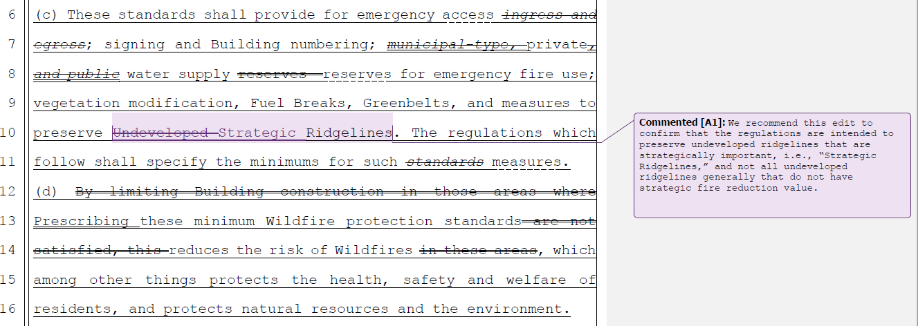
Board response: PRC 4290 requires the Board to adopt measures to “preserve undeveloped ridgelines,” so it is appropriate to use the term “undeveloped” in this subsection. Later sections of the regulations specify how undeveloped ridgelines are to be protected (first by identifying ridgelines as strategic, then preserving those strategic ridgelines that are undeveloped).

Rule text edit: No

Comment W231–5: CBIA (“Housing Coalition”)
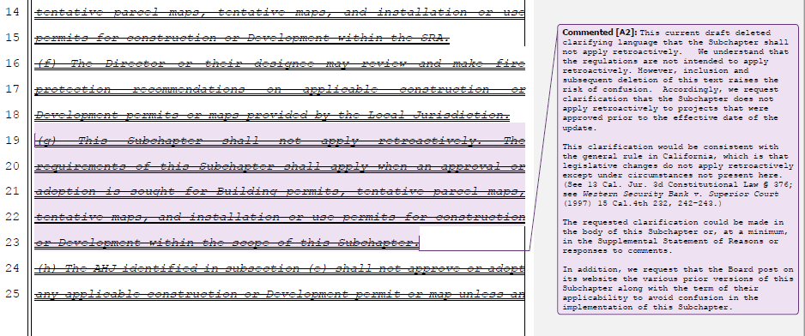
Board response: The Board is only proposing changes to Article 1 that are necessary to comply with the changes to PRC 4290 required by SB 901, consistent with the narrowed scope of the proposed action as identified within the Supplemental Statement of Reasons published with the “Second 15-Day Notice of Addition of Documents and Information to Rulemaking File and Modified Text” on May 10, 2022. The comments are not specifically directed at the Board’s proposed action or to the procedures followed by the Board in proposing the action.

Rule text edit: No

Comment W231–6: CBIA (“Housing Coalition”)
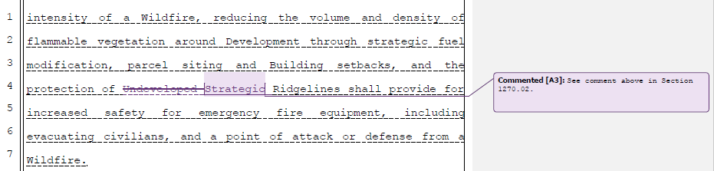

Board response: Please see response to W231-4

Rule text edit: No

Comment W231-7: CBIA (“Housing Coalition”)
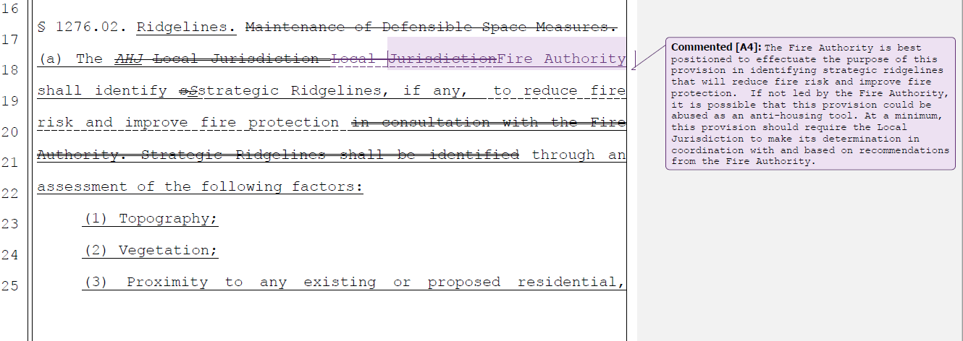

Board response: The term “local jurisdiction” does not preclude the Fire Authority from making decisions regarding Strategic Ridgelines. As these are statewide minimum standards, it would be overly prescriptive for the Board to mandate exactly which local jurisdiction agency is responsible for identifying strategic ridgelines. The most appropriate authority to determine strategic ridgelines may vary from jurisdiction to jurisdiction.

Rule text edit: No

Comment W231-8: CBIA (“Housing Coalition”)
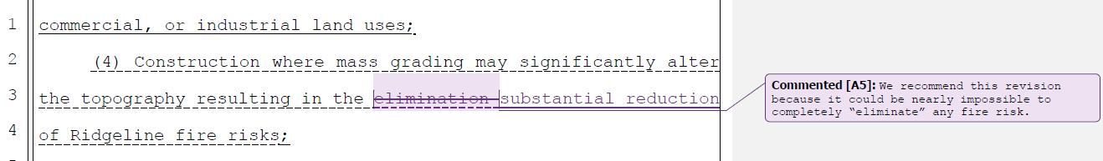

Board response: The term “substantial reduction” does not provide for the same regulatory clarity as the term “elimination.” The intention of this section is to allow for mass grading that completely demolishes the ridgeline such that a ridgeline no longer exists, and therefor the fire risk related to the ridgeline is eliminated. The term “substantial reduction” does not provide for this same intent. The term is too broad and offers too many opportunities for inconsistent application across the state.

Rule text edit: No

Comment W231-9: CBIA (“Housing Coalition”)
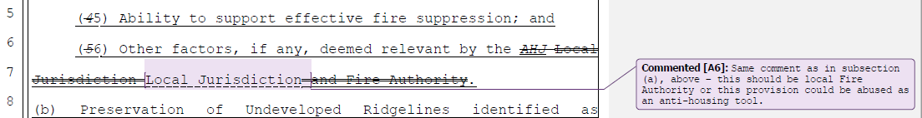
Board response: Please see response to W231-7

Rule text edit: No

Comment W231-10: CBIA (“Housing Coalition”)
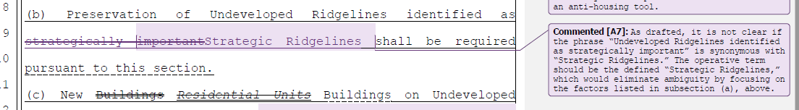
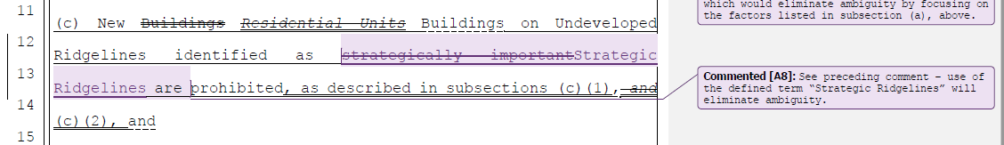
Board response: The phrase “undeveloped ridgelines identified as strategically important” is not intended to be synonymous with “strategic ridgelines.” A ridgeline may be identified as strategic but not have qualify as “undeveloped,” based on the Board’s definition of “undeveloped ridgeline.” An “undeveloped ridgeline identified as strategically important” is a ridgeline that meets the definition of “undeveloped ridgeline” and also is designated as a “strategic ridgeline” (ie, identified as strategically important). Replacing this phrase with the term “strategic ridgeline” would not implement the purpose of this section.

Rule text edit: No

Comment W231–11: CBIA (“Housing Coalition”)
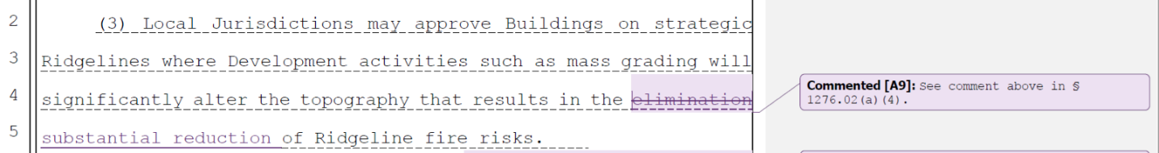
Board response: Please see response to W231-8

Rule text edit: No

Comment W231–12: CBIA (“Housing Coalition”)
Board response: Please see response to W231-7

Rule text edit: No

Comment W231–13: CBIA (“Housing Coalition”)
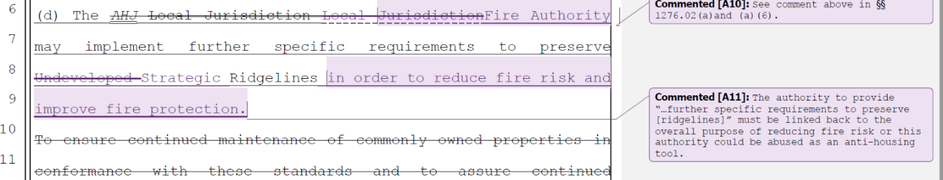
Board response: The Board is required to adopt measures “to preserve undeveloped ridgelines” and PRC 4290(c) specifies that “These regulations do not supersede local regulations which equal or exceed minimum regulations adopted by the state.” It would be outside of the scope of the Board’s authority to limit local jurisdictions to only apply stricter standards to strategic ridgelines versus undeveloped ridgelines.

Repeating the phrase “in order to reduce fire risk and improve fire protection” is unnecessarily redundant. This language is in statute and in relevant places throughout the regulations.

Rule text edit: No

Comment W231–14: CBIA (“Housing Coalition”)
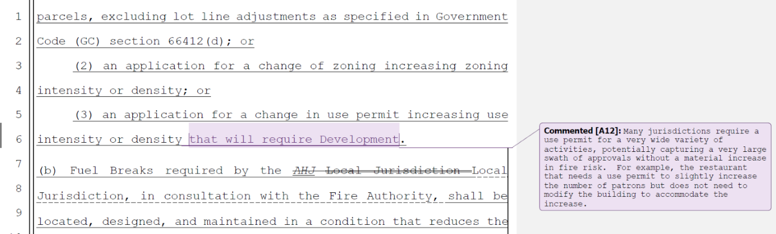
Board response: In § 1276.03(a), the local jurisdiction and fire authority are given the authority to determine the need for fuel breaks. In the situation the letter writer describes, a local jurisdiction may determine that no fuel break is necessary to provide for the safety of the restaurant patrons.

Rule text edit: No

Comment W231–15: CBIA (“Housing Coalition”)
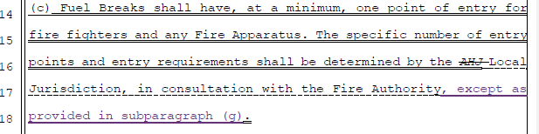
Board response: The Board is not proposing a subsection (g) in this section.

Rule text edit: No

Comment W231–16: CBIA (“Housing Coalition”)
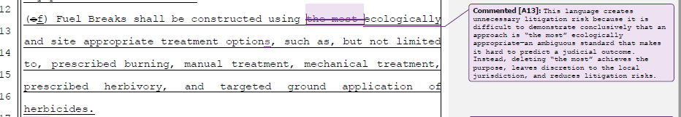
Board response: See response to W116-42

Rule text edit: No

Comment W231–17: CBIA (“Housing Coalition”)
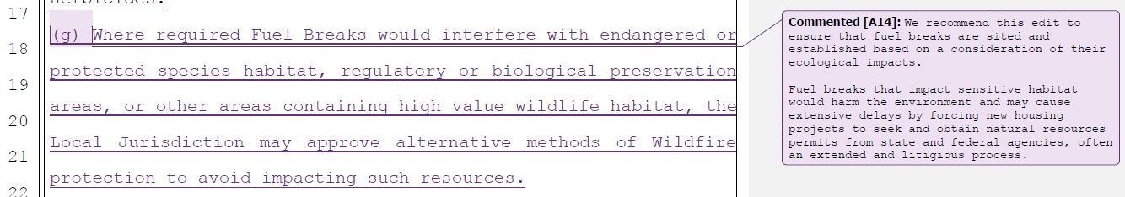
Board response: Please see response to W116-30

Rule text edit: No

Comment W232-1: Hessel Farmers Grange
The Hessel Farmers Grange membership is concerned about the current language and some of the language redacted from the BOF fire safe roads proposed ordinance. Language such as “harvesting of plants (including related activities such as processing, storage, and transportation) for the marketing of the resulting products.” would have put exemptions in place for the various agricultural practices that take place on a working farm, of any kind.

We are deeply concerned about the cost burden and environmental impacts of the Fire
Safe Road ordinance. We feel that there are solutions being overlooked that would
bring more cost effective rural economic development with much less environmental
impact. We are concerned about the cost of the road widening and other project/site
specific costs landing on the landowners, as most counties will just pass that buck if
given the opportunity.
We are facing another drought year, with a looming threat of wildfires and widening
roads and causing more irreparable damage to the environment and local rural
ecosystems is not the answer. Building more rural community resilience is.

Board response: The Board is not proposing changes to the exemptions from the Fire Safe Regulations; the comments are not specifically directed at the Board’s proposed action or to the procedures followed by the Board in proposing the action.

Rule text edit: No

Comment W232-2: Hessel Farmers Grange
These are the overall pressing recommendations/considerations:
● A thorough cost-analysis
● An EIR
● Cannabis to be considered Agriculture for these fire-safe rules. For example
under the scope say exemptions include mining, timber and agriculture
including Hemp and Cannabis.
● Allow commercial and industrial uses to have driveways. This is especially
important for small businesses.
● Include drying, harvesting and processing of crop materials in BOF/FSR
exemptions
● Without specific measures in place, or state/fed funds available, to prevent
local jurisdictions from assigning the cost of road-widening to its constituents -
most of them will shift the burden to landowners.
● Permits should be authorized at the local level and not go through the BOF for
additional conditions to the projects and oversight to the counties. That
additional step will add time delay and extra cost to the applicant.

Board response: Please see Economic and Fiscal Impact Statement and general CEQA response.

The Board is not proposing changes to the thresholds for driveway standards versus road standards. The comments are not specifically directed at the Board’s proposed action or to the procedures followed by the Board in proposing the action.

Permits do not go through the Board of Forestry and Fire Protection for review.

Rule text edit: No

Comment W232-3: Hessel Farmers Grange
Recommendations that have not been thoroughly explored:
● Instead of using funds to push trees around, widen roads and further disrupt
wildlife and local ecology - use any funds to strengthen rural economic
resilience as follows:
○ Incentivize/subsidize water tanks and foam retardant tanks for rural
communities to improve local infrastructure.
○ Incentivize / Subsidize training of local residents for fire-preparedness
(volunteer firefighting and heavy equipment operations training).
○ Build local disaster relief and heavy equipment resilience, whether
privately or state-owned. Even just subsidizing fuel, and maintenance
costs for locals who use their equipment as preventative measures.
● Encouraging, instead of discouraging the population of rural California. At this
point, these types of rules are completely discouraging ANY rural economic
development. Where sustainable and eco-conscious development should be
encouraged and the right development in these communities could create a
robust fire-break between rural and urban landscapes.

Board response: These recommendations are outside the scope of the proposed action. The comments are not specifically directed at the Board’s proposed action or to the procedures followed by the Board in proposing the action.

Rule text edit: No

Comment W233-1: Bruce Fenton
Section 1270.01 (y) Road
It is unclear where jurisdiction for a private project would start based on the latest
definition for a “Road”. I recommend that the definition be revised to “Private Road
from the County or City Right of Way”. This would create clarity and not require that
private projects upgrade public roads which would be a very significant cost; an undue
burden particularly for residential construction but also for commercial improvements.
Even the analysis of Public Roads for conformance with a standard represents significant effort by a consultant and thus a cost to a property owner. Also, the definition of a “Road” should be limited to commercial occupancy that generates 40 Average Daily Trips (ADT) or more. This is equivalent traffic that generated by 4 dwelling units and thus it would seem reasonable that a driveway could serve commercial occupancy with ADT of 40 or less.

Board response: The Board is no longer proposing changes to the definition of “Road,” consistent with the narrowed scope of the proposed action as identified within the Supplemental Statement of Reasons published with the “Second 15-Day Notice of Addition of Documents and Information to Rulemaking File and Modified Text” on May 10, 2022. The comments are not specifically directed at the Board’s proposed action or to the procedures followed by the Board in proposing the action.

Rule text edit: No

Comment W233-2: Bruce Fenton
Section 1270.03 Scope (a) (1) Timing of applicability
To provide for reasonable degree of certainty these regulations should apply to permit
applications that are submitted after the date that the regulations come into effect. As
written it is unclear if building or entitlement permits currently in process would be
exempt from the regulations. As is typical with Building Code changes, the applicable
code is the current code when a first submittal is made. Further to this, some projects require significant driveway planning and improvements at the Entitlement (Use Permit) Phase. These projects should be allowed to complete Entitlement and Building Permits under the same Regulation that was in effect when the Entitlement was first submitted. Perhaps with a sunset of say 5 years.

Board response: Please see response to W234

Rule text edit: No

Comment W233-3: Bruce Fenton
Section 1270.03 Scope (a) (2) Accessory Dwelling Units
These regulations should not apply to accessory dwelling units as these are needed to
improve housing availability with the State of California. If there is already a residence at the property, there should only be a minimum requirement to meet turnout spacing as
well as turnaround at the residence/ADU location.

Board response: The regulatory exemption for ADUs was a previous emergency regulatory action and is outside the scope of the proposed action. Please see General Response to Exceptions and Exemptions Comments.

Rule text edit: No

Comment W233-4: Bruce Fenton
Deleted Sections 1270.08 and 1273.12 Rebuilding of Burnt Structures and Existing
Roads
These regulations should allow for rebuilding of a burnt dwelling or commercial
structure subject to similar current requirements of County of Napa Road and Street
Standards i.e. same size building, same use, existing road did not impair egress or
ingress. Also the proposed regulation should allow for additional residences on an
existing road or driveway with requirements to meet turnout and turnaround
requirements only. The regulation as written will be a hardship for landowners that
have not yet built where their property is located on a shared driveway that meets the
definition of a Road.

Board response: The regulatory exemption for wildfire rebuilds was a previous emergency regulatory action and is outside the scope of the proposed action. Please see General Response to Exceptions and Exemptions Comments.

Rule text edit: No

Comment W233-5: Bruce Fenton
This comment is limited in scope to Articles 2-4. The Board is no longer proposing to revise Articles 2-4, consistent with the narrowed scope of the proposed action as identified within the Supplemental Statement of Reasons published with the “Second 15-Day Notice of Addition of Documents and Information to Rulemaking File and Modified Text” on May 10, 2022. The comments are not specifically directed at the Board’s proposed action or to the procedures followed by the Board in proposing the action.

Comment W233-6: Bruce Fenton
This comment is limited in scope to Articles 2-4. The Board is no longer proposing to revise Articles 2-4, consistent with the narrowed scope of the proposed action as identified within the Supplemental Statement of Reasons published with the “Second 15-Day Notice of Addition of Documents and Information to Rulemaking File and Modified Text” on May 10, 2022. The comments are not specifically directed at the Board’s proposed action or to the procedures followed by the Board in proposing the action.

Comment W234-1: Mono County Community Development Department
The first and last paragraphs of this letter are introductory/conclusive in nature; the comments are either not specific or are unnecessarily redundant with more specific comments presented elsewhere in the letter.

Paragraph 1A of this comment is limited in scope to Articles 2-4. The Board is no longer proposing to revise Articles 2-4, consistent with the narrowed scope of the proposed action as identified within the Supplemental Statement of Reasons published with the “Second 15-Day Notice of Addition of Documents and Information to Rulemaking File and Modified Text” on May 10, 2022. The comments are not specifically directed at the Board’s proposed action or to the procedures followed by the Board in proposing the action.

Comment W234-2: Mono County Community Development Department
1B. The definition of “Driveway” may not allow for the density outright permitted on multi-family residential parcels or where density has been increased to comply with state housing directives or law (e.g. ADUs or Junior ADUs permitted by building permit pursuant to state law). The result would require these types of parcels to upgrade a Driveway to a Road, which is an unnecessary burden on housing development, likely prohibitive, and in direct conflict with State housing directives. A modification to the definition of a Driveway would increase the consistency between state housing directives and multifamily residential permitted uses. Other proposed changes below are consistent with RCRC’s suggestions in its 2021 comment letter.

The letter writer proposes changes to the definition of “road” for consistency with their and RCRC’s proposed changes to the definition of “driveway.”

Board response: Please see response to W30. W126-6 and 126-16..

Rule text edit: No

Comment W234-3: Mono County Community Development Department
B. Exemptions & Exceptions

Section 1270.03(d) “Scope Exemptions – ADUs” has been eliminated from the current draft. Interestingly, this exemption was previously part of an “emergency action” by the BOF approved July 27, 2020, exempting the creation of accessory (ADU) or junior accessory dwelling units (JADUs). Did the BOF intend to eliminate this exemption from the current draft? If so, it seems in conflict with the “emergency action” taken by the BOF in 2020 and in direct conflict with state housing strategies. The County recommends reinstating the exemption for ADUs & JADUs in order to meet state housing directives and address the State-wide housing crisis. Otherwise, situations could arise where an ADU or JADU addition could result in significant and prohibitive road upgrade requirements if current proposed definitions are retained. A transitional period is needed if the BOF removes this exemption for projects currently being processed and those that are currently in the design phase.

CAL FIRE is currently the Inspection Entity in Mono County, and applicants and staff find requests for exemptions and will-serve letters for projects under the existing regulations to be extraordinarily onerous due to lack of response. In some cases, permits have been held up for extended time periods while awaiting a response. The additional approval process associated with exceptions would significantly delay the processing and implementation of planning and building permits for both commercial and residential projects which would negatively impact the County’s economic base, future housing stock, and fire victim housing security.

Suggested Solutions
2A. §1270.03 revert this section back to the language from the November 2021 MFSR draft (which aligned with the language in the 2020 “Emergency Action” take by the BOF).

Board response: The regulatory exemption for ADUs was a previous emergency regulatory action and is outside the scope of the proposed action. Please see General Response to Exceptions and Exemptions Comments.

Rule text edit: No

Comment W234-4: Mono County Community Development Department
2B. Add specified timeframes to §1270.07 “Exceptions to Standards” within which the inspection authority must respond to a request for an exception, otherwise the exception is deemed granted. To be consistent with ministerial building permit plan checks timeframes in Mono County, the deemed granted timeframe should be less than 30 days. Longer timeframes have the potential to delay ministerial building permit processing and efforts to rebuild communities after a wildfire.

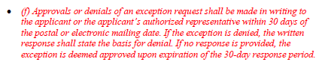
Board response: The Board is only proposing changes to 1270.07 that are necessary to implement the changes to PRC 4290 as a result of SB 901, consistent with the narrowed scope of the proposed action as identified within the Supplemental Statement of Reasons published with the “Second 15-Day Notice of Addition of Documents and Information to Rulemaking File and Modified Text” on May 10, 2022. The comments are not specifically directed at the Board’s proposed action or to the procedures followed by the Board in proposing the action.

Rule text edit: No

Comment W234-5: Mono County Community Development Department
2C. A transition period in alignment with the adoption date of the 2022 MFSRs is needed to ensure a smooth transition for projects currently being processed and those that are currently in the design phase. The County suggests that the MFSRs should apply to new proposals submitted after the approval date of the 2022 MFSRs, to allow projects with applications submitted prior to the approval date to proceed unencumbered by the new regulations.

Board response: See response to W123-5

Rule text edit: No

Comment W234-6: Mono County Community Development Department
Section II of this letter is limited in scope to Articles 2-4. The Board is no longer proposing to revise Articles 2-4, consistent with the narrowed scope of the proposed action as identified within the Supplemental Statement of Reasons published with the “Second 15-Day Notice of Addition of Documents and Information to Rulemaking File and Modified Text” on May 10, 2022. The comments are not specifically directed at the Board’s proposed action or to the procedures followed by the Board in proposing the action.

Comment W234-7: Mono County Community Development Department
C. Criteria Triggering Fuel Breaks
Similar to previously submitted comments about the previous Existing Roads standards, §1276.03 has the potential to force significant expenditures and project expansion if a Fuel Break is required. The standards should allow for minor development projects, and minor zoning or use permit changes. Further, the threshold of increased density and use intensity is extremely vague and, under Mono County zoning regulations, will be triggered for minor projects such as a <2,500 square-foot kitchen or seating expansion at a local restaurant or a second dwelling unit (other than an accessory dwelling unit) in a residential zone. These projects would have been exempt under the California Environmental Quality Act (CEQA) and therefore relatively simple to process. If a Fuel Break were to be required, however, the project could trigger more extensive environmental analysis, which could include a hefty price tag and a significant investment of time, which is disproportionate to the impact and intensity of the project.
Suggested Solutions
3A. Modify §1276.03(a) (1) – (3) to increase the thresholds for consideration of Fuel Breaks to allow for implementation of minor development projects and minor zoning or use permit changes.
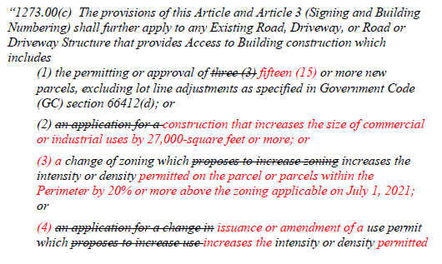
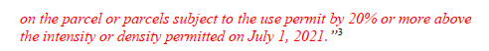
Board response: A local jurisdiction is required to determine the need and location for fuel breaks – the local jurisdiction is not required to install fuel breaks. Upon reviewing a project that meets the criteria in § 1276.03(a), the local jurisdiction may determine that no fuel breaks are necessary. There is no mechanism in the Fire Safe Regulations that compels a fuel break to be constructed.

Rule text edit: No

Comment W234-8: Mono County Community Development Department
III. Miscellaneous Comments & Suggested Solutions for Articles 1, 2, 4 and 5

A. In order to facilitate clear communication between the BOF and stakeholders about the MFSR update, all subsequent drafts of the MFSR should include a “draft date” or “version number” in the header of the proposed text and in the file name. The most current draft hasn’t been discernable through this process, especially when the BOF releases updates in close proximity to the previous update.

B. The BOF should consider updating the title of the document referenced to 2022 MFSR. The County understands that there are state mandated regulations that went into effect in July 2021, however, the regulations have yet to be adopted thus far so the year associated with the formal document name should reflect this and be changed to 2022. Upon adoption, which will likely be in 2022, the inconsistency in years associated with adoption and the formal document name will cause unnecessary confusion.
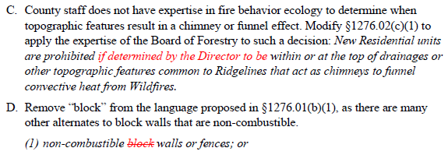

Board response: The Board will consider the suggestions offered by Mono County in its next rulemaking projects in order to improve clarity regarding document drafts. The Board appreciates the County’s input on this matter.

Regarding C. in relation to determining the fire risk of certain topographic features, the Board of Forestry and Fire Protection does not have the staffing capabilities to evaluate every ridgeline in the state for drainages and other similar high fire risk topographic features. The Local Jurisdiction is not precluded from employing the expertise of other local officials where that expertise may be necessary to comply with 1276.02(c)(1).

Regarding D. in relation to block walls, please see responses to W139-8 and 145-7.

Rule text edit: No

Comment W234-9: Mono County Community Development Department
IV. Cooperation and Collaboration Between Jurisdictions

This regulatory system is a cooperative effort between the BOF, CAL FIRE staff, and local governments with the common goal of protecting our communities from fire hazards. Mono County appreciates the modifications made in response to comments by the County and other stakeholders, and outreach conducted by the BOF with the State Department of Housing and Community Development and local jurisdictions. However, conflicts still exist and a collaborative forum for discussion and problem solving was not convened. In the spirit of improving cooperation, the County continues to raise the following points in the hopes that the BOF will engage in a more collaborative process to develop regulations that accomplish the mutual interests of partners and stakeholders while minimizing practical detrimental effects:

• Address the presumably unintended consequences and state-level policy conflicts being raised by local jurisdictions.
• Engage in a deliberative and thoughtful process that incorporates local government participation about practical impacts, restarting the process if necessary to provide clarity and understanding, rather than rapid and reactionary policymaking in response to recent wildfires.
• Mono County staff would be happy to meet with BOF staff. No outreach from BOF staff has been received to date.
Suggested Solution: Consider the input from local jurisdictions and RCRC, make changes where warranted, recognize the practicalities of existing development patterns and environmental constraints, and use existing standards and definitions when possible. Take the time to craft thoughtful policy and regulatory solutions to enhance community fire safety with meaningful input from local jurisdictions.

Board response: Please see response to W180.

Rule text edit: No

Comment W235: Bill Martin
The entirety of this letter is general in nature; the comments are either not specific, unnecessarily redundant, or irrelevant to the Board’s proposed changes.

Comment W236-1: John and Waltzie Janeski
The first and last paragraphs of this letter are introductory/conclusive in nature; the comments are either not specific or are unnecessarily redundant with more specific comments presented elsewhere in the letter.

Paragraphs 2-4 of this letter are limited in scope to Articles 2-4 of the regulation. The Board is no longer proposing to revise Articles 2-4, consistent with the narrowed scope of the proposed action as identified within the Supplemental Statement of Reasons published with the “Second 15-Day Notice of Addition of Documents and Information to Rulemaking File and Modified Text” on May 10, 2022. The comments are not specifically directed at the Board’s proposed action or to the procedures followed by the Board in proposing the action.

Comment W236-2: John and Waltzie Janeski
It is also important that accessible mitigations, such as the use of clearing and open space, designated materials for construction, areas of refuge, and so on, be provided for every regulation that limits development based on fire risk. Applications for exemptions should strongly consider the complete picture after examining the overall conditions on the particular parcel and its access route as well as the likelihood and potential severity of a fire nearby.

Board response: Exceptions are regulated under 1270.07.

Rule text edit: No

Comment W236-3: John and Waltzie Janeski
Paragraph 6 of this letter is general in nature; the comments are either not specific or are unnecessarily redundant with more specific comments presented elsewhere in the letter.

Comment W236-4: John and Waltzie Janeski
The changed definitions of Driveway and Road in the current version of the proposed
Regulations are a move in the right direction. FURTHERMORE, WE ASK THE BOARD TO MODIFY THE SECTION OF THE REGULATIONS REGARDING SCOPE TO ALLOW A HOMEOWNER TO REPAIR OR REPLACE A SINGLE EXISTING RESIDENCE WITHOUT RESTRICTIONS ON THEIR EXISTING ACCESS THAT MAY PROHIBIT RECONSTRUCTION.

Board response: The Board is not proposing changes to the scope of these regulations. The comments are not specifically directed at the Board’s proposed action or to the procedures followed by the Board in proposing the action.

Rule text edit: No

Comment W237-1: Stefan Walker
I am writing to express my profound concern regarding the latest draft of the California Fire Safe Regulations. As detailed in Lynn Kennedy’s letter of May 26th, this version, if adopted, would render scores of previously buildable parcels in the State suddenly and unfairly unbuildable. I have been representing real property buyers and sellers in California for 30 years. In my experience, the vast majority of unbuildable parcels have very little value. So, if the State elects to adopt the current draft of the Fire Safe Regulation, it would in doing so rob countless property owners of the equity they have built in their properties.

Further, our State is in the midst of a severe housing shortage. The lack of housing supply has caused housing costs to skyrocket in recent years, making housing in the state less affordable than ever before. Fewer and fewer Californians have the means to live in our State and are leaving in droves in search of more affordable communities in places like Oregon, Washington, Arizona, Idaho, Texas, and Colorado. Government officials at every level are searching for realistic ways to increase our housing supply. I urge to preserve thousands of buildable lots in our State and REJECT this latest draft of the Fire Safe Regulations.

Board response: Please see response to W238.

Rule text edit: No

Comment W238-1: Lynn Kennedy
The first two paragraphs and last paragraph of this letter are introductory/conclusive in nature; the comments are not specifically directed at the Board’s proposed action or to the procedures followed by the Board in proposing the action.

California zoning laws now allow almost anyone to put an ADU on their property. I have a vacant lot next door to a lot with a home. My neighbor can build a second house. I can’t build a first house. My new home would have no more impact on CALFIRE than his new unit. This is entirely unfair and is the perfect example of why legally created vacant lots previously approved for development (i.e. building site approval, part of a legal subdivision, etc.) MUST be treated differently than parcels in unimproved areas.

• You MUST grandfather in the property rights of people who own legal and previously buildable lots in existing legal subdivisions.
• If you do not do this then you must compensate property owners for the lost value of their land (I can provide a cancelled purchase contract to prove the value of my land; value that has currently been taken from me).
• You can do this by reinstating all the language differentiating new road from existing roads.

Board response: The Board is not proposing changes to the scope or applicability of these regulations nor to the standards for new versus existing roads, consistent with the narrowed scope of the proposed action as identified within the Supplemental Statement of Reasons published with the “Second 15-Day Notice of Addition of Documents and Information to Rulemaking File and Modified Text” on May 10, 2022. The comments are not specifically directed at the Board’s proposed action or to the procedures followed by the Board in proposing the action.

Rule text edit: No

Comment W238-2: Lynn Kennedy
Furthermore, very recently-released maps clearly illustrate that fire risk in different areas of California varies considerably. As an example, the risk in the coastal hills in the SF Bay Area is far less than risk in inland hills and mountains. The California Fire Safe Regulations do not take this into account and instead take a “one-size-fits-all” approach. This approach is fundamentally flawed. I own property that (unfortunately) is in a State Response Area. Not only is it in the lower risk coastal range, it is also designated High/Moderate risk as opposed to Very High Risk. If it were in Town it would be exempt from these regulations.

• Limit the regulations to covering only Very High Risk areas regardless of who must respond (change the blanket definition of State Response Area to only SRA+VHR).
• Better yet, abandon the idea of a statewide law in light of new risk reports; let county or regional boards assess what’s needed locally.

Board response: PRC 4290 requires the Board to write regulations applicable to “all residential, commercial, and industrial building construction within state responsibility areas approved after January 1, 1991, and within lands classified and designated as very high fire hazard severity zones, as defined in subdivision (i) of Section 51177 of the Government Code after July 1, 2021.” The Board does not have the authority to apply these regulations to a different geographic area of California, nor to delegate the creation of minimum standards to local or regional boards or agencies.

Rule text edit: No

Comment W238-3: Lynn Kennedy
This crisis you have created is time sensitive! The most efficient fair solution is to adopt the prior draft of the regulations that was circulated in January, with distinctions between new and existing roadways, etc. I urge you to take this action immediately. Further delay in overturning the sudden and unwarranted prohibitions on building that began last year continues to cause severe hardship (financial, emotional, logistical, etc.) for property owners in California. This is even more difficult today than it was when I last wrote you in January, as inflation is soaring and our retirement portfolio has shrunk. We
simply cannot afford to write off our million-dollar piece of land! We will appeal our five-figure taxes this year; we’d waited to do so trusting you would have adopted the earlier draft by now.

Board response: Without a specific objection or recommendation regarding the specific adoption, amendment, or repeal proposed in this rulemaking, the Board has no specific response to this comment.

Rule text edit: No

Comment W239-1: Michael Burke
The first paragraph and last two paragraphs of this letter are introductory/conclusive in nature; the comments are either not specific or are unnecessarily redundant with more specific comments presented elsewhere in the letter.

We have been attending web meetings, and writing letters. We thought, based
on earlier drafts, that progress was being made. Language was being added to
the draft regulations that differentiated being new and existing. We felt we were
going to get back the property rights that have been taken from us.

When we looked at the latest draft regulations, all of the needed changes have
been removed. Not only that, but you have removed the definitions of “existing
road,” “collector road,” “new,” and “existing.” It is almost as if you want to
erase any trace of evidence that you were working to solve this injustice.

Board response: The Board is no longer proposing changes to the applicability of the regulations, except those necessary to comply with the changes to PRC 4290 required by SB 901, consistent with the narrowed scope of the proposed action as identified within the Supplemental Statement of Reasons published with the “Second 15-Day Notice of Addition of Documents and Information to Rulemaking File and Modified Text” on May 10, 2022. The comments are not specifically directed at the Board’s proposed action or to the procedures followed by the Board in proposing the action.

Rule text edit: No

Comment W240-1: Plumas County Board of Supervisors
The first three paragraphs and last three paragraphs of this letter are introductory/conclusive in nature; the comments are not specifically directed at the Board’s proposed action or to the procedures followed by the Board in proposing the action.

Comment W240-2: Plumas County Board of Supervisors
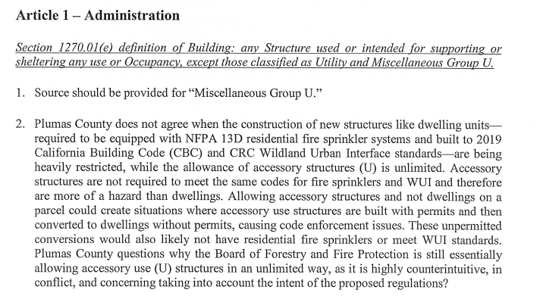
Board response: Regarding 1, relating to a source for “miscellaneous group U,” the term “Utility and Miscellaneous Group U Structures” are defined in 1270.01.

Regarding 2, relating to allowing the use of accessory group U structures, please see response to W32-6.

Rule text edit: No

Comment W240-3: Plumas County Board of Supervisors
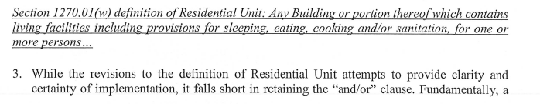
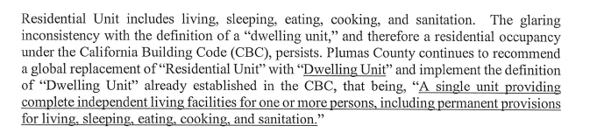
Board response: Please see response to W242-3.

Rule text edit: No

Comment W240-4: Plumas County Board of Supervisors
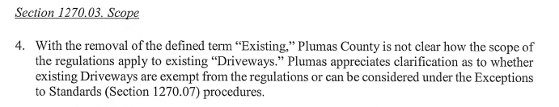
Board response: These regulations are not applicable to existing driveways absent any development or construction permitting. Where a permit is applied to a relevant existing driveway, the driveway standards must be met.

Rule text edit: No

Comment W240-5: Plumas County Board of Supervisors
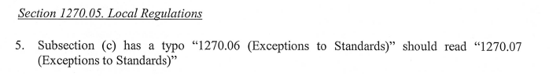
Board response: This error will be corrected in the final rule text. Thank you for bringing it to the Board’s attention.

Rule text edit: Yes

Comment W240-6: Plumas County Board of Supervisors
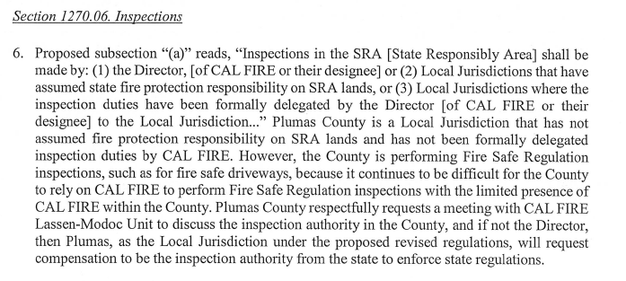
Board response: The Board will communicate this request to the Lassen-Modoc Unit.

Rule text edit: No

Comment W240-7: Plumas County Board of Supervisors
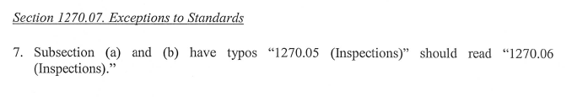
Board response: This error will be corrected in the final rule text. Thank you for bringing it to the Board’s attention.

Rule text edit: Yes

Comment W240-8: Plumas County Board of Supervisors
Board response: This error will be corrected in the final rule text. Thank you for bringing it to the Board’s attention.

Rule text edit: Yes

Comment W240-9: Plumas County Board of Supervisors
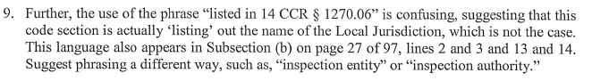
Board response: Section 1270.06(a) does provide a list of entities that may conduct inspections. The letter writer may be expecting a list with different information, but the language “listed in 14 CCR 1270.06” does provide clarity in directing the reader to the list of potential inspection entities provided for in 1270.06(a).

Rule text edit: No

Comment W240-10: Plumas County Board of Supervisors
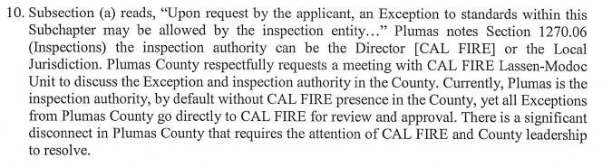
Board response: The Board will communicate this request to the Lassen-Modoc Unit.

Rule text edit: No

Comment W240-11: Plumas County Board of Supervisors
Board response: This error will be corrected in the final rule text. Thank you for bringing it to the Board’s attention.

Rule text edit: Yes

Comment W240-12: Plumas County Board of Supervisors
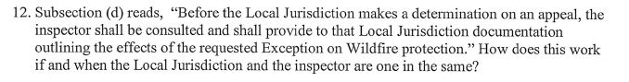
Board response: The “local jurisdiction” and the “inspector” are not the same entity. The “local jurisdiction” refers in general to a government agency (see definition), which the “inspector” is the individual person who inspected that particular property. The inspector may work for the local jurisdiction, but the inspector is an individual while the local jurisdiction is the governmental agency.

Rule text edit: No

Comment W240-13: Plumas County Board of Supervisors
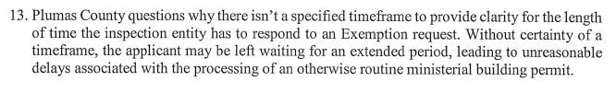
Board response: The Board is only proposing changes to this section necessary to implement changes to PRC 4290 required by SB 901, consistent with the narrowed scope of the proposed action as identified within the Supplemental Statement of Reasons published with the “Second 15-Day Notice of Addition of Documents and Information to Rulemaking File and Modified Text” on May 10, 2022. The comments are not specifically directed at the Board’s proposed action or to the procedures followed by the Board in proposing the action.

Rule text edit: No

Comment W240-14: Plumas County Board of Supervisors
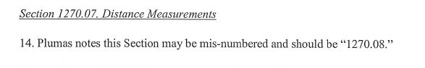
Board response: This error will be corrected in the final rule text. Thank you for bringing it to the Board’s attention.

Rule text edit: Yes

Comment W240-15: Plumas County Board of Supervisors

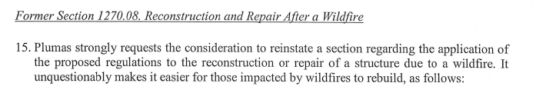
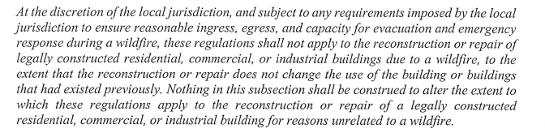
Board response: The regulatory exemption for wildfire rebuilds was a previous emergency regulatory action and is outside the scope of the proposed action. Please see General Response to Exceptions and Exemptions Comments.

Rule text edit: No

Comment W240-16: Plumas County Board of Supervisor
Suggestions numbered 16-19 of this comment are limited in scope to Articles 2-4 of the rule text. The Board is no longer proposing to revise Articles 2-4, consistent with the narrowed scope of the proposed action as identified within the Supplemental Statement of Reasons published with the “Second 15-Day Notice of Addition of Documents and Information to Rulemaking File and Modified Text” on May 10, 2022. The comments are not specifically directed at the Board’s proposed action or to the procedures followed by the Board in proposing the action.

Comment W240-17: Plumas County Board of Supervisors
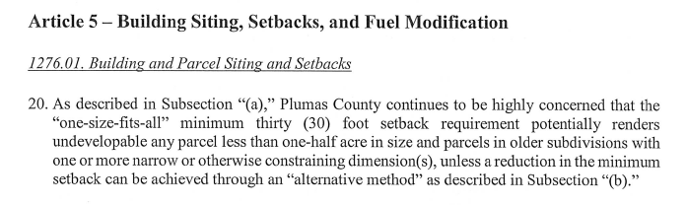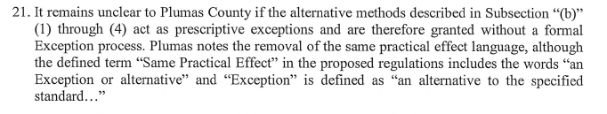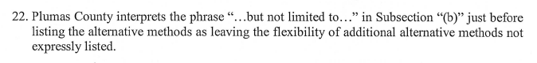
Board response: Please see response to W126-51. A reduction in the 30 foot setback does not have to go through the exception process.

Rule text edit:

Comment W240-18: Plumas County Board of Supervisors
Board response: Please see response to W147-12.

Rule text edit: No

Comment W240-19: Plumas County Board of Supervisors
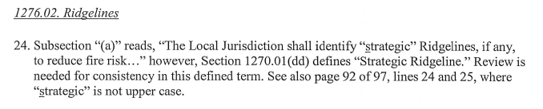
Board response: “Strategic” should be in upper case in those sections. Thank you for bringing this to the Board’s attention.

Rule text edit: No

Comment W240-20: Plumas County Board of Supervisors
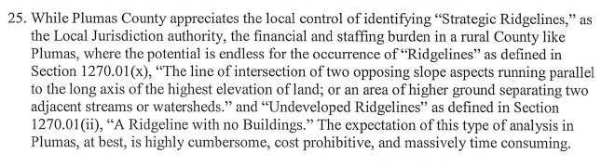
Board response: Without a specific objection or recommendation regarding the specific adoption, amendment, or repeal proposed in this rulemaking, or alternatives to conisder, the Board has no specific response to this comment.

Rule text edit: No

Comment W240-21: Plumas County Board of Supervisors
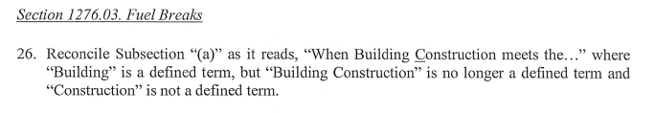
Board response: The Board will confirm this is the case in the final rule text. Thank you for bringing attention to the matter.

Rule text edit: No

Comment W240-22: Plumas County Board of Supervisors
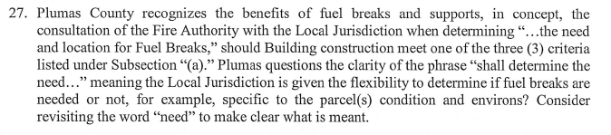
Board response: The regulations provide the Local Jurisdiction the ability to determine the need and location for fuel breaks.

Rule text edit: No

Comment W240-23: Plumas County Board of Supervisors
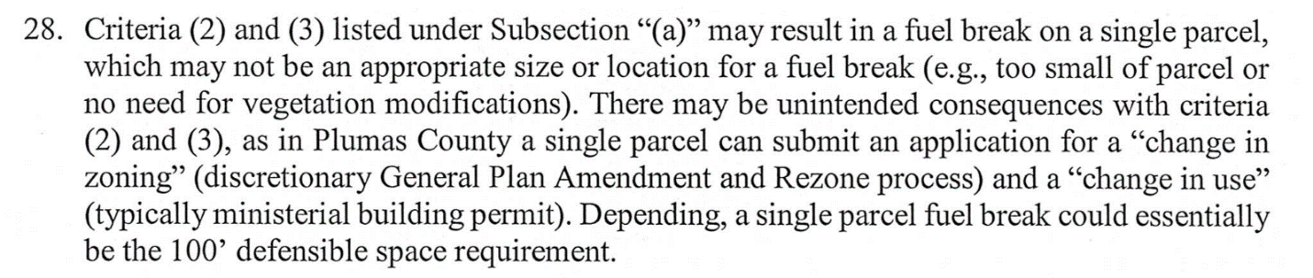
Board response: In that case, the local jurisdiction may determine that a fuel break is not needed for fire protection for that particular project. Upon reviewing a project that meets the criteria in § 1276.03(a), the local jurisdiction may determine that no fuel breaks are necessary. There is no mechanism in the Fire Safe Regulations that compels a fuel break to be constructed.

Rule text edit: No

Comment W240-24: Plumas County Board of Supervisors
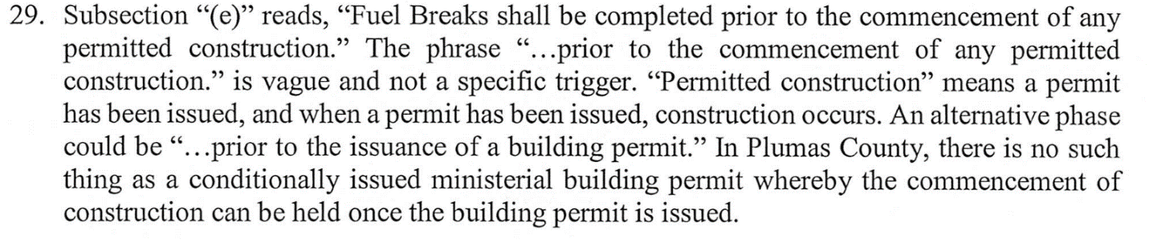
Board response: The regulations require that the fuel break must be constructed first, prior to commencement of any other permitted construction.

Rule text edit: No

Comment W240-25: Plumas County Board of Supervisors
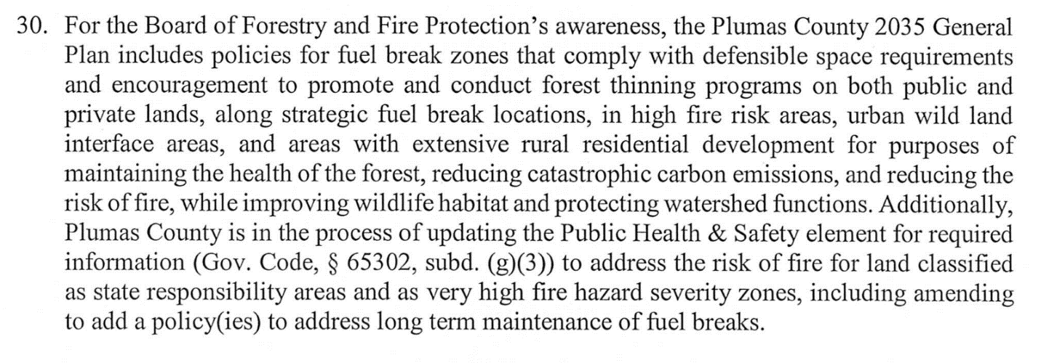
Board response: The Board appreciates Plumas County’s local fire prevention and protection efforts, and looks forward to reviewing the Public Health and Safety Element when it comes before the Board for recommendations.

Rule text edit: No

Comment W241-1: Deborah Eppstein
The first two paragraphs of this letter are introductory in nature; the comments are not specifically directed at the Board’s proposed action or to the procedures followed by the Board in proposing the action.

Misinterpretations by some local jurisdictions in limiting the meaning of access to
only ‘within a parcel’, or to not applying standards to existing roads is in
disagreement with PRC 4290, the state Attorney General’s opinion and subsequent
letters as well as a BOF letter. Such misapplications of the regulations would make
PRC 4290 and the entire regulations meaningless (e.g., if a fire truck could not reach
the parcel perimeter due to subpar roads it obviously could not then enter or access
the parcel or structure).
To avoid continued misapplication, it would be beneficial to re-clarify that “Access to
a structure is from the nearest fire station and is via roads meeting the minimum
requirements of Article 2 that enable safe concurrent evacuation of civilians and
ingress of Fire Apparatus.” Ideally this clarification should be incorporated into the
regulations as well as the training for all regulators discussed in point 3 below.
Access is such a fundamental point in correctly applying the regulations that it
must be accurately and consistently applied.

Board response: See response to W218.

Rule text edit: No

Comment W241-2: Deborah Eppstein
2) Exceptions to Standards ¶ 1270.07. There has been significant misapplication of
the Exception process and lack of documentation concerning Same Practical Effect
under the current regulations. As BOF had proposed language in the December
2021 draft to clarify the intent and application of the Exception process, it would be
beneficial to add such clarification that the requirements of the Exception request
include “material facts demonstrating the proposed Exception Substantially Complies
with the State Minimum Regulations for which the Exception is requested”. The
definition of “Substantially Compliance/Complies” proposed by BOF in the December
2021 draft is “Nearly complete satisfaction of each applicable requirement consistent
with the purpose of the State Minimum Fire Safe Regulations, including without
limitation to concurrent Fire Apparatus ingress and civilian evacuation.” Concurrent
ingress and egress is a basic premise if not paramount in the Fire Safe Regulations,
but which has often been ignored by some local jurisdictions in the Exception
process.
BOF had also previously proposed the clarification that Substantial Evidence must be
provided with and support the Exception request, “to include facts, reasonable
assumptions predicted upon facts, and expert opinion supported by facts.” BOF had
proposed that “Substantial Evidence” constitutes “Enough relevant information and
reasonable inferences from this information that a fair argument can be made to
support a conclusion, in light of the whole record of evidence, even though other
conclusions might also be reached. Argument, speculation unsubstantiated opinion or
narrative, or evidence which is clearly erroneous or inaccurate does not constitute
Substantial Evidence. Substantial Evidence shall include facts, reasonable
assumptions predicated upon facts, and expert opinion supported by facts.”
Clarification to require material facts that demonstrate concurrent ingress and
egress for an Exception is important to prevent prior and ongoing abuses that
circumvent the intent of the regulations, e.g., where 12 ft wide roads were stated to
provide concurrent ingress and egress, with no supporting evidence, although that
clearly was not possible on a one-lane road. Such clarifications to the Exception
process could be incorporated into the regulations as well as the training program
discussed in point 3 below.

Board response: The Board is only proposing those changes to Article 1 that are necessary to comply with the changes to PRC 4290 required by SB 901, consistent with the narrowed scope of the proposed action as identified within the Supplemental Statement of Reasons published with the “Second 15-Day Notice of Addition of Documents and Information to Rulemaking File and Modified Text” on May 10, 2022. The comments are not specifically directed at the Board’s proposed action or to the procedures followed by the Board in proposing the action.

Rule text edit: No

Comment W241-3: Deborah Eppstein
The last three paragraphs of this letter are limited to suggestions regarding the implementation of the regulations, and do not propose specific changes to the rule text.

Board response: Responsibility for the implementation of the regulations is described within 1270.06.

Rule text edit: No

Comment W242-1: Ventura County Fire Department
The first two paragraphs and last paragraph of this letter are introductory/conclusive in nature; the comments are not specifically directed at the Board’s proposed action or to the procedures followed by the Board in proposing the action.

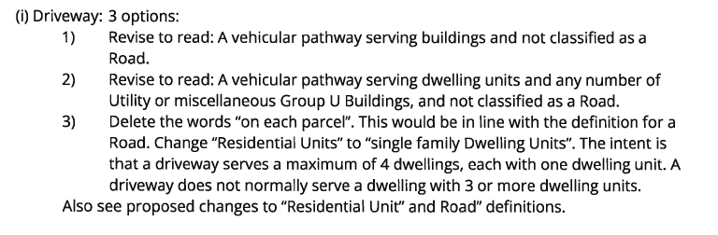
Board response: These proposed changes to the definition of “driveway” would not serve the intent of the regulations nor provide greater clarity to the regulated public. The proposed definition specifies that a “Driveway” serves no more than four residential units, and there can be any number of non-industrial or non-commercial Utility or Miscellaneous Group U structures on each parcel.

Rule text edit: No

Comment W242-2: Ventura County Fire Department
Board response: Please see response to W113-4.

Rule text edit: No

Comment W242-3: Ventura County Fire Department
(w) Residential Unit: Staff is attempting to create a new definition when sufficient definitions for the terms Dwelling Unit and Group R-3 already exist in the California Building, Residential and Fire Codes (CCR Title 24) adopted by the State Marshal. In addition, the term "residential Unit" as proposed does not distinguish a single-family dwelling from a multifamily dwelling. A 20-unit apartment building can be considered a single 'Residential Unit" using the definition proposed by the BOF. We proposed to replace the term "Residential Unit" with Dwelling Unit as follows:

Residential Dwelling Unit: A single unit providing complete, independent living facilities for one or more persons, including permanent provisions for living, sleeping, eating, cooking, and sanitation. Manufactured homes, mobile homes, and factory-built housing are considered dwelling units.
(y) Road: Replace "Residential Units" with "Dwelling Units". See proposed revision to
"Residential Unit" above.
Board response: The definition of Residential Unit is largely existing language that has been slightly modified in response to changes to PRC 4290 required by SB 901. The Board has not received reports of “residential unit” being interpreted in this manner, where a multi-unit building is considered as one residential unit, so a revision to the definition of “residential unit” is not necessary.

Rule text edit: No

Comment W242-4: Ventura County Fire Department
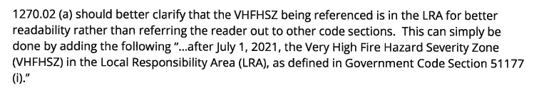
Board response: Government Code section 51177(i) does not specify Vh

Rule text edit: No

Comment W242-5: Ventura County Fire Department
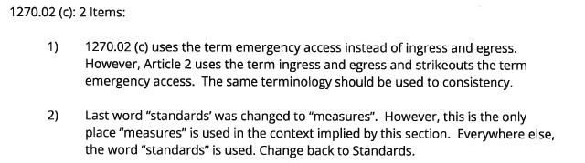
Board response: The Board is not proposing changes to 1270.02(c), consistent with consistent with the narrowed scope of the proposed action as identified within the Supplemental Statement of Reasons published with the “Second 15-Day Notice of Addition of Documents and Information to Rulemaking File and Modified Text” on May 10, 2022. The comments are not specifically directed at the Board’s proposed action or to the procedures followed by the Board in proposing the action.

Rule text edit: No

Comment W242-6: Ventura County Fire Department
Board response: The effective dates of the regulations with regard to the VHFHSZ is specified within PRC 4290.

Rule text edit: No

Comment W242-7: Ventura County Fire Department
Board response: This error will be corrected in the final rule text. Thank you for bringing it to the Board’s attention.

Rule text edit: No

Comment W242-8: Ventura County Fire Department
Board response: The “local jurisdiction” may include the fire authority. It was determined that requiring a specific government agency be responsible for inspections in the VHFHSZ would be overly burdensome and unnecessarily prescriptive. The local jurisdiction is delegated the authority to determine which government agency is the most appropriate inspection authority.

Rule text edit: No

Comment W242-9: Ventura County Fire Department
Board response: This error will be corrected in the final rule text. Thank you for bringing it to the Board’s attention.

Rule text edit: No

Comment W242-10: Ventura County Fire Department
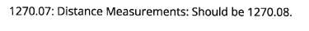
Board response: This error will be corrected in the final rule text. Thank you for bringing it to the Board’s attention.

Rule text edit: No

Comment W242-11: Ventura County Fire Department
Paragraphs 13-15, 19-24, and 26 of this comment are limited in scope to Articles 2-4 of the regulation. The Board is no longer proposing to revise Articles 2-4, consistent with the narrowed scope of the proposed action as identified within the Supplemental Statement of Reasons published with the “Second 15-Day Notice of Addition of Documents and Information to Rulemaking File and Modified Text” on May 10, 2022. The comments are not specifically directed at the Board’s proposed action or to the procedures followed by the Board in proposing the action.

Comment W242-15: Ventura County Fire Department
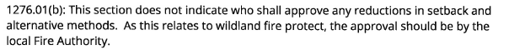
Board response: It is unnecessarily duplicative and overly burdensome to specify an approval authority for every section in the regulations. The approval and inspection authorities are enumerated in Article 1, Administration, and apply throughout the regulations except where otherwise specified.

Rule text edit: No

Comment W242-16: Ventura County Fire Department
Board response: “Development patterns that promote low-carbon emission outcomes” are those types of development where their development patterns promote the reduction of carbon emissions. The comments are not specifically directed at the Board’s proposed action or to the procedures followed by the Board in proposing the action.

Rule text edit: No

Comment W242-17: Ventura County Fire Department
Board response: Please see response to W51-1 and W242-8

Rule text edit: No

Comment W242-18: Ventura County Fire Department
Board response: The intention of 1276.02(c)(1) is to specifically prohibit residential units within or at the top of topographic features that act as “chimneys” to funnel convective heat. Other buildings that are not residential units are allowed within or at the top of those features. It is necessary to prevent the construction of residential units near these particularly dangerous topographic features, but it was determined to be overly burdensome to prohibit all buildings in those areas. This provides for flexibility for local jurisdictions when permitting the siting and placement of buildings and residential units on or near ridgelines.

Rule text edit: No

Comment W242-19: Ventura County Fire Department
Board response: It would be impossible to determine an appropriate distance in which new buildings are prohibited on undeveloped ridgelines, as ridgelines vary greatly in size, dimensions, and topography. It was determined that appropriate distances would be best determined by the local jurisdiction when they identify strategic, undeveloped ridgelines.

Rule text edit: No

Comment W243-1: Mahaman Development
The first four pages of this letter are introductory/conclusive in nature; the comments are not specifically directed at the Board’s proposed action or to the procedures followed by the Board in proposing the action.

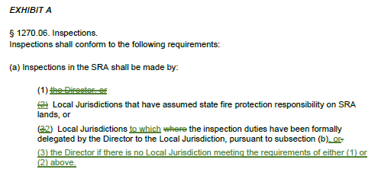

Board response: Fire protection and prevention in the SRA is specifically the responsibility of CAL FIRE, so it is appropriate that the director is listed first in this list of agencies that may be responsible for inspections related to the Fire Safe Regulations.

Rule text edit: No

Comment W243-2: Mahaman Development
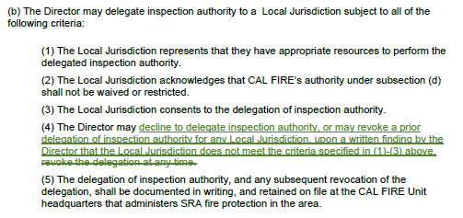

Board response: The use of the term “may” in 1270.06(b) provides for the same allowance proposed by the letter writer. The Director is not obligated to delegate inspection authority to a local jurisdiction, but may do so upon the local jurisdiction meeting the criteria outlined in the regulations. This provides for the same functionally permissibility the letter writer proposes here.

Rule text edit: No

Comment W243-3: Mahaman Development
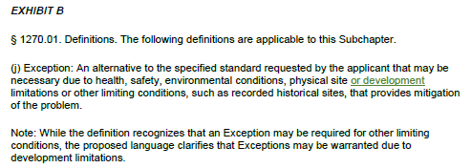

Board response: It is unclear what the letter writer means with the term “development limitations.” Without greater specificity, it is unclear what kinds of limitations the letter writer believes “development limitations” captures that is not captured in the existing regulatory text. “Development limitations” may be covered by “other limiting conditions” in the definition of “Exception.”

Rule text edit: No

Comment W243-4: Mahaman Development
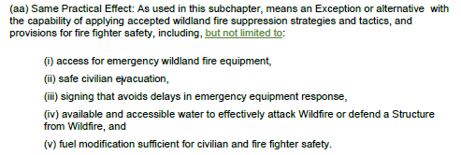

Board response: PRC 4290 requires the Board to write regulations relevant to “(1) Road standards for fire equipment access.
(2) Standards for signs identifying streets, roads, and buildings.
(3) Minimum private water supply reserves for emergency fire use.
(4) Fuel breaks and greenbelts.”

As such, an exception or alternative to the specified standards in these regulations that provides for “same practical effect” must provide for safety as it relates to those concerns. An exception or alternative cannot provide for the same practical effect as a standard that is not enumerated in these regulations, so to add the phrase “but not limited to” would exceed the Board’s authority to write regulations under PRC 4290.

Rule text edit: No

Comment W243-5: Mahaman Development
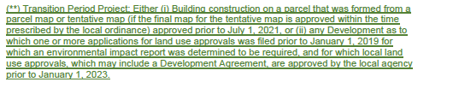

Board response: Please see response to W123-5

Rule text edit: No

Comment W243-6: Mahaman Development

Board response: PRC 4290 requires these regulations be applicable to “the perimeters and access to all residential, commercial, and industrial building construction.” In addition, a local ordinance only supersedes these regulations when they “equal or exceed minimum regulations adopted by the state” (PRC 4290(c)). When a local jurisdiction applies an exemption not enumerated in these regulations, they are not equaling or exceeding the minimum standards adopted by the state. Therefor, a local jurisdiction cannot apply an exemption that is not in these regulations.

Rule text edit: No

Comment W243-7: Mahaman Development
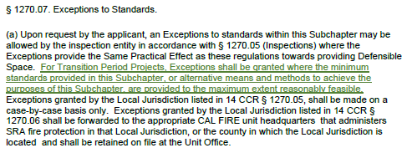

Board response: Please see response to W123-5

Rule text edit: No

Comment W243-8: Mahaman Development
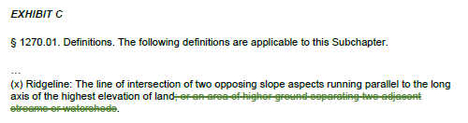

Board response: Please see response to W123-10.

Rule text edit: No

Comment W243-9: Mahaman Development
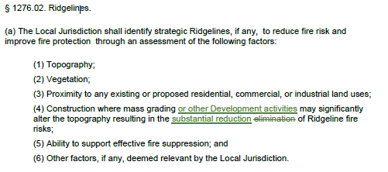

Board response: Please see response to W231-11

Rule text edit: No

Comment W243-10: Mahaman Development
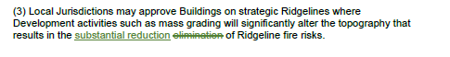

Board response: Please see response to W231-11

Rule text edit: No

Comment W244-1: Sierra County Board of Supervisors
Paragraphs 1-3 and 5 of this letter are introductory/conclusive in nature; the comments are not specifically directed at the Board’s proposed action or to the procedures followed by the Board in proposing the action.

We fail to see any analysis of economic impacts or any recognition of the environmental impacts that this body of regulation will impose onto the County. It is not an overstatement for Sierra County to suggest that the regulations, if adopted will all but stop most development potential on the entire west side of the county and a large percentage of the east side of the County if the agricultural standards remain as proposed. The County understands the priority to implement effective fire safe regulations but rushing to adopt standards that are known to be conflicting and ambiguous is not the proper path to take.

Board response: Please see the Economic and Fiscal Impact Statement

Rule text edit: No

Comment W245-1: Farella Braun and Martel LLP
The first six paragraphs and the last paragraph of this letter are introductory/conclusive in nature; the comments are not specifically directed at the Board’s proposed action or to the procedures followed by the Board in proposing the action.

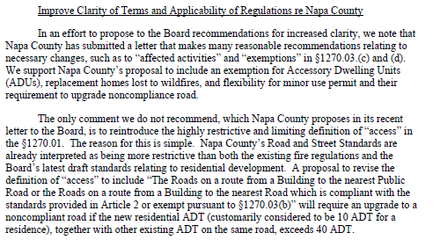
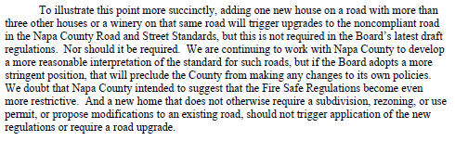
Board response: Please see response to W215. Regarding the definition of “Access,” the Board is no longer proposing a definition for the term “Access,” consistent with the narrowed scope of the proposed action as identified within the Supplemental Statement of Reasons published with the “Second 15-Day Notice of Addition of Documents and Information to Rulemaking File and Modified Text” on May 10, 2022.

Rule text edit: No

Comment W245-2: Farella Braun and Martel LLP
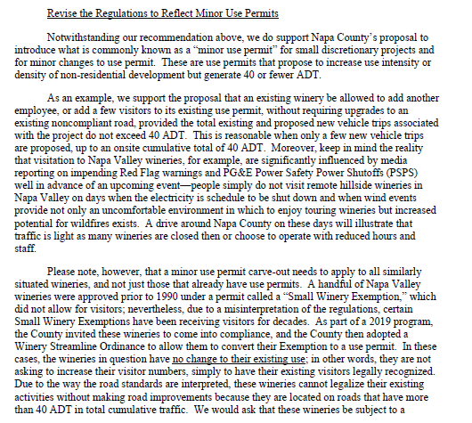
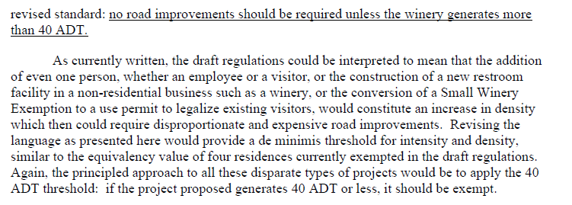
Board response: Please see response to W215

Rule text edit: No

Comment W245-3: Farella Braun and Martel LLP
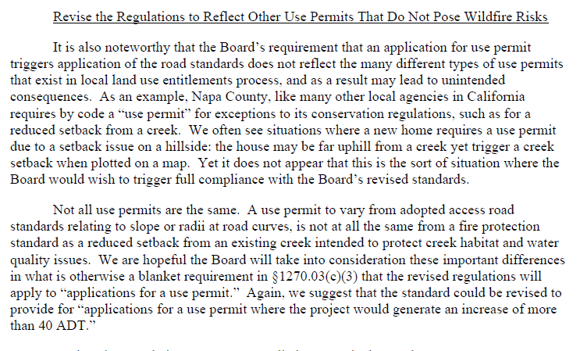
Board response: The language in § 1270.03(c)(3) is existing language in § 1270.02(c)(3). The Board has not received field reports that indicate this language has resulted in the application of the regulations to projects described by the letter writer. Although the Fire Safe Regulations may apply to such a project, the local jurisdiction may grant an exception from the regulations if they determine that is appropriate.

Rule text edit: No

Comment W245-4: Farella Braun and Martel LLP
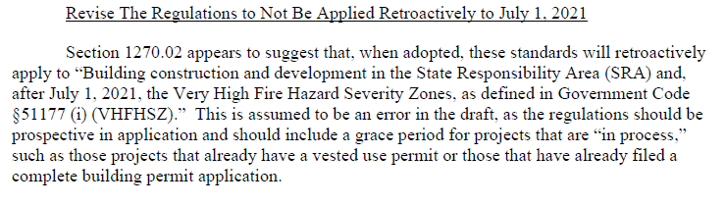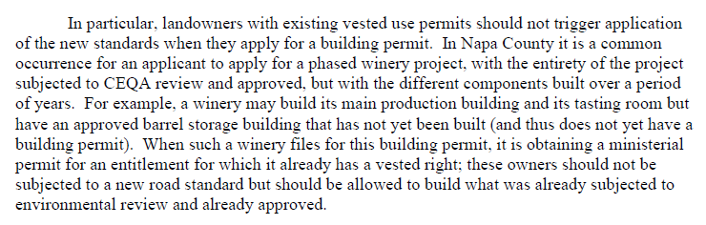
Board response: PRC 4290 applies these regulations to the VHFHSZ as of July 1, 2021. The Board does not have the authority to apply a different effective date. The regulations have been in place since 1991; on July 1, 2021, the existing regulations were applicable to the VHFHSZ.

Rule text edit: No

Comment W245-5: Farella Braun and Martel LLP
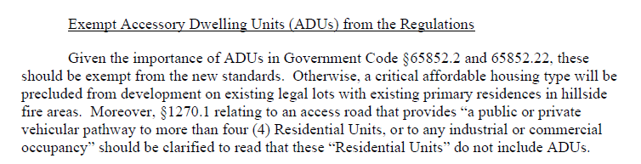
Board response: The regulatory exemption for ADUs was a previous emergency regulatory action and is outside the scope of the proposed action. Please see General Response to Exceptions and Exemptions Comments.

Rule text edit: No

Comment W245-6: Farella Braun and Martel LLP
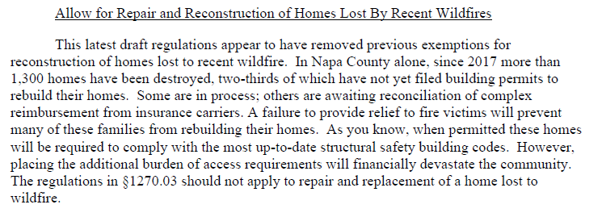
Board response: The regulatory exemption for wildfire rebuilds was a previous emergency regulatory action and is outside the scope of the proposed action. Please see General Response to Exceptions and Exemptions Comments.

Rule text edit: No

Comment W245-7: Farella Braun and Martel LLP
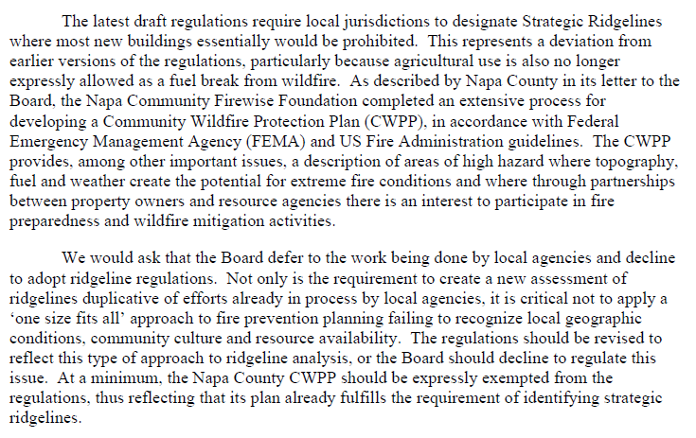
Board response: Please see response to W215

Rule text edit: No

Comment W245-8: Farella Braun and Martel LLP
Paragraph 20 of this letter is limited in scope to Articles 2-4 of the regulations. The Board is no longer proposing to revise Articles 2-4.

Comment W246-1: Omari Bouknight
The first four paragraphs and last paragraph of this letter are introductory/conclusive in nature; the comments are not specifically directed at the Board’s proposed action or to the procedures followed by the Board in proposing the action.

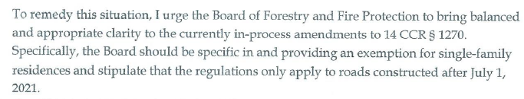

Board response: The Board is not proposing changes to the application of these regulations, consistent with the narrowed scope of the proposed action as identified within the Supplemental Statement of Reasons published with the “Second 15-Day Notice of Addition of Documents and Information to Rulemaking File and Modified Text” on May 10, 2022. The comments are not specifically directed at the Board’s proposed action or to the procedures followed by the Board in proposing the action.

Rule text edit: No

Comment W247-1: Monterey County Department of Housing and Community Development
The first, second, fifth, sixth, and last paragraph of this letter is introductory/conclusive in nature; the comments are not specifically directed at the Board’s proposed action or to the procedures followed by the Board in proposing the action.

In past letters, we have offered our staff to participate in a working group to achieve a safer set of regulations that are clear, consider local housing needs, and are truly implementable at the local level. However, our offer has gone unanswered. While the currently proposed revisions to the regulations have much improved language in some areas, many topics critical to our local communities, including exceptions for accessory dwelling units, clarity on the ability to rebuild after a disaster, no provisions for alternative designs for existing roads, and the ability to rely on agricultural roads for minor discretionary development, have been deleted from the draft amended Regulations. This is unfortunate; with our collaboration, Monterey County believes that we could have honed earlier language to better serve both local jurisdictions and the public.

Board response: Please see response to W180

Rule text edit: No

Comment W247-2: Monterey County Department of Housing and Community Development
We believe that any revisions to the Fire Safe Regulations should be undergirded by two important principles: 1) clarity, both for consistency and to avoid possible conflict with each fire chief; and 2) limiting small- scale development to on-site access requirements, leaving off-site access requirements to larger-scale development. The latter would likely reduce exception requests significantly, as the bulk would stem only from large-scale projects.

Board response: The proposed action achieves clarity and consistency as described and defined by the APA. The purpose of the proposed action is not to avoid conflict with individual fire chiefs, nor does the purpose include the limitation of development in any capacity. The comments are outside the scope of the proposed action.

Rule text edit: No

Comment W247-3: Monterey County Department of Housing and Community Development
Section 1270.03(a)(3)-we pointed out in earlier letters that many subdivisions had access included in the design, and not through conditions of approval. In that case, they would not qualify for this text and would be subject to the regulations. Same comment for subsection b immediately following, which provides an exception for subdivisions with conditions, but that exception is not provided if the design included perimeter and access considerations. We suggest that the language be modified to include “…to the extent that the design or conditions…” Alternatively, pre-1991 subdivisions could be handled through the regulations rather than being singled out in these sections.

Board response: The Board is not proposing changes 1270.03, consistent with the narrowed scope of the proposed action as identified within the Supplemental Statement of Reasons published with the “Second 15-Day Notice of Addition of Documents and Information to Rulemaking File and Modified Text” on May 10, 2022. The comments are not specifically directed at the Board’s proposed action or to the procedures followed by the Board in proposing the action.

Rule text edit: No

Comment W247-4: Monterey County Department of Housing and Community Development
Section 1270.03(c)(2) would mean that any vacant lot would be subject to all the regulations. This would include property where a home has been destroyed by disaster, including wildfires. If that is not the intent, this needs to be clarified.

Board response: The Board is not proposing changes to 1270.03(c)(2), consistent with the narrowed scope of the proposed action as identified within the Supplemental Statement of Reasons published with the “Second 15-Day Notice of Addition of Documents and Information to Rulemaking File and Modified Text” on May 10, 2022. The comments are not specifically directed at the Board’s proposed action or to the procedures followed by the Board in proposing the action.

Rule text edit: No

Comment W247-5: Monterey County Department of Housing and Community Development
Section 1270.04(a) requires that the local jurisdiction provide notice of all applications for building permits in the SRA. Neither of our staffs have the resources to handle that kind of workload. All applications go through our local jurisdiction fire district representative, or CALFIRE if the property is not within a district.

Board response: The requirement that local jurisdiction provide CAL FIRE with notices of application is an existing requirement in the regulations. The Board is not proposing any changes to this section except to capitalize defined terms.

Rule text edit: No

Comment W247-6: Monterey County Department of Housing and Community Development
Section 1270.04(c)-this requires that code requirements be put on permits as conditions of approval. This is unnecessary and puts an additional burden on staff.
Board response: This requirement is an existing requirement in the regulations. The Board is not proposing any changes to this section except to capitalize defined terms.

Rule text edit: No

Comment W247-7: Monterey County Department of Housing and Community Development
Section 1270.05(c)—The first sentence is ambiguous; we are unclear what you are trying to achieve. The reason someone requests an exemption is that they cannot meet the regulations.

Board response: Exemptions and exceptions are distinct within the regulations. The regulations provide a process for exceptions within 1270.05.

Rule text edit: No

Comment W247-8: Monterey County Department of Housing and Community Development
Section 1270.06—thank you for more clearly identifying the responsible agency in this section.
Board response: The Board appreciates the letter writer’s comment.

Rule text edit: No

Comment W247-9: Monterey County Department of Housing and Community Development
Section 1270.06(f)—requiring an inspection prior to issuing a use permit or recording a map may be of little value, as it would often result in looking at raw land. We are not sure that is what is intended; we suggest that the requirement apply only prior to a final inspection. Also, the term “notice of completion” is ambiguous; if you keep it, please clarify to what specific notice you refer.
Board response: § 1270.06(f) is existing language from § 1270.05(e). The Board is not proposing any changes to this section, except to renumber it.

Rule text edit: No

Comment W247-10: Monterey County Department of Housing and Community Development
Section 1270.07--while 1270.06 is renumbered, 1270.07 "Distance Measurements" is not - making for two 1270.07s
Board response: Thank you for bringing this to the Board’s attention. This will be corrected in the final rule text.

Rule text edit: Yes

Comment W247-11: Monterey County Department of Housing and Community Development
Section 1273.01 and 02—needs to be clear that these apply to new roads or certain other triggers that could be enumerated in these regulations.
Section 1273.03(a) and (b) should be combined so they are read together. That may reduce confusion as to which one takes precedence.
Section 1274.02(c)(ii)—should the word “more” be “less?” No more than 100 feet means it can be placed one foot away.
Section 1274.04—a few edits are needed in this section. Add “additional” before unobstructed to (b). You may want to add “if feasible” to (d). We are not sure that (e) is clear as to the location of the address sign.
Board response: The Board is no longer proposing changes to Articles 2, 3, or 4, consistent with the narrowed scope of the proposed action as identified within the Supplemental Statement of Reasons published with the “Second 15-Day Notice of Addition of Documents and Information to Rulemaking File and Modified Text” on May 10, 2022.

Rule text edit: No

Comment W247-12: Monterey County Department of Housing and Community Development
Section 1276.01(b)(3)—we are not sure what “a reduction of exposed windows” means – how would this reduction occur (shades? permanent removal?) and how much of a reduction would be required? Also, that should be separated from the first part of subsection (3) and be labeled as subsection (4).

Board response: A reduction of exposed windows means designing the structure such that there are fewer exposed windows on the side of the structure where a 30 foot setback can’t be achieved. Instead of 5 windows, 3 might be appropriate, for example. The typographical error will be fixed in the final rule text.

Rule text edit: No

Comment W247-13: Monterey County Department of Housing and Community Development
Section 1276.02—we still object to the Strategic Ridgeline requirements as we explained in earlier letters.

Board response: The Board did not receive any additional letters from the Monterey County Department of Housing and Community Development. The comments are not specifically directed at the Board’s proposed action or to the procedures followed by the Board in proposing the action.

Rule text edit: No

Comment W247-14: Monterey County Department of Housing and Community Development
Section 1276.03(g) and (h) should be combined, as (h) explains the maintenance mechanisms found in (g) and should therefore be within the same subsection.

Board response: This change is stylistic in nature and does not add any additional clarity.

Rule text edit: No

Comment W248-1: Denis Zaff, Sunnyvale, CA
The first four paragraphs of this letter are introductory/conclusive in nature; the comments are not specifically directed at the Board’s proposed action or to the procedures followed by the Board in proposing the action.

As reform is needed, at the very minimum, the law should provide clarity in two
areas:

a) Clarification of terms
One area that needs clarifying is the term “Conditions relating to the Perimeters and Access to the Buildings”. It is a key parameter in defining eligibility for grandfathering under proposed clause §1270.03 (3) (b).
This term was included in the law after the publication of the Opinion of the Attorney General No. 92-807 on March 17, 1993. In that Opinion, the Attorney General states:
“The Subdivision Map Act (Gov. Code, §§ 66410-66499.37; "Act") establishes general criteria for land development planning in the creation of subdivisions throughout the state. […]The Act sets forth procedures by which cities and counties may impose a variety of specific conditions when approving the subdivision maps. Such conditions typically cover streets, public access rights, drainage, public utility easements, and parks, among other improvements. (§§66475-66489; see Associated Home Builders etc., Inc. v. City of Walnut Creek (1971) 4 Cal.3d 633, 639-647; Ayers v. City Council of Los Angeles (1949) 34 Cal.2d 31, 37-43.)”

During the recent relevant public appeal hearings in Santa Clara County, it has become apparent to the public that there is much confusion as to what exactly constitutes “Conditions relating to the Perimeters and Access to the Buildings”. It is also unclear where and how these conditions are defined and recorded in every particular case.
In addition, the exact definition or mechanism of this imposition of Conditions by a map also remains fuzzy. Should the map already depict, say, all utility easements and public parks, or should the map only provide a hint on whether such easements or parks or drainage installations are possible?
It is also unclear whether all or a part of such conditions need to be established by the subdivision map that forms a particular parcel. Further, it is unclear what should be done in cases where such conditions have been established by the maps, but then changed due to either public or private legally permitted development activities.
Perhaps a good illustration of this confusion is the situation with public enquiries for clarification to the Chief Fire Marshalls in Santa Clara County. These professionals lack guidance, technical expertise and the legal knowledge to consult the public on these questions, so they simply ignore the public and do not respond to such queries at all or they readdress the issue to the County’s Planning officials, who also do not give a definitive answer. Perhaps a good illustration of this confusion is the situation with public enquiries for clarification to the Chief Fire Marshalls in Santa Clara County. These professionals lack guidance, technical expertise and the legal knowledge to consult the public on these questions, so they simply ignore the public and do not respond to such queries at all or they readdress the issue to the County’s Planning officials, who also do not give a definitive answer.
It is therefore desirable to amend the draft as follows It is therefore desirable to amend the draft as follows:
a) Amend § 1270.01. “Definitions” with a dedicated entry for “Conditions relating the Perimeters and Access to the Buildings”. This definition ideally should set a clear list of conditions to be used for the purposes of defining eligibility for grandfathering.
b) Further clarifying §1270.03 as to which of such conditions are absolutely necessary, and which should be disregarded for purposes of defining eligibility for grandfathering.

Board response: The Board is not proposing any revisions to the existing regulations described by the comment. The comment is outside the scope of the proposed rulemaking.

Rule text edit: No

Comment W248-2: Denis Zaff, Sunnyvale, CA
b) Make it mandatory for Inspection Authorities/Fire officials to provide a
path to compliance via alternative means

Members of the public who communicate with fire officials are simply ignored when they ask questions about measures that provide “Same Practical Effect”. Local fire officials seem to have absolutely no clue what Same Practical Effect means.

Every time they deny an application for an exception they just write that the proposed measures do not provide for Same Practical Effect. When asked what set of measures will provide for Same Practical Effect, there is no answer – local fire officials either do not know or do not want to bother setting a safety standard locally when no such safety standard exists on State level.

As a result, decisions are made in a way that is lacking transparency, which is often perceived as arbitrary and capricious. This does not in any way instill trust in public institutions, but instead seeds widespread resentment and distrust towards fire protection agencies.

The law will not be complete without a clear set of alternative compliance standards and approaches. These standards have to be set based on the wealth of data that is currently available.

Fire officials must be legally obliged to provide a path to compliance via alternative measures in every case at the request of the applicant. The current practice of avoiding public queries on this question is the least productive way of dealing with the issue at hand.

Board response: The Board does not propose any changes to the exception process within 1270.05 or the term “same practical effect” as described by the comment. The comment is outside the scope of the proposed action.

Rule text edit: No

Comment W249-1: Lee Ann & Eric Wade, Los Gatos, CA
The first and last paragraphs of this comment are introductory/conclusive in nature; the comments are not specifically directed at the Board’s proposed action or to the procedures followed by the Board in proposing the action.

While it does seem clear when reading the proposed regulations that they are intended for new developments on new roads, this NEEDS TO BE CLEARLY STATED THAT THEY APPLY TO NEW ROADS ONLY. Previous versions of the draft included this language about “new” roads but it was removed for some strange reason.

There should be a categorical exemption for roads constructed prior to 1991. Regulations in areas outside the SRA should only be applied to NEW roads constructed after July 1, 2021. Update all exemptions for pre-1991 parcels to mean any parcel approved from a pre-1991 parcel or tentative map and strike language referencing to conditions to Perimeters and Access to the Buildings. The exclusion of single-family homes should be made explicit.
This vague terminology has had the practical effect of stopping the development of projects on existing legal lots. Without the permission to build a new fire safe home, the Board of Forestry is for all practical effects creating a situation with older more fire prone homes that have none of the practical and useful A-1 fire safety measures. Surely this is not the effect that the Board wishes to achieve with their Fire Safe regulations. We do not believe that the Legislature or the Board intended to prohibit small-scale, residential development on existing legal lots along existing roads. This is consistent with the Board’s decision to categorically exempt Accessory Dwelling Units (ADUs) from the Fire Safe regulations as these projects add to California’s housing supply. The Regulations must be amended to clearly state that new homes may be built on existing legal lots in existing neighbors. There is no fire safety to be gained from preventing new homes from being built which are subject to A-1 fire standards. It’s in fact, creating a more dangerous situation.

The proposed terminology remains uninterpretable by Cal Fire Chiefs and by city and county planning departments statewide. In order for these regulations to be practically and fairly implemented, language should be clear and unambiguous. Furthermore, it’s our understanding that there is much variation about how these regulations are being enforced in the different Cal Fire offices statewide. There is no clear understanding about the language in the regulations applying to roads constructed prior to 1991. Define “...to the extent that conditions relating to the perimeters and access to the buildings were imposed by the parcel map or final tentative map approved prior to January 1, 1991” Define “same practical effect”. This is highly subjective. These laws were in effect in the SRA since 1991, however, it was only recently that Cal Fire began interpreting and applying them differently (more strictly) than before.

Board response: Please see General Response to Comments Regarding Existing Roads:.

The Board is not proposing changes to the application of these standards, consistent with the narrowed scope of the proposed action as identified within the Supplemental Statement of Reasons published with the “Second 15-Day Notice of Addition of Documents and Information to Rulemaking File and Modified Text” on May 10, 2022. The comments are not specifically directed at the Board’s proposed action or to the procedures followed by the Board in proposing the action.

The regulatory exemption for wildfire rebuilds was a previous emergency regulatory action and is outside the scope of the proposed action. Please see General Response to Exceptions and Exemptions Comments. The comment is not specifically directed at the Board’s proposed action or to the procedures followed by the Board in proposing the action.

Rule text edit: No

Comment W250-1: Masrani Family & David Hutchison
(Duplicate letter sent by two separate commenters.)
The first and last paragraph of this letter is introductory/conclusive in nature; the comments are not specifically directed at the Board’s proposed action or to the procedures followed by the Board in proposing the action.

It seems clear when reading the new regulations that they are intended for new developments on new roads, however in Santa Clara County ALL projects on existing dead-end roads are being blocked. Please clarify very clearly in the new regulations that it applies to newly created roads.

It’s my understanding the current draft would excuse from adherence to these regulations any lot created prior to 1991. (And as a new draft will come into effect at some future point, it would make sense to extend that to 2022 or whenever the draft becomes law.) However that is not the way it is being interpreted in Santa Clara County. Case in point: in an email from my Planning Department today: "From everything staff has heard with PRC 4290, any new development is subject to the regulations, regardless of creation date of the lot." This is frankly illegal, since 4290 provides legal protection and exclusion for lots created pre- 1991, however the problem is due to grey area in the wording. Elimination of the grey area would mean defining unambiguously what “conditions relating to access and perimeter” means, and strengthening the message that this is for new lots on new roads; that lots created before 1991 (or 2022) are exempt.

Right now in Santa Clara County, projects are being denied without the applicant being given a clear set of alternative measures that would provide “same practical effect”. It would alleviate some problems if the Fire officials were mandated to provide applicants with a timely, clear, and reasonable list of exactly what measures would be acceptable for a particular project in non-standard cases.

The current regulations apply with equal force to large developers creating many new lots and paving new roads, and to the final landowner on a very old road where all the other lots are already built. I’m in the latter category and asking me to buy easements from all my neighbors all the way along the road and then to pay to widen it a few feet is not as reasonable as requiring new developers to create new roads already wide enough. Some sense of scale is missing from the regulation draft – it should be written in a manner that does not block small-scale, single-site residential development on existing legal lots.

Board response: Please see General Response to Comments Regarding Existing Roads.

The Board is not proposing changes to the application of these standards, consistent with the narrowed scope of the proposed action as identified within the Supplemental Statement of Reasons published with the “Second 15-Day Notice of Addition of Documents and Information to Rulemaking File and Modified Text” on May 10, 2022. The comments are not specifically directed at the Board’s proposed action or to the procedures followed by the Board in proposing the action.

Rule text edit: No

Comment W251-1: Multiple Writers
Sent by: David and Kim Simon, Stephen Henkenmeier, Chris Wallace, Dave Bell, Steve Bobzin, Neal Roseblum, James Young, Paul Hanson, Chip Sutherland, David Staats, Holli & Jens Roever, Benjamin Adams, Jeff Williams, Bill & Jennifer Appleton, John & Jennifer Halsey, Matthew Swenson, Eric Piziali, Julie & Gary Riele, Laura & William Giles, Carolyn Harnish, Pamela Wilde, Karen Giordano, Jamie Bell, Shannon & Christopher Newton, Leighanne Neville, Leah Williams, Dave & Kim Simon, Amanda Jacobs, Margo McNeill & David Moore, Melanie & Eric Piziali, Gretchen Mair, Suzanne Nestor, Ron Biagini, Jim Gannon & Sara Zehnder-Wallace
The first and last paragraph of this letter is introductory/conclusive in nature; the comments are not specifically directed at the Board’s proposed action or to the procedures followed by the Board in proposing the action.

The vague, and often confusing, terminology has had the practical effect of stopping the development of projects on existing legal lots. Without the permission to build a new fire safe home, the Board of Forestry is for all practical effects creating a situation with older more fire prone homes that have none of the practical and useful A1-rated building materials and other modern safety measures. Surely this is not the effect that the Board wishes to achieve with their Fire Safe regulations. We do not believe that the Legislature or the Board intended to prohibit small-scale, residential development on existing legal lots along existing roads. This is consistent with the Board’s decision to categorically exempt Accessory Dwelling Units(ADUs) from the Fire Safe regulations as these projects add to California’s housing supply. The Regulations must be amended to clearly state that new homes may be built on existing legal lots in existing neighbors.

There should be a categorical exemption for new building permits on dead-end roads constructed prior to 1991. Regulations in areas outside the SRA should only be applied to NEW roads constructed after July 1, 2021. Update all exemptions for pre-1991 parcels to mean any parcel approved from a pre-1991 parcel or tentative map and strike language referencing to conditions to Perimeters and Access to the Buildings. The exclusion of single-family homes should be made explicit.

Board response: Please see response to W249.

Rule text edit: No

See, e.g., Mann et al, “Incorporating Anthropogenic Influences into Fire Probability Models: Effects of Human Activity and Climate Change on Fire Activity in California.” PLOS ONE, 2016.
See, e.g., Alexandre et al, “The relative impacts of vegetation, topography, and spatial arrangement on building loss to wildfires in case studies of California and Colorado.” Landscape Ecology, 2016.
https://www.dictionary.com/browse/ridgeline

