City of Beverly Hills - Climate Vulnerability Assessment
Climate change is a global phenomenon that may affect each community differently. In recognition of this, Senate Bill 379, Land Use: General Plan: Safety Element (Jackson, 2015) requires “a city or county to adopt a comprehensive, long-term general plan that includes various elements, including, among others, a safety element for the protection of the community from unreasonable risks associated with the effects of various geologic hazards, flooding, and wildland and urban fires.” Thus, a city or county’s safety element is to be reviewed and updated as necessary to address applicable climate adaptation and resiliency strategies, including a set of goals, policies, and objectives based on a vulnerability assessment. A Climate Vulnerability Assessment (CVA) serves as the foundation for the Safety Element’s Update and Climate Change section, as described in the State’s General Plan Guidelines (2017). This CVA is also designed to meet the requirements set forth in the Board of Forestry and Fire Protection’s June 2020 General Plan Safety Element Assessment.
Based on guidance from the California Governor’s Office of Emergency Services (Cal OES) California Adaptation Planning Guide (APG) and the Southern California Climate Adaptation Planning Guide the following five steps must be completed to assess the vulnerability of the City of Beverly Hills (City) to the effects of climate change:
- Exposure – Identify the climate change effects a community will experience.
- Sensitivity – Identify the key community structures, functions, and populations that are potentially susceptible to each climate change exposure.
- Potential Impacts – Analyze how climate change exposure will affect the community structures, functions, and populations (impacts). Adjust the impact assessment to account for uncertainty, timing, and adaptive capacity.
- Adaptive Capacity – Evaluate the community’s current ability to address the projected impacts.
- Vulnerability Scoring – Determine and rank potential impacts and adaptive capacity.
Each of these steps is described in detail below. Data for this CVA was collected from sources including the following:
- Cal-Adapt
- California’s Fourth Climate Change Assessment, 2018
- Southern California Association of Governments (SCAG) Southern California Climate Adaptation Planning Guide, 2020
- City of Beverly Hills Local Hazard Mitigation Action Plan 2017-2022
- A Wildfire Assessment Report for Beverly Hills, July 27, 2021, and
- City of Beverly Hills Integrated Water Resources Master Plan, November 2020.

Executive Summary
Based on guidance from the State’s Office of Planning and Research’s California Adaptation Planning Guide, the City identified ten climate-related effects and hazards applicable to the City of Beverly Hills: air quality, precipitation changes, flooding, severe rainstorms, extreme weather, Santa Ana winds, landslides, extreme heat days, cooling degree days and wildfire. In alignment with the California Adaptation Planning Guide, the City identified the risk that certain structures (e.g., residential, government, institutional), functions (e.g., government continuity, public safety, food security), and populations (e.g., seniors, individuals with disabilities, low-income) (collectively, the assets) may face from climate change impacts. Following SCAG’s suggested approach, impact scores were assigned to each asset for each stressor. Lower impact scores indicate the asset will incur limited damage or operational interruptions due to the climate change effects. Based on the City’s adopted policies, programs, and ordinances, adaptive capacity scores were assigned to each asset. A higher adaptive capacity score is assigned to those assets and populations that can adapt with little or no effort, while a lower adaptive capacity score is assigned to solutions that are expensive, technologically difficult, politically unpopular, or require widespread lifestyle changes.
Each impact score and adaptive capacity score are combined, resulting in a vulnerability score ranging from V0 (low) to V5 (high). For the ten climate change effects studied, vulnerability scores ranged from V0 to V3. For example, extreme weather garnered a V0 due to the high adaptive capacity and the slow rate at which extreme weather will occur. Adapting to a change in the average local rainfall, the risk of flooding, and the risk to infrastructure from severe storms each garnered a vulnerability score of V1, implying that the current policies, plans, and ordinances are adequate to address these risks. Risks from degrading air quality, the increase in drought and resultant threat to water supply, the risk to sensitive populations from severe storms, the increased potential of landslides, and impacts from increasing temperature changes earned a vulnerability score of V2, implying that the current plans, policies, and ordinances exist as solutions but may still threaten sensitive populations and assets.
The risk of wildfires earned a vulnerability score of V3, in agreement with the City’s wildfire assessment report which states “wildfires remain one of the most complex of all natural disasters.” While the City has performed comprehensive reviews and assessments of fire risks, and implemented numerous plans, policies, and ordinances to address these risks, the City’s vulnerability to wildfire impacts remains relatively high, requiring additional prioritization of City efforts.

EXPOSURE – What climate change effects will the community experience?
Climate change affects communities all around the world regardless of their contribution to this phenomenon. Jurisdictions across California are expected to experience different climate change effects to varying degrees based on geography, density of urban development, and environmental factors. Table 1: Climate-Related Effects and Hazards Potentially Applicable to Beverly Hills below, based on guidance from the California Adaptation Planning Guide, identifies the direct effects of climate change and the associated secondary effects potentially applicable to Beverly Hills. Each of the six is discussed in detail below.
Table 1: Climate-Related Effects and Hazards Potentially Applicable to Beverly Hills
Primary Hazard | Secondary Hazard
Air quality | Public health effects
Precipitation changes | Snowpack loss, drought, subsidence
Flooding (riverine) | Flooding, erosion, mud- or land- slides
Severe storms and extreme weather | Intense rainstorms, severe wind, flood, lightning, hail
Temperature changes - warming | Extreme heat/heat waves
Wildfire | Erosion, landslide
Source: Adapted from OPR’s California Adaptation Planning Guide, June 2020
Note: Due to the City’s inland location, potential hazards such as sea level rise, storm surge, hurricane, ocean acidification, and hypoxia are not listed as potentially applicable climate-related effects and hazards. Due to the City’s urbanized nature, agricultural distress, pests, and disease are not listed as potential hazards. Due to the relatively low topography of the City, avalanche is also not considered a potential hazard.
The projection of the likelihood, timing, and severity of these primary and secondary hazards to impact the City is based on the trajectory of greenhouse gas (GHG) concentrations in the Earth’s atmosphere, commonly referred to as Representative Concentration Pathways (RCPs). RCPs represent a combination of the historical data and estimates of concentrations through 2100, based on a set of formulated human behaviors. The pathways describe different climate futures, all of which are considered possible depending on the volume of GHGs emitted in the years to come. The Intergovernmental Panel on Climate Change (IPCC) adopted a number of RCPs in its latest assessment, and SCAG, in its recent guidance, chose to focus on three RCPs representing a reasonable range of outcomes, as follows:
- A low emissions scenario (RCP2.6) – this represents an aggressive emissions reduction scenario that assumes global greenhouse gas emissions will be significantly curtailed. RCP 2.6 most closely corresponds to the aspirational goals of the United Nations Framework Convention on Climate Change 2015 Paris Agreement.
- A medium emissions scenario (RCP4.5) – this represents a mitigation scenario where global greenhouse gas emissions peak by 2040 and then decrease for the rest of the century.
- A high emissions scenario (RCP8.5) – this represents a “business-as-usual” scenario where global greenhouse gas emissions continue to rise throughout the 21st century.
Because the RCP2.6 scenario depends on substantive changes in the current set of world-wide policies, regulations, and behaviors, it is considered unlikely, and therefore not especially helpful in a climate vulnerability assessment. This CVA will rely primarily on RCP8.5, the high emissions scenario, in alignment with OPR’s recommendation that agencies use RCP8.5 when considering impacts through 2050 because there are minimal differences between the low and high emissions scenarios through the first half of the century. When available and illustrative, the RCP4.5 scenario may be shown for additional context.

1.1 Air Quality
The City is located in Los Angeles County, which lies in the western portion of the South Coast Air Basin (Basin). As such, the air quality of the region is under the jurisdiction of the South Coast Air Quality Management District (SCAQMD), tasked with setting regulations to ensure that the Basin obtain and maintain the National Ambient Air Quality Standards (NAAQS) and continue progress towards meeting the more stringent California Ambient Air Quality Standards (CAAQS).
Despite considerable progress in reducing ground level concentrations in the Basin, Los Angeles County continues to experience high levels of ozone (O₃) and particulate matter (PM), which according to the California Air Resources Board (CARB), can result in the following health impacts:,
Ozone can damage the tissues of the respiratory tract, causing inflammation and irritation, and result in symptoms such as coughing, chest tightness and worsening of asthma symptoms. Specifically, inhalation of ozone causes inflammation and irritation of the tissues lining human airways, causing and worsening a variety of symptoms. Exposure to ozone can reduce the volume of air that the lungs breathe in and cause shortness of breath. Ozone in sufficient doses increases the permeability of lung cells, rendering them more susceptible to toxins and microorganisms. The occurrence and severity of health effects from ozone exposure vary widely among individuals, even when the dose and the duration of exposure are the same.
Ozone exposure reduces the overall productivity of plants, damaging cells and causing destruction of leaf tissue. As a result, ozone exposure reduces the plants’ ability to photosynthesize and produce their own food. Plants respond by growing more leaves thereby reducing the amounts of stored carbohydrates in roots and stems. This weakens plants, making them susceptible to disease, pests, cold and drought. Ozone also reduces crop and timber yields, resulting in millions of dollars in economic losses. Additionally, ozone disturbs the stability of ecosystems, leading to sensitive species dying out. Furthermore, ozone exposure reduces the production of roots, seeds, fruit and other plant constituents, reducing the amount of food available for wildlife.
A number of adverse health impacts have been associated with exposure to both PM2.5 and PM10. For PM2.5, short-term exposures (up to 24-hours duration), have been associated with premature mortality, increased hospital admissions for heart or lung causes, acute and chronic bronchitis, asthma attacks, emergency room visits, respiratory symptoms, and restricted activity days. These adverse health effects have been reported primarily in infants, children, and older adults with preexisting heart or lung diseases. In addition, of all of the common air pollutants, PM2.5 is associated with the greatest proportion of adverse health effects related to air pollution, both in the United States and world-wide based on the World Health Organization’s Global Burden of Disease Project.
Short-term exposures to PM10 have been associated primarily with worsening of respiratory diseases, including asthma and chronic obstructive pulmonary disease (COPD), leading to hospitalization and emergency department visits. Long-term (months to years) exposure to PM2.5 has been linked to premature death, particularly in people who have chronic heart or lung diseases, and reduced lung function growth in children. The effects of long-term exposure to PM10 are less clear, although several studies suggest a link between long-term PM10 exposure and respiratory mortality. The International Agency for Research on Cancer (IARC) published a review in 2015 that concluded that particulate matter in outdoor air pollution causes lung cancer.
PM can adversely affect ecosystems, including plants, soil and water through deposition of PM and its subsequent uptake by plants or its deposition into water where it can affect water quality and clarity. The metal and organic compounds in PM have the greatest potential to alter plant growth and yield. PM deposition on surfaces leads to soiling of materials. Particulate matter has been shown in many scientific studies to reduce visibility, and also to adversely affect climate, ecosystems and materials. PM, primarily PM2.5, affects visibility by altering the way light is absorbed and scattered in the atmosphere. With reference to climate change, some constituents of the ambient PM mixture promote climate warming (e.g., black carbon), while others have a cooling influence (e.g., nitrate and sulfate), and so ambient PM has both climate warming and cooling properties.
Changes in climate can result in impacts to local air quality. Ozone is not emitted directly, rather it is formed when emissions of oxides of nitrogen (primarily from the combustion of fossil fuels) and reactive organic gases (from evaporative sources such as gasoline, solvents, paints, and other consumer and industrial products and processes) react in the presence of sunlight. Thus, it is widely recognized that atmospheric warming associated with climate change has the potential to increase ground-level ozone formation. Locally, this threatens the ability of the Basin to obtain the applicable ozone NAAQS and CAAQS under the business-as-usual (BAU) (RCP8.5) scenario.
PM is caused both by natural and anthropomorphic activities; it is emitted directly from sources (such as earth moving, smokestacks, and fires) and also forms secondarily in the atmosphere when gases and aerosols combine (from sources such as power plants, industries and automobiles). According to the United States Environmental Protection Agency (USEPA), the impact of climate change on PM is less certain, but research is underway to address these uncertainties. Climate change, such as decreasing precipitation and increasing wildfires, can result in higher emission of PM into the atmosphere.
The SCAQMD maintains a network of 39 air pollutant monitoring stations throughout the Basin, 17 of which are In Los Angeles County. PM is monitored at only four stations in the County year-round (and thus used for regulatory purposes); these locations were purposefully selected because these are areas with higher levels of sources and activities that emit PM, such as central Los Angeles, south central Los Angeles, the port communities, and west San Fernando Valley. None of the monitors are located near Beverly Hills.

1.2 Precipitation Changes
Beverly Hills, like most of the Los Angeles subregion, is a combination of Mediterranean and semi-arid climates, characterized by mild-to-hot, dry summers and mild-to-warm, wet winters. The average precipitation observed in Beverly Hills between 1950 and 2005 was 19.2 inches with a high of 44.1 inches and a low of 5.4 inches.
As presented in Figure 1, local annual levels of precipitation are not anticipated to change drastically for the City. It is projected that the average precipitation in Beverly Hills from 2022 to 2050 will increase slightly to 20.6 inches, but would increase slightly to 21.4 inches in the 2051 to 2099 time frame under the RCP8.5 scenario. Changes in annual precipitation of these minimal ranges alone are not expected to pose much risk to the built or human environment. The role of changing precipitation amounts and patterns in expanding the extent or geographic distribution of vector-born disease is not clearly understood at this time.
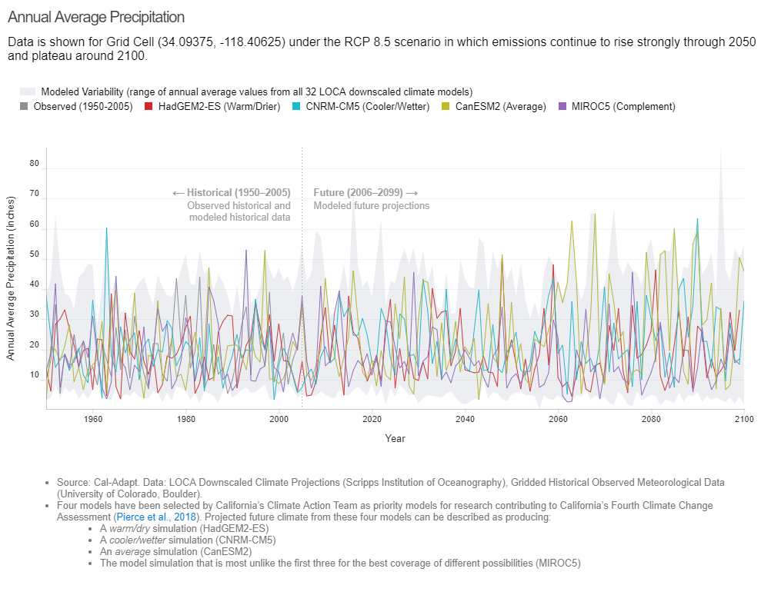
Figure 1: Annual Average Precipitation
However, much of the subregion’s potable water supply is provided by importing water originating from the Colorado River or the State Water Project (San-Joaquin River Delta). The Metropolitan Water District (MWD) has declared a water alert due to 0 percent allocation from the State Water Project in 2021, combined with the Colorado River’s dwindling reservoirs and the State’s drought. However, MWD has sufficient storage capacity and was not anticipated to affect Beverly Hills in 2021. In addition, Beverly Hills will begin producing local groundwater in 2022 to reduce dependence on MWD in the near- and long-term. In addition, the City’s water conservation program will continue to reduce water inefficiencies and reduce the City’s overall demand. According to Cal-Adapt, a climate change induced decline in the northern Sierra Nevada of 32 percent in snow water equivalence by 2050 and 77 percent by 2099 is anticipated, and declines in the southern Sierra Nevada of up to 10 percent and up to 40 percent by 2050 and 2099, respectively. Precipitation levels are not expected to change significantly for the Colorado River Basin. However, as temperatures rise and precipitation levels decrease on a larger geographic scale, the snowpack volume is expected to drop, potentially resulting in a 9 percent decline in the total flow of the Colorado River.
Droughts are common in California, and it is widely recognized that dry conditions may be experienced more regularly in the future given the impact of climate change on California’s snowpack. Currently the Los Angeles region is classified within the -2 to -5 range of the Palmer Drought Severity Index (PDSI), where a value of -4 and beyond represents “extreme drought.” Drought can lead to reductions in the quality and quantity of water, degradation of air quality, increase in agricultural vectors and disease, and decreases in crop yield. According to the California Department of Public Health, health consequences of drought may impact the following vulnerable/sensitive populations most: “the elderly, children, individuals of low socioeconomic status, rural communities, populations living in nursing homes, hospitalized patients, those who rely on electrical equipment to survive, farmers, and agricultural workers.”

1.3 Flooding
The accumulation of excess water due to increased precipitation or natural water flows has the potential to result in the flooding of nearby floodplains or low-lying valleys. Floodplains, or areas adjacent to water bodies, are especially susceptible to flooding hazards. The severity of flooding within a floodplain is directly related to the capacity and volume of the neighboring body of water or waterway. Flooding within larger, flatter floodplains occurs more predictably for longer durations.
Although Cal Adapt does not provide emissions-based flooding projections, the City has produced a Local Hazard Mitigation Action Plan (LHMAP) which outlines the existing flooding risks present in the City. According to the City’s LHMAP, historically, the southeast section of the City was vulnerable to flooding due to its lower elevation and outdated storm drain system. With completion of the Los Angeles County Flood Control District’s Holly Hill Storm Drain upgrade project, the risk was downgraded to minimal. It was therefore determined that the City would no longer be susceptible to flooding conditions and flood-related damages. Since precipitation is expected to remain fairly consistent, increased flood hazards due to annual average precipitation is unlikely. While the City’s storm drain system has sufficient capacity to withstand storm events, the increase in the frequency and intensity of severe rainstorms in the future (see Section 1.4.1 below), may result in increased risk of localized flooding events.

1.4 Severe Storms and Extreme Weather
California’s Fourth Climate Change Assessment explains that, despite model predictions of only small changes in average precipitation in the Los Angeles region (of which the City is included), overall, extreme dry and wet patterns are both expected to increase in the future. Please refer to the discussion of precipitation changes and droughts in Section 1.2 above. This section also addresses land and mudslides that may result from severe rain events.

1.4.1 Severe Rainstorms
In southern California, extreme precipitation often arrives via so called “atmospheric rivers,” which the National Oceanic and Atmospheric Administration (NOAA) defines as “a flowing column of condensed water vapor in the atmosphere responsible for producing significant levels of rain and snow, especially in the Western United States.” Further, the NOAA recognizes that atmospheric rivers “that contain the largest amounts of water vapor and the strongest winds can create extreme rainfall and floods.” Data presented in California’s Fourth Climate Change Assessment suggests “the frequency of atmospheric river events may increase in the future, and that the storms themselves will be associated with higher water vapor transport rates compared to historical conditions.” Please refer to Section 1.3 for discussion of the change in potential flooding impacts that could affect the City.

1.4.2 Extreme Weather
In addition to extreme rain events, other severe weather phenomena including strong winds (see additional discussion under Section 1.4.3), hail, and lightning, may occur with increased frequency. Severe weather can pose direct hazards resulting in injury or death, damage to buildings, structures, infrastructure, and trees, fires, and diminished or blocked transportation access. Hail and lightning events are considered rare in the sub-region and therefore are not discussed further. Extreme weather can lead to secondary effects, such as wildfires, and can lead to increased fire spread and intensity. According to the City’s wildfire assessment, “weather has the most significant influence on the local vegetation to determine its ignition and burning potential…with winds being the single most important weather factor contributing to fire spread and intensity.”

1.4.3 Santa Ana Winds
Between October and April, southern California is susceptible to the unique phenomenon of so called “Santa Ana Winds.” These dry, hot, offshore winds originate when high pressure sets up over the Great Basin, combined with low pressure off the southern California coast. Santa Ana winds frequently exceed 40 miles per hour. Theories hypothesize that “warming of interior land masses may weaken the ocean-to-desert temperature gradient that partly drives Santa Ana winds.” The Fourth Climate Change Assessment recognizes the uncertainty in predicted changes to the patterns of Santa Ana winds due to global climate change, with some models predicting increases and others decreases in the number of annual events.

1.4.4 Landslides
Weather induced landslides occur when a hillside becomes unstable, caused by severe or persistent rain events, causing soil and rocks to slide downslope. In some cases, the hillsides can become so saturated that slope failures result in a mudslide, a mixture of soil and water moving downslope. Unstable hillsides, such as those denuded of vegetation by wildfires or drought, are at greater risk of land- and mudslides. The climate change induced increase in rainfall, especially severe rain events, may result in an increase in landslides and mudslides.
As discussed in the LHMAP, “Due to Beverly Hill’s [sic] steep terrain and geological makeup, the conditions are right for a landslide. However, historical occurrences have only had a minimal impact on the City. Therefore, the City is at a medium risk for landslides.” Slope failures were reported in the northern hillside areas of the City due to heavy rainfalls and soil erosion. The hillside residential development has also placed additional loads on the subsurface bedrock, which further contributed to the slope failure. As stated in the LHMAP, no significant or major debris flow resulting from landslides in the northern hillside area has been recorded in the City, and small debris flows in the past were localized and were cleaned up by the City’s Public Works crew. While a major landslide in the hillside area would destroy roadway pavement and limit access to residents in the northern hillside areas, the City is at a minimal risk for landslides.
The LHMAP provides a map of areas within the City with hillside areas north of Sunset Boulevard that have potentially unstable hillside slopes, see Figure 2. However, this map does not take into account or predict future risks of landslides accounting for the effects of climate change.
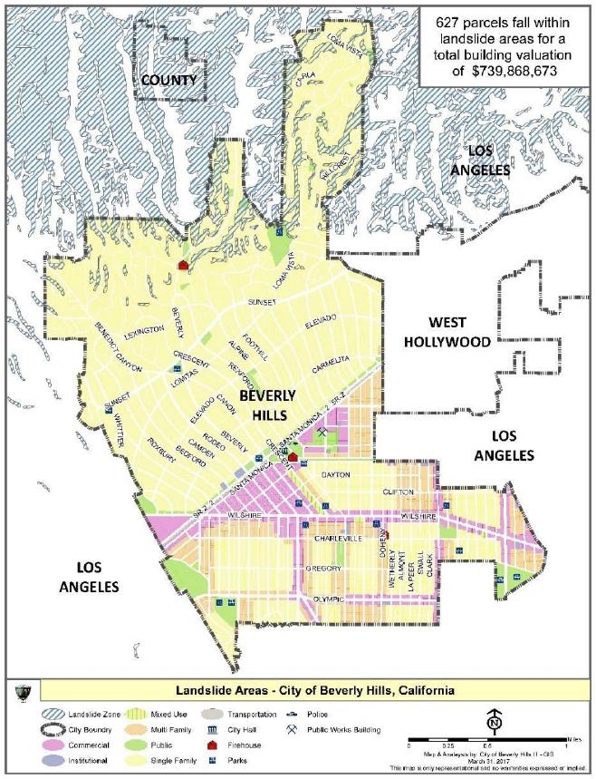
Figure 2: Landslide Susceptibility

1.5 Temperature Changes
A rise in temperature has been observed in many Southern California communities including those in Los Angeles County. According to long-term data (the approximately 12 decades from 1896 to 2015) presented in California’s Fourth Climate Change Assessment, trends in annual average, maximum, and minimum temperatures show an increase of 0.16 degree Celsius (equal to 0.29 °F) per decade. Warming is expected to increase across the region in the coming decades, with interior regions “expected to experience the highest amounts of warming, up to 10°F in the late-21st century under RCP8.5.” According to Cal-Adapt, the average maximum temperature observed for the City in the years 1950 through 2005 was 70.7 degrees Fahrenheit (°F).
In the projections based on the RCP8.5 scenario, Beverly Hills could experience an average maximum temperature of 73.6°F during the years 2022-2050. through 2099, the projections for Beverly Hills include an average maximum temperature of 77.3°F. Figure 3 provides the estimated annual average maximum temperatures for Beverly Hills in an RCP8.5 scenario. According to the California Office of Environmental Health Hazard Assessment (OEHHA) and California Department of Public Health (CDPH), disruptions in weather patterns due to global climate change, such as warmer spring temperatures and overall increases in temperatures will “likely alter the distribution and occurrence of West Nile virus, Lyme disease, hantavirus, and other insect or animal transmitted diseases in California.”
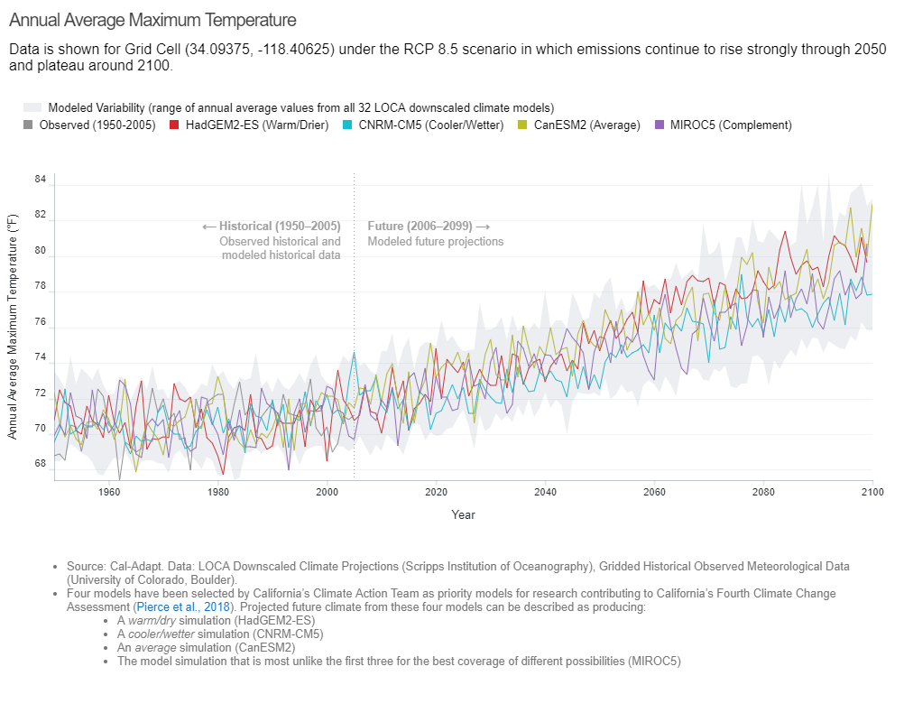
Figure 3: Annual Average Maximum Temperature

1.5.1 Extreme Heat Days
According to California’s Fourth Climate Change Assessment, “[t]he intensity and frequency of extreme heat are also projected to increase over the LA region.” Extreme heat days are defined as a day in a year when the daily maximum temperature on any day in April through October exceeds the 98th historical percentile of maximum temperatures between 1961 and 1990. According to Cal-Adapt, for Beverly Hills, the extreme heat temperature threshold is 90.9 °F. The average number of extreme heat days observed for the City in the years 1950 through 2005 was 4 days per year. In the RCP8.5 high emissions scenario, Beverly Hills is projected to experience 7 extreme heat days per year between the years 2022 and 2050. Figure 4 provides the estimated number of extreme heat days for the City in an RCP8.5 scenario. This is a 3-day increase from the annual extreme heat days observed during the years 1950 to 2005. Models predict the number of extreme heat days in Beverly Hills may rise to 19 per year in the 2051 – 2099 timeframe.
An increase in extreme heat days can correlate with an overall increase in temperature. Further, the heightened frequency of extreme heat days can pose a risk to sensitive communities such as homeless residents, senior citizens, and people with disabilities. This would create a greater reliance on high energy demand electrical equipment such air conditioning. The increased use of these would impact the demands in the state’s power grid and could increase the risk of blackout events.
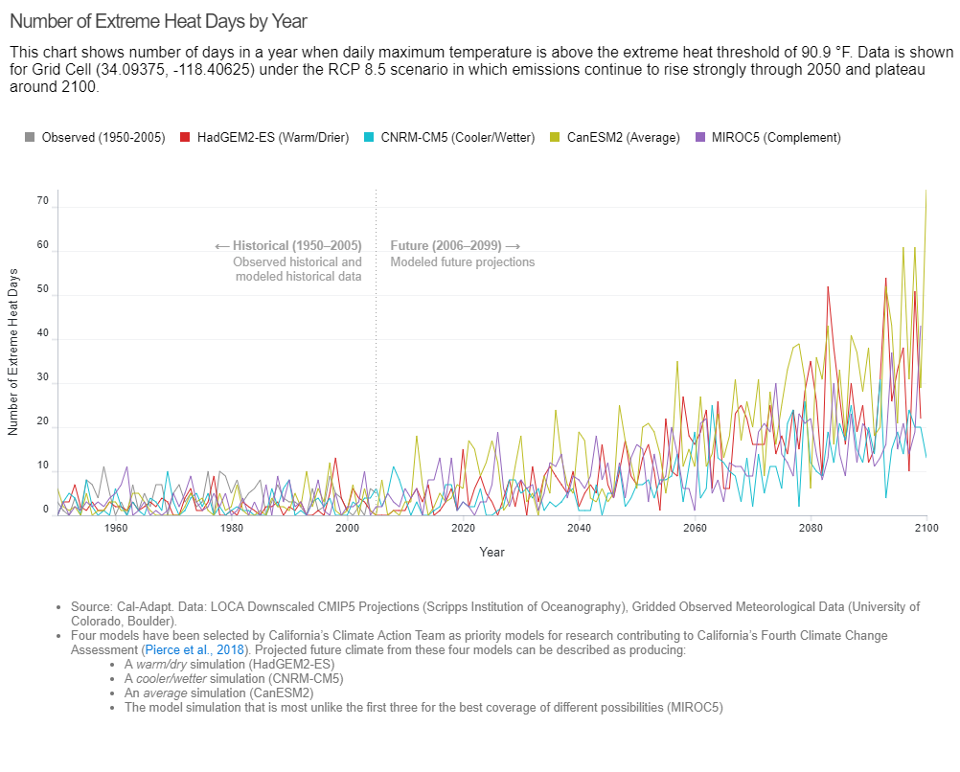
Figure 4: Number of Extreme Heat Days by Year

1.5.2 Cooling Degree Days
A goal of the Southern California Climate Adaptation Planning Guide is to ensure that infrastructure and built systems can withstand changing conditions and shocks, including changes in climate, while continuing to provide essential services. The City recognizes that most of the built environment within the City is capable of withstanding many natural hazards due to the added safety resulting from advances in building design and construction. Nonetheless, even small increases in average temperatures and in the number of extreme heat days can lead to sharp increases in utility demand to cool buildings. A helpful measure of this demand is the Cooling Degree Day (CDD), which, according to Cal-Adapt, is defined as the number of degrees by which a daily average temperature exceeds a reference temperature (typically 65 °F). Figure 5 presents the CDD for Beverly Hills, showing an increase from 582 CDDs from 1950 – 2005, to 1,024 CDDs projected for 2021 to 2050, and up to 1,927 CDDS in the 2051 to 2099 period under the RCP8.5 scenario. For additional context, under the RCP4.5 scenario, these would range from 928 (for the years 2021 to 2050) to 1,318 (for 2051 to 2099).
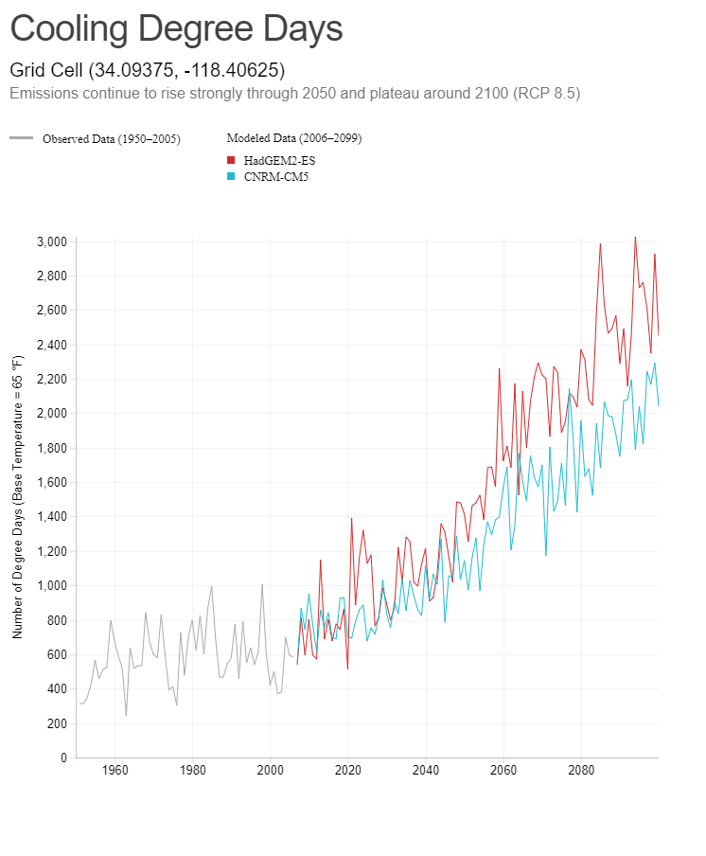
Figure 5: Cooling Degree Days

1.6 Wildfire
Across California, wildfire season typically runs between late summer to early spring, but the California Department of Forestry and Fire Protection (CalFire) reports that fires are starting earlier and ending later with each passing year. Intense dry seasons, warmer spring and summer temperatures, reduced snowpack, and earlier snowmelt make forests and vegetation more susceptible to wildfires. CalFire estimates the length of fire season had increased by 75 days in 2020. Natural events such as warm and dry Santa Ana winds, which typically occur in early fall, further increase the growth of fires and threat to the urban areas of Southern California. Locally, during Santa Ana winds, the steep slopes and deep canyons located north of Sunset Boulevard “can funnel the wind in a more forceful manner, adding to a fire’s speed and intensity”.
According to the National Fire Protection Association (NFPA), during 2011-2015, fire departments throughout the United States responded to an estimated average of 306,000 brush, grass, and forest fires per year. According to the Global Institute of Sustainable Forestry at Yale University, taxpayers spent more than $1.6 billion to combat more than 88,400 fires nationwide. Many of these fires burned in wildland urban interface (WUI) areas and exceeded the fire suppression capabilities of those areas. According to the LHMAP, approximately 1,620 parcels with an estimated valuation of at least $2.1 billion are located in a VHFHSZ. Wildfires present a substantial hazard to life and property in communities built within or adjacent to hillside and mountainous areas. Those areas most susceptible to a large and destructive wildland/urban interface fire include the areas north of Sunset Boulevard, extending north to the City limits.
Figure 6 shows that the northern portion of the City (north of Sunset Boulevard) falls within the Very High Fire Hazard Severity Zone (VHFHSZ) for a Local Responsibility Area (LRA), but not within a State Responsibility Area (SRA). As structures are built within the VHFHSZs adjacent to the WUI areas, which is the transition area between unoccupied land and human development, fires will become an increasing problem for fire departments, per the U.S. Fire Administration. Additionally, according to CalFire, Wildland Urban Interface is a condition when structures abut wildland areas and therefore have a greater potential for house-to-house ignition. Land located within the VHFHSZ consists of areas north of Sunset Boulevard and includes areas with Single-Family Residential Low Density zoning designations. Given these concerns, the City has historically taken proactive measures to reduce the risk of wildfires, including the thinning and maintenance of street trees, educating the public and residents on methods to reduce wildfire risk to their homes, and has received recognition from the Firewise USA program in 2005. The City has also completed Phase 1 of the Urban Forest Management Plan (UFMP), which inventories the age and fire hazard of some trees and offers recommendations for maintenance and long-term replacement for such trees. The City has prepared a Wildfire Assessment, which assesses the specific wildfire risks for the City, and provides additional recommendations to reduce risks in the VHFHSZ. These methods include the use of ember-resistant materials, since embers are the primary cause of structure ignitions.
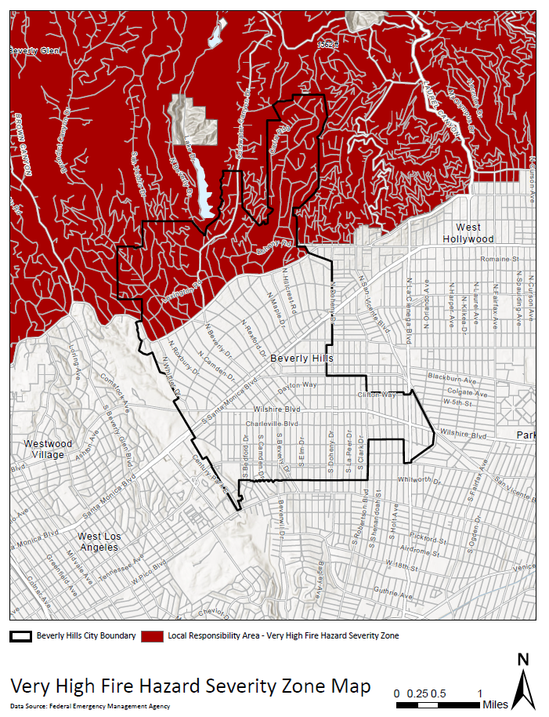
Figure 6: Very High Fire Hazard Severity Zones

SENSITIVITY – What aspects of the community will be affected?
Sensitivity refers to the risk that certain structures, functions, and populations may face from climate change-impacts. In alignment with the California Adaptation Planning Guide, this step identifies the levels to which a species, natural system, or community, government, etc., would be affected by climate changes. The next step in the process evaluates how the impacts may occur and how severe they may be.

2.1 Structures
Climate change-related impacts may affect the integrity of structures or buildings depending on, but not limited to the age, location, and materials used in the resource. The structures at risk include those which may pose a direct threat to the community, as well as those which may threaten the environment, economy, and current livelihood of the City. The California Adaptation Planning Guide recommends evaluating the potential risk to non-traditional “structures” such as parks and open spaces, and historic, cultural, and natural resource areas as part of this category.
Residential | Parks and Open Space | Dikes and Levees
Commercial | Recreational Facilities | Water Treatment Plan and Delivery Infrastructure
Industrial | Transportation Facilities and Infrastructure | Wastewater Collection Infrastructure
Government | Marine Facilities
Institutional (schools, churches, hospitals, prisons, etc.) | Communication Infrastructure

There are no marine facilities, dikes, or levees within the City. Therefore, these structures are not addressed as part of this assessment.
The following is an example of the type of structures that are considered sensitive to climate change:
- Residential neighborhoods and communities, especially those in the hillside areas north of Sunset Boulevard.
- City of Beverly Hills City Hall, Fire Stations, Police Department, Emergency & Disaster Offices, and other municipal structures.
- Hospitals and other medical care facilities.
- Roxbury Park, La Cienega Park, and other recreational facilities.
- The City’s main access roads and arterial roadways (Sunset, Wilshire, Santa Monica, and Olympic Boulevards).
- The City’s water distribution and wastewater conveyance systems.

Transportation Systems
Transportation systems serve to move residents and visitors through the City as efficiently as possible and are critical in the event of a climate emergency for evacuation purposes. Roads, highways, railways, public transportation, and overpasses may be affected by climate change. There are no highways or overpasses in the City. There are several major arterials, all of which serve as major corridors for the City to other areas in the region: Sunset Boulevard, Wilshire Boulevard, North and South Santa Monica Boulevard, La Cienega Boulevard, Burton Way, and Olympic Boulevards. Vehicular impacts may inhibit residents and visitors from accessing safety and resources. Transportation infrastructure in the subregion is vulnerable to extreme heat, flooding, and wildfire. The City’s General Plan Circulation Element, in Appendix A: Bicycle Master Plan, identifies a 22-mile bikeway system proposed to connect schools, parks, and other public or semi-public facilities with residential neighborhoods. The proposed bikeway system would also connect into systems proposed by the adjoining jurisdictions and Los Angeles County. Bikeways provide local opportunities for cyclists and regional connections which may be affected by climate change such as, but not limited to: precipitation, extreme heat days, and/or wildfires.

Utility Systems
The City owns, operates, and maintains the water system within the City’s service area. The water system includes storage reservoirs, pump stations, groundwater wells, pipelines, and the Foothill Water Treatment Plant (WTP). The City owns, operates, and maintains the sewer system, but discharges all wastewater to the City of Los Angeles’s system which is conveyed to the Hyperion Water Reclamation Plant near the Los Angeles International (LAX) Airport. The City’s system conveys sewer flow generated outside the City boundary, primarily flows from the City of Los Angeles and the City of West Hollywood. The City of Beverly Hills is also served by water, wastewater, energy, and communication services which may be overwhelmed or damaged during a climate change event. The City’s Conservation Element of the General Plan identifies energy resources available to the City, which include natural gas supplied by Southern California Gas Company and electricity supplied by Southern California Edison (SCE). Extreme heat days or wildfire risks may result in temporary energy blackouts which may prevent the community from accessing air conditioning and cooling services.

2.2 Functions
The climate change effects expected to impact the City have the potential to affect the function types indicated below. Critical emergency response functions, which may include, but are not limited to: emergency services, medical care, firefighting, property protection, public safety, and government functions, must be able to operate quickly and effectively in the event of a climate-related hazard or disaster. As with sensitive structures, impacts of varying severity on certain functions may cause damage to the economy, the environment, and public safety.

Government Continuity | Business Continuity | Social Services
Water/Sewer/Solid Waste | Housing Access | Ecological Function
Energy Delivery | Employment and Job Access | Tourism
Emergency Services | Food Security | Recreation
Public Safety | Mobility/Transportation/Access | Urban Forest
Public Health | Quality of Life | Industrial Operations
Emotional and Mental Health
The City does not include natural resource areas that provide ecological functions that would be impacted by climate change. Furthermore, there are no agriculture, forest, and fishery production areas and no parcels zoned for industrial uses in the City. Therefore, these functions are not addressed as part of this assessment.

2.3 Populations
The population of the City may be affected differently by climate hazards depending on income, age, employment, housing type and location, health and disabilities, gender, language, race/ethnicity, and access (to medical services, technology, transportation, etc.). Populations within the City that may be additionally affected by climate hazards include the following:
Seniors | Individuals without access lifelines (e.g. car or transit, telephones) | Renters
Children | Non-White communities | Students
Individuals with disabilities | Low-Income, unemployed, or underemployed communities | Seasonal residents
Individuals with compromised immune systems | Individuals with limited English skills | Individuals uncertain about available resources because of citizenship status
Individuals who are chronically ill

A person may experience greater threats to their livelihood from climate change depending on, but not limited to: their income, access to transportation, language, physical ability, and/or age. For example, seniors may be at higher risks of injury or heat-related sickness during extreme heat events. During wildfire season, certain populations, including seniors, children, and those with chronic respiratory illnesses may be more sensitive to the effects of poor air quality.
As stated in the Housing Element, the City of Beverly Hills was estimated to have a population of 33,775 persons in the year 2020. From 2016 to 2045, population growth of 3.2 percent is forecasted for the City, which is less than the Los Angeles County’s forecasted growth of 15.5 percent. Beverly Hills’ population is comprised mostly of individuals between 18 and 65 years of age. This age group includes approximately 58.9 percent of Beverly Hills residents, which is lower than the regional makeup of 63.6 percent. The population above the age of 65 years makes up 21.6 percent of the population, which is higher than the regional share of 13 percent. In 2018, the median age of the City’s population was 43.4 years. The City population is approximately 78.8 percent White, 9.8 percent Asian, 5.8 percent Hispanic, 1.3 percent Black, 0.1 percent American Indian or Alaska Native, and 4.2 percent other.
Employment characteristics may point toward a population’s ability to recover from a climate change event. Persons with lower incomes may be disproportionately affected by climate change events and may therefore benefit more substantially from community services. Approximately 56 percent of the City’s households are renters, and approximately 28 percent of households are considered low income, with 11 percent earning extremely low incomes. 70 percent of extremely low income households are renters. These populations would more likely require City services in a climate change event. Those who are unemployed, for example, may not have the means to prepare emergency resources or alternative temporary shelter. According to the State of California Employment Development Department, as of October 2021, the City has an unemployment rate of 6.3 percent, compared to the entire County (7.8 percent). The City also has a higher (57.2 percent higher) median income than Los Angeles County.

POTENTIAL IMPACTS AND RISK – How will climate change affect the points of sensitivity? How likely are the impacts and how quickly will they occur?
In this step, we address how climate change exposure may affect the community structures, functions, and populations. For infrastructure components or functions/services, this evaluation may include consideration of the following:
- Asset value and intangible importance
- Location of asset (current or future hazard zone)
- Extent of community reliance
- Potential for partial or total loss of service
- Consequence of loss or interruption
- Ease of restoration of service
For populations, this evaluation may include answering the following:
- What sort of hardships would be felt by the population as a result of exposure to the hazard? Would it result in a decrease in quality of life or threaten to damage and/or destroy property?
- Is there a risk of mortality or morbidity to the population as a result of the hazard?
- How many people are affected by the hazard? Is it a relatively small group within the community, or is it most or all of the residents?
- In the event that hardships occur, how long would the population be affected? Would hardships diminish in severity over time or remain at the same level of severity during the course of the impact?
As part of climate adaptation planning, the City would establish a scoring rubric to score vulnerability to help clarify which climate change impacts pose the greatest threats and should be prioritized in adaptation planning. The California Adaptation Planning Guide recommends using values and assigning potential impact ratings to characterize the degree of impact that would result from a given amount of exposure and the asset’s sensitivity. Higher sensitivity indicates that the asset will have higher vulnerability for a given amount of exposure, whereas a lower sensitivity indicates that the asset will incur limited damage or operational interruptions. The City will utilize impact scores suggested by SCAG, replicated below as Table 2: Impact Scores, to determine impact scores and adaptive capacity scores (see Section 4, below).
Table 2: Impact Scores
Impact Score | Summary (Buildings and Infrastructure, Economic Assets, Community Services) | Summary (Populations and Biological Resources)
IM0 | Impacts are minimal. There are no service disruptions that community members are aware of. | All impacts are minimal. Community members may not notice effects.
IM1 | Performance or services may be somewhat degraded on occasion. | Community members notice minor impacts. There may be mild disruptions to some behaviors or actions.
IM2 | The asset is likely to experience chronic stress, limiting the ability to reliably function. Effectiveness may be entirely disrupted on occasion. | There is a marked decline in overall quality of life. Reductions to health, public safety, and/or community viability are likely.
IM3 | The asset may only function in a limited way. It may frequently or always be unable to meet community needs. | There is a substantial drop in the well-being of the affected communities. Current lifestyles/habitat may no longer be viable.
IM4 | The ability of the asset to provide beneficial service is destroyed. | There is a severe risk of injury or death in human populations and of major habitat shifts or degradation for biological communities.
Source: SCAG, Southern California Climate Adaptation Planning Guide, page 99.
As shown in Table 2 above, each potential point of sensitivity identified above is given an impact score from IM0 (minimal impact) to IM4 (severe impact) for each hazard.

3.1 Air Quality
As discussed above, the City is predicted to experience slowly increasing temperatures and slightly decreasing rates of precipitation by the end of the century, both of which could pose a threat to the ability of the region to meet and maintain the NAAQSs for ozone and PM. Air pollution is considered a risk factor for serious and sometimes fatal public health outcomes, such as heart attacks, asthma, and cardiovascular and lung disease. In addition to public health, other functions such as quality of life may be directly impacted while recreation and tourism may be indirectly impacted. Elevated ground level pollutant levels pose no threat to structures.
The elderly, children, and the chronically ill are most at risk, and the NAAQS are designed to be health protective of these sensitive populations. The SCAQMD issues periodic Air Quality Advisories (for specific events such as fires, windblown dust, and ash) and produces next-day air quality forecasts that residents, public administrators, employers, and workers can consult regarding decisions to minimize exposure or curtail activities for sensitive populations, or in extreme cases, all populations. SCAQMD offers predictions of both the pollutant concentrations and the Air Quality Index (AQI) score for 38 distinct areas, including the Westwood station near Beverly Hills. The AQI rating system, where a pollutant-specific score of 100 equates to meeting the applicable NAAQS, is the USEPA’s index for reporting air quality. The SCAQMD offers a mobile app in English and Spanish. The greatest limitation may be accessibility to the internet for people of low economic means. Those engaged in physical labor outdoors are also at elevated risk.
Tourism and recreation functions in Beverly Hills may be indirectly impacted by increasing pollutant levels if the AQI were to become consistently elevated and results in a perceived decrease in the value of the recreational or tourism activity. This outcome is considered minimal and not likely to occur. Given the availability of data regarding daily predictions of potentially elevated pollutant levels, that the majority (approximately 58.9 percent) of the City’s residents are between ages 18 and 65, and Beverly Hills enjoys a higher-than-County-average income, the impact from air quality to most populations, and to public health and quality of life is considered low. In alignment with suggested summary language in Table 2, above, community members may notice minor impacts from air quality hazards, and there may be mild disruptions to some behaviors or actions, garnering an impact score of IM1.

3.2 Precipitation Changes
The IPCC reports the probability of precipitation changing is over 90 percent. As discussed in Section 1.2 above, changes in annual average precipitation for the City due to climate change are expected to be minimal, increasing 1.4 to 2.2 inches, a range of 7.3 to 11.5 percent. See discussion regarding the potential for secondary flooding impacts in Section 3.3 below. The potential impact to water supplies in Beverly Hills due to potential loss of snowpack in the Sierras or Colorado River Basin or prolonged and more extreme droughts regionally is generally a greater concern.
Most structures in Beverly Hills are predicted to withstand the minimal increase in annual precipitation, including the sewage and water supply systems. The routine functions of the City, including water and sewer service, are expected to remain unchallenged by the increases in annual rainfall; the groundwater supplies in the local Hollywood Basin will likely benefit from the increases. With no service disruptions expected related to the increase in annual average local rainfall amounts, the potential for impacts to structures and functions would garner a score of IM0.
Historically, the City obtains its water supply from two sources: imported surface water purchased from MWD and local groundwater extracted from the local Hollywood Basin. Threats to the quantity and quality of the water supply due to decreases in the snowpack that provide the majority of the City’s potable water, and local drought conditions could impact the City’s water supply infrastructure and functions, including water delivery and energy production (from hydroelectric plants). These impacts could in turn negatively impact food security (rising prices) and employment (loss of employment and job access), emotional and mental health, recreation, and overall quality of life. These burdens would be felt most by low-income communities, seasonal or unhoused individuals, and individuals uncertain about available resources because of citizenship status, who lack the resources to maintain a standard of living in the face of potential water rationing, rising food costs, and job loss. The City issues annual grant funds to various social service organizations and community programs as it relates to food security, including the Westside Food Bank which provides food for low-income or in-need residents, or for rental assistance for low-income households. While the City provides funding for these organizations and social services, chronic stress to these functions, structures, and places may still occasionally limit their reliability and effectiveness. Sensitive populations may experience a marked decline in overall quality of life. These would be considered an impact score of IM2.

3.3 Flooding
The City’s LHMAP acknowledges that historically, flood risks existed within the City. However, according to the LHMAP, the completion of the Los Angeles County Flood Control District’s Holly Hill Storm Drain upgrade project in 2005 (Unit 7 Drainage System) would protect the region from a 100-year flood; therefore, the risk of flooding was downgraded to “minimal”. However, the increase in frequency and intensity of severe rainstorms predicted to occur in the future may likely result in an increased potential for flooding, the risk to structures, transportation and mobility, energy delivery, public safety, and public health could also be expected to increase. The effects are not expected to impact sensitive receptors more than the general population. The performance of these assets and services may be somewhat degraded on occasion, resulting in an impact score of IM1.

3.4 Severe Storms and Extreme Weather
As discussed in Section 1.4 above, despite predictions of minimal changes in annual precipitation, the City is predicted to experience an increase in the frequency of and water vapor transport rates associated with severe rainstorms, or so called “atmospheric rivers.” The ability of structures, functions, and sensitive populations to withstand extreme events may be different than impacts discussed for precipitation changes in Section 3.2 above.
The capacity of structures such as the storm sewer, sewage treatment system, and water supply system, to withstand more intense single-event rainstorms, or more frequent large storms, should be further studied, but is generally thought to be at some risk of increased stress to reliability. Secondary impacts, such as falling trees resulting in disruption to energy delivery and mobility, combined with stressed emergency and social services, could occasionally degrade public safety functions noticeably. These impacts would be experienced more by the elderly, individuals with disabilities, individuals without access lifelines, seasonal residents, low-income communities, renters (not responsible for maintenance or repair of housing, for example), and individuals with limited English skills, than the general population of Beverly Hills. This is primarily because temporarily moving out of storm-impacted housing to shelters is difficult to accomplish without access to reliable transportation, emergency communications in people’s primary language, paid time off, or trust in government assistance. These would be considered an impact score of IM1 (water infrastructure) to IM2 (functions and sensitive populations).
Extreme weather (e.g., hail, fog, lightning) is rare in Beverly Hills, and as such, impacts to structures, functions, and sensitive populations from extreme weather are minimal. Santa Ana winds, as described in Section 1.4.3 above, threaten to topple trees, interrupt energy delivery, and damage structures, creating temporary public safety and possible mobility/access issues. All populations share the potential to experience impacts from Santa Ana winds. Santa Ana windstorms may decrease as the effects of climate change increase through the end of the century, and the impact score would be IM1.
Land- or mud-slides could result in the loss of structures, communication infrastructure, energy delivery, or transportation infrastructure (i.e., roadways), on a temporary or more substantive basis. There could be injuries and/or deaths, and damage to structures and personal property from landslides due to debris flow and/or flooding. While the City has had minimal impact due to historical occurrences of landslides, climate change would increase storm severity and increased wildfire activity which may lead to an increase in land- or mudslides. Due to the existing residential uses on the hillside areas that would be susceptible to land- or mudslides, the increase in land- or mudslides could create issues related to access, mobility, utility services, emergency services, and public safety. However, due in part to the medium probability rating and the inclusion of mitigation activities and regulations for hillside development (as discussed in the LHMAP), these would be considered an impact score of IM1.

3.5 Temperature Changes
As discussed in Section 1.5, the average maximum daytime temperature in Beverly Hills is expected to rise noticeably by 2.9 °F (from 70.7 °F to 73.6 °F), in the 2022 to 2050 time frame, as compared to historic averages, and another 3.7 °F (from 73.6 °F to 77.3 °F) in the latter half of this century from 2051 through 2099. Additionally, the number of extreme heat days per year (when maximum temperatures climb above 90.9 °F) in Beverly Hills is predicted to rise appreciably, as are the CDDs.
As the City is accustomed to generally hot, dry temperatures, the integrity of the built environment, including structures and roadways, is not expected to be compromised by these rising temperatures. However, parks and recreational amenities may be negatively impacted. Energy delivery is most threatened as the demand for power to cool buildings increases when people seek shelter indoors from the heat. Hot temperatures can threaten water supply also. Agricultural productivity, on a regional level, could decrease due to the decrease in water supply, thereby increasing food insecurity. Employment and job access can be impacted, especially for populations reliant upon mass transit due to the hardship of accessing public transportation (e.g., lack of adequate bus shelters, distance to nearest transit stop traversed by walking). Heat sensitivity (or heat intolerance) and heat stroke could increase, mosquito borne diseases would increase, air quality would degrade, and the desirability of recreating outdoors could decrease, threatening public health and quality of life. Seniors, children, individuals with disabilities, compromised immune systems, or chronic illnesses, individuals without access to lifelines, low-income communities, renters, and seasonal residents and the unhoused are most at risk from impacts due to rising temperatures. These impacts would be considered an IM2 for buildings, functions, and sensitive populations.

3.6 Wildfire
The State has seen increased wildfire activity and greater burn areas with each passing year and experts anticipate the trend to continue if climate change is not immediately addressed. CalFire shows that the northern portion of the City (north of Sunset Boulevard) falls within the VHFHSZ for an LRA. The VHFHSZ is at higher risk and greater danger of experiencing potentially devastating wildfires. Therefore, the City has adopted numerous policies and ordinances focused on reducing wildfire risk in the VHFHSZ. As demonstrated in the Safety Element, no essential public facilities, besides a local-serving fire station, are located within the VHFHSZ. However, “the City cannot ignore the additional far-reaching impacts that a wildfire would pose on the remainder of the City [non-VHFHSZ areas].”
In addition to posing direct risks to structures and populations, wildfires can also create additional indirect impacts to the health and safety of a community such as destruction of communication infrastructure, destruction or damage to recreational facilities, parks, and open spaces (such as environmental and ecological preserves), damage to power distribution infrastructure, and blocked evacuation routes, and stressed emergency services. Secondary impacts can include erosion, loss of vegetation leading to landslides, poor air quality, and public health issues. As noted in the City’s wildfire assessment, “not only will [smoke from a wildfire] pose a significant health risk, especially to those with compromised breathing capacities, but the smoke can also cause significant impacts to homes and businesses.”
Extreme heat can exacerbate wildfire risks. All populations can experience threats and effects of wildfires, but some are more pronounced in those with chronic illnesses and from lower economic means. The potential increase in wildfires could exacerbate conditions for those living and working in the VHFHSZs in the City, but taking into account the preventative measures taken by the City to reduce such risks, the impact score for wildfires would be IM2.

ADAPTIVE CAPACITY – What is or can be currently done to address the impacts?
Adaptive capacity is the ability of community and populations and assets to adjust to climate change stressors and cope with the consequences. Adaptive capacity can be provided through physical design or can take the form of policies, plans, programs, governance, or institutions. Although the process of evaluating the ability of a community, function, or asset to address the projected impacts relies on a combination of quantitative and qualitative data, an adaptive capacity assessment is primarily a qualitative effort.
For structures and functions, the following topics are considered:
- Extent of existing policies, plans, or programs in place or being considered to manage climate impacts;
- Availability and capacity of temporary alternatives while service is being restored;
- Fiscal impact and ability to respond or repair;
- Whether recovery would be voluntary or mandatory; and
- Significant or insurmountable barriers to a full or timely response (i.e., requiring solutions that are technologically and/or politically infeasible).
To evaluate the adaptive capacity of populations, consider:
- Whether existing or planned policies or programs exist to assist individuals with the response, and whether community members have easy (and equitable) access to such services;
- The ability of the different populations to respond to an impact, including overcoming barriers such as fiscal, language, immigration status, access to lifelines (transportation, internet, cell phone, etc.), physical limitations, etc.;
- Access to alternatives that may reduce or eliminate the hardships caused by the hazard; and
- Significant or insurmountable barriers to adaptation (i.e., requiring solutions that are expensive of technologically difficult, require widespread lifestyle changes, and/or politically unpopular).
Following the approach suggested by SCAG, scores ranging from AC0 (no feasible adaptation method available) to AC4 (adaptation easily implementable) will be assessed, based on the following definitions as shown in Table 3: Adaptive Capacity Scores:
Table 3: Adaptive Capacity Scores
Impact Score | Summary
AC4 | Assets and populations can adapt with little or no effort. Overall quality of life may improve as a result.
AC3 | Adaptive solutions are feasible for most or all sensitivities. Some sensitivities may face limited challenges.
AC2 | Threats can be reduced or mitigated, but solutions are only feasible for some assets. Many assets are likely to face substantive difficulties in adapting.
AC1 | Adaptive solutions are expensive and/or technologically difficult, but feasible. Approach may require politically unpopular actions or widespread lifestyle changes.
AC0 | No method of adapting is currently feasible, although solutions may be possible in the future.
Source: SCAG, Southern California Climate Adaptation Planning Guide, page 100, Table A-4.
The City and Los Angeles County both have a variety of plans adopted which each address various aspects of the potential threats outlined in this Climate Vulnerability Assessment. Both jurisdictions recognize the importance of public and private partnerships and planning for potential issues the community may face in the coming years. Table 4: Planning Documents identifies plans, programs, and reports that participate in ensuring the City’s preparedness during future potential climate change events.
Table 4: Planning Documents
Document | Adoption Date
City of Beverly Hills
General Plan | 2010
Urban Water Management Plan | 2021
Integrated Water Resources Master Plan | 2021
Local Hazard Mitigation Action Plan | 2019
Los Angeles County
Community Climate Action Plan | 2015
Los Angeles Countywide Sustainability Plan | 2019
SCAG Sustainable Communities Strategy | 2020
SCAG Southern California Climate Adaptation Planning Guide | 2020
The City is currently in the process of developing a Climate Action and Adaptation Plan (CAAP) in order to achieve the City’s long-standing goal of becoming carbon neutral by 2045 and provide measures to manage the effects of climate change. Thus far, the CAAP process has collected community asset information such as roadway networks, public transportation, utilities, parks and recreation facilities, schools, high occupancy structures and community and government buildings. In addition, asset managers were interviewed to place context on the data collected and link existing and future policies to the vulnerability assessment. It is anticipated that a draft CAAP will be released in 2022. The programs that will be included in the CAAP will focus on GHG reduction measures and resiliency measures from the LHMAP that focus on reinforcing the transportation and utility assets, and public facilities to withstand the effects of climate change and continue to provide service to the entire community.

4.1 Air Quality
Local ground level air pollutant levels are created by emissions generated within the City, in the surrounding vicinity and communities, and, for some pollutants, emissions released upwind “can travel great distances (i.e., hundreds of miles), affecting air quality and public health regionally.” The SCAQMD, CARB, and USEPA are regulatorily mandated to make progress towards meeting and maintaining the NAAQS, and substantial progress has been made within the Basin to reduce emissions. Feasible adaptive solutions, such as reducing reliance on fossil fuels in personal and commercial vehicles, and requiring enhanced filtration in residences, exist. However, the State has adopted several policies that are anticipated to improve air quality. These policies include greening building standards, lowering vehicle emission standards by expanding the availability of electric vehicles and charging stations and expanding renewable electricity. Currently, these are expensive and technology is continually evolving. The State and the Los Angeles region are anticipating to use the federal infrastructure fund to accelerate the greening of vehicles and utility infrastructure. Locally, the City has established a number of policies in the Open Space, Circulation, and Conservation Elements to the General Plan that would help to reduce GHG emissions, and provide the co-benefit of reducing emissions of harmful air pollutants, including:
Open Space Element
OS 2.5: Urban Heat Island Effects. Continue to promote appropriate species selection and tree placement that encourages adequate shading of rooftops, parking facilities, streets and other facilities to minimize heat island effects. Continue to phase street tree Master Plan projects to minimize tree canopy loss.
OS 7.1: Transit Ridership. Collaborate with local transit agencies to develop programs and educate employers about employee rideshare and transit, and promote mass transit ridership through careful planning of routes and by developing a local point of contact for potential ride-sharers.
OS 7.2: City Fleet Vehicles. Continue to purchase low-emission vehicles for the City’s fleet and use available clean fuel sources for trucks and heavy equipment. Update purchasing policies to consider purchase of lower emission vehicles in the future to the extent economically feasible.
OS 7.3: Transportation Systems Management and Trip Reduction. Encourage City employees to use means other than a single-occupant vehicle for their daily work commute.
OS 7.4: Incentives for Privately Owned Low-Emission Vehicles. Encourage the use of zero-emission and low emission vehicles, and provide incentives for privately-owned alternative fuel vehicles such as permit waivers, free or priority parking or other incentives for low emission vehicles on city streets and parking structures. Evaluate feasibility of installing alternative fuel recharging stations in municipal parking structures.
OS 7.5: Coordination with South Coast Air Quality Management District (SCAQMD). Coordinate with SCAQMD to ensure that projects incorporate feasible mitigation measures if those measures are not already provided for through project design,
OS 7.6: Employer Education Programs. Encourage employers to participate in South Coast Air Quality Management District (SCAQMD) public education programs.
OS 7.7: Maintain Standards. Work with the South Coast Air Quality Management Board to meet state and federal ambient air quality standards.
OS 7.8: Emissions Reduction. Require new development projects that exceed the South Coast Air Quality Management Board’s (SCAQMB) Reactive Organic Gases (ROG) and Nitrogen Oxides (NOX) operational thresholds to incorporate design or operational features that reduce emissions equal to 15-percent from the level that would be produced by an unmitigated project.
OS 7.9: Greenhouse Gas Reduction. Work with the California Air Resources Board (CARB) and the South Coast Air Quality Management District (SCAQMD) to comply with statewide greenhouse gas reduction goals as established in the “Global Warming Solutions Act of 2006 for 2020” (AB 32) and any other subsequent legislation.
OS 7.10: Citywide Greenhouse Gas Assessment. Comply with pertinent State regulations to assess citywide greenhouse gas emissions for existing land uses and the adopted general plan build-out.
OS 7.11: Air Quality Education. Educate the public about air quality standards, health effects, and efforts that residents can make to improve air quality and reduce greenhouse gas emissions in the Los Angeles Basin.
OS 7.12: New Development. Review proposed development projects to ensure projects incorporate feasible measures that reduce construction and operations emissions for Reactive Organic Gases (ROG), Nitrogen Oxides (NOX), and Particulate Matter (PM10 and PM2.5).
OS 7.13: Preference for Reduced Emission Equipment. Give preference to contractors using reduced-emission equipment for City and private construction projects as well as for City contracts for services (e.g., garbage collection).
OOS 12.5: Development of a Bikeway/Route System. As a relatively compact community with a broad range of community facilities and services in relatively close proximity to a large proportion of the residents, Beverly Hills offers a unique opportunity to develop a bikeway system which can serve both transportation and recreation needs.
In order to develop a system which is compatible with the heavy automobile use of major streets, a bikeway route system should be developed to encourage bicycling on less-travelled streets and thereby separate transportation modes and lower the probability of accidents. The bike lanes (exclusive routes) or bike routes (portion of street or sidewalk labeled for bicycle use) should connect facilities such as schools and parks – places between which children may want to ride bicycles. They should offer a safe pathway to and from the Business Triangle and other commercial or employment areas for adults. And they ought to connect into the systems proposed for the city and county of Los Angeles in order to allow Beverly Hills residents to ride safely into West Hollywood or Westwood, etc. Hence, the system would be capable of serving both recreation and transportation needs. Some intersections might have to be signed or signaled for increased safety.
Circulation Element
CIR 2.1: Metro Subway Extension. Support the extension of the Metro subway extension through the City along Wilshire Boulevard with stations at Beverly/Rodeo and La Cienega to enhance transit service and increase transit ridership within the City and the West LA region. Explore other stops as appropriate.
CIR 2.1a: Linking Transit and Development. Encourage appropriate development that may include parking for local transit riders, local-serving retail, high-end retail, restaurant and supporting uses in and around transit stops and stations.
CIR 2.2: Multi-modal Transit. Consider a variety of transit services including rail, light rail transit, bus rapid transit, trolleys (streetcars), enhanced buses, express buses, local buses, school buses, and neighborhood shuttles to meet the needs of residents, workers, and visitors.
CIR 2.5: Transit Frequency. Support increased frequency transit service and capital investments to serve high-density employment, commercial, residential, or mixed-use areas and activity centers.
CIR 2.6: Transit Priority Measures. Consider improvements in transit efficiency and travel times by implementing transit priority measures to help bypass congested areas. Such measures may include transit signal priority, queue bypass lanes, and exclusive transit lanes.
CIR 2.10: Interconnected Transit System. Create or collaborate on an interconnected transportation system that allows a shift in travel from private passenger vehicles to alternative modes, including public transit, ride sharing, car-sharing, bicycling, and walking. Before funding transportation improvements that increase vehicle miles traveled, consider alternatives such as increasing public transit or improving bicycle or pedestrian travel routes.
CIR 6.1: Transportation Demand Programs. Encourage existing major employers to develop and implement Transportation Demand Management (TDM) programs to reduce peak-period trip generation.
CIR 6.2: Transportation Demand Measures. Utilize Transportation Demand Management (TDM) measures to encourage and create incentives for the use of alternate travel modes.
CIR 6.3: Transportation Demand Strategies. Identify trip reduction credits and consider reduced transportation impact fees for demonstrated commitment to Transportation Demand Management (TDM) strategies.
CIR 6.4: Transportation Demand Amenities. Encourage employers to provide transit subsidies, bicycle facilities (including changing/shower facilities), alternative work schedules, ridesharing, telecommuting, work-at-home programs, employee education, and preferential parking for carpools/vanpools.
CIR 6.5: City Transportation Demand Management. Continue and expand a TDM program for City employees.
CIR 6.7: Multi-Modal Design. Require proposed development projects to implement site designs and on-site amenities that support alternative modes of transportation, and consider TDM programs with achievable trip reduction goals as partial mitigation for project traffic impacts.
CIR 7.3: Streetscape Enhancements. Update or prepare Design Guidelines that foster the enhancement of streets, sidewalks, and other public rights-of-way with amenities such as lighting, street trees, benches, plazas, public art, or other measures to encourage walking.
CIR 7.6: Pedestrian Network—Connections. Provide a continuous pedestrian network that connects buildings to each other, to the street, and to transit facilities.
CIR 7.7: Pedestrian Network—Private. Design access to new developments and buildings to encourage walking.
CIR 8.1: Bicycle Master Plan. Prepare a citywide bicycle master plan to determine desired improvements to the City’s bicycle network, including exploring opportunities where dedication may be required to connect regional pathways. Gather input from the community and provide bicycle education as part of the Bicycle Master Plan update.
CIR 8.5: Bikeway Amenities. Require that new development projects (e.g., employment centers, educational institutions, and commercial centers) provide bicycle racks, personal lockers, showers, and other bicycle-support facilities.
CIR 8.7: Mobility Plan. Prepare a citywide bicycle and mobility plan that will establish bicycling as an option for short trips and allow bicycles to connect to mass transit.
Conservation Element
CON 18.4: Energy Choice Aggregation. Continue to research and consider participating in programs like Community Choice Aggregation to increase the percentage of renewable energy over that available from Southern California Edison, including rate setting that would promote conservation.
CON 19.1: Energy Efficient Lighting. Install light emitting diodes (LED) for traffic, street, and other outdoor lighting.
CON 19.2: Energy Conservation Program. Prepare a comprehensive Energy Conservation Program that provides goals, benchmarks, strategies, and criteria to improve energy efficiency for existing and new public facilities and for private development and renovation projects. The program should provide incentives and disincentives to discourage practices such as night time building illumination and leaving doors open when air conditioning is on, to reduce energy use and minimize “night sky” effect.
CON 19.3: Reduced Energy Consumption for Public and Private Facilities. Install energy efficient appliances and alternative energy infrastructure such as solar energy panels (photovoltaic panels) on all City facilities. Encourage installation of solar energy panels on private development. Develop partnerships with residents to encourage use of solar energy panels and other solar energy technologies.
CON 19.4: Solar Power Stations and Use of Photo-Voltaic Systems. Consider satisfying some or all of the City’s electrical power needs through creation of solar power stations (photovoltaic stations) and require the use of these systems whenever possible in City facilities. These stations could be located on parking structures and roofs.
CON 19.6: Cooperative Venture with Other Jurisdictions. Study the feasibility of City partnerships with other agencies to purchase and supply power to residents. Partnering with other communities to purchase and supply power could increase the amount of renewable energy used over that which is available from Southern California Edison, and allow local rate setting that would promote conservation.
CON 19.7: Green Building Standards. Review and update the City’s Green Building standards to apply to all public and private facilities to ensure the design, construction and operation of buildings are utilizing the best and most up to date “green” practices.
The City has made progress in implementing the above policies by accomplishing the following:
- Electricity: The City joined the Westside Cities Energy Partnership Program that allows the cities to collaborate regionally to develop energy efficiency audits and programs that would reduce the City’s GHG emissions. Energy efficiency projects such as the LED Street Light Projects have stemmed from the partnership. The partnership has helped the City formulate a workplan on starting a CAAP, which is expected to be completed in 18 months starting January 2021.
- The City is a member of the Clean Power Alliance (CPA), a program that provides an opportunity to utilize renewable electricity City-wide. As a member, Beverly Hills inhabitants are able to use 36 percent, 50 percent, and 100 percent renewable electricity in their property. This will help to reduce carbon footprint and improve air quality Statewide. Residents and businesses began using 50 percent renewable electricity starting in January 2019.
- The City has converted 5,800 street lights to LEDs thus far. This will reduce consumption by approximately 79 percent and reduce GHG equivalent to 240 vehicles off the road annually. The City has a restaurant food waste program that helps reduce GHG production from landfills.
The City proposes the following additional policy to further reduce air quality impacts:
S 7.16 Prepare a Climate Action and Adaptation Plan. Create a climate action and adaptation plan that identifies strategies to reduce greenhouse gas emissions and to prepare and mitigate the impacts resulting from climate change.
Overall, the City has adopted numerous policies related to transportation and mobility, lower polluting vehicles, building energy efficiency, and green energy supplies which directly or indirectly reduce air quality impacts. Substantially reducing community reliance on single-occupancy vehicle, replaced by multi-modal transportation (e.g., public transit, bicycling) is feasible, but the actions may be unpopular and would require widespread lifestyle changes. Therefore, the adaptive capacity of the potentially impacted functions and sensitive populations would be rated as AC1, in accordance with Table 3, above.

4.2 Precipitation Changes
This section will focus on the functions, structures, and places, which were identified in Section 3.2 as susceptible to reliability and effectiveness issues arising from the chronic stress of decreased or threatened water supply, and sensitive populations negatively impacted by food insecurity, employment challenges, and declines in emotional and mental health, recreation, and overall quality of life. Drought conditions are becoming increasingly common in California and are best managed at the State level. Water supply in Beverly Hills is ultimately provided by MWD while the City is increasing its local water supply to lessen its dependence on imported water. Threats to water supply can be somewhat mitigated by reducing demand but not fully alleviated. Some functions, such as open space/recreation facilities may face substantial difficulties in adapting. MWD developed a Water Shortage Contingency Plan (WSCP) to serve as a guide for MWD’s intended actions during water shortage conditions. MWD periodically provides updates to the water supply and updates policies related to water shortage, including but not limited to use restrictions, tiered rates, and water efficient landscaping requirements, to provide long-term water reliability for existing and future customers.
The City’s Open Space and Conservation Elements contain policies aimed at increasing the resiliency of water and wastewater infrastructure and systems, including the following:
Open Space Element
OS 9.5: Sustainable Design and Operational Concepts. Use sustainable concepts and practices in the design, materials, and operation of parks in the City, and require such concepts with respect to open space required in new developments in the City. Such practices may include, but are not limited to, use of drought tolerant plant palettes in landscaping and strategic use of plants for fire protection near areas of wildland fire hazard, external shading of building and parking lots, and landscape design that allows irrigation and stormwater to recharge groundwater systems and filter out pollutants.
Conservation Element
CON 1.2: Urban Water Master Plan. Review, evaluate, and update the City’s Urban Water Master Plan (UWMP) and related capital improvement programs on a regular basis in order to maintain plans for expansion and improvement of distribution and storage facilities. The Department of Public Works shall determine water facilities needed to service the City, prepare capital improvements plans that include prioritization and identification of funding sources, and upgrade the water supply and distribution system accordingly.
CON 1.3: Water Distribution System. Upgrade, maintain, and expand water supply, distribution, pumping, storage, and treatment including facilities to address potential shortages in water supply from the California State Water Project and the Colorado River.
CON 1.4: Water Storage. Maximize the City’s access to water supplies, including possible acquisition of wells outside the City, and designate and acquire land, if necessary, for siting future water supply, storage, and distribution facilities.
CON 2.1: Water Conservation Goals. Continue to establish, review, and update water conservation goals and benchmarks on a continuous basis.
CON 2.3: Water Conservation Measures for Public Facilities. Continue to require water conservation measures and devices that limit water usage for all new municipal projects and major alterations to existing municipal facilities.
CON 2.4: Water Conservation Measures for Private Projects. Continue providing incentives, and where practical, require the installation of water conserving measures, devices and practices for new private construction projects and major alterations to existing private buildings, including requirements for using reclaimed water for construction watering and for pumping subterranean water back into the ground rather than into the storm drain system.
CON 2.5: Water Efficient Landscaping. Where feasible, encourage installation of drought tolerant landscaping or water-efficient irrigation systems for all private and city landscaping and parkways. Identify and implement minimum design and installation efficiency criteria for landscape irrigation systems.
CON 2.6: New Conservation Technology. Explore ways to strengthen local building codes for new construction and to implement ordinances that require existing buildings to generate a higher level of water efficiency as a requirement for renovations or additions, and upon sale of the property.
CON 3.1: Water Conservation Ordinance. Review the City’s water conservation ordinance and efficient landscaping ordinance regularly, and modify them as appropriate to achieve best management practices.
CON 3.2: Green Building Program. Review the City’s green building program to ensure that the program achieves water conservation, energy efficiency of buildings, encourages resource conservation, reduces waste generated by construction projects, and promotes the health and productivity of residents, workers, and visitors to the City.
CON 3.3: Rebate Programs. Continue cooperating with the Metropolitan Water District of Southern California (MWD) to offer rebate incentives for the replacement of inefficient plumbing fixtures with water saving fixtures for all residential, commercial, industrial, and institutional uses.
CON 3.7: Water Conservation Measures for Public Facilities. Require water conservation measures/devices that limit water usage for all new municipal projects and major alterations to existing municipal facilities. These measures should include the use of water-efficient landscaping and irrigation, storm water capture, efficient appliances, and use of “gray water” for irrigation. Explore partnerships with other public agencies such as the Beverly Hills Unified School District to reduce water consumption.
CON 3.8: Water Conservation Measures for Private Projects. Require the installation of water conserving measures, devices and practices that meet “green building” standards for new private construction projects and major alterations to existing private buildings.
CON 3.9: Water-Efficient Landscaping. Encourage and promote drought-tolerant landscaping or water-efficient irrigation systems for all private and city landscaping and parkways.
CON 3.11: New Conservation Technology. Ensure all new private and City facility projects utilize conservation technologies.
CON 3.12: Monitoring System. Adopt state-of-the-art water monitoring systems to remotely monitor the City’s water usage, leaks, and ruptures.
CON 3.13: Infrastructure Upgrades. Continue to upgrade the City’s water infrastructure to minimize water leakage, ensure adequate supply for residents and businesses, and incorporate earthquake hardening techniques.
CON 5.1: Cooperative Ventures for Alternative Water Sources. Continue to explore new sources of water to serve the community, including cooperative ventures with other jurisdictions for reclaimed water or desalinization.
CON 5.2: Recycled Water Master Plan. Prepare and implement a Recycled Water Master Plan to serve irrigation and firefighting needs. Explore all possible reclaimed water opportunities, including the Los Angeles Department of Water and Power’s and Los Angeles Bureau of Sanitations and Integrated Resource Plan, and any rights to Hyperion treated water. Explore feasibility of developing a city reclamation plant for reclaimed water, including potential sites.
CON 7.1: System Maintenance. Maintain, upgrade, and expand existing wastewater collection and treatment facilities as appropriate.
CON 7.4: Water Conservation. Require that wastewater flows be minimized in existing and future developments through water conservation and recycling efforts.
CON 7.6: Wastewater Management Plan. Undertake the preparation of a Sewer System Management Plan (SSMP) to identify the extent of any system deficiencies, including areas of overflows, identify users, and support long-term capital planning for necessary system upgrades.
CON 9.4: Sewer System Upgrades. Continue to upgrade, inspect, and improve the City’s sewer infrastructure to minimize deficiencies, reduce leaks and contamination, and minimize the number of Sanitary Sewer Overflows (SSOs).
CON 9.6: Implement Tiered Conservation Rates for Water Consumption. Consider tiered water rates to encourage water conservation and corresponding sanitary sewer conservation efforts.
The City has made progress in implementing the above policies by accomplishing the following:
- In 2010, the City adopted the State’s model landscape ordinance for all new and upgraded irrigation systems installed. This requirement is currently in effect. The City updated its UWMP in 2020. State law requires the plan to be updated every five years, with the next update scheduled for 2025. Additionally, the City is updated its Water Master Plan in 2019 and conducted a recycled water feasibility analysis as part of the Integrated Water Resources Master Plan (IWRMP) development in 2019. The IWRMP includes the following water supply priorities: Prioritizing conservation and the efficient use of water; Optimizing existing local water supplies; Developing new local water supplies; Keeping an eye toward long-term opportunities; and Reducing the use of imported water from MWD.
- Conservation: As part of its Water Conservation Program, the City continues to enforce outdoor irrigation limits. This program limits the number of days and times a week landscape watering is permitted.
- Wells: The City has completed the development of two shallow groundwater aquifer wells (Maple Wells) located in the Entertainment Business District (EBD). Search for alternative sources of water including groundwater, recycled water, storm water, and other potential sources is on-going. The City has acquired a potential well site property in the La Brea subarea of the unadjudicated Central Basin and is in the process of investigation 2 additional groundwater well site locations.
- Water Enterprise Plan: The City has been working on implementing its Water Enterprise Plan, a long term planning document that includes a 10-year Water Master Plan that strategically outlines capital projects and programs to reduce reliability on imported water sources and promote conservation. Conservation programs that have been developed meet the Senate Bill X7-7 requirement and fulfills the "20% reduction by 2020" goal in urban usage required under this statute.
- Sewer System Management Plan (SSMP): The City’s SSMP was adopted by the City in 2012 and was revised in 2017 to update the City’s programs to reduce sewer overflows. Staff will be starting the process to revise the SSMP plan to meet the 2022 SSMP Update requirement. The 2017 SSMP has resulted to the reduction of SSO up to zero (0) occurrences in calendar year 2020 through enhanced maintenance, implementation of an asset management system and beginning of capital improvement project that rehabilitated the sewer system through plastic lining, manhole and sewer pipe repairs and closed-circuit television (CCTV) inspections.
- Integrated Water Resources Master Plan (IWRMP): The IWRMP assessed the integrity of the wastewater and stormwater infrastructure. The IWRMP identified improvement projects for both assets that would reduce the potential of sewer overflow due to capacity and flood event. The recommended projects in the IWRMP will be planned for future capital improvement projects (CIP) projects which includes multi-benefit approach to urban runoff capture and use. Monitoring: To date, CCTV surveillance has been implemented along approximately 84 percent of the sewer system . In 2019 to present, the current CIP project will complete approximately more than 20 miles of CCTV inspection to complete a system CCTV inspection within a five-year term. Ongoing CCTV inspections will be the result of private sewer backups and public sanitary sewer overflows (SSOs).
- Stormwater Capture: The City completed the feasibility of a stormwater capture facility at La Cienega Park. The City is moving forward with options and cost-sharing scenarios to capture stormwater and discharge it to the sewer system to meet regulatory requirements. The City is starting the feasibility study for a regional stormwater project to be constructed in the City Parks. This is part of completing the Enhanced Watershed Management Program (EWMP). The City is preparing to construct the Burton Way Median Green Streets and Water Efficient Landscape project that will have a 7 acre-foot capacity and expected to capture and treat approximately 69 acre-feet of runoff annually. The project will also be able to use the captured runoff for landscape irrigation and in essence removing the median off the potable water irrigation grid.
According to the California Department of Public Health, health consequences of drought may impact the following vulnerable/sensitive populations most: “the elderly, children, individuals of low socioeconomic status, rural communities, populations living in nursing homes, hospitalized patients, those who rely on electrical equipment to survive, farmers, and agricultural workers.” Therefore, even with the policies that would increase the resiliency of water and wastewater infrastructure and systems, sensitive populations would still experience a marked decline in overall quality of life and would face substantive difficulties in adapting. This would result in an Adaptive Capacity score of AC2.

4.3 Flooding
The City’s Conservation and Safety Elements contains policies aimed at reducing flood risks and the risk of damage to structures, infrastructure, and services related to flood risks:
Conservation Element
CON 10.1: Storm Drain Maintenance. Maintain and upgrade public storm drains and storage control facilities, and construct or expand storm drain and flood control facilities, to protect the community from risks to lives and property associated with flooding and storm water runoff.
CON 10.2: Drain System Master Plan. Review and update the City’s Drain System Master Plan to outline needed improvements and ensure that pollutants entering the system are minimized.
CON 10.3: Storm Runoff Impacts. Require new development to prepare hydrologic studies to assess storm runoff impacts on the local and sub-regional storm drainage systems, and, if warranted, require new development to provide adequate drainage facilities and mitigate increases in stormwater flows and/or cumulative increases in regional flows. Require final drainage plans be submitted for review and approval.
CON 10.6: Flood Mitigation Activities/Programs. Continue to implement existing flood mitigation activities and programs, including the following:
CON 10.6a: Inspect and clean all storm water catch basins and culverts on a monthly schedule.
CON 10.6b: Inspect and clean catch basins owned and operated by the Los Angeles Flood Control District in key locations within the City prior to storm events.
CON 10.6c: Schedule street cleaning to remove organic and nonorganic debris from roadways to mitigate or reduce debris entering catch basins.
CON 10.6d: Replace old cast iron pipes with more ductile iron pipes, to be more resilient in the event of a flood hazard.
CON 12.2: Permeable Surfaces. Require the use of landscaping and permeable service treatments in new developments as alternatives to nonpermeable surfaces, and explore the feasibility of retrofitting existing large asphalt surfaces in the community such as alleys, parking lots, and driveways into more permeable alternatives.
Safety Element
S 4.1: Flood Mitigation Design. Require that new development incorporate sufficient measures to mitigate flood hazards, including the design of onsite drainage systems linking with citywide storm drainage, gradation of the site so that runoff does not impact adjacent properties or structures on the site, and elevation of the structures above any flooding elevation.
S 4.2: Permeable Surface Area. Require the use of permeable surfaces for new development and redevelopment, including alleys and driveways for residential, commercial, and City properties.
S 4.3: Storm Drain Clearance. Research and implement new technologies to prevent trash and debris from entering storm water drains.
S 4.6: Facility Use or Storage of Hazardous Materials. Require that all new facilities storing, using, or otherwise involved with substantial quantities of on-site hazardous materials within flood zones comply with standards of elevation, anchoring, and flood proofing, and that hazardous materials be stored in watertight containers.
The City has made progress in implementing the above policies by accomplishing the following:
- Storm system capacities were evaluated as part of the IWRMP. The draft IWRMP was completed in 2020 and adopted in 2021. The stormwater section of the IWRMP listed storm drain system recommended to be upgraded to meet the runoff volume from a 100-year storm event and reduction of alley flooding as result of assessing and improving alley drains.
- Catch Basins: The City completed the installation of trash-excluders and full capture devices on all catch basins to meet the Trash Total Maximum Daily Load (TMDL) requirements. As a result, the City will be upgrading its catch basin cleaning program to prevent flooding and vector issues that are associated with filled catch basins. The retrofitted catch basins treat 96 percent of the City’s drainage areas. The 4 percent non-treated areas are a result of the current Metropolitan Transportation Authority (MTA) subway projects where these basins have not been retrofitted and the 3 percent drainage areas where small catch basins reside. By Fiscal Year (FY) 21-22, the City will be performing a Daily Generation Rate (DGR) study to see if the City meets its trash and debris compliance requirement.
- The City also completed the feasibility evaluation of the La Cienega Park Regional Stormwater Project where it is designed to capture 21 acre-feet of urban runoff and discharge it to the sewer to increase recycled water source for the Los Angeles region. The project is currently placed on hold pending on the La Cienega Park Master Plan which includes total renovation of the park campus where the stormwater capture reservoir site will be put in place.
- The City is partnering with The City of Culver City to construct the Culver Boulevard Median Stormwater Regional Project, which is designed to capture 19.5 acre-feet of urban runoff from a 300-acre tributary area in the region. The City of Beverly Hills and Culver City executed a Memorandum of Understanding (MOU) which will provide Beverly Hills a stormwater compliance credit of 4.4 acre-feet for its cost-sharing responsibility for the project. The project is currently under construction and is expected to be completed by February 2022.
As the City has a minimal risk of flooding due to the completion of the Los Angeles County Flood Control District’s Holly Hill Storm Drain upgrade project, the City has already implemented infrastructure to reduce flooding hazards. Furthermore, while the increase in frequency and intensity of severe rainstorms which may increase in flooding and damage to functions, the solutions are feasible and already exist. Thus the City’s efforts warrant the relatively high Adaptive Capacity score of AC3.

4.4 Severe Storms and Extreme Weather
The City has established several policies in support of its existing disaster preparedness, response, and recovery planning process, which are applicable to severe rain and windstorms, including:
Safety Element
S 4.1: Flood Mitigation Design. Require that new development incorporate sufficient measures to mitigate flood hazards, including the design of onsite drainage systems linking with citywide storm drainage, gradation of the site so that runoff does not impact adjacent properties or structures on the site, and elevation of the structures above any flooding elevation.
S 4.4: Hazard Mitigation Action Plan. Ensure that the City's Hazard Mitigation Action Plan is evaluated annually and revised every five years, that the current mitigation strategies addressing flood hazards are implemented where feasible, and that effective public outreach and education is included.
S 7.1: Emergency Operations Center. Maintain the Emergency Operations Center (EOC), ensuring that the City has a functional EOC that meets Federal and State guidelines.
S 7.2: Emergency Operations Plan. Review and update the City's Emergency Operations Plan on an annual basis and submit the plan to the State for approval every five years.
S 7.4: Emergency Funding. Review and update regularly plans and procedures that allow the City to declare a disaster area and receive its fair share of Federal and State emergency funds in the event of a serious emergency or disaster.
S 7.5: Joint Effort in Emergency/Disaster Management. Ensure that emergency disaster management is the mutual responsibility of all City Departments and a variety of stakeholders, including the Citizen Corp Program, Beverly Hills Unified School District, private schools, local residents, and the business community.
S 7.6: Mutual Aid Systems. Maintain participation in local, regional, State, and national mutual aid systems.
S 7.7: Emergency Drills and Exercises. Conduct emergency drills and exercises throughout the City to test the effectiveness of emergency operation plans. Collaborate with other agencies, jurisdictions, and stakeholders on a regular basis.
S 7.13: Risk Assessment of Critical Facilities. Perform a risk assessment of critical City facilities, and perform upgrades as necessary to improve security levels, including Information Technology infrastructure such as communication, "smart city" infrastructure improvements, and disaster recovery capability.
S 7.14: Post-disaster Reconstruction. Participate in the development of programs and procedures that emphasize coordination between appropriate public agencies and private entities to remove debris and promote rapid reconstruction following a disaster event.
S 7.15: Disaster Technology Communication Systems. Evaluate and upgrade as necessary the technology and communication systems that first responders and others use to coordinate disaster response. Coordinate communications with Beverly Hills Unified School District, regional, State and Federal entities.
The City has made progress in implementing the above policies by accomplishing the following:
- The City has updated its comprehensive, Citywide Strategic Communications Plan, which will include recommendations for technology enhancements, improved communication tools and community outreach.
- The City participates in the Los Angeles County Area A, State, and Federal emergency preparedness tests, drills and exercises. The City regularly tests its emergency notification system, which is capable of reaching residents and businesses alike. The City coordinated local outreach regarding the first ever nationwide Wireless Emergency Alert. The City, through joint powers agreements, shares information and technology with the Cities of West Hollywood and Los Angeles, Santa Monica, Culver City, and the County of Los Angeles. This includes the purchase of radios.
- The City actively collaborates with other local, Regional, State, and Federal agencies. Staff is encouraged to work closely with Federal, State and Regional agencies as appropriate. Currently, the City has mutual aid agreements with the City of Los Angeles, County of Los Angeles, County of Los Angeles Public Works, and County of Los Angeles Fire Department. The City also has a Disaster Management Area A Joint Powers Agreement with other Westside cities and the County of Los Angeles. The City continues to develop Memoranda of Agreement (MOAs) with stakeholders for disaster preparedness.
- The Just in Case BH program began this year and consists of emergency preparedness training, crime prevention and communication networks for disseminating information, while negating rumors or misleading reports. The City's primary communications platform is Everbridge as well as Nixle text alerts in which residents and business owners sign up to receive emergency notifications.
A number of these policies address the risks to sensitive infrastructure and populations discussed above in Section 3.4. Even with these policies, the adaptive capacity would be considered a score of AC2, as it relates to extreme rain and wind events, because many of the sensitive populations, such as the elderly, disabled, and those without access to lifelines and transportation, would likely face substantive difficulties in adapting. As for land- and mudslides, the adaptive capacity is lower, AC1, because adaptive solutions would be expensive and potentially unpopular. Other extreme weather (e.g., hail, fog, lightning) is rare and poses little threat to assets in Beverly Hills, and as such, assets can adapt with little to no effort (AC4).

4.5 Temperature Changes
As stated under Section 4.1, the City has adopted policies to help reduce GHG emissions, the increase of which would increase climate change effects and temperature change. Therefore, the policies listed in Section 4.1 would also be applicable to temperature change impacts and sensitivities.
As the City is already accustomed to generally hot, dry temperatures, the City’s structures and roadways are not expected to be compromised by rising temperatures. However, outdoor amenities, such as parks and recreation facilities, may be affected. Furthermore, energy production and delivery may be threatened as the demand for power to cool buildings will increase. Additionally, rising temperatures can result in threatened food security and water supply, which would affect sensitive populations. The policies that the City has in place may reduce threats to these sensitive populations, but will not eliminate the threats. Populations such as individuals with disabilities, compromised immune systems, chronically ill, and others will likely face substantive economic hardship in implementing feasible adaptation strategies. Thus, the adaptive capacity related to increases in temperatures, extreme heat days, and cooling days is rated AC2.

4.6 Wildfire
The northern portion of the City falls within the VHFHSZ for an LRA, and those areas would be at a higher risk and greater danger of experiencing potentially devastating wildfires. Wildfire in and near the City will continue to be an ongoing threat. As such, the City has established policies applicable to managing wildfire risks:
Open Space Element
OS 9.5: Sustainable Design and Operational Concepts. Use sustainable concepts and practices in the design, materials, and operation of parks in the City, and require such concepts with respect to open space required in new developments in the City. Such practices may include, but are not limited to, use of drought tolerant plant palettes in landscaping and strategic use of plants for fire protection near areas of wildland fire hazard, external shading of building and parking lots, and landscape design that allows irrigation and stormwater to recharge groundwater systems and filter out pollutants.

Safety Element
S 1.1: Water Supply Reliability. Improve water supply reliability and capacity to fight wild fires and structure fires in the Zone 9 area, the Coldwater Canyon area, and other areas contiguous to the City, such as City of Los Angeles and Franklin Canyon Reservoir.
S 1.2: Property Maintenance. Continue to require property owners to conduct regular maintenance on their properties to reduce the fire danger and maintain a fire-safe landscape.
S 1.3: Brush Clearance. Conduct annual inspections and enforcement of the expanded requirement of 200 feet of brush clearance to increase defensible space around structures in the Very High Fire Hazard Severity Zone.
S 1.5: Fire Hazard Mitigation. Require that fire hazard mitigation strategies, such as accelerating the 2013 compliance year for replacement of all non-Class A roofs in the VHFHSZ, are implemented and that effective public outreach and education is provided.
S 2.1: Fire Protection Service. Continue to research and implement methods for modernizing and improving the efficiency and effectiveness of the Fire Department in responding to fires, suppressing fires, and mitigating fire hazards.
S 2.3: Emergency Management Exercises. Conduct periodic fire related emergency management exercises with City personnel and surrounding jurisdictions.
S 3.1: Safety Standards. Continue to regularly update and enforce the City's building and fire codes to reflect the highest and best available standards for fire safety design as well as recommendations set forth by the "Fire Wise" assessment and Joint Wildland Interface Task Force.
S 3.5: Fire Protection for New and Existing Buildings. Require all new residential and commercial buildings, all substantial renovations, and all existing buildings having five-stories or exceeding a height of 55-feet, to be equipped with an automatic fire extinguishing system.
The City has made progress in implementing the above policies by accomplishing the following:
- In 2010, the BHFD increased the brush clearance requirement in the VHFHSZ.
- The BHFD appointed a full-time inspector assigned to the VFHFSZ areas in the City to educate residents through the Brush Inspection Program.
- The City continues to invest in ongoing pruning cycles to sustain tree health, maintain aesthetics and protect the City’s infrastructure. A consultant review of the City’s tree related policies and programs was commissioned with the goal of providing a holistic approach to the policies that impact the management of the City’s public and private trees. The consultant’s work on the project included field analysis, analyzing inventory and management data and gathering input from residents and the numerous City departments and policies that impact both public and private trees. The result of this effort will be a long-term roadmap to the management of public and private trees in the City of Beverly Hills memorialized in the document “Urban Forest Management Plan.”
- The City actively collaborates with other local, Regional, State, and Federal agencies. Staff is encouraged to work closely with Federal, State and Regional agencies as appropriate. Currently, the City has mutual aid agreements with the City of Los Angeles, County of Los Angeles, County of Los Angeles Public Works, and County of Los Angeles Fire Department. The City also has a Disaster Management Area A Joint Powers Agreement with other Westside cities and the County of Los Angeles.
- Water supply reliability in Zone 9 has been addressed with the upgrades in Reservoir 3A, Monte Cielo pumpstation and interconnect service line from the City of Los Angeles.
The City proposes additional policies to further reduce wildfire risks:
S 3.6 Retrofit Existing Building and Related Infrastructure. Ensure that the needs to protect the most critical essential public facilities and related infrastructure from climate change hazards such as temporary inundation due to inland flooding, increased wind/storm events, an increase in high heat days, and/or wildfire are considered at the time at which retrofitting or expansion projects are undertaken.
S 3.7 Fuel Modification Standards. Enforce a prohibition on the planting of certain vegetation that are considered to be undesirable and invasive due to their physical or chemical characteristics related to flammability risk on private properties in the Very High Fire Hazard Severity Zone, and encourage compliance with this standard in all other areas of the City.
S 3.8 Ensure all new development and/or redevelopment within the Local Responsibility Area (LRA) and Very High Fire Hazard Severity Zone (VHFHSZ) will comply with all provisions of the California Code of Regulations related to Fire Hazard Reduction Around Buildings and Structures Regulations for LRAs and VHFHSZs, and the most current version of the California Building Codes and California Fire Code.
S 3.9 Required Fire Plans. All new development located in the Local Responsibility Area and/or Very High Fire Hazard Severity Zones shall be required to provide a site-specific Fire Protection Plan (FPP) and a Fuel Modification Plan that address fuel modification or incorporate open space and other defensible space areas, as well as multiple points of ingress and egress before approval.
S 3.10 New Essential Public Facilities. Locate new essential public facilities, where feasible, outside of Very High Fire Hazard Severity Zones to ensure their reliability and accessibility during disasters, unless the facility is designed to mitigate the hazard.
S 3.11 Post-Fire Assessment. Directly following a wildfire disaster, the City shall conduct a post-fire assessment to identify vulnerabilities and projects that address vulnerabilities. The goal of the post-fire assessment shall be to protect public safety, enhance access and evacuation, and reestablish essential functional needs to communities and ecosystems to minimize flooding, protect water quality, reduce landslide and debris flow occurrence, and limit pollution.
As shown above, the City has established policies, programs, and ordinances to reduce the risk of wildfires, such as increasing fire resistance of structures and changes in landscaping and vegetation. However, even with the addition of new policies, threats to structures and functions from wildfires will remain due to the presence of VHFHSZ within the City. According to the City’s wildfire assessment, it is widely understood that “changes in landscaping choices such as a noncombustible zone around structures, and vegetation reduction can reduce [the risk of wildfire behavior and fire spread]” and “changes in landscaping techniques, vegetation choices, defensible space initiatives, home hardening and long-term maintenance have proven overwhelmingly to help reduce losses during wildfire events.” However, the report also concludes that changes in landscaping choices prioritizing fire reduction “significantly impact privacy issues and traditional paradigms of ‘attractive landscaping’ for many people, causing a negative reaction or outright refusal to change.” More stringent, more restrictive adaptive measures are expensive or politically unpopular. Thus, the adaptive capacity related to wildfire is rated AC1.

Vulnerability Scoring – What are the outcomes of the Vulnerability Assessment?
Following the approach as referenced within the SCAG Southern California Climate Adaptation Planning Guide, each sensitivity’s impact score and adaptive capacity score are combined, which results in a vulnerability score, ranging from V0 (low) to V5 (high), as shown in Table 5: Vulnerability Scoring Matrix. The following table illustrates how a sensitivity’s impact score and adaptive capacity score combine to create a vulnerability score. For example, a low impact score and high adaptive capacity score results in a low vulnerability score, while the opposite results in a higher vulnerability score.
Table 5: Vulnerability Scoring Matrix
 |  | Impact Score
 |  | IM0 | IM1 | IM2 | IM3 | IM4
Adaptive Capacity Score | AC0 | V2 | V3 | V4 | V5 | V5
 | AC1 | V1 | V2 | V3 | V4 | V5
 | AC2 | V1 | V1 | V2 | V3 | V4
 | AC3 | V0 | V1 | V1 | V2 | V3
 | AC4 | V0 | V0 | V0 | V1 | V2

Table 6: Summary of Vulnerability Assessment Scores summarizes the impact scores and adaptive capacity scores related to each of the six potential climate change induced environmental stressors. The vulnerability score ranges from V0 (low) to V5 (high).
Table 6: Summary of Vulnerability Assessment Scores
Topic | Impact Score | Adaptive Capacity Score | Vulnerability Score
Air Quality | IM1 | AC1 | V2
Precipitation Changes
Average Local Rainfall | IM0 | AC2 | V1
Drought/Water Supply | IM2 | AC2 | V2
Flooding | IM1 | AC3 | V1
Severe Storms and Extreme Weather
Severe Rain | IM1 and IM2 | AC2 | V1 and V2
Extreme Weather | IM1 | AC4 | V0
Landslides | IM1 | AC1 | V2
Temperature Changes | IM2 | AC2 | V2
Wildfire | IM2 | AC1 | V3

5.1 Air Quality
An increase in air quality hazards has an impact score of IM1 as many of the functions within the City that would be directly or indirectly impacted by increasing pollutant levels would be minimal and not likely to occur. Further, due to the demographic of the City, the impact from air quality to most populations, and to public health and quality of life, is considered low. The adaptive capacity score of the potentially impacted functions and sensitive populations of AC1 as actions may be unpopular and would require lifestyle changes. The impact score of IM1 and adaptive capacity score of AC1 results in a vulnerability score of V2.

5.2 Precipitation Changes
Increases in annual average local rainfall amounts has a very low impact score of IM0. The increase in rainfall would be minimal and gradual, and the adaptive capacity of structures, functions, and populations may face substantial difficulties in adapting, with a score of AC2. The impact score of IM0 and adaptive capacity score of AC2 results in a vulnerability score of V1 for changes in average local rainfall.
Threats to the quantity and quality of the water supply and local drought conditions combined with a marked decline in overall quality of life for sensitive populations result in an impact score of IM2. Although threats to water supply can be reduced, the adaptive capacity score would be AC2. The resultant vulnerability score would be V2.

5.3 Flooding
The performance of the potentially impacted assets and services may be somewhat degraded on occasion, but would not be expected to impact sensitive receptors more than the general population, resulting in an impact score of IM1. With the incorporation of numerous policies and the completion of the Los Angeles County Flood Control District’s Holly Hill Storm Drain upgrade project, adaptive capacity would be limited, resulting in an adaptive capacity score of AC3. The overall vulnerability score is V1.

5.4 Severe Storms and Extreme Weather
As discussed above, an impact score of IM1 was assigned to water infrastructure and IM2 to functions and sensitive populations related to severe rain. The City’s policies to address risks to sensitive infrastructure and populations would still result in sensitive populations facing substantive difficulties in adapting, resulting in an adaptive capacity score of AC2. Thus, the vulnerability to severe rain garners a vulnerability score of V1 for infrastructure and V2 for functions and sensitive populations.
The impact from extreme weather will be minimal, IM1. Structures, functions, and populations can adapt easily, AC4. The result is a vulnerability score of V0.
Land- or mudslides could result in the loss of structures, communication infrastructure, or transportation infrastructure (i.e., roadways), which would be considered an impact score of IM1. The City is aware of the hazards and recommended mitigation activities and regulations in the LHMAP. However, adaptive solutions are potentially expensive and potentially unpopular, earning an AC1. The combination of impact score and adaptive capacity results in a vulnerability score of V2 for landslides and mudslides.

5.5 Temperature Changes
Sensitive populations (e.g., seniors, children, individuals with disabilities, compromised immune systems, or chronic illnesses, individuals without access to lifelines, low-income communities, renters, and seasonal residents and the unhoused) are most at risk from impacts due to temperature changes. These impacts would be considered an IM2 for buildings, functions, and sensitive populations. Even with this robust list of policies, threats to sensitive populations can be reduced but not eliminated. Certain populations, such as low-income individuals, will face substantive economic hardship in implementing feasible adaptation strategies. Thus, the adaptive capacity related to increases in temperatures, extreme heat days, and cooling days is rated AC2. This combination results in a vulnerability score of V2.

5.6 Wildfire
Due to the presence of VHFHSZ in the northern portion of the City, the potential for increased wildfires, and the burden to sensitive populations, the impact score for wildfires would be IM2. Although the City is taking steps to minimize the risk, further adaptive solutions are expensive and/or politically unpopular, and the adaptive capacity is AC1. Thus, the vulnerability score would be V3.

Senate Bill No. 379, Approved by Governor October 8, 2015. Available at https://leginfo.legislature.ca.gov/faces/billTextClient.xhtml?bill_id=201520160SB379. Accessed November 4, 2021.
Governor’s Office of Planning and Research (OPR), General Plan 2017 Guidelines. Available at https://opr.ca.gov/docs/OPR_COMPLETE_7.31.17.pdf. Accessed November 4, 2021.
California Board of Forestry and Fire Protection, General Plan Safety Element Assessment, June 2020. Available at https://bof.fire.ca.gov/media/10117/ada-safety-element-assessment-2020.docx. Accessed November 4, 2021.
Governor’s Office of Emergency Services, California Adaptation Planning Guide, March 2020 Final Public Review Draft. Available at https://www.caloes.ca.gov/HazardMitigationSite/Documents/APG2-FINAL-PR-DRAFTAccessible.pdf. Accessed November 4, 2021.
Southern California Association of Government (SCAG), Southern California Climate Adaptation Planning Guide, October 2020. Available at https://scag.ca.gov/sites/main/files/file-attachments/socaladaptationplanningguide_oct2020_0.pdf. Accessed November 4, 2021.
OPR, State of California Energy Commission, and California Natural Resources Agency, California’s Fourth Climate Change Assessment, 2018. Available at https://www.climateassessment.ca.gov/. Accessed November 4, 2021.
Wildfire DefenseWorks, A Wildfire Assessment Report for Beverly Hills, July 27, 2021. Available at www.beverlyhills.org/cbhfiles/storage/files/18691474021044163244/BeverlyHillsWildfireAssessmentV6.0FINAL7-27-2021.pdf. Accessed December 27, 2021.
Wildfire DefenseWorks, A Wildfire Assessment Report for Beverly Hills, page 65.
SCAG, Southern California Climate Adaptation Planning Guide.
OPR, Planning and Investing for a Resilient California: A Guidebook for State Agencies, 2019, page 19. Available at http://opr.ca.gov/docs/20180313-Building_a_Resilient_CA.pdf. Accessed November 4, 2021.
California Air Resources Board (CARB), Health & Environmental Effects of Ozone. Available at https://ww2.arb.ca.gov/resources/fact-sheets/health-effects-ozone. Accessed November 4, 2021.
CARB, Inhalable Particulate Matter and Health (PM2.5 and PM10). Available at https://ww2.arb.ca.gov/resources/inhalable-particulate-matter-and-health. Accessed November 4, 2021.
PM with a diameter of 10 microns or less (PM10) are inhalable into the lungs and can induce adverse health effects. Fine particulate matter is defined as particles that are 2.5 microns or less in diameter (PM2.5). Therefore, PM2.5 comprises a portion of PM10.
Cal-Adapt, Annual Averages. Available at https://cal-adapt.org/tools/annual-averages/. Accessed November 4, 2021.
Cal-Adapt, Annual Averages.
Vicki Kramer, PhD, Impact of Climate Change on Vector-Borne Diseases. Available at https://oehha.ca.gov/media/downloads/climate-change/document-presentation/13humankramer.pdf. Accessed November 4, 2021.
City of Beverly Hills, 2020 Urban Water Management Plan, July 2021, page 6-3. Available at https://www.beverlyhills.org/cbhfiles/storage/files/1228820328661696592/BeverlyHillsFINAL2020UWMP_July_2021.pdf. Accessed November 10, 2021.
Desert Sun, Colorado River water shortage declared for first time; California could see cuts by 2024, August 16, 2021. Available at https://www.desertsun.com/story/news/environment/2021/08/16/colorado-river-water-shortage-declared-california-could-face-cuts-2024/8155692002/. Accessed November 11, 2021.
WestWideDroughtTracker, California – PDSI. Available at https://wrcc.dri.edu/wwdt/index.php?region=ca. Accessed November 10, 2021.
California Department of Public Health (CDPH), California Building Resilience Against Climate Effects (CalBRACE) Project. Available at https://www.cdph.ca.gov/Programs/OHE/CDPH%20Document%20Library/CHVIs/Drought_802_Narrative_11-8-2016.pdf. Accessed November 4, 2021.
CDPH, CalBRACE Project, page 1.
City of Beverly Hills, Local Hazard Mitigation Action Plan 2017-2022, 2019. Available at https://www.beverlyhills.org/cbhfiles/storage/files/308161150947855524/BeverlyHillsFinalLHMAP5.29.pdf. Accessed November 10, 2021.
City of Beverly Hills, Local Hazard Mitigation Action Plan 2017-2022, page 18.
City of Beverly Hills, Local Hazard Mitigation Action Plan 2017-2022, page 50.
National Oceanic and Atmospheric Administration (NOAA), What are atmospheric rivers?. Available at https://www.noaa.gov/stories/what-are-atmospheric-rivers. Accessed November 4, 2021.
NOAA, What are atmospheric rivers?
OPR, State of California Energy Commission, and California Natural Resources Agency, California’s Fourth Climate Change Assessment: Los Angeles Region Report, page 14. Available at https://www.energy.ca.gov/sites/default/files/2019-11/Reg%20Report-%20SUM-CCCA4-2018-007%20LosAngeles_ADA.pdf. Accessed November 4, 2021.
Wildfire DefenseWorks, A Wildfire Assessment Report for Beverly Hills, page 11.
OPR, State of California Energy Commission, and California Natural Resources Agency, California’s Fourth Climate Change Assessment: Los Angeles Region Report, page 14.
City of Beverly Hills, Local Hazard Mitigation Action Plan 2017-2022, page 185.
OPR, State of California Energy Commission, and California Natural Resources Agency, California’s Fourth Climate Change Assessment: Los Angeles Region Report, page 9.
OPR, State of California Energy Commission, and California Natural Resources Agency, California’s Fourth Climate Change Assessment: Los Angeles Region Report, page 11.
Vicki Kramer, PhD, Impact of Climate Change on Vector-Borne Diseases.
OPR, State of California Energy Commission, and California Natural Resources Agency, California’s Fourth Climate Change Assessment: Los Angeles Region Report, page 11.
Cal-Adapt, Extreme Heat. Available at https://cal-adapt.org/tools/extreme-heat/. Accessed November 4, 2021.
Ibid.
Southern California Association of Government (SCAG), Southern California Climate Adaptation Planning Guide, page 51.
City of Beverly Hills, Local Hazard Mitigation Action Plan 2017-2022, page 31.
The reference temperature loosely represents an average daily temperature below which space cooling (e.g., air conditioning) is not needed.
Wildfire DefenseWorks, A Wildfire Assessment Report for Beverly Hills, page 10.
National Fire Protection Assocation (NFPA), Brush, Grass, and Forest Fires, September 2018. Available at https://www.nfpa.org//-/media/Files/News-and-Research/Fire-statistics-and-reports/WUI/osbrushgrassforest.pdf. Accessed December 27, 2021.
Morton et al, Assessing the Environmental, Social, and Economic Impacts of Wildfire, May 2003. Available at https://yff.yale.edu/sites/default/files/files/wildfire_report(1).pdf. Accessed December 27, 2021.
City of Beverly Hills, Local Hazard Mitigation Action Plan 2017-2022, page 130.
U.S. Fire Administration, What is the WUI? Available at https://www.usfa.fema.gov/wui/what-is-the-wui.html. Accessed November 10, 2021.
Wildfire DefenseWorks, A Wildfire Assessment Report for Beverly Hills, page 44.
Governor’s Office of Emergency Services, California Adaptation Planning Guide, March 2020 Final Public Review Draft, page 151.
City of Beverly Hills, Integrated Water Resources Master Plan, November 2020. Available at https://www.beverlyhills.org/cbhfiles/storage/files/14728993651517350915/_IWRMPPart1-Elec2020-11-04.pdf. Accessed December 27, 2021.
City of Beverly Hills, 2021-2029 Housing Element, adopted October 12, 2021, page A-3.
The City is projected to have a population of 34,700 and 35,800 in 2016 and 2045, respectively. SCAG, 2020-2045 Regional Transportation Plan/Sustainable Communities Plan (Connect SoCal), Demographics and Growth Forecast, page 33. Available at https://scag.ca.gov/sites/main/files/file-attachments/0903fconnectsocal_demographics-and-growth-forecast.pdf?1606001579. Accessed November 12, 2021.
The County is projected to have a population of 10,110,000 and 11,674,000 in 2016 and 2045, respectively. SCAG, 2020-2045 RTP/SCS, Demographics and Growth Forecast, page 29.
SCAG, Profile of the City of Beverly Hills, May 2019. Available at https://scag.ca.gov/sites/main/files/file-attachments/beverlyhills_localprofile.pdf?1605663947. Accessed November 11, 2021.
City of Beverly Hills, 2014-2021 Housing Element, page A-2. Available at http://www.beverlyhills.org/cbhfiles/storage/files/1198609286369206648/BeverlyHills20142021HousingElementCombinedAppendices.pdf. Accessed December 27, 2021.
State of California Employment Development Department, Labor Force and Unemployment Rate for Cities and Census Designated Places. Available at https://www.labormarketinfo.edd.ca.gov/data/labor-force-and-unemployment-for-cities-and-census-areas.html#Data. Accessed December 1, 2021.
The City has a median income of $106,936, compared to the County’s median income of $68,044. Data USA, Beverly Hills, CA.
SCAG, Southern California Climate Adaptation Planning Guide, page 99.
SCAQMD, Air Quality Advisories. Available at https://www.aqmd.gov/home/air-quality/air-quality-advisories. Accessed November 12, 2021.
SCAQMD, Air Quality Forecasts. Available at https://www.aqmd.gov/home/air-quality/air-quality-forecasts. Accessed November 12, 2021.
AirNow, Air Quality Index (AQI) Basics. Available at https://www.airnow.gov/aqi/aqi-basics/. Accessed November 12, 2021.
Intergovernmental Panel on Climate Change, Climate Change 2021: The Physical Science Basis, Summary for Policymakers, page 5. Available at https://www.ipcc.ch/report/ar6/wg1/downloads/report/IPCC_AR6_WGI_SPM_final.pdf. Accessed November 12, 2021.
Wildfire DefenseWorks, A Wildfire Assessment Report for Beverly Hills, page 55.
Wildfire DefenseWorks, A Wildfire Assessment Report for Beverly Hills, page 55.
SCAG, Southern California Climate Adaptation Planning Guide, page 93.
United States Environmental Protection Agency (USEPA), What is Interstate Air Pollutant Transport?. Available at https://www.epa.gov/interstate-air-pollution-transport/what-interstate-air-pollution-transport. Accessed November 17, 2021.
Metropolitan Water District of Southern California (MWD), Water Shortage Contingency Plan, June 2021. Available at https://www.mwdh2o.com/media/21648/water-shortage-contingency-plan-june-2021.pdf. Accessed November 17, 2021.
CDPH, California Building Resilience Against Climate Effects (CalBRACE) Project, page 1.
Wildfire DefenseWorks, A Wildfire Assessment Report for Beverly Hills, page 53.
Wildfire DefenseWorks, A Wildfire Assessment Report for Beverly Hills, page 53.

