City of Monrovia
General Plan

Safety Element

Adopted

June 12, 2002
Resolution No. 2002-40
Wildfire, Sustainability, and Adaptation Updates
November 2021, Revised 11.30.21

Table of Contents (page numbers will be revised upon adoption)

I. Introduction 1

II. Seismic Activity 2
A. Background 2
1. Geologic Setting 2
2. The Alquist-Priolo Earthquake Fault Zone Act 2
Major Faults 3
B. Goals, Objectives and Policies - Seismic Activity 7

III. Flood Control 9
A. Background 9
1. Setting 9
2. Mud and Debris Flows 9
3. Landslide Activity 10
4. Dam Failure Potential 10
5. Flood Aversion 11
B. Goals, Policies, and Actions - Flood Aversion 11

IV. Fire Safety 18
A. Background 18
1. Fire Hazards …..…………………………………………………………………………..18
B. Goals, Policies, and Actions - Fire Prevention 22

V. Climate Adaptation 25
A. Background 25
1. Flooding and Landslides 25
2. Heatwaves and Drought 25
2. Wildfires 26
2. Pollution Exposure 26
B. Goals, Policies, and Actions - Climate Adaptation 29

VI. Emergency Preparedness 30
A. Background 30
1. California Governor's Office of Emergency Services (Cal OES) 30
2. City Disaster Management Plan 30
3. Emergency Resources 33
B. Goals, Objectives and Policies - Emergency Operations 39

Resources 39

Appendices ……………………………………………………………………………………………...40
A. Vulnerability Assessment: Resiliency, Climate Adaptation, and Wildfire
B. Properties within a Seismic Zone
C. Properties within a Fire Hazard Zone

List of Figures

- Earthquake Fault Zone 6
- Areas at Risk of Flooding Hazards 14
- Areas Susceptible to Landslides 15
- Sawpit Wash and Debris Basin Flood Inundation Area 16
- Santa Anita Wash and Dam Flood Inundation Area 17
- High Fire Hazard Zone 21
- Toxic Release Inventory Sites 28
- Fire Station Services Areas 36
- Police Station Services Areas 37

List of Tables
1. Earthquake Design Magnitudes 3
2. Major Wildfire Events in Monrovia and Nearby Communities 18

Note to Reader:
The City of Monrovia Safety Element revision focus on wildfire, climate change, and adaptation as required by recent State Law. Most revisions pertain to fire, flooding, climate change issues. In addition, other focused updates are provided as well. The proposed revisions are highlighted in yellow throughout the text.

I. Introduction

This Safety Element updates and combines the 1983 "Safety Element” and “Seismic Safety Element" of the City of Monrovia's General Plan. Unlike the previous document that combined these two required elements into a single volume into a single element, this document reflects the 1984 State Planning law amendment deleting the requirement for two separate elements and instead only requires a single Safety Element to discuss all issues related to public safety. This Safety Element is updated in 2021 to comply with recent statutory requirements.

This document identifies and evaluates natural hazards associated with seismic activity, landslides, flooding and fire within the City of Monrovia. The document provides the goals for each of the relevant City departments to provide responsible planning resulting in reduction of loss of life, injuries, damage to property and other losses associated with such disasters, and to act as a guide to prepare for possible natural or man-caused disasters.

As such, the Safety Element is to serve as a policy document of the City Council and as a reference for the Planning Commission and City staff in making decisions on public and private development. The element identifies potential hazards associated with seismic, flood, landslide, and fire issues, and provides the relevant objectives, principles, and standards to deal effectively with each.

Preparation of the Safety Element was conducted for the City's Planning Division with consultation of the City of Monrovia's departments of Community Development, Community Services, Public Works, Police, and Fire. Further consultation was conducted with the California State Department of Mines and Geology regarding seismic areas and activity, CAL FIRE, and the Los Angeles County's Department of Public Works and Department of Regional Planning to identify flood inundation areas and relevant regional coordination associated with public safety.

II. Seismic Activity

A. Background

1. Geologic Setting

The City of Monrovia is located in the northern San Gabriel Valley at the southern face of the San Gabriel Mountains. During the past two decades most single family development in the City has resulted in new development being located in the geologically hazardous terrain of the foothills at the northern edge of the valley.

The San Gabriel Mountains to the north of the City, as opposed to the valley basin, consists of relatively hard, igneous, and metamorphic rocks, which support the steep slopes and major canyons. The less steep San Rafael Hills, to the northwest of the City, are composed of the same substance. It is this difference in terrain of the valley basin and surrounding hills suggesting the past uplift along the front of the San Gabriel Mountains.

The western San Gabriel Valley is underlain by Holocene and Pleistocene alluvium up to 5,000 to 6,000 feet in thickness. The valley floor, south of the Raymond Hill fault, is underlain by tertiary rocks. North of the same fault the valley floor is underlain by granite and metamorphic rocks comparable to those in the hills to the west and north.

2. The Alquist-Priolo Earthquake Fault Zone Act -

The Alquist-Priolo Earthquake Fault Zone Act was passed in 1972 by the State of California to mitigate the hazard of surface faulting to structures for human occupancy. This state law was a direct result of the 1971 San Fernando Earthquake, which resulted in extensive surface fault ruptures that damaged numerous homes, commercial buildings, and other structures.

The Act's main purpose is to prevent the construction of buildings used for human occupancy of the surface trace of active faults. The Act only addresses the hazard of surface fault rupture and is not directed toward other earthquake hazards, such as ground shaking or liquefaction.

The law requires the State Geologist to establish regulatory zones (known as Earthquake Fault Zones) around the surface traces of active faults and issue appropriate maps. These maps are distributed to all affected cities, counties, and state agencies for their use in planning and controlling new or renewed construction. Local agencies must regulate most development projects within the zones. Projects include all land divisions and most structures for human occupancy. Single family wood-frame and steel-frame dwellings up to two stories not part of a development of four units or more are exempt. However, local agencies can be more restrictive than the state law requires.

Before a project can be permitted, cities and counties must require a geologic investigation to demonstrate the proposed buildings will not be constructed across active faults. An evaluation and written report of a specific site must be prepared by a registered geologist. If an active fault is found, a structure for human occupancy cannot be placed over the trace fault and must be set back from the fault (generally 50 feet).

Major Faults

The most prominent faults (see Table 1) in close proximity to the City of Monrovia are the Sierra Madre Fault Zone (includes the Duarte Fault), the San Andreas Fault, and the Raymond Hill fault. The former Sierra Madre Fault is located in the San Gabriel Mountains, while the Raymond Hill Fault is situated in the foothills in the northern portion of the City of Monrovia. The San Andreas Fault, which is located twenty miles to the north of the City, is also important as a major source of shaking at the base of the foothills.

Table 1: Earthquake Design Magnitudes

Use Category | Approximate Recurrence Interval (Years) | San Andreas  Fault | Sierra  Madre  Fault | Raymond Hill Fault
Limited Occupancy  (warehouses, automated manufacturing, facilities, etc.) | 50-100 | 8.50 | - | 5.0
Normal Occupancy (residences, normally occupied factories, etc.) | 100-200 | 8.5 | 6.5 | 5.6
Critical Facilities (hospitals, fire and police stations, schools, critical utilities, etc.) | 300-800 | 8.5 | 7.5 | 6.5
Source: Safety and Seismic Safety Element, General Plan, City of Monrovia, 1983.

Sierra Madre Fault Zone

Fault Name: SIERRA MADRE FAULT ZONE
Type of Faulting: Reverse
Length: The zone is about 34 miles long; total length of main fault segments is about 46.5 mile, with each segment measuring roughly 9.3 miles long
Affected Communities: Monrovia, Sunland, Altadena, Sierra Madre, Duarte, and Glendora
Most Recent Surface Rupture: Holocene
Slip Rate: between 0.36 and 4 mm/yr.
Interval Between Surface Ruptures: Several thousand years
Probable Magnitudes: M_{W} 6.0 - 7.0 (?)
Other Notes: This fault zone dips to the north.

The Sierra Madre fault zone is often divided into five main segments to more easily characterize this fairly complex system. Figure 1 shows the location of the zone.

These five divisions, while simpler than the entire fault zone, should not be thought of as individual faults, however -- some of these segments are themselves complex systems of parallel and branching faults. It has been suggested that differing fault geometry in this zone keep each lettered segment separate during rupture events -- thus, neighboring segments should not rupture simultaneously. Others, however, suggest that the fault zone may rupture both in single-segment and multiple-segment breaks. The most recent surface ruptures are seen on the B and D segments. The least active segment, at least in surficial appearance, is the A segment, also known as the Vasquez Creek fault, which runs between the San Gabriel fault and the intersection of the B and C segments of the Sierra Madre fault zone. At the junction of the C and D segments, the Clamshell - Sawpit Canyon fault splays off from the fault zone, toward the northeast. One of the strands that makes up segment D is known as the Duarte fault, because of its location near that community. Segment E represents the easternmost part of this fault zone, and at its eastern end, it meets up with several other faults in a complex zone northwest of the town of Upland, near the epicenter of the 1990 Upland earthquake.

San Andreas Fault

While rupture on the Sierra Madre fault zone (theoretically) could be limited to one segment at a time, it has recently been suggested that a large event on the San Andreas fault to the north (like that of 1857) could cause simultaneous rupture on reverse faults south of the San Gabriel Mountains -- the Sierra Madre fault zone being a prime example of such. Whether this could rupture multiple Sierra Madre fault zone segments simultaneously is unknown.

Fault Name: SAN ANDREAS FAULT ZONE
Type of Fault: right-lateral strike-slip
Length: 764 miles (340 miles south from the central valley community of Parkfield; 414 miles northward

Affected Communities: Parkfield, Frazier Park, Palmdale, Wrightwood, San Bernardino, Banning, and Indio.
Last Major Rupture: January 9, 1857 (Mojave segment)
April 18, 1906 (Northern segment)
Slip Rate: about 20 to 35 mm per year
Interval Between Major Ruptures: average of about 140 years on the Mojave segment; recurrence interval varies greatly -- from under 20 years (at Parkfield only) to over 300 years
Probable Magnitudes: M_{W} 6.8 - 8.0

San Andreas Fault Zone -- San Gorgonio Pass Area

The San Gorgonio Pass area is fairly complex, geologically speaking. Here the San Andreas fault interacts with other faults (most notably the San Jacinto fault zone and the Pinto Mountain fault) and thereby becomes somewhat fractured, over the distance extending from just north of San Bernardino to just north of Indio, some 70 miles. Because this deformation has been going on for well over a million years, ancient and inactive strands of the San Andreas fault can be found here. Other faults in this area have been "reawakened" recently after being dormant for hundreds of thousands of years. There is even evidence to suggest that there is no active, continuous main trace of the San Andreas fault going all the way through the pass, not even at depth -- implying that the San Andreas fault may currently be in the process of creating a new fault path through this area!

This could also mean that a single, continuous rupture from Cajon Pass to the Salton Sea (a stretch of the San Andreas that has not ruptured in historical times) is unlikely to occur. Fault rupture mechanics are still not well understood, however, and the discontinuity could prove to have little effect on tempering a major earthquake on this southern stretch of the San Andreas Fault zone

Raymond Hill Fault Zone

Name of Fault: RAYMOND FAULT (RAYMOND HILL FAULT)
Type of Fault: left-lateral; only minor reverse slip
Length: 16.5 miles
Affected Nearby Communities: Monrovia, San Marino, Arcadia, Pasadena, South Pasadena
Most Recent Surface Rupture: Holocene
Slip Rate: between 0.10 and 0.22 mm/yr
Interval Between Major Ruptures roughly 4,500 years
Probable Magnitudes: M_{W} 6.0 - 7.0

This fault dips at about 75 degrees to the north. There is evidence that at least eight surface-rupturing events have occurred along this fault in the last 36,000 years.

The exact nature of the slip along the Raymond Hill fault has been a subject of debate for quite some time. The fault produces a very obvious south-facing scarp along much of its length, and this has made many favor reverse-slip as the predominant sense of fault motion. However, there are also places along this scarp where left-lateral stream offsets of several hundred meters can be seen.

The matter will not be conclusively resolved until the Raymond fault ruptures at the surface, but some new light was shed on the debate in late 1988, when the Pasadena Earthquake occurred. Apparently located on the Raymond fault, the motion of this quake was predominantly left-lateral, with a reverse component only about 1/15th the size of the lateral component. Curiously enough, this corresponds very well with a scarp height of about 30 meters (reverse slip) versus a left-lateral stream offset of about 400 meters (lateral slip), which are found along the scarp of the Raymond fault south of Pasadena.

If the Raymond fault is indeed primarily a left-lateral fault, it could be responsible for transferring slip southward from the Sierra Madre fault zone to other fault systems. (See Figure 1 for specific areas affected by the Raymond Hill Fault in the City of Monrovia.) All of the area affected by the Raymond Hill Fault are all zoned R-L (Residential Low Density), R-E (Residential Estate), and R-F (Residential Foothill) and the area is predominantly developed.

Figure 1: Earthquake Fault Lines 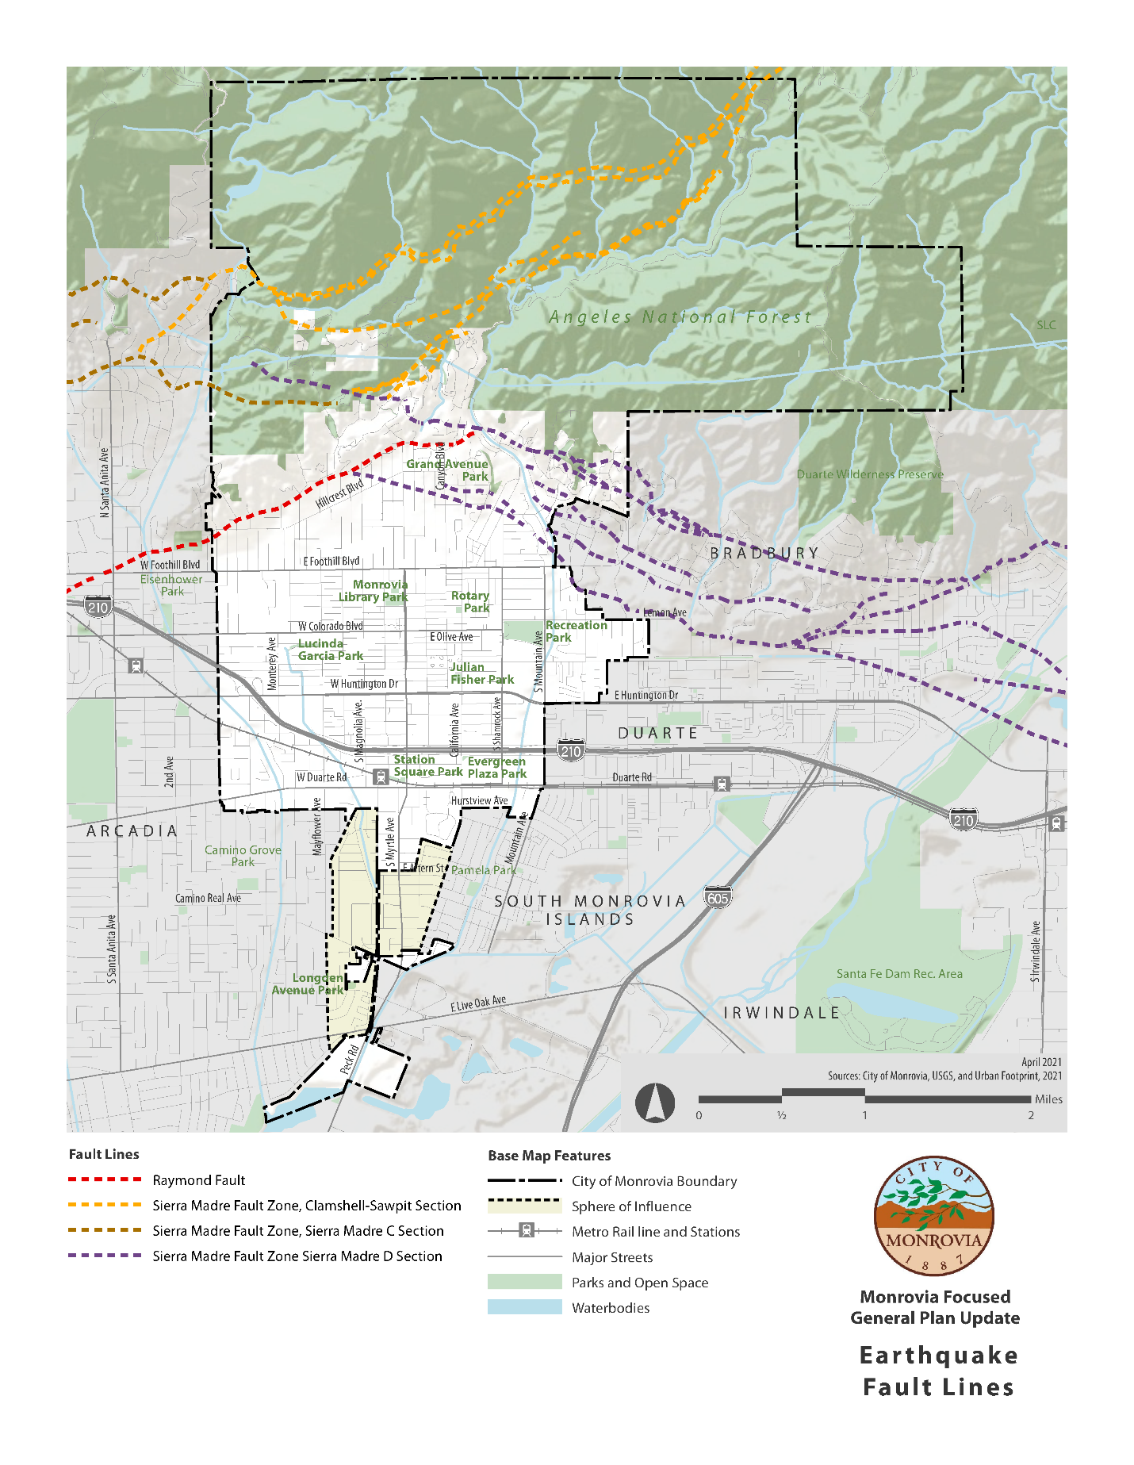

B. Goals, Objectives, and Policies - Seismic Activity

The following objectives and standards were developed to protect citizens and property from seismic hazards while taking existing and future development into consideration.

Goal 1: Reduce to a minimum the loss of life, disruption of goods and services and destruction of property associated with an earthquake

Objective 1.1: Take potential fault areas into account in the General Plan.

Policy 1.1.1 No structures for human occupancy are permitted on or across the trace of the Raymond Hill Fault. Prior to approval of development of properties within the Alquist-Priolo Geologic Studies Zone, as delineated by the California Division of Mines and Geology, an applicant shall submit a report of the geologic investigation of potential faults that may affect structures proposed at the site. The Report shall be required for parcel maps, tract maps, development on residential lots, and residential additions adding floor area for human occupancy, and shall be prepared by a Registered Geotechnical Engineer registered with the State of California.

Policy 1.1.2 Properties located within known or potential fault areas shall be required to submit a geotechnical report at the time of submittal of the parcel or tract map, or for development on residential lots with single family dwellings, or additions to dwellings that add floor area for human occupancy (see policy 1.1.4). The report shall analyze the surface and subsurface geology of the site, the degree of seismic hazard and shall include conclusions and recommendations regarding the effect of geologic conditions on the proposed development, opinions and recommended criteria to mitigate any identified geologic hazards. This investigation and report shall be performed by a professional geotechnical engineer experienced in the practice of engineering geology and registered with the State of California.

Policy 1.1.3: Modifications to the set back limits specified by the Alquist-Priolo Act may be permitted at the discretion of the City, if such modifications also comply with the Municipal Code, based on a geotechical report prepared by an independent licensed geotechnical engineer and/or geologist, mutually agreed upon between the City and developer and paid for by the developer. The geotechnical report shall be reviewed and subject to the approval of the City Engineer or his designee and shall be maintained on file by the City. The recommendations made in the geotechical report may be approved, modified or denied by the City. Setback modifications may be permitted only if the developer and/or owner executes and records a restrictive covenant, in a form acceptable to the City Attorney, against the title to the property.
Such a restrictive covenant shall specifically define and require compliance with the permitted setbacks on the property and any applicable conditions required by the geotechnical report. Such restrictive covenant shall run with the land, be binding on successors in interest, acknowledge that the applicable setbacks have been modified at the request of the property owner in reliance on a geotechnical study, and further require that the property owner hold harmless, indemnify and defend the City, its officers, agents and employees from and against any liability or damage in any way arising out of the construction, maintenance and use of residential structures on the property.

Policy 1.1.4: Geotechnical reports submitted in response to the standards above shall be reviewed for adequacy by a Registered Geotechnical Engineer, and a report of that review submitted to the appropriate agency of the City. All costs for the preparation of these required reports are to be borne by the developer/applicant.

Policy 1.1.5 A geotechnical report, prepared by a geologist registered with the state, shall be provided for all projects listed below located within an Alquist-Priolo Special Studies Zone:

- All new buildings for human occupancy. This shall include single family dwellings, guest houses and rental units.
- Additions to buildings discussed in Item 1 above when the area of the addition will exceed 50% of the area of the existing building.
- Any conversion from a building not used for human occupancy into one which is. (Authority: Section 3603(c), Title 14, CCR.)

No report shall be required for accessory buildings such as garages, tool sheds, swimming pool dressing rooms, etc. since these buildings are not normally used for human occupancy more than 2,000 person-hours per year.

Objective 1.2: Implement programs to deal with hazardous areas or buildings.

Policy 1.2.1: Advocate and support state legislation that would require existing vital facilities to be brought into compliance with modern seismic design and construction standards.

Policy 1.2.2: Support legislation that provides for income tax incentives to encourage the repair of potentially hazardous buildings.

Objective 1.3: The City shall require that all development take appropriate measures to protect public health and safety.

Policy 1.3.1: Continue to adopt and implement the most recent uniform building code (with special attention to Chapter 23 and Chapter 70), and all supplements which include the latest most stringent earthquake regulations for new construction.

Policy 1.3.2: If an EIR, or detailed geologic investigation confirms existence of seismic hazards, the City shall require special earthquake resistant design features or use limitations, as appropriate, to protect the public health and safety and to reduce the exposure of individuals and property to seismic risks.

III. Flood Control

- Background

1. Setting

The San Gabriel Valley has historically been subject to seasonal flooding associated with major storms, with stormwaters overflowing the banks of the San Gabriel and Rio Hondo Rivers and spreading across adjacent lands. Beginning in the 1950s, the U.S. Army Corps of Engineers and Los Angeles County Department of Public Work impounded the floodwaters behind dams and channelized the rivers to protect the growing region from flood hazards associated with 100-year and 500-year storm events, thus creating a high degree of flood protection. As a result, Monrovia has minimal flood hazards, as shown on Figure 2.

The Federal Emergency Management Agency (FEMA) prepares flood maps as way to allow communities to know which areas have the highest risk of flooding. High risk areas are those located in a 100-year flood zone and lower risk areas are those located in 500-year flood zones. A common misconception is that 100-year or 500-year floods are floods that occur every 100 or 500 years. However, the phrase refers to the probability of flood of a certain magnitude occurring in any given year. A 100-year flood has a one percent chance of occurrence, whereas a 500-year flood zone has 1-in-500 chance (0.2%). A 500-year flood is larger in magnitude and severity than a 100-year flood, but it is so rare it poses minimal risk. FEMA has not mapped any 100-year flood zones in Monrovia, meaning that flood hazards are minimal and flood insurance is not required for any property with a federally backed mortgage. Risk of flooding from a 500-year flood event occurs in a small, localized pocket of the City, as shown in Figure 2, but risks are so low that federal programs do not require flood insurance.

Flood containment usually involves preparing for the Standard Project flood. This type of flood is defined by the Corps of Engineers as follows:

"Standard Project Flood: The flood that may be expected from the most severe combination of meteorological and hydrological conditions that are considered reasonably characteristic of the geographical area in which the drainage basin is located, excluding extremely rare combinations. Peak discharges for these floods are generally about 40-60 percent of the Probably Maximum Floods for the basins. As used by the Corps of Engineers, Standard Project Floods are intended as practical expressions of the degree of protection that should be sought In the design of flood control works, the failure of which might be disastrous."

The effect of any large flood on the City depends on the available capacity of the dams and debris basins, which are located to the north (Sawpit Debris Basin) and northwest (Santa Anita Dam) of the central business district of Monrovia. The combined capacity of the Sawpit and Santa Anita dams is 1,852 acre-feet. Therefore, the retention of some flood flow in these reservoirs could greatly reduce the flood flow into the City. The most common flood hazard is standing water resulting from blockage or inadequate capacity of storm sewers.

- Mud and Debris Flows

The effects of a fire in the hillside areas of Monrovia would be a potential for rapid downhill movement of mud and debris flows. This would occur in hillside areas where the soil horizon is well developed and the soil has poor drainage characteristics. The lack of vegetation, resulting from fire, lowers the stability of exposed soils and decreases the water-holding capacity of the local watershed.

3. Landslide Activity

A previous study of landslides in the Monrovia hillside areas (Monrovia Hillside Study, by Leighton and Associates), identifies many landslides of various sizes and types within the foothills of Monrovia. The majority of the landslides are primarily in the steep northern area, which is underlain by granite bedrock. The reasons for this activity relate with such factors as weakened bedrock by fracturing, faulting and weathering. Another major reason for this would be the abnormally high seismic forces and rapid uplift of the mountain range. Additionally, due to the increase in frequency and intensity of wildfires, landslides are more likely to occur during heavy rainstorms in areas impacted by wildfires. Wildfires that have occurred on hills covered with shrubland plants are often a precursor to debris flows in burned-out canyons. The extreme heat of a wildfire can create a soil condition in which the earth becomes impervious to water. Figure 3 illustrates areas that are susceptible to landslide hazards, most of which occurs in the foothills.

Most of the previous landslides appear to be shallow rock falls. However, several of the larger slide areas involve massive volumes of bedrock. While most of these slides may be stable at present, they are not suitable for building unless they were stabilized or removed.

4. Dam Failure Potential

There are three upstream uses, Sawpit Dam, Sawpit Debris Basin, and Santa Anita Dam which have the potential for failure caused by seismic activity.

The Sawpit Dam is a concrete dam located in Sawpit Canyon in the foothills of the San Gabriel Mountains. It was built in 1927 and is owned by the Los Angeles County Department of Public Works. The dam was originally used for flood control and water conservation purposes and had an original capacity of 960 acre-feet. At some time since its original construction, a hole was created in the bottom of the dam to allow the stream to flow through the dam. Over time, accumulation of debris and operating restrictions have significantly reduced the reservoir storage capacity. If the dam failed at capacity, most of the flooding would occur in the northeastern area of the city. The Sawpit Debris Basin is located in the foothills in northern portion of the City of Monrovia, has a capacity of 476 acre-feet. If the debris basin failed at capacity, it would require a drainage area of three square miles. The ensuing flood would last approximately 25 minutes and be confined largely within the area bounded by Santa Anita Wash and the Santa Fe Flood Control Basin. A flood of this type would inundate portions of the cities of Monrovia, Duarte, and Bradbury.

The Santa Anita Dam, which was built in 1927, is located to the northwest of downtown Monrovia and is owned by the Los Angeles County Department of Public Works. This dam has a capacity of 1,376 acre-feet. If the Santa Anita Dam failed at capacity the drainage area required would be 11 square miles. Most of the flooding would occur in Sawpit Canyon between Myrtle Avenue and Santa Anita Wash north of the Foothill Freeway.

The flood inundation boundaries from these upstream facilities are shown in Figure 4.

5. Flood Aversion

The City of Monrovia is located in an area that has a potential for flooding due to surface water runoff from the San Gabriel Mountains to the immediate north. However, with the appropriate flood control measures, potential flooding can be avoided, and flood insurance maps have been rescinded for Monrovia. The flooding potential which may have been realized has been successfully cycled through the Los Angeles County Flood Control District (LACFCD) system. In addition to the infrastructure drainage system there are other facilities which ensure the public safety in relation to flooding.

This larger scale LACFCD system consists of Sawpit Wash in the eastern section of the City and Santa Anita Wash along the westerly boundary. These major drainage courses flow generally southerly and converge at a point south of Live Oak Avenue.

Other LACFCD facilities include two temporary debris basins in the Buena Vista Canyon at the north end of Norumbega Drive, and three settling basins: Ruby Canyon Debris Basin; Oak Glade Debris Basin; and Sawpit Debris Basin.

The City of Monrovia has also installed a storm drain in the Hidden Valley area. This, combined with the LACFCD system, provides the City with adequate flood control facilities for the present level of development.

B. Goals, Policies, and Actions - Flood Aversion

Goal 2: Minimize flooding hazards in the City of Monrovia.

Policy 2.1.1: Design new development to incorporate flood control measures.

Policy 2.1.2: Monitor and adopt appropriate flood management programs.

Policy 2.1.3: Design flood control infrastructure to accommodate existing and anticipated storm flows associated with changing climatic conditions.

Policy 2.1.4: Coordinate with appropriate agencies to identify and construct needed local and regional flood control improvements to address areas of concern.

Action 2.1.1.1: Implement the following development standards as flood control and landslide protection measures:

- Graded slopes, other than those constructed in rock, shall be planted or otherwise protected from the effects of storm runoff erosion and shall be benched or terraced as required to provide for adequate drainage. Planting shall be designed to blend with the surrounding terrain and development. Graded slopes in rock shall be provided with soil pockets to contain landscaping where appropriate. Irrigation facilities shall be provided where necessary for proper establishment and maintenance of the planted areas.

- Provision shall be made to prevent surface waters from eroding natural and graded slopes.

- Within six months, or such other period established by the Director of Public Works, after the commencement of grading activities, graded areas shall be stabilized as approved by the City Engineer. Slope planting shall not lag grading completion by more than six months.

- Grading on building sites shall not occur until specific site plans and elevations have been approved for the individual site except where, as part of a subdivision grading and public improvements, approved after a public hearing, the grading of a lot has been determined necessary for public safety (and is done in accordance with the intent and purpose of these policies.)

- Graded slopes over three feet in vertical height and all graded slopes to be maintained by a Landscape Maintenance District, or other City approved maintenance agreement, shall be planted to protect against erosion. Planting shall be in the ratio of at least one tree per three hundred square feet of slope and one shrub per one hundred fifty square feet, with ground cover sufficient to cover the bank within one year from planting.

- For all projects that require grading, a soils engineering report shall be required to include data regarding the nature, distribution and strengths of existing soils, conclusion and recommendations for grading procedures, design criteria for and identified corrective measures, and opinions and recommendations regarding existing conditions and proposed grading. This investigation and report shall be performed by a professional soil engineer experienced in the practice of soil mechanics and registered with the State of California.

- For lots greater than 7,500 square feet, a hydrology report shall be submitted at the time a grading plan is submitted to the City. The hydrology report shall identify areas of possible inundation, downstream effects, natural drainage courses, conclusions, and recommendations regarding the effects of hydrologic conditions on the proposed development, opinions and recommendations regarding the adequacy of facilities proposed for the site, and design criteria to mitigate identified hydrologic hazards. This report shall account for runoff and debris from tributary areas and shall provide consideration for each lot or dwelling unit site in a development. Runoff and debris volumes shall be computed using Los Angeles County Flood Control District criteria. This investigation and report shall be prepared by a registered civil engineer experienced in hydrologic investigation.

- Covenants, Conditions and Restrictions (CC&R's), including but not limited to development plans, common area and slope maintenance, private area landscaping and maintenance, shall be submitted and approved prior to the recordation of a final tract map.

- Hillside development shall provide all necessary sewers, storm drains, debris basins and other flood control measures as specified in specific plans.

Action 2.1.1.2: Periodically update dam inundation maps and consider the proximity of dams in the site selection of vital public facilities.

Action 2.1.1.3: Coordinate with the Los Angeles County Department of Public Works, the owner of all three dams, to develop Emergency Action Plans as required by State law.

Action 2.1.1.4: The City Engineer will monitor the Cobey-Alquist Flood Plain Management Act for application in Monrovia.

Action 2.1.1.5: Prepare an assessment of capacity needs of flood control and storm drainage infrastructure resulting from extreme weather caused by climate change.

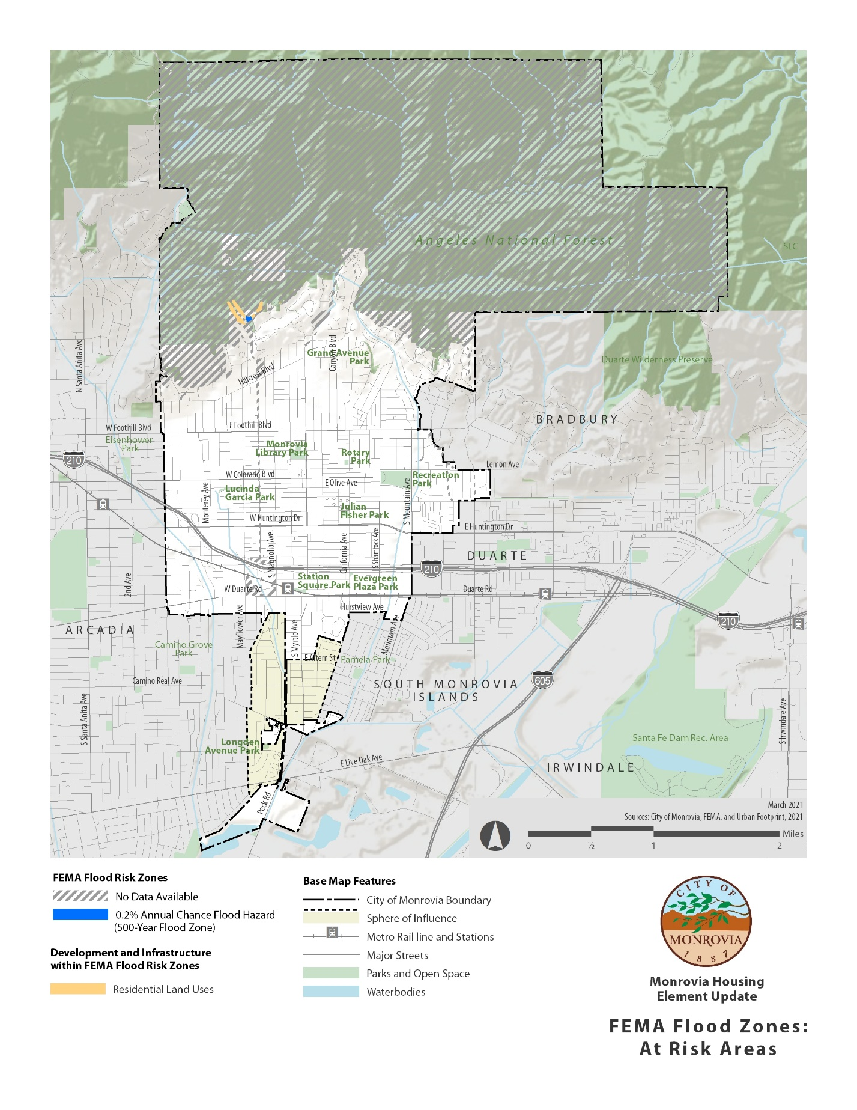
Figure 2: Areas at Risk of Flooding Hazards

Figure 3: Areas Susceptible to Landslides
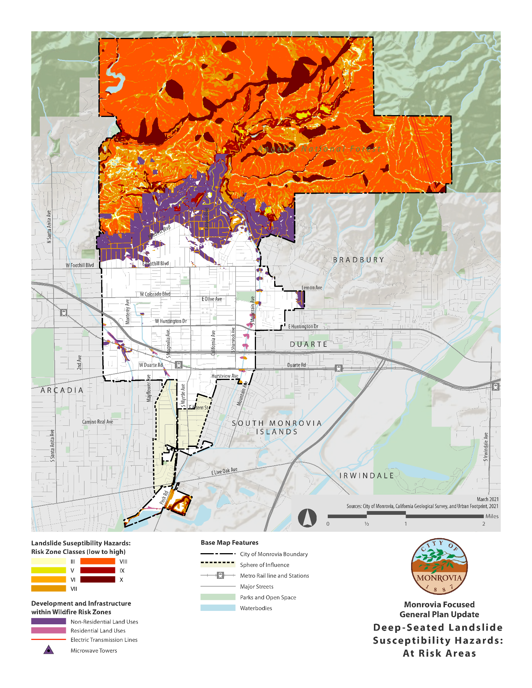

Figure 4: Sawpit Wash and Debris Basin Flood Inundation Area

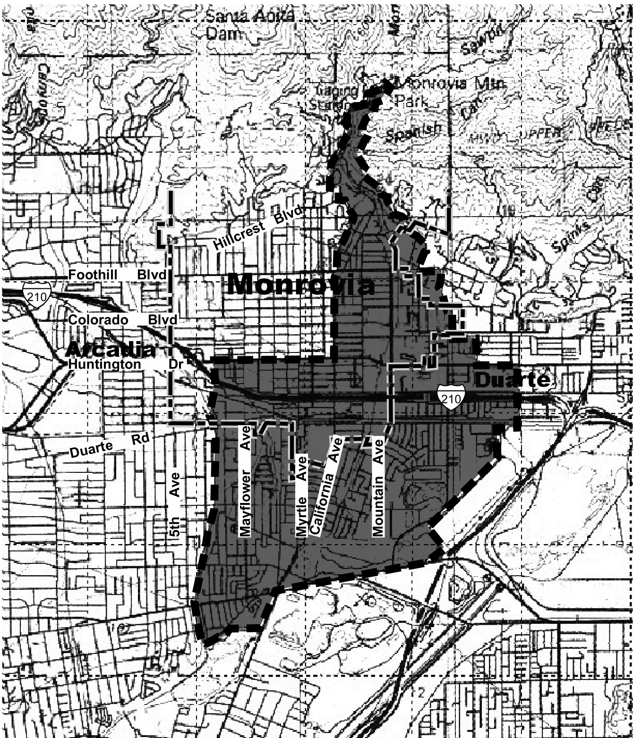

Source: Inundated Area – Sawpit Debris Basin, DWG No. 54-H2 (8/73), L.A. County Flood Control District

Figure 5: Santa Anita Wash and Dam Flood Inundation Area

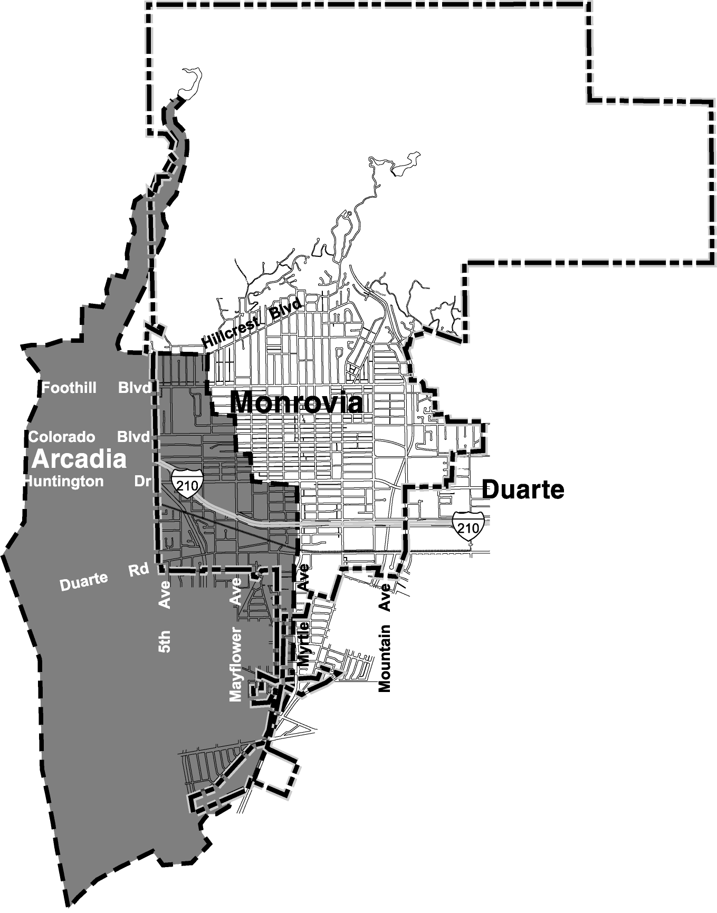

Source: Inundated Area – Santa Anita Dam, DWG No. 55-H2 (8/73), L.A. County Flood Control District

IV. Fire Safety

A. Background

Fire safety in the City of Monrovia is concentrated on suppression, prevention, and emergency care. Fire prevention is addressed primarily through enforcement of the Uniform Fire and Building Codes and State and City ordinances. Additionally, several other programs concentrate primarily on avoidance or impact reduction strategies. Despite these efforts, residential, commercial, industrial, and brush fires remain a continual threat, particularly in times of severe drought. It is the purpose of this section to provide for fire prevention programs.

The City’s water pumping plant has a capacity of 11,475.55 gallons per minute and has guidelines set for operational, fire, and emergency storage stated in 1.53 MGD. Including all nine reservoirs, the water storage capacity increases to 24.43 MGD. Fire flow guidelines are established by land use type and are based on the local fire authority and requirements of the California Fire Code.

1. Fire Hazards

Historically, large portions of the Foothill area have been subject to wild land fires of 100 to 500 acres. However, within the past decade wildfires have increased drastically in frequency, magnitude, and severity due to climate change. Since 2009, wildfires in the Foothill communities have grown to burn thousands of acres. The Station Fire of 2009 and Bobcat Fire of 2020 illustrate the catastrophic impacts wildfires can have on local communities and provide insight into future wildfire events compounded by climate change. Table 1 summarizes wildfire events in Monrovia and surrounding communities over the past four decades.

Table 2: Major Wildfire Events in Monrovia and Nearby Communities
Event | Data | Location | Damages
Stable Fire | November 1980 | Bradbury | 57 structures destroyed.
Curve Fire | September 2002 | Azusa Canyon | 72 structures destroyed.
Station Fire | August 2009 | Angeles National Forest, La Cañada-Flintridge | 209 structures destroyed; 2 fatalities
Madison Fire  170 acres | April 2013 |  | No structures lost.
San Gabriel Complex (Fish & Reservoir) Fire | June/July 2016 | Azusa Canyon | 5,399 acres  No structures lost.
Ranch 2 Fire (also known as Mountain Cove fire) | August 2020 | Azusa Canyon | 4,237 acres  No structures lost.
Bobcat Fire | September 2020 | Angeles National Forest, from north of Monrovia to Juniper Hills | 170 structures destroyed.
Source: Los Angeles Almanac, Wildfires in Los Angeles County, 2021.
City of Monrovia, Local Hazard Mitigation Plan, 2017.

While most of California is subject to some degree of fire hazard there are specific features that make some areas more hazardous. The California Department of Forestry and Fire Protection is required by State law to map areas of significant fire hazards based on fuels, terrain, weather, and other relevant factors. The maps show areas referred to as Fire Hazard Severity Zones (FHSZ), which are designations that mandate how people construct buildings and protect property to reduce risk associated with wildland fires. The three levels of fire hazard are moderate, high, and very high.

In Monrovia, the major fire threat exists in the steeper slopes of the San Gabriel Mountains to the north, which is an area considered to be in a Very High Fire Severity Zone. Figure 6 illustrates the severity risk zone as well as the location of critical facilities, development, and infrastructure within this zone.

Residential Fires: New wood roof coverings are prohibited throughout the City. Smoke detectors are required in all residential properties at change of ownership. While prevention efforts must be emphasized, the fire program must be aimed at suppression. With the use of residential fire sprinklers in all new housing as approved by the City Council, the staffing needs in 10-30 years may be adjusted based on the number of new homes constructed with fire sprinklers. Until then, to meet the current and near future needs, appropriate staffing and apparatus must meet the service demand.

Hazardous Buildings: All commercial buildings are inspected annually by fire company personnel for general hazards, including electrical. Special hazards, use of flammable liquids, and the storage and use of hazardous materials require special inspection which are technical in nature due to the complexity of the code requirements. These types of inspections require personnel with specialized inspection education.

Industrial Fire Hazards: Those occupancies classified as industrial hazards are similar in nature to the hazardous buildings above and require specialized personnel to conduct the necessary inspections.
Brush Fire Hazards: The greatest fire danger to the City is from Wildland Urban Interface (WUI), where homes meet the 30-50 year brush growth. Flying embers pose a danger anywhere in the City where wood shake roofs exist. An aggressive 5-10 year program to reduce the fuel hazard is critical to the safety of the public and their homes. In order to work with many owners of undeveloped property and the approximate 1,450 owners of homes in the brush hazard area, a year-round inspection and abatement program is critical. Additionally, it is crucial that road widths, water supply, and signage are adequate to facilitate optimal fire suppression services.

The City of Monrovia’s Evacuation Plan provides for emergency routes, evacuation routes, equipment deployment as well as staging areas and a possible evacuation center as shown on Figure 7.

Figure 6: High Fire Hazard Zone
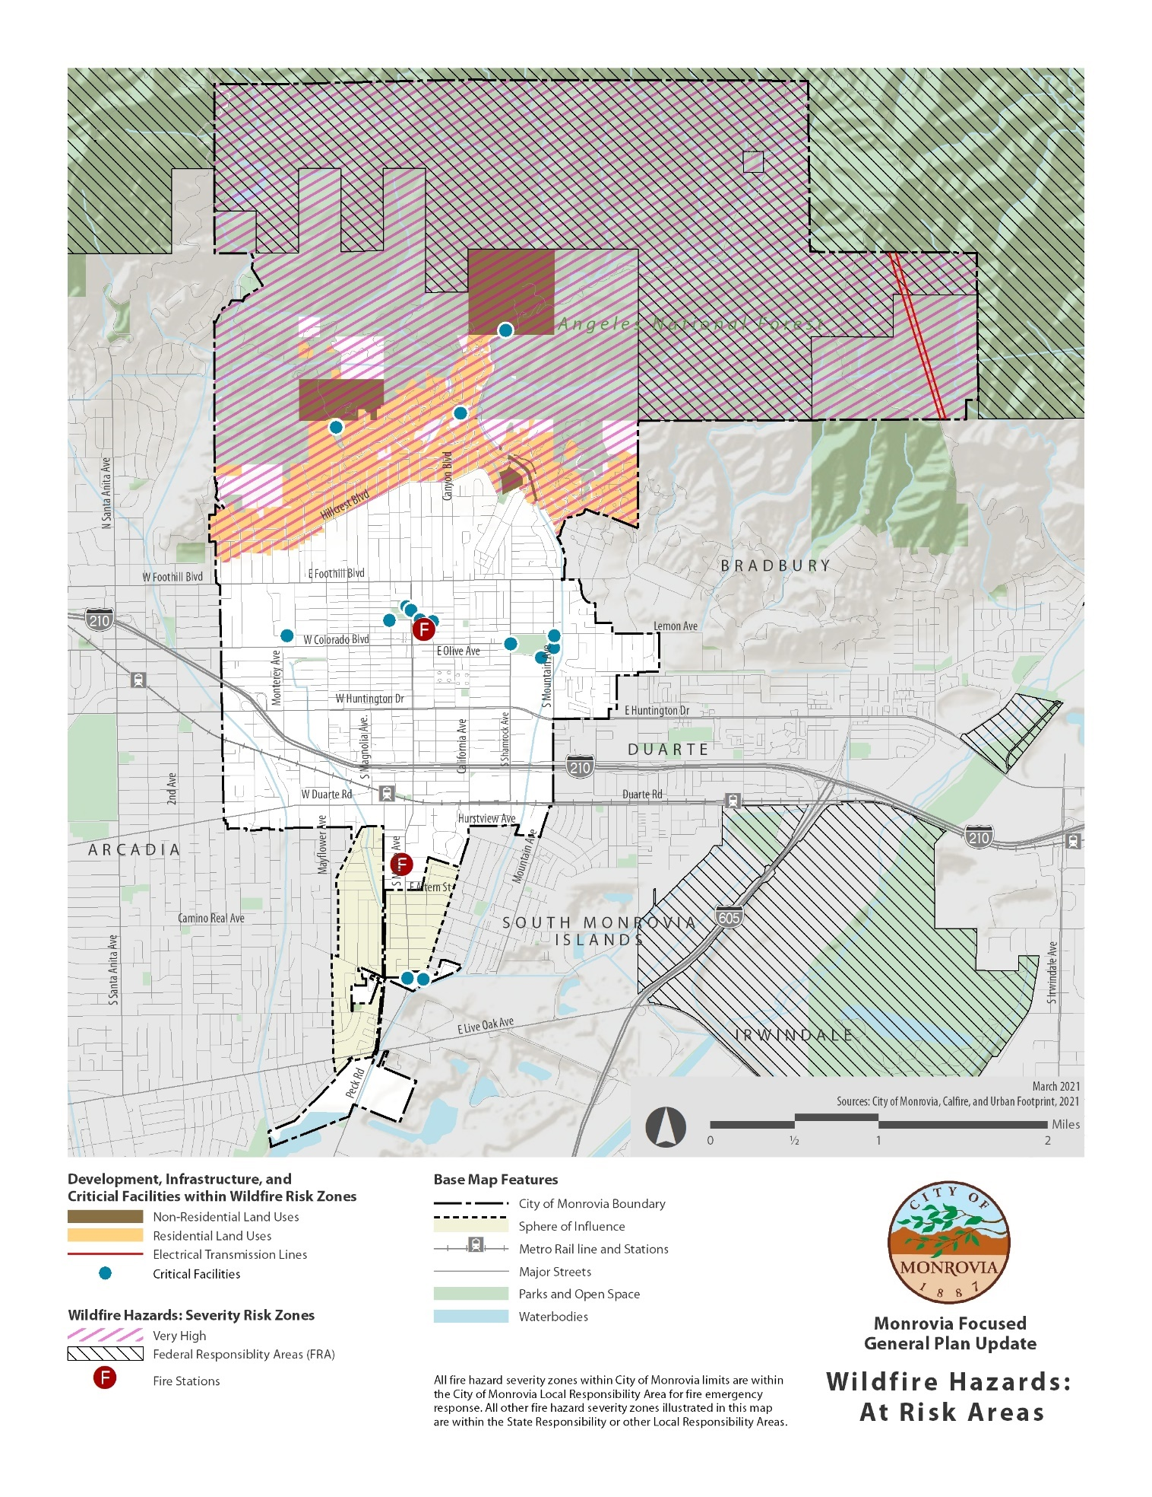
Figure 7: Evacuation Plan

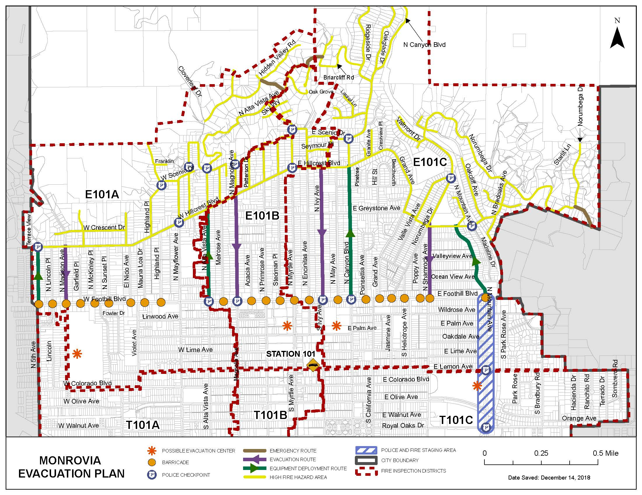
B. Goals, Policies, and Actions - Fire Prevention

Goal 3: Reduce the risk of fire and minimize consequences from fire events in Monrovia.

Planning and Design

Policy 3.1.1: Continue to plan for new construction and redevelopment that decreases the likelihood of fire and decreases tie impacts of fire damage.

Action 3.1.1.1: Require development to provide adequate defensible space to minimize the risk of structural damage associated with wildland fires.

Action 3.1.1.2: Require new development to be located in areas with adequate water supply and water supply infrastructure.

Action 3.1.1.3: Continue to implement the California Building and California Fire Codes, as well as the following policies and standards for hillside development:

- Fire suppression access to natural chaparral areas shall be provided and maintained.

- Landscape materials for the coverage and stabilization of graded slopes shall be selected to be compatible with surrounding natural vegetation and shall recognize climatic, soil, exposure, and ecological characteristics of the site. Plant materials that require substantial water after becoming established shall be avoided. Native dry climate grasses and other saprophytic materials shall be selected wherever feasible. (Fire Department approval required).

- Cantilevered construction, including stairs, balconies, porches, open structure under buildings shall be fire retardant construction and shall be protected by fire sprinklers, when applicable, which have been reviewed and approved by the Fire Department.

- Eaves shall be fully boxed in with exterior stucco or its equivalent. Vents shall be covered with one-sixteenth inch mesh or its equivalent.

- New roofs shall be class "All non-flammable materials.”

- Flammable chaparral, excluding mature trees, on a lot within 200 feet of a home, shall be cleared, maintained, and replaced with vegetation to minimize fire hazard.

- Fire hydrants shall be provided and located within 300 feet of structures except where a greater distance is allowed by the Fire Chief in conjunction with the installation of automatic fire sprinklers. All water main installations will be "looped" with no dead-end main allowed

- To provide adequate Fire Department access, foothill neighborhoods shall be linked with a continuous circulation system. Segments of that system may consist of emergency access roads.

Action 3.1.1.4: Continue to enforce the following ordinances promoting fire prevention.

- Enforce installation of fire alarm systems and or sprinklers to provide protection to life and property.

- Enforce regulations requiring smoke detectors in all structures.

- Enforce installation of chimney spark arrestors.

- Prohibit the use of flammable roofing materials.

- Continue to adopt, implement, and require new structures to incorporate latest California Building Code, California Fire Code (including a minimum of 40-foot right-of-way and a grade less than six percent to ensure adequate access for fire emergencies), Government Code sections 51175 and 51189 related to VHFSZ, and Board of Forestry and Fire Protection Fire Safe Regulations, among others.

To prevent life hazard and to protect the hillsides and residential, industrial, and commercial areas, enforce ban on use of all fireworks.
Action 3.1.1.5: Control hazardous or potentially dangerous operations or land uses.

- Require a conditional use permit for industrial operations involving the compounding of radioactive materials, petroleum refining, manufacturing of explosives, or any other operation of a dangerous nature.

- Enforce ordinances prohibiting the igniting or burning of flammable materials on public or private property.

- Restrict and regulate devices or equipment that could create fire, explosion, or bodily injury.

- Restrict storage of flammable liquids and explosives to manufacturing zones.

Action 3.1.1.6: Update zoning and/or building code to require residential and nonresidential structures have street numbers (and street name, as appropriate) visible from public and private roadways and alleys.

Action 3.1.1.7: Identify all development that does not comply with current fire safety standards, in terms of road standards and vegetative hazard; establish and implement a mitigation plan to remedy the noncompliance.

Action 3.1.1.8: Consider relocating and work with other agencies to facilitate the relocation of essential public facilities out of the high-risk, wildfire prone areas.

Action 3.1.1.9: Avoid, if possible, or minimize new residential development in the VHFSZ.

Action 3.1.1.10: Ensure that infrastructure located within VHFSZ has the capacity to support emergency services and operations.

Action 3.1.1.11: Require all new essential public facilities be sited outside of the VHFSZ, when feasible.

Action 3.1.1.12: Require new development within the VHFSZ provide a pre-plan, which includes:
    - location and direction of evacuation routes,
    - at least two points of ingress and egress,
    - maintenance of defensible space clearances around structures and subdivisions,
    - provision and maintenance of fuel breaks, and
    - provision and maintenance of roadside fuel reduction plan to prevent fires along public roads, and
    - a fire resistive vegetation landscape plan

Action 3.1.1.13: Require all new and redevelopment occurring within the VHFSZ be designed, constructed, and maintained in accordance with the latest building and fire codes.

Action 3.1.1.14: Ensure new and existing development located within the Very High Fire Severity Zone (VHFSZ) is designed to implement fire prevention measures.

Action 3.1.1.15: Develop outreach programs that educate residents regarding:
- evacuation routes and wildfire evacuations,
- defensible space,
- fire hazard impacts, such as structural damage, wildfire smoke, etc.,
- fire prevention measures, and
- structural hardening.

Redevelopment (Rebuilding) Policy

Policy 3.1.2: Continue to allow structures and infrastructures located in the VHFSZ to be rebuilt or redeveloped, after a large fire, in accordance with the Building and Fire Codes in place at the time of the rebuilding.

Action 3.1.2.1 Periodically, consider amending the City’s VHFSZ Rebuilding policy to ensure it reflects community vision and best practices.

Water supply

Policy 3.1.3: Ensure Monrovia’s water supply and distribution system is adequate and appropriate to facilitate fire suppression.

Action 3.1.3.1: Develop and implement a plan to ensure the maintenance and long-term integrity of water supply and its supply infrastructure.

Action 3.1.3.2: Regularly assess the water supply systems for development are adequate to combat structural and wildland fires.

Action 3.1.3.3: Ensure or install fire protection water systems for all new construction projects in the VHFSZ , including the installation of fire hydrants providing adequate water flow, fire sprinklers or suppression systems.

Evacuation Plans and Roadway Capacity

Policy 3.1.4: Ensure the roadway system provides adequate capacity to provide for emergency service provision and emergency evacuations.

Action 3.1.4.1: Evaluate the City’s Evacuation Plan to identify the evacuation routes’ capacity, safety, and viability under a range of scenarios. Expand the Evacuation Plan to include all areas of the City, including areas south of Walnut Avenue, Royal Oaks Drive, and Orange Avenue. Once capacities and new routes are determined regularly update emergency evacuation plans and routes for the VHFSZ areas.

Action 3.1.4.2: Conduct a survey of public and private streets to determine those that lack two means of ingress and egress. Identify measures to mitigate the single access issue. Prioritize the planning for and the construction of or the redevelopment of single access roadways within the VHFSZ.

Action 3.1.4.3: Periodically evaluate access roads to ensure there is sufficient capacity to provide the safe access of emergency equipment and civilian evacuation concurrently.

Fuel Modification

Policy 3.1.5: Continue to support and implement fuel management programs.

Action 3.1.5.1: Maintain or require the maintenance of fire hazard reduction projects, including but not limited to community fire breaks, private road clearance, and public road clearance.

Action 3.1.5.2: Regularly assess the effectiveness, and modify as appropriate, the City’s SAFE Landscaping materials and Community Wildfire Protection Plan.

Fire Protection Plans

Policy 3.1.6: Develop and implement fire protection policy and programs including the incorporation of the Monrovia Local Hazard Mitigation Plans.

Action 3.1.6.1: Regularly assess that emergency response services (including Fire and Police) are adequate to combat structural and wildland fires and to direct emergency evacuations.

Action 3.1.6.2.: Regularly assess the effectiveness, and update as appropriate, the City’s MONROVIA RED (Rescue for Elderly and Disabled) REGISTRATION program at identifying and noting the location of Monrovia’s at-risk populations.

Action 3.1.6.3: Continue to coordinate with cities of Sierra Madre, Arcadia, Azusa, and Duarte; Los Angeles County, and other emergency response agencies to provide for mutual aid in the prevention and response services.

Action 3.1.6.4: Regularly assess and project future emergency response needs and create implementation programs and actions to address the identified needs.

Action 3.1.6.5: Regularly assess the need for and develop additional fire and police training.

V. Climate Adaptation

A. Background

Climate change is a long-term shift in average weather patterns that are typical in local, regional, and global climates. Climate change has been linked to more frequent and more intense weather events such as hurricanes, floods, winter storms, and heatwaves. The State has developed the Cal-Adapt tool which provides projections of future climate conditions and has been used to understand changing climatic conditions in the City. In Monrovia, projections show more frequent, prolonged, and intense heatwaves, droughts, wildfires, and landslides.

Climate adaption is the process of adjusting to climate change in order to moderate its potential impacts. Curbing dangerous climate change requires very deep cuts in greenhouse gas emissions and implementing climate adaptation strategies to ensure communities remain resilient in the face of climate change impacts. For a more detailed discussion on climate change effects and impacts refer to the Climate Change Vulnerability Assessment in Appendix B.

- Flooding and Landslides

California’s climate varies between wet and dry years. Research suggests that for much of the state, wet years will become wetter and the dry years will become drier. Monrovia is expected to experience the same patterns in precipitation as the State. Historically, Monrovia has had a range of 23.0 to 28.8 inches of rain during a 30-year period. Projections show that this range could vary significantly (from 16.6 to 37.0 inches) by the end of the century if emissions continue to increase drastically. Exceptionally dry years could lead to drought conditions and wet years could lead to more significant landslide or flooding events.

The City contains a 500-year Flood Zone in one localized area in the foothills between Cloverleaf Drive and Hidden Valley Avenue, as shown in Figure 2. Any potential flooding occurring in this area or elsewhere in the City can be avoided due to adequate flood control measures provided the Los Angeles County Flood Control District system.

Landslides are a natural geologic process that can be caused by earthquakes, subterranean water flow, and rainfall. However, climate change can also exacerbate the problem through the combination of extremely dry and wet periods. Wildfires that have occurred on hills covered with shrubland plants are often a precursor to debris flows in burned-out canyons. The extreme heat of a wildfire can create a soil condition in which the earth becomes impervious to water. Landslides are then more likely to occur during periods of heavy rainfall. Areas along the foothills and steep slopes can experience more dangerous conditions as debris movements can be more rapid, as shown in Figure 3. It is critical that preventive measures be implemented after the occurrence of a wildfire event, since landslides are more likely to occur during heavy rainstorms in areas impacted by wildfires.

- Heatwaves and Drought

Overall temperatures are projected to rise in California during the 21st century. In Monrovia, the historical maximum temperature has an average of 76.7°F. Extreme heat days, which are days when the daily maximum temperature is above the threshold temperature of 99.1°F, have a historical average of four days. The average maximum temperature is projected to increase by 8.9°F and extreme heat days are projected to increase by 46 days by the end of the century if emissions continue to rise. These significant increases in temperatures can have dangerous impacts, such as more frequent and prolonged heatwaves, wildfires, and droughts.

Severe heatwaves can affect sensitive populations such as elderly residents, lower-income populations who cannot afford air conditioning systems or potential price surges for water and electricity, and homeless individuals without access to cooling centers. These weather events can cause severe symptoms, such as heat exhaustion, heat stroke, and severe dehydration, and sometimes even death. People with chronic diseases are at greater risk of complications and death during a heatwave. Those with disabilities could also face difficulty accessing resources to stay cool and hydrated. Increasing access to cooling centers and devices and implementing building design strategies to reduce heat island effect can help mitigate the impacts of heatwaves. Extreme heat events can increase the demand for air conditioning and water putting a strain on electrical and water supplies. This could cause power outages or water shortages. Demand management strategies for electric and water utilities are useful in mitigating impacts to electrical and water supply systems.

A drought is characterized as a period of unusually persistent dry weather that continues long enough to cause serious problems such as regional water supply shortages. Environmental justice communities are likely to be more impacted by water shortages as these communities may be unlikely to afford price surges caused by increased demand for water. Additionally, drought can cause respiratory illnesses due to the lack of available rainwater to flush out airborne pollutants. This could have severe effects on those with respiratory illnesses or other disabilities. Water conservation strategies can ensure that supplies are not exhausted during periods of drought.

- Wildfires

Heatwaves combined with drought and Santa Ana wind conditions can increase the likelihood and severity of wildfires. Monrovia is particularly susceptible to wildfire as it is located in the foothills, which are areas that are generally covered with dry and dense vegetation. Historically, Monrovia has experienced a 30-year average of 308.3 acres burned. This is projected to increase by 116.1 acres by the end of the century. The Bobcat and Station fires, which have occurred in the past decade and have been recorded as some of the largest wildfires in California history, are a glaring insight into the potential future frequency and severity of wildfire hazards.

Wildfires also place stress on critical assets within the city. Roadways are at risk of physical damage and/or closure, which could impact the effectiveness of evacuation routes and emergency service access. Water supply can also be strained as there is likely to be an increase in demand for water for wildfire fire suppression and resident needs. Wildfire smoke is another hazard associated with wildfires. Smoke releases high concentrations of dangerous air pollutants such as particulate matter and carbon monoxide, which could be especially harmful to those with underlying lung conditions such as asthma or to environmental justice communities who already experience significant pollution burdens. The Bobcat Fire of 2020 produced concentrations of toxic contaminants at levels that exceeded federal air quality standards that required air quality control agencies to advise residents throughout Los Angeles County to avoid the outdoors.

- Pollution Exposure

The EPA’s Toxic Release Inventory (TRI) Program tracks the industrial management of toxic chemicals that may be harmful to human health and the environment. U.S. facilities in different industry sectors must report annually how much of each chemical is released to the environment and/or managed through recycling, energy recovery, and treatment. This information is submitted and compiled in the TRI program. Two TRI facilities are located within Monrovia, one of which is in the textiles industry and the other in chemicals (see Figure 8). Several other TRI sites are located outside of, but in close proximity, to City boundaries. These sites are mostly concentrated near the Irwindale gravel pits and are associated with the mineral and metals industry.

Figure 8: Toxic Release Inventory Sites

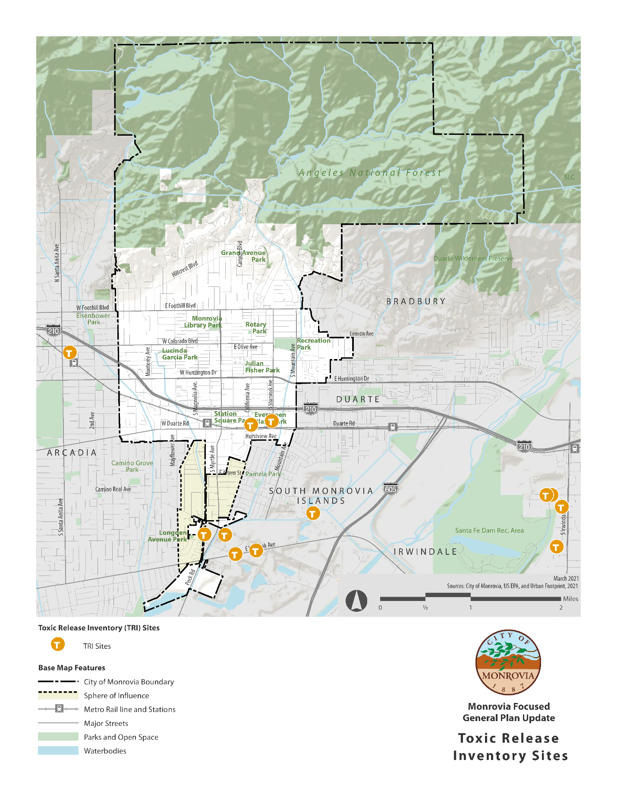

B. Goals, Policies, and Actions – Climate Adaptation

Goal 4: Ensure that Monrovia is adaptive in response to changing climate conditions.

Policy 4.1.1: Incorporate climate resiliency principles into relevant planning and development policies and practices.

Policy 4.1.2: Ensure that emergency response services maintain adequate capacity to respond to hazard events associated with climate change (wildfires, landslides, heatwaves, etc.)

Policy 4.1.3: Design future utility and infrastructure improvements in the city to respond and withstand climate change impacts.

Policy 4.1.4: Promote education and outreach to residents and businesses regarding the effects of climate change on the economy, environment, infrastructure, and special populations (elderly, homeless, immune-compromised, etc.

Action 4.1.1.1: Update relevant city policies as necessary to include climate adaption strategies, such as building codes, development standards, safety response etc.

Action 4.1.1.2: Track and monitor first responder calls to hazard events associated with wildfires, extreme wind events, flooding, and mudslides to identify increasing trends related to changing climatic conditions.

Action 4.1.1.3: Continue to work in close collaboration with water and energy providers in identifying and implementing demand management strategies.

Action 4.1.1.4: Develop a heat response plan to set up systems to predict and communicate with the public about heat events, coordinate response, and designate cooling centers.

Action 4.1.1.5: Upgrade city facilities used as cooling centers, evacuation centers, and other emergency facilities to accommodate changing future needs and conditions.

Action 4.1.1.6: Coordinate with public health departments on the increased risk to community health from reduced air quality, higher temperatures, reduction in mental and physical well-being, and an increase in occurrence and spread of infectious disease.

Action 4.1.1.7: Coordinate and support property owners in implementing various climate adaptation measures in their homes or businesses, such as installation of energy efficient appliances, air filtration systems, water capture infrastructure, etc.

VI. Emergency Preparedness

A. Background

1. California Governor’s Office of Emergency Services (Cal OES)

California Governor’s Office of Emergency Services (Cal OES) is responsible for the coordination of overall state agency response to disasters. This includes assuring the state’s readiness to respond to, recover from all hazards and assisting local government in their emergency preparedness, response, recovery and mitigation.

The Cal OES Agency is divided into three administrative regions, Inland, Coastal and Southern, with agency offices in Sacramento, Fairfield, and Los Alamitos, respectively. The City of Monrovia is located within the Southern Region and is part of Los Angeles County Operational Area. Within the Los Angeles County Operational Area, the City of Monrovia is located in Area D whose headquarters is in San Dimas.

In the event that an incident overwhelms the resources and capabilities of the City, additional support will be requested through this regional and state multi-jurisdictional system. By pooling resources within the statewide mutual aid system, there is an abundance of fire service, medical supplies, and related services. In case of disaster, these assets can be systematically assembled and utilized quickly and efficiently.

2. City Emergency Operations Plan

The City’s Disaster Management Plan establishes the operational organization that is relied on to respond to an emergency. The City uses the Standardized Emergency Management System (SEMS), the National Incident Management System (NIMS), and the Incident Command System (ICS) to be consistent with the National Response Framework concepts, as well as coordinated with other jurisdictional partners within the Los Angeles County.

This plan uses the “whole community” approach where residents, emergency management representatives, organizational and community leaders, and government officials can understand and assess the needs of their respective communities and determine the best ways to organize and strengthen their resources, capabilities, and interest. This “whole community” approach focuses on:
- Understanding and meeting the needs of the entire community, including people with disabilities and those with other access and functional needs,
- Engaging and empowering all parts of the community to assist in all phases of the disaster cycle, and
- Strengthening what works well in communities on a daily basis.

The effectiveness of the emergency response is largely based on the preparedness and resiliency of the community.

In the event of an Emergency Operations Center activation, each City department is responsible to support emergency response and recovery objectives and taking the lead regarding the emergency function to which they have been assigned. The departments also provide representatives to the Emergency Operations Center (EOC) to coordinate people, resources, and information in order to manage an incident that occurs in the city, and to communicate emergency efforts between departments and/or jurisdictions. The specific roles and responsibilities assigned to each City of Monrovia department are as follows:

- City Manager’s Office’s responsibility is to:
- Serve as the EOC Manager/Director,
- Establish policy level decisions related formation of policies/procedures, authorization of expenditures, support of local emergency management operations with additional staff, resources, etc., as well as other operations as determined appropriate,
- Prepare necessary legal documents,
- Provide legal services, and
- Serve as the primary communication line between the press, the public, and the EOC.

- Human Resources Department’s responsibility is to:
- Manage all efforts associated with City personnel and volunteers,
- Prepare records and reports,
- Monitor and assist other department's reports, and
- Manage resources, including financial.

- Community Development Department's responsibility is to:
- Provide support on public infrastructure evaluation/damage assessment,
- Provide GIS support upon request,
- Ensure structural safety of possible shelter locations,
- Administer evaluations and permits in the recovery process, and
- Support the economic recovery and development phase.

- Finance Department’s responsibility is to oversee all expenditures related to emergency management and response operations.

- Information Technology Department’s responsibility is to:
- Ensure operation of critical IT infrastructure, and
- Provide GIS, mapping, and any other technical resources support.

- Community Services Department's responsibility is to:
- Support mass care operations, including the implementation of shelter operations,
- Provide animal care services to sheltering/evacuation, and
- Report damage assessment information related to park facilities.

- Fire Department's responsibility is to:
- Prevent, control and suppress fires,
- Conduct rescue operations,
- Provide and coordinate medical aid efforts, including triage, and
- Provide and coordinate radiological monitoring, as needed.

- Police Department's responsibility is to:
- Receive and disseminate warning information. The department has the ability to send community-wide notifications through ALERT LOS ANGELES COUNTY through the Sheriff’s Department, as well as access to NIXLE that can be used to send out community-wide notifications. The police department also uses various social media platforms to disseminate community-wide notifications, such as but not limited to, Facebook, Instagram, Twitter, Ring, and NextDoor. In the advent of a failure of normal communications systems, a two (2) member volunteer amateur radio system (Ham radio operators) is maintained.
- Direct evacuation of citizens through approved evacuation routes,
- Enforce laws and temporary rules,
- Control traffic,
- Provide security, and
- Coordinate with other law enforcement agencies.

- Public Works Department's responsibility is to:
  - Provide emergency electric power, sewer and water services,
  - Provide for transportation access lanes,
  - Manager flood response operations,
  - Monitor weather-related data, and
  - Assist in rescue activities.

3. Emergency Resources

a. Fire Department Fire Fighting Resources

The Fire Department for the City of Monrovia is in the "Area C" region for automatic aid resource assistance. Area C fire response is coordinated through the City of Glendale Fire Department and comprises 13 communities including Monrovia, Arcadia, San Marino, Sierra Madre, Alhambra, Monterey Park, Montebello, San Gabriel, Pasadena, South Pasadena, Glendale, Burbank, and Hollywood/Burbank Airport. Figure 9 shows the location of the two fire stations operated by the Monrovia Fire Department.

Since 1990 the United States Forest Service (USFS), the Los Angeles County Fire Department and the cities of Arcadia and Sierra Madre provide fire-fighting assistance to the City of Monrovia though a Cooperation Fire Protection Agreement, and are referred to as the Foothill Fire Departments. These fire fighting departments have defined jurisdiction areas and boundaries, initial response resources for wildfire protection, Mutual Threat Zones (MTZ) designate mutual areas where fire would pose a threat to adjoining jurisdictions, and Special Areas assistance, e.g., wilderness, roadless, other modified suppression action areas.

A Memorandum of Understanding (MOU) has been established between the fire departments of the City of Arcadia and the City of Monrovia. The MOU provides for fire protection, emergency medical services (EMS), and rescue services through automatic aid dispatch between the two cities. The MOU defines how communication is coordinated to responding units, how joint training exercises are to be carried out, the assignment of Incident Command when units arrive on scene, and for the sharing of information to complete reports.

Another MOU, first established on July 17, 1985, exists between the Consolidated Fire Protection District of Los Angeles County and the City of Monrovia. This MOU outlines the procedures for carrying out an automatic aid/initial action response between the District and the City. The MOU is a guide for day-to-day operations and is not intended to replace or adjust any Uniform Mutual Assistance Agreement which may be in effect. The MOU defines the methodology for communications and dispatching of response services, defined limitations of service when departments are temporarily not available, scheduling of joint training exercises, incident command authority at the scene, cooperation in fire incident reporting, and a provision of MOU revision or amendment.

b. Paramedics

The two Monrovia Paramedic Squads of four on-duty paramedics ---the City of Monrovia has authorized a total of 15 paramedics--- work under a written mutual aid agreement with the Arcadia Paramedic Resources of two rescue ambulances. Both cities share their combined four ambulances working out of two full service hospitals, Arcadia Methodist Hospital in Arcadia and Huntington Memorial Hospital in Pasadena as the trauma catchment area facility. One hundred percent of all requests for emergency care for sick and injured are answered by paramedic level service through the mutual automatic air response between the cities of Monrovia and Arcadia.

Monrovia's paramedics answer the entire spectrum of requests for aid and are also firefighters who maintain journeyman skill levels in this area as well. The squad is recognized as being one of the finest in the state.

c. Paramedic and Fire Department Personnel Training

Periodic drills are conducted to ensure quality control, and urban search and rescue (USAR) procedures are coordinated, and a necessary degree of standardization is maintained between companies. There is specialized training in fire hydraulics, hazardous materials, and fire tactics. In addition, special classes are conducted periodically by gas representatives, County Fire and United States Forestry officers. Personnel are also sent to outside education programs in arson investigation, emergency operations, leadership, and fire protection.

Department personnel have participated in ongoing training for citizens in CPR, fire prevention and safety. Operational safety is heavily stressed and the basic safety advisory is that the safest firefighter is one who is fully trained in the profession.

To keep mutual aid operations at maximum efficiency, multi-city (quarterly training activity is conducted with the City of Arcadia), multi-company drills were conducted to test communications and the ability of firefighters from seven different cities to function together.

d. Fire Department Inventory

The Monrovia Fire Department is staffed by 42 full-time safety personnel ---of which 14 are constantly on duty, and one administrative personnel. Major fire-fighting equipment includes three major engines and an aerial unit in reserve, and two paramedic rescue squads, plus one reserve unit. Over the past two decades emergency calls number average approximately 3,000 per year, a capacity workload for the present staff to manage.

e. Police Assistance

In addition to its everyday duties, the Police Department plays a pivotal role in public safety in emergency situations. The Department's primary concern is public safety, and to take a proactive approach to minimizing criminal activity through community policing resources. However, its main duty is responding to police calls throughout the City of Monrovia. Figure 9 shows the location of the Monrovia Police Station.

The Department maintains the same responsibilities in the event of disaster. The only difference is that the effectiveness of police activity in this situation is a prerequisite for efficient disaster response. The Department, along with Fire and National Guard personnel, assumes the responsibility of crowd control, crime prevention and general recovery operations when tragedy strikes.

The Monrovia Police Department is a member of "Area-D Platoon" (with headquarters in San Dimas) in providing mutual aid with the following fourteen local police departments: Arcadia, Azusa, Baldwin Park, Cal Poly Pomona, Claremont, Covina, El Monte, Glendora, Irwindale, La Verne, Pomona, Sierra Madre, and West Covina.

In 1999 the City of Monrovia, together with the cities of Alhambra, Arcadia, Covina, Glendora, Irwindale, Pasadena, Pomona, San Marino, Sierra Madre, and South Pasadena , approved the establishment of the Foothill Air Support Team (F.A.S.T.) to maintain and operate one helicopter to provide air support for the F.A.S.T. member communities.
f. Police Inventory

The Monrovia Police Department accomplishes the above responsibilities with a staff of 50 police officers and twenty professional support staff. The Police Department maintains a fleet of 12 radio patrol vehicles and another 17 support vehicles, utilized for detective, community policing, court officers and tactical response. The department is a member of the Foothill Special Enforcement Team (FSET). FSET is uniquely qualified to handle specialized and high risk situations. Additionally, the department draws upon resources from the residents of Monrovia for citizen patrol, crowd control, and other services as needed.

g. Community Policing Programs

The Monrovia Police Department implemented the Community Activist Policing (CAP) Program in June 1990. The program is dedicated to the concept that the community itself must change the environment that breeds crime. This strategy consists of four key components:
- A cooperative problem-solving relationship between private and public agencies and the community as a whole.
- Recognition of the importance of cleaning up graffiti, rundown facilities, and other signs of neighborhood blight.
- The development of necessary family and support systems.
- Eliminating crime and the fear of crime.

The Community Activist Policing Bureau consists of a CAP Police Officer, School Resource Officer (SRO), Los Angeles Department of Mental Health Social Worker, CAP Sergeant, and various community volunteers. This bureau conducts and oversees multiple proactive community oriented programs to curb criminal activity at businesses, schools and the residential areas. These community-wide programs include:

- Neighborhood Watch Program
- Business Watch Program
- Mental Health Evaluation Team
- Homeless Services Liaison Program
- Graffiti Removal Program – provides graffiti removal within 24 hours after the graffiti is reported. All City employees and citizens are encouraged to immediately report any graffiti observed.
- Anti-Graffiti Bounty – community members who witness an individual in the act of vandalism will receive a $100 bill if the police department is able to locate and arrest the suspect responsible.
- Volunteer Program – community volunteers have varied assignments ranging from Records to the Detective Bureau.
- Chaplin Program
- Citizen Patrol Program – senior community volunteers assist with traffic control, subpoena service, and vacation checks.
- Crime Stoppers – a non-governmental system for citizens to anonymously report crimes.
- Gun Violence Bounty Program
- Free Gun Safety Locks
- Uniformed Bike Patrol
- Bullying Prevention
- National Night Out – an annual police and community awareness event.
- Prescription Drug Take Back Day
- Active Shooter Training

Figure 9: Fire Station Service Areas
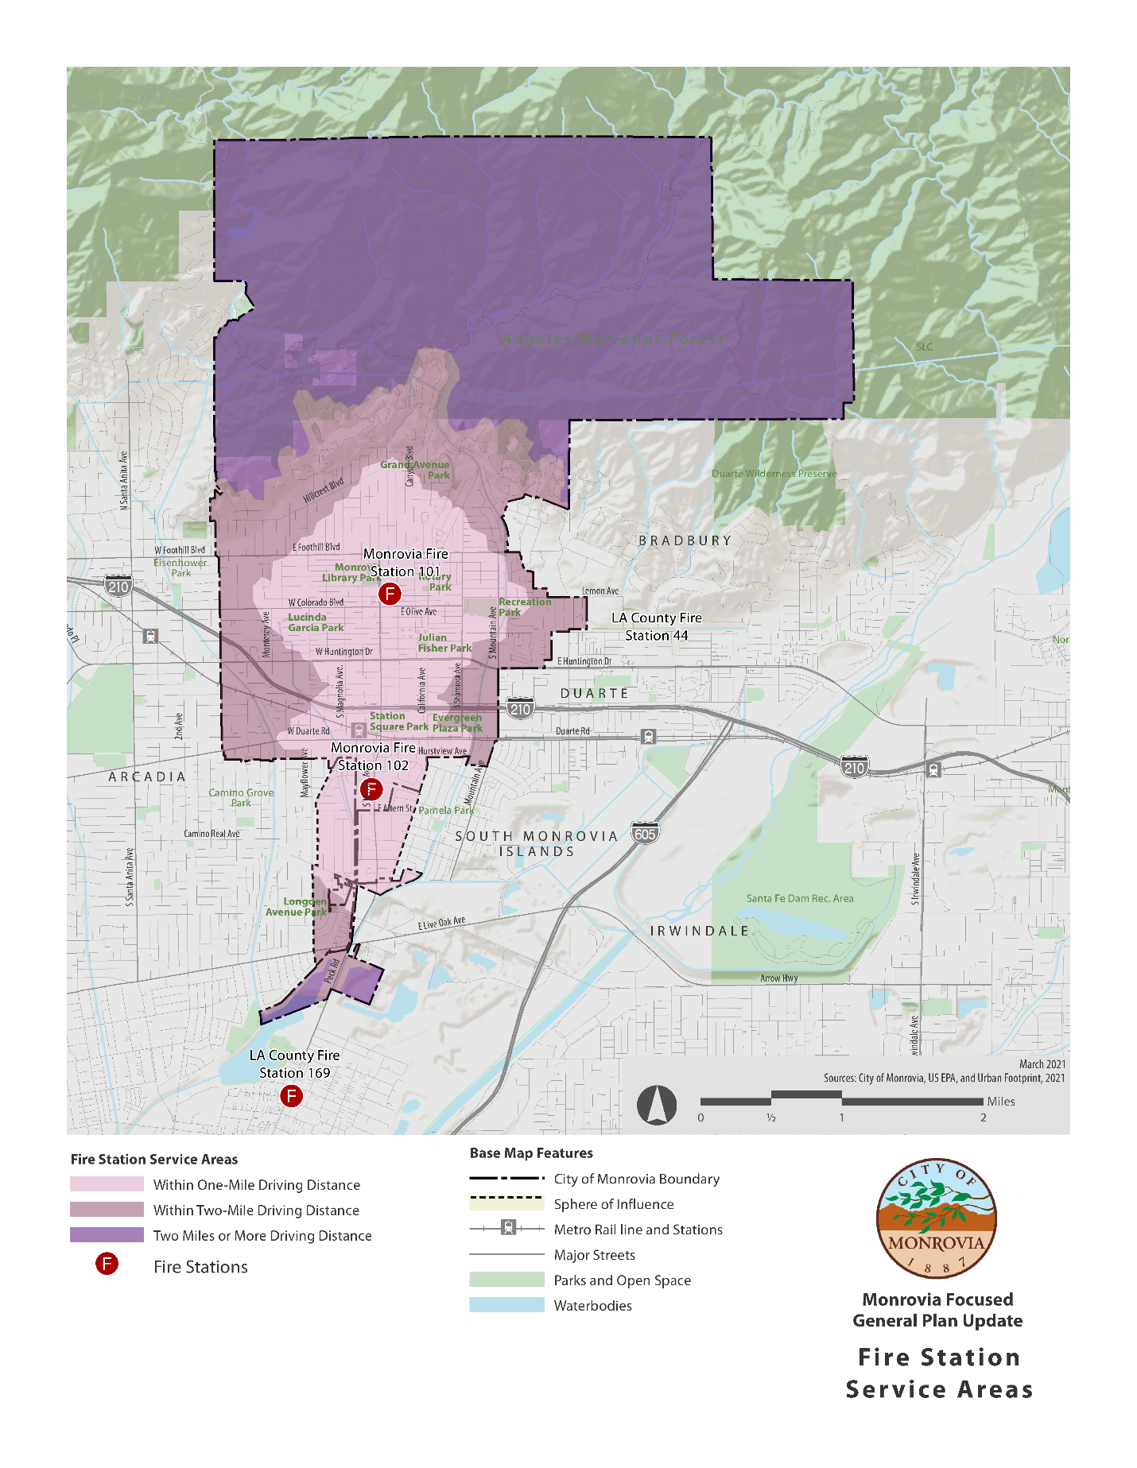

Figure 10: Police Station Service Areas
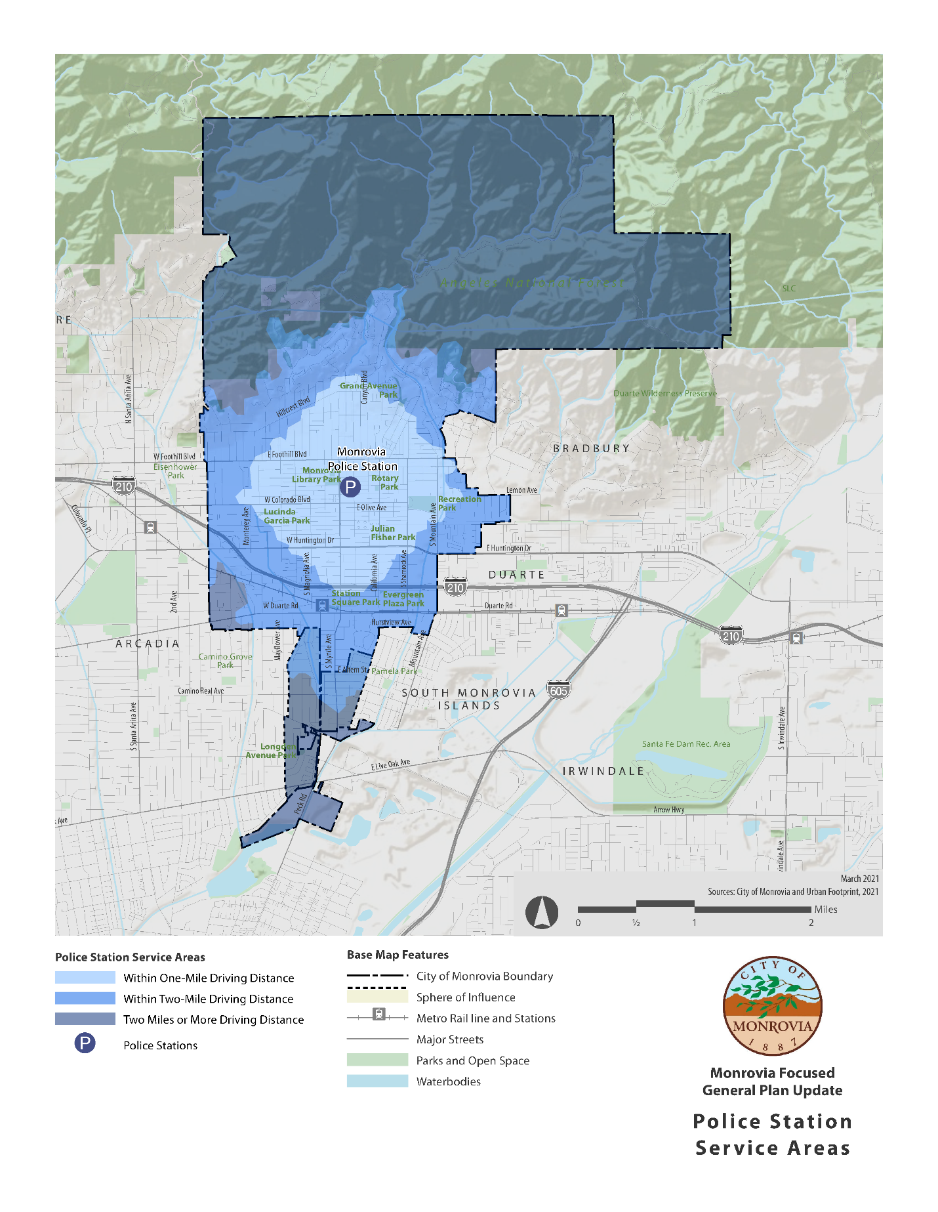

B. Goals, Objectives and Policies - Emergency Operations

Goal 4: Maximize the efficiency of City's Disaster Program.

Objective 4.1: Maximize the efficiency of City's Emergency Management Operations System
Policy 4.1.1: Conduct required Emergency Operation Center exercises to keep skills current.

Policy 4.1.2: Sponsor earthquake disaster drills at public schools including a community awareness program outlining a procedure where students would be reunited with their parents, after the disaster.

Policy 4.1.3: Require preparation of internal emergency response plans for medium and high-rise buildings.

Policy 4.1.4: Enact an ordinance requiring the preparation of internal emergency response plan for all facilities housing dependent population such as elderly.

Policy 4.1.5: Promote expansion of disaster recovery program to Include assurance of maximum citizen awareness.

Objective 4.2: Enact Ordinances to Aid in Prevention of Disasters.

Policy 4.2.1: In hillside areas, home sites must be planned, designed, and developed to provide maximum safety with respect to fire, earthquake faults, geology, drainage, erosion, and siltation hazards.

Policy 4.2.2: Give primary emphasis to the alleviation of the most critical hazards affecting existing populations and development.

Policy 4.2.3: Give greater emphasis to abatement strategies for dealing with critical hazards.

Policy 4.2.4: Employ incentives to encourage private actions aimed at reducing safety hazards.

Objective 4.3: Enact Ordinance to Aide in Evacuation of/or Access to Areas of Disasters.

Policy 4.3.1: Designate evacuation routes for all areas of the City.

Policy 4.3.2: In hillside areas, no cul-de-sac street shall have a length exceeding one thousand feet unless provided with an emergency access connector.

Policy 4.3.3: Hillside streets shall have minimum widths as specified in hillside development policies and standards.

Resources

http://www.scec.org - earthquake information
http://www.consrv.ca.gov - earthquake information

APPENDIX A

Vulnerability Assessment: Resiliency, Climate Adaptation, and Wildfire

APPENDIX B

Properties within a Seismic Zone

APPENDIX C

Properties within a Fire Hazard Zone

1. The Alquist-Priolo Earthquake Fault Zone Act, Department of Conservation, State of California, Division of Mines and Geology, 1972
Sierra Madre Fault Zone, http://www.scec.org/madre.html; May 25, 2000
3. http://www.scecdc.scec.org/raymond.html; May 25,2000.
6. Strategic Planning Report, Draft report, City of Monrovia, Fire Department, May 2000, page 3.
⁵ Ibid, page 4. ⁶ Ibid, page 4.
⁷ Ibid, page 4.

