## IconPurpose Statement

The Health and Safety Element is a required element of the General Plan. This element identifies potential natural and human-caused hazards that could affect the City of Hesperia’s (City’s) residents, businesses, and services; establishes a framework that anticipates these hazards and impacts; and prepares the community to minimize exposure to these risks. This element is also intended to improve the health of residents by incorporating healthy community policies and programs. These efforts are designed to reduce exposure to environmental pollution and improve air quality and address the need for healthy food physical activity, safe/sanitary housing, public facilities, and meaningful civic engagement. The Health and Safety Element seeks to protect life and property from impacts due to natural and human-made disasters as well as ensuring a healthy community.

To achieve these purposes, the Health and Safety Element: 1) identifies the potential hazards that can significantly affect Hesperia, 2) provides policies that, if implemented, can minimize the potential risk to residents, workers, and visitors; 3) provides policies that, if implemented, can reduce the losses to property resulting from a given disaster; 4) identifies procedures that the City can use to respond to emergency situations; and 5) addresses contemporary planning issues of community health and wellness. Investing in both public safety and community health helps make Hesperia more sustainable, viable, healthy, and prosperous.

The Health and Safety Element provides the public, decision makers, and City staff with policies that will help create a community that is minimally at risk from natural hazards; that responds quickly, effectively, and efficiently to hazards; and that is healthier for residents. This involves the design, development, and maintenance of neighborhoods, commercial areas, and industrial districts as safe and healthy places to live, shop, work, and interact. It also involves the development and maintenance of essential facilities that remain fully functional after a disaster. This element identifies disaster preparedness, response, and recovery systems that can reduce loss of life, injury, damage to property and infrastructure, and economic losses and social dislocation, and in the process promote sustainability.

## Background

### Relationship to State Law

Section 65302 of the State of California Government Code identifies seven mandatory elements in a general plan, including Health and Safety. Section 65302(g) of the Government Code requires that the Health and Safety Element contain background information and policies to address natural hazards, an analysis of vulnerabilities from climate change, policies to improve climate change adaptation and resilience, and an assessment of residential areas with evacuation constraints. Hesperia’s safety issues are:

* Seismic and geologic hazards
* Flood and inundation hazards
* Urban and wildfire hazards
* Hazardous waste and materials
* Emergency preparedness and response

Climate change resilience

Section 65302(h) of the California Government Code also requires that a general plan include goals, policies, and objectives to further environmental justice when a city has a disadvantaged area within its jurisdiction. In that event, the general plan must address seven required topics:

* Reduction of pollution exposure
* Improvement in air quality
* Opportunities for physical activity
* Access to healthy food
* Affordable, safe, and sanitary homes
* Access to public facilities and services

Increasing opportunities for resident involvement

This element includes a discussion for each health and safety issue and identifies goals and policies. This element is supported by the Safety and Healthy Community Background Reports (Appendix E and F), which provide detailed information for each issue addressed in this element.

### Consistency with the General Plan

The Health and Safety Element provides policy direction that complements the policies of other General Plan elements, most notably the Land Use, Conservation, Circulation, Housing, and Open Space Elements. Crucial relationships exist between the Health and Safety Element and the other General Plan elements. How land uses are determined in areas prone to hazards, what regulations limit development in these areas, and how hazards are mitigated for development, are issues that tie the elements together.

For instance, the Open Space Element considers how hazards affect City parks and facilities but also recognizes that parks can provide strategies to reduce flood risks. The Open Space Element strives to preserve and/or manage development in natural open space (e.g. washes, bluffs, ridges, etc.) that may cause damage to the built environment. The Housing Element is also closely tied to the Health and Safety and Circulation Elements because future development must be protected from hazards, be able to adapt to climate change hazards, and have access to evacuation routes.

Table SF-1 identifies the issues discussed in this element and identifies other elements that include discussions that also address these issues.

Table SF-1   
Coordination with Other Elements

|  |  |  |  |  |  |  |
| --- | --- | --- | --- | --- | --- | --- |
| ISSUES | Circulation | Conservation | Housing | Land Use | Noise | Open Space |
| **Safety** |  |  |  |  |  |  |
| Seismic and Geologic Hazards |  | X |  | X |  | X |
| Flooding Hazards | X | X |  | X |  | X |
| Fire Hazards | X | X |  | X |  | X |
| Hazardous Materials | X |  |  | X |  |  |
| Emergency Preparation/Response | X | X |  | X |  |  |
| Climate Change Resilience |  | X | X | X |  | X |
| Healthy Community | X | X | X | X | X | X |

### Consistency with Other Plans

The Health and Safety Element is also consistent with other local plans. These include the Hesperia Local Hazard Mitigation Plan, Emergency Operation Plan, Climate Action Plan, and various local regulations. This ensures that the City has a unified strategy to address the wide range of public safety and resilience issues affecting the community.

#### Hesperia Local Hazard Mitigation Plan

Hesperia’s Local Hazard Mitigation Plan (LHMP) is prepared in accordance with the federal Disaster Mitigation Act of 2000 and the Federal Emergency Management Agency’s (FEMA) hazard mitigation assistance guidance. Hesperia’s LHMP assesses hazard vulnerabilities from natural and human-caused hazards, including risk to people and facilities, and identifies short-term mitigation actions to reduce or eliminate hazard risks. Hazards evaluated in the LHMP include earthquake/geologic hazards, flooding, severe/extreme weather, dam failure/inundation, wildfire, human-caused hazards, and climate change. The current LHMP, as certified by the Federal Emergency Management Agency, is incorporated into this Health and Safety Element by reference, as permitted by California Government Code Section 65302.6. It is available online at: https://www.cityofhesperia.us/1307/Hazard-Mitigation.

#### Hesperia Emergency Operations Plan

The City of Hesperia’s Emergency Operations Plan is an all-hazard plan that describes how Hesperia will respond to large-scale emergencies and disasters in the City. The Emergency Operations Plan is used to implement operational procedures and protocols to protect public safety. The Emergency Operations Plan includes a framework for emergency management activities along with responsibilities for the various City departments. The Emergency Operations Plan is a collaborative effort among City departments with input from San Bernardino County Sheriff's Department, San Bernardino County Fire Protection District, Hesperia Unified School District, healthcare entities, businesses, and local stakeholders. More information about the plan can be found on the City’s website at: <http://ca-hesperia.civicplus.com/1446/Emergency-Operations>.

#### Hesperia Climate Action Plan

The Climate Action Plan describes a series of community-wide and municipal measures and actions that will aid the City in reducing GHG emissions to meet community goals. The Climate Action Plan outlines a course of action for the City government and the community of Hesperia to reduce per capita greenhouse gas emissions and adapt to effects of climate change. It provides clear guidance to City staff regarding when and how to implement key provisions and sets an implementation and monitoring framework for its strategies. Furthermore, it demonstrates that the General Plan Update policies and Climate Action Plan strategies would reduce emissions to the reduction target. The Climate Action Plan is available online at: <https://www.cityofhesperia.us/409/Hesperia-General-Plan>.

#### Healthy Community Technical Report

Hesperia commissioned a Healthy Community Technical Report (Appendix F) to provide baseline information that could support the goals, policies, and programs for this general plan element. This report analyzed the health of Hesperia residents; identified disadvantaged communities using state- and locally defined criteria in Government Code Section 65302; analyzed features of the City’s built and social environment that need to be improved based on a community survey; and concluded with an analysis of unincorporated disadvantaged communities to comply with state law.

The Healthy Community Technical Report documented significant health challenges facing residents of Hesperia, but conditions which are also prevalent in the High Desert as a whole. These include premature adverse health conditions among residents, high prevalence of risk factors that could be reduced, and links to the conditions of the built environment. Equally important, many of the City’s residential neighborhoods have lower resources and could therefore benefit from proactive programs that direct additional investments in infrastructure, housing, and services for them.

#### Vulnerability Assessment Technical Report

Under California law, the safety element is required to include a vulnerability assessment that looks at how people, buildings, infrastructure, and other key community assets may be affected by climate change. The City’s Climate Change Vulnerability Assessment analyzes how eight different climate-related hazards (air quality and smoke, drought, extreme temperatures, human health hazards, flooding, landslides, severe storms, and wildfire) may affect 48 different population groups and community assets. Each population or asset received a score of low, medium, or high vulnerability for each climate-related hazard.

The Vulnerability Assessment indicates that Hesperia’s populations and assets are most vulnerable to wildfire, extreme temperatures, and severe storms. Populations are specifically most vulnerable to wildfire, extreme temperatures, and severe weather, which directly affect health. The most vulnerable population groups are persons with chronic illness and/or disabilities, seniors, households in poverty, linguistically isolated immigrant communities, and homeless persons. Hazards such as wildfire, extreme temperatures, and severe weather pose heightened risks to these groups due to socioeconomic and health factors, including lack of access to healthcare in the high desert region.

To increase community resilience and help lower vulnerability, the Health and Safety Element includes goals and policies, several of which are particular to the populations and assets that received a score of “high” in the Vulnerability Assessment. Hesperia’s Vulnerability Assessment is included in the Safety Element Background Report, **Appendix E** to this element.

## Issues

### Seismic and Geologic Hazards

Seismic and geologic hazards are caused by the movement of different parts of the earth’s surface. Seismic hazards include earthquakes and hazardous events caused by them. Geologic hazards involve land movements that are not linked to seismic activity but can inflict harm to people or property.

#### Seismic Hazards

Seismic activity occurs along boundaries in the earth’s crust, called faults. Pressure along the faults builds over time and is ultimately released, resulting in ground shaking, commonly referred to as an earthquake. Earthquakes can also trigger other hazards, including surface rupture (cracks in the ground surface), liquefaction (causing loose soil to lose its strength), landslides, and subsidence (sinking of the ground surface).

##### Earthquakes

Earthquakes present the greatest potential for loss of life or property and economic damage in Hesperia. Damaging earthquakes affect widespread areas and trigger many secondary effects that can overwhelm the ability of local jurisdictions to respond. Nearby faults include the San Andreas, North Frontal, Cleghorn, Cucamonga, Helendale, and San Jacinto faults. All of these faults have the potential to generate moderate to large earthquakes.

Southern California is known for the San Andreas Fault, a 400-mile-long fault running from the Mexican border to a point offshore west of San Francisco. The San Andreas Fault is the principal boundary between the Pacific and North American Plates. This fault is the “master fault” in Southern California because it has frequent large earthquakes and controls the seismicity of the area.

The closest zoned faults include the North Frontal Fault, which includes the Ord Mountains Fault, approximately two miles east of Hesperia; the Ord Mountains Fault; and the San Andreas Fault, approximately four miles to the southwest at its closest point. The North Frontal Fault, given its location near Hesperia, has the potential to cause the most severe shaking in the city; loss estimation modeling indicates that a maximum magnitude 7.2 earthquake on this fault would be a worst-case scenario for the city.

There are no Alquist-Priolo Earthquake Fault Zones in the city. **Exhibit SF‑1** shows the location of regional faults and Alquist-Priolo Fault Zones.

Earthquakes are likely to continue to occur on an occasional basis. A major earthquake along any of the nearby faults could result in substantial casualties and damage, although the greatest risk in Hesperia is from the North Frontal Fault and San Andreas Fault due to their proximity and high potential to cause a severe earthquake. A major earthquake on either fault could damage or destroy transportation infrastructure, such as I-15, SR-138, SR-173, SR-395, or bridges, limiting access in and out of the community.

##### Liquefaction

In addition to ground shaking, earthquakes may generate surface fault rupture and secondary ground failure in the form or liquefaction or slope failure. In addition to the physical damage from the motion of an earthquake, damage can result from liquefaction. Liquefaction happens primarily in saturated, loose, fine- to medium-grained soils in areas where the groundwater table is within 50 feet of the surface. Soils susceptible to liquefaction are typically found in low-lying, current, or former floodplains. Geologically young, loose, unconsolidated sediments occur throughout the Hesperia area, but shallow groundwater occurs only within the Mojave River floodplain, where water has been recorded at depths of less than 30 feet Therefore, areas along the floodplains of Mojave River are likely to face liquefaction during an earthquake and liquefaction-related lateral spreads, which can occur adjacent to stream channels and deep washes. Lateral spreads can cause extensive damage to pipelines, utilities, bridges, roads, and other structures.

##### Slope Failure

Slope failure is a common secondary effect of earthquakes. Although most of Hesperia is on terrain that is basically level or gently sloping, there are a few natural slopes in the southern portion of the city vulnerable to this hazard.

***Seiches***

Seiches due to seismic shaking could occur in Silverwood Lake, Hesperia Lake, and any recharge basin in the City that is filled with water at the time of the earthquake. In unlined lakes and basins, sloshing of water against the basin sides could result in erosion and surficial slope failures.

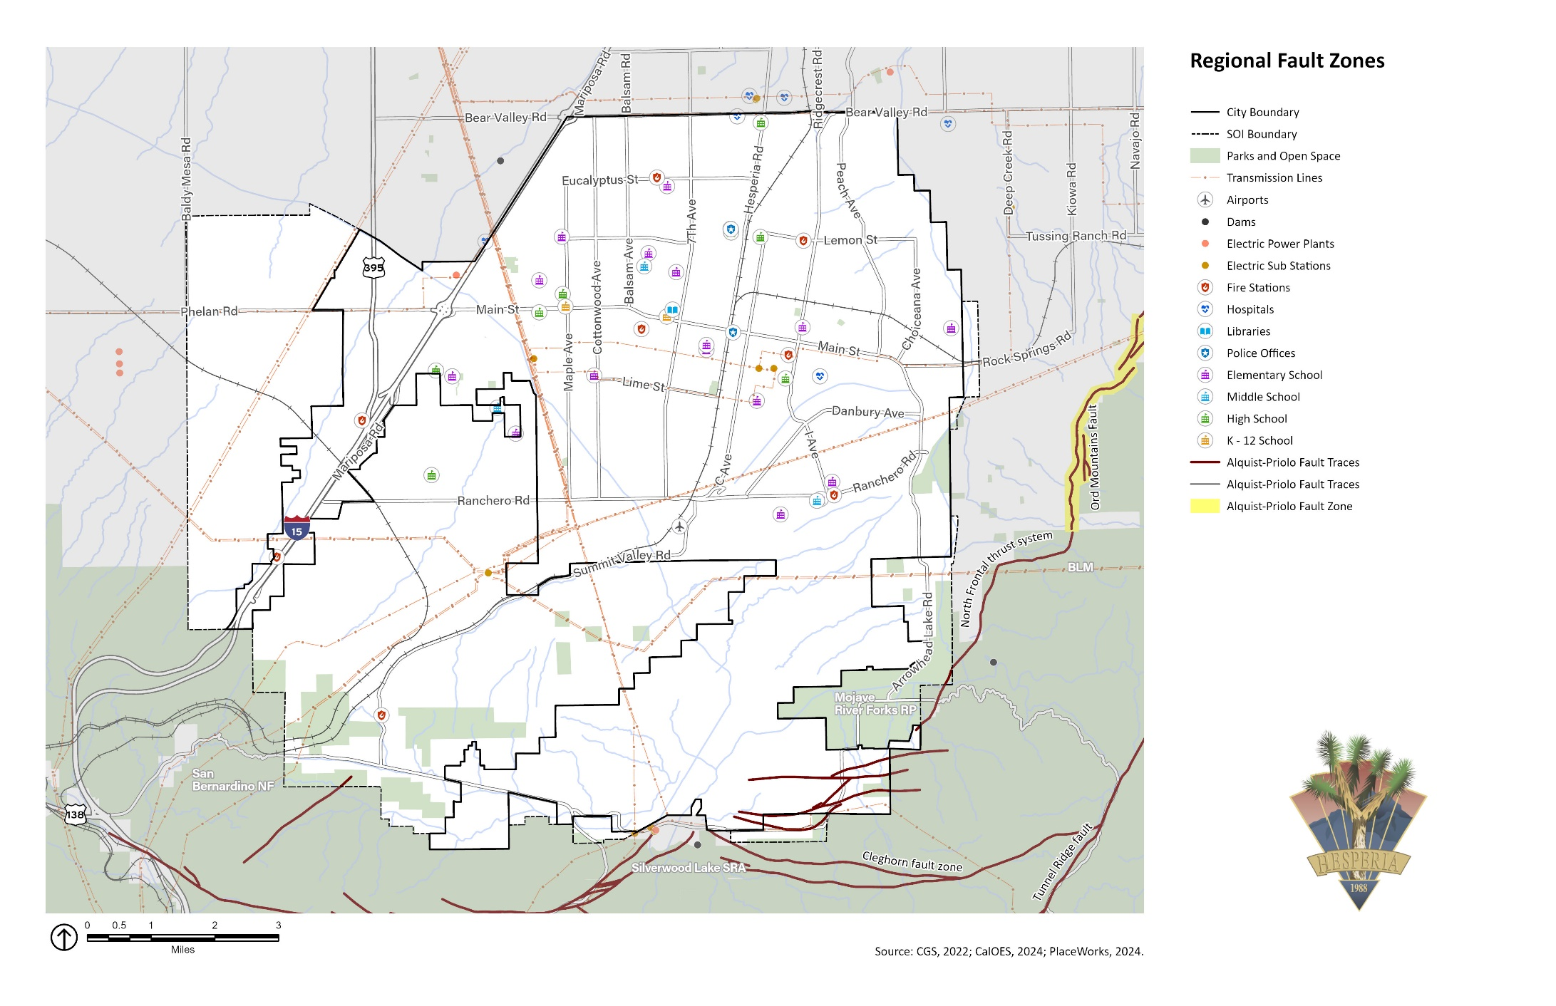Exhibit SF-1 Regional Fault Lines

#### Geologic Hazards

Hesperia lies within the Mojave Desert Province, an arid region of overlapping alluvial fans, desert plains, dry lakebeds, and scattered mountain ranges. Hesperia is underlain by the informally named Victorville Fan, which is shed primarily from the San Gabriel Mountains, and whose composition reflects the rocks eroded by the various streams that enter the valley from the south. Deposition is ongoing, with the youngest alluvium filling drainage channels and the Mojave River floodplain.

Geologic hazards such as landslides, erosion, and subsidence depend on the geologic composition of the area. Landslides and rock falls usually occur in sloped areas, especially areas with steep slopes, and in loose and fragmented soil areas. Landslides, rockfalls, and debris flows occur continuously on all slopes—some processes act very slowly, others are sudden. Groundwater withdrawal is a major cause of subsidence because it can lead to compaction of fine-grained sediments like clay.

The foothills in southern Hesperia are in moderate to very high landslide susceptibility zones. Landslides pose the greatest geologic hazard in the City and are more likely in winter during heavy rainfall years. **Exhibit SF-2** illustrates areas in Hesperia that are most susceptible to landslides.

Climate change may result in heavier rainfall periods and drier dry periods, and rainfall may be concentrated in more intense precipitation events. Heavy rainfall could increase the number of landslides or make landslides larger than normal. Increased wildfire frequency can destabilize hillsides due to loss of vegetation and changes in soil composition, contributing to greater runoff and erosion. The combination of drier climate in the future, wildfires, and the occasional extreme downpour is likely to cause more mudslides and landslides.

Hesperia is also susceptible to hazards from erosion, which is the geological process in which earthen materials are worn away and transported by natural forces, such as water or wind, causing the soil to deteriorate. Eroded topsoil can be transported into streams and other waterways. Water erosion is when water removes soil and transports it elsewhere. Highly erosive soil can damage roads, bridges, buildings, and other structures.

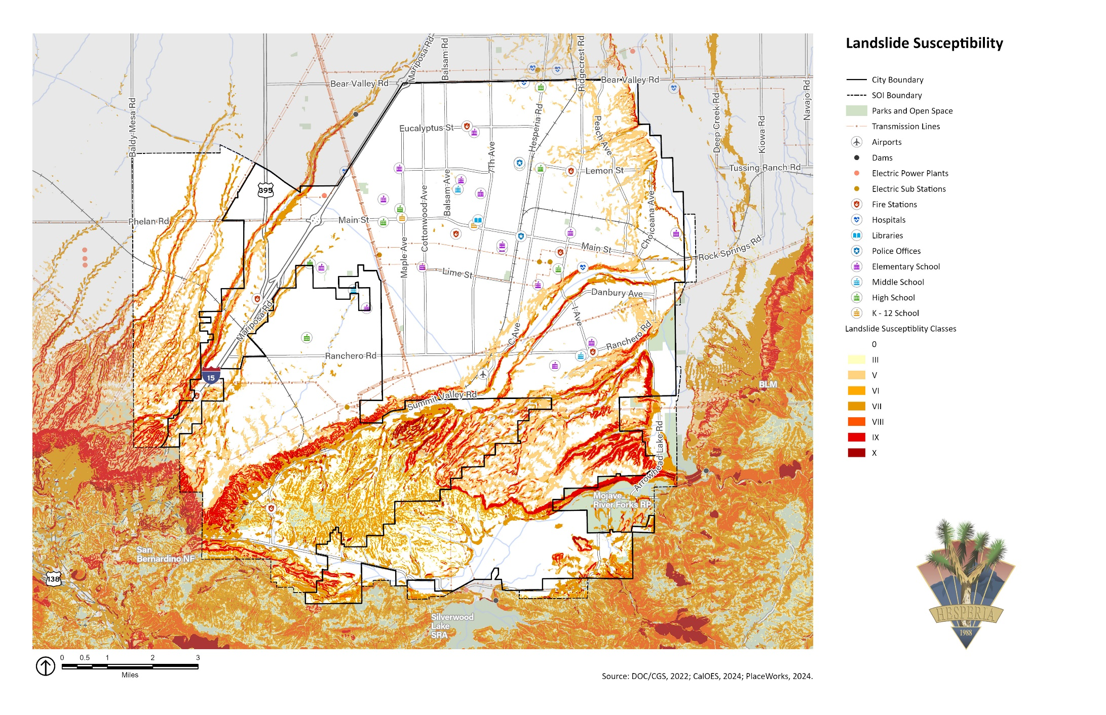Exhibit SF-2 Landslide Susceptibility Areas

The following goal and implementation policies aim to reduce the effects of seismic and geologic hazards in the city of Hesperia:

|  |  |
| --- | --- |
| Goal SF-1 | Minimize injury, loss of life, property damage, and economic and social disruption caused by seismic shaking and other earthquake-induced hazards, and by geologic hazards such as slope instability, compressible and collapsible soils, and subsidence. |
| Policy SF-1.1 | Require preparation of geotechnical and engineering geological investigations, prepared by State-certified professionals (geotechnical engineers and engineering geologists, as appropriate) following the most recent guidelines by the California Geological Survey and similar organizations, as a condition of approval, for all projects proposed in areas identified as within geologic and/or seismic hazard zones (see Exhibits SF-1 and SF-2). These reports shall provide mitigation measures to reduce those hazards identified at a site to an acceptable level. City staff that review geotechnical, geological, and structural reports submitted by development applicants, and that review grading operations, shall have the necessary professional credentials and certifications in their area of expertise to conduct these reviews. |
| Policy SF-1.2 | Require development to minimize grading and other changes to the natural topography to protect public safety and reduce the potential for property damage as a result of geologic hazards. |
| Policy SF-1.3 | Require preparation of liquefaction assessment studies, as a condition of approval, for all projects proposed in areas identified by the California Department of Conservation as potentially susceptible to liquefaction. The studies shall be prepared by State-certified professionals (geotechnical engineers and engineering geologists, as appropriate) following the most recent guidelines by the California Geological Survey. |
| Policy SF-1.4 | Encourage owners of unreinforced masonry buildings to assess the seismic vulnerability of their structures and conduct seismic retrofitting as necessary to improve the buildings’ resistance to seismic shaking. |

### Flooding Hazards

Flooding is when water rises and overflows onto normally dry land. Floods are one of the most frequent natural hazards in Hesperia and among the costliest natural disasters nationwide in terms of human hardship and economic loss. They cause substantial damage to structures, landscapes, and utilities as well as life and safety issues.

Floods prompt the second-greatest number of disaster declarations in the state and are a regular feature in Hesperia. To maintain flood insurance for properties throughout the City, Hesperia adopts and maintains Flood Hazard Protections Regulations as required by FEMA. On August 20, 2023, tropical Storm Hilary caused significant damage in San Bernardino County, including Hesperia, with initial estimates indicating repair costs could reach $26 million. The storm caused extensive damage to public infrastructure, including bridges, roads, and water basins.

Like most of southern California, Hesperia is subject to unpredictable rainfall. Every few years, the region is subjected to periods of intense and sustained precipitation. Most of the flooding happens in the numerous washes, natural drainage courses, drainage easements, and floodways. Construction of the Mojave Forks Dam in 1971 greatly reduced the impact of flooding along the Mojave River, although a few parcels adjacent to the river are still at risk. Most of Hesperia is on alluvial fans, flat to sloping areas covered with sediment deposited by shallow, intermittent streams that spread out from their source in the mountains to the south. Alluvial fan flooding is unpredictable, and floodwaters can travel at dangerously high speeds, be highly erosive, and can carry large amounts of sediment and other debris. These characteristics make it difficult to assess the flood risk and develop reliable mitigations for alluvial fans.

Areas at an elevated risk of flooding are divided into 100- and 500-year flood zones. A 100-year flood zone has a 1 percent chance of experiencing a major flood in any given year, and a 500-year flood zone has a 0.2 percent chance of flooding in any given year. The 100-year floodplain in Hesperia is primarily along the Mojave River, Antelope Valley Wash, and Summit Valley, as shown on **Exhibit SF-3**.

Several structures in the Antelope Valley Wash area are in this zone. In the Summit Valley area, most homes are above the floodplain, but access to these homes can be cut off during severe flooding of the West Fork of the Mojave River. SR-138, SR-173, and several major roadways, including I Avenue, Rock Springs Road, and Ranchero Road, are within the 100-year flood zone. Owners of all structures in the 100-year flood zone are required to purchase and maintain flood insurance as a condition of receiving a federally backed mortgage or home equity loan on that structure.

Though climate change may not change average precipitation levels significantly, it is expected to cause more years with extreme precipitation events, that is, more years with intense storm systems that drop substantial volumes of rain over a short period and cause flooding. Because of this, floods are expected to happen more often in Hesperia, and climate change may expand the parts of the City that are considered prone to flooding.

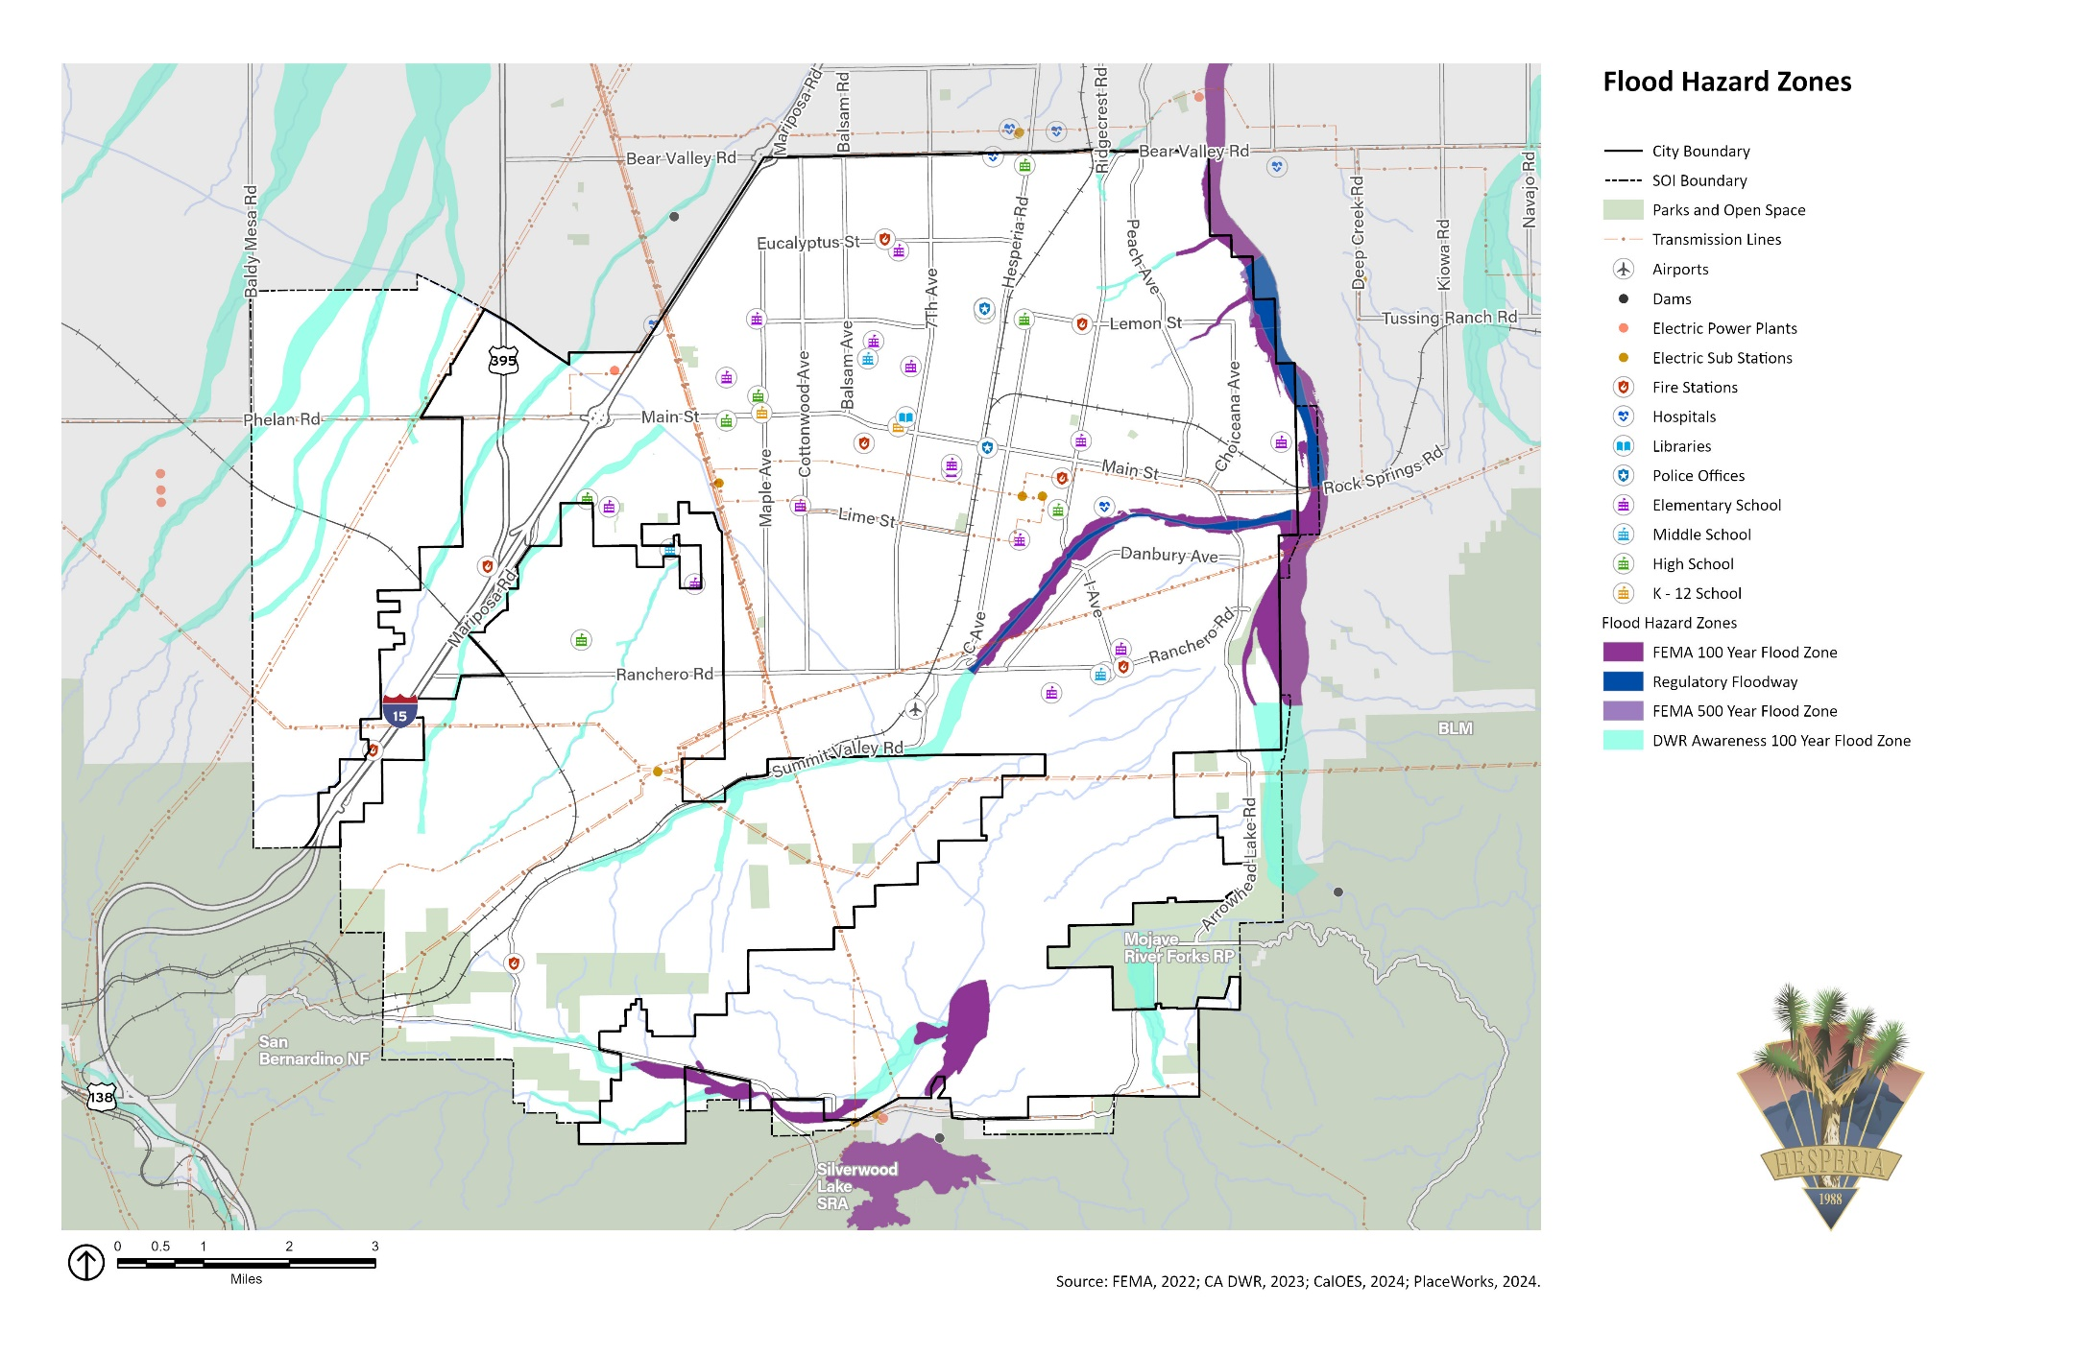Exhibit SF-3 Flood Hazard Zones

#### Dam Failure

A dam failure is an uncontrolled release of water from a reservoir because of structural failures or deficiencies. Dam failures can range from minor to catastrophic, harming human life and property downstream. In addition, ecosystems and habitats can be destroyed by fast-moving floodwaters, debris, and sedimentation from the inundation. Failures are rare but not unprecedented; they can be caused by overtopping, foundation defects, piping and seepage failures, or conduit and valve failures. Many dam failures are the secondary result of other natural disasters, such as earthquakes, landslides, and extreme storms.

Three dams can inundate portions of Hesperia if they fail—the Mojave Forks Dam, owned by the U.S. Army Corps of Engineers; the Cedar Springs Dam; and Lake Arrowhead Dam, owned by the California Department of Water Resources. The Amethyst Basin Dam is to the north of the city limits, and the inundation area would not flood areas within Hesperia.

As shown on **Exhibit SF-4**, if these dams outside the City’s boundary failed, the inundation zone would generally be confined to land adjacent to the Mojave River along the City’s eastern border. Water released by the Mojave Forks Dam would be confined to the bed of the Mojave River, the mouth of Antelope Valley Wash channel, and several other smaller tributaries. Water released by the Cedar Springs Dam would flood a significant portion of eastern Summit Valley, an area that is mostly undeveloped except for SR-173. Water from Lake Arrowhead Dam would most likely be contained in the Mojave Forks reservoir.

As mandated by the National Dam Inspection Act, the U.S. Army Corps of Engineers has the responsibility to conduct inspections of all dams under federal control, including Mojave Forks Dam. The purpose of these inspections is to check the structural integrity of the dam and appurtenant structures, ensuring protection of human life and property. Periodic inspections disclose conditions that might disrupt operation or dam safety.

The California Department of Water Resources (DWR), Division of Safety of Dams, inspects dams on an annual basis to ensure they are safe and perform as intended. DWR also reviews applications for dam construction, removal, alteration, or repair; has inspection oversight over dam construction projects; and periodically reviews the stability of dams and their critical related structures. The Division of Safety of Dams works closely with dam owners to identify and correct issues on an ongoing basis.

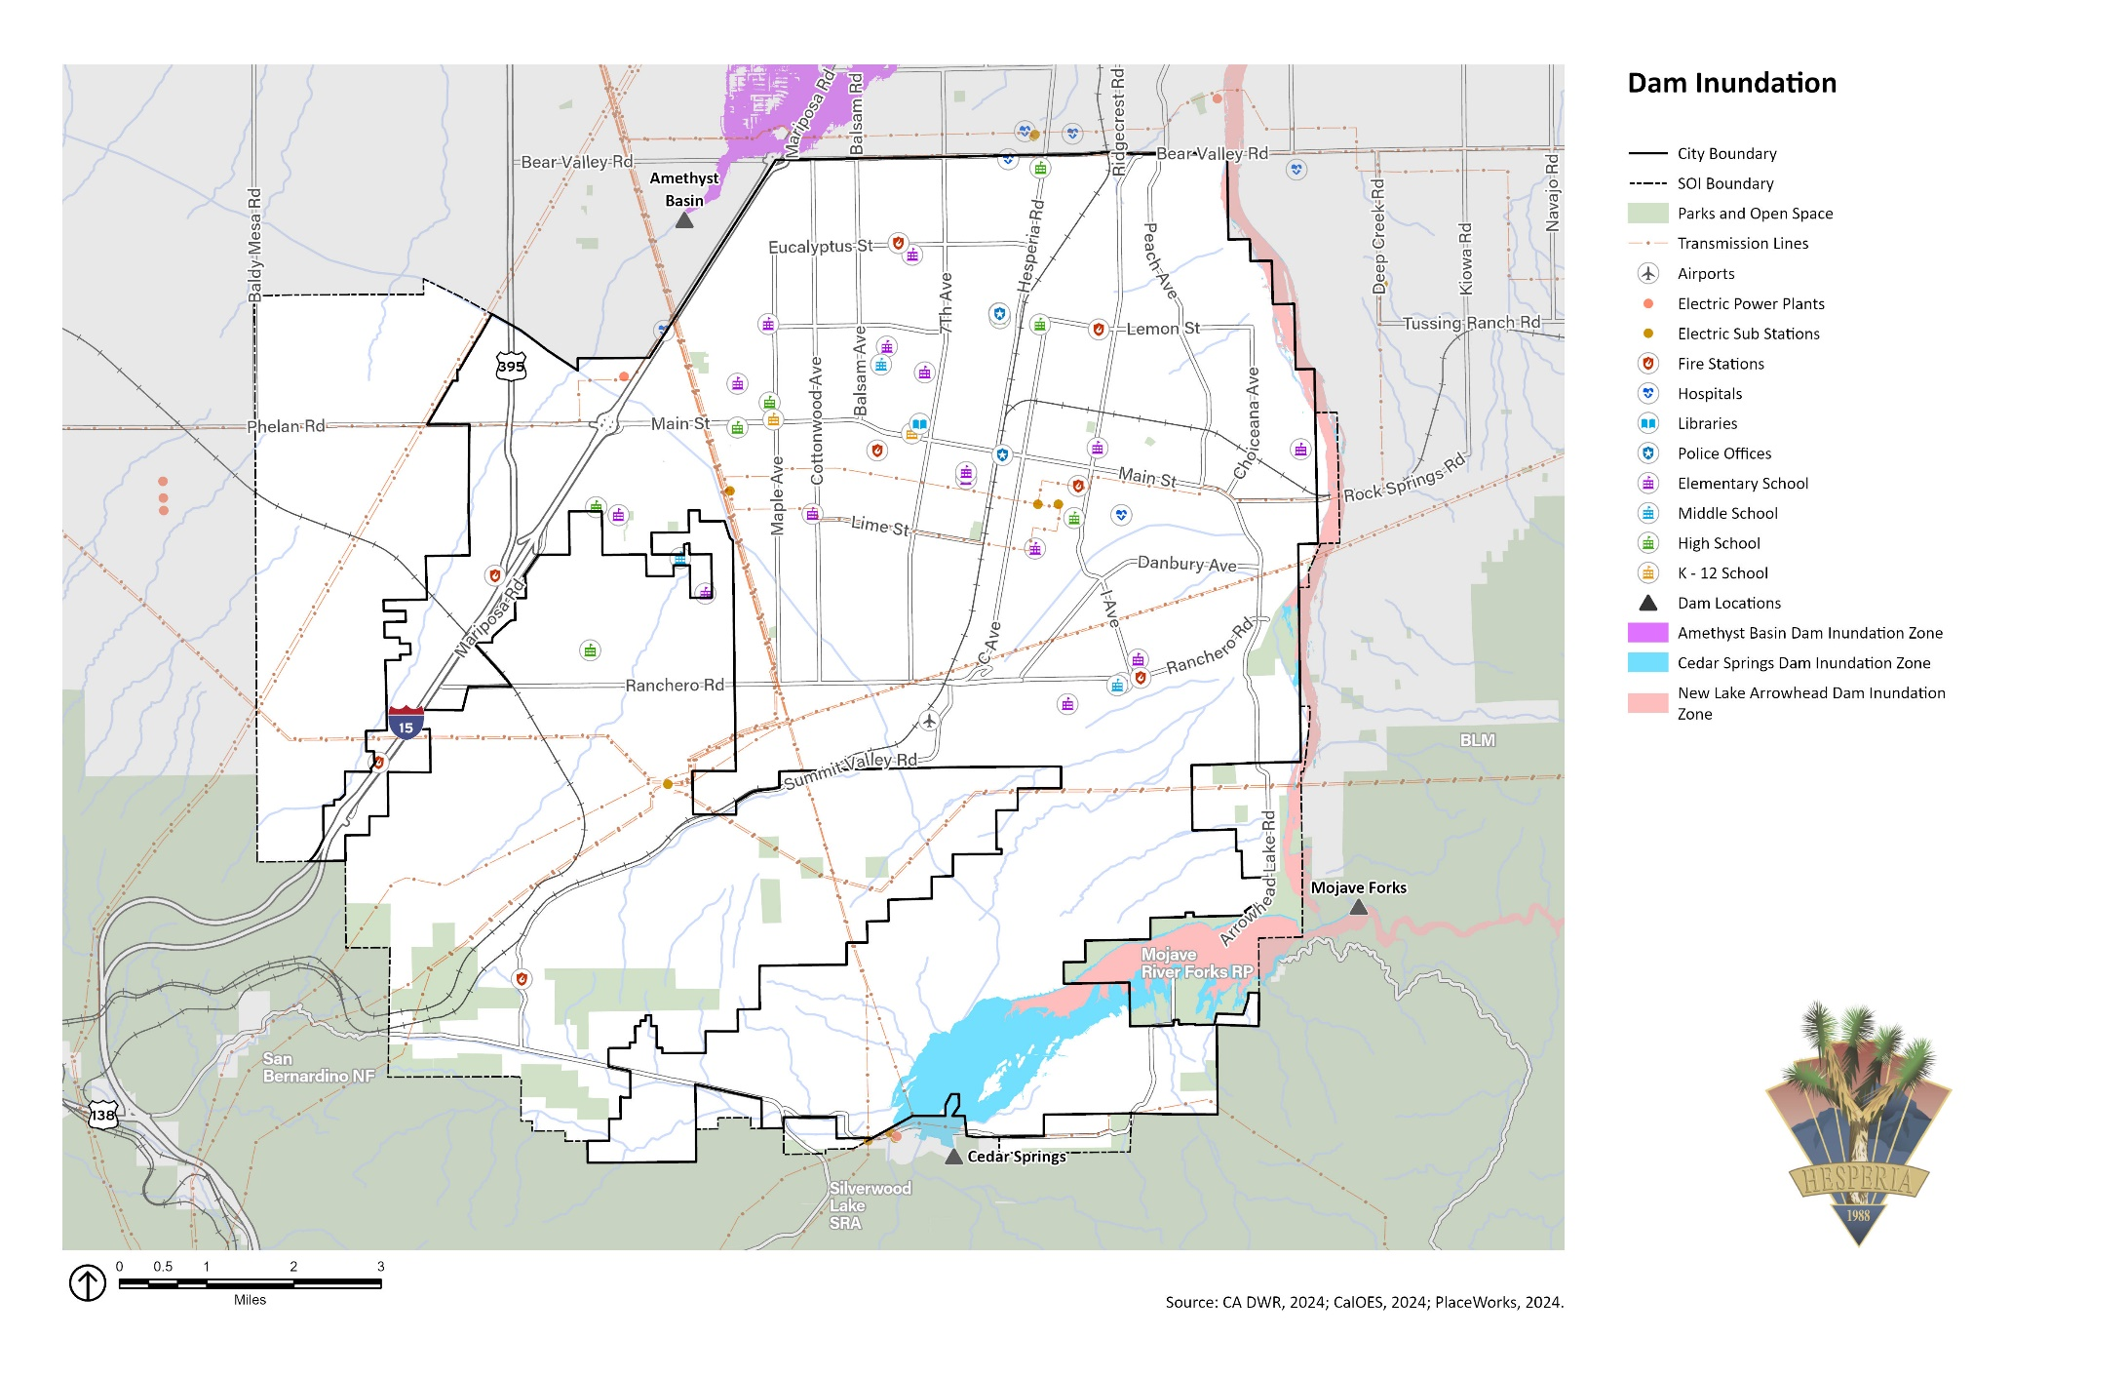Exhibit SF-4 Dam Inundation Areas

To reduce the impacts of flooding and dam inundation, the City will act on the following goal and implementation policies.

|  |  |
| --- | --- |
| Goal SF-2 | Minimize injury, loss of life, property damage, and economic and social disruption caused by flooding and inundation hazards. |
| Policy SF-2.1 | Require hydrological studies, prepared by a State-certified engineer with expertise in this area, as a condition of approval for all projects proposed in the 100-year or 500-year floodplain, as shown on Exhibit SF-3. These studies shall assess the impact that the new development will have on the flooding potential of existing development down-gradient. The studies shall provide mitigation measures to reduce this impact to an acceptable level. Single-family homes shall be exempt, except for infill lots with natural drainage courses, washes, master plan of drainage are subject to providing hydrology reports. |
| Policy SF-2.2 | Participate in the National Flood Insurance Program and require that all owners of properties located within the 100-year floodplain and repeat-flood properties in the 500-year floodplain purchase and keep flood insurance for those properties. |
| Policy SF-2.3 | Maintain, and improve where needed, the storm drain systems, with an emphasis on those areas that flood repeatedly. This entails maintaining and regularly cleaning the storm drains and other flood-control structures in low-lying areas so floodwaters can be effectively conveyed away from structures. Explore the construction of additional drainage channels where necessary. |
| Policy SF-2.4 | Coordinate with the Hesperia Recreation and Park District to explore the use of floodplains as parks, nature trails, equestrian parks, golf courses, or other types of recreational facilities that can withstand periodic inundation. |
| Policy SF-2.5 | Encourage new development and existing property owners to slow or absorb floodwaters, including through installation of permeable pavements and green infrastructure. |
| Policy SF-2.6 | Coordinate with the Hesperia Recreation and Park District and surrounding jurisdictions to conduct habitat restoration projects in passive recreation areas to improve the capacity of local ecosystems to absorb or slow floodwaters. |
| Policy SF-2.7 | Prepare to respond to a potential dam failure from dams shown in Exhibit SF-4. |

### Fire Hazards

Fire hazards include wildfires, wildland-urban interface fires, and structural fires. The combination of complex terrain, climate, vegetation, and development patterns contributes to an elevated risk of wildfire. Historically, the fire season extended from early summer through late fall of each year during the hotter, dryer months, although fires can occur year-round. Fire conditions arise from a combination of high temperatures, low moisture content in the air and plants, accumulation of vegetation, and high winds.

#### Wildfire

Wildfires are a necessary part of the natural ecosystem in southern California, but they become a hazard when they extend out of control into developed areas and cause loss of property, injuries, or loss of life.

Wildfires occur on mountains, hillsides, and grasslands. Fuel, weather, and topography are primary factors that affect how wildfires spread. Hesperia is in the lower Mojave section of the Southeastern Deserts Bioregion, an area characterized by isolated, steep-sided mountain ranges separated by broad alluvial basins. The predominant vegetation types in this area are desert shrub, creosote bush shrub, and succulent shrub. Other important vegetation types include Joshua Tree woodland, shad-scale scrub, blackbrush scrub, and desert scrub-steppe. Approximately one-third of the desert floor in the Mojave section is devoid of vegetation, limiting the surface fuel loads available to burn. However, flammable vegetation exists in the southern hillsides of Hesperia. The climate of Hesperia keeps the grass dry and more readily combustible during fire season.

Several historic wildfires have impacted Hesperia, shown on **Exhibit SF-5**. On June 19, 2024, the Hesperia Fire burned 1,330 acres in southeastern Hesperia. An evacuation warning was ordered for the Lake Arrowhead Equestrian Estates neighborhood.

Changing climate is expected to increase the wildfire risk in and around Hesperia. Warmer temperatures brought on by climate change can exacerbate drought conditions, weakening plants and creating more fuel for wildfires. Increased winds result in more erratic fire behavior, making fires harder to contain. Warmer temperatures are also expected to last until later in the year, extending the wildfire season.

#### Fire Hazard Severity Zone

The California Department of Forestry and Fire Protection establishes Fire Hazard Severity Zones, designated as moderate, high, or very high severity. Incorporated areas such as Hesperia are considered local responsibility areas. **Exhibit SF-6** shows the Fire Hazard Severity Zones in and around Hesperia. California law requires properties in a Very High Fire Hazard Severity Zone or in a State Responsibility Area to be disclosed in real estate transactions. This is important because the relatively rapid turnover of home ownership can create an information gap; as a result, uninformed homeowners in fire hazard areas may attempt landscaping or other home modifications that could increase the risk of fire hazards.

#### Wildland-Urban Interface Area

In addition to the Very High Fire Hazard Severity Zone designation by the California Department of Forestry and Fire Protection, the City has areas designated as Wildland-Urban Interface. The Wildland-Urban Interface is an area where buildings (e.g., housing) and infrastructure (e.g., cell towers and water supply facilities) mix with flammable wildland vegetation, allowing wildland fires to spread to buildings and structures easily. **Exhibit SF-7** identifies the Wildland-Urban Interface in Hesperia.

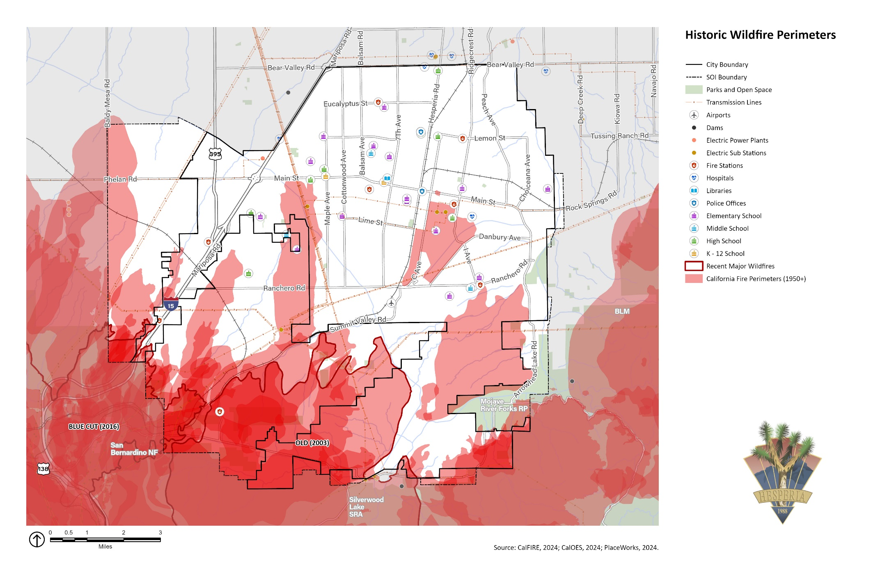Exhibit SF-5 Historic Wildfire Perimeters

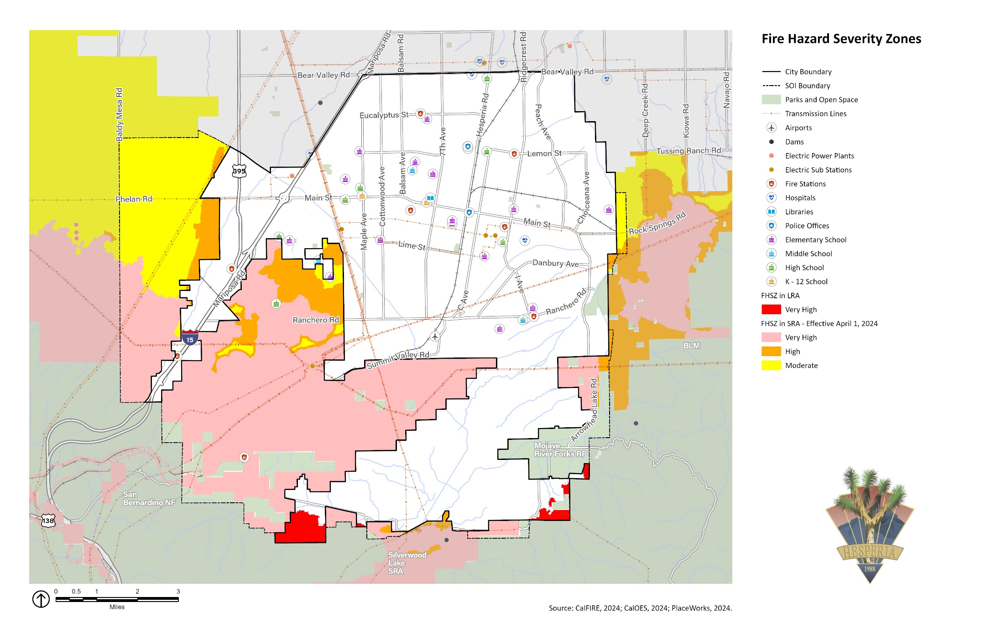Exhibit SF-6 Fire Hazard Severity Zones

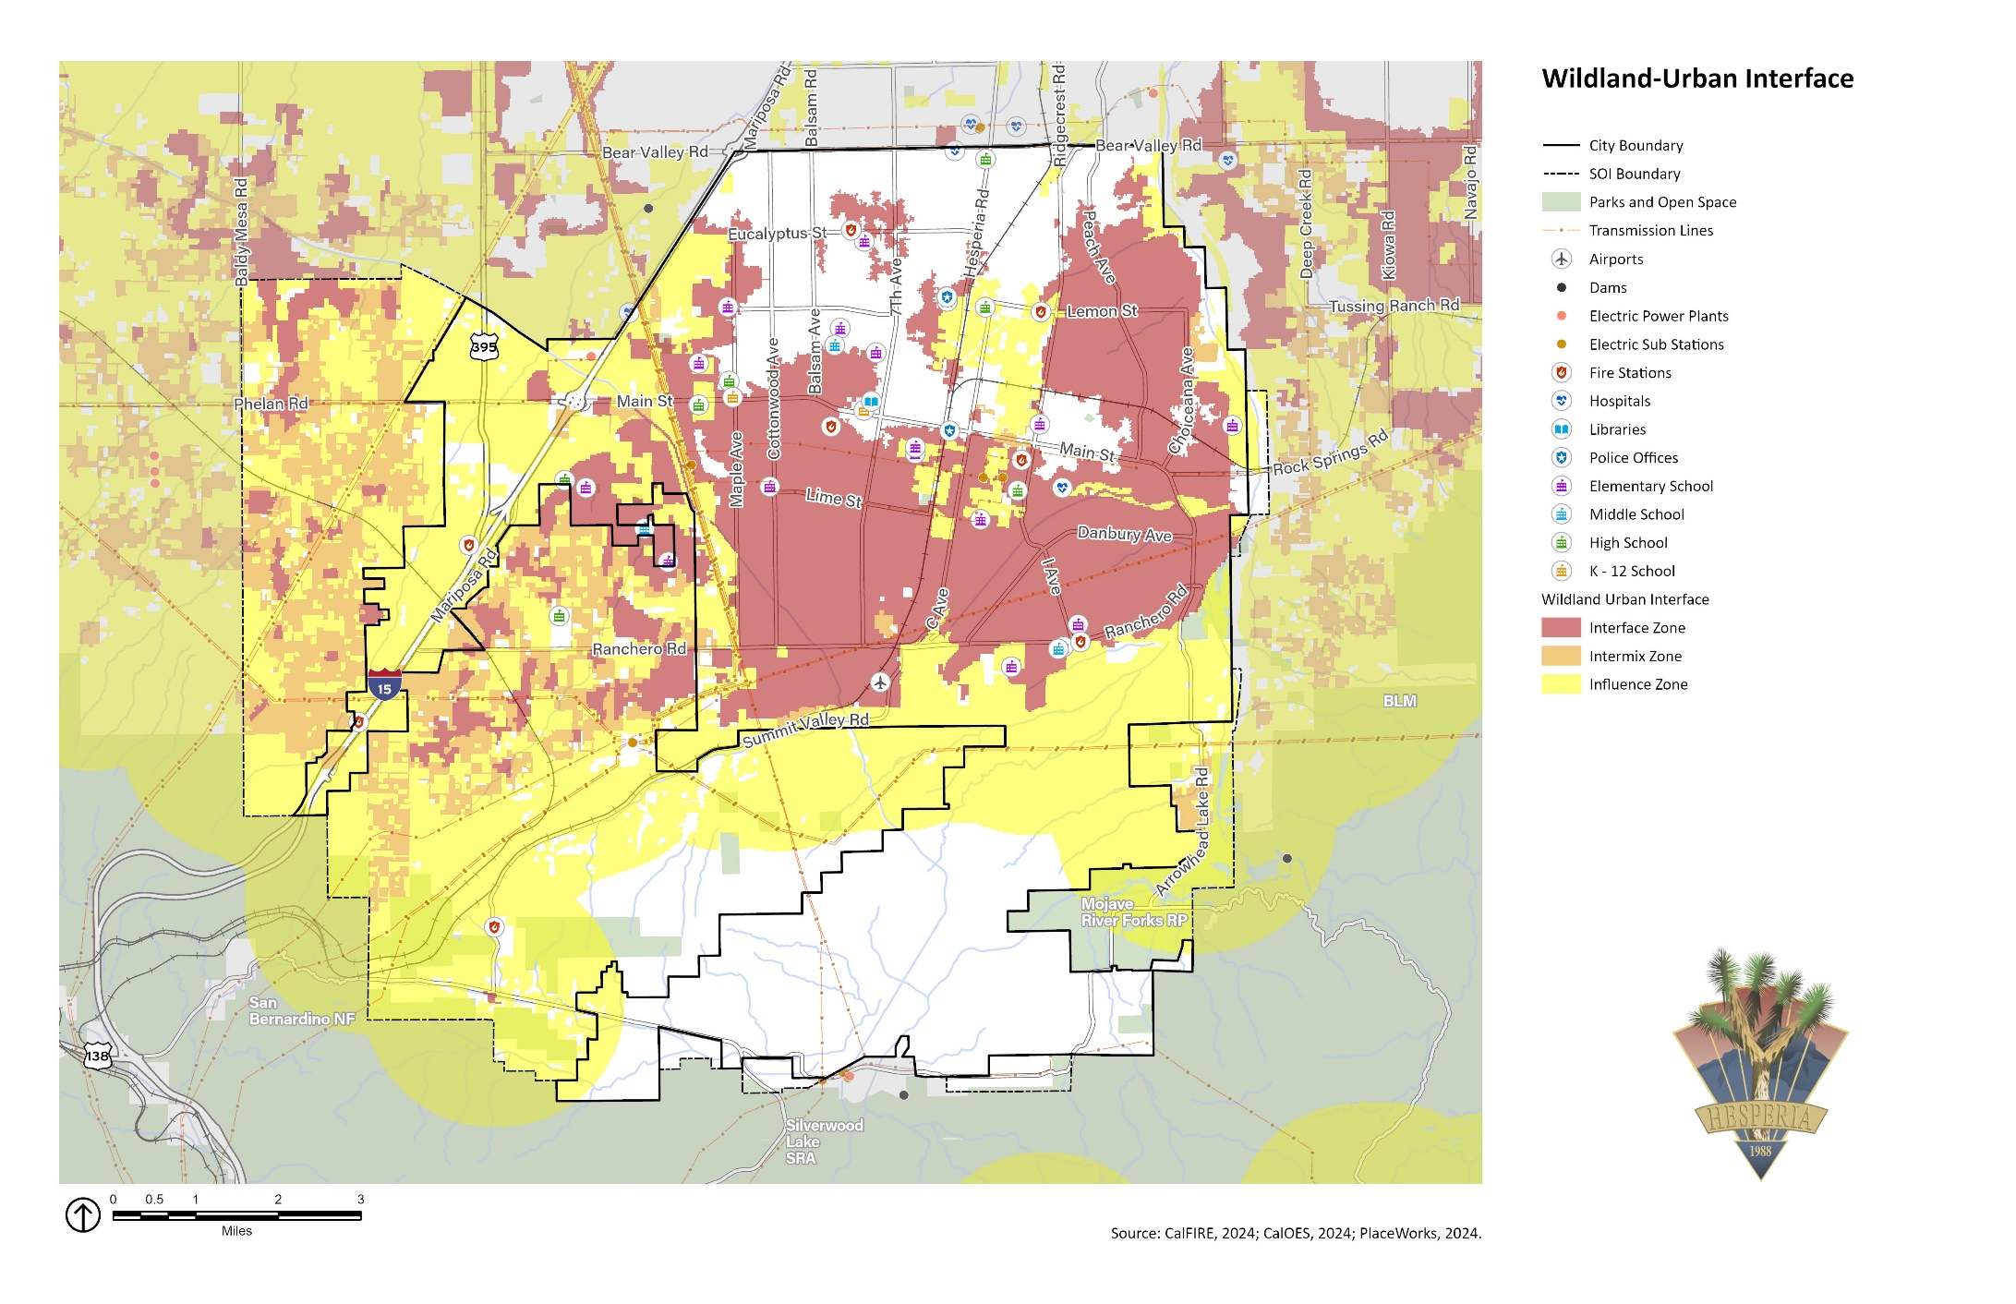Exhibit SF-7 Wildland-Urban Interface Areas

#### Structural Fires

Hesperia is also at risk from structural fires. These fires burn in built-up environments, destroying buildings and other human-made structures. Structural fires are often due to faulty wiring, mechanical equipment, or combustible construction materials. The absence of fire alarms and fire sprinkler systems often exacerbates the damage associated with a structural fire. Structural fires are largely caused by human accidents, although arson causes some events. Older buildings lack modern fire safety features and may face greater risk of fire damage. A small number of structure fires are reported annually in Hesperia, but depending on the size, age, and occupancy of the structure, the economic and social losses can be substantial.

#### Fire Protection

The San Bernardino County Fire Protection District provides fire prevention and suppression services in Hesperia on a contract basis. The County Fire Protection District also provides ambulance service to local High Desert hospitals. In addition to three fire stations near Hesperia, the San Bernardino County Fire Protection District operates four fire stations in Hesperia (listed below):

* Hesperia Fire Station #302 at 17288 Olive Street
* Hesperia Fire Station #304 at 15660 Eucalyptus Street
* Hesperia Fire Station #305 at 8331 Caliente Road
* Hesperia Fire Station #306 at 17801 Ranchero Road

Due to the increase in population and associated rise in traffic, emergency calls to the Fire Department have steadily risen. Response times are controlled by the distance between the responding fire station and the site; factors that may affect the response time include obstructions provided by the aqueduct and the railroad lines, multiple alarms, traffic congestion, and availability of personnel and equipment.

If needed, fire stations from nearby communities, such as Victorville and Apple Valley, can respond to emergency calls in Hesperia. All three cities are part of the San Bernardino County Operational Area, which allows for mutual aid agreements among jurisdictions. These agreements enable additional emergency resources to be deployed by unaffected members of the group, as needed.

In addition to local resources, numerous local, state, and federal agencies are available to assist the San Bernardino County Fire Protection District depending on the nature of the incident. Emergency response across all jurisdictions in California adheres to the Standardized Emergency Management System, ensuring a coordinated and efficient approach to managing emergencies.

The following goal and policies aim to reduce fire hazards in Hesperia.

|  |  |
| --- | --- |
| Goal SF-3 | Minimize injury, loss of life, property damage, and economic and social disruption caused by wildland and urban fires. |
| Policy SF-3.1 | In cooperation with the San Bernardino County Fire Protection District, ensure, to the maximum extent possible, that fire services—such as firefighting equipment and personnel, infrastructure, and response times—are adequate for all sections of the city. |
| Policy SF-3.2 | Encourage new development outside of Very High Fire Hazard Severity Zones. Development in the Very High Fire Hazard Severity Zones shall demonstrate compliance with applicable state and local building and fire code regulations as well as appropriate mitigation measures and design considerations. |
| Policy SF-3.3 | Require new developments in Very Fire Hazard Severity Zones (see Exhibit SF-6, Fire Hazard Severity Zones) to include the following, at a minimum, in applicable permit applications:  Site plan, planting plan, planting palette, and irrigation plan to reduce the risk of fire hazards and with consideration to site conditions, including slope, structures, and adjacencies.  Identification of defensible space for all buildings and plans for maintenance plan of defensible space.  More than one point of ingress and egress to improve evacuation, emergency response, and fire equipment access and adequate water infrastructure for water supply and fire flow that meets or exceeds the standards in the California Fire Safe Regulations. This specifically includes two sections of the California Code of Regulations, Title 14, Division 1.5, Chapter 7: Subchapter 2, Articles 1–5 (commencing with section 1270, SRA Fire Safe Regulations), and Subchapter 3, Article 3 (commencing with section 1299.01, Fire Hazard Reduction Around Buildings and Structures Regulations).  Class A roof materials for new and replacement roofs.  Location and source of anticipated water supply.  Fire protection plans for long-term, comprehensive fuel reduction and management, consistent with California Fire Code, Chapter 49. Fire protection plans shall include a risk analysis, fire response capabilities, fire safety requirements, mitigation measures, design considerations for nonconforming fuel modifications, and wildfire education maintenance and limitations. |
| Policy SF-3.4 | All new development in the wildland-urban interface or Very High Fire Hazard Severity Zone must comply with fire-resistant landscaping and defensible space requirements. These standards shall meet or exceed Title 14 of the California Code of Regulations. This specifically includes Division 1.5, Chapter 7, Subchapter 2, Articles 1 to 5 (commencing with section 1270, SRA Fire Safe Regulations), and Division 1.5, Chapter 7, Subchapter 3, Article 3 (commencing with section 1299.01, Fire Hazard Reduction Around Buildings and Structures Regulations). New development shall also comply with the Public Resource Code Section 4291 (State Defensible Space Requirements), which requires the following:  Create a defensible space of at least 100 feet around the structure.  Remove all dead plants, grass, weeds, and other flammable vegetation from the defensible space.  Remove tree limbs that are within 10 feet of the chimney or stovepipe of the structure.  Trim tree limbs that are within 6 feet of the ground or within 10 feet of the structure.  Remove all dead branches, leaves, and other debris from roofs and rain gutters.  Create horizontal and vertical spacing between trees and shrubs to prevent the spread of fire.  Space trees at least 10 feet apart from each other.  Maintain the defensible space throughout the year, not just during fire season.  Obtain any necessary permits from local fire agencies before conducting any vegetation management activities.  Provide and maintain access to the property for emergency vehicles. |
| Policy SF-3.5 | Require development, including infrastructure, in the wildland-urban interface or Very High Fire Hazard Severity Zone, as indicated on Exhibit SF‑6 and SF-7, to establish and maintain vegetation management practices to reduce the risk of wildfire ignition and spread. These practices shall include fire-safe site planning, home hardening, vegetation management, the use of native drought-tolerant and fire-resistant species, and defensible space consistent with State and San Bernardino County Fire Protection District regulations. |
| Policy SF-3.6 | In coordination with San Bernardino County Fire Protection District, require that new development be located where fire and emergency services have sufficient capacity to meet project needs, and require existing development be upgraded to provide necessary capacity as part of the proposed development activities to ensure new development has adequate fire protection. |
| Policy SF-3.7 | Require new development to provide adequate access for fire and emergency vehicles and equipment that meets or exceeds State standards in two parts of the California Fire Safe Regulations (California Code of Regulations, Title 14, Division 1.5, Chapter 7): Subchapter 2, Articles 1–5 (commencing with section 1270, SRA Fire Safe Regulations), and Subchapter 3, Article 3 (commencing with section 1299.01, Fire Hazard Reduction Around Buildings and Structures Regulations). |
| Policy SF-3.8 | Ensure that street and building address signage support firefighting crews and emergency response teams in their response to fire under low-visibility conditions, including installation of high-visibility signage for streets and building addresses that meet or exceed the standards in the California Fire Safe Regulations (California Code of Regulations Title 14, Division 1.5, Chapter 7, Articles 2 and 3, Sections 1273 and 1274). |
| Policy SF-3.9 | Coordinate with State and regional partners to ensure roadways in fire hazard severity zones comply with current fire safety regulations. The City will maintain City-owned roadways to meet current regulations to the extent feasible and given the absence of other site constraints. These regulations include standards for evacuation and emergency vehicle access, vegetation clearance, and other requirements of the California Fire Safe Regulations in California Code of Regulations Title 14, Division 1.5, Chapter 7), specifically Subchapter 2, Articles 1–5 (commencing with section 1270, SRA Fire Safe Regulations), and Subchapter 3, Article 3 (commencing with section 1299.01, Fire Hazard Reduction Around Buildings and Structures Regulations). |
| Policy SF-3.10 | Encourage owners of unsprinklered high-occupancy structures to retrofit their buildings to include automatic fire sprinklers. |
| Policy SF-3.11 | Make available and share relevant educational and outreach materials, rebate programs, and incentives with the public to help residents understand appropriate fire mitigation and preparedness activities, such as vegetation management, home hardening, defensible space, evacuation routes, and emergency evacuation procedures during a fire hazard. |
| Policy SF-3.12 | Coordinate with CAL FIRE, San Bernardino County Fire Protection District, and landowners to ensure maintenance of existing fuel breaks, vegetation clearance, and emergency access routes for effective fire suppression on public and private roads, especially evacuation routes. |
| Policy SF-3.13 | Develop programs and provide updates, as appropriate, that ensure recovery and redevelopment after a large fire and reduce future vulnerabilities to fire hazard risks through site preparation, redevelopment layout design, fire-resistant landscape planning, and fire-retarding building design and materials. |
| Policy SF-3.14 | Coordinate with the Hesperia Water District to maintain an adequate, long-term water supply for fire suppression needs for the community. |
| Policy SF-3.15 | Coordinate with San Bernardino County Fire Protection District to provide resources to seniors and physically disabled residents to assist in maintaining defensible space around their homes. |
| Policy SF-3.16 | Seek designation as a Fire Risk Reduction Community through CAL FIRE. |
| Policy SF-3.17 | Work with the San Bernardino County Fire Protection District to determine Insurance Services Office ratings for the City of Hesperia and the sphere of influence. |
| Policy SF-3.18 | Evaluate the feasibility of a fee structure to improve fire response services in the city. |
| Policy SF-3.19 | Work with San Bernardino County Fire Protection District to minimize risks to existing development by identifying existing non-conforming development and support San Bernardino County Fire Protection District’s Ready, Set, Go, Fire Program to assist property owners in upgrading buildings and properties to current fire safe standards, in terms of road standards and vegetative hazard, requiring all development to meet or exceed CCR, division 1.5, chapter 7, subchapter 2, articles 1 -5 requirements (SRA Fire Safe Regulations). |

### Hazardous Materials

Hazardous materials are substances that pose a significant risk to public safety, or human and environmental health. Hazardous materials are used every day in industrial, commercial, medical, and residential applications. The primary concern associated with a hazardous materials release is the short- and/or long-term effect to the public from exposure to these substances.

Several State agencies monitor hazardous materials/waste facilities. The Regional Water Quality Control Board and the California Department of Toxic Substances Control monitor and document potential and known contamination sites. The leaking underground storage tank list produced by the Regional Water Quality Control Board and the California Department of Toxic Substances Control EnviroStor database indicates 13 cleanup sites (all case closed) and 12 school investigation sites (no action required).

The most serious concern regarding hazardous materials sites in Hesperia is the potential for leaks and reactive chemical interactions as a result of an earthquake compromising their storage containers. Hazardous materials spills have happened with past earthquakes, even when the building does not suffer significant damage.

Hazardous materials can also be released accidentally during transportation because of vehicle crashes. The release or spill of bulk hazardous materials could result in fire, explosion, toxic cloud, or direct contamination of water, people, and property. Transportation of most hazardous materials in the region occurs on truck routes along major roadways that pass through Hesperia, such as I-15, SR-138, SR-173, and SR-395. The most vulnerable areas along this route are considered the on-/off-ramps and interchanges. The State requires vehicles transporting hazardous materials to have placards to identify the chemicals they carry and whether they are corrosive, flammable, and/or explosive. The drivers must carry detailed “material data sheets” for each of the substances on board. These documents help emergency response personnel assess the situation immediately upon arrival at the scene of an accident and take the appropriate precautionary and mitigation measures.

In addition to major roadways, other hazardous materials are transported through Hesperia on the BNSF railway, which bisects the city from north to south. Hazardous materials are shipped via the railway, and though a rail accident in the city is unlikely, it could have devastating effects.

The California Department of Transportation regulates the transport of hazardous materials/wastes and explosives through the city. I-15, SR-138, SR-173, and SR-395 are open to vehicles carrying hazardous materials/wastes. San Bernardino County Fire Protection District, San Bernardino County Office of Emergency Services, and Hazardous Materials Division of the San Bernardino County Fire Protection District are responsible for hazardous materials accidents at all locations in the city. If a hazardous material spill poses an imminent public health threat, the City will support local regulating agencies in notifying the public.

High-pressure gas and hazardous liquid pipelines also extend across the city. Pipeline operators are responsible for the continuous maintenance and monitoring of their pipelines. Excavations or drilling near pipelines should be conducted only after proper clearance by the appropriate utility agencies or companies. This is done locally by the Underground Services Alert of Southern California, or DigAlert.

The San Bernardino County Fire Protection District, which is the local Certified Unified Program Agency, manages hazardous materials and waste in Hesperia. The Certified Unified Program Agency consolidates, coordinates, and makes consistent the regulatory activities of several hazardous materials and hazardous waste programs, including Hazardous Materials Management, California Accidental Release Prevention, Hazardous Waste Management, Underground Storage Tanks, Aboveground Storage Tanks, and Emergency Response. All businesses that handle more than a specified amount of hazardous or extremely hazardous materials are required to submit a Hazardous Materials Business Plan to the local Certified Unified Program Agency. These businesses are also required to prepare Risk Management Plans, detailed engineering analyses that identify the potential accident factors present, and the mitigation measures that can be implemented to reduce this accident potential.

The following goal and implementation policies are aimed at reducing the hazards of hazardous materials in Hesperia.

|  |  |
| --- | --- |
| Goal SF-4 | Minimize the potential for hazardous materials contamination in Hesperia. |
| Policy SF-4.1 | In cooperation with the San Bernardino County Fire Protection District, Hazardous Materials Division, continue to enforce disclosure laws that require all users, generators, and transporters of hazardous materials and wastes to clearly identify the materials that they store, use, or transport, and to notify the appropriate city, county, state, and federal agencies of a change in quantity or type of materials, and in the event of a violation. |
| Policy SF-4.2 | Identify roadways along which hazardous materials are routinely transported and maintain these roadways to prevent vehicle accidents and the release of hazardous materials. If critical facilities, such as schools, medical facilities, childcare centers, or other facilities with special evacuation needs are located along these routes, the City, together with these facilities, will identify emergency response plans that can be implemented in the event of a roadway accident nearby that results in the release of hazardous materials. |
| Policy SF-4.3 | Continue to reduce or eliminate the use of hazardous materials by using nontoxic, safer alternatives that do not pose a threat to the environment, or buying and using only the smallest amount of a hazardous substance to get the intended job done. Encourage residents and businesses in the city to do the same. |
| Policy SF-4.4 | Prohibit new facilities that will be involved in the production, use, storage, transport, or disposal of hazardous materials within identified hazard zones or within 1,000 feet of existing land uses that may be adversely impacted by such activities. |
| Policy SF-4.5 | Prohibit new sensitive uses within 1,000 feet of existing facilities that are involved in the production, use, storage, transport, or disposal of hazardous materials or in identified hazard zones. |
| Policy SF-4.6 | Prohibit any new facilities that use or store hazardous materials in quantities that would place them in the State’s Toxics Release Inventory (TRI) or Small Quantity Generators (SQG) databases to be located in a natural hazard zone. |

### Emergency Preparation and Response

The California Office of Emergency Services defines a disaster as an event that causes significant disruption to a community or society, leading to severe danger and substantial losses to people and property. When a disaster occurs, the threatened community strives to protect its residents, care for victims, and restore basic services as soon as possible.

The San Bernardino County Sheriff’s Department and San Bernardino County Fire Protection District conduct emergency preparedness activities in Hesperia. The San Bernardino County Sheriff’s Department provides local police services and leads evacuation efforts in close cooperation with the Fire Protection District. The San Bernardino County Fire Protection District provides fire prevention and suppression as a community-based, all-hazard emergency services provider. If needed, the Apple Valley Fire Protection District may respond to emergency calls in Hesperia.

The Town of Apple Valley and the City of Hesperia are part of the San Bernardino County Operational Area, which has mutual aid agreements allowing additional emergency resources to be deployed from unaffected members of the group as needed. Numerous other local, state, and federal agencies are available to assist the San Bernardino County Fire Protection District depending on the type of incident.

In response to a disaster, the community needs to respond quickly, dynamically, and as effectively as possible. People impacted by a disaster generally respond actively to the situation, seeking safety for themselves, their families, and others, improvising if necessary to respond to changing conditions. However, some basic level of preparedness can be very useful. Emergency managers realize the need to regularly educate and/or remind the public about potential hazards and urge individuals, families, and businesses to be prepared. Agencies responsible for emergency response need to review and update their preparedness plans and emergency operations plan as new conditions and requirements develop, which is a continuous process.

Planning can help speed the response to an emergency while ensuring that the response is appropriate to the situation. Coordination between all levels of responders is critical. Direct, clear updates on the situation, provided in a timely manner by public officials, are important and prompt cooperation from the public. The City of Hesperia Alert Center hosts an online webpage for residents to view all alerts and emergencies in the city. Hesperia residents also use the Ready San Bernardino County app to help individuals prepare and plan for how to respond to a disaster in the area.

When an incident occurs anywhere in Hesperia, the San Bernardino County Sheriff’s Office and/or the San Bernardino County Fire Protection District is typically the first to arrive at the scene, where they secure the area and determine if other agencies need to be involved.

#### Emergency Shelters

Earthquakes, flooding, wildfires, and other disasters can render housing uninhabitable. Displaced households need alternative short-term shelter provided by family and friends, temporary rentals, or public shelters established by relief organizations such as the Red Cross or Salvation Army in facilities around the city.

Potential short-term shelter locations in Hesperia include parks, schools, and churches. These locations are generally ideal for short-term emergency shelters because they have open space where people can set up tents, restroom facilities and possibly kitchens, and large parking lots where displaced families can park their cars and recreational vehicles, which can be used for housing. Because not all of these facilities may be available or fully functional after a disaster, having several options is ideal. The selection of which sites to open during an emergency should be made after consideration of the hazard involved, and the potential for that hazard to progress (e.g., a northward-moving wildfire) into the area of a shelter. These are short-term shelter facilities to be used for a few hours to a few days.

Long-term alternative housing may require import of manufactured homes; occupancy of vacant units; and eventually, the repair or reconstruction of new private and public housing.

#### Emergency Evacuation

Evacuation refers to moving people that are at risk during a disaster to a safer location, using routes that do not pose a significant danger to the evacuees. The Sheriff’s Department typically serves as the lead organization in issuing and carrying out evacuations, supported by the Fire Protection District as appropriate. The Public Works department typically assists in the identification of the best evacuation routes and in barricading the evacuated areas.

With advanced warning, evacuation can effectively reduce injury and loss of life during a catastrophic event. Primary emergency access and evacuation routes include I-15, which intersects the city from north to south through the western portion of the city; SR-395, which intersects the city from north to south through the western portion of the city, and other local roadways that connect to these primary evacuation routes. In certain disaster situations, Hesperia may experience an influx of evacuees living in the mountains to the south and southwest of the city when emergencies, such as wildfires or severe weather events, threaten those mountain communities.

**Exhibit SF-8** shows the results of an evacuation route analysis conducted through the Resilient IE project, illustrating the water crossings under potential evacuation routes identified by the San Bernardino County Transportation Authority. These are a critical concern because they can endanger lives during floods, delay and compromise evacuation and response efforts, and damage infrastructure. All evacuation routes in Hesperia face potential disruption from flooding or earthquake if they block roadways, damage the roadway surface, or collapse bridges and overpasses.

**Exhibit SF-9** shows residential parcels with evacuation constraints in compliance with California Government Code Section 65302(g)(5), as well as evacuation routes identified by the city. **Exhibit SF-9** identifies residential developments in any hazard area that do not have at least two emergency evacuation routes, as well as parcels that are at least a half mile from a designated potential evacuation route. The lack of multiple emergency access points may create difficulties if there is a need to evacuate.

The City is participating in the San Bernardino County Transportation Authority’s Emergency Evacuation Network Resilience Study, which will meet the requirements of California Government Code Section 65302.15 when completed. The Emergency Evacuation Network Resilience Study is anticipated to be completed in February 2026.

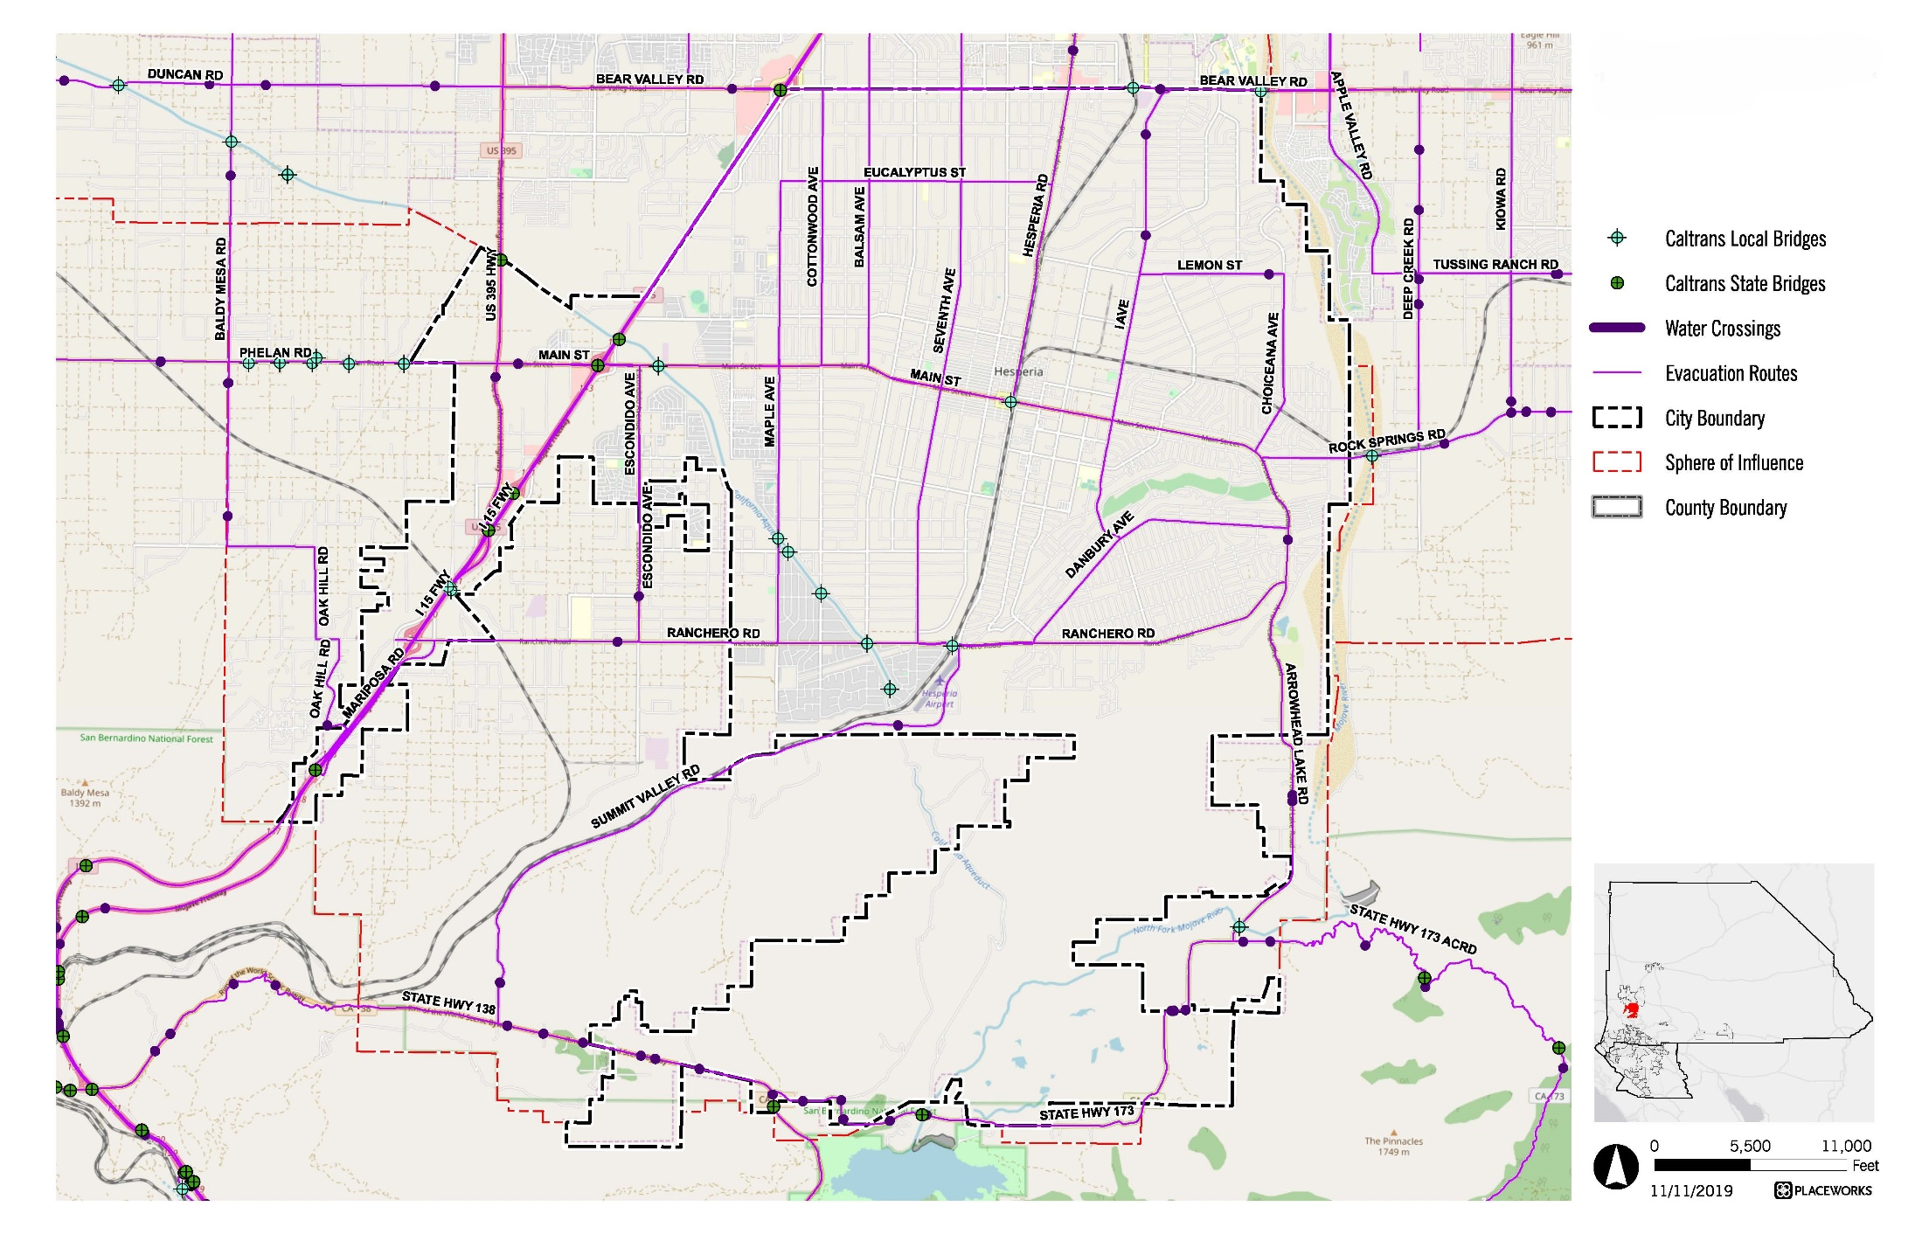Exhibit SF-8 Evacuation Routes with Water Crossings

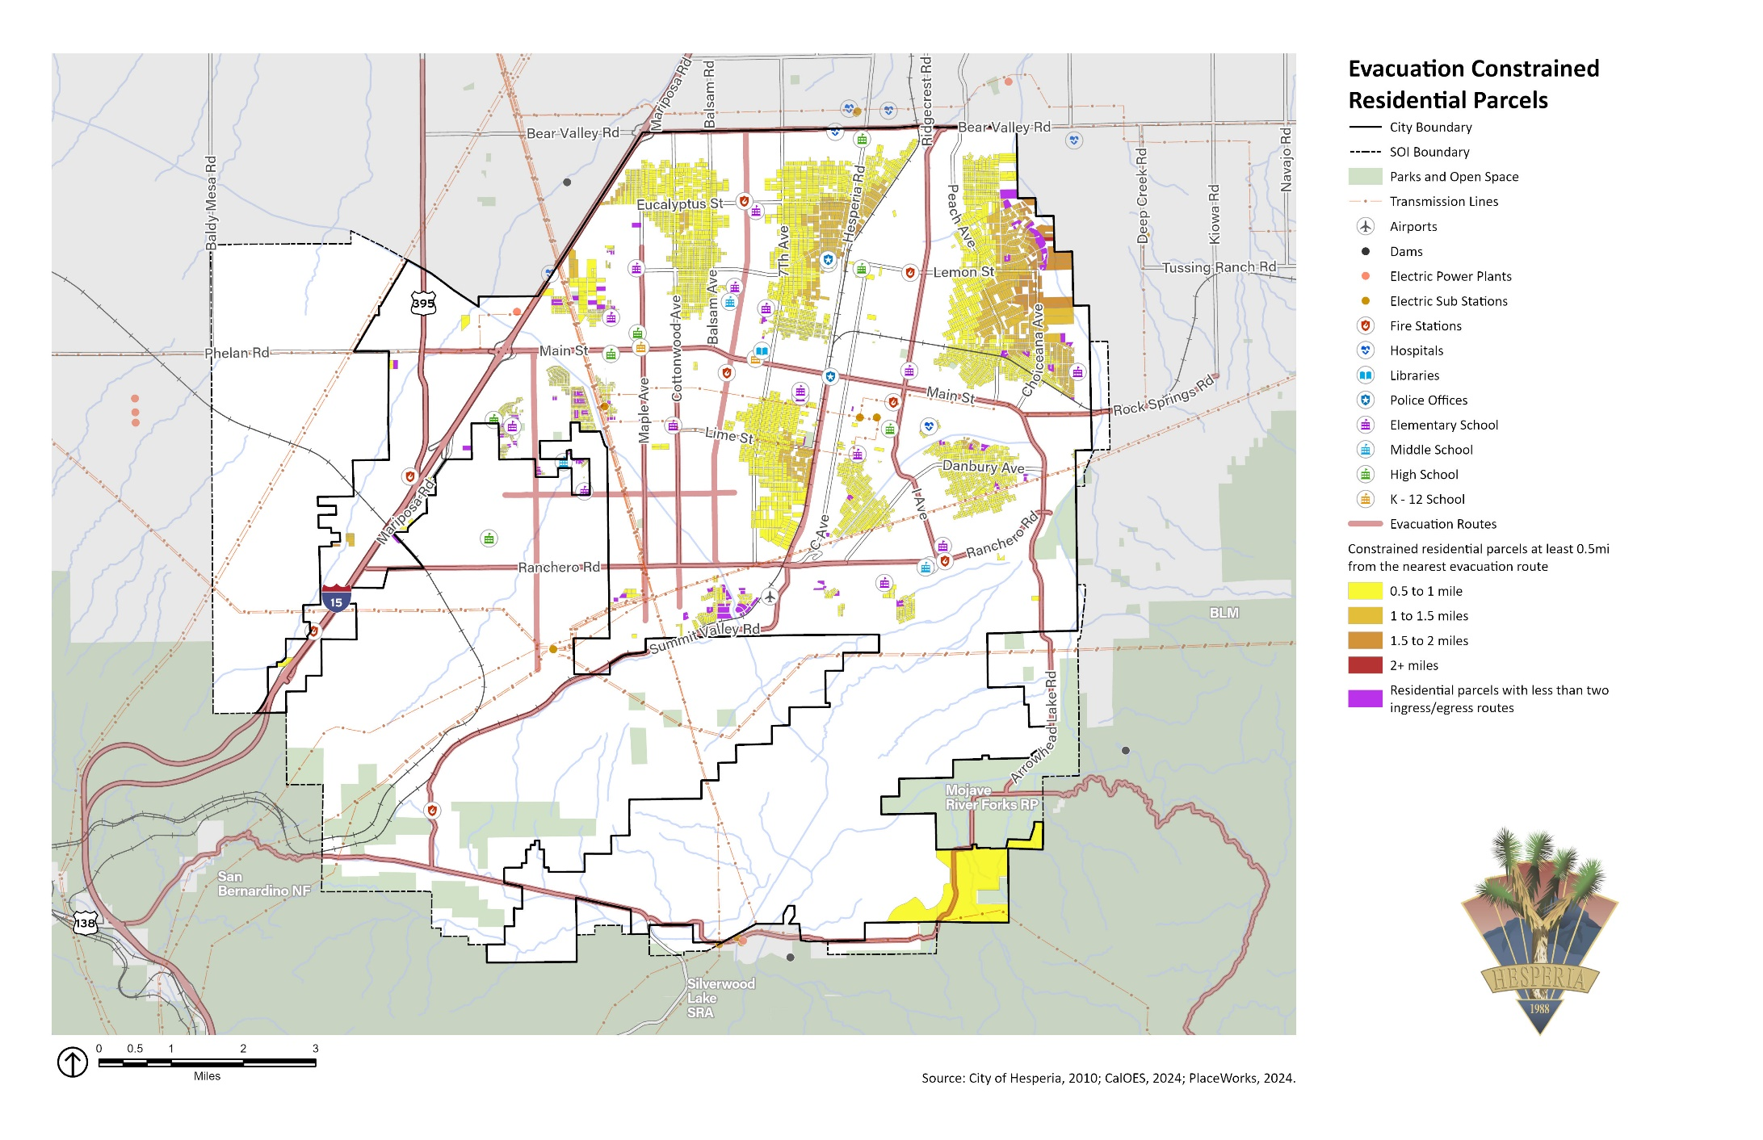Exhibit SF-9 Evacuation Constrained Residential Parcels

#### Recovery

Many communities are well prepared for a disaster but ill prepared for recovery. They may hope that if their pre-disaster planning is effective, long-term damages will be small. However, some post-disaster recovery efforts are necessary to restore community life. This includes the re-establishment of essential services and the rebuilding and repair of damaged properties. Recovery is an opportunity to improve the community so that it becomes more sustainable and less likely to be impacted by a future, similar disaster. Having a recovery plan in place can help with the decision-making process of reconstruction and improve communication with other levels of government that were involved in the disaster response phase and now have a vested interest in the recovery process.

The following goal and implementation policies aim to make Hesperia more disaster resistant.

|  |  |
| --- | --- |
| Goal SF-5 | A community prepared to withstand and recover from natural disasters and other emergencies. |
| Policy SF-5.1 | Consistent with Public Resources Code Section 4290.5, require new development of 30 units or more in Fire Hazard Severity Zones, as shown on Exhibit SF-6, to have two ingress and egress routes that account for existing and proposed traffic evacuation volumes at buildout. |
| Policy SF-5.2 | Coordinate with emergency responders and Caltrans to maintain potential evacuation routes to ensure adequate capacity, safety, and viability of those routes in the event of an emergency, including making improvements to existing roads as needed to support safe evacuations. |
| Policy SF-5.3 | Continue to participate in the countywide Ready San Bernardino County emergency alert system and Storm Ready Program with the National Weather Service, issuing evacuation notices for affected neighborhoods in a timely manner in languages and formats accessible to all residents. |
| Policy SF-5.4 | Maintain a FEMA-certified and adopted Local Hazard Mitigation Plan (LHMP). Implement and regularly update the LHMP through a partnership consisting of representatives from all City departments, the San Bernardino County Fire Protection District and Sheriff’s Department, local quasi-governmental agencies, private businesses, citizens, and other community partners involved in emergency relief and/or community-wide services. |
| Policy SF-5.5 | Upon update and certification by the Federal Emergency Management Agency, incorporate the Hesperia Local Hazard Mitigation Plan (LHMP) into this Health and Safety Element by reference, as permitted by California Government Code Section 65302.6. |
| Policy SF-5.6 | Continue to support the development of local preparedness plans and multi-jurisdictional cooperation and communication for emergency situations consistent with regional, state (SIMS), and federal standards, guidelines, and/or recommendations (NIMS). |
| Policy SF-5.7 | Maintain mutual aid agreements with neighboring cities and the San Bernardino County Operational Area. Cooperate with other public agencies to ensure adequate medical and other emergency services, including assessing and projecting future emergency service needs. |
| Policy SF-5.8 | Ensure to the fullest possible extent that, in the event of a major disaster, including extreme weather events, critical, dependent care, and high-occupancy facilities remain functional. |
| Policy SF-5.9 | To the greatest extent possible, locate new essential public and critical facilities, such as police stations, schools, and community centers, outside of mapped hazard zones. If essential facilities must be located in these zones, site and design them to minimize the risk of damage and maintain their operational capacity during and after a hazard. Require all essential and critical facilities in an identified hazard zone (100-year/500-year flood zone, dam inundation zone, fire hazard severity zone, landslide susceptibility zone, or others), to develop disaster response and evacuation plans that address the actions that will be taken in the event of an emergency. |
| Policy SF-5.10 | Coordinate with local and regional agencies to establish resilience centers to support residents, in accordance with State guidance. Resilience centers consist of well‐used, existing, community‐serving facilities that are equipped to provide residents and workers with shelter, water, restrooms, showers, and electricity during poor air quality events, extreme heat events, or disasters. Ensure that resilience centers are not in areas at risk from hazards and equitably located to the extent possible, are equipped with renewable energy generation and backup power supplies, and accessible by the City's most vulnerable residents. Work with transit, dial-a-ride, and paratransit services to provide transit services to and from resilience centers for seniors and people with disabilities in the community. |
| Policy SF-5.11 | Coordinate with the Victor Valley Transit Authority and community service organizations to assist with evacuation efforts for those with limited English proficiency, who lack access to a vehicle, and/or who have limited mobility. |
| Policy SF-5.12 | Offer educational programs to promote measures that residents and businesses should take prior to, during, and after an emergency. Promote public awareness of City emergency response plans, resources, risk reduction, and preparation of emergency kits. Provide emergency preparedness educational programs in languages and formats accessible to all Hesperia residents and businesses. |
| Policy SF-5.13 | In cooperation with the San Bernardino County Fire Protection District, develop and hold regular Community Emergency Response Team (CERT) training exercises to residents and members of the business community to empower individuals and neighborhoods and increase disaster awareness and emergency response capability. |
| Policy SF-5.14 | Support and participate in San Bernardino County Transportation Authority’s regional evacuation study to identify evacuation route capacity, safety, and viability and evacuation locations under a range of hazard scenarios. |

### Climate Change Resilience

Changes to the global climate system are expected to affect future occurrences of natural hazards in and around Hesperia. Many hazards are projected to become more frequent and intense in coming years and decades, and in some cases, these trends have already begun. Key climate change considerations that affect Hesperia include increasing temperatures and changes in precipitation. Overall, precipitation levels are expected to increase slightly, with more years of extreme precipitation events and droughts that last longer and are more intense. According to California’s *Fourth Climate Change Assessment,* Hesperia can expect to experience various climate-related hazard events.

Climate change is expected to lead to an increase in wildfires across San Bernardino County due to hotter and drier conditions. More frequent and intense wildfires may also create poor air quality for Hesperia. As the climate changes, warmer temperatures will create more pollutants, such as ozone, wildfire smoke, dust, and pollen, contributing to poor air quality. Warmer temperatures are projected to cause an increase in extreme heat events. The number of extreme heat days, defined in Hesperia as a day when the high temperature is at least 98°F, is expected to rise from a historical annual average of 5 days to 36 days by the middle of the century (2035 to 2064), and an average of 59 days by the end of the century (2070 to 2099).

Both droughts and floods are expected to become more frequent because climate change is expected to cause rainfall in fewer, more intense storms. Although Hesperia is likely to experience minimal change in overall annual rainfall levels from climate change, the region is also expected to see an increase in the number of extreme rainfall events. Also, climate change can increase infection rates from various diseases because many of the animals that carry diseases are more active during warmer weather. When temperatures are warmer earlier in the spring and later in the winter, animals are active for longer, increasing the time that diseases can be transmitted.

#### Resilient IE

The Resilient IE project is a joint effort between the Western Riverside Council of Governments and San Bernardino County Transportation Authority to prepare the western Riverside County‐San Bernardino County region for the increasing climate‐related hazards. Resilient IE supports regional and local efforts to prepare for and mitigate risks on the region's transportation infrastructure associated with climate adaptation.

The Resilient IE Toolkit is a collection of resources that provide data on the risk from climate‐related hazards and tools and resources for developing and implementing climate adaptation and resilience strategies to reduce these risks. The toolkit specifically addresses the anticipated increasing risks and impacts of climate‐related hazards on the inland areas of southern California. The primary function of this toolkit is to facilitate greater resilience and adaptive capacity in the face of climate‐related impacts in the western Riverside County‐San Bernardino County region. It is available online at: https://wrcog.us/285/Resilient-IE.

#### Air Quality

Air quality is determined by the composition of gases and particles in the atmosphere, and it is a critical aspect of environmental health. Air pollution comes from mobile sources (e.g., cars, trucks, airplanes) and stationary sources (e.g., agricultural and industrial uses). The Mojave Air Quality Management District has the responsibility to create strategies and monitor the targets set by State and federal standards for San Bernardino County’s High Desert.

The increasing frequency of fire statewide creates more frequent degradation of air quality, leading to respiratory health effects. Wildfire smoke consists of a mix of gases and fine particulate matter from burning vegetation and materials. The pollutant of most concern from wildfire smoke is PM2.5, which can deeply penetrate lung tissue and affect the heart and circulatory system. Although wildfire smoke is a health risk to everyone, sensitive groups experience more severe acute and chronic symptoms from exposure to wildfire smoke. Sensitive groups include children (particularly younger children), older adults, people with chronic respiratory or cardiovascular disease, and low-resourced persons.

In many regions of the United States, climate-driven changes in weather conditions, including temperature and precipitation, are expected to increase ground-level ozone and particulate matter (such as windblown dust or smoke from wildfires). These changes worsen existing air pollution. More wildfires will release particulate matter and other pollutants into the air. Possible changes in wind patterns may also trap air pollutants in Victor Valley, increasing exposure to air pollution.

#### Drought

A drought is an extended period when precipitation levels are well below normal. Drought may affect domestic water supply, regional energy production, public health, and wildlife and contribute to wildfire. Like most of California and the western United States, Hesperia chronically experiences drought cycles.

The US Drought Monitor recognizes a five-point scale for drought events: D0 (abnormally dry), D1 (moderate drought), D2 (severe drought), D3 (extreme drought), and D4 (exceptional drought). According to the US Drought Monitor, the most intensive recent drought was during most of 2022, when all of San Bernardino County was classified as “severe” drought. As of June 2024, San Bernardino County, including Hesperia, was not classified in a drought. During severe drought, water shortages are common, and water restrictions may be imposed to meet essential community needs. The Hesperia Water District’s 2020 Water Shortage Contingency Plan contains actions to implement and enforce regulations and restrictions for managing a water shortage when it declares a water shortage emergency under the authority of the California Water Code.

Given Hesperia’s desert climate and reliance on groundwater, the city is generally not considered especially vulnerable to drought. However, chronic drought can affect groundwater levels if decreased basin inflow and increased demand for water are not managed effectively.

Although droughts are a regular feature of California’s climate, climate change will likely lead to more frequent and intense droughts statewide. Overall, precipitation levels are expected to stay similar to historic levels in Hesperia, potentially increasing by the end of the century.

#### Extreme Heat

Extreme heat has no universal definition, but California guidance documents define extreme heat as hotter than 98 percent of the historical high temperatures for the area measured between April and October of 1961 to 1990. In Hesperia, the extreme heat threshold is 98°F. A heat wave is an event with five extreme heat days in a row, so in Hesperia, a heat wave would be five days in a row over 98°F.

The Center for Disease Control and Prevention recognizes extreme heat as a serious public health concern. The most vulnerable to extreme heat are children and youth, households in poverty, immigrant/linguistically isolated communities, low-resourced people of color, outdoor workers, persons experiencing homelessness, persons living in mobile homes, persons with chronic illnesses and/or disabilities, persons without access to lifelines, and older adults.

According to the US Census, roughly a quarter of all housing in the city was built before 1980 and is unlikely to have air conditioning or effective insulation to regulate indoor temperatures. During extreme heat days, temperatures in poorly insulated homes may reach unhealthy temperatures. Therefore, people living in these homes, especially vulnerable populations, are at higher risk for heat-related illnesses during extreme heat events.

The warmer temperatures brought by climate change are likely to cause more extreme heat events locally. Depending on the location and emissions levels, the state Cal-Adapt database indicates the number of extreme heat days is expected to rise from a historical annual average of 5 to 36 days by the middle of the century (2035 to 2064), and an average of 59 days by the end of the century (2070 to 2099).

#### Severe Weather

Severe weather is generally any destructive weather event, but in Hesperia it manifests as localized storms that bring heavy rain, hail, thunderstorms, and strong winds. Severe weather is usually caused by intense storm systems, although strong winds can occur without a storm. The dangers posed by severe weather vary widely—injuries or deaths, damage to buildings and structures, fallen trees, roads, and railways blocked by debris, and fires sparked by lightning. Severe weather often produces high winds and lightning that can damage structures and cause power outages. Lightning can ignite wildfires and structure fires that can damage buildings and endanger people.

In Hesperia, most severe weather is linked to high winds, often accompanying severe storms, that can cause significant property damage, threaten public safety, and have adverse economic impacts from business closures and power loss. Santa Ana winds have caused extensive damage and increased the fire damage level dramatically. Santa Ana winds are generally defined as warm, dry winds that blow from the east or northeast (offshore). These winds occur below the passes and canyons of the coastal ranges of Southern California. Santa Ana winds often blow with exceptional speed through the Cajon Pass, beginning in Hesperia. Wind speeds are typically east to west at 40 miles per hour (mph) through and below passes and canyons, with gusts to 74 mph. Additionally, an “atmospheric river” is a relatively common weather pattern that brings southwest winds and heavy rain. Atmospheric rivers can be associated with heavy precipitation, landslides, and high winds.

Electricity utilities throughout California, including Southern California Edison, have begun to occasionally “de-energize” or turn off the electricity for power lines that run through areas with an elevated fire risk. Public Safety Power Shutoffs are intended to reduce the risk of power lines sparking or being damaged and starting a wildfire. As previously described, these activities result in a loss of power for customers served by the affected power lines. A Public Safety Power Shutoff can happen at any time of year, but usually during high wind events and dry conditions. Public Safety Power Shutoffs may be limited to specific communities or affect broad swaths of the state.

Climate change is expected to cause an increase in intense rainfall and strong storm systems, such as atmospheric rivers. However, the frequency of Santa Ana winds is expected to decrease, particularly in the fall and spring months. An increase in intense rainfall and strong storm systems means that Hesperia could see more intense weather in the coming years and decades, although not all forms of severe weather may increase. However, heavy rainfall can increase the frequency and severity of other hazards, including flooding.

#### Human Health Hazards

Human health hazards are bacteria, viruses, parasites, and other organisms that cause diseases and illness in people. Some of these diseases may cause only mild inconvenience, but others are potentially life threatening. These diseases are often carried by animals, such as mice and rats, ticks, and mosquitos. Warmer temperatures and high precipitation levels can lead to larger populations of disease-carrying animals and therefore a greater risk of disease and higher rates of infection.

Populations most vulnerable to human health hazards are those who spend a disproportionate amount of time outdoors (such as outdoor workers or persons experiencing homelessness), those with fragile immune systems or existing illnesses (which may include persons with chronic illnesses and seniors), and those who live in substandard housing or do not have access to health insurance and medical care (households in poverty, low-resourced people of color, immigrant/linguistically isolated communities, and cost-burdened/low-income/overcrowded households). Many of the vector-carrying organisms thrive in warmer and wetter conditions, and therefore the overall risk of human health hazards is expected to increase.

The following goal and implementation policies aim to make Hesperia more resilient to climate change.

|  |  |
| --- | --- |
| Goal SF-6 | A resilient community able to adapt to climate change hazards. |
| Policy SF-6.1 | Promote water conservation measures in all public and private development. |
| Policy SF-6.2 | Work with regional water providers to implement extensive water conservation measures and ensure sustainable water supplies, including for fire suppression needs. |
| Policy SF-6.3 | Support local agencies to promote public awareness on resilience initiatives related to poor air quality, drought, extreme heat, severe weather, water conservation, and human health hazards. |
| Policy SF-6.4 | Coordinate with the Victor Valley Transit Authority to increase shading and use of heat-mitigating materials on pedestrian walkways and at transit stops. |
| Policy SF-6.5 | Develop and maintain an Extreme Heat Action Plan in accordance with State guidance. |
| Policy SF-6.6 | Promote the use of drought‐tolerant green infrastructure, including landscaped areas, as part of cooling strategies in public and private spaces. |
| Policy SF-6.7 | Encourage local businesses to develop workplace heat safety protocols and provide training for employers and employees in heat-exposed occupations. |
| Policy SF-6.8 | Improve the resiliency of City-owned structures to severe weather events and support homeowners and business owners to improve the resilience of their buildings and properties through retrofits, weatherization, and other improvements. |
| Policy SF-6.9 | Coordinate with the City’s utility service providers to upgrade, harden, and/or underground their facilities and infrastructure in Hesperia, to improve their survivability of a natural or human-caused hazard event. |
| Policy SF-6.10 | Participate in regional partnerships that support increased community resilience, such as the Inland Southern California Climate Collaborative. |
| Policy SF-6.11 | Coordinate with the San Bernardino County Department of Public Health and healthcare providers to support free or reduced-cost medical care for low-resourced households. |
| Policy SF-6.12 | Coordinate with local agencies, healthcare providers, and community-based organizations that provide resources to help residents respond to poor air quality events (e.g., transportation to resilience centers and supply free N95 masks). |
| Policy SF-6.13 | Work with local contractors and community-based organizations to help low-income households and community service providers obtain or upgrade indoor air filtration systems. |