**Effectiveness Monitoring Committee -**

**Completed Research Assessment for EMC-2015-001**

**EMC Members:**

Drew Coe – CAL FIRE

Matthew House – Green Diamond Resource Company

1. **Does study fulfill and address scientific question(s) posed in proposed research?**

**Yes**. The study was able to address the questions posed in the original scope of work.

1. **Does the study inform a rule, numeric target, performance target, or resource objective?**

**Yes**. The study informs rules and resource objectives.

1. **Does the study inform the Forest Practice Rules?**
2. **Yes**

* The study informs the rule language in 14 CCR § 916.9 [936.9, 956.9] (c)(4), which states that:

Class II-L watercourses can have greater individual effects on receiving Class I watercourse temperature, sediment, nutrient, and large wood loading than Class II standard (Class II-S) watercourses due to larger channel size, greater magnitude and duration of flow, and overall increased transport capacity for watershed products.

* It also informs 14 CCR § 916.9 [936.9, 956.9] (g)(1)(a)(1 and 2), which states:

(A)A Class II-L Watercourse is defined as a Class II Watercourse having either of the following characteristics:

1.A contributing drainage area of ≥100 acres in the Coast Forest District, or ≥150 acres for the Northern and Southern Forest Districts, as measured from the confluence of the receiving Class I Watercourse.

2.An average Active Channel width of five feet (5 ft.) or greater near the confluence with the receiving Class I Watercourse. Where field measurements are necessary to make this determination, Active Channel width measurements shall be taken at approximately fifty foot (50 ft.) intervals beginning at the point where the Class II Watercourse intersects the Class I WLPZ boundary and moving up the Class II Watercourse for a distance of approximately two-hundred feet (200 ft.). The combined average of these five (5) measurements shall be used to establish the average Active Channel width. Measurement points may be adjusted based upon site-specific conditions, and should occur at riffle locations and outside the influence of Watercourse crossings to the extent feasible.

* Furthermore, it also informs 14 CCR § 916.9 [936.9, 956.9] (v) which allows for site-specific measures or nonstandard operational provisions as an alternative to the ASP requirements.

1. The study partially addresses critical questions from EMC Strategic Plan including:
   * Are the FPRs and associated regulations effective in maintaining and restoring stream water temperature?
   * Are the FPRs and associated regulations effective in maintaining and restoring riparian function of Class II-L watercourses in the Coast District?
   * Are the FPRs and associated regulations effective in maintaining and restoring riparian function of Class II-L watercourses in the Northern District?
2. **Is the study scientifically sound?**

**A. Was the study carried out pursuant to valid scientific protocols (i.e., study design, peer review)?**

**Yes.** The project evaluated flow permanence and network connectivity as well as longitudinal stream temperature variability in headwater streams. The broad scale regional assessment on flow permanence and network connectivity was published in Hydrological Processes in 2020 (Pate et al., 2020). The longitudinal stream temperature study performed at Jackson Demonstration State Forest and LaTour Demonstration State Forest was submitted to Hydrological Processes in January 2021. The paper was rejected, but reviewers encouraged a resubmittal with modifications to the paper. Modifications are currently in process.

1. **Is the study scalable?**

**A. What does the study tell us? What does the study not tell us?**

**Findings**

The study had three main objectives:

* 1. Investigate the variability of the relationship between drainage area, active channel width, and perennial flow extent across the Anadromous Salmonid Protection (ASP) area (**Broad scale study on flow permanence and network connectivity**);
  2. Compare the relationships derived in (a) to the rule criteria for Class II-L identification in terms of both drainage area and average active channel width (i.e., 14 CCR § 916.9 [936.9, 956.9] (g)(1)(a)(1 and 2))[1]; determine if these criteria are effective in identifying perennial Class II-L watercourses in different lithologies, or if rule modifications are needed (**Broad scale study on flow permanence and network connectivity**); and
  3. Conduct a pilot study to investigate the downstream propagation of water temperature from Class II-L systems in sites with contrasting lithology (**Longitudinal stream temperature study**).

**Broad Scale Study on Flow Permanence and Network Connectivity**

For the broad scale study, a total of 101 Class II stream reaches were surveyed above their confluence with Class I watercourses across four geomorphic provinces including the Northern Coast Ranges, Klamath Mountains, Southern Cascade Ranges, and the Sierra Nevada . Ten or more cross-sections were measured for each watercourse and evenly spaced across the reach length that was 20 times the bankfull width[2] of the channel, or approximately 60 meters in length. At each cross-section, the presence of surface flow was determined along with channel dimensions and grain size information. Additionally, other metrics were extracted including local gaged weather data, climate data, and topographic variables extracted from DEMs. To accommodate various interpretations of the FPRs, watercourses were classified as either:

* “Connected” if the last cross-section before the Class I confluence/transition was flowing water (Figure 1); and/or
* “Perennial” if all cross-sections were flowing water (Figure 1).

**Figure 1.** Conceptual diagram of (a) flow permanence classifications based on the presence (perennial) or absence (non-perennial) of surface flow at each cross-section throughout the entirety of the stream reach and (b) network connectivity classifications based on the presence (connected) or absence (disconnected) of surface flow within the furthest downstream cross-section of a reach, which drained into a larger downstream watercourse. Figure taken from Pate et al. (2020).

Altogether, the study found that the presence of connected and/or perennial streams were most strongly controlled by the amount of precipitation during the winter (Figure 2). Drainage area was positively associated with the presence of connected and/or perennial streams, with larger watershed having watercourses that were either more connected and/or more perennial in nature. Alternatively, the presence of connected and/or perennial streams was not strongly controlled by channel width. In fact, increased channel width was generally associated with less connected and/or perennial streams, which runs counter to the assumptions of the ASP Rules. It is important to note that the findings are influence by the 20 Sierra Nevada streams outside of ASP boundaries.

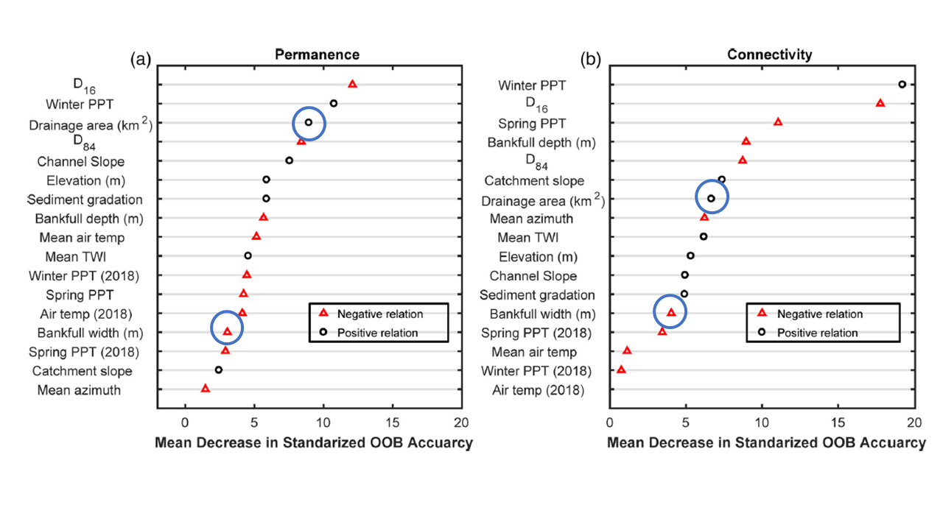

**Figure 2.** Relative importance of each variable as indicated by mean decrease in standardized out-of-bag (OOB) accuracy for (a) flow permanence and (b) network connectivity. Marker colors indicate if the relationship between a covariate and the likelihood of a site being perennial or connected was positive or negative as inferred from partial dependence plots. Circled markers indicate drainage area and bankfull width. Results included data from the Sierra Nevada, which is outside of the ASP boundaries. Figure modified from Pate et al. (2020).

Findings from the broad scale study on flow permanence and network connectivity provide evidence that the width criteria in 14 CCR § 916.9 [936.9, 956.9] (g)(1)(a)( 2) does not adequately predict watercourses that are perennial and/or connected versus ones that are dry and/or disconnected. Since Pate et al. (2020) includes data from the Sierra Nevada, it was necessary to remove the Sierra Nevada watercourses to determine whether this pattern persists for watercourses within ASP Rule boundaries.

Once removing the Sierra Nevada watercourses from the dataset, channel width is still a poor predictor of flow permanence and network connectivity. This is particularly true for watercourses in the Northern Forest District (Figures 3 and 4). As such, potential consideration could be given to simplify the ASP Rules by removing the width criteria. Drainage area is also a more objective and repeatable criteria than width, as the width criteria requires the practitioner to select cross-sections, measure channel width, and calculate an average of the measurements. The data suggests that the coefficient of variation for channel width ranges from approximately 25 to 40% (Figure 5), indicating that channel width is moderately variable. While it is unclear how much variability there is in drainage area calculation, objective geospatial analysis tools (e.g., Arc Hydro Tools) for drainage area calculation are readily available to field practitioners. In addition, larger drainage areas will have a higher likelihood of transporting sediment,

**Figure 3.** Bankfull channel width for perennial versus non-perennial watercourses by Forest Practice District. Class II-L channel width criterion is represented by the horizontal line. Data suggests that wider streams in the Northern Forest District are less perennial than narrower streams.

**Figure 4.** Bankfull channel width for connected versus disconnected watercourses by Forest Practice District. Class II-L channel width criteria is represented by the horizontal line. Data suggests that wider streams in the Northern Forest District are less connected than narrower streams.

nutrients, and large woody debris due to the increase in transport capacity. In contrast, channel width might be more a reflection of local hydraulic controls (e.g., slope, grain size, and LWD presence; Pate et al., 2020), and therefore may not directly reflect the potential to transport watershed products downstream. As such, drainage area might be a better reflection of potential transport capacity for the watershed constituents mentioned in 14 CCR § 916.9 [936.9, 956.9] (c)(4).

Findings from the broad scale study on flow permanence and network connectivity indicate that the drainage area criteria in 14 CCR § 916.9 [936.9, 956.9] (g)(1)(a)( 1) is a better predictor of perennial and/or connected flow than the width criteria. After removing data from the Sierra Nevada, Figures 6 and 7 show that perennial and/or connected watercourses were generally associated with larger drainage areas. Table 1 shows the median, mean, and geometric mean of drainage area for various flow conditions (i.e., flow permanence versus connectivity) by Forest Practice District. The geometric mean of drainage area for perennial watercourses in the Coast Forest District was 103 acres, as compared to the drainage area criteria of greater than equal to 100 acres. The geometric mean of drainage area for perennial watercourse in the Northern Forest District was 150 acres, as compared to drainage area criteria of greater than equal to 150 acres (Table 1). Similarly, the geometric mean of connected watercourses were very similar to the drainage area criteria (Table 1) across both Forest Practice Districts. Altogether, this suggests that the drainage area criteria does a reasonable job of predicting flow permanence and watercourse connectivity. However, it should be noted that drainage area was only the third most important variable for predicting perennial flow, and the seventh most important variable for predicting watercourse connectivity (Figure 2), although this finding includes data from the Sierra Nevada.

**Figure 5.** Coefficient of variation for bankfull channel width by forest practice district and geomorphic province.

**Figure 6.** Drainage area for perennial versus non-perennial watercourses by Forest Practice District. Class II-L drainage area criteria is represented by the horizontal lines. Data suggests that larger drainage areas were more associated with perennial flow.

**Figure 7.** Drainage area for connected versus disconnected watercourses by Forest Practice District. Class II-L drainage area criteria is represented by the horizontal lines. Data generally suggests that larger drainage areas were more associated with connected flow.

**Table 1.** Summary statistics of drainage area for flow permanance and network connectivity by Forest Practice District.

Table 1.  Summary statistics of drainage area for flow permanance and network connectivity by Forest Practice District

Longitudinal Stream Temperature Study

A central assumption of the ASP Rules is that stream temperature warms in the downstream direction (i.e., asymptotic warming), and the requirement for more robust riparian prescriptions near the Class I/II transition is based on this assumption. However, stream temperatures may vary depending on characteristics of the stream, catchment, or region. To improve the knowledge of the key drivers of stream thermal regime, stream and air temperature data were collected along eight headwater streams in two regions with distinct lithology, climate, and riparian vegetation. Five streams were in the Northern California Coast Range at the Caspar Creek Experimental Watershed Study, which is characterized by permeable sandstone lithology. Three streams were in the Cascade Range at the LaTour Demonstration State Forest, which is characterized by fractured and resistant basalt lithology. Each stream was instrumented with 12

stream temperature and four air temperature sensors during summer 2018. The objectives were to compare stream thermal regimes and thermal sensitivity—slope of the linear regression relationship between daily stream and air temperature—within and between both study regions.

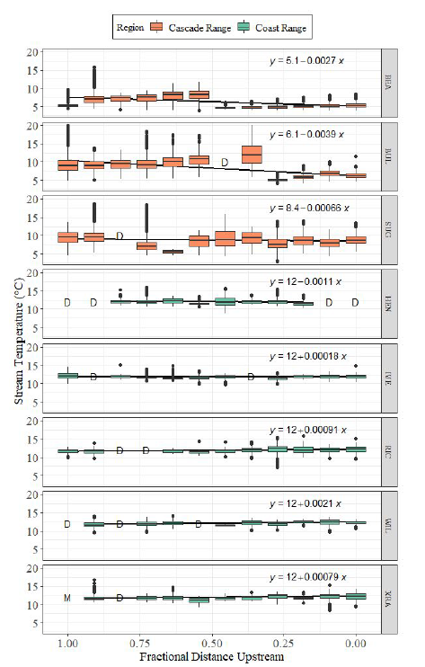

**Figure 8.**  Longitudinal distribution of daily mean summer stream temperatures measured along each stream with the longitudinal linear regression equation predicting average daily mean stream temperature from downstream distance (m) shown to indicate downstream warming or cooling. Slope of the regression lines are significant (p<0.05) for all streams with the exception of IVE.

The longitudinal study indicated that not all Class III or II watercourses warmed in the downstream direction (Figure 8). In particular, three of the monitored streams in the LaTour Demonstration State Forest (DSF) and one in Caspar Creek cooled in the downstream direction. The assumption of asymptotic warming was met by 4 out of the 5 streams monitored in the Jackson Demonstration State Forest. Results also indicate that the watercourse stream temperature in LaTour DSF were less coupled to air temperature than those from Jackson DSF (Figure 9).

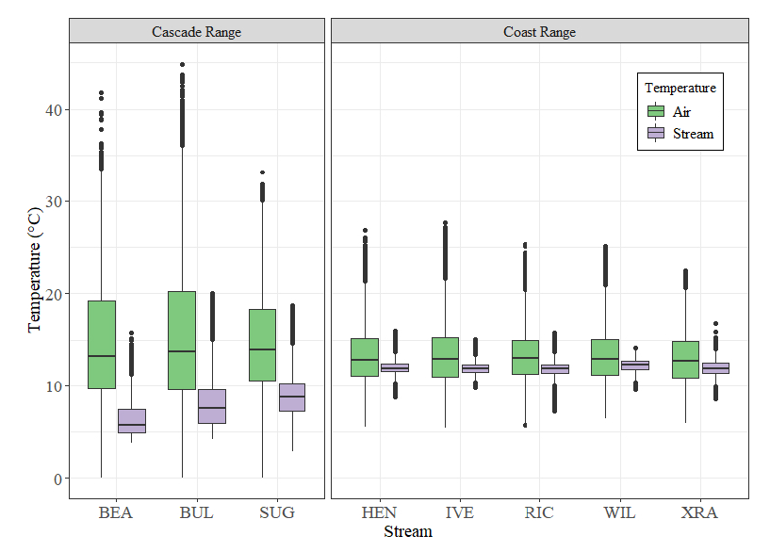

**Figure 9.** Comparison of air and stream temperature distributions among streams in the Coast and Cascade Ranges. Data were pooled from all temperature sensors within each stream. The boxplot central tendency line is the median, shaded boxes represent the interquartile range (IQR), whiskers represent the largest value up to 1.5-times the IQR, and the black dots indicate outliers beyond 1.5-times the IQR.

The longitudinal study validates some of the concepts in 14 CCR § 916.9 [936.9, 956.9] (v) “Option V”, which allows for the customization of riparian prescriptions as an alternate to standard ASP prescriptions. Anecdotal evidence suggests “Option V” has been used sparingly due to substantial time and resource investment to craft a site-specific plan, and the time it takes to approve the site-specific plan during the review period.

1. **More Research Needed?**
2. **Literature Review Sufficient? – Yes.** The literature review in the papers was sufficient in terms of covering relevant research on surface water connectivity and downstream temperature trends for headwater streams.
3. **Further Funding Needed? - Yes.** This particular study addressed one element of the ASP Rules. To further test the effectiveness of the ASP Rules, additional work needs to be done to test the effectiveness of the ASP prescriptions on protecting, maintaining, and restoring functions and processes related to sediment, nutrients, and large wood debris.
4. **What is the relationship between this study and any others that may be planned, underway, or recently completed?**
   1. **Feasibility of obtaining more information to better inform policy about resource efforts –** It is feasible to obtain more information to better inform policy. For instance, it may be possiblee to determine a more refined drainage area criteria with more sampling within each Forest Practice District. Also, the longitudinal study was only performed in two relatively small portions of the area subject to the ASP Rules, and more work is needed to determine how commonly watercourses fit the assumption of downstream warming as a function of lithology and/or other variables. However, further research comes at the expense of funding other studies that answer critical questions where uncertainty remains high.
   2. **Are other relevant studies planned, underway, or recently completed? (If yes, what are they?** This study is related to EMC-2018-006, which seeks to verify the ASP riparian prescriptions for maintaining or protecting canopy closure, water temperature, and primary productivity.
   3. **What are the costs associated with additional studies?** The EMC with additional support from CALFIREis providing $694,371 in funding for EMC-2018-006.
   4. **What will additional studies help us learn?** Overall, this study will tell us if there is a significant difference in protection afforded by the Class II-L prescription versus a pre-ASP riparian prescription.
   5. **When will these additional studies be completed (i.e., when will we learn the information)?** The results of EMC-2018-006 will be available in the middle of 2023.
   6. **Will additional information from these other studies reduce uncertainty? - Yes**. EMC-2018-006 will evaluate the effectiveness of the ASP Class II-L riparian prescriptions relative to alternative riparian prescriptions in maintaining canopy closure, stream water temperature, primary productivity and terrestrial habitat.
5. **Scientific Applications - What is the scientific basis that underlies the rule, numeric target, performance target, or resource objective that the study informs? How much of an incremental gain in understanding do the study results represent?**

We learned that the controls on the presence of surface flow during summer months are multi-factored. While the ASP Rules assume that the presence of surface water is a function of active channel width and/or drainage area, this study indicates that climate, geology, and watershed properties all play a factor in influencing the downstream connectivity of surface waters. Altogether, these variables are able to classify the presence of perennial and/or connected streams 73 to 76 percent of the time, respectively. As such, our understanding of the controls for perennial/connected flow for headwater streams in California has increased substantially.

While the studies have advanced our understanding regarding the controls on surface water connectivity during summer low flows for Class II watercourses, as well as downstream temperature dynamics under varying lithologies, there are several limitations to the study.

1. Mitigation of Thermal Impacts is Only One Aspect of the ASP Rules – The ASP Rules were put into place not only to protect against the downstream transmission of disturbance-induced water temperature increases, but were also crafted to maintain, protect, and restore key processes and functions related to sediment, nutrients, and large woody debris. While this study suggests that the width criteria does not effectively distinguish perennial or connected watercourses, the width criteria may correspond to other processes like large woody debris and/or sediment transport.
2. The Broad Scale Study May Not Adequately Characterize Spatial Variability Across the Range of the ASP Rules – The field work for the broad scale assessment occurred over 10 weeks, with over 1000 cross-sections characterized. For logistical reasons, many of the surveyed watercourses were clustered. Also, access to private timberlands was very difficult. Hence, many areas subject to the ASP Rules were not surveyed. As with most studies a larger sample size would have been ideal but it is uncertain whether the findings would change if additional streams were surveyed in an area with significantly different climate, geology, or physiography.
3. The Broad Scale Study May Not Adequately Characterize Temporal Variability Across the Range of the ASP Rules –Surveys were only conducted during one summer season. For the North Coast and Klamath provinces, precipitation was 26-38% lower than average, while it was close to average in the Cascades. It is unclear how findings related to the width and drainage area criteria would change if watercourses were surveyed following a much wetter winter, although findings from the current study suggest that there would be more downstream connectivity and perennial flow.
4. The Longitudinal Study is a Case Study and May Not Reflect Downstream Temperature Dynamics Across the Entire Range of ASP– The longitudinal study documents downstream temperature dynamics in two geomorphic provinces of the ASP area (i.e., North Coast and Cascades). However, we lack data from the Klamath province, where differences in climate and underlying geology may affect downstream temperature response.

**References**

Pate, A.A., Segura, C. and Bladon, K.D., 2020. Streamflow permanence in headwater streams across four geomorphic provinces in Northern California. Hydrological Processes, 34(23), pp.4487-4504.

1. Drainage area criteria for Class II-L is 100 acres for the Coast Forest District and 150 acres for the Northern Forest District. Active channel width criteria is 5 feet for both Forest Districts.
2. The criterion for identifying bankfull width in the broad scale study is the same for active channel width as defined in the FPRs.