(Special Note to the Reader: All updates to the Safety Element are noted as text that is underlined and/or strikethrough.)

Introduction

Protecting What Matters
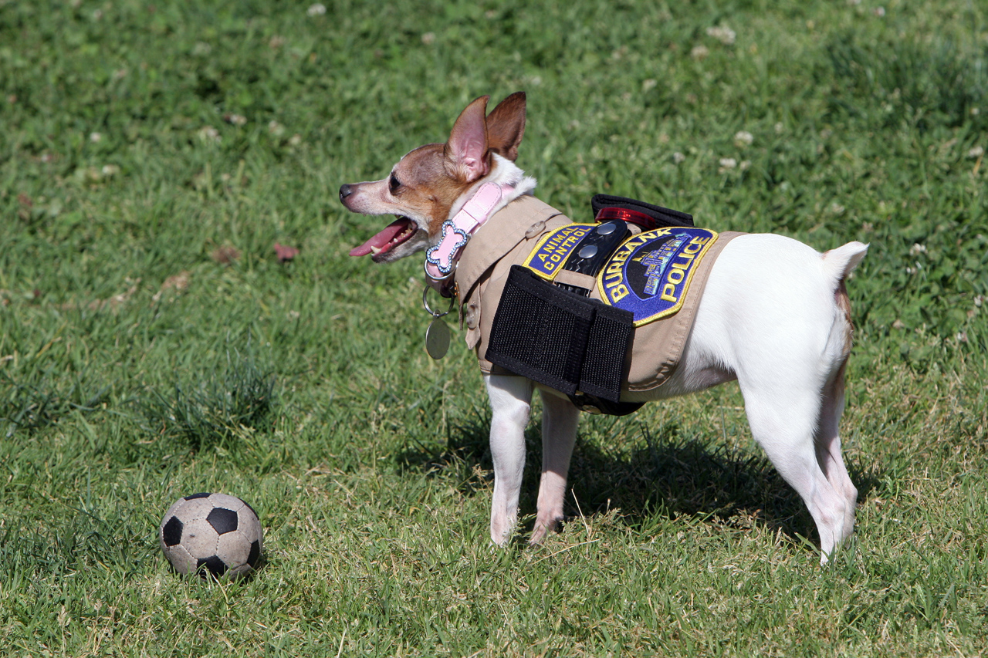
The City develops and supports programs that take a bite out of crime.
Burbank is a safe community with high-quality emergency services and a high level of emergency preparedness. The Safety Element offers tools to address threats like natural and human-caused hazards, crime, and homeland security. Future planning decisions must be considered in the context of natural hazards such as earthquakes and floods, and provision of police, fire, and emergency medical services.

Purpose and Statutory Requirements
The Safety Element satisfies the requirements of state planning law and is a mandated component of Burbank2035. Section 65302(g) of the California Government Code sets forth the following list of hazards that the element must cover, if these hazards pertain to conditions in the city: seismically induced conditions including ground shaking, surface rupture, ground failure, tsunami, seiche, and dam failure; slope instability leading to mudslides and landslides; subsidence, liquefaction, and other geologic hazards; flooding; wildland and urban fires; and evacuation routes; and climate change. State law allows communities to address additional safety issues. The following additional issues are addressed in this Safety Element: police protection, fire protection, emergency response and preparedness, airport safety, and hazardous materials.

Relationship to Other Elements
The Safety Element identifies areas prone to natural hazards, which must be considered in the designation of land uses in the Land Use Element. For example, proposed land uses must comply with the land use compatibility standards contained in this element for various types of hazards. Traffic-calming goals and policies in the Mobility Element may have implications for emergency response, and recommendations for evacuation and emergency access routes in the Safety Element affect the Mobility Element. The Open Space and Conservation Element is also linked to the Safety Element, because open space zones and allowable uses are often related to hazard-prone locations. For example, areas prone to land sliding hazards are often set aside as open space because their steep slopes limit other uses.

Relationship to All-Hazard Mitigation Plan
California Assembly Bill 2140 (2006) allowed cities and counties to adopt a local hazard mitigation plan (HMP), specified in the federal Disaster Mitigation Act of 2000, as a part of their safety elements. The bill limits funds from the California Disaster Assistance Act for jurisdictions that have not adopted a Hazard Mitigation Plan as part of their Safety Element. Specifically, Section 8685.9 of the California Government Code states, “the state share shall not exceed 75% of total state eligible costs unless the local agency is located within a city, county, or city and county that has adopted a local hazard mitigation plan in accordance with the federal Disaster Mitigation Act of 2000 … as part of the safety element of its general plan.” If a jurisdiction has adopted a HMP as part of its Safety Element then the legislature may provide a state share of costs in excess of 75%.
Burbank’s All-Hazard Mitigation Plan was first adopted by the City Council in 2005 in compliance with federal regulations. The purpose of the All-Hazard Mitigation Plan is to integrate hazard mitigation strategies into the City’s daily activities and programs. The All-Hazard Mitigation Plan assesses risk from earthquakes, transportation accidents, transportation loss, wild land/urban interface fires, terrorism and weapons of mass destruction, utility loss or disruption, water and wastewater disruption, hazardous materials incidents, aviation disasters, information technology loss or disruption, severe weather, explosions, economic disruption, floods, drought, dam failure, sinkholes, volcanic activity, and special events.
The All-Hazard Mitigation Plan as amended by the Burbank City Council from time to time is hereby incorporated into the Burbank2035 Safety Element by reference as though it were fully set forth herein. In the event of any conflict between the provisions of the All-Hazard Mitigation Plan and the provisions of Burbank2035, the provisions of the All-Hazard Mitigation Plan shall control. A copy of the All-Hazard Mitigation Plan is on file in the Community Development Department for use and examination by the public.

Safety Goals and Policies
The goals and policies contained in this Safety Element provide Burbank with a framework for keeping residents, businesses, and visitors safe from natural and human hazards. They also provide increased safety for the City’s emergency response personnel. Where the policies below refer to location-based hazards, those hazards are as illustrated in the Safety Plan.
Goal 1 EMERGENCY RESPONSE AND PREPARATION
Burbank is prepared to respond to emergency situations.
Policy 1.1 Regularly update all hazard mitigation plans, disaster preparedness and emergency response plans.
Policy 1.2 Coordinate disaster preparedness and emergency response with appropriate agencies, neighboring cities, and the Burbank-Glendale-Pasadena Airport Authority.
Policy 1.3 Sponsor and support public education programs for emergency preparedness and disaster response.
Policy 1.4 Promote the development of community or neighborhood disaster relief groups and workplace self-help groups to improve the effectiveness of local emergency response teams.
Policy 1.5 Establish designated emergency response and evacuation routes throughout the city, for each climate hazard (e.g., flooding, fire, etc.), focusing on the most vulnerable populations.
Goal 2 Police Protection
Burbank provides high-quality police protection services to residents and visitors.
Policy 2.1 Maintain an average police response time of less than 4 minutes to emergency calls for service.
Policy 2.2 Ensure adequate staffing, facilities, equipment, technology, and funding for the Burbank Police Department to meet existing and projected service demands and response times.
Policy 2.3 Provide and use up-to-date technology to improve crime prevention.
Policy 2.4 Develop and support crime prevention programs throughout the city, including the Crime Prevention Through Environmental Design (CPTED) and Neighborhood Watch programs.
Policy 2.5 Provide public education for neighborhood safety programs to encourage active participation by Burbank residents and businesses.
Goal 3 Crime Prevention
Burbank is protected from the threat of civil disturbances and terrorism and is prepared to achieve and maintain a safe and secure environment to reduce the number of lives lost, injuries, and amount of property damage.
Policy 3.1 Adapt to the changing safety needs of the community.
Policy 3.2 Reduce opportunities for criminal activity through physical design standards such as CPTED and youth programs, recreation opportunities, educational programs, and counseling services.
Goal 4 FIRE Protection
Burbank provides high-quality fire protection services to residents and visitors. Threats to public safety are reduced and property is protected from wildland and urban fire hazards.
Policy 4.1 Maintain a maximum response time of 5 minutes for fire suppression services. Require new development to ensure that fire response times and service standards are maintained.
Policy 4.2 Provide adequate staffing, equipment, technology, training and funding for the Burbank Fire Department to meet existing and projected service demands and response times.
Policy 4.3 Implement fire prevention and suppression programs in areas of high fire hazard areasrisk, including both urban and wildland areas.
Policy 4.4 Maintain adequate fire breaks in areas within and adjacent to areas of high wildfire hazardrisk.
Policy 4.5 Coordinate firefighting efforts with local, state, and federal agencies.
Policy 4.6 Increase the resilience of existing development in high-hazard areas built prior to modern fire safety codes or wildfire hazard mitigation guidance. Reduce fire hazards associated with older buildings, multi-story structures, and industrial facilities.
Policy 4.7 Maintain adequate fire suppression capability in areas of intensifying urban development, as well as areas where urban uses and open spaces mix.
Policy 4.8 Use public funding, where available, to the greatest extent practical to assist private landowners in implementing defensible space and building retrofits to achieve a low-risk condition.
Policy 4.9 Ensure that all existing and new residential development located in the Very High Fire Hazard Severity Zone and High Fire Hazard Severity Zone, has at least two emergency evacuation routes as well as adequate evacuation access (ingress and egress).
Policy 4.10 Continue annual brush inspections and enforce clearance requirements on public and private property within the Very High Fire Hazard Severity Zone (VHFHSZ), as dictated by Cal Fire, in accordance with the Board of Forestry and Fire Protection Fire Safe Regulations, California Building Standards Code, and Burbank Municipal Code related to ongoing maintenance of vegetation clearance on public and private roads, roadside fuel reduction plan, and defensible space clearances.
Policy 4.11 Continue to sponsor and support public education programs, such as neighborhood events, the Burbank Fire Department websites and social media contents, and printed educational materials to promote defensible space and emergency evacuation. Prioritize outreach and public education programs for vulnerable populations, as identified by CalEnviroScreen.
Policy 4.12 Increase the resilience of new development in Very High Fire Severity Zones in compliance with the Board of Forestry and Fire Protection Fire Safe Regulations, California Building Standards Code, and Burbank Municipal Code. Require all new development to be served by a water system that meets applicable fire flow requirements.
Policy 4.13 Increase the resilience of existing development in Very High Fire Severity Zones built prior to modern fire safety codes or wildfire hazard mitigation guidance in compliance with the Board of Forestry and Fire Protection Fire Safe Regulations, California Building Standards Code, and Burbank Municipal Code.
Policy 4.14 Require development of new public facilities, when feasible, to be located outside of Very High Fire Severity Zones to ensure critical infrastructure is fire resilient.
Policy 4.15 Ensure that re-development after a large fire complies with the requirements for construction in the Very High Fire Hazard Severity Zones for fire safety.
Policy 4.16 Ensure that the planning and design of development in Very High Fire Hazard Severity Zones minimizes wildfire hazards and includes adequate provisions for vegetation management, emergency vehicle access, and firefighting while also complying with current fire codes.
Policy 4.17 Require fire protection plans for new development in Very High Fire Hazard Severity Zones.
Policy 4.18 Require visible home and street addressing, and signage across the City.
Policy 4.19 The Burbank Police and Fire Departments should routinely assess and project future emergency service needs associated with wildland and urban fire hazards.
Policy 4.20 Burbank Water and Power shall manage and regularly maintain water supply infrastructure so that water pressure is adequate for fire-fighting purposes. Regular maintenance and long term integrity of water supply locations for fire fighting purposes should be identified.
Goal 5 SEISMIC SAFETY
Injuries and loss of life are prevented, critical facilities function, and property loss and damage is minimized during seismic events.
Policy 5.1 Require geotechnical reports for development within a fault area that may be subject to risks associated with surface rupture.
Policy 5.2 Require geotechnical reports for new development projects in areas with the potential for liquefaction or landslide. Include projected climate change impacts of slope stability changes after wildfires and develop mitigation strategies for areas deemed at risk to slope instability.
Policy 5.3 Enforce seismic design provisions of the current California Building Standards Code related to geologic, seismic, and slope hazards.
Policy 5.4 Encourage and facilitate retrofits of seismically high-risk buildings to reduce risks from seismic ground shaking.
Policy 5.5 Facilitate the retrofitting of bridges and highway structures in the city to reduce risks associated with seismic ground shaking.
Policy 5.6 Ensure that water supplies are not interrupted by seismic events such as surface rupture, ground shaking, ground failure, tsunami, seiche, or dam failure.
Goal 6 FLOOD SAFETY
Potential risks—such as injury, loss of life and property, and economic and social disruption—caused by flood and inundation are minimized.
Policy 6.1 Inform applicants of flood risks and development requirements within the 100-year, 200-year, or 500-year floodplains or in other high-risk inundation areas and require incorporation of risk reduction measures to achieve an acceptable level of risk from potential flooding hazards. Mitigation measures should include the projected impacts from climate change. Recommend hazard mitigation where possible.
Policy 6.2 Continue to participate in the National Flood Insurance Program to ensure that flood insurance will be available to individuals in the community. Publicize the availability of flood insurance to Burbank residents and business owners.
Policy 6.3 Continue to maintain and upgrade the City-operated flood control system to ensure the system is capable of protecting existing and planned development. Include evaluation of the system under projected changes in storm frequency and intensity.
Policy 6.4 Consult with Los Angeles County and other agencies to maintain and improve capacity of local and regional flood control systems.
Policy 6.5 Enforce regulations prohibiting the draining of rainwater into the sewer system.
Policy 6.6 Prepare and update a stormwater master plan to Ensure proper maintenance and improvements to storm drainage facilities. Evaluate maintenance and improvements to storm drainage facilities based on projected changes to storm frequencies and intensity.
Policy 6.7 Employ strategies and design features to reduce the area of impervious surface in new development projects.
Policy 6.8 Whenever feasible, locate new essential public facilities, including health care facilities, emergency shelters, fire stations, emergency command centers, and emergency communications facilities, outside flood hazard zones.
Goal 7 AIRPORT HAZARDS
Threats to public safety, lives, and property resulting from an airport-related incident are reduced.
Policy 7.1 Maintain consistency with the Los Angeles County Airport Land Use Plan as it pertains to Bob Hope Airport.
Policy 7.2 Ensure that land uses, densities, and building heights within Airport Land Use Compatibility Zones, including those in disadvantaged communities, are compatible with safe operation of Bob Hope (Hollywood Burbank) Airport.
Policy 7.3 Review and update City procedures for responding to airport and aircraft-related emergencies.
Policy 7.4 Coordinate disaster response with the Bob Hope Hollywood Burbank Airport Fire Department.
Goal 8 HAZARDOUS MATERIALS
Hazardous materials threats to public health and safety are reduced.
Policy 8.1 Review proposed projects involving the use or storage of hazardous materials.
Policy 8.2 Encourage businesses and organizations that store and use hazardous materials to improve planning and management procedures.
Policy 8.3 Encourage and promote practices that will reduce the use of hazardous materials and the generation of hazardous waste at its source, recycle the remaining hazardous wastes for reuse, and treat those wastes that cannot be reduced at the source or recycled. Distribute information and use incentives and disincentives to reduce or eliminate the use of hazardous materials where feasible.
Policy 8.4 Maintain a hazardous materials response capability that will adequately handle Burbank's hazardous materials safety needs.
Policy 8.5 Consult with appropriate agencies regarding hazardous materials regulations.
Policy 8.6 Provide the residents of Burbank with information on the proper storage and disposal of hazardous materials and e-waste and encourage the use of City disposal facilities.
Policy 8.7 Include information on soil contamination and storage of hazardous materials in the City's Geographic Information System.
Policy 8.8 Advocate the continued review and mitigation of the effects of operation of natural gas and petroleum pipelines, and other pipelines used to transport hazardous substances.
Policy 8.9 Reduce the loss of life, property, and injures incurred as a result of hazardous materials spills by offering comprehensive spill prevention information to businesses using hazardous materials, public education, and emergency response programs. Focus outreach and emergency response on vulnerable populations.

Safety Plan
As in all communities, human activities and natural conditions in Burbank affect residents’ quality of life. It is essential to provide an environment where businesses and residents can not only prosper and feel safe, but also be prepared for emergency situations. The City can minimize hazards and protect public health and private property through a combination of appropriate land use planning, development review, and emergency preparedness planning.

Emergency Services and Safety
Achieving ideal response levels from law enforcement and emergency service providers requires coordination between the City and the community. The Burbank Police and Fire Departments work with the community to identify the levels of service desired and continually assess services, facilities, equipment, and personnel to determine their ability to meet current and future demands. The locations of Burbank’s existing emergency service facilities, including fire services and police services, are dispersed throughout the community to adequately respond to and serve all areas, including SRAs or VHFHSZs. Fire Station 16 (1600 North Bel Aire Drive) is located in the northeastern fire zone and Fire Station 11 (311 East Orange Grove Avenue), although not in the northeastern fire zone, also serves the area. Fire Station 12 (644 North Hollywood Way) is not located in the fire zone but serves the southern fire zone in the city.
The Police and Fire Departments will continue to use public outreach and education to increase community awareness regarding hazards, emergency response, and homeland security in Burbank. In addition, the City will support programs that address crime and fire prevention activities. The Burbank Police and Fire Departments will continue proactive training and planning programs, and will use state-of-the-art technology to improve response and increase public safety.

Police Services
The Burbank Police Department responds to emergency situations and patrols neighborhoods and commercial areas of the city to promote a safe environment. The staff maintains official criminal records, investigates crime, and, in an emergency, assesses the situation and quickly dispatches appropriate emergency responders. The Police Department operates five facilities: Police Headquarters located at 200 North Third Street, the animal shelter at 1150 North Victory Place, a police pistol range at 2244 Wildwood Canyon, the City Jail, and a heliport in Sun Valley.
The Police Department uses 11 patrol beats to provide services to all portions of the city and respond to calls outside of Burbank, if needed. The average response time for emergency calls in 2009 was 3 minutes, 12 seconds, and the average response time for non-emergency calls was 16 minutes.
The Burbank Police Department maintains mutual aid agreements with the police departments for the Cities of Los Angeles, San Fernando, Glendale, and Pasadena, and shares resources and receives assistance from those departments, if needed. In addition, as part of the State Emergency Aid System, the Police Department will provide a specified number of officers and equipment to other jurisdictions in the event of an incident. The department can also request aid from the Los Angeles County Sheriff’s Department or the California Emergency Management Agency.

Crime Prevention through Environmental Design
Burbank values environmental design as a tool to help prevent crime. The concepts of crime prevention through environmental design (CPTED) offer non-invasive and permanent measures to prevent crime in the city. CPTED includes the following five concepts: territoriality, natural surveillance, activity support, access control, and maintenance.
Territoriality: Demarcating the boundary of a property or an area through walls and fences can discourage intrusion. People tend to protect territory that they feel is their own and to respect the territory of others. Low decorative fences, artistic pavement treatments, well-designed signs, good property maintenance, and high-quality landscaping express pride in ownership and identify personal space.
Natural Surveillance: Arranging populated functions or rooms in homes and businesses to face the street allows easy surveillance by residents and employees. Crime is discouraged by designing and orienting buildings and public spaces, and placing physical features, activity centers, and people, in ways that maximize the ability of others to see what is going on. Conversely, barriers such as bushes, sheds, or shadows make observing activities difficult. Windows or doors oriented to streets and public areas, in conjunction with landscaping and lighting that promote natural surveillance from inside a home or building and from the outside by neighbors, are effective means of passive crime prevention.
Access Control: Circulation and access to sites and buildings can be controlled by designating paths and placing bollards or fences to limit access.
Activity Support: Supporting activities on the street attracts people and encourages natural surveillance. Encouraging legitimate activity in public spaces helps discourage crime. Improvements such as a basketball court in a public park and community activities such as a clean-up day, block party, or civic or cultural event bring people out, get them involved, and help discourage vagrancy and potential illegal acts. Providing a mix of land uses, types of residential development, and public or quasi-public spaces encourages diverse households and patterns of activity. The resulting round-the-clock activity and increase in eyes on the street raises the level of security.
Maintenance: Maintaining sidewalks, street trees, lighting, and private property discourages negative behavior such as littering and vandalism.
CPTED concepts enable developers and designers to incorporate crime prevention measures into building design. Territoriality can be achieved by demarcating boundaries with various surface treatments and careful design to make intrusion and suspicious activities easy to identify. Building orientations that face the street, window placements and size, and provision of lighting allow neighbors to survey their neighborhood and discourage intrusion. Pathways and obstructions such as walls and gates allow property owners and the City to control access.
Crime prevention relies on programs implemented by government agencies. To reduce crime, the City will emphasize the need for well-lighted community areas and extra surveillance in areas susceptible to high crime rates, such as parking lots. Complementary uses within mixed-use areas will be encouraged to reduce crime. Activity support is strengthened by intentionally placing programs and activities in areas that improve the perception of safety and discourage potential offenders.
The success of CPTED depends on maintenance of all these programs. Maintaining streets, lighting, and landscaping facilitate natural surveillance and access control. Maintaining private and public properties requires participation from property owners and City departments. Continuing and monitoring CPTED programs will help to promote safety in Burbank neighborhoods.

Fire Services
The Burbank Fire Department consists of six divisions: Fire Prevention, Suppression, Emergency Medical Services, Disaster Preparedness, Equipment Maintenance, and Training and Safety. These divisions function in a manner that allows the Fire Department to effectively serve the community in emergency and nonemergency situations.
The Burbank Fire Department operates six fire stations, as listed below and a Fire Training Center:
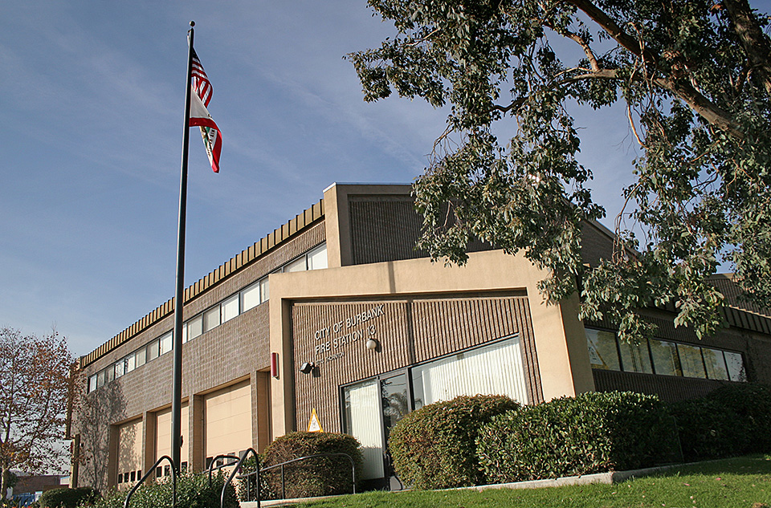
Burbank’s Fire Department operates from six fire stations distributed throughout the city.

- Station 11—311 East Orange Grove Avenue
- Station 12—644 North Hollywood Way
- Station 13—2713 West Thornton Avenue
- Station 14—2305 West Burbank Boulevard
- Station 15—1420 West Verdugo Avenue
- Station 16—1600 North Bel Aire Drive
Fire Training Center—1845 North Ontario Street
The Fire Training Center is used both for training purposes and as an Emergency Operations Center in times of emergency.
The Fire Department has jurisdiction over all fires and life-threatening incidents in the city. Even when private companies have their own trained firefighting personnel and equipment who respond first to a fire emergency, the Fire Department takes over control of the scene. The only exception to this is on interstate and state highways, where the California Highway Patrol has ultimate responsibility.
The Burbank Fire Department is a member of the Verdugo Fire Communications Center, a regional communications center that fields calls for service for the Cities of Burbank, Glendale, Pasadena, Alhambra, Arcadia, Monrovia, Montebello, Monterey Park, San Gabriel, San Marino, Sierra Madre, and South Pasadena. The communications center was established by the Cities of Burbank, Glendale, and Pasadena under a “no borders” agreement in which the closest fire station to a reported incident responds to the call, regardless of jurisdiction. The remaining nine jurisdictions subsequently joined the Communications Center.
Because no community has resources sufficient to cope with all emergencies that could occur, a statewide system of mutual aid provides assistance. Mutual aid requests are processed through the California Emergency Management Agency. Under this system, each jurisdiction relies on its own and/or the neighboring jurisdiction's resources to deal with a disaster before calling for outside assistance.
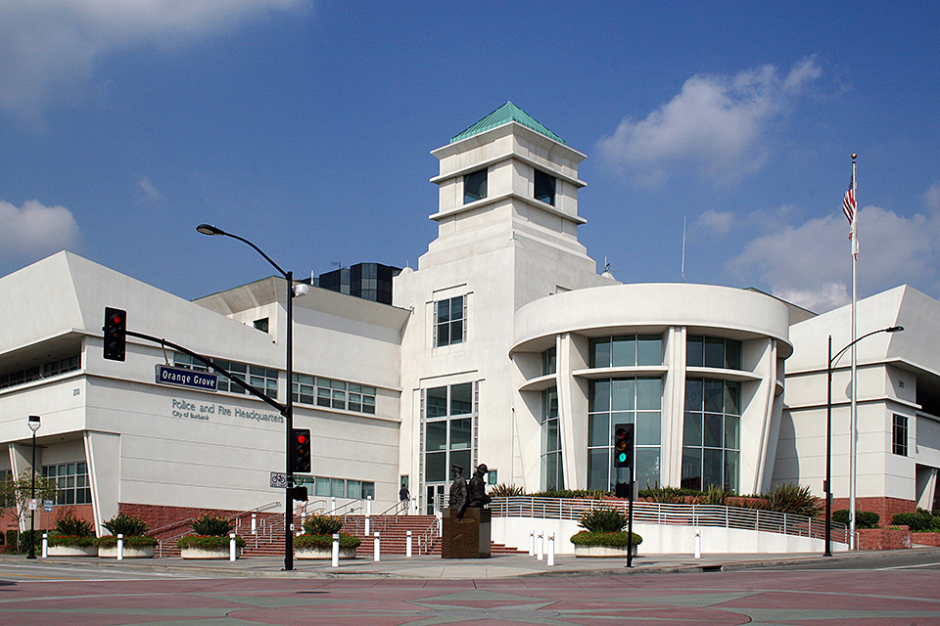
The headquarters building for both the Burbank Police and Fire Departments is located at the intersection of North Third Street and Orange Grove Avenue.
The Burbank Fire Department also operates a multi-faceted public education program, aimed at students, businesses, senior citizens, scouts and other clubs, and the city's residents at large. These programs are an important part of the Fire Department’s efforts to prevent fire and other disasters in the community. Among the Fire Department’s public education efforts are public school demonstrations, safety talks, annual events (e.g., Disaster Preparedness Fair, Fire Prevention Week, Fire Service Day), and informational inserts in utility bills.

Fire Hazards
Fire is a safety concern both within the urban area of Burbank and in hillside areas. Urban fire risks are reduced by enforcing code provisions and maintaining a high-quality fire department. Wildland fires are most problematic along the developed residential fringes of the hillsides. Dry vegetation, seasonal swings in precipitation, and wind conditions combine to increase the potential for wildfires.

Wildland Fires
Like any urban environment, Burbank is subject to fire hazards. In particular, Burbank’s location adjacent to the Verdugo Mountains and the Hollywood Hills makes the city susceptible to loss from fire in the urban-wildland interface, where urban uses begin to mix with undeveloped land in its natural state. The hills are already subject to wildfire hazards because of their vegetation and climate; where the city’s urban uses extend into the hills, these hazards is risk combineds with additional sources of fire and special difficulties in firefighting in these areas (which have steep slopes and fewer access points). Major historical fires that have occurred in the Verdugo Mountains in or near Burbank are described below.
The 1927 Brush Fire destroyed over 100 homes and encompassed parts of the Verdugo Mountains and Sunset Canyon.
The 1964 Verdugo Brush Fire caused by downed power lines from high winds in Whiting Woods resulted in minor structural damages.
The 1980 Verdugo Brush Fire was started by downed power lines in the La Tuna Canyon area and impacted a water reservoir and transmission lines outside of city limits.
The 1993 Fire Storms occurred over a 10-day period as a result of Santa Ana winds. This event ignited several regional fires and caused large-scale structural damage and several hundred thousand acres of burned area.
Various wildfires in October of 2003 spanned from Mexico to Ventura County resulted in over 750,000 acres burned, almost 5,000 structures destroyed, and several deaths.
The 2005 Harvard Fire started on Harvard Road and burned about 1,000 acres of brush with no structural damage and approximately $2,000,000 in fire suppression costs.
The 2009 Station Fire occurred on Angeles Crest Highway and burned over 160,000 acres consuming 90 homes, about 100 other structures, and resulted in two firefighter deaths.
Additional historical data and information about historical wildfires can be found in the 2011 Burbank All-Hazard Mitigation Plan.
Two Mountain Fire Zones, as illustrated in Exhibit S-1, are designated by the California Department of Forestry and Fire Protection and the Burbank Fire Department as Very High Fire Hazard Severity Zones. One zone is located along the foothills of the Verdugo Mountains in northeast Burbank, and the other is located in southwestern portion of the city adjacent to the Warner Bros. Studios. The Fire Department’s mission during a wildland fire is to protect life, property, and the environment. All available personnel and equipment are used to protect structures and provide perimeter control within the urban-wildland interface. See Exhibit S-2 for the City’s Very High Fire Severity Zones, Public Services and Zoning.
Fire Responsibility and Planning
The City will continue to reduce the potential for dangerous fires by operating the focused divisions within the Burbank Fire Department to implement fire hazard education, fire protection, and fuel modification programs, and to make sure that the city maintains sufficient emergency capacity, as described in the 2011 Burbank All-Hazard Mitigation Plan, Burbank Fire Hazard Reduction Program (Brush Clearance) and the 2019 County of Los Angeles All-Hazards Mitigation covering Los Angeles County, California. These include the Fire Prevention Bureau, the Fire Film Safety Office, the Fire Suppression Division, Emergency Medical Services, and Emergency Management. In addition, the City will work to ensure that water pressure is adequate for fire-fighting purposes. Development proposals within Very High Fire Hazard Severity Zones will be required to provide adequate safeguards and response capabilities to prevent the loss of structures and to ensure established development does not experience reduced service. New development may be required to pay development impact fees toward this end, subject to a nexus study and assurance as to the rough proportionality of project impacts to the demands for required new fire facilities and/or equipment.
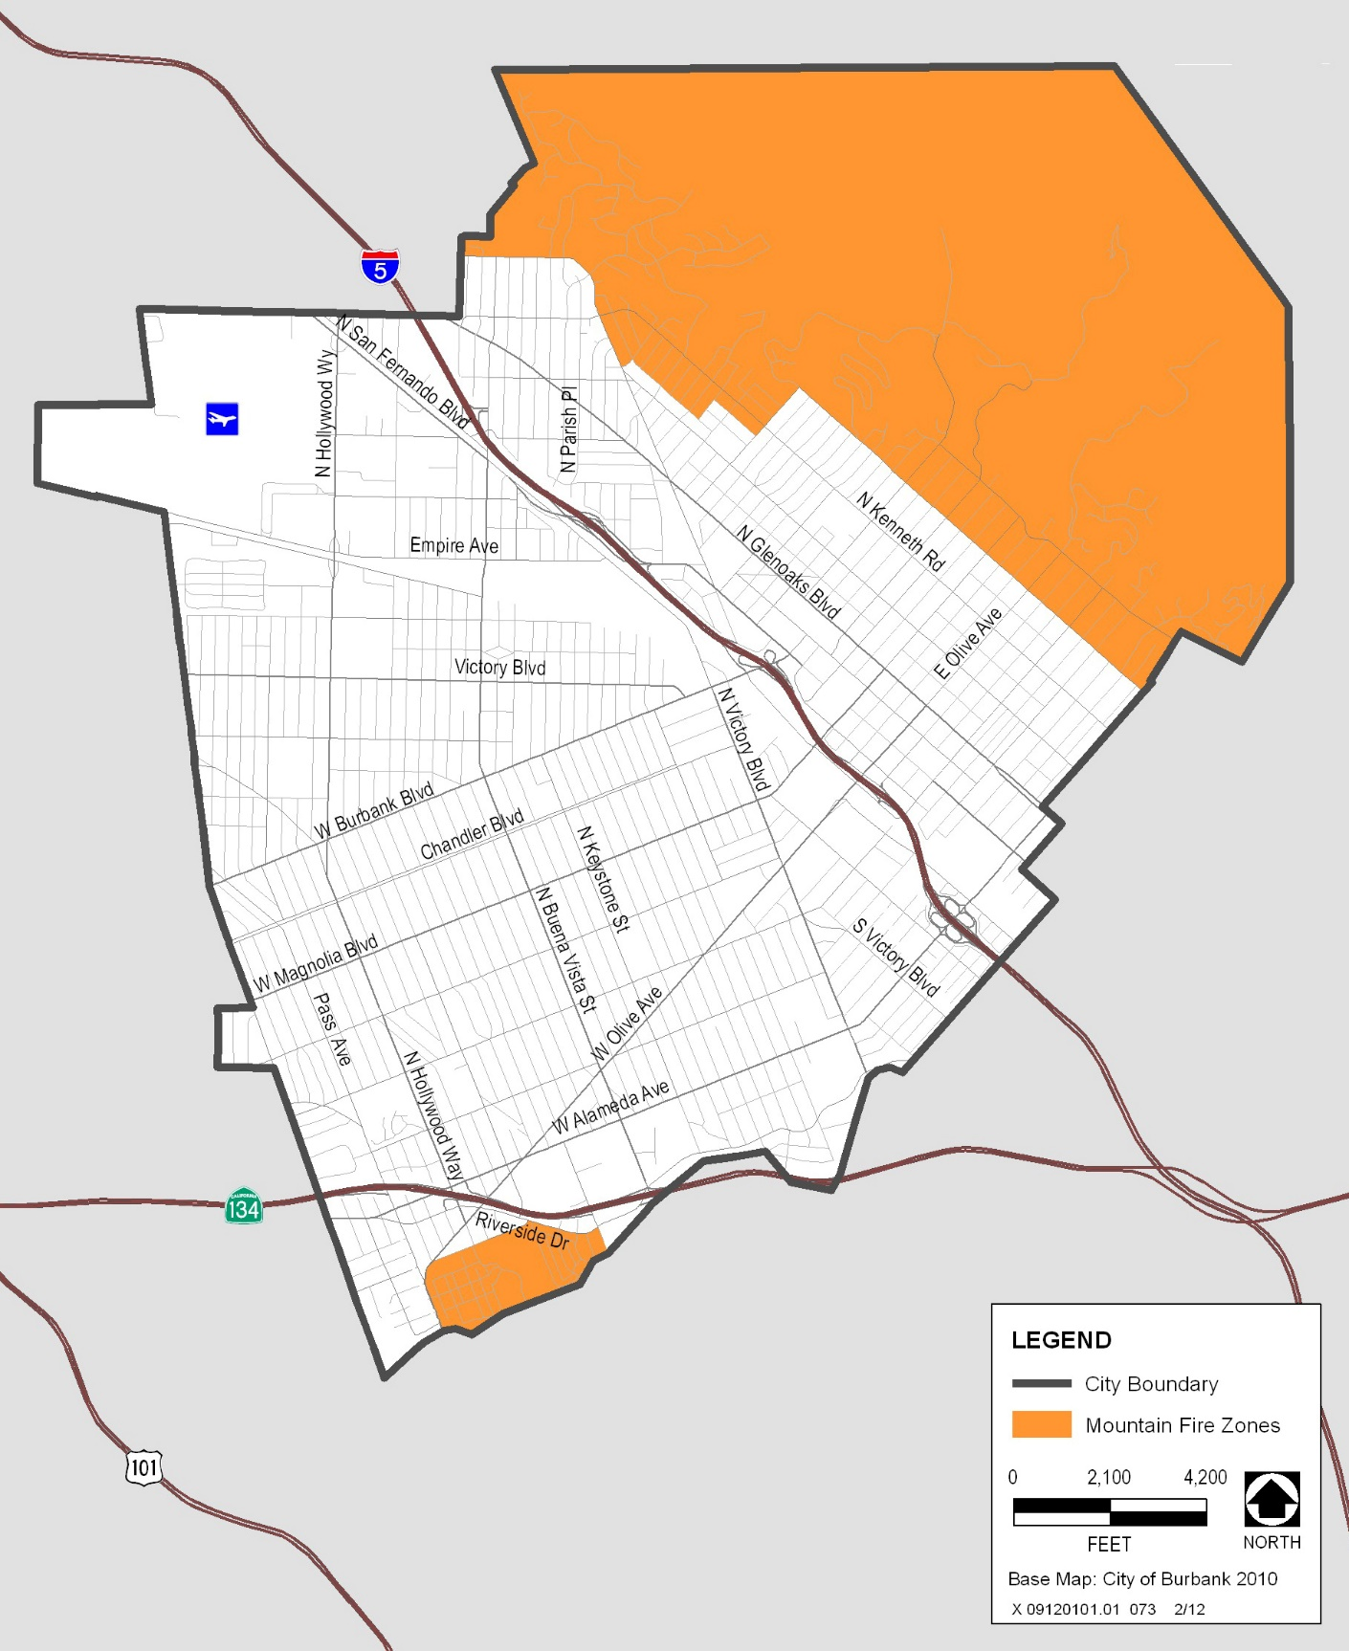
Source: City of Burbank 2010, CASIL 1990
Exhibit S-1. Very High Fire Hazard Severity Zones

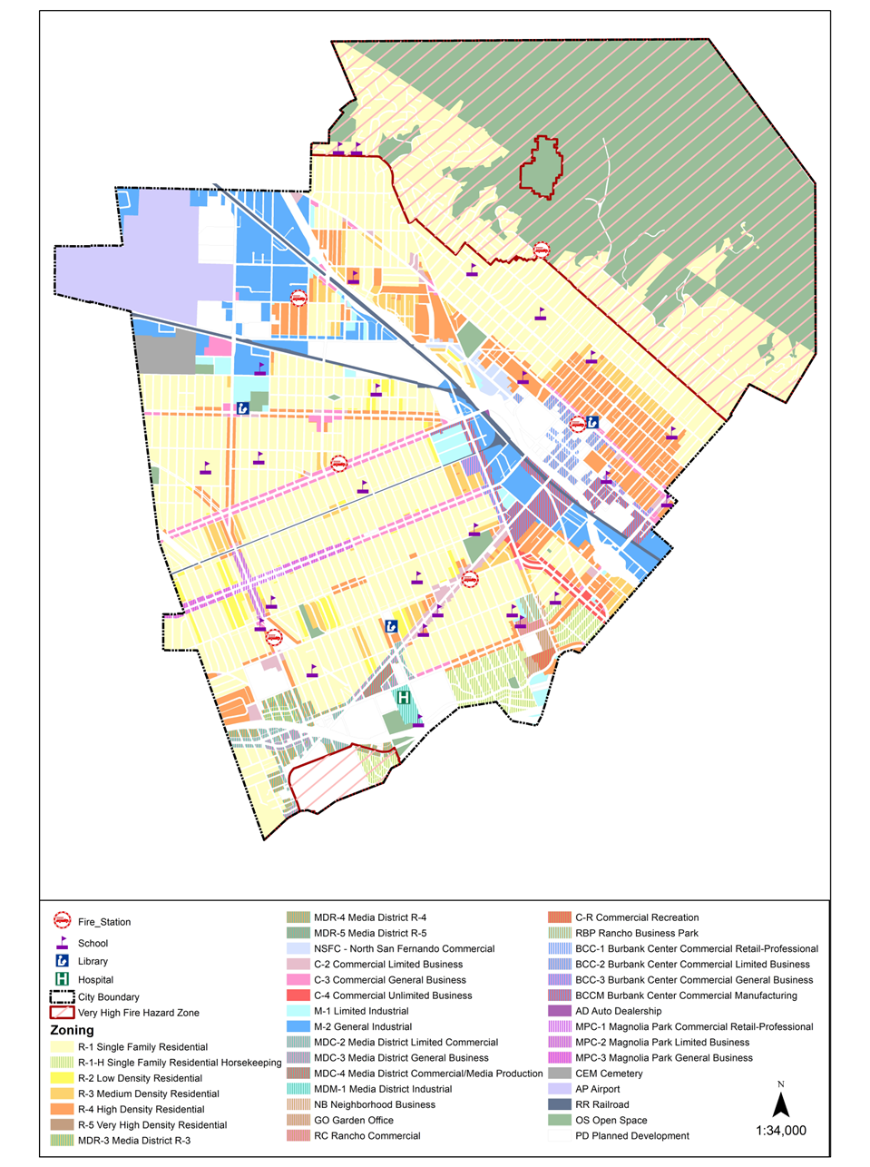

Source: City of Burbank, 2022

Exhibit S-2. Very High Fire Hazard Zones, Public Services, and Zoning

Urban Fires
While wildland fires pose a serious threat in areas located within and adjacent to the Verdugo Mountains, the rest of the city is susceptible to the threat of urban fires. Structure fires and grass fires present a safety hazard for Burbank’s residents, visitors, and properties. Burbank contains some land uses that may be more susceptible than others to property damage and/or loss of life (e.g., the Media Studios, high-rise buildings, and Bob Hope Airport).
Most fire protection services are provided by the Burbank Fire Department, which also provides emergency medical services, fire prevention services, and disaster preparedness services throughout the city. Bob Hope Airport has its own fire department, which responds to fire incidents at the airport. Warner Bros. Studios also has its own fire department to respond to incidents that may occur on studio property.

Disaster and Emergency Preparedness
Being prepared and knowing what courses of action to take in case of emergencies reduces the chance of injury and damage. Educating staff members and the public about hazards prepares them mentally and physically, leading to quick and appropriate responses. The City will initiate and support the practice of emergency evacuation measures at home, at work, and in schools to reduce the effects of emergencies on everyday life.

All-Hazard Mitigation Plan and Multi-Hazard Functional Plan
Burbank’s All-Hazard Mitigation Plan identifies and characterizes hazards facing the city, ranging from earthquakes to floods to information technology disruptions. The plan identifies strategies and mitigation actions to reduce the risks posed by these hazards. The City also has a Multi-Hazard Functional Plan, which addresses the City's planned response to extraordinary emergency situations associated with natural disasters, technological incidents, and national security emergencies.

Emergency Operations
When a major emergency or disaster occurs, the City's Emergency Operations Center is activated to coordinate response by staff members and representatives from various City departments who are assigned emergency management responsibilities. The Disaster Preparedness Division of the Burbank Fire Department coordinates most disaster response in the city. The Police Department assists in many phases of disaster response, especially traffic control and controlling civil disturbances.

Emergency Access and Evacuation
Emergency vehicles primarily use main streets during an emergency. In the event of an citywide evacuation, the primary routes used, if available, are Glenoaks Boulevard, San Fernando Boulevard, Burbank Boulevard, and Victory Boulevard (Exhibit S-23). Most areas of the City have at least two evacuation routes. The only two locations with only one evacuation route are Country Club Drive above N. Sunset Canyon Drive and Hamline Place, a cul-de-sac at the end of Groton Drive. Both locations are in the foothills of the Verdugo Mountains in the eastern portion of the City and development of additional evacuation routes is not feasible for either.
The City promotes the use and maintenance of back-up power generators in critical facilities such as group care homes, day care centers, hospitals, and other health care facilities, and in emergency and high-risk facilities such as Bob Hope Airport, schools, and other sites that are likely to be used as shelters. As of 2011, the City is equipped to provide facilities for evacuees at the Tuttle Adult Center, Robert Ovrom Community Center, and Olive Recreation Center. The Joslyn Adult Center may also be used as an evacuation center for senior citizens. However, none of these facilities currently have the amenities needed to use these facilities as overnight stay locations. The McCambridge Recreation Center and Verdugo Recreation Center can accommodate overnight stays in the event of an emergency. Additional facilities may be added in the future based on need.
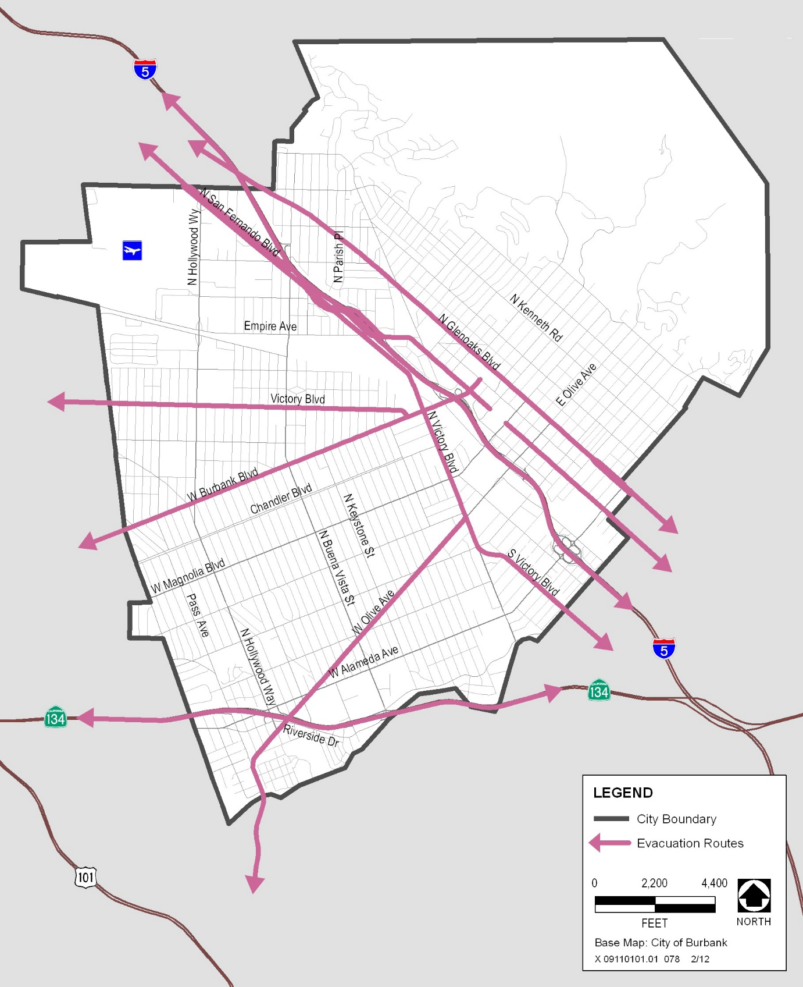
Source: City of Burbank 2010
Exhibit S-23. Evacuation Routes

Geologic and Seismic Hazards
As in other communities in the Los Angeles region, seismic hazards are the most substantial environmental hazards affecting land uses in Burbank. Earthquakes and their related effects (seismic shaking, surface rupture, liquefaction, landslides, and subsidence) have the greatest potential to affect a large portion of the city’s population. Sound planning practices and continued improvements to buildings and structures will minimize risks from seismic hazards.

Earthquakes
An earthquake is a manifestation of the constant movement and shifting of the earth’s surface. Movement occurs along fractures or faults, which represent the contact point between two or more geologic units. Earth movement, known as seismic activity, causes pressure to build up along a fault, and the release of pressure results in the ground-shaking effects that are known as an earthquake. Earthquakes can cause damage through surface fault rupture, ground shaking, liquefaction, and landslides. These topics are described in more detail below.

Surface Fault Rupture
Surface fault rupture is an actual cracking or breaking of the ground along a fault during an earthquake. Structures built over an active fault can be torn apart if the ground ruptures. The potential for surface fault rupture exists along the traces of active faults and is generally limited to a linear zone a few yards wide. Burbank contains one active fault, the Verdugo Fault, located just south of the Verdugo Mountains. Other active faults exist in the region, but they are not located within Burbank, so those faults do not pose the risk of surface fault rupture in the city. Exhibit S-34 illustrates faults in the city and nearby vicinity.
The Alquist-Priolo Earthquake Fault Zoning Act requires the State of California to map areas with high risk for surface fault rupture. This law prohibits locating structures designed for human occupancy on top of the surface traces of active faults, thereby reducing the loss of life and property from an earthquake. No Alquist-Priolo Earthquake Fault Zone has been designated in Burbank.

Ground Shaking
Ground shaking is motion that occurs as a result of energy released during an earthquake. Ground shaking could damage or destroy buildings, bridges, and pipelines, depending on the magnitude of the earthquake, the location of the epicenter, and the character and duration of the ground motion. The characteristics of the underlying soil and rock and, where structures exist, the building materials used and the workmanship of the structures are important details to consider when determining the potential effect of seismic ground shaking.
In addition to the Verdugo Fault, several other active faults have the potential to cause ground shaking that would affect Burbank. These faults are the San Fernando Fault (northwest of Burbank), Sierra Madre Fault (at the base of the San Gabriel Mountains east of Burbank), Hollywood Fault (south of Burbank), Newport-Inglewood Fault (12.5 miles southwest of Burbank), and the Raymond Fault (6 miles southeast of Burbank). The San Andreas Fault, a large fault that runs nearly the entire length of California, is located approximately 27 miles to the northwest. Although these faults would not cause a surface rupture in Burbank, a seismic event on any of these faults could cause ground shaking that could damage structures and facilities in the city.
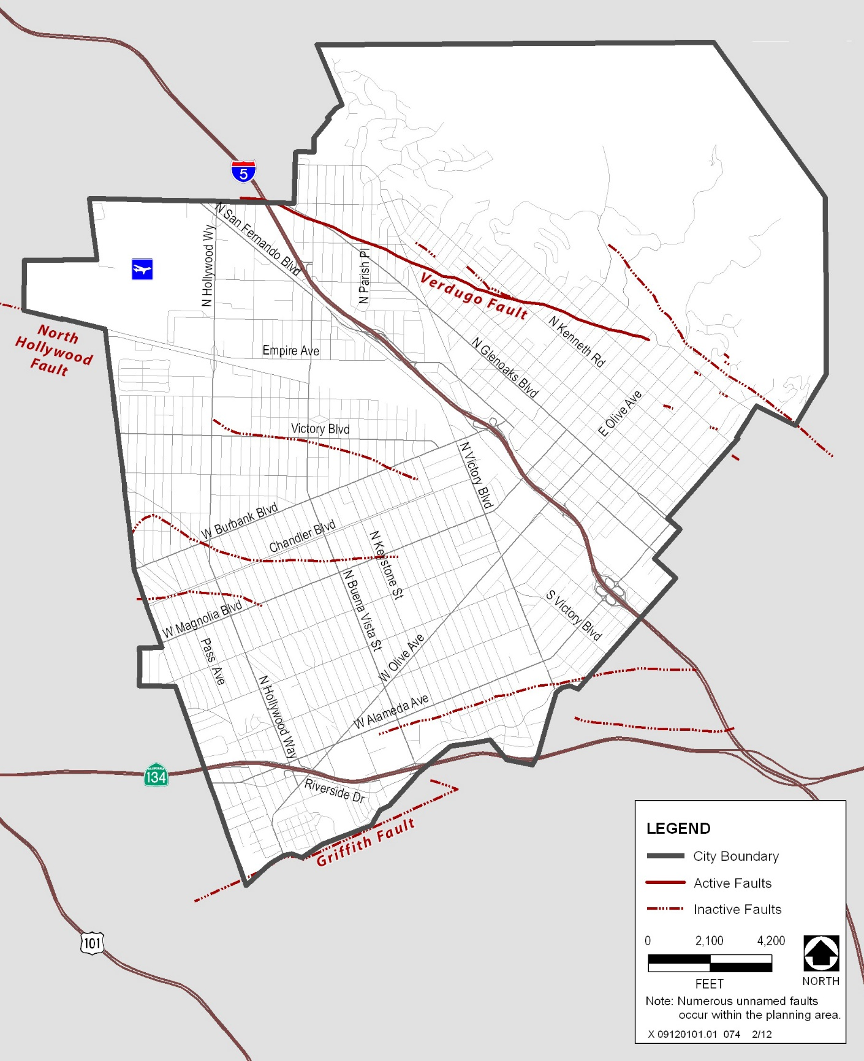
Source: City of Burbank 2010, CASIL 1990
Exhibit S-34. Fault Locations

Liquefaction
Liquefaction is a destructive side effect of seismic shaking. Liquefaction happens when shaking increases pore water pressure and causes the soil to lose its strength and behave as a liquid. The excess pore pressures are often pushed upward through fissures and soil cracks, which causes water-soil slurry to bubble onto the ground surface. Liquefaction occurs primarily in saturated and loose, fine- to-medium-grained soils, in areas where the groundwater table lies within 50 feet of the surface.
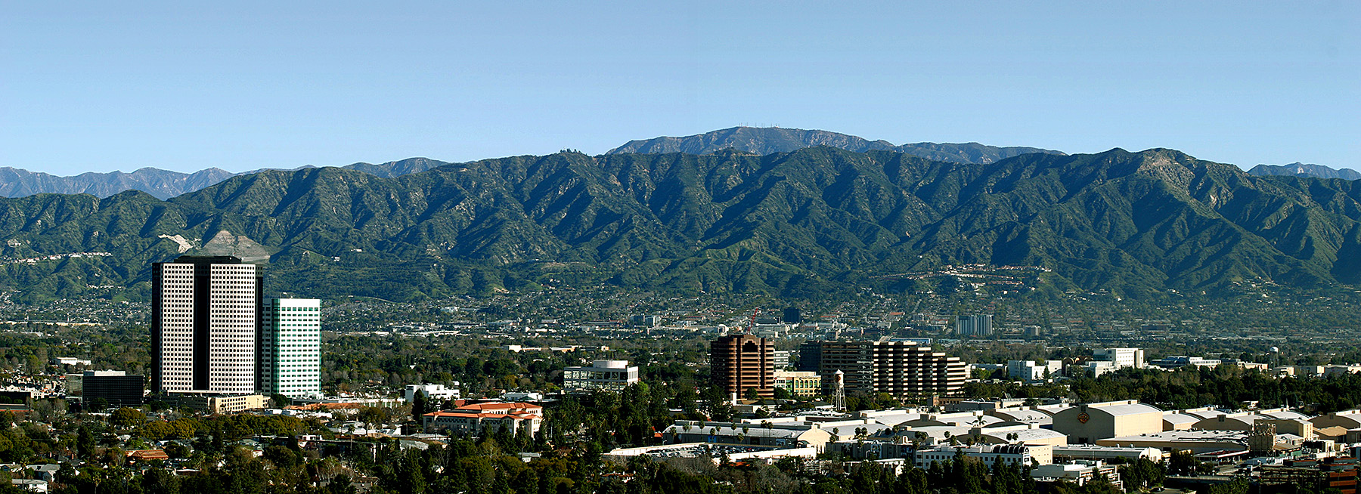
Steep slopes, such as those in the Verdugo Mountains in the northern part of Burbank, are subject to landslide hazards.
As illustrated in Exhibit S-45, much of Burbank is located atop soils susceptible to liquefaction, particularly in areas west of the Golden State Freeway (I-5). In general, soils in these areas are recently deposited sediments that may include potentially liquefiable layers. Except in some areas along the Ventura Freeway (SR 134) in the southwestern portion of the city, most groundwater underlying Burbank is deeper than 100 feet below the ground surface. Groundwater levels have been dropping because of pumping in water wells. As long as groundwater continues to be extracted in the upper Los Angeles River area and annual rainfall remains at normal levels, groundwater levels in Burbank can be expected to remain deeper than 50 feet, resulting in a low risk of liquefaction for most of the city.

Landslides and Mudslides
Landslide hazards are related to both slope and to seismic activity. Mudslide hazards are related to storm events, especially following long dry periods or fires that have reduced hillside vegetation. The City will work to mitigate mudslide and landslide hazards for both existing and new development.
A landslide is the downhill movement of masses of earth material under the force of gravity. Factors contributing to landslide potential are steep slopes, unstable terrain, and proximity to earthquake faults. The process of landsliding typically involves the surface soil and an upper portion of the underlying bedrock. Movement may be very rapid, or so slow that a change of position is noticed only over a period of weeks or years. The size of a landslide can range from several square feet to several square miles. Mudflows consist of rivers of rock, earth, and other debris saturated with water. Flows develop when water rapidly accumulates in the ground during heavy rainfall, changing the earth into a flowing river of mud or slurry. These mudflows can strike with little or no warning at avalanche speeds. Mudslide potential exists in the hillside portions of Burbank during heavy rains, especially in areas recently affected by fire.
In Burbank, hazards from landslides and mudslides are limited to properties at the base of undeveloped or unimproved slopes in the Verdugo Mountains, north of Sunset Canyon Drive. Exhibit S-56 illustrates locations that are subject to landslide hazards.

Flood Hazards
Flooding may occur in Burbank when streams and channels overflow as a result of excessive precipitation, storm runoff, or inadequate, undersized, or unmaintained storm drainage infrastructure. Flood zones, including areas with flood hazards from potential overflow from drainage channels, are shown in Exhibit S-67.
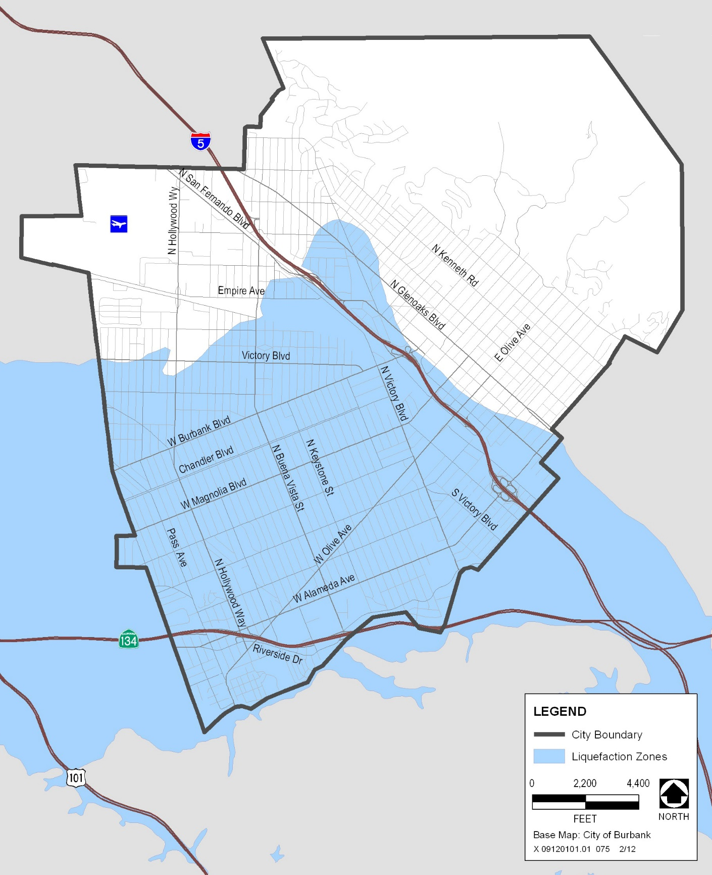
Source: City of Burbank 2010, CASIL 1990
Exhibit S-45. Liquefaction Zones
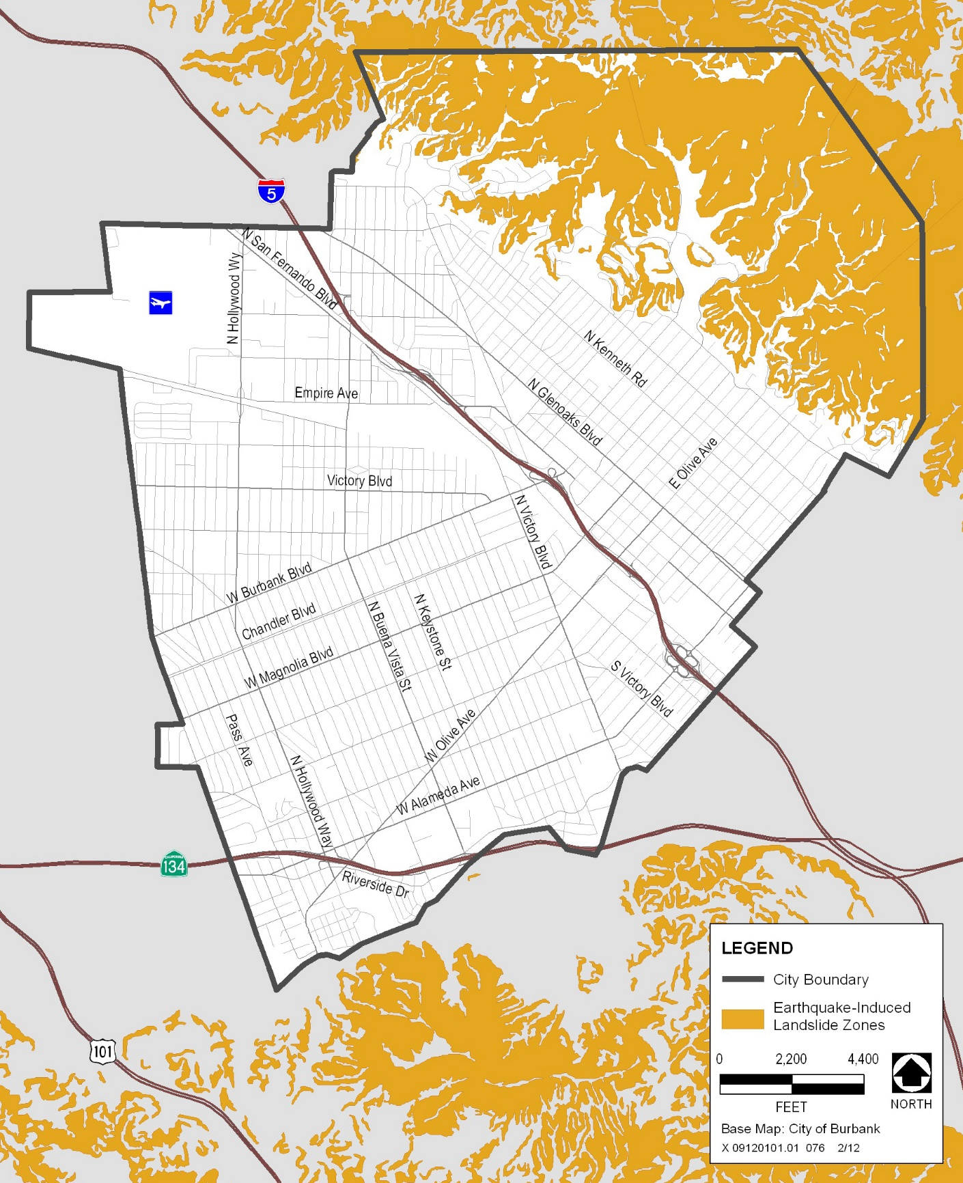
Source: City of Burbank 2010, CASIL 1990
Exhibit S-56. Earthquake-Induced Landslide Zones
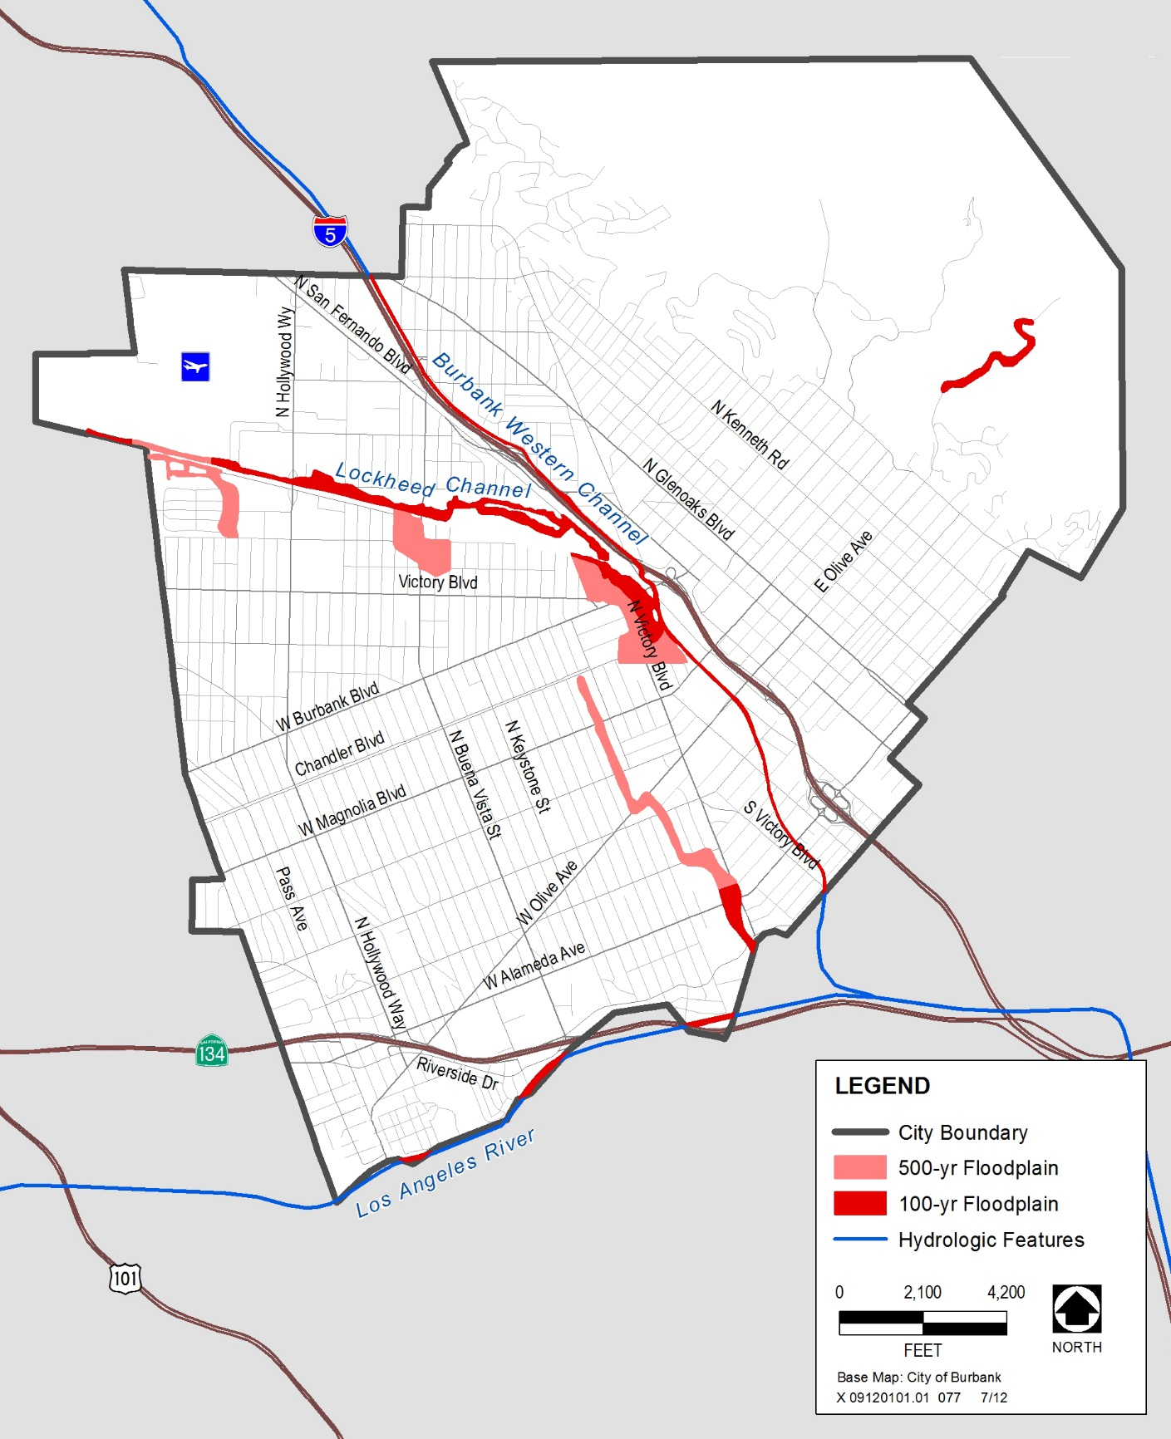
Source: AECOM 2010, FEMA 1996
Exhibit S-67. FEMA Flood Zone Areas
Flood hazards related to storm events generally are described in terms of the “100-year flood,” which is the largest flood event that may be expected to occur within 100 years. This flood is considered a severe flood, but one that can be reasonably predicted and thus reasonably mitigated. The “500-year flood” is the largest flood event that may be expected to occur within 500 years. Other areas of Burbank may be affected by smaller storm events, such as the 10-year storm event.
Burbank’s stormwater is managed by the storm drainage system, including surface stormwater channels. The City is studying the storm drainage system to determine the condition of the entire system and the need for new and/or updated facilities. The City’s storm drain master plan describes necessary improvements to the stormwater drainage system to accommodate growth anticipated as a result of Burbank2035.

Dam Inundation Hazards
Dam inundation describes flooding that could result from the structural failure of a dam, generally caused by seismic activity. Seismic activity may also cause inundation by a seismically induced wave, called a seiche, that overtops the dam without also causing dam failure. Landslides flowing into a reservoir could also cause dam failure or overtopping.
Three reservoirs upstream from Burbank, Reservoirs #1, #4, and #5, are classified as dams by the California Department of Water Resources. Though small, these reservoirs impound more than 50 acre-feet of water. However, these reservoirs are not large enough to result in considerable risk of inundation in Burbank that would result from failure of any of the facilities.

Airport Operations
Bob Hope Airport is located in the northwestern corner of the city. The airport serves commercial airlines and the needs of military aviation and general aviation. The Burbank-Glendale-Pasadena Airport Authority runs the airport and maintains a contract with Airport Group International, Inc., to provide daily operations and maintenance. In 2009, approximately 4.6 million passengers used Bob Hope Airport, for an average of about 12,600 passengers per day.
Bob Hope Airport, run by the Burbank-Glendale-Pasadena Airport Authority, served approximately 4.6 million passengers in 2009.
Although hazardous incidents associated with air transportation are extremely rare, aircraft accidents have the potential to be severe. The City works in consultation with the Burbank-Glendale-Pasadena Airport Authority to minimize hazards associated with air transportation and plan for a coordinated response to any potential incident.

Air Crash Hazards
An "aircraft emergency" is any crash, accident, fire, or other disaster involving aircraft or any potential mishap for which standby equipment has been alerted by the Burbank Air Traffic Control Tower. An airport disaster has the potential to affect almost any part of Burbank because virtually all populated areas of the city are within the perimeter of building height limitations imposed by Part 77 of the Federal Aviation Regulations. Numerous secondary hazards could result from an airport-related disaster, such as fires, hazardous materials incidents, traffic disruption, and loss of utilities.
Bob Hope Airport has a Federal Aviation Administration–approved Airport Emergency Plan. This plan establishes actions that responsible agencies should take to respond promptly to emergencies, minimizing the possibility and extent of personal injury and property damage around the airport. The Airport Fire Department is the first responder to all airport emergencies, but the Burbank Fire Department has ultimate responsibility for all incidents in the city.
The Los Angeles County Airport Land Use Commission has adopted an Airport Influence Area for Bob Hope Airport. This describes the area in which noise, overflight, safety, or airspace protection factors may affect land uses or necessitate restrictions on those uses, as determined by the Airport Land Use Commission. The Airport Influence Area (shown in Exhibit N-3) is generally defined by the 65-dBA CNEL noise contour (described in the Noise Element). In accordance with state regulations (Section 11010 of the Business and Professions Code and Sections 1102.6, 1103.4, and 1353 of the Civil Code), the seller of a property in the Airport Influence Area must provide the purchaser with a Real Estate Transfer Disclosure Statement that includes a “Notice of Airport in Vicinity,” indicating that the property is located in an Airport Influence Area.
The Los Angeles County Airport Land Use Plan identifies two safety zones within the planning boundaries of the airport: the Approach Surface and the Runway Protection Zone. The Approach Surface governs the height of objects on or near the airport. This surface is an imaginary inclined plane that extends from the end of the runway surface to an outward distance that is dependent on runway use. The width and slope of the Approach Surface also depend on runway use. Generally, objects are not allowed to extend above this imaginary plane. If one does, it must be marked or removed.
The Runway Protection Zone is the ground-level area that provides for unobstructed passage of landing aircraft through the airspace above. This zone begins at the end of the runway surface, and its size is dependent on the designated use of the runway. This area should be kept free of all obstructions; no structure should be permitted or people allowed to congregate in this zone.

Hazardous Materials and Human-Caused Hazards
Manufacturing, transporting, and storing hazardous materials in an urban environment can pose threats to the safety of workers, and to the safety of businesses and residences located near these materials. The City recognizes the importance of identifying and regulating the use, production, and transportation of hazardous materials and making planning decisions to minimize exposure to hazards. Hazardous materials—cleaning products, paints, solvents, and fuels—are commonly used and found in small quantities throughout Burbank.

Transport of Hazardous Materials
Hazardous materials are transported through Burbank on roadways (highways and city streets), by rail, by pipeline, and in the air. Types of hazardous cargo regularly transported into, out of, and through the city consist of flammable liquids, corrosive materials, compressed and/or poisonous gases, explosives, flammable solids, and irritating materials.
Accidents on major roadways could result in releases of hazardous materials. The U.S. Department of Transportation regulates the transport of hazardous materials on city streets, I-5, and SR 134. When acutely toxic hazardous materials are transported, the California Highway Patrol must be notified. If city streets are used, the Burbank Police Department must be notified. The City does not designate specific haul routes for hazardous materials, because the handlers and users of hazardous materials are dispersed throughout the city.
The Southern Pacific Railroad operates several miles of rail lines in the city that may be used to transport hazardous materials. The Burbank Fire Department tracks real-time incident data for hazardous materials transport and passenger railroad travel. The Fire Department also maintains an inventory of the loads of hazardous materials shipped through the city.
A hazardous materials incident involving aircraft traveling to or from Bob Hope Airport is less likely than an incident involving another mode of transport. The Airport Fire Department would be the first to respond to an incident occurring at the airport, and the Burbank Fire Department would assume command after arriving at the site. If an incident were to occur outside of the airport property, the Airport Fire Department could assist the Burbank Fire Department or other agencies as necessary.

Former Landfills
Areas formerly used as landfills contain wastes that can release toxins into the air or contaminate groundwater. The City operates one active landfill, Burbank Landfill, located in the Verdugo Mountains. The Burbank Recycling Center, located approximately five minutes from Downtown, is a private/public partnership that houses a materials recovery facility, buyback drop-off center, used-oil center, compost corner, and learning center. This facility collects and diverts wastes that contribute to landfill capacity.
In addition, two former landfill sites are located in the city. The former Stough Park Landfill is located in Stough Park near the Starlight Bowl and DeBell Golf Course. This facility was closed and solid waste was then transported to Burbank Landfill, located nearby. This site is monitored and inspected regularly by the Los Angeles County Environmental Health Department. Other former landfill sites include the former Sunset Canyon Dump, located at the edge of the Verdugo Mountains near the entrance to Stough Park. This site has been developed with residential uses, but is still monitored by the Los Angeles County Environmental Health Department to ensure that the former landfill uses do not result in potential public safety issues.

Pipelines
Underground pipelines that transport and deliver natural gas, liquid petroleum, and other products can be found throughout Burbank. Most homes and businesses require small pipelines to deliver these products. Larger transmission pipelines are less common in urbanized areas, but they pose the greatest threat in the event of upset.
Several large pipelines are located in the city. If any of these pipelines crack or are broken, major hazardous materials incidents may result. These underground pipelines, typically located 42 inches below the ground surface, include gas fuel supply lines and crude-oil shipping lines. The Pacific Pipeline System, Inc., has a 20-inch crude-oil pipeline that runs parallel to the Southern Pacific Railroad’s right-of-way. The Four Corners Pipeline Company has a 14-inch petroleum pipeline that runs from north to south following Glenoaks Boulevard to Tulare Avenue, traveling south on Sixth Street to Glendale. A 30-inch Southern California Gas Company natural gas pipeline runs south on Glenoaks Boulevard to Glendale. Other smaller pipelines that also contain natural gas follow Hollywood Way, Verdugo Avenue, and Burbank Boulevard. The Burbank Fire Department maintains a list of the major pipelines in the city.

Underground Storage Tanks
Underground storage tanks (USTs) are used to store a variety of materials, including hazardous chemicals. Some of the most common UST contents are gasoline, diesel, other petroleum fuels, and solvents.
The Health Hazardous Materials Division of the Los Angeles County Fire Department is the Certified Uniform Program Agency for Burbank. The Burbank Fire Department serves as a Participating Agency that implements some requirements of the Certified Uniform Program Agency, including disclosure of hazardous materials and UST regulation requirements. The overall purpose of the UST program is to protect public health and safety and the environment from releases of petroleum and other hazardous substances from tanks. The program includes requirements for tank installation, construction, testing, leak detection, spill containment, and overfill protection. Cleanup of leaking tanks often requires a soil and groundwater investigation and remediation under the direction of a regulatory agency.

Table of Contents

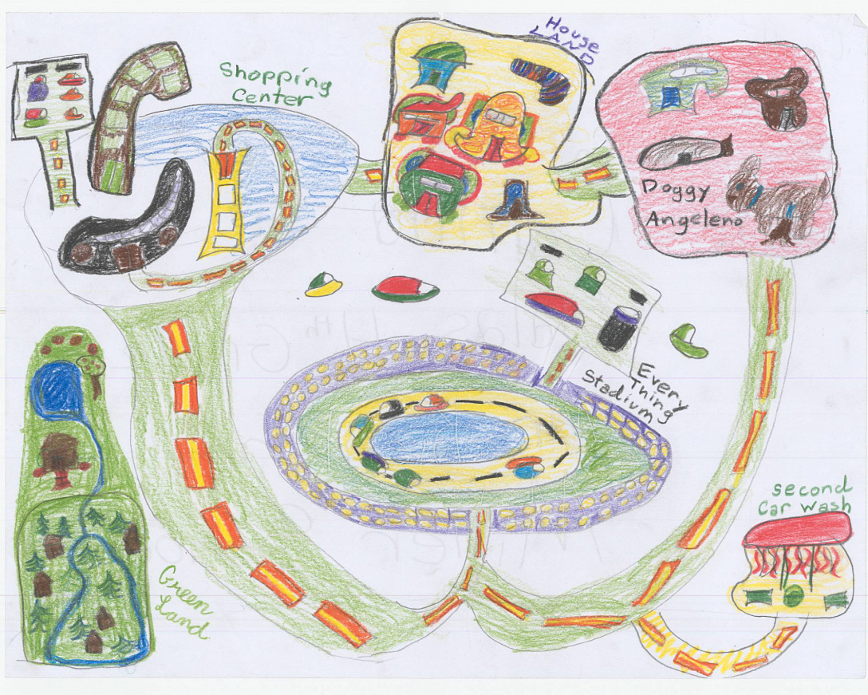
Burbank in 2035: Drawing by Camila Salas of Miller Elementary School
Introduction 7-1
Protecting What Matters 7-1
Purpose and Statutory Requirements 7-1
Relationship to All-Hazard Mitigation Plan 7-2
Safety Goals and Policies 7-2
Safety Plan 7-6
Emergency Services and Safety 7-7
Fire Hazards 7-9
Disaster and Emergency Preparedness 7-13
Geologic and Seismic Hazards 7-15
Dam Inundation Hazards 7-21
Airport Operations 7-21
Hazardous Materials and Human-Caused Hazards 7-22

Exhibits
Exhibit S-1. Fire Zones 7-11
Exhibit S-2. Very High Fire Hazard Zones, Public Services, and Zoning 7-12
Exhibit S-23. Evacuation Routes 7-14
Exhibit S-34. Fault Locations 7-16
Exhibit S-45. Liquefaction Zones 7-18
Exhibit S-56. Earthquake-Induced Landslide Zones 7-19
Exhibit S-67. FEMA Flood Zone Areas 7-20

