THE BOARD OF FORESTRY AND FIRE PROTECTION

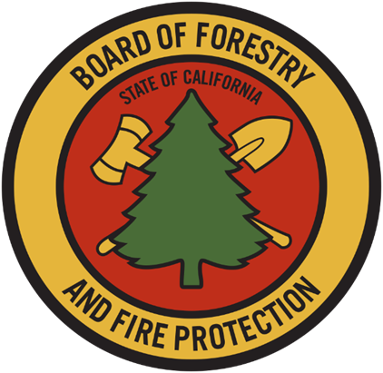

**ANNUAL REPORT *2019***

#### CAL FIRE fuels crew constructing a fuel break in a pine forest.

#### MEMBERS OF THE CALIFORNIA

#### STATE BOARD OF FORESTRY AND FIRE PROTECTION

**J. KEITH GILLESS, CHAIR**

**DARCY WHEELES, Vice Chair**

**Susan Husari**

**RICH WADE**

**MIKE JANI**

**MARC LOS HUERTOS**

**KATIE DELBAR**

**CHRIS CHASE**

#### STAFF

**MATT DIAS, EXECUTIVE OFFICER**

**DAN STAPLETON, ASSISTANT EXECUTIVE OFFICER**

**EDITH HANNIGAN, LAND USE PLANNING POLICY MANAGER**

**ERIC HEDGE, REGULATIONS PROGRAM MANAGER**

**DAVID LUDWIG, FORESTRY ASSISTANT II**

**KATIE HARRELL, JOINT INSTITUTE FOR WOOD PRODUCTS INNOVATION**

**BRANDI GOSS, ENVIRONMENTAL SCIENTIST**

Table of Contents

*Board Background and Organization* 6

Committees of the Board 6

*Committees Required by Statute* 6

*Internal Standing Committees* 6

*External Advisory Committees* 7

*Committee Updates* 7

*Chaptered Legislation with Future Regulatory Action by the Board* 10

SB 632: 10

AB 1823: 10

AB 1160: 11

SB 99: 11

*Forest Health Trends* 11

Stand Management 11

Pest Conditions 12

Coastal Pine Decline 12

Goldspotted Oak Borer (*Agrilus auroguttatus*) 13

Invasive Shot Hole Borers (ISHB) 13

Sudden Oak Death (*Phytophthora ramorum*) 14

Bark Beetles 15

Valley Oak Wilt 15

Incense Cedar Dieback 15

*Forest Products Trends* 16

In-State Harvest and Production 16

Biomass 21

*Rangeland and Hardwood Trends* 22

Rangelands and Range Industry 22

Hardwoods Trends 23

*Fire Protection Trends* 23

Weather Patterns 23

Prescribed Fire and Fuel Reduction Efforts 28

California Statewide Vegetation Treatment Program 30

Wildfire Activity 30

*Accomplishments 2019 – Regulatory* 32

*Accomplishments 2019 - Policy* 36

Fire Protection Policies 36

Local Government 36

General Plan Safety Elements 36

Appointment of Authorized Designees for Less Than Three Acre Conversions 38

*AB 1504 California Forest Ecosystem and Harvested Wood Product Carbon Inventory* 40

*State Forests* 41

*Stewardship Lands* 42

*Professional Licensing and Forest Practice Enforcement* 43

Professional Discipline 43

Enforcement 44

*Acronyms:* 45

Works Cited 47

APPENDIX A: 2019 Standing Committee Priorities 50

***California State Board of Forestry and Fire Protection Mission***

*The mission of the Board is to lead California in developing policies and programs that serve the public interest in environmentally, economically, and socially sustainable management of forest and rangelands and a fire protection system that protects and serves the people of the state*.

# *Board Background and Organization*

The California State Board of Forestry and Fire Protection (Board) is a Governor-appointed body within the California Department of Forestry and Fire Protection (CAL FIRE). Members are appointed on the basis of their professional and educational qualification and their general knowledge or interest in problems that relate to watershed management, forest management, wildland fire management, fish and wildlife, range improvement, forest economics, or land use policy. Of its nine members, five are chosen from the general public, three from the forest products industry, and one from the range-livestock industry.

The Board is responsible for developing the general forest policy for the State, determining the guidance policies of CAL FIRE, and representing the State's interests in federal land located within California. Together, the Board and CAL FIRE work to carry out the California Legislature's mandate to protect and enhance the State's unique forest and wildland resources.

## Committees of the Board

### *Committees Required by Statute*

1. Range Management Advisory Committee
2. Professional Foresters Examining Committee
3. Soquel Advisory Committee

### *Internal Standing Committees*

1. Forest Practice: The mission of the Forest Practice Committee is to evaluate and promote an effective regulatory system which ensures the continuous growth and harvest of commercial forests and protects soil, air, fish, wildlands, and water resources.
2. Resource Protection: The mission of the Resource Protection Committee is to develop and promote a policy and regulatory program that implements fire safe land use planning and effective vegetation management, pursues a fire prevention program in alignment with the State Fire Plan, and improves forest and rangeland health in California.
3. Management: The mission of the Management Committee is to evaluate and promote long-term, landscape-level planning approaches to support natural resource management on California’s non-federal forests and rangelands and to evaluate State Forest management plans.

### *External Advisory Committees*

1. Effectiveness Monitoring Committee
2. California Forest Pest Council and the California Oak Mortality Task Force
3. Jackson Advisory Group
4. Joint Institute for Wood Products Innovation

### *Committee Updates*

#### Range Management Advisory Committee

The Range Management Advisory Committee (RMAC) has been engaged with a variety of issues affecting rangelands in California, including water quality, grazing on public lands, rangeland health indicators, and grazing as a fuel reduction tool. RMAC’s chief 2019 efforts included:

* Ensuring that the State and Regional Water Resources Control Boards’ (Water Boards) efforts to develop statewide regulations for rangeland water quality protection were science based and capable of being implemented flexibly across the spectrum of ecosystems and management practices in the state. RMAC has also been facilitating the Water Boards’ engagement with land managers and technical specialists (chiefly UC Cooperative Extension) to shape policies and practices.
  + RMAC addressed this issue by engaging directly with Water Board leadership (through a letter to CalEPA), encouraging Water Board attendance at RMAC meetings, and requesting that the Water Board engage with RMAC on the development and implementation of non-point source permits pursuant to the federal Clean Water Act.
* Aiding state agencies in developing tools for grazing, where appropriate, to accomplish land management objectives on state lands, which included invasive weed control, improvement and maintenance of wildlife habitats, and management of fine fuels in the wildland-urban interface (WUI) and connected areas.
  + RMAC addressed this issue by coordinating and hosting a full-day workshop centered around grazing for fuel reduction, which was attended by public stakeholders and staff from nonprofits and from local, state, and federal agencies and legislatures.
  + RMAC intends to coordinate additional workshops in the future.
* Facilitating relationships between different land management professionals (chiefly CRMs and RPFs) to enable landscape-wide restoration and fire resilience.
  + RMAC addressed this issue by coordinating a presentation and membership discussion at the annual fall California Licensed Foresters Association (CLFA) workshop centered around opportunities for collaboration and integrated land management.

#### Professional Foresters Examining Committee

In 2019, the Professional Foresters Examining Committee (PFEC) and the Office of Professional Foresters Registration continued deliberations on several licensing items that carried over from 2018.

The PFEC submitted to the Board for adoption the “Registered Professional Forester and Certified Specialty Amendments, 2019” which identified and clarified several areas within the Specialty and CRM regulations (14 CCR §§ 1600 *et seq.*). The proposed rules are going through a final OAL review and should become effective by April 2020.

The PFEC took action to address the Professional Foresters Fund condition in 2019. The fund, which is entirely financed by licensing fees, has been depleted for the first time in 45 years due to a dwindling registry. Retirements are projected to increase in the next decade due to the aging demographic of current RPFs. Renewal fees for RPFs have not been increased for 28 years, adding to the problem. The PFEC evaluated alternatives and submitted for adoption to the Board the “Licensing Fee Amendments, 2020.” This proposed regulation will increase the biennial renewal fee for RPFs from $190 to $350 and for Certified Specialists from $70 to $130. To address RPF retirements and incentivize RPF license retention, a new discounted fee of $250 was proposed for any RPF with 30 years or more in the registry. All other licensing fees were raised to their statutory maximum.

The PFEC also reviewed several applications for the RPF Exam and had 100 applicants sit for the RPF and CRM exams in 2019. This was a 10-year high for exam participation. With the continued outreach performed by the Office of Professional Foresters Registration, it is expected that exam participation will continue to increase and help meet the demand for forestry professionals in California. Additionally, the PFEC reviewed exam results, certified new licensees for Board approval, reviewed questions for the upcoming exams, reviewed cases for discipline, and evaluated new technologies and methodologies for examinations and exam grading. In 2019, the Board licensed 20 RPFs and 2 CRMs.

Lastly, the Executive Officer for Professional Foresters Registration continues to perform outreach to increase awareness of careers in forestry in California and the licensing requirements for foresters. Outreach required travel throughout the state to universities, community colleges, high schools, and California Conservation Corps field offices to inform young people about the opportunities that exist in the California forestry sector.

#### Effectiveness Monitoring Committee

The Board formed the Effectiveness Monitoring Committee (EMC) in 2014 to develop and implement a monitoring program to address both watershed and wildlife concerns and to provide a more effective feedback loop to policymakers, managers, agencies, and the public. Effectiveness monitoring is necessary to assess whether management practices are achieving the resource goals and objectives set forth in the California Forest Practice Rules (FPRs) and other natural resource protection statutes and regulations. This kind of monitoring is a key component of adaptive management. Effectiveness monitoring is also a crucial component for complying with the “ecological performance” reporting requirements outlined in AB 1492. The EMC and the Board developed a suite of critical monitoring questions based on input from a variety of stakeholders and organized them into 11 themes. The EMC uses these themes and critical questions as guidance to solicit and evaluate monitoring projects with the goal of developing a process-based understanding of the effectiveness of the FPRs and associated regulations in maintaining and enhancing water quality and aquatic and wildlife habitats.

Two projects were funded by the EMC in 2019 and five proposals were received in response to the September 3, 2019 published request for proposals. EMC meetings continued to be held quarterly. The following is a summary of EMC activities and progress made in 2019:

• The Annual Report and Work Plan was updated.

• Strategic Plan themes and critical questions for 2019 were reviewed and retained. No additions or alterations were made to the priorities for 2020.

• Received an allocation of $425,000 each year for the 2018/2019 and 2019/2020 fiscal years from the Timber Regulation and Forest Restoration Fund.

• A Request for Proposals was developed and posted to the EMC website, soliciting monitoring projects for the 2019 review cycle.

* Susan Husari was reappointed as Co-Chair. Loretta Moreno of the California Natural Resources Agency was newly appointed as Co-Chair.

• Three academic members were selected to fill EMC vacancies.

• Strategic Plan project ranking procedures were used to rank five proposed monitoring projects. Additional information on each project, request for funding, and ranking are located on the [EMC website](https://bof.fire.ca.gov/board-committees/effectiveness-monitoring-committee/).

#### Joint Institute for Wood Products Innovation

Established in response to Senate Bill 859 (2016) and the California Forest Carbon Plan, the Joint Institute for Wood Products Innovation (Institute) reports to the Board of Forestry and Fire Protection.

The first meeting of the Institute was held on April 24, 2019. Since then, a charter was adopted, and the initial scope of work was outlined. Deliverables for the scope of work include a review of forest product innovation literature and research gap analysis, the identification of potential strategic partnerships with external stakeholders, recommendations for near-term priorities, and a summary of barriers to in-state production of mass timber as well as other innovative forest products. Findings from the initial scope of work will be used to inform the Institute moving forward. A report is expected to be published by February 28, 2020.

# *Chaptered Legislation with Future Regulatory Action by the Board*

## SB 632:

This bill requires that the Board complete a program environmental impact report (PEIR) for the vegetation treatment program (CalVTP) as soon as practically feasible, but not later than February 1, 2020.

## AB 1823:

Existing law instructs the Board to develop criteria for, and maintain a list of, local agencies located in SRA or a VHFHSZ that meet best practices for local fire planning. The list must be completed by July 1, 2022. When developing criteria for the list, the Board is to consider compliance with existing regulations, participation in certain nationally recognized certification programs, adoption of Board recommendations to improve safety elements of a city or county’s general plan, and new or existing community wildfire protection plans. This bill instructs the Board to include compliance with the Board’s fire safe regulations, including minimum fire safety standards, and requires the Board to post the list on its website.

Existing law instructs the Board, in cooperation with CAL FIRE and other relevant stakeholders, to identify barriers to the success of the forest products industry in California and to seek creative solutions to produce and market forest products and develop the forest products workforce in the future. This bill extends the compliance date from on or before January 31, 2020 to on or before July 1, 2020.

Existing law establishes the Forest Management Task Force pursuant to a specified executive order issued by the Governor, and requires the Task Force or its successor entity, on or before July 1, 2020, in consultation with specified entities, to develop recommendations for siting additional wood product manufacturing facilities in the state. Existing law specifies that it is the intent of the Legislature, in developing those recommendations, that the location and activities of mass timber production facilities be, among other things, located in, or be approximate to, areas that are near the locations of large landscape fires, as described, and in areas identified as federal opportunity zones or in areas that have an average household income of five percent below the state’s median household income. This bill adds a definition of the Task Force for purposes of those provisions and recasts the median household income threshold from five percent below to at least five percent below the state’s median household income.

## AB 1160:

This bill changes the maximum effective timeframe for a Sustained Yield Plan (SYP) pursuant to the Forest Practice Act from 10 years to 20 years.

## SB 99:

This bill requires that the safety element of a city or county’s general plan include, among other things, information about the wildfire risks within their jurisdiction, specifically in areas classified as SRA or VHFHSZs. The safety element must include plans to mitigate said risks and must be updated at least once every eight years. Notably, this act requires that safety elements of plans updated on or after January 1, 2020 must include information identifying residential developments in hazard areas that do not have at least two emergency evacuation routes.

# *Forest Health Trends*

## Stand Management

Monitoring of the Forest Practice Rules (FPRs) on private and public forestlands showed generally high compliance with water-quality related rules, and that those rules were generally effective in preventing erosion and sedimentation when properly implemented (FORPRIEM, 2014). An additional effort occurred in 2019 to reassess compliance. Effectiveness is monitored on a continuing basis through the EMC – a sub-committee of the Board. The Exemption and Emergency Notice Monitoring Pilot Project was also recently completed. The report was published on May 7, 2019 ([Olsen et al., 2019](https://www.researchgate.net/publication/335149799_Exemption_and_Emergency_Notice_Monitoring_Pilot_Project_Report)).

Even as harvest levels have declined, the number of acres harvested using uneven-aged systems has remained constant, resulting in an increase in the overall percentage of acres harvested using uneven-aged systems. However, as climate change continues to impact California’s landscape, there will likely be changes in where timberland occurs. Losses of between 0.6 and 1.4 million acres of timberland are predicted by 2069. This would likely result in changes in timber harvest locations and management practice trends ([FRAP, 2017](https://frap.fire.ca.gov/media/3180/assessment2017.pdf)).

Additionally, estimates indicate that between 5.5 and 9.5 million acres of productive timberland are potentially in need of treatment to improve stocking levels. Commercial conifer species, specifically, have a similar number of acres in the “overstocked” and “understocked” categories if 60 percent Stand Density Index (SDI) is used as the minimum threshold for “overstocking.” Understocked stands are particularly common on nonindustrial lands where technical and financial assistance for reseeding is not readily available after a burn event [(FRAP, 2017).](https://frap.fire.ca.gov/media/3180/assessment2017.pdf)

A recent USFS Forest Inventory Analysis indicates that while lands are sequestering carbon at a positive rate, long-term carbon storage will be a function of management inputs over the next 100 years ([USFS, 2017](https://www.fs.usda.gov/sites/default/files/15817-usda-forest-service-fia-annual-report-508-update.pdf)). See the discussion pertaining to AB 1504 on page 40.

Much of Northern California and the Sierra Nevada have positive Fire Return Interval Departure (FRID), meaning that fires are less common than they were historically (although fires that do burn are often more severe). In much of the Central Coast and Southern California, FRID is negative, sometimes greatly so, indicating that fires are occurring more often than under pre-settlement conditions. Neither situation is ideal, as positive FRID can lead to accumulation of hazardous fuels and increased risk of intense fire, while negative FRID can burn landscapes at rates that exceed their ability to recover to baseline conditions ([FRAP, 2017](https://frap.fire.ca.gov/media/3180/assessment2017.pdf)). In fact, chaparral systems are often at risk of being converted to non-native grasslands if FRID becomes too great, as is the case in many parts of Southern California ([Rundel, 2018](https://www.researchgate.net/publication/324337489_California_Chaparral_and_Its_Global_Significance)).

A recent study of federal lands in the Sierra Nevada, however, found that portions of the region (at least 75,000 acres based on landscape-level assessments) have recovered to near-reference conditions with regard to historical fire regimes ([Jeronimo et al., 2019](https://www.fs.usda.gov/treesearch/pubs/58601)). Most of these areas are in the central and southern Sierra in Yosemite and Sequoia-Kings Canyon National Parks, along with smaller areas of the Sierra, Sequoia, and Inyo National Forests. Reference areas in the northern Sierra were also found in the Plumas and Lassen National Forests and in Lassen National Park. These varied reference areas correspond well with a variety of climate and forest types, and could provide invaluable insights for landowners, foresters, and others seeking to mimic the effects of natural fire regimes on actively managed landscapes in the region.

## Pest Conditions

The following is a summary of notable pest and disease issues that continued to threaten and alter urban and wildland forests in California in 2019. Forest pest conditions can change dramatically from year to year. For a summary of forest pests and diseases, see the 2018 California Forest Pest Conditions Report ([California Forest Pest Council, 2018](https://www.fs.usda.gov/Internet/FSE_DOCUMENTS/fseprd617799.pdf)). The 2019 California Forest Pest Conditions Report will be available on the [California Forest Pest Council website](http://caforestpestcouncil.org/) in early 2020.

### Coastal Pine Decline

Coastal pine decline intensified in many areas of the North Coast (coastal Sonoma County north through coastal Del Norte County). Tree species affected included shore, bishop, and Monterey pine. In some areas, individual branch dieback progressed seemingly randomly throughout the crown of the tree. In others, the tree crown faded all at once. Areas of note included approximately 150 acres of declining shore pine north of Lake Earl (Del Norte County); approximately 10 acres of declining and dying Monterey pine along Highway 101 near Loleta (Humboldt County); and severe decline in the Timber Cove and Fort Ross areas (Sonoma County). Several tree pests have been implicated in the decline, and their activity may have been increased by changes in climate (e.g., increased minimum winter temperatures) and specific weather events (e.g., warm rain in May). Some of the most prevalent native pests included *Onnia* sp. (cause of a white root and butt rot), *Phaeolus schweinitzii* (brown cubical butt rot)*, Armillaria* sp., *Diplodia scrobiculata* (branch canker pathogen)*,* and *Endocronartium harknessii* (western gall rust), while non-native pests included *Phytophthora cinnamomi, Phytophthora pseudocryptogea,* and *Fusarium circinatum* (cause of pine pitch canker)*.*

### Goldspotted Oak Borer (*Agrilus auroguttatus*)

Notable new GSOB infestations found in 2019 or late 2018 include discoveries in Los Angeles (Bouquet Canyon), Orange (Trabuco Canyon), Riverside (Hagador Canyon, Cleveland National Forest), San Bernardino (Oak Glen and Big Bear), and San Diego (Escondido Creek) Counties.

Significant resources went toward management of these infestations. In the Green Valley area (Los Angeles County), 6,653 coast live oak trees were inspected, with 31 percent (2,031) found infested. Of those found infested, 669 oaks are marked for removal. To date, the Irvine Ranch Conservancy (Orange County), has treated 2,500 oaks with carbaryl insecticide. Treated trees had a low frequency of new attacks in 2019. In San Bernardino County on private land in Oak Glen, the Inland Empire Resource Conservation District contacted homeowners, surveyed trees for GSOB (250 trees over 14 properties), felled and chipped five heavily infested trees, and treated 246 oaks with insecticide. At the Oak Glen Preserve, 37 dead or heavily infested California black oaks were felled and the wood was chipped onsite. A total of 187 large black oaks were injected with systemic insecticides and 150-250 trees were treated with a topical insecticide. At a new Big Bear infestation, a CAL FIRE crew felled, debarked, and chipped the bark of the two recently discovered infested trees.

### Invasive Shot Hole Borers (ISHB)

Polyphagous shot hole borer (PSHB) is established in Los Angeles, Orange, Riverside, San Bernardino, San Diego, and Ventura Counties. Kuroshio shot hole borer (KSHB) is established in Los Angeles, Orange, Santa Barbara, San Diego, and Riverside Counties. No infestations have been found in San Luis Obispo County on the landscape to date; one KSHB beetle was detected on a trap in 2016, but there have no further finds. Notable new infestations were found in Los Angeles (Santa Clarita), San Bernardino (Loma Linda), San Diego (Camp Pendleton), and Ventura (Ojai and Santa Paula) Counties. In some infested areas, such as Santa Paula, infestation rates are increasing over time, yet trees are also partially recovering, particularly in willow stands.

In Orange County, the removal of 239 ISHB-infested trees cost $1,139,610 in 2019. In addition, 1,206 trees were treated using various management techniques determined by host species, location, and level of infestation. From 2013-2019, 3,922 ISHB-infested trees were removed from parks.

### Sudden Oak Death (*Phytophthora ramorum*)

Levels of tanoak mortality caused by the sudden oak death pathogen (*Phytophthora ramorum*) continued to be high after an initial steep increase between 2017 and 2018 (Figure 1), resulting from the very wet 2016-2017 winter.

**Figure 1. Estimated acres of tanoak mortality in coastal California from 2017 to 2019.**

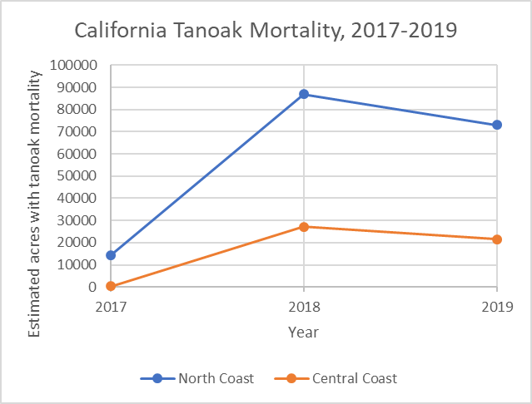

Mortality intensified in the Fort Ross-Timber Cove-Salt Point area of the Sonoma County coast and the Redwood Creek watershed in Humboldt County. The pathogen also caused mortality in new scattered areas of Mendocino County, including on Jackson Demonstration State Forest. Farther north, it was detected for the first time in Del Norte County (currently a non-regulated county for *P. ramorum*) on symptomatic tanoak foliage near two dead tanoaks underneath old-growth redwood in Jedediah Smith State Park, east of Crescent City. Three rounds of follow-up sampling, including sampling by California Department of Food and Agriculture staff for regulatory purposes, failed to redetect the pathogen. Sampling will continue throughout the winter and spring.

The greater San Francisco Bay Area had some areas with notable pathogen activity in 2019, including parts of Marin County, the western portion of the East Bay (along the I-580 corridor), and Santa Cruz County. Significant tanoak and coast live oak mortality was noted in Big Sur, and *P. ramorum-*caused tanoak mortality was observed for the first time on both slopes of the divide between Santa Cruz and Santa Clara County (along the Hwy 152 corridor).

### Bark Beetles

Conifer-killing bark beetle outbreaks were not at the explosive levels observed during the 2011-2016 drought. However, there were populations observed at levels considered to be above “background” levels, including western pine beetle (attacking ponderosa pine) in both the northern and southern Sierra Nevada region and fir engraver beetle (attacking true firs) throughout the state. Notable new western pine beetle activity was observed in the Merced River area within Yosemite Valley. Elevated levels of fir engraver activity were found in Barton Flats, Jenks Lake, and the Santa Ana River in San Bernardino County; several areas within the Sequoia National Forest, Sequoia-Kings Canyon National Park, and Yosemite National Park; and Castle Lake on the Shasta-Trinity National Forest. Flatheaded fir borer—which is not technically a bark beetle but can act in a similar way and kill apparently healthy trees—was responsible for increased mortality of Douglas-fir throughout Northern California, although the mortality was sometimes not easily apparent because of its scattered nature across the landscape. It is suspected that many of these trees sustained sublethal attacks from these insects during the severe drought and are now succumbing*.*

### Valley Oak Wilt

Large, mature valley oaks were declining in various locations near Calistoga on the Napa-Sonoma County line. While symptoms resembled those of invasive shot hole borers, they were caused by a related, non-native ambrosia beetle identified as *Xyleborus monographus.* This is the first detection of this insect in the US, apart from one beetle caught in a trap in Portland, Oregon in 2018.It has been collected from numerous locations throughout the world. In Napa and Sonoma Counties, it caused branch dieback leading to whole-tree mortality. Symptoms included staining on the bark and copious boring dust around the lower boles of attacked trees, especially during later stages of decline. The insect has been associated with several pathogenic fungi, including species of *Raffaelea* and *Fusarium,* both of which are genera commonly associated with tree-killing diseases. Initial trapping efforts to delineate the extent of the infestations are underway, as is confirmatory identification of the insect and pathogens by the California Department of Food and Agriculture*.*

### Incense Cedar Dieback

Unusual levels of incense-cedar mortality were noted in various parts of Northern California. No pattern was apparent in the mortality, with trees of all sizes and growing on a variety of site types affected. In many trees, mortality began as top dieback and progressed downward. In other trees, scattered branch dieback was more evident, sometimes followed by whole-tree mortality. No insect activity was apparent. A species of *Cytospora* was recovered from killed branches at one site near Weaverville (Trinity County); however, it was not recovered from other locations. *Cytospora* spp. invade stressed and wounded tissues. An unknown abiotic stress is suspected as the inciting event for this unexplained dieback.

# *Forest Products Trends*

## In-State Harvest and Production

About 80 percent of lumber and 90 percent of all wood products used in the state of California are imported. As of 2012, there were 52,000 workers in the forest products sector with total earnings of over $3.3 billion annually. There has been a major decline in timber harvesting that has resulted in a 72% decrease in volume since 1955. Sawmills have seen a similar decline in response to lower harvest volumes as well as improvements in technology and automation (about 675 sawmills were in operation in 1956 versus 28 in 2018). Softwood sawmill capacity in California has somewhat stabilized over the last several years after decades of constriction. In response to this decline in processing facilities, the state has shown growth in diversified markets for wood products. However, that diversification is not necessarily equivalent to the historic economic benefits of softwood sawmills ([FRAP, 2017](https://frap.fire.ca.gov/media/3180/assessment2017.pdf)).

Generally, the volume of timber harvested has declined steadily from a high in 1988. It has recently started to level out after a significant drop in 2009 likely attributed to the housing market crash of 2008. Figure 2 below illustrates the changes in harvest levels for public and private lands, indicating that recently more volume has been harvested from private lands by a wide margin. In 2018 (not shown), approximately 1,580 million board feet (MMBF) were harvested, in line with the previous five years’ approximate totals (CDTFA, 2019). Approximately 88 percent came from private land, and 12 percent from public land, again keeping with recent trends. The leading counties were Humboldt with 273 MMBF, Siskiyou with 213, Shasta with 190, and Mendocino with 137. These four counties accounted for just over half of all timber harvested in California in 2018.

**Figure 2. Annual Volume of Timber Harvested in California (FRAP)**

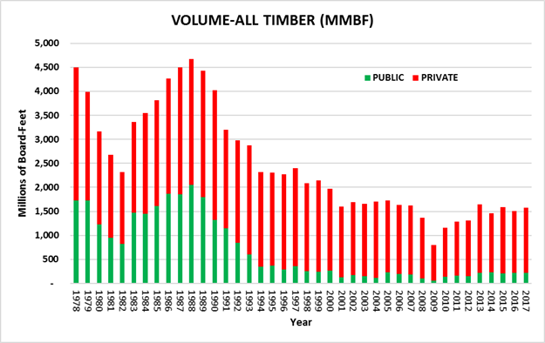

Note: Public refers to timber removed from local, state, and federal government lands. It does not include timber removed from tribal lands.

California has also been experiencing a fluctuating export market over the past few years, with logs being shipped via container to Asia. This is a very volatile market with demand ebbing and flowing dramatically from one year to another and even from month to month.

For managed timberlands, net growth of softwoods (commercial conifer species) provides a measure of whether harvest levels can be sustained. In California, commercial forest management is regulated under the Forest Practice Act and the Forest Practice Rules, which require maximum sustained production of high-quality timber products. A recent USFS Forest Inventory Analysis [(USFS, 2017](https://www.fs.usda.gov/sites/default/files/15817-usda-forest-service-fia-annual-report-508-update.pdf)) of the re-measurement period between 2001-2006 and 2011-2016 produced key findings pertaining to net growth of softwoods. On industry-owned timberlands, the most actively managed timberlands within California, growth exceeded harvest and mortality by an average of 22 ft3/acre/year over the re-measurement period. On nonindustrial timberlands, a portion of which are actively managed, growth exceeded harvest and mortality by an average of over 85 ft3/acre/year. On Forest Service managed (i.e., non-wilderness) timberlands, which are managed for multiple objectives including ecosystem services, growth exceeded harvest and mortality by an average of over 33 ft3/acre/year. These values can be shown in Figure 3 ([FRAP, 2017](https://frap.fire.ca.gov/media/3180/assessment2017.pdf)).

**Figure 3. Net Softwood Timberland Growth**

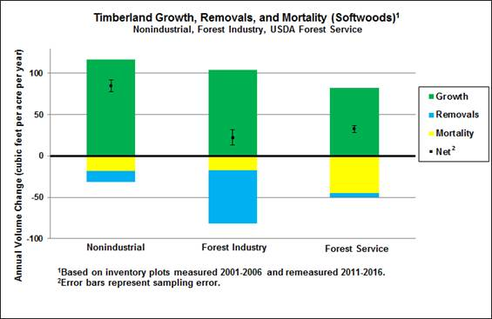

Of the approximately 33 million forested acres in California, about 57 percent are owned and managed by federal agencies, 3 percent by state and local agencies, and 40 percent by families, Native American tribes, and companies. Industrial timber companies own 14 percent of the total forested acres in California. 9 million acres are owned by individuals, with nearly 90 percent of these owners having less than 50 acres of forest land. ([UCANR, 2019](https://ucanr.edu/sites/forestry/California_forests/)a). Ownership patterns have changed for large industrial forest landowners within California. All industrial ownerships are now privately held firms, in contrast with 1970 when 56 percent were publicly traded firms.

The utilization of exemptions, as allowed for under PRC § 4584 and 14 CCR § 1038, decreased in acreage, but increased slightly in number (Figure 4). Drought exemptions decreased substantially in number and acreage. Emergency Notices provided for under 14 CCR § 1052.1 increased substantially in number and in acreage (Figure 5). The Board and CAL FIRE recently completed the Exemption-Emergency Notice Pilot study. The study gathered data on the utilization of exemptions and emergency notices and a variety of environmental indicators to begin to determine how the use of exemptions impacts the land. An initial report was published in May, 2019 ([Olsen et al., 2019](https://www.researchgate.net/publication/335149799_Exemption_and_Emergency_Notice_Monitoring_Pilot_Project_Report)). Monitoring will continue with additional reporting to the Legislature required beginning December, 2019 and going through 2024.

Individual Timber Harvesting Plans (THPs) decreased slightly in number and acreage in Fiscal Year 2018-2019 (Figure 6). The number of Non-Industrial Timber Management Plans (NTMPs) remained the same, but acreage was almost halved (Figure 7). The first Working Forest Management Plan (WFMP) was approved in 2019 (Figure 8).

**Figure 4. Exemption Statistics for Fiscal Years 14/15-18/19**

| **Fiscal Year** | **Harvest Document Type** | **Number of Notifications** | **Acres** | **Total Acres** |
| --- | --- | --- | --- | --- |
| 2014/15 | 1038(b) Exemptions[1] | 781 | 2,884,982 |  |
|  | All other Exemptions[2] | 1,009 | 41,563 |  |
|  | Total Exemptions | 1,790 |  | 2,926,545 |
| 2015/16 | 1038(b) Exemptions | 697 | 2,589,358 |  |
|  | 1038(k) Exemptions[3] | 776 | 110,224 |  |
|  | All other Exemptions | 1,003 | 27,433 |  |
|  | Total Exemptions | 2,476 |  | 2,721,015 |
| 2016/17 | 1038(b) Exemptions | 522 | 2,592,252 |  |
|  | 1038(k) Exemptions | 956 | 10,358 |  |
|  | All other Exemptions | 1,032 | 208,111 |  |
|  | Total Exemptions | 2,510 |  | 2,910,721 |
| 2017/18 | 1038(b) Exemptions | 554 | 2,933,286 |  |
|  | 1038(k) Exemptions | 414 | 44,357 |  |
|  | All other Exemptions | 1,042 | 482,206 |  |
|  | Total Exemptions | 2,010 |  | 3,459,849 |
| 2018/19[4] | 1038(a) & 1038(b) Exemptions (prior to 3/1/19) | 320 | 1,310,933 |  |
|  | 1038(b) Exemptions (after 3/1/19) | 131 | 999,762 |  |
|  | 1038(f) Exemptions (after 3/1/19)[5] | 3 | 112 |  |
|  | 1038(k) Exemptions | 94 | 7,464 |  |
|  | 1038.3 Exemptions (after 3/1/19)[6] | 15 | 1,892 |  |
|  | All other Exemptions | 1,605 | 454,582 |  |
|  | Total Exemptions | 2,168 |  | 2,774,745 |

Note: FY 2017/18 calculated as Exemptions accepted by CAL FIRE July 1, 2017-June 30, 2018. 2018/19 calculated as Exemptions validated by CAL FIRE review team between July 1 and June 30.

Note: 14 CCR §§ 1038 (e), (f), and (h) are not exemptions for the commercial harvesting of trees, but rather are regulatory provisions that apply to exemptions that address special conditions, such as geographic location or the presence of large trees that may be harvested under an exemption.

**Figure 5. Emergency Notice Statistics for Fiscal Years 14/15-18/19.**

| **Fiscal Year** | **Harvest Document Type** | **Number of Notifications** | **Total Acres** |
| --- | --- | --- | --- |
| 2014/15 | Emergency Notice | 266 | 66,735 |
| 2015/16 | Emergency Notice | 231 | 28,921 |
| 2016/17 | Emergency Notice | 81 | 15,123 |
| 2017/18 | Emergency Notice | 189 | 14,133 |
| 2018/19 | Emergency Notice | 289 | 42,247 |

Note: Calculated as Emergency Notices validated by CAL FIRE review team between July 1 and June 30 of each FY.

**Figure 6. THP Statistics for Fiscal Years 11/12-18/19.**

| **Fiscal Year** | **Harvest Document Type** | **Number of Plans** | **Acres** |
| --- | --- | --- | --- |
| 2011-12 | THP | 270 | 139,553 |
| 2012-13 | THP | 243 | 107,051 |
| 2013-14 | THP | 278 | 146,384 |
| 2014-15 | THP | 260 | 128,644 |
| 2015-16 | THP | 249 | 99,271 |
| 2016-17 | THP | 219 | 91,067 |
| 2017-18 | THP | 266 | 105,433 |
| 2018-19 | THP | 244 | 100,888 |

Note: FY 2017/18 calculated as THPs approved by CAL FIRE between July 1, 2017 and June 30, 2018. FY 18/19 calculated as THPs validated by CAL FIRE review team between July 1, 2018 and June 30, 2019.

**Figure 7. NTMP Statistics for Fiscal Years 11/12-18/1****9**

| **Fiscal Year** | **Harvest Document Type** | **Number of Plans** | **Acres** |
| --- | --- | --- | --- |
| 2011-12 | NTMP | 14 | 10,932 |
| 2012-13 | NTMP | 12 | 7,365 |
| 2013-14 | NTMP | 10 | 4,126 |
| 2014-15 | NTMP | 12 | 3,367 |
| 2015-16 | NTMP | 17 | 8,100 |
| 2016-17 | NTMP | 23 | 5,105 |
| 2017-18 | NTMP | 14 | 4,448 |
| 2018-19 | NTMP | 14 | 2,410 |

Note: FY 2017/18 calculated as NTMPs approved by CAL FIRE between July 1, 2017 and June 30, 2018. FY 18/19 calculated as NTMPs validated by CAL FIRE review team between July 1, 2018 and June 30, 2019.

**Figure 8. WFMP Statistics for Fiscal Year 19/20**

| **Fiscal Year** | **Harvest Document Type** | **Number of Plans** | **Acres** |
| --- | --- | --- | --- |
| 2019-20 | WFMP | 1 | 4,470 |

## Biomass

Biomass utilization is recognized by many stakeholders as a carbon-neutral opportunity to facilitate management of California’s forested ecosystems. The expenses of forest restoration and sustainable management on both public and private lands can be supported through the sale of biomass and forest products. However, for this sale to be profitable, there is a need for increased biomass processing capacity to handle dead trees and other traditionally unmerchantable vegetative material removed for hazard control ([FCAT, 2018](http://resources.ca.gov/wp-content/uploads/2018/05/California-Forest-Carbon-Plan-Final-Draft-for-Public-Release-May-2018.pdf)). In addition to producing electricity, biomass can also be used to produce biochar and biofuel through pyrolysis. Pyrolysis is a controlled combustion at high temperatures, and biochar is a stable and carbon-dense product that shows promise as a soil amendment and a means for sequestering carbon over the long term ([Aines and McCoy, 2018](https://www.osti.gov/servlets/purl/1459143)). For these reasons, the Board is interested in the development of biomass utilization policy as an important component of the forest product sector within California.

The forest products biomass market remains narrow. Challenges to expansion include short-term contracts between energy producers and purchasers, fluctuating energy values, lack of energy sector subsidies, competition with other forms of renewable energy, and the economics involved in the treatment, handling, and transportation of forest material ([FCAT, 2018](http://resources.ca.gov/wp-content/uploads/2018/05/California-Forest-Carbon-Plan-Final-Draft-for-Public-Release-May-2018.pdf)).

Biomass facilities across the state have been closing for many years. The retention of the remaining biomass facilities has been a priority for the Legislature, largely due to high numbers of drought-killed trees and to the amount of biomass created by fuels reduction treatments. Thus, SB 859 (2016) was passed by the Legislature and ultimately chaptered by the Brown Administration. The bill, in part, calls on electricity retailers to enter into five-year contracts for 125 megawatts of biomass power from facilities that have the ability to generate energy from wood harvested from high fire hazard zones, as identified by the Tree Mortality Task Force. SB 901 (2018) both expanded the fuels and feedstocks which are eligible to meet those wildfire risk reduction requirements and requires that any organization which currently has an active contract for electricity generated from biomass expiring on or before December 31, 2023 seek to extend that contract for 5 additional years ([FCAT, 2018](http://resources.ca.gov/wp-content/uploads/2018/05/California-Forest-Carbon-Plan-Final-Draft-for-Public-Release-May-2018.pdf)).

The Forest Carbon Plan recommends building out the 50MW small scale wood-fired bioenergy facilities that were mandated through SB 1122 (2012). The California Energy Commission’s Electric Program Investment Charge will continue public investment in this build out. Additionally, there will be an effort to expedite the siting and establishment of facilities fueled by biomass from tree mortality High Hazard Zones ([FCAT, 2018](http://resources.ca.gov/wp-content/uploads/2018/05/California-Forest-Carbon-Plan-Final-Draft-for-Public-Release-May-2018.pdf)).

# *Rangeland and Hardwood Trends*

## Rangelands and Range Industry

Cattle and calf production generated $2.63 billion in revenue in 2017 (up slightly from $2.56 billion in 2016), placing it as California’s 5th most valuable agricultural commodity for 2017. California is also the 7th largest producer of cattle and calves in the nation, with 5.15 million raised in 2017, according to the California Agricultural Statistics Service Report. ([CDFA, 2018](https://www.cdfa.ca.gov/statistics/PDFs/2017-18AgReport.pdf)). The majority of this production comes from grazed forages, most of which are produced on rangelands.

The value of rangelands to the State extends well beyond their value for feeding domestic livestock. These ecosystems also contribute to environmental quality and ecosystem services by improving water quantity and quality, air quality, and atmospheric carbon capture. Additionally, rangelands serve as wildlife habitat for a variety of species, including many special-status species. Rangelands also provide opportunities for public recreation and production of wind and solar power. Overall, rangelands are an important California resource because they often occur in arid and semi-arid regions; as climate change continues to worsen the number, length, and severity of droughts, these arid communities become even more important for economic production and wildlife habitat due to their existing resilience to dry conditions.

Rangelands are being impacted by a variety of anthropogenic and environmental issues. Development is one of the greatest anthropogenic impacts to rangeland; since 1984, nearly 20,000 acres of rangeland have been lost per year to intensive agriculture and urbanization. Additionally, impacts from climate change and invasive species are resulting in changes in forage production and composition. Restoration of some of these functions will be difficult and expensive to accomplish. Therefore, the Range Management Advisory Committee has been engaging with users and managers of the State’s rangelands to improve their beneficial and sustainable uses, protect their resources and productive capacities, and ensure that sound management and monitoring continues contributing to the State’s environmental and economic objectives into the future.

## Hardwoods Trends

California’s hardwood resource provides value to landowners through firewood, opportunities for conservation easements, and opportunities for recreation (FRAP, 2003). Oak woodlands support some of the most diverse assemblages of wildlife in California. In fact, California’s oak woodlands support over 300 terrestrial vertebrates and a wide variety of insects ([UCANR, 2019b](https://oaks.cnr.berkeley.edu/wildlife/)). Hardwoods are found on rangelands, in montane regions, and in riparian corridors and play important ecological roles in each of these areas. They contribute significantly to carbon sequestration and are some of the most cost-effective tree species in areas where water availability is of concern. Most of the state’s oak woodlands are found on privately owned rangeland and are threatened by pests and diseases such as the goldspotted oak borer (*Agrilus* *auroguttatus*) and sudden oak death (*Phytophthora ramorum*).

Hardwoods can also be found in conifer-dominated forests throughout the state, and provide important habitat for wildlife, including many threatened and endangered species. Hardwoods in these forests are generally replaced by conifers in the absence of fire or other disturbances. However, in a recent examination of trends from 1991 to 2016 ([Long et al., 2018](https://www.fs.usda.gov/treesearch/pubs/58482)), most hardwood species in conifer-dominated forests experienced stable or increased basal area during the study period. One exception was black oak, which showed slight declines in smaller trees largely due to mortality from wildfire on National Forest lands. Larger, more severe fires may pose a greater threat to these hardwoods in the coming years due to direct mortality, but fire may also provide new opportunities for hardwood growth in a post-burn environment with reduced competition. In the absence of interventions, hardwoods can temporarily replace formerly softwood stands after severe fires, although this can often be a natural response and represent return to an earlier stage of ecological succession ([White and Long, 2019](https://www.fs.usda.gov/treesearch/pubs/57834)). Some currently accepted reference conditions may underestimate the historic extent of hardwoods, due to bias from decades of fire suppression and timber management in favor of softwoods ([White and Long, 2019](https://www.fs.usda.gov/treesearch/pubs/57834)).

# *Fire Protection Trends*

## Weather Patterns

The entire state of California emerged from drought status for a portion of 2019. According to the U.S. Drought Monitor, in the second full week of March 2019, “California emerged from drought conditions for the first week since December 11, 2011, breaking its 376-week streak,” ([USDM,](https://droughtmonitor.unl.edu/Summary.aspx) March 19, 2019). As illustrated in Figure 9, nearly all of California has received above average precipitation for this calendar year, especially near the Sacramento Valley and in parts of the Mojave Desert ([NOAA, 2019](https://www.ncdc.noaa.gov/temp-and-precip/us-maps/)). Precipitation was also above average for the water year (which ran October 1, 2018 through September 30, 2019, Figure 10), although not as dramatically as for the calendar year, possibly reflecting a slightly later than average start to winter precipitation in 2018 ([NOAA, 2019](https://www.ncdc.noaa.gov/temp-and-precip/us-maps/)). Temperatures have generally been slightly above average for the calendar year, with greater departures in the central coast, the bay area, and the central valley; eastern California saw near average temperatures, with parts of the northern Sierra experiencing below-average temperatures (Figure 11) ([NOAA, 2019](https://www.ncdc.noaa.gov/temp-and-precip/us-maps/)).

The California Department of Water Resources reported excellent snowpack conditions this year, with snow water equivalents on April 1 between 154 and 164 percent of average levels for that date ([DWR,](http://cdec.water.ca.gov/snowapp/sweq.action) 2019a). Measurable snow persisted from reporting stations in the Southern and Central Sierra regions through at least July 3 and remained in the Northern Sierra/Trinity region through July 16. Snowpack water content was above average for the 2018-19 winter, far exceeding 2017-18, but falling slightly short of 2016-17 (Figure 12) ([DWR, 2019b](https://water.ca.gov/Programs/Flood-Management/Flood-Data/Snow-Surveys)). Snowpack is incredibly important in California’s Mediterranean climate as it typically predicts how much water will reach streams and reservoirs in summer months. Snowpack provides about one-third of the water used by State cities and farms as it melts during the summer months. Thanks largely to the above-average snowpack, the state began the new water year on October 1 with reservoir storage at 128 percent of average for that date ([DWR,](https://water.ca.gov/News/News-Releases/2019/October-19/Water-Year-2020-Begins-with-Robust-Reservoir-Storage) 2019c).

**Figure 9. Precipitation Rankings for January-December 2019 When Compared with Local Averages from 1895-2019. NOAA National Centers for Environmental Information.**

[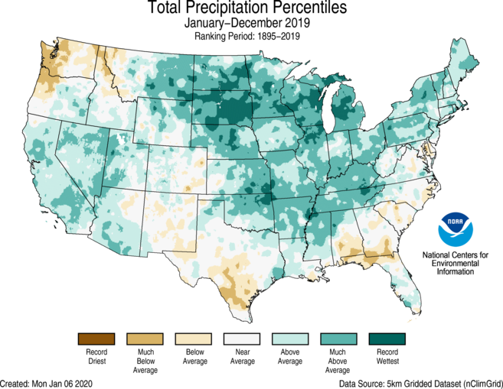](https://www.ncdc.noaa.gov/monitoring-content/sotc/national/grid-ranks-prcp/grid-ranks-prcp-201901-201912.png)

**Figure 10. Precipitation Rankings for October 2018-September 2019 When Compared with Local Averages from 1895-2019. NOAA National Centers for Environmental Information.[7]**

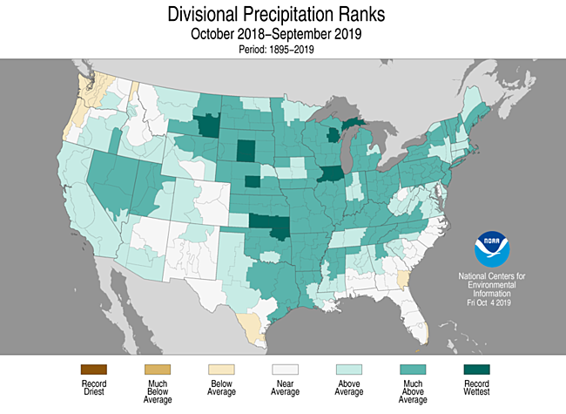

**Figure 11. Temperature Rankings for January-December 2019 When Compared with Local Averages from 1895-2019. NOAA National Centers for Environmental Information.**

[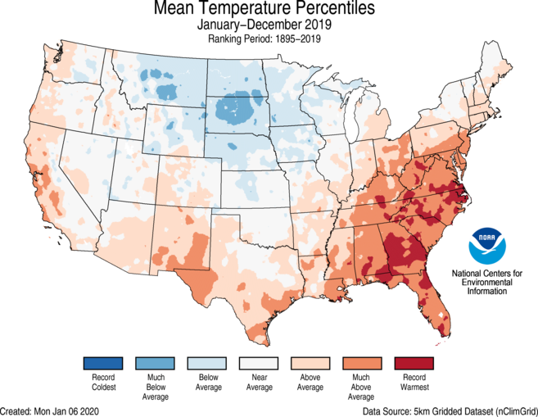](https://www.ncdc.noaa.gov/monitoring-content/sotc/national/grid-ranks-temp/grid-ranks-tavg-201901-201912.png)

**Figure 12. California Snow Water Content,[8] July 17, 2019, Percent of April 1 Average. California Department of Water Resources.[9]**

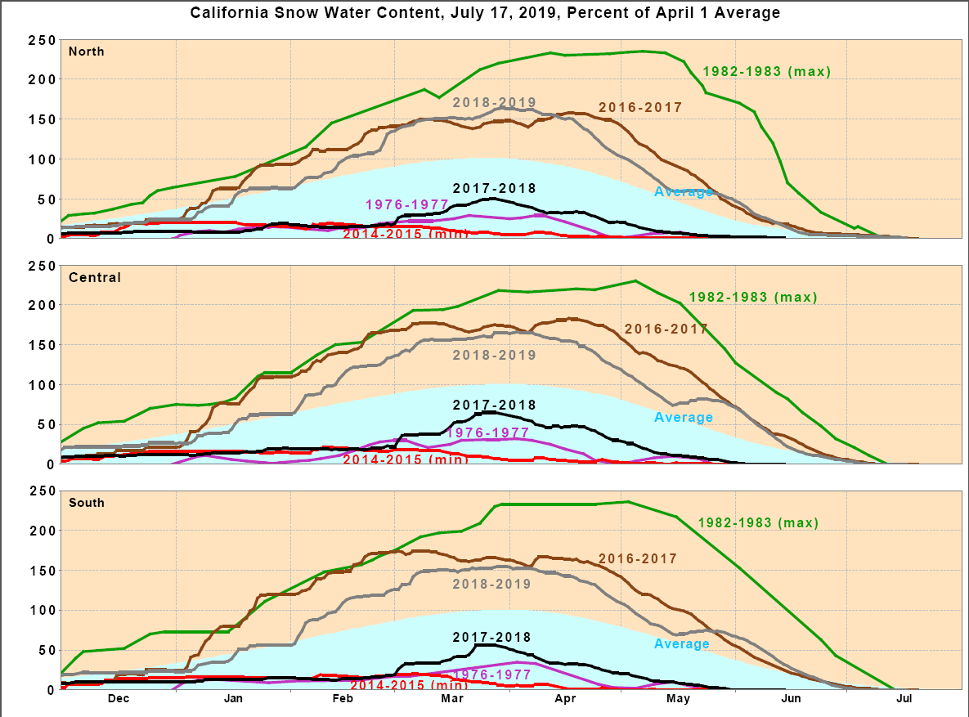

## Prescribed Fire and Fuel Reduction Efforts

As fire size and severity have worsened over the past decade, mandates to focus on fuels reduction treatments have arisen. In 2018, Executive Order B-52-18 from then-governor Brown ordered the doubling of forest acres treated per year from 250,000 to 500,000 statewide within five years. The expanded use of fuels treatments to prevent catastrophic wildfire continues to be a high priority for the Board and CAL FIRE. Fuel treatments are intended to reduce the amount of surface and ladder fuels and thereby reduce the risk of catastrophic fires that burn longer, further, and hotter. The modification of fire behavior as a result of fuel reduction efforts may prevent loss of life, reduce fire suppression costs, reduce property losses, and protect natural resources. Fuel treatments utilized by CAL FIRE include, but are not limited to, prescribed fire, mechanical clearing, cooperative fuel reduction grants, and encouraging stand management by timber owners through application of the FPRs. EO B-52-18 also encouraged the use of prescribed fire as a management tool.

CAL FIRE’s Vegetation Management Program (VMP) is a cost-sharing program that encourages fuel reduction in SRA and focuses on prescribed fire. The use of fire mimics natural processes, enables fuel reduction, and restores fire to its historic role in wildland ecosystems, which may improve native communities. The VMP can be utilized by private landowners to accomplish fuel reduction goals on their property using prescribed fire and other fuel management techniques. Figures 13 and 14 below illustrate the acreage goals and number of acres treated by the VMP in the three most recent fiscal years.

**Figure 13. Broadcast/Prescribed Burn Targets and Acres Completed.**

**\*FY 19/20 is through December 31, 2019**

| **Fiscal Year** | **Target** | **Completed** | **% Completed** |
| --- | --- | --- | --- |
| 2017/2018 | 20,000 | 19,413 | 97.07% |
| 2018/2019 | 25,000 | 31,305 | 125.22% |
| 2019/2020* | 25,000 | 13,450 | 53.80% |

**Figure 14. All Other Fuel Reduction Method Targets and Acres Completed.**

**\*FY 19/20 is through December 31, 2019**

| **Fiscal Year** | **Target** | **Completed** | **% Completed** |
| --- | --- | --- | --- |
| 2017/2018 | 20,000 | 13,344 | 66.70% |
| 2018/2019 | 20,000 | 15,331 | 76.66% |
| 2019/2020* | 20,000 | 13,730 | 68.65% |

Defensible space is managed space around a structure or other site of importance designed to reduce the risk of a fire spreading into adjoining wildland, and vice versa. Reduced natural fuel loads, decreased continuity of fuels, the removal of flammable materials from near structures, and the use of fire-resistant materials in landscaping and home construction are just some of the techniques that contribute to defensible space. These techniques reduce the chances of a structure igniting during a wildfire and increase firefighter safety during structure defense operations. Defensible space and the management of fuels, particularly around homes and public buildings, have become increasingly important as the Wildland-Urban Interface (WUI) continues to expand and more severe fires threaten WUI areas. CAL FIRE recently updated the Defensible Space Collector App to make inspections more efficient and accurate. Figure 15 illustrates the goals for defensible space inspections and how many were accomplished within the three most recent fiscal years.

**Figure 15. Defensible Space Inspections Completed.**

**\*FY 19/20 is through December 31, 2019**

| **Fiscal Year** | **Target** | **Completed** | **% Completed** |
| --- | --- | --- | --- |
| 2017/2018 | 250,000 | 217,666 | 87.07% |
| 2018/2019 | 250,000 | 204,341 | 81.74% |
| 2019/2020* | 250,000 | 115,117 | 46.05% |

CAL FIRE also sponsors several grant opportunities which focus on fuels reduction and forest health. The California Forest Improvement Program (CFIP) can be used by small landowners for reimbursement of forestry practices that improve the health and resilience of their lands. These activities may include fuels reduction practices. Additionally, CAL FIRE sponsors the Forest Health, Urban and Community Forestry, and Fire Prevention grants, which are funded through the Greenhouse Gas Reduction Fund. Part of their overarching goal is improving carbon sequestration by reducing the risk of intense wildfires and improving general forest health.

Finally, CAL FIRE has developed designated fuels reduction crews. Previously, fuels reduction was often completed by local CAL FIRE teams when they were not fighting fire. The development of designated crews for fuels reduction is anticipated to increase prescribed fire and manual fuels treatment numbers in the coming years. Five crews are headquartered in the Northern Region and five in the Southern Region. CAL FIRE approved 318 applications to take the most recent Forestry Technician exam. The new members of these crews are currently rotating between their required trainings and working in the field.

## California Statewide Vegetation Treatment Program

On December 30, 2019, the Board certified a Program Environmental Impact Report (PEIR) and approved the California Statewide Vegetation Treatment Program (CalVTP), a Statement of Overriding Considerations, and a Mitigation Monitoring and Reporting program. This CalVTP and PEIR will streamline California Environmental Quality Act (CEQA) compliance for CAL FIRE and other state and local public agencies’ vegetation management projects. The CalVTP PEIR is intended for vegetation management activities that lower the risk of catastrophic wildfires on nonfederal lands by managing vegetation to modify or reduce hazardous fuels.

## Wildfire Activity

2019 proved to be a slow fire season throughout the state compared to 2017 and 2018. A significant increase in precipitation and a substantial snowpack that lasted into June, along with the moderate weather we have experienced throughout the state over the course of the year, has made this a reality. The total number of fires responded to by CAL FIRE personnel were more than the 2018 season counts; however, the amount of acreage burned is dramatically different. This year saw 135,573 acres burn in CAL FIRE jurisdiction compared to 827,481 acres burned in 2018, an 84% decrease in acres burned in 2019 compared to 2018. In 2018 a total of 1.96 million acres burned throughout all jurisdictions in the state of California, destroying over 22,700 structures and killing 100 individuals. This year, 259,823 acres burned on CAL FIRE and Federal jurisdiction lands in California. Wildfires destroyed a total of 732 structures and killed 3 individuals throughout the state in 2019.

On October 23, 2019, the Kincade Fire started. It was located northeast of Geyserville in Sonoma County. It burned a total of 77,758 acres and destroyed 376 structures, making it both the largest and most destructive fire of 2019.

| **Figure 16. Most Destructive Incidents, 2019 (all jurisdictions)** | | | |
| --- | --- | --- | --- |
| **Name (Unit or Contract County Abbreviation)** | **Acreage** | **Structures Destroyed** | **Fatalities** |
| Kincade Fire (CALNU) | 77,758 | 376 | 0 |
| Maria Fire (VNC) | 9,999 | 4 | 0 |
| Saddle Ridge Fire (LAC) | 8,799 | 24 | 1 |
| Sand Fire (CALNU) | 2,512 | 4 | 0 |
| Sandalwood Fire (CARRU) | 1,011 | 73 | 2 |
| Getty Fire (LAC) | 745 | 13 | 0 |
| Mountain Fire (CASHU) | 600 | 14 | 0 |
| Swedes Fire (CABTU) | 496 | 2 | 1 |
| 46th Fire (CARRU) | 328 | 7 | 0 |
| **TOTAL** | **102,248** | **513** | **3** |

**Figure 17. Fire Season 2018 and 2019 Comparison.**

| **Interval** | **Fires** | **Acres** |
| --- | --- | --- |
| January 1, 2019 through December 31, 2019 | 6,592 | 135,573 |
| January 1, 2018 through December 31, 2018 | 5,914 | 827,481 |
| 5-year average (2015-19) | 5,767 | 453,633 |
| 2019 Combined (CAL FIRE & US Forest Service) | 7,869 | 259,827 |

***Note: Unless noted otherwise, these values tabulate wildfires responded to by CAL FIRE in SRA and LRA regions under contract with CAL FIRE.*** *The statistics for 2018 were pulled from the draft copy of the 2018 Wildfire Activity Statistics Report (Redbook). The 2019 statistics were pulled from the CAD system. Both sets of statistics are preliminary and final numbers will be provided in the annual Redbooks once published.*

# *Accomplishments 2019 – Regulatory*

#### *State Forest Regulations Update, 2018*

PRC 4652 allows CAL FIRE to collect user fees for overnight camping and reserved group activities in Demonstration State Forests. Despite this, existing regulation did not provide for the collection of such fees, which have become increasingly necessary to maintain high-quality facilities for public use and protect environmental quality in areas surrounding recreational facilities in state forests. This regulatory package explicitly allowed CAL FIRE to collect fees for the above-mentioned activities and created a schedule for such fees. It also clarified existing and, sometimes, outdated regulatory language regarding state forests. Following Office of Administrative Law (OAL) approval in April, these regulations took effect on July 1, 2019.

#### *Emergency Exemption Amendments, 2019*

These amendments were necessary to maintain consistency with Senate Bill (SB) 901 (2018), which required that the initial adoption of regulations pursuant to the bill were to be adopted as emergency regulations pursuant to the Administrative Procedure Act (APA). The amendments restructured and modified several of the Board’s existing regulatory exemptions to the Forest Practice Act (FPA). The amendments included the addition of the new Small Timberland Owner exemption, intended to provide regulatory relief for small, nonindustrial landowners. Additional amendments included conditional allowances for the construction of up to 600 feet of temporary road under the Forest Fire Prevention Exemption, as well as the standardization of many of the other conditional requirements of previous exemptions. The amendments were adopted as emergency regulations in January of 2019 and became permanent upon filing in February of 2019, consistent with SB 901.

#### *Emergency Rulemaking to Implement Legislative Changes to the Working Forest Management Plan (WFMP) Statutes Pursuant to SB 901*

Like the Emergency Exemption Amendments, 2019 (above), these changes were originally adopted as emergency regulations in accordance with SB 901. They provided clarifying changes to ensure compliance with amendments to the FPA within SB 901 of statutes related to WFMPs. The amendments allowed multiple landowners to join together to submit a single WFMP, reduced the number of acres within a single WFMP to 10,000, required the harvest area to be within a single defined hydrologic area, and clarified requirements for road construction and erosion control. They were adopted as emergency regulations in January of 2019 and became permanent upon filing in February, consistent with SB 901.

#### *Emergency Emergency Fuel Hazard Reduction Amendments, 2019*

These regulations were intended to clarify and simplify the Emergency Notice for Hazard Fuel Reduction exemption within the FPRs to encourage greater use of the specific Emergency Notice process and to improve the effectiveness of hazardous fuel removals by landowners in strategic areas. They were adopted as emergency regulations in August of 2019. The Board has re-adopted these emergency regulations and is currently engaged in the process of permanent rulemaking on this topic.

#### *Emergency Rulemaking to Facilitate Post-Fire Recovery Efforts within the Counties of Lake, Siskiyou, Mendocino, Shasta, Trinity, and Napa*

These emergency regulations provided an exemption from the plan preparation and submission requirements and from the completion report and stocking report requirements of the FPA. This exemption permitted the cutting or removing dead or dying trees within 300 feet of a structure in areas damaged by 2018 wildfires in Lake, Siskiyou, Mendocino, Shasta, Trinity, and Napa Counties, with conditional elements. These regulations were first adopted on September 27, 2018 and were readopted twice in 2019 before expiring in August of 2019.

#### *Categorical Exemption Amendments, 2019*

These amendments clarified several of the Board activities which are consistent with the established classes of categorically exempt projects as identified within CEQA. Specifically, the amendments clarified that actions related to regulating defensible space, Board approval of state forest management plans, and management of hazardous fire areas are consistent with extant classes of categorical exemptions. The Board adopted these amendments at their November 2019 meeting, and they will become effective on April 1, 2020.

#### *Emergency Rulemaking to Facilitate Post-Fire Recovery Efforts within the County of Butte*

These emergency regulations provided an exemption from the plan preparation and submission requirements and from the completion report and stocking report requirements of the FPA. This exemption permitted the cutting or removing dead or dying trees within 300 feet of a structure in areas damaged by 2018 wildfires in Butte County, with conditional elements. The regulations were adopted in January and readopted in August of 2019. A certificate of compliance was submitted in October of 2019 (see permanent post-fire recovery exemption below).

#### *Fire Safety Survey, 2019*

The Board, in consultation with the State Fire Marshal, is required by Public Resources Code § 4290.5 to identify existing subdivisions at significant fire risk and without a secondary egress route that are located in SRA or VHFHSZs. The regulatory amendments within this rulemaking specified which subdivisions were to be surveyed. All subdivisions within SRA and VHFHSZs of LRA are to be surveyed under these rules. The rulemaking also clarified definitions related to roads and egress routes. The measure was adopted in June of 2019, submitted in September to OAL, and withdrawn from OAL in October due to clarity issues. The revised rules were adopted in December of 2019 and will likely be resubmitted to OAL in January of 2020, likely taking effect on April 1, 2020.

#### *Subdivision Map Findings, 2019*

Government Code (GOV) § 66474.02, a provision of the Subdivision Map Act, requires a legislative body of a county to make two findings before approving a tentative or parcel map for a subdivision within SRA or a VHFHSZ. These findings are required to ensure that fire protection was taken into consideration when planning the subdivision, and that appropriate protection from a fire department is provided. These regulations provide specific guidance to local governments regarding compliance with this statute and demonstrating that compliance to the Board. The regulations were adopted in April of 2019, submitted in September to OAL, and withdrawn from OAL in October due to clarity issues. The revised rules were adopted in December of 2019 and resubmitted to OAL in January of 2020, likely taking effect on April 1, 2020.

#### *Very High Fire Hazard Severity Zones (VHFHSZ) Adoption, 2019*

This regulatory action provided improved clarity and direction for local governments when designating VHFHSZs within their jurisdictions and communicating that information to the Board. This measure was adopted in April of 2019, submitted in September to OAL, and withdrawn from OAL in October due to clarity issues. The revised rules were adopted in December of 2019 and resubmitted to OAL in January of 2020, likely taking effect on April 1, 2020.

#### *Safety Element Review, 2019*

GOV § 65302.5(b)(1) requires a draft element of, or a draft amendment to, the safety element of a county or a city’s general plan to be submitted to the Board if that county or city contains SRA or VHFHSZ, and GOV § 65302.5(b)(2) requires the Board to review the submitted safety elements for how well they address wildland fire risk reduction and mitigation in the planning area. This rulemaking clarified and implemented a new statutory mandate that the Board request a consultation with a local government if that government does not implement the Board’s recommendations to reduce wildland fire risk in the safety element of their general plan. Adopted by the Board in April of 2019, this was approved by OAL in October of 2019 and became effective on January 1, 2020.

#### *Fire Safe Development Regulations*

The Board has been regulating defensible space in SRA since 1991. These SRA Fire Safe Regulations have, in some cases, come into conflict with other overlapping regulations, including county and state fire codes. These amendments specified that the SRA Fire Safe Regulations shall be updated every three years, concurrently with the California Fire Code. Additionally, they clarified and updated existing requirements to make these regulations suitable for modern buildings, land use patterns, firefighting tactics, and dimensions of firefighting apparatus. Adopted by the Board in March of 2019, these regulations were approved by OAL in September of 2019 and became effective on January 1, 2020.

#### *Licensing Fee Amendments, 2020*

The Registered Professional Foresters Fund has not had a fee increase since 1991 and is facing severe financial limitations due to inflation and to a declining number of fee-paying RPFs and CRMs, as more individuals retire and relinquish their licenses than successfully obtain new licenses. This rulemaking addressed imminent budgetary shortfalls by raising renewal fees for RPFs and CRMs, raising the costs of other fees to the maximum allowed by statute, offering discounted renewal fees to RPFs with at least 30 years of licensure, and allowing renewal fees to be paid by credit card in addition to other payment methods. Biennial renewal fees for RPFs were increased from $190 to $350, with an exception for RPFs who have been licensed for 30 years or more, who will pay $250 biennially. Biennial CRM renewal fees increased from $70 to $130. The fee to reinstate a license following withdrawal increased from $5 to $50, and the fee for duplicate licenses or specialty certificates increased from $5 to $25. The Board adopted and submitted to OAL these amendments in December of 2019 for a likely April 1, 2020 effectiveness date.

#### *Nonindustrial Timber Management Plan (NTMP) Amendments, 2019*

Sections of the Forest Practice Rules relating to NTMPs were updated to provide clarity, reflect modern mapping standards and technologies, and make regulations consistent with recently passed legislation (SB 901). Notably, the amendments made explicit that multiple small landowners may participate in one NTMP and that one agent may be designated as a single point of contact for all landowners involved. Certain exemptions are also made permissible within the footprint of an NTMP. Having been adopted by the Board in September of 2019, and approved by OAL in November, these regulations went into effect on January 1, 2020.

#### *Stocking and Silvicultural Amendments, 2019*

Stocking standards for replanting following harvest or disturbance have been in place for several decades. Over that time, seedling survival has improved dramatically, and stressors facing forests, such as diseases, drought, insects, and fire, have increased in frequency and severity. The amendments lowered the required stocking of seedlings on a district by district basis in order to address various forest health and ecological goals as identified by the Board, as well as aligned the requirements of specific sylvicultural prescriptions with those goals. Having been adopted by the Board in September of 2019, and approved by OAL in November, these regulations went into effect on January 1, 2020.

#### *Permanent Post-Fire Recovery Exemption*

The adoption of this exemption was intended to aid in protecting structures and public safety in the aftermath of a wildfire. It allowed dead or dying trees to be harvested or removed, when within 300 feet of a structure, without a need to satisfy completions report and stocking report requirements and plan preparation and submission requirements of the FPA. To qualify, the activities must be consistent with a current state of emergency or an emergency declared by a gubernatorial executive order, or an RPF must certify that trees are dead or dying as a result of a wildfire that took place within the previous three years. Having been adopted by the Board in September of 2019, and approved by OAL in November, these regulations went into effect on January 1, 2020.

#### *Registered Professional Forester and Certified Specialty Amendments, 2019*

The Board is responsible for the certification and certain aspects of discipline of Registered Professional Foresters and Certified Specialties. These amendments were intended to clarify several procedural and semantic issues within existing regulatory text regarding the execution of those duties. The amendments were adopted by the Board in May of 2019, and were withdrawn from OAL in June of 2019 due to clarity issues. It is anticipated that the Board will adopt them in January of 2020 and that they will take effect on April 1, 2020.

# *Accomplishments 2019 - Policy*

## Fire Protection Policies

The Board’s fire protection policies have gone through extensive changes throughout the years. In 2018, the Board reviewed these policies with significant buy-in from CAL FIRE, and changes were approved at the Board’s May 2019 meeting in Chico. These changes included encouraging SRA contracted fire departments to enforce forest and fire policy and law, enhancing local governments’ involvement in response to wildland fire incidents, reducing Amador Plan agreements when local governments improve their capabilities, and advising the US Forest Service on management decisions for lands adjacent to SRA.

## Local Government

### General Plan Safety Elements

Under Government Code § 65302.5, the Board is required to review the General Plan Safety Elements for jurisdictions with SRA or VHFHSZ. Utilizing staff from CAL FIRE’s Land Use Planning team, the Board has established a standardized method to review the safety element of general plans. The methodology includes:

1. Reviewing the safety element for the requirements in Government Code §65302, subdivision (g)(3)(A),
2. Examining the safety element for goals, policies, objectives, and implementation measures that mitigate the wildfire risk in the planning area (Gov. Code, § 65302, subd. (g)(3)(B) & (C)), and
3. Making recommendations for methods and strategies that would reduce the risk of wildfires (Gov. Code, § 65302.5, subd. (b)(3)(B)).

Once completed, the Safety Element Assessment should provide clear guidance to a city or county regarding any areas of deficiency in the safety element as well as specific goals, policies, objectives, and implementation measures the Board recommends adopting in order to mitigate or reduce the wildfire threat in the planning area. The Board does not have the authority to approve safety elements, but rather offers recommendations to improve fire hazard planning in the planning area. If jurisdictions choose not to implement the Board’s recommendations, they must respond in writing to the Board discussing the reasons why not. SB 1260 (Jackson, 2018) now allows the Board to request a consultation with local jurisdictions who choose not to adopt the Board’s recommendations and prevents the jurisdiction from approving the draft element or amendment if a consultation is requested. These changes will improve communication between the Board and local jurisdictions and enable further dialogue to better protect citizens. Regulations to implement this consultation process became effective January 1, 2020.

**Figure 18. General Plan Safety Elements Reviewed by the Board in 2019**

| **Region** | **Type** | **Jurisdiction** | **Received** | **Reviewer** | **Board Review** |
| --- | --- | --- | --- | --- | --- |
| CNR | City | Portola | 3/8/19 | Shane Vargas | 4/9/2019 |
| CNR | City | Berkeley | 5/6/19 | Jeff Hakala | 6/11/19 |
| CSR | City | Mammoth Lakes | 6/28/19 | Raymond Martinez | 8/20/19 |
| CSR | City | Santa Paula | 6/24/19 | Gene Potkey | 8/20/19 |
| CSR | County | Tuolumne | 8/5/19 | Kevin Lindo | 8/20/19 |
| CSR | County | Mariposa | 8/6/19 | Kevin Lindo | 8/20/19 |
| CSR | City | Desert Hot Springs | 8/26/19 | Marcus Hernandez | 9/24/19 |
| CSR | City | Villa Park | 9/3/19 | Marcus Hernandez | 9/24/19 |
| CNR | City | Dunsmuir | 9/13/19 | Shane Vargas | 11/6/19 |
| CNR | County | Nevada | 10/15/19 | Carmel Barnhart | 11/6/19 |

**Figure 19. Local Ordinances Certified as Meeting or Exceeding SRA Fire Safe Regulations (14 CCR § 1270 et seq.) in 2019**

| **SRA Counties** | **Certification Date** | **Ordinance Number** |
| --- | --- | --- |
| **Napa** | 7/18/19 | Road and Street Standards |

## Appointment of Authorized Designees for Less Than Three Acre Conversions

The Board has been working on issues of conversion of timberland to cannabis cultivation for the past several years. The conversion of timberland to a use other than growing timber requires, prior to conversion, a Timberland Conversion Permit (or its equivalent) to be approved by CAL FIRE or, if eligible, a Less Than 3 Acre Conversion Exemption to be accepted by CAL FIRE. In the context of cooperation with local entities, the Board, pursuant to §1104.1(a)(1)(D) of Title 14 of the California Code of Regulations (14 CCR), gives the county the opportunity to determine if proposed timberland conversions are in conformance with all county regulatory requirements through the incorporation of a signed and dated statement from an authorized designee of the County Board of Supervisors.

When a county does not have an authorized designee, the authority falls to the RPF preparing the Exemption to certify that the county has been contacted and the conversion is in conformance with county regulatory requirements. RPFs have communicated that this determination can be challenging if they work in multiple counties, each of which may have different regulatory requirements. Consequently, the Board communicated with County Boards of Supervisors to encourage them, if they have not already done so, to appoint an authorized designee to ensure land uses conform to county regulatory requirements. Figure 20 below indicates the response to the Board's request for counties to appoint an Authorized Designee to determine if conversions are in compliance with county regulatory requirements. These efforts have been successful since their inception, with many counties appointing Authorized Designees. In 2019, the Board continued outreach and policy related to Less Than 3 Acre Conversions.

**Figure 20. Response to Board’s Request to Appoint an Authorized Designee**

| **County** | **Appointed Prior to Request** | **Appointed After Request** |
| --- | --- | --- |
| Alameda | No | No |
| Alpine | No | Yes |
| Amador | Yes | N/A |
| Butte | No | Yes |
| Calaveras | No AD, does not sign exemption form | N/A |
| Colusa | No | Yes |
| Contra Costa | No | No |
| Del Norte | No | Yes |
| El Dorado | No | Yes |
| Fresno | No | Yes |
| Glenn | No | Yes |
| Humboldt | Yes | N/A |
| Imperial | No | No |
| Inyo | No | No |
| Kern | No | Yes |
| Kings | No | No |
| Lake | No | Yes |
| Lassen | Yes | N/A |
| Los Angeles | No | Yes |
| Madera | No | No |
| Marin | No | No |
| Mariposa | No | Yes |
| Mendocino | No | Yes |
| Merced | No | Yes |
| Modoc | Yes | N/A |
| Mono | No | Yes |
| Monterey | No | Yes |
| Napa | Yes | N/A |
| Nevada | No | Yes |
| Orange | No | No |
| Placer | Will no longer review | N/A |
| Plumas | Yes | N/A |
| Riverside | No | Yes |
| Sacramento | No | Yes |
| San Benito | No | No |
| San Bernardino | No | Yes |
| San Diego | No | No |
| San Joaquin | No | No |
| San Luis Obispo | No | No |
| San Mateo | No | Yes |
| Santa Barbara | No | Yes |
| Santa Clara | No | No |
| Santa Cruz | Yes | N/A |
| Shasta | No | Yes |
| Sierra | Yes | N/A |
| Siskiyou | No | No |
| Solano | No | No |
| Sonoma | No | Yes |
| Stanislaus | No | Yes |
| Sutter | No | No |
| Tehama | Yes | N/A |
| Trinity | Yes | N/A |
| Tulare | No | Yes |
| Tuolumne | No | Yes |
| Ventura | No | Yes |
| Yolo | No | Yes |
| Yuba | No | No |

# *AB 1504 California Forest Ecosystem and Harvested Wood Product Carbon Inventory*

California has set a net carbon sequestration target for the forest sector of five million metric tons (MMT) of carbon dioxide equivalent (CO2e) annually until 2020. The Board is required to analyze above ground and below ground carbon stocks within all forested landscapes in California (AB 1504, 2010). In response, the Board publishes annual reports which discuss several elements of the State's effort to meet these greenhouse gas (GHG) emissions reduction targets.

In February of 2019, the Board released a full AB 1504 California Forest Ecosystem and Harvested Wood Product Carbon Inventory for the 2017 reporting period. The report indicates that California’s forests are sequestering carbon at a rate of 27.9 MMT CO2e per year, down slightly from the 2016 reporting period which estimated 30.7 MMT CO2e per year. This value includes changes in forest ecosystem pools (29.2 MMT CO2e per year), harvested wood product pools (0.9 MMT CO2e per year), non-CO2 emissions from wildfires (-0.5 MMT CO2e per year), and forest land conversions (-1.7 MMT CO2e per year). Estimates of harvested wood product carbon are a new addition to this report, and include information from historic harvests from 1952 to 2017. Also new to this report are improved carbon stock and flux estimates for the soil organic carbon pool, and estimates of carbon stock and flux for the forest floor pool and for all pools at the county, National Forest, and Forest Practice District levels.

The annual update for the 2018 reporting period was delayed due to several plots being carried over into 2019 for field measurement due to fire closures and other factors. The 2018 annual data update is expected in the spring of 2020. The 2019 data update should follow at the end of 2020. Work is currently underway to establish a new agreement with the Forest Service Pacific Northwest Research Station (PNW) to complete the full 10-year measurement cycle carbon report following completion of data collection in 2020. Collaboration with the states of Oregon and Washington, as well as with British Columbia, have been ongoing, with a forest carbon workshop being completed in Portland, OR in the fall of 2019. Oregon and Washington are following suit and producing reports similar to California’s AB 1504 inventory. There is also discussion of a regional western states forest carbon report that would incorporate results from the California, Oregon, and Washington forest carbon inventories.

**Figure 21. California forest land statewide estimate of average annual carbon flux (MMT CO2/year) by pool and ownership, 2001-2007 to 2011-2017.*[10]**

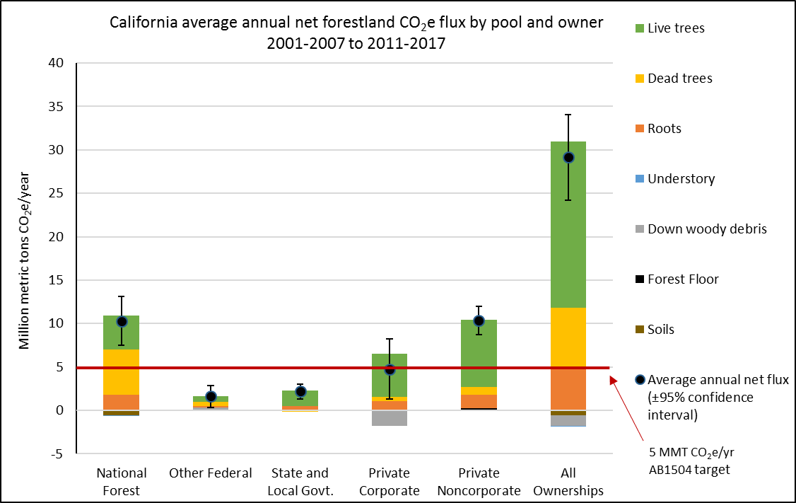

*Excludes contributions from forest land-use changes, non-CO2 GHG from fire, and HWP C.

# *State Forests*

The Board has changed the review periods for Initial State Forest Management Plans from five to ten years. This change was made following concerns expressed by forest managers, citing limited staffing and increasing workload. The longer period will allow the plans to be broader, encompass longer-term changes and trends, and reduce pressures on staff. Figure 23 (below) outlines the proposed schedule for management plan updates.

**Figure 23. Proposed Management Plan Update Schedule**

| **Demonstration State Forest** | **Management Plan Update (Year)** | **Management Plan Status** |
| --- | --- | --- |
| Mountain Home | 2020 | Extension granted 2017 |
| LaTour | 2022 | Approved 2013 |
| Soquel | 2024 | Approved 2014 |
| Jackson | 2026 | Approved 2016 |
| Boggs Mountain | 2028 | Approved 2018 |

# *Stewardship Lands*

The Stewardship Council Board has recommended fee title transfer of lands within the North Fork Mokelumne River, Pit River, Tunnel Reservoir, Battle Creek, Cow Creek, Lake Spaulding, and Bear River planning units to CAL FIRE. With the Stewardship Council Board recommendation for transfer of lands to CAL FIRE at Bear River in November 2018, fee title recommendations have been completed. In 2018, the Stewardship Council Board approved final Land Conservation and Conveyance Plans (conservation easements and agreements known also as LCCPs) for North Fork Mokelumne River, Pit River, and Tunnel Reservoir. The Stewardship Council continued to develop the final LCCPs for the remaining projects during 2019.

The Department of General Services and Pacific Gas & Electric (PG&E) have developed the final form and content for each of the transaction documents, which will be utilized to construct documents for each of the transactions going forward. The California Natural Resources Agency has also participated in these discussions and is working to bring along associated transactions with State Parks. CAL FIRE and PG&E signed the Property Acquisition Agreement for the North Fork Mokelumne property in 2019 and received subsequent approval from the California Public Utilities Commission on October 7, 2019 to proceed with closing the transaction. It is expected to go to the Public Works Board in December for final State approval allowing for the close of escrow.

Conservation easement holders for each of the properties have been recommended by the Stewardship Council Board and include: Shasta Land Trust (Pit River, Tunnel Reservoir, Cow Creek), Western Shasta Resource Conservation District (Battle Creek), Mother Lode Land Trust (North Fork Mokelumne River), Placer Land Trust (Lake Spaulding), and Bear, Yuba, and Placer Land Trusts (Bear River). As currently written, CAL FIRE has successfully negotiated identical or very similar terms with each of the conservation easement holders to reduce the number of unique restrictions on any property. CAL FIRE has been on site to document baseline conditions and discuss the intended management with each of the conservation easement holders.

It is expected that the Pitt River, Tunnel Reservoir, Lake Spaulding, and Bear River planning units will close in late 2020.

# *Professional Licensing and Forest Practice Enforcement*

Pursuant to California Public Resources Code (PRC) § 750 *et seq.,* the Board is authorized to grant licenses to Registered Professional Foresters (RPFs) and specialty certificates (Certified Rangeland Managers (CRMs)). Earning either license is contingent upon meeting certain ethical standards, educational and work experience, and ultimately passing an examination specific to the license or specialty.

The term “Professional Forester” is defined in PRC § 752 and refers to a person who, by reason of his or her knowledge of the natural sciences, mathematics, and the principles of forestry, acquired by forestry education and experience, performs services, including, but not limited to, consultation, investigation, evaluation, planning, or responsible supervision of forestry activities when those professional services require the application of forestry principles and techniques. The CRM certification is the only “Certified Specialist” (pursuant to 14 CCR § 1600) credential bestowed and recognized by the Board. A CRM is defined in 14 CCR § 1651 as “… a person who provides services pursuant to 14 California Code of Regulations (CCR) 1602, at the request of the landowner or hiring agent, relating to the application of scientific principles to the art and science of managing rangelands and range.”

**Figure 24. Board Licensed Professionals**

| **Year** | **RPFs** | **CRMs** |
| --- | --- | --- |
| 2005 | 1334 | 74 |
| 2007 | 1341 | 80 |
| 2009 | 1285 | 81 |
| 2011 | 1251 | 78 |
| 2013 | 1254 | 79 |
| 2015 | 1205 | 86 |
| 2016 | 1194 | 85 |
| 2017 | 1161 | 84 |
| 2018 | 1132 | 88 |
| 2019 | 1126 | 89 |

## Professional Discipline

Most professional disciplinary matters are confidential in nature. They are handled administratively and do not culminate in a hearing before an Administrative Law Judge and/or the Board. In 2019, the Professional Foresters Examining Committee (PFEC) received three complaints of which one (case 335) required disciplinary action resulting in a Stipulated Settlement Agreement between the Board and the RPF respondent. The remaining two are still in the investigation process.

## Enforcement

PRC § 4601 *et seq.* authorizes the Board to investigate and discipline, “Any person who willfully violates any provision of this chapter or rule or regulation of the Board….” These civil penalties are identified, investigated, and pursued by CAL FIRE, with final adjudicative authority on these matters residing with the Board. During the 2019 calendar year, the Board deliberated and took action on nine civil penalties for non-compliance with the Forest Practice Act and/or the Forest Practice Rules.

# *Acronyms:*

*The following acronyms and abbreviations are used in this document:*

**APA:** Administrative Procedure Act

**Board:** California State Board of Forestry and Fire Protection

**CalEPA:** California Environmental Protection Agency

**CAL FIRE:** California Department of Forestry and Fire Protection

**CalVTP:** California Vegetation Treatment Program

**CDTFA:** California Department of Tax and Fee Administration

**CEQA:** California Environmental Quality Act

**CFIP:** California Forest Improvement Program

**CLFA:** California Licensed Foresters Association

**CRM:** Certified Rangeland Manager

**DWR:** California Department of Water Resources

**EMC:** Effectiveness Monitoring Committee

**FCAT:** Forest Climate Action Team

**FPA:** Z’berg-Nejedly Forest Practice Act of 1973

**FPRs:** Forest Practice Rules

**FRAP:** Fire and Resource Assessment Program

**FRID:** Fire Return Interval Departure

**LRA:** Local Responsibility Area

**NTMP:** Nonindustrial Timber Management Plan

**OAL:** Office of Administrative Law

**PG&E:** Pacific Gas & Electric

**PEIR:** Program Environmental Impact Report

**PFEC:** Professional Foresters Examining Committee

**RMAC:** Range Management Advisory Committee

**RPF:** Registered Professional Forester

**SRA:** State Responsibility Area

**SYP:** Sustained Yield Plan

**UCANR:** University of California Agriculture and Natural Resources

**USDM:** United States Drought Monitor

**USFS:** United States Forest Service

**VHFHSZ:** Very High Fire Hazard Severity Zone

**WFMP:** Working Forest Management Plan

**WUI:** Wildland-Urban Interface

# Works Cited

Aines, R.D., and McCoy, S.T. 2018. Making Negative Emissions Economically Feasible: The View from California. *Lawrence Livermore National Laboratory.* Online at: <https://www.osti.gov/servlets/purl/1459143>

California Department of Food & Agriculture (CDFA). 2018. California Agricultural Statistics Review: 2017-2018. Available online at: <https://www.cdfa.ca.gov/statistics/PDFs/2017-18AgReport.pdf>

California Department of Tax and Fee Administration (CDTFA). 2019, November 22. Personal communication from Terri Covert, Business Taxes Specialist I, CDTFA, to David Ludwig, Forestry Assistant II, Board of Forestry and Fire Protection.

California Department of Water Resources (DWR). 2019a. California Data Exchange Center: Snow Water Equivalent (inches). Last accessed November 12, 2019. Available online at: <http://cdec.water.ca.gov/snowapp/sweq.action>

California Department of Water Resources (DWR). 2019b. Snow Surveys. Last accessed November 12, 2019. Available online at: <https://water.ca.gov/Programs/Flood-Management/Flood-Data/Snow-Surveys>

California Department of Water Resources (DWR). 2019c. Water Year 2020 Begins with Robust Reservoir Storage. Last accessed November 12, 2019. Available online at: <https://water.ca.gov/News/News-Releases/2019/October-19/Water-Year-2020-Begins-with-Robust-Reservoir-Storage>

California Forest Pest Council. 2018. California Forest Pest Conditions. Available online at: <https://www.fs.usda.gov/Internet/FSE_DOCUMENTS/fseprd617799.pdf>

California Forest Pest Council. n.d. Website. Online at: <http://caforestpestcouncil.org/>

Effectiveness Monitoring Committee (EMC). n.d. Website. Online at: <https://bof.fire.ca.gov/board-committees/effectiveness-monitoring-committee/>

Fire and Resource Assessment Program (FRAP). 2003. The Changing California Forest and Range 2003 Assessment. Chapter 1: Biodiversity: Hardwoods. No longer available online.

Fire and Resource Assessment Program (FRAP). 2017. California’s Forests and Rangelands 2017 Assessment. Available online at: <https://frap.fire.ca.gov/media/3180/assessment2017.pdf>

Forest Climate Action Team (FCAT). 2018. California Forest Carbon Plan: Managing Our Forest Landscapes in a Changing Climate. Sacramento, CA. 178p. Available online at: <http://resources.ca.gov/wp-content/uploads/2018/05/California-Forest-Carbon-Plan-Final-Draft-for-Public-Release-May-2018.pdf>

Forest Practice Rules Implementation and Effectiveness Monitoring Program (FORPRIEM). 2014. Brandow, C.A and Cafferata, P.H. This report is not available online. For a copy, interested parties may email Pete Cafferata at [Pete.Cafferata@fire.ca.gov](mailto:Pete.Cafferata@fire.ca.gov).

Jeronimo, S.M.A., Kane, V.R., Churchill, D.J., Lutz, J.A., North, M.P., Anser, G.P., and Franklin, J.F. 2019. Forest structure and pattern vary by climate and landform across active-fire landscapes in the montane Sierra Nevada. *Forest Ecology and Management. 437*:70-86. doi: 10.1016/j.foreco.2019.01.033. Available online at: <https://www.fs.usda.gov/treesearch/pubs/58601>

Long, J.W., Gray, A., and Lake, F.K. 2018. Recent Trends in Large Hardwoods in the Pacific Northwest, USA. *Forests. 9*(10): 651-674.doi: 10.3390/f9100651. Available online at: <https://www.fs.usda.gov/treesearch/pubs/58482>

National Oceanic and Atmospheric Administration (NOAA). 2019. National Centers for Environmental Information. Last accessed: January 9, 2020. Online at: <https://www.ncdc.noaa.gov/temp-and-precip/us-maps/>

Olsen, W., Coe, D., Stanish, S., Cafferata, P., Huff, E., Lang, S., and Rohr, F. 2019. Exemption and Emergency Monitoring Pilot Project Report. *CAL FIRE and Board of Forestry and Fire Protection*. Available online at: <https://www.researchgate.net/publication/335149799_Exemption_and_Emergency_Notice_Monitoring_Pilot_Project_Report>

Rundel, P.W. 2018. California Chaparral and Its Global Significance. *Valuing Chaparral,* Springer Series on Environmental Management. doi: 10.1007/978-3-319-68303-4_1 Available online at: <https://www.researchgate.net/publication/324337489_California_Chaparral_and_Its_Global_Significance>

University of California Agriculture and Natural Resources (UCANR). 2019a. Forest Research and Outreach: California Forests. Last accessed: November 12, 2019. Available online at: <https://ucanr.edu/sites/forestry/California_forests/>

University of California Agriculture and Natural Resources (UCANR). 2019b. UC Oaks: Oak Woodland Wildlife. Last accessed: November 14, 2019. Available online at: <https://oaks.cnr.berkeley.edu/wildlife/>

U.S. Drought Monitor (USDM). March 19, 2019. Drought Summary. Available online at: <https://droughtmonitor.unl.edu/Summary.aspx>

U.S. Forest Service (USFS). 2017. Forest Inventory and Analysis: Fiscal Year 2016 Business Report. Available online at: <https://www.fs.usda.gov/sites/default/files/15817-usda-forest-service-fia-annual-report-508-update.pdf>

White, A.M. and Long, J.W. 2019. Understanding ecological contexts for active reforestation following wildfires. *New Forests. 50*(1): 41-56. doi: 10.1007/s11056-018-9675-z. Available online at: <https://www.fs.usda.gov/treesearch/pubs/57834>

# APPENDIX A: 2019 Standing Committee Priorities

1. 1038(b) is the 10% or less Dead and Dying Exemption. Due to the lack of the requirement for mapping specific project areas, the numbers reported are elevated beyond what specific areas are managed by the exemption.
2. This category includes 1038(a) Christmas Trees, 1038(c) Up to 300 Foot Habitable Structure, 1038(d) Biomass, 1038(g) Slash Pile Removal, 1038(i) the original Forest Fire Prevention Exemption (FFPE), and 1038(j) Pilot Project FFPE.
3. 1038(k) Drought Mortality Exemption, adopted by the Board in July, 2015.
4. On February 19, 2019, categories of many exemptions and reporting structures were changed, hence a change in the categories reported on March 1, 2019. Additionally, several new categories were added under “All other Exemptions”, including several post-fire recovery exemptions.
5. 1038(f) is a new Small Timberland Owner Exemption.
6. 1038.3 is a new Forest Fire Prevention Exemption.
7. Note: Data for this time period were not found presented at the same fine scale used for the annual data, Figures 9 and 11.
8. The Y-axis of the figure is percent of April 1st average Snow Water Content, which refers to the depth of liquid that would result over the same land area if the entire snowpack were to be melted instantaneously.
9. Image retrieved on 11/12/19 from <http://cdec.water.ca.gov/reportapp/javareports?name=PLOT_SWC.pdf>
10. Figure excludes sequestration from harvested wood product pools (0.9 MMT CO2e per year) and emissions from land-use changes (1.7 MMT CO2e/yr) and non-CO2 greenhouse gases (0.5 MMT CO2e/yr). Roots include belowground live and dead tree roots. Understory includes aboveground and belowground understory vegetation. Error bars represent the 95 percent confidence interval of net change.