5.0 SAFETY ELEMENT

5.1 INTRODUCTION
The purpose of the General Plan Safety Element for the City of Dunsmuir is to evaluate the risks associated with potential hazards, and provide goals and proposed actions for their mitigation to reduce the risk of death, injuries, property damage, and other economic and social consequences associated with natural and societal hazards. Major disasters are usually beyond the ability of the City to prevent, yet it is important to be prepared to respond when emergencies occur. It is the City's objective to be well prepared for emergencies and, where possible, control the exposure of people to hazards in known hazardous areas. This includes attempting to estimate increase in risk over time due to climate change. The types of emergencies include, but are not limited to, seismically induced surface rupture, ground shaking, ground failure, seiche, and dam failure; slope instability leading to mudslides and landslides; subsidence and other known geologic hazards; flooding; wildland and urban fires; and hazardous materials.

California Government Code Section 65302(g) requires that each city and county develop, and periodically update, a Safety Element, to protect communities from unreasonable risks. The process utilized for updating the Safety Element was lengthy and involved. It began in May of 2016 with consultation of the Board of Forestry and Fire Protection’s Lan Use Panning Program staff, including review of SB 1241 and its implementation requirements, Government Code Section 65302(g)(3); and Government Code Section 65302, which requires, among other things, submission of the draft update to the State Board of Forestry and Fire Protection, for review. The City reviewed State Law for Safety Element requirements, and met with staff and consultants. The City reviewed documents from other cities as examples, including the City of Paradise, CA which influenced final preparation of the document, in terms of scope and presentation. Staff and Consultants reviewed the existing element and discussed areas that warrant amendment.
The format of the Safety Element has been revised. The previous Element Contained descriptions of each of 5 potential risks as they pertain to Dunsmuir (Overall, Flood, Geologic, Wildfire, and Hazardous materials, in that order) and then had a separate section listing the goals, objectives and implementation measures. The proposed revised Element adds sections on Climate Change and Urban Fires, and separates the geologic hazards into separate sections of landslide, seismic events, mud slides, volcanic activity. The discussion in each section is expanded and includes right there the Goals, Objectives and Implementation measures of that section.

A presentation was prepared for the February 7, 2018 Planning Commission meeting designed to educate the Commissioners on the requirements of the Safety Element Update, and its process. Initial comments were taken regarding overall content considerations. A Rough Draft was prepared by staff and submitted to the Planning Commission for review and comment on May 9, 2018. Comments were gathered and utilized to further refine the draft element.

A CEQA Analysis (Initial Study) was prepared, and a Mitigated Negative Declaration was prepared. A Notice of Intent to file a Mitigated Negative Declaration has been filed with the County of Siskiyou and with the State Clearinghouse.

Following the public hearing at the Planning Commission level, responses to comments will be provided, and the draft will be revised where appropriate and sent to the Dunsmuir City Council for further public hearing and approval to send the plan to the State for review and comment. The final document addressing State concerns will be brought to the City Council for final adoption.

Focus of Update

The Housing Element Update, adopted in 2016, triggered the Safety Element Update. It is important to note that housing starts are still slow in Dunsmuir and have not changed significantly. Impacts to the Safety Element due to housing starts are, therefore, not noticeable. None of the Safety Element Goals or Policies have been revised due to housing impacts.

When updating a required element of the General Plan, it is important to address any new regulations adopted by the State since implementation of the last Safety Element Update. New requirements of the Safety Element include the following:
Issue | Section
Climate Change and its Impacts to Safety | G52 and each section
Evacuation | G54
Peak Water Load | G54
Minimum Road Widths | G54
Clearance around structures | G54
Historical Event Data | Section 5.4, 5.5 & 5.6
Local Hazard Mitigation Plan | Application in Process for Planning Grant

Other issues which must be addressed in the Safety Element include local development standards to meet or exceed the SRA Fire Safe Regulations. State Responsibility Areas mapping, and a map of fire hazard severity zones are included in the Dunsmuir Community Wildfire Protection Plan (CWPP) that is included by reference in this document. The Siskiyou County Office of Emergency Services Hazard Mitigation Plan and Dunsmuir Community Wildfire Protection Plan which include elements related to all-hazard identification and mitigation within the city are other sources of information on these topics. (See List of Resources for more information on these documents.

The Safety Element must include mapping of known seismic and geologic hazards. Sections 5.8 & 5.9 contain the required maps and a description of seismic and geologic conditions, including slope, landslides, subsidence, liquefaction, volcanic, erosion, expansive soils and dam inundation hazards.

Flood hazards are incorporated into Section 5.7.

Hazardous waste and the Siskiyou County Hazardous Waste Management Plan are discussed in Section 5.10.

The primary goals of the element are to protect the residents of and visitors to Dunsmuir from these hazards, as well as assuring that both law enforcement and fire protection are ready to meet the demands of new and existing land use development. The listed objectives include maintaining specific fire protection and law enforcement levels of service, while enhancing the local hazard alert system, implementing the Community Wildfire Protection Plan, as well as preparing and adopting a Dunsmuir Hazard Mitigation Plan, and Dunsmuir Emergency Plan.

Summary Overview of the Element’s Progress:

Element became effective on December 15, 2016. As of this reporting period (May 8, 2018) the performance period for this element is considered to be 65% complete. The Safety Element targeted 19 implementation measures to be pursued. The following overall progress can be reported:

Old Goal/Policy  # | New # | No longer needed | Completed but Maintenance necessary | Implementation Required | Modification Required
S-1.1.1, |  |  | Yes
S-1.1.2 |  |  |  |  | Yes
S-2.1.1 |  |  | Yes
S-2.1.2 |  |  | Yes
S-2.1.3 |  |  | Yes
S-3.1.1 |  |  |  | Yes
S-3.1.2 |  |  |  | Yes
S-3.1.3 |  |  |  | Yes
S-4.1.1 |  |  | Yes
S-4.1.2 |  |  |  | Yes
S-4.1.3- |  |  | Yes
S-4.1.4 |  |  |  | Yes
S-4.1.5 |  |  | Yes
S-5.1.1 |  |  | Yes
S-5.1.2 |  |  |  | Yes
S-5.2.1 |  |  | Yes
S-5.2.2 |  |  | Yes
S-5.2.3 |  |  | Yes
S-5.2.4 |  |  | Yes

5.2 GEOGRAPHIC SETTING
Latitude 41.208209, Longitude-122.271953
The City of Dunsmuir is located at an average elevation of 2,289 feet above sea level in the Upper Sacramento River Canyon approximately 12 miles south of Mount Shasta (a dormant volcano with a height of 14,162 feet). The steep canyon walls around the City are heavily forested. Much of this land is productive timberland managed by the U.S. Forest Service or owned by private timber companies. Two major surface transportation facilities, Interstate 5 and the Union Pacific Railroad, share a corridor through the canyon and through the City of Dunsmuir. Box Canyon Dam on the Sacramento River (which impounds Lake Siskiyou) is located eight miles north and upstream of Dunsmuir, and has lessened the danger of flooding.

Dunsmuir's geographical setting presents several unique public safety concerns. They are listed here and introduced below. Goals and actions to be discussed in a separate section and goals and actions will be set with each.

  - Dunsmuir is in an area that has substantial forest fire risks and hazards. Wildfires close to Dunsmuir could endanger portions of the City.

  - Dunsmuir has an inventory of buildings that are older and sit close together, particularly in the Historic District. Fire, no matter the source could quickly spread due to the age of the materials and the close proximity.

  - Certain areas in Dunsmuir are susceptible to flood damage, especially along the Sacramento River, caused by over-abundant rainfall or snowmelt in the surrounding mountains.

  - The collapse of Box Canyon Dam could inundate much of Dunsmuir within 15 minutes of collapse.

  - A toxic or hazardous chemical accident on either Interstate 5 or the railroad could have serious and immediate implications in Dunsmuir.

  - Mount Shasta presents potential hazards from possible future volcanic activity.

  - Landslides caused by seismic or heavy rainfall events or ground subsidence could cause property damage at sites in Dunsmuir that are adjacent to hillsides.

Climate Change and its impacts on the land and resources of Dunsmuir

Climate change is the newest component of Safety Elements in California cities and counties. Previously known as Global Warming, the effect is now referred to as Climate Change, because the impacts of the warming effect change weather patterns overall, making some areas wetter or colder than previously seen as normal, while others are hotter and drier. Hard science seems to disprove those who theorize that there is no such thing. The State of California has seen fit to take a proactive stance on this issue, in order to make communities aware of how climate change can affect hazardous conditions and impact the safety of its residents and its infrastructure.

California created tools to study the impacts of Climate Change and enable communities to predict the type, severity and timing of those changes. It includes those tools in it’s Cal Adapt website. The City of Dunsmuir has utilized this tool, found at http://cal-adapt.org/tools/ . The tool was accessed on February 7, 2018, and the summary findings are included below. For more detailed information see the Appendix.

- Peak air quality emissions for Dunsmuir are projected to rise throughout the near future and to the year 2040 and plateau near the year 2100. Dunsmuir, situated in a narrow canyon, may experience rising air quality concerns, especially during periods of quiet air movement. This data is according to Cal Adapt tool visited on February 7, 2018.
- Mean Temperature for 1960 was 68 degrees. Mean temperature projected for 2020 is 71 degrees, and for 2040 is 71 degrees.
- Extreme Heat events in 1960 totaled about 17 days within the months of June through September. Projections for 2020 indicate they will increase to 36 days within the same time frame. Projections for 2040 indicate a growing heat season from May to October, to include 45 days.
- Snow Pack in 1960 measured 6.5 feet. Snow pack projected for 2020 is 1.5 feet, and for 2014 is 0.25 feet. The decrease in snow pack can likely be attributed partially to rising temperatures, and partly to the migration of storm patterns which may cause Dunsmuir to miss out on winter storm events.
- Precipitation in 1960 averaged between 50 and 80 inches per year. Precipitation in 2020 is projected to be between 40 and 90 inches a year. Precipitation in 2040 is projected to be between 35 and 100 inches per year. These extremes may reflect wetter, more frequent storm events, depending on the season, or years with more drought conditions than previously considered normal.

Air Quality:

Dunsmuir’s Air Quality is monitored and regulated via the Siskiyou County Air Pollution Control District. The Air Pollution Control District (District) monitors for criteria pollutants in the ambient air and regulates stationary sources of air emissions within the County. The California Air Resources Board (CARB(link is external) has the responsibility for regulating mobile emission sources, state-wide compliance assistance, forecasting, air monitoring, research, and emergency response, rule development, and for District oversight. The table below is a guideline for air quality indexes for various pollutants.

Local air pollution control districts, newspaper, radio, and TV use the air quality index (AQI) to report daily air pollution levels. The AQI was developed by the U.S. Environmental Protection Agency. It includes the AQI number, air quality description, and health precaution. …The chart below shows the range of index numbers, the air quality values, and the associated health effects. (https://www.arb.ca.gov/knowzone/students/airpollu/aqi.htm 3/22/19)

Air Quality Index (AQI): Particle Pollution
Index Values | Levels of Health Concern | Cautionary Statements
0-50 | Good | None
51-100 | Moderate | Unusually sensitive people should consider reducing prolonged or heavy exertion.
101-150 | Unhealthy for Sensitive Groups | People with heart or lung disease, older adults, and children should avoid prolonged or heavy exertion. Everyone else should reduce prolonged or heavy exertion.
151-200 | Unhealthy | People with heart or lung disease should avoid all physical activity outdoors. Everyone else should avoid prolonged or heavy exertion.
201-300 | Very Unhealthy | People with heart or lung disease, older adults, and children should remain indoors and keep activity levels low. Everyone else should avoid all physical activity outdoors.
300-500 | Hazardous

Potential Impacts for Dunsmuir:

Degradation of air quality in Dunsmuir has the potential to impact residents, employees and visitors alike.

Dunsmuir’s population consists of a large segment of senior citizens, which may increase as more people retire here to enjoy the lower costs of living.

Dunsmuir’s economy is largely dependent on outdoor enthusiast tourism. Degradation of the air quality can vastly impact the desirability of Dunsmuir as a destination for hiking, fishing, etc.

Source: Siskiyou County website at https://www.co.siskiyou.ca.us/content/agriculture-air-pollution-control-district

Air Quality is not currently an aspect of the Dunsmuir General Plan, Safety Element. If the reader is interested, current emissions can be found at any time on various weather station sites and at https://www.wunderground.com/health/us/ca/dunsmuir/96025
Air Quality monitoring stations are located many miles away from Dunsmuir. For a map of those sites, visit https://www.wunderground.com/health/us/ca/dunsmuir/96025 .

5.3 CITY-WIDE GENERAL GOAL

Goal 5.3. A City free of hazards

Objective 5.3. To maintain plans and systems to reduce risks to people and property to the extent feasible.

Policy 5.3.A. The City shall periodically review, and update as necessary, emergency plans that advise City staff, emergency services and residents on actions that should be taken in response to an emergency.

Implementation Measures:
5.3.A.1. The City shall prepare and implement and Local Emergency Plan and Local Hazard Mitigation Plan, and update them from time to time. The plans shall meet the requirements of OES and FEMA and shall include at a minimum the necessary steps to be taken in order to protect residents in the case of a hazardous event.

5.3.A.2: The City shall prepare an Evacuation Plan geared toward flexibility according to location and type of threat. The plan shall be subject to drills held with City staff and emergency services and coordinated with County, State and Federal agencies.

Policy 5.3.B. The plans should be readily available for public distribution.

Implementation Measures:
5.3.B.1: Utilize the existing DPAC (Disaster Preparedness Advisory Committee) to educate residents regarding the dangers of all hazards, including but not limited to seismic activity and wildland fires via public outreach efforts and promotion of the findings contained within the adopted plans.

Policy 5.3.C: Align allowed uses with zoning in conformance with the General Plan so that in an area identified as subject to a specific hazard, the City shall not approve applications for uses without adequate provisions to mitigate known hazards.

Implementation Measures:
5.3.C.1. Safety Element polices will not permit development that will cause Police and Fire Department response times to fall below established service levels:
Police: Five minutes
Fire: Within 5 minutes for 90% of all incidents

5.3.C.2: Assure that law enforcement and fire protection services are sufficiently equipped to meet the demands of new and existing land use development including qualified up-to-date equipment and training meeting or exceeding state and national standards.

5.3.C.3: Improve the communication system(s) used during City wide emergencies, such as wildland fires, earthquakes or volcanic occurrences.

5.3.C.4: Provide adequate access, including emergency vehicle access and evacuation, to all new parcels and, where feasible, to existing parcels.

5.3.C.5: Maintain operational readiness for emergency response personnel and the City Emergency Operations Center (EOC) by continual training which shall include EOC training exercises.

Policy 5.3.D: Enforce and comply with the provisions of the California Building Code and the California Fire Code including, but not limited to provisions for making visible street addressing and signage.

Implementation Measures:
5.3.D.1: Recovery and rebuilding efforts following natural or man-made disasters shall involve and employ strict adherence to current City-adopted Fire and Building Standards Codes and shall consider re-evaluation of General Plan land use compatibility as well as zoning districts and standards such as setbacks, height, coverage and more.

5.4 WILDFIRE
Physical Setting
Safety Element policies call for ensuring local development standards meet or exceed the SRA Fire Safe Regulations and Fire Hazard Reduction Around Building & Structures Regulations, adequate fire flows, and evaluating standard of response cover for police and fire to ensure that all areas of City are within a five-minute response time.
The City of Dunsmuir is rated as being in a "Very High Fire Hazard Severity Zone" pursuant to California Government Code Section 51 179. (See the map at https://frap.fire.ca.gov/media/6413/fhszl06_1_map47.pdf). Located in a heavily forested canyon with steep hillside slopes, Dunsmuir’s potential for a wildfire is very high. Fires in this type of situation are particularly dangerous since they are not readily accessible by most fire equipment due to the steepness of the terrain. Depending on the wind direction, the impacts to Dunsmuir structures from a major fire in the canyon could vary from relatively little damage to major destruction. A fire with limited wind assistance may simply burn up the side of the canyon and away from the City, while a wind blowing from the south could push a fire north through the City in addition to going up the side of the canyon. In this latter scenario, major structural damage in the City is likely. While these scenarios are severe, potential mudflows from heavy winter rains on fire-denuded slopes could result in additional significant damage to property below.

The town of Dunsmuir predates the fire ratings, the oldest parts of town exceed 100 years. There are a few vacant lots where older buildings have been demolished. Otherwise, there is little land left to develop. The Photo on the next page shows areas of development. The map on the following page indicates the zoning districts in Dunsmuir.

Some, residential development adjacent to the City core has occurred on the fringe of the canyon where steep grades and heavy vegetation cover exist. In some of
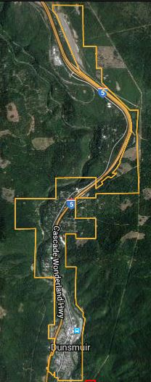 Photo Map Courtesy of ENPLAN
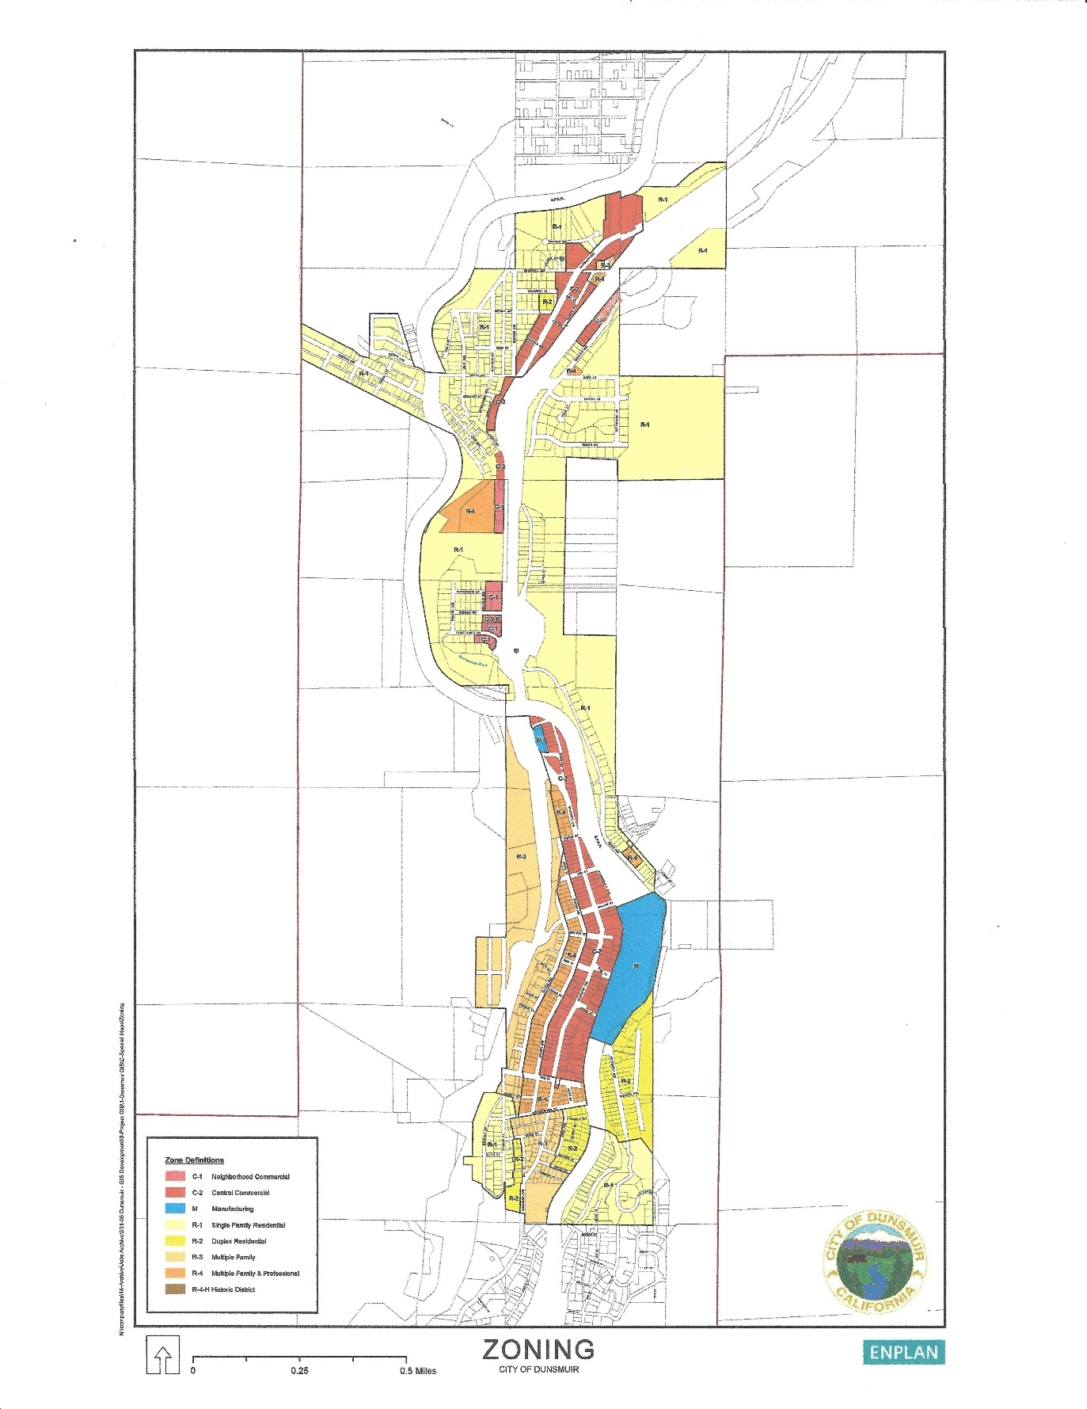

these situations roads are very narrow, steep and dead-end with only one way in and out. These roads also usually lack adequate turnarounds for fire vehicles. Many of these areas lack fire hydrants as well. Some of the problems mentioned above regarding development outside of City limits also apply to isolated areas within the City. Numerous streets on the west side of the City, especially near Interstate 5, are steep, narrow, lack adequate turnarounds and, in some instances, have heavy vegetation. These characteristics slow the response and effectiveness of fire fighters and could result in a fire quickly getting out of control.

While the airport property and lands north of the north Dunsmuir Avenue/1-5 Interchange have received little development pressure at present, this area of the City poses a challenge for timely response by fire equipment due to distance and grade. The airport is over three miles from the Fire Station and requires the equipment to climb over 900 vertical feet on Interstate 5 in that distance. It is anticipated that, as this area of north Dunsmuir develops, a satellite fire station would be needed.

Existing Conditions
The City Council has created a committee to study creation of an Emergency Plan. It plans to involve the entire community in workshops or meetings in order to include all stakeholders.
The City is currently awaiting acceptance of a grant application for FEMA funds to use for the creation of at Local Hazard Mitigation Plan. Once adopted, the City will re-adopt the Safety element in order to include the Hazard Mitigation Plan by reference.

A Community Wildfire Protection Plan was produced by Geo Elements, LLC and adopted by the City of Dunsmuir in May of 2016 after several months of research and collaboration. It is incorporated by reference into the Safety Element in its entirety, as originally created or as modified from time to time. The document can be obtained from the Dunsmuir City Website at https://static1.squarespace.com/static/54c9a764e4b0ee5502d31f04/t/5a559c430d92974f913bc5f3/1515560025354/Dunsmuir_CWPP_Signed-Final.pdf.
The Plan sites Dunsmuir in a Very High Fire Hazard Severity Zone (section 5.4) and includes maps of agency responsibility areas, fire history, vegetation, fuel treatment areas, and other information.

The City’s General Plan Land Use Map is a great reference for existing development within the City. It can be accessed at https://static1.squarespace.com/static/54c9a764e4b0ee5502d31f04/t/5611fee9e4b033aa912a496c/1444019945831/20151001120525.pdf

Chapter 6 of the plan addresses mitigation actions and long-term maintenance of fire hazard reduction projects, including community fire breaks and private road and public road clearance. (See Tables 11, 12 & 13). This Chapter also talks about Emergency Preparedness, and lists radio and television stations that can be contacted for information during an emergency.

It is a Goal to prepare a more specific Evacuation & Response Plan which may become art of the Emergency Plan referenced above. The assessment and projection of future emergency service needs will be part of the Hazard Mitigation Plan as will standards for emergency services training.
The following excerpt summarizes the Community Wildfire Prevention Plan (CWPP) plan:
The Community Wildfire Protection Plan developed for the City of Dunsmuir:
Was collaboratively developed. Interested parties, key stakeholders, local fire departments, and federal land management agencies managing land in the vicinity of Dunsmuir have been consulted. ✓ This plan identifies and prioritizes areas for hazardous fuel reduction treatments and recommends the types and methods of treatment that will protect the community of Dunsmuir. ✓ This plan recommends measures to reduce the ignitability of structures throughout the area addressed by the plan. The following entities mutually agree with the contents of this Community Wildfire Protection Plan:

From the INTRODUCTION:
This plan provides guidance for current and future community wildfire protection activities by homeowners, property-owners, business-owners, fire protection entities and other interested groups/parties in their collaborative efforts to reduce the critical wildfire threat. Wildfire protection implementation activities presented in the CWPP are subject to available funding, access to work on private lands, other City priorities, and environmental review under the California Environmental Quality Act (CEQA), National Environmental Policy Act (NEPA), or other potential permitting processes, as required; pending site specific land ownership/administration stipulations.

Local Agency
The Dunsmuir Fire Department provides fire and emergency first aid medical services to the City of Dunsmuir and the Dunsmuir Fire Protection District. It is also contracted to provide emergency medical services to the Castle Rock Fire Protection District. The Department consists of approximately 25 volunteers.
Founded in 1897 the Dunsmuir Volunteer Fire Company has a century of tradition, and history. Through the years agreements were made to protect the city, and outlying districts of the city. Today, the Dunsmuir – Castella Fire Department is a comprised of three different governmental entities; City of Dunsmuir, Dunsmuir Fire Protection District, and Castella Fire Protection District.
Dunsmuir - Castella Fire Department has a response area of over 30 square miles. Responders go as far North to Mott Road, on Interstate 5, and as far South as Slate Creek on Interstate 5. It operates apparatus out of four stations.

Dunsmuir, Station 1 (which includes the administrative offices of the Fire Chief, Battalion Chief, Fire Prevention Inspector, and Administrative Assistant.
Castella, Station 2
Isgrigg, Station 3
Crag View, Station 4
(See map on following page)

Cal Fire locations and State Responsibility Areas near Dunsmuir
As stated in the CWPP, (See section 2.2. Page 21) there are no state responsibility areas within the corporate limits of Dunsmuir.
The closest CAL Fire stations are located in Weed, and McCloud.

Federal Responsibility Areas near Dunsmuir.
As stated in the CWPP, (See section 2.2, Page 21) there are no federal responsibility areas within the corporate boundaries of Dunsmuir.
The nearest unit is the Shasta Trinity national Forest Fire and Aviation Ranger Station is located at 204 West Alma Street in Mount Shasta.
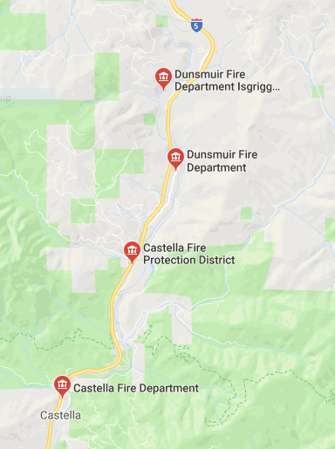Source: https://www.google.com/search?rlz=1C1JZAP_enUS774US775&q=fire+stations+in+siskiyou+county&npsic=0&rflfq=1&rlha=0&rllag=41581991,-122511545,19851&tbm=lcl&ved=2ahUKEwj5k_Hw7ujaAhUS3WMKHaJsASsQtgN6BAgAEDY&tbs=lrf:!3sIAE,lf:1,lf_ui:2&rldoc=1#rldoc=1&rlfi=hd:;si:;mv:!1m3!1d68810.839806171!2d-122.24666078141047!3d41.185695226516415!3m2!1i915!2i550!4f13.1
The Dunsmuir Fire & Rescue team maintains a current vehicle fleet which includes two Front Line Engines, two Reserve Engines, one Type 3 Engine, one Ladder Truck, one Type 3 Squad, one Breathing Support trailer, and three staff vehicles.
The current minimum staffing for the department is three personnel assigned to each engine. Typical engine staffing includes a captain, an engineer, and a firefighter.
As part of its service, Dunsmuir has an auto mutual aid agreement with the Mt. Shasta City Fire Department. As both cities have emergencies, both can count on departments to come and assist to ensure saving lives and property. Agencies are dispatched by the Yreka Interagency Communications Center located at the California Department of Forestry and Fire Protection Siskiyou Ranger Unit Headquarters in Yreka.
Contact Information
Emergencies: 911
Business: 530-235-2551
Address: 5915 Dunsmuir Avenue
Dunsmuir, California 96025
Recent Fire Event Data
Since the last update of the Safety Element, there has been one wild fire event in the city limits:
- Wild fire known as the Bradley Fire accidentally set by transients.
- There have been wildfires in the larger region including Siskiyou County, Shasta County and other neighboring counties in California and Oregon. For more information about historical Wildfires in the area, please refer to the Community Wildfire Prevention Plan (CWPP) 3.2 Fire History, Figure 3 Fire History Map and Table 2 Historical Large Wildfires.

Potential Impacts of Climate Change on Wild Fire

To prepare for this section, the City of Dunsmuir utilized the state’s CalAdapt website and performed exercises which revealed potential impacts, explained below. Please refer to the exhibits in the Appendix for images in support of the following text. For more information please visit http://cal-adapt.org/.
- Longer dryer summers could lengthen and intensify wildland fire seasons.
- Wetter winters could cause more vegetation growth, and fuel for wild fires
- Dryer winters could weaken root systems for trees, creating hazards for home owners and powerlines, and impacting roadway travel.

GOAL 5.4: - A community protected from the hazards of wild fire.

Objective 5.4: Areas within and adjacent to Dunsmuir are identified as wildfire hazard areas and are subject to potentially devastating fires. It is the City's objective to reduce both the likelihood of wildfires and the impact of fires on the community should they occur.

Policy 5.4.A: The City shall support programs to prevent and prepare for wildfires, including and will consider fire-related hazards in review of all project proposals.

Implementation Measures:
5.4.A.1: The City shall adopt and enforce the standards of the "Fire Safe Regulations" outlined in Title 14 of the California Code of Regulations for all new development within the City, including clearance around structures, minimum roadway widths and peak load water supply requirements. Standards to consider include
- Requiring a Fire Plan for all new development to include:
- Removal of vegetation
- Providing adequate access, including emergency vehicle access and evacuation, to all new parcels and, where feasible, to existing parcels.
- Adequacy of Fire Flow
- Minimum standards for evacuation of residential areas throughout the city.

5.4.A.2: The City shall incorporate by reference into this document, the Dunsmuir Community Wildfire Protection Plan (May 2016, and as updated from time to time) and follow it’s recommendations regarding preventative maintenance projects and development standards. Any future subdivision of land shall look to the document for guidance on land use issues.

5.4.A.3: Where practical, emergency access to dwellings that are isolated due to steep, narrow dead-end roads should be improved. New development on vacant lots in such areas should be limited to 1 per 10 acres until basic safety standards have been satisfied. Refer to the Zoning Map and General Plan Land Use map for identifying those area. The City shall include a map identifying such areas in its Hazard Mitigation Plan, together with improvement plans to mitigate each situation and outreach strategies for at-risk populations.

5.4.A.4: The City should limit creation of additional residential development by adopting a resolution or ordinance to ban approval of development proposals that do not provide adequate water storage and capacity for fire protection, including:
- Water supply and fire flow
- Maintenance and long-term integrity of water supplies
- Evacuation and emergency vehicular access
- Fuel modification and defensible space
- Visible home and street addressing and signage
- Creation and maintenance of Fire breaks where warranted

5.4.A.5: Through the development review process, adequate roads shall be required to be constructed and/or improved for emergency vehicle access, particularly in very high wildland fire hazard areas. Emergency vehicle access shall be developed and maintained via the administration of City-adopted access requirements contained within the Dunsmuir Municipal Code subdivision and zoning ordinances, City-adopted road standards and City-adopted current California Fire Codes.

5.4.A.6: Future development should be designed to take maximum advantage of known fire prevention measures, orientation and building techniques, and which meet building and fire safe standards contained within current California Building and Fire Codes regarding development within very high wildland fire hazard zones. Remodel of existing buildings to current standards should be supported whenever possible.

5.4.A.7: The City shall encourage Siskiyou County to enforce standards conforming to the fire safety standards established by the state Board of Forestry for state responsibility areas within the Dunsmuir secondary and tertiary planning areas, including:
- Road standards for fire equipment access.
- Common road standards for the City’s sphere of influence and the City of Dunsmuir.
- Standards for signs identifying streets, roads and buildings, including standards for address identification
- Minimum private water supply reserves for emergency fire use
- Fuel breaks and greenbelts
- Land use policies and safety standards that consider the recurrent nature of wildland fires
- Design standards establishing minimum road widths and clearances around structures
- Emergency preparedness protocol and procedures
- Maximum length of cul-de-sac roadways

5.4.A.8: The City should coordinate with any nearby local Irrigation Districts and Community Services Districts or other agencies that control groundwater and surface water flows to assure the adequacy of fire flow and peak load water supplies in accordance with City-adopted and current California Fire Codes.

5.4.A.9: The City shall promote fire prevention by continuing to require brush removal and vegetation clearance in accordance with the SRA Fire Safe Regulations and City adopted Fire Hazard Reduction around Buildings and Structure Regulations, the Siskiyou County Local Hazard Mitigation Plan and the Dunsmuir Community Wildfire Protection Plan. Further, the City shall continue to promote the activities and fire prevention programs of the Dunsmuir Fire Safe Council, and to create a plan for continual maintenance of all fuel breaks and as stated in the CWPP ( See sections 6.3.1 on page 50 and 8.2 on page 67 of that document.).

5.4.A.10: City will support, to the extent possible the efforts of the Dunsmuir Ridge and Siskiyou County Fire Safe Councils in their education and fuel reduction work within the City of Dunsmuir by requiring home owners to reduced wildland fuels and through community fuel reduction, including lineal fuel breaks within and adjacent to the City, and defensible space around homes through hazard abatement at the parcel level.

5.4.A.11: The city shall search for grant funds to allow existing homeowners and business owners to modify their buildings to conform to current fire safety codes, including boxed eaves, roofing, sprinklers, and more.

Policy 5.4.B: Steps should be taken to provide a fire station with basic equipment at or near the airport to serve both the airport and this most-northern area of the City. The airport is potentially volatile due to potential storage of aircraft fuels, and is also a vital safe zone for local emergency aircraft.

Implementation Measures:
5.4.B.1: The City shall improve Access to said station as part of development.
5.4.B.2: The City shall improve water storage capacity at this location at the time of development.
5.4.B.3: The City shall acquire additional engines and response equipment, including equipment necessary for aircraft related incidents, at the time of development.

Policy 5.4.C: The City shall continue to take appropriate measures to support a well­ trained, equipped and staffed volunteer fire department.

Implementation measures:
5.4.C.1: The City shall budget annually for wild fire training for fire protection personnel. Said training shall meet or exceed state and national standards.

Policy 5.4.D: Reduce risk of wild fires

Implementation measures:
5.4.D.1: Provide means for local landowners to maintain fuel modification zones adjacent to their structures.
5.4.D.2: Obtain additional resources for water whenever feasible.
5.4.D.3: Strengthen existing agreements and relationships with other fire agencies by arranging for cross training of City fire fighters with Cal Fire methods.
5.4.D.4: Implement Plans to protect integrity of water infrastructure.
5.4.D.5: Plan to implement and maintain all fuel clearance and modification along public and private roads.
5.4.D.6: Implement and Maintain all fuel breaks identified in the CWPP and maintain them per Section 6.3, pages 50-53.

5.5 URBAN FIRE
Existing Setting
The City of Dunsmuir is composed of an older downtown core with historic buildings, many of which abut each other at common lot lines. Some of the buildings lie vacant from time to time or are filled with merchandise or material but without daily supervision. In some cases, updates to improvements have not been made to meet current code requirements. This is often due to slow transfer of buildings from owner to owner or no new uses permitted that would trigger inspections.

Outside the downtown core, the general housing stock and commercial structures are also aged and may not contain up to date code requirements. Lot sizes throughout most of Dunsmuir are small. Coupled with the tight steep terrain, this urban setting is ripe for rapid spreading of structure fires to neighboring structures and to adjacent wildlands.

See Section 5.4 above for a detailed accounting of the current status of the Fire District serving Dunsmuir.

Urban Fire Event Data
Since the last update of the Safety Element, there have been several structure fire events:

2010- 4109 Oak Street 07/17/2010 Residential Structure Fire
2011- 5928 Butterfly Ave 11/08/2011 Residential Structure Fire
2012- 5950 Dunsmuir Ave 10/31/2012 Commercial Structure Fire
5327 Dunsmuir Ave 11/01/2012 Residential Structure Fire
2013- No structure fires reported
2014- 5501 Shasta Ave 06/10/2014 Residential Structure Fire
6022 &amp; 6026 Butterfly Ave Structure Fire 08/22/2014
5906 Shasta Ave Residential Structure Fire 08/29/2014
2015- 4400 Vista Drive Residential Structure Fire 07/05/2015
2016- 5956 Castle Ave Residential Structure Fire 04/18/2016
5922 Shasta Ave Residential Structure Fire 04/11/2016
4124 Vernie Street Residential Structure Fire 05/09/2016
5731 Dunsmuir Ave Commercial Structure Fire 07/11/2016
2017- 4737 Dunsmuir Ave Commercial Structure Fire 09/06/2016
2018- 6000 Dunsmuir Ave Commercial Structure Fire 04/27/2018
4833 Siskiyou Ave Residential Structure Fire 05/05/2018
4425 Hart Ave Residential Structure Fire 06/17/2018
4427 Dunsmuir Ave Residential Structure Fire 12/22/2018
(*data provided by Dunsmuir Fire Dept. 3/10/19)

Potential Impacts of Climate Change on Urban Fires

To prepare for this section, the City of Dunsmuir utilized the state’s CalAdapt website and performed exercises which revealed potential impacts, explained below. Please refer to the exhibits in the Appendix for images in support of the following text. For more information please visit http://cal-adapt.org/.

  - Longer dryer summers could lower well water levels for homes dependent on well water for fire protection.
  - Wetter winters could cause more vegetation growth, and fuel between homes
  - Dryer winters could weaken root systems for trees, creating hazards for home owners and powerlines, and impacting roadway travel.

GOAL 5.5: - A community protected from the hazards of urban fires.

Objective 5.5.1: It is understood that Wild fires can turn into Urban fires and Urban fires and turn into wild fires. Due to the topography and configuration of the Dunsmuir community it is vital to be vigilant on both fronts. Techniques, however, may vary. It is the City's objective to reduce both the likelihood of urban fires and the impact of fires on the community should they occur.

Policy 5.5.A: The City shall endeavor to maintain an overall fire insurance (ISO) rating of three or better.

Implementation Measures:

5.5.A.1: New fire stations(s) shall be located as necessary so that all areas within City limits are within a five-minute emergency response time for 90% of all emergency incidents.

5.5.A.2: Zoning restrictions shall be maintained in order to understand the hazards of particular zones.

5.5.A.3: Business plans shall be required of all businesses in order to log known sources of flammables and other hazardous materials at each business.

5.5.A.4: As necessary, establish law enforcement and fire protection impact fees for new land use development sufficient to assure that established levels of protection are maintained.

5.5.A.5: Fire personnel shall be trained in accordance with state and national fire protection standards.

5.5.A.6: The City shall annually budget for urban fire training for its fire district staff.

Policy 5.5.B: The City shall maintain adoption of a current California Fire Code amended to reflect the unique needs of Dunsmuir, and require compliance with its provisions.

Implementation Measures:

5.5.B.1: Establish and maintain standards for adequate fire flows for new land use development and expansion of existing development in accordance with the requirements of City-adopted current California Fire codes.

5.5.B.2: Periodically review existing standards for roadway widths, emergency access and road and structural identification and amend as necessary and continue the City of Dunsmuir Public Works Department-implemented annual roadside vegetation management program in a manner that is consistent with the Cal Fire Siskiyou Unit Fire Plan and the Siskiyou County Community Wildfire Protection Plan.

5.5.B.3: Strive to reduce fire hazards and seek removal of obstructions to adequate fire and emergency services access routes through enforcement of the City’s Public Nuisance Abatement Ordinance, including elimination of conditions which would materially hamper or interfere with the prevention or suppression of fire or the obstruction of other public safety or emergency services upon real properties within the City.

Policy 5.5.C: Reduce risk of urban fires

Implementation measures:

5.5.C.1: Explore options to provide means for local landowners to maintain fuel modification zones adjacent to their structures, including but not limited to:
  - Use of volunteers, like high school students
  - Availability of green waste storage or chipping
  - Code enforcement
  - Prioritizing Risks
5.5.C.2: Obtain additional resources for water whenever feasible.
5.5.C.3: Strengthen existing agreements and relationships with other fire agencies by arranging for cross training of City fire fighters with those of adjacent communities.

Potential Impacts of Climate Change on Urban Fires
A major factor causing extended fire attacks are drought conditions that dry out the large and medium fuels which create hotter and longer burning fires.

Policy 5.5.D: Require weed abatement and fuel modification and maintenance on all residential and commercial properties.

Implementation Measure:
5.5.D.1: Review existing ordinance for weed abatement and fuel modification requirements. Analyze them for adequacy and improve where necessary.

5.6. FLOODING
Existing Setting
The Sacramento River and its local tributaries are subject to flooding caused by unusually heavy rains, snowmelt or both. Flooding at varying levels of intensity occurs frequently, and occasionally presents a significant hazard to life, property and infrastructure. The "Big Flood" of 1974 floated houses down the river. The flood of January 1997 also caused major property and infrastructure damage.

The Federal Emergency Management Agency (FEMA) has developed a Flood Insurance Rate Map for Dunsmuir to identify flood prone areas. Flood hazard areas affecting Dunsmuir are indicated in Figure 5-4 at the end of this element. Zone A as identified on the map represents the area of greatest flood hazard as might be expected to occur once every 100 years (or a 1 percent chance in any given year). Zone B is an area expected to have lesser impacts due to the shallower flood depth anticipated. Within these areas properties are required to carry flood insurance. The rates for insurance are dependent on the floodwater depth on the affected parcel. New construction is required to meet the City's Flood Protection ordinance. Typically, placement of the ground-level floor is required to be at least one foot above the 100-year flood level. The key areas subject to flooding located in the A Zone are:

Gill Avenue | Approximately 6 lots
Cave Avenue | Approximately 22 lots
Butterfly Avenue | Approximately 39 lots
Scherrer Avenue | Approximately 12 lots
Gillis Street | Approximately 3 lots

Additionally, a large area north of Grover Street to a point approximately 200 plus feet north of Oak Street is subject to shallow flooding from Alder Creek. Continued implementation of the Flood Ordinance will protect new construction from serious flooding and will help correct the current flood hazard over a long period of time as remodeling activities in the area bring additional structures into compliance with the Ordinance as a means to reduce flood impact and insurance rates.

Climate Change Impacts on Flooding
To prepare for this section, the City of Dunsmuir utilized the state’s CalAdapt website and performed exercises which revealed potential impacts, explained below. Please refer to the exhibits in the Appendix for images in support of the following text. For more information please visit http://cal-adapt.org/.

- Increased severity of storm events could create more frequent flooding events
- Increased flooding events could hamper evacuation efforts in the event of other emergencies.

GOAL 5.6: - A city that has minimized, to the maximum extent feasible, potential impacts to structures as a result of flooding.

Objective 5.6: Flooding occurs on a fairly regular basis on the Sacramento River and local tributary streams. It is the City's objective to ensure that all development in flood prone areas is done in a manner that minimizes the potential for damage as a result of flooding.

Policy 5.6.A: Development within identified floodplains shall be controlled to reduce potential damage from floods.

Implementation Measures:

5.6.A.1: When relevant, the City shall deny proposed development that would have unacceptable exposure to flood hazards. It should not be permitted if identified or potential flooding and drainage impacts cannot be overcome by sound engineering practices

5.6.A.2: The City will continue to apply the City's Floodplain Management Ordinance to development of properties within the FEMA identified flood plain.

5.6.A.3: The City will encourage residents within the floodplain to take all practical steps to flood-proof their dwellings, including the use of low interest loans and grants if such are available for this purpose.

5.6.A.4: The City should assure that increased runoff resulting from additional coverage of surface area on developing properties does not adversely affect surrounding properties, roads or stream courses.

5.6.A.5: All new development should comply with the procedures and regulations of the Master Storm Drain Study and Facilities Plan.

Policy 5.6.B: Transportation systems shall be improved to the extent possible to ensure safe evacuation routes.

Implementation Measures:
5.6.B.1: Rebuild bridge across Sacramento River between Sacramento Avenue and South First Street.

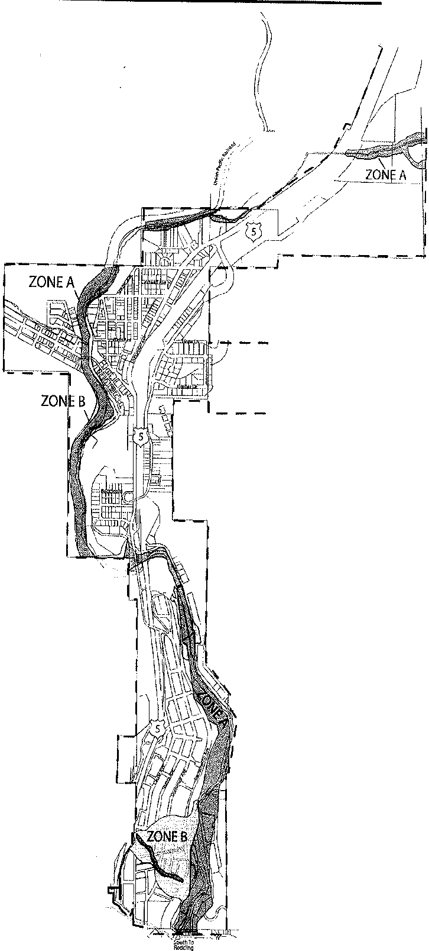
I MN!oSnhh•T1o•
t
I \ :
I
J
•
ZONE A
Areas of 100-year food; base flood elevations and flood hazard factors not determined.
ZONE B
Areas between limits of the 100-year flood and 500-year flood; or certain areas subject to
10-year flooding with average depths less than one foot; or where the contributing drainage area is less than one square mile; or areas protected by levees from the base flood.

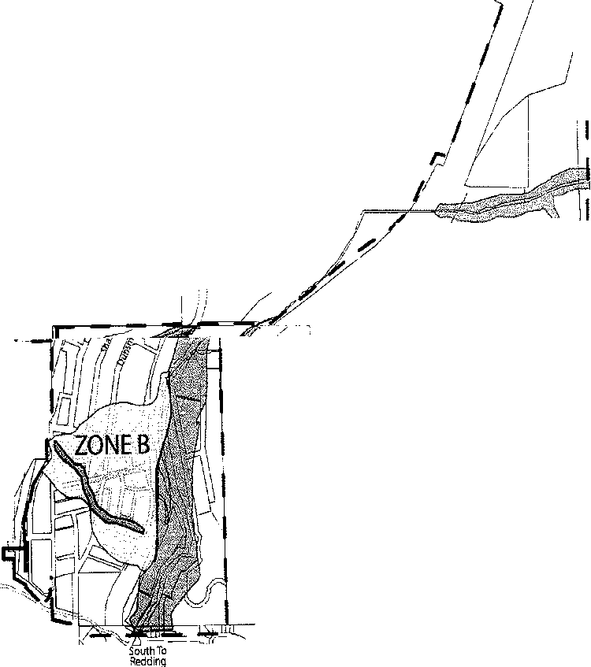
+
')·
. I
I
[,
North To I
Mt5hasta
I
\\ I
, I
i I
·.
·
,lo/
'r,o /
,,:
I
t
.
\ I
//
· //
\\,,,r
ZONE A
11
Source: FEMA FIRM Panel # 060363 0001 B
FIGURE 5·4

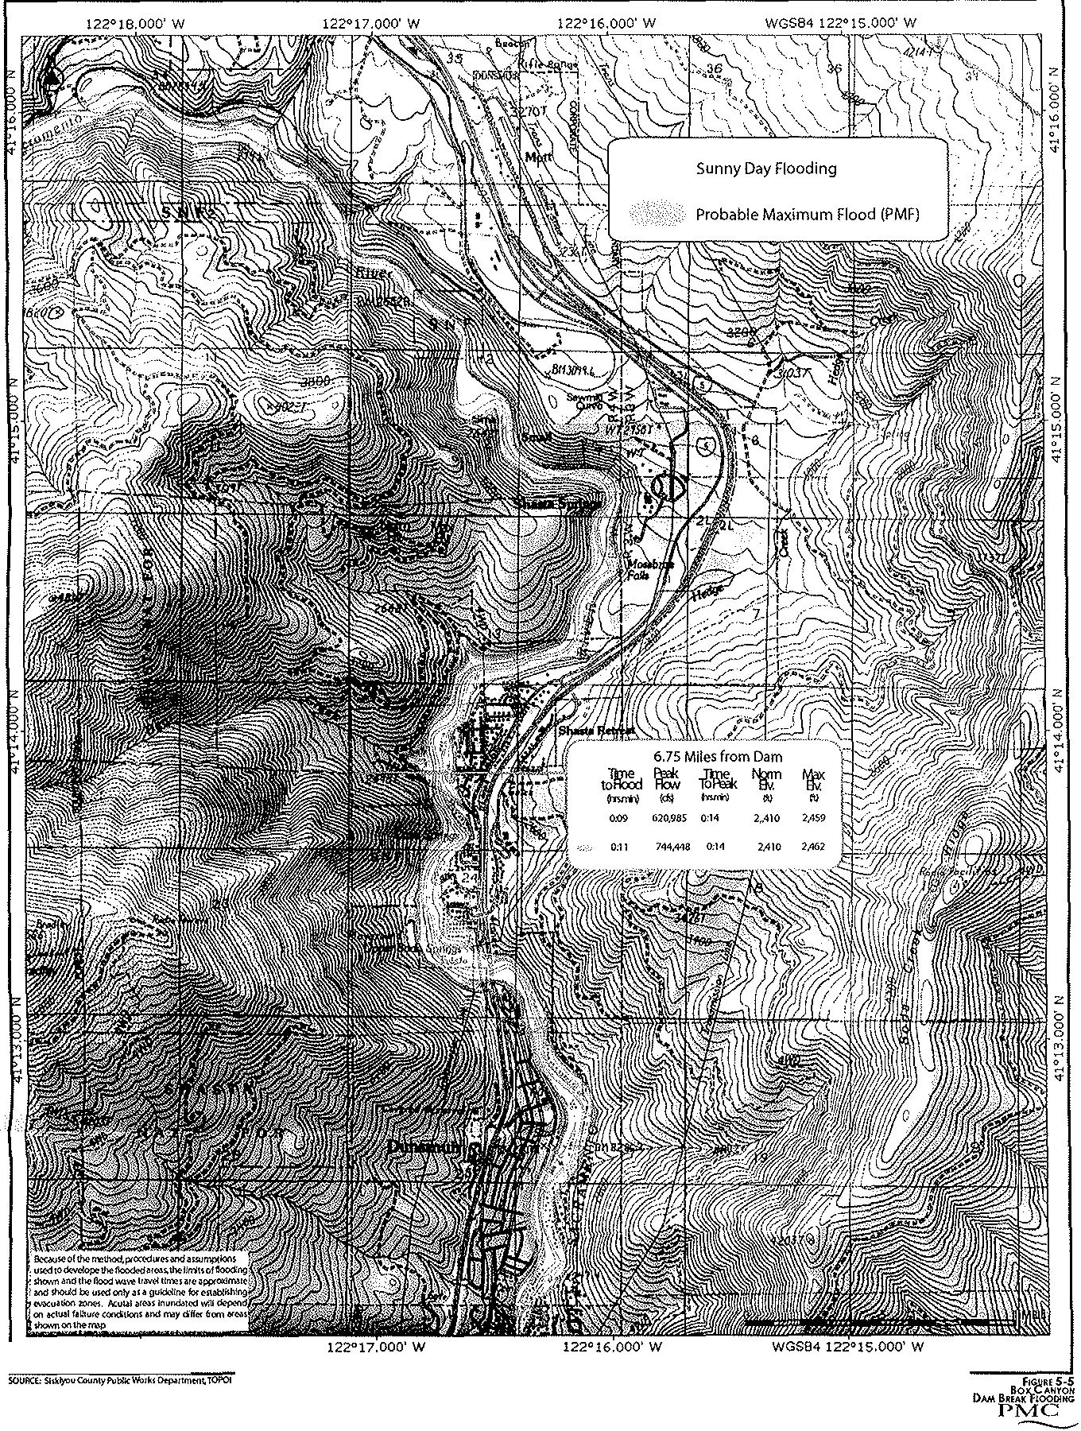

5.7 DAM FAILURE INUNDATION
Existing Conditions
Box Canyon Dam, which impounds Lake Siskiyou, is located approximately eight miles north and upstream of Dunsmuir on the Sacramento River. The Box Canyon Dam lies in the path of potential mudflows from Mount Shasta, should there be that type of volcanic activity, and near an unnamed fault running southwest­ northeast from Cedar Lake to a point near the Darn. Significant events in either one of these areas could result in water breaching the darn or actual darn failure. Aging or other geologic effects could also affect the stability of the structure.
While it is certainly not expected to occur, dams can and do occasionally fail. When they do occur, failures have resulted in significant damage and some deaths since they can fail unexpectedly with little or no warning. A study prepared in 1983 by the Siskiyou County Public Works Department (Emergency Action Plan- Box Canyon Dam), identified areas subject to flooding and the approximate time floodwater would reach Dunsmuir (see Figure 5-5. North Dunsmuir would, of course, be hit first after about eight minutes of failure. Central Dunsmuir would be hit in about 13 minutes and the southerly City limits in about 16 minutes. The water depth would be significant, approaching Dunsmuir Avenue as it passes near the downtown area. Actual depth of the water would depend on the magnitude of the failure and the size and location of temporary debris darns that occur as the flood clears the river canyon of nearly everything in its path. With early warning, residents within the flood area may have time to reach higher ground. Significant damage would occur, wiping out bridges, power and other infrastructure. Residents could be stranded across the river without a means to cross and emergency services would be severely hampered.
The Siskiyou Power Authority has control over Box Canyon Dam and implementation of its emergency plan. There are 4 categories of emergency stats related to dam failure, “A” being the most crucial, and follows:
The emergency is classified as either:
a. Condition A (failure is imminent or has occurred) or
b. Condition B (potentially hazardous situation is developing)
c. Condition C (Non-Failure Emergency / Possible Hazardous Situation Developing)
d. Condition D (High Flow Event)
The City of Dunsmuir is on the phone tree for automatic notification. Calls would be made by the Siskiyou County Flood Control District to the City (Fire Department, City Manager, Public Works Department, or Water Department), and also to Union Pacific.
Background – Taken from the October 2017 plan.
FERC Project No. 2796-CA consists of Box Canyon Dam and its reservoir, Lake Siskiyou, located on the headwaters of the Sacramento River in Siskiyou County, California (See Figure 1).
The dam is owned and operated by the Siskiyou County Flood Control and Water Conservation District.
The dam is located about 60 miles north of Redding and two miles southwest of the town of Mt. Shasta.
The dam is owned by Siskiyou County. The Siskiyou Power Authority manages the operation of the hydroelectric facilities, supported by contract personnel.
A large concessionaire operates a major recreation area around Lake Siskiyou that includes a campground and a golf course above the dam. Concessionaires provide opportunities for boating and fishing on the lake during the day.
The drainage area above Box Canyon Dam is about 126 square miles. The inflow to the lake ranges from a maximum of about 12,200 cfs, to a minimum of 37 cfs, with an average of about 250 cfs (181,000 acre-feet per year).
The elevation in the project area ranges from about 3,000-3,500 feet (USGS Datum). The landscape is composed of recent volcanic deposits covered with pine-fir forest. Below the dam the Sacramento River flows through a stretch of sheer cliff walls approximately 150 feet high.
According to the report prepared by the California Department of Water Resources (1979) for the U.S. Army Corps of Engineers, National Dam Inspection Program, Box Canyon Dam is located within Zone 3 (Major Seismic Probability) on the Seismic Zone Map of California, Nevada, and Arizona extracted from the Corps of Engineers Recommended Guidelines.
The nearest known faults to the Box Canyon area are the Likely Fault, some 75 miles to the east, and the San Andreas Fault, about 130 miles southwest. Due to their distance from the dam, neither of these is capable of producing significant ground shaking or damage to Box Canyon structures. Despite this fact, the design of the existing project conservatively incorporated pseudo static horizontal seismic forces of 0.10g. This is roughly equivalent to a dynamic force of 0.10g to 0.25g, depending upon other characteristics of the particular earthquake involved. (Box Canyon Hydro Project Emergency Action Plan /FERC No. 2796-CA Revised and Reprinted, October 2016/Siskiyou Power Authority Page I-7)

Projected flood inundation in Dunsmuir from dam failure is shown in the following exhibit.
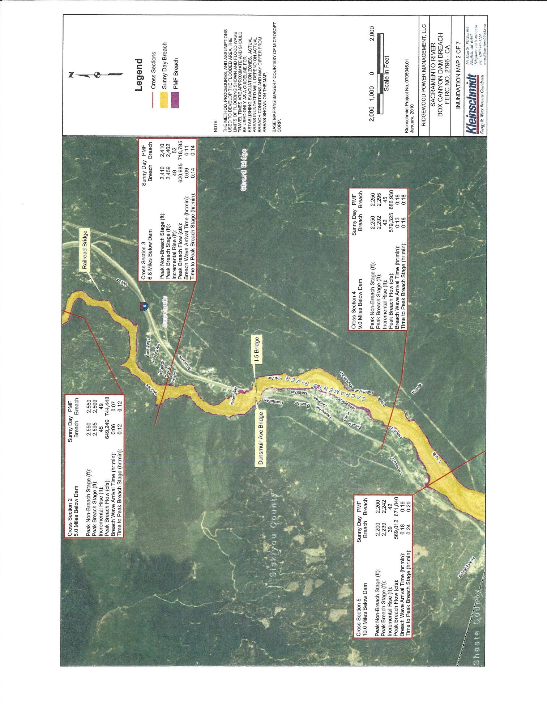

Climate Change Impacts on Dam Failure
- No impacts on the potential for dam failure are anticipated due to climate change

Goal 5.7 Prevent or mitigate to the extent possible any impacts resulting from a failure at Box Canyon Dam.

Policy 5.7.A: Include in our Hazard Mitigation Plan, the protocol of the Siskiyou Power Authority’s “Emergency Action Plan” for the Box Canyon Hydroelectric Project”.

Implementation Measures:
5.7.A.1: Study and assist in annual updates to the Plan.
5.7.A.2: Prepare for implementation of the Plan.
5.7.A.3: Include a link to the most current Plan on the City Website.

Policy 5.7.B: As much as possible, control the height, speed and amount of water reaching Dunsmuir should the Dam fail.

Implementation Measures:
5.7.B.1: The City Shall maintain a working relationship with the Siskiyou County agency responsible for maintaining Box Canyon Dam in order to communicate on a regular basis and to make and receive calls when critical conditions are present.
5.7.B.2: The City shall prepare a plan and ready it for implementation should the dam fail. The plan shall include, at a minimum, consideration of strategies to divert the water away from housing and roadways, to slow the arrival of water.
5.7.B.3: The City shall create an early warning system or alert that can be triggered when necessary, referring specifically to flood upstream conditions and imminent danger due to dam failure.

5.8 LANDSLIDES and EARTH MOVEMENT
Existing Setting
The 1985 General Plan identified eleven sites where landslide activity has either occurred or is believed to have the potential to occur. The source for this information has not been identified, nor has a recent survey of landslide prone areas in and around Dunsmuir been conducted. The 1985 General Plan did, however, identify each of these sites on a rough map. These areas have not been identified in this document due to the uncertainty of the past data and the lack of more current studies. Caution must be taken whenever new construction is proposed on steep slopes in order to ensure the safety of future occupants.

Climate Change Impacts on Landslides
To prepare for this section, the City of Dunsmuir utilized the state’s CalAdapt website and performed exercises which revealed potential impacts, explained below. Please refer to the exhibits in Appendix for images in support of the following text. For more information please visit http://cal-adapt.org/.

- Reduced rainfall could impact the ability of native plant life to hold slopes in place.
- Increased flooding events could increase erosion of bare hillsides, especially after fire events

GOAL 5.8: - A community protected from landslides.

Objective 5.8: Due to steep hillsides and soil types in the Dunsmuir area, the potential for landslides exists. It is the City's objective to protect its citizens from the potential impacts of landslides.

Policy 5.8.A.
The City should review landslide prone areas in and around the City in order to update the landslide information that was referenced in the 1985 General Plan.
Implementation Measures
5.8.A1: Monitor Bradley fire area for the need for vegetation modification or other slope stabilization techniques.

Policy 5.8.B: Develop and enforce a rigorous set of development standards designed to minimize slope instability.

Implementation Measures:
5.8.B.1: The City should review the sites referenced in the 1985 General Plan, as well as any recently noted landslide-prone areas, and determine if these areas should and can be stabilized through plantings, walls or other soil stabilization techniques.

5.8.B.2: Development projects should be designed to minimize soil erosion, and shall be required to comply with all City of Dunsmuir-adopted soil erosion standards.

5.8.B.3: The City should require all development proposals on sites which contain slopes exceeding twenty percent, and/or which border or include significant and sensitive stream courses or natural drainageways, to include programs for replanting and slope stabilization, erosion control plans, and to incorporate designs which minimize grading and cut-and-fill.

5.8.B.4: Building on slopes more than thirty percent should not be permitted.

5.8.B.5: Amend the City ordinances as necessary to require erosion control plans, site design which minimizes grading and cut-and-fill, and programs for replanting and slope stabilization.

5.8.B.6: Constantly re-evaluate and continue to implement the all City Master Plans, including storm drain, sewer, water and roadway.

Policy 5.8.C: Areas known to hove slopes or soils that are prone to sliding should only be developed when all necessary steps are taken to protect life and property.

Implementation Measure
5.8.C.1: Large hillside areas known to have soils prone to sliding should be protected with an open space or resource zone or district having a development density of not greater than one dwelling unit per 20 acres.

5.8.C.2: Assure that logging is performed safely and will not have a detrimental effect on the quality of life in Dunsmuir.

5.8.C.3: The City shall develop and maintain a working relationship with the various logging companies working on hillsides above Dunsmuir. This relationship shall include regular communications and review of all logging plans filed with the State.

5.9 VOLCANC ACTIVITY
Existing Setting
Mount Shasta, located twelve miles northeast of Dunsmuir, is a large and imposing volcano. It is believed to have erupted approximately ten or eleven times during the last 3,400 years, and at least three times in the last 750 years. While it has not erupted at regular intervals, its history suggests that it erupts at an average rate of roughly once every 250 to 300 years. The last eruption is believed to have occurred in 1786. Even though the volcano has not been active for two centuries, Mount Shasta, like Mount St. Helens before 1980, is only dormant and almost certainly will erupt again. (Volcanic Hazards al Mount Shasta, California, by Dwight R. Crandell and Donald R. Nichols. U.S. Geological Survey, pamphlet, 1 987.) In fact, a recent study by the United States Geological Survey (USGS) places Mt. Shasta at a 16% probability of eruption within the next 30 years. See the report at https://pubs.usgs.gov/sir/2018/5159/sir20185159.pdf . The 1987 USGS pamphlet, "Volcanic Hazard s at Mount Shasta" describes the characteristics of volcanic activity which would most likely affect the area near the mountain. Each of these characteristics are discussed below along with the possible effect upon the City of Dunsmuir. For a visual representation of potential impacts, please refer to Figure 5-1 through 5-3.

Pyroclastic Flows: Pyroclastic flows are streams of hot ash and rock fragments, mixed with hot air and other gases, that move rapidly along the ground surface during an eruption. These flows are especially dangerous due to their high temperatures and their high speeds which may be more than l00 miles per hour. Due to the speed of pyroclastic flows, escape is nearly impossible. They are best avoided by evacuation of threatened areas before an eruption.

Lateral Blasts: This type of blast is a sideways-directed volcanic explosion that carries large pieces of rock and ash at a very high speed along and above the ground surface. The rock debris carried by the lateral blast of Mount St. Helens in 1980 had an initial speed of more than 250 miles per hour, and it was still moving about 60 miles per hour near its outer limit about 15 miles from the volcano. Lateral blasts may cause fatalities as the result of impact, burial or heat.

Dunsmuir is located in Zone 3 for pyroclastic flows and lateral blasts. This is the outer limit of the area potentially affected by these activities, so the likelihood of the threat is limited.

Lava Flows: Lava flows are rarely life-threatening because they move slowly enough for people to get out of their way and seldom occur at the outset of an eruption. Dunsmuir's distance from the volcano is sufficient that such flows are not particularly life threatening. However, lava flows can destroy property and ignite wildfires.

Mudflows: A mudflow is a mass of water-saturated rock debris that moves downslope generally as a fluid. Mudflows can form when lava flows, pyroclastic flows or hot lateral blast melt snow on the side of a volcano. Mudflows tend to follow stream valleys and can travel long distances generally at a rate of 10 to 20 miles per hour, but faster on steep slopes. Due to their slower speed and distance from Dunsmuir, should a mudflow occur, there should be adequate time in Dunsmuir to evacuate to higher ground. However, before a mudflow would reach Dunsmuir, it would pass Lake Siskiyou. A heavy flow into the reservoir could cause the lake to breach the dam, or could weaken the dam itself causing a structural failure and flood that would reach Dunsmuir in 15 minutes or less.

Landslides: A volcanic explosion, severe earthquake or heavy rains could start landslides of rock debris from the side of the volcano. A landslide triggered by an earthquake at Mount St. Helens on May 18, 1 980, traveled about 14 miles beyond the volcano. Mount Shasta has also been subject to mudflows that have been triggered by heavy rains on top of snow, although this type of mudflow is not considered to be a threat to Dunsmuir.

Volcanic Ash: Ash resulting from an eruption could cover a large area and could reach a depth of two inches or greater, depending on the amount of ash released into the atmosphere and the direction of wind at the time. Given that the prevailing winds generally blow in an area between the northeast and southeast, the probability is high that most ash would fall east of the volcano and away from Dunsmuir. However, the area does experience periodic winds from the north.

Seismic Hazards
There are numerous faults near the City that present potential dangers in the form of ground shaking, landslides and subsidence, and possible collapse of the Box Canyon Dam eight miles north of Dunsmuir on the Sacramento River. An unnamed fault runs southwest from Cedar Lake and ends near the Box Canyon Dam. Another north-south fault runs beneath Mount Shasta. Other faults run north­ south on Soda Creek Ridge to the east of Dunsmuir. While none of these faults are known to be active, an earthquake with a 3.1 local magnitude occurred 3 miles southeast of Dunsmuir on November 29, 2005. Earthquake activity in Siskiyou County, as reported by the Siskiyou County General Plan Seismic Element, has been very limited. There has been limited structural damage in the past and there have been no known deaths.

Experience with Cascade Range volcanoes including Mount St. Helens (1980 to present) and Mt. Lassen (1 91 1-1920), demonstrates that eruptive episodes can and do occur in present time involving volcanoes that are generally considered inactive.
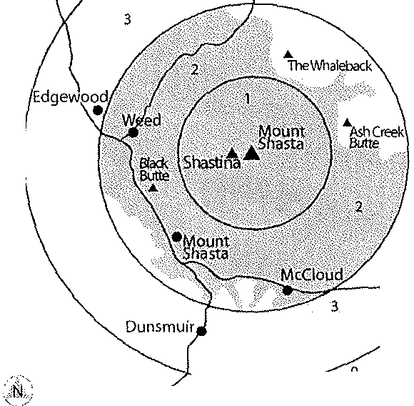
Figure 5-1: Map of hazard zones for pyroclastic flows and surges from future eruptions at or near the summit of Mount Shasta.

;;......,..,...,...,101.0MffiRS
0 SMILES
Crandell ond Nichols, 1987.

Sites in zone 1 are most likely to be overrun by future flows, whereas those in zone 3 are only likely to be affected by pyroclastic flows longer than any that have occurred during the past 1 0,000 years. Sites in zone 3 may, however, be affected by pyroclastic surges sweeping out ahead of pyroclastic flows from the inner zones.

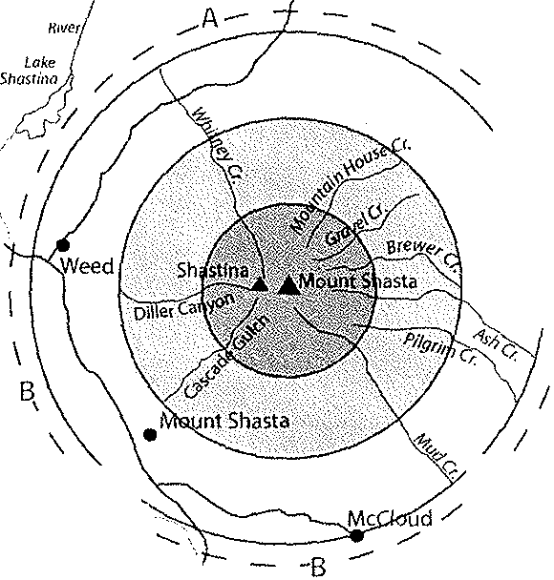
Figure 5-2: Map of hazard zones for lava flows from future eruptions at or near the summit of Mount Shasta.
Sh05ta
"\
\
Ji.
I
',.;..
[Okl'\ r·\
Siskiyou "'-... ·-
/
SacramPnto/
River Dunsmuir
0I ,,, ,, I ,, . ' . '10IKILOMETERS

Concentric zones show possible hazard from lava flows with respect to distance from the top of the volcano. The recent history of Mount Shasta suggests that most future lava flows will originate at the summit or on the northeastern flank of the volcano in sector A. Sector B is less likely to receive lava flows.

Zone 1: areas likely to be affected most frequently. Most future flows from summit eruptions probably would stay within this zone.

Zone 2: areas likely to be affected by lava flows erupted from vents on the flank of the volcano or that move into zone 2 from zone 1.

Zone 3: areas likely to be affected infrequently and then only by long lava flows that originate at vents in zones 1 and 2.

In the following Exhibit, Zones designated by letters A-C show relative likelihood of being affected by future mudflows. Zone A is most likely and Zone C is least likely to be affected. No mudflow hazard exists on high areas within or beyond the zones. Hazard decreases within the zones with greater height above stream channels and greater distance from Mount Shasta.

Effects of climate change on Volcanic Activity
- There are no impacts to volcanic activity anticipated due to climate change.

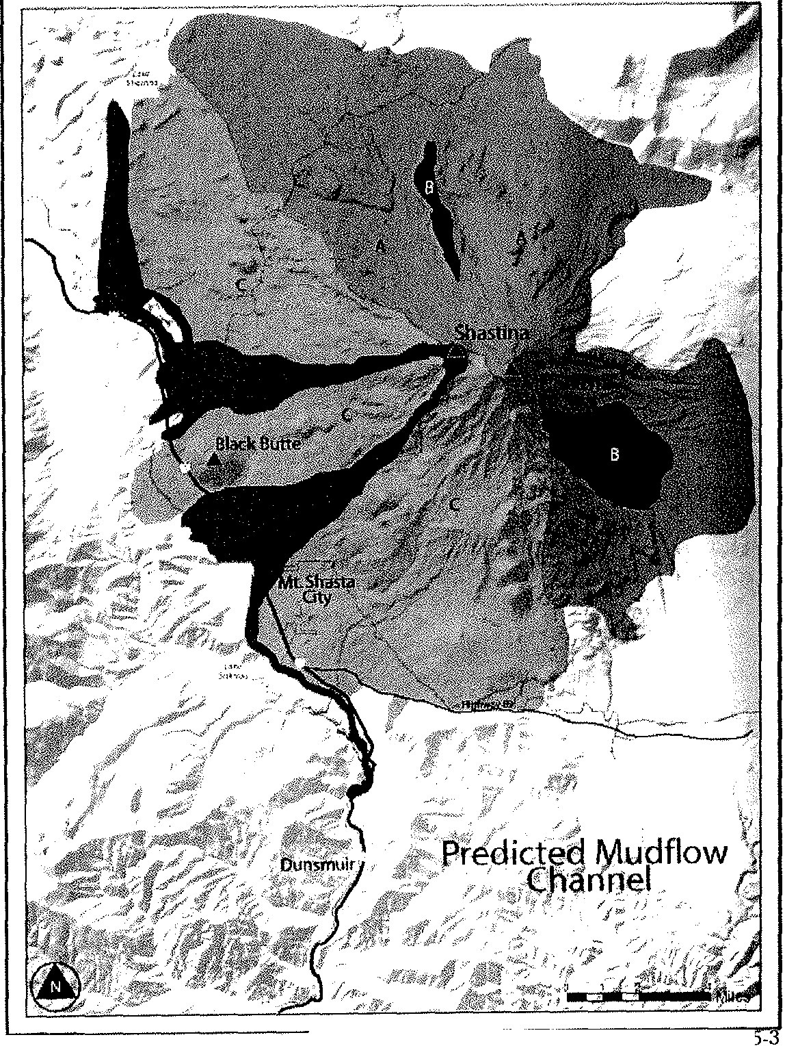
Source: Cra ndall and Nichols, 1987
FIGURE
MUDFLOW HAZARD Z0NES

Goal 5.9. A Community Protected from Volcanic Activity and the Effects of Seismic Events

Objective 5.9: Due to its proximity to Mt. Shasta, the potential for volcanic activity exists. It is the City’s objective to provide its citizens with as much information as possible in the event of volcanic activity at Mt. Shasta.

Policy 5.9.A: Gather as much information as possible and include it in the Emergency Plan.

Implementation measures:

Maintain open lines of communication with the United States Geological Service, Volcano Hazards Program, as soon as tremors are noticed, and coordinate the information with OES.

Policy 5.9.B: Disseminate information quickly and accurately.

Implementation measures:

5.9.B.1: Include a warning signal as part of the City Audible Alert System.

5.9.B.2: Include relevant information on City Website.

Policy 5.9.C: Mitigate Traffic Blockages

Implementation Measure:

5.9.C.1: Review annual CalTrans reports on Bridge Inspections and plan for upgrades as needed.

5.10 HAZARDOUS MATERIALS
Existing Setting
With two major transportation routes passing through the City, Interstate 5 and the Union Pacific Railroad, and after the experience of the 1 991 "Cantara Spill", it is very possible that a toxic material spill may again affect the City at some point in its future. Winter road conditions and local topography increase the possibility of an accident involving toxic materials.

Concerning the transport of materials on Interstate 5, the California Vehicle Code assigns the California Highway Patrol the responsibility for serving as statewide information, assistance and notification coordinator on all hazardous material spill incidents occurring on highways. The County Health Department and state and federal agencies would be actively involved on a similar incident with the railroad.

The Cantara Spill of 1991, which is sometimes regarded as California's largest inland ecological disaster, dramatized the risk of hazards in the Dunsmuir area related to the transport of toxic materials and the potential effects of toxic spills. On July 14, 1 991, railcars of a Southern Pacific train derailed at the hairpin turn of the Cantara Loop at one of the crossings of the Sacramento River. One railcar was ruptured by the fall and spilled approximately 19,000 gallons of the herbicide metam sodium into the river. As the metam sodium mixed with the water, highly toxic compounds were created. Virtually all aquatic life in the river between the Cantara Loop, through Dunsmuir and down to Shasta Lake was destroyed.

The river ecosystem has slowly recovered, but the spill had a significant impact on the river as well as the community. During the first six days after the spill, an estimated 480 residents left their homes and went to evacuation centers. While the stay of some residents in the centers were short, others were there for several weeks. Some residents were forced to temporarily leave the area to stay with friends or relatives in unaffected communities. There were many and various health-related complaints as a result of the spill.

In spite of corrective measures taken by the railroad, continued incidences demonstrate that the City is still at risk from railroad-related hazardous material spills. In July 2003, five railcars from a Union Pacific train plunged into the Sacramento River just two miles from the site of the 1991 toxic spill. In January 2005, another Union Pacific train derailment occurred in the canyon just south of Dunsmuir, this time spilling approximately 30 gallons of diesel fuel into the river. Fortunately, neither these or other recent accidents have had a significant effect on the environment or the City, but they demonstrate the continuing vulnerability of the Dunsmuir area to accidents of this kind.

Effects of climate change on Hazardous materials
- There are no impacts to hazardous materials anticipated due to climate change.

The County of Siskiyou

The County of Siskiyou has prepared and adopted a Hazardous Waste Management Plan in accordance with state law. The plan contains information on sites that may be potentially suitable for various hazardous waste facilities, including transfer and storage facilities, treatment and recovery facilities, and solidification for storage or residuals repositories. Using a "constraints and opportunities mapping" process, the county has selected candidate areas that may be appropriate for siting the various facilities. Maps contained in the plan show portions of the City of Dunsmuir, as well as the secondary and tertiary planning areas, as "potentially suitable" or "potentially usable with adequate mitigation measures."

State law provides that the City of Dunsmuir, and all Siskiyou County cities, must incorporate the approved Hazardous Waste Management Plan into the City's General Plan. The entire text of Siskiyou County’s Hazardous Waste Management Plan is incorporated by reference, in its entirety and as amended from time to time, into the Dunsmuir General Plan, including goals, objectives, policies, siting criteria and implementation measures. The goals, objectives, policies and implementation measures listed below are a partial list which has been limited to those that have direct pertinence to the City of Dunsmuir. Goals, objectives, policies and implementation measures have also been added or modified where appropriate.

The Siskiyou County Environmental Health Division (SCEH) regulates hazardous waste generation. Hazardous waste is defined in the California Code of Regulations 22 CCR 66261.3(link is external). In California, there are four characteristics that identify a hazardous waste:
- Ignitable
- Reactive
- Corrosive
- Toxic
In addition to the four characteristics, if a waste is listed in the State and/or Federal regulations, then it is also considered a hazardous waste.

Program Overview
In conjunction with the Hazardous Materials Business Plan program, Siskiyou County CUPA (Certified Unified Program Agency) staff:
- Inspect businesses for compliance with the Hazardous Waste Control Act
- Verify Hazardous Waste accumulation, labeling, container and tank management standards, and waste generator status
- Respond to complaints of illegal disposal of hazardous waste
- Issue permits and inspects businesses that treat hazardous waste pursuant to permit by rule, conditional authorization, or conditional
- Exemption laws and regulations
There are three types of hazardous waste generators:
- CESQG (Conditionally Exempt Small Quantity Generator)
- SQG (Small Quantity Generator)
- LQG (Large Quantity Generator)

Recycle and Transfer Sites
Note: All transfer stations are closed on major holidays. Days and hours of operation for recycling & transfer stations are subject to change due to budget constraints.
Most transfer stations will accept used oil, electronics, batteries, and florescent lights from residents; this option is not available to businesses. Call your transfer station for more information.

Transfer Stations
- Black Butte Transfer Station - Mount Shasta
- Happy Camp Transfer Station
- Salmon River Area
- Tulelake Transfer Station
- Yreka - Oberlin Road Transfer & Recycling Station
Sourcehttps://www.co.siskiyou.ca.us/content/general-services-sanitation-division

Hazardous Waste Generator Regulatory Summary

Environmental Health Division - Hazardous Materials Management (CUPA)
The Hazardous Materials Management Group implements the Unified Program (UP), at the local government level pursuant to Title 27 § 15110(a)(2). Siskiyou County Environmental Health Division of the Community Development Department became the Certified Unified Program Agency (CUPA) on January 1, 1997. The Environmental Health Division is certified by the Cal/EPA Secretary to implement the Unified Program specified by Health and Safety Code § 25404(a)(1)(A), within Siskiyou County.
Senate Bill 1082 (Chapter 418, Statutes of 1993) created the Unified Program (UP) to consolidate, coordinate, and make consistent the administrative requirements, permits, inspections and enforcement activities, and fees for the program elements detailed below.
With a State of California Registered Environmental Health Specialist (REHS) on call 24 hours a day, Siskiyou County Environmental Health is responsible for responding to incidents involving any release or threatened release of hazardous materials. Threats to people, property and the environmental are assessed, and then remedial action procedures are conducted under the supervision of an REHS.
Any questions regarding this may be directed to the division by e-mailing ehpermittech@co.siskiyou.ca.us(link sends e-mail) or calling 530-841-2113.

Environmental Health Hazardous Material Programs
Haz Mat - California Environmental Reporting System (CERS)
Beginning January 1, 2013 State law requires that all CUPA-regulated businesses submit hazardous materials business plan (HMBP) and underground storage tank (UST) information electronically through the California Environmental Reporting System (CERS)(link is external). For assistance with how to use CERS please visit the CERS Help Center(link is external) or contact your inspector.
Siskiyou County business must annually certify or update their HMBP by March 1 of each year.
Haz Mat - Hazardous Materials Release Response Plans & Inventories (Business Plans)
Haz Mat - California Accidental Release Program (CalARP)
Haz Mat - Underground Storage Tanks
Haz Mat - Aboveground Petroleum Storage
Haz Mat - Hazardous Waste

The following web address can provide more detailed information

https://www.co.siskiyou.ca.us/content/environmental-health-division-hazardous-materials-management

GOAL 5.10. - A city protected from potential hazardous material spills.

It is the City's objective to minimize both the potential for a hazardous materials spill and the resulting impacts should one occur.

Policy 5.10.A: In order to diminish the likelihood of future hazardous materials spills in the Upper Sacramento River Canyon, the City should advocate its concerns with regard to rail and highway safety.

Implementation Measures:
5.10.A:1 The City should advocate for stricter laws governing rail safety in the Upper Sacramento River Canyon, especially in the Cantara Loop area. This may entail maintaining lines of communication with appropriate members of Congress and with regulatory agencies in an effort to amend the Federal Railroad Safety Act.

5.10.A.2: The City shall maintain an open dialogue with Caltrans and the California Highway Patrol to ensure that the City's concerns with regard to the transport of hazardous materials along Interstate 5 are adequately addressed by those agencies.

Policy 5.10.B: The City shall take all necessary steps to prepare for a hazardous materials spill, as well as protect its residents should one occur.

Implementation Measures:
5.10.B.1: The City will maintain and periodically update a list of official emergency contacts to notify in the case of hazardous materials spill, and will make this information readily available to City staff and emergency services personnel in order to facilitate a rapid response should the need arise.

5.10.B.2: The City shall work with the owner of the railroad, currently Union Pacific, and the California Highway Patrol to ensure that rapid notification of residents in the event of a spill.

5.10.B.3: The City will continue to promote the training of, and the provision of appropriate protection gear for, local "first responders" who would respond to hazardous material spills in the Dunsmuir area.

Policy 5.10.C. Provide for the safe disposal and handling of toxic and hazardous waste.

Implementation Measures:

5.10.C.1: Direct and promote hazardous waste management practices and technologies that will, in order of priority:
- reduce the use of hazardous substances and the generation of hazardous wastes at their source;
- recover and recycle the remaining waste for reuse to the extent feasible;
- treat those wastes not amenable to source reduction or recycling so that the environment and community health are not harmed by their ultimate release or disposal;
- ensure the safe transportation and disposal of treated hazardous waste residuals in repositories made secure from liquids that might create a toxic leachate and contaminate groundwater.

5.10.C.2: Recognize the responsibility of Siskiyou County and the City of Dunsmuir for permitting on-site facilities and siting offsite facilities capable of meeting the need of generators in the county.

5.10.C.3: Minimize the ‘generation X’ hazardous wastes by seeking waste reduction alternatives which are safe, economically viable, and which represent the best technology available to the generator.

5.10.C.4: Provide assistance to hazardous waste generators to enable adoption of waste reduction strategies.
5.10.C.5: Work with Siskiyou County to develop a countywide hazardous waste reduction program which will identify economically feasible waste reduction practices and incentives available to the following key target groups: large and small quantity industrial and commercial hazardous waste generators, agriculture and individual households.

5.10.C.6: Work with Siskiyou County to establish a program to manage waste oil produced by households and small quantity generators in Siskiyou County.

5.10.C.7: Establish a collection program for household hazardous waste.

5.10.C.8: Initiate public education programs for household hazardous waste.

Policy 5.10.D: The county and its cities shall ensure that onsite and offsite hazardous waste treatment facilities are subject to complete local review.

Implementation Measures:

5.10.D.1: The City shall require that all local land use decisions on siting specified hazardous waste management facilities are consistent with the goals and policies and the siting criteria contained in the County of Siskiyou Hazardous Waste Management Plan and with any future adopted City plan.

5.10.D.2: Review of development proposals shall take into consideration the findings, recommendations and policies of the County Hazardous Waste Management Plan.

5.10.D.3: Work with Siskiyou County to develop educational programs that provide information as to types of hazardous waste products, State and local requirements for disposal of hazardous wastes, available means for disposal of small quantities of hazardous wastes.

5.10.D.4: Work with Siskiyou County to develop a public information program to improve the level of general understanding about hazardous waste management and siting issues; to educate residents, visitors and employees as to particular hazardous waste issues of concern, such as the risk to groundwater and drinking water supplies; to involve the public in hazardous waste management; and to build a vehicle for incorporating public concerns into subsequent Safety Element updates.

5.10 APPENDICES

    - CEQA Documentation
    - Approval Documents
    - Local Emergency Signals
    - California Government Code Title 7. Division 1. Chapter 3. Article 5. Authority for Scope of General Plans. Section 65302
    - http://cal-adapt.org/ CalAdapt exhibits

Appendix A. CEQA Documentation – This will be completed after the public hearing. For current information see the draft negative declaration posted at the County Clerk office, and available at the Library and at City Hall and on the city website as part of the Planning Commission staff report (March 13, 2019).

Appendix B. Approval Documents – These will be done after the public hearing for final adoption.

Appendix C. Local Emergency Signals

Audible Alert System

The City’s Outdoor Public Warning System is designed to alert residents and visitors of Dunsmuir about possible danger. Sirens are located throughout the city. To learn more about the system please click the learn more button below.
The City’s Outdoor Public Warning System is designed to alert residents and visitors of Dunsmuir about possible danger. Sirens are located throughout the city
Airhorn - Dunsmuir Fire Department
Siren - Dunsmuir Cemetery
Siren - Dunsmuir Ball Park (currently inoperable)

Notifications
Single 4 second blast
- Daily noon test, No emergency.
5 Blasts, 4 seconds each with 3 second pauses between each blast
- Fire Department Alert, mostly used for notification for fires and occasionally for high priority medical calls.
Continual 1 second blast with 1 second pauses
- Evacuation Imminent, Tune to local radio stations for information.
Continuous 30 second blasts
- Alert, tune to local radio stations for information.
Single 2 second blast
- Testing or Maintenance - No emergency or public notification.

Appendix D. California Government Code Title 7. Division 1. Chapter 3. Article 5.
Authority for Scope of General Plans. Section 65302

GOVERNMENT CODE - GOV

TITLE 7. PLANNING AND LAND USE [65000 - 66499.58]
( Heading of Title 7 amended by Stats. 1974, Ch. 1536. )

DIVISION 1. PLANNING AND ZONING [65000 - 66210]
( Heading of Division 1 added by Stats. 1974, Ch. 1536. )

CHAPTER 3. Local Planning [65100 - 65763]
( Chapter 3 repealed and added by Stats. 1965, Ch. 1880. )

ARTICLE 5. Authority for and Scope of General Plans [65300 - 65303.4]
( Article 5 added by Stats. 1965, Ch. 1880. )

65300.

Each planning agency shall prepare and the legislative body of each county and city shall adopt a comprehensive, long-term general plan for the physical development of the county or city, and of any land outside its boundaries which in the planning agency’s judgment bears relation to its planning. Chartered cities shall adopt general plans which contain the mandatory elements specified in Section 65302.
(Amended by Stats. 1984, Ch. 1009, Sec. 3.)

65300.2.

(a) For the purposes of this article, a “200-year flood plain” is an area that has a 1 in 200 chance of flooding in any given year, based on hydrological modeling and other engineering criteria accepted by the Department of Water Resources.
(b) For the purposes of this article, a “levee protection zone” is an area that is protected, as determined by the Central Valley Flood Protection Board or the Department of Water Resources, by a levee that is part of the facilities of the State Plan of Flood Control, as defined under Section 5096.805 of the Public Resources Code.
(Added by Stats. 2007, Ch. 369, Sec. 1. Effective January 1, 2008.)

65300.5.

In construing the provisions of this article, the Legislature intends that the general plan and elements and parts thereof comprise an integrated, internally consistent and compatible statement of policies for the adopting agency.
(Added by Stats. 1975, Ch. 1104.)

65300.7.

The Legislature finds that the diversity of the state’s communities and their residents requires planning agencies and legislative bodies to implement this article in ways that accommodate local conditions and circumstances, while meeting its minimum requirements.
(Added by Stats. 1980, Ch. 837.)

65300.9.

The Legislature recognizes that the capacity of California cities and counties to respond to state planning laws varies due to the legal differences between cities and counties, both charter and general law, and to differences among them in physical size and characteristics, population size and density, fiscal and administrative capabilities, land use and development issues, and human needs. It is the intent of the Legislature in enacting this chapter to provide an opportunity for each city and county to coordinate its local budget planning and local planning for federal and state program activities, such as community development, with the local land use planning process, recognizing that each city and county is required to establish its own appropriate balance in the context of the local situation when allocating resources to meet these purposes.
(Added by Stats. 1984, Ch. 1009, Sec. 3.5.)

65301.

(a) The general plan shall be so prepared that all or individual elements of it may be adopted by the legislative body, and so that it may be adopted by the legislative body for all or part of the territory of the county or city and any other territory outside its boundaries that in its judgment bears relation to its planning. The general plan may be adopted in any format deemed appropriate or convenient by the legislative body, including the combining of elements. The legislative body may adopt all or part of a plan of another public agency in satisfaction of all or part of the requirements of Section 65302 if the plan of the other public agency is sufficiently detailed and its contents are appropriate, as determined by the legislative body, for the adopting city or county.
(b) The general plan may be adopted as a single document or as a group of documents relating to subjects or geographic segments of the planning area.
(c) The general plan shall address each of the elements specified in Section 65302 to the extent that the subject of the element exists in the planning area. The degree of specificity and level of detail of the discussion of each element shall reflect local conditions and circumstances. However, this section shall not affect the requirements of subdivision (c) of Section 65302, nor be construed to expand or limit the authority of the Department of Housing and Community Development to review housing elements pursuant to Section 65585 of this code or Section 50459 of the Health and Safety Code.
The requirements of this section shall apply to charter cities.
(Amended by Stats. 2006, Ch. 890, Sec. 1. Effective January 1, 2007.)

65301.5.

The adoption of the general plan or any part or element thereof or the adoption of any amendment to such plan or any part or element thereof is a legislative act which shall be reviewable pursuant to Section 1085 of the Code of Civil Procedure.
(Added by Stats. 1980, Ch. 837.)

65302.

The general plan shall consist of a statement of development policies and shall include a diagram or diagrams and text setting forth objectives, principles, standards, and plan proposals. The plan shall include the following elements:
(a) A land use element that designates the proposed general distribution and general location and extent of the uses of the land for housing, business, industry, open space, including agriculture, natural resources, recreation, and enjoyment of scenic beauty, education, public buildings and grounds, solid and liquid waste disposal facilities, greenways, as defined in Section 816.52 of the Civil Code, and other categories of public and private uses of land. The location and designation of the extent of the uses of the land for public and private uses shall consider the identification of land and natural resources pursuant to paragraph (3) of subdivision (d). The land use element shall include a statement of the standards of population density and building intensity recommended for the various districts and other territory covered by the plan. The land use element shall identify and annually review those areas covered by the plan that are subject to flooding identified by flood plain mapping prepared by the Federal Emergency Management Agency (FEMA) or the Department of Water Resources. The land use element shall also do both of the following:
(1) Designate in a land use category that provides for timber production those parcels of real property zoned for timberland production pursuant to the California Timberland Productivity Act of 1982 (Chapter 6.7 (commencing with Section 51100) of Part 1 of Division 1 of Title 5).
(2) Consider the impact of new growth on military readiness activities carried out on military bases, installations, and operating and training areas, when proposing zoning ordinances or designating land uses covered by the general plan for land, or other territory adjacent to military facilities, or underlying designated military aviation routes and airspace.
(A) In determining the impact of new growth on military readiness activities, information provided by military facilities shall be considered. Cities and counties shall address military impacts based on information from the military and other sources.
(B) The following definitions govern this paragraph:
(i) “Military readiness activities” mean all of the following:
(I) Training, support, and operations that prepare the men and women of the military for combat.
(II) Operation, maintenance, and security of any military installation.
(III) Testing of military equipment, vehicles, weapons, and sensors for proper operation or suitability for combat use.
(ii) “Military installation” means a base, camp, post, station, yard, center, homeport facility for any ship, or other activity under the jurisdiction of the United States Department of Defense as defined in paragraph (1) of subsection (g) of Section 2687 of Title 10 of the United States Code.
(b) (1) A circulation element consisting of the general location and extent of existing and proposed major thoroughfares, transportation routes, terminals, any military airports and ports, and other local public utilities and facilities, all correlated with the land use element of the plan.
(2) (A) Commencing January 1, 2011, upon any substantive revision of the circulation element, the legislative body shall modify the circulation element to plan for a balanced, multimodal transportation network that meets the needs of all users of streets, roads, and highways for safe and convenient travel in a manner that is suitable to the rural, suburban, or urban context of the general plan.
(B) For purposes of this paragraph, “users of streets, roads, and highways” mean bicyclists, children, persons with disabilities, motorists, movers of commercial goods, pedestrians, users of public transportation, and seniors.
(c) A housing element as provided in Article 10.6 (commencing with Section 65580).
(d) (1) A conservation element for the conservation, development, and utilization of natural resources including water and its hydraulic force, forests, soils, rivers and other waters, harbors, fisheries, wildlife, minerals, and other natural resources. The conservation element shall consider the effect of development within the jurisdiction, as described in the land use element, on natural resources located on public lands, including military installations. That portion of the conservation element including waters shall be developed in coordination with any countywide water agency and with all district and city agencies, including flood management, water conservation, or groundwater agencies that have developed, served, controlled, managed, or conserved water of any type for any purpose in the county or city for which the plan is prepared. Coordination shall include the discussion and evaluation of any water supply and demand information described in Section 65352.5, if that information has been submitted by the water agency to the city or county.
(2) The conservation element may also cover all of the following:
(A) The reclamation of land and waters.
(B) Prevention and control of the pollution of streams and other waters.
(C) Regulation of the use of land in stream channels and other areas required for the accomplishment of the conservation plan.
(D) Prevention, control, and correction of the erosion of soils, beaches, and shores.
(E) Protection of watersheds.
(F) The location, quantity, and quality of the rock, sand, and gravel resources.
(3) Upon the next revision of the housing element on or after January 1, 2009, the conservation element shall identify rivers, creeks, streams, flood corridors, riparian habitats, and land that may accommodate floodwater for purposes of groundwater recharge and stormwater management.
(e) An open-space element as provided in Article 10.5 (commencing with Section 65560).
(f) (1) A noise element that shall identify and appraise noise problems in the community. The noise element shall analyze and quantify, to the extent practicable, as determined by the legislative body, current and projected noise levels for all of the following sources:
(A) Highways and freeways.
(B) Primary arterials and major local streets.
(C) Passenger and freight online railroad operations and ground rapid transit systems.
(D) Commercial, general aviation, heliport, helistop, and military airport operations, aircraft overflights, jet engine test stands, and all other ground facilities and maintenance functions related to airport operation.
(E) Local industrial plants, including, but not limited to, railroad classification yards.
(F) Other ground stationary noise sources, including, but not limited to, military installations, identified by local agencies as contributing to the community noise environment.
(2) Noise contours shall be shown for all of these sources and stated in terms of community noise equivalent level (CNEL) or day-night average sound level (Ldn). The noise contours shall be prepared on the basis of noise monitoring or following generally accepted noise modeling techniques for the various sources identified in paragraphs (1) to (6), inclusive.
(3) The noise contours shall be used as a guide for establishing a pattern of land uses in the land use element that minimizes the exposure of community residents to excessive noise.
(4) The noise element shall include implementation measures and possible solutions that address existing and foreseeable noise problems, if any. The adopted noise element shall serve as a guideline for compliance with the state’s noise insulation standards.
(g) (1) A safety element for the protection of the community from any unreasonable risks associated with the effects of seismically induced surface rupture, ground shaking, ground failure, tsunami, seiche, and dam failure; slope instability leading to mudslides and landslides; subsidence; liquefaction; and other seismic hazards identified pursuant to Chapter 7.8 (commencing with Section 2690) of Division 2 of the Public Resources Code, and other geologic hazards known to the legislative body; flooding; and wildland and urban fires. The safety element shall include mapping of known seismic and other geologic hazards. It shall also address evacuation routes, military installations, peakload water supply requirements, and minimum road widths and clearances around structures, as those items relate to identified fire and geologic hazards.
(2) The safety element, upon the next revision of the housing element on or after January 1, 2009, shall also do the following:
(A) Identify information regarding flood hazards, including, but not limited to, the following:
(i) Flood hazard zones. As used in this subdivision, “flood hazard zone” means an area subject to flooding that is delineated as either a special hazard area or an area of moderate or minimal hazard on an official flood insurance rate map issued by the Federal Emergency Management Agency (FEMA). The identification of a flood hazard zone does not imply that areas outside the flood hazard zones or uses permitted within flood hazard zones will be free from flooding or flood damage.
(ii) National Flood Insurance Program maps published by FEMA.
(iii) Information about flood hazards that is available from the United States Army Corps of Engineers.
(iv) Designated floodway maps that are available from the Central Valley Flood Protection Board.
(v) Dam failure inundation maps prepared pursuant to Section 6161 of the Water Code that are available from the Department of Water Resources.
(vi) Awareness Floodplain Mapping Program maps and 200-year flood plain maps that are or may be available from, or accepted by, the Department of Water Resources.
(vii) Maps of levee protection zones.
(viii) Areas subject to inundation in the event of the failure of project or nonproject levees or floodwalls.
(ix) Historical data on flooding, including locally prepared maps of areas that are subject to flooding, areas that are vulnerable to flooding after wildfires, and sites that have been repeatedly damaged by flooding.
(x) Existing and planned development in flood hazard zones, including structures, roads, utilities, and essential public facilities.
(xi) Local, state, and federal agencies with responsibility for flood protection, including special districts and local offices of emergency services.
(B) Establish a set of comprehensive goals, policies, and objectives based on the information identified pursuant to subparagraph (A), for the protection of the community from the unreasonable risks of flooding, including, but not limited to:
(i) Avoiding or minimizing the risks of flooding to new development.
(ii) Evaluating whether new development should be located in flood hazard zones, and identifying construction methods or other methods to minimize damage if new development is located in flood hazard zones.
(iii) Maintaining the structural and operational integrity of essential public facilities during flooding.
(iv) Locating, when feasible, new essential public facilities outside of flood hazard zones, including hospitals and health care facilities, emergency shelters, fire stations, emergency command centers, and emergency communications facilities or identifying construction methods or other methods to minimize damage if these facilities are located in flood hazard zones.
(v) Establishing cooperative working relationships among public agencies with responsibility for flood protection.
(C) Establish a set of feasible implementation measures designed to carry out the goals, policies, and objectives established pursuant to subparagraph (B).
(3) Upon the next revision of the housing element on or after January 1, 2014, the safety element shall be reviewed and updated as necessary to address the risk of fire for land classified as state responsibility areas, as defined in Section 4102 of the Public Resources Code, and land classified as very high fire hazard severity zones, as defined in Section 51177. This review shall consider the advice included in the Office of Planning and Research’s most recent publication of “Fire Hazard Planning, General Plan Technical Advice Series” and shall also include all of the following:
(A) Information regarding fire hazards, including, but not limited to, all of the following:
(i) Fire hazard severity zone maps available from the Department of Forestry and Fire Protection.
(ii) Any historical data on wildfires available from local agencies or a reference to where the data can be found.
(iii) Information about wildfire hazard areas that may be available from the United States Geological Survey.
(iv) General location and distribution of existing and planned uses of land in very high fire hazard severity zones and in state responsibility areas, including structures, roads, utilities, and essential public facilities. The location and distribution of planned uses of land shall not require defensible space compliance measures required by state law or local ordinance to occur on publicly owned lands or open space designations of homeowner associations.
(v) Local, state, and federal agencies with responsibility for fire protection, including special districts and local offices of emergency services.
(B) A set of goals, policies, and objectives based on the information identified pursuant to subparagraph (A) for the protection of the community from the unreasonable risk of wildfire.
(C) A set of feasible implementation measures designed to carry out the goals, policies, and objectives based on the information identified pursuant to subparagraph (B) including, but not limited to, all of the following:
(i) Avoiding or minimizing the wildfire hazards associated with new uses of land.
(ii) Locating, when feasible, new essential public facilities outside of high fire risk areas, including, but not limited to, hospitals and health care facilities, emergency shelters, emergency command centers, and emergency communications facilities, or identifying construction methods or other methods to minimize damage if these facilities are located in a state responsibility area or very high fire hazard severity zone.
(iii) Designing adequate infrastructure if a new development is located in a state responsibility area or in a very high fire hazard severity zone, including safe access for emergency response vehicles, visible street signs, and water supplies for structural fire suppression.
(iv) Working cooperatively with public agencies with responsibility for fire protection.
(D) If a city or county has adopted a fire safety plan or document separate from the general plan, an attachment of, or reference to, a city or county’s adopted fire safety plan or document that fulfills commensurate goals and objectives and contains information required pursuant to this paragraph.
(4) Upon the next revision of a local hazard mitigation plan, adopted in accordance with the federal Disaster Mitigation Act of 2000 (Public Law 106-390), on or after January 1, 2017, or, if a local jurisdiction has not adopted a local hazard mitigation plan, beginning on or before January 1, 2022, the safety element shall be reviewed and updated as necessary to address climate adaptation and resiliency strategies applicable to the city or county. This review shall consider advice provided in the Office of Planning and Research’s General Plan Guidelines and shall include all of the following:
(A) (i) A vulnerability assessment that identifies the risks that climate change poses to the local jurisdiction and the geographic areas at risk from climate change impacts, including, but not limited to, an assessment of how climate change may affect the risks addressed pursuant to paragraphs (2) and (3).
(ii) Information that may be available from federal, state, regional, and local agencies that will assist in developing the vulnerability assessment and the adaptation policies and strategies required pursuant to subparagraph (B), including, but not limited to, all of the following:
(I) Information from the Internet-based Cal-Adapt tool.
(II) Information from the most recent version of the California Adaptation Planning Guide.
(III) Information from local agencies on the types of assets, resources, and populations that will be sensitive to various climate change exposures.
(IV) Information from local agencies on their current ability to deal with the impacts of climate change.
(V) Historical data on natural events and hazards, including locally prepared maps of areas subject to previous risk, areas that are vulnerable, and sites that have been repeatedly damaged.
(VI) Existing and planned development in identified at-risk areas, including structures, roads, utilities, and essential public facilities.
(VII) Federal, state, regional, and local agencies with responsibility for the protection of public health and safety and the environment, including special districts and local offices of emergency services.
(B) A set of adaptation and resilience goals, policies, and objectives based on the information specified in subparagraph (A) for the protection of the community.
(C) A set of feasible implementation measures designed to carry out the goals, policies, and objectives identified pursuant to subparagraph (B) including, but not limited to, all of the following:
(i) Feasible methods to avoid or minimize climate change impacts associated with new uses of land.
(ii) The location, when feasible, of new essential public facilities outside of at-risk areas, including, but not limited to, hospitals and health care facilities, emergency shelters, emergency command centers, and emergency communications facilities, or identifying construction methods or other methods to minimize damage if these facilities are located in at-risk areas.
(iii) The designation of adequate and feasible infrastructure located in an at-risk area.
(iv) Guidelines for working cooperatively with relevant local, regional, state, and federal agencies.
(v) The identification of natural infrastructure that may be used in adaptation projects, where feasible. Where feasible, the plan shall use existing natural features and ecosystem processes, or the restoration of natural features and ecosystem processes, when developing alternatives for consideration. For the purposes of this clause, “natural infrastructure” means the preservation or restoration of ecological systems, or utilization of engineered systems that use ecological processes, to increase resiliency to climate change, manage other environmental hazards, or both. This may include, but is not limited to, floodplain and wetlands restoration or preservation, combining levees with restored natural systems to reduce flood risk, and urban tree planting to mitigate high heat days.
(D) (i) If a city or county has adopted the local hazard mitigation plan, or other climate adaptation plan or document that fulfills commensurate goals and objectives and contains the information required pursuant to this paragraph, separate from the general plan, an attachment of, or reference to, the local hazard mitigation plan or other climate adaptation plan or document.
(ii) Cities or counties that have an adopted hazard mitigation plan, or other climate adaptation plan or document that substantially complies with this section, or have substantially equivalent provisions to this subdivision in their general plans, may use that information in the safety element to comply with this subdivision, and shall summarize and incorporate by reference into the safety element the other general plan provisions, climate adaptation plan or document, specifically showing how each requirement of this subdivision has been met.
(5) After the initial revision of the safety element pursuant to paragraphs (2) and (3) upon each revision of the housing element, the planning agency shall review and, if necessary, revise the safety element to identify new information relating to flood and fire hazards that was not available during the previous revision of the safety element.
(6) Cities and counties that have flood plain management ordinances that have been approved by FEMA that substantially comply with this section, or have substantially equivalent provisions to this subdivision in their general plans, may use that information in the safety element to comply with this subdivision, and shall summarize and incorporate by reference into the safety element the other general plan provisions or the flood plain ordinance, specifically showing how each requirement of this subdivision has been met.
(7) Prior to the periodic review of its general plan and prior to preparing or revising its safety element, each city and county shall consult the California Geological Survey of the Department of Conservation, the Central Valley Flood Protection Board, if the city or county is located within the boundaries of the Sacramento and San Joaquin Drainage District, as set forth in Section 8501 of the Water Code, and the Office of Emergency Services for the purpose of including information known by and available to the department, the agency, and the board required by this subdivision.
(8) To the extent that a county’s safety element is sufficiently detailed and contains appropriate policies and programs for adoption by a city, a city may adopt that portion of the county’s safety element that pertains to the city’s planning area in satisfaction of the requirement imposed by this subdivision.
(h) (1) An environmental justice element, or related goals, policies, and objectives integrated in other elements, that identifies disadvantaged communities within the area covered by the general plan of the city, county, or city and county, if the city, county, or city and county has a disadvantaged community. The environmental justice element, or related environmental justice goals, policies, and objectives integrated in other elements, shall do all of the following:
(A) Identify objectives and policies to reduce the unique or compounded health risks in disadvantaged communities by means that include, but are not limited to, the reduction of pollution exposure, including the improvement of air quality, and the promotion of public facilities, food access, safe and sanitary homes, and physical activity.
(B) Identify objectives and policies to promote civil engagement in the public decisionmaking process.
(C) Identify objectives and policies that prioritize improvements and programs that address the needs of disadvantaged communities.
(2) A city, county, or city and county subject to this subdivision shall adopt or review the environmental justice element, or the environmental justice goals, policies, and objectives in other elements, upon the adoption or next revision of two or more elements concurrently on or after January 1, 2018.
(3) By adding this subdivision, the Legislature does not intend to require a city, county, or city and county to take any action prohibited by the United States Constitution or the California Constitution.
(4) For purposes of this subdivision, the following terms shall apply:
(A) “Disadvantaged communities” means an area identified by the California Environmental Protection Agency pursuant to Section 39711 of the Health and Safety Code or an area that is a low-income area that is disproportionately affected by environmental pollution and other hazards that can lead to negative health effects, exposure, or environmental degradation.
(B) “Public facilities” includes public improvements, public services, and community amenities, as defined in subdivision (d) of Section 66000.
(C) “Low-income area” means an area with household incomes at or below 80 percent of the statewide median income or with household incomes at or below the threshold designated as low income by the Department of Housing and Community Development’s list of state income limits adopted pursuant to Section 50093 of the Health and Safety Code.
(Amended by Stats. 2017, Ch. 26, Sec. 64. (SB 92) Effective June 27, 2017.)

65302.1.

(a) The Legislature finds and declares all of the following:
(1) The San Joaquin Valley has a serious air pollution problem that will take the cooperation of land use and transportation planning agencies, transit operators, the development community, the San Joaquin Valley Air Pollution Control District and the public to solve. The solution to the problem requires changes in the way we have traditionally built our communities and constructed the transportation systems. It involves a fundamental shift in priorities from emphasis on mobility for the occupants of private automobiles to a multimodal system that more efficiently uses scarce resources. It requires a change in attitude from the public to support development patterns and transportation systems different from the status quo.
(2) In 2003 the district published a document entitled, Air Quality Guidelines for General Plans. This report is a comprehensive guidance document and resource for cities and counties to use to include air quality in their general plans. It includes goals, policies, and programs that when adopted in a general plan will reduce vehicle trips and miles traveled and improve air quality.
(3) Air quality guidelines are recommended strategies that do, when it is feasible, all of the following:
(A) Determine and mitigate project level and cumulative air quality impacts under the California Environmental Quality Act (CEQA) (Division 13 (commencing with Section 21000) of the Public Resources Code).
(B) Integrate land use plans, transportation plans, and air quality plans.
(C) Plan land uses in ways that support a multimodal transportation system.
(D) Local action to support programs that reduce congestion and vehicle trips.
(E) Plan land uses to minimize exposure to toxic air pollutant emissions from industrial and other sources.
(F) Reduce particulate matter emissions from sources under local jurisdiction.
(G) Support district and public utility programs to reduce emissions from energy consumption and area sources.
(4) The benefits of including air quality concerns within local general plans include, but are not limited to, all of the following:
(A) Lower infrastructure costs.
(B) Lower public service costs.
(C) More efficient transit service.
(D) Lower costs for comprehensive planning.
(E) Streamlining of the permit process.
(F) Improved mobility for the elderly and children.
(b) The legislative body of each city and county within the jurisdictional boundaries of the district shall amend the appropriate elements of its general plan, which may include, but are not limited to, the required elements dealing with land use, circulation, housing, conservation, and open space, to include data and analysis, goals, policies, and objectives, and feasible implementation strategies to improve air quality.
(c) The adoption of air quality amendments to a general plan to comply with the requirements of subdivision (d) shall include all of the following:
(1) A report describing local air quality conditions including air quality monitoring data, emission inventories, lists of significant source categories, attainment status and designations, and applicable state and federal air quality plans and transportation plans.
(2) A summary of local, district, state, and federal policies, programs, and regulations that may improve air quality in the city or county.
(3) A comprehensive set of goals, policies, and objectives that may improve air quality consistent with the strategies listed in paragraph (3) of subdivision (a).
(4) A set of feasible implementation measures designed to carry out those goals, policies, and objectives.
(d) At least 45 days prior to the adoption of air quality amendments to a general plan pursuant to this section, each city and county shall send a copy of its draft document to the district. The district may review the draft amendments to determine whether they may improve air quality consistent with the strategies listed in paragraph (3) of subdivision (a). Within 30 days of receiving the draft amendments, the district shall send any comments and advice to the city or county. The legislative body of the city or county shall consider the district’s comments and advice prior to the final adoption of air quality amendments to the general plan. If the district’s comments and advice are not available by the time scheduled for the final adoption of air quality amendments to the general plan, the legislative body of the city or county may act without them. The district’s comments shall be advisory to the city or county.
(e) The legislative body of each city and county within the jurisdictional boundaries of the district shall comply with this section no later than one year from the date specified in Section 65588 for the next revision of its housing element that occurs after January 1, 2004.
(f) As used in this section, “district” means the San Joaquin Valley Air Pollution Control District.
(Added by Stats. 2003, Ch. 472, Sec. 1. Effective January 1, 2004.)

65302.2.

Upon the adoption, or revision, of a city or county’s general plan, on or after January 1, 1996, the city or county shall utilize as a source document any urban water management plan submitted to the city or county by a water agency.
(Added by Stats. 1995, Ch. 881, Sec. 2. Effective January 1, 1996.)

65302.3.

(a) The general plan, and any applicable specific plan prepared pursuant to Article 8 (commencing with Section 65450), shall be consistent with the plan adopted or amended pursuant to Section 21675 of the Public Utilities Code.
(b) The general plan, and any applicable specific plan, shall be amended, as necessary, within 180 days of any amendment to the plan required under Section 21675 of the Public Utilities Code.
(c) If the legislative body does not concur with any provision of the plan required under Section 21675 of the Public Utilities Code, it may satisfy the provisions of this section by adopting findings pursuant to Section 21676 of the Public Utilities Code.
(d) In each county where an airport land use commission does not exist, but where there is a military airport, the general plan, and any applicable specific plan prepared pursuant to Article 8 (commencing with Section 65450), shall be consistent with the safety and noise standards in the Air Installation Compatible Use Zone prepared for that military airport.
(Amended by Stats. 2002, Ch. 971, Sec. 4. Effective January 1, 2003.)

65302.4.

The text and diagrams in the land use element that address the location and extent of land uses, and the zoning ordinances that implement these provisions, may also express community intentions regarding urban form and design. These expressions may differentiate neighborhoods, districts, and corridors, provide for a mixture of land uses and housing types within each, and provide specific measures for regulating relationships between buildings, and between buildings and outdoor public areas, including streets.
(Added by Stats. 2004, Ch. 179, Sec. 1. Effective January 1, 2005.)

65302.5.

(a) At least 45 days prior to adoption or amendment of the safety element, each county and city shall submit to the California Geological Survey of the Department of Conservation one copy of a draft of the safety element or amendment and any technical studies used for developing the safety element. The division may review drafts submitted to it to determine whether they incorporate known seismic and other geologic hazard information, and report its findings to the planning agency within 30 days of receipt of the draft of the safety element or amendment pursuant to this subdivision. The legislative body shall consider the division’s findings prior to final adoption of the safety element or amendment unless the division’s findings are not available within the above prescribed time limits or unless the division has indicated to the city or county that the division will not review the safety element. If the division’s findings are not available within those prescribed time limits, the legislative body may take the division’s findings into consideration at the time it considers future amendments to the safety element. Each county and city shall provide the division with a copy of its adopted safety element or amendments. The division may review adopted safety elements or amendments and report its findings. All findings made by the division shall be advisory to the planning agency and legislative body.
(b) (1) The draft element of or draft amendment to the safety element of a county or a city’s general plan shall be submitted to the State Board of Forestry and Fire Protection and to every local agency that provides fire protection to territory in the city or county at least 90 days prior to either of the following:
(A) The adoption or amendment to the safety element of its general plan for each county that contains state responsibility areas.
(B) The adoption or amendment to the safety element of its general plan for each city or county that contains a very high fire hazard severity zone as defined pursuant to subdivision (i) of Section 51177.
(2) A county that contains state responsibility areas and a city or county that contains a very high fire hazard severity zone as defined pursuant to subdivision (i) of Section 51177 shall submit for review the safety element of its general plan to the State Board of Forestry and Fire Protection and every local agency that provides fire protection to territory in the city or county in accordance with the following dates, as specified, unless the local government submitted the element within five years prior to that date:
(A) Local governments within the regional jurisdiction of the San Diego Association of Governments: December 31, 2010.
(B) Local governments within the regional jurisdiction of the Southern California Association of Governments: December 31, 2011.
(C) Local governments within the regional jurisdiction of the Association of Bay Area Governments: December 31, 2012.
(D) Local governments within the regional jurisdiction of the Council of Fresno County Governments, the Kern County Council of Governments, and the Sacramento Area Council of Governments: June 30, 2013.
(E) Local governments within the regional jurisdiction of the Association of Monterey Bay Area Governments: December 31, 2014.
(F) All other local governments: December 31, 2015.
(3) The State Board of Forestry and Fire Protection shall, and a local agency may, review the draft or an existing safety element and recommend changes to the planning agency within 60 days of its receipt regarding both of the following:
(A) Uses of land and policies in state responsibility areas and very high fire hazard severity zones that will protect life, property, and natural resources from unreasonable risks associated with wild land fires.
(B) Methods and strategies for wild land fire risk reduction and prevention within state responsibility areas and very high fire hazard severity zones.
(4) Prior to the adoption of its draft element or draft amendment, the board of supervisors of the county or the city council of a city shall consider the recommendations, if any, made by the State Board of Forestry and Fire Protection and any local agency that provides fire protection to territory in the city or county. If the board of supervisors or city council determines not to accept all or some of the recommendations, if any, made by the State Board of Forestry and Fire Protection or local agency, the board of supervisors or city council shall communicate in writing to the State Board of Forestry and Fire Protection or the local agency, its reasons for not accepting the recommendations.
(5) If the State Board of Forestry and Fire Protection’s or local agency’s recommendations are not available within the time limits required by this section, the board of supervisors or city council may act without those recommendations. The board of supervisors or city council shall take the recommendations into consideration the next time it considers amendments to the safety element.
(Amended by Stats. 2013, Ch. 76, Sec. 101. (AB 383) Effective January 1, 2014.)

65302.6.

(a) A city, county, or a city and county may adopt with its safety element pursuant to subdivision (g) of Section 65302 a local hazard mitigation plan (HMP) specified in the federal Disaster Mitigation Act of 2000 (Public Law 106-390). The hazard mitigation plan shall include all of the following elements called for in the federal act requirements:
(1) An initial earthquake performance evaluation of public facilities that provide essential services, shelter, and critical governmental functions.
(2) An inventory of private facilities that are potentially hazardous, including, but not limited to, multiunit, soft story, concrete tilt-up, and concrete frame buildings.
(3) A plan to reduce the potential risk from private and governmental facilities in the event of a disaster.
(b) Local jurisdictions that have not adopted a local hazard mitigation plan shall be given preference by the Office of Emergency Services in recommending actions to be funded from the Pre-Disaster Mitigation Program, the Hazard Mitigation Grant Program, and the Flood Mitigation Assistance Program to assist the local jurisdiction in developing and adopting a local hazard mitigation plan, subject to available funding from the Federal Emergency Management Agency.
(Amended by Stats. 2013, Ch. 352, Sec. 312. (AB 1317) Effective September 26, 2013. Operative July 1, 2013, by Sec. 543 of Ch. 352.)

65302.7.

(a) For the purposes of complying with Section 65302.5, each county or city located within the boundaries of the Sacramento and San Joaquin Drainage District, as set forth in Section 8501 of the Water Code, shall submit the draft element of, or draft amendment to, the safety element to the Central Valley Flood Protection Board and to every local agency that provides flood protection to territory in the city or county at least 90 days prior to the adoption of, or amendment to, the safety element of its general plan.
(b) The Central Valley Flood Protection Board and each local agency described in paragraph (1) shall review the draft or an existing safety element and report their respective written recommendations to the planning agency within 60 days of the receipt of the draft or existing safety element. The Central Valley Flood Protection Board and each local agency shall review the draft or existing safety element and may offer written recommendations for changes to the draft or existing safety element regarding both of the following:
(1) Uses of land and policies in areas subjected to flooding that will protect life, property, and natural resources from unreasonable risks associated with flooding.
(2) Methods and strategies for flood risk reduction and protection within areas subjected to flooding.
(c) Prior to the adoption of its draft element or draft amendments to the safety element, the board of supervisors of the county or the city council of a city shall consider the recommendations made by the Central Valley Flood Protection Board and any local agency that provides flood protection to territory in the city or county. If the board of supervisors or the city council determines not to accept all or some of the recommendations, if any, made by the Central Valley Flood Protection Board or the local agency, the board of supervisors or the city council shall make findings that state its reasons for not accepting a recommendation and shall communicate those findings in writing to the Central Valley Flood Protection Board or to the local agency.
(d) If the Central Valley Flood Protection Board’s or the local agency’s recommendations are not available within the time limits required by this section, the board of supervisors or the city council may act without those recommendations. The board of supervisors or city council shall consider the recommendations at the next time it considers amendments to its safety element.
(Added by Stats. 2007, Ch. 369, Sec. 2. Effective January 1, 2008.)

65302.8.

If a county or city, including a charter city, adopts or amends a mandatory general plan element which operates to limit the number of housing units which may be constructed on an annual basis, such adoption or amendment shall contain findings which justify reducing the housing opportunities of the region. The findings shall include all of the following:
(a) A description of the city’s or county’s appropriate share of the regional need for housing.
(b) A description of the specific housing programs and activities being undertaken by the local jurisdiction to fulfill the requirements of subdivision (c) of Section 65302.
(c) A description of how the public health, safety, and welfare would be promoted by such adoption or amendment.
(d) The fiscal and environmental resources available to the local jurisdiction.
(Added by Stats. 1980, Ch. 823.)

65302.9.

(a) Within 24 months of July 2, 2013, each city and county within the Sacramento-San Joaquin Valley shall amend its general plan to contain all of the following:
(1) (A) The data and analysis contained in the Central Valley Flood Protection Plan pursuant to Section 9612 of the Water Code, including, but not limited to, the locations of the facilities of the State Plan of Flood Control and the locations of the real property protected by those facilities.
(B) The locations of flood hazard zones, including, but not limited to, locations mapped by the Federal Emergency Management Agency Flood Insurance Rate Map or the Flood Hazard Boundary Map, locations that participate in the National Flood Insurance Program, locations of undetermined risk areas, and locations mapped by a local flood agency or flood district.
(2) Goals, policies, and objectives, based on the data and analysis identified pursuant to paragraph (1), for the protection of lives and property that will reduce the risk of flood damage.
(3) Feasible implementation measures designed to carry out the goals, policies, and objectives established pursuant to paragraph (2).
(b) An undetermined risk area shall be presumed to be at risk during flooding that has a 1-in-200 chance of occurring in any given year unless deemed otherwise by the State Plan of Flood Control, an official National Flood Insurance Program rate map issued by the Federal Emergency Management Agency, or a finding made by a city or county based on a determination of substantial evidence by a local flood agency.
(c) To assist each city or county in complying with this section, the Central Valley Flood Protection Board, the Department of Water Resources, and local flood agencies shall collaborate with cities or counties by providing them with information and other technical assistance.
(d) In implementing this section, each city and county, both general law and charter, within the Sacramento-San Joaquin Valley, shall comply with this article, including, but not limited to, Sections 65300.5, 65300.7, 65300.9, and 65301.
(e) Notwithstanding any other law, this section shall apply to all cities, including charter cities, and counties within the Sacramento-San Joaquin Valley. The Legislature finds and declares that flood protection in the Sacramento and San Joaquin Rivers drainage areas is a matter of statewide concern and not a municipal affair as that term is used in Section 5 of Article XI of the California Constitution.
(f) This section shall not be construed to limit or remove any liability of a city or county prior to the amendment of the general plan except as provided in Section 8307 of the Water Code.
(Amended by Stats. 2012, Ch. 553, Sec. 2. (SB 1278) Effective January 1, 2013.)

65302.10.

(a) As used in this section, the following terms shall have the following meanings:
(1) “Community” means an inhabited area within a city or county that is comprised of no less than 10 dwellings adjacent or in close proximity to one another.
(2) “Disadvantaged unincorporated community” means a fringe, island, or legacy community in which the median household income is 80 percent or less than the statewide median household income.
(3) “Fringe community” means any inhabited and unincorporated territory that is within a city’s sphere of influence.
(4) “Island community” means any inhabited and unincorporated territory that is surrounded or substantially surrounded by one or more cities or by one or more cities and a county boundary or the Pacific Ocean.
(5) “Legacy community” means a geographically isolated community that is inhabited and has existed for at least 50 years.
(b) On or before the due date for the next adoption of its housing element pursuant to Section 65588, each city or county shall review and update the land use element of its general plan, based on available data, including, but not limited to, the data and analysis developed pursuant to Section 56430, of unincorporated island, fringe, or legacy communities inside or near its boundaries. The updated land use element shall include all of the following:
(1) In the case of a city, an identification of each island or fringe community within the city’s sphere of influence that is a disadvantaged unincorporated community. In the case of a county, an identification of each legacy community within the boundaries of the county that is a disadvantaged unincorporated community, but not including any area within the sphere of influence of any city. This identification shall include a description of the community and a map designating its location.
(2) For each identified community, an analysis of water, wastewater, stormwater drainage, and structural fire protection needs or deficiencies.
(3) An analysis, based on then existing available data, of benefit assessment districts or other financing alternatives that could make the extension of services to identified communities financially feasible.
(c) On or before the due date for each subsequent revision of its housing element pursuant to Section 65588, each city and county shall review, and if necessary amend, its general plan to update the analysis required by this section.
(Amended by Stats. 2012, Ch. 330, Sec. 14. (SB 1090) Effective January 1, 2013.)

65302.11.

(a) Notwithstanding subdivision (b) of Section 65302.3, the general plan, and any applicable specific plan, for the City of Coronado shall be amended, as necessary, within 540 days of any amendment to the plan required under Section 21675 of the Public Utilities Code if the amendment is made prior to January 1, 2017.
(b) This section shall remain in effect only until January 1, 2019, or 540 days after an amendment to the plan required under Section 21675 of the Public Utilities Code, whichever is earlier, and as of that date is repealed.
(Added by Stats. 2013, Ch. 606, Sec. 1. (SB 758) Effective January 1, 2014. Repealed on or before January 1, 2019, as prescribed by its own provisions.)

Appendix E. http://cal-adapt.org/ Selected CalAdapt Exhibits
The following exhibits are taken from the CalAdapt tool located at http://cal-adapt.org/tools/. Please go to the website for information about these exhibits and for additional tools.
