EFFECTIVENESS MONITORING COMMITTEE (EMC)
Strategic Plan

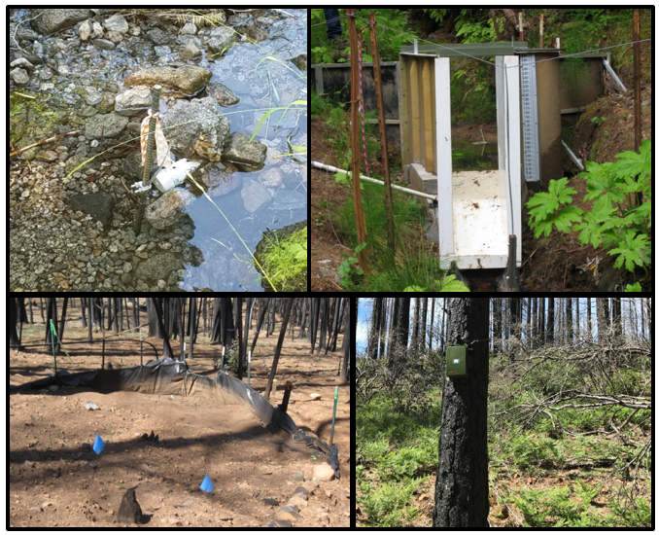
Submitted to the California State Board of Forestry and Fire Protection
(BOF Logo -small- here)
Revision: September XX, 2022

Loretta Moreno, Co-Chair
California Natural Resources Agency

Liz Forsburg Pardi, Co-Chair
Member, California State Board of Forestry and Fire Protection

Cover photos (clockwise from the top left): Class II-Large water temperature study site on LaTour Demonstration State Forest; Montana weir at a gaging station in the South Fork of Caspar Creek watershed, Jackson Demonstration State Forest; Automated bird recorder installed on Boggs Mountain Demonstration State Forest (BMDSF); and plot-scale sediment fence installed as part of the BMDSF post-fire runoff and erosion study.

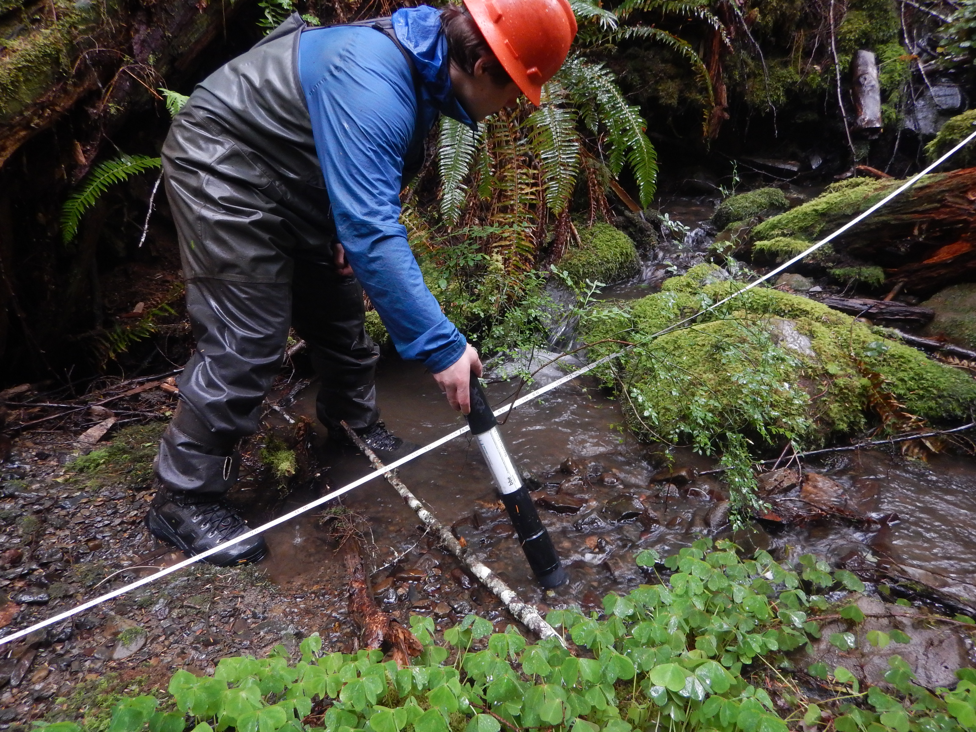
Proposed photos and captions:
Measuring algal concentrations with a BentoTorch at a study site in a lower Klamath River tributary for the of Class II riparian prescription effectiveness study. Photo by Jonah Nicholas.

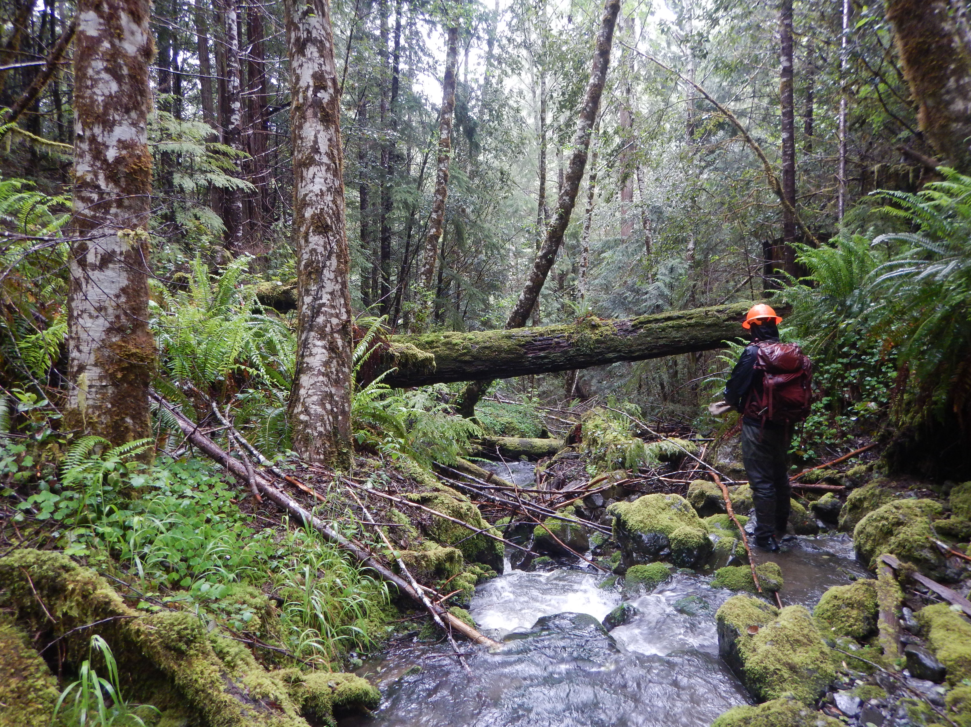
Conducting a stream survey at a study site in a lower Klamath River tributary for the Class II riparian prescription effectiveness study. Photo by Cedric Pimont.

EXECUTIVE SUMMARY
The California State Board of Forestry and Fire Protection (Board) formed the Effectiveness Monitoring Committee (EMC) in 2014 to develop and implement a monitoring program to address both watershed and wildlife concerns and to provide a better active feedback loop to policymakers, managers, agencies, and the public as to the impact and effectiveness of state regulations in California’s timberland ecosystems. Effectiveness monitoring is necessary to assess whether management practices are achieving the various resource goals and objectives set forth in the California Forest Practice Rules (FPRs), and associated regulations, including other natural resource protection statutes and laws, codes, and regulations (EMC 2013, MacDonald et al. 1991) and is a key component of Adaptive Management (AM). Effectiveness monitoring is also a crucial component for complying with the “ecological performance” reporting requirements outlined in Assembly Bill (AB) 1492 (Forest resource management 2012).
The EMC’s Strategic Plan was first released in 2017 and documents the AM framework utilized by the EMC and the Board to evaluate the impacts of the FPRs and associated regulations based on the results of EMC-funded scientific research, and the process to adapt rules and regulations to new information. The Strategic Plan describes the process for project solicitation, implementation, and evaluation. The Strategic Plan is reviewed and updated approximately every three years and presented to the Board for approval. This 2022 Strategic Plan has been updated to clarify and simplify language and include newly adopted procedures approved by the Board.

Companion documents that should be consulted along with the Strategic Plan include:
- EMC Charter: The Board-approved Charter (EMC 2013) directs the EMC to implement a collaborative, transparent, and science-based monitoring effort. The Charter communicates the goals and objectives of the EMC; describes the membership and structure of the committee; and details meeting organization, rules of conduct, and how the committee acts and communicates with the Board. EMC members represent a wide range of natural resource expertise from academia, state and federal agencies, private and state forestland owners, and the public. Expertise includes forest management and ecology, hydrology, geology, aquatic ecology, fisheries, wildlife management, and resource monitoring and sampling.

- EMC Research Themes and Critical Monitoring Questions: First drafted in 2017 and updated in 2022, the EMC and the Board adopted a suite of critical monitoring questions based on input from a variety of stakeholders and organized them into 11 themes. The goal is to develop a process-based understanding of the effectiveness of FPRs and associated regulations in maintaining and enhancing forest ecosystem function, water quality, and aquatic and wildlife habitats. The EMC uses established themes and critical monitoring questions as guidance to the EMC itself and prospective grantees to solicit and evaluate prospective effectiveness monitoring projects for funding support.

- EMC Annual Report and Work Plan: Updated annually, EMC accomplishments, changes to EMC membership, project selection process for the year, and updates on the status of previously funded monitoring projects are documented. The work products and processes of the EMC include the following:

- Periodically update EMC Strategic Plan for Board consideration.
- Prepare an Annual Report and Workplan for Board consideration.
- Regularly meet in open, webcast public meetings to conduct its work.
- Annual distribution of a Request for Proposal (RFP) soliciting project proposals for monitoring research investigating the FPRs and associated regulations.
- Review and rank project proposals and recommend projects for funding by December of each year. Funding of projects occurs from an annual allocation of up to $425,000 each fiscal year from the Timber Regulation and Forest Restoration Fund (TRFRF).
- Review Committee membership as needed due to term expirations or resignations. A Call for Membership, if necessary, is widely distributed to encourage a broad spectrum of applicants that meet membership qualifications.

TABLE OF CONTENTS
1.0 INTRODUCTION 1
2.0 EMC STRATEGIC PLAN ROAD MAP 2
2.1 Development of Critical Monitoring Questions 2
2.2 Adaptive Management Framework 3
3.0 Guidelines for EMC-Funded Research 6
3.1 Study Design within an Adaptive Management Framework 6
3.2 Additional Study Design Considerations 9
- 3.2.1 Appropriate Scale 9
- 3.2.2 Rare or Large Event Monitoring 10
4.0 EMC PROJECT DEVELOPMENT AND MANAGEMENT 10
4.1 Project Solicitation and Initial Review 10
4.2 Project Ranking and Selection 12
- 4.2.1 Ranking Metrics 12
- 4.2.2 Consideration of Funding Request 13
4.3 Project Management 14
- 4.3.1 Proposal Agreement Development and Administration 14
- 4.3.2 Status Reports and Presentations 14
- 4.3.3 Final Reports, Presentations, and Publications 14
4.4 EMC Supported Monitoring Projects 15
5.0 SUMMARY 15
5.0 REFERENCES (pending updates) 16

LIST OF FIGURES
Figure 1. Example: Structure of relationships among the EMC critical monitoring questions, natural resources of concern, and the California Forest Practice Rules. 3
Figure 2. The Adaptive Management Framework using EMC-funded research to inform Board policy and regulations. 4
Figure 3. EMC Project Solicitation, Submission, Selection, and Funding General Timeline. 11
Figure 4. Ranking of proposed effectiveness monitoring projects. 13

LIST OF ABBREVIATIONS
AM Adaptive Management
Basin Plan Water Quality Control Plan (WQCP)
Board California State Board of Forestry and Fire Protection
CAL FIRE California Department of Forestry and Fire Protection
CCR California Code of Regulations
CDFW California Department of Fish and Wildlife
CEQA California Environmental Quality Act
CGS California Geological Survey
CRA Completed Research Assessment
CNRA California Natural Resources Agency
EMC Effectiveness Monitoring Committee
ESA Endangered Species Act
EX-EM Exemption and Emergency Notices
FGC Fish and Game Code
FGCom Fish and Game Commission
FPA Forest Practice Act
FPC Board Forest Practice Committee
FPP Full Project Proposal
FPRs California Forest Practice Rules
ICP Initial Concept Proposal
PI Principal Investigator
Plans Timber Harvesting Plans and all other harvest documents as defined under 14 CCR § 895.1
RPF Registered Professional Forester
THP Timber Harvesting Plan
TRFR Timber Regulation and Forest Restoration Program
WLPZ Watercourse and Lake Protection Zone
Working Groups AB 1492 program Working Groups: Ecological Performance Measures, Data and Monitoring, Administrative Performance Measures, and Interagency Information Systems.
WQCP Water Quality Control Plan, commonly referred to as Basin Plan.

1.0
0F

- 1F

EMC STRATEGIC PLAN ROAD MAP: Bringing science to policymakers
To facilitate the AM process that informs proposed changes to forestry policy, the EMC supports research that evaluates the FPRs and associated regulations. This section briefly describes the development of critical monitoring questions and related research themes that highlight gaps in knowledge related to the effectiveness of the FPRs and associated regulations; directs readers to the Research Themes and Critical Monitoring Questions, and context for their relationships to the policies, goals, and priorities of other Agencies, Departments, and Boards¹ (EMC n.d.); and describes the AM Framework, which is a process for utilizing research results to inform changes to the FPRs and associated regulations.

2.1 Development of Critical Monitoring Questions
Critical monitoring questions guide and focus research funding and were established by the EMC via a public process in which the EMC sought and accepted priorities from a wide variety of stakeholders including agencies, departments, boards, EMC members, and the interested public. The EMC transformed the priorities into critical monitoring questions following a specific structure which is intended to improve understanding and allow better comparisons between multiple monitoring questions (see example in Figure 1). The Board approved the list of Critical Monitoring Questions and initial Strategic Plan on December 6, 2017 (EMC 2018). The Research Themes and Critical Monitoring Questions were revised by the EMC during open public meetings, and unanimously recommended to present the revised set of questions to the Board on DATE 2022; the Board approved the revised set of questions at a public meeting on DATE 2022. Additional information about the process for development of the questions, along with a list of and justification for all Critical Monitoring Questions, is available online in the Research Themes and Critical Monitoring Questions2F (EMC 2022).
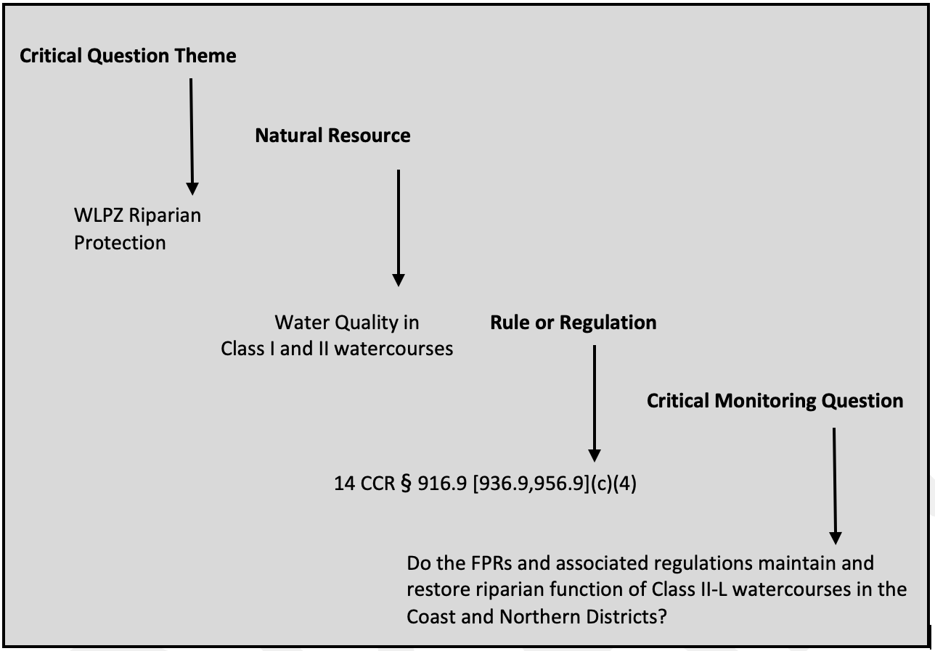
Figure 1. Example: Structure of relationships among the EMC critical monitoring questions, natural resources of concern, and the California Forest Practice Rules.

2.2 Adaptive Management Framework Guides EMC Funding and Research Review
Due to relatively small sample sizes and lack of controls for both dependent and independent variables associated with “specific question” studies, statistically rigorous testing of water quality, aquatic habitat, and wildlife resource questions is often difficult. However, well-developed resource monitoring questions can improve scientific monitoring designs to limit spurious results and enhance the range of inference. The Board recognizes there is scientific uncertainty in how forested ecosystems function within the framework of managed forestlands, and in how various ecosystem components and processes interact. Even with these known uncertainties, The EMC and Board seek a better understanding of the effectiveness of FPRs and associated regulations by formally employing an AM Framework. The EMC therefore focuses on funding effectiveness monitoring research that feeds an information feedback loop to inform Board policy (Figure 2). Specifically, the Board reviews results of EMC-sponsored scientific studies to evaluate the effectiveness of the FPRs and associated regulations in meeting the goals of the Board.
Figure 2. The Adaptive Management Framework using EMC-funded research to inform Board policy and regulations.
Additionally, the Board may also consider the following four general goals—in alignment with the policies, goals, and priorities of other Agencies, Departments, and Boards3F (EMC n.d.) as part of the AM Framework:
- To provide compliance with the State and federal ESAs for species found on State and private forestlands.
- To maintain and restore forest-dependent species on State and private forestlands.
- To meet the requirements of the federal Clean Water Act and Porter-Cologne Water Quality Control Act on State and private forestlands.
- To keep private forestlands economically viable in the State of California, by furthering regulatory streamlining efforts, while still enhancing California’s timberland habitat.
The goal of any EMC effectiveness monitoring study design is to determine if the FPRs and associated regulations related to natural resources management are maintaining and/or restoring ecological conditions. The goal of environmental monitoring studies is to detect changes from individual and/or cumulative effects of activities that are both spatially and temporally distributed across representative study areas plan areas. Results will be used in an AM framework to help the Board determine the appropriateness of policies and practices, and to revise or craft new management practices, policies, or regulations when the current ones do not meet desired results.
When the Board reviews scientific information from EMC-funded studies it is important for Board members to understand the overall context and implications of the research. Therefore, as part of the AM feedback loop, the findings of the EMC-sponsored studies required a means for integrating research results into future forest management plans, either through changed policy, landowner outreach, or a combination of approaches. To address this, the EMC developed a protocol for such an assessment—approved by the BOF in 2021—to further assist in translation of scientific results to the Board, which will aid the Board in adapting policy and regulations to reflect new information gleaned from EMC-funded research. This Completed Research Assessment (CRA)4F (EMC 2021) (also referenced as “Science to Policy Framework”) provides a step-by-step approach to guide EMC and Board members in verifying scientific integrity and validity of the research, and interprets the results of the scientific research as to the implications for management and policy. Two EMC members work with the Principal Investigator(s) of a project to complete the required document, which is then presented to the EMC and amended as necessary prior to presentation to the Board.

This process provides an avenue for members to report to the Board with a screening and objective assessment of the scientific results received by the EMC at the conclusion of a given project. Further it can include a high-level assessment of the trade-offs and outcomes of different management practices based on EMC-funded research results, as described in the CRA guidelines (EMC 2021). The role of the EMC is not to determine the “best” course of action for policymakers or managers; rather, it is to provide the Board details as to the strength of the science conducted and an assessment of possible policy implications based on science results. Thereafter, the Board determines whether rule changes and policy changes are merited given that information.

3.0 Guidelines for EMC-Funded Research
New research proposals are assessed by the EMC for scientific rigor and integrity, and the likelihood and ability of the proposed research in answering the critical monitoring questions. This section describes acceptable study designs and methods that EMC-supported research projects should generally follow, including content on: recommended protocols for field and laboratory methods; selection of appropriate temporal and geographic scale; statistical analysis; reporting guidance and assessment; evaluation and utilization of project results; how the AM framework may be utilized to evaluate the relationships between scientific research results and Board-developed policies; and how policy (i.e., the FPRs and associated regulations) may need to be altered in response to project results.

3.1 Study Design within an Adaptive Management Framework

Adaptive management “provides a framework for making good decisions in the face of critical uncertainties, and a formal process for reducing uncertainties so that management performance can be improved over time” (Williams et al. 2009). The AM process facilitates learning “not by trial and error, but by a structured process,” resulting in reduced uncertainty (Allen and Gunderson 2011). To further account for the complexity and uncertainty surrounding natural resource management, EMC-sponsored study protocols, and EMC and Board responses to results, will be embedded within an adaptive resource management model (Williams et al. 2009), summarized as:
- Define research objectives and scope of management to be studied
- Develop operational plans to meet the objectives
- Implement plans
- Collect information about impacts of plans
- Evaluate collected information considering stated objectives
- Adjusting plans as informed by new information

Each of the steps in the AM cycle, and its relevance for the EMC, is elaborated below.

(1) Define research objectives and scope of management to be studied.
Studies considered by the EMC must be designed to address: (1) existing or proposed forest management practices; and (2) objectives as defined through legislation (e.g., ESA, FPA), FPRs and associated regulations, and/or by stakeholders. Studies should state the management objectives being addressed, and include relevant research questions, which can include ecological, economic, and social metrics, as appropriate. Objectives should be attainable with the data collection and analysis methods described. This step in the AM cycle is paralleled by Step 1 (Research Objectives) in the Adaptive Management Framework (Figure 2).

(2) Develop operational plans to meet objectives -AND- (3) Implement plans.
The EMC will support evaluation of project impacts from forest management activities implemented by landowners, managers, and researchers, which may include any activities of interest described in the Plan (e.g., a THP). Research designs may be observational (e.g., testing existing management or conditions, or analyzing existing datasets) or experimental. In either case, anticipated outcomes of forest management and contributions toward achieving defined objectives will be described based on a thorough literature review outlining existing knowledge and research gaps.
Studies will develop sampling designs using peer-reviewed literature or pilot tests to determine population variability (if applicable) and will include statistical power analyses to determine adequate sample sizes and ensure that differences, if present, can be detected with the selected experimental and analytical methods. Scale may play an important role in detecting statistically significant differences and can strongly impact variability (see Section 3.2.1 for a discussion of appropriate scale). The high natural variability commonly found in natural systems can make finding appropriate comparative groups difficult, as the goal is to have these groups as similar to each other as possible to allow for the detection of differences.
Monitoring studies must have valid study designs to ensure proper inference and application of study results to management. There are a variety of potential approaches to design effectiveness monitoring studies. For example, populations may be sampled by comparing response variables from one set of existing management practices with another set (e.g., treatment-control). A second approach is using experiments where treatments are deliberately prescribed and randomly assigned to experimental units. The advantage of the experimental approach is that the treatments may be of greater or different forest management intensities than the current FPRs allow, and the results of an experiment can provide information that would not be available from a simple observational study. This step in the AM cycle is paralleled by Steps 2 (Study Design) and 3 (Implementation) in the Adaptive Management Framework (Figure 2).

(4) Collect information about impacts of plans.
The EMC will rely on information collected through monitoring, which can take multiple forms, including baseline monitoring (measuring current conditions); trend monitoring (measuring attributes over time); effectiveness monitoring (measuring whether objectives of a project have been met); and validation monitoring (testing whether models are accurate).
Of note, anadromous fish monitoring warrants additional consideration when developing monitoring methods. Anadromous fish reside most of their adult life in the ocean and return to freshwater to spawn; although, juveniles and adults of some species may hold in freshwater for extended periods while others spend more of time in the ocean. Chinook salmon (Oncorhynchus tshawytscha), coho salmon (Oncorhynchus kisutch), and steelhead trout (Oncorhynchus mykiss) in California have complex life cycles, not only among the different species, but also among the different runs (e.g., winter vs. spring run) of species. This complexity, along with the quality and/or abundance of available data and other confounding factors (e.g., climate change, ocean conditions, predator-prey dynamics, etc.), may cause difficulties in identifying correlations between fisheries populations and timber harvesting practices or restoration projects, particularly at the reach or watershed scale.
Determining impacts to fish populations requires intensive, multi-year monitoring, as long-term trends may not be detectable for many years due to high natural variability, as well as the complexity and variation of life histories. Habitat data are relatively easy to collect, less costly, and less intensive than monitoring for populations. It is also relatively easier to document changes—positive or negative—from timber harvesting practices or restoration projects at a reach or watershed scale within a short timeframe. Various types of stream habitat monitoring allow managers to make inferences on potential impacts to fish populations from timber operations. For these reasons, the EMC will focus primarily on stream habitat monitoring and, when available, will use fish population data as a basis to evaluate the effectiveness of specific FPRs and associated regulations. Research results will be collected to answer critical monitoring questions about the impacts of the activities being evaluated. This step in the AM cycle is paralleled by a portion of Step 4 (Monitoring Results) in the Adaptive Management Framework (Figure 2).

(5) Evaluate collected information in light of stated objectives.
The EMC will evaluate the results for evidence of consistency with the project’s identified objectives. Analysis of the data will frequently take the form of statistical analysis, using either frequentist or Bayesian statistical methods. However, data may take multiple forms and they should be analyzed according to the research questions posed. At times, analysis and subsequent inference may need to rely on expert opinion, especially when statistical analysis is inconclusive. This step in the AM cycle is paralleled by a portion of Step 5 (Evaluation) in the Adaptive Management Framework (Figure 2).

(6) Adjust plans as informed by new information.
Research results can be utilized to determine if changes in the FPRs and associated regulations outside the existing allowed practices might be advisable. Final project reports are presented to the EMC and the Board and refined in an iterative and interactive process at publicly noticed open meetings led by the EMC, followed with review by the Board. If determined to be prudent, proposals for changes to regulations may follow as initiated by the Board and standing committees, and the Forest Practice Committee (FPC) in particular. This step in the AM cycle is paralleled by Step 6 (Policy Rule or Modification) in the Adaptive Management Framework (Figure 2).

3.2 Additional Study Design Considerations

3.2.1 Appropriate Scale
This section provides guidance for the selection of appropriate spatial and temporal scales when designing a monitoring study. The selection of appropriate scales for a monitoring study requires a review of current knowledge and professional judgment. Selection must correspond to the specific study objectives, which should define the resource of concern (e.g., water quality), the controlling factors affecting the resource, and the geographic scope of those controlling processes (e.g., hillslope, reach, or watershed scale). Using an AM framework, experience and refinements made from initial study phases can be used to adjust temporal and spatial scales so that study objectives are achieved. To address more complex study objectives, a monitoring plan framework of nested and cross-referenced monitoring studies at a range of scales can be applied (MacDonald 2000). Such a framework can be used to identify linkages and increase certainty in cause-and-effect relationships for complex studies, as well as save on costs and resources over time (Cafferata and Reid 2013).

Spatial or Geographic Scale
Spatial scale defines the geographic area of a study such as a road segment, hillslope, or watershed. It is an objective of the EMC that science conducted should attempt to provide maximum insights for broader application in other areas of the state, to the degree feasible. However, monitoring at large spatial or temporal scales increases the number and complexity of controlling processes, and dependent on the questions posed and spatial scale chosen, this has the potential to make it difficult to discern specific linkages between a controlling process and resource of concern. Therefore, spatial scale must be carefully managed in developing monitoring questions and objectives (MacDonald and Coe 2007). Consequently, monitoring projects should focus on the smallest spatial and temporal scales necessary to achieve the study objectives.

Temporal Scale
Temporal scale defines the period of interest; in forest practice, this may be as short as one storm event, or could span several decades. Most FPR effectiveness monitoring studies to date are directed at effectiveness over one- to four-year periods (e.g., Brandow and Cafferata 2014). For studies conducted over time with repeated measures, controlling processes should be identified as deterministic or stochastic.
Deterministic processes are finite and produce the same result for a given set of input variables, whereas stochastic (i.e., probabilistic) processes are indeterminate—they produce a range of possible outcomes defined by a probability distribution. The temporal scale of a study should be at least as long as the duration (including lag times) of controlling processes relevant to the study objectives. Temporal and spatial scales are not effortlessly separated, and knowledge of variability over time and space is necessary to effectively allocate monitoring efforts (Bunte and MacDonald 1999).

3.2.2 Rare or Large Event Monitoring
An effectiveness monitoring program that relies on annual measurements may not capture the information necessary to determine the effectiveness of the FPRs relative to large, frequent, or rare events. Kirchner et al. (2001) found that catastrophic erosion events are infrequent and of short duration, but can control long-term sediment yield, although they also noted that management activities may alter the probability or magnitude of catastrophic events. Since these events are rare and can be difficult to capture with infrequent or short-term monitoring, they should be proactively targeted for effectiveness monitoring. Therefore, a different approach to standard monitoring is required to detect and respond to large or rare events immediately following occurrence and thereafter. This type of monitoring will require that a reserve of funds be set aside to respond immediately following the occurrence of such events to determine the effectiveness of the FPRs—an approach sometimes referred to as “post-mortem” monitoring (Stewart et al. 2013).
A critical component of any monitoring or research design is to identify the potential for rare or large events that would trigger the need for “post-event” monitoring and allocate needed resources should such an event occur. Timing can be critical, as much of the forestry monitoring or research evidence can quickly fade away or be lost during restoration activities or other management activities.
Once a rare or large event has occurred, the following procedure should be implemented:
- The project proponent will notify the EMC as soon as possible regarding the event; the EMC will work with the project proponent to review the event and determine if the event qualifies as a rare or large event, as identified in the study plan.
- The pre-approved study plan will be reviewed and modified to best match the conditions that resulted from the rare or large event. Minor adjustments to the monitoring or research plan should be made and then executed without delay.

4.0 EMC PROJECT DEVELOPMENT AND MANAGEMENT

4.1 Project Solicitation and Initial Review
The EMC generally awards effectiveness monitoring research projects on an annual basis. In fiscal year (FY) 2021/2022 and prior, projects were awarded as contracts. Beginning in 2022/23 FY, projects are solicited through a once-a-year Grant Solicitation. The solicitation for project proposal is usually released at the start of the FY in July (also see Figure 3 for general timeline), although the solicitation may be released sooner in future years. Prospective projects must be proposed to the EMC using the Initial Concept Proposal (ICP), which is a form that must be submitted electronically by a specified date and time (typically September). All ICPs that are not submitted by the specified deadline in the solicitation, are not complete, or are outside the scope of the EMC will be rejected. All ICPs that are not submitted by the specified deadline in the RFP, are not complete, or are outside the scope of the EMC will be rejected.
JULY
SEPT
OCT
NOV
DEC
JAN–MAR
MAR/APR
Figure 3. EMC Project Solicitation, Submission, Selection, and Funding General Timeline.
The EMC conducts a preliminary technical review at a publicly noticed open meeting, considering the completeness of the proposals and whether they are within the scope of the Research Themes and Critical Monitoring Questions, which are available online5F. At this meeting, which typically occurs in the late summer or fall, the EMC sends an email invitation the Principal Investigator (PI) for any ICPs on which it would like to see a Full Project Proposal (FPP). Detailed instructions for completing and submitting the ICP are given in the grant guidelines, which can be found on the EMC website6F under the section titled “Project Applicants,” along with other related documents (i.e., the ICP and FPP).

4.2 Project Ranking and Selection
Applicants may reference the CRA (EMC 2021), which provides additional information on how projects will be evaluated once complete, which provides further guidance as to the expectations of EMC-funded research. The EMC will conduct a thorough technical review of all FPPs that are received by the indicated due date. When a FPP is deemed complete and ready for ranking, EMC members will individually rank each project and the average ranking score will be calculated for each project. No specific minimum average ranking score is required for support; rather, individual project scores will be considered relative to other project scores.
Once all FPPs have been ranked, the EMC members discuss the projects in detail, and vote whether to allocate available EMC funds to the project proposed, taking into consideration the project ranking score, likelihood of effectively testing the effectiveness of the FPRs, and the requested budget. Ranking, discussion, and voting takes place during regular, publicly noticed meetings of the EMC. The EMC may decide to recommend funding a proposal in full, in part, or not at all. The Board will make the final funding decision.
Subsequent to ranking actions, both written notes of the meeting and ranking results are published on the EMC’s website. Principal Investigators will be notified of their project ranking, and any comments regarding their project referred to them from the Committee.

4.2.1 Ranking Metrics
The metrics used for ranking proposed EMC projects were modeled on the Cooperative, Monitoring, Evaluation and Research Committee (CEMR) (established by the State of Washington Forest Practices Board) general method for ranking projects. This was deemed prudent during the initial formation of the EMC, as CEMR is roughly similar in scope and mission as the EMC and is a well-respected governmental advisory committee7F. Proposals will be evaluated based on the guidelines described in Section 3.0, and ranked in five categories (see Figure 4).

  - Critical Question(s) Proposed monitoring project addresses one or more EMC critical monitoring questions with appropriate study design and experimental methods. Projects addressing multiple themes and critical monitoring questions will be ranked higher. Approximate time frame required for results that may be used by the Board in an evidence-based approach in rule revision(s) will also be considered.
  - Scientific Uncertainty Projects will be ranked higher when the current scientific understanding of effectiveness in the FPRs and associated regulations is incomplete or not validated. This ranking is weighed twice (2 times) the weight of other rankings.
  - Geographic Proposed project has broad geographic application to California
Application forestlands—both public and private—will be ranked higher than those with limited geographic applicability. Projects need not be physically located in California to produce findings that apply to multiple areas in the State.
  - Collaboration Projects with relatively more actively contributing collaborators with
& Feasibility substantive expertise and multi-disciplinary approaches will rank higher.
Feasibility of monitoring project to meet stated goals and objectives within expected budget and timelines needed by the EMC, Board, or stakeholders.
On a categorical scale of 1 to 5, reviewers should refer to the following guidance when reviewing and ranking a proposal:
1 = Does not meet any portion of the Ranking
2 = Does not meet key portions of the Ranking
3 = May meet some portions of the Ranking, either key or ancillary
4 = Meets key portions of the Ranking and does not address ancillary portions
5 = Meets all portions of the Ranking
Figure 4. Ranking of proposed effectiveness monitoring projects.

Projects will receive higher ranking when they have a broad array of collaborative partners involved with substantive expertise in the proposed study. This is to encourage multidisciplinary approaches in the proposals. Project proponents are encouraged to collaborate with state and federal agencies, universities, private industry, non-governmental organizations (NGOs), watershed groups, and others. Past performance in delivering timely, acceptable monitoring reports within available budgets will be considered.

4.2.2 Consideration of Funding Request
The EMC reports the amount of funding requested, but it is not a ranking criterion. The proposed monitoring projects need to describe existing collaboration and funding sufficient to ensure achieving the stated goals and objectives of monitoring. Proposals must clearly state the amount of funding requested from the EMC. Project proponents shall provide the information on the requested funding in proportion to the total project budget, and any sources, types, and amounts of matching funding or other resources.

4.3 Project Management
The following describes the process of contract development, implementation, periodic management and assessment, and final reporting.

4.3.1 Proposal Agreement Development and Administration
Project agreements will be developed by Board staff under guidance of CAL FIRE contracting or grants staff. It is critical that project selection is completed as early as possible in the fiscal year to ensure that deadlines related to developing the project agreements can be met, and funds are encumbered in the appropriate fiscal year. Beginning in 2022/23 FY, the EMC solicited projects through a once-a-year Grant Solicitation.

4.3.2 Status Reports and Presentations
EMC members and staff, as well as Board and agency staff as needed, will work closely with Principal Investigators to manage the current and ongoing project workload. The EMC implemented a new communication system in 2020 in which individual committee members are assigned as Project Liaisons, and regularly check-in with PIs to ensure project progress and deliverables are on track for EMC and Board review. Project Liaisons or PIs are also asked to provide project updates at regularly scheduled EMC meetings., approximately four times per year. Principal Investigators will provide at least bi-annual updates on project status and progress by no later than June 30th and December 31st of each year. Presentations are requested by the EMC when key results have been collected, or events have occurred that impact the project, and PIs may also initiate project presentations at committee meetings.

4.3.3 Final Reports, Presentations, and Publications
Final deliverables will vary depending on the project proposal and agreed-upon deliverables. Any project presentations are given during open, publicly noticed meetings of the EMC. In general, a final project report and a live presentation shall be provided by the PI to the EMC. Reports shall include descriptions of purpose and need, scientific methods, technical and/or statistical analysis, results, evaluation of implications for resources and forest management operations, and scientific uncertainties or possible limitations of results. Any publications, presentations, or other forms of project reporting given to other organizations, or published papers or reports, should also be shared with the EMC within 12 months of official publication date, and these will be posted to the EMC website.
As discussed in Section x, two members of the EMC work with the PI to synthesize project results into the CRA for translation of scientific results to the EMC, and these members will present the results of the CRA to the EMC at an open, publicly noticed meeting. Thereafter, the final CRA shall be submitted to the appropriate Board committee. Reports and presentations in any form shall not provide policy or regulatory recommendations, though considerations can be discussed. Further, the EMC shall suggest relevant need for potential further refinement of study methods to address any significant limitations and remaining scientific uncertainty. All final reports will be made available to the public on the EMC webpage. Development of possible rule language changes based on results and findings of EMC reports, if necessary, shall be initiated by the relevant Board committee for review and comment prior to submittal to the full Board.

4.4 EMC Supported Monitoring Projects
Details on past and current EMC supported projects are available on the EMC Website,8F and include project proposals along with all other deliverables related to the project, including presentations, videos, technical reports, or other products. The EMC Annual Report and Workplan also provides detailed status updates on active or recently completed EMC-funded projects.

5.0 SUMMARY
In summary, the EMC supports and funds effectiveness monitoring research that seeks to answer or further clarify information about critical monitoring questions related to the impacts of the FPRs and related regulations. Based on resultant scientific reports, presentations, publications, and a final assessment (i.e., CRA), the EMC translates the results of research to the Board, which utilizes an iterative Adaptive Management Framework to further refine forestry-related rules and regulations based on evidence-based effectiveness monitoring.

REFERENCES (pending updates)
Allen, C.R., and L.H. Gunderson. 2011. Pathology and failure in the design and implementation of adaptive management. Journal of Environmental Management 92: 1379–1384. https://usgs-cru-individual-data.s3.amazonaws.com/allencr/intellcont/Allen%20and%20Gunderson%202011-1.pdf
Benda, L., D. Miller, K. Andras, P. Bigelow, G. Reeves, and D. Michael. 2007. NetMap: A new tool in support of watershed science and resource management. Forest Science 53(2):206–218.
Board. 2009. Monitoring study group meeting minutes from July 22, 2009. Redding, CA. 6 p. http://bofdata.fire.ca.gov/board_committees/monitoring_study_group/meeting_minutes/2009_meeting_minutes/msg_meeting_minutes_07-22-09__1_.pdf
Board. 2014. Cumulative effects assessment: Scope of review. Sacramento, CA. 14 p.
Brandow, C.A., and P.H. Cafferata. 2014. Forest practice rules implementation and effectiveness monitoring (FORPRIEM) program: Monitoring results from 2008 through 2013. Monitoring Study Group Report prepared for the California State Board of Forestry and Fire Protection. Sacramento, CA. 121 p. plus Appendix. http://bofdata.fire.ca.gov/board_committees/monitoring_study_group/msg_monitoring_reports/forpriem_report_final_022715.pdf
Brown, E.G., Jr. 2018. Executive Order B-52-18, 3 C.F.R. 4 (2018). State of California: Office of the Governor. May 10, 2018. https://www.gov.ca.gov/wp-content/uploads/2018/05/5.10.18-Forest-EO.pdf
Bunte, K., and L.H. MacDonald. 1999. Scale considerations and the detectability of sedimentary cumulative watershed effects. Technical Bulletin no. 776, National Council for Air and Stream Improvement (NCASI), New York, NY. 326 p.
California Department of Forestry and Fire Protection (CAL FIRE). 2020. California Forest Practice Rules 2020. Title 14, California Code of Regulations Chapters 4, 4.5, and 10. Prepared for California Licensed Timber Operators and California Registered Professional Foresters. Compiled by The California Department of Forestry and Fire Protection Resource Management, Forest Practice Program, Sacramento, CA. https://bof.fire.ca.gov/media/9478/2020-forest-practice-rules-and-act_final_ada.pdf
Cafferata, P.H., and L.M. Reid. 2013. Applications of long-term watershed research to forest management in California: 50 years of learning from the Caspar Creek experimental watersheds. California Forestry Report No. 5. California Department of Forestry and Fire Protection. Sacramento, CA. 110 p. http://calfire.ca.gov/resource_mgt/downloads/reports/California_Forestry_Report_5.pdf
Central Coast Regional Water Quality Control Board. 2011. Water Quality Control Plan (Basin Plan). State of California, San Luis Obispo, CA. http://www.waterboards.ca.gov/centralcoast/publications_forms/publications/basin_plan/
Central Valley Regional Water Quality Control Board (CVRWQCB). 2011. Water Quality Control Plan (Basin Plan). State of California, Rancho Cordova, CA. http://www.waterboards.ca.gov/centralvalley/water_issues/basin_plans/
CVRWQCB. 2014. Central Valley Water Board timber harvest waiver for activities on federal and non-federal lands. Order No. R5-2014-0144, Conditional Waiver of Waste Discharge Requirements for Discharges Related to Timber Harvesting Activities, adopted 4 December 2014, includes Attachment A (Categorical Waiver), Attachment B (Monitoring and Reporting Conditions) and Attachment C (Monitoring and Reporting Program). https://www.waterboards.ca.gov/centralvalley/water_issues/forest_activities/
Effectiveness Monitoring Committee (EMC). 2013. Charter of the effectiveness monitoring committee. California Board of Forestry and Fire Protection. August 12, 2013. 11 p. https://bof.fire.ca.gov/media/10115/effectiveness-monitoring-committee-charter-7120_ada.pdf
EMC. 2018. Effectiveness Monitoring Committee (EMC) Strategic Plan. Revised November 6, 2018. https://bof.fire.ca.gov/media/9122/2018-emc-strategic-plan-ada.pdf
EMC. 2021. Completed Research Assessment. California Board of Forestry and Fire Protection. https://bof.fire.ca.gov/media/lufd3n5t/emc-completed-research-assessment_final_ada.pdf
EMC. 2022. 2021 Effectiveness Monitoring Committee Annual Report and Workplan. California Board of Forestry and Fire Protection. January 28, 2022. 22 p. https://bof.fire.ca.gov/media/0yipqkwn/emc-annual-report-and-workplan-2022_final_ada.pdf
EMC. n.d. Table C1. Priorities received from Boards, Departments and Agencies. California Board of Forestry and Fire Protection. https://bof.fire.ca.gov/media/dqxggvjd/priorities-received-from-boards-departments-and-agencies.pdf
Fish and Game Commission (FGCom). 1973. Endangered and threatened species policy. Fish and Game Code. December 31, 2014:598.
http://www.fgc.ca.gov/policy/p4misc.aspx#ENDANGERED
FGCom. 1993. Raptor policy. Fish and Game Code. December 31, 2014:596.
http://www.fgc.ca.gov/policy/p3wild.aspx#RAPTORS
FGCom. 1994. Water policy. Fish and Game Code. December 31, 2014:618. http://www.fgc.ca.gov/policy/p4misc.aspx#WATER
FGCom. 2008. Salmon policy. Fish and Game Code. December 31, 2014:588. http://www.fgc.ca.gov/policy/p2fish.aspx#SALMON
FGCom and Board of Forestry and Fire Protection (Board). 1994a. Interim joint policy on pre, during, and post fire activities and wildlife habitat. Fish and Game Code. December 31, 2014: 633–637. http://www.fgc.ca.gov/policy/p5joint.aspx#INTERIM
FGCom and Board. 1994b. Policy on hardwoods. Fish and Game Code. December 31, 2014:637–639. http://www.fgc.ca.gov/policy/p5joint.aspx#POLICY
FGCom and Board. 2009. Joint policy statement on pacific salmon and anadromous trout. Fish and Game Code. December 31, 2014:625–633. http://www.fgc.ca.gov/policy/p5joint.aspx#saltrout
Forest Resource Management. Assembly Bill (AB) 1492. Chapter 289. Committee on Budget. 2012. https://leginfo.legislature.ca.gov/faces/billTextClient.xhtml?bill_id=201120120AB1492
Kirchner, J.W., R.C. Finkel, C.S. Riebe, D.E. Granger, J.L. Clayton, J.G. King, and W.F. Megahan. 2001. Mountain erosion over 10 yr, 10 k.y., and 10 m.y. time scales. Geology 29(7):591–594.
Lahontan Regional Water Quality Control Board. 2014. Water quality control plan (Basin Plan). State of California, South Lake Tahoe, CA. X p. http://www.waterboards.ca.gov/lahontan/water_issues/programs/basin_plan/index.shtml#plan
MacDonald, L.H., A. Smart, and R.C. Wissmar. 1991. Monitoring guidelines to evaluate the effects of forestry activities on streams in the Pacific Northwest and Alaska. EPA/910/9-91-OO1, U.S. Environmental Protection Agency Region 10. Seattle, WA. 166 p. http://www.nrel.colostate.edu/assets/nrel_files/labs/macdonald-lab/pubs/MonitoringGuidelinestoEvaluateEffectsofForestryActivitiesonStreams.pdf
MacDonald, L.H. 2000. Evaluating and managing cumulative effects: Process and constraints. Environmental Management 26(3):299–315. http://www.nrel.colostate.edu/assets/nrel_files/labs/macdonald-lab/pubs/EvaluatingandManagingCumulativeEffectsProcessandConstraints.pdf
MacDonald, L.H., and D. Coe. 2007. Influence of headwater streams on downstream reaches in forested areas. Forest Science 53(2):148–168. http://www.nrel.colostate.edu/assets/nrel_files/labs/macdonald-lab/pubs/MacDonald_Coe_Forest_Science.pdf
Martinson, E.J., and P.N. Omi. 2003. Performance of fuel treatments subjected to wildfires. pp. 7–13 in: Omi, P.N., and L.A. Joyce, eds. Fire, fuel treatments, and ecological restoration: Conference proceedings, April 16-18, 2002. RMRS-P-29. U.S. Department of Agriculture, Forest Service, Rocky Mountain Research Station. Fort Collins, CO. https://www.fs.fed.us/rm/pubs/rmrs_p029/rmrs_p029_007_014.pdf
National Marine Fisheries Service (NMFS). 2012. Recovery plan for the evolutionary significant unit of central California coast coho salmon. Volumes I–III. National Marine Fisheries Service, Southwest Region. Santa Rosa, CA. https://www.fisheries.noaa.gov/resource/document/recovery-plan-evolutionarily-significant-unit-central-california-coast-coho
NMFS. 2014. Final recovery plan for the Southern Oregon/Northern California Coast evolutionarily significant unit of Coho Salmon (Oncorhynchus kisutch). National Marine Fisheries Service. Arcata, CA. https://www.fisheries.noaa.gov/west-coast/endangered-species-conservation/southern-oregon-northern-california-coast-coho-salmon
North, M., P. Stine, K. O’Hara, W. Zielinski, and S. Stephens. 2009. An ecosystem management strategy for Sierran mixed-conifer forests. Gen. Tech. Rep. PSW-GTR-220. U.S. Department of Agriculture, Forest Service, Pacific Southwest Research Station. Albany, CA. 49 p. https://www.fs.fed.us/psw/publications/documents/psw_gtr220/psw_gtr220.pdf
North Coast Regional Water Quality Control Board (NCRWQCB). 2015. Water quality control plan (basin plan). State of California, Santa Rosa, CA. http://www.waterboards.ca.gov/northcoast/water_issues/programs/basin_plan/
North Coast Regional Water Quality Control Board (NCRWQCB). 2015. amendment to the water quality control plan for the north coast region to establish a policy for the implementation of temperature objectives and establish implementation plans for the Eel, Mattole, and Navarro TMDLs. State of California, Santa Rosa, CA. http://www.waterboards.ca.gov/northcoast/water_issues/programs/basin_plan/temperature_amendment.shtml
Omi, P.N., and E.J. Martinson. 2004. Effectiveness of thinning and prescribed fire in reducing wildfire severity. Pages 87-92 in: Murphy, D.D., and P.A. Stine, eds. Proceedings of the Sierra Nevada science symposium: science for management and conservation. Gen. Tech. Rep. PSW-193. U.S. Department of Agriculture, Forest Service, Pacific Southwest Research Station. Albany, CA. http://www.fs.fed.us/psw/publications/documents/psw_gtr193/psw_gtr193_2a_04_Omi_Martinson.pdf
Resolution 68-16, the "Statement of Policy with Respect to Maintaining High Quality of Waters in California". see: https://www.waterboards.ca.gov/board_decisions/adopted_orders/resolutions/1968/rs68_016.pdf and https://www.waterboards.ca.gov/plans_policies/antidegradation.html
Safford, H.D., J.T. Stevens, K. Merriam, M.D. Meyer, and A.M. Latimer. 2012. Fuel treatment effectiveness in California yellow pine and mixed conifer forests. Forest Ecology and Management 274:17–28. http://www.fs.fed.us/rm/pubs/rmrs_gtr292/2012_safford.pdf
San Francisco Bay Regional Water Quality Control Board. 2015. Water quality control plan (basin plan). State of California, Oakland, CA. http://www.waterboards.ca.gov/sanfranciscobay/basin_planning.shtml
State Water Resources Control Board. 2015. Regional board water quality control plans (basin plans). Plans and Policies webpage. State of California, Sacramento, CA. http://www.waterboards.ca.gov/plans_policies/
Stewart, G., J. Dieu, J. Phillips, M. O’Connor, and C. Veldhuisen. 2013. The mass wasting effectiveness monitoring project: An examination of the landslide response to the December 2007 storm in Southwestern Washington. CMER Publication 08-802. Olympia, WA. https://www.dnr.wa.gov/publications/fp_cmer_08_802.pdf
Williams, B.K., R.C. Szaro, and C.D. Shapiro. 2009. Adaptive management: The U.S. Department of Interior Technical Guide. Adaptive Management Working Group, U.S. Department of Interior, Washington D.C. https://www.doi.gov/sites/doi.gov/files/migrated/ppa/upload/TechGuide.pdf

LINK TO revised version of Research Themes and Critical Monitoring Questions
https://bof.fire.ca.gov/media/dqxggvjd/priorities-received-from-boards-departments-and-agencies.pdf
https://bof.fire.ca.gov/media/lufd3n5t/emc-completed-research-assessment_final_ada.pdf
LINK TO revised version of Research Themes and Critical Monitoring Questions
https://bof.fire.ca.gov/board-committees/effectiveness-monitoring-committee/)
https://www.dnr.wa.gov/about/boards-and-councils/forest-practices-board/cooperative-monitoring-evaluation-and-research
https://bof.fire.ca.gov/board-committees/effectiveness-monitoring-committee/

