Project Number: EMC-2017-001

Project Name: Effects of Forest Stand Density Reduction on Nutrient Cycling and Nutrient Transport at the Caspar Creek Experimental Watersheds
March 27, 2017

Background Information
Forest management strategies, and forest harvesting are often implicated as having adverse effects on nutrient cycling, sediment transport and hydrological processes in forested watersheds. This study is examining changes in major nutrients across sub-watersheds harvested with varying levels of stand density reduction in the South Fork of Caspar Creek. A range of treatments will be used, going from 25% reduction to a 75% reduction. Six research sub-watersheds will be harvested in 2018 at a rate of 25, 35, 45, 55, 65, and 75% reduction in leaf area, while two sub-watersheds will be established as long-term controls. The overarching objective of the third experiment is to quantify the influence of multi-aged sylvicultural systems on physical, chemical, and biological watershed processes. This experiment in the Caspar Creek watershed will result in a systematic understanding of the connection between forest canopy removal and watershed processes that can be used to develop sound management practices in similar Coastal Range watersheds in the future (Dymond 2016).
This project is part of a suite of sub-studies collectively known as the Third Experiment at Caspar Creek. The other sub-studies include the watershed resilience and recovery study, plant-soil-water dynamics study, Water Worlds study, bioassessment study, DHSVM (Distributed Hydrology Soil Vegetation Model) study, sediment fingerprinting study, fine sediment study, road rehabilitation study, and landslide mapping study. This work complements what is being learned through implementation of several of these sub-studies in the South Fork, including the plant-soil-water dynamics, the Water Worlds, sediment fingerprinting, and bioassessment studies (all currently funded). The response of biogeochemical processes to disturbance may also provide useful information when evaluating the impacts of emerging land uses, such as cannabis cultivation.

Relationship to the Effectiveness Monitoring Committee and EMC Strategic Plan

EMC Critical monitoring questions to be addressed with this study include: See
Theme 1—WLPZ riparian function (Section 2.3)
Are the FPRs and associated regulations effective in …
(d) retaining of conifer and deciduous species to maintain or restore riparian shade, maintaining or restoring water temperature, and maintaining or restoring primary productivity?

(e) maintaining or restoring input of organic matter to maintain or restore primary productivity as measured by macroinvertebrate assemblages?
Study linkages to (d) and (e): Numerous references in the literature describe the relationship between primary productivity and nutrient cycling, and the effects of nutrient cycling on long-term forest productivity (Johnson et al. 1982). The literatures provides evidence that nutrient leaching into forested streams can impact algal growth and macroinvertebrate assemblages.

Types of Monitoring to be Used
The Effects of Forest Stand Density Reduction on Nutrient Cycling and Nutrient Transport study will utilize four types of monitoring (MacDonald et al. 1991):
Baseline Monitoring—Characterization of existing water quality conditions, and establishment of a data base for future comparisons.
Effectiveness Monitoring—Determination of whether the management practices implemented produced the desired effect.
Project Monitoring—Assessment of the impact of a project (timber sale) on water quality parameter(s).
Validation Monitoring—Quantitative evaluation of a proposed water quality model to predict a particular water quality parameter.

Study Design
Elevated nitrogen (N) leaching immediately following the disturbance of the forest ecosystem after timber harvest can acidify streams and cause eutrophication in estuaries and coastal waters (Vitousek et al. 1997; Fenn et al. 1998; Murdoch and Stoddard 1992). Although large variability in N export from forested watersheds has been observed (Mattson et al. 2015, Sugimoto et al. 2016), some studies (e.g. Lovett et al. 2002) have concluded that NO₃– leaching and total N export from forested watersheds is more closely related to rates of soil N transformation controlled by the soil-microbe-root complex (Williard et al. 1997), the soil C:N ratio of the watershed soils, and the variation in tree species composition than instream N cycling processes (Lovett et al. 2000). In contrast, Bernhardt et al. (2005) hypothesized in response to a recent decline in NO₃– export from the Hubbard Brook Experimental Forest (Aber et al. 2002) that increased assimilative uptake by microbes in streams and transformation of stream NO₃– into its gaseous components play an increasing role in the overall export of NO₃– from watersheds. They suggested that additional research is needed to provide accurate measures of denitrification for forested streams, as it appears that denitrification is the largest sink for NO₃– once it reaches the stream.
In the North Fork of Caspar Creek watershed Dahlgren (1998) observed increased NO₃– and sulfate but decreased base cation concentrations in the discharge collected from clearcut sub-watersheds during storm events. He hypothesized that the observed changes in nutrient dynamics in the clearcut watersheds were reflecting a change in hydrological flow pathways and the source of the water, resulting in increased contributions of NO₃–-enriched water from the upper soil horizons during storm events via pipeflow (Fig. 1). Although dilution of the exported base cations and NO₃–-enriched runoff from the clearcut watersheds was observed with increasing downstream distance from the clearcut watersheds, the underlying mechanisms for the observed dynamics remain largely unknown.
The stand density reductions that will occur in the South Fork of Caspar Creek sub-watersheds are expected to affect stream nutrient export and provide an opportunity to elucidate response across a gradient of disturbance. However, it remains unclear how the terrestrial components of the watershed (e.g. hillslopes), the riparian zone and the processes within the stream ecosystem influence, and at times may dominate, watershed nutrient export, and as such may affect our overall interpretation of watershed processes. The streams and their catchments affected by the stand density reduction can respond along different trajectories during their recovery from disturbance. Thus, understanding of the impact of contemporary timber management practices on watershed hydrology and biogeochemistry will be improved by incorporating watershed mass balance studies that provide a rigorous understanding of biogeochemical cycling in both the terrestrial and aquatic components of the watershed.

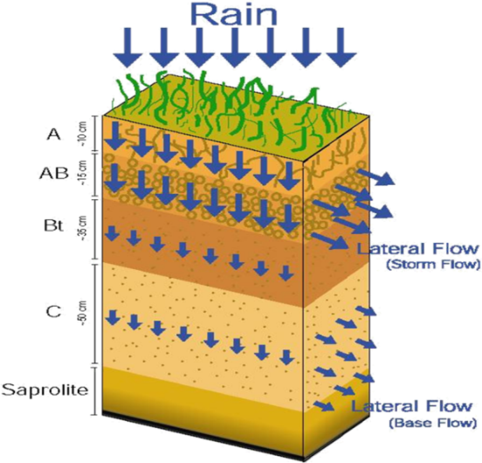

Figure 1. Illustration of rapid subsurface stormflow processes and flow pathways in relationship to soil hydraulic characteristics.

Hypotheses and Objectives of Proposed Project
The goal of this research proposal is to examine changes in the mass balance of major nutrients (C, N, P) and base cations/anions across the main functional watershed units (e.g. whole watershed vs. hillslope vs. riparian vs. instream) within the South Fork watershed of Caspar Creek in response to stand density reductions. The hypothesis is that stand density reduction will increase export of total N, total P, NO3–, and particulate/dissolved organic C from the treated watersheds immediately following the forest harvest, with greater impacts observed with greater stand density reduction. The hypothesis is that the increased hydrologic connectivity associated with macropore flow and fast subsurface stormflow above the clay-rich, argillic soil horizon promote rapid flow pathways for storm flow and nutrient transport from hillslopes to streams. The proposed research attempts to address this hypothesis through the following specific objectives:
1) Determine the changes in stream water and soil water solute concentrations and nutrient fluxes during storm flow and baseflow conditions prior- and post-harvest in the South Fork Caspar Creek watershed. [note that pre-logging water samples are currently being analyzed]
2) Compare nutrient export between harvested and reference watersheds.
3) Examine the linkage between nutrient flux and biotic response (using macroinvertebrate data collected as part of the bioassessment study in place).

Scope of Work
In 2018, six of the eleven sub-watersheds within the 424 ha South Fork of Caspar Creek will be harvested across a range (i.e. 25–75%) of percent leaf area removal. Three of the eleven sub-watersheds will remain non-treated to serve as controls to determine thresholds at which hydrologic and ecological functions of the watersheds may be compromised. To address the above stated hypotheses and objectives, the following research activities to be conducted during the one-year project period.
The work will focus on a watershed-wide assessment of solute and nutrient export from the harvested and reference sub-watersheds within South Fork Caspar Creek. To characterize the flow regime and biogeochemistry of Caspar Creek at near-pristine conditions, baseline sampling of stream water has been conducted in at different nodes in the South Fork watershed since April 2016 (Fig. 2). The baseline sampling has been continued over the winter of 2016/17to capture important data during the stormflow period of Caspar Creek.
To quantify the impact of forest thinning on stream water biogeochemistry and nutrient export, solute concentrations of key elements (calcium, magnesium, potassium, sodium, chloride, sulfate) and nutrients (carbon, nitrogen, phosphorus) will be measured in stream water samples collected during and after the harvest activities for comparison to the baseline conditions. Solute concentrations are planned to be monitored for the duration of three years after the timber harvesting to reliably determine changes and shifts in biogeochemical cycling with respect to other, influential environmental factors such as climate and year-to-year variability in streamflow. The funding requested from the EMC and CAL FIRE will allow water sample collection and analysis for the years during and after timber harvesting. Funding for the first year before harvest activities in the South Fork of Caspar Creek has been provided by a Save the Redwoods League grant ($25,000).
Changes in nutrient export over time in response to forest treatment and hydro-climatic conditions will be determined based on the detailed analysis of stream water samples collected at different nodes within the watershed for major nutrients (carbon, nitrogen, phosphorus) and base cations (calcium, magnesium, potassium, sodium) and anions (chloride, sulfate). The data collected during year one of the timber harvest will allow formulating specific research hypotheses on the role of forest harvesting practices, runoff generation mechanisms, hydrologic connectivity between hillslopes and the riparian zone, and instream processes on nutrient export from Caspar Creek watershed.
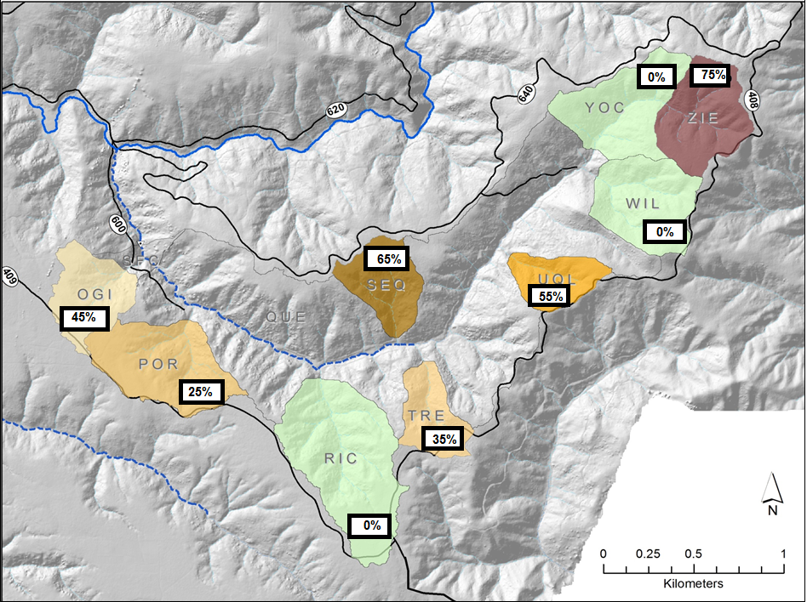
Figure 2. Study sites are located in a subset of gauged sub-watersheds in the South Fork Caspar Creek, with percent reduction in stand density displayed.

Methods
Stream and soil water sampling: In order to document the disturbance effects of the proposed stand density reductions on nutrient fluxes, stream water samples (storm events and baseflow) are being collected from selected treated, non-treated and mainstem sites (i.e. integration sites) within the South Fork Caspar Creek watershed. Stream sampling locations are co-located with stream water gauging stations to allow us to determine constituent loads (kg/unit time). This preliminary data will allow formulation of a hypothesis of the fate and transport mechanisms of nutrients and solutes along the hydrologic continuum: watershed hillslope riparian zone instream/hyporheic, which will be analyzed in more detail in the study during year 2 and 3.
To collect samples, ISCO automatic samplers are installed at gauging stations and programmed to sample stream water at hourly intervals during peak flow events. From the collected storm water samples, two samples each collected on the rising and falling limb of the hydrograph and the sample collected closest to the peak of the streamflow event are transferred into 125 ml HDPE bottles for further laboratory analysis. Stream water samples are collected bi-weekly during the summer dry season and during extended periods with no storm events. Precipitation samples are collected as bulk samples at three locations within the watershed following precipitation events. All samples are stored in the fridge until shipment for laboratory analysis. The water samples are shipped to the University of California, Davis on a weekly basis to reduce the risk of degradation of the sample over time. In order to discern pre- and post-harvest effects on nutrient fluxes, at least 2-3 storm events and 6 baseflow periods will be sampled prior to onset of the harvesting activities from different sub-watersheds and mainstem locations within South Fork Caspar Creek. These baseline data will allow assessment of whether the individual sub-watersheds can be considered comparable (i.e., paired watersheds) in terms of nutrient cycling.
Laboratory Analysis: A subsample of the collected streamwater samples and the collected soil water is filtered through a pre-rinsed 0.2 µm polycarbonate membrane (Millipore) for quantification of soluble reactive phosphorus (SR-PO₄), nitrate-N (NO₃-N), ammonium (NH₄-N), and dissolved organic carbon (DOC). SR-PO₄ is determined using the ammonium molybdate spectrophotometric method (LOD ~0.005 mg LP⁻¹) (Clesceri et al., 1998). The vanadium chloride method is used to spectroscopically determine NO₃-N (LOD =0.01 mg L⁻¹) (Doane and Horwath 2003). NH₄-N is determined spectroscopically with the Berthelot reaction, using a salicylate analog of indophenol blue (LOD ~ 0.010 mg L⁻¹; Forster 1995). TOC and DOC are measured using a Dohrmann UV enhanced-persulfate TOC analyzer (EPA Standard Method 5310C; Phoenix 8000; LOD ~0.1 mg L⁻¹). Particulate organic carbon (POC) is determined by difference: TOC – DOC. Electrical conductivity (EC), pH, and turbidity are measured on unfiltered subsamples using laboratory meters. TN and TP are measured on a non-filter sample following oxidization with 1% persulfate (Clesceri et al. 1998) and subsequent quantification of nitrate and phosphate, respectively, using the methods described above. Major cations (Ca, Mg, K, Na) and anions (Cl, SO₄) are quantified by ion chromatography and HCO₃/CO₃ by acid titration. Laboratory quality assurance/quality control includes replicates, spikes, reference materials, setting of control limits, criteria for rejection, and data validation methods (Puckett 2002).
LOAD ESTimator (LOADEST) is used to estimate constituent loads in streams from daily measurements of streamflow (http://water.usgs.gov/software/loadest/). Given a time series of streamflow, additional data variables, and constituent concentration, LOADEST develops an optimized regression model for the estimation of constituent loads (calibration). The formulated regression model can then be used to estimate loads over a user-specified time interval (estimation). Mean load estimates, standard errors, and 95 percent confidence intervals are developed for a daily, monthly and/or seasonal basis. A successful calibration of LOADEST for water quality constituents allows the estimation of constituent loads for time periods during which field measurements are not taken, based on daily stream flow records that are continuously available from the watershed gauging stations.

Relevance of anticipated results
There is a concern that nutrient losses from hillslopes to streams associated with erosion and leaching after timber operations may compromise the long-term sustainability of forest ecosystems. Increased nutrient levels in streams can increase algal growth, particularly where near-stream logging or climate warming has increased stream temperatures or increased light to the stream water column. This study will evaluate the effect of different forest harvest practices (e.g. different degrees of forest stand removal) on nutrient cycling processes in a California coast redwood watershed. The results will be particularly important to improve understanding of how nutrient removal due to timber harvest impacts forest regrowth and food webs in downstream aquatic systems.

Education and outreach activities
Upong completion of this multi-year study the PIs will present preliminary findings at the UC ANR Redwood Science Symposium, the American Geophysical Union Fall Meeting, and other relevant state meetings. Further, results will be summarized in a agency summary report for dissemination to stakeholders.

Timeline

Background water sampling will occur during 2016 and 2017. Timber harvesting will take place in the spring, summer and fall of 2018 in the six treated sub-watersheds. Post logging sampling will end on June 30, 2020.

Funding
Drs. Dahlke and Dahlgren, UC Davis PIs, covered the analytical cost associated with streamwater chemical analyses of the pretreatment samples collected from April 2016 to January 2017.
To conduct the further pre-treatment research, the PIs requested the following from the Save the Redwoods League: support for 3 months for a lab technician ($12,610 in salary and $6,579 in benefits for 1 year at 25% effort), support for consumables needed to collect stream water samples (e.g. bottles: $1,500) and to support the laboratory analysis ($3,500), and shipping costs ($750). The Save the Redwoods League provided a $24,939 grant for one additional year of pre harvest data collection (February 1, 2017—January 31, 2018).
Funding is required for data collection and analysis from February 1, 2018 through June 30, 2020. Two years of funding is proposed for EMC and CAL FIRE support. CAL FIRE will provide $100,000; the funding requested from the EMC is $92,252.
 | 2018 | 2019 | Total Cost
Student Salary | 30,437 | 32,828 | 63,265
Laboratory Technician | 20,375 | 21,209 | 41,584
Travel | 3,500 | 3,500 | 7,000
Supplies | 3,500 | 3,500 | 7,000
Tuition and Fees | 16,053 | 17,658 | 33,711
Indirect Costs | 17,344 | 18,311 | 35,655
Total | 93227 | 99025 | 192,252

References
Aber JD, Ollinger SV, Driscoll CT, Likens GE, Holmes RT, Freuder RJ, Goodale CL. 2002. Inorganic nitrogen losses from a forested ecosystem in response to physical, chemical, biotic, and climatic perturbations. Ecosystems 5: 648–658.
Bernhardt, E.S., Likens, G.E., Hall, R.O., Buso, D.C., Fisher, S.G., Burton, T.M., Meyer, J.L., McDowell, W.H., Mayer, M.S., Bowden, W.B. and Findlay, S.E., 2005. Can't see the forest for the stream? In-stream processing and terrestrial nitrogen exports. Bioscience, 55(3), pp.219-230.
Clesceri, L.S., Greenberg, A.E., Eaton, A.D., 1998. Standard methods for the examination of water and wastewater, American Public Health Assoc., American Water Works Assoc., and Water Environment Assoc., Washington, DC, 20th Ed.
Dahlgren, R.A., 1998. Effects of forest harvest on stream-water quality and nitrogen cycling in the Caspar Creek watershed.
Doane, T.A., Horwath, W.R., 2003. Spectrophotometric determination of nitrate with a single reagent. Anal. Lett. 36, 2713–2722.
Dymond, S.F. 2016. Caspar Creek Experimental Watersheds experiment three study plan: the influence of forest stand density reduction on watershed processes in the South Fork. USDA Forest Service Pacific Southwest Research Station, Arcata, CA. 28 p.
Fenn ME, Poth MA, Aber JD, Baron JS, Bormann BT, Johnson DW, Lemly AD, McNulty SG, Ryan DF, Stottlemeyer R. 1998. Nitrogen excess in North American ecosystems: predisposing factors, ecosystem responses and management strategies. Ecol Appl 8:706–33.
Forster, J.C., 1995. Soil nitrogen. In: Alef, K., Nannipieri, P. (Eds.), Methods in Applied Soil Microbiology and Biochemistry. Academic Press, San Diego, pp. 79–87.
Johnson, D.W.; Cole,D.W.; Bledsoe, C.S.; Cromack, K.; Edmonds, Robert L.; Gessel, S.P.; Grier, C.C.; Richards, B.N.; Vogt, K. A. 1982. Nutrient cycling in forests of the Pacific Northwest. Pgs 186-232 in: (RL Edmonds, ed.) Analysis of Coniferous Forest Ecosystems in the Western United States. Hutchinson and Ross, Inc., Stroudsburg, PA.
Lovett GM, Weathers KC, Sobczak W. 2000. Nitrogen saturation and retention in forested watersheds of the Catskill Mountains, NY. Ecol Appl 10:73–84.
MacDonald, L.M., Smart, A., and Wissmar, R.C. 1991. Monitoring guidelines to evaluate the effects of forestry activities on streams in the Pacific Northwest and Alaska. EPA/910/9-91-OO1, U.S. Environmental Protection Agency Region 10, Seattle, WA, 166 p.
Murdoch PS, Stoddard JL. 1992. The role of nitrate in the acidification of streams in the Catskill Mountains of New York. Water Resources Res 28:2707–20.
Puckett, M. 2002. Quality Assurance Management Plan for the State of California's Surface Water Ambient Monitoring Program ("SWAMP"). California Department of Fish and Game, Monterey, CA. Prepared for the State Water Resources Control Board, Sacramento, CA. 145 pages plus Appendices.
Sugimoto, R. and Tsuboi, T., 2016. Seasonal and annual fluxes of atmospheric nitrogen deposition and riverine nitrogen export in two adjacent contrasting rivers in central Japan facing the Sea of Japan. Journal of Hydrology: Regional Studies.
Vitousek PM, Aber J, Howarth RW, Likens GE, Matson PA, Schindler DW, Schlesinger WH, Tilman GD. 1997. Human alteration of the global nitrogen cycle: causes and consequences. Ecol Appl 7:737–50.
Williard KWJ, DeWalle DR, Edwards PJ, Schnabel RR. 1997. Indicators of nitrate export from forested watersheds in the mid-Appalachians, United States of America. Global Biogeochem Cycles 11:649–56.

