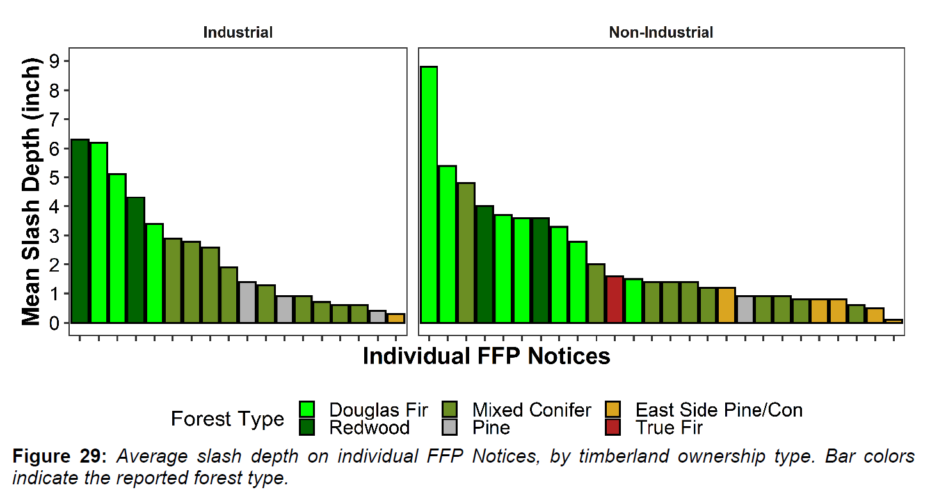We are starting to generate some good data from our various monitoring samples. The first figure shows mean slash depth for each Notice from our modified Brown transects. The second figure shows a representative transect in terms of slash depth and size class vs. transect distance. Post-treatment slash can be quite deep and continuous in coastal redwood and Douglas fir.  We see fewer issues inland.

