**Uneven-aged Working Group Update -August 20, 2024**

* + **Overview**

In the three years since its original mandate, the Board has addressed several of the areas. Specifically, the issue of Group Selection, technical issues related to hardwoods and retention standards of residual trees, and the Southern sub-district (SSD).

For the Uneven age Working Group, the issues to be considered further are outlined below. The rules themselves are geared to a well-distributed and evenly distributed stand, but there are indications that “patchy” (or gappy-clumpy”) distributions may be more favorable to overall stand resilience in certain fire conditions. Given the increasing interest in overall spatial arrangement, additional examination is required.

* + **Unevenaged Basal Area Requirements, and other issues**
    - Two potential issues are under review.
      * Treatment of groups in group selection post-harvest
        + Point count vs Basal Area
        + Should standard be based on Stand Density Index?
      * Standards for most Site Classes/Regions appear correct
        + Possible exception: Site II and III in Northern Region

Original recommendation from DTAC indicated a 60 sq ft standard

Yellow Pine Mixed Conifer (xeric)

True Fire Mixed Conifer (mesic)

* Next Steps:
  + - * Organizing expert group (Collins. York, Bernal)
      * Review of various approaches to Basal Area retention in Sierra Cascade
      * Review of Stand Density Approach in group selection openings, or other options
      * Examination of Rulemaking Files 13, 18, 25

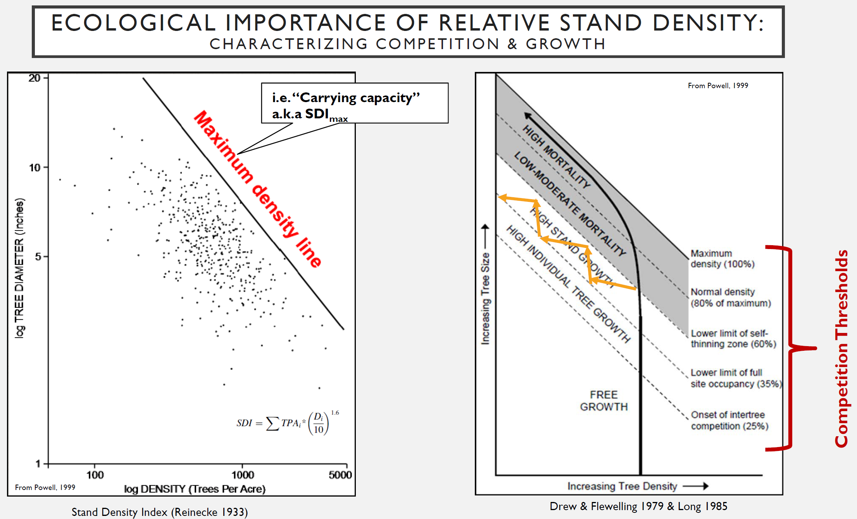

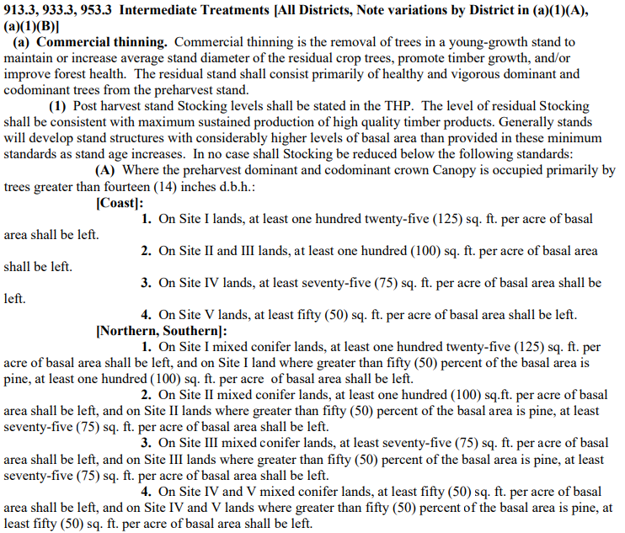

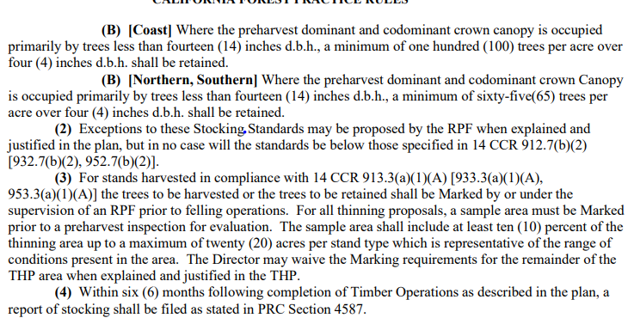

* + **Transition method- no work beyond initial discussion**
    - The group discussed utilizing the transition method in areas of single tree selection. This would mean using this expanding this method to not only encourage uneven age structure, but to gain control of species composition (see opening remarks). This could also apply in certain coastal areas, according to those RPFs practicing there. After much discussion, it was concluded that a field tour would probably be needed to demonstrate how and when this prescription could be applied.

**Transition Silviculture Potential Changes as discussed:**

1. Eliminate the upper limit of stocking, which is presently 150 sq. ft. BA/ac for Site I and 125 sq. ft. BA/ac for Site II, III, IV, and V. *Allows for transitioning overstocked mixed conifer forests dominated by white fir back to ponderosa pine dominated stands.*
2. Reduce Site I stocking level from current 85 to 50 sq. ft. BA/ac. A*llows more flexibility and more incentive to practice unevenaged management on the best sites. This would be the one FPR standard that should be examined as potentially being too high for Selection.*
3. Allow up to 35% of the area in group clearings with a requirement for immediate postharvest restocking of groups with appropriate species to meet point count stocking within 5 years if more than 20% of the area is harvested in groups. A*llows more area to be actively regenerated with the proper species.*
4. Remove the requirement for Selection regeneration method after two subsequent Transition entries. *Allows for more flexibility in transitioning stands to a more regulated unevenaged state, and also allows for adaptive management as current research is indicating maintaining lower standing inventory levels for more drought and fire resiliency, which reflects data from pre-fire suppression stands and also more allowance for clumpy/gappy stand structures such as described in the ICO Guide. High stocking levels may not lead to Maximum Sustained Production if mortality is increased due to high levels of competition for soil moisture.*

Other Outstanding issues from the Board in this category:

* + - **14 CCR § 913.2 (b) – Transition Silviculture:**

***Objective:*** *It has been reported that CAL FIRE does not allow use of the Transition silviculture method in timber stands which were most previously harvested utilizing the Selection method. This ‘policy’ is not consistent with 14CCR § 913.2(b) or (b)(2). THP was returned on this issue without being evaluated through PHI to support the determination.*

* + - **14 CCR § 913.4(d) - Variable Retention Silviculture:**

***Objective:*** *Several questions have been raised regarding implementation of this Special Prescription: (1) Should the Variable Retention regulation specify a minimum re-entry period for designated retention areas?; (2) Should the current regulation require a minimum stand age necessary for harvest to occur in order to demonstrate maximum sustained production (MSP) as is required for even-age silviculture under 14 CCR § 913.11(c)?; and (3) Are the minimum stocking requirements of CCR § 913.4 (d)(3)(H) relative to aggregate versus dispersed retention clear enough for consistent application and enforcement?*

**Completed**

* + **Group selection issues**
    - Rulemaking completed
  + **Southern Sub District Rules**
    - Rulemaking completed
  + **Technical Issues-** 
    - Rulemaking completed
  + Allow for basal area credit hardwoods as well as snags (like current oak silviculture standard). Allow for lower snag standards (smaller sizes allowed).
  + Allow for more flexibility in group B justification- like current oak standards.
  + Rules do not reflect heterogeneity in many stands.
  + More flexibility for plan submitters on the “8 18” rule to allow for better spacing.